Supplementary Information

Organometallic Perovskite Metasurfaces

Behrad Gholipour,^{1,†} Giorgio Adamo,^{1,†} Daniele Cortecchia,^{2,3} Harish N. S. Krishnamoorthy,¹
Muhammad. D. Birowosuto,⁴ Nikolay I. Zheludev^{1,5} and Cesare Soci^{1,3,*}

¹ Centre for Disruptive Photonic Technologies, TPI, SPMS, Nanyang Technological University, 21 Nanyang Link, Singapore 637371
² Interdisciplinary Graduate School, Nanyang Technological University, Singapore 639798
³ Energy Research Institute @ NTU (ERI@N), Research Techno Plaza, Nanyang Technological University, 50 Nanyang Drive, Singapore 637553
⁴ CINTRA UMI CNRS/NTU/THALES 3288, Research Techno Plaza, 50 Nanyang Drive,
Border X Block, Level 6, Singapore 637553
⁵ Optoelectronics Research Centre & Centre for Photonic Metamaterials, University of Southampton, SO17 1BJ, UK

†These authors contributed equally
*Corresponding author: csoci@ntu.edu.sg

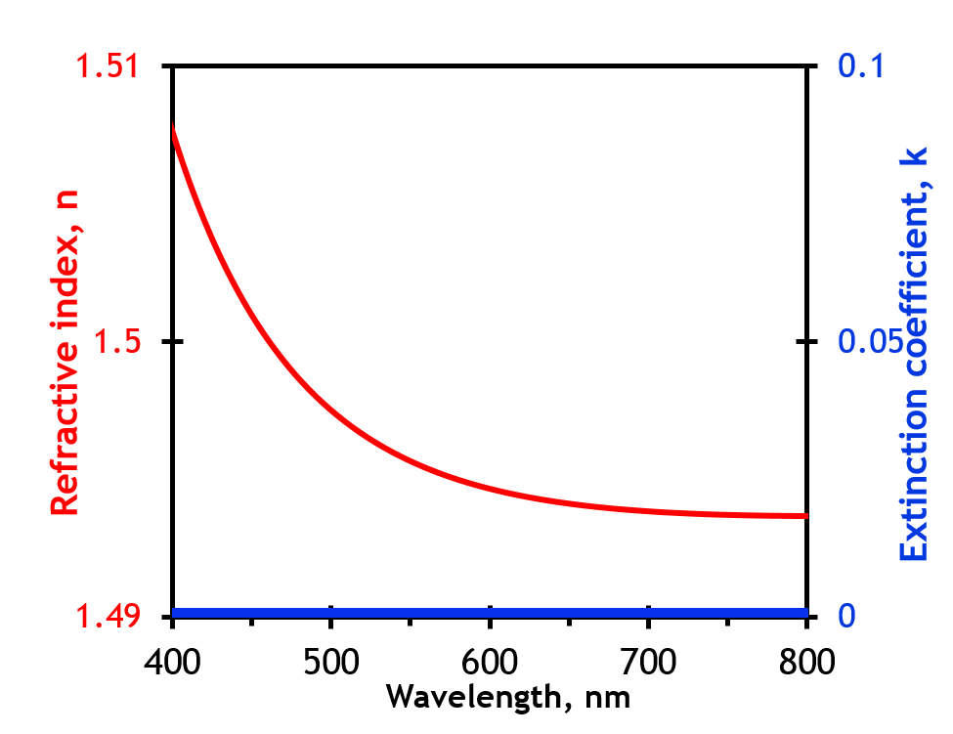

Figure S1: Measured optical constants of the substrate obtained from variable angle spectroscopic ellipsometry.

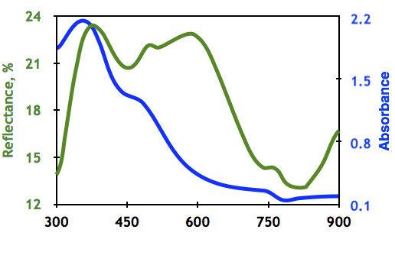

Figure S2: Reflectance and absorbance of a representative unstructured organolead halide perovskite.

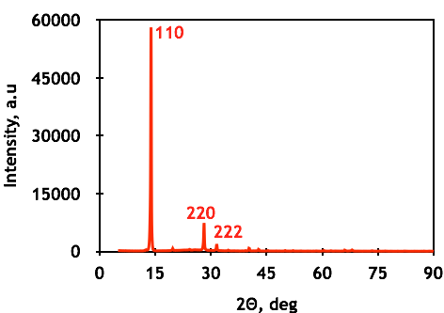
Figure S3: X-ray diffraction of a representative unstructured organolead halide perovskite. The XRD pattern on thin film confirms the formation of MAPbI₃ with strong preferential orientation towards the 110 direction. The pattern obtained is consistent with the tetragonal crystal system, space group I4/mcm and lattice parameters a = 8.889 Å and c = 12.562 Å.

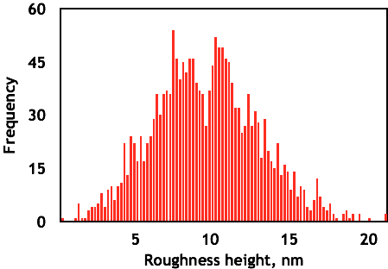
Figure S4: Roughness of spin-coated solution processed organolead halide perovskite. Roughness analysis of an unstructured organolead halide perovskite, obtained using atom force microscopy.

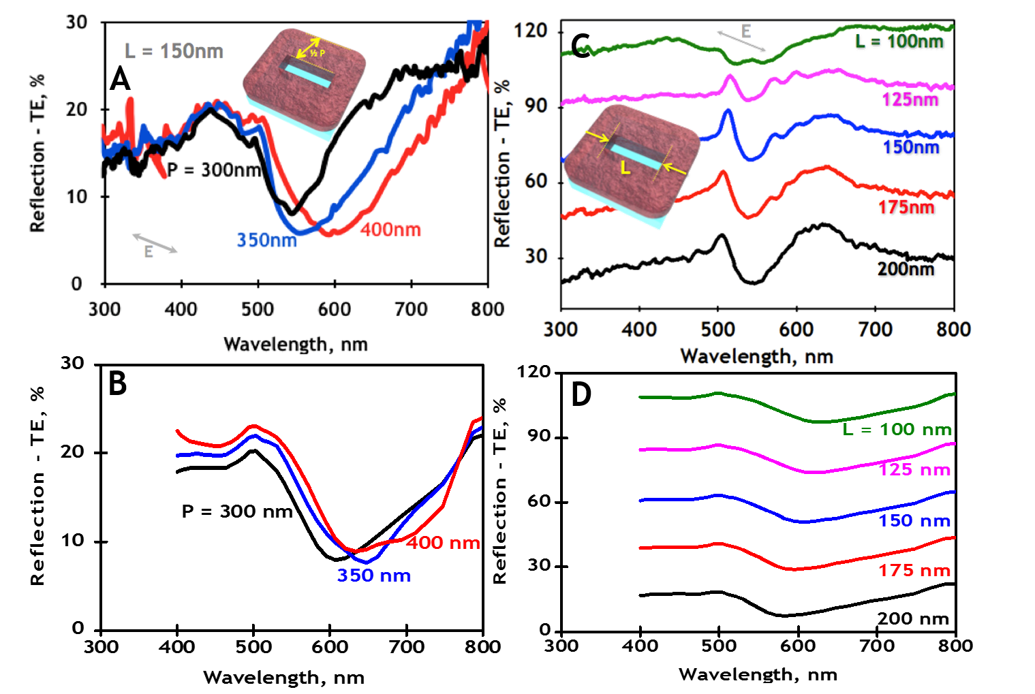
Figure S5: Structural tuning, by period and length of reflection properties of nanoslit metasurfaces. A) Structural tuning (P=300-400 nm) of reflection spectra for TE polarised incident light on the nanoslit metasurfaces, showing good agreement with, B) corresponding simulated spectra. C) Structural tuning of the length of nanoslits (L=100-200 nm), along with D) corresponding simulated spectra.

Figure S6 – Colour tunable all-perovskite nanoslit metasurfaces. Optical microscope image of nanoslits showing a range of vibrant colours.

