Abstract
Objectives
To evaluate the validity of the Digit Triplet Test (DTT) in a simulated home environment for measuring speech recognition in adults with cochlear implants by comparing the result to clinic speech perception tests. To evaluate the acceptability of the DTT in adults using cochlear implants.
Methods
A prospective single-centre study with the following outcomes:
- Digit Triplet Test Speech Reception Threshold
- Clinic speech perception tests (BKB sentences in quiet and noise, CUNY sentences with lip-reading)
- A satisfaction questionnaire to assess patient perception of the Digit Triplet Test
Sixteen people using cochlear implants aged from 43 to 83 years took part.
Results
- Eighty-eight percent of participants were able to be tested on the DTT; there were no floor or ceiling effects.
- DTT SRT was highly correlated with clinic BKB sentence scores in quiet and adaptive noise, and participants felt positive about using the DTT for home testing.
Conclusion
The majority of adults using cochlear implants in this study were able and willing to use the DTT to test their speech recognition in a simulated home environment. The DTT SRT was highly correlated with traditional clinic sentence scores, supporting its validity as a home test for hearing in adults using cochlear implants. Hearing testing in the clinic is still the gold standard of clinical care for people with cochlear implants, but a home test could provide a useful addition.

Keywords:
Cochlear implant, speech perception, telemedicine, person-centred care

Introduction
People using cochlear implants are routinely evaluated with speech recognition testing because the primary aim of cochlear implantation is usually improved understanding of speech. An ideal test would be reliable, highly sensitive to different conditions and correlate well with speech perception abilities in the real world (Mackersie, 2002). In the United Kingdom (UK), candidacy for adult implantation is determined using Bamford-Kowal-Bench sentences (Bench, Kowal, & Bamford, 1979) presented in quiet at 70 dBSPL (NICE, 2009). Consequently BKB sentences are typically used after implantation too in order to demonstrate improvement. Although a sentence test in quiet has high face validity, it may not be appropriate for all people for several reasons:
- BKB and HINT (based on BKB sentences (Nilsson, Soli, & Sullivan, 1994)) sentences are based on utterances of children describing everyday scenarios and are therefore very predictable e.g. ‘She cut with her knife’. Many adults are able to use top-down cognitive skills to fill in the gaps and identify what is being said despite limited auditory information being received (Vickers et al., 2016). This can make it more a test of cognitive ability than speech recognition.
- People using cochlear implants who have lower levels of English language or limited auditory-alone speech understanding are likely to obtain floor scores on BKB sentences.
- Performance with a cochlear implant has improved over the years resulting in between 49 and 71% of adults with implants approaching or at ceiling on sentence testing in quiet (Firszt et al., 2004; Gifford, Shallop, & Peterson, 2008) with 28% scoring 100% (Gifford et al., 2008). Near ceiling scores can be achieved by adults with postlingual deafness after as little as 3 months of implant use (Litovsky, Parkinson, Arcaroli, & Sammeth, 2006). Ceiling scores present a challenge because improvements in performance over time or differences between two conditions cannot be evaluated.

In most UK cochlear implant centres, sentence testing in quiet is supplemented with sentence testing in fixed or adaptive noise. In addition, City University of New York (CUNY) sentences (Boothroyd, Hanin, & Hnath, 1985) are used in an audiovisual format for those who are unable to achieve auditory-alone speech recognition (Craddock, Cooper, Riley, & Wright, 2016). CUNY sentences are longer and more complex linguistically than BKB sentences e.g. CUNY sentence ‘Did you ever win any trophies for sports competitions when you were at university?’ At the University of Southampton Auditory Implant Service (USAIS) all adults are assessed with BKB sentences in quiet, then if the score is between 50 and 70% a further test is done with fixed speech-shaped background noise using a +10 dB signal to noise ratio. If a BKB score of greater than or equal to 70% in quiet is obtained, testing in adaptive noise will be used. If the tester considers that the patient is unlikely to achieve open-set speech understanding, CUNY sentences presented audiovisually are used. Other material is used on a case by case basis e.g. Arthur Boothroyd (AB) monosyllabic words (Boothroyd, 1968) and the ASSE® Psychoacoustic Test Suite (Otoconsult NV, Antwerp, Belgium). This situation means that there is not a single valid test that measures speech understanding in all adults using cochlear implants. Although BKB sentences in quiet are attempted with everyone, many people score either at ceiling or floor for reasons described above. This makes comparison of a group of people with cochlear implants problematic.

Measuring speech understanding with digits is increasingly used, starting with the Dutch digit triplet test (Smits, Kapteyn, & Houtgast, 2004), and may offer distinct advantages. Digits are highly familiar stimuli known to people with even limited language ability and testing has a smaller learning effect (Smits, Theo Goverts, & Festen, 2013; Vlaming, MacKinnon, Jansen, & Moore, 2014). The closed set response makes digits suitable for self-testing over the telephone (Smits & Houtgast, 2005; Watson, Kidd, Miller, Smits, & Humes, 2012) or internet (Leensen, de Laat, & Dreschler, 2011; Smits, Merkus, & Houtgast, 2006). Testing using digit triplets in noise has been used to screen hearing in hundreds of thousands of people worldwide (Stam et al., 2015; Williams-Sanchez et al., 2014) and is freely available to the public online (Action on Hearing Loss, 2015; MED-EL, 2015). Digit triplet testing in noise has also been successfully used in adults (Dutch version used in Kaandorp, Smits, Merkus, Goverts, & Festen, 2015) and children (Mishra, Boddupally, & Rayapati, 2015) using cochlear implants, and correlates well with a sentence test in noise, has adequate repeatability and is relatively immune to learning effects, linguistic ability and personal factors such as education level (Kaandorp et al., 2015).

The aim of this project was to evaluate the validity and feasibility of using the English Digit Triplet Test in a simulated home environment in adults with cochlear implants, with the aim of introducing the test for home use in a later clinical trial (H. Cullington et al., 2016).
Hypotheses
- There is a significant correlation between the Digit Triplet Test (DTT) speech reception threshold (SRT) (dB) in the simulated home environment and clinic speech perception tests
- The majority of adults using cochlear implants find the DTT an acceptable and appropriate test to assess their speech recognition

Methods and material
Design
This was a prospective single-centre study which aimed to assess the validity and acceptability of using the Digit Triplet Test to measure speech recognition in adults with cochlear implants. The study received approval from the University of Southampton Institute of Sound and Vibration Research Safety and Ethics Committee (ref 14648) on 24 June 2015. The study also received National Research Ethics Service approval (NRES Committee South Central – Oxford C 15/SC/0425) on 14 July 2015.

Setting
The study testing took place in a side room at the University of Southampton Auditory Implant Service. The room was chosen to simulate a quiet home environment in terms of levels of distraction and background noise. The ambient noise level was 35 - 45 dB(A).

Participants
Inclusion criteria:
- Person using cochlear implant (any device, unilateral or bilateral)
- Cochlear implant use for at least 1 month
- Aged 18 years or more
- Able to give informed consent
- No cognitive difficulties that would preclude consent or test participation
- Sufficient English to understand study documentation and participate in testing
- Existing USAIS appointment during data collection period with the expectation of speech recognition testing occurring on that day
- Willing to be invited to join research projects

Recruitment
Sixty-six people fulfilled the eligibility requirements and were invited to take part (52 were emailed; 14 were mailed). They were sent a Participant Information Sheet detailing the study and asked to come 20 minutes early for their appointment if they wished to take part. On the day of attendance, discussion of the project occurred, and potential participants were invited to sign the informed consent form.

Interventions
Digit Triplet Test, DTT
The test was run using a custom MATLAB (The MathWorks, Inc, Natick, Massachusetts, USA) program on a laptop computer. Participants were asked to use direct connection between their sound processor and the laptop headphone socket if they were familiar with this. The CochlearTM Nucleus mains isolation cable was also used; it has surge protection to protect the sound processor when using mains powered equipment. Even if the participant used a device that was not made by Cochlear, they could connect their own personal audio cable into the CochlearTM Nucleus mains isolation cable before connecting it to the computer. If participants were unfamiliar with direct connection, they used a mini GEAR4 (St Albans, UK) portable loudspeaker which presented the material in the sound field.
The stimuli were sets of three monosyllabic digits from zero (pronounced as ‘oh’) to nine such as (3-4-8) excluding the disyllabic digit (seven); these digit triplets were spoken by a female talker at a fixed presentation level. The listeners were asked to set the volume to a comfortable listening level; by adjusting the computer volume in the usual way. The digits were presented in speech-shaped noise which was varied adaptively in a 2 down 1 up paradigm (Levitt, 1971) with a theoretical asymptote of 71%. The maximum signal to noise ratio presented was +15 dB. If subjects scored two correct responses in a row, the test became harder i.e. the noise was louder. However when they scored one incorrect response, the test became easier (noise became softer). The step size was 8 and 4 dB for the first and second reversals respectively, and then subsequently 2 dB for the remaining 8 reversals. The maximum number of trials presented was 60. The outcome SRT (dB) was the average of the presentation signal to noise ratio (SNR) of the final 8 reversals.

In order to obtain a correct response, the listener was required to correctly identify all three digits in the triplet. They could speak or sign the digits they heard or use the keyboard to enter responses themselves. No feedback was given and no repetition was permitted.
The experimenter aimed to perform the research testing before the clinical appointment; if this was not possible, it was done afterwards.

Clinic speech perception testing
The clinician seeing the participant for their planned appointment evaluated their speech perception following the usual USAIS protocol. This was a different person from the researcher running the study testing.
BKB sentences in quiet: Two lists of 16 sentences spoken by a male talker were presented in the sound field at 70 dBSPL in a sound-treated room. Loose keyword scoring was used, requiring only the root of the keyword to be reported correctly. The outcome was % keywords correctly identified.
BKB sentences in fixed noise: If the patient scored between 50 and 70% on BKB sentences in quiet, a further two lists were presented in speech-shaped noise with a SNR of + 10 dB.
BKB sentences in adaptive noise: If a score of greater than or equal to 70% was obtained in quiet, an adaptive presentation of noise was used, with the speech level remaining fixed at 70 dBSPL. The starting SNR was +10 dB, and a 2 up 1 down adaptive procedure was followed (Levitt, 1971) meaning that if two consecutive sentences were correctly identified (two out of three keywords loosely correct), the noise was increased. Noise intensity decreased after one incorrect sentence; this estimates the 71% correct level. The initial step size was 5 dB, then 2dB and the outcome SRT (dB) was the average SNR of the final eight reversals.
CUNY sentences in quiet with lipreading: If the clinician felt it was appropriate, the participant was tested with one list of 24 CUNY sentences presented at 70 dBSPL by a male talker in a pre-recorded audiovisual format.
Satisfaction questionnaire
After doing the DTT, participants were asked to complete a short questionnaire either on the laptop or on paper (Appendix 1). The questionnaire comprised two sections: nine statements were given and the participant was asked to indicate their level of agreement with them using a five item Likert scale (Strongly agree, agree, neither agree nor disagree, disagree, strongly disagree). Participants then had a free text opportunity to list positive and negative points about being tested with the DTT.

Outcome measures
- Percentage of adults using cochlear implants who were able to have their speech recognition tested using the DTT in a simulated home environment
- Speech reception threshold (dB) of DTT and results of clinic speech perception testing (BKB sentences in quiet, BKB sentences in fixed and adaptive noise, CUNY sentences) tested on the same day
- Percentage of adults who felt positive about the DTT for speech recognition testing, measured using a satisfaction questionnaire

Data analysis
The statistics package SPSS (IBM Corporation, Armonk, New York, USA) version 22 was used for analyses and the generation of graphs. Boxplots were used to show the spread of results. The variables DTT SRT, BKB score in quiet, BKB score in noise, BKB SRT in adaptive noise, CUNY sentence score were evaluated with the one-sample Kolmogorov-Smirnov test to check whether parametric assumptions were violated. The p value was set at 0.05; two-tailed tests were used. Bias corrected accelerated (BCa) 95% confidence intervals were used. Satisfaction questionnaire responses were analysed qualitatively.
Results
Demographics
Eleven females and 5 males aged from 43 to 83 years (mean 64 years; standard deviation 13 years) took part. All used unilateral cochlear implants. Participants used various cochlear implant sound processors: Advanced Bionics NaidaTM (n = 3), MED-EL Opus 2 (n = 2), MED-EL Rondo (n = 2), MED-EL Sonnet (n = 1), Nucleus® CP810 (n = 1), and Nucleus® CP910 (n = 7). One participant was tested with a Naida™ sound processor for the DTT after the clinic appointment when clinic testing was done using the Harmony sound processor (this was the occasion of sound processor upgrade).
Digit Triplet Test
Fourteen out of 16 people (88%) were able to be tested successfully on the DTT. The test took about 5 minutes to run and the SRTs were between -2.55 and 12 dB. All participants except one were tested in the CI alone condition; one person was tested bimodally i.e. cochlear implant plus contralateral hearing aid (this participant did not have clinic speech perception testing on the same day due to mistakenly being included in the project after only three weeks and 1 day of sound processor use). The DTT was performed before the clinic testing in fourteen out of 16 cases; two participants participated in the study after their clinic testing because there was insufficient time before. All participants chose to do the test using the mini loudspeaker rather than using direct connect.

Correlation to clinic testing
Fifteen out of 16 participants had speech perception testing performed on the same day as the DTT. All clinic speech perception testing was performed implant alone (no contralateral hearing aid). Fourteen results were obtained for BKB sentences in quiet, two for BKB sentences in +10 dBSNR, eight for BKB sentences in adaptive noise, and six for CUNY sentences with lipreading; 12 people (80%) were tested on more than one measure. It is local protocol to test everyone on BKB sentences in quiet at set intervals (for example 1, 2, 3 years of implant use); one participant was not tested as the appointment was not at a fixed interval. Figure 1 shows a boxplot of the % scores for the clinic testing in quiet and noise; Figure 2 shows a boxplot of the DTT and BKB Speech Reception Thresholds (SRT) in dB.

Figure 3 shows a scatterplot of DTT SRT against BKB score in quiet for the 13 subjects who obtained scores on both; Figure 4 shows DTT SRT against adaptive BKB SRT for the 8 subjects who obtained scores on both tests. DTT SRT was significantly related to BKB sentence score in quiet (Pearson correlation coefficient r = -.749, [confidence interval -.368, -.938], p = 0.003, n = 13) and adaptive BKB SRT (Pearson correlation coefficient r = .760, [confidence interval .115, .981], p = 0.029, n = 8).
Due to insufficient numbers and ceiling effects in the case of CUNY sentences (Figure 1), no correlation analyses were performed for BKB sentences in fixed noise (n = 2) or CUNY sentences with lip-reading (n = 6).

Satisfaction questionnaire
All 16 participants answered all nine questions on the satisfaction questionnaire. Frequency tables of the participants’ agreement with the nine statements are show in Figure 5. On average (considering the median values), participants strongly agreed that the DTT costs less time and money (e.g., travel time and waiting time, cost of transportation and parking. Participants agreed that testing with the DTT speeds up measuring speech perception and they liked the idea of using the DTT to test speech perception at home. Participants felt neutral about whether the DTT is more comfortable than clinic tests, and whether the DTT could be less safe than clinic tests. They expressed no preference about whether they were tested with numbers rather than words or sentences, or testing was in the sound field or by direct connect. Participants on average felt that the DTT was no more complicated than clinic tests and they preferred not to be tested with lip-reading.

The questionnaire also had a free text area for participants to list four positive and four negative aspects about testing with the DTT. Apart from the benefits related to home use, simplicity, comfort and saving of travel time and expense listed in questions 1 to 9, participants mentioned the following advantages: can be used any time (2), instant feedback on progress available (2), short test that is not tiring (1), less staff needed (1). One participant felt positive about the potential scope for further home testing. Negative points raised related to: not being able to hear or identify the stimuli (2), the lack of pictures and lip-reading (1), the lack of sentence material and the risk of guessing numbers (1), difficulties for people without computer skills (2), reliance on home sound quality from computer (1), the inability to ask the clinician a question (1). One participant suggested that a test using three words rather than three digits may be useful.

Discussion
Eighty-eight percent of adults in this project were able to be tested with the DTT in a simulated quiet home environment using a low-priced mini loudspeaker. A minority of people using cochlear implants do not obtain closed set speech recognition; this would not be an appropriate test for them. All participants chose to do the test in the sound field using a mini loudspeaker rather than using direct connect. Direct connection between the computer and sound processor has the advantage of reducing or eliminating the effects of background noise at home, and removes dependence on speaker quality. However testing with a speaker in the sound field has the advantage of evaluating the whole hearing pathway: direct connection totally or partially excludes input from the processor microphone – a part vulnerable to deterioration due to dust, damage, or humidity. An ideal combination for future home testing may be speech perception testing using direct connection plus a separate home test of the characteristics of the sound processor microphone (Naskov, 2016). Participants in this project felt positive about home hearing testing using the DTT, but these people had volunteered to take part in the project so may have been a biased population.

Unlike in many projects, there were no speech perception eligibility requirements for participation. Although the DTT is a closed set test, two participants failed to obtain a score: one used sign language for communication and was unable to do open set sentence testing (BKB) and showed low performance on CUNY sentences with lipreading (22%). The other participant who was unable to complete the test found it very difficult and was unable to achieve 8 reversals. This person was unhappy with cochlear implant performance and hoped to perform better after the clinical mapping sessionthe open set sentence score was the lowest (48%) of the 14 subjects who did a sentence test without lip-reading. . The maximum SNR used in this project was +15 dB; an increase in this may allow more people to participate. The test was fast (around 5 minutes).

In this small sample who took clinic speech perception tests, 8 out of 14 people (57%) were at or approaching ceiling (scored ≥ 80%) on BKB sentences in quiet, 5 out of 6 people (81%) on CUNY sentences in quiet with lip-reading. Although it is undoubtedly heartening and impressive for a person with severe to profound deafness to obtain close to 100% on a sentence test in quiet for the first time, on subsequent occasions there is no scope to demonstrate improvement. In addition, no comparison can be made to people with normal hearing, as the test is too easy for them and almost all will obtain 100%. An adaptive test has the advantage of no ceiling effect, but the BKB sentence test in adaptive noise requires speech scores in quiet of 70% or more so only eight people were tested. Almost all people (80%) were tested on more than one clinic speech perception test: there was not one unified measure that all participants could obtain a score on.

People using cochlear implants and their families are increasingly requesting more control of their hearing care, including self-evaluation at home (H. E. Cullington, 2013; Tsay, 2013). This fits in with National Health Service (NHS) commitment to supporting self-care for people with long-term conditions. The Digit Triplet Test could be offered to people using cochlear implants for home use in order to give them the ability to monitor their hearing at home and act quickly if any deterioration is found. However, this will not be suitable for all patients, and the clinicians and patients would need to decide together if a home hearing test was appropriate. A clinic visit remains the gold standard for cochlear implant care, but offering a hearing test at home allows people to monitor their hearing regularly in a relaxed home environment or when they feel concerned and take appropriate remedial action. Service user feedback of a clinical trial of remote tools for people with cochlear implants suggested strong approval for a home hearing test, with some people doing it every day for reassurance (H. E. Cullington, 2016).

A home hearing test could be offered on a computer connected to the internet or on a mobile device. In the UK in 2015, 86% of adults had used the internet in the previous 3 months, although this decreased to 33% of people aged 75 years or over (Office for National Statistics, 2015). This figure however increases each year. Improved penetration may be obtained by using mobile devices; smartphones are now used by two thirds of UK adults, with ownership in 55-64 year olds more than doubling since 2012, from 19% to 50% (Ofcom, 2015).

Conclusion
- The majority of adults using cochlear implants in this study were able to use the DTT to test their speech recognition in a simulated home environment. The DTT SRT was highly correlated to traditional clinic sentence scores in quiet and adaptive noise and had no floor or ceiling effects
- Adults using cochlear implants felt positive about testing their own hearing using the DTT in a home environment, finding it easier and faster than clinic tests and reducing the inconvenience and expense related to travel.

Acknowledgments
The authors thank the people with cochlear implants who give so freely of their time and experience in order to further cochlear implant research. Thank you also to Daniel Rowan for help with the Digit Triplet Test.

Declaration of interest
The first author performs private consultancy work for Cochlear Europe Ltd.

Figure 1. Percent correct scores for all participants tested in clinic with BKB sentences in quiet (n = 14), BKB sentences in fixed noise (+10 dB SNR) (n = 2) and CUNY sentences in quiet with lipreading (n = 6). The box represents the portion of the distribution falling between the 25th and 75th percentiles (lower and upper quartiles). The horizontal line represents the median. The vertical lines outside the box (whiskers) contain the largest and smallest values that are not categorised as outliers or extreme values. The asterisk labelled 9 is deemed an extreme score by SPSS due to its position more than 3 box lengths below the lower quartile.

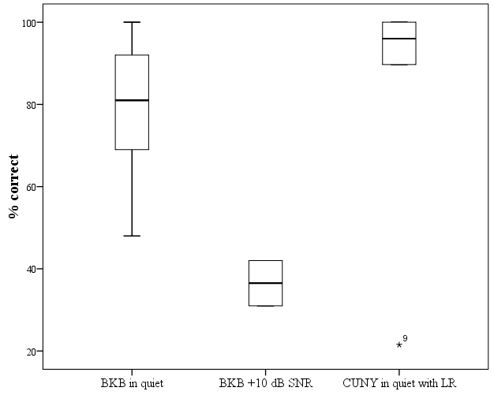

Figure 2. Speech reception thresholds (dB) using the DTT (n = 14) and BKB sentences (n = 8). A lower score signifies better speech recognition in noise.

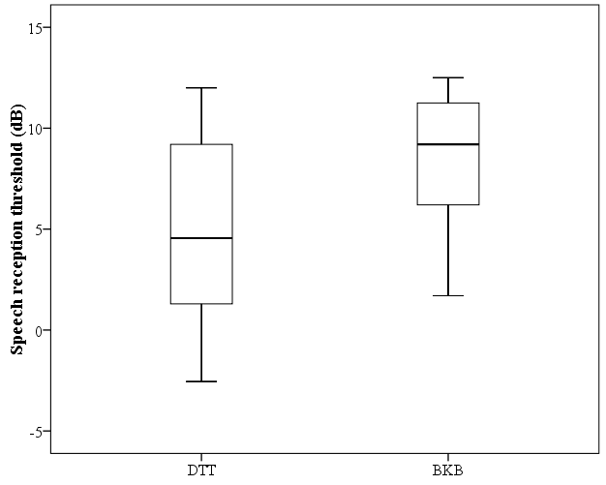

Figure 3. Scatterplot of DTT SRT (dB) against BKB sentence score in quiet (%) (n = 13)

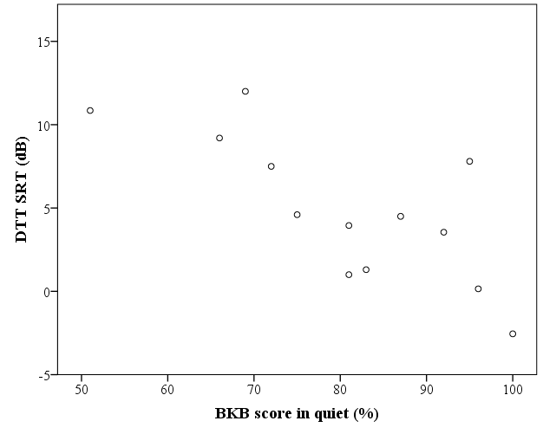

Figure 4. Scatterplot of DTT SRT (dB) against adaptive BKB SRT (dB) (n = 8)

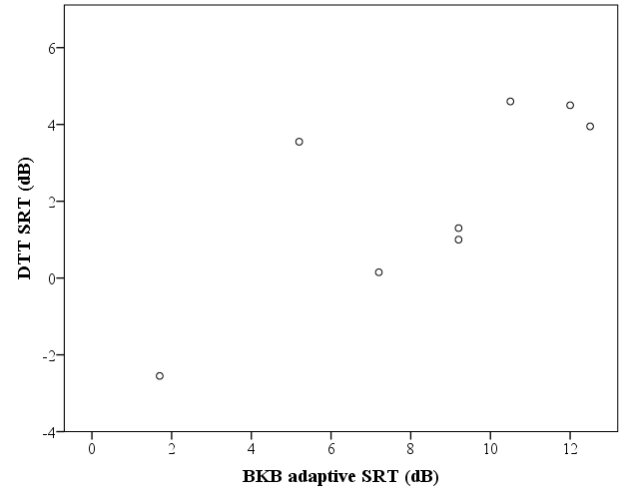

Figure 5. Frequency tables showing participant agreement with statements from the 9 questions (a to i) of the remote testing satisfaction questionnaire (n = 16 participants). For clarity, the direction of the x axis was reversed on three graphs (e, f and h below) so that a leftward skewed plot demonstrated positive feelings towards testing with the DTT; a rightward skew demonstrated negative feelings

a
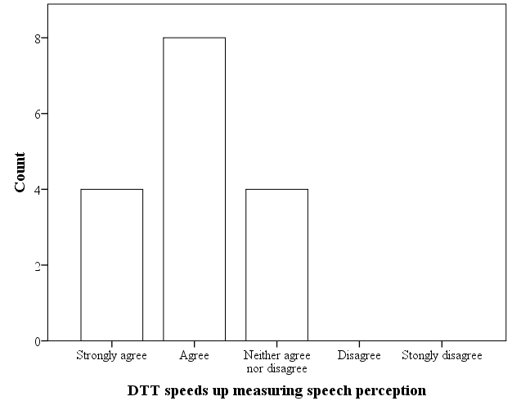

b
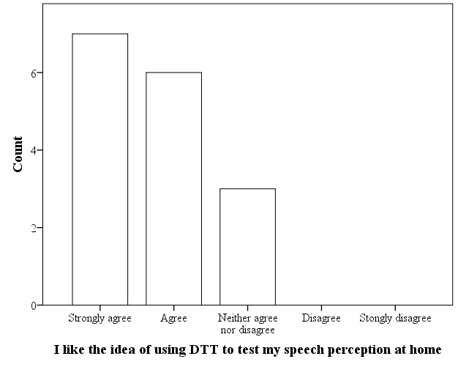

c
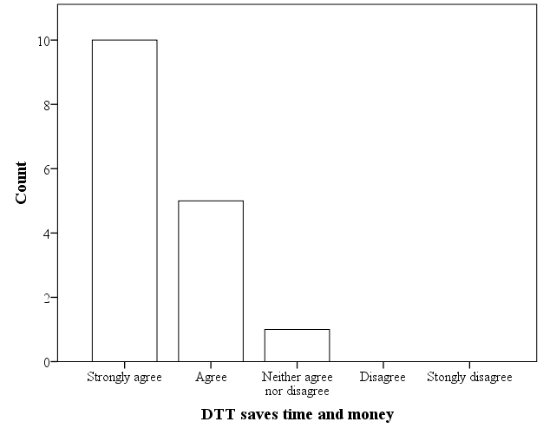

d
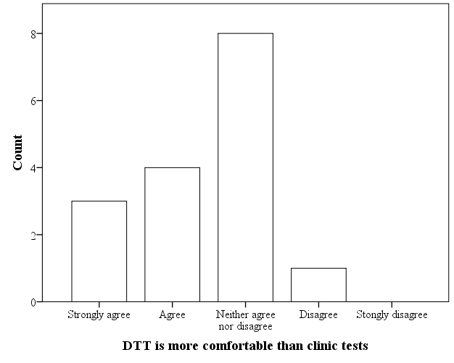

e
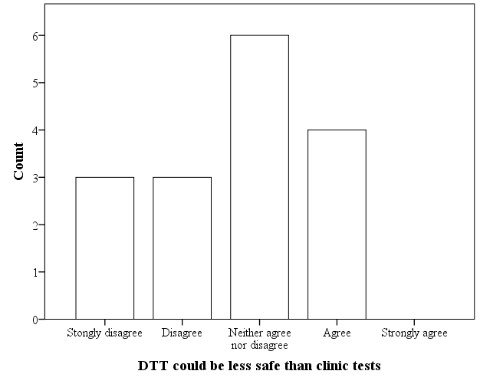

f
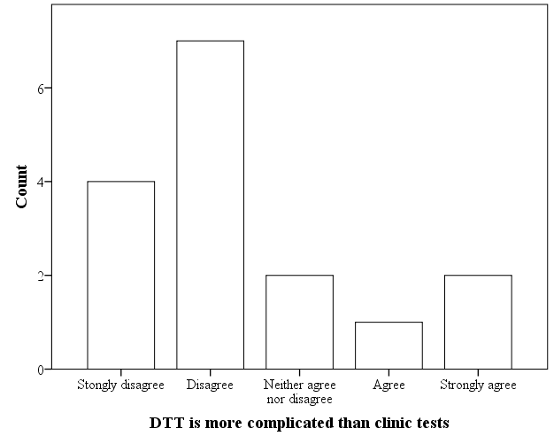

g
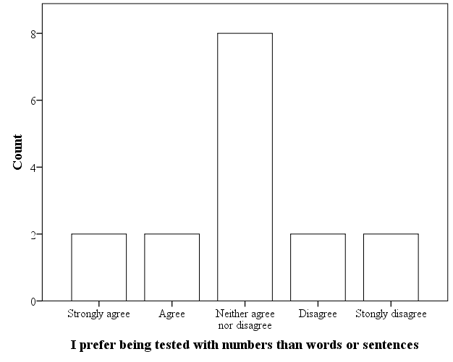

h
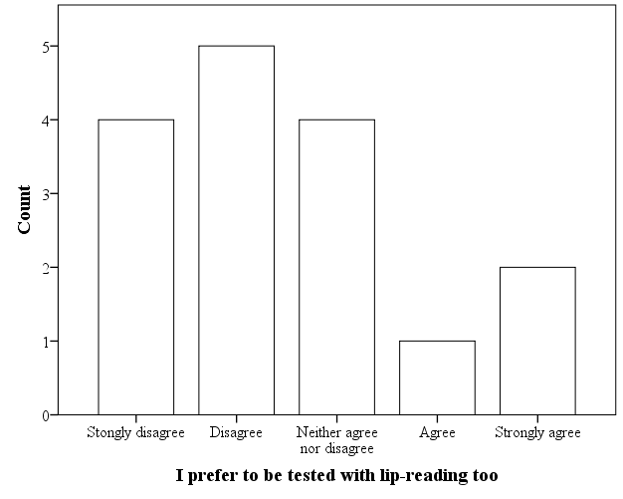

i
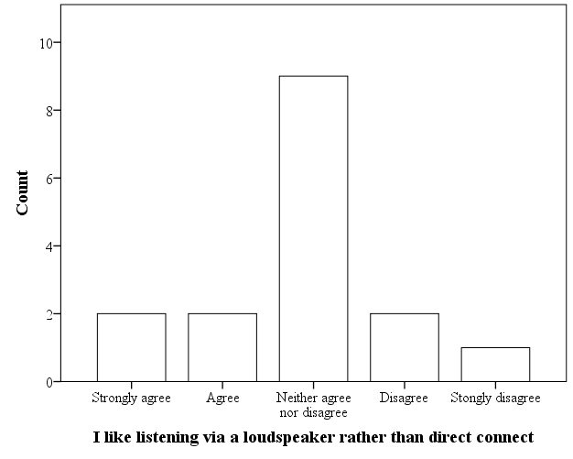

Appendix 1. Satisfaction questionnaire

 | Statement | Strongly agree | Agree | Neither agree nor disagree | Disagree | Strongly disagree
a | I believe that the Triple Digit Test (TDT) speeds up the process of measuring speech perception.
b | I like the idea that in the future I may be able to use the TDT myself at home to test my own speech perception.
c | I think the TDT costs less time and money (e.g., travel time and waiting time, cost of transportation and parking).
d | I think that the TDT is a more comfortable test than the clinical tests used.
e | I think that the TDT could be less safe than doing another speech perception test in clinic.
f | I think that the TDT is more complicated than the other speech perception tests used in clinic.
g | I prefer being tested with numbers rather than words or sentences.
h | I would prefer to be tested with lipreading too.
i | I like listening via a loudspeaker rather than using a direct connect cable (lead).

Please state any positives points about the TDT:
1
2
3
4
Please state any negatives points about the TDT:
1
2
3
4

Thanks very much for taking the time to complete this questionnaire

References
Action on Hearing Loss. (2015). Check your hearing. Retrieved from http://www.actiononhearingloss.org.uk/your-hearing/look-after-your-hearing/check-your-hearing/take-the-check.aspx
Bench, J., Kowal, A., & Bamford, J. (1979). The BKB (Bamford-Kowal-Bench) sentence lists for partially-hearing children. Br. J. Audiol., 13(3), 108-112
Boothroyd, A. (1968). Developments in speech audiometry. Sound, 2, 3-10
Boothroyd, A., Hanin, L., & Hnath, T. (1985). A sentence test of speech perception: Reliability, set equivalence, and short-term learning. Internal report RCI10. New York.
Craddock, L., Cooper, H., Riley, A., & Wright, T. (2016). Cochlear implants for pre-lingually profoundly deaf adults. Cochlear Implants Int, 17 Suppl 1, 26-30. doi: 10.1080/14670100.2016.1161122
Cullington, H., Kitterick, P., DeBold, L., Weal, M., Clarke, N., Newberry, E., & Aubert, L. (2016). Personalised long-term follow-up of cochlear implant patients using remote care, compared with those on the standard care pathway: study protocol for a feasibility randomised controlled trial. BMJ Open, 6(5), e011342. doi: 10.1136/bmjopen-2016-011342
Cullington, H. E. (2013). What do our service users really want? [poster]. British Cochlear Implant Group Annual Conference, Ayrshire.
Cullington, H. E. (2016). Cochlear implant remote care service user feedback on home hearing test [10:13]. Retrieved from http://bit.do/remote_hearing_test
Firszt, J. B., Holden, L. K., Skinner, M. W., Tobey, E. A., Peterson, A., Gaggl, W., . . . Wackym, P. A. (2004). Recognition of speech presented at soft to loud levels by adult cochlear implant recipients of three cochlear implant systems. Ear Hear, 25(4), 375-387
Gifford, R. H., Shallop, J. K., & Peterson, A. M. (2008). Speech recognition materials and ceiling effects: considerations for cochlear implant programs. Audiol Neurootol, 13(3), 193-205. doi: 10.1159/000113510
Kaandorp, M. W., Smits, C., Merkus, P., Goverts, S. T., & Festen, J. M. (2015). Assessing speech recognition abilities with digits in noise in cochlear implant and hearing aid users. Int J Audiol, 54(1), 48-57. doi: 10.3109/14992027.2014.945623
Leensen, M. C., de Laat, J. A., & Dreschler, W. A. (2011). Speech-in-noise screening tests by internet, part 1: test evaluation for noise-induced hearing loss identification. Int J Audiol, 50(11), 823-834. doi: 10.3109/14992027.2011.595016
Levitt, H. (1971). Transformed up-down methods in psychoacoustics. J Acoust Soc Am, 49(2(2)), 467-477
Litovsky, R. Y., Parkinson, A., Arcaroli, J., & Sammeth, C. (2006). Simultaneous bilateral cochlear implantation in adults: a multicenter clinical study. Ear Hear, 27(6), 714-731
Mackersie, C. L. (2002). Tests of speech perception abilities. Current Opinion in Otolaryngology & Head and Neck Surgery, 10(5), 392-397
MED-EL. (2015). Online hearing test http://www.medel.com/hearing-test/. Retrieved from http://www.medel.com/hearing-test/
Mishra, S. K., Boddupally, S. P., & Rayapati, D. (2015). Auditory Learning in Children With Cochlear Implants. J Speech Lang Hear Res, 58(3), 1052-1060. doi: 10.1044/2015_jslhr-h-14-0340
Naskov, N. D. (2016). Evaluating Cochlear Implant's Microphone Acoustic
Performance in an Uncontrolled Environment. (BSc Computer Science BSc), University of Southampton, University of Southampton.
NICE. (2009). NICE Technology Appraisal Guidance 166. Cochlear implants for children and adults with severe to profound deafness: National Health Service National Institute for Health and Care Excellence.
Nilsson, M., Soli, S. D., & Sullivan, J. A. (1994). Development of the Hearing in Noise Test for the measurement of speech reception thresholds in quiet and in noise. J Acoust Soc Am, 95(2), 1085-1099
Ofcom. (2015). The UK is now a smartphone society http://media.ofcom.org.uk/news/2015/cmr-uk-2015/. Retrieved from http://media.ofcom.org.uk/news/2015/cmr-uk-2015/
Office for National Statistics. (2015). Internet users: 2015.
Smits, C., & Houtgast, T. (2005). Results from the Dutch speech-in-noise screening test by telephone. Ear Hear, 26(1), 89-95
Smits, C., Kapteyn, T. S., & Houtgast, T. (2004). Development and validation of an automatic speech-in-noise screening test by telephone. International Journal of Audiology, 43, 15-28
Smits, C., Merkus, P., & Houtgast, T. (2006). How we do it: The Dutch functional hearing-screening tests by telephone and internet. Clin Otolaryngol, 31(5), 436-440. doi: 10.1111/j.1749-4486.2006.01195.x
Smits, C., Theo Goverts, S., & Festen, J. M. (2013). The digits-in-noise test: assessing auditory speech recognition abilities in noise. J Acoust Soc Am, 133(3), 1693-1706. doi: 10.1121/1.4789933
Stam, M., Smits, C., Twisk, J. W., Lemke, U., Festen, J. M., & Kramer, S. E. (2015). Deterioration of Speech Recognition Ability Over a Period of 5 Years in Adults Ages 18 to 70 Years: Results of the Dutch Online Speech-in-Noise Test. Ear Hear, 36(3), e129-137. doi: 10.1097/aud.0000000000000134
Tsay, I. A. (2013). Using a patient-driven software tool for programming multiple cochlear implant patients simultaneously in a telemedicine setting. Thesis (PhD). (PhD), University of Colorado at Denver, US.
Vickers, D. A., Riley, A., Ricaud, R., Verschuur, C., Cooper, S., Nunn, T., . . . Kitterick, P. T. (2016). Preliminary assessment of the feasibility of using AB words to assess candidacy in adults. Cochlear Implants Int, 17 Suppl 1, 17-21. doi: 10.1080/14670100.2016.1161143
Vlaming, M. S., MacKinnon, R. C., Jansen, M., & Moore, D. R. (2014). Automated screening for high-frequency hearing loss. Ear Hear, 35(6), 667-679. doi: 10.1097/aud.0000000000000073
Watson, C. S., Kidd, G. R., Miller, J. D., Smits, C., & Humes, L. E. (2012). Telephone screening tests for functionally impaired hearing: current use in seven countries and development of a US version. J Am Acad Audiol, 23(10), 757-767. doi: 10.3766/jaaa.23.10.2
Williams-Sanchez, V., McArdle, R. A., Wilson, R. H., Kidd, G. R., Watson, C. S., & Bourne, A. L. (2014). Validation of a screening test of auditory function using the telephone. J Am Acad Audiol, 25(10), 937-951. doi: 10.3766/jaaa.25.10.3

