Vegetation of Eurasia from the last glacial maximum to present: pollen dataset

Structure of the database:
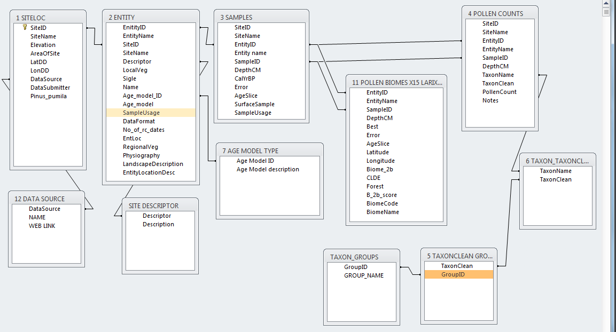

1. SITE LOC (Site location table)
SiteID – Unique ID (number)
SiteName – Site name (text)
Elevation – Altitude above sea level (m) (number)
AreaOfSite – Square metres (where available) (number)
LatDD – Latitude (decimal degrees) (number)
LonDD – Longitude (decimal degrees) (number)
DataSource – Source of data (text) (see Table 12 ‘DATA SOURCE’)
DataSubmitter – Contributor of the data (where available) (text)
Pinus_pumila – site is within contemporary distribution of P. pumila (number)

2. ENTITY

EnitityID – Unique ID (number)
EntityName – Entity name (text)
SiteID – SiteID, as in Table 1 ‘SITE’ (number)
SiteName – Site name, as in Table 1 ‘SITE’ (text)
Descriptor – Site description (where available) – see Table ‘SITE DESCRIPTOR’
LocalVeg – Description of local vegetation (where available) (text)
Sigle – original identifier from other databases (where appropriate) (text)
Name – alternative name from other databases (where approapriate) (text)
Age_model_ID – Unique ID – see Table ‘7 AGE MODEL TYPE’ (number)
Age_model – Description of age model used and notes (where applicable) (text)
SampleUsage – Notes (text)
DataFormat – note of percentage data format (where available) (text)
No_of_rc_dates – Number of radiocarbon dates (where available) (number)
EntLoc – Entity location (where available) (text)
RegionalVeg – Regional vegetation (where available) (text)
Physiography – Physiography (where available) (text)
LandscapeDescription – where available (text)
EntityLocationDesc – additional entity location information (where available) (text)

3. SAMPLES
SiteID – SiteID, as in Table 1 ‘SITE’ (number)
SiteName – Site name, as in Table 1 ‘SITE’ (text)
EnitityID –Entity ID, as in Table 2 ‘ENTITY’ (number)
EntityName – Entity name, as in Table 2 ‘ENTITY’ (text)
SampleID – Sample ID (non-unique) (number)
DepthCM – Depth of sample (cm) (number)
Cal yr BP – Age of sample, calibrated years before present (number)
Error – Error of age estimate (number)
AgeSlice – Age slice sample is assigned to (kyr BP) (999 = n/a)
SurfaceSample – 1 = surface sample (number)
SampleUsage – Description of sample usage (text)

4. POLLEN COUNTS

SiteID – SiteID, as in Table 1 ‘SITE’ (number)
SiteName – Site name, as in Table 1 ‘SITE’ (text)
EnitityID –Entity ID, as in Table 2 ‘ENTITY’ (number)
EntityName – Entity name, as in Table 2 ‘ENTITY’ (text)
SampleID – Sample ID (non-unique), as in Table 3 ‘SAMPLES’ (number)
DepthCM – Depth of sample (cm), as in Table 3 ‘SAMPLES’ (number)
TaxonName – Original identification taxon name (text)
TaxonClean – Taxon name checked against taxonomy list (ITIS), corrected where necessary (text)

PollenCount – Number of pollen grains counted (number)
Notes – additional notes (text)
‘TaxonName’ is the original identification assigned by the pollen analyst. However, there are regional differences in the use of taxonomy, for example, Duschekia fruticosa, is more commonly known as Alnus fruticosa outside the Former Soviet Union. Some non-pollen identifications were deleted, for example, Dyadosporites is a fungus and therefore of no use for pollen analyses. The dataset has been checked for consistent taxonomy, and a redundancy-free taxonomy has been produced (Table 6 – Taxonomy). The use of both TaxonName and TaxonClean allows the user to refer to the original identification.

5 TAXONCLEAN GROUP IDS
TaxonClean – Taxon name as in Table 4, ‘POLLEN COUNTS’ (text)
GroupID – Ecological group for used in percentage calculations (text) (see TAXON_GROUPS)

6 TAXON_TAXONCLEAN

TaxonName – Original identification taxon name (text)
TaxonClean – Taxon name checked against taxonomy list (see Table 4 ‘POLLEN COUNTS’)

7 AGE MODEL TYPE
Age Model ID – unique ID (number)
Age Model description – description of age model (text)

ADDITIONAL TABLES

AGE_MODEL_DATES

EnitityID –Entity ID, as in Table 2 ‘ENTITY’ (number)
EntityName – Entity name, as in Table 2 ‘ENTITY’ (text)
RC_name – Laboratory code or name for model (text)
C14_age – radiocarbon date (number)
Cal_BP – calibrated radiocarbon date (number)
sd – 2 standard deviation (number)
Depth – Depth of sample (cm) (number)
Thickness_sample – Thickness of dated sample (cm) (number)
Calmin – Calibrated age (minimum) (number)
Calmax – Calibrated age (maximum) (number)
Probability – Percent probability of age assignment (number)

RADIOCARBON_DATES

EnitityID –Entity ID, as in Table 2 ‘ENTITY’ (number)
SiteName – Site name, as in Table 1 ‘SITE’ (text)
Depth_up – upper sample depth (cm) (number)
Depth_down – lower sample depth (cm) (number)
Thickness – thickness of sample (cm) (number)
Lab_No – laboratory number (where known) (text)
RC_Date – Radiocarbon date (number)
RC_plus – Radiocarbon date error (number)
RC_minus - Radiocarbon date error (number)
Material – Type of material dated (where known) (text)
Date_type – Type of radiocarbon date (text)
Cal_min – Calibrated age (minimum) (number)
Cal_max – Calibrated age (maximum) (number)
Cal_age_mid – Calibrated age (middle) (number)
Probability – Percent probability of age assignment (number)
Comment1 – Comments (text)
Comment2 – Comments (text)

SITE DESCRIPTOR

Descriptor – four letter code to describe site (text) (see Table 2 ‘Entity’)
Description – Description of site (text)

TAXONOMIC GROUPS

GroupID - Ecological group for used in percentage calculations (text) (see Table 5 ‘TAXONCLEAN GROUP IDS)
GROUP_NAME – taxon group name

