Investigation of scalability of all-fiber fused mode selective coupler for generating multiple OAM states

Shankar Pidishety^{1,2*}, Srinivas Pachava^{1,2}, Patrick Gregg³, Asher McGuffin³, Siddharth Ramachandran³, Gilberto Brambilla² and Balaji Srinivasan¹
1. Department of Electrical Engineering, Indian Institute of Technology Madras, Chennai-600036, India
2. Optoelectronics Research Centre, University of Southampton, Southampton, SO171BJ, United Kingdom
3. Electrical and Computer Engineering Department, Boston University, 8St Mary’s St, Boston, MA, USA
*Email: pd.shankara@gmail.com

Abstract: We present the scalability of all-fiber fused couplers for generating multiple OAM states (charge l=±5, ±6 and ±7) by mode’s phase matching in the SMF and air-core fiber coupler configuration carried out through the simulations.
OCIS codes: (060.2310) Fiber optics; (230.1150) All-optical devices; (050.4865) Optical vortices

1. Introduction
The optical fields characterized by a helical phase front, exp(ilϕ) (l & ϕ being topological charge and azimuthal angle, respectively), carry the quantized orbital angular momentum (OAM) of lħ per photon. Such optical beams have gained much interest in recent years due to the potential use of OAM states as orthogonal signal channels for scaling the bandwidth of upcoming optical communication networks [1–3]. The generation of OAM modes has been widely investigated in free space [1,4,5], on silicon chips [6,7], and to a limited extent, in fiber [8,9]. However, none of them are directly fiber compatible and not all of them can multiplex many OAM modes with low loss. Hence, alternative mode-scalable all-fiber based techniques which offer the potential for direct integration with existing telecom, are highly desirable.
We have recently demonstrated a fused fiber coupler based on single mode fiber (SMF) and air-core fiber that generates OAM mode with charge l =±1 [10]. Extending our previous work, in this paper, we present our simulation studies focused on the excitation of multiple OAM states in a fused fiber coupler by using the mechanism of selectively coupling specific higher order modes (HOM) [10,11]. We also present the phase patching mechanism and related parameter optimization for the excitation of OAM beams with charge l=5, 6 and 7, and associated (spin-orbit-aligned and anti-aligned) states in SMF and air-core fiber coupler configuration [10]. As fused fiber couplers has been widely utilized in Mode Division Multiplexing (MDM), the carried out simulation studies are of immense interest for all-fiber based fused coupler configuration as such devices can provide realistic pathway to multiplexing many OAM states in fibers with low loss.
2. Air-core fiber index profile and degeneracy properties of its vector modes
The effective index (n_{eff}) is indistinguishable for the modes propagating in a weakly guiding fiber with small refractive index differences between core and cladding. In such fibers, different OAM states of same charge propagate with strong mode coupling resulting from birefringent perturbations along the fiber. Thus, the quality of OAM modes degrades in such fibers. The large splitting in n_{eff} of degenerate pairs of OAM states can be achieved by designing a waveguide such that the large field overlaps with a high index contrast region [12,13].
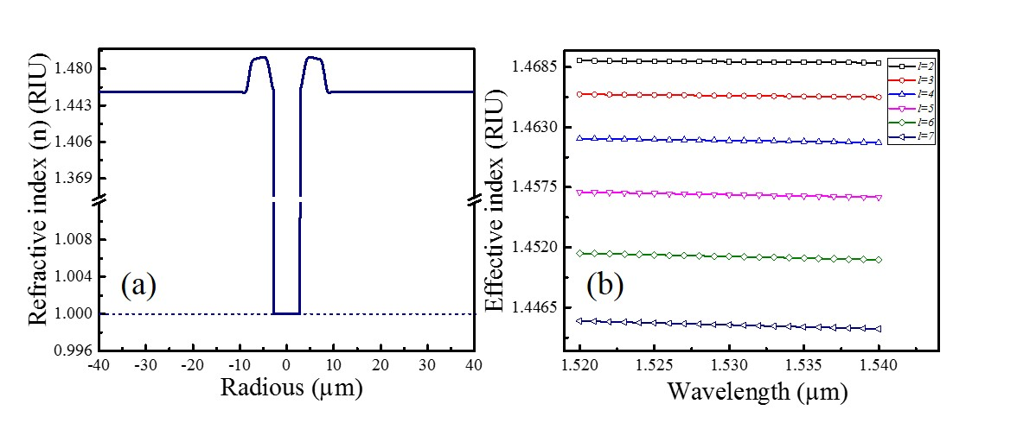
Figure 1 (a): The refractive index profile of the selected air-core fiber and (b): Effective index of OAM modes with different charge l-number
The index profile of such specially designed air-core fiber is shown in Fig. 1. (a). The selected fiber has an air-core radius of 3 µm and an annular guiding region with outer radius of 8.25 µm and an index difference of 0.035 with respect to the adjacent silica cladding [14]. This fiber is suitable for stable propagation of different OAM states as its design mimics the field structure of OAM modes in fiber. In addition the ring thickness has been chosen to restrict guidance to primarily the m=1 radial order. The high index contrast and the annular ring guiding structure enable propagation of its vector modes with high effective index separation (Fig. 1. (b): in the order of 10⁻⁴), as shown in Fig. 1. (b), since the degeneracy between the spin-orbit aligned (spin and orbital angular momentum of the same handedness) and anti-aligned (opposite handedness) states is removed [12,13], their selective excitation and stable propagation are possible.
The effective index or propagation constant of the LP₀₁ mode in the SMF is different from that of OAM modes in the air-core fiber. Thus, in order to efficiently couple light from LP₀₁ mode in the SMF to targeted OAM state in the air-core fiber, it is essential that both modes have the same n_{eff} . In addition, since the different modes in the fiber have a different overlap with the core, the diameter of the SMF fiber should be manipulated to match n_{eff} of the targeted modes. Such phase matching can be achieved by pre-tapering the SMF until the value of the n_{eff} of the LP₀₁ in the SMF equals to that of the desired OAM mode in the air-core fiber, as discussed below.
3. Phase matching of modes and excitation of multiple OAM states
As shown in Fig. 2 (a), the effective index difference (∆n_{eff} ) between the degenerate modes increases as the charge l-number of OAM mode increases for selected air-core fiber. As the ∆n_{eff} is relatively large for the l = ±5, ±6 and ±7, the phase matching condition has been studied to find out pre-taper diameters of SMF for selectively exciting these sates in SMF-air core fiber coupler. The corresponding aligned (V±_{l,m} ) and anti-aligned (W±_{l,m}) OAM states can be represented as [14],
(1)
(2)
where, m-radial mode number, σ±-left and right circular polarizations and F_{l,m} is the electric field envelope of modes. The phase matching condition was studied at 1530nm using COMSOL Multiphysics® eigenmode solver as shown in Fig. 2 (b). A three-layer system consisting of the coupler cores, cladding and air regions was considered in our simulations as the guided mode in the core-cladding interface could still be affected by the mode guidance in the cladding and the surrounding environment at the smaller tapering diameters [10,11].
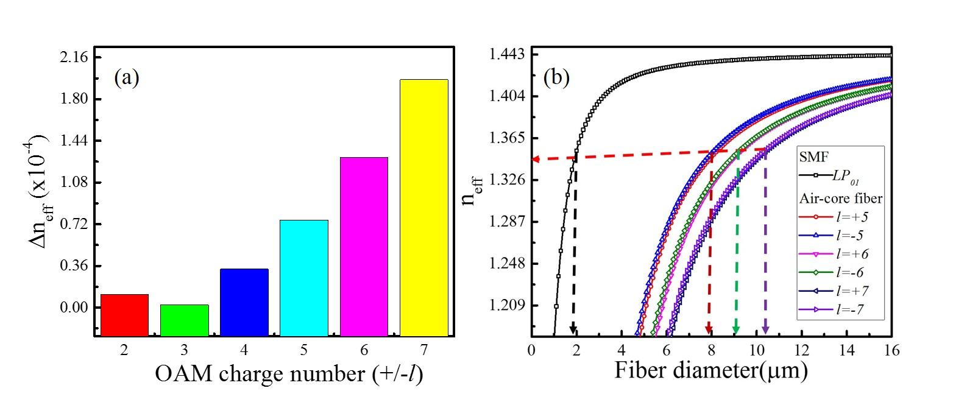
Figure 2 (a): The difference of effective index (Δn_{eff}) of different OAM states in the selected air-core fiber and (b): Phase matching plot: n_{eff} of the LP₀₁ mode in the SMF and that of the l = ±5, ±6 and ±7 modes in the air-core fiber are mapped as a function of fiber’s diameter.

In Fig 2 (b), n_{eff} of the LP₀₁ mode in the SMF and that of the l = ±5, ±6 and ±7 modes in the air-core fiber are mapped as a function of fiber’s diameter (d) in order to determine the ratio of fiber diameters needed to achieve the phase matching between the selected modes [10,11,15]. The different OAM states are identified based on their polarization structure and using eq. (1) & (2) [14]. It can be seen that the LP₀₁ in the SMF has n_{eff}=1.3355 at the diameter of d_{SMF}~1.80 μm, and the l = ±5, ±6 and ±7 in the air-core fiber shows the same n_{eff} at corresponding different diameters. This means that the diameter of the SMF should be reduced by the corresponding ratio (d_{SMF}/d_{air-core}). The pre-tapered diameters of SMF required for coupling the different modes were calculated to be d-V±_{l,m}: 30.48, 26.72 and 23.78 µm for aligned, d-W±_{l,m}: 29.92, 26.40 and 23.58 µm for anti-aligned OAM states of charge l = 5, 6 and 7, respectively. It can be understood that excitation of aligned and anti-aligned sate with in the same-charge is quite challenging as compared to that with different charge as the difference between the calculated pre-taper diameter for aligned d-V±_{l,m} and anti-aligned d-W±_{l,m} states is very small (~0.5µm) for a particular charge. The presented mode order is not fixed for all diameters of air-core fiber as we have noticed in our simulations that it was changing for some diameters around the 9-12 µm. The fabrication of SMF-air-core fiber with above parameters is under progress and some of those results will be discussed during the conference.
In conclusion, we have presented our simulation results on investigation of scalability of SMF and air-core fiber fused coupler for generation of multiple OAM states. We calculated the pre-diameter of SMF fiber that is required to couple the LP₀₁ mode in SMF to different OAM states in air-core fiber from the phase matching condition. It is realized that the excitation of aligned and anti-aligned sate with the same charge is quite challenging as compare to that with different charges as difference between the calculated pre-taper diameter for aligned d-V±_{l,m} and d- W±_{l,m} is very small (~0.5µm) for a particular charge. The presented results indicates that the extreme care has to be taken during the fabrication of above coupler for accurate excitation of targeted mode.

Authors (Shankar and Srinivas) thank the financial support for visiting to ORC, University of Southampton, UK through the IRSES grant (PIRSES-GA-2012-318941).

4. References

[1] Yao A M and Padgett M J 2011 Orbital angular momentum: origins, behavior and applications Adv. Opt. Photonics 3 161
[2] Wang J, Yang J-Y, Fazal I M, Ahmed N, Yan Y, Huang H, Ren Y, Yue Y, Dolinar S, Tur M and Willner A E 2012 Terabit free-space data transmission employing orbital angular momentum multiplexing Nat. Photonics 6 488–96
[3] Bozinovic N, Yue Y, Ren Y, Tur M, Kristensen P, Huang H, Willner A E and Ramachandran S 2013 Terabit-Scale Orbital Angular Momentum Mode Division Multiplexing in Fibers Science 340 1545–8
[4] Marrucci L, Manzo C and Paparo D 2006 Optical Spin-to-Orbital Angular Momentum Conversion in Inhomogeneous Anisotropic Media Phys. Rev. Lett. 96 163905
[5] Berkhout G C G, Lavery M P J, Courtial J, Beijersbergen M W and Padgett M J 2010 Efficient Sorting of Orbital Angular Momentum States of Light Phys. Rev. Lett. 105 153601
[6] Cai X, Wang J, Strain M J, Johnson-Morris B, Zhu J, Sorel M, O’Brien J L, Thompson M G and Yu S 2012 Integrated Compact Optical Vortex Beam Emitters Science 338 363–6
[7] Sun J, Moresco M, Leake G, Coolbaugh D and Watts M R 2014 Generating and identifying optical orbital angular momentum with silicon photonic circuits Opt. Lett. 39 5977
[8] Ramachandran S, Kristensen P and Yan M F 2009 Generation and propagation of radially polarized beams in optical fibers Opt. Lett. 34 2525
[9] Grosjean T, Courjon D and Spajer M 2002 An all-fiber device for generating radially and other polarized light beams Opt. Commun. 203 1–5
[10] Pidishety S. Abdul Khudus M I ., Gregg P, Ramachandran S, Srinivasan B and Brambilla G 2016 OAM Beam Generation using All-fiber Fused Couplers (OSA) p STu1F.2
[11] Ismaeel R, Lee T, Oduro B, Jung Y and Brambilla G 2014 All-fiber fused directional coupler for highly efficient spatial mode conversion Opt. Express 22 11610
[12] Ramachandran S, Golowich S, Yan M F, Monberg E, Dimarcello F V, Fleming J, Ghalmi S and Wisk P 2005 Lifting polarization degeneracy of modes by fiber design: a platform for polarization-insensitive microbend fiber gratings Opt. Lett. 30 2864
[13] Ramachandran S and Kristensen P 2013 Optical vortices in fiber Nanophotonics 2 455–474
[14] Gregg P, Kristensen P and Ramachandran S 2015 Conservation of orbital angular momentum in air-core optical fibers Optica 2 267
[15] Park K J, Song K Y, Kim Y K, Lee J H and Kim B Y 2016 Broadband mode division multiplexer using all-fiber mode selective couplers Opt. Express 24 3543

