Progressive Damage Modelling of Hybrid RTM-made Composite Π-joint under Four-point Flexure Using Mixed Failure Criteria
J B Bai¹, R A Shenoi², XY Yun¹, J J Xiong^{1*}
1 School of Transportation Science and Engineering, Beihang University, Beijing, 100191, People’s Republic of China (*, corresponding author: jjxiong@buaa.edu.cn)
2 Southampton Marine and Maritime Institute, University of Southampton, Southampton, UK
Abstract: This paper deals with four-point flexure tests on hybrid Π-joints, made out of multi-layer carbon Fiber/epoxy resin reinforced composites, processed using the RTM (resin transfer moulding) technique. Static bending properties and failure mechanism were determined by experimental observations. Failure of the Π-joints in four-point flexure tests was through interlaminar debonding in triangular zone followed by debonding propagation along the interface between the triangular zone and the adjacent boundary angle until complete breakage of the top skin. A progressive damage model (PDM) based on mixed failure criteria was developed to predict failure loads. Good correlation was achieved between experimental and numerical results.
Key words: composite joint; progressive damage; delamination; mixed failure criteria; cohesive zone model

1 INTRODUCTION
Composite joints (e.g., T-joint, Π-joint, cross-joint, etc.) are commonly used as stiffening structures in aircraft engineering with typical examples as shown in Figure 1 ^{[1-5]}. The joints are designed to provide adequate strength and stiffness for minimum weight and manufacturing cost. However, many investigations and practical experiences have revealed that joints were usually the weak link in structures and that their failure can lead to global structural failure in some worst cases^{[6-10]}. Therefore, characterizing mechanical behaviour and failure mechanism of composite joints becomes very important.
From practice, it is proved that mechanical behaviour of and failure mechanisms in composite joints depend on a number of factors such as mechanical properties of joint material, joint configuration, geometric dimensions, processing parameters, as well as loading magnitudes and sequences. A significant body of research is available dealing with the effects of the above factors. Blake et al. ^{[11]} conducted three-point bending tests of composite T-joints to investigate the static structural response and found that the initial load versus displacement response is fairly linear until a series of load drop-offs when substantive failure leads to progressive increase in structural flexibility. Vijayaraju et al. ^{[12]} experimentally investigated failure and failure progression of composite T-joints with different design configurations under peel load conditions and determined the failure initiation sites, path of failure propagation and final failure loads. Koh et al. ^{[6]} implemented an experimental investigation to examine the efficacy of z-pins to improve the structural properties of composite T-joints. It was found that z-pins increased the joint properties under both pure normal tension (pull-off) loading and mixed normal tension/in-plane secondary bending loading and didn’t improve the stiffness and failure initiation stress. May et al. ^{[13]} performed pull tests to assess the performance of composite T-joints with different materials and showed that the toughened resin system resulted in a significant increase of joint strength, but the post-failure behaviour was not affected by the resin system. Fan et al. ^{[14]} carried out bending tests to investigate the failure mechanisms in a novel RTM-made composite Π-joint and found that initial delamination occurs at the bolt holes in the base panel and delamination of the fillet region in L-preform; this was the dominant failure mode which leaded to the final failure. Tserpes et al. ^{[15]} detected bonding quality imperfection in a non-crimp fabric Π-joint utilizing ultrasonic and C-scan methods. It was found that the effect of imperfect bonding depended on the location of the voids and the loading condition. Luo et al. ^{[7]} presented three-dimensional FE models of RTM-made composite T-joints under pull and push bending loadings to simulate the load transfer path and failure initiation mechanism of based on the maximum stress criterion. It was shown that the normal and interlaminar shear stresses along through-thickness direction led to the failure initiation of T-joints under pull bending loading while the bending normal stress resulted in the critical failure initiation under push bending loading. Their numerical results coincided well with experiments. Dharmawan et al. ^{[16]} analyzed the effect of the geometry and disbonds between the filler and overlaminate of the composite T-joints on the strain distribution using FE method. They found that joint geometry and disbonds significantly affected the critical strains. Good correlation between numerical and experimental results was achieved. Wu et al. ^{[17]} simulated progressive failure process of composite T-joints subjected to tensile loading in terms of the Tsai-Wu failure criterion and a cohesive zone model. The results demonstrated the initiation and propagation paths of delamination cracks between the fillet and the L-ribs. Numerical results agreed well with experiments. Zhao et al. ^{[18]} proposed a parameter FE model of co-bonded composite Π-joint using cohesive element to predict delamination and filler crack of out-of-plane composite joint under tensile load. Numerical predictions agreed well with experimental results. Cheng et al. ^{[14, 19]} developed 3D progressive damage model to predict multiple damage modes of composite Π-joint under bending loading and found that the shear-out failure of lug bolt holes was the failure mode of joints and the location of lug bolt hole influenced the load carrying ability of the joint.
The previous literature proves that mechanical behaviour of composite tee joints have been investigated comprehensively. However, there is scope for improving our understanding of Π-joint behaviour. The hybrid RTM-made composite Π-joint is receiving widely application in aerospace engineering owing to its superiority in terms of mechanical properties and impact resistance. It is important to understand structural behaviour and failure mechanism of hybrid RTM-made Π-joint consisting of multi-layer (woven fabric and continuous strand mat or roving) located near the flange-web connections. This paper, therefore, makes an effort to provide an insight into failure development in hybrid RTM-made composite Π-joints through four-point flexure tests and to propose a new progressive damage model based on mixed failure criteria for predicting structural behaviour.

2 MATERIAL AND SPECIMENS
Test specimens for hybrid Π-joint were made of multi-layer carbon Fiber/epoxy resin reinforced composites (including TWF CF3031/5284 and UCF U3160/5284) and manufactured using the RTM technique. The specifications and properties of CF3031 and U3160 are listed in Table 1. 5284 epoxy resin was selected as the matrix of the composite Π-joint.
Figure 2 details the geometry and dimensions of the Π-joint with 300mm length, 100mm height, 40mm width, 4mm web thickness, 5mm flange and skin thickness, 48mm flange width from the free edge of flange to the web. The cross-section of the multi-layer Π-joint is shown in Figure 3. A representative stacking sequence for a typical right mandrel of Figure 3 is illustrated in Figure 4. The Π-joint is composed of sublaminates A, B, C and D and filler E. It is well known that layer orientations with 0, 90, 45, -45 degrees are widely used in aerospace engineering. Generally, the 0º plies mainly bear the tensile and compressive loadings, whilst the +45º and -45º layers sustain the shear loads and the ±45º plies overlaid over the outface of the parts are used to improve impact resistance. Therefore, a 0, 90, 45, -45 degrees configuration is chosen for this study. The direction along the cross width of Π-joint is through 0 degree layers. The stacking sequences and thicknesses of the sublaminates are as follows:
- Sublaminate A : [(±45)/0/45/0/-45/0/45/90/-45 /0/45/0/-45/0/45/90/-45/0], 3mm
- Sublaminate B : [(±45)/0/45/90/-45/0/45/90/-45/45/0/-45], 2mm
- Sublaminate C : [(±45)/0/45/90/-45/0/45/90/-45/45/0/-45] , 2mm
- Sublaminate D : [(±45)/0/45/90/-45/0/45/90/-45/45/0/-45] , 2mm
- Filler E: U3160 with fiber volume fraction of 55%
The fiber volume fraction of all sublaminates is 55%. The triangular zone is filled by UCFs of U3160 with fiber volume fraction of 55% that is consistent with the whole Π-joint.

3 FOUR-POINT DENGDING EXPERIMENTS
Four-point flexure tests of the hybrid RTM-made Π-joint specimens were conducted on an INSTRON-5565 servo-hydraulic machine at a displacement rate of 2mm/min in a dry state at room temperature. The test configuration is shown in Figures 5. The specimens were supported on two cylindrical rollers of a supporting fixture to simulate simply supported boundary conditions and the bending loads were symmetrically applied by two cylindrical rollers with a distance of 70mm (shown in Figures 2 and 5). Load versus displacement curves of the composite Π-joint under four-point flexure were automatically recorded. In order to analyze the damage mechanism of composite Π-joint, cameras were placed in front of the specimens to capture the failure process (shown in Figure 5).
The load-displacement curves of three tests on composite Π-joints are shown in Figure 6. A typical damage process captured in the experiment is shown in Figure 7. From figures 6 and 7, it is clear that an interlaminar debonding crack first appeared at the interface between the triangular zone and the adjacent outboard boundary angle (Figure 7a). This happened at a bending load of about 1616 N; see load drop at Figure 6. With increase in loading, the interlaminar debonding crack subsequently propagated along the interface and some secondary cracks appeared in the boundary angle (shown in Figure 7b). After the debonding crack initiation, the residual bending stiffness of the whole Π-joint significantly reduced. Still, the Π-joint continued to carry load until ultimate failure owing to the undamaged inboard boundary angle. With further increase of loading, the interlaminar debonding occurred at top skin of the Π-joint near the loading rollers and gradually propagated to the midspan until the fiber breakage of top skin occurred (shown in Figure 7c). This signified the loss of load bearing capability. Initial and ultimate failure loads for the Π-joint are listed in Table 2. The mean values of initial and ultimate failure loads for the Π-joint are 1616.00N and 3790.01N respectively, i.e. initial failure load of the Π-joint is about 42.64 % of final failure load.
From figure 6, all the experimental load-displacement curves are approximately of bilinear natures, with small initial load drops and a final large load drop. It is clear that the curves of the tested RTM-made specimens are almost identical till a load about 1500 N, with almost same ultimate failure loads. The differences in initial failure loads representing interlaminar debonding at the interface seem a little larger than those of stiffness and ultimate failure loads. This is probably caused by the scatter of local mechanical properties of triangular zone filled with heterogeneous UCFs of U3160. In addition, the stress concentration in the triangular zone and boundary angle may further add to the sensitivity of initial failure load to the local mechanical properties.

4 PROGRESSIVE DAMAGE ANALYSIS

4.1 Progressive Damage Model
Progressive damage modeling (PDM) has been proven to be an effective method in predicting the failure strength and failure process of composite structures in recent years^{[20]}. The numerical response is evaluated using non-linear finite element analysis with a special routine to define the failure modes and with the progressive degradation of elastic properties at increasing damage levels. A 3D FE model of the composite Π-joint is established by ABAQUS code (shown Figure 8). A layered solid element C3D8R is employed to model the composite layup such as flange, skin and web laminates denoted by the blue in Figure 8, and the total number of elements is 38808. A solid element C3D6 is used to model triangular zone. The total number of elements is 192. In order to effectively model the interlaminar debonding failure process at the interfaces between the triangular zone, the adjacent outboard boundary angle and the contiguous plies of the top skin, cohesive elements COH3D8 are implemented between the free surface of crack zone with an ultra-thin thickness of 0.01mm. The total number of such elements is 13392. The length of cohesive element is a third of the length of the adjacent layered solid element to obtain the higher accuracy of crack tip stress distribution. A tie constraint is adopted to connect the neighbouring nodes of the cohesive and layered solid elements to realize stress transfer. The mesh of the FE model was refined iteratively until the mesh subdivision had almost no effect on the prediction of the PDM response. The relevant material properties used in the 3D FE moidel are listed in Table 3. Properties of cohesive element are listed in Table 5.
Because it considers the interaction between longitudinal, transverse and through-thickness strengths of material, the Tsai-Wu criterion^{[21]} seems more appropriate and effective for predicting the failure of composites in contrast to the maximum stress or strain rule. However, Tsai-Wu is not suitable for isolating individual damage modes. The Hashin criterion^{[22]} though has been proven to be more apt in identifying damage modes, but not in the delamination mode. The cohesive zone model and relative criterion^{[18]} though have been comprehensively used for simulating the delamination failure. Thus a mixed damage criterion incorporating the Hashin criterion and cohesive zone model is adopted in this work to identify the matrix, fiber and delamination failures (listed in Table 5).
The calculations leading to the progressive damage process in the composite Π-joint are realized by a user subroutine USDFLD. The failure criteria and material property degradation rules are for written in the subroutine USDFLD in Fortran languages. In order to define the progressive degradation of elastic properties with increasing damage levels, the method for stiffness reduction is simple but effective, while the reduction of stiffness depends on the failure mode ^{[23]}. In simulation, except for the interlaminar debonding failure mode that is characterized by the cohesive zone model, all the failure modes are attributed to material degradation. Once failure is reached, the stiffness of the material is degraded according to the degradation rules in Table 6. Then the degraded material properties corresponding to failure modes are assigned to the failure locations in the FE model before the new iterative calculations. Figure 9 gives the schematic flowchart of progressive damage analysis using subroutine USDFLD in Abaqus code.

4.2 Failure Prediction
Figure 6 shows the numerical and experimental load-displacement curves of composite Π-joint under four-point flexure. From Figure 6，the numerical curves based on the mixed damage criterion and pure Hashin criterion correlate very well with experiments in the linear elastic region. This indicates that the non-linear FE model accurately depicts the structural stiffness before failure initiation. It is also obvious that the numerical prediction curve using the mixed damage criterion exactly gives the two critical load drops that respectively characterize initial interlaminar debonding and ultimate failures. Also, the numerically predicted residual stiffness trend after initial failure agrees well with experiments. In contrast, the simulating curve from the pure Hashin criterion only obtains the ultimate failure but fails in capturing the initial small load drop due to interlaminar debonding failure. From Table 2, it can be observed that the numerically predicted initial and ultimate failure loads using the mixed damage criterion are lower than the experiment values. The maximum relative deviations between numerical simulations and experiments are respectively 20.48% and 5.17%. The calculated results using the pure Hashin criterion only attain the ultimate failure load and the maximum relative deviation between numerical simulations and experiments is 18.05%. Thus the mixed damage criterion is more suitable and effective than the pure Hashin criterion in progressive damage analysis for the composite Π-joint.
Figure 10 shows the simulated failure processes in the triangular zone and adjacent web of the composite Π-joint. From Figure 10(a), it is clear that an interlaminar debonding crack first occurs at the interface between the triangular zone and the neighbouring outboard boundary angle. Meanwhile, matrix tensile failure appears at the 2nd ply (i.e. 0º ply) of outboard boundary angle. With an increase in bending loading, the interlaminar debonding crack propagates along the interface between the triangular zone and the neighbouring outboard boundary angle. Further, the matrix tensile failure spreads to inner plies such as the 11th ply. It is evident from Figures 7 and 10 that the simulations of interlaminar debonding initiation and propagations at the interface between triangular zone and web of composite Π-joint correlate well with experimental observation. The outboard and inboard boundary angles respectively bear the tensile and compressive stresses resulting from bending action. With increasing flexure load, fiber tensile breakage appears at the 1st ply (i.e. ±45º ply) of outboard boundary angle (shown in Figure 10b) and the Fiber-matrix shear failure occurs at the 1st ply of inboard boundary angle (shown in Figure 10c).
Figure 11 demonstrates simulations of the failure process in the top skin of the composite Π-joint. From Figure 11(a), it is obvious that matrix failure first appears at plies near the central bottom surface and gradually propagates to upper layers until failure. The matrix failure leads to further increase of bending tensile stress in the fiber, especially around the matrix failure regions, before fiber tensile breakage occurs (shown in Figure 11b). The Fiber-matrix shear failure appears and propagates from the up ply of top skin (shown in Figure 11c).
In summary, the critical initial and ultimate failure loads, the initiation and propagation of interlaminar debonding and the other separated failure modes can be numerically simulated using the PDM based on mixed criteria. Experimental results correlate well with these numerical simulations. In addition, the PDM and the mixed criteria presented in this paper are also capable of being applied to evaluating the mechanical behaviuor of other composite structures only from the basic material properties and geometrical dimensions.

5 CONCLUSIONS
The mechanical behaviour of hybrid RTM-made Π-joints made of multi-layer TWF U3160/5284 and UCF CF3031/5284 reinforced composites were investigated. The static response and failure mechanism under four-point flexure were described and analyzed. Significant results emerging from the studies are as follows.
(1) Failure mode of the tested hybrid RTM-made Π-joints in four-point flexure tests is reckoned to be characteristic of the interlaminar debonding in the inverted triangular zones and the debonding propagation along the interface between the triangular zone followed by the adjacent boundary angle until complete breakage of the top skin.
(2) PDM can effectively simulate the progressive damage process with different failure modes and accurately predict initial and ultimate failure loads of the tested hybrid RTM-made Π-joints made of multi-layer TWF U3160/5284 and UCF CF3031/5284 reinforced composites under four-point flexure. Good correlation was achieved between experimental and numerical results.

ACKNOWLEDGEMENTS
This project was supported by the National Natural Science Foundation of China (Grant No. 51375033 and 51405006).

REFERENCES
- Blake JIR, Shenoi RA, House J, Turton T. Progressive damage analysis of tee joints with iscoelastic inserts. Composites Part A: Applied Science and Manufacturing, 2001; 32(5): 641-653.
- Feih S, Shercliff HR. Composite failure prediction of single-L joint structures under bending. Composites Part A: Applied Science and Manufacturing, 2005; 36(3): 381-395.
- Cheng X, Xiong JJ, Peng B, Cheng ZL, Li HY. Mechanical properties of RTM-made composite cross-joints. Chinese Journal of Aeronautics, 2009; 22: 211-217.
- Zhao LB, Qin TL, Shenoi RA, Zhang JY, Liang XZ, Huang H. Strength prediction of composite π joints under tensile load. Journal of Composite Materials, 2010; 44(23): 2759-78.
- Zhao LB, Qin TL, Zhang JY, Shenoi RA. Modified maximum stress failure criterion for composite π joints. Journal of Composite Materials, 2012;47(23): 2995-3008.
- Koh TM, Feih S, Mouritz AP. Experimental determination of the structural properties and strengthening mechanisms of z-pinned composite T-joints. Composite Structures, 2011; 93: 2222-2230.
- Luo CY, Xiong JJ. Static pull and push bending properties of RTM-made TWF composite tee-joints. Chinese Journal of Aeronautics, 2012, 25(2): 198-207.
- Heimbs S, Nogueira AC, Hombergsmeier E, May M, Wolfrum J. Failure behaviour of composite T-joints with novel metallic arrow-pin reinforcement. Composite Structures, 2014; 110: 16-28.
- Fu Y, Xiong JJ, Luo CY, Yun XY. Static mechanical properties of hybrid RTM-made composite I-and Π-beams under three-point flexure. Chinese Journal of Aeronautics, 2015; 28(3): 903-913.
- Burns L, Mouritz AP, Pook D, Feih S. Bio-inspired hierarchical design of composite T-joints with improved structural properties. Composites: Part B, 2015; 69: 222-231.
- Blake JIR, Shenoi RA, House J, Turton T. Strength modelling in stiffened FRP structures with viscoelastic inserts for ocean structures. Ocean Engineering, 2002; 29: 849-869.
- Vijayaraju K, Mangalgiri PD, Dattaguru B. Experimental study of failure and failure progression in T-stiffened skins. Composite Structures, 2004; 64: 227-234.
- Maya M, Ganzenmüller G, Wolfrum J, Heimbs S. Analysis of composite T-joint designs for enhanced resistance to hydrodynamic ram. Composite Structures, 2015; 125: 188-194.
- Fan J, Cheng X, Wang S, Guo X, Zhang T. Experimental and numerical investigation of composite bolted π-joint subjected to bending load. Composites Part B, 2015; 78: 324-330.
- Tserpes KI, Pantelakis SP, Kappatos V. The effect of imperfect bonding on the pull-out behavior of non-crimp fabric Pi-shaped joints. Computational Materials Science, 2011; 50: 1372-1380.
- Dharmawan F, Thomson RS, Li H, Herszberg I, Gellert E. Geometry and damage effects in a composite marine T-joint. Composite Structures, 2004; 66: 181-187.
- Wu H, Xiao J, Xing S, Wen S, Yang F, Yang J. Numerical and experimental investigation into failure of T700/bismaleimide composite T-joints under tensile loading. Composite Structures, 2015; 130: 63-74.
- Zhao L, Gong Y, Qin T, Mehmood S, Zhang J. Failure prediction of out-of-plane woven composite joints using cohesive element. Composite Structures, 2013; 106: 407-416.
- Cheng X, Fan J, Liu S, Guo X, Xu Y, Zhang T. Design and investigation of composite bolted π-joints with an unconventional configuration under bending load. Composites Part B, 2016; 85: 59-67.
- Tong L, Li S, Xiong JJ. Material parameter modeling and solution technique using birth–death element for notched metallic panel repaired with bonded composite patch. Chinese Journal of Aeronautics, 2014, 27(2): 445-452.
- Daniel IM, Ishai O. Engineering mechanics of composite materials. 2nd ed. Oxford: Oxford University Press, 2006.
- Hashin Z. Failure criteria for unidirectional fiber composites. Journal of Applied Mechanics, 1980; 47: 329–334.
- Chang FK , Chang KY. A progressive damage model for laminated composites containing stress concentrations. Journal of Composite Materials, 1987; 21(9): 834-855.

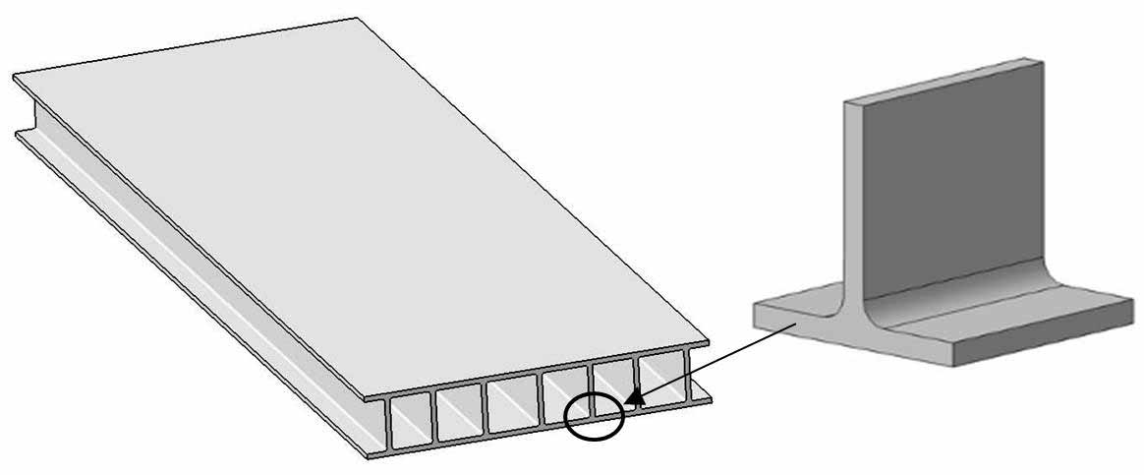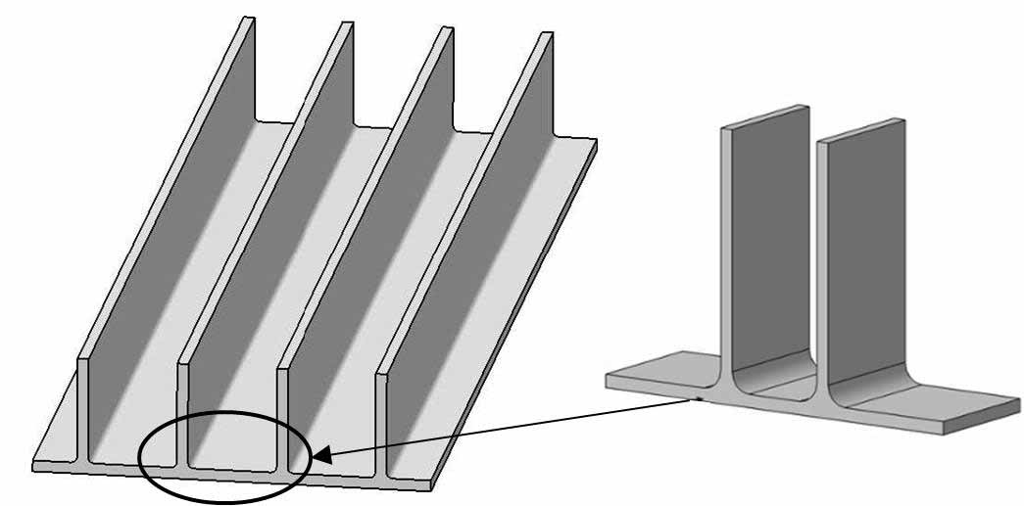
(a) T-joint stiffening (b) Π-joint stiffening
Figure 1 Composite joints stiffening skin element in the RTM-made wing box
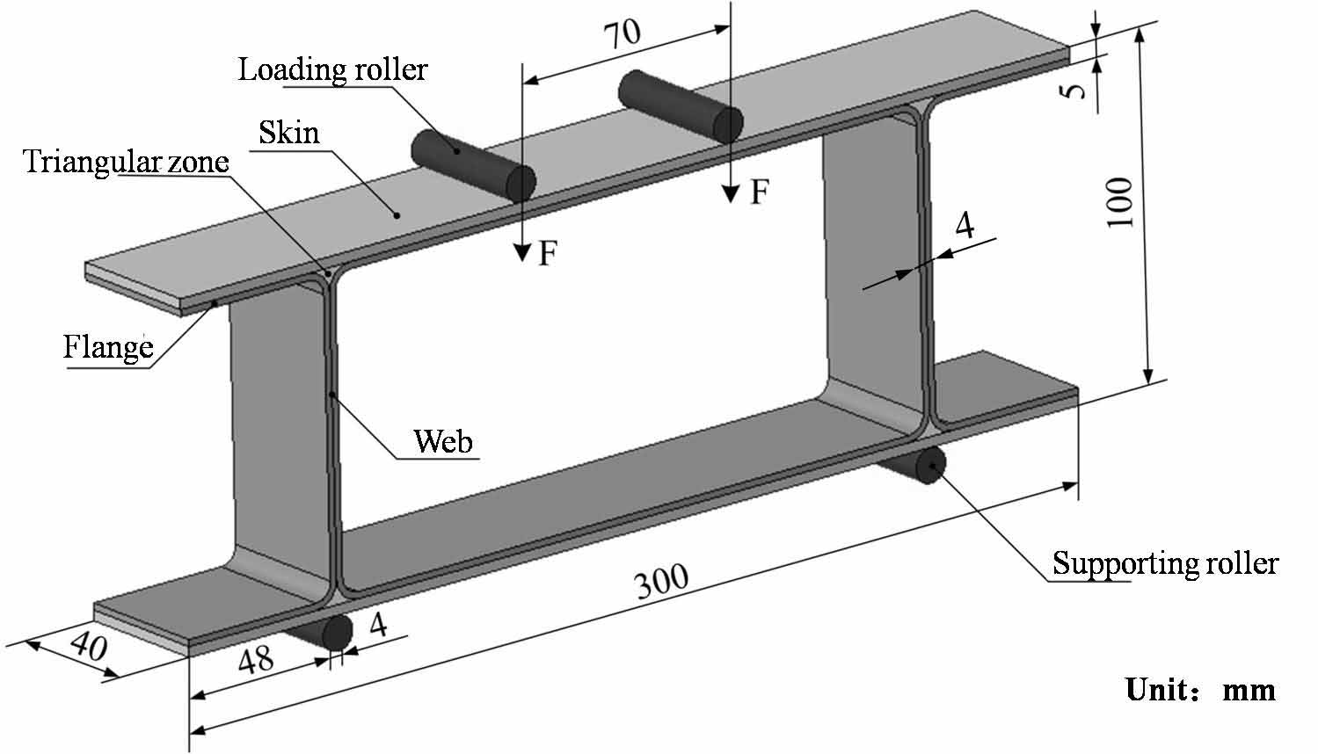
Figure 2 Geometry and dimensions of the composite Π-joint and loading fixtures

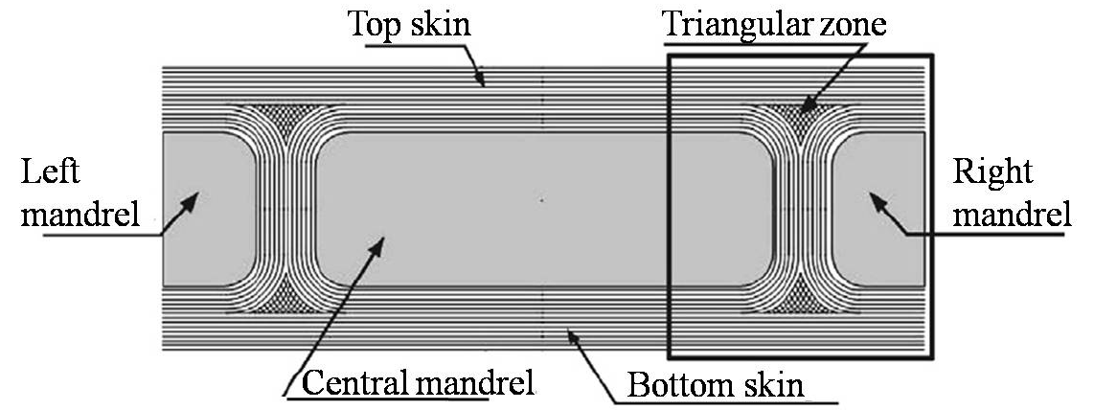
Figure 3 Cross-section of the composite Π-joint

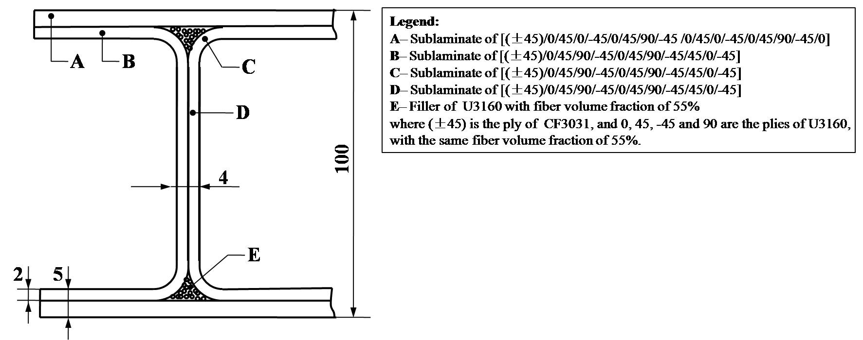
Figure 4 Hybridization schemes of the composite Π-joint
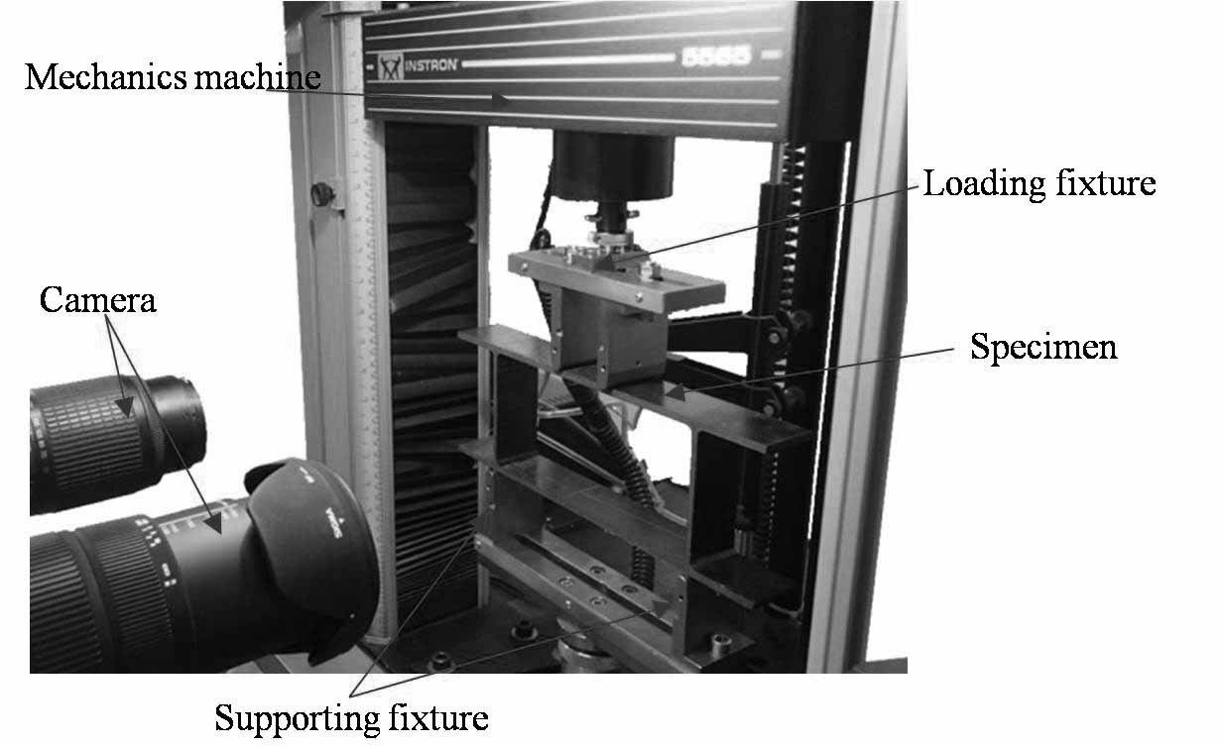
Figure 5 Four-point flexure testing system of the composite Π-joint

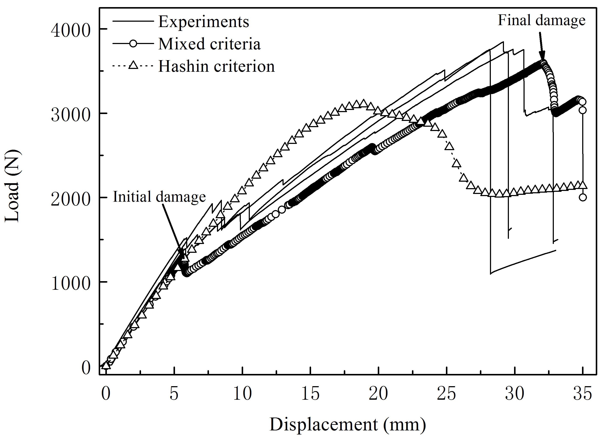
Figure 6 Load versus displacement curves of the composite Π-joint under four-point flexure
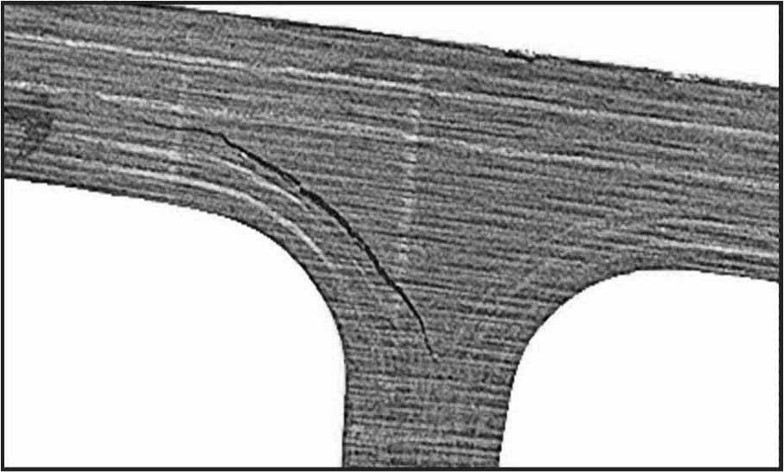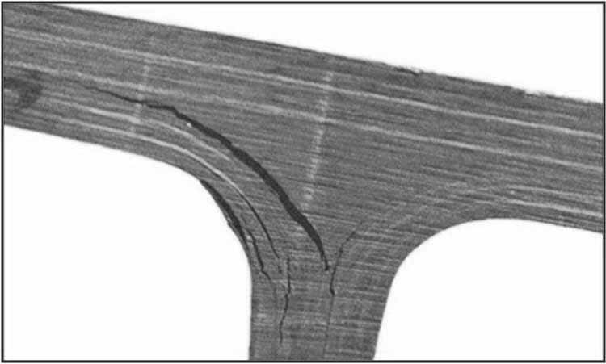
(a) Debonding at the interface (b) Debonding propagation along the interface
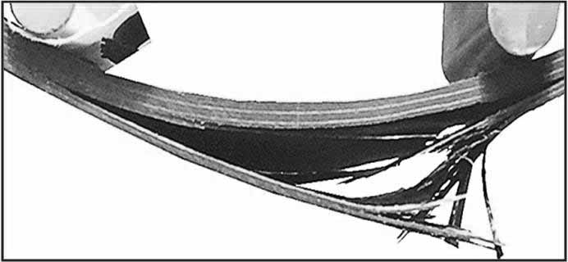
(c) Failure of the top skin
Figure 7 Failure process of the composite Π-joint under four-point flexure

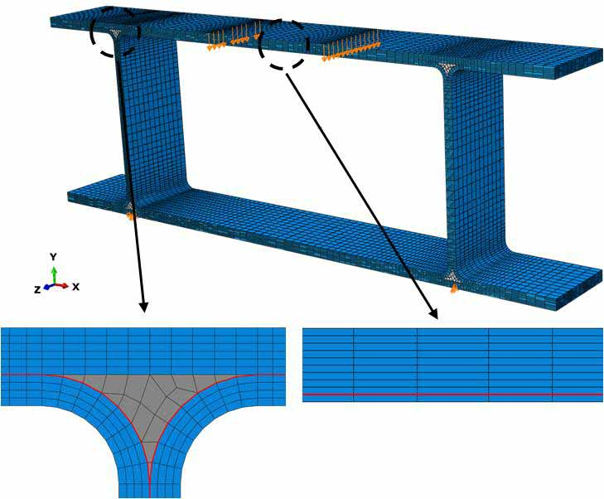
Figure 8 FE model of the composite Π-joint
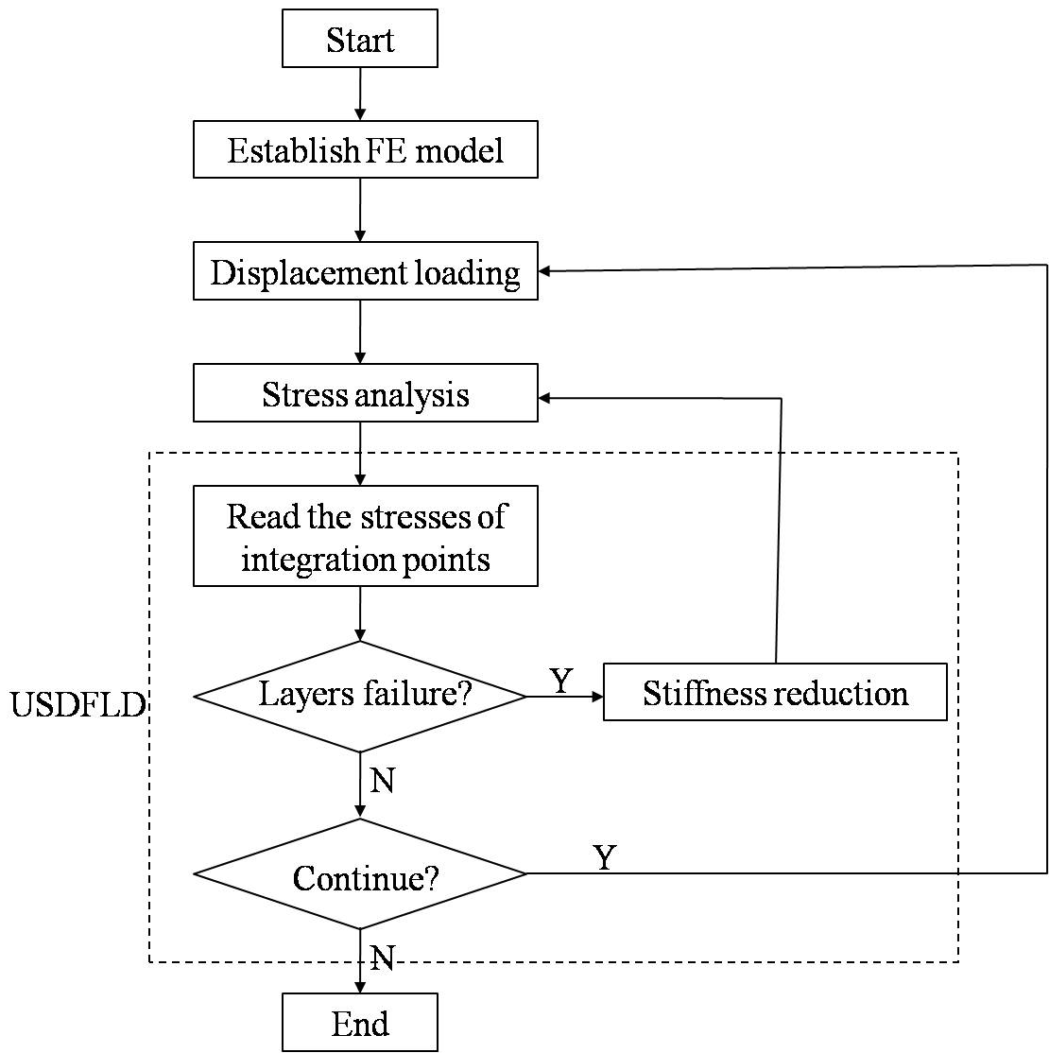
Figure 9 Scheme flowchart of progressive damage analysis using subroutine USDFLD

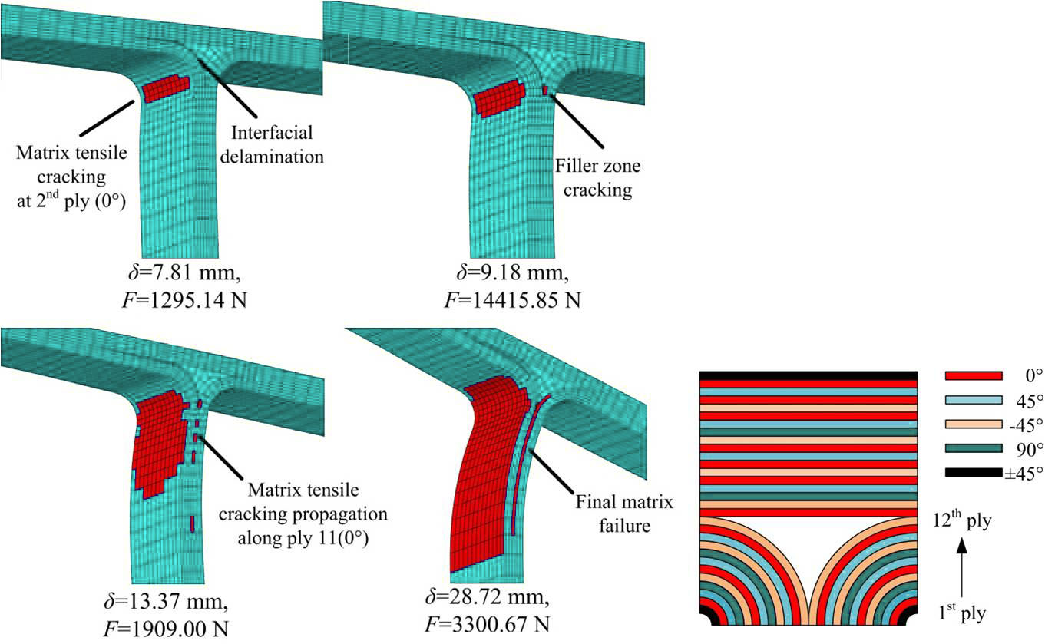
- Matrix failure process in the triangular zone and adjacent laminates
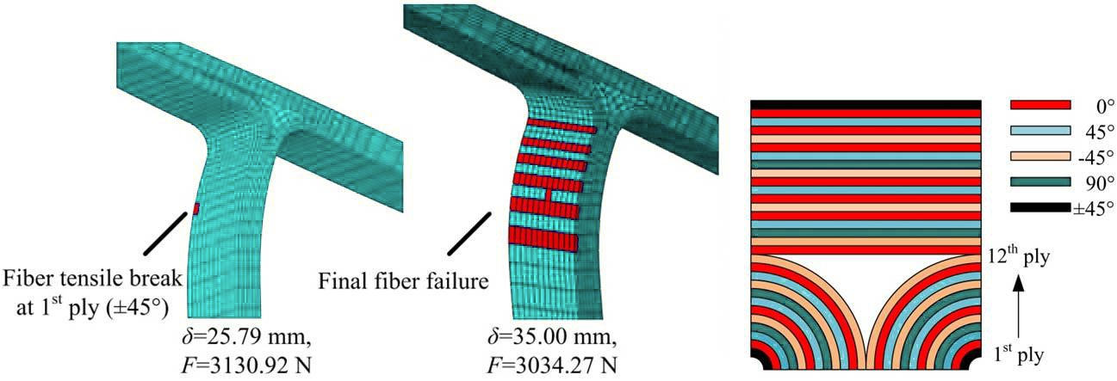
(b) Fiber tensile failure process in the outboard boundary angle
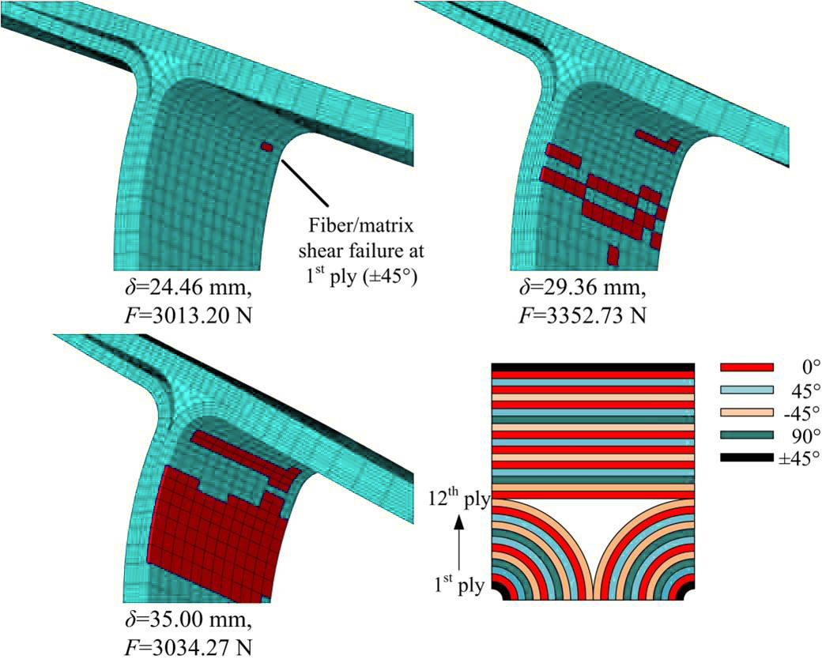
(c) Fiber-matrix shear failure in the inboard boundary angle
Figure 10 Simulations of failure process in the triangular zone and web of the composite Π-joint

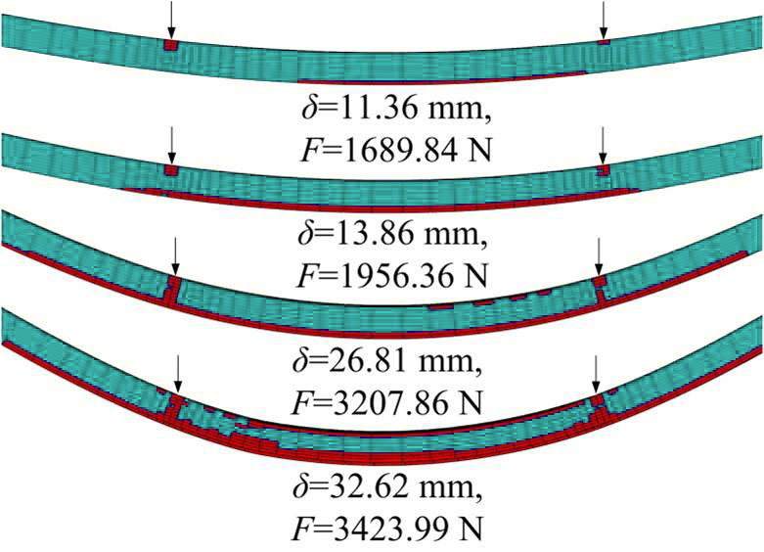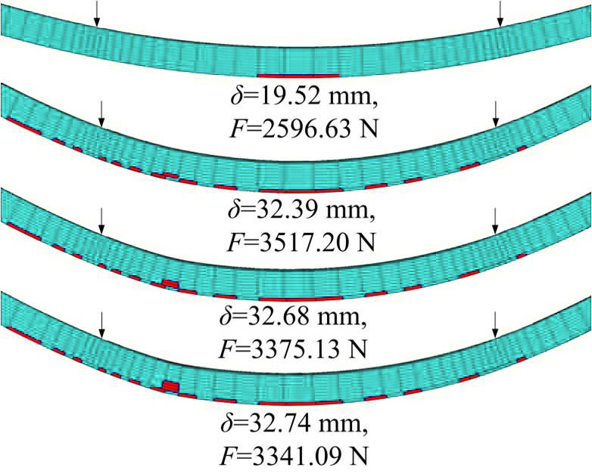
(a) Matrix crack failure (b) Fiber breakage failure
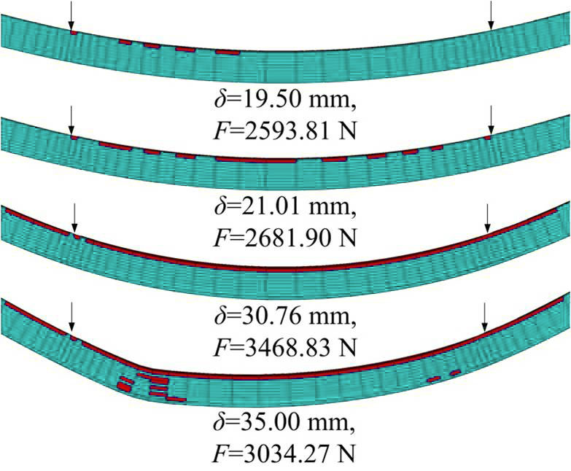
(c) Fiber-matrix shear failure
Figure 11 Simulations of failure process in the top skin of the composite Π-joint
Table1 Fabric specifications and properties of U3160 and CF3031
Geometry parameter | CF3031 | U3160
Ply thickness ( mm) | 0.30 | 0.167
Area destiny ( g·m⁻²) | 220 | 160
Warp fabric destiny (bundles·cm⁻¹) | 54 | 80
Weft fabric destiny (bundles·cm⁻¹) | 54 | 40

Table2 Experimental results of initial and ultimate failure loads
 | Initial failure load (N) | Ultimate failure load (N)
Experiments | 1522.95 | 3759.88
Experiments | 1393.28 | 3761.15
Experiments | 1931.78 | 3848.99
Mean | 1616.00 | 3790.01
Mixed criteria* | 1285.00 | 3593.99
Relative deviation | 20.48% | 5.17%
Hashin criterion | N. A. | 3106.00
Relative deviation | N. A. | 18.05%
* See Table 5 for definition and details
Table3 Properties of U3160/5284 and CF3031/5284 used in FE model
Properties | U3160/5284 | CF3031/5284
Longitudinal Young’s modulus E₁ / GPa | 116.32 | 6.28
Transverse Young’s modulus E₂ / GPa | 8.4 | 6.12
Through-thickness Young’s modulus E₃ / GPa | 8.4 | 8.4
Poisson’s ratio ν₁₂ | 0.296 | 0.0459
Poisson’s ratio ν₁₃ | 0.15 | 0.15
Poisson’s ratio ν₂₃ | 0.15 | 0.15
In-plane shear modulus G₁₂ / GPa | 4.1 | 4.09
Inter-laminar shear modulus G₁₃ / GPa | 3 | 3
Inter-laminar shear modulus G₂₃ / GPa | 3 | 3
Longitudinal tensile strength X_{1t} / MPa | 1415 | 556
Transverse tensile strength X_{2t} / MPa | 43 | 601
Though-thickness tensile strength X_{3t} / MPa | 23 | 601
Longitudinal compressive strength X_{1c} / MPa | 993 | 673
Transverse compressive strength X_{2c} / MPa | 184 | 651
Through-thickness compressive strength X_{3c} / MPa | 184 | 651
In-plane shear strength X₁₂ / MPa | 88.3 | 83.2
Interlaminar shear strength X₁₃ / MPa | 86 | 80
Interlaminar shear strength X₂₃ / MPa | 86 | 80
Ply thickness / mm | 0.163 | 0.225
Fiber volume fraction / % | 55% | 55%

Table 4 Properties of cohesive element
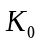 |  |  | 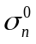 | 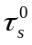 | 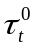
2.5×10⁵ N / mm³ | 0.65 kJ / m² | 1.8 kJ / m² | 50 MPa | 95 MPa | 95 MPa

Table5 Mixed damage criteria
Failure Modes | Failure Criterion
Matrix cracking in tension | 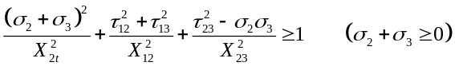
Matrix cracking in compression
Fiber breakage in tension | 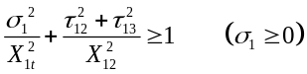
Fiber breakage in compression | 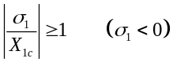
Fiber-matrix shear failure | 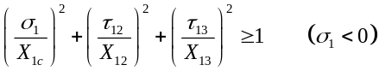
Initial delamination failure | 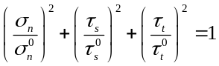
Delamination propagation | 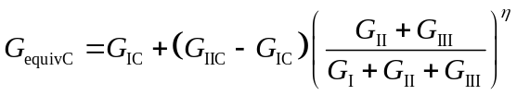

Table 6 Material property degradation rules
 | 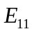 | 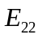 | 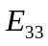 | 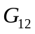 | 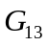 | 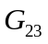 | 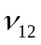 | 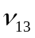 | 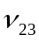
Fiber breakage in tension/compression | 0.015 | 0.015 | 0.015 | 0.015 | 0.015 | 0.015 | 0.015 | 0.015 | 0.015
Matrix cracking | 0.1 | 0.1 | 0.1 | 0.1 | 0.1 | 0.1 | 0.1 | 0.1 | 0.1
Fiber-matrix shear failure | 0.1 | 0.1 | 0.1 | 0.1 | 0.1 | 0.1 | 0.1 | 0.1 | 0.1

