Stroke in Sickle Cell Anaemia is more than stenosis and thrombosis:
The role of anaemia and hyperemia in ischaemia

Michael M Dowling, MD, PhD, MSCS
Departments of Pediatrics and Neurology & Neurotherapeutics, UT Southwestern Medical Center, Dallas, TX

Fenella J Kirkham, MB BChir, MD res, FRCPCH
Developmental Neurosciences, UCL Institute of Child Health, London, UK

Stroke is one of the major morbidities in children with sickle cell anaemia, and the degree of anaemia itself is a risk factor (Azab et al, 2014; Dowling et al, 2012). Those with homozygous sickle cell disease (HbSS; SCD) are particularly at risk of clinically “overt” stroke (Earley et al, 1998) with an even higher risk of “covert” or clinically silent strokes (DeBaun & Kirkham, 2016). This is where the field gets complicated and the “haematological perspective” differs from the neurological. The focal neurological deficits that result from large artery strokes are relatively well recognized but for the smaller ischaemic events, separation of “silent” from “overt” depends more on the anatomical location of the smaller lesions rather than the mechanism of the stroke. This has muddled the distinction of the causes, the consequences, and the treatment of the two poorly named types. The ischaemic lesions in the deep watershed areas (typically more associated with hypoperfusion than to large arterial occlusion) can occur without focal neurological deficits unless they happen to injure, for example, the descending motor pathways where they result in an easily recognizable clinical deficit in motor function and thus are identified as “overt” stroke. An ischaemic lesion of the same size and occurring due the same physiologic mechanism but located centimetres or even millimetres away could easily go undetected and be identified only later on MRI as a “silent cerebral infarction” (Figure 1).

So what is the mechanism of either or any of these infarctions? Historically this was thought to be a result of vaso-occlusive disease similar to that which occurs during a sickle cell crisis. However, pathological studies demonstrated that the majority of children who have SCD and overt stroke have a steno-occlusive arteriopathy usually involving the distal internal carotid, proximal middle cerebral, and anterior cerebral arteries of the Circle of Willis (Stockman et al, 1972). Sometimes this occurs in association with the formation of moyamoya vessels and collaterals and is associated with increased risk of recurrent stroke. These observations gave rise to the “occlusive vascular model” of stroke in SCD where endothelial hyperplasia in medium to large vessels increased the risk of thrombo-embolism while sludging of sickle cells within the cerebral microcirculation led to small vessel infarction (Pavlakis et al, 1989).

There is also evidence to support a “haemodynamic ischaemic model” of stroke in children with SCD. The normal response to ischaemia is vasodilation which is usually accompanied by an increased distal arterial blood flow and consequent increased cerebral perfusion. In this issue, Kosinski and co-workers have used MRI arterial spin labelling techniques to demonstrate increased cerebral blood flow in neurologically normal children with SCD compared to controls. They also demonstrated that children with SCD have a decreased ability to dilate their cerebral vessels in response to hypercapnia and both are highly correlated with the degree of anaemia. That is, they have a lower cerebrovascular reserve. So, untransfused children with SCD approach the upper limit of cerebral vasodilation with chronically increased cerebral perfusion rates. So, despite increased tissue oxygen supply, an uncoupling of cerebral flow and cerebral perfusion may occur under any condition where there is an additional requirement for oxygen supply (e.g. increased metabolic demand during seizures, hypotensive episodes, or local embolic events) putting the child at risk of haemodynamic ischaemic sequelae including stroke that is either silent or overt, depending on its location.

Thus, clinical events that are common in SCD such as acute hypoxia (from acute chest syndrome) or acute exacerbation of anaemia (from aplastic crisis or acute splenic sequestration) may cause injury if cerebral blood flow is already close to the ischaemic threshold, either because flow is low distal to stenotic vessels or because the CBF is maximal, so that the reserve is exhausted. This may occur under any condition where there is an additional requirement for oxygen supply. Acute silent infarction has been demonstrated in children with and without SCD in the setting of an acute anemic event (Dowling, et al., 2012). In these circumstances, hypoperfusion and reduced cerebrovascular reserve in the borderzones between the large vessels may lead directly to ischaemia or may precipitate thrombosis in small vessels secondary to slow passage of microemboli and local ‘sludging’. The brain may also be particularly vulnerable to hypoxic-ischaemic damage during sleep as CBF increases during rapid eye movement sleep and during the hypercapnia which is common in SCD (Kaleyias et al, 2008), so that the cerebrovascular reserve is likely to be compromised in the context of the hypoxia associated with obstructive sleep apnoea (Rosen et al, 2014).

Risk factors for overt and covert stroke include intracranial and cervical arteriopathy (Telfer et al, 2011; Bernaudin et al, 2015) as well as the severity of anaemia (Ohene-Frempong et al, 1998; DeBaun et al, 2012). But these two risk factors do not correlate directly with the “occlusive vascular” and the “haemodynamic ischemic” models of stroke discussed above. The STOP clinical trial of transfusion in SCD demonstrated the association between increased cerebral blood flow velocities as detected by TCD and stroke risk. Children with TCD velocities >170 cm/sec had a stroke risk of 7% over 36 months and children with TCD velocities >200 cm/sec had a stroke risk of 40% over 36 months. Children without stroke were randomly assigned to treatment with blood transfusion or no (standard) treatment. A 90% reduction in stroke risk was observed in the transfused group and the trial was terminated early given overwhelming evidence of the protection offered by transfusion (Adams, et al., 1998). TCD velocity rather than MRA abnormality was the strongest predictor of stroke between the transfused and non-transfused groups. Lee et al (2006) also reported in the extended follow-up of the STOP trial patients all six patients who developed stroke had elevated TCD velocities, but only two had abnormal MRAs. This would suggest that steno-occlusive disease is not necessarily the sole or major cause of stroke in SCD, and that cerebral haemodynamics have a significant role. The children in Kosinski’s study did not have steno-occlusive disease (although disease of the neck vessels may not have been completely excluded) but presumably, the exhausted cerebrovascular reserve in vessels distal to areas of stenosis only further heightens stroke risk in affected children.

Kosinki’s study provides evidence that CVR is related to the severity of anaemia in SCD. The data from Hurlet-Jensen et al., (1994) suggests that there could be an additional effect of HbS itself on CBF in addition to the effect of the anaemia itself. It would be of interest to compare children with other anaemias and to include data on haemoglobin oxygen saturation and HbS% (Borzage et al, 2016). Relative hypotension, “ischaemic hypoxia”, (Pegelow et al, 1997) and low oxygen saturation, “hypoxic hypoxia”, might add to the effect of the “anaemic hypoxia” in reducing CVR. This relationship between anaemia and CBF/CVR demonstrated by Kosinski et al needs to be explored in children with sickle vasculopathy and focal hypoperfusion and the mechanisms of ischaemic injury in SCD warrant reexamination with these more sophisticated techniques.

The problem of stroke in SCD is one of multiple, overlapping challenges to the cerebrovascular physiology including not just the anaemia and resultant high flow and decreased cerebrovascular reserve, but also thromobotic and embolic disease as well additional concerns of stenosis, hyperviscosity, hypoxia, and potentially cerebral venous thrombosis with venous infarction. It is not clear how much of the problem of cerebral ischaemia in SCD is due to the sickle haemoglobin and how much is due to the anaemia, but more of these dynamic assessments of cerebral blood flow and vascular reserve that Kosinski et al provide are needed, including measures of cerebral metabolism (Jordan et al, 2016) ideally at the bedside (Nur et al, 2009). Are children with SCD and vasculopathy living outside the range of a protective cerebrovascular reserve? Is this important in terms of brain development and acute (Figure 2) or long-term cognitive difficulties? Can assessments of cerebral blood flow and cerebrovascular reserve serve to stratify risk or individualize treatment regimens? Can such approaches and a more neurological perspective of stroke be applied to clinical trials? These questions need urgent exploration.

References

Azab,S.F., Abdelsalam,S.M., Saleh,S.H., Elbehedy,R.M., Lotfy,S.M., Esh,A.M., Srea,M.A., & Aziz,K.A. (2014) Iron deficiency anemia as a risk factor for cerebrovascular events in early childhood: a case-control study. Ann.Hematol., 93, 571-576.
Bernaudin,F., Verlhac,S., Arnaud,C., Kamdem,A., Vasile,M., Kasbi,F., Hau,I., Madhi,F., Fourmaux,C., Biscardi,S., Epaud,R., & Pondarre,C. (2015) Chronic and acute anemia and extracranial internal carotid stenosis are risk factors for silent cerebral infarcts in sickle cell anemia. Blood, 125, 1653-1661.
Borzage,M.T., Bush,A.M., Choi,S., Nederveen,A.J., Vaclavu,L., Coates,T.D., & Wood,J.C. (2016) Predictors of cerebral blood flow in patients with and without anemia. J.Appl.Physiol (1985.), 120, 976-981.
DeBaun,M.R. & Kirkham,F.J. (2016) Central nervous system complications and management in sickle cell disease. Blood, 127, 829-838.
DeBaun,M.R., Sarnaik,S.A., Rodeghier,M.J., Minniti,C.P., Howard,T.H., Iyer,R.V., Inusa,B., Telfer,P.T., Kirby-Allen,M., Quinn,C.T., Bernaudin,F., Airewele,G., Woods,G.M., Panepinto,J.A., Fuh,B., Kwiatkowski,J.K., King,A.A., Rhodes,M.M., Thompson,A.A., Heiny,M.E., Redding-Lallinger,R.C., Kirkham,F.J., Sabio,H., Gonzalez,C.E., Saccente,S.L., Kalinyak,K.A., Strouse,J.J., Fixler,J.M., Gordon,M.O., Miller,J.P., Noetzel,M.J., Ichord,R.N., & Casella,J.F. (2012) Associated risk factors for silent cerebral infarcts in sickle cell anemia: low baseline hemoglobin, sex, and relative high systolic blood pressure. Blood, 119, 3684-3690.
Dowling,M.M., Quinn,C.T., Plumb,P., Rogers,Z.R., Rollins,N.K., Koral,K., & Buchanan,G.R. (2012) Acute silent cerebral ischemia and infarction during acute anemia in children with and without sickle cell disease. Blood, 120, 3891-3897.
Earley,C.J., Kittner,S.J., Feeser,B.R., Gardner,J., Epstein,A., Wozniak,M.A., Wityk,R., Stern,B.J., Price,T.R., Macko,R.F., Johnson,C., Sloan,M.A., & Buchholz,D. (1998) Stroke in children and sickle-cell disease: Baltimore-Washington Cooperative Young Stroke Study. Neurology, 51, 169-176.
Jordan,L.C., Gindville,M.C., Scott,A.O., Juttukonda,M.R., Strother,M.K., Kassim,A.A., Chen,S.C., Lu,H., Pruthi,S., Shyr,Y., & Donahue,M.J. (2016) Non-invasive imaging of oxygen extraction fraction in adults with sickle cell anaemia. Brain, 139, 738-750.
Kaleyias,J., Mostofi,N., Grant,M., Coleman,C., Luck,L., Dampier,C., & Kothare,S.V. (2008) Severity of obstructive sleep apnea in children with sickle cell disease. J.Pediatr.Hematol.Oncol., 30, 659-665.
Kosinski P, Leung J, Williams S, Odame I, Shroff M, Kassner A. The severity of anaemia depletes cerebrovascular dilatory reserve in children with sickle cell disease: a quantitative MRI study. Br J Haem
Lee,M.T., Piomelli,S., Granger,S., Miller,S.T., Harkness,S., Brambilla,D.J., & Adams,R.J. (2006) Stroke Prevention Trial in Sickle Cell Anemia (STOP): extended follow-up and final results. Blood, 108, 847-852.
Nur,E., Kim,Y.S., Truijen,J., van Beers,E.J., Davis,S.C., Brandjes,D.P., Biemond,B.J., & van Lieshout,J.J. (2009) Cerebrovascular reserve capacity is impaired in patients with sickle cell disease. Blood, 114, 3473-3478.
Ohene-Frempong,K., Weiner,S.J., Sleeper,L.A., Miller,S.T., Embury,S., Moohr,J.W., Wethers,D.L., Pegelow,C.H., & Gill,F.M. (1998) Cerebrovascular accidents in sickle cell disease: rates and risk factors. Blood, 91, 288-294.
Pavlakis,S.G., Prohovnik,I., Piomelli,S., & DeVivo,D.C. (1989) Neurologic complications of sickle cell disease. Adv.Pediatr., 36, 247-276.
Pegelow,C.H., Colangelo,L., Steinberg,M., Wright,E.C., Smith,J., Phillips,G., & Vichinsky,E. (1997) Natural history of blood pressure in sickle cell disease: risks for stroke and death associated with relative hypertension in sickle cell anemia. Am.J.Med., 102, 171-177.
Rosen,C.L., DeBaun,M.R., Strunk,R.C., Redline,S., Seicean,S., Craven,D.I., Gavlak,J.C., Wilkey,O., Inusa,B., Roberts,I., Goodpaster,R.L., Malow,B., Rodeghier,M., & Kirkham,F.J. (2014) Obstructive sleep apnea and sickle cell anemia. Pediatrics, 134, 273-281.
Stockman,J.A., Nigro,M.A., Mishkin,M.M., & Oski,F.A. (1972) Occlusion of large cerebral vessels in sickle-cell anemia. N.Engl.J.Med., 287, 846-849.
Telfer,P.T., Evanson,J., Butler,P., Hemmaway,C., Abdulla,C., Gadong,N., Whitmarsh,S., Kaya,B., & Kirkham,F.J. (2011) Cervical carotid artery disease in sickle cell anemia: clinical and radiological features. Blood, 118, 6192-6199.

Figure 1
Small Deep Watershed Infarctions in Children with SCD
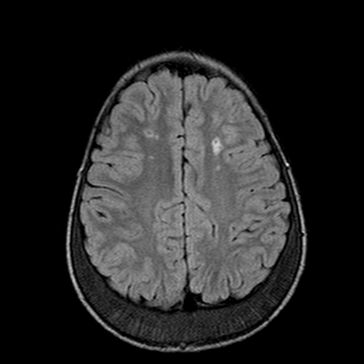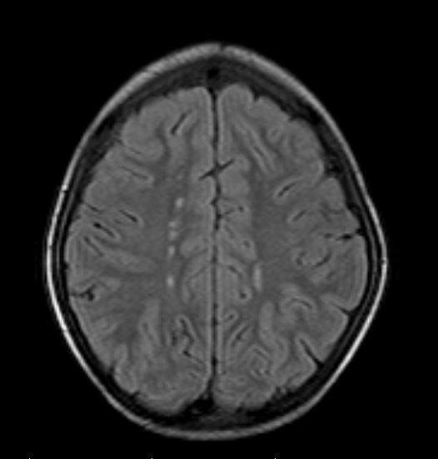
A
B
FLAIR MRI images of two children with SCD showing multiple infarctions (areas of increased signal as indicated by the arrows) in the bilateral white matter in the “deep watershed” regions rather than a typical arterial distribution. The lesions in A did not cause focal neurologic symptoms and thus this child had silent cerebral infarctions while the lesions in B resulted in focal neurologic deficits and thus this child had an overt stroke.

Figure 2
The Effect of Severe Anaemia on Cognitive Function
A 6 year old boy (without SCD) presented with fever and joint pain with an acute haemolytic anaemia of unknown etiology with initial haemoglobin 37 g/L. He was judged to be “neurologically normal”. He was asked to write “The cat is black” as part of a more detailed evaluation. He was transfused and on day 3 with haemoglobin 93g/L, he repeated the writing task with improved performance.

