**Abstract**

**Objectives**

To evaluate the feasibility of adults with cochlear implants using an online speech recognition test and questionnaire at home to assess whether they need to come to the clinic or not.

**Methods**

A prospective single-centre feasibility study evaluating:

* An online speech recognition test (digit triplet test, DTT)
* A long-term follow-up questionnaire to assess aspects that a clinician would ask in a face to face appointment
* A satisfaction questionnaire to assess patient perception of remote speech recognition testing

Seventeen people using cochlear implants aged from 34 to 84 years took part.

**Results**

* The majority of adults were able and willing to use tools at home to assess if they need to come to the centre
* The DTT Speech Reception Threshold, SRT was repeatable on three occasions within three weeks
* The majority of adults felt positive about testing their own hearing using the DTT at home. However only a minority (2 out of 17) felt they preferred remote testing to clinic testing (the majority was undecided).

**Conclusion**

The concept of a dual approach of online speech recognition test and questionnaire both done at home has potential to identify which adults with cochlear implants require clinic intervention, although sensitivity and specificity measures are unknown. A clinic visit remains the gold standard of care, but remote care may supplement traditional care pathways.

Keywords:

Cochlear implant, speech perception, telemedicine, person-centred care

**Introduction**

People using cochlear implants who have passed the early intensive intervention period are generally offered review appointments at the cochlear implant centre annually (British Cochlear Implant Group, 2016). This happens on a clinic-led schedule, not based on the patient’s clinical need. There is evidence that these appointments may not always offer benefit to the patient, for example in a review of 100 follow-up appointments, over 89% of patients had stable or better hearing compared to the previous year (Howe & Mawman, 2015). Due to the specialised nature of cochlear implantation, many patients travel a long distance to their centre. A more efficient model may be to give patients tools to assess at home whether they need to be seen at the cochlear implant centre or not. This would offer advantages for the patient: more stable hearing (problems identified and resolved more quickly); reduction in travel cost, time and inconvenience; increased confidence to manage their own hearing. It may also allow the clinic to prioritise care to those who need it more, and plan appointment schedules more efficiently. When a patient using a cochlear implant is seen for a routine review appointment, the clinician assesses their hearing, questions them on the device use and self-perceived hearing abilities, checks the device, and provides intervention in terms of device adjustment, equipment replacement and rehabilitation or counselling as required. If this assessment could be completed at home by the patient themselves, the clinician may be able to identify whether the patient needs to come to clinic at that time or not.

In the United Kingdom (UK), speech recognition with a cochlear implant is generally measured using Bamford-Kowal-Bench sentences (Bench, Kowal, & Bamford, 1979) presented in quiet and noise. A sentence test has the advantage of high face validity, but relies heavily on top-down processing and linguistic abilities of the listener. In the past ten years, speech understanding has increasingly been measured with digits, starting with the Dutch digit triplet test (Smits, Kapteyn, & Houtgast, 2004); digits are highly familiar stimuli which are known by people with even limited language skills and testing has a smaller learning effect (Smits, Theo Goverts, & Festen, 2013; Vlaming, MacKinnon, Jansen, & Moore, 2014). The closed set nature of the response makes digits suitable for self-testing over the telephone (Smits & Houtgast, 2005; Watson, Kidd, Miller, Smits, & Humes, 2012) or internet (Leensen, de Laat, & Dreschler, 2011; Smits, Merkus, & Houtgast, 2006). Testing using digit triplets in noise has successfully been used to screen hearing in hundreds of thousands of people worldwide (Stam et al., 2015; Williams-Sanchez et al., 2014) and is freely available to the public online (Action on Hearing Loss, 2015; MED-EL, 2015). Digit triplet testing in noise has also been successfully used in adults (Kaandorp, Smits, Merkus, Goverts, & Festen, 2015) and children (Mishra, Boddupally, & Rayapati, 2015) using cochlear implants. It correlates well with sentence testing in noise, has adequate repeatability and is relatively immune to learning effects, linguistic ability and personal factors such as education level (Kaandorp et al., 2015).

The UK National Health Service is committed to supporting self-care for people with long-term conditions (NHS, 2014)**.** People who are able to self-manage and are more actively involved in their care have been shown to have better outcomes (Hibbard, Greene, Shi, Mittler, & Scanlon, 2015; Mosen et al., 2007; Panagioti et al., 2014). A patient-led questionnaire approach to long-term care of people with cochlear implants has successfully been introduced in at least one UK cochlear implant centre (Howe & Mawman, 2015). Although adults with cochlear implants may be able to assess their benefit via questionnaire (Amann & Anderson, 2014; Calvino et al., 2016), sometimes people may attend for review and a hearing decrement is found which was not noticed by the patient, perhaps due to a gradual decline. A dual approach of self-assessment and an objective speech recognition test may offer the best sensitivity.

The aim of this project was to evaluate the feasibility of assessing adults with cochlear implants remotely using an online speech recognition test (digit triplet test, DTT) and a questionnaire.

**Hypotheses**

* A dual approach of online speech recognition test and questionnaire both done at home can be used to identify which adults with cochlear implants require intervention at the clinic
* The majority of adults using cochlear implants are able and willing to use tools at home (hearing test and questionnaire) to assess if they need to come to the cochlear implant centre or not
* The digit triplet test SRT will be repeatable on three separate test occasions within three weeks
* The majority of adults using cochlear implants will feel positive about testing their own hearing at home

**Methods and material**

**Design**

This was a prospective pilot study which aimed to assess the concept of adults using cochlear implants being willing and able to use tools at home to decide if they needed to attend clinic or not. Three tools were used: a speech recognition test (DTT) performed online by the user, a cochlear implant long-term follow-up questionnaire, and a satisfaction questionnaire.

The study received approval from the University of Southampton Institute of Sound and Vibration Research Safety and Ethics Committee (ref 1218) on 20/07/2011. The study also received National Research Ethics Service approval (NRES Committee South West – Exeter 11/SW/0162) on 11 August 2011.

**Setting**

All the study testing took place via the internet or by mail or email in the participants’ homes; no attendance at clinic was required.

**Participants**

*Inclusion criteria:*

* Person using cochlear implant (any device, unilateral or bilateral)
* Cochlear implant use for at least 6 months1 (to avoid early rapid improvement in speech perception)
* Aged 18 years or more
* Able to give informed consent
* Sufficient English to understand study documentation and participate in testing
* Access to a computer with internet access and a sound card

**Sample size**

No power calculations were done as this was a feasibility trial.

**Recruitment**

Two hundred and sixty-three people using cochlear implants at the University of Southampton Auditory Implant Service (USAIS) were eligible for inclusion. Eighty patients were invited: the most recent 79 to be implanted and one additional patient who had already expressed interest in participating. The most recent patients were selected because it was more likely to find a wider range of cochlear implant devices in these patients. Twenty-one people responded; seventeen were willing to participate.

**Interventions**

*Digit triplet test, DTT*

A customised version of the Action on Hearing Loss digit triplet test was created by setting up a new web-server instance of the existing online test (Action on Hearing Loss, 2015). This modified test had an additional authentication table to verify users, and the raw Extensible Markup Language (XML) results coded with the user identification were sent by email to the researchers as soon as each speech recognition test was completed. The test comprised up to 27 presentations of a female talker speaking sets of three digits in background noise selected at random from 80 different triplets. The background noise was white noise filtered to have the same long-term average spectrum as the speech material (Hall, 2006). Only monosyllabic digits were used: zero (spoken as ‘oh) to nine excluding the disyllabic digit seven. The speech presentation level remained constant and the noise was varied to give 11 different SNRs from -12 to +8 (-12, -10, -8, -6, -4, -2, 0, 2, 4, 6, 8 dB). Each presentation was preceded by the carrier phrase ‘the digits’ (e.g. ‘the digits 1 3 4’). The test began with a signal to noise ratio, SNR, of +8dB and used a maximum of ten levels to attempt to find the starting SNR for the adaptive series. The SNR was decreased by 2dB after a correct response until an incorrect response was made and that SNR was then the starting level for the second averaging stage. An incorrect response was made when one or more digits was incorrectly identified; all digits had to be correct. If correct responses were given for all SNRs (from +8 to -10dB) then the starting level for the second stage would be a SNR of -10dB. Sixteen triplets were then presented using a 1 up 1 down adaptive algorithm (Levitt, 1971) whereby a correct response resulted in the SNR decreasing by 2dB and an incorrect response caused the SNR to increase by 2dB, in common with the original Dutch test (Smits et al., 2004). In such a staircase procedure a change in direction of the function is termed a ‘reversal’; in a 1 up 1 down adaptive algorithm a reversal occurs whenever the response pattern changes from correct to incorrect or incorrect to correct. The Speech Reception Threshold, SRT, defined as the SNR when the listener scored 50% was then calculated as the average of all 16 presentation levels in the averaging stage.

Participants were asked to perform the test by connecting their cochlear implant speech processor directly to the computer headphone socket. This reduced the variability associated with the use of speakers and interference from noisy environments at home. People using cochlear implants routinely use a cable to connect their speech processors to audio devices. Participants were also asked to use the CochlearTM Nucleus mains isolation cable which has surge protection to protect the speech processor when using mains powered equipment. Even if they used a device that was not made by Cochlear, they connected their own personal audio cable into the CochlearTM Nucleus mains isolation cable before connecting it to the computer; this was our centre’s clinical recommendation at that time as the other manufacturers did not include a surge protection cable. Participants were sent a link to the online test by email and were given a unique identifier (telemed1 to 17) and password to access the site; no personal information was required. A series of numbers spoken without background noise were presented to allow the participants to set the volume to a comfortable level. This was accomplished by clicking and dragging the volume control on the page, adjusting the computer volume in the usual way, or using the volume adjustment on the CochlearTM Nucleus mains isolation cable (only for Nucleus® Freedom processor users). No direct measure of sound output was made, but as the test relies on the ratio between signal and noise level, the absolute values were not considered important. They then proceeded to the full test, following instructions given on the screen. Their task was to type in the digits they had heard using their computer keyboard. The test lasted approximately five minutes; no feedback was given. Participants were asked to complete the test three times in a period of three weeks. Email reminders were sent one week and two weeks after they had done the first test.

*Long-term follow-up questionnaire*

A questionnaire was designed to cover areas typically assessed by clinicians reviewing people with cochlear implants in clinic (Appendix 1); input from experienced cochlear implant clinicians was incorporated into its construction. Four sections covered health issues relating to the cochlear implant; use of implant and perception of hearing; equipment issues and any spares required; general satisfaction and desire to see a clinician. The aim was to produce a measure that could be reviewed by clinicians to determine if the person using a cochlear implant needed to come to clinic or not. The questionnaire was sent by mail to participants at the start of the study; they were asked to complete it when they had consented and return it in a prepaid envelope.

Depending on the answers given to the questionnaire, the clinician may take several courses of action: send equipment, provide information, arrange clinic appointment, or no intervention required. Table 1 shows the question numbers, the responses that would generate clinician concern, and the action that would be taken.

*Satisfaction questionnaire*

After the three speech recognition tests were completed, participants were sent a second questionnaire (Appendix 2) to complete and return in a prepaid envelope. This assessed their perceptions of remote testing. It comprised nine statements; participants were asked how much they agreed with each statement on a five-point Likert scale (strongly agree, agree, neither agree nor disagree, disagree, strongly disagree). Participants were also asked to give three benefits and three concerns about remote testing.

**Outcome measures**

* Percentage of adults using cochlear implants who are able and willing to use tools at home (speech recognition test and questionnaire), measured as project completion rate
* Speech reception threshold (dB) of digit triplet test on three weekly occasions
* Perceptions of testing their speech recognition at home, measured using a satisfaction questionnaire

**Data analysis**

The statistics package IBM SPSS version 22 was used for analyses and the generation of graphs. Boxplots were used to show the spread of results. Stability of the DTT was analysed using repeated measures ANOVA (after checking that parametric assumptions were not violated using the Kolmogorov-Smirnov test). Sphericity assumptions were checked using Mauchly’s test of sphericity. The p value was set at 0.05. Due to the pilot nature of this experiment, statistical analyses results were viewed with caution.

**Results**

**Demographics**

Eight males and 9 females aged from 34 to 84 years (mean 58 years; standard deviation 16 years) took part. One person used bilateral cochlear implants; the other 16 had a unilateral implant. Participants used various cochlear implant speech processors: Advanced Bionics HarmonyTM (n = 5), MED-EL Opus 2 (n = 6), Nucleus® CP810 (n = 1), and Nucleus® Freedom (n = 5).

**Digit triplet test**

Sixteen participants performed the digit triplet test three times giving a total of 49 test instances; one participant performed the test only once and then was unable to do the further tests. This person felt that the test carried on for too long and he or she was unable to concentrate and also not able to log in to the site. The remaining 16 completed the test three times; the third test occurred between 4 and 34 days after the first test, with 15 out of 16 result sets being achieved within 3 weeks. One subject reported internet problems and the third result was received 27 days after the second result. One participant performed the test twice within 5 minutes on the first occasion – the first result only was used. Raw data were examined and results were not included if there were less than 6 reversals in the adaptive trial; the recommended procedure for an adaptive method is to continue testing until at least six or eight reversals have occurred (Wetherill & Levitt, 1965). This resulted in 7 test instances out of 49 being discarded, leaving 42 valid tests. One participant failed to achieve 6 reversals on all three test occasions; the other four instances were one test occasion (the first test in three out of four). With the exception of one participant, all tests were valid (6 or more reversals) on the third occasion, resulting in a completion rate of 15 out of 17 (88%). The one participant who could not obtain a score on the test at all was congenitally deaf and had obtained 0% on BKB sentences in quiet in clinic; this participant also had internet difficulties so was the same person who supplied the results outside the three-week period. Figure 1 shows all valid DTT SRT results at the three test intervals.

*Reliability of DTT*

The DTT SRT was not significantly different to a normal distribution at each test interval (Kolmogorov-Smirnov Z = 0.550, 0.620, 0.585; two-tailed p = 0.923, 0.836, 0.884 for the three intervals) so a one-way repeated measures ANOVA was used to assess if there was any change in the DTT SRT over time. No significant effect was found (F(2, 20) = 3.089, p = 0.068) suggesting that the DTT result is repeatable.

**Long-term follow-up questionnaire**

All 17 participants completed the long-term follow-up questionnaire. Four out of 17 had no issue that required intervention; six further people had an issue that could be dealt with by sending equipment or information to the patient. Seven people reported that there was a problem or deterioration in their hearing, and soreness or other discomfort associated with the speech processor in three cases (although three said that everything was fine on further questioning by email, suggesting the questions were insensitive). Only four people indicated that they would like to come to clinic (or already had an upcoming appointment), although one of these had indicated by email that everything was fine. On the basis of this questionnaire and the subsequent email, four people reported problems indicating the necessity of a clinic visit or other intervention.

**Satisfaction questionnaire**

All 17 participants answered all nine questions on the satisfaction questionnaire. Frequency tables of the participants’ agreement with the nine statements are show in Figure 2. On average (considering the median values), participants strongly agreed that remote testing saves travel time and that the internet connection worked smoothly. Participants agreed that the test was easy, and that remote care saves waiting time at the clinic and parking difficulties. However participants agreed that a *clinic* test assesses their hearing better and that it is easier to explain difficulties face to face. On average, participants were unsure whether they preferred remote testing over coming to the clinic and whether they would prefer not to come to the clinic unless there was a problem.

The questionnaire also had a free text area for participants to list three benefits and three concerns they had with remote testing. Apart from the benefits related to ease and comfort of test and travel arrangements listed in questions 1 to 9, participants listed the following advantages: test can be done any time (5 people said this), no time off work needed (4), saves expense for patient (4) and clinic (3), being at home is more relaxing (3), better for the environment (1), clinic can prioritise their time for patients with more needs (1), less tiring than clinic testing (1), encourages people to use a direct connection to the computer (1), and is less inconvenient for others (presumably other family members) (1). In terms of concerns about remote testing, those not covered in questions 1 to 9 were: computer skills and equipment required (4), worries about not doing the test right (3), direct connection being difficult to use (2), no feedback or reassurance from the clinician (3), doesn’t work for someone who cannot understand speech without lip-reading (1), the government may cut clinic funding (1), no check of equipment (1), not meeting other people with cochlear implants (1), other problems may be missed e.g. magnet strength issue (1), and too much paperwork (1) (research study documentation).

**Comparison of DTT speech perception in clinic**

Although not an objective of this project, it was felt useful to relate the DTT SRT to speech perception tests done previously in clinic. The most recent clinic speech recognition scores on BKB sentences were obtained from the patients’ medical files. A significant limitation of this was that the clinic testing was done at widely varying times prior to the project participation: between 40 and 739 days before the first DTT test, with an average of 215 days (standard deviation 184 days). In addition, in 14 out of 17 cases the clinic testing had been done while the patient listened bimodally (cochlear implant plus contralateral hearing aid); this may have inflated the result compared with cochlear implant alone testing done for the project. All participants had a previous score on BKB sentences in quiet measured in clinic; testing was done by audiologists at 70dBSPL in a sound-treated room using loose keyword scoring. BKB score in quiet ranged from 0 to 100% although the results demonstrated significant ceiling effects as shown in Figure 3a. BKB sentences in adaptive noise were completed on 12 people (the clinic audiologists only did this test if the quiet score was 70% or more and one additional person had not had the test for unspecified reasons). The adaptive BKB score ranged from -1.8dB to 8.7dB, and due to the adaptive nature of the test demonstrated no floor or ceiling effects (Figure 3b). Figure 4 shows the DTT SRT plotted against the adaptive BKB SRT; the third DTT test was chosen for this comparison as it had more data and any practice effects would have been alleviated. There appeared to be an outlier in the data: one subject had obtained the second best (lowest) score for adaptive BKB in the clinic (-1.5 dB), but the DTT SRT was the second worst (0.5 dB). This patient was contacted to inform them of the discrepancy; she or he had not reported a problem with hearing in the questionnaire. After removal of this outlier, there was a positive correlation between the DTT SRT and the clinic adaptive BKB SRT (Pearson correlation coefficient = 0.812, n = 11, two-tailed p = 0.002).

**Discussion**

On the basis of the long-term follow-up questionnaire, five people reported problems which may necessitate a clinic visit or other intervention (see Table 1 for responses and the intervention recommended). The speech recognition test identified one additional person whose DTT results appeared worse than the previous clinic speech perception result. As the participants had not previously been tested with the DTT, it was not possible to make a judgment about whether there had been any deterioration in their hearing from the basis of these acute tests. However the stability of the measure in this short time period suggests that the DTT could be used as a monitoring tool to check for any hearing deterioration long-term. In order to assess the sensitivity and specificity of these tools to intervention being required, an acute study would be required where participants used the tools and then saw a clinician immediately afterwards.

Using tools for cochlear implant care at home will not be suitable for all; some people will be unable or unwilling to complete a questionnaire or perform a hearing test themselves. Patients and clinicians could work together to decide whether some tools should be offered. This was a research study to assess the concept of remote tools; no consideration was given to the funding of these procedures. Those markets that receive funding from insurance carriers would need to investigate whether remote care services are billable.

With practice, 15 out of 17 people (88%) using cochlear implants were able to obtain a valid score on the DTT. One participant dropped out after one session, finding the test too long and difficult to access; another participant was able to access the test each time, but was unable to obtain a score due to not discriminating the digits. No training for the test was given: a link was simply sent by email. Improved compliance may be obtained after one training session in clinic to introduce the test. The initial signal to noise ratio presented was +8dB; an increase of this in future test versions may allow more people to use the test. However a small percentage of people using cochlear implants do not ever obtain any open-set speech recognition, so the test may not be suitable for all. Participants were asked to use a direct connection between their speech processor and computer. This has the advantage of reducing or eliminating the effects of background noise at home (depending on what mixing ratio of microphone: direct input was used). There was also no dependence on computer speaker quality. However a disadvantage of testing with direct connection is that the whole hearing pathway is not assessed: direct connection completely or partially excludes input from the processor microphone – a part that may deteriorate over time due to humidity, dust or damage. Changing mixing ratio would have involved a clinic visit for some people as it is not a user-adjustable setting for all devices. Participants did the test in their usual direct connect condition and no data were collected on mixing ratio, so there is the possibility that there was background noise for some participants.

All participants completed the long-term follow-up questionnaire. The majority of participants were therefore able and willing to use tools to assess their hearing at home. However this result may be biased by the inclusion criteria of the project requiring access to a computer with internet access and a sound card. In addition, those people who agree to take part in a research project related to telemedicine may already be more committed to these ideas than the general population of people using cochlear implants. In the UK, 86% of adults use the internet regularly (had used internet in previous 3 months), although usage is lowest in the older age group, with only 33% of people aged 75 years or over having used the internet recently (Office for National Statistics, 2015). This figure has increased from previous years, and can be expected to increase further. Improved penetration in the older age group may be obtained by using apps on smartphones. In the UK, although not statistically significant, the rate of smartphone use in those aged 75 years or more doubled between 2012 and 2013, and the rate of tablet use tripled (Ofcom, 2014).

Although seven people reported that there was a problem or deterioration in their hearing, and soreness or other discomfort associated with the speech processor, only four people indicated that they would like an appointment (or already had an upcoming appointment). Three people whose responses on the long-term questionnaire indicated that intervention was required reported that everything was fine on further questioning by email. This suggested that modifications to the questions were required in order to improve their clarity and sensitivity and specificity to problems requiring intervention. We have continued to use a modified version of this tool at the University of Southampton Auditory Implant Service for all adults with cochlear implants who are able to complete a questionnaire. The long-term questionnaire used in this project was administered on paper, requiring a clinician to individually review the responses. Using an online questionnaire allows automated scoring and flagging, so the clinician would only need to be alerted if there was a problem that required intervention. This would minimise the administrative workload. An online version has now been developed and is currently being used in a clinical trial (Cullington et al., 2016).

The participants gave useful feedback concerning their perceptions of remote testing. Most found the DTT easy (12 out of 17) with the internet implementation running smoothly (16 out of 17). The majority agreed that the DTT saves travel time (15 out of 17), saves clinic waiting time (12 out of 17), and eliminates parking difficulties (9 out of 17). These travel-related questions may have been biased by respondents having never experienced long waiting times or parking difficulties when attending clinic; the questions were worded for example ‘Remote testing saves me from parking difficulties I experience when I attend clinics’. The majority of participants felt that a test in clinic assessed their hearing better (9 out of 17) and that is was easier to explain problems face to face rather than writing them down (9 out of 17). The majority were unsure whether they preferred remote testing to coming to clinic (9 out of 17). When asked if they would prefer to only come to clinic when experiencing a problem, only four agreed with this. Comments suggested that the inclusion of feedback about the test result may improve acceptability.

This project did not aim to assess the correlation of the DTT with clinic-based measures, although very preliminary data suggested an association. However the clinic results were collected at varying time points prior to the DTT results, and in a different listening condition in many cases (cochlear implant plus hearing aid). In addition, the authors do not believe that the currently-used clinic speech perception measure using sentences is necessarily the gold standard for comparison, due to its reliance on top-down processing and linguistic abilities (Kaandorp et al., 2015). Future work should address the objective of a comparison between traditional clinic measures and the DTT.

**Conclusion**

* The concept of a dual approach of online speech recognition test and questionnaire both done at home has the potenial to identify which adults with cochlear implants require intervention at the clinic, although sensitivity and specificity measures are not known. A clinic visit remains the gold standard of care for someone using a cochlear implant, but offering some tools remotely may supplement care especially in those unable to attend clinic regularly. Remote care will not be suitable for every person using a cochlear implant, but that is no reason not to offer it as a choice to appropriate patients
* The majority of adults using cochlear implants in this study were able and willing to use tools at home (speech recognition test and questionnaire) to assess if they need to come to the cochlear implant centre or not during this research project; this may not extrapolate to a full clinical roll-out
* The digit triplet test SRT was repeatable on three separate test occasions within three weeks
* The majority of adults using cochlear implants felt positive about testing their own hearing using the DTT at home, feeling it is easy to use, and reduces the inconvenience and expense related to travel. However only a minority (2 out of 17) felt they preferred remote testing to clinic testing (the majority was undecided). The majority (9 out of 17) felt it was easier to explain problems face to face.

**Acknowledgments**

The authors thank the people with cochlear implants who give so freely of their time and experience in order to further cochlear implant research. Thank you also to Action on Hearing Loss; Thomas Fiddian and Darren Dignam worked hard to set up the customised Action on Hearing Loss online speech recognition test that was used for this study

**Declaration of interest**

The first author performs private consultancy work for Cochlear Europe Ltd.

Table 1. Analysis of answers to Long-term follow-up questionnaire using in this project. If the response to a question is flagged, action is required.



Figure 1. Digit triplet test (DTT) Speech Reception Threshold (SRT) at three time points within 20 days. A lower score indicates better speech recognition in noise. Results from 13 subjects are in the first test, 14 subjects in the second, and 15 subjects in the third test. The box represents the portion of the distribution falling between the 25th and 75th percentiles (lower and upper quartiles). The horizontal line represents the median. The vertical lines outside the box (whiskers) contain the largest and smallest values that are not categorised as outliers or extreme values. The circle labelled 27 is deemed an outlier by SPSS due to its position more than 1.5 box lengths above the upper quartile.

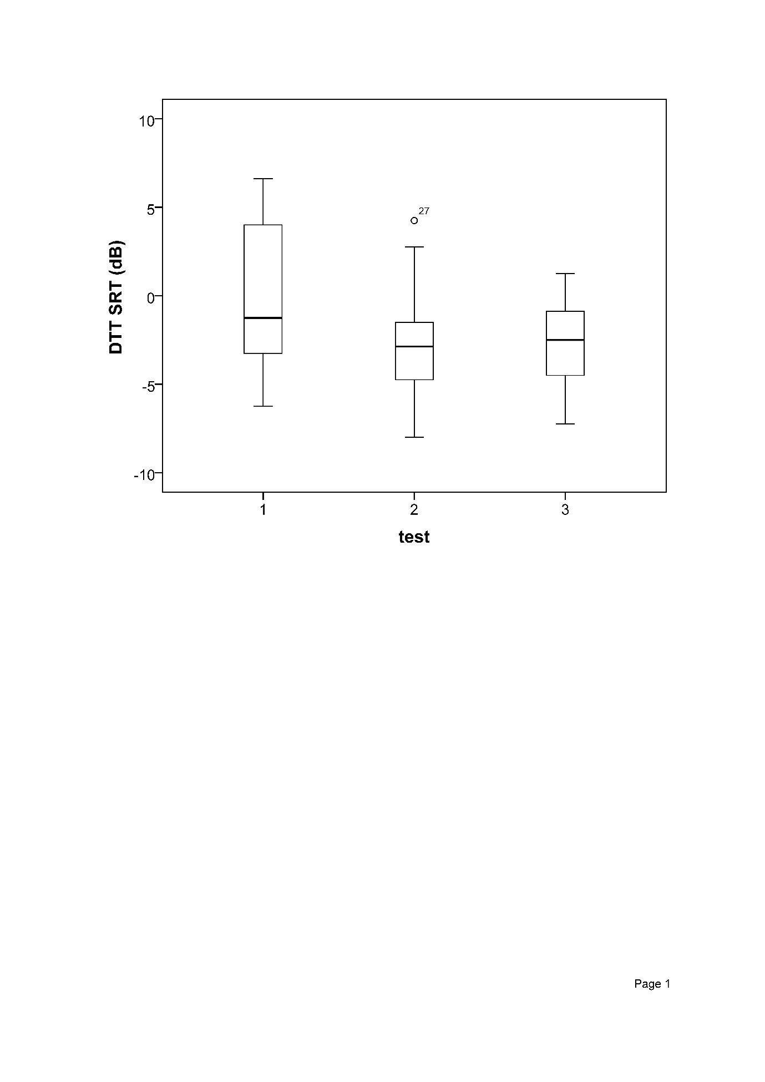

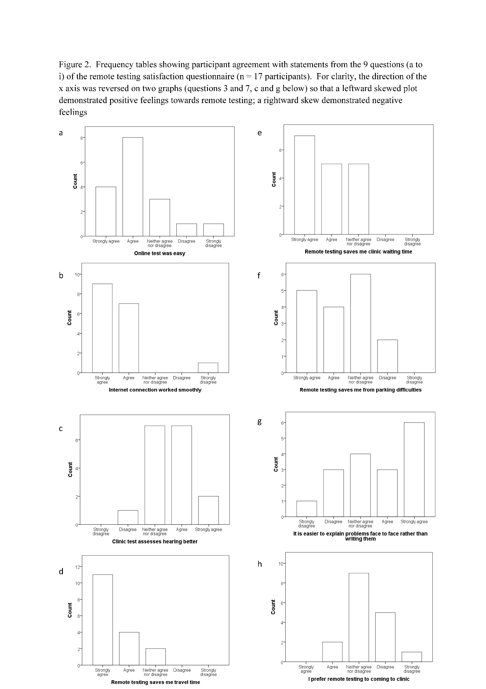

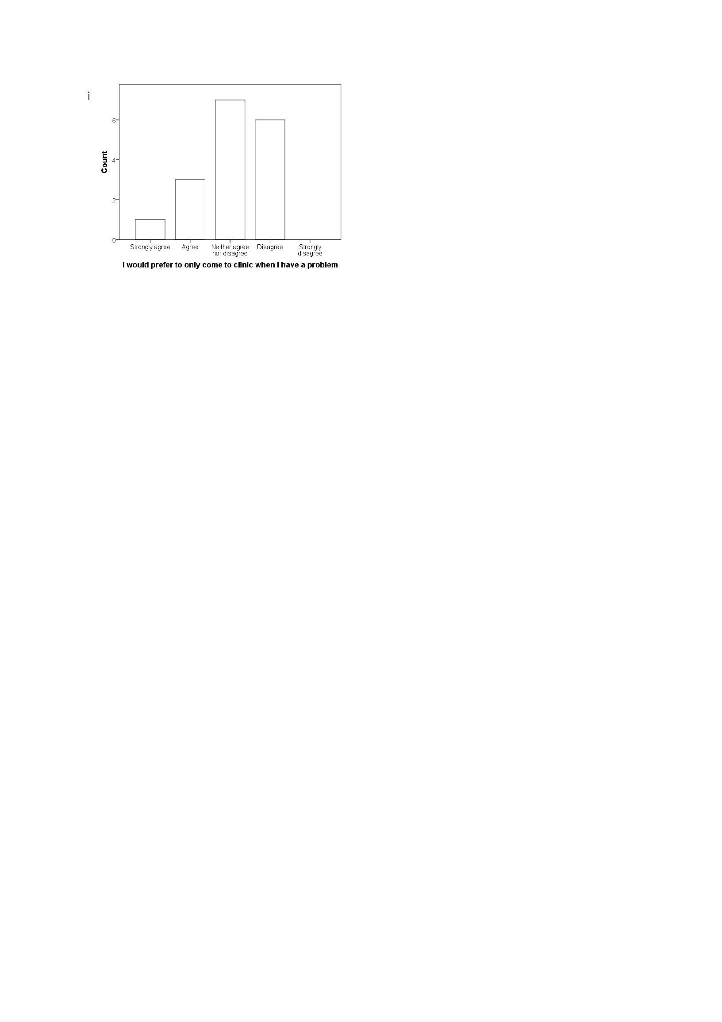

Figure 3. Speech perception measures completed in the clinic at varying time points prior to study participation.

3a Open set sentence recognition score (% correct) using BKB sentences measured in all 17 participants. The asterisk labelled 5 is deemed an extreme outlier by SPSS due to its position more than 3 box lengths below the lower quartile.

3b Adaptive speech reception threshold (SRT) in dB using BKB sentences measured in 12 participants (SNR when score was 50% correct). A lower score indicates better speech recognition in noise.

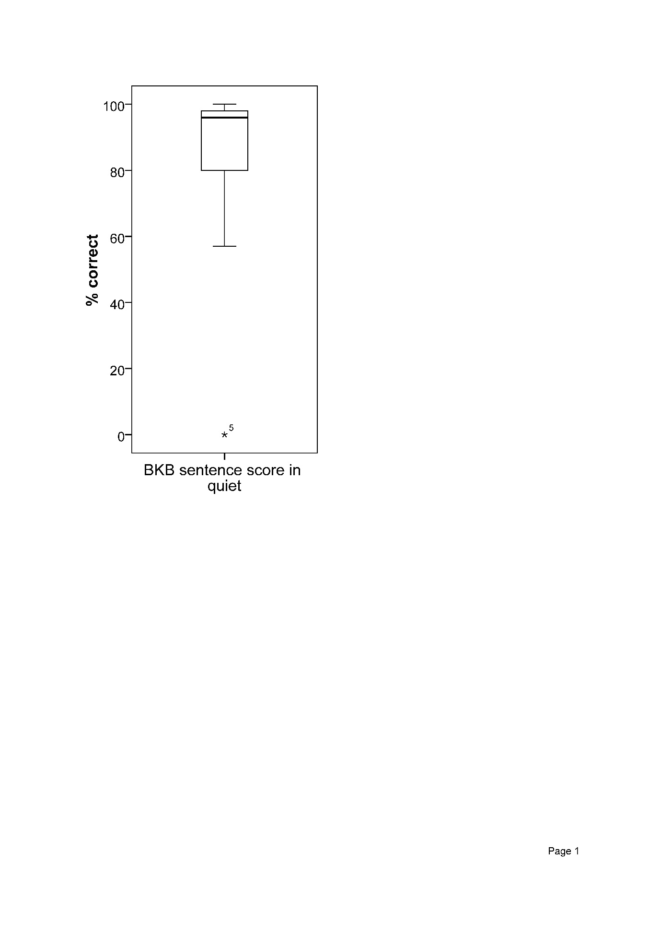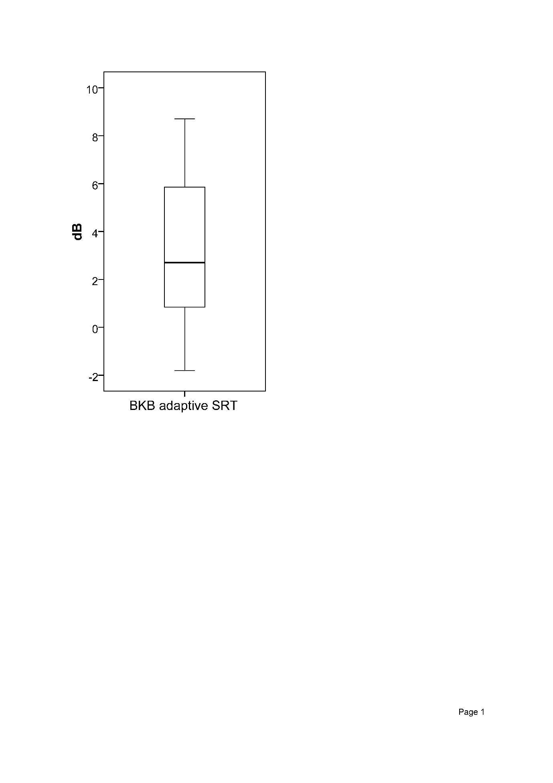

Figure 4. Scatterplot of DTT SRT against adaptive BKB SRT measured in clinic at varying time points prior to study participation.

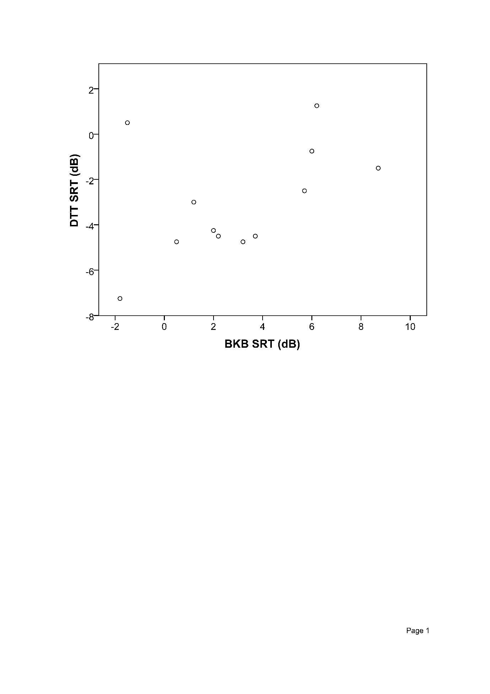

Table 1. Analysis of answers to Long-term follow-up questionnaire using in this project. If the response to a question is flagged, action is required.

Figure 1. Digit triplet test (DTT) Speech Reception Threshold (SRT) at three time points within 20 days. A lower score indicates better speech recognition in noise. Results from 13 subjects are in the first test, 14 subjects in the second, and 15 subjects in the third test. The box represents the portion of the distribution falling between the 25th and 75th percentiles (lower and upper quartiles). The horizontal line represents the median. The vertical lines outside the box (whiskers) contain the largest and smallest values that are not categorised as outliers or extreme values. The circle labelled 27 is deemed an outlier by SPSS due to its position more than 1.5 box lengths above the upper quartile.

Figure 2. Frequency tables showing participant agreement with statements from the 9 questions (a to i) of the remote testing satisfaction questionnaire (n = 17 participants). For clarity, the direction of the x axis was reversed on two graphs (questions 3 and 7, c and g below) so that a leftward skewed plot demonstrated positive feelings towards remote testing; a rightward skew demonstrated negative feelings

Figure 3. Speech perception measures completed in the clinic at varying time points prior to study participation.

3a Open set sentence recognition score (% correct) using BKB sentences measured in all 17 participants. The asterisk labelled 5 is deemed an extreme outlier by SPSS due to its position more than 3 box lengths below the lower quartile.

3b Adaptive speech reception threshold (SRT) in dB using BKB sentences measured in 12 participants (SNR when score was 50% correct). A lower score indicates better speech recognition in noise.

Figure 4. Scatterplot of DTT SRT against adaptive BKB SRT measured in clinic at varying time points prior to study participation.

Appendix 1. Long-term follow-up questionnaire designed for this project.

**Health Information**

1. Is your coil/headpiece comfortable on your head? Yes No
2. Does the implant site feel different, sore, hot or itchy? Yes No
3. Have you had a significant bang to your head around Yes No

the implant site?

1. Does your speech processor cause soreness? Yes No
2. Do you have an ear infection in your implanted ear? Yes No
3. Have you been to your GP for any ear problems in the last year? Yes No

If yes, what was the problem ………………………………………………………………………………………………………….

Any other medical diagnoses since your last appointment …………………………………………………………

**Use of implant and accessories**

1. How many hours per day do you wear your processor? ..............................................................

If you don’t wear your processor all your waking hours, can you explain why?

………………………………………………………………………………………………………………………………………………………..

1. Since your last appointment, have you noticed any increase in the difficulties you face when listening to speech in a quiet environment?

Yes No

1. Since your last appointment, have you noticed any increase in the difficulties you face when listening to speech in a noisy background?

Yes No

1. Since your last appointment, has any member of your family or a friend said they think your hearing has become worse?

Yes No

1. Are you happy with your current mapping/tuning? Yes No

**Equipment**

1. If you have a Cochlear/Nucleus processor have you changed your microphone cover in the past 2-3 months?

Yes No

1. If you have an Advanced Bionics Harmony processor, have you changed your T mic in the last 6 months?

Yes No

1. What type of batteries do you use? (disposable or rechargeable?) …………………………..
2. How long do your batteries last? ………………
3. Has your battery life got worse? Yes No
4. Do you have enough spare batteries? Yes No
5. Do you use any of these accessories?

Personal audio cable Yes No

TV HiFi lead Yes No

Telecoil Yes No

Radio aid Yes No

* If you would be interested in learning more about using accessories, please contact us as we run regular workshops.
* Please take a moment to examine your speech processor and check it fits together securely and is in good condition. If you have a remote control, is it working? If there are any problems, please request replacement items.
* You should have a spare cable if you use a Cochlear processor, a spare cable if you use a Med-El processor, a spare T mic and headpiece if you use an Advanced Bionics processor, and spare cables if you use a Neurelec processor.

1. Do you require any spare equipment? Yes No

If yes, see attached spares sheet and fill out the products you require

**Overall**

1. Are you satisfied with the overall performance of your cochlear implant? Yes No

If not, what are your concerns? ………………………………………………………………………………………………………..

………………………………………………………………………………………………………………………………………………………….

1. Would you like to come to the clinic to address any concerns? Yes No

If yes, what are those concerns? ……………………………………………………………………………………………………….

…………………………………………………………………………………………………………………………………………………………..

* Please remember we do offer **hearing therapy** and **clinical psychology** services. You may want to access these services if you need help with tinnitus, adaptations to your work environment to help your hearing, or if difficulties with your hearing are having a significant impact on other areas of your life, for example your relationships or your mood. Please phone us for more information.
* Remember … it is your responsibility to keep us updated with your contact details, including GP information. If anything has changed since your last appointment, please let us know.

**Please list the replacements/spares you need. Return this list to us in the enclosed SAE, and we will send you the items. (Once you receive the new items, please send the broken ones to us). Remember, if you have an Advanced Bionics cochlear implant, you should contact the company directly for any spares you need (01223 847222, support@abforyou.co.uk).**

|  |  |  |  |
| --- | --- | --- | --- |
| **Study ID** | | **Ear** | |
| **Item** | **Length** | **Colour** | **Notes** |
|  |  |  |  |
|  |  |  |  |
|  |  |  |  |
|  |  |  |  |
|  |  |  |  |
|  |  |  |  |
|  |  |  |  |

Appendix 2. Satisfaction questionnaire

This questionnaire consists of statements with which you can agree or disagree. You are asked to tick one of five boxes to indicate your opinion: *strongly agree, agree, neither agree nor disagree, disagree, strongly disagree.* Please tick only one box per statement and do not leave any blank. **Please read the questions carefully.**

|  |  |  |  |  |  |
| --- | --- | --- | --- | --- | --- |
|  | **Strongly agree** | **Agree** | **Neither agree nor disagree** | **Disagree** | **Strongly disagree** |
| 1. I found the online hearing test easy to do |  |  |  |  |  |
| 1. The internet connection worked smoothly |  |  |  |  |  |
| 1. I think a test at the *clinic* assesses my hearing better |  |  |  |  |  |
| 1. Remote testing saves me travel time |  |  |  |  |  |
| 1. Remote testing saves me waiting time at the clinic |  |  |  |  |  |
| 1. Remote testing saves me from parking difficulties I experience when I attend clinics 2. I find it easier to explain any difficulties face to face, rather than writing them down |  |  |  |  |  |
|  |  |  |  |  |  |
| 1. I prefer remote testing to coming to the clinic |  |  |  |  |  |
| 1. I would prefer to not come to the clinic routinely unless I have a problem |  |  |  |  |  |

Please state 3 benefits you see in remote testing

|  |
| --- |
| 1.  2.  3. |

Please state 3 concerns you have with remote testing

|  |
| --- |
| 1.  2.  3. |

**Thank you very much for agreeing to complete the questionnaire.**

**References**

Action on Hearing Loss. (2015). *Check your hearing*. Retrieved from <http://www.actiononhearingloss.org.uk/your-hearing/look-after-your-hearing/check-your-hearing/take-the-check.aspx>

Amann, E., & Anderson, I. (2014). Development and validation of a questionnaire for hearing implant users to self-assess their auditory abilities in everyday communication situations: the Hearing Implant Sound Quality Index (HISQUI19). *Acta Otolaryngol, 134*(9), 915-923. doi: 10.3109/00016489.2014.909604

Bench, J., Kowal, A., & Bamford, J. (1979). The BKB (Bamford-Kowal-Bench) sentence lists for partially-hearing children. *Br. J. Audiol., 13*(3), 108-112

British Cochlear Implant Group. (2016). Quality Standards. Cochlear implant services for children and adults.

Calvino, M., Gavilan, J., Sanchez-Cuadrado, I., Perez-Mora, R. M., Munoz, E., & Lassaletta, L. (2016). Validation of the Hearing Implant Sound Quality Index (HISQUI19) to assess Spanish-speaking cochlear implant users' auditory abilities in everyday communication situations. *Acta Otolaryngol, 136*(1), 48-55. doi: 10.3109/00016489.2015.1086021

Cullington, H. E., Kitterick, P. T., DeBold, L., Weal, M., Clarke, N., Newberry, E., & Aubert, L. (2016). Personalised long-term follow-up of cochlear implant patients using remote care, compared to those on the standard care pathway: study protocol for a feasibility randomised controlled trial. *BMJ Open,* 6(5), e011342. 10.1136/bmjopen-2016-011342

Hall, S. J. (2006). *The development of a new English sentence in noise test and an English number recognition test.* (MSc MSc), University of Southampton.

Hibbard, J. H., Greene, J., Shi, Y., Mittler, J., & Scanlon, D. (2015). Taking the long view: how well do patient activation scores predict outcomes four years later? *Med Care Res Rev, 72*(3), 324-337. doi: 10.1177/1077558715573871

Howe, S., & Mawman, D. (2015). Audit of adult post-implant annual reviews and evaluation of patient-led review. *Cochlear Implants Int, 16*(1), 3-8. doi: 10.1179/1754762814Y.0000000079

Kaandorp, M. W., Smits, C., Merkus, P., Goverts, S. T., & Festen, J. M. (2015). Assessing speech recognition abilities with digits in noise in cochlear implant and hearing aid users. *Int J Audiol, 54*(1), 48-57. doi: 10.3109/14992027.2014.945623

Leensen, M. C., de Laat, J. A., & Dreschler, W. A. (2011). Speech-in-noise screening tests by internet, part 1: test evaluation for noise-induced hearing loss identification. *Int J Audiol, 50*(11), 823-834. doi: 10.3109/14992027.2011.595016

Levitt, H. (1971). Transformed up-down methods in psychoacoustics. *J Acoust Soc Am, 49*(2(2)), 467-477

MED-EL. (2015). *Online hearing test* [*http://www.medel.com/hearing-test/*](http://www.medel.com/hearing-test/). Retrieved from <http://www.medel.com/hearing-test/>

Mishra, S. K., Boddupally, S. P., & Rayapati, D. (2015). Auditory Learning in Children With Cochlear Implants. *J Speech Lang Hear Res, 58*(3), 1052-1060. doi: 10.1044/2015_jslhr-h-14-0340

Mosen, D. M., Schmittdiel, J., Hibbard, J., Sobel, D., Remmers, C., & Bellows, J. (2007). Is patient activation associated with outcomes of care for adults with chronic conditions? *J Ambul Care Manage, 30*(1), 21-29

NHS. (2014). *Five year forward view*.

Ofcom. (2014). *Adults' media use and attitudes report 2014* [*http://stakeholders.ofcom.org.uk/binaries/research/media-literacy/adults-2014/2014_Adults_report.pdf*](http://stakeholders.ofcom.org.uk/binaries/research/media-literacy/adults-2014/2014_Adults_report.pdf). Ofcom.

Office for National Statistics. (2015). *Internet users: 2015*.

Panagioti, M., Richardson, G., Small, N., Murray, E., Rogers, A., Kennedy, A., . . . Bower, P. (2014). Self-management support interventions to reduce health care utilisation without compromising outcomes: a systematic review and meta-analysis. *BMC Health Serv Res, 14*, 356. doi: 10.1186/1472-6963-14-356

Smits, C., & Houtgast, T. (2005). Results from the Dutch speech-in-noise screening test by telephone. *Ear Hear, 26*(1), 89-95

Smits, C., Kapteyn, T. S., & Houtgast, T. (2004). Development and validation of an automatic speech-in-noise screening test by telephone. *International Journal of Audiology, 43*, 15-28

Smits, C., Merkus, P., & Houtgast, T. (2006). How we do it: The Dutch functional hearing-screening tests by telephone and internet. *Clin Otolaryngol, 31*(5), 436-440. doi: 10.1111/j.1749-4486.2006.01195.x

Smits, C., Theo Goverts, S., & Festen, J. M. (2013). The digits-in-noise test: assessing auditory speech recognition abilities in noise. *J Acoust Soc Am, 133*(3), 1693-1706. doi: 10.1121/1.4789933

Stam, M., Smits, C., Twisk, J. W., Lemke, U., Festen, J. M., & Kramer, S. E. (2015). Deterioration of Speech Recognition Ability Over a Period of 5 Years in Adults Ages 18 to 70 Years: Results of the Dutch Online Speech-in-Noise Test. *Ear Hear, 36*(3), e129-137. doi: 10.1097/aud.0000000000000134

Vlaming, M. S., MacKinnon, R. C., Jansen, M., & Moore, D. R. (2014). Automated screening for high-frequency hearing loss. *Ear Hear, 35*(6), 667-679. doi: 10.1097/aud.0000000000000073

Watson, C. S., Kidd, G. R., Miller, J. D., Smits, C., & Humes, L. E. (2012). Telephone screening tests for functionally impaired hearing: current use in seven countries and development of a US version. *J Am Acad Audiol, 23*(10), 757-767. doi: 10.3766/jaaa.23.10.2

Wetherill, G. B., & Levitt, H. (1965). Sequential Estimation of Points on a Psychometric Function. *Br J Math Stat Psychol, 18*, 1-10

Williams-Sanchez, V., McArdle, R. A., Wilson, R. H., Kidd, G. R., Watson, C. S., & Bourne, A. L. (2014). Validation of a screening test of auditory function using the telephone. *J Am Acad Audiol, 25*(10), 937-951. doi: 10.3766/jaaa.25.10.3