LIST OF FIGURES

FIGURE 1: CUMULATIVE CONSUMPTION OF ALCOHOL IN HECTOLITRES IN ENGLAND AND WALES BY ALCOHOL TYPE4

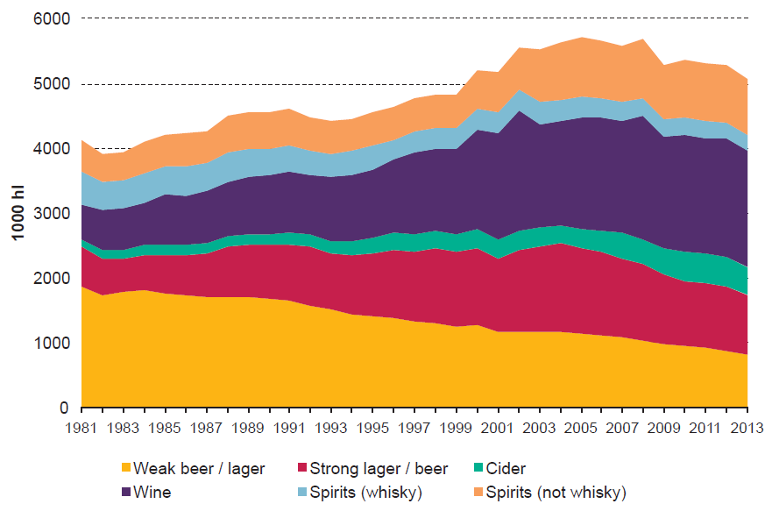

Note, consumption of beer and lager is split between weak and strong beverages with a cut-off of around 4.2% alcohol by volume (ABV). Spirits consumption is categorised as whisky/non-whisky

FIGURE 2: ALCOHOL CONSUMPTION RECORDED IN THE 2012 TO 2014 HEALTH SURVEY FOR ENGLAND BY LEVEL OF ALCOHOL CONSUMPTION (female/male units per week) [adapted from4]

FIGURE 3: TREND IN THE AFFORDABILITY OF ALCOHOL IN ENGLAND AND WALES BY TYPE OF ALCOHOL (INCOME AND AFFORDABILITY NORMALISED TO 100% IN 1980) [adapted from4]

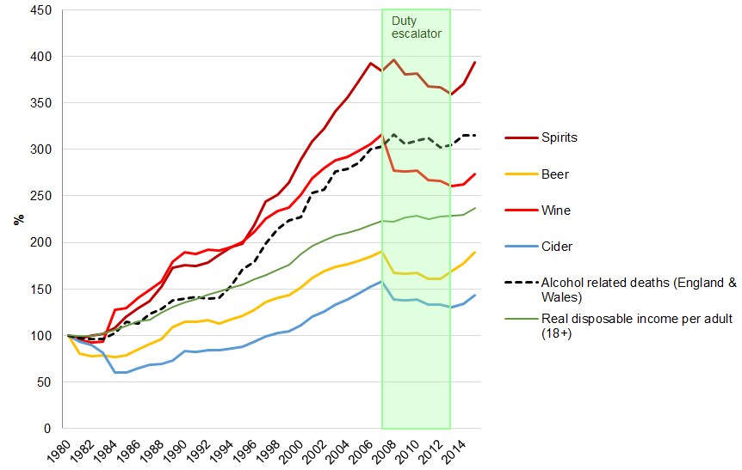

Note, consumption of beer and lager is split between weak and strong beers with a cut-off of around 4.2%, real disposable income per adult (18+) based on quarter 3 2015

FIGURE 4: CHANGE IN CONSUMPTION (UNITS PER YEAR) AT 20 YEARS BY POLICY AND DRINKER GROUP49

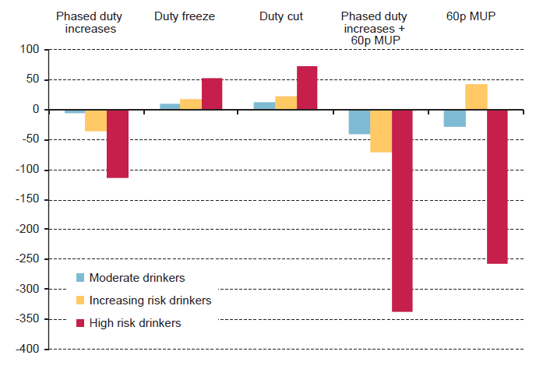

Note, phased duty increases are defined as annual duty increases in line with inflation +2%, a cut in duty is defined as a one-off 2% duty cut followed by a four-year duty freeze and a 60 pence MUP policy is modelled assuming duty remains constant in real terms

FIGURE 5: CHANGE IN CONSUMPTION (UNITS PER YEAR) AT 20 YEARS BY POLICY AND SOCIOECONOMIC GROUP 49

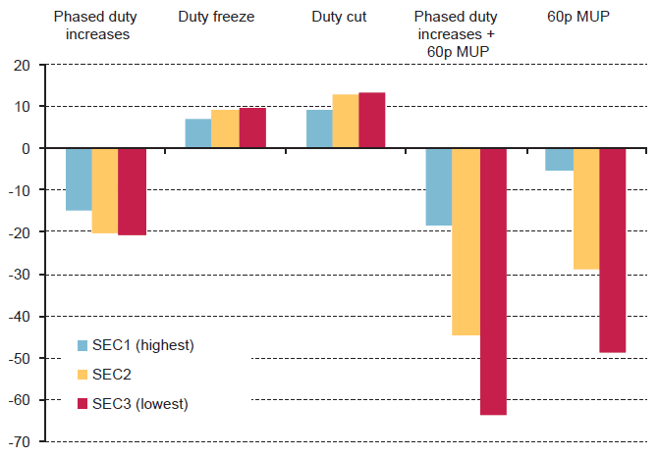

Note, phased duty increases are defined as annual duty increases in line with inflation +2%, a cut in duty is defined as a one-off 2% duty cut followed by a four-year duty freeze and a 60 pence MUP policy is modelled assuming duty remains constant in real terms

FIGURE 6: THE CUMULATIVE VALUE OF REDUCTIONS IN ALCOHOL-RELATED HARM OVER 5 YEARS BY OUTCOME65

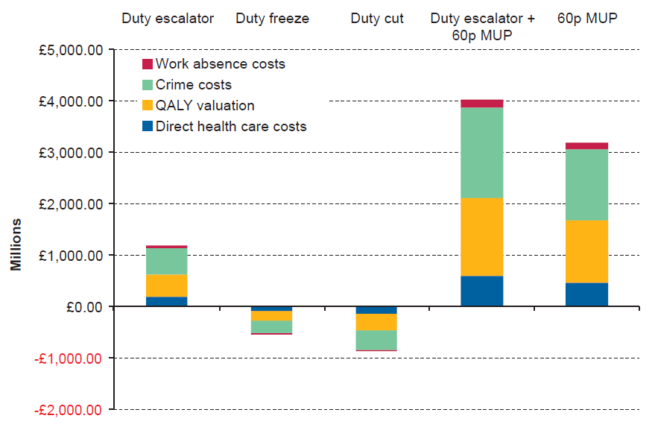

*Note: QALY valued at £60,000*

FIGURE 7: THE RELATIVE RISK OF BEING INVOLVED IN A FATAL OR NON-FATAL ROAD TRAFFIC CRASH IN ENGLAND AND WALES [adapted from170]

FIGURES USED IN APPENDIX

FIGURE 1: HIERARCHY OF EVIDENCE [adapted from 210]

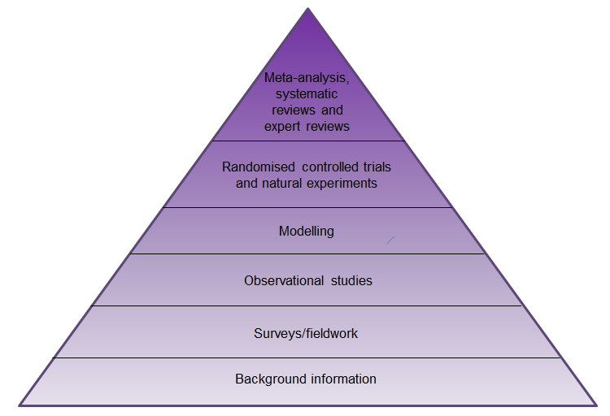

FIGURE 2: FLOW DIAGRAM OF STUDY SCREENING AND SELECTION PROCESS

Records identified through database searching  
(n = 2514)

Additional records identified through other sources  
(n = 73)

## Identification

Records excluded  
(n = 2067)

Records screened  
(n = 2587)

## Screening

## Eligibility

Full-text articles excluded, with reasons (n = 362)

No stated aim to evaluate interventions to reduce alcohol consumption or harm or no outcome data (n = 203)

Superseded by a more recent/higher quality review (n = 105)

Outside scope of rapid review (n = 35)

Non-OECD country (n = 13)

Not English language (n = 4)

Intervention carried out or directly funded by alcohol industry (n = 2)

Full-text articles assessed for eligibility  
(n = 520)

Studies included in qualitative synthesis  
(n = 158)

## Included