Frequent inundation helps counteract land use impacts on wetland propagule banks

Authors:
S.K. Dawson¹(corresponding author, samantha.k.dawson@gmail.com),
R.T. Kingsford¹ (richard.kingsford@unsw.edu.au),
P. Berney² (peter.berney@environment.nsw.gov.au),
D.A. Keith¹ (david.keith@unsw.edu.au),
F.A. Hemmings³ (frank.hemmings@unsw.edu.au),
D.I. Warton⁴ (david.warton@unsw.edu.au),
C. Waters⁵ (cathy.waters@dpi.gov.nsw.au),
J.A. Catford^{6,7,8} (j.a.catford@soton.ac.uk)

¹Centre for Ecosystem Science, School of Biological, Earth and Environmental Sciences, UNSW, Sydney 2052, Australia;
²NSW National Parks and Wildlife Service, Narrabri, NSW 2390, Australia;
³John T. Waterhouse Herbarium, School of Biology, Earth and Environmental Sciences, University of New South Wales, Kensington, NSW 2052, Australia;
⁴School of Mathematics and Statistics and Evolution & Ecology Research Centre,
The University of New South Wales, Sydney, NSW 2052, Australia;
⁵NSW Department of Primary Industries, Agricultural Research Centre, Mitchell Highway, Trangie, NSW 2823, Australia;
⁶School of BioSciences, The University of Melbourne, Vic 3010, Australia;
⁷Fenner School of Environment and Society, The Australian National University, Canberra, ACT 2601, Australia;
⁸Biological Sciences, University of Southampton, Southampton, SO17 1BJ, UK

Word count: 6213 words (7.7 pages), figures 1.3 pages, total 9 pages.
Abstract
Question: How do contrasting influences of inundation and historical land uses affect restoration of soil propagule bank composition in floodplain wetlands?
Location: Northern Nature Reserve (large ephemeral floodplain), Macquarie Marshes, New South Wales, Australia
Methods: We conducted germination assays on soil samples collected from fields with different land use histories, stratified along an inundation gradient. We used generalised linear models to determine whether native and exotic species richness and abundance varied along gradients of inundation and land use.
Results: Species richness and plant abundance in soil propagule banks were positively related to inundation and negatively related to intense historic land use. The abundance of native species was significantly higher in more frequently inundated areas. Abundances of exotic and ruderal species were higher in areas of intense prior land use. Overall species richness was generally similar across land use histories.
Conclusions: Land use legacies compromised the ability of propagule banks to rejuvenate native vegetation in this floodplain wetland, especially in less frequently flooded parts of the floodplain, which harboured more ruderal and exotic species. Negative effects of prior land use may be alleviated by increased inundation. Native soil propagule banks were remarkably intact, providing a reservoir for restoration of wetland vegetation, even in soils highly disturbed by up to 20 years of agricultural cropping. With appropriate inundation, soil propagule banks in less degraded areas of the Macquarie Marshes can provide diverse mixtures of desired species in high abundance but, in highly degraded areas, full restoration may be delayed.
Keywords: agricultural impacts, land use, exotic plant invasion, wetland restoration, environmental flows, flood regime management, floodplain wetland vegetation, soil seedbank, assisted natural restoration, regulated river, flow regulation
Nomenclature: Australian Plant Name Index, National Species List, Council of Heads of Australasian Herbaria [https://biodiversity.org.au/nsl/services/apni, searched 26/09/2016]
Running Head: Flooding offsets landuse in wetland propagule bank

1 Introduction
Soil propagule banks play a crucial role in the restoration of native wetland plant communities, but their potential to facilitate restoration can be compromised because of impacts from past land use and low inundation frequency (Wienhold & van der Valk 1989, Galatowitsch & van der Valk 1996, Wetzel et al. 2001, Suding et al. 2004). This is particularly problematic for natural or ‘assisted natural restoration’ of wetland ecosystems that rely on the presence of propagule banks and reinstatement of inundation regimes to promote recovery of vegetation communities (Wienhold & van der Valk 1989, Hölzel & Otte 2001, Middleton 2003).
Whereas “natural restoration” refers to ecosystem restoration that is achieved without any human intervention, “assisted natural restoration” refers to situations where humans may give minimal help by, for example, reinstating key historical abiotic processes. Assisted natural restoration is more cost effective than restoration techniques that are totally reliant on human intervention, e.g. planting vegetation. The assistance is deliberate reinstatement of abiotic processes, allowing natural restoration as species recolonise without planting or seeding (Suding et al. 2004, Moreno-Mateos et al. 2015). For example, environmental flows (water allocated for environmental benefit that is usually released from dams in regulated rivers) can be used to restore vegetation communities in ephemeral floodplain wetlands that are highly degraded (Kingsford 2000, Robertson & James 2006). Understanding the efficacy of such approaches is critical, given the high value of environmental water (Robertson & James 2006, Brudvig 2011, Reid & Capon 2011).
Soil propagule banks promote persistence of many species in temporally variable environments, such as ephemeral wetlands. Propagule banks allow species to persist locally, as seeds during dry periods (i.e. “storage”) and establish in the vegetation when suitable environmental conditions arise (Brock et al. 2003, Ooi 2012). For this mechanism to facilitate vegetation restoration, the propagule bank must contain sufficient numbers of viable propagules of target species (i.e. species desired in restoration; Robertson & James 2006; Wetzel et al. 2001). Degradation of wetlands can compromise restoration goals by eliminating target species or increasing abundance of undesirable exotic and dryland native species in the propagule bank, potentially dominating standing vegetation (Middleton 2003, Williams 2008). Encroachment by native dryland arid species, such as Chenopodium, into some wetlands is detrimental to floodplain vegetation (Thomas et al. 2010). The dynamics of wetland soil propagule banks, and their sensitivity to different types, intensities and durations of human land use disturbance remain poorly understood, but crucial for developing well-informed restoration strategies (but see Wienhold & van der Valk 1989, Middleton 2003).
Propagules of many plants in temporary wetlands are dispersed by water (hydrochory), and so the extent, frequency and timing of inundation strongly influence the composition of propagule banks (James et al. 2006, Nilsson et al. 2010, Greet et al. 2012). Changes to inundation regimes (e.g. timing, extent and frequency of inundation) can alter propagule bank composition (e.g. Hölzel & Otte 2001, Greet et al. 2012). Environmental and managed flows in regulated rivers can inundate floodplain wetlands to: 1) deliver seeds and propagules that help restore propagule bank composition; 2) provide necessary moisture for germination; and 3), depending on the characteristics of the flood regime, may act as an environmental filter to exclude undesired (exotic) species (Catford et al. 2011). Inundation can also introduce new exotics (e.g. Phyla canescens; Whalley et al. 2011), which needs to be accounted for in restoration planning.
Intensive land use may compromise propagule bank composition by reducing abundance of native wetland plant seeds or by altering soil characteristics, making the soil unsuitable for germination or seedling emergence (but see Wienhold & van der Valk 1989, Middleton 2003). Three effects may drive propagule bank composition: inundation effects on germination conditions; prior land use; and flooding. To investigate these, we germinated propagules from soil samples taken across a floodplain elevation gradient and various levels of land use history, under a range of flooding treatments. Soil properties (e.g. chemistry and compaction) were quantified to account for potential effects. We hypothesized that increased ecosystem degradation from past land use would increase abundance and richness of exotic and ruderal species, and decrease abundance and richness of wetland specialist species targeted in restoration (see Wienhold & van der Valk 1989). Further, we predicted that the floodplain gradient would influence propagule bank composition, with characteristic wetland species found in higher abundance in low areas of the floodplain, and terrestrial species in high abundance at sites high on the floodplain.

2 Methods

2.1 Study Site
The Macquarie Marshes is a floodplain wetland in the northern Murray-Darling Basin (Fig. S1, 147.55°E 30.8°S), in south-eastern Australia. This hydrologically complex system supports flood-dependant vegetation communities, which reflect inundation regimes. Floods depend on upstream rainfall events, as the Marshes receives < 500 mm of average rainfall per annum. On average, daily temperatures range between 4-16 ̊C (winter) and 20-36 ̊C (summer). The lowest parts of the floodplain support annually inundated reed beds of Typha domingensis/orientalis and Phragmites australis, with Paspalum distichum grasslands. Higher elevation, but frequently inundated, areas support flood-dependent river red gum forests (Eucalyptus camaldulensis) and lignum swamps (Duma florulenta), with mixed marsh understoreys of native amphibious wetland species. The highest parts of the floodplain support less frequently inundated black box woodlands (Eucalyptus largiflorens) and terrestrial species (e.g. chenopods; Bowen & Simpson 2010, Thomas et al. 2010).
Throughout the Murray-Darling Basin, floodplain vegetation communities have progressively degraded with river regulation and diversions of water for irrigation (Catford et al. 2011), including the Macquarie Marshes (Kingsford & Thomas 1995, Bino et al. 2015). Recent initiatives to restore degraded inland floodplain wetlands in the Murray-Darling Basin included the purchase of 2436 hectares (Pillicawarrina property) in the Macquarie Marshes, with its 8658 ML water licence (AUD $10.5 million; DECCW NSW 2011). Historical floodplain vegetation on this developed area was similar to flood-dependant vegetation across the Marshes (Paijmans 1981, Kidson et al. 2000), until progressively cleared for cultivation. Different fields across the site had different histories of land use, ranging from relatively undisturbed through to fields cultivated for 23 years. The Government’s goal was to restore vegetation communities to match those of undisturbed sites (Waters et al. 2011). In addition to agricultural land use, artificial levee banks (‘dikes’), adjacent to the river channel held back all but the highest flows, disrupting river/floodplain connectivity (supplementary Appendix 1; L. Johnson, pers. comm., 2014 Pillicawarrina property manager). In 2009, cropping ceased and management focused on restoration (Waters 2011, Berney 2012). Subsequently, in June 2010, levees were breached at strategic points and culverts enlarged to enhance passage of water (Appendix 1, DECCW NSW 2011, Hesse 2009).

2.2 Soil sampling
We sampled (January 2014) soil for propagule bank analysis at 108 sites across 12 fields (nine sites per field), differing by land use history and floodplain position, in Pillicawarrina Reserve. Samples were taken from each field: an uncleared field; five fields cleared respectively in 1982, 1998, 2000, both 2002 and 2006, and 2003; and six fields cultivated once to 23 times (years each field was cultivated: 2003; 2006; 2002 & 2004 & 2006; 2005-07; 1997-2009; 1985-2008). Two of the five cleared fields were cleared by chain, and three were cleared by bulldozer, including one cleared twice. The samples spanned a spectrum of land use intensity from fields cultivated often and recently to those cultivated only a few times or not at all (Appendix 2).
To stratify samples along the inundation gradient, we identified small marsh channels across the floodplain (<20 cm deep; Hesse 2009), using LIDAR-based Digital Elevation Model (DEM; Steinfeld et al. 2013). Within each field, three sites were randomly located within marsh channels (“channel”); three immediately adjacent to marsh channels (“riparian”); and three 50-100 m from marsh channels (“plain”). While receding waters may deposit more seeds in channels, the low elevation gradient in the Northern Marshes (1m fall over 2.4km; Brock 1998) probably produced reasonably uniform deposition, meaning that observed differences were more likely due flooding frequency or duration.
We used rectangular quadrats (5 m x 10 m) to sample longitudinal marsh channels and 20 m x 20 m quadrats for other sites on the floodplain (Quinn & Keough 2002). We randomly collected 10 soil cores, 5 cm diameter and 5 cm deep (0.3925L of soil) from each site (Capon 2007). We also collected samples for soil chemistry; using another five soil cores, collected along the edge of quadrats (across channel sites and perpendicular to the channel for riparian and plain sites). Propagule bank soil samples collected within each site were aggregated (preserving the 9 sites/field in three topographic settings design; Brock et al. 1994). All samples were air-dried and stored for two months in the dark before chemical analysis and germination experiments. We also recorded extant vegetation data following methods used in previous surveys to compare extant vegetation with seed bank (Dawson et al. accepted). Extremely dry conditions during the survey (no flood that year and the previous three months were 20-40% of average rainfall; Bureau of Meteorology Australia, accessed 30/8/2016 www.bom.gov.au) meant few annual species were present (i.e. <5% of a 1m² quadrat contained vegetation). Consequently, surveyed vegetation was not representative of the plant community composition typical after inundation and not used in analyses.
We collected additional data on seven variables that may vary with land use intensity, floodplain position and affect soil propagule banks: soil carbon, nitrogen, potassium and phosphorus, land use type, geomorphology and soil compaction (Appendix S3). Soil samples collected for chemical analysis were aggregated for each level of stratification (three sites in each land use/floodplain position combination) and analysed to quantify organic carbon, nitrogen, phosphorus and potassium (LECO/XRF analysis; Willis et al. 2011). Soil compaction was measured five times at each site by penetrometer. At each site we also recorded type of land use (cultivation, chain clearing & bulldozing), geomorphology (as per Hesse 2009; Appendix S3). Additionally, we tested for residual herbicides in heavily cultivated areas but none were detected (NR51 using UPLC-MS/MS; conducted by the National Measurement Institute).

2.3 Germination methods
We laid out soil samples for germination in a greenhouse over three months (February - May 2014), with three flooding treatments. The greenhouse was heated to 20-27◦C, mimicking spring temperatures in the Macquarie Marshes. Following Williams et al. (2008), flooding treatments consisted of: 1) a nine week flood, where the water level was above soil surface, followed by a three week draw down; 2) a nine week saturation, where the water was level with soil surface, followed by a three week draw down; and 3) damp, where the samples were watered twice per day but drained freely. Flooding depths (5-10 cm) matched inundation depths observed across the Pillicawarrina floodplain during 2012/2013 field surveys.
Each aggregated soil sample was divided into three and placed into clean plastic potting tubs (3.1 L, 200 mm diameter) to a soil depth of 1-2 cm, with 5 cm of steam-sterilised potting soil underneath. We did not sift samples to remove soil and vegetative parts as we were interested in seeds and vegetative propagules that could germinate in-situ and these were not differentiated later. We assigned pots to one of the three flooding treatments. Flooded treatment pots were placed in individual inundated 4 L containers to avoid cross-contamination (Capon 2007). Seven control pots, with sterilised potting mix only, were added and subjected to the same flooding treatments. Tubs were randomly placed within the flooding treatment group and re-randomised every two weeks. Germinants of angiosperms, pteridophytes and charophytes were identified to species’ level, recorded and removed to avoid flowering and seed release or overcrowding (Appendix S4; Capon 2007). We refer throughout to all emerging plants “germinants” for ease of communication, recognising some plants originated from spores and vegetative propagules, not seeds. Unidentified individuals were transplanted and grown, until they developed diagnostic features. Species were categorised as native, exotic or unknown provenance (Australian Plant Name Index, 2016). The latter included species only identifiable to genus due to lack of reproductive structures, plant mortality, time constraints (six months growing time) or high germinating densities, which prevented growth of all individuals to development of reproductive structures.

2.4 Data analyses
We examined differences in numbers of individuals of natives, exotics and provenance unknowns among sites, across the floodplain gradient, using means and 95% confidence intervals. We also calculated means of species richness for each field and floodplain gradient category, after grouping species (or genus) by wetland functional group (Appendix S5; Brock & Casanova 1997). Plants that could only be identified to genus level were analysed using the genus as the taxon.
We examined the relationships between the soil propagule bank, land use intensity and floodplain gradient category using multivariate mvabund package in R (version 3.1; R Development Core Team 2012, Wang et al. 2012). mvabund uses multiple generalised linear models, and accounts for mean-variance relationships and multiple correlated variables (Wang et al. 2012, Warton et al. 2012). The manyany function allowed sites to be nested within land use histories and floodplain gradient (Warton et al. 2012). Singletons and doubletons were removed before modelling for computational stability. Explanatory variables used in the primary model consisted of floodplain gradient (channel, riparian, plain), duration of land use (years used; number of years cleared or cropped), time since last land use (an inverse function: 1/number of years since last use).
Relationships between all explanatory variables were explored using pairwise scatterplots and Pearson correlation to assess multi-collinearity (Zuur et al. 2010). There was moderate correlation (0.6) between duration of land use and time since last used, below the predicted distortion level for models (0.7; Dormann et al. 2012) and we included both land use variables. We then developed models with each of the other seven potential explanatory variables added individually, to examine the contribution of all explanatory variables (removing variables when correlation exceeded >0.7, Appendix S6). We also produced a model without land use and floodplain gradient variables. These models enabled us to test whether different predictor variables explained more variance in the data. The Bayesian Information Criterion (BIC) for each model was extracted and the lowest BIC model was used to examine relationships between each explanatory variable and individual species, limiting description to the ten species with the most explanatory power.

3 Results

3.1 Floristics
A total of 29,974 germinants were identified from 92 taxa. The taxa ranged from completely aquatic (e.g. charophytes) to terrestrial (e.g. Sclerolaena species). Generally, there were significantly more native germinants than exotic and unknown-provenance germinants. Unknown-provenance germinants were mainly Echinochloa species (94% of 2,199 germinants), a genus that includes native and exotic species, which colonises disturbed areas and tolerates shallow flooding (Cunningham et al. 1992). Natives were especially dominant in soil propagule banks from uncleared and cleared fields, but relative differences were smaller in cultivated fields (Figures 1 & 2). Total numbers of native germinants were generally similar across the land use gradient, while germinants of exotic and unknown provenance taxa increased in number with increasing land use (Figure 1). Channel sites had significantly more native germinants than drier, higher elevation riparian and plain positions, but exotic and unknown provenance species showed no such trend (Figure 2). Species richness did not vary across the floodplain gradient and land use histories, except for terrestrial species, where more species were observed in higher elevation floodplain sites (Appendix S7). There was only one group of submerged taxa: a Chara braunii and Nitella spp. complex. None of the characteristic woody and shrub species, such as river red gum, lignum, black box or river cooba (Acacia stenophylla) were found in the soil propagule bank and some key clonal herbaceous groups (e.g. Typha domingensis/ orientalis and Paspalum distichum) were found in very low abundances.
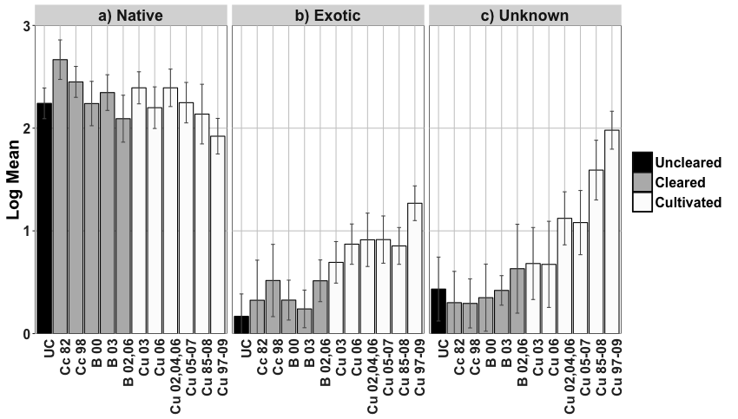
Figure 1: Log (10) of the mean (±95% CI) numbers of a) native, b) exotic and c) unknown provenance germinants in the Pillicawarrina restoration area of the Macquarie Marshes, where different fields varied in increasing land use intensity (uncleared, cleared and cultivated). Results are organised by type of land use and year of last use: uncleared (UC), chain cleared 1982 (Cc 82), chain cleared 1998 (Cc 98), bulldozed 2000 (B 00), bulldozed 2003 (B 03), bulldozed 2002&06 (B02,06), cultivated 2003 (Cu 03), cultivated 2006 (Cu 06), cultivated 2002,04,06 (Cu 02,04,06), cultivated 2005-07 (Cu 05-07), cultivated 1985-2008 (Cu 85-08), cultivated 1997-2009 (Cu 97-09).
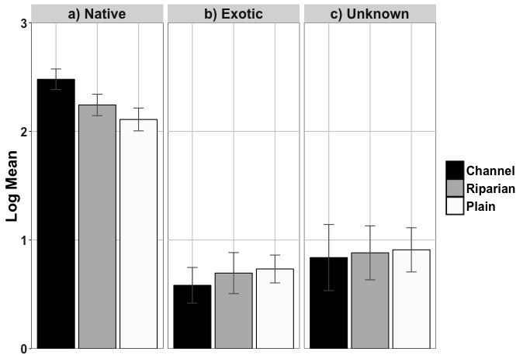
Figure 2: Log (10) of the mean (±95% CI) number of a) native, b) exotic and c) unknown provenance germinants within the channel, riparian and plain sites, reflecting decreasing flooding across the floodplain.

3.2 Factors influencing propagule bank composition
Our best model of propagule composition included only land use intensity factors and floodplain position, with no soil property variable selected (lowest BIC by more than 70 points; Appendix S8). Abundance of native wetland species, the targets of restoration, was negatively related to land use intensity (time since last use and duration of use) and positively related to flooding.
The ten taxa with the highest explanatory power in the model (the ten species driving model trends) explained 46.5% of the deviance from the null model, capturing considerable variation. With the exception of Echinochloa species, all taxa linked strongly to floodplain position. Among the top ten taxa, only the abundance of terrestrial exotic and ruderal taxa had positive relationships with time since last use (i.e. Rapistrum rugosum, Oxalis perennans and Echinochloa spp.; Figure 3). Conversely, abundance of wetland native species, such as Myriophyllum papillosum and Cardamine paucijuga / Rorippa laciniata (abundances pooled), had negative relationships with recently and frequently cultivated areas (Figure 3). The abundance of these and other wetland species (Azolla spp. and Alternanthera denticulata / A. sp. A Flora of New South Wales (M.Gray 5187) J. Palmer) was highest in channel sites, intermediate in riparian sites and lowest in plain sites, reflecting a gradient in floodplain elevation (Figure 3). Plain sites were more likely to have Rapistrum rugosum and Oxalis perennans (terrestrial exotic and ruderal species), even though channel sites had some terrestrial species, such as Dysphania cristata, Dysphania melanocarpa and Dysphania pumilo. Duration of use had a significant but weak relationship with germinant abundance in propagule banks (Figure 3). Terrestrial species, exotic species and ruderal species were most abundant in high elevation areas, recently cultivated and with a long history of cultivation, while native wetland species were most abundant where land use intensity was low and flooding frequent.
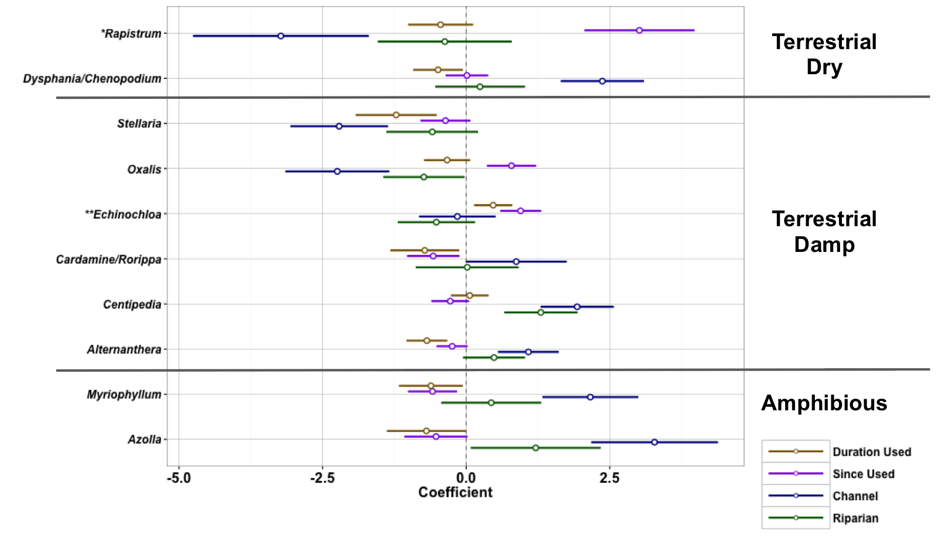
Figure 3: Standardised coefficients (±95%) of variables for the 10 taxa accounting for most variation (46.5%) in the selected model. Taxa groups are broken into wetland conditions they grow in (sensu Brock & Casanova, 1997). Groups comprising more than one species were used when germinants were indistinguishable prior to removal from germination pots to avoid overcrowding and resulting groups of morphologically similar species. * denotes exotic species and ** denotes taxa with exotic species in them. ‘Since Used’ was an inverse function of number of years since last use (positive relationships indicated increased association with sites with recent land use), ‘Channel’ and ‘Riparian’ contrasted effects on species compared to plain sites. Species were Stellaria angustifolia, Rapistrum rugosum, Oxalis perennans, Myriophyllum papillosum, Echinochloa spp., Cardamine paucijuga/Rorippa laciniata, Centipedia minima, Dysphania cristata/D. melanocarpa/D. pumilio, Azolla spp. and Alternanthera denticulata/A. sp. A Flora of New South Wales (M.Gray 5187) J. Palmer

4 Discussion
Flood regime management is often used to restore wetlands, but the factors determining restoration success and failure remain poorly understood (Brudvig 2011, Moreno-Mateos et al. 2015). Clearing and cultivation detrimentally affected native soil propagule banks in our floodplain ecosystems, increasing the prevalence of terrestrial ruderal and exotic species. However, the abundance (Figure 1 & 2) and richness (Appendix S7) of native species increased with time since last use, indicating that propagule bank composition can recover over time, especially where inundation is frequent. Wetland specialist species, the target species for wetland restoration, were more abundant in frequently inundated sites and areas with less intensive land use, contrasting the distribution and abundance of terrestrial, ruderal and exotic species (Figure 3).
4.1 Effects of land use history on propagule bank composition
There were high numbers of terrestrial and exotic or unknown-provenance taxa in recently and prolonged cultivated fields (13 years or more), suggesting that high land use intensity facilitates exotic and dryland species in this floodplain wetland. This is consistent with the wetlands in the prairie region of the United States, where a similar gradient of propagule bank degradation with land use intensity occurred (Wienhold & van der Valk’s 1989). Although Middleton (2003) found that cultivation reduced the species’ diversity of propagule banks in bald cypress swamps in Illinois (1-50 years chronosequence), there was no evidence that duration of cultivation was important; Middleton (2003) found that the propagule banks of areas cultivated once were similar to those cultivated continuously for 50 years. Eldridge & Lunt (2010), who examined propagule banks along a gradient of livestock grazing intensity on an Australian floodplain, also found increased numbers of exotics in more degraded areas. Australian floodplain wetlands may become more susceptible to exotic invasion with increasing land use intensity.
The even distribution of native, amphibious and floating taxa across the land use gradient indicated potential for future restoration. Although we found terrestrial taxa and those of exotic or unknown provenance (i.e. Echinochloa spp., early colonising graminoids of either native or exotic provenance) were more abundant in degraded areas, native propagule densities (and hence abundances) were similar across land use intensities. In contrast, other studies have recorded higher densities of seeds in degraded compared to natural areas (Wetzel et al. 2001, Williams et al. 2008, Eldridge & Lunt 2010). This could indicate potential for restoration in less degraded fields where there may be less competition from ruderal species. There were high abundances of Juncus species, which can dominate communities, become monocultures and may negatively affect restoration (Wetzel et al. 2001).
Despite high native abundances, some characteristic taxa were absent from our study, while others were in low abundances. Key wetland shrub and woody species present in natural communities, such as river red gum (Eucalyptus camaldulensis), and lignum (Duma florulenta), were not present in the propagule bank. These species do not form soil seedbanks (Chong & Walker, 2005). Sites with high land use intensities had reduced numbers of wetland species, while characteristic clonal species, such as Typha spp. and water couch were in low abundances across the floodplain. Similarly elsewhere, degraded sites were missing characteristic species (Wienhold & van der Valk 1989, Middleton 2003). The scarcity of woody and characteristic wetland species highlighted the reliance of these species on propagule dispersal from populations upstream or direct seeding by managers for regeneration.
The time since last land use had a considerable effect on the composition of soil propagule banks. Wetland vegetation communities can take decades to restore (Moreno-Mateos et al. 2012) and soil propagule banks likewise have long recovery periods (Schmiede et al. 2009). Although the moderate correlation (r = 0.6) between duration of land use and time since last use was not strong enough to warrant the exclusion of one variable from the model, the effects of one land use variable may have masked effects of the other. Given that both land use variables generally had the same relationships with species occupancy, we think it unlikely that this correlation would have altered interpretation of results though.
4.2 Effect of floodplain position on propagule bank composition
Floodplain position, reflecting differences in inundation frequency and duration, affected the accumulation of propagules in the soil, consistent with the findings of other studies in Australia (Capon & Brock 2006, James et al. 2006, Capon 2007) and elsewhere (e.g. Central Europe; Valkó et al. 2014). More propagules of native species and taxa that are wetland specialists were found in the lower, more frequently inundated parts of the floodplain, whereas terrestrial and ruderal species were more common on elevated areas, with low inundation frequencies. The strength of this result was surprising because floodwaters had extended over the whole floodplain for three of the four years, since the river and floodplain were reconnected in 2010. This underlines the importance of flood duration and depth, as well as frequency, for enhancing the restoration capacity of wetland ecosystems.
4.3 Management implications
It is not yet clear whether the most degraded wetland areas can be fully restored. Soil propagule banks from formerly cultivated areas in our study were different to those in areas never cultivated. Soil propagule banks can follow alternate trajectories of change (Suding et al. 2004, Stroh et al. 2012), with fields used for less than 20 years considered most suitable for restoration from propagule banks (Wienhold & van der Valk 1989). Some of our fields were already significantly degraded after only 13 years, impeding the likelihood or rate of restoration. The main compositional change with higher land use was increased abundances of ruderal, terrestrial and exotic species. Increased inundation could reduce these species (Lunt et al. 2012), but other management actions may be necessary in dry years. These could include spraying or physical removal depending on resources available.
Attempts at restoring wetlands using ‘assisted natural restoration’ techniques need to account for past land use. Increasingly, wetland restoration projects in Australia and overseas are relying on the reinstatement of historical inundation regimes to restore vegetation communities (Arthington and Pusey, 2003; Toth and van der Valk, 2012). Past land use is often ignored or inadequately addressed in restoration management plans. Areas of intense historic land use may need additional management actions to achieve restoration, such as the use of donor seed banks (Tozer et al. 2012) and more frequent flooding, or more achievable target vegetation communities should be sought instead (e.g. drier communities such as open black box, E. largiflorens woodlands or semi-natural grasslands). These strategies would help direct restoration management plans and ensure realistic targets are set for individual areas within a restoration site.
Our study highlighted the importance of considering land use history when identifying potential areas for restoration works and incorporating varying land use history into restoration targets. Reintroduction of inundation to Pillicawarrina may not produce targeted vegetation communities where there was high disturbance from historical land use caused but flooding is clearly crucial for maintaining a diverse propagule bank, dominated by wetland species where historical land use intensity has been low.

Acknowledgements
We thank those who helped in the field and greenhouse: Chantel Benbow, Stephanie Creer, Andrea Fullagar, Veronica Grigaltchik, Thao Le, Ellery Johnson, and Esthel Verma. Study expenses were funded by the Peter Cullen Scholarship to SKD from the; New South Wales Office of Water, Sydney Catchment Authority, Hunter Water, State Water and Sydney Water. We also acknowledge support through the Australian Postgraduate Award (SKD). JAC acknowledges support from the Australian Research Council (DE120102221 and ARC Centre of Excellence for Environmental Decisions) and RTK for the Australian Research Council Linkage Project (LP0884160).
Appendices
Appendix S1: Maps of the sampling area, site and field history
Appendix S2: Table of sampling design
Appendix S3: Table of environmental conditions/measurements taken at each site
Appendix S4: Table of the number of germinants at each site
Appendix S5: Description of vegetation functional groups
Appendix S6: Paired plots showing correlation between explanatory variables
Appendix S7: Taxon richness across sites
Appendix S8: BIC values for all of the models constructed

References
Arthington, AH, Pusey BJ. 2003. Flow restoration and protection in Australian rivers. River Research and Applications 19: 377–95
Berney, P. 2012. Pillicawarrina; Summary of findings from vegetation surveys 2009 2012. Technical report, Office of Environment and Heritage NSW, Sydney.
Bino, G., Sisson, S. A., Kingsford, R. T., Thomas, R. F. & Bowen, S. 2015. Developing state and transition models of floodplain vegetation dynamics as a tool for conservation decision-making: a case study of the Macquarie Marshes Ramsar wetland. J. Appl. Ecol. 52: 654–664
Bowen, S., & Simpson, S. 2010. Changes in Extent and Condition of the Vegetation Communities of the Macquarie Marshes Floodplain 1991-2008; Final Report to NSW Wetland Recovery Program, Department of Environment, Climate Change and Water, Sydney.
Brock, M.A. & Casanova, M.T. 1997. Plant life at the edges of wetlands; ecological responses to wetting and drying patterns, Frontiers in Ecology: Building the Links (Eds N. Klomp & I. Lunt), pp. 181–192. Elsevier Science, Oxford.
Brock, P. 1998. The significance of the physical environment of the Macquarie Marshes. Aust. Geogr. 29: 71–90
Brock, M.A., Nielsen, D.L., Shiel, R.J., Green, J.D. & Langley, J.D. 2003. Drought and aquatic community resilience: the role of eggs and seeds in sediments of temporary wetlands, Freshwater Biology, 48: 1207–1218.
Brock, M.A., Theodore, K. & O’Donnell, L. 1994. Seed-bank methods for Australian wetlands, Marine and Freshwater Research, 45: 483–93.
Brudvig, L.A. 2011. The restoration of biodiversity: where has research been and where does it need to go?, American Journal of Botany, 98: 549–58.
Capon, S.J. 2007. Effects of flooding on seedling emergence from the soil propagule bank of a large desert floodplain, Wetlands, 27: 904–914.
Capon, S.J. & Brock, M.A. 2006. Flooding, soil propagule bank dynamics and vegetation resilience of a hydrologically variable desert floodplain, Freshwater Biology, 51: 206–223.
Catford, J.A., Downes, B.J., Gippel, C.J., & Vesk, P.A. 2011. Flow regulation reduces native plant cover and facilitates exotic invasion in riparian wetlands. Journal of Applied Ecology, 48: 432–442
Chong, C. & Walker, K.F. 2005. Does lignum rely on a soil seed bank? Germination and reproductive phenology of Muehlenbeckia florulenta (Polygonaceae). Australian Journal of Botany, 53: 407-415
Cunningham, G.M., Mulham, W.E., Milthorpe, P.L., & Leigh, J.H. 1992. Plants of Western New South Wales. First Edition. CSIRO Publishing, Canberra.
Dawson, S. K., Kingsford, R.T., Berney, P., Catford, J.A., Keith, D.A., Hemmings, F. and Stoklosa, J. Accepted. Contrasting influences of inundation and land-use intensity on the rate of floodplain restoration. Aquatic Conservation Marine and Freshwater Ecosystems
DECCW NSW. 2011. NSW Rivers Environmental Restoration Program Final Report, Technical report, Department of Environment Climate Change and Water NSW, Sydney.
Dormann, C.F., Elith, J., Bacher, S., Buchmann, C., Carl, G., Carré , G., Marquéz, J.R. G., Gruber, B., Lafourcade, B., (…) & Lautenbach, S. 2012. Collinearity: a review of methods to deal with it and a simulation study evaluating their performance, Ecography, 36: 27–46.
Eldridge, D.J., & Lunt, I.D. 2010. Resilience of soil seed banks to site degradation in intermittently flooded riverine woodlands, Journal of Vegetation Science, 21: 157–166
Galatowitsch, S.M. & van der Valk, A. 1996. The Vegetation of Restored and Natural Prairie Wetlands, Ecological Applications, 6: 102–112.
Greet, J., Cousens, R.D., & Webb, J.A. 2012 Flow regulation is associated with riverine soil seed bank composition within an agricultural landscape: potential implications for restoration. Journal of Vegetation Science, 24: 157–167
Hesse, P. 2009. Geomorphic Mapping For Pillicawarrina Environmental Water Management Plan, Technical report, NSW Department of Environment, Climate Change and Water, Sydney.
Hölzel, N. & Otte, A. 2001. The impact of flooding regime on the soil propagule bank of flood-meadows, Journal of Vegetation Science, 12: 209–218.
James, C.S., Capon, S.J., White, M.G., Rayburg, S.C. & Thoms, M.C. 2006. Spatial variability of the soil propagule bank in a heterogeneous ephemeral wetland system in semi-arid Australia, Plant Ecology, 190: 205–217.
Kidson, R., Witts, T., Martin, W. & Raisin, G. 2000. Historical vegetation mapping of the Macquarie Marshes 1949 - 1991, Technical report, NSW Department of Land and Water Conservation, Sydney.
Kingsford, R.T., & Thomas, R.F. 1995. The Macquarie Marshes in Arid Australia and Their Waterbirds : A 50-Year History of Decline, Environmental Management, 19: 867–878.
Kingsford, R.T. 2000. Ecological impacts of dams, water diversions and river management on floodplain wetlands in Australia, Austral Ecology, 25: 109–127
Lunt, I.D., Jansen, A. & Binns, D.L. 2012. Effects of flood timing and livestock grazing on exotic annual plants in riverine floodplains. Journal of Applied Ecology 49: 1131–1139
Middleton, B. A. 2003. Soil propagule banks and the potential restoration of forested wetlands after farming, Journal of Applied Ecology, 40: 1025– 1034.
Moreno-Mateos, D., Power, M.E., Comín, F.A. & Yockteng, R. 2012. Structural and functional loss in restored wetland ecosystems, PLoS Biology, 10: e1001247.
Moreno-Mateos, D., Meli, P., Vara-Rodríguez, M.I. & Aronson, J. 2015. Ecosystem response to interventions: lessons from restored and created wetland ecosystems. Journal of Applied Ecology, 52: 1528–1537
Nilsson, C., Brown, R. L., Jansson, R. & Merritt, D. M. 2010. The role of hydrochory in structuring riparian and wetland vegetation, Biological Reviews of the Cambridge Philosophical Society, 85: 837–58.
Ooi, M.K. 2012 Propagule bank persistence and climate change, Seed Science Research, 22: 53–60.
Paijmans, K. 1981. The Macquarie Marshes of inland northern New South Wales. Technical report, CSIRO, Canberra, Australia
Quinn, G. & Keough, M. 2002. Experimental Design and Data Analysis for Biologists, Cambridge University Press.
R Development Core Team 2012. R: A language and environment for statistical computing.
Reid, M. & Capon, S.J. .2011. Role of the soil propagule bank in vegetation responses to environmental flows on a drought-affected floodplain, River Systems, 19: 249–259.
Robertson, H.A. & James, K.R. 2006. Plant Establishment from the Propagule bank of a Degraded Floodplain Wetland: A Comparison of Two Alternative Management Scenarios, Plant Ecology, 188: 145–164.
Schmiede, R., Donath, T. W. & Otte, A. 2009. Seed bank development after the restoration of alluvial grassland via transfer of seed-containing plant material. Biological Conservervation 142: 404–413
Steinfeld, C.M.M., Kingsford, R.T. & Laffan, S.W. 2013. Semi-automated GIS techniques for detecting floodplain earthworks, Hydrological Processes, 27: 579–591.
Stroh, P.A., Hughes, F.M.R., Sparks, T.H. & Mountford, J.O. 2012. The Influence of Time on the Soil Propagule bank and Vegetation across a Landscape-Scale Wetland Restoration Project, Restoration Ecology, 20: 103–112.
Suding, K.N., Gross, K.L. & Houseman, G.R. 2004. Alternative states and positive feedbacks in restoration ecology. Trends in Ecology and Evolution, 19: 46–53.
Thomas, R. F., Bowen, S., Simpson, S., Cox, S., Sims, N., Hunter, S. & Lu, Y. 2010. Inundation response of vegetation communities of the Macquarie Marshes in semi-arid Australia. In Saintalin, .N & Overton, I. Ecosystem response modelling in the Murray-Darling Basin , CSIRO Publishing, pp. 139–150.
Toth LA, van der Valk AG. 2012. Predictability of flood pulse driven assembly rules for restoration of a floodplain plant community. Wetlands Ecology and Management 20: 59–75
Tozer, M. G., Mackenzie, B. D. E. & Simpson, C. C. 2012. An Application of Plant Functional Types for Predicting Restoration Outcomes. Restor. Ecol. 20: 730–739
Valkó, O., Tóthmérész, B., Kelemen, A., Simon, E., Miglécz, T., Lukács, B., Török, P. 2014: Environmental factors driving vegetation and seed bank diversity in alkali grasslands. Agriculture, Ecosystems & Environment 182: 80-87.
Wang, Y., Naumann, U., Wright, S.T. & Warton, D.I. 2012. mvabund - an R package for model-based analysis of multivariate abundance data, Methods in Ecology and Evolution, 3: 471–474.
Warton, D.I., Wright, S.T. & Wang, Y. 2012. Distance-based multivariate analyses confound location and dispersion effects, Methods in Ecology and Evolution, 3: 89–101.
Waters, C. 2011. Vegetation Restoration Plan for the Pillicawarrina Floodplain, Technical Report May, NSW Department of Primary Industries.
Wetzel, P.R., Valk, A.G. & Toth, L.A. 2001. Restoration of wetland vegetation on the Kissimmee River Floodplain: Potential role of propagule banks, Wetlands, 21: 189–198.
Whalley, R. D. B., Price, J. N., Macdonald, M. J. & Berney, P. J. 2011. Drivers of change in the Social Ecological Systems of the Gwydir Wetlands and Macquarie Marshes in northern New South Wales, Australia. Rangel. J. 33: 109–119.
Wienhold, C. E. & van der Valk, A. G. 1989. The impact of duration of drainage on the seed banks of northern prairie wetlands, Can. J. Bot, 67: 1878–1884
Williams, L., Reich, P., Capon, S. J. & Raulings, E. 2008. Soil Seed Banks Of Degraded Riparian Zones In Southeastern Australia And Their Potential Contribution To The Restoration Of Understorey Vegetation, River Res. Appl, 24: 1002–1017
Willis, J.P., Turner, K. & Pritchard, G. 2011. XRF in the workplace: a guide to practical XRF spectrometry, PANalytical Australia, Chipping Norton, NSW
Zuur, A. F., Ieno, E. N. & Elphick, C. S. A protocol for data exploration to avoid common statistical problems, Methods Ecol. Evol. 1: 3–14

Black and White Figures for print:

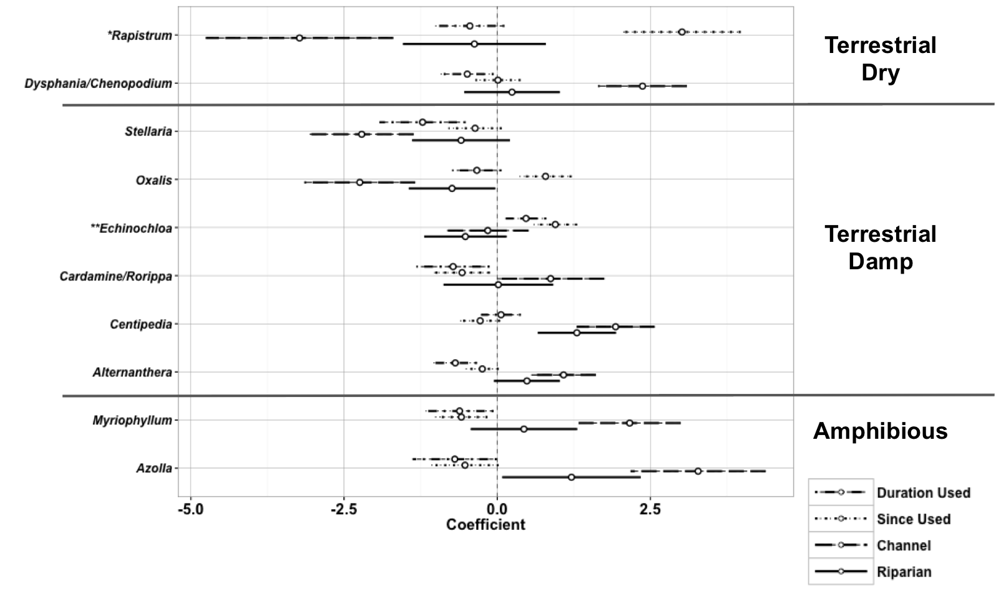
Figure 3: Standardised coefficients (±95%) of variables for the 10 taxa accounting for most variation (46.5%) in the selected model. Taxa groups are broken into wetland conditions they grow in (sensu Brock & Casanova, 1997). Groups comprising more than one species were used when germinants were indistinguishable prior to removal from germination pots to avoid overcrowding and resulting groups of morphologically similar species. * denotes exotic species and ** denotes taxa with exotic species in them. ‘Since Used’ was an inverse function of number of years since last use (positive relationships indicated increased association with sites with recent land use), ‘Channel’ and ‘Riparian’ contrasted effects on species compared to plain sites. Species were Stellaria angustifolia, Rapistrum rugosum, Oxalis perennans, Myriophyllum papillosum, Echinochloa spp., Cardamine paucijuga/Rorippa laciniata, Centipedia minima, Dysphania cristata/D. melanocarpa/D. pumilio, Azolla spp. and Alternanthera denticulata/A. sp. A Flora of New South Wales (M.Gray 5187) J. Palmer

