Figure S3. Forest plots showing differences in standardised second trimester measurements between individuals whose mothers smoked and did not smoke
- Femur Length
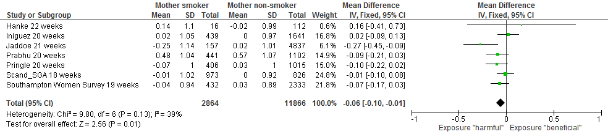
C. Abdominal Circumference
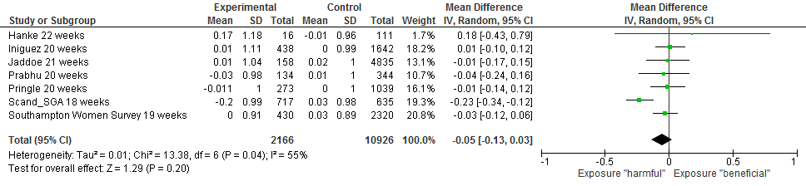
- Estimated Fetal Weight
