Figure S5. Funnel plots for standardised second trimester measurements between individuals whose mothers smoked and did not smoke. The dashed sloping lines correspond to the area where 95% of studies are expected to lie assuming no bias or heterogeneity.
- Biparietal Diameter
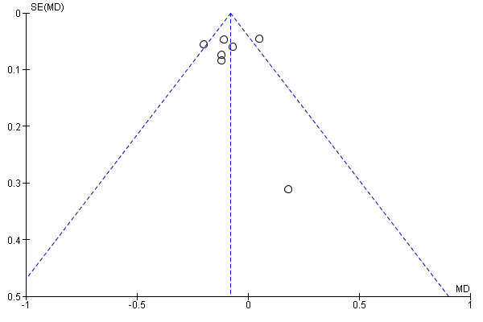
- Femur Length

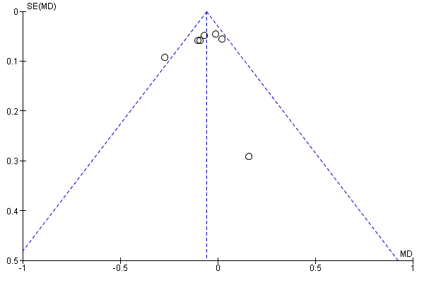
- Abdominal Circumference
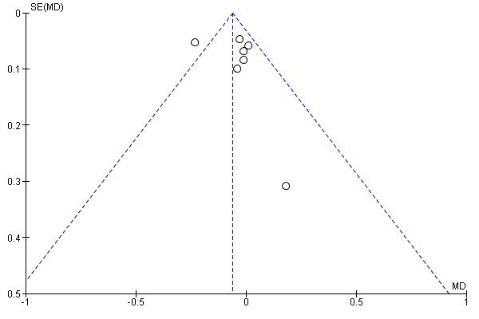

- Estimated Fetal Weight
