Figure S6. Forest plots showing differences in standardised third trimester measurements between individuals whose mothers smoked and did not smoke
- Femur Length
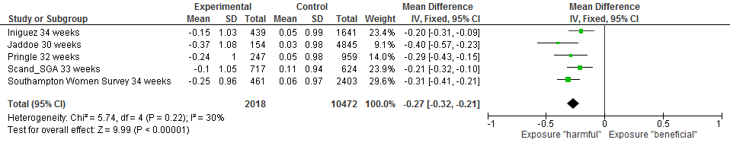

- Abdominal Circumference
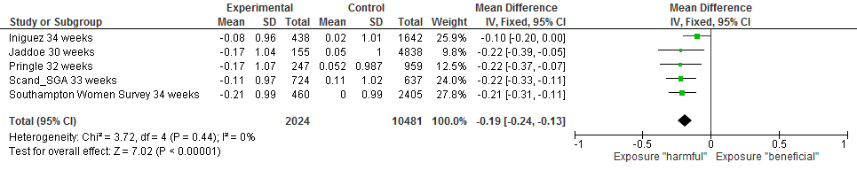
- Estimated Fetal Weight
