Forecasting the Daily Time-varying Beta of European Banks during the Crisis Period: Comparison between GARCH models and the Kalman Filter

TAUFIQ CHOUDHRY AND YUANYUAN ZHANG

University of Southampton, UK
Southwestern University of Finance and Economics, P.R. China

Abstract

This intention of this paper is to empirically forecast the daily betas of a few European banks by means of four GARCH models and the Kalman Filter method during the pre-global financial crisis period and the crisis period. The four GARCH models employed are BEKK GARCH, DCC-GARCH, DCC-MIDAS GARCH and Gaussian-Copula GARCH. The data consist of daily stock prices from 2001 to 2013 from two large banks each from Austria, Belgium, Greece, Holland, Ireland, Italy, Portugal and Spain. We apply the rolling forecasting method and the Model Confidence Sets (MCS) to compare the daily forecasting ability of the five models during one month of the pre-crisis (January 2007) and the crisis (January 2013) periods. Based on the MCS results, the BEKK proves the best model in the January 2007 period, and the Kalman Filter overly outperforms the other models during the January 2013 period. Results have implications regarding the choice of model during different periods by practitioners and academics.

JEL Classification: G1, G15
KEY WORDS Forecasting; Kalman Filter; GARCH; Time-varying beta; Financial Crisis; Volatility

INTRODUCTION
One of the major changes to the standard Capital Asset Pricing Model (CAPM) is the replacement of the constant beta by a time-varying beta (Fabozzi and Francis, 1978).Over the years several different econometric methods have been applied to estimate time-varying betas of different countries and firms (Brooks et al., 1998). Along with other methods, different versions of the GARCH model and the Kalman Filter have been employed in previous studies to estimate the time-varying beta. The GARCH models apply the conditional variance information to construct the conditional beta series, while the Kalman approach recursively estimates the beta series from an initial set of priors, generating a series of conditional alphas and betas in the market model.
By employing four GARCH models and the Kalman Filter method, this paper empirically estimates and attempts to forecast the daily betas of 16 banks from eight small European Union (EU) countries during the pre-global financial crisis and the crisis period. The rolling forecast procedure is applied to forecast the time-varying beta, and the Model Confidence Set (MCS) is applied to provide a comparison of the forecasting ability of the different models. This paper thus draws a comparison between the forecasting ability of the five models during the non-volatile pre-crisis and the volatile crisis periods. The four GARCH models employed are the BEKK GARCH, DCC-GARCH, DCC-MIDAS GARCH and Gaussian-Copula GARCH. We investigate these GARCH models because of their high quality forecasting ability as recorded in literature. The BEKK-GARCH model has high forecasting performance in predicting out-of-sample volatility and hedge ratio (Huang et al., 2010; Zhang and Choudhry, 2013). Peters (2008) found that the DCC model forecasts the covariance matrix better than the naïve model over a short period of time given high persistence. The DCC is often the most accurate forecasting model, depending on the forecasting criteria (Engle, 2002). Patton (2006) suggests that copula has high potential for measuring value-at-risk, multivariate estimations and forecasting for economists, practitioners and academics. The Gaussian-Copula-GARCH is the simplest copula family models, and Hsu et al. (2008) find that it effectively reduces the variance of returns of hedged portfolios in both the in-sample estimate and out-of-sample forecast. The DCC-MIDAS model reduces the persistence of the short-run correlation dynamics in the correlation prediction (Colacito et al., 2011). More recently, Baele and Londono (2013) study the dynamics and determinants of industry beta and support the advantage of DCC-MIDAS-GARCH in reducing the downside risk based on 30 US industry portfolios between 1970 and 2009. We also apply the Kalman Filter because of the evidence in literature of its superiority in forecasting ability over GARCH models (see Choudhry and Wu).
The data applied in this study consist of daily stock prices during 2001 to 2013 from two large banks each from Austria, Belgium, Greece, Holland, Republic of Ireland, Italy, Portugal and Spain. Given the robust forecasting ability of these models and the dramatic effect of the financial crisis on banks across Europe, it is of interest to empirically investigate the effect of the crisis on the betas of a few European banks and the ability of these models to forecast the betas of these banks during the erratic crisis period. It is well documented that, during periods of turmoil, financial crisis volatility of financial market tends to rise (Schwert, 2011) which directly affects the beta of firms. It is of empirical interest to investigate which model provides the best forecast during volatile period compared to non-volatile periods. To the best of our knowledge, this is the first empirical attempt to forecast beta of banks during the current crisis period and compare this to the pre-crisis period forecast.
Forecasting time-varying beta is important for several reasons. Since the beta (systematic risk) is the only risk that investors should be concerned about, prediction of the beta value makes it easier for them to make investment decisions. The value of beta can also be used by market participants to measure the performance of fund managers through the Treynor ratio. For corporate financial managers, forecasts of the conditional beta are beneficial in capital structure decisions and investment appraisal. Accurate estimation of beta helps measure cost of capital and enhance supervisions of systematic risk (Baele et al., 2015).
The current global financial crisis is considered to be the worst financial crisis since the Great Depression of 1929-33 (Guidolin and Tam, 2013). According to Guidolin and Tam (2013), the Great Depression involved runs on banks by depositors, whereas the current crisis reflected panic in wholesale funding markets that left banks unable to roll over short term debt. The crisis started with the burst of the price bubble in the US real estate market in mid-2007. The crisis reached its peak by October 2008 when the Lehman Brothers defaulted (Bordo and Meissner, 2012; Adcock et al., 2014). During the current crisis period we see an increase in the level of private debt in the EU. This is particularly pronounced in Greece (217%), Ireland (101%), and Spain (75.2%). After the crisis there was a steep rise in public debt, by a magnitude of five in Ireland and by a magnitude of three in Spain. The resulting necessary EU financial assistance to a few of these countries was substantial. In July 2012, the Eurogroup agreed to provide Spain with bailout financial assistance of EUR 100 billion. Two Greek economic adjustment programs were agreed in May 2010 and May 2012 and were worth more than EUR 150 billion. Assistance to Ireland and Portugal, in 2011 summed to a total amount of more than EUR 48 billion. Among the countries under study, Austria was least affected by the crisis.
This paper contributes to the literature in two main ways. First, we forecast the time-varying betas of a few European banks during the crisis. As discussed earlier, forecasting of the betas is important from an investor’s and a practitioner’s points of view. This is even more crucial during the current atmosphere of the global financial crisis. Second, as advocated by previous research papers (e.g. Brooks et al., 1998 and Faff et al., 2000) we provide an extended comparison between the forecasting ability of the GARCH models and the Kalman Filter procedure. As stated earlier, we apply the rolling forecast method and the Model Confidence Sets (MCS) to compare the forecasting ability of the five models. We provide a comparison of the forecasting results between the pre-crisis and the crisis periods. In this manner, we can assess which model provides a better forecast during non-volatile and volatile periods. This is the unique contribution of the paper to the literature - taking into consideration the use of MCS and the rolling method of forecasting.
In summary of our results, during the pre-crisis period, the BEKK is the best model and the Kalman Filter predominantly outperforms other models during the crisis period. The performance of the Kalman Filter is also robust during the pre-crisis period. The ability of the Kalman Filter procedure to estimate the beta directly may have given it the advantage of forecasting the beta during the high volatility financial crisis period. These results have implications for model selection during volatile and non-volatile periods by practitioners and academics.
The remainder of this paper is structured as follows. A summary of previous studies is provided in section 2. Section 3 briefly discusses the conditional CAPM model. Sections 4 and 5 discuss, in depth, the four GARCH models and the Kalman Filter method, respectively. Section 6 includes a brief discussion of the rolling forecasting procedure, and the selected data are described in section 7. The model confidence set is described and discussed in section 8. While section 9 presents briefly the GARCH and Kalman Filter results, the forecasted tests’ results are presented in section 10. Conclusion and implications are presented in section 11.

PREVIOUS STUDIES
Although a large body of literature exists on forecasting models, no single model emerges as superior. Hansen and Lunde (2005) could not conclude that the GARCH(1,1) beats all the other competing models when they compared 330 different volatility GARCH and non-GARCH models to predict the intra-day volatility for DM-$ exchange rate. Zhang and Choudhry (2013), forecasting daily hedge ratios in the agricultural futures market, find the BEKK GARCH to have superior forecasting ability using the storable products data and the asymmetric GARCH model for the non-storable products data, while in an examination of the UK equity market, Dimson and Marsh (1990) conclude that the simple models provide more accurate forecasts than the GARCH models. Akgiray (1989), and West and Cho (1995) both find the GARCH forecasting ability superior to other GARCH models, and Day and Lewis (1992) find limited evidence that, in certain instances, GARCH models provide better forecasts than EGARCH models. Asgharian et al. (2013) show that GARCH-MIDAS outperforms the GARCH model in forecasting returns variance in the short and long terms. Ghysels and Ozkan (2015) also find that the MIDAS-type regression has more powerful forecasting ability, and Koundouri et al. (2016) show that the single-factor model outperforms the GARCH models in terms of in-sample and out-of-sample forecasting of the US stock market returns.
Kang et al. (2009) and Wei et al. (2010) investigate and demonstrate the superior forecasting ability of the GARCH-family models in volatility prediction for crude oil markets compared to non-GARCH models. Pagan and Schwert (1990) compare the forecasting abilities of the GARCH, EGARCH, Markov switching regime, and three non-parametric models; they claim that both the GARCH and EGARCH models perform better than the non-GARCH models, while Meade (2002) finds that the linear AR-GARCH model is not outperformed in forecasting accuracy by the non-linear models. Franses and Van Dijk (1996) investigate the performance of the standard GARCH model and non-linear Quadratic GARCH and GARCH-GJR models. Their results indicate that non-linear GARCH models cannot beat the original model; however, Brailsford and Faff (1996) find evidence that favors the GARCH-GJR model for predicting monthly stock volatility compared with the standard GARCH model. Finally, Harrison and Moore (2012) show that asymmetric GARCH model outperforms other GARCH models in forecasting Central and East European stock market volatility.
Our paper is one of only a handful in the literature that compares the forecasting ability of the Kalman Filter method against GARCH models. According to the results presented by Brooks et al. (1998), in the case of in-sample and out-of-sample return forecasts based on beta estimates, the Kalman Filter is superior to both the GARCH and a time-varying beta market model suggested by Schwert and Segiun (1990). A similar conclusion is also put forward by Faff et al. (2000) and Choudhry and Wu (2008) when drawing comparison between the Kalman Filter and GARCH models for forecasting beta. According to Mergner and Bulla (2008), the Kalman Filter approach with the random walk is more efficient than other alternative methods, such as GARCH, Markov switching models, and so on. Bedendo and Hodges (2009) assess the prediction ability of the Kalman Filter method to forecast the density of daily returns for several option portfolios, and reveal that the Kalman Filter approach is superior to the sticky-delta model and the vega-gamma expansion in this case. According to Bai et al. (2013) the Kalman Filter generally provides more accurate forecasts than the MIDAS regression methods. However, these papers do not estimate and/or forecast the beta during the volatile period of the crisis or apply the MCS method of comparison. Our paper adds to the literature by expanding the investigation to include both of these.

THE (CONDITIONAL) CAPM AND THE TIME-VARYING BETA
The conditional capital asset pricing model (CAPM) implies a time-varying beta, compared to a constant beta of the standard CAPM. Based on the assumptions of the standard CAPM, economic agents may have common expectations on the moments of future returns: however, according to Bollerslev et al. (1988), these are conditional expectations and therefore random rather than constant variables.
The following analysis relies heavily on Bodurtha and Mark (1991) and Choudhry and Wu (2008). The conditional CAPM in excess returns may be given as

E(r_{i,t}|I_{t-1}) = β_{iIt-1} E(r_{m,t}|I_{t-1}), (1)
where
β_{iIt-1} = cov(R_{i,t}, R_{m,t}|I_{t-1})/var(R_{m,t}|I_{t-1}) = cov(r_{i,t}, r_{m,t}|I_{t-1})/var(r_{m,t}|I_{t-1}) (2)
and E(|I_{t-1}) is the mathematical expectation conditional on the information set available to the economic agents in the last period (t-1), I_{t-1}.R_{i,t} is the nominal return on asset i (i= 1, 2, ..., n) and R_{m,t} is the nominal return on the market portfolio m. The excess (real) return of asset i and the market portfolio over the risk-free asset return are presented by r_{i,t} and r_{m,t,,} respectively. The time-varying beta is expressed in equation 2. According to Bodurtha and Mark (1991), asset i’s risk premium varies over time due to three time-varying factors: the market’s conditional variance; the conditional covariance between the asset’s return; and the market’s return and/or the market’s risk premium.

GARCH MODELS
As stated above, we employ four different versions of the GARCH model, the BEKK GARCH, DCC-GARCH, DCC-MIDAS GARCH and Gaussian-Copula GARCH, to estimate and forecast the time-varying betas of the banks under study. The following section provides a short description of each GARCH model.

GARCH- BEKK
The BEKK-GARCH model, proposed by Baba et al. in 1990, avoids the non-negative conditional covariance matrix, and the quadratic form for the conditional covariance eliminates the problem of assuring the positivity of the conditional covariance estimate of the vech-GARCH model (Engle and Sheppard, 2001).
The BEKK parameterization is shown as
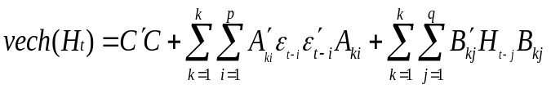 . (3)

In this equation,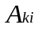, i = 1,...q, k = 1,...k, and 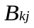j = 1,...q, k = 1,..k are 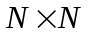matrices. As long as the constant term 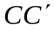is positive, 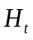 is guaranteed to be non-negative.
The bivariate BEKK GARCH (1, 1) is
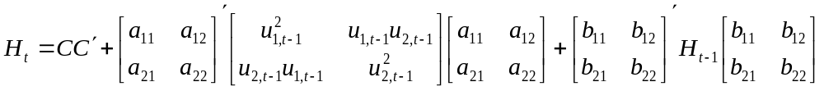. (4)
A bivariate BEKK GARCH(1,1) requires only 11 parameters to estimate in the conditional variance-covariance structure.The one-step-ahead forecast from the BEKK GARCH is similar to GARCH forecasting, since it is easily converted to the GARCH(1,1) model.

Dynamic Condition Correlation GARCH (DCC-GARCH)
The DCC-GARCH model was proposed by Engle and Sheppard (2001) and Engle (2002) to estimate large time-varying covariance matrices. This model combines dynamic correlation and the GARCH model, and hence it is capable of dealing with heteroskedasticity and large dynamic covariance matrices.
There are two steps in the estimation procedure. In the first step, a series of univariate GARCH models are estimated for each residual series. In the second step, standardized residuals from the first step are used to estimate parameters of dynamic correlation that are independent of the number of correlated series. This multi-stage estimation has computational advantages over multivariate GARCH models in terms of the number of parameters (Engle, 2002).
Assume that the returns of N assets are conditionally normally distributed; and that the DCC-GARCH model is a generalized framework of the constant conditional correlation GARCH (CCC-GARCH) model; and is as follows:
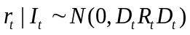
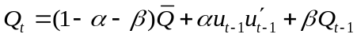 (5)
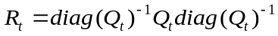,

where 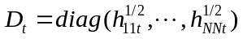is the 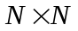 diagonal matrix of standard deviation from univariate GARCH models, and 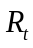 is the dynamic correlation matrix; 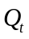 is a positive semi-definite matrix; 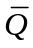 is the unconditional variance matrix of 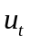; 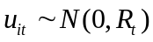 are the standardized residuals from GARCH models; that 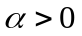, 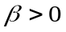; and this model is mean-reverting on the condition that 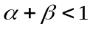.
With respect to forecasting co(variance) by DCC-GARCH, one standard approach is to generate the -step ahead forecast of with the supposition that 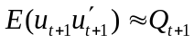. Alternatively, we can directly predict with the approximation that 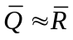 and 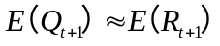(Engle and Sheppard, 2001). The DCC-GARCH model provides accurate approximation of time-varying correlations in practice, even for large covariance matrices. Furthermore, the original correlations do not change when new variables are added to the system (Engle, 2002).
In this paper, we employ a two-step approach for forecasting. First, we estimate the parameters and conditional variance of two univariate GARCH models for log-returns of a bank and market separately, and then we construct the standardized residuals. Second, we estimate the correlation parameters between the log-returns of the bank and the market based on the outcomes from the first step. In rolling forecasting, the whole process is repeated for each rolling sample to predict the one-day-ahead beta.
Gaussian-Copula-GARCH
Skalar’s Copula theory was first introduced as a distribution method in the field of probability and statistics in 1959. In most cases, the simplest Gaussian Copula-GARCH is sufficient to describe correlation and dependency in financial markets. In principle, a copula combining marginal distribution is able to describe cumulative distribution functions of random variables, without any assumption of the distribution of margins. It has advantages when dealing with high-dimensional joint distributions. In practice, it has positive implications for investors who have a large number of asset portfolios. Compared with the GARCH-family model, it has a more flexible dependence structure with fewer parameters, even in the case of high dimensions.
One of the more popular Copulas is the Elliptical Copula in which the dependence function is associated with elliptical distributions; the Gaussian Copula has bivariate normality for the case of two margins. Jondeau and Rockinger (2006) combined Copula and the GARCH model to measure the dependency of daily returns of four major stock markets. The combination captures both heteroskedasticity and dependency.
We introduce the Gaussian Copula-GARCH model here. Equations 6 and 7 present the GARCH(1,1) :
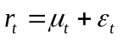, 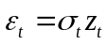,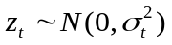 (6)
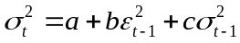 (7).

Equation 9 provides the bivariate Gaussian Copula with density function 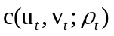

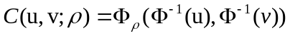 (8)
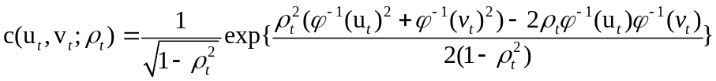, (9)

where 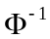 is the inverse of the standard normal cdf; 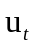and 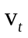are transformed from the marginal standardized residuals into uniform distributed. Furthermore, we follow Patton (2006) and assume the conditional correlation 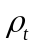is time-varying -
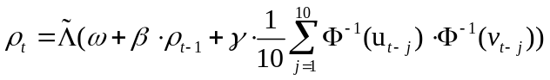 - (10)
where 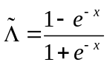 is the modified logistic transformation, which ensures the time-varying correlation in (-1, 1). Since the Gaussian Copula is symmetric, it has zero dependence in the extreme tails. For the case of the student’s t distribution, the extreme tail dependence that exists for correlation is not equal to one.
The estimation procedure is divided into two steps. In the first step, we estimate the parameters of the GARCH and transfer the marginal standardized residuals into uniform distribution, since the margins of the Copula assume uniform distribution. In the second step, we estimate the Gaussian-Copula.In the rolling procedure, we repeat the two-step estimation process for each rolling sample, and then we forecast the one-day-ahead beta based on the outcomes of estimation.

DCC-MIDAS (Mixed Data Sampling)
Colacito et al. (2011) propose a new model DCC-MIDAS (dynamic conditional correlation-mixed data sampling) by combining the Engle (2002) DCC model with a component specification of correlation in Engle et al. (2008). Colacito et al. (2011) find that the DCC-MIDAS model can improve a portfolio’s performance and gains more benefits compared with constant unconditional correlation and the DCC model in the G-7 countries’ stock markets. Furthermore, the one-step-ahead estimator of the DCC-MIDAS may bring some potential benefits for investors.
As stated in Colacito et al. (2011), the DCC-MIDAS model is generally described as:

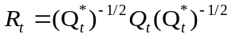 ;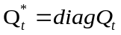, (11)
where residuals are assumed to be normally distributed and the elements in are expressed as follows:
, (12)
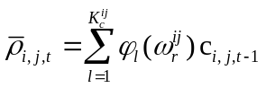, (13)
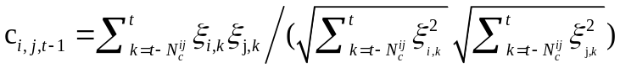 .(14)

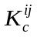 is the largest lag-length determined by AIC;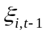 and 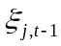are standardized residuals; 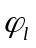represents weight in the weighting scheme 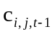 which can be a simple cross-product of standardized residuals; 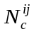 is the number of days in the low frequency factor (such as month, quarter) and 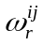is the rate of decay in the weighting scheme. The forecasting procedure is similar to the DCC-GARCH model. In the first step, we estimate each return volatility series by the GARCH model and in the second step the correlation in the DCC-MIDAS model is reformed with equation (13). The DCC-MIDAS model incorporates a time-varying conditional correlation with a short- and a long-term component specification. The DCC framework describes the short-term effect on correlation, and the long-run component MIDAS (equations (12) and (13)) captures the long-term impact on correlation. It can deal with mixed frequency sampling and capturing correlations between low- and high-frequency data.
KALMAN FILTER (KF)
One of the main contributions of this paper is the comparison between the forecasting ability of the four GARCH models and the Kalman Filter procedure. The Kalman Filter (KF) is a ‘state space’ model that includes an observation (or measurement) equation and a transition (or state) equation to describe dynamic systems.
In contrast to the GARCH family models, which estimate conditional beta, requiring a knowledge of the conditional (co)variance of assets and the market portfolio first, the Kalman Filter algorithm is able to estimate conditional beta directly (Mergner and Bulla, 2008). Relying on Meinhold and Singpurwalla (1983), we estimate the conditional beta by using the KF method with regression(observation equation) as follows,
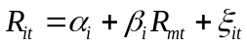 (15)

where 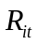 and 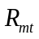 are the returns of asset and the market portfolio for period ; 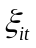is the disturbance vector, and it is assumed to follow normal distribution with zero mean and variance 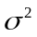, and 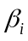 represents systematic risk of asset and is mathematically expressed as
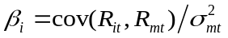. (16)

Here we connect the KF model with the random walk as a transition equation in this paper:
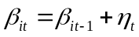. (17)
Moreover, to predict future value we have to employ some prior conditions for using the KF approach, these are:
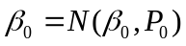 (18)
In most cases, the first two observations are used as the prior conditions but this is adjustable depending on the situation. In the rolling forecasting, time-varying beta can be obtained based on the daily updated sample.
ROLLING FORECAST PROCEDURE
Forecasting can be done based on a recursive window or rolling window.In this paper we apply the rolling window method. A rolling window is one where the sample size used to estimate the model is fixed; and the start and end dates move forward by one day for daily rolling. In other words, as the start and end dates move one day ahead with a fixed sample size, the oldest datum is dropped and the newest one is added. For one-step-ahead forecasts, the observations from the first observation to are applied to forecast the 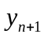; to forecast the 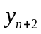, sample, the second observations to the 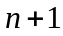 observation is used (Brockwell and Davis, 2002). In this manner the fixed rolling window is updated by one observation at the start and at the end each time to forecast one step ahead. This forecasting method estimates and keeps parameters updated for each rolling window. This method avoids the stability (parameter drift) problem of estimated parameters that are updated for each fixed rolling window estimate. The rolling scheme has consistent power, compared to the recursive forecasting method (Cheung et al., 2005). In the modern financial markets, business conditions change rapidly. The rolling forecast keeps updating the estimated parameters to respond to rapid market changes, and thus investors can adjust investment position and budget in timely manner (Lalli, 2011). The effectiveness of rolling forecasting makes it a more attractive approach than recursive forecasting.

DATA AND FORECASTING TIME-VARYING BETA SERIES
We apply data from eight stressed European countries during the current crisis - Austria, Belgium, Holland, Greece, Ireland, Italy, Portugal and Spain, and select two of the largest banks from each country. All data are obtained from Datastream and Bloomberg. Table 1 below provides some information regarding these banks and the corresponding risk-free rate and proxy for market portfolio for each country.
Table I. Information on the data
Country | Banks | Risk-free Rate | Market Portfolio
Italy | Unicredit | Italy T-Bill Auct. Gross 3-month-middle rate | MSCI
Italy | IntesaSanpaolo | Italy T-Bill Auct. Gross 3-month-middle rate | MSCI
Greece | National Bank of Greece | Greece Treasury bill 3-month-middle rate | Athex Composite
Greece | Eurobank Ergasias S A | Greece Treasury bill 3-month-middle rate | Athex Composite
Ireland | Bank of Ireland | Ireland Interbank 1 month-Offered rate | ISEQ
Ireland | Allied Irish Banks | Ireland Interbank 1 month-Offered rate | ISEQ
Spain | Banco Santander | Treasury bill 1-3 month-red. Yield | IBEX 35
Spain | BBV. Argentaria | Treasury bill 1-3 month-red. Yield | IBEX 35
Spain | Commerzbank | Treasury bill 1-3 month-red. Yield | IBEX 35
Austria | BKS bank | Eibor 3M - Offered rare | ATX
Austria | ERSTE Group bank | Eibor 3M - Offered rare | ATX
Belgium | KBC Group | Belgium Treasury Bill 3M- middle rate | BEL 20
Belgium | DEXIA | Belgium Treasury Bill 3M- middle rate | BEL 20
Holland | ING Group | Netherland Interbank 3M - middle rate | AEX All Share
Holland | KAS Bank | Netherland Interbank 3M - middle rate | AEX All Share
Portugal | Banco Espirito | PT EU-Escudo3M Deposit (FT/TR) - middle rate | PSI20
Portugal | Santo Banco Bpi | PT EU-Escudo3M Deposit (FT/TR) - middle rate | PSI20

The total sample period ranges from 1 January 2002 to 31 January 2013. The total sample is further divided into the pre-crisis period (1 January 2002 to 31 January 2007) and the crisis period (1 January 2008 to 31 January 2013).The daily rolling forecasting in this paper is carried out to predict the beta in three steps. In the first step, in the very first rolling process of one-month beta forecasting from 1 January 2007 to 31 January 2007, we estimate a set of parameters using data from 1 January 2000 to 31 December 2006 and then employ the estimated parameters to forecast the beta on the first trading day, 2 January 2007, using the four GARCH models and the Kalman Filter methods. In the next rolling procedure, a new set of parameters is estimated based on data from 2 January 2000 to 2 January 2007, and the beta of the following trading day, 3 January 2007, is predicted with the new estimated parameters. The rolling process is repeated 22 times across the one-month rolling forecasting. The whole rolling procedure is exactly the same for the one-month rolling forecast from 1 January 2013 to 31 January 2013.

The basic statistics of the log-returns for all the banks and markets during the total period show that almost all log-returns are slightly skewed at the 5% significance level. The significant excess kurtosis statistic suggests that the density function of each log-return series for all banks has a fat tail. The values of the Jarque-Bera statistic are high, indicating that the returns are not normally-distributed. Based on the results of skewness, kurtosis and the Jarque-Bera statistics, we can conclude that the log-returns follow non-normal distribution with fat-tails and sharp peaks for most markets. These results are available from the authors on request.

GARCH, Kalman Filter and Forecasting Method Results
The GARCH model results obtained for all periods are quite standard for equity market data. As an example we provide a few of the GARCH and Kalman Filter estimations. Tables 2 and 3 present the estimates which produce the maximum likelihood value among the one-month daily rolling estimation for both January 2007 and January 2013 from the BEKK-GARCH, Kalman Filter, DCC-GARCH, GARCH-Copula and DCC-MIDAS models for Italy. Results from other countries are similar to the presented results and are available from the authors on request. The majority of coefficients of the ARCH and GARCH effects are significant for both periods, while 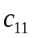,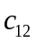,and 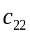are insignificant for Unicredit during January 2013. In table 3, all the coefficients of the other four models, DCC-GARCH, GARCH-Copula, DCC-MIDAS and KF, are significant except Leps for the KF method for January 2007.
Basic statistics for the forecasted betas during January 2007 and January 2013 are presented in tables 4 and 5, respectively. The means of the forecasted betas for all banks during January 2007 are around unity for all five models. The MIDAS provides the smallest beta. The Kalman Filter (KF) and BEKK methods produce the lowest variance of beta in most cases. Most of the estimated betas are found to be normally distributed by means of the J-B statistics with zero skewness and kurtosis, except for the case of Portugal. The betas during January 2013 (table 5) are similar to the January 2007 betas - most are around unity. Again most betas are found to be normally distributed with no skewness or kurtosis, and the smallest betas are (again) provided by the MIDAS model. Given that the betas are similar statistically during the two periods, it is of empirical interest to study which model provides the best forecast during the two different periods.
It is important to point out that the lack of a benchmark is an inevitable weak point for studies on time-varying beta forecasts, since the beta value is unobservable in the real world. Although the point estimation of beta generated by the market model is a moderate proxy for the actual beta value, it is not an appropriate scale to measure a beta series forecast with time variation. As a result, evaluation of forecast accuracy based on comparing conditional betas estimated and forecast by the same approach cannot provide compelling evidence of the worth of each individual approach. To assess predictive performance, a logical extension is to examine the returns out-of-sample based on equation 1. With the out-of-sample forecasts of conditional betas, the out-of-sample forecasts of returns can be easily calculated by equation (1), in which the market return and the risk-free rate of return are actual returns observed. The relative accuracy of conditional beta forecasts can then be assessed by comparing the return forecasts with the actual returns. In this way, the issue of a missing benchmark can be settled.
Figures 1 and 2 present and compare the actual and forecasted returns of all the banks during the pre-crisis period (January 2007) and the crisis period (January 2013) for Italy and Holland, respectively. Graphs from the remaining countries are available on request from the authors. In figure 1, most returns are small, ranging from -0.05 to 0.05, and the actual return series shows more volatility relative to forecasted returns for the two banks of Italy during both January 2007 and January 2013. In January 2013, returns show higher volatility than those in January 2007. All models fit well in the crisis period. In figure 2, the real and forecasted returns series of Holland banks are generally lower, but with higher volatility. Overall, return forecasts are more stable and show less return volatility than actual returns for all cases. The ING group has negative returns during crisis most of the time during January 2013 and this is quite a contrast to the case during January 2007, as expected. Visual inspection of the graph fails to provide convincing proof: the results provided by the MCS tests are expected to provide more robust evidence.

MODEL CONFIDENCE SET (MCS)
As stated above, we apply the Model Confidence Sets (MCS) (Hansen et al., 2003, 2011) to compare the forecasting ability of the five models. The MCS selects the best model among a set of competing models with a certain confidence level. According to Hansen et al. (2005), the MCS has several advantages compared to other comparison techniques. First, it takes into consideration the limitations of the data. Second, the MCS procedure makes it possible to make statements about significance that are valid in the traditional sense. This is a property that is not satisfied by the more commonly used approach of reporting p-values from multiple pairwise comparisons (Hansen et al., 2011). Third, the MCS procedure allows for the possibility that more than one model can be the best.
The MCS is constructed from a collection of competing models, 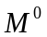, and a criterion for evaluating these models empirically (Hansen et al., 2005). This method has two procedures - an equivalence test 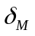and an elimination rule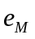. The equivalence test is similar but more effective than the equal predictive ability (EPA) of Diebold and Mariano (1995) and Harvey et al. (1997). The equivalence test is applied to the set of models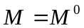. If the equivalence test is rejected, there is evidence that the models in are not equally ‘good’ and an elimination rule is used to eliminate a model with poor sample performance from . This procedure is repeated until is accepted and the MCS is now defined by the set of surviving models. The MCS yields a p-value for each model in and if the MCS 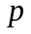-value of model is larger than the significance level , we say that model is the ‘best’ candidate in at significance level . In other words, the model with a higher MCS -value is more likely to survive in . If we fail to reject the null, it shows that all models in set are equally good, and we define the 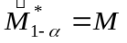; if the null is rejected, it is evidence that all forecasting models are not equally good and the elimination rule will be applied to discard the inferior model(s) from . The 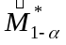 is the model confidence set which consists of the best models which are not eliminated from with confidence level .

In the case of forecasting, the set contains forecasting models with index 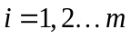 and we assume that the set . For equivalence test , we evaluate the forecasting models in terms of a loss function, such as MAE, MSE and RMSE, and we denote the model in time period as 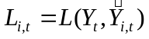where 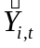 is the forecast of . Firstly, the bootstrap method is applied to resample the time index for each model, and we define the corresponding bootstrap variable, 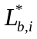. By generating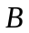 samples in the sequential testing, we can estimate some parameters and the high-dimensional covariance matrix.
Secondly, to calculate the test statistic, we let 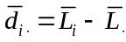,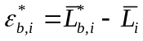 and set
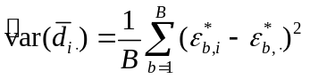 . (19)
Here we define 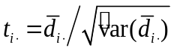and the estimated bootstrap distribution 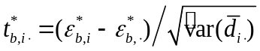, and then we can get the test statistics 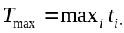 and 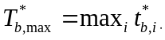 for 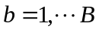.
Thirdly, under the null hypothesis, we set the p-value of 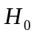 as
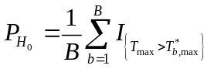 (20)
where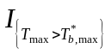is the indicator function. As stated, if 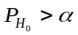, we accept the null hypothesis, and we have the 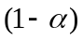 model confidence set ; otherwise, we move on to the elimination rule to find out the ‘worst performing model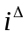‘which is equal to 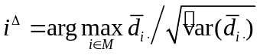, and remove the model from until we get an acceptance.

FORECAST ERROR TEST RESULTS
Since the MAD (mean absolute deviation) criterion is less sensitive to outliers which may lead to larger mis-predictions than the MSE-type method (Hansen et al., 2003),and the RMSE method produces larger values than MSE when the mean square error is smaller than 1, we report the root mean absolute error (RMSE) and MCS p-value for each forecasting model for each bank during January 2007 and January 2013 (table 6). We find that a low RMSE of forecasts is associated with a high MCS p-value, and this result is in line with the principle of the MCS approach that the models with high MCS p-values are more likely to be ‘the best’ models at a certain level of confidence. The MCS is applied based on two confidence levels, 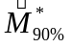 and 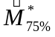which contain ‘best models’ at 90% and 75% confidence levels in these sets, respectively. Moreover, the results in 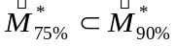are as expected. Table 6 presents the forecast error results.
For Austria, during the pre-crisis period (January 2007), for the BKS bank, BEKK, Kalman Filter and Copula are all within the MCS confidence level but the Kalman Filter performs the best. For ERSTE only the Kalman Filter is within the level. During the crisis period (January 2013) the BKS bank provides a different result as the DCC-GARCH model performs the best. For ERSTE both the BEKK and Kalman Filter are within the level but again the Kalman Filter performs the best. Using the Belgium data, during the pre-crisis period the BEKK model performs the best for both the banks. Once again, during the crisis period, the result is different. The Kalman Filter is the best model using KBC data and Copula using the DEXIA data during the crisis period. The crisis period results are substantially strong as the bulk of the models falls within both the confidence levels, and . The Dutch results show that, during the pre-crisis period, Kalman Filter performs the best for ING and BEKK does the best forecasting for the KAS bank. The result for the KAS bank is stronger as all models except DCC-GARCH and DCC-MIDAS are within both confidence levels. All models fall within the confidence level for the Banco Espirito of Portugal during the pre-crisis period, but the Kalman Filter provides the best forecast. The Copula model performs the best for Santo Banco during the same period. The crisis period results are simpler; the Copula models provide the best forecast for both banks, beating the Kalman Filter for Banco Espirito and the BEKK for Santo Banco.
In the case of Italy during pre-crisis for Unicredit, only the BEKK and Kalman Filter are within . The BEKK outperforms the Kalman Filter. For IntesaSanpaolo, all models except DCC-MIDAS are within ,but only the BEKK and Copula are within with the Copula outperforming the BEKK. During the crisis period, for Unicredit, except for DCC and DCC-MIDAS, all models are within with the Kalman Filter providing the best forecast. For Intesa Sanpaolo all models fall within and again the Kalman Filter performs the best.
Using the Greek data during January 2007 for the National Bank, all models except for DCC and DCC-MIDAS are within but only BEKK is within . For Eurobank all models are within but only the BEKK, Kalman Filter and Copula are within. The Copula outperforms the other models. During the volatile period of January 2013, for the National Bank, all models except Copula are returned within but only the Kalman Filter and MIDAS are within with the Kalman Filter doing the best. Using the Eurobank, only the Kalman Filter and MIDAS are and only MIDAS is within.
For Ireland during the pre-crisis period January 2007, using the Bank of Ireland data, the MCS returns all models, but only the BEKK, Kalman Filter and Copula are within the with the Kalman Filter outperforming the rest. For the Allied Irish bank, once again the Kalman Filter performs best. During the volatile crisis period January 2013, Copula is the only model within for the Bank of Ireland; and for the Allied Irish bank all models are within ,but only the Kalman Filter, Copula and MIDAS are within the with the Kalman Filter outperforming the rest.
Spain provides the simplest results. During January 2007 for both banks, the BEKK outperforms the other models. During January 2013, the DCC-MIDAS outperforms other models.
In summary, the results presented show that the superior models are different for the non-volatile pre-crisis period (January 2007) and the volatile crisis period (January 2013) in most cases. Overall, the Kalman Filter procedure performs the best more than 30% of the time. During the crisis period, in more than 40% of the tests, the Kalman Filter outperforms the rest of the models - during the pre-crisis period it performs the best 25% of the time. The ability of the Kalman Filter procedure to estimate the beta directly may give it the forecasting advantage during the volatile crisis period. The BEKK model performs the best more than 30% of the time during the pre-crisis period. Overall, results back the findings of the few previous studies that the Kalman Filter outperforms most other models (see Choudhry and Wu, 2008).

CONCLUSION
By means of four GARCH models and the Kalman Filter method, this paper set out to empirically forecast the daily betas of a few European banks during the pre-global financial crisis and the crisis period. In this manner this paper investigates the quality of forecast during each period and the change in the forecast quality by these models between the two periods - volatile and non-volatile. The four GARCH models employed are the BEKK GARCH, DCC-GARCH, DCC-MIDAS GARCH and Gaussian-Copula GARCH. We investigate these models because of their high and robust forecasting ability. We apply the Kalman Filter because of the evidence in the literature of its superior forecasting ability compared to the different GARCH models. The rolling forecast procedure is applied to forecast the time-varying beta, and the Model Confidence Set (MCS) is applied to provide a comparison of the forecasting ability of the different models. The rolling forecasting method has consistent power, compared to the recursive forecasting method. The MCS has several advantages compared to other methods, such as taking into consideration the limitations of the data and allowing for the possibility that more than one model can be the best.
This paper contributes to the literature in two main ways. First, we estimate and forecast the time-varying betas of the European banks during the crisis. Second, as advocated by previous research papers, we provide an extended comparison between the forecasting ability of the GARCH models and the Kalman Filter procedure. We provide a comparison of the forecasting results between the pre-crisis (January 2007) and the crisis periods (January 2013); thus it can be seen which model provides the best forecast during non-volatile and volatile periods. This is the unique contribution of the paper to the literature - taking into consideration the use of MCS and the rolling method of forecasting.
The data consist of daily stock prices from 2001 to 2013 from two large banks each from Austria, Belgium, Greece, Holland, Ireland, Italy, Portugal and Spain. These European countries, except Austria, were all adversely affected by the global financial crisis, with the banking industries of these countries hit particularly hard. Since the beta (systematic risk) is the only risk that investors should be concerned about, prediction of the beta value makes it easier for them to make investment decisions. This is particularly important during the volatile period of the financial crisis.
The daily rolling forecasting in this paper is carried out to predict the one-month betas for banks in three steps. In the first step, in the very first rolling process of one-month beta forecasting from 1 January 2007 to 31 January 2007, we estimate a set of parameters using data from 1 January 2000 to 31 December 2006 and then employ the estimated parameters to forecast the beta on the first trading day, 2 January 2007, using four GARCH models and the Kalman Filter methods. In the next rolling procedure, a new set of parameters is estimated based on data from 2 January 2000 to 2 January 2007, and the beta of the following trading day, 3 January 2007, is predicted with the new estimated parameters. The rolling process is repeated 22 times in the one-month rolling forecasting. The whole rolling procedure is exactly the same for the one-month rolling forecasting from 1 January 2013 to 31 January 2013. We then apply the Model Confidence Sets (MCS) to compare the forecasting ability of the five models.
Our results show that the superior forecasting models are different for the non-volatile pre-crisis period (January 2007) and the volatile crisis period (January 2013) in most cases. Specifically, the BEKK model generally is the best model during January 2007, and during January 2013 the Kalman Filter outperforms the other models most of the time. On average, the Kalman Filter outperforms the four GARCH models during the volatile period of the global financial crisis but also performs well during the non-volatile pre-crisis period without dominating. The Kalman Filter procedure outperforms the other methods more than 40% of the time during crisis period. This superior forecasting performance by the Kalman Filter backs the findings of Faff et al. (2000), Choudhry and Wu (2008), and Mergner and Bulla (2008). In order to test the robustness of our results we also apply different non-overlapping forecast periods during the pre-crisis (January 2006) and the crisis (January 2010) eras. Results from these periods provide the same conclusion. This result confirms the robustness of our overall results and conclusion. Results presented in this paper advocate further research in this field applying and comparing other forecasting method, periods and variables.

REFERENCES
Adcock C, Hua X, Mazouz K, Yin S. 2014. Does the Stock market Reward Innovation? European Stock Index Reaction to negative News during the Global Financial Crisis. Journal of International Money and Finance 49: 470-491.
Akgiray V. 1989. Conditional Heteroscedasticity in Time Series of Stock Returns: Evidence and Forecast, Journal of Business 62: 55-80.
Asgharian H, Hou AJ, Javed F. 2013. The Importance of the Macroeconomic Variables in Forecasting Stock Return Variance: A GARCH-MIDAS Approach. Journal of Forecasting 32: 600-612.
Baba Y, Engle RF, Krafet D, Kroner KF. 1990. Multivariate simultaneous generalized ARCH. Unpublished Manuscript, Department of Economics, University of California, San Diego.
Baele L, Londono JM. 2013. Understanding industry betas. Journal of Empirical Finance 22(2): 30-51.
Baele L, Bruyckere VD, Jonghe OD, Vennet RV. 2015. Model uncertainty and systematic risk in US banking. Journal of Banking and Finance 53: 49-66.
Bai J, Ghysels E, Wright JH. 2013. State Space Models and MIDAS Regressions. Econometric Reviews 32(7): 779-813.
Bedendo M, Hodges SD. 2009. The dynamics of the volatility skew: A Kalman filter approach.. Journal of Banking & Finance Vol. 33: 1156-1165.
Black A, Fraser P, Power D. 1992. UK Unit Trust Performance 1980-1989: A Passive Time-varying Approach. Journal of Banking and Finance 16: 1015-1033.
Bodurtha J, Mark N. 1991. Testing the CAPM with Time-Varying Risk and Returns. Journal of Finance 46: 1485-1505.
Bollerslev T, Engle RF, Wooldridge JM. 1988. A Capital Asset Pricing Model with Time-Varying Covariances. The Journal of Political Economy 96: 116-131.
Bordo M, Meissner C. 2012. Does Inequality lead to a Financial Crisis? Journal of International Money and Finance 31: 2147-2161.
Bos T, Newbold P. 1984. An Empirical Investigation of the Possibility of Stochastic Systematic Risk in the Market Model. Journal of Business 57: 35-41.
Brailsford TJ, Faff RW. 1996. An Evaluation of Volatility Forecasting Techniques. Journal of Banking and Finance 20: 419-438.
Braun PA, Nelson DB, Sunier AM. 1995. Good News, Bad News, Volatility, and Betas. Journal of Finance 50: 1575-1603.
Brockwell P J, Davis RA. 2002.Introduction to time series and forecasting, Springer.
Brooks RD, Faff RW, McKenzie MD. 1998. Time-Varying Beta Risk of Australian Industry Portfolios: A Comparison of Modelling Techniques. Australian Journal of Management 23: 1-22.
Case B, Yang Y, Yildrim Y. 2012. Dynamic correlations among asset classes: REIT and stock returns. The Journal of Real Estate Finance and Economics 44: 298-318.
Chen CR, Gerlach EL, Lee W. 2012. Bayesian Forecasting for Financial Risk Management, Pre and Post the Global Financial Crisis. Journal of Forecasting 31: 661-687.
Cheung YW, Chinn MD, Pascual AG. 2005. What Do We Know about Recent Exchange Rate Models? In-Sample Fit and Out-Sample Performance Evaluated. In; DeGrauwe, P. (Ed.), Exchange Rate Modelling: Where Do We Stand? MIT Press for CESIfo, Cambridge, MA, pp. 239-276.
Choudhry T, Wu H. 2008. Forecasting Ability of GARCH vs Kalman Filter Method: Evidence from Daily UKTime-Varying Beta. Journal of Forecasting 27: 670–689.
Colacito R, Engle RF, Ghysels E. 2011. A component model for dynamic correlations. Journal of Econometrics 164: 45-59.
Conrad C, Loch K, Rittler D. 2014. On the Macroeconomic Determinants of the Long-Term Oil-Stock Correlation in U.S. Stock and Crude Oil Markets. Journal of Empirical Finance 29: 26-40.
Day TE, Lewis CM. 1992. Stock Market Volatility and the Information Content of Stock Index Options. Journal of Econometrics 52: 267-287.
Diebold FX, Mariano RS. 1995. Comparing Predictive Accuracy. Journal of Business and Economic Statistics 13: 253-265.
Dimson, E. and Marsh, P. (1990). Volatility Forecasting without Data-Snooping, Journal of Banking and Finance, Vol. 44, pp. 399-421.
Engle C, Rodrigues A. 1989. Tests of International CAPM with Time-Varying Covariances. Journal of Applied Econometrics 4: 119-138.
Engle RF. 2002. Dynamic Conditional Correlation: A Simple Class of Multivariate GARCH models. Journal of Business and Economics Statistics 20: 339-350.
Engle RF, Kroner KF. 1995. Multivariate Simultaneous GARCH. Econometric Theory 11: 122-150.
Engle RK, Kroner KF. 1991. Multivariate simultaneous generalized ARCH. Working paper, UCSD.
Engle RF, Sheppard K. 2001. Theoretical and empirical properties of dynamic conditional correlation multivariate GARCH. Discussion Papers 2001-15, Dept. of Economics, UCSD.
Engle RF, Ghysels E, SohnB. 2008.On the economic sources of stock Market volatility. Unpublished working paper, UCSD.
Fabozzi F, Francis J. 1978. Beta as a Random Coefficient. Journal of Financial and Quantitative Analysis 13: 101-116.
Faff RW, Hillier D, Hillier J. 2000. Time Varying Beta Risk: An Analysis of Alternative Modelling Techniques. Journal of Business Finance and Accounting 27: 523-554.
Franses PH, Van Dijk D. 1996. Forecasting Stock Market Volatility Using Non-Linear GARCH Models. Journal of Forecasting 15: .229-235.
Ghysels E, Ozkan N. 2015. Real-time forecasting of the US federal government budget: A simple mixed frequency data regression approach. International Journal of Forecasting 31: 1009-1020.
Giannopoulos K. 1995. Estimating the Time-Varying Components of International Stock Markets Risk. European Journal of Finance 1: 129– 164.
Guidolin M, Tam Yu Man. 2013. A yield spread perspective on the great financial crisis: Break-point test evidence. International Review of Financial Analysis 26: 18-39.
Gonzales-Rivera G. 1996. Time-Varying Risk. The Case of American Computer Industry. Journal of Empirical Finance 2: 333-342.
Hansen P, Lunde A. 2005. A forecast comparison of volatility models: Does anything beat a GARCH (1, 1)? Journal of Applied Econometrics 20: 873-889.
Hansen PR, Lunde A, Nason JM. 2003. Choosing the Best Volatility Models: The Model Confidence Set Approach*. Oxford Bulletin of Economics and Statistics 65: 839-861.
Hansen PR, Lunde A, Nason JM. 2005. A test for superior predictive ability. Econometrica 23: 365-380.
Hansen PR, Lunde A, Nason JM. 2011. The Model Confidence Set. Econometrica 79: 453-497.
Harrison B, Moore W. 2012. Forecasting Stock Market Volatility in Central and Eastern European Countries. Journal of Forecasting 31: 490-503.
Harvey D, Leybourne SJ, Newbold P. 1997.Testing the Equality of Prediction Mean Squared Errors. International Journal of Forecasting 13: 281–291.
Hsu CC, Tseng CP, Wang YH. 2008. Dynamic hedging with futures: A copula‐based GARCH model. Journal of Futures Markets 28: 1095-1116.
Huang Y, Su W, Li X. 2010. Comparison of BEKK GARCH and DCC GARCH Models: An Empirical Study. Advanced Data Mining and Applications : 99–110.
Jondeau E, Rockinger M. 2006. The copula-garch model of conditional dependencies: An international stock market application. Journal of International Money and Finance 25: 827-853.
Kang SH, Kang S, Yoon S. 2009. Forecasting volatility of crude oil markets. Energy Economics 31: 119-125.
Klemkosky R, Martin J. 1975. The Adjustment of Beta Forecasts. Journal of Finance 30: 1123-1128.
Koundouri P, Kourogenis N, Pittis N, Samartzis P. 2016. Factor Models of Stock Returns: GARCH Errors versus Time-Varying Betas. Forthcoming Journal of Forecasting.
Koutmos G, Lee U, Theodossiou P. 1994. Time-Varying Betas and Volatility Persistence in International Stock Markets. Journal of Economics and Business 46: 101-112.
Lalli WR. Ed. 2011. Handbook of budgeting. Vol. 562. John Wiley & Sons.
Lintner J. 1965. The Valuation of Risk Assets and the Selection of Risky Investments in Stock Portfolios and Capital Budgets. Review of Economics and Statistics 47: 13-37.
Markowitz H. 1952. Portfolio Selection. Journal of Finance 7: 77-91.
Meade N. 2002. A Comparison of the Accuracy of Short Term Foreign Exchange Forecasting Methods. International Journal of Forecasting 18: 67-83.
Meinhold RJ, Singpurwalla ND. 1983. Understanding the Kalman filter. The American Statistician 37: 123-127.
Mergner S, Bulla J. 2008. Time-varying beta risk of Pan-European industry portfolios: A comparison of alternative modeling techniques. The European Journal of Finance 14: 771-802.
Muth J. 1961. Rational Expectation and the Theory of Price Movements. Econometrica 29: 1-23.
Ng L. 1991. Tests of the CAPM with Time-Varying Covariances: A Multivariate GARCH Approach. Journal of Finance 46: 1507-1521.
Pagan A, Schwert GW. 1990. Alternative Models for Conditional Stock Volatilities. Journal of Econometrics 46: 267-290.
Patton AJ. 2006. Modelling asymmetric exchange rate dependence. International Economic Review 47: 527-556.
Peters T. 2008. Forecasting the covariance matrix with the DCC GARCH model. Mathematical Statistics Stockholm University dissertation paper.
Poon S, Granger C. 2003. Forecasting volatility in financial markets: A review. Journal of Economic Literature 41: 478-539.
Rosenberg B, Guy J. 1976a. Prediction of the Beta from Investment Fundamentals. Part 1. Financial Analysts Journal 32: 60-72.
Rosenberg B, Guy J. 1976b. Prediction of the Beta from Investment Fundamentals. Part 2. Financial Analysts Journal 32: 62-70.
Schwert GW, Seguin PJ. 1990. Heteroscedasticity in Stock Returns. Journal of Finance 4: 1129–1155.
Schwert, G.W. 2011. Stock volatility during the recent financial crisis: National Bureau of Economic Research.
Sharpe WF. 1964. Capital Asset Price: A Theory of Market Equilibrium under Conditions of Risk. Journal of Finance 19: 425–442.
Turhan MI, Sensoy A, Ozturk K, Hacihasanoglu E. 2014. A view to the long-run dynamic relationship between crude oil and the major asset classes. International Review of Economics and Finance 33(3): 286-299.
Wei Y, Wang Y, Huang D. 2010. Forecasting crude oil market volatility: Further evidence using GARCH-class models. Energy Economics 32: 1477-1484.
Well C. 1994. Variable Betas on the Stockholm Exchange 1971-1989. Applied Economics 4: 75-92.
West KD, Cho D. 1995. The Predictive Ability of Several Models of Exchange Rate Volatility. Journal of Econometrics 69: 367-391.
Wilhelmsson A. 2013. Density Forecasting with Time-Varying Higher Moments: A Model Confidence Set Approach. Journal of Forecasting 32: 19-31.
Yun J. 2002. Forecasting Volatility in the New Zealand Stock Market Applied Financial Economics 12: 193-202.
Zhang Y, Choudhry T. 2013. Forecasting the daily dynamic hedge ratios by GARCH models: evidence from the agricultural futures markets. The European Journal of Finance 21: 1-24.

Table II. The maximum likelihood estimates of the BEKK-GARCH model for Italy (daily rolling for January 2007 and January 2013)

 | January 2007 |  | January 2013
Variable/bank | Unicredit | Sanpaolo | Unicredit | Sanpaolo
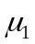 | -0.00009  (0.6314) | 0.00054  (0.12871) | 0.00074  (0.5600) | -0.00166  (0.2078)
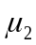 | 0.00008  (0.6466) | 0.00014  (0.5947) | 0.00079  (0.4829) | -0.00097  (0.4321)
 | 0.01028  (0.0000) | 0.00251  (0.0000) | -0.0000  (0.9995) | 0.02822  (0.0000)
 | 0.00904  (0.0000) | 0.00587  (0.0000) | -0.0000  (0.9995) | 0.03040  (0.0000)
 | 0.00004  (0.9525) | 0.00014  (0.8159) | -0.0000  (0.9997) | 0.00258  (0.0000)
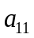 | 0.81336  (0.0000) | 0.18571  (0.0000) | -0.01520  (0.7301) | 3.88928  (0.0000)
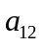 | 0.47044  (0.0000) | -0.20329  (0.0000) | -0.24388  (0.0000) | 3.88641  (0.0000)
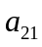 | -0.70416  (0.0000) | -0.14218  (0.0000) | 0.00896  (0.8370) | -3.86513  (0.0000)
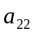 | -0.37117  (0.0000) | 0.21449  (0.0000) | 0.21537  (0.0000) | -3.84567  (0.0000)
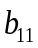 | 0.73249  (0.0000) | 1.00710  (0.0000) | 1.32665  (0.0000) | 1.64515  (0.0000)
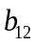 | -0.19560  (0.0000) | 0.13550  (0.0000) | 0.33442  (0.0000) | 0.79189  (0.0000)
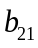 | -0.15076  (0.0000) | -0.05005  (0.0000) | -0.41494  (0.0000) | -1.49349  (0.0000)
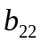 | 0.84937  (0.0000) | 0.70671  (0.0000) | 0.61872  (0.0000) | -0.72979  (0.0000)
LLF | 8080.212 | 7578.910 | 5346.031 | 5377.553
Note: The estimated coefficients for each parameter are reported in this table, with p-values in parentheses, where 0.0000 indicates that the value is less than 0.00005;The bivariate BEKK GARCH (1, 1) is
.
Suppressing the time subscripts and the GARCH terms, the BEKK GARCH (1, 0) will be
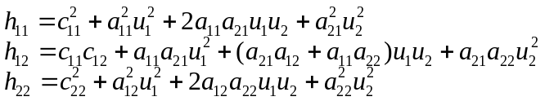.

In this representation, the diagonal elements in , and the parameters and are restricted to be positive.

Table III. The maximum likelihood estimates of the Kalman Filter, DCC-GARCH, GARCH-Copula and DCC-MIDAS models for Italy (daily rolling for January 2007 and January 2013).
 | January 2007 |  | January 2013
Variable/bank | Unicredit | Sanpaolo | Unicredit | Sanpaolo
DCC-GARCH
A | 0.02514  (0.00125) | 0.02775  (0.0007) | 0.04094  (0.0000) | 0.26267  (0.0000)
B | 0.92983  (0.0000) | 0.90428  (0.0000) | 0.78135  (0.0000) | -0.00393  (0.1741)
LLF | -3004.114 | -3159.014 | -2185.274 | -2268.711
GARCH-Copula
Beta | 0.33273  (0.0000) | -1.09402  (0.0000) | -2.88544  (0.0000) | 0.35694  (0.0000)
Omega | 2.04155  (0.0000) | 2.77366  (0.0000) | 6.49293  (0.0000) | 3.43030  (0.0000)
Gama | -1.62937  (0.0000) | 0.24655  (0.0000) | 0.41118  (0.0000) | -2.43113  (0.0000)
LLF | 574.9873 | 415.1446 | 1166.854 | 1180.965
DCC-Midas
A | 0.31728  (0.0000) | 0.54114  (0.0000) | 0.28256  (0.0000) | 0.39369  (0.0000)
B | 0.65704  (0.0000) | 0.44923  (0.0000) | 0.71226  (0.0000) | 0.60506  (0.0000)
Omega | 1.41154  (0.0000) | 0.20778  (0.0000) | 0.77306  (0.0000) | 1.00269  (0.0000)
LLF | -3215.149 | -4043.209 | -2706.228 | -3342.520
Kalman Filter
Leps | 0.50124  (0.6614) | -1.00499  (0.5097) | 4.36076  (0.0000) | 4.34879  (0.0000)
Leta | -23.9681  (0.0000) | -28.5523  (0.0000) | -12.9173  (0.0679) | -26.2921  (0.0000)
LLF | 4159.092 | 3614.933 | 3180.117 | 3516.033
Note: the GARCH-Copula is the GARCH-Gaussian-Copula model.

Table IV. Basic statistics of Beta series for all banks during January 2007
Bank | Mean |  | variance |  | skewness |  |  | Kurtosis |  |  | J-B |  |  | mean | variance | skewness |  |  | Kurtosis |  |  |  | J-B
Italy(Unicredit) |  |  |  |  |  |  |  |  |  |  |  | Italy(Sanpaolo)
BEKK | 0.9974 |  | 0.0045 |  | -0.0295 |  |  | -0.0374 |  |  | 0.0047 |  |  | 1.0748 | 0.0281 | -2.0868* |  |  | 5.1530* |  |  |  | 42.140ª
DCC | 0.9472 |  | 0.0352 |  | 1.2368* |  |  | 0.5867 |  |  | 6.1938ª |  |  | 0.8821 | 0.0305 | 1.2368* |  |  | 0.5867 |  |  |  | 6.1938ª
KF | 1.0090 |  | 1.0e-06 |  | -0.4231 |  |  | 1.2134 |  |  | 2.0973 |  |  | 1.0412 | 0.0000 | -1.5052* |  |  | 1.7644 |  |  |  | 11.668ª
Copula | 0.9285 |  | 0.0055 |  | 0.8448 |  |  | 0.0938 |  |  | 2.7442 |  |  | 1.0661 | 0.0248 | -0.8386 |  |  | -0.4369 |  |  |  | 2.8785
MIDAS | 0.9939 |  | 0.0273 |  | 0.9485* |  |  | -0.1293 |  |  | 3.4644 |  |  | 0.1670 | 0.0008 | 0.9485* |  |  | -0.1292 |  |  |  | 3.4644
Greece(National bank) |  |  |  |  |  |  |  |  |  |  |  |  | Greece(Eurobank)
BEKK | 1.2363 |  | 0.0031 |  | 0.699* |  |  | 2.2690* |  |  | 6.8086ª |  |  | 0.9679 | 0.0275 | -3.8520* |  |  | 16.971* |  |  |  | 332.88ª
DCC | 1.0855 |  | 0.0932 |  | 1.8400* |  |  | 2.7627* |  |  | 20.290ª |  |  | 1.0558 | 0.0882 | 1.8398* |  |  | 2.7627* |  |  |  | 20.290ª
KF | 1.0858 |  | 0.0012 |  | -0.1658 |  |  | -1.3007 |  |  | 1.7268 |  |  | 0.9574 | 0.0001 | 0.1052 |  |  | -1.3617 |  |  |  | 1.8194
Copula | 1.0653 |  | 0.0168 |  | -1.3839* |  |  | 1.3891* |  |  | 9.1902ª |  |  | 0.9731 | 0.0380 | -1.1237* |  |  | 0.2173 |  |  |  | 4.8844^{b}
MIDAS | 0.8974 |  | 0.0637 |  | 1.8398* |  |  | 2.7627* |  |  | 20.290ª |  |  | 0.3842 | 0.0117 | 1.8398* |  |  | 2.7627* |  |  |  | 20.290ª
Ireland(Bank of Ireland) |  |  |  |  |  |  |  |  |  |  |  | Ireland(AlliedIrishbank)
BEKK | 0.9395 |  | 0.0109 |  | -0.4871 |  |  | 0.1782 |  |  | 0.9398 |  |  | 1.0323 | 0.0298 | 0.4518 |  |  | -0.0889 |  |  |  | 0.7902
DCC | 0.7752 |  | 0.0027 |  | 0.3598 |  |  | -0.0883 |  |  | 0.5038 |  |  | 0.7514 | 0.0025 | 0.3598 |  |  | -0.0883 |  |  |  | 0.5037
KF | 1.0920 |  | 0.0008 |  | -0.2564 |  |  | -1.3795 |  |  | 2.0758 |  |  | 1.3756 | 0.0830 | 0.2670 |  |  | -1.1865 |  |  |  | 1.6225
Copula | 0.9650 |  | 0.0032 |  | 0.3557 |  |  | 0.0469 |  |  | 0.4870 |  |  | 1.2471 | 0.0194 | -0.3363 |  |  | -1.5491 |  |  |  | 2.7331
MIDAS | 0.7524 |  | 0.0025 |  | 0.3570 |  |  | -0.0810 |  |  | 0.4949 |  |  | 0.9483 | 0.0040 | 0.3570 |  |  | -0.0810 |  |  |  | 0.4948
Spain(Santander) |  |  |  |  |  |  |  |  |  |  |  |  | Spain(Argentaria)
BEKK | 1.01693 |  | 0.0001 |  | 0.8663 |  |  | 0.0881 |  |  | 2.8848 |  |  | 1.0187 | 0.0002 | -0.1889 |  |  | -1.3812 |  |  |  | 1.9652
DCC | 0.8380 |  | 0.0205 |  | 0.2978 |  |  | -1.0475 |  |  | 1.3917 |  |  | 0.9111 | 0.0205 | 2.0320* |  |  | 5.3206* |  |  |  | 42.9572ª
KF | 1.0169 |  | 0.0001 |  | 0.8663 |  |  | 0.0881 |  |  | 2.8848 |  |  | 1.0187 | 0.0002 | -0.1889* |  |  | -1.3812 |  |  |  | 1.9652ª
Copula | 1.0296 |  | 0.0084 |  | -0.6577 |  |  | 0.5669 |  |  | 1.9665 |  |  | 0.8588 | 0.0291 | -0.2763 |  |  | -1.3100 |  |  |  | 1.9374
MIDAS | 0.8545 |  | 0.02138 |  | 0.2978 |  |  | -1.0475 |  |  | 1.3917 |  |  | 0.9374 | 0.0217 | 2.0320* |  |  | 5.3206* |  |  |  | 42.957ª
Austria(BKS Bank) |  |  |  |  |  |  |  |  |  |  |  |  | Austria (ERSTE Group)
BEKK | 0.0328 |  | 0.0011 |  | -0.3161 |  |  | -0.9267 |  |  | 1.2061 |  |  | 1.2471 | 0.0039 | 0.7278 |  |  | 0.1069 |  |  |  | 2.0414
DCC | 0.2009 |  | 0.0012 |  | 0.3189 |  |  | -0.9013 |  |  | 1.1685 |  |  | 0.9327 | 0.0275 | 0.3189 |  |  | -0.9013 |  |  |  | 1.1685
KF | 0.0182 |  | 0.0001 |  | -0.1723 |  |  | -1.3511 |  |  | 1.8633 |  |  | 1.2801 | 0.0001 | -0.9446* |  |  | 0.1589 |  |  |  | 3.4448
Copula | 0.1061 |  | 0.0003 |  | 0.5946 |  |  | -0.2431 |  |  | 1.4123 |  |  | 1.1258 | 0.0162 | 0.3138 |  |  | -1.4242 |  |  |  | 2.3214
MIDAS | 5.4194 |  | 0.0002 |  | -0.2710 |  |  | -0.9102 |  |  | 1.0757 |  |  | 0.8978 | 0.0232 | 0.2710 |  |  | -0.9102 |  |  |  | 1.0757
Belgium(KBC Group) |  |  |  |  |  |  |  |  |  |  |  | Belgium (DEXIA)
BEKK | 1.0627 |  | 0.0088 |  | 0.1492 |  |  | -1.3434 |  |  | 1.8149 |  |  | 0.8513 | 0.0067 | -0.6001 |  |  | 0.7038 |  |  |  | 1.8554
DCC | 0.7054 |  | 0.0067 |  | 0.3974 |  |  | 0.4800 |  |  | 0.8263 |  |  | 0.6657 | 0.6657 | 0.3974 |  |  | 0.4800 |  |  |  | 0.4800
KF | 1.0890 |  | 0.0000 |  | 0.0219 |  |  | -1.1556 |  |  | 1.2816 |  |  | 0.8042 | 0.0001 | -0.0146 |  |  | -0.4853 |  |  |  | 0.2266
Copula | 1.0897 |  | 0.0035 |  | -0.8134 |  |  | 0.3375 |  |  | 2.6460 |  |  | 0.9896 | 0.0141 | -0.7139 |  |  | -0.7102 |  |  |  | 2.4374
MIDAS | 1.0757 |  | 1.0757 |  | 0.3693 |  |  | 0.4270 |  |  | 0.6975 |  |  | 0.6518 | 0.0048 | 0.3693 |  |  | 0.4270 |  |  |  | 0.6975
Holland(ING Group) |  |  |  |  |  |  |  |  |  |  |  | Holland (KAS Bank)
BEKK | 1.2910 |  | 0.0057 |  | 0.2383 |  |  | -0.5458 |  |  | 0.5032 |  |  | 0.4081 | 0.0038 | -0.1131 |  |  | -0.9364 |  |  |  | 0.8895
DCC | 0.9370 |  | 0.0037 |  | 0.0067 |  |  | -1.3923 |  |  | 1.8580 |  |  | 0.3919 | 0.0006 | 0.0067 |  |  | -1.3923 |  |  |  | 1.8580
KF | 1.3992 |  | 0.0001 |  | 0.3004 |  |  | -1.5899 |  |  | 2.7688 |  |  | 0.5697 | 0.0000 | 0.928** |  |  | -0.4039 |  |  |  | 3.4613
Copula | 1.2657 |  | 0.0038 |  | 0.8444 |  |  | 0.2729 |  |  | 2.8048 |  |  | 0.3791 | 0.0007 | 2.1030* |  |  | 4.6222* |  |  |  | 37.432ª
MIDAS | 1.0332 |  | 0.0049 |  | 0.0382 |  |  | -1.3992 |  |  | -1.3992 |  |  | 0.5323 | 0.0013 | 0.0382 |  |  | 0.0382 |  |  |  | 0.0382
Portugal(BANCO Espirito Santo Susp) |  |  |  |  |  |  |  |  |  |  |  | Portugal (BANCO Bpi)
BEKK | 0.5102 |  | 0.0056 |  | 0.5798 |  |  | -1.0495 |  |  | 2.3444 |  |  | 1.3568 | 0.6153 | 1.1152* |  |  | 0.2009 |  |  |  | 4.8050^{b}
DCC | 0.4026 |  | 0.0001 |  | 0.8060 |  |  | 1.9906* |  |  | 6.2882* |  |  | 0.3998 | 0.0001 | 0.8060 |  |  | 1.990** |  |  |  | 6.2887ª
KF | 0.6750 |  | 0.0000 |  | 1.1891* |  |  | -1.8162 |  |  | 8.5894* |  |  | 0.8969 | 0.0000 | -0.2968 |  |  | -0.5091 |  |  |  | 0.5861
Copula | 1.1226 |  | 0.0086 |  | -0.5702 |  |  | 0.6987 |  |  | 1.7144 |  |  | 1.5811 | 0.3800 | 1.2961* |  |  | 0.5263 |  |  |  | 6.7112ª
MIDAS | 0.0382 |  | 0.0001 |  | 0.936** |  |  | 2.034** |  |  | 2.0345* |  |  | -0.0652 | 0.0000 | -0.936** |  |  | 2.034** |  |  |  | 7.3293ª
Note: ‘*’ and ‘**’ represents that it shows significance at 5% and 10% significance levels, respectively
‘a’ and ‘b’ imply rejection of the null hypothesis of JB at the 5% and 10% levels, respectively.

Table V. Basic statistics of Beta series for all banks during January 2013
Bank | Mean |  | variance |  | skewness |  |  | Kurtosis |  |  | J-B |  |  | mean | variance | skewness |  |  | Kurtosis |  |  |  | J-B
Italy(Unicredit) |  |  |  |  |  |  |  |  |  |  |  | Italy(Sanpaolo)
BEKK | 1.0591 |  | 0.0008 |  | -0.0909 |  |  | -0.6533 |  |  | 0.4407 |  |  | 1.0370 | 0.0006 | -0.1392 |  |  | -1.4355 |  |  |  | 2.0491
DCC | 0.7704 |  | 0.0022 |  | 3.1525* |  |  | 9.7169* |  |  | 128.58ª |  |  | 0.7644 | 0.0021 | 3.1526* |  |  | 9.7169* |  |  |  | 128.58ª
KF | 1.4042 |  | 0.0011 |  | -0.946** |  |  | 0.13825 |  |  | 3.4513 |  |  | 1.1947 | 0.0257 | -0.5644 |  |  | -0.7209 |  |  |  | 1.7183
Copula | 1.0260 |  | 0.0015 |  | -0.1525 |  |  | 3.7688* |  |  | 13.701ª |  |  | 0.9257 | 0.0074 | 1.7878* |  |  | 3.3520* |  |  |  | 23.0200
MIDAS | 0.7404 |  | 0.0020 |  | 3.1525* |  |  | 9.7169* |  |  | 128.58ª |  |  | 0.7167 | 0.0019 | 3.1526* |  |  | 9.7169* |  |  |  | 128.58ª
Greece(National bank) |  |  |  |  |  |  |  |  |  |  |  |  | Greece(Eurobank)
BEKK | 0.9851 |  | 0.0063 |  | -0.1774 |  |  | 1.7219 |  |  | 2.9622 |  |  | 0.9851 | 0.0063 | -0.1774 |  |  | 1.7219 |  |  |  | 2.9622
DCC | 0.9235 |  | 0.0000 |  | 1.8803* |  |  | 2.8772* |  |  | 21.487ª |  |  | 0.9235 | 0.0000 | 1.8803* |  |  | 2.8772* |  |  |  | 21.487ª
KF | 0.1871 |  | 0.0041 |  | 0.7270 |  |  | -1.0266 |  |  | 3.0365 |  |  | 0.1871 | 0.0041 | 0.7270 |  |  | -1.0266 |  |  |  | 3.0365
Copula | 1.0743 |  | 0.0000 |  | -1.5315* |  |  | 1.5798 |  |  | 11.383ª |  |  | 1.0743 | 0.0000 | -1.5315* |  |  | 1.5798 |  |  |  | 11.383ª
MIDAS | -0.1860 |  | 0.0000 |  | -1.8803* |  |  | 2.8772* |  |  | 21.487ª |  |  | -0.1860 | 0.0000 | -1.8803* |  |  | 2.8772* |  |  |  | 21.487ª
Ireland(Bank of Ireland) |  |  |  |  |  |  |  |  |  |  |  | Ireland(AlliedIrishbank)
BEKK | 1.3303 |  | 0.0712 |  | -0.7407 |  |  | -0.5419 |  |  | 2.3849 |  |  | 1.0463 | 0.3437 | 3.0329* |  |  | 12.818* |  |  |  | 192.72ª
DCC | 0.4465 |  | 0.0009 |  | 2.1594* |  |  | 4.3452* |  |  | 35.970ª |  |  | 0.2532 | 0.0002 | 2.1594* |  |  | 4.3452* |  |  |  | 35.970
KF | 0.9092 |  | 0.0013 |  | -0.0499 |  |  | -1.5093 |  |  | 2.1927 |  |  | 0.9853 | 0.1827 | 0.5833 |  |  | -0.9923 |  |  |  | 2.2481
Copula | 1.2082 |  | 0.0565 |  | 0.4197 |  |  | -0.3893 |  |  | 0.8208 |  |  | 1.7752 | 0.5133 | 0.8278 |  |  | 0.2844 |  |  |  | 2.7047
MIDAS | 0.3131 |  | 0.0004 |  | 2.1594* |  |  | 4.3452 |  |  | 35.970ª |  |  | 0.6544 | 0.0019 | 2.1594* |  |  | 4.3452* |  |  |  | 35.970ª
Spain(Santander) |  |  |  |  |  |  |  |  |  |  |  |  | Spain(Argentaria)
BEKK | 1.0035 |  | 0.0000 |  | -0.2389 |  |  | -0.1544 |  |  | 0.2416 |  |  | 1.0060 | 0.0000 | 0.5955 |  |  | 0.9959 |  |  |  | 2.3102
DCC | 1.3898 |  | 0.1120 |  | -0.6072 |  |  | -0.3451 |  |  | 1.5277 |  |  | 1.4022 | 0.1178 | -0.5878 |  |  | -0.3895 |  |  |  | 1.4701
KF | 1.0037 |  | 0.0000 |  | 0.4734 |  |  | -1.0411 |  |  | 1.8981 |  |  | 1.0068 | 0.0000 | 1.2131* |  |  | -0.1038 |  |  |  | 5.6516^{b}
Copula | 1.0023 |  | 0.0021 |  | 1.4776* |  |  | 3.4694* |  |  | 19.905ª |  |  | 1.0050 | 0.0023 | 1.4231* |  |  | 3.0166* |  |  |  | 16.484ª
MIDAS | 1.4155 |  | 0.1198 |  | -0.5963 |  |  | -0.3703 |  |  | 1.4948 |  |  | 1.4076 | 0.1187 | -0.5878 |  |  | -0.3895 |  |  |  | 1.4701
Austria(BKS Bank) |  |  |  |  |  |  |  |  |  |  |  |  | Austria (ERSTE Group)
BEKK | 0.0317 |  | 0.0011 |  | -0.3975 |  |  | -0.7338 |  |  | 1.1218 |  |  | 1.2483 | 0.0041 | -0.7340 |  |  | 0.0683 |  |  |  | 2.0701
DCC | 0.1922 |  | 0.0010 |  | 0.3456 |  |  | -0.8987 |  |  | 1.2321 |  |  | 0.9052 | 0.0239 | 0.3456 |  |  | -0.8987 |  |  |  | 1.2321
KF | 0.0160 |  | 0.0160 |  | 0.1487 |  |  | -1.4756 |  |  | 2.1716 |  |  | 1.2911 | 0.0001 | -0.7839 |  |  | -0.0317 |  |  |  | 2.3567
Copula | 0.0713 |  | 0.0003 |  | 2.3313* |  |  | 2.3315* |  |  | 81.12** |  |  | 1.1315 | 0.0182 | 0.2372 |  |  | -1.4769 |  |  |  | 2.3063
MIDAS | 0.0755 |  | 0.0001 |  | 0.3425 |  |  | -0.9001 |  |  | -0.9001 |  |  | 0.9767 | 0.0292 | 0.3464 |  |  | -0.8976 |  |  |  | 1.2323
Belgium(KBC Group) |  |  |  |  |  |  |  |  |  |  |  | Belgium (DEXIA)
BEKK | 1.0555 |  | 0.0095 |  | 0.1681 |  |  | -1.3876 |  |  | 1.9536 |  |  | 0.8565 | 0.0040 | -0.3913 |  |  | 0.7208 |  |  |  | 1.0849
DCC | 0.7297 |  | 0.0055 |  | 0.4537 |  |  | 0.7332 |  |  | 1.3045 |  |  | 0.6981 | 0.0050 | 0.4537 |  |  | 0.7332 |  |  |  | 1.3045
KF | 1.0888 |  | 0.0000 |  | -0.0639 |  |  | -1.6202 |  |  | 2.5314 |  |  | 0.9719 | 0.0000 | 1.4673* |  |  | 1.2163 |  |  |  | 1.2162 ª
Copula | 1.0626 |  | 0.0032 |  | -0.7593 |  |  | 0.5659 |  |  | 2.5172 |  |  | 0.9709 | 0.0153 | -0.6794 |  |  | -0.5975 |  |  |  | 2.1118
MIDAS | 0.6907 |  | 0.6907 |  | 0.4520 |  |  | 0.7342 |  |  | 1.3000 |  |  | 1.3000 | 0.0048 | 0.4520 |  |  | 0.7342 |  |  |  | 1.3000
Holland(ING Group) |  |  |  |  |  |  |  |  |  |  |  | Holland (KAS Bank)
BEKK | 1.2704 |  | 0.0074 |  | -0.3429 |  |  | -0.7962 |  |  | 1.0582 |  |  | 0.4089 | 0.0580 | -0.4477 |  |  | -1.2080 |  |  |  | 2.1670
DCC | 0.9669 |  | 0.0045 |  | 0.0183 |  |  | -1.4041 |  |  | 1.8907 |  |  | 0.4088 | 0.0008 | 0.0183 |  |  | -1.4041 |  |  |  | 1.8907
KF | 1.3902 |  | 0.0000 |  | 0.2813 |  |  | -1.1128 |  |  | 1.4902 |  |  | 0.5574 | 0.0000 | 0.8172 |  |  | -0.5671 |  |  |  | 2.8682
Copula | 1.2640 |  | 0.0033 |  | 0.6619 |  |  | 0.3888 |  |  | 1.8243 |  |  | 0.3796 | 0.0005 | 2.4771* |  |  | 9.0163* |  |  |  | 101.42 ª
MIDAS | 0.9442 |  | 0.0043 |  | 0.0043 |  |  | -1.4059 |  |  | 1.8963 |  |  | 1.8963 | 0.0024 | 0.0027 |  |  | -1.4059 |  |  |  | 1.8963
Portugal(BANCO Espirito Santo Susp) |  |  |  |  |  |  |  |  |  |  |  | Portugal (BANCO Bpi)
BEKK | 0.5056 |  | 0.0046 |  | 0.6545 |  |  | -0.8590 |  |  | 2.3495 |  |  | 1.2390 | 0.3221 | 1.5308* |  |  | 2.2632* |  |  |  | 13.882 ª
DCC | 0.3421 |  | 0.0001 |  | 1.2557* |  |  | 3.2684* |  |  | 16.272* |  |  | 0.3823 | 0.0001 | 1.2556* |  |  | 3.268** |  |  |  | 16.278 ª
KF | 2.8682 |  | 2.8682 |  | -0.3839 |  |  | 0.7451 |  |  | 1.0973 |  |  | 1.0973 | 0.0000 | -0.908** |  |  | -0.8314 |  |  |  | 3.8252
Copula | 1.1241 |  | 0.0071 |  | -0.3903 |  |  | 1.3359 |  |  | 2.2946 |  |  | 2.2946 | 2.2946 | 1.1803* |  |  | 0.2892 |  |  |  | 5.4194 ^{b}
MIDAS | 0.3015 |  | 0.0001 |  | 1.2512* |  |  | 3.9853* |  |  | 21.229* |  |  | 0.1157 | 0.1157 | 1.2516* |  |  | 3.985** |  |  |  | 21.226 ª
Note: ‘*’ and ‘**’ represents that it shows significance at 5% and 10% significance levels, respectively
‘a’ and ‘b’ imply rejection of the null hypothesis of JB at the 5% and 10% levels, respectively.

Table VI. The RMSEs and MCS p-value of forecasted returns for two banks in Italy, Greece, Ireland, Spain, Germany, Austria, Belgium, Holland and Portugal in January 2007 and January 2013, respectively (daily rolling )
 | 01.Jan.2007- 31.Jan.2007 |  |  |  |  | 01.Jan.2013- 31.Jan.2013
models | RMSE | P-value | RMSE |  | P-value | RMSE |  | P-value | RMSE |  | P-value
Italy Unicredit Intesa Sanpaolo Unicredit Intesa Sampaolo
BEKK | 0.01409 | 1.000** | 0.01611 | 0.631** |  | 0.01376 | 0.508** |  | 0.01270 | 0.952**
DCC- | 0.01820 | 0.087 | 0.02145 | 0.172* |  | 0.01507 | 0.072 |  | 0.01347 | 0.344**
Kalman Fil. | 0.01463 | 0.157* | 0.01697 | 0.193* |  | 0.01322 | 1.000** |  | 0.01144 | 1.000**
Copula | 0.01614 | 0.087 | 0.01492 | 1.000** |  | 0.01385 | 0.443** |  | 0.01267 | 0.903**
DCCMIDAS | 0.01740 | 0.087 | 0.03095 | 0.075 |  | 0.01526 | 0.055 |  | 0.01372 | 0.326**
Greece National bank Eurobank National bank Eurobank
BEKK | 0.01202 | 1.000** | 0.01611 | 0.999** |  | 0.03297 | 0.179* |  | 0.04259 | 0.046
DCC- | 0.01804 | 0.056 | 0.01851 | 0.215* |  | 0.03250 | 0.232* |  | 0.04128 | 0.068
Kalman Fil. | 0.01411 | 0.192* | 0.01712 | 0.440** |  | 0.03013 | 1.000** |  | 0.03823 | 0.224*
Copula | 0.01420 | 0.157* | 0.01591 | 1.000** |  | 0.03332 | 0.002 |  | 0.04251 | .0002
DCCMIDAS | 0.01598 | 0.056 | 0.02601 | 0.249* |  | 0.03069 | 0.577** |  | 0.03782 | 1.000**
Ireland Bank of Ireland Allied Irish bank Bank of Ireland Allied Irish bank
BEKK | 0.00686 | 0.503** | 0.00896 | 0.019 |  | 0.02492 | 0.240* |  | 0.08020 | 0.243*
DCC- | 0.00709 | 0.181* | 0.00977 | 0.014 |  | 0.02779 | 0.018 |  | 0.08133 | 0.149*
Kalman Fil. | 0.00644 | 1.000** | 0.00613 | 1.000** |  | 0.02552 | 0.112* |  | 0.07704 | 1.000**
Copula | 0.00665 | 0.975** | 0.00807 | 0.194* |  | 0.02463 | 1.000** |  | 0.07831 | 0.558**
DCCMIDAS | 0.00715 | 0.119* | 0.00889 | 0.026 |  | 0.02860 | 0.016 |  | 0.08002 | 0.399**
Spain Santander Argentaria Santander Argentaria
BEKK | 0.02873 | 0.201* | 0.02867 | 0.542** |  | 0.22528 | 0.007 |  | 0.22473 | 0.010
DCC- | 0.03472 | 0.001 | 0.034672 | 0.025 |  | 0.14142 | 0.043 |  | 0.13971 | 0.017
Kalman Fil. | 0.02849 | 0.006 | 0.02917 | 0.047 |  | 0.22535 | 0.007 |  | 0.22506 | 0.007
Copula | 0.02803 | 0.006 | 0.03164 | 0.047 |  | 0.22475 | 0.019 |  | 0.22451 | 0.017
DCCMIDAS | 0.03422 | 0.006 | 0.03394 | 0.020 |  | 0.13720 | 0.547** |  | 0.13883 | 0.555**
Austria BKS bank ERSTE Group bank BKS bank ERSTE Group bank
BEKK | 0.00292 | 0.802** | 0.00844 | 1.0e-04 |  | 0.03037 | 8.0e-04 |  | 0.01837 | 0.988**
DCC- | 0.00343 | 1.0e-04 | 0.00948 | 2.0e-04 |  | 0.02798 | 0.999** |  | 0.02306 | 0.000
Kalman Fil. | 0.00283 | 0.990** | 0.00812 | 0.737** |  | 0.03060 | 8.0e-04 |  | 0.01822 | 0.996**
Copula | 0.00297 | 0.713** | 0.00864 | 0.000 |  | 0.02985 | 0.012 |  | 0.01948 | 2.0e-04
DCCMIDAS | 0.00311 | 1.0e-04 | 0.00965 | 4.0e-04 |  | 0.02973 | 0.017 |  | 0.02225 | 1.0e-04
Belgium KBC Group DEXIA KBC Group DEXIA
BEKK | 0.00787 | 0.777** | 0.00860 | 0.856** |  | 0.01793 | 0.920** |  | 0.16037 | 0.049
DCC- | 0.00901 | 0.024 | 0.00892 | 0.037 |  | 0.01891 | 0.201* |  | 0.16073 | 0.243*
Kalman Fil. | 0.00830 | 0.517** | 0.00867 | 0.921** |  | 0.01773 | 1.000** |  | 0.16028 | 1.000**
Copula | 0.00808 | 0.642** | 0.00863 | 2.0e-04 |  | 0.01779 | 0.865** |  | 0.16008 | 0.814**
DCC-MIDAS | 0.00879 | 0.024 | 0.00894 | 0.040 |  | 0.01907 | 2.0e-04 |  | 0.16075 | 0.242*
Holland ING Group KAS Bank ING Group KAS bank
BEKK | 0.00491 | 6e-04 | 0.00472 | 0.828** |  | 0.03098 | 0.786** |  | 0.03396 | 0.074
DCC- | 0.00624 | 0.035 | 0.00488 | 0.000 |  | 0.03276 | 1.0e-04 |  | 0.03438 | 1.0e-04
Kalman Fil. | 0.00447 | 0.930** | 0.00480 | 0.117* |  | 0.03091 | 1.000** |  | 0.03268 | 0.999**
Copula | 0.00482 | 4.0e-04 | 0.00472 | 0.727** |  | 0.03094 | 0.895** |  | 0.03449 | 0.074
DCCMIDAS | 0.00582 | 0.085 | 0.00486 | 1.0e-04 |  | 0.03287 | 1e-04 |  | 0.03150 | 0.995**
Portugal Banco Espirito Santo Banco Bpi Banco Espirito Santo Banco Bpi
BEKK | 0.00823 | 0.122* | 0.01264 | 0.152* |  | 0.25018 | 0.008 |  | 0.15946 | 0.978**
DCC- | 0.00820 | 0.204* | 0.01280 | 2.0e-04 |  | 0.27753 | 0.008 |  | 0.26262 | 0.024
Kalman Fil. | 0.00814 | 0.945** | 0.01241 | 0.548** |  | 0.22196 | 0.994** |  | 0.17910 | 0.024
Copula | 0.00838 | 0.122* | 0.01236 | 0.718** |  | 0.15756 | 0.983** |  | 0.12639 | 0.925**
DCCMIDAS | 0.00815 | 0.825** | 0.01343 | 2.0e-04 |  | 0.28449 | 0.008 |  | 0.30748 | 0.020
The RMSEs and MCS p-value for the different forecasts; the forecasts in and are marked by one and two asterisks, respectively.

Figure 1. Patterns of actual vs forecasted returns for Unicredit and IntesaSanpaolo (Italy) January 2007 and January 2013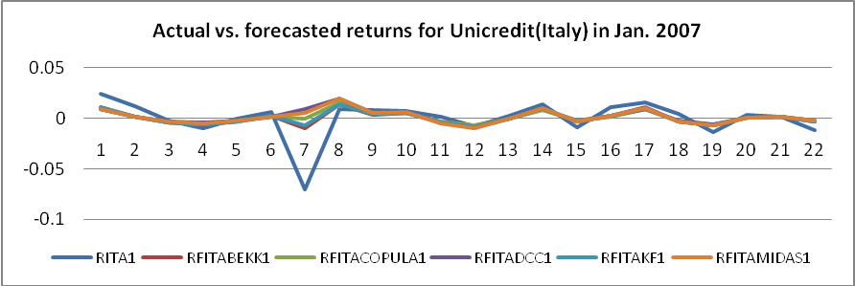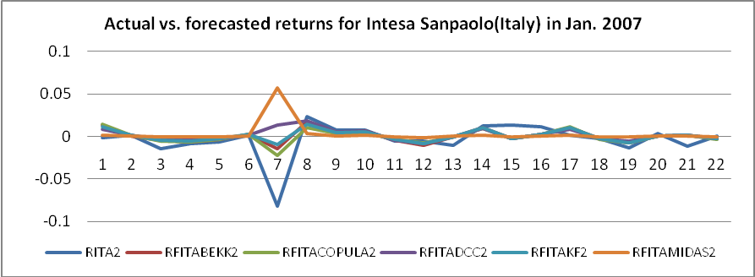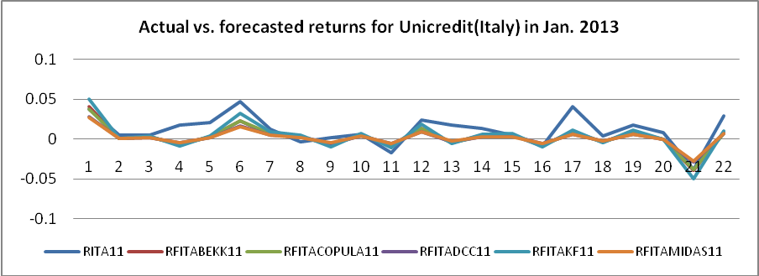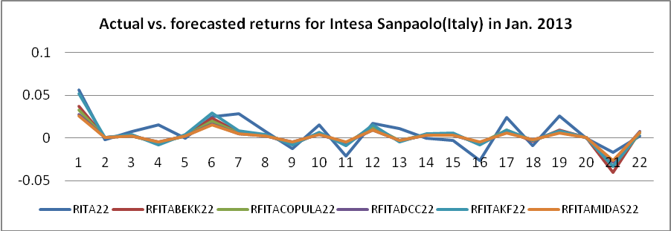

Figure 2. Patterns of actual v.s. forecasted returns for ING group and KAS bank(Holland) in January 2007 and January 2013
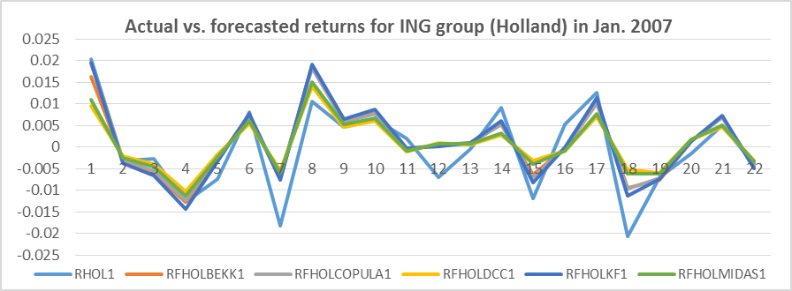
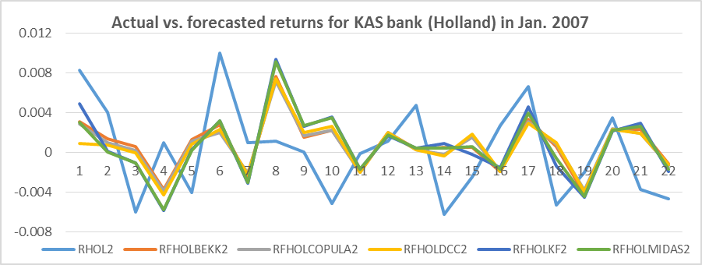
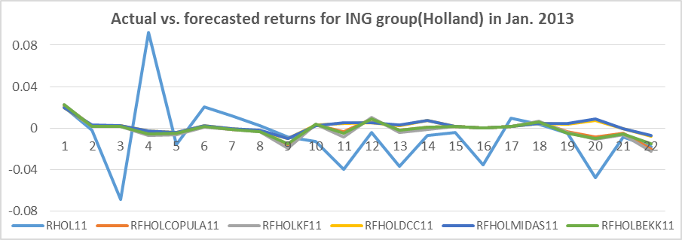
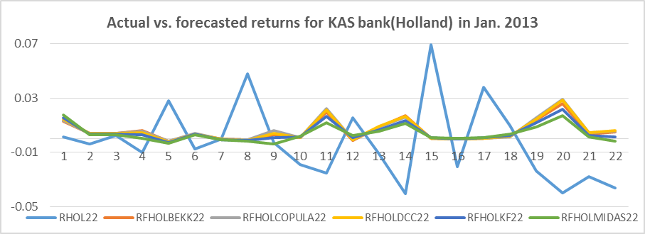

Corresponding author, address: School of Business, University of Southampton, Southampton SO17 1BJ, UK, email: t.choudhry@soton.ac.uk, phone: +442380599286. We thank two anonymous referees for several useful comments. We are solely responsible for any remaining errors and omissions. This paper was funded by the financial grant (UMO-2014/13/B/HS4/01556) provided by the National Science Centre, Poland.
According to Bos and Newbold (1984), the variation in the stock’s beta may be due to the influence of microeconomic factors and/or macroeconomic factors. A detailed discussion of these factors is provided by Rosenberg and Guy (1976a, 1976b).
Brooks et al. (1998) cite several papers that apply these different methods to estimate the time-varying beta.
A variety of GARCH models have been employed to model time-varying betas for different stock markets (see Bollerslev et al., 1988; Engle and Rodrigues, 1989; Bodurtha and Mark, 1991; Ng, 1991; Koutmos et al., 1994; Braun et al., 1995; Giannopoulos, 1995; Gonzales-Rivera, 1996; Brooks et al., 1998; Yun, 2002; Choudhry and Wu, 2008). Similarly, the Kalman filter technique has also been used by some studies to estimate the time-varying beta (see Black et al., 1992; Well, 1994, Choudhry and Wu, 2008).
Wilhelmsson (2013) applies the MCS procedure in the S&P 500 returns in out-of-sample density forecast.
Poon and Granger (2003) provide an excellent survey of GARCH and other models’ forecasting ability.
More implications of the DCC-MIDAS model are provided in Turhan et al. (2014)
Using Asia-Pacific stock markets, Chen et al. (2012) find that GARCH-skewed t outperforms other models during and post- current global crisis.
See Markowitz (1952), Sharpe (1964) and Lintner (1965) for details of the CAPM.
According to Klemkosky and Martin (1975) betas will be time-varying if excess returns are characterized by conditional heteroskedasticity.
Expectations are rational based on Muth’s (1961) definition of rational expectation where the mathematical expected values are interpreted as the agent’s subjective expectations.
In the BEKK model, the parameters do explain how much impact and shocks of squared errors, cross-product of errors and its lags has on the conditional covariance (Engle and Kroner, 1995).
Zhang and Choudhry (2013) find that the BEKK-GARCH model has the best forecasting performance in predicting dynamic hedge ratios for storable products. Huang et al. (2010) find that the BEKK-GRACH model is superior to the DCC-GARCH in terms of forecasting the volatility of three AAA-rated Euro zero-coupon bonds.
The DCC-GARCH can be estimated using a quasi-maximum likelihood estimator if the returns are not normally distributed.
On the other hand, this model has the disadvantage that all correlations follow the same dynamic structure (Peters, 2008).
Case et al. (2012) used the DCC-GARCH model to examine the dynamic correlations of returns between publicly traded REIT and non-REIT stocks, and stated that this model is a strong framework to analyze dynamic correlations. In terms of forecasts, Peters (2008) shows that the DCC model forecasts a covariance matrix better than the naïve sample in a short time frame and given high persistence.
For the alternative Archimedean Copula families, they do not make any assumptions of margin distribution, and they measure tail dependence via the linear correlation Peason’s rho and rank correlations with Kendall’s tau and Spearman’s rho. Pearson’s rho, Kendall’s tau and Spearman’s rho are dependence measures. The first method is the most frequently used linear correlation measurement, and the latter two are the main approaches to ranking correlations in statistics.
Hsu et al. (2008) find that the Copula-GARCH model effectively reduces the variance of returns of hedged portfolios compared to other dynamic conditional correlation (DCC) models in both the in-sample estimate and out-of-sample forecast.
Conrad et al. (2014) employ this model to measure the correlation between long-term oil stocks and macroeconomic factors. Moreover, Asgharian et al. (2013) demonstrate the improvement on the GARCH-MIDAS model’s prediction ability by considering low-frequency macroeconomic factors. Comparison between the out-of-sample forecasts of correlations from the DCC and the DCC-MIDAS models shows that the DCC-MIDAS reduces the persistence of the short-run correlation dynamics (Colacito et. al., 2011).
The Kalman Filter has many practical advantages such as its applicability to cases where there are missing observations, measurement errors and variables which are observed at different frequencies.
For one-day-ahead recursive forecasts, the sample size is increased by one day by including the latest data for each forecast, and we obtain a set of optimal estimates with corresponding parameters.
As stated above, the crisis started with the burst of the price bubble in the US real-estate market in mid-2007. The crisis reached its peak by October 2008 when the Lehman Brothers defaulted.
In order to test the robustness of our results we also apply different non-overlapping forecast periods during the pre-crisis (1 January to 31 January 2006) and the crisis (1 January 2010 to 31 January 2010) eras. Results from these periods provide the same conclusion. These results are available on request from the authors.
For the GARCH models, except the BEKK, the BHHH algorithm is used as the optimization method to estimate the time-varying beta series. For the BEKK GARCH, the BFGS algorithm is applied. For the Kalman Filter approach the BHHH algorithm is used as the optimization method to estimate the 20 time-varying beta series.
Brooks et al. (1998) and Choudhry and Wu (2008) also provide a comparison in the context of the market model.
It is worth noticing that the -value for model 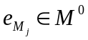 does not necessarily equal the -value from the null hypothesis, yet it is defined as 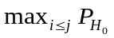.
RITA, RFITABEKK, RFITACOPULA, RFITADCC, RFITAKF and RFITAMIDAS represent actual return and return forecasts from BEKK, COPULA, DCC, Kalman Filter and DCC-MIDAS models, respectively.

