Clinical Trial Protocol

A randomized double-blind placebo controlled cross-over trial of sodium nitrate in patients with stable angina. Inorganic Nitrate in Angina Study (INAS)
Konstantin Schwarz^{1,2}, Satnam Singh¹, Satish Kumar Parasuraman^{1,3}, Maggie Bruce¹, Lee Shepstone³, Martin Feelisch⁴, Magdalena Minnion⁴, Shakil Ahmad⁵, John Horowitz^{1,6}, Dana Dawson¹, Michael Frenneaux^{1,3*}
¹School of Medicine & Dentistry, University of Aberdeen, Aberdeen, UK
²Worcestershire Royal Hospital, Worcester, UK
³Norwich Medical School, University of East Anglia, Bob Champion Research and Education Building
James Watson Road, Norwich, NR4 7UQ, UK
⁴University of Southampton, Southampton, UK
⁵Aston Medical Research Institute, Aston Medical School, Aston University, Birmingham, B4 7ET, UK
⁶University of Adelaide, Adelaide, Australia
*m.frenneaux@uea.ac.uk

Abstract
In an aging western population a significant number of patients continue to suffer from angina once all revascularization and optimal medical treatment options are exhausted. Under experimental conditions oral supplementation with inorganic nitrate was shown to exhibit blood pressure lowering effect, and has also been shown to promote angiogenesis, improve endothelial dysfunction and mitochondrial efficiency in skeletal muscle. It is unknown whether similar changes occur in cardiac muscle. In the current study we investigate whether oral sodium nitrate treatment will improve myocardial ischaemia in patients with stable angina.

Background
In 2013 the British Heart Foundation reported that 2.3 million patients (3.5% of the population) were registered with the diagnosis of angina in the United Kingdom [1]. Despite impressive advances in revascularization options and optimal medical treatment over the last two decades, a significant number of patients continue to suffer from limiting angina. With improving survival and active life-style clinicians increasingly encounter patients 10-20 years after their initial revascularization procedure in whom repeat revascularization is not possible or only to a limited extent. Current first line anti-anginal drugs are very effective, but in some patients their use can be precluded due to side effects (especially in pre-existing bradycardia or hypotension).
Over the last decade inorganic nitrate (putatively via the nitrate-nitrite-nitric oxide pathway) has been at the centre of considerable interest as a potential therapeutic option for cardiovascular diseases [2,3]. The human body is able to produce endogenous nitrite and nitrate via oxidation of nitric oxide originating from nitric oxide syntheses (NOSs). However the major source of the body storage pool comes from diet. Beetroot and leafy green vegetables are especially rich in inorganic nitrate. Inorganic nitrate is actively transported into the salivary glands and secreted into the saliva. Salivary bacteria reduce the nitrate into nitrite. This is in turn reduced to nitric oxide in the stomach, an effect which is facilitated by the presence of low pH. This effect of oral nitrate load on stomach nitric oxide production has been elegantly demonstrated by Spieglhalder et al, Benjamin et al and Lundberg et al[4-6]. The nitric oxide and some of the remaining nitrite is absorbed in the upper small intestine and reaches all tissues via circulation presumably via conversion back to nitrite which is more stable. Intravenous nitrite (the main metabolite of inorganic nitrate) is a potent vasodilator under hypoxia, but only a modest vasodilator under normoxia, an effect demonstrated first by Cosby et al and later confirmed by others [7-9]. Nitrite reduces the increase in pulmonary arterial pressure induced by hypoxia in healthy volunteers, an effect which persisted even one hour after cessation of nitrite infusion when plasma levels returned back to the baseline [9]. A single dose of oral sodium nitrate elevated angiogenic markers and recruited circulating angiogenic cells in healthy human volunteers [10]. Improved angiogenesis was confirmed in an experimental animal model of chronic hind limb ischaemia following chronic oral supplementation [11]. Recently four week supplementation with sodium nitrate resulted in improved endothelial dysfunction when assessed by brachial artery flow mediated vasodilation and also reduce arterial stiffness in an elderly population[12]. A beneficial effect of inorganic nitrate or beetroot supplementation on endothelial function was reported by a recent metanalysis [13]. Another recent meta-analysis (total number of participants n=254, 7-30 participants per study) suggests that a dose of 300 to 600mg of sodium nitrate modestly reduces blood pressure [14]. In this metanalysis of inorganic nitrate and beetroot supplementation was associated with grater mean changes in systolic BP (-4.4 mmHg, p<0.001) than diastolic BP (-1.1 mmHg, p=0.06). Oral inorganic nitrate supplementation was shown to reduce the oxygen cost of submaximal exercise in healthy volunteers [15-17], to improve skeletal muscle contractile function [16,18] and skeletal muscle mitochondrial ATP production efficiency [19]. Recently improved skeletal muscle contractile function was documented following a single dose of oral inorganic nitrate load (11.2 mmol beetroot juice) in patients suffering with systolic heart failure [20]. It is unclear whether these effects in skeletal muscle also occur in cardiac muscle. However these vascular and myocyte properties would potentially be of therapeutic value in patients suffering from angina.

Hypothesis
The main hypothesis is to assess any potential anti-ischaemia effects of oral sodium nitrate treatment in patients with stable angina treated with background cardiovascular and anti-anginal medication.

Primary outcome:
- Time to 1mm ST depression (exercise treadmill test)
Secondary outcomes:
- Time to chest pain onset (exercise treadmill test)
- Total exercise time (exercise treadmill test)
- Angina and GTN use frequency
- Modified Seattle Questionnaire
- Nitrate and nitrite plasma levels, angiogenic markers
- Dobutamine Stress Echocardiography - Tissue Doppler Imaging
  - Myocardial contractility assessment by peak systolic velocity
Previously the best validated primary outcome was time to 1mm ST depression in several clinical cross-over design studies assessing the effects of pharmacological intervention in patients suffering from stable angina [21-25]. Some studies report several treadmill ‘main outcomes’ including time to change in total exercise time, time to chest pain onset and time to 1mm ST depression [26,27]. The treadmill test results will be the best validated set of data. These results will be least likely to vary due to daily life challenges of patients when not under standardised research facility observation. However we will report also the other above secondary outcomes including the angiogenic marker and dobutamine stress echocardiogram results which may contribute to the mechanistic explanation of the potential anti-anginal benefits.

Methods

Design
The trial has a randomised, placebo controlled, double-blind, crossover design. The study is approved by the Scotland A Research Ethics Committee (SAREC), subject to MHRA regulation, and ran in accordance with the Declaration of Helsinki. All patients will sign an informed written consent.

Patient selection and protocol
Patients will be recruited from several sources: Aberdeen Royal Infirmary cardiology department, GP surgeries via Scottish Primary Care Research Network (SPCRN), patients attending the Heart Health Community Study in Aberdeen, and by posters in public places and adverts in local newspapers.

Patients aged 18 and over with chronic exertional angina (≥2 months duration) will be interviewed, examined and asked to give a written informed consent. Entry criteria will be positive ECG treadmill test (ETT) and either angiographic evidence of obstructive coronary artery disease or if not available a positive dobutamine stress echocardiogram or a positive myocardial perfusion scan. Patients will be screened with two modified-Bruce protocol ETTs on separate days and enrolled only if they have replicable exercise induced ECG evidence of ischaemia (≤15% difference in time to 1mm ST segment depression at the J+80ms point between the first and the second baseline ETT [25], Figure 1.
Exclusion criteria will be inability to perform an exercise treadmill test, women of child bearing potential, G6PD deficiency, LV ejection fraction <45% or New York Heart Association heart failure class III or IV, myocardial infarction or revascularisation within the last two months, resting ST depression ≥ 1mm or LBBB. Additionally patients in non-sinus rhythm and significant valvular disease will not included in the study as these may render the data interpretation unreliable.
Patients will be able to continue their regular anti-anginal medication at a fixed dose apart from long-acting organic nitrates which will be stopped in all patients at least 72 hours prior enrollment. Patients undergoing a concomitant dobutamin stress echocardiogram will be asked to omit their beta-blocker for 48 hours prior their visits in order to facilitate the dobutamine response, unless clinically contraindicated in which case the beta-blocker treatment may continue uninterrupted. This decision will be at the discretion of the researcher (mainly depending on the severity of symptoms) and the elected strategy will be kept fixed throughout all subsequent patient’s visits. Patients will be allowed to continue short-acting sublingual GTN use and other background angina medication at a fixed dose.

Figure 1
Flowchart: randomised double-blind placebo controlled crossover design
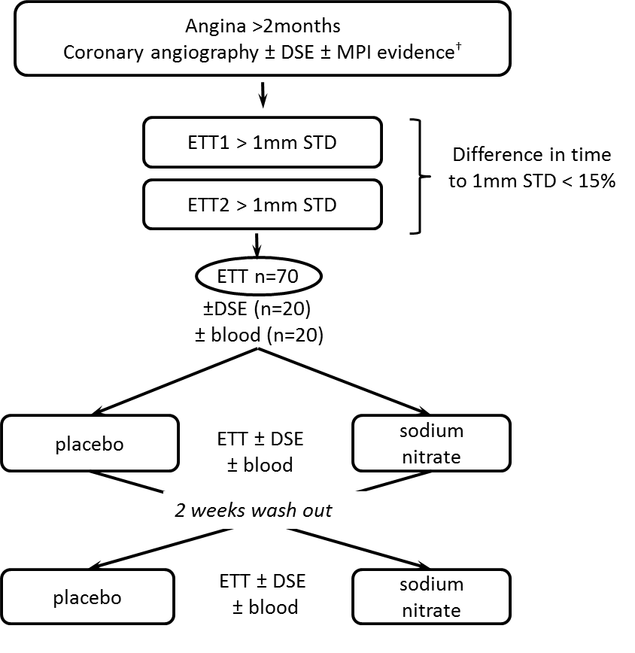
† Patient will be excluded if DSE or MPI positive but recent angiographic evidence of non-obstructive coronary artery disease

Treatment and randomization process
The rationale for the dose used in the study [600mg (7mmol) sodium nitrate per day] is based on evidence from previous studies using similar or smaller doses (often given in a single bolus) when assessing blood pressure lowering effects [14,28] and exercise capacity studies [17]. Doses as low as 3.5 mmol nitrate (beetroot juice) were effective to lower blood pressure when given to drug naïve grade 1 hypertensive volunteers [29]. A single dose of 4mmol nitrate (potassium nitrate) in a single oral dose was sufficient to lower the blood pressure in healthy volunteers [28].
A recent meta-analysis of 17 studies showed that doses ranging from 300mg to 600mg of inorganic nitrate (either in form of beetroot juice or sodium nitrate, ranging from single bolus to 15 day supplementation) showed a significant moderate benefit on exhaustion time [17]. Larsen et al demonstrated in young healthy volunteers that a dose of 0.1mmol/kg (7mmol=600mg for 70kg) split in three doses over the day given for 3 consecutive days can improve mitochondrial efficiency in the skeletal muscle [19]. Kenjale et all gave single dose of 9 mmol inorganic nitrate in form of a 750ml beetroot juice showing improvement in claudication onset [30]. The dose used in our study (600mg, 7mmol) is several times higher than an average western diet intake which contains approximately 100mg/d [31], but this should be safe as the similar or even higher nitrate content can be achieved by nitrate rich Mediterranean diet or the fruit and vegetable rich DASH diet which confer health benefits [2,31,32].
The trial medication will be manufactured and placed into packs containing two bottles labelled 1 (first treatment visit) and 2 (second treatment visit) at the Western Glasgow Infirmary Pharmacy. Sodium Nitrate powder will be purchased from Merck KGaA, Damstadt, Germany. Each bottle will include 14 capsules and contains either 600mg (7mmol) of sodium nitrate or placebo (lactose monohydrate) filled in opaque matching hard gelatin capsules.
The sequence of treatment randomization to bottle 1 and 2 will be decided according to a list provided by Aberdeen Randomisation Service (CHaRT, University of Aberdeen). At no point during the study will the research team or the patient know which bottle contains which treatment. Following treatment enrollment the patient will be handed out the first bottle and start treatment with one capsule a day for a period of 7-10 days before undergoing a treadmill test and/or DSE and/or blood tests and a second bottle will be handed out. After a two weeks wash out period the second bottle will be started for 7-10 days and same tests performed on the last day. After each arm the patient will returned the bottle with the remaining capsules for compliance assessment and returned to pharmacy. The two weeks wash out period should be sufficient to avoid any confounding carry-over effects of nitrate treatment as its plasma half-life ranges from 5-8h.
Following verbal instruction, patients will be handed-out a written diet advice sheet and asked to follow a low nitrate and nitrite diet, to limit caffeine intake and avoid use of anti-bacterial mouthwash during the treatment weeks. The latter is in order to prevent the loss of nitrate to nitrite bacterial bioconversion which occurs in the oral cavity and forms an integral part of the nitrate/nitrite entero-salivary circulation [33-36]. On the morning of the test the patients will be asked to avoid any caffeine intake and take the last study capsule approximately two hours prior their visit.

Exercise Treadmill Test
Seventy patients will undergo an ECG treadmill test following each treatment arm. They will be performed approximately two hours following ingestion of the last study capsule to ensure the nitrate to nitrite bioconversion can take place. Automated blood pressure monitoring and 12 lead ECGs will be recorded at rest in standing position and during a modified Bruce protocol (at the end of each stage, at the time of first 1mm ST depression, at time of first chest pain onset, at peak exercise and every three minutes into recovery). In patients with minor resting ST depression (<1mm), the time to 1mm ST change will be defined as additional ST depression of 1mm below the resting value as digitally displayed at J point + 80 ms[26].

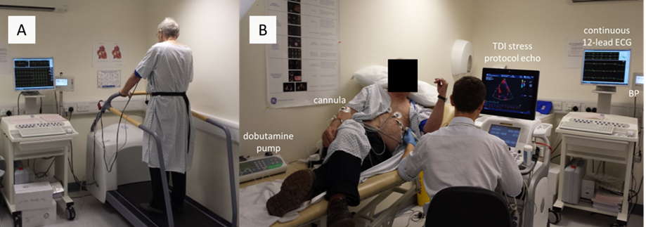
Figure 2
Set-up for A) ECG treadmill test and B) dobutamine stress echocardiography examination (one echocardiographer + two assistants)

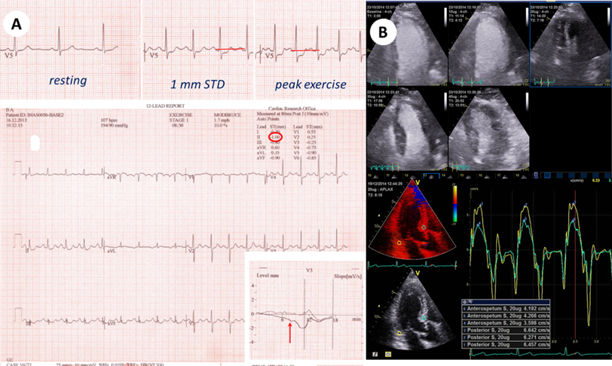
Figure
A: Example of ECG exercise treadmill test and time to 1 mm ST depression end-point
B: Dobutamine stress echocardiography, top – screening contrast echocardiography (different stages of dobutamine stress, four chamber view), bottom – example of TVI systolic velocity measurement, three chamber view).

Dobutamine Stress Echocardiography
All patients with a positive ECG treadmill test will be invited for a screening contrast dobutamine stress echocardiogram (DSE). Only patients with evidence of inducible regional wall motion abnormalities, satisfactory echo windows, tolerating well the baseline scan will be enrolled into the DSE arm. All tests will run two hours following finish of the ETT and approximately five hours following the last capsule ingestion (to allow optimal treatment plasma levels).
A standard protocol will involve resting for 20 minutes, baseline acquisition, loading with dobutamine 10ug/kg/min for 5 minutes and then 20, 30 and 40ug/kg/min each for 3 minutes. The pre-defined endpoints will be: inducible regional wall motion abnormality, significant chest pain, ST depression >2mm or ST elevation, persistent arrhythmia and symptomatic BP fall. In patients with poor heart rate rise without any other predefined end-points atropine (up to total of 1.2mg) can be added from 30mcg/kg/min stage onwards to reach at least 85% of age predicted target HR (0.85*220-age)[37]. LV contrast agent will be used as this was previously shown to significantly improve detection of inducible regional wall motion abnormalities [38]. Six views (apical 4-chamber, 2-chamber, 3-chamber, parasternal short axis at base, mid ventricle and apex) will be routinely obtained.
Patients with an evidence of inducible regional wall motion abnormality on screening will be enrolled into the DSE arm and undergo two further tests, one following each treatment arm. These on-treatment DSEs will run using exactly the same individual pharmacological protocol (dobutamine stage ± fixed atropine dose) as defined during the patient’s screening exam. Images will be obtained without contrast using Doppler tissue velocity imaging (TVI, Q-stress) in apical 4-chamber, 2-chamber and 3-chamber view only. Image depth, width, color tissue doppler velocity scale and frame rate will be optimized to avoid aliasing and aim at >120 frames/s. During passively held end-expiration three loops will be recorded in each view in the last minute of each stage. Digitized images will be later analyzed off line. Longitudinal basal segment peak systolic velocity (Sp) is the most reproducible tissue Doppler parameter, sensitive to ischaemia and related to blood flow [39,40]. Sp will be measured in 6 segments: basal inferoseptum, basal lateral, basal inferior, basal anterior, basal posterior and basal anteroseptum as previously described [41]. Sp will be measured as the maximal velocity following isovolumic contraction averaged from three cycles.

Bloods
Twenty patients will be invited additionally to take part in the blood subgroup. These patients will have blood taken on three occasions: their final screening visit and the two on-treatment visits. All will attend fasting from midnight, but clear water will be allowed with their morning medication. Patients will be advised to take the last study capsule approximately two hours prior to their study visit. Diabetic patients taking either tablet or insulin treatment will not be included in this substudy in order to avoid hypoglycemia when fasting and exercising. Blood will be taken prior to the treadmill test and samples for Angiogenic markers- sFlt-1, PlGF and VEGF in Li-Heparin tubes and nitrate/nitrite aliquots will be sampled into EDTA tubes which will supplemented with N-Ethylmalmeide (NEM).

Nitrite/nitrate plasma levels
All samples will be spun immediately for 5 minutes at 1000g at room temperature, supernatant will be saved and snap frozen in liquid nitrogen and stored by -80°C. Nitrite/nitrate levels will be analyzed at the University of Southampton [42]. Frozen plasma samples will be thawed in the presence of N-ethylmaleimide (10 mM final concentration) and deproteinized by methanol precipitation immediately prior to analysis. Plasma nitrite and nitrate will be measured by high-pressure liquid ion chromatography with post-column derivatization using a dedicated analysis system (ENO-20 with Gilson 234 autoinjector, EPC-500 data processor and PowerChrome software; Eicom).

Angiogenic markers
Vascular endothelial growth factor (VEGF) and its receptor (VEGFR-1 = Flt-1) play a central role in maintaining endothelial cell integrity and in the promotion of angiogenesis and lymphogenesis. Soluble Flt-1 (soluble Fms-like tyrosine kinase-1 also known as soluble VEGF receptor-1 or sFlt-1) is derived from the ligand binding region of VEGFR-1/Flt-1 and its main function is believed to be in the regulation of VEGF bioavailability and hence suppression of VEGF signaling[43].

Modified Seattle Questionnaire, GTN use and angina frequency
The Seattle Questionnaire (SQ) was developed in the 1990’s as a 19-item quality of life questionnaire assessing five dimensions of patients suffering from angina: physical limitation, angina stability, angina frequency, treatment satisfaction and disease perception [44]. It is widely used and was validated as a functional instrument in cardiovascular research outcome [45-49]. We modified the questionnaire to reflect the short treatment period of one week in our study when compared to the original SQ which in contrast interrogates over a period of the last four weeks. The higher the score the better is the quality of life, angina control and disease perception. Patients will be handed out a checklist where they will document the frequency of their angina attacks and GTN use during their treatment weeks.

Statistical analysis
Based on data from several previous randomized controlled studies testing the efficacy of anti-anginal medication with ECG exercise treadmill tests, the mean improvement in time to 1 mm ST depression between the active and placebo groups was around 50 sec [36sec with amlodipine [23,50], 60 sec with organic nitrates [24], 46 sec with atenolol and ranolazine [51], 46 sec with ivabridine[52] or 43 sec with allopurinol [25]]. The standard deviation in cross-over studies ranged around 80-90 sec [21-24]. Projecting an expected absolute mean treatment difference between the two arms of 30 s and a SD of 80 sec and allowing for a significance of 0.05 at 80% power in a paired crossover trial design, would require a sample size of 58 patients. To allow for drop-outs we planned to randomize 70 patients.
For the secondary dobutamine stress echocardiogram endpoint of tissue Doppler velocity derived peak systolic velocity (Sp) we aim to invite all eligible patients, but we recognize that many patients may not participate either due to contraindications, not tolerating the baseline scan or frequently their personal choice to opt out of this subgroup as the research visits will last significantly longer and often may interfere with their social or working life. We will aim to recruit a minimum of twenty patients based on a previous study by Ingram et al who showed that single intravenous nitrite infusion (30µmol NaNO2) increased peak systolic velocity in ischaemic segments when compared to saline infusion (N=10, 9.5±0.5 vs 12.4±0.6cm/s, p<0.001) (Ingram, JACC 2013). A sample size of 16 patients would be necessary to observe 1.0 cm/s velocity difference Sp and a standard deviation of 1.0 cm/s (two-tailed, paired, power 0.95 and p=0.05).
The primary endpoint (time to 1mm ST-Depression) is assumed to follow a Normal distribution. The analysis will follow that recommended by Senn[53] for the analysis of a 2-treatment, 2-period cross-over trial. A General Linear Model (GLM) will be constructed with the following terms included: participant (as a random effect), period and treatment (both as fixed effects). Baseline terms will not be included as baseline data is not available for both treatment periods. Baseline data will, however, be tabulated and described, by randomised group (i.e. by treatment sequence). Treatment efficacy will be estimated as the treatment effect estimate from the GLM with a 95% confidence interval constructed and the hypothesis of zero effect tested (at the 5% significance level).
Secondary endpoints will be analysed in the same manner. For some endpoints (for example number of angina attack episodes), the assumption of a Normal distribution is unlikely to hold and an appropriate transformation will be carried out prior to analysis (for example a logarithmic or square-root transformation). The residuals from each model with be check to follow and approximate Normal distribution. The trial statistician will conduct and report the analyses blind, i.e. simply comparing treatment ‘A’ to treatment ‘B’ according to the randomisation schedule provided, without knowing which treatment is active or placebo. All analyses will be carried out in SAS version 9.3.

Trial Oversight
A Trial Steering Committee will oversee, monitored and supervised the progress of the study and will be responsible for the scientific integrity of the research. Data Monitoring Committee will monitor the safety of the study and research validity of its conduct. Research and Development department of the University of Aberdeen will act as the sponsor and monitor of the study. The study is registered and underwent regulatory approvals by the MHRA (Medicine and Healthcare Regulatory Agency), NHS-Grampian R&D department and the Research Ethics Committee.

Conclusion
In the aging population increasing proportion of patients with advanced coronary disease survive to the stage when no more revascularization is possible and first line antianginal treatment options are exhausted. Inorganic nitrate treatment offers via nitrate-nitrite-nitric oxide treatment pathway a unique anti-anginal strategy by theoretical improving selective vasodilation in hypoxic territories, promotion of vasodilation or improved mitochondrial efficiency. While sound in experimental animal studies and pilot studies on healthy volunteers, this study proposes to investigate potential anti-anginal benefits of sodium nitrate in elderly population of patients suffering from angina and known advanced atherosclerotic disease who are on background poly-pharmacy.

Funding
The study is funded by the Medical Research Council.
Edura CT number: 2012-000196-17
Trial Registration: ClinicalTrials.gov NCT02078921

Acknowledgement
We are very grateful to Amanda Cardy (Scottish Primary Research Network) for her help with recruitment from primary care centres. Further thanks are to Val Harries, Amelia Rudd and Frances Adamson for their assistance with facilitation of study recruitment.
Executive summary
Background
- Angina remains a therapeutic challenge in the era of an aging Western population once all revascularization options are exhausted and the use of first line anti-anginal drugs is limited due to their side effects
- Oral inorganic nitrate supplementation was shown to selectively vasodilate under hypoxic conditions, lower blood pressure, improve endothelial dysfunction, promote angiogenesis, and improve mitochondrial efficiency in skeletal muscle
Aim
- We hypothesize that if similar effects occur in heart, oral sodium nitrate could improve markers of myocardial ischaemia in patients suffering from stable angina
Methods
- Design, treatment protocol and proposed analysis methods are reviewed in this trial protocol paper
Conclusion
- This study proposes to investigate potential anti-anginal benefits of sodium nitrate in elderly population of patients suffering from angina and known advanced atherosclerotic disease who are on background poly-pharmacy

References
1. British Heart Foundation: Cardiovascular Disease Statistics 2014.
2. Lundberg JO, Weitzberg E, Gladwin MT: The nitrate-nitrite-nitric oxide pathway in physiology and therapeutics. Nature Reviews Drug Discovery 7(2), 156-167 (2008).**
3. Butler AR, Feelisch M: Therapeutic uses of inorganic nitrite and nitrate: From the past to the future. Circulation 117(16), 2151-2159 (2008).
4. Spiegelhalder B, Eisenbrand G, Preussmann R: Influence of dietary nitrate on nitrite content of human saliva: possible relevance to in vivo formation of N-nitroso compounds. Food Cosmet. Toxicol. 14(6), 545-548 (1976).
5. Benjamin N, O'Driscoll F, Dougall H et al.: Stomach NO synthesis. Nature 368(6471), 502 (1994).
6. Lundberg JO, Weitzberg E, Lundberg JM, Alving K: Intragastric nitric oxide production in humans: measurements in expelled air. Gut 35(11), 1543-1546 (1994).
7. Cosby K, Partovi KS, Crawford JH et al.: Nitrite reduction to nitric oxide by deoxyhemoglobin vasodilates the human circulation. Nat. Med. 9(12), 1498-1505 (2003).
8. Maher AR, Milsom AB, Gunaruwan P et al.: Hypoxic modulation of exogenous nitrite-induced vasodilation in humans. Circulation 117(5), 670-677 (2008).
9. Ingram TE, Pinder AG, Bailey DM, Fraser AG, James PE: Low-dose sodium nitrite vasodilates hypoxic human pulmonary vasculature by a means that is not dependent on a simultaneous elevation in plasma nitrite. Am. J. Physiol. Heart Circ. Physiol. 298(2), H331-9 (2010).
10. Heiss C, Meyer C, Totzeck M et al.: Dietary inorganic nitrate mobilizes circulating angiogenic cells. Free Radical Biology and Medicine 52(9), 1767-1772 (2012).
11. Hendgen-Cotta UB, Luedike P, Totzeck M et al.: Dietary nitrate supplementation improves revascularization in chronic ischemia. Circulation 126(16), 1983-1992 (2012).
12. Rammos C, Hendgen-Cotta UB, Sobierajski J, Bernard A, Kelm M, Rassaf T: Dietary nitrate reverses vascular dysfunction in older adults with moderately increased cardiovascular risk. J. Am. Coll. Cardiol. 63(15), 1584-1585 (2014).
13. Lara J, Ashor AW, Oggioni C, Ahluwalia A, Mathers JC, Siervo M: Effects of inorganic nitrate and beetroot supplementation on endothelial function: a systematic review and meta-analysis. Eur. J. Nutr. 55(2), 451-459 (2016).
14. Siervo M, Lara J, Ogbonmwan I, Mathers JC: Inorganic nitrate and beetroot juice supplementation reduces blood pressure in adults: A systematic review and meta-analysis. J. Nutr. 143(6), 818-826 (2013).*
15. Bailey SJ, Winyard P, Vanhatalo A et al.: Dietary nitrate supplementation reduces the O2 cost of low-intensity exercise and enhances tolerance to high-intensity exercise in humans. J. Appl. Physiol. 107(4), 1144-1155 (2009).*
16. Larsen FJ, Weitzberg E, Lundberg JO, Ekblom B: Dietary nitrate reduces maximal oxygen consumption while maintaining work performance in maximal exercise. Free Radical Biology and Medicine 48(2), 342-347 (2010).
17. Hoon MW, Johnson NA, Chapman PG, Burke LM: The effect of nitrate supplementation on exercise performance in healthy individuals: A systematic review and meta-analysis. Int. J. Sport Nutr. Exerc. Metab. 23(5), 522-532 (2013).*
18. Bailey SJ, Fulford J, Vanhatalo A et al.: Dietary nitrate supplementation enhances muscle contractile efficiency during knee-extensor exercise in humans. J. Appl. Physiol. 109(1), 135-148 (2010).
19. Larsen FJ, Schiffer TA, Borniquel S et al.: Dietary inorganic nitrate improves mitochondrial efficiency in humans. Cell Metabolism 13(2), 149-159 (2011).*
20. Coggan AR, Leibowitz JL, Anderson Spearie C et al.: Acute Dietary Nitrate Intake Improves Muscle Contractile Function in Patients with Heart Failure: A Double-Blind, Placebo-Controlled, Randomized Trial. Circ. Heart Fail. (2015).
21. Thadani U, Smith W, Nash S et al.: The effect of vardenafil, a potent and highly selective phosphodiesterase-5 inhibitor for the treatment of erectile dysfunction, on the cardiovascular response to exercise in patients with coronary artery disease. J. Am. Coll. Cardiol. 40(11), 2006-2012 (2002).
22. Fox KM, Thadani U, Ma PT et al.: Sildenafil citrate does not reduce exercise tolerance in men with erectile dysfunction and chronic stable angina. Eur. Heart J. 24(24), 2206-2212 (2003).
23. Dunselman PHJM, Van Kempen LHJ, Bouwens LHM, Holwerda KJ, Herweijer AH, Bernink PJLM: Value of the addition of amlodipine to atenolol in patients with angina pectoris despite adequate beta blockade. Am. J. Cardiol. 81(2), 128-132 (1998).
24. Halcox JPJ, Nour KRA, Zalos G et al.: The effect of sildenafil on human vascular function, platelet activation, and myocardial ischemia. J. Am. Coll. Cardiol. 40(7), 1232-1240 (2002).
25. Noman A, Ang DS, Ogston S, Lang CC, Struthers AD: Effect of high-dose allopurinol on exercise in patients with chronic stable angina: a randomised, placebo controlled crossover trial. The Lancet 375(9732), 2161-2167 (2010).*
26. Chaitman BR, Skettino SL, Parker JO et al.: Anti-ischemic effects and long-term survival during ranolazine monotherapy in patients with chronic severe angina. J. Am. Coll. Cardiol. 43(8), 1375-1382 (2004).
27. Chaitman BR, Pepine CJ, Parker JO et al.: Effects of Ranolazine with Atenolol, Amlodipine, or Diltiazem on Exercise Tolerance and Angina Frequency in Patients with Severe Chronic Angina: A Randomized Controlled Trial. J. Am. Med. Assoc. 291(3), 309-316 (2004).
28. Kapil V, Milsom AB, Okorie M et al.: Inorganic nitrate supplementation lowers blood pressure in humans: Role for nitrite-derived no. Hypertension 56(2), 274-281 (2010).*
29. Ghosh SM, Kapil V, Fuentes-Calvo I et al.: Enhanced vasodilator activity of nitrite in hypertension: Critical role for erythrocytic xanthine oxidoreductase and translational potential. Hypertension 61(5), 1091-1102 (2013).
30. Kenjale AA, Ham KL, Stabler T et al.: Dietary nitrate supplementation enhances exercise performance in peripheral arterial disease. J. Appl. Physiol. 110(6), 1582-1591 (2011).
31. Hord NG, Tang Y, Bryan NS: Food sources of nitrates and nitrites: The physiologic context for potential health benefits. Am. J. Clin. Nutr. 90(1), 1-10 (2009).
32. Machha A, Schechter AN: Inorganic nitrate: A major player in the cardiovascular health benefits of vegetables? Nutr. Rev. 70(6), 367-372 (2012).
33. Govoni M, Jansson EA, Weitzberg E, Lundberg JO: The increase in plasma nitrite after a dietary nitrate load is markedly attenuated by an antibacterial mouthwash. Nitric Oxide 19(4), 333-337 (2008).
34. Webb AJ, Patel N, Loukogeorgakis S et al.: Acute blood pressure lowering, vasoprotective, and antiplatelet properties of dietary nitrate via bioconversion to nitrite. Hypertension 51(3), 784-790 (2008).*
35. Kapil V, Haydar SM, Pearl V, Lundberg JO, Weitzberg E, Ahluwalia A: Physiological role for nitrate-reducing oral bacteria in blood pressure control. Free Radic. Biol. Med. 55, 93-100 (2013).
36. Bondonno CP, Liu AH, Croft KD et al.: Antibacterial Mouthwash Blunts Oral Nitrate Reduction and Increases Blood Pressure in Treated Hypertensive Men and Women. Am. J. Hypertens. (2014).
37. Senior R, Becher H, Monaghan M et al.: Contrast echocardiography: Evidence-based recommendations by European Association of Echocardiography. European Journal of Echocardiography 10(2), 194-212 (2009).
38. Schnaack SD, Siegmund P, Spes CH, Tammen AR, Theisen K, Angermann CE: Transpulmonary contrast echocardiography: Effects on delineation of endocardial border, assessment of wall motion and interobserver variability in stress echocardiograms of limited image quality. Coron. Artery Dis. 11(7), 549-554 (2000).
39. Fraser AG, Payne N, Mädler CF et al.: Feasibility and reproducibility of off-line tissue Doppler measurement of regional myocardial function during dobutamine stress echocardiography. European Journal of Echocardiography 4(1), 43-53 (2003).
40. Vatner SF: Correlation between acute reductions in myocardial blood flow and function in conscious dogs. Circulation Research 47(2), 201-207 (1980).
41. Ingram TE, Fraser AG, Bleasdale RA et al.: Low-dose sodium nitrite attenuates myocardial ischemia and vascular ischemia-reperfusion injury in human models. J. Am. Coll. Cardiol. 61(25), 2534-2541 (2013).*
42. Siddiqi N, Neil C, Bruce M et al.: Intravenous sodium nitrite in acute ST-elevation myocardial infarction: A randomized controlled trial (NIAMI). Eur. Heart J. 35(19), 1255-1262a (2014).
43. Shibuya M: VEGF-VEGFR Signals in Health and Disease. Biomol. Ther. (Seoul) 22(1), 1-9 (2014).
44. Spertus JA, Winder JA, Dewhurst TA et al.: Development and evaluation of the Seattle Angina Questionnaire: a new functional status measure for coronary artery disease. J. Am. Coll. Cardiol. 25(2), 333-341 (1995).
45. Safley DM, Grantham JA, Hatch J, Jones PG, Spertus JA: Quality of life benefits of percutaneous coronary intervention for chronic occlusions. Catheter. Cardiovasc. Interv. 84(4), 629-634 (2014).
46. Beatty AL, Spertus JA, Whooley MA: Frequency of angina pectoris and secondary events in patients with stable coronary heart disease (from the Heart and Soul Study). Am. J. Cardiol. 114(7), 997-1002 (2014).
47. Arnold SV, Kosiborod M, Li Y et al.: Comparison of the Seattle Angina Questionnaire With Daily Angina Diary in the TERISA Clinical Trial. Circ. Cardiovasc. Qual. Outcomes 7(6), 844-850 (2014).
48. Arnold SV, Masoudi FA, Rumsfeld JS, Li Y, Jones PG, Spertus JA: Derivation and validation of a risk standardization model for benchmarking hospital performance for health-related quality of life outcomes after acute myocardial infarction. Circulation 129(3), 313-320 (2014).
49. Abdallah MS, Wang K, Magnuson EA et al.: Quality of life after PCI vs CABG among patients with diabetes and multivessel coronary artery disease: a randomized clinical trial. JAMA 310(15), 1581-1590 (2013).
50. Knight CJ, Fox KM: Amlodipine versus diltiazem as additional antianginal treatment to atenolol. Am. J. Cardiol. 81(2), 133-136 (1998).
51. Rousseau MF, Pouleur H, Cocco G, Wolff AA: Comparative efficacy of ranolazine versus atenolol for chronic angina pectoris. Am. J. Cardiol. 95(3), 311-316 (2005).
52. Tardif J-, Ponikowski P, Kahan T: Efficacy of the If current inhibitor ivabradine in patients with chronic stable angina receiving beta-blocker therapy: A 4-month, randomized, placebo-controlled trial. Eur. Heart J. 30(5), 540-548 (2009).
53. Senn S: Cross-over Trials in Clinical Research. John Wiley & Sons, Chichester (1993).
**this is an excellent overview of nitrate-nitirite-nitric oxide patway and physiology
*articles with considerable interest

