ERF74 Acts as an on-off Switch Controlling an RbohD-Dependent Mechanism in Response to Different Stresses in Arabidopsis

Yuan Yao^{1,2}, Run Jun He³, Qiao Li Xie^{1,2}, Xian hai Zhao^{1,2}, Xiao mei Deng^{1,2}, Jun bo He^{1,2} Alan Marchant ⁴, Xiao-Yang Chen^{1,2 *}, Ai-Min Wu^{1,2 *}
¹ State Key Laboratory for Conservation and Utilization of Subtropical Agro-bioresources, South China Agricultural University, Guangzhou, 510642, China;
² Guangdong Key Laboratory for Innovative Development and Utilization of Forest Plant Germplasm, College of Forest, South China Agricultural University, Guangzhou, 510642, China;

³ Guangdong Provincial Key Laboratory of Organ Donation and Transplant Immunology, the First Hospital Affiliated to Sun Yat-Sen University, Guangzhou, 510080, China;
⁴ Biological Sciences, University of Southampton，SO17 1BJ, Southampton, Hampshire, United Kingdom.

Corresponding authors: Xiao-Yang Chen (xychen@scau.edu.cn) and Ai-Min Wu (wuaimin@scau.edu.cn)

Short title: AtERF74 triggers stress responses via RbohD

The author responsible for distribution of materials integral to the findings presented in this article in accordance with the policy described in the Instructions for Authors is: wuaimin@scau.edu.cn

Synopsis: In stressed plants, AtERF74 relocates from the membrane to the nucleus and binds to the RbohD promoter, directly regulating the early stage ROS burst and thereby increasing resistance.

Total word count (excluding summary, references and legends): | 6353
Summary: | 200
Introduction: | 990
Materials and Methods: | 1214
Results: | 2857
Discussion: | 1218
Acknowledgements: | 74
No. of figures: | 8(all in colour)
No. of Tables: | 0
No of Supporting Information files: | 12(Fig.S1-S14;Table S1

Summary:
Recent studies indicate that the ethylene response factor VII (ERF-VII) transcription factor is an important regulator of osmotic and hypoxic stress responses in plants. However, the molecular mechanism of ERF-VII-mediated transcriptional regulation remains unclear.
Here, we investigated the role of ERF74 (a member of the ERF-VII protein family) by examining the abiotic stress tolerance of an ERF74 overexpression line and a T-DNA insertion mutant using flow cytometry, transactivation and electrophoretic mobility shift assays.
35S::ERF74 showed enhanced tolerance to drought, high light, heat and aluminum stresses, whereas the T-DNA insertion mutant erf74 and erf74;erf75 double mutant displayed higher sensitivity. Using flow cytometry analysis, we found that erf74 and erf74;erf75 lines lack the ROS burst in the early stages of various stresses, due to the lower expression level of RbohD. Furthermore, ERF74 directly binds to the promoter of RbohD and activates its expression under different abiotic stresses. Moreover, induction of stress marker genes and ROS-scavenging enzyme genes under various stress conditions are dependent on the ERF74-RbohD-ROS signal pathway.
We propose a pathway that involves ERF74 acting as an on-off switch controlling an RbohD-dependent mechanism in response to different stresses, subsequently maintaining H₂O₂ homeostasis in Arabidopsis.
Keywords: Arabidopsis thaliana, Reactive Oxygen Species (ROS), Ethylene Response Factor (ERF), Respiratory Burst Oxidase (Rboh), Abiotic stress, Transactivation, Signal pathway

Introduction
Abiotic stress conditions such as flooding, drought, high light (HL) and high temperatures have adverse effects on plant growth and crop production. Plants are sessile organisms that have evolved complicated systems to regulate their response to stress signals. It is known that a class of reactive forms of molecular oxygen, collectively referred to as reactive oxygen species (ROS) play a critical role in stress signaling (Foyer & Noctor, 2009; Petrov & Van Breusegem, 2012). In plants, ROS control biological processes (Miller et al., 2009; Suzuki et al., 2011) including pathogen defense (Kadota et al., 2015), abiotic stress tolerance (Rhoads et al., 2006; Blomster et al., 2011; Sierla et al., 2013), stomatal regulation (Zhang et al., 2009), wound responses (Monshausen et al., 2009; Miller et al., 2009) and cell expansion (Suzuki et al., 2011). Although continuously produced at basal levels during normal plant growth and development in mitochondria, chloroplasts and peroxisomes, ROS can also be produced in high quantities in the apoplast by at least two characterized types of enzymes that include the membrane-bound NADPH oxidases (also referred to as Rboh) and the cell wall-bound type III peroxidases (Daudi et al., 2012). The rapid generation of ROS during the early stages of plant biotic and abiotic stress signaling is known as the oxidative burst (Miller, G et al., 2010). In parallel, a vast network of antioxidants, such as catalase (CAT), ascorbate (APX) and glutathione reductases (GR) act as scavengers of H₂O₂ controlling ROS levels (Gechev et al., 2006; Miller, G et al., 2010). Given the dual role of ROS as stress signals and toxic byproducts, further elucidation of the plant stress signaling pathway is needed to better understand how the production and regulation of ROS can impact crop improvement and plant health.

In plants, NADPH oxidase is known as the respiratory burst oxidase homolog (Rboh), which is the homolog of a mammalian 91 kDa glycoprotein subunit of the phagocyte oxidase (gp91^{phox}) (Torres & Dangl, 2005). In the Arabidopsis thaliana genome, there are 10 Rboh genes (AtRbohA–J) (Torres & Dangl, 2005). RbohD is highly expressed in all tissues and plays an important role in systemic signaling during the stress response (Miller et al., 2009; Xie et al., 2011; Kadota et al., 2014), lateral root development (Li et al., 2015) and lignification (Denness et al., 2011). RbohF may function redundantly with RbohD, since the double mutant rbohd;rbohf showed a stronger phenotype following various stresses (Ma et al., 2011; Morales et al., 2016) and effects on primary root growth (Jiao et al., 2013). Multiple reports have indicated that many different proteins and transcription factors in animals and fungi regulate RbohD/F (Sumimoto, 2008), but few regulatory genes have been identified in plants. CORONATINE INSENSITIVE1 (COI1), a master regulator of the JA response, increases the production of ROS via RbohD and RbohF in the jasmonic acid (JA) signaling pathway (Maruta et al., 2011). AtSRC2, a low temperature-inducible protein, enhances ROS production via interaction with the N-terminal region of RbohF to activate it (Kawarazaki et al., 2013). However, regulation of the ROS-producing signal pathway under different stresses through RbohD remains largely unknown.

The AP2/ERF superfamily is defined by the APETALA2 (AP2) domain, which is necessary for protein–DNA interactions (Okamuro et al., 1997). The ERF domain can bind as an activator or repressor to the GCC (GCCGCC) box (Fujimoto et al., 2000) and to the DRE (dehydration- responsive element; CCGACAT) element (Xu et al., 2007) in target promoters. In Arabidopsis, ERFs are known to be involved in the plant stress response, due to their role in ROS scavenging. ERF6 (At4g17490) transcription levels were found to be induced by Botrytis cinerea infection (Meng et al., 2013), and erf6 T-DNA insertion mutant plants showed reduced growth and increased H₂O₂ and anthocyanin levels (Sewelam et al., 2013). RAP2.6L (At5g13330) is another AP2/ERF gene involved in enhancing waterlogging tolerance by increasing antioxidant enzyme activity and expression of stress-responsive genes, such as SOD, APX, and CAT through the ABI1-mediated ABA signaling pathway (Liu et al., 2012). It has been reported that ERF98 (At3g23230) enhances tolerance to salt through the transcriptional activation of Ascorbic acid production (Zhang et al., 2012). However, there has been no report of AtERFs being implicated in ROS production during different plant stresses.

The ERF-VII family of Arabidopsis transcription factors (TFs) consists of five members: ERF71 (Hypoxia Responsive ERF1, HRE1; At1g72360), ERF72 (RELATED TO AP2.3, RAP2.3; At3g16770), ERF73 (HRE2; At2g47520), ERF74 (RAP2.12; At1g53910) and ERF75 (RAP2.2; At3g14230) (Nakano et al., 2006). These ERF-VII TFs are involved in plant responses to hypoxia (Xu et al., 2006; Hattori et al., 2009; Hinz et al., 2010; Licausi et al., 2010) and share a similar N-terminal degron motive MCGGAI/V that is regulated by the N-end rule pathway of protein degradation (Gibbs et al., 2011; Licausi et al., 2011). Besides hypoxia, ERF71-ERF75 also have a role in other stresses. Elevated expression of rice SUB1A was found to increase oxidative stress and drought tolerance (Fukao et al., 2011). In addition, 35S::ERF75 transgenic plants and erf75 T-DNA insertion mutants yielded insensitivity and sensitivity, respectively, to Botrytis necrotrophic compared to WT (Zhao et al., 2012). Last but not least, ERF72-ERF75 also have a role in modulating oxidative and osmotic stress tolerance (Park et al., 2011; Papdi et al., 2015). However, the molecular mechanism of ERF-VII-mediated transcriptional regulation under stress conditions remains unclear.

In this study, we show that ERF74 and ERF75 plays a redundant role in the upregulation of RbohD transcription and enhances the ROS burst during the early stages of the stress response. Induction of stress marker genes and ROS-scavenging enzyme genes under various stress conditions are dependent on this ROS burst. The overexpression of ERF74 increased the ROS burst and stress resistance, whereas the knockout mutants erf74 and erf74;erf75 showed a reduced ROS burst and decreased tolerance to various stresses, such as flooding, drought, high light, aluminum (Al) and heat. These findings indicate that the ERF74 and ERF75 response to various stresses is dependent on ROS signals.

Materials and Methods

Plant materials and growth conditions
Arabidopsis thaliana ecotype Col-0 was the WT line used in this study and served as the genetic background of every transgenic line tested. The T-DNA insertion mutant erf74 (SALK_019873), erf75 (SALK_010265) and erf74;erf75 were kind gifts from Genji Qin (Zhao et al., 2012), rbohd (SALK_109396C) was obtained from ABRC. Arabidopsis plant growth conditions and different stress tolerance assays are summarized in Fig.S1. Five pots containing nine plants each were used for each genotype for the different stress treatments. N. benthamiana seeds were planted in a potting soil mixture (rich soil: vermiculite, 2:1, v/v) and were grown in controlled environment room at 23°C with 16 hours light per day (80 mmol m⁻² s⁻¹) After 4 weeks growth, the plants were used for transformation. Root growth assays were performed by transferring 5-day-old seedlings grown on MS agar to fresh media supplemented with 10µM ABA. Root lengths were measured after 6 days following transfer. The experiments were repeated three times.

Vector construction and generation of transgenic plants
The full-length ERF74pro:ERF74 and ERF74 DNA were amplified by PCR and cloned into the pDonR207 Gateway vector using the BP clonase reaction (Invitrogen). After sequence verification, the ERF74pro:ERF74 was subcloned into the phGEAR (Kubo et al., 2005) Gateway vector and ERF74 DNA was recombined into the pEarley100 and pEarley101 Gateway vectors (Earley et al., 2006) using the LR clonase reaction (Invitrogen). The recombinant plasmids were transformed into Agrobacterium tumefaciens stain GV3101. Agrobacterium-mediated transformation into the WT was performed by the floral dip method (Clough & Bent, 1998). ERF74-DR transgenic T1 seedlings were selected on 0.5×Murashige and Skoog phytoagar medium supplemented with 2 mM MES buffer (pH 5.8) and 15 mg L⁻¹ hygromycin and the first generation of transgenic plants was used for examination of phenotypes. To screen for transformants with 35S::ERF74, T1 plants were grown on soil and sprayed at 7 and 9 d after germination with 0.1% (v/v) BASTA.

For the protoplast transactivation assays, 1.6kb~2kb promoter regions of ERF71-ERF75, AOXa1, APX1, APX2, HSP18.2 and the full length cDNAs of ERF71-ERF75 were amplified by PCR and cloned into the pDonrR207 Gateway vector using the BP clonase reaction (Invitrogen). The fragments were subcloned into the PUGW2 or PUGW35 vector (Nakagawa et al., 2007) Gateway vector using the LR clonase reaction (Invitrogen).

Arabidopsis protoplasts extracted for transactivation and stress tested
Protoplasts were prepared following a previously described protocol (Yoo et al., 2007). A Luc-overexpressing vector (35S:rLuc) was used as the normalization control for PpLuc reporters. All assays were performed with at least four replicates and repeated twice. Average relative signals are shown, together with their relative standard deviation.

For Al and ABA application, 100 μL of protoplasts in 24-well plates were treated with 50 mM AlCl₃ or 20μM ABA for the required time at room temperature in darkness. For heat treatment, 100µL of prepared protoplasts were challenged by 42°C heat for the required time. To study the effects of Rbohs, seedlings and protoplasts were incubated with 20μM diphenylene iodonium (DPI) for 0.5h before stress treatment.

Subcellular location of AtERF74 under different abiotic stresses
The pEarly101-AtERF74 construct was infiltrated into Nicotiana benthamiana plants by Agrobacterium tumefaciens strain GV3101 as previously described (Sparkes et al., 2006). For GFP observations, whole plants were treated with either 4 hours flooding, 13 days drought or 36 hours HL (400 mmol m⁻² s⁻¹) before observation using a confocal laser scanning microscope (Leica 700 Live). To assess the membrane-to-nucleus relocalization of ERF74:GFP, areas of more than 100 cells were analyzed for the appearance of a fluorescent signal in the nucleus. GFP was excited with the 488 nm laser and the emission wavelength was 500-520 nm.

Flow cytometry analysis
The flow cytometer Navios (Beckman-Coulter, CA, USA) equipped with Kaluza analysis software was used to analyze the level of ROS and cell survival rate under various stresses. A 488 nm laser was used as the excitation source for the fluorescence of H₂DCFDA and FDA. Protoplasts were incubated with 5 μM H₂DCFDA for 30 min or 2 μM FDA for 10 min at room temperature after treatment with various stresses, and then immediately subjected to flow cytometry analysis. For each sample, 1×10⁴ protoplasts were gated. Histograms were processed with FlowJo 7.6 analysis software.

Quantitative PCR (qPCR) analysis
All tissue for RNA extracted was collected at 12 noon. Total RNA was extracted from plant tissue using the plant total RNA extraction kit (Promega). First-strand cDNAs were prepared with 1 mg of total RNA in a 20 µL reaction volume using the PrimeScript RT reagent Kit with gDNA Eraser (TAKARA) according to the manufacturer’s protocol and then diluted with water to 200 µL. The quantitative PCR mixtures contained 2 µL cDNA template, 10 µL 2× SYBR Green PCR Master Mix (TAKARA) and 0.25 µM forward and reverse primers for each gene. Primer sequences for each gene are listed in Supplemental Table 1. Quantitative PCR was performed using the Light Cycler 480 (Roche Diagnostics). The expression stability of reference genes, including EF1α, ACT2, ACT8, UBQ10, MOM, PP2A, UBQ5, 18S under flooding, drought and HL condition was assessed using geNorm (Vandesompele et al., 2002). The results obtained using geNorm showed that the combination of MOM (M=0.281), PP2A (M=0.306) and ACT2 (M=0.334) would be appropriate as a reference panel for normalizing gene expression under stress conditions in our experiment.

Electrophoretic Mobility Shift Assays (EMSA)
In EMSA, purified recombinant GST-ERF74 (110-190aa) proteins were used. Oligonucleotide probes of RbohD (-1724 to -1702 bp) sequences were commercially synthesized with 3'-end biotin-labelling as single-stranded DNA. To generate double-stranded oligonucleotides, equal amounts of complementary single-stranded oligonucleotides were mixed, heated to 95°C for 5 min, and slowly cooled to 25°C. For binding, the purified protein was incubated with binding buffer (2.5% glycerol, 50 mM Tris-HCl (pH 8.0), 1 mM EDTA, 150 mM KCl, 1 mM DTT) mixed with the labelled probe for 1 h at 4°C in a 20 μL reaction volume. After the binding incubation, the reaction mixture was loaded on a 5% polyacrylamide gel (acrylamide:bisacrylamide, 29:1; Bio-Rad) and run in 0.5×Tris-borate- EDTA buffer at 4°C. The DNA-protein complex was transferred to a Hybond-N⁺ membrane, and the membrane was cross-linked. Detection was performed according to the manufacturer’s instructions (Thermo).

Quantification of anthocyanin content and lipid peroxidation
To determine anthocyanin levels, all leaf tissue was excised from one plant per assay. Leaf tissue of 4-week-old plants grown under normal and HL conditions were excised, weighed, and then extracted in 1 ml acidic (1% HCl) methanol. The optical density was measured at 530nm (OD₅₃₀) and 657nm (OD₆₅₇) for each sample, and the relative anthocyanin levels determined using the following equation: OD₅₃₀ - (0.25 × OD₆₅₇)/weight of tissue sample (g) = relative units of anthocyanin per gram fresh weight of tissue. For each data point, extractions were repeated with at least ten biological replicates. Lipid peroxidation was analyzed using the thiobarbituric acid test, which determines MDA as an end product of lipid peroxidation (Fukao et al., 2011).

Statistical analyses
Significant variations between genotypes or treatments were analyzed by Microsoft Excel using t-test, one-way analysis. A p value of <0.05 was considered statistically significant, and p values of <0.01 were considered extremely significant.

RESULTS

Dominant repression of ERF74 results in a dark leaf color phenotype and sensitivity to normal light and drought
The EAR dominant repression approach (Hiratsu et al., 2004) was employed for functional studies because the five ERF-VII genes are functionally redundant (Gasch et al., 2016). EAR domain–induced dominant repression (DR) was expected to block the functions of the transcription factors and their homologs. The EAR repression domain was fused to ERF74 at the C terminus and the chimeric proteins were expressed under the control of the ERF74 promoter in transgenic Arabidopsis plants. It was found that in 25 out of 44 independent transgenic plants with ERF74 repression (ERF74-DR), the leaves were darker in color with over 100-fold increase in anthocyanins compared to the wild-type (WT) when grown under white light with an intensity of 100 mmol m⁻² s⁻¹ (Fig. S2a, c). However, this phenotype decreased when plants were grown under lower light intensity (50 μmol m⁻²s⁻¹, data not shown). To test whether the enhanced sensitivity of the ERF74-DR to normal light corresponds with scavenging of ROS, lipid peroxidation was monitored by measuring malondialdehyde (MDA) in WT and ERF74-DR plants (Fig. S2d). MDA levels were significantly increased in ERF74-DR under normal growth conditions indicating that ERF-VII genes have a role in ROS scavenging. Next, we examined how ERF74-DR plants respond to drought stress conditions. When 18-day-old ERF74-DR plants were grown under drought conditions for 15 days, ERF74-DR showed severe wilting symptoms compared with WT plants (Fig. S2b).

ERF74 and ERF75 are induced under different stress condition
To study the role of ERF-VII genes under different types of stress, WT ERF71-ERF75 expression levels were measured under various abiotic stress conditions using quantitative RT-PCR (qPCR). Drought conditions resulted in a 4-7 fold increase in ERF73, ERF74, and ERF75 transcript levels but did not affect ERF71 and ERF72 transcript levels. HL resulted in about 4-fold increase in ERF74 and ERF75 transcript levels, a 2.5-fold increase in ERF72 and ERF73 and no change in ERF71 (Fig. 1a). After recovery for 3 days, WT ERF71-ERF75 expression levels rapidly returned to the basal levels observed in plants grown under normal conditions. Additionally, WT protoplasts were used in a transient expression assay to further investigate the expression levels of the ERF-VII genes under selected abiotic stress conditions. Transactivation results showed that ERF74 and ERF75 and, to a lesser extent ERF72 promoters were induced by a temperature of 42°C, 0.5mM AlCl₃ and 20µM ABA treatment (Fig. 1b), whereas ERF71 and ERF73 luciferase (LUC) levels did not change under the same treatment conditions. Taken together, these results indicate that ERF74 and ERF75 respond strongly to all stresses that were tested, whereas ERF71, ERF72 and ERF73 only respond to a subset of the stresses. Therefore, we next examined the role of ERF74 and ERF75 in response to abiotic stresses.

ERF74 and ERF75 act as positive regulators in response to various stresses
To examine whether erf74 (SALK_019873), erf75 (SALK_010265), erf74;erf75(Zhao et al., 2012) or 35S::ERF74 transgenic plants display susceptible or tolerant phenotypes under drought and HL conditions, 15 day-old plants were dehydrated for 15d. Rosette leaves of 35S::ERF74 plants were greener than WT, whereas erf74 and erf74;erf75 plants showed severe wilting symptoms compared to WT. However, erf75 plants displayed similar phenotypes to the WT (Fig. 2a). After 3d rehydration, all lines recovered, apart from the erf74;erf75 double mutant and some erf74 plants that were slower to recover with some leaves appearing necrotic (Fig. 2a). To further investigate the role of ERF74 and ERF75 in response to HL, 20-day-old 35S::ERF74, WT, erf74, erf75, erf74;erf75 plants grown under a normal light regime (100 μmol m⁻² s⁻¹) were exposed to a moderately elevated light intensity (250 μmol m⁻² s⁻¹) . There was a notable difference in leaf color between WT and erf74/erf75 plants (Fig. 2a bottom and 2b). This purple pigmentation is due to a 10-fold, 5-fold and 16-fold increase in anthocyanins in erf74, erf75 and erf74;erf75, respectively compared with WT plants after 10d HL treatment (Fig. 2c).

To further investigate whether ERF74 and ERF75 have a role in response to heat and Al treatment, the viability of 35S::ERF74, WT, erf74, erf75, erf74;erf75 protoplasts was measured using flow cytometry analysis (FCM) with fluorescein diacetate (FDA) staining following exposure to heat or Al. The marker bar H was set to indicate cells with high FDA efflux, and the fluorescence incidence of protoplasts in all lines was 95%-96% before the treatment, indicating that most cells were alive (Fig. 2d and Fig. S3-S4). However, a 42°C heat treatment resulted in a more rapid reduction in cell viability of the erf74 and erf74;erf75 protoplasts compared to WT protoplasts (Fig. 2d and Fig. S3). Approximately 37% of the protoplasts in the erf74 and erf74;erf75 mutants were viable after heat treatment for 180s, and this decreased to 26.4% and 20.9%, respectively, after 900s of heat challenge. In contrast, 50% of 35S::ERF74 protoplasts were still viable after 900s of heat treatment (Fig. 2d). Treatment with 0.5mM Al exhibited similar results to the heat treatment (Fig. 2d, Fig. S4), but ABA did not act as a stress influencing protoplast viability in our hands (data not shown). Taken together, the results show that overexpression and inactivation of ERF74 yields enhanced resistance and sensitivity respectively to a variety of different abiotic stresses.

To determine whether overexpression of ERF74 or reduced expression of ERF74 and ERF75 reflected a change in ABA sensitivity, root elongation was tested after transferring 5-day-old seedlings for 6 days on MS media with or without 20µM ABA. Compared to seedlings grown in ABA-free media, the average root length of 35S::ERF74, WT and erf75 was reduced by 62%, 35% and 30%, respectively, whereas erf74 and erf74;erf75 root length was only reduced by 17% and 14% (Fig. S5). These results indicate an increase of ABA sensitivity in 35S::ERF74 lines and a strong decrease of ABA sensitivity in erf74, erf74;erf75 lines.

Recent reports suggest that ERF74 translocates from the plasma membrane to the nucleus upon hypoxia (Licausi et al., 2011; Kosmacz et al., 2015). To examine whether ERF74 is translocated to the nucleus under drought and HL conditions, ERF74-GFP localization was observed by transient expression of 35S::ERF74-GFP in epidermal cells of Nicotiana tabacum leaves under different stresses. Under normal growth conditions, only 23% of the cells exhibited a GFP signal in the nucleus with most of the GFP signal being membrane localized. In contrast, flooding, drought and HL conditions resulted in 92%, 65% and 86% of the cells exhibiting a GFP signal in the nucleus (Fig. S6). These results show that expression of ERF74 and ERF75 was induced and the protein translocated from the membrane to the nucleus upon different abiotic stresses.

erf74 and erf74;erf75 mutant lines lack a ROS burst in the early stages of responses to different stresses
The sensitivity of ERF74-DR to normal light and drought may be related to the regulation of ROS (Fig. S2), Therefore, the accumulation or scavenging of intracellular ROS in 35S::ERF74, WT, erf74, erf75, erf74;erf75 protoplasts or plants upon different stresses was measured by FCM with H₂DCFDA (2’,7’-dichlorodihydrofluorescein diacetate) staining. First, ROS accumulation in protoplasts following heat stress was determined by FCM. Under 42°C heat treatment, a ROS burst was observed between 45s to 420s with a peak at 180s in all tested lines (Fig. S7). 35S::ERF74 protoplasts showed a greater ROS burst than WT, whereas erf74 and erf74;erf75 protoplasts showed a weaker ROS burst during the same timeframe. After 420s of heat treatment, the ROS burst had mostly disappeared (Fig.3a and Fig. S7), and the level of DCF mean fluorescence began to decrease in 35S::ERF74, WT, and erf75 protoplasts, whereas in erf74 and erf74;erf75 protoplasts, ROS levels increased slightly during the later stages of treatment (Fig. 3a). ABA, which is not regarded as a stress, but as a hormone signal to produce ROS (Wang & Song, 2008), was applied and then ROS levels were measured in 35S::ERF74, WT, erf74, erf75, and erf74;erf75 protoplasts. Interestingly, changes in ROS levels following ABA treatments were more obvious than all the other stresses that were tested. The FCM results showed that, 35S::ERF74, WT, and erf75 protoplasts had a prominent and more intense ROS burst just 7 minutes after ABA treatment, whereas erf74 had a smaller ROS burst and erf74;erf75 had negligible ROS production (Fig. 3b; Fig. S8). Changes in ROS levels following Al treatment were similar to changes observed following heat and ABA treatments (Fig. 2c; Fig. S9). Next, we used 35S::ERF74, WT, erf74, erf75, erf74;erf75 plants for flooding, drought and HL treatment. The FCM results showed that changes in ROS levels following these treatments in plants were similar to changes observed following heat, ABA and Al treatments in protoplasts (Fig. 2d-f; Fig. S10-S12). These results indicate that the production of ROS in the early stages of the response to the tested stresses may be associated with ERF74.

Changes in RbohD transcript levels and the RbohD-dependent ROS burst upon abiotic stress
It has been reported that RbohD is unique among the 10 different Rbohs of Arabidopsis in showing a high degree of stress responsiveness both in shoots and roots (Suzuki et al., 2011).The functions of AtRbohD and AtRbohF in ROS production under biotic and abiotic stresses conditions has been confirmed (Torres et al., 2002; Torres & Dangl, 2005; Miller et al., 2009; Xie et al., 2011; Kadota et al., 2014). Previously, AtPRX33 and AtPRX34 were identified as being involved in apoplastic ROS production in response to biotic stresses (O'Brien et al., 2012). Given these results, the levels of these ROS production genes including RbohD, RbohF, PRX33 and PRX34 were measured under different stress conditions in 35S::ERF74, WT, erf74, erf75, erf74;erf75 plants using qRT-PCR. In the early stages of flooding, drought or HL, 35S::ERF74 plants exhibited a pronounced increase in the expression of RbohD, whereas erf74 and erf74;erf75 lines showed a smaller increase at the same time point (Fig. 4a). Changes in expression of RbohD measured by qRT-PCR were similar to changes in ROS levels observed by FMC under the same conditions (Fig. 3 a-f; Fig. 4a). However, the expression level of PRX34 and RbohF was not induced in the early stages of these stresses, and the induction of PRX33 upon flooding was independent of ERF74 or ERF75 (Fig. S13).

To further examine the relationship between ERF74, ERF75 and RbohD, the RbohD promoter was fused to LUC and used as a reporter for transient expression assays. 35S::ERF74, WT, erf74, erf75 and erf74;erf75 protoplasts were used and no effector was added to the assay. Transactivation results showed that plants deficient in ERF74 (single erf74 mutant and double erf74;erf75 mutant) blocked the induction of RobhD under temperature, Al and ABA stress conditions (Fig. 4b).

In order to clarify the possible link between ERF74, ERF75 and RbohD in ROS production under the early stages of the tested stresses, the effect of DPI (diphenyleneiodonium, an inhibitor specific for Rboh) on the accumulation of H₂O₂ in response to ABA and Al was examined by FCM for 35S::ERF74, WT, erf74, erf75, and erf74;erf75 protoplasts. When pretreated with DPI for 30 min, the ABA-related and Al-related transient increase of ROS accumulation was suppressed in all lines (Fig. 4c), consistent with the disappearance of ROS burst under the tested stresses in erf74;erf75 without DPI pretreatment. The results confirm that the production of ROS in the early stages of the stress response may be associated with the ERF74-RbohD signalling pathway.

ERF74 binds to the GCC cis-elements of RbohD
The finding that ERF74 was able to induce the expression of RbohD under various abiotic stresses prompted further investigation as to whether ERF74 binds directly to the RbohD promoter. To examine this, the 2kb promoter sequences of four ROS production-associated genes (RbohD, RbohF, PRX33 and PRX34) were analyzed. Neither the GCC element nor the DRE element was found in any of the genes apart from RbohD. The RbohD promoter harbored one GCC (gccgcc) element 1.709kb upstream of the start codon.

To further test whether this GCC element is essential for transactivation of the RbohD promoter by ERF-VII transcription factors, transient transactivation assays were performed in protoplasts. The reporter construct consisted of the firefly Luciferase gene (PpLuc) under control of the Arabidopsis 1.829kb RbohD promoter or the 1.676kb RbohD promoter lacking the GCC element (Fig. 5a). The transactivation assay revealed that ERF71, ERF73 and ERF75 weakly activated the RbohD1 reporters, while ERF74 shows a much stronger activation (Fig. 5b). Deletion of the GCC element in the RbohD promoter resulted in a loss of the transactivation activity of ERF71, ERF73 and ERF75, whereas the activity of ERF74 was strongly reduced (Fig. 5b).

The role of the GCC element in RbohD induction was further confirmed by heat, Al and ABA stress treatments. The transactivation assay revealed that LUC activity was slightly higher in plants harboring the GCC element construct than in those lacking the GCC element under non-stressed conditions (Fig. 5c). However, the activity of the RbohD promoter2 lacking the GCC element was decreased by 48%, 52% and 60% compared to the full length RbohD promoter1 when they were subjected to heat, Al and ABA stress conditions, respectively, indicating the importance of the GCC element in the stress response (Fig. 5c).

To examine whether the ERF74 protein binds directly to the RbohD promoter, electrophoresis mobility shift assays (EMSAs) were performed using DNA fragments corresponding to the RbohD GCC element and the GST-ERF74 protein expressed in E. coli. ERF74 was shown to bind strongly to the GCCGCC motifs of RbohD, whereas binding activity was abolished when both C residues within the GCC box were replaced by A residues (GGAGGA) (Fig. 5d,e). These results indicate that ERF74 binds specifically to the GCC element in the promoter of RbohD.

Transactivation of stress genes by ERF74 is dependent upon the RbohD-mediated ROS burst
Previously, the role of ERF74 in the activation of anaerobic gene expression following hypoxia was studied (Licausi et al., 2011; Papdi et al., 2015). We speculated that the induction of anaerobic marker genes upon hypoxia might be dependent on RbohD. To clarify the role of RbohD in the flood signaling pathway, the effect of pretreatment with DPI in the induction of flooding marker genes was examined. Quantitative RT-PCR results showed that expression of flooding marker genes, including ADH, PDC1, SUS1, SUS4 and LDH, was significantly elevated in WT leaves after 3 h of flooding in the absence of DPI, whereas the response was much weaker in the erf74;erf75 double mutant (Fig. 6a). However, the induction of flooding marker genes was inhibited by pretreatment with 10µM DPI for 30 min after a 3 h flooding treatment. Furthermore, in rbohD mutants (Maruta et al., 2011), the increase in flooding marker gene expression was drastically inhibited after flooding treatment for 3 h, which was consistent with WT leaves pretreated with DPI under flooding conditions (Fig. 6a). These findings provide genetic evidence that the RobhD-mediated ROS burst was essential for the activation of flooding marker genes in response to flooding. Similar results were obtained for the drought marker gene RD20, under drought conditions (Fig. 6a).

A previous study demonstrated that aluminium (Al) treatment could induce AOX1a (ALTERNATIVE OXIDASE1a) gene expression (Liu et al., 2014), making it as a suitable marker gene for Al stress. To examine whether RbohD was required for ERF74-mediated transactivation of AOXa1, transactivation experiments were performed using the AOXa1 promoter driving a LUC reporter in different protoplast backgrounds with 0.5mM Al treatment. Al treatment dramatically activated the expression of LUC driven by the AOXa1 promoters. This activation was significantly enhanced in 35S::ERF74 and almost disappeared in erf74, erf74;erf75 protoplasts, consistent with the role of ERF74 in regulating stress responses (Fig. 6b left). Pretreatment of protoplasts with 10µM DPI fully blocked the induction of AOXa1 under Al stress (Fig. 6b left). Similar results were obtained for the HSP18.2 (HEAT SHOCK PROTEIN 18.2) (Volkov et al., 2006), under heat stress (Fig. 6b right).

Induction of ROS scavenging genes by ERF74 in the late stages of different stresses is dependent upon the RobhD-mediated ROS burst
Data presented in the earlier sections indicates that all the tested stresses trigger accumulation of ROS in the late stages of the stress response in erf74 and erf74;erf75 mutant lines, whereas other lines can scavenge the excess ROS. These observations led us to consider whether ERF74 might regulate levels of ROS scavenging genes in the late stages of different stresses. It has been reported that ascorbate peroxidases (APX), catalase (CAT), and AOX detoxify superoxide and hydrogen peroxide under stress conditions in plants (Mittler et al., 2011). Quantitative RT-PCR results showed that APX1 is HL and drought stress inducible, whereas weak induction was observed in erf74;erf75 under HL condition(Fig. 7a). CAT1 mRNAs were upregulated under drought, HL and flooding conditions in all lines, but the induction was stronger in 35S::ERF74 and weaker in erf74;erf75 (Fig. 7a). In 35S::ERF74, WT and erf75, AOXa1 and APX2 mRNAs were elevated by flooding and HL stress, whereas AOXa1 and APX2 mRNAs decreased or only have a weak induction in erf74 and erf74;erf75 (Fig. 7a).

To ascertain whether the induction of APX1, APX2 and AOXa1 is dependent upon RbohD activity under ABA, heat and Al conditions, a transactivation assay was used to determine the level of ROS scavenging gene expression and the effect of pre-treatment with DPI. ABA- and heat-induced APX1, APX2 and AOXa1 expression in the WT pre-treated with DPI was strongly reduced compared to WT without DPI pretreatment (Fig. 7b), whereas Al treatment did not influence the expression of APX1 and APX2 (Fig. S14).

DISCUSSION

Currently, a major gap exists in our understanding of how plants modulate the expression of Rboh genes and ROS production under various environmental conditions. To date, only a few TFs and proteins have been shown to be involved in stress-induced ROS production via Rbohs. In the present investigation, we provide unprecedented insight into the role of ERF74 in ROS production via direct transcriptional modulation of RbohD involving a GCC element under different abiotic stresses. We also conclude that the induction of many stress marker genes is dependent on a ROS burst in the early stages of different stresses.

ERF74 is a membrane bound transcription factor closely related to stress signal transduction in Arabidopsis
Recently, a novel transcriptional regulation mechanism called proteolytic processing of membrane bound transcription factors (MTFs) has been extensively investigated (Seo et al., 2008). These MTFs are anchored in the cellular membrane and maintained in a non-active form under normal conditions. Upon exposure of plants to environmental stresses, MTFs are translocated from the plasma membrane to the nucleus. This process skips both transcriptional and translational regulation, which is critical for plant survival under abrupt environmental changes (Seo, 2014).

Numerous studies have shown that membrane bound transcription factors are closely related to stress perception and signaling in plants. NTL6, a cold sensor in Arabidopsis, is anchored in the plasma membrane and released from the membrane under cold conditions (Seo et al., 2010). NTL8 is translocated from the membrane to the nucleus under high salt conditions and has a role in GA regulation of salt signaling in seed germination (Kim et al., 2008). NTL4, another MTF, triggers ROS production by inducing the expression of AtRbohC and AtRbohE, resulting in programmed cell death (PCD) under drought conditions (Lee et al., 2012). However, not much is known about the role of the ERFs in this context.

In our research, ERF74 and ERF75 were induced not only by hypoxia and Botrytis cinerea infection but also by drought, HL, heat, Al and ABA (Fig. 1) implying that ERF74 and ERF75 may act as sensors in the plasma membrane, responding to various environment stresses. It was also found that ERF74 was released from the membrane and translocated to the nucleus under HL and drought conditions (Fig. S6). Taken together, these results demonstrate that ERF74 is constitutively expressed and anchored in the cellular membrane in an inactive state under non-stress conditions. Upon stress, ERF74 is released from the membrane and translocated into the nucleus, where it transcriptionally activates target genes. This mechanism is critical to ensure a rapid response by plantsto abrupt environmental stresses.

Roles of ERF74 and ERF75 in ROS homeostasis under stress conditions
It was originally assumed that ROS were merely a toxic by-product of biochemical processes, but recently, an increasing number of studies have demonstrated that ROS can serve as signaling molecules in a diverse range of biological processes. There are several advantages for plants to use ROS as a signaling molecule. First, plants have the cellular capacity to rapidly produce and scavenge different forms of ROS, enabling rapid and dynamic changes in ROS levels under stress conditions (Mittler et al., 2011). Second, H₂O₂ has a long half-life and small size, meaning it can readily traverse cellular membranes and migrate into different compartments, thereby facilitating signal transduction (Miller, EW et al., 2010). Moreover, ROS as part of a cellular signaling network could be integrated with other signaling pathways, such as ABA, SA and ethylene pathways (Mittler et al., 2011; Shapiguzov et al., 2012).

The appropriate regulation of ROS is crucial to survival of the plant. Thus, as a ROS-producing gene, the expression level of RbohD must be finely tuned, both positively and negatively. Previous studies and our own observations have investigated how plants tightly regulate the expression of RbohD and ROS through ERF74. Under normal conditions, only a low level of ERF74 is located in the nucleus (Fig. S6) to sustain a low level of RbohD expression (Fig. 4a,b). This is necessary as plants require a basal level of ROS production to maintain normal growth and development processes including root hair formation, pollen tip growth and lignification (Suzuki et al., 2011). When plants are exposed to biotic and abiotic stresses, most of the ERF74 protein localized in the plasma membrane is released and translocated to the nucleus, immediately increasing the expression of RbohD (Fig. 4a,b) and resulting in increased ROS production (Fig. 3). The findings that the erf74 and erf74;erf75 mutant lines do not show induction of RbohD (Fig. 4a,b) or increased ROS production (Fig. 3) under the early stages of stress conditions strongly indicates that ERF74 functions as a positive regulator of RbohD.

Over time, a high level of ROS would lead to oxidative damage of the plant’s DNA, proteins, membrane lipids and cellular machinery, especially under stress conditions. Therefore, plants need a mechanism for ROS scavenging while ROS completes transduction of the stress signal. In our study, we found that the decrease of H₂O₂ concentration in stressed plants was associated with an increase in expression of ROS scavenging genes, such asAPX1, APX2, CAT1, AOXa1 (Fig. 7a). Therefore, it is hypothesized that early ROS accumulation during various stresses might serve as a second messenger to induce the activity of ROS scavenging genes. This hypothesis is supported by the fact that pre-treatment of plants and protoplasts with DPI led to significantly lower APX1, APX2, AOXa1 activities under different stresses as compared to non-pre-treated plants and protoplasts placed under the same stress (Fig. 7b). Taken together, our results indicate that plants use these ERF74-RbohD-ROS feedback pathways for correctly controlling dangerous or biochemically useful ROS molecules under various abiotic stress conditions.

The regulatory network of the ERF74-RbohD-ROS stress response pathway
In summary, the results presented in this study demonstrate that ERF74 and ERF75 act as an on-off switch that controls a RbohD-dependent mechanism in response to different stresses and maintains H₂O₂ homeostasis in Arabidopsis (Fig. 8). The transcription factor ERF74 is constitutively expressed under normal conditions, but most of it is located in the plasma membrane bound to ACBP (Licausi et al., 2011) to control ROS homeostasis when the switch is off. Under stress conditions, ERF74 moves into the nucleus, binds to the RbohD promoter (Fig. 5) and strongly upregulates its expression within a few minutes (Fig. 4). At this time, the RbohD-dependent switch is turned on. It appears that ERF75 plays a redundant role in this process, whereas ERF74 plays a major role. Associated with an increase in RbohD levels caused by various stresses, there is a ROS burst is observed in the apoplast (Fig. 3). H₂O₂ serves as a secondary messenger and relays the signal to downstream effectors, including TFs, MAP kinases, and miRNAs (Wrzaczek et al., 2013). Some of these effectors can in turn upregulate the stress marker genes and ROS scavenging genes to respond to the stress and ROS scavenging (Fig. 6,7). We also found that induction of these stress marker genes and ROS scavenging genes under stress conditions is RbohD-dependent (Fig. 6,7). When the stress is over, the expression level of ERF74 is rapidly downregulated (Fig. 1a), possibly via the N-end rule pathway (Licausi et al., 2011), and the RbohD dependent mechanism is turned off. However, details of how and whether the N-end rule pathway functions in other stresses apart from hypoxia is not clear.

Acknowledgements
We thank Tingting Tong, Pingzhou Du for technical support. Tsuyoshi Nakagawa (Shimane University, Japan) supplied the pUGW vectors and Taku Demura (Nara Institute of Science and Technology, Ikoma, Japan) supplied the phGEAR vector. Arabidopsis mutants and pEARLEY vectors were provided by ABRC at Ohio State University (www.arabidopsis.org). Financial support for this work was obtained from National key research and development program of China (2016YFD0600105), the National Natural Science Foundation of China (Grant Number 31170165 and 31270594), and Ministry of Science and Technology of China (2013AA102705).

References:
Blomster T, Salojarvi J, Sipari N, Brosche M, Ahlfors R, Keinanen M, Overmyer K, Kangasjarvi J. 2011. Apoplastic reactive oxygen species transiently decrease auxin signaling and cause stress-induced morphogenic response in Arabidopsis. Plant Physiology 157(4): 1866-1883.
Clough SJ, Bent AF. 1998. Floral dip: A simplified method for Agrobacterium-mediated transformation of Arabidopsis thaliana. Plant Journal 16(6): 735-743.
Daudi A, Cheng Z, O'Brien JA, Mammarella N, Khan S, Ausubel FM, Bolwell GP. 2012. The apoplastic oxidative burst peroxidase in arabidopsis is a major component of Pattern-Triggered immunity. The Plant Cell 24(1): 275-287.
Denness L, McKenna JF, Segonzac C, Wormit A, Madhou P, Bennett M, Mansfield J, Zipfel C, Hamann T. 2011. Cell wall Damage-Induced lignin biosynthesis is regulated by a reactive oxygen species- and jasmonic Acid-Dependent process in Arabidopsis. Plant Physiology 156(3): 1364-1374.
Earley KW, Haag JR, Pontes O, Opper K, Juehne T, Song K, Pikaard CS. 2006. Gateway-compatible vectors for plant functional genomics and proteomics. Plant Journal 45(4): 616-629.
Foyer CH, Noctor G. 2009. Redox regulation in photosynthetic organisms: Signaling, acclimation, and practical implications. Antioxid Redox Signal 11(4): 861-905.
Fujimoto SY, Ohta M, Usui A, Shinshi H, Ohme-Takagi M. 2000. Arabidopsis ethylene-responsive element binding factors act as transcriptional activators or repressors of GCC box-mediated gene expression. Plant Cell 12(3): 393-404.
Fukao T, Yeung E, Bailey-Serres J. 2011. The submergence tolerance regulator SUB1A mediates crosstalk between submergence and drought tolerance in rice. The Plant Cell 23(1): 412-427.
Gasch P, Fundinger M, Muller JT, Lee T, Bailey-Serres J, Mustroph A. 2016. Redundant ERF-VII transcription factors bind to an evolutionarily conserved cis-Motif to regulate Hypoxia-Responsive gene expression in Arabidopsis. Plant Cell 28(1): 160-180.
Gechev TS, Van Breusegem F, Stone JM, Denev I, Laloi C. 2006. Reactive oxygen species as signals that modulate plant stress responses and programmed cell death. Bioessays 28(11): 1091-1101.
Gibbs DJ, Lee SC, Md Isa N, Gramuglia S, Fukao T, Bassel GW, Correia CS, Corbineau F, Theodoulou FL, Bailey-Serres J, Holdsworth MJ. 2011. Homeostatic response to hypoxia is regulated by the N-end rule pathway in plants. Nature 479(7373): 415-418.
Hattori Y, Nagai K, Furukawa S, Song X, Kawano R, Sakakibara H, Wu J, Matsumoto T, Yoshimura A, Kitano H, Matsuoka M, Mori H, Ashikari M. 2009. The ethylene response factors SNORKEL1 and SNORKEL2 allow rice to adapt to deep water. Nature 460(7258): 1026-1030.
Hinz M, Wilson IW, Yang J, Buerstenbinder K, Llewellyn D, Dennis ES, Sauter M, Dolferus R. 2010. Arabidopsis RAP2.2: An ethylene response transcription factor that is important for hypoxia survival. Plant Physiology 153(2): 757-772.
Hiratsu K, Mitsuda N, Matsui K, Ohme-Takagi M. 2004. Identification of the minimal repression domain of SUPERMAN shows that the DLELRL hexapeptide is both necessary and sufficient for repression of transcription in Arabidopsis. Biochem Biophys Res Commun 321(1): 172-178.
Jiao Y, Sun L, Song Y, Wang L, Liu L, Zhang L, Liu B, Li N, Miao C, Hao F. 2013. AtrbohD and AtrbohF positively regulate abscisic acid-inhibited primary root growth by affecting Ca²⁺ signalling and auxin response of roots in Arabidopsis. Journal of Experimental Botany 64(14): 4183-4192.
Kadota Y, Shirasu K, Zipfel C. 2015. Regulation of the NADPH oxidase RBOHD during plant immunity. Plant and Cell Physiology 56(8): 1472-1480.
Kadota Y, Sklenar J, Derbyshire P, Stransfeld L, Asai S, Ntoukakis V, Jones JD, Shirasu K, Menke F, Jones A, Zipfel C. 2014. Direct regulation of the NADPH oxidase RBOHD by the PRR-associated kinase BIK1 during plant immunity. Molecular Cell 54(1): 43-55.
Kawarazaki T, Kimura S, Iizuka A, Hanamata S, Nibori H, Michikawa M, Imai A, Abe M, Kaya H, Kuchitsu K. 2013. A low temperature-inducible protein AtSRC2 enhances the ROS-producing activity of NADPH oxidase AtRbohF. Biochimica et Biophysica Acta (BBA) - Molecular Cell Research 1833(12): 2775-2780.
Kim SG, Lee AK, Yoon HK, Park CM. 2008. A membrane-bound NAC transcription factor NTL8 regulates gibberellic acid-mediated salt signaling in Arabidopsis seed germination. Plant Journal 55(1): 77-88.
Kosmacz M, Parlanti S, Schwarzlander M, Kragler F, Licausi F, Van Dongen JT. 2015. The stability and nuclear localization of the transcription factor RAP2.12 are dynamically regulated by oxygen concentration. Plant Cell and Environment 38(6): 1094-1103.
Kubo M, Udagawa M, Nishikubo N, Horiguchi G, Yamaguchi M, Ito J, Mimura T, Fukuda H, Demura T. 2005. Transcription switches for protoxylem and metaxylem vessel formation. Genes Dev 19(16): 1855-1860.
Lee S, Seo PJ, Lee HJ, Park CM. 2012. A NAC transcription factor NTL4 promotes reactive oxygen species production during drought-induced leaf senescence in Arabidopsis. Plant Journal 70(5): 831-844.
Li N, Sun L, Zhang L, Song Y, Hu P, Li C, Hao FS. 2015. AtrbohD and AtrbohF negatively regulate lateral root development by changing the localized accumulation of superoxide in primary roots of Arabidopsis. Planta 241(3): 591-602.
Licausi F, Kosmacz M, Weits DA, Giuntoli B, Giorgi FM, Voesenek LACJ, Perata P, van Dongen JT. 2011. Oxygen sensing in plants is mediated by an N-end rule pathway for protein destabilization. Nature 479(7373): 419-422.
Licausi F, Van Dongen JT, Giuntoli B, Novi G, Santaniello A, Geigenberger P, Perata P. 2010. HRE1 and HRE2, two hypoxia-inducible ethylene response factors, affect anaerobic responses in Arabidopsis thaliana. The Plant Journal 62(2): 302-315.
Liu J, Li Z, Wang Y, Xing D. 2014. Overexpression of ALTERNATIVE OXIDASE1a alleviates mitochondria-dependent programmed cell death induced by aluminium phytotoxicity in Arabidopsis. Journal of Experimental Botany 65(15): 4465-4478.
Liu P, Sun F, Gao R, Dong H. 2012. RAP2.6L overexpression delays waterlogging induced premature senescence by increasing stomatal closure more than antioxidant enzyme activity. Plant Molecular Biology 79(6): 609-622.
Ma L, Zhang H, Sun L, Jiao Y, Zhang G, Miao C, Hao F. 2011. NADPH oxidase AtrbohD and AtrbohF function in ROS-dependent regulation of Na⁺/K⁺ homeostasis in Arabidopsis under salt stress. Journal of Experimental Botany 63(1): 305-317.
Maruta T, Inoue T, Tamoi M, Yabuta Y, Yoshimura K, Ishikawa T, Shigeoka S. 2011. Arabidopsis NADPH oxidases, AtrbohD and AtrbohF, are essential for jasmonic acid-induced expression of genes regulated by MYC2 transcription factor. Plant Science 180(4): 655-660.
Meng X, Xu J, He Y, Yang KY, Mordorski B, Liu Y, Zhang S. 2013. Phosphorylation of an ERF transcription factor by arabidopsis MPK3/MPK6 regulates plant defense gene induction and fungal resistance. The Plant Cell 25(3): 1126-1142.
Miller EW, Dickinson BC, Chang CJ. 2010. Aquaporin-3 mediates hydrogen peroxide uptake to regulate downstream intracellular signaling. Proc Natl Acad Sci U S A 107(36): 15681-15686.
Miller G, Schlauch K, Tam R, Cortes D, Torres MA, Shulaev V, Dangl JL, Mittler R. 2009. The plant NADPH oxidase RBOHD mediates rapid systemic signaling in response to diverse stimuli. Science Signaling 2(84): a45.
Miller G, Suzuki N, Ciftci-Yilmaz S, Mittler R. 2010. Reactive oxygen species homeostasis and signalling during drought and salinity stresses. Plant Cell and Environment 33(4): 453-467.
Mittler R, Vanderauwera S, Suzuki N, Miller G, Tognetti VB, Vandepoele K, Gollery M, Shulaev V, Van Breusegem F. 2011. ROS signaling: The new wave? Trends in Plant Science 16(6): 300-309.
Monshausen GB, Bibikova TN, Weisenseel MH, Gilroy S. 2009. Ca²⁺ regulates reactive oxygen species production and pH during mechanosensing in Arabidopsis roots. Plant Cell 21(8): 2341-2356.
Morales J, Kadota Y, Zipfel C, Molina A, Torres MA. 2016. The Arabidopsis NADPH oxidases RbohD and RbohF display differential expression patterns and contributions during plant immunity. Journal of Experimental Botany.
Nakagawa T, Kurose T, Hino T, Tanaka K, Kawamukai M, Niwa Y, Toyooka K, Matsuoka K, Jinbo T, Kimura T. 2007. Development of series of gateway binary vectors, pGWBs, for realizing efficient construction of fusion genes for plant transformation. Journal of Bioscience and Bioengineering 104(1): 34-41.
Nakano T, Suzuki K, Fujimura T, Shinshi H. 2006. Genome-wide analysis of the ERF gene family in Arabidopsis and rice. Plant Physiology 140(2): 411-432.
O'Brien JA, Daudi A, Finch P, Butt VS, Whitelegge JP, Souda P, Ausubel FM, Bolwell GP. 2012. A peroxidase-dependent apoplastic oxidative burst in cultured Arabidopsis cells functions in MAMP-elicited defense. Plant Physiology 158(4): 2013-2027.
Okamuro JK, Caster B, Villarroel R, Van Montagu M, Jofuku KD. 1997. The AP2 domain of APETALA2 defines a large new family of DNA binding proteins in Arabidopsis. Proc Natl Acad Sci U S A 94(13): 7076-7081.
Papdi C, Pérez-Salamó I, Joseph MP, Giuntoli B, Bögre L, Koncz C, Szabados L. 2015. The low oxygen, oxidative and osmotic stress responses synergistically act through the ethylene response factor VII genes RAP2.12, RAP2.2 and RAP2.3. The Plant Journal 82(5): 772-784.
Park H, Seok H, Woo D, Lee S, Tarte VN, Lee E, Lee C, Moon Y. 2011. AtERF71/HRE2 transcription factor mediates osmotic stress response as well as hypoxia response in Arabidopsis. Biochemical and Biophysical Research Communications 414(1): 135-141.
Petrov VD, Van Breusegem F. 2012. Hydrogen peroxide--a central hub for information flow in plant cells. AoB Plants 2012: s14.
Rhoads DM, Umbach AL, Subbaiah CC, Siedow JN. 2006. Mitochondrial reactive oxygen species. Contribution to oxidative stress and interorganellar signaling. Plant Physiology 141(2): 357-366.
Seo PJ. 2014. Recent advances in plant membrane-bound transcription factor research: Emphasis on intracellular movement. Journal of Integrative Plant Biology 56(4): 334-342.
Seo PJ, Kim MJ, Song JS, Kim YS, Kim HJ, Park CM. 2010. Proteolytic processing of an Arabidopsis membrane-bound NAC transcription factor is triggered by cold-induced changes in membrane fluidity. Biochemical Journal 427(3): 359-367.
Seo PJ, Kim S, Park C. 2008. Membrane-bound transcription factors in plants. Trends in Plant Science 13(10): 550-556.
Sewelam N, Kazan K, Thomas-Hall SR, Kidd BN, Manners JM, Schenk PM. 2013. Ethylene response factor 6 is a regulator of reactive oxygen species signaling in Arabidopsis. PLoS One 8(8): e70289.
Shapiguzov A, Vainonen JP, Wrzaczek M, Kangasjärvi J. 2012. ROS-talk – how the apoplast, the chloroplast, and the nucleus get the message through. Frontiers in Plant Science 3.
Sierla M, Rahikainen M, Salojarvi J, Kangasjarvi J, Kangasjarvi S. 2013. Apoplastic and chloroplastic redox signaling networks in plant stress responses. Antioxid Redox Signal 18(16): 2220-2239.
Sparkes IA, Runions J, Kearns A, Hawes C. 2006. Rapid, transient expression of fluorescent fusion proteins in tobacco plants and generation of stably transformed plants. Nature Protocols 1(4): 2019-2025.
Sumimoto H. 2008. Structure, regulation and evolution of Nox-family NADPH oxidases that produce reactive oxygen species. FEBS Journal 275(13): 3249-3277.
Suzuki N, Miller G, Morales J, Shulaev V, Torres MA, Mittler R. 2011. Respiratory burst oxidases: The engines of ROS signaling. Current Opinion in Plant Biology 14(6): 691-699.
Torres MA, Dangl JL. 2005. Functions of the respiratory burst oxidase in biotic interactions, abiotic stress and development. Current Opinion in Plant Biology 8(4): 397-403.
Torres MA, Dangl JL, Jones JD. 2002. Arabidopsis gp91phox homologues AtrbohD and AtrbohF are required for accumulation of reactive oxygen intermediates in the plant defense response. Proc Natl Acad Sci U S A 99(1): 517-522.
Vandesompele J, De Preter K, Pattyn F, Poppe B, Van Roy N, De Paepe A, Speleman F. 2002. Accurate normalization of real-time quantitative RT-PCR data by geometric averaging of multiple internal control genes. Genome Biology 3(7): H34.
Volkov RA, Panchuk II, Mullineaux PM, Schoffl F. 2006. Heat stress-induced H(2)O (2) is required for effective expression of heat shock genes in Arabidopsis. Plant Molecular Biology 61(4-5): 733-746.
Wang P, Song CP. 2008. Guard-cell signalling for hydrogen peroxide and abscisic acid. New Phytologist 178(4): 703-718.
Wrzaczek M, Brosche M, Kangasjarvi J. 2013. ROS signaling loops - production, perception, regulation. Current Opinion in Plant Biology 16(5): 575-582.
Xu K, Xu X, Fukao T, Canlas P, Maghirang-Rodriguez R, Heuer S, Ismail AM, Bailey-Serres J, Ronald PC, Mackill DJ. 2006. Sub1A is an ethylene-response-factor-like gene that confers submergence tolerance to rice. Nature 442(7103): 705-708.
Xu ZS, Xia LQ, Chen M, Cheng XG, Zhang RY, Li LC, Zhao YX, Lu Y, Ni ZY, Liu L, Qiu ZG, Ma YZ. 2007. Isolation and molecular characterization of the Triticum aestivum L. Ethylene-responsive factor 1 (TaERF1) that increases multiple stress tolerance. Plant Molecular Biology 65(6): 719-732.
Yoo SD, Cho YH, Sheen J. 2007. Arabidopsis mesophyll protoplasts: A versatile cell system for transient gene expression analysis. Nature Protocols 2(7): 1565-1572.
Zhang Y, Zhu H, Zhang Q, Li M, Yan M, Wang R, Wang L, Welti R, Zhang W, Wang X. 2009. Phospholipase dalpha1 and phosphatidic acid regulate NADPH oxidase activity and production of reactive oxygen species in ABA-mediated stomatal closure in Arabidopsis. Plant Cell 21(8): 2357-2377.
Zhang Z, Wang J, Zhang R, Huang R. 2012. The ethylene response factor AtERF98 enhances tolerance to salt through the transcriptional activation of ascorbic acid synthesis in Arabidopsis. The Plant Journal 71(2): 273-287.
Zhao Y, Wei T, Yin KQ, Chen Z, Gu H, Qu LJ, Qin G. 2012. Arabidopsis RAP2.2 plays an important role in plant resistance to Botrytis cinerea and ethylene responses. New Phytologist 195(2): 450-460.

Supplemental Data
Fig. S1 Diagram of stress tolerance assays in Arabidopsis plants.
Fig. S2 ERF74-DR is sensitive to normal light and drought.
Fig. S3 Analysis of the cell viability of 35S:ERF74, WT, erf74, erf75, erf74;erf75 protoplasts following a 42°C heat treatment using FDA by Flow Cytometry.
Fig. S4 Analysis of the cell viability of 35S:ERF74, WT, erf74, erf75, erf74;erf75 protoplasts treated with Al using FDA by Flow Cytometry.
Fig.S5 ERF74 and ERF75 modulate ABA sensitivity.
Fig. S6 ERF74 is translocated from the membrane to the nucleus under various stress conditions.
Fig. S7 Analysis of changes in H₂O₂ under 42°C heat treatment by flow cytometry.
Fig. S8 Analysis of changes in H₂O₂ with ABA treatment by flow cytometry.
Fig. S9 Analysis of changes in H₂O₂ with Al treatment by flow cytometry.

Fig. S10 Analysis of changes in H₂O₂ under flooding conditions by flow cytometry.

Fig. S11 Analysis of changes in H₂O₂ under drought conditions by flow cytometry.
Fig. S12 Analysis of changes in H₂O₂ under HL condition by flow cytometry.
Fig. S13 Analysis of ROS producing gene expression under the condition of flooding, drought and HL.

Fig. S14 The expression level of APX1 and APX2 are not induced by Al treatment.
Table S1. Primers used in this study.

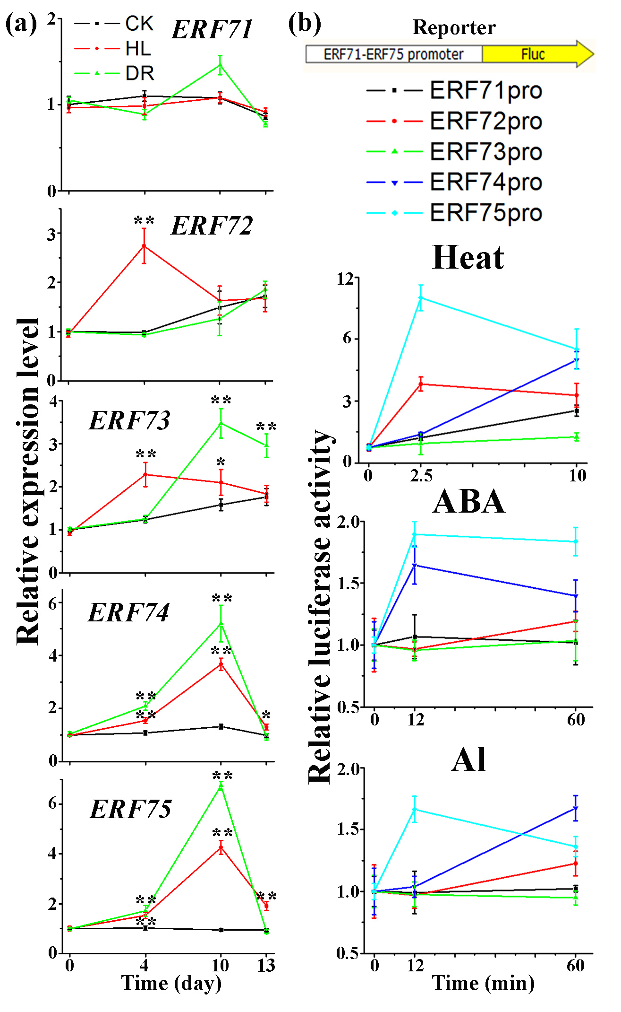
Fig.1 Expression analysis of ERF71-ERF75 during different treatments.
(a) Effects of drought and HL on the expression of group VII ERFs. The expression level of ERF71-ERF75 without treatment was set to 1. Data are means ± SD (n = 4) of three independent experiments (asterisks indicate a significant difference from WT at the zero timetpoint using a Student’s t test: *P<0.05, **P<0.01).
(b) Arabidopsis mesophyll protoplasts were transiently transformed with a plasmid bearing a Firefly Luciferase (FLuc) gene under control of an ERF group VII promoter and a normalization plasmid (35S:RLuc). Protoplasts were placed at 42°C for either 2.5 min or 10 min and incubated with 0.5mM AlCl₃, 20µM ABA for 12 min or 60 min before the promoter activities were measured. The level of promoter activity without treatment was measured and set to an arbitrary value of 1. Data are presented as mean ± SE (n = 4), the experiment was repeated twice.

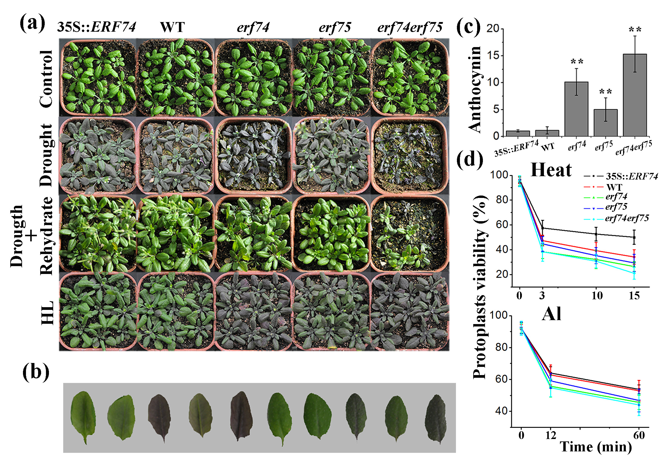
Fig.2 ERF74 and ERF75 have an important role in regulating various abiotic stresses
(a) Phenotype of Arabidopsis erf74, erf75 and erf74;erf75 compared with WT and 35S::ERF74 plants under normal, drought and HL conditions on soil. The experiments were repeated three times with similar results.
(b) The phenotype of leaves of plants following HL treatment (from right to left: 35S::ERF74, WT, erf74, erf75, erf74;erf75).
(c) The anthocyanin content of leaves from plants under HL conditions. Mean ± SD were calculated from three replicates with more than 18 plants each. Asterisks indicate significant differences between the WT and 35S::ERF74, erf74, erf75, erf74;erf75.
(d) Kinetics of changes in the viability of protoplasts measured by flow cytometry analysis in 35S:ERF74, WT, erf74, erf75, erf74;erf75 protoplasts at different times under 42°C heat and 0.5mM Al treatment. Results are shown as means ± SD for three independent experiments.
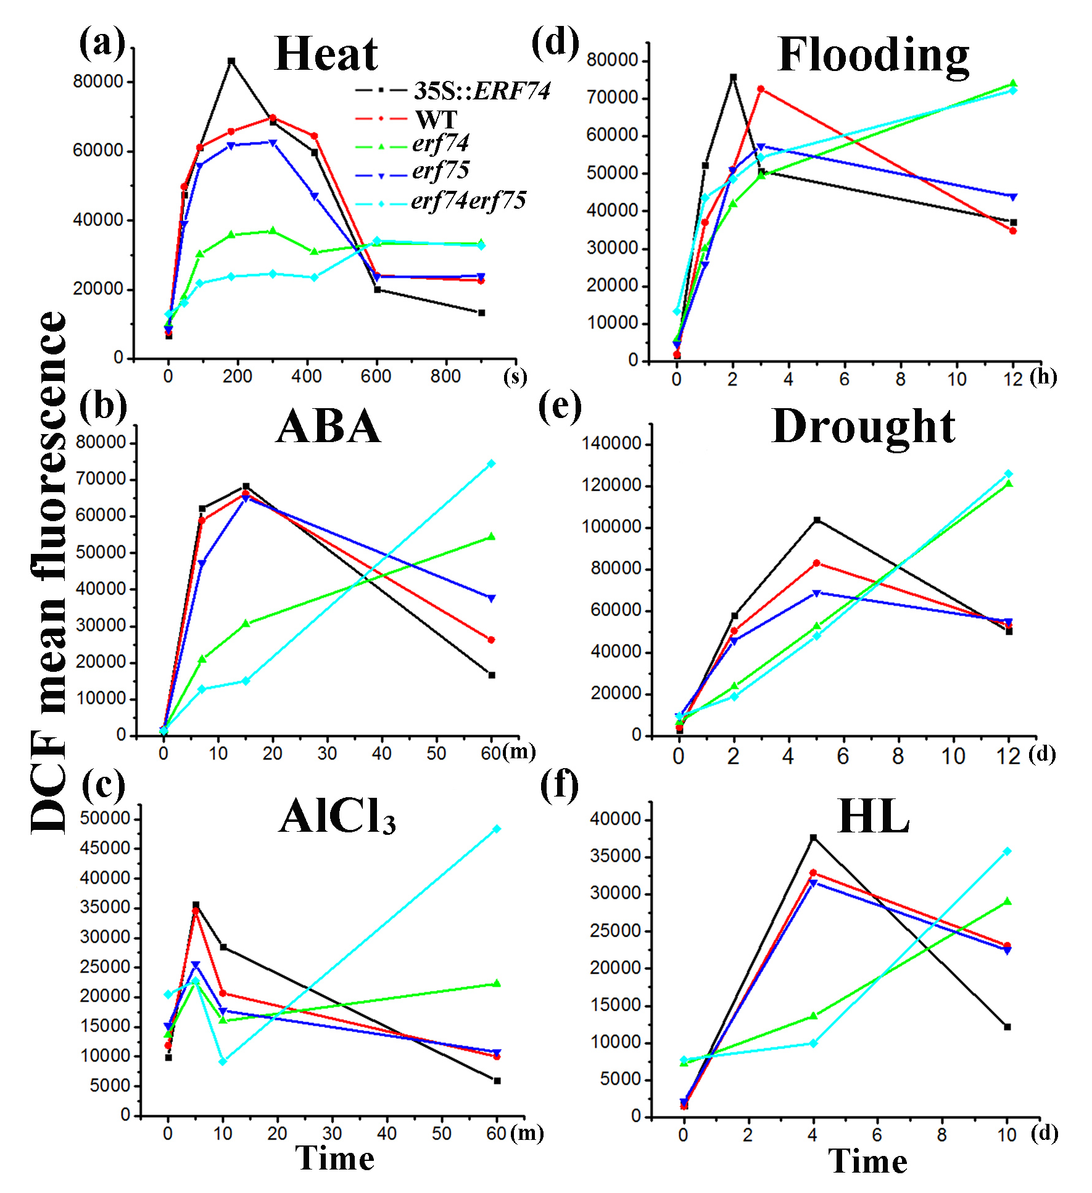

Fig.3 Change in ROS levels under different stress conditions.
(a)-(f) Kinetics of changes in H₂O₂ levels using H₂DCFDA by flow cytometry analysis in 35S:ERF74, WT, erf74, erf75, erf74;erf75 plants or protoplasts under different treatments.

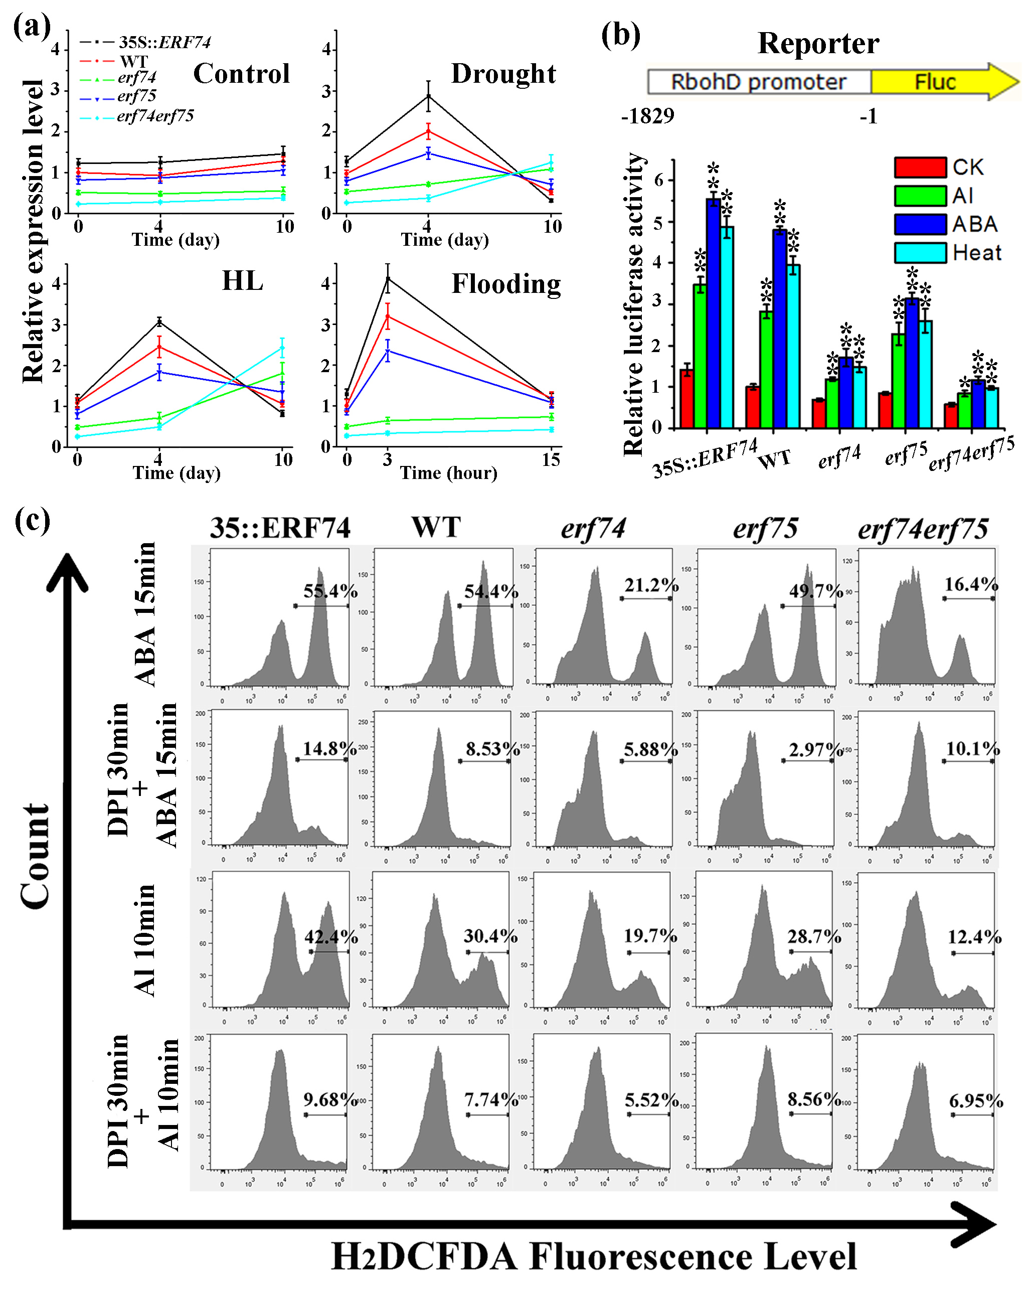

Fig. 4 ERF74 Regulates RbohD under different abiotic stress conditions
(a) RT-qPCR analysis of RbohD transcription in 35S::ERF74, WT, erf74, erf75, erf74;erf75 plants under normal, drought, HL and flooding conditions. The expression level of RbohD without treatment in WT was set to 1. Data are means ± SD (n = 4) of three independent experiments.
(b) Arabidopsis 35S::ERF74, WT, erf74, erf75, erf74;erf75 protoplasts were transfected with RbohD-LUC reporter constructs and treated at 42°C for 2.5 min or incubated with 0.5mM AlCl₃, 20µM ABA for 12min before the promoter activities were measured. The level of RobhD promoter activity without treatment in WT plants was set to 1. Data are presented as mean ± SE (n=4, the experiment was repeated two times, Asterisks indicate a significant difference from CK by t-test: *P<0.05, **P<0.01).
(c) 35S::ERF74, WT, erf74, erf75, erf74;erf75 protoplasts pretreated with or without DPI (10µM) for 30 min, and then incubated with 20µM ABA 15 min or 0.5mM AlCl₃ 10 min. Estimation of changes in H₂O₂ using H₂DCFDA by flow cytometry.

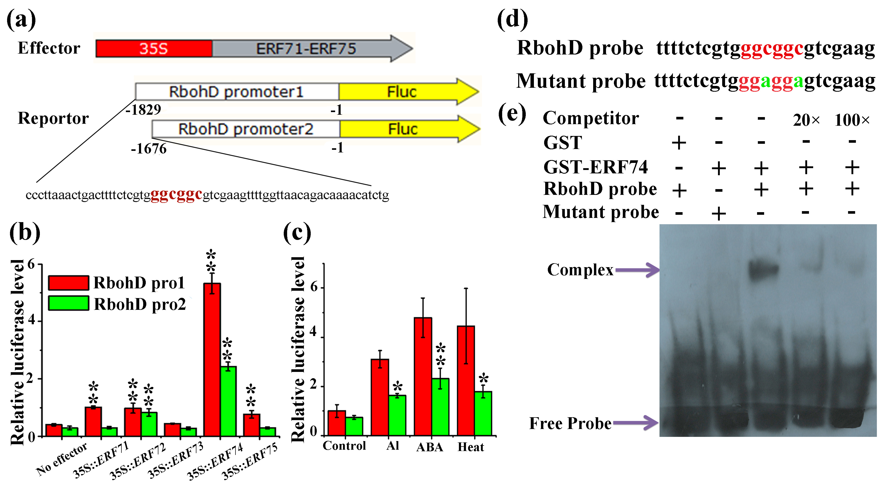

Fig. 5 ERF74 binds to the GCC cis-element of RbohD promoter
(a) Schematic diagram of the LUC reporter vectors containing different RbohD promoters and the effector vectors used in this study. Numbers indicate locations relative to the transcription start site.
(b) The interaction of ERF VII genes with the different RbohD promoter fragments using a transient assay. The level of RbohD pro1 activity in the absence of any effector was set to 1. Data are presented as mean ± SD (n = 4), Asterisks indicate a significant difference from the no effector control using a t-test: *P<0.05, **P<0.01.
(c) Arabidopsis WT protoplasts were transfected with different RbohD-LUC reporter constructs and treated at 42°C for 2.5 min or incubated with 0.5mM AlCl₃ or 20µM ABA for 12 min before the promoter activities were measured. The level of RobhD promoter1 activity without treatment was set to 1. Data are presented as mean ± SE (n = 4, the experiment was repeated twice, asterisks indicate significant differences between RbohD pro1 and RbohD pro2 using a t-test: *P<0.05, **P<0.01).
(d) Biotin–labeled probe sequence of RbohD (-1.724 to -1.702 bp). The core GCCGCC motif is indicated in red. Both C residues within the GCC box were replaced by A residues in the mutant probe and are indicated in green.
(e) EMSA assay using purified GST-ERF74 fusion protein. 1 of protein was added in every lane, non-biotin-labeled probe was added as a cold competitor.

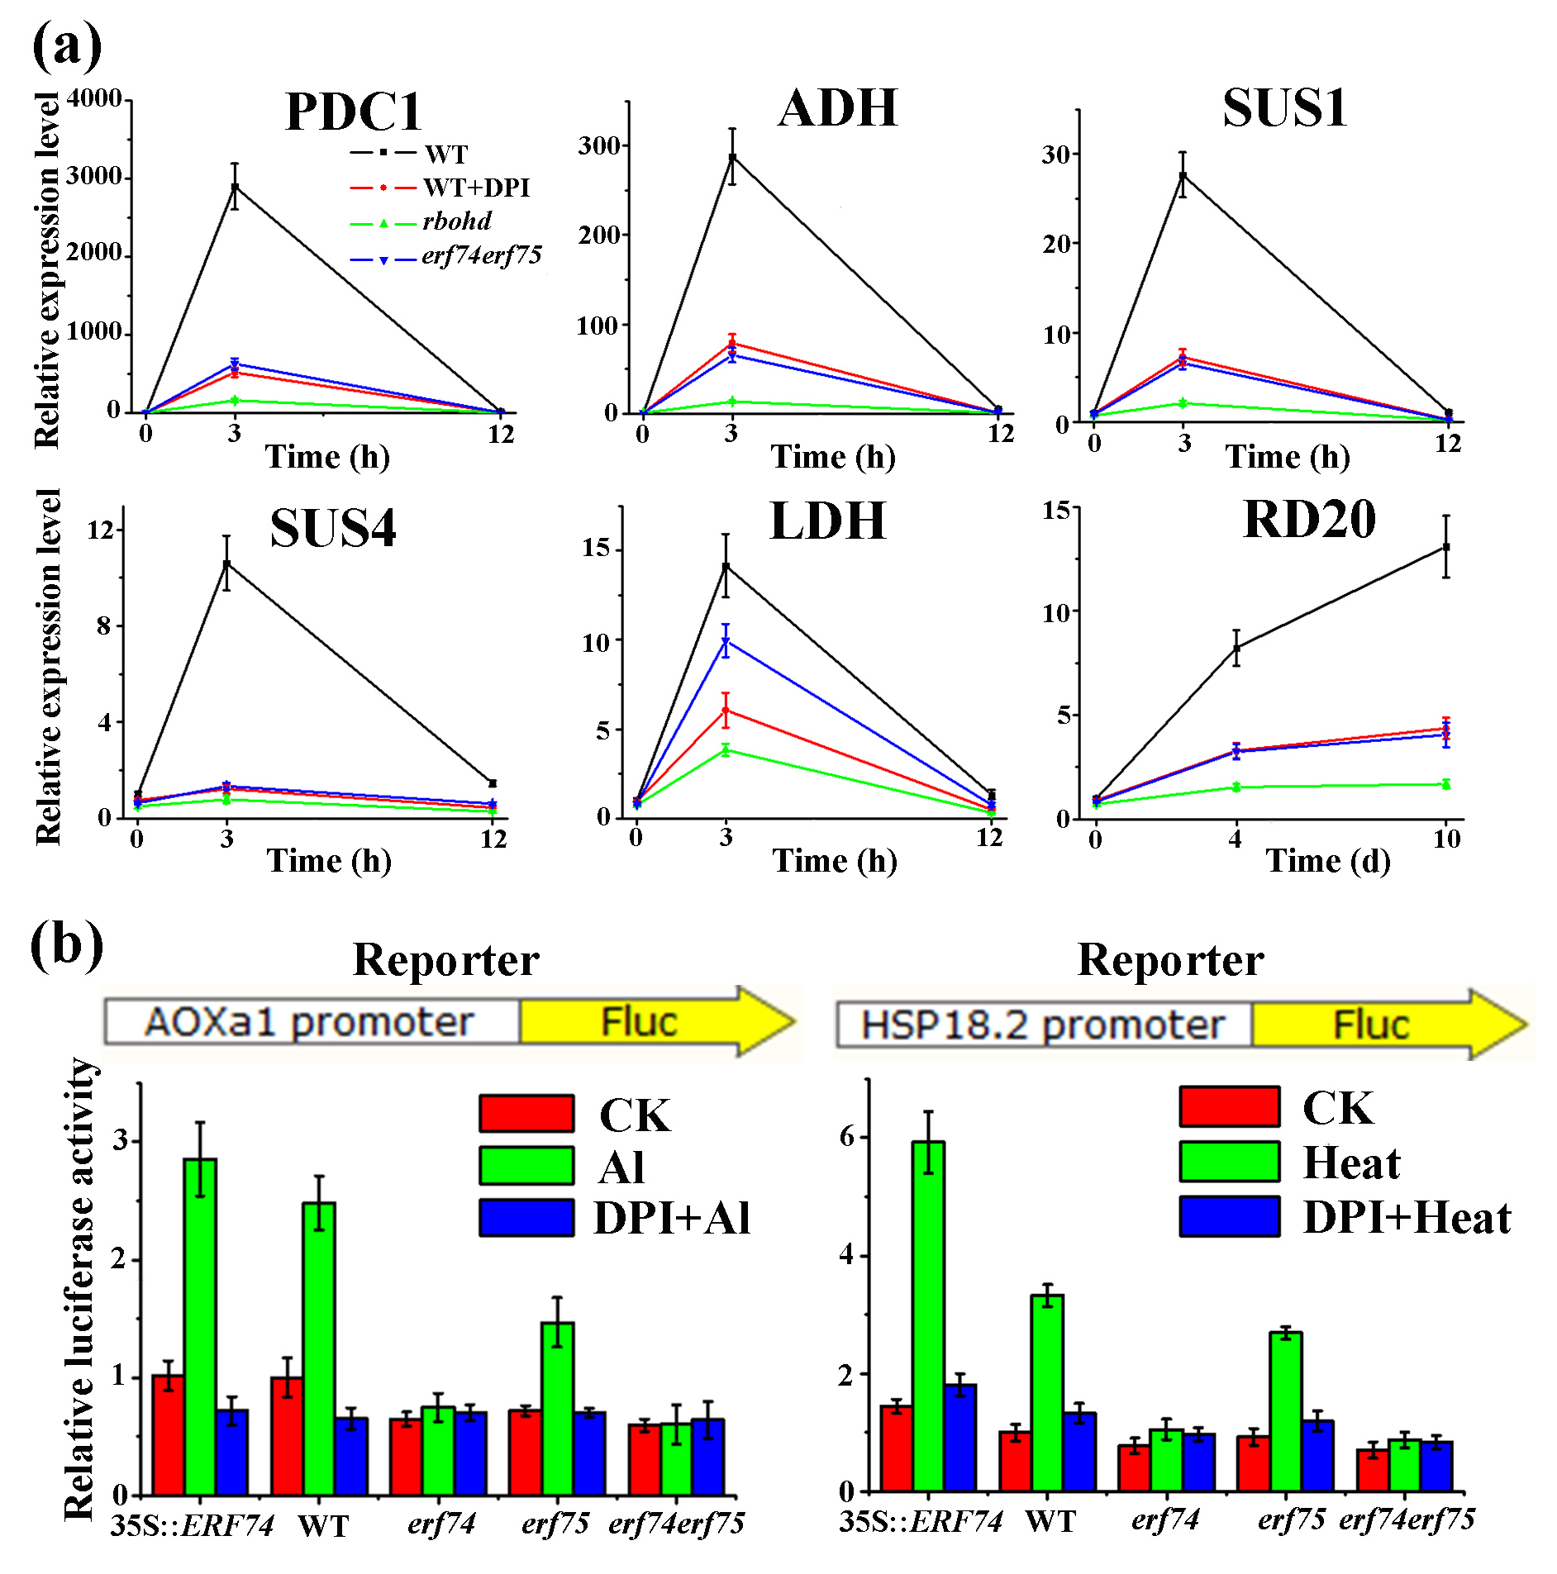

Fig. 6 Analysis of stress marker gene expression under different stress conditions.
(a) Relative transcription levels of flooding and drought marker genes, including ADH, PDC1, SUS1, SUS4, LDH and RD20 in WT pretreated with or without DPI (10µM) for 30 min, rbohd and erf74;erf75 plants under flooding and drought conditions respectively. The expression level of the target gene without treatment in WT was set to 1. Data are means ± SD (n = 3) of two independent experiments.
(b) Arabidopsis 35S::ERF74, WT, erf74, erf75, erf74;erf75 protoplasts were transfected with AOXa1-LUC and HSP18.2-LUC reporter constructs with heat and Al treatments respectively. The level of AOXa1 and HSP18.2 promoter activity without treatment in WT plants was set to 1. Data are presented as mean ± SE (n=4, the experiment was repeated two times, asterisks indicate a significant difference from control by Student’s t test: *P<0.05, **P<0.01).

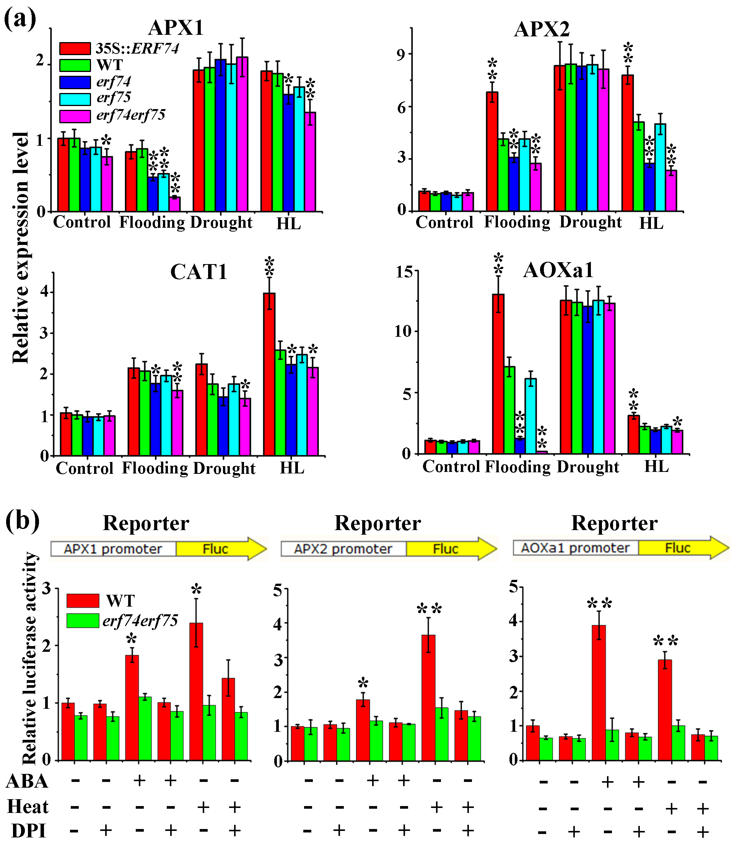

Fig. 7 Analysis of ROS scavenging gene expression under different stress conditions.
(a) Relative transcript levels of APX1, APX2, CAT1 and AOXa1 in 35S::ERF74, WT, erf74, erf75, erf74;erf75 plants after different stress treatments. Total RNA was isolated from seedlings grown under drought or HL conditions for 10d and under flooding conditions for 15h, and subjected to qRT-PCR analysis. The expression level of the target gene without treatment in WT was set to 1. Data are means ± SD (n = 3) of two independent experiments (asterisks indicate a significant difference from WT by Student’s t test: *P<0.05, **P<0.01).
(b) Arabidopsis WT and erf74;erf75 protoplasts were transfected with APX1-LUC (left), APX2-LUC (middle) and AOXa1-LUC (left) reporter constructs with different treatments. The level of ROS scavenging gene promoter activity without treatment in WT plants was set to 1. Data are presented as mean ± SE (n = 4, the experiment was repeated twice, asterisks indicate a significant difference from the control by Student’s t test: *P<0.05, **P<0.01).

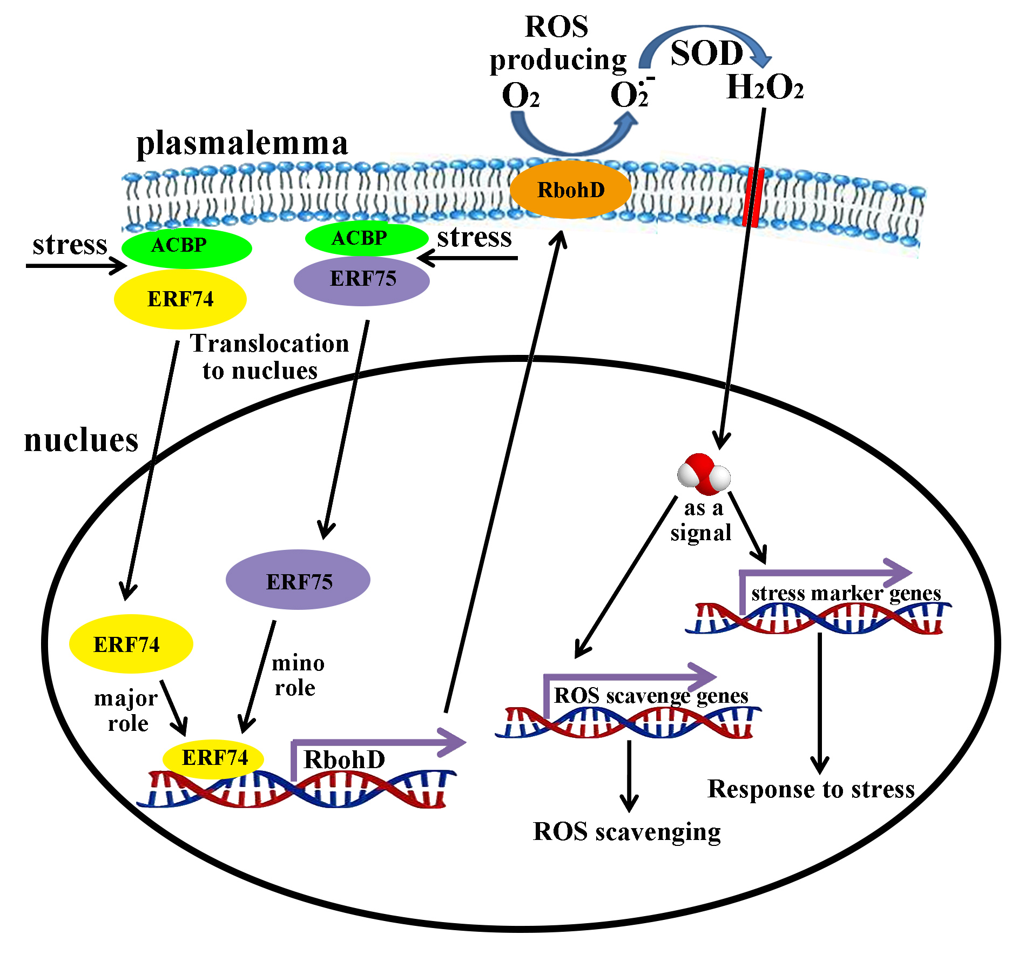

Fig. 8 Model of the ERF74-mediated stress-responsive signaling pathway.
Most of the transcription factor ERF74 is localised to the plasma membrane under normal conditions. Under stress conditions, ERF74 moves into the nucleus, strongly upregulates RbohD expression and enhances the ROS burst during the early stages of the stress response. ROS serves as a secondary messenger and relays the signal to downstream effectors, upregulates stress marker genes and ROS scavenging genes to respond to stress and ROS.

Fig. S1 Diagram of stress tolerance assays in Arabidopsis plants.
All Arabidopsis seeds were planted in the potting soil mixture (rich soil: vermiculite, 2:1, v/v). Plants were kept in growth chambers at 22 to 24°C under 100 mmol m⁻² s⁻¹ long day (LD) conditions (16 h light/8 h dark), with approximately 70% humidity under normal growth conditions. Total RNA was extracted from leaves of plants grown under normal growth conditions for 20d, 24d, 30d, 33d for qPCR control. For drought stresses, the plants were last watered on day 15 after having being sown in soil and then followed by 15 days of drought. A timepoint 5 days after the last watering was taken as the start point of the drought stress (DR 0d). Total RNA and protoplasts were extracted from plant leaves at drought 0d, 4d, 10d and 3d after drought stress for qPCR and FCM respectively. The pictures in Fig 2a were taken in at DR 10d and 3d after drought stress. For light treatment, 20-day-old plants grown under normal light conditions (100 mmol m⁻² s⁻¹) were transferred to high light conditions (250 mmol m⁻² s⁻¹). Total RNA and protoplasts were extracted from plant leaves at HL 0d, 4d, 10d and 3d after HL stress for qPCR and FCM respectively. HL 10d plants and leaf tissue were used for the pictures in Fig 2a-b and anthocyanin content quantification. For flooding stress assay, plants were grown in soil for 29 days, then submerged with deionized water in 20-cm-high plastic boxes and kept in the dark for the indicated time. The different flooding stress times were organized to finish at the same time at which point at which point, total RNA and protoplasts were extracted for qPCR and FCM respectively.

Fig. S2 ERF74-DR is sensitive to normal light and drought
(a) The phenotype of WT and three independent transgenic plants expressing ERF74-DR on soil. Plants were grown on soil at 22 to 24°C under cool-white fluorescent light (90 to 100 μmol m⁻²s⁻¹) under LD (16 h light/8 h dark) conditions.
(b) Drought tolerance phenotype of WT and ERF74-DR on soil. 18-day-old plants were dehydrated for 15 d.
(c) The anthocyanin content of leaves from ERF74-DR plants grown under normal conditions. Data represent mean ± SE (n = 3).
(d) The level of MDA, an end product of lipid peroxidation, was monitored in leaves of plants grown under normal condition. Data represent mean ± SE (n = 3). Asterisks ([C] and [D]) indicate significant differences between the WT and ERF74-DR (Student’s t test P values, *P < 0.05 and **P < 0.01).

Fig. S3 Analysis of the cell viability of 35S:ERF74, WT, erf74, erf75, erf74;erf75 protoplasts under 42°C heat condition using FDA by Flow Cytometry.
The marker bar H was set to indicate cells with high FDA efflux. FDA efflux was measured by counting cells in the H region of the plot.

Fig. S4 Analysis of the cell viability of 35S:ERF74, WT, erf74, erf75, erf74;erf75 protoplasts treated with Al using FDA by Flow Cytometry.
The marker bar H was set to indicate cells with high FDA efflux. FDA efflux was measured by counting cells in the H region of the plot.

Fig.S5 ERF74 and ERF75 modulate ABA sensitivity.
(a) Phenotypes of the 35S:ERF74, WT, erf74, erf75, erf74;erf75 lines following ABA treatment. Five-day-old seedlings were transferred to MS medium containing 20µM ABA and grown for a further 5 days.
(b) ABA sensitivity of root elongation. 5-day-old seedlings were transferred to MS medium with or without 20µM ABA. Graphs show average root lengths of more than 20 seedlings grown for 10 days. The bars represent the SE (±) of three assays. Asterisks indicate significant differences between the WT and 35S::ERF74, erf74, erf75, erf74;erf75 (Student’s t test P values, *P < 0.05 and **P < 0.01).

Fig. S6 ERF74 is translocated from the membrane to the nucleus under various stress conditions.
(a) Subcellular localization of ERF74-GFP in N. benthamiana leaves under normal conditions as well as under flooding, drought and HL conditions. For the drought stress treatment, three-week-old plants were dehydrated until transfection and observed (13 d); For HL stress treatment, plants were grown for 16 h at 70 μmol m⁻ ²s⁻¹ light/8 h dark and then transferred to 16 h at 250 μmol m⁻²s⁻¹light/8 h dark for 48h before observed. The experiments were repeated more than three times with similar results.
(b) Histogram representing the percentage of epidermal cells with nuclear localization of ERF74-GFP under various stresses. Each micrograph contained more than 50 cells on average.

Fig. S7 Analysis of changes in H₂O₂ under 42℃ heat treatment by flow cytometry.
Estimation of changes in H₂O₂ using H₂DCFDA by flow cytometry in 35S::ERF74, WT, erf74, erf75, erf74;erf75 protoplasts under 42℃ heat treatment. Results are from a single analysis that is representative of three independent experiments that yielded similar results.

Fig. S8 Analysis of changes in H₂O₂ with ABA treatment by flow cytometry.
Estimation of changes in H₂O₂ using H₂DCFDA by flow cytometry in 35S::ERF74, WT, erf74, erf75, erf74;erf75 protoplasts with 20µM ABA treatment. Results are from a single analysis that is representative of three independent experiments that yielded similar results.

Fig. S9 Analysis of changes in H₂O₂ with Al treatment by flow cytometry.
Estimation of changes in H₂O₂ using H₂DCFDA by flow cytometry in 35S::ERF74, WT, erf74, erf75, erf74;erf75 protoplasts with 0.5mM AlCl₃ treatment. Results are from a single analysis that is representative of three independent experiments that yielded similar results.

Fig. S10 Analysis of changes in H₂O₂ under flooding condition by flow cytometry.
Estimation of changes in H₂O₂ using H₂DCFDA by flow cytometry in 35S::ERF74, WT, erf74, erf75, erf74;erf75 plants upon flooding treatment. Results are from a single analysis that is representative of three independent experiments that yielded similar results.

Fig. S11 Analysis of changes in H₂O₂ under drought conditions by flow cytometry.
Estimation of changes in H₂O₂ using H₂DCFDA by flow cytometry in 35S::ERF74, WT, erf74, erf75, erf74;erf75 plants upon drought treatment. Results are from a single analysis that is representative of three independent experiments that yielded similar results.

Fig. S12 Analysis of changes in H₂O₂ under HL condition by flow cytometry.
Estimation of changes in H₂O₂ using H₂DCFDA by flow cytometry in 35S::ERF74, WT, erf74, erf75, erf74;erf75 plants upon HL treatment. Results are from a single analysis that is representative of three independent experiments that yielded similar results.

Fig. S13 Analysis of ROS producing gene expression under the condition of flooding, drought and HL.
Relative transcription levels of PRX33, PRX34 and RbohF in 35S::ERF74, WT, erf74, erf75, erf74;erf75 plants after different stresses. Total RNA was isolated from seedlings under flooding, drought and HL conditions at the indicated times, and subjected to qRT-PCR analysis. Data presented are means ± SD (n = 4) of two independent experiments.

Fig. S14 The expression level of APX1 and APX2 are not induced by Al treatment.
Arabidopsis WT and erf74;erf75 protoplasts were transfected with APX1-LUC (a) and APX2-LUC (b) reporter constructs and incubated with or without 0.5mM AlCl₃. The level of ROS scavenging gene promoter activity without treatment in WT plants was set to 1. Data are presented as mean ± SE (n = 4, the experiment was repeated two times, Student’s t test P values, *P < 0.05 and **P < 0.01).

Table S1. Primers Used in This Study.

Gene | Primer (5’→3’)
 | Primers used for gene cloning
ERF71 CLONE F  ERF71 CLONE R  ERF72 CLONE F  ERF72 CLONE R  ERF73 CLONE F  ERF73 CLONE R  ERF74 CLONE F  ERF74 CLONE R  ERF74 DR F  ERF74 DR R  ERF75 CLONE F  ERF75 CLONE R  APX1 PRO F  APX1 PRO R  APX2 PRO F  APX2 PRO F  AOXa1 PRO F  AOXa1 PRO R  RbohD PRO1 F  RbohD PRO2 F  RbohD PRO R  HSP18.2 PRO F  HSP18.2 PRO R  ERF74F IN-PGEX  ERF74R IN-PGEX | GGGGACAAGTTTGTACAAAAAAGCAGGCTTCATGTGTGGGGGAGCTATCATTTC  GGGGACCACTTTGTACAAGAAAGCTGGGTCGAGATTTAATTGGAGTCTTGATAGCTCC  GGGGACAAGTTTGTACAAAAAAGCAGGCTTCATGTGTGGCGGTGCTATTATTTC  GGGGACCACTTTGTACAAGAAAGCTGGGTCTTACTCATACGACGCAATGACATCATC  GGGGACAAGTTTGTACAAAAAAGCAGGCTTCATGTGCGGAGGAGCTGTAATTTC  GGGGACCACTTTGTACAAGAAAGCTGGGTCTCAGGACCATAGACCCATGTCATTG  GGGGACAAGTTTGTACAAAAAAGCAGGCTTCATGTGTGGAGGAGCTATAATATCCG  GGGGACCACTTTGTACAAGAAAGCTGGGTCTCAGAAGACTCCTCCAATCATGG  GGGGACAAGTTTGTACAAAAAAGCAGGCTTCACAGGGACATAGACACTCTTTGG  GGGGACCACTTTGTACAAGAAAGCTGGGTCGAAGACTCCTCCAATCATGGATG  GGGGACAAGTTTGTACAAAAAAGCAGGCTTCATGTGTGGAGGAGCTATAATCTCC  GGGGACCACTTTGTACAAGAAAGCTGGGTCTCAAAAGTCTCCTTCCAGCATG  GGGGACAAGTTTGTACAAAAAAGCAGGCTTCCACTATCTCACAAACCTGCATTATC  GGGGACCACTTTGTACAAGAAAGCTGGGTCTCTTAGCTAAGCTCTGGAACAAATAC  GGGGACAAGTTTGTACAAAAAAGCAGGCTTCCTTGACTTGTTCTCTTATCAACCG  GGGGACCACTTTGTACAAGAAAGCTGGGTCTTTTTTCAAATTCGCTTCCTTCTGG  GGGGACAAGTTTGTACAAAAAAGCAGGCTTCTCTGAAGAGCTTCTAGCTTTGTTTTG  GGGGACCACTTTGTACAAGAAAGCTGGGTCTGTTTCAAATCGGAAAAAGTGAAATC  GGGGACAAGTTTGTACAAAAAAGCAGGCTTCCCATCGATTTGTACTATGTGCTC  GGGGACCACTTTGTACAAGAAAGCTGGGTCTTCATGATGCCTGCATAACTCTATG  GGGGACCACTTTGTACAAGAAAGCTGGGTCCGAATTCGAGAAACCAAAAAGATCTC  GGGGACAAGTTTGTACAAAAAAGCAGGCTTCTTGTTACTACGCCACAGAACCTC  GGGGACCACTTTGTACAAGAAAGCTGGGTCTGTTCGTTGCTTTTCGGGAGAC  GTTCCGCGTGGATCCTCTGCAAATAGGAAGAGGAAGAATCAG  CGACCCGGGAATTCCCTGAGAATTAGCCTTCATGTTTTCTTC
 | Primers used for qRT-PCR
ACTIN2-F  ACTIN2-R  RbohD F  RbohD R  APX1 F  APX1 R  APX2 F  APX2 R  CAT1 F  CAT1 R  AOXa1 F  AOXa1 R  ERF71 F  ERF71 R  ERF72 F  ERF72 R  ERF73 F  ERF73 R  ERF74 F  ERF74 R  ERF75 F  ERF75 R  PRX33 RT F  PRX33 RT R  PRX34 RT F  PRX34 RT R  SOD3 F  SOD3 R  RbohF  RbohF  RD20 RT F  RD20 RT R  ADH RT F  ADH RT R  PDC1 RT F  PDC1 RT R  SUS1 RT F  SUS1 RT R  SUS4 RT F  SUS4 RT R  LDH RT F  LDH RT R | TCCCTCAGCACATTCCAGCAGAT  AACGATTCCTGGACCTGCCTCATC  GGCACTGATAATGGAAGAGTTGGAC  AGTATCCTGCTGTCTCCCATCC  CCCAACCGTGAGCGAAGATTAC  TCGAAAGTTCCAGCAGAGTGC  ACCCTATCAAGGAGCTGTTCCC  CCAGGATGAAATGGAATCTCTGGTC  CGTGAAGCGTTTTGTTGAAGC  CGAGTTGCTAGTTTCTGTCCCAG  CTCTTCGTTGGCCTACCGATTTG  CCTCCAACCATTCCAGGTACTG  GAAGCGTAAACCCGTCTCAGT  TTTGCTCGGGTCACGAATCT  CCGACGACTTCTGGGGTTTC  CCCATGGACGCTTACGTATCC  GTCTTCCTGGAGAAGTAATGGCG  CCCAAGGCCTTCTTCTGATTCC  CGCCGATGTGAAACCATTCG  CGCCGATGTGAAACCATTCG  AAGCCTTTCGTCTTCACCGC  AGGACGCTGCCTAATCCCTC  GAGCATCCTTCGTCTTCACTTCC  GGGCTGAATTTGCATTTCCAAGTG  GTTAAGGTCGGACCCTCGTATC  GAGCCGAATTTGCGTTTCCAAAC  GCTCTCTTAGGTCTCGAGGTGG  CTCGATGGTGTTTTCCCCAATG  CCGTTCTCAAAGAACGATCGGC  TCGACGCTACGAAGAACGATTG  CGCGCTAACGGTTAAAGATAA  AACCATCTTCGTCCTTAGCAA  CATGAACAAGGAGCTGGAGCTTG  CTCTCCCTTCAGCATGTAATCAAAGG  CCAATTTAGTGACATTTTCTGATAAGTGTTG  AAACATGATTAAACCCAACGGTCGA  GAGAAGAGAAAAGACTCGGAACCAGT  CACAGAGGCAAAGGAAAACAAAGAC  GAAGAGTGAAAGAAGAAGATTTTCTACATTC  TAAAAAACAATGGTGAAGCATATCATAAAA  AGGAATGGTGTGGTTGCTGTGAC  GCAGCTTCTCAGCCTCTTCATCA

