Reply to: ‘Underestimate of annual malaria imports to Canada’

Andrew J Tatem^{1,2}
- WorldPop, Department of Geography and Environment, University of Southampton, Southampton, UK
- Flowminder Foundation, Stockholm, Sweden

We thank Boggild et al¹ for highlighting datasets and important insights on malaria cases imported to Canada. Their letter provides an excellent example of the challenges of undertaking a consistent and comprehensive meta-analysis of nationally-reported statistics on imported malaria. With a focus on the geography of imported malaria globally, our analyses were built around publicly-available national data with information on the origin country or region of cases. Unfortunately the notifiable disease data highlighted by Boggild et al¹ provide no such geographical components. This meant that the follow-on processing steps that were the main analysis components of the paper could not be undertaken with these data (e.g. figure S1²). Boggild et al¹ show how this can be circumvented through triangulating between these publicly available national statistics and data from surveillance networks that are typically not available beyond network members. This goes beyond the remit of Tatem et al², but is an important area for future research if further details on geographical patterns and trends are to be uncovered that cannot be discerned from publicly available data. It may be a significant challenge to assemble restricted-access surveillance data across all non-endemic countries and to develop the variety of approaches required to integrate them with national reporting data in a consistent fashion, but would be a valuable next step.
Boggild et al¹ request an amended figure 1. The figure represents a mapping of national data where origin country was publicly reported, which is not the case for the Canadian notifiable data. We have however relaxed these criteria here, with an amended version of figure 1a (Figure 1) that includes an exception for Canada, and readers should be aware of this inconsistency. For clarity, figure 1b in Tatem et al² presents annual average flows greater than 50 cases between individual countries. Boggild et al¹ show in their recent analysis of CanTravNet data³ that the largest source countries of cases are Nigeria (9.4%) and India (9.2%). Applying these proportions to the 420 annual average imported cases from the notifiable disease data produces 39 cases for both routes, lower than the 50 case threshold and not altering figure 1b in Tatem et al².
As stated in Tatem et al², we encourage input from those who have access to data unavailable to the wider community, such as those from CanTravNet, to enable continual updates and insights, and better understand how human mobility is impacting global malaria movement.
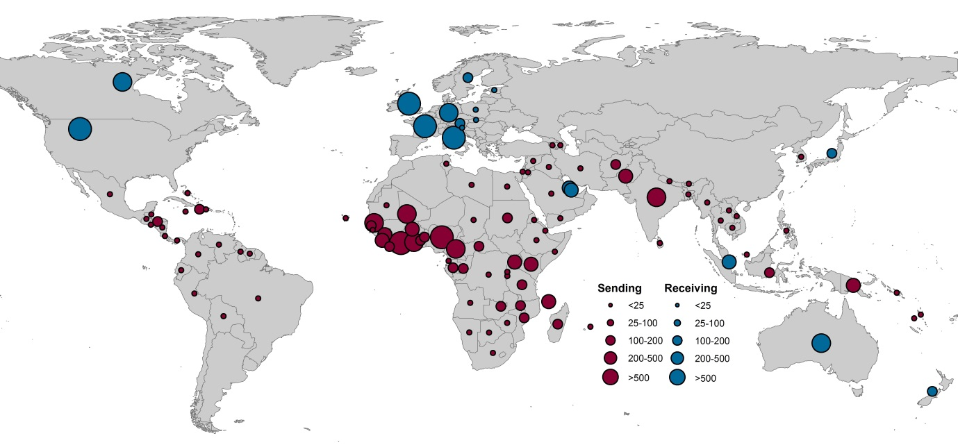
Figure 1. Origins and destinations of imported cases of malaria from endemic to non-endemic countries. Of the non-endemic countries that reported the origin country of imported cases, the average annual number of malaria cases (all species) between 2005 and 2015 exported from endemic to non-endemic countries (red) and imported cases to non-endemic from endemic countries (blue). An exception is made here for Canada, where notifiable data on the number of cases received, without reported origins, has been included.

References
1. Boggild AK, McCarthy AE, Libman M, Freedman DO, Kain KC. Underestimate of annual malaria imports to Canada. Lancet Infectious Diseases 2017; in press.
2. Tatem AJ, Jia P, Ordanovich D, et al. The geography of imported malaria to non-endemic countries: a meta-analysis of nationally reported statistics. The Lancet Infectious diseases 2017; 17(1): 98-107.
3. Boggild AK, Geduld J, Libman M, et al. Malaria in travellers returning or migrating to Canada: surveillance report from CanTravNet surveillance data, 2004-2014. CMAJ open 2016; 4(3): E352-E8.

