Simulation of Electrostatic Oil Line Sensing and Validation Using Experimental Results
R.C. Liu^{a,}*, H.F. Zuoª, J.Z. Sunª, L. Wang^{b}
ª College of Civil Aviation, Nanjing University of Aeronautics and Astronautics, Nanjing, 210016, China
^{b} national Centre for Advanced Tribology at Southampton (nCATS), Faculty of Engineering and the Environment, University of Southampton, Highfield, Southampton, SO17 1BJ, UK

Abstract: Electrostatic Oil Line Sensor (OLS) is one type of the electrostatic sensors based on electrostatic charging phenomenon and has been used in wear debris monitoring in oil lubricated tribological systems. With the advantages of high sensitivity and resolution, OLS has been proved to be an effective sensing technique for sliding, rolling and bearing contacts. However the sensing technique has so far not been widely used in industrial systems due to the difficulties in identify the exact charge sources and charging mechanisms in a complex tribological system. This paper presents the results from a simulation of the sensing mechanisms that is successfully validated by experimental results. The initial OLS simulation results have led to a better sensor design and its application.
Keywords: electrostatic sensing; Oil Line Sensor; charge simulation; ratio of length and diameter

1. Introduction
Electrostatic sensing was firstly developed to detect wear debris presented in the exhaust path of gas turbine engines due to deterioration of engine components [1, 2]. Two electrostatic monitoring systems, EDMS (Engine Distress Monitoring System) and IDMS (Ingested Debris Monitoring System), were installed in gas turbine engines [3, 4]. Later on, significant amount of research has been conducted to develop the electrostatic sensing to monitor wear and debris generation in tribological systems under both dry and lubricated conditions [5]. There are two types of electrostatic sensors, namely OLS (Oil Line Senor) and WSS (Wear Site Sensor) detecting charges in lubricant circulations and on worn surfaces respectively [6]. A large number of experimental work have been conducted to investigate the electrostatic sensing of the tribological contracts, such as sliding rolling and bearing wear systems [7-10], demonstrated that the electrostatic sensing techniques have considerable advantages in condition monitoring of tribo-contacts [11-21]. One of the advantages of electrostatic monitoring techniques is its high sensitivity and resolution. Electrostatic charges at wear site and on wear debris can be directly measured using electrostatic charge signals from the sensors, hence is regarded as a direct measurement of wear rather than measuring the secondary effects of wear, such as vibration and temperature. It can not only detect deterioration due to severe failures similar to conventional techniques but can also provide early warnings and detections [22-25].
Although a large number of investigations have been undertaken on the electrostatic monitoring techniques through experimental studies, limited efforts have been made to investigate the influence of sensor structures and characteristics on the detection. The exact relationships between the charge induced on the sensor surface (sensor output) and the charge in the system that induces the charge on the sensor surface (sensor input) are not confirmed. The detection performance, range and factors of the sensors should be clarified and determined prior to their applications in real engineering systems to ensure robust sensing. Only a few investigations have been carried out in this aspects. Morris [22] used a number of charged steel balls with different diameters to investigate the sensor response and the best sensor geometry was selected, while Harvey [12] developed an oil droplet rig to investigate the electrostatic charges. The concept of the sensor efficiency and the field of view for OLS was firstly raised by Morris [22]. Gajewski and Yan et al. [26-31] established a mathematical model for the ring type probe based on charging principles, focused on the output type. However no further investigations into the optimisation of sensors using more effective parameters have been conducted. Also the lack of sufficient experimental work has limited the validation of the model. More suitable parameters and validation methods are required for the optimization of the sensor designs and the better applications of electrostatic sensors
Based on previous research results, a number of parameters have been chosen in this study to characterize electrostatic sensors. A mathematical model based on the electrostatic sensing principle and a predefined OLS structure has been developed to simulate the charging and charge detection mechanisms using OLS. The simulation results have been validated using experimental results obtained through an electrostatic sensor calibration system.

2. Sensing principle and sensor model

2.1. OLSs and their sensing principle
Electrostatic sensing that translate the initial charge in a tribological system to an electrostatic charge signal is a complex process. There are many charging mechanisms that could potentially be involved in a tribological system, including tribo-charging, surface charge, tribo-emission and debris generation [5, 20]. For an OLS, which typically has a ring shape sensing face, is normally positioned in a lubricant flow downstream from wear components. An OLS is consist of four parts, including a conductive probe (ring type sensing face and could have more than one), an insulation layer, a shielding layer and a signal output connector (corresponding to the probe). A schematic diagram of an OLS is shown in Fig. 1.
When a charge source (denoted as q with +Q charge quantity), such as charged debris or lubricant charge species (e.g. additives or soot particles), or the combination of the two, passes through the bore of the sensor, an equal opposite charge will be induced on the sensing face that can be detected as a charge response. For multiple charge sources, the overall charge signal can be obtained by adding the single individual charge sources together. Therefore, single charge source is used and discussed in details during sensor simulation and validation using experimental data.
It is worth mentioning that Fig. 1(b) is a picture of one of the used OLSs in this study which has two identical probes. The two ring probes are relatively far apart and do not interfere each other. Also the results of two outputs are nearly the same with one output condition in experiments. Hence the researches focus on the situation of one ring probe corresponding to one output to simplify the analysis processes and result.
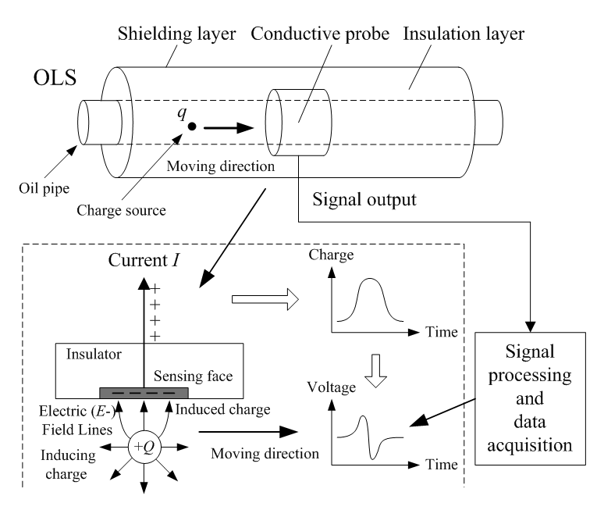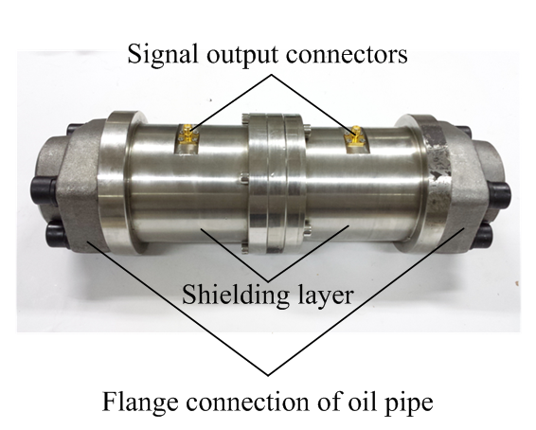
(a) (b)
Fig. 1. Electrostatic OLS (a) A schematic of OLS sensor structure and monitoring principle. (b) A picture of the OLS used in this study.

2.2. A mathematical model
Fig. 2 shows the space coordinate system of a point charge in the sensing zone of an OLS according to the mathematical model provided in [30, 31]. It is assumed that the probe has a perfectly conductive ring with its outer surface earthed. The origin of the coordinate is at the geometrical center (symmetrical center) of the probe. The axial direction of the probe is Z axis. The diameter of the probe is set at 2R and a length of 2L in the axial direction is considered. The thickness of the probe in the radial direction is ignored. The ring shape probe is symmetrical thus a point charge within the 3D space can be transformed into the XOZ plane. For a point charge q in the XOZ plane with a coordinate of A(x,0,z), the projection of A on the XOY plane is A_{x}(x,0,0).
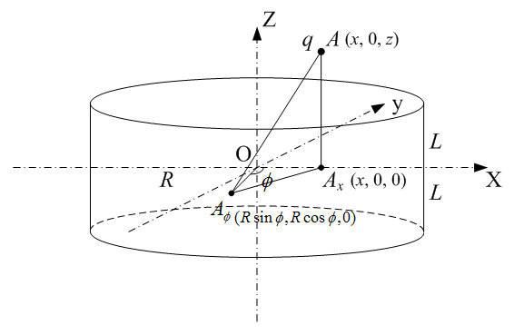
Fig. 2. The coordinate system for the sensing zone of an OLS ring probe
By Coulomb's law and Gauss theorem, using the notations in Fig. 2, the total induced charge Q on the inner surface of the probe for a given point charge q can be calculated using the following equation
(1)
where is the angle between line OA_{x} and line , is any point of the probe in the XOY plane. Considering the structure of the OLS, where the induced charge will be shielded outside the ring, x has values in the range of (-R, R) in the radial direction.

3. Sensor parameters

3.1. Spatial sensitivity
From Equation (1), it can be seen that the charge Q induced on the sensor at a fixed length and diameter is affected by the point charge q, its radial position x and axial position z. Since the induced charged Q is proportional to the inducing charge q (seen from Equation (1)), the spatial sensitivity [30] is a proposed parameter which is only related to the spatial position getting rid of the influence of inducing charge quantity q. In addition, based on the electrostatic sensing principle and the conservation law of charge, the induced charge Q on probe and the inducing point charge q have opposite polarities, whereas the sensor output Q' has the same polarity as the inducing charge q.
Thus, in order to ensure the parameter to be positive, the spatial sensitivity of a ring type electrostatic probe is defined as the negative value of the ratio of the induced charge to the inducing point charge and is represented by the following dimensionless parameter
(2)
where s is the spatial sensitivity, Q is the induced charge on the probe and q is the inducing point charge, x and z are the space relative radial and axial position of the point charge to the probe. The induced charge Q can be calculated using the above mentioned mathematical model for a point charge at any positions in the sensing zone.

3.2. Input and output correlation curve
To understand the relationship between input and output, experimental sensor calibration is usually required to produce an input-output correlation curve, which becomes the basis of the sensor characteristic and other parameters. For the electrostatic OLS, the input is the inducing charge located in the sensing zone that can be measured using suitable devices, while the corresponding output is the voltage signal that is acquired and processed by the electrostatic sensing system. According to Ohm's law, the actual output voltage signal and the induced charge are related according to the following equation
(3)
where U is the output voltage and R_{i} is equivalent resistance of the electrostatic monitoring system, and t is the change time of the induced charge Q. A typical result of an inducing point charge passing through OLS is illustrated in Fig. 3. Even conducted in a relatively clean environment, charge measurements in different laboratories using different instrumentation could end up different absolute values due to cabling, charge amplifiers and connectors etc. However the output voltage is always proportional to the factor R_{i}. Hence the ratio together with the maximum value is used to ensure repeatability and consistency of the measurements.
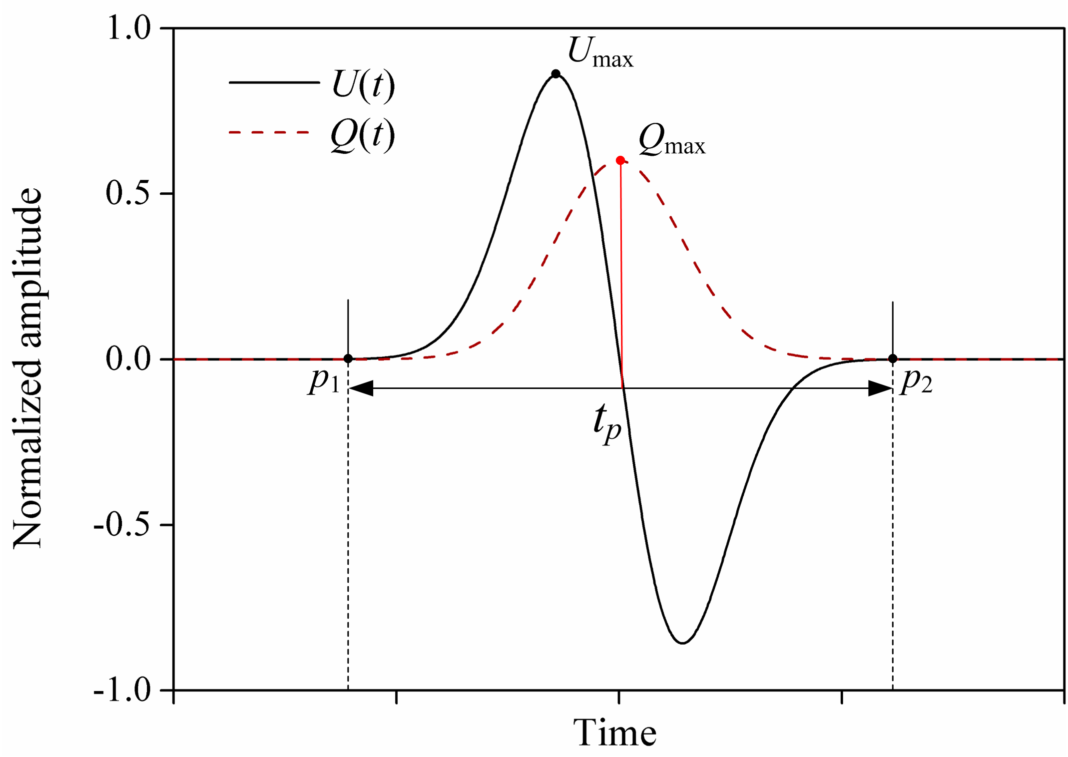
Fig. 3. A schematic of an induced charge and the corresponding output voltage when the inducing point charge passes through the sensing zone.

3.3. Sensor efficiency
Sensor efficiency or sensitivity is an important parameter that measures the sensor’s detection ability. Since the spatial sensitivity and input-output correlation curve change with the position of the inducing point charge, a relatively static parameter i.e. sensor efficiency corresponding to a specific and fixed spatial position to the probe which can directly reflect the minimum detection ability while the inducing charges are passing through the sensing zone [22]. It means no matter how the charge sources pass through the sensor (position, velocity, trajectory and rotation), the detected output can at least have the corresponding ratio of values to the inducing charges.
Morris [22] defined the sensor efficiency as the ratio of the negative value of the induced charge on the probe to the inducing point charge at a specific position in the sensing zone of the OLS and multiply by 100%. The theoretical efficiency can be thus be expressed by the following:
(4)
where η is the sensor theoretical efficiency, Q is the induced charge on the probe and q is the inducing point charge, x₀ and z₀ are the selected specific space relative radial and axial position to the probe. It is obvious that the sensor theoretical efficiency is actually equal to the spatial sensitivity of the position (x₀, z₀) to the probe.
The ‘real’ sensing efficiency of the electrostatic OLSs is measured through experiments based on the actual input and output signals. It is defined as the ratio of the sensor output charge to the sensor input charge at a specific position and also multiply by 100%, can be represented by the following:
(5)
where η' is the sensor real efficiency, Q' is the charge of the sensor output and q' is the charge of the sensor input, x₀ and z₀ are the same parameters used in Equation (4), i.e. same position as the theoretical sensor efficiency. The reason for theoretical efficiency with minus has been given above in section 3.1. However, since the input and output charge measured by sensors have same polarity, there is no minus sign in Equation (5). More details on the position of charge in the OLS will be given in the results and discussions part below. The range of both efficiencies should be between 0 and 1.

3.4. Static sensitivity
Due to the fact that an input charge will be in a state of constant motion, it is difficult to determine the specific position of the charge at a specific time. While the sensor output is a voltage signal instead of charge, it makes it more difficult to calibrate and validate the sensor through experiment. Thus, static sensitivity [28] has been introduced to define sensor’s physical characteristics. Static sensitivity has been used to quantify the sensor’s ability in responding to charge variations that can be obtained from the sensor input and output correlation curve. Different from the spatial sensitivity, the static sensitivity is defined as the ratio of the increment of voltage of the sensor output to the increment of charge of the sensor input, which can be expressed by the following:
(6)
where s' is sensor static sensitivity, ΔU' is the increment of voltage of the sensor’s output and Δq' is the increment of charge of the sensor’s input. The corresponding position of this parameter will be further explained in the experimental setup and discussion below.

3.5. Field of view
Similar to that in optics [32-34], 'field of view' is introduced as an essential and significant parameter for electrostatic OLSs due to the fact that OLSs only detect charge in the field of the sensing zone of a probe. The electrostatic field of view used in Morris's work [22] was defined as the measurable maximum range in space detected by the electrostatic sensor when an inducing charge passes through the sensing zone of the sensor probe. The part of charge that is out of the range cannot be detected by the electrostatic OLS thus is the 'blind area' of the sensor. Field of view is an important parameter that characterizes the scope of a sensor and can also be used to optimizing the design of OLSs.
Assuming the inducing point charge is passing through an OLS at a constant velocity v_{c} at a constant radial position, as seen in Fig. 1(a), the corresponding charge induced on the sensor can be illustrated as the red curve in Fig. 3, where a peak starts at p₁ when the level first rises above the baseline and ends at p₂ when the level returns to the baseline level. The duration from p₁ to p₂ is taken as the duration of charge passing the probe t_{p}. The electrostatic field of view m_{p} at the corresponding radial position can thus be calculated by the following equation [22],
(7)
The duration t_{p} can be calculated using . The total field of view in the axial direction of the OLS is the collection of the field of view at all the corresponding radial positions. Since the field of view of an electrostatic OLS in the radial direction is limited to inside of the sensor so has the maximum length of the probe internal radius. Hence the field of view for electrostatic OLSs is typically referred to the range in the axial direction. Due to the symmetrical nature of the ring shape probes, the field of view is identical on the two sides from the centre of the probe. The investigation will thus only be looking at one side of the sensor for simplification. Then the total field of view can be obtained and doubled by the half range.

4. Experimental setup and calibration method
According to the principle of electrostatic sensing and the presented sensor parameters, the charging oil droplet is selected as the input inducing charge in the experiment calibration, referring to the investigation conducted by Harvey et al [12]. A further modified experimental setup and the monitoring system is designed and used for calibration and validation of the electrostatic OLS, as shown in Fig. 4.
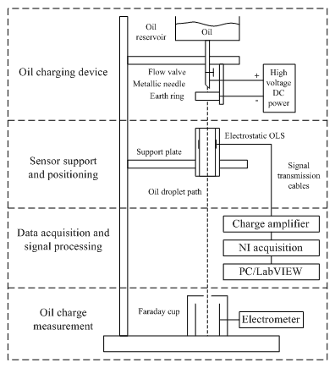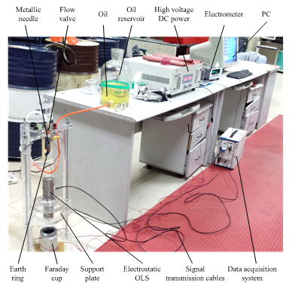
(a) (b)
Fig. 4. The experimental setup and electrostatic OLS calibration system (a) Schematic diagram. (b) Organization of the instrumentation
The electrostatic OLS calibration system consists of four parts, namely, oil charging device, sensor support and positioning, data acquisition & signal processing and oil charge measurement. The oil charging device is the part to produce the charged oil droplet, with charging quantity and polarity adjustable, as the input to the sensor. It consists of an oil reservoir, from which a valve feeds an electrically insulated metallic needle holder. A high voltage power supply is connected to the reservoir and needle holder so that the potentials of up to ±500 V can be applied to the droplet. When the valve is opened a droplet forms on the needle and the applied potential between the needle and an earthed ring induces charge on the oil droplet.
The sensor support and positioning platform is the part to fasten the OLS to be tested and control the relative position of the droplet path to the sensor probe. The direction of the sensor is fixed vertical to the ground (parallel to the droplet path) in order to ensure the oil droplet passing through the sensor and falling into the Faraday cup.
The part of data acquisition and signal processing is a monitoring system connected to the electrostatic OLS through a charge amplifier (amplified 1000 times) and cables for acquiring the electrostatic signal output from the sensor. The output voltage is recorded by an NI data acquisition card through a LabVIEW program. The absolute charge of the oil droplet is measured using a Faraday cup connected to a Keithley 6517B electrometer as the sensor input.
The corresponding input and output signals are both measured to further analysis the electrostatic sensor. Moreover, all the following experiments are processed in a relative pure environment with little electromagnetic background noise to enlarge the signal to noise ratio, while the test errors exist inevitably.

5. Results and discussion

5.1. Simulation of spatial sensitivity and theoretical efficiency
Based on the mathematical model for electrostatic OLS described in sections 2.2 and 3 above, the spatial sensitivity of oil line sensor can be simulated using Equations (1) and (2). Due to the symmetrical structure of the probe, the distribution of spatial sensitivity is investigated in two directions, i.e. in the axial direction at a fixed radial position and in the cross-section plane at a fixed position along the axial direction. In simulation, the length in axial direction H and diameter D of the probe are considered, while the thickness of probe (radial thickness), insulation and shielding layer are neglected due to the relatively small value compared to D. From Fig.2, it can be seen that H =2L and D=2R. All the lengths described below are in millimeter (mm).
The distribution of spatial sensitivity is simulated for a range of H and D values and the results are presented in Fig. 5. Figs. 5(a) and 5(b) show the results for H=20 and D=20. From Fig. 5(a), it can be seen that the spatial sensitivity s increases with the decrease of the absolute value of axial position z (|z|) when radial position x is fixed; the spatial sensitivity s has the maximum values when z=0, i.e. at the center of the ring; as expected, the spatial sensitivity in the axial direction is symmetrical on the two sides of z=0; all the curves intersect at about |z|=10, i.e. the probe length. It can be seen that the s value gradually decreases to close to zero at about |z|=40 mm, which means that the spatial sensitivity of OLS exists both inside and outside of the probe. From Fig. 5(b), it can be seen that the spatial sensitivity s increases with the increase of |x| inside of the probe (|z|<10mm) while it decreases outside of the probe; the spatial sensitivity s has a minimum at the center inside the probe and a maximum at the center outside the probe.
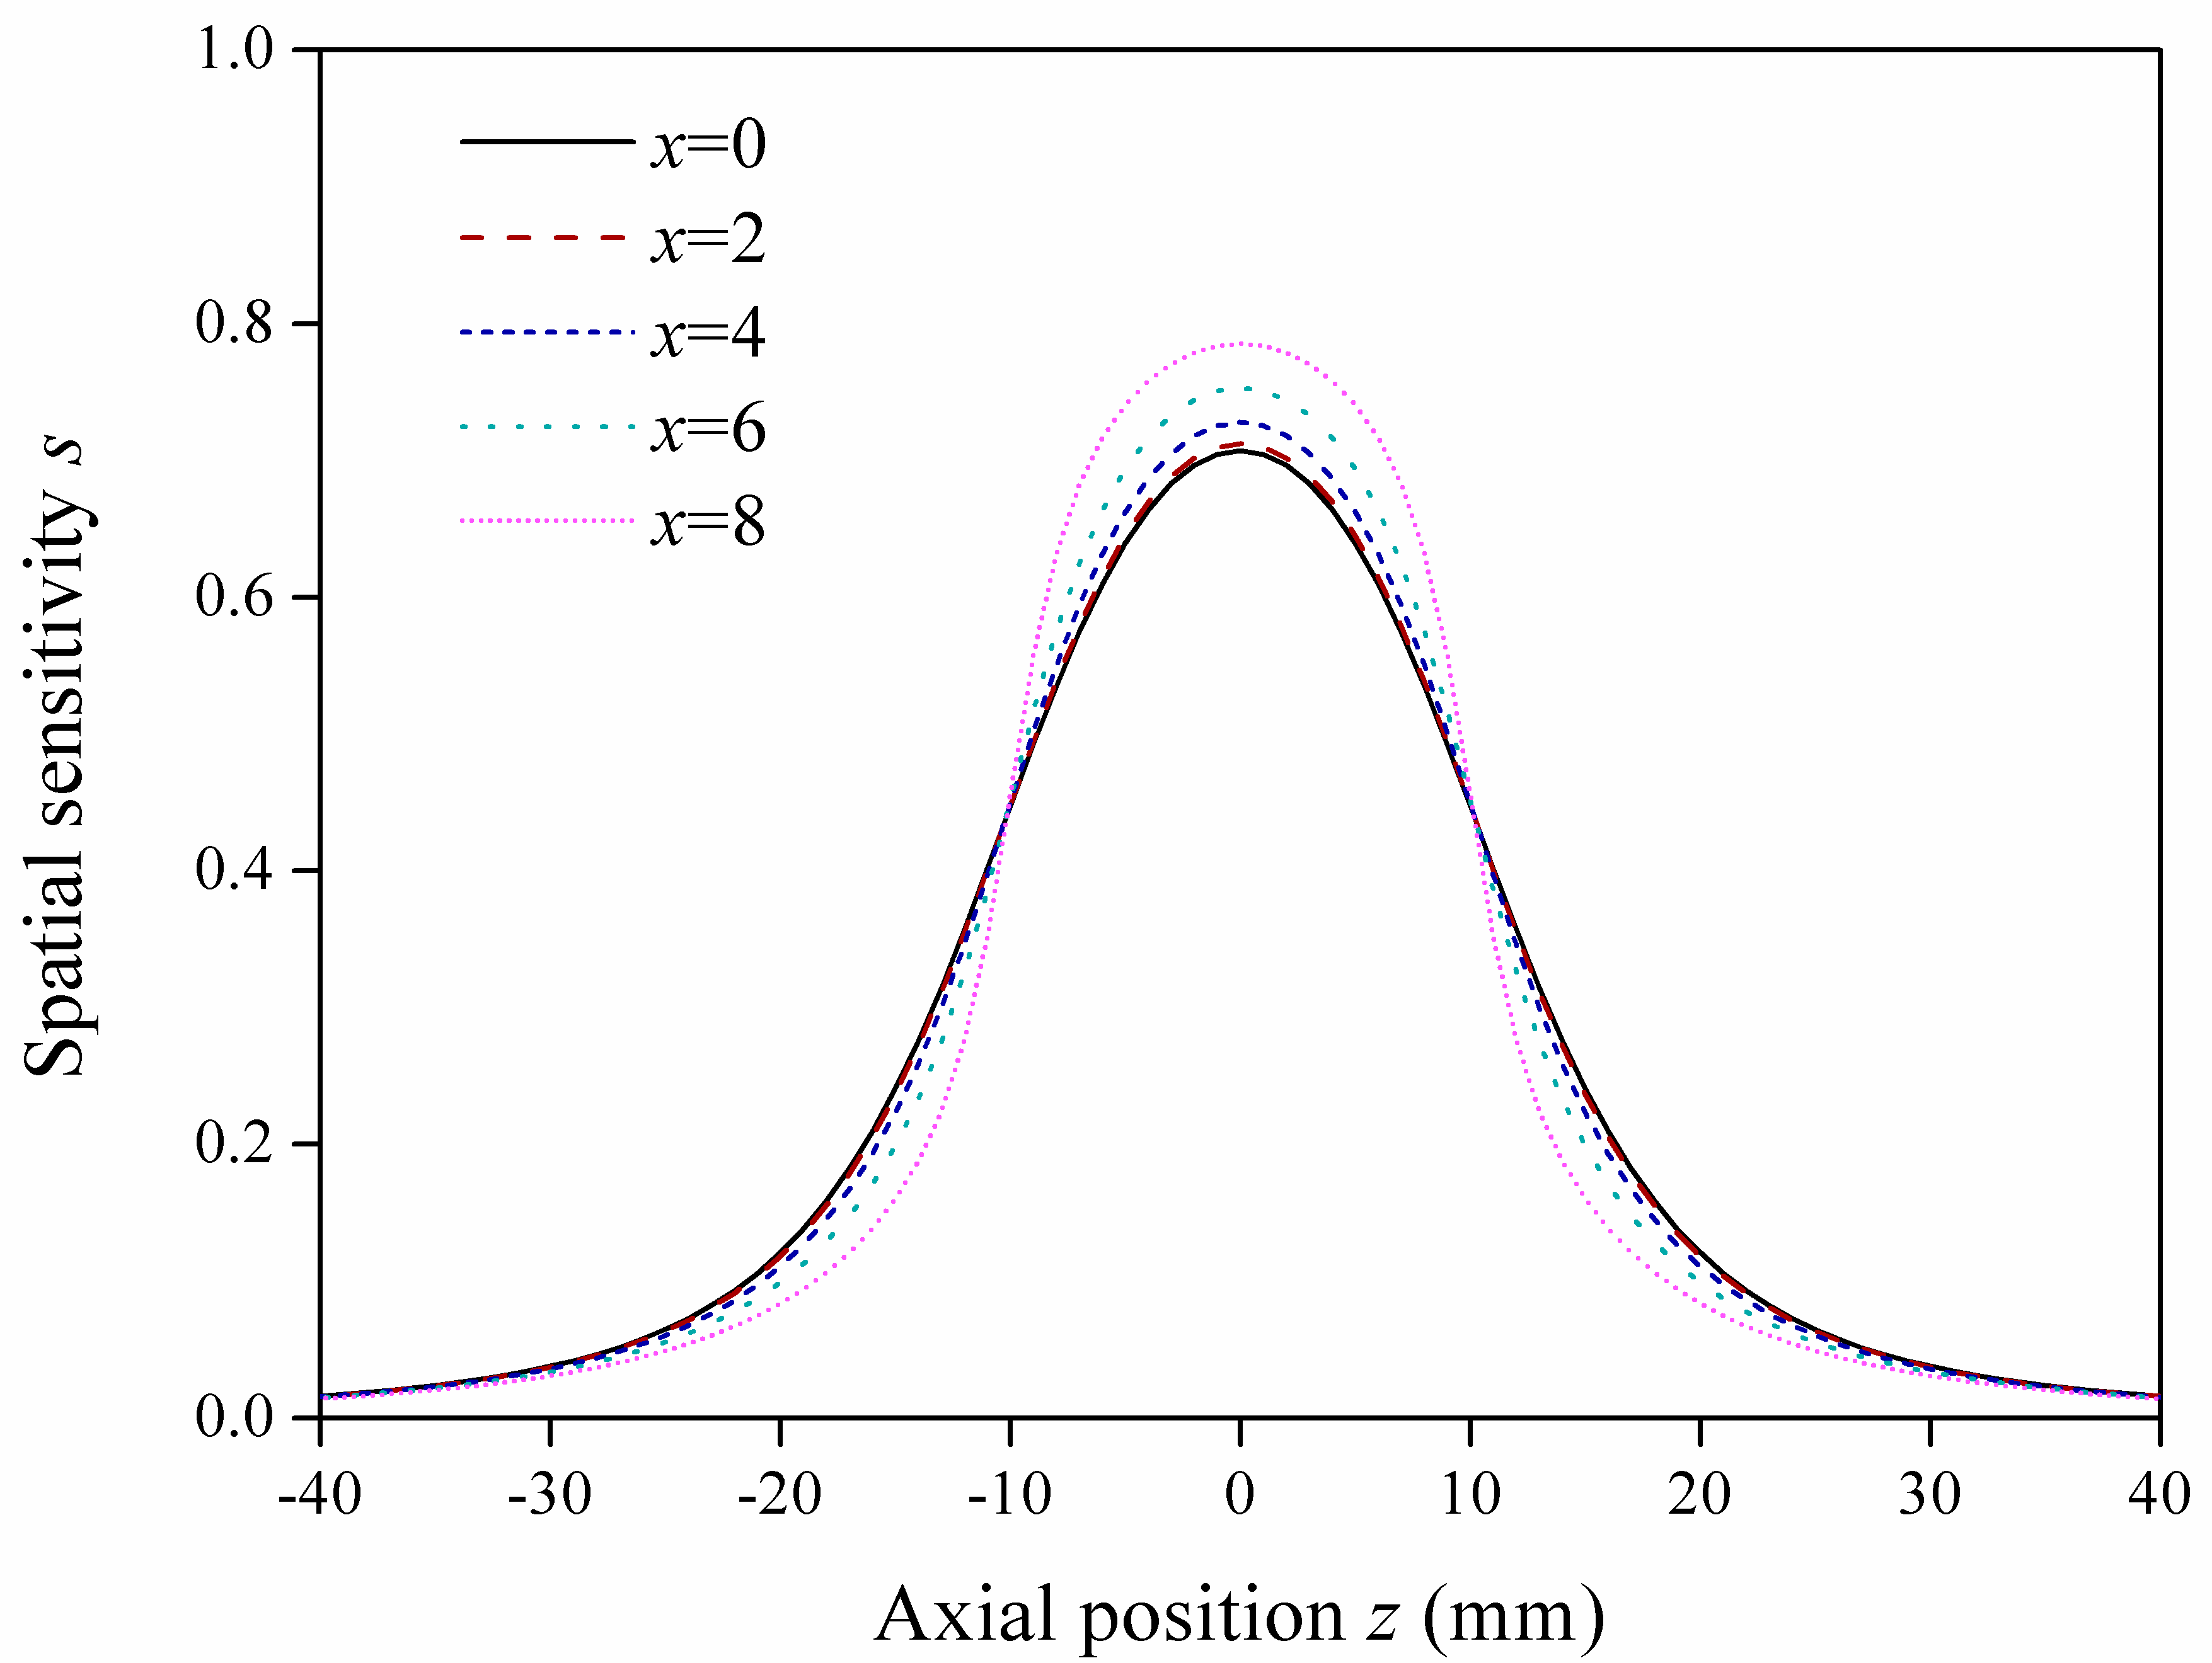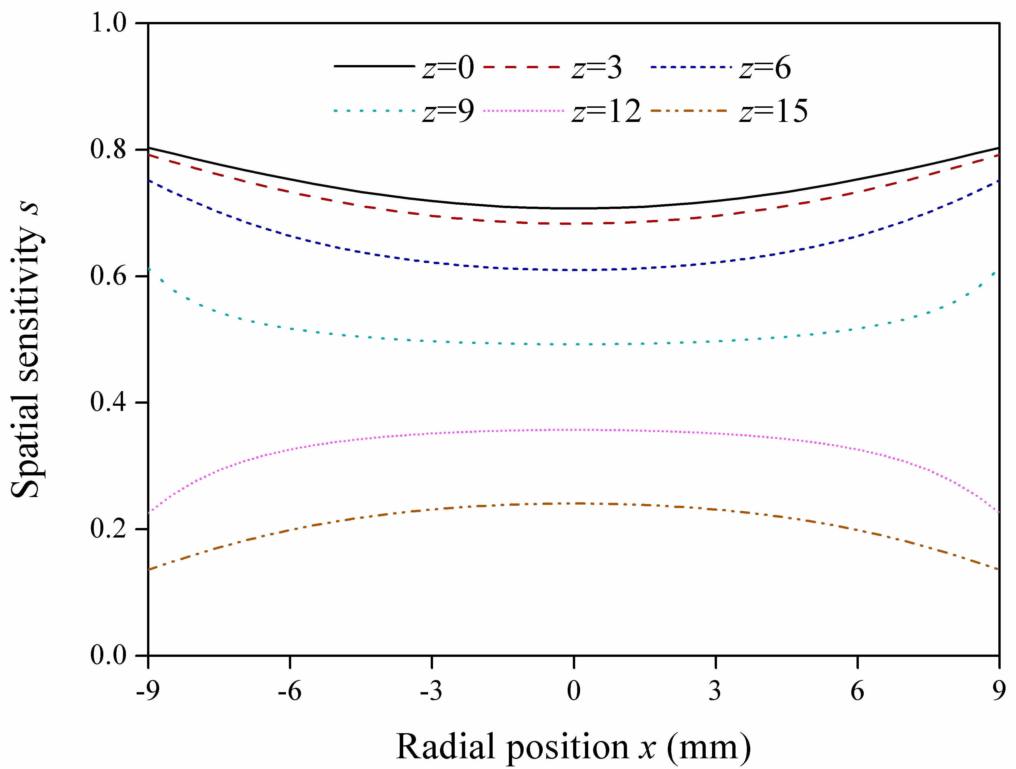
(a) (b)
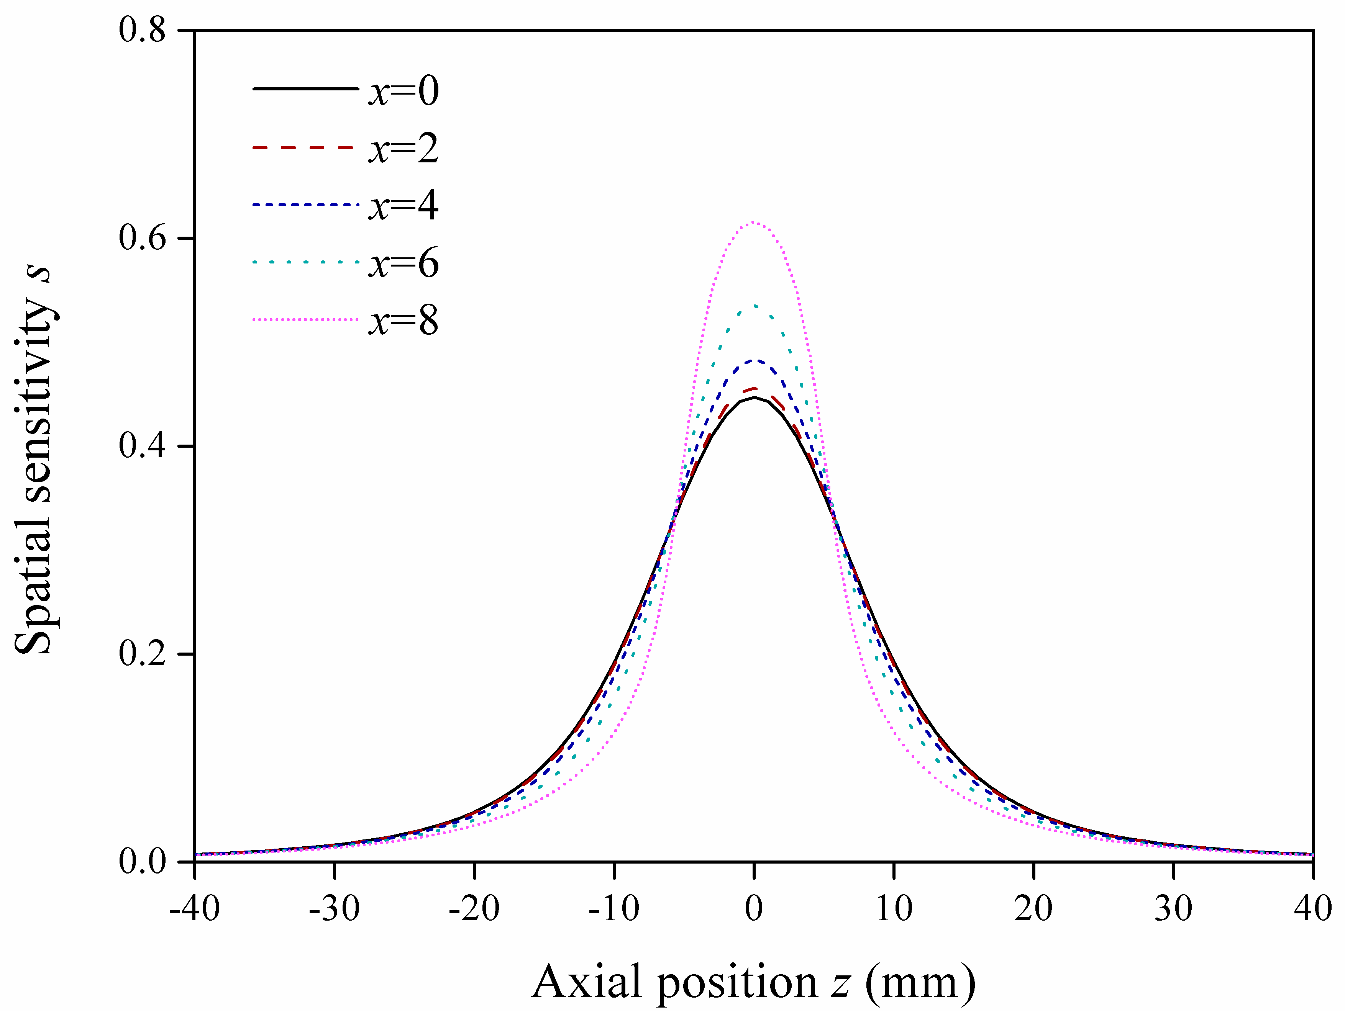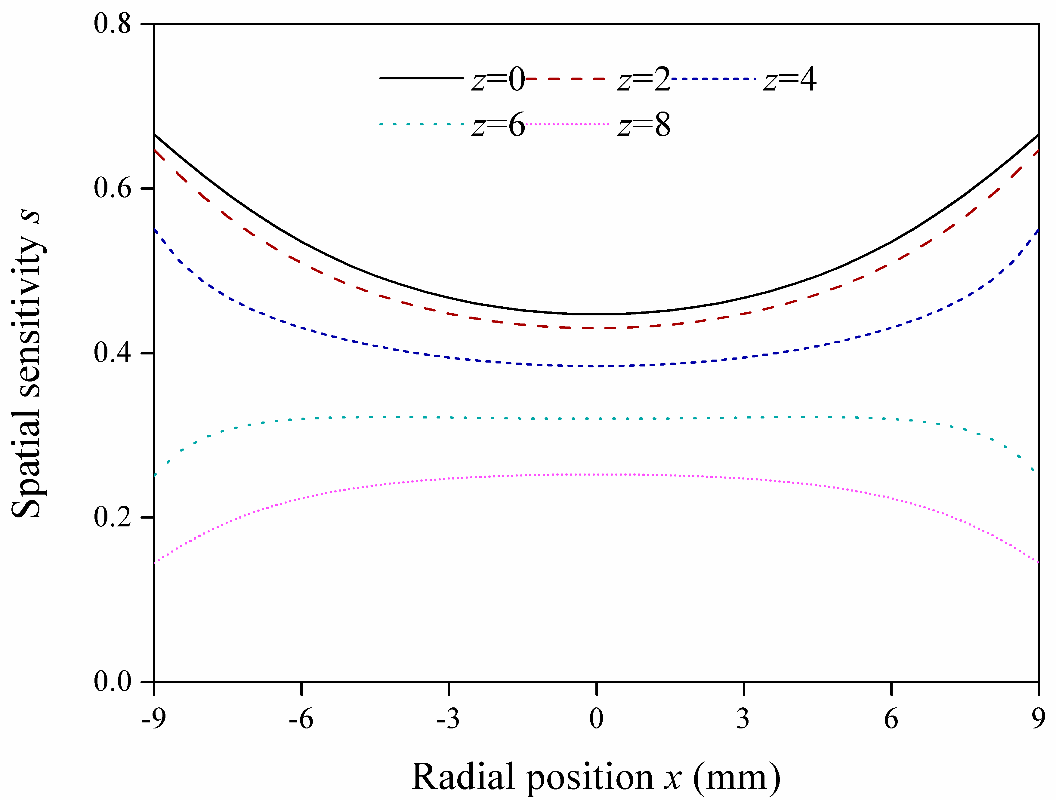
(c) (d)
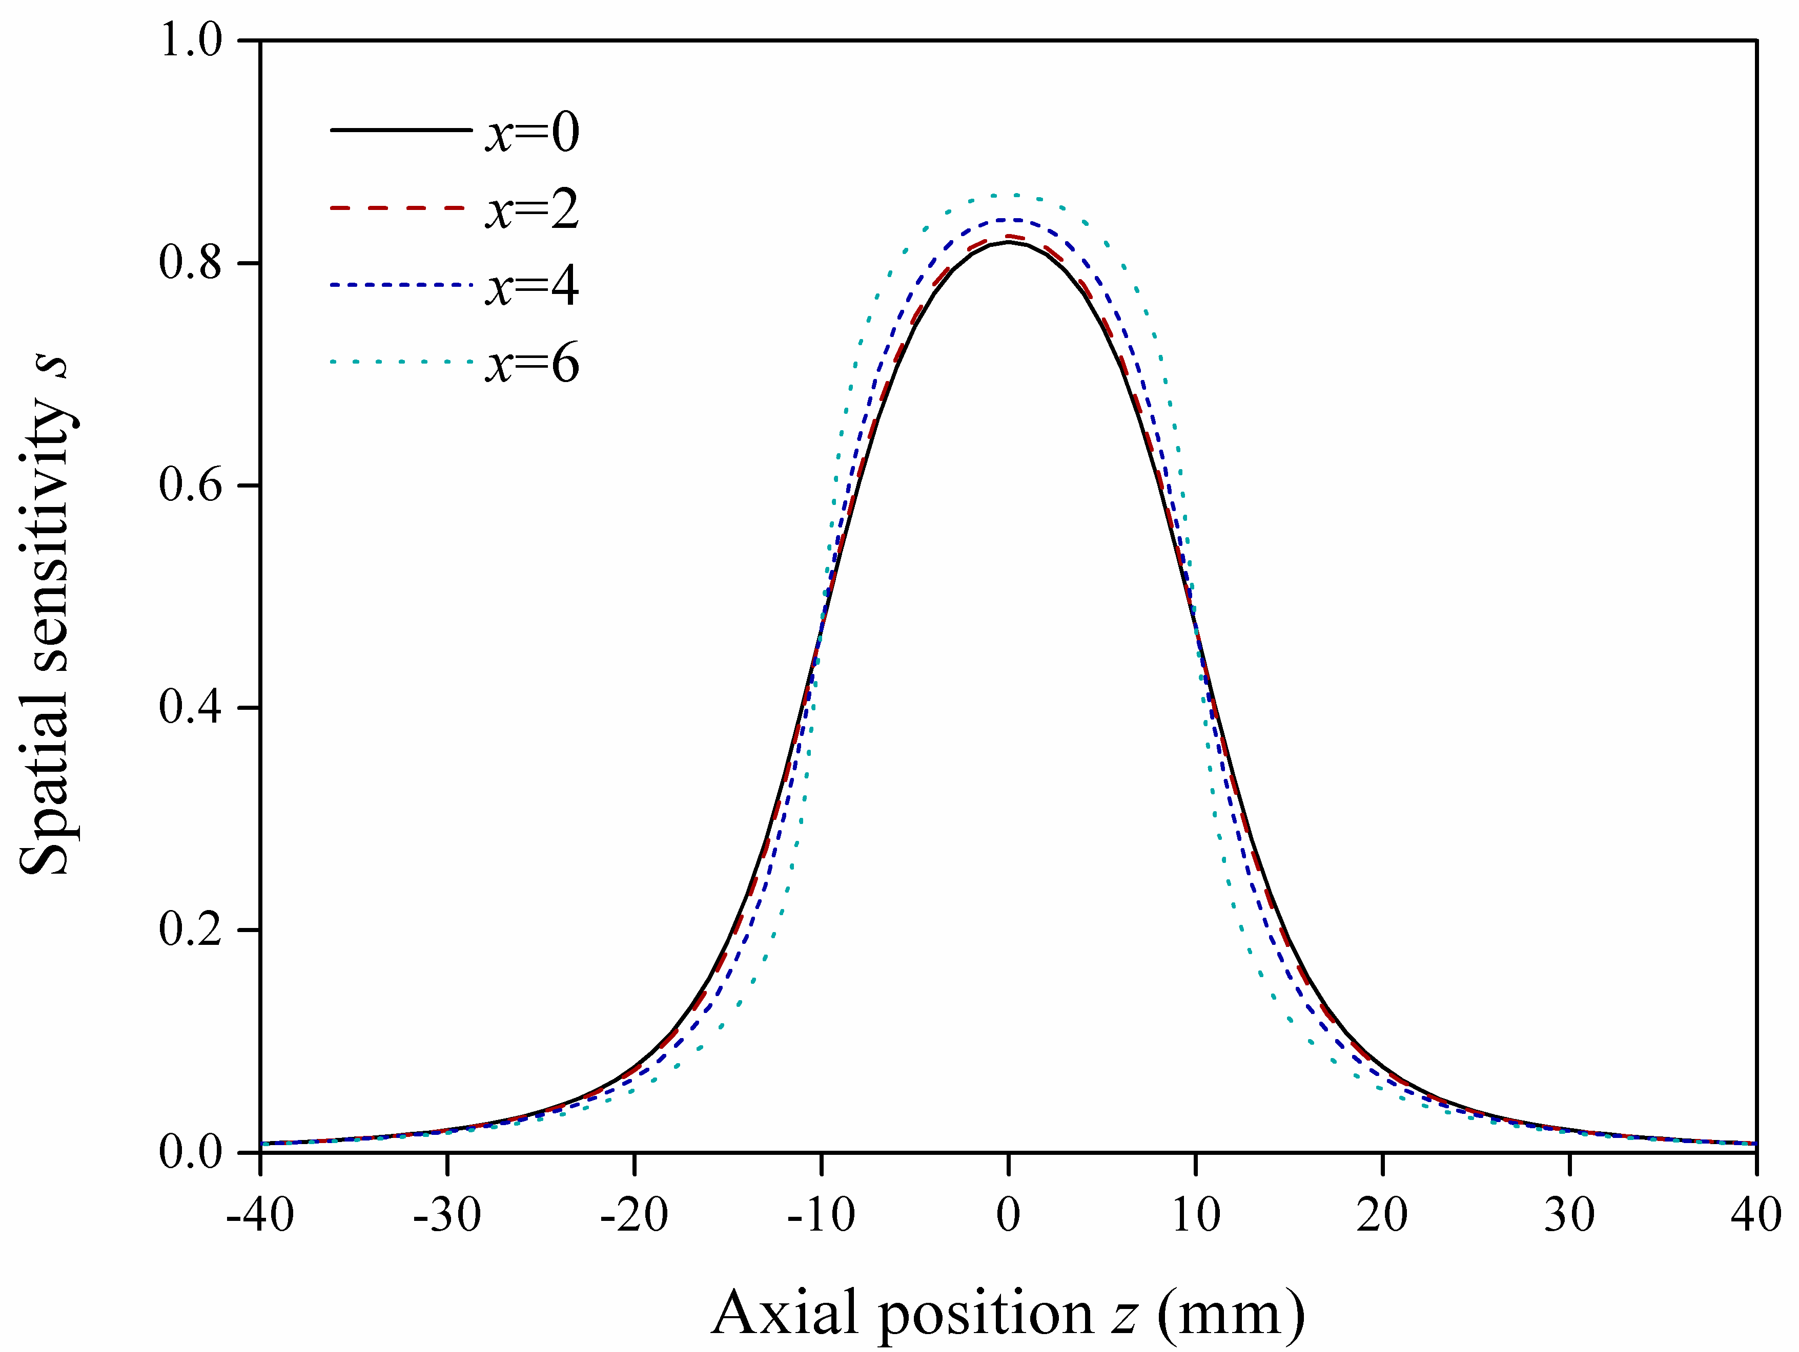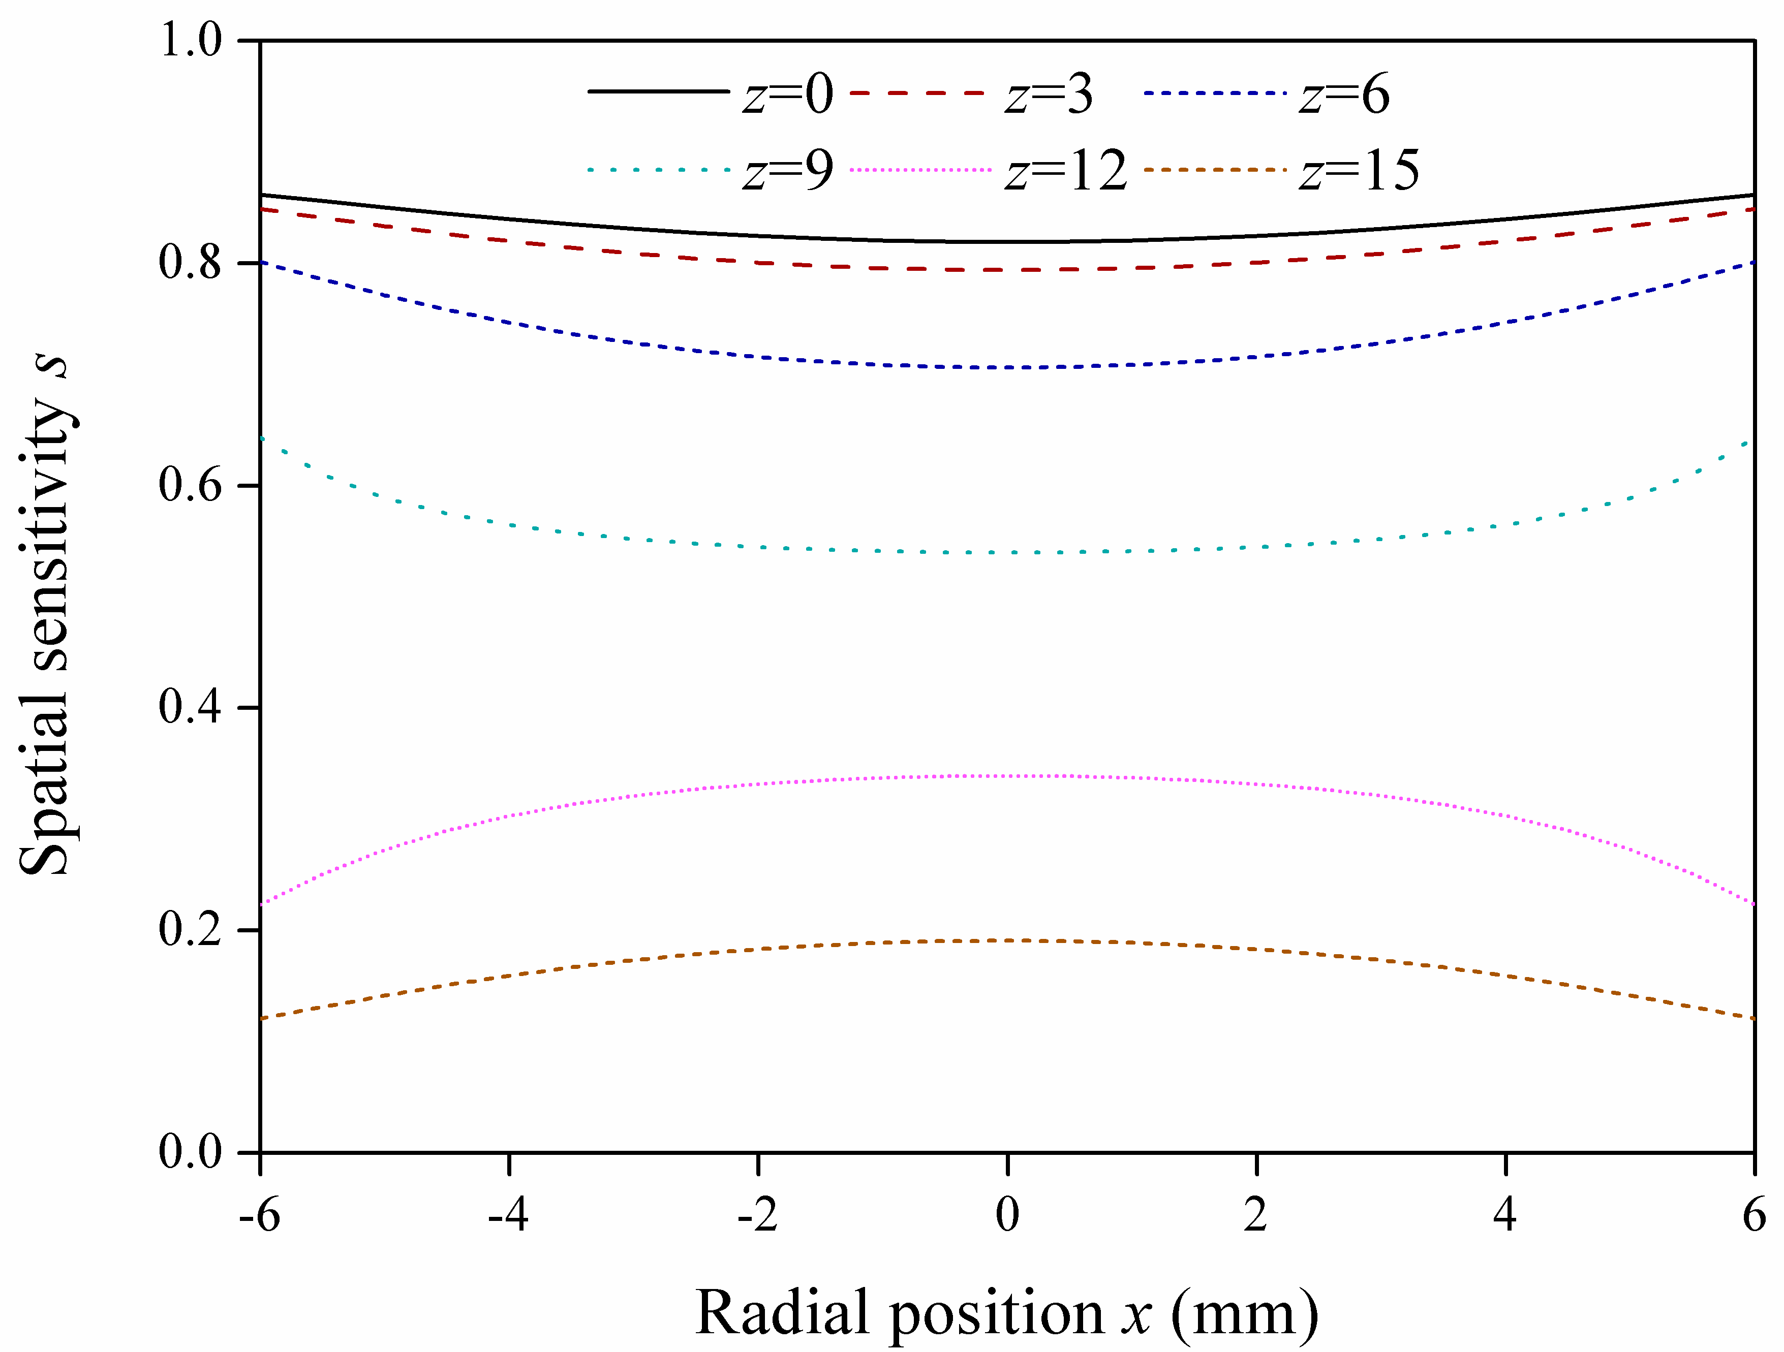
(e) (f)
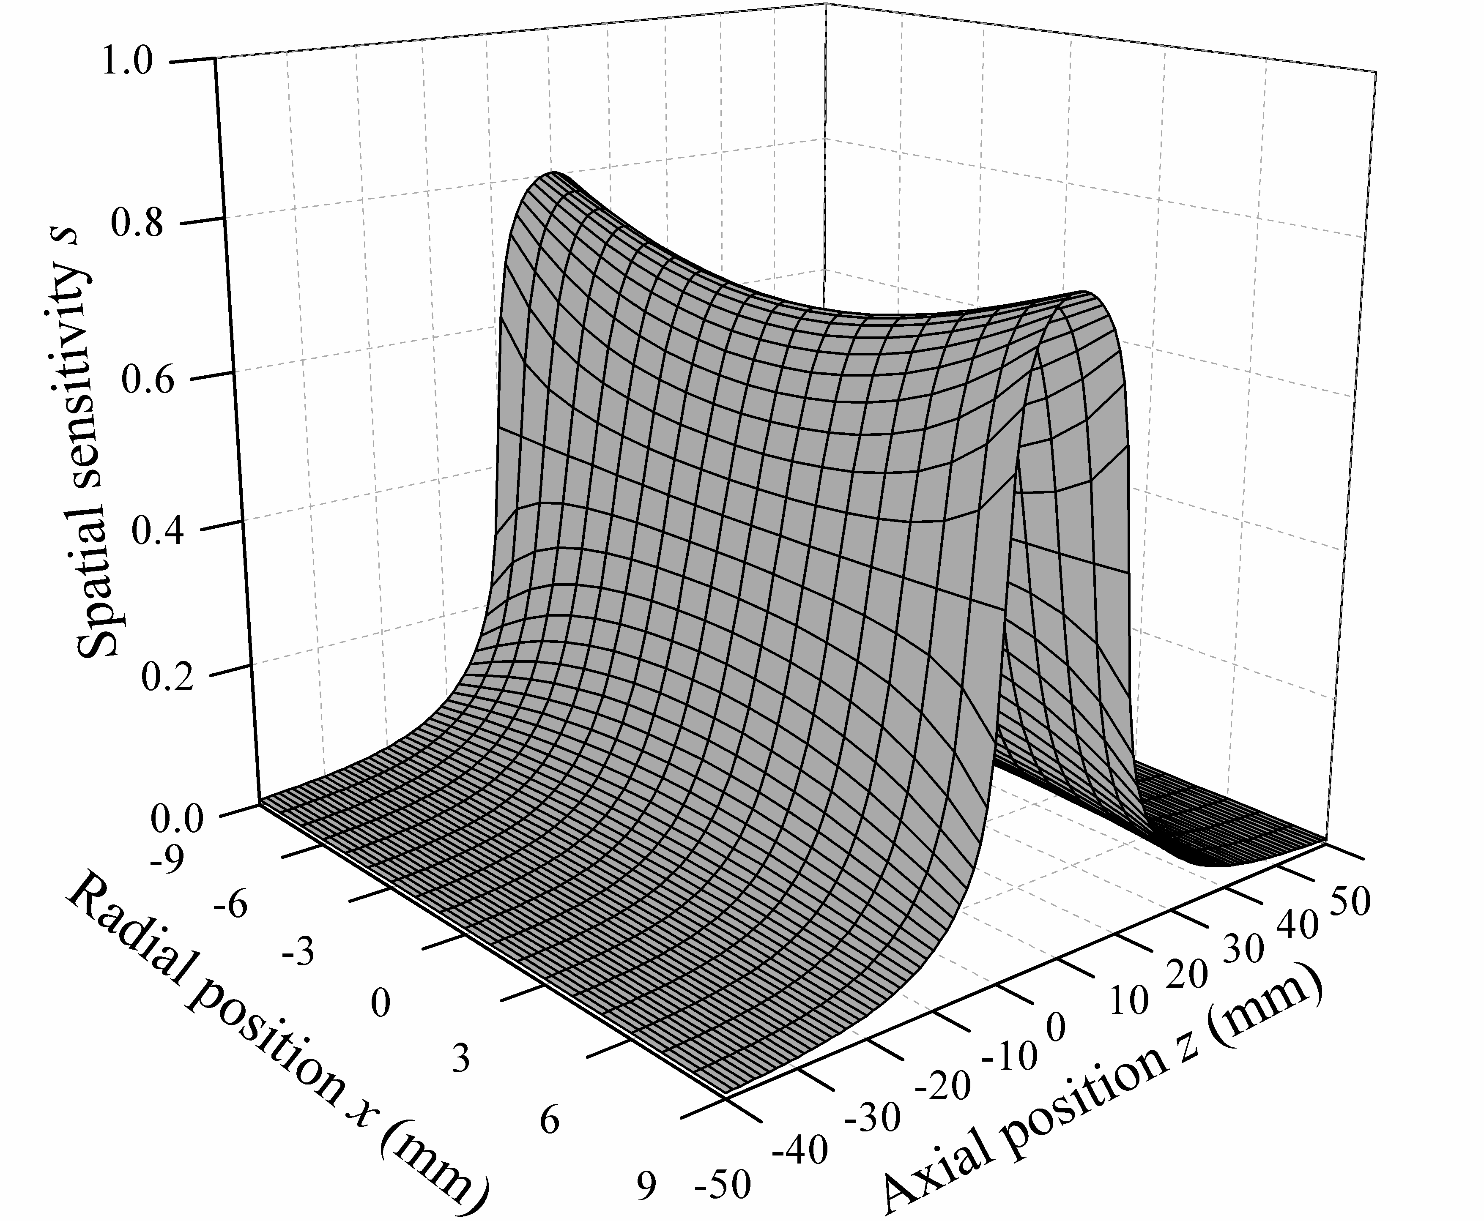
(g)
Fig. 5. Simulated spatial sensitivity of OLS (a) Axial distribution with probe parameters H=20 & D=20. (b) Radial distribution with H=20 & D=20. (c) Axial distribution with H=10 & D=20. (d) Radial distribution with H=10 & D=20. (e) Axial distribution with H=20 & D=14. (f) Radial distribution with H=20 & D=14. (g) 3D distribution with H=20 & D=20
Figs. 5(c)-(f) show similar results for two other H & D variations: (c) & (d) for H=10 and D=20; while (e) & (f) for H=20 and D=14. The results show that the variation of probe length and diameter does change the spatial sensitivity values and it distributions however the trend and the relationships between s and the probe geometrical parameters are similar. The results also agree with the basic principle of electrostatic charging, i.e. the closer the distance between the inducing charge and probe surface, the more electric flux terminates on the sensing face and the more charge is induced in the sensor surface. A 3D diagram of spatial sensitivity distribution for the H=20 and D=20 is plotted in Fig.5(g) to illustrate the spatial sensitivity in both radial and axial directions.
To further investigate the influences of the probe parameters H and D, Fig. 6 and Fig. 7 show the spatial sensitivity distributions in the axial direction at varied probe length and diameter respectively. Fig. 6 shows the spatial sensitivity distributions at five probe lengths and at three radial positions when D was kept at 20mm as well as at the central axial position when D was 30mm. It can be seen that the spatial sensitivity increases with the increase of H at the same radial position when D is fixed. Also, the maximum spatial sensitivity increases as H increases. Comparing Fig. 6 (d) with (a), it seems that, increasing the probe diameter will reduce its spatial sensitivity when the length is relatively short (H<60) however similar sensitivity can be achieved when H=80mm. This is further investigated by varying the diameter of the probe at two lengths in Fig. 7. It shows that the maximum spatial sensitivity decreases with the increase of D inside of the probe and increases outside when the H is fixed. Since the spatial sensitivity inside of the probe is essential in electrostatic detection that should be enhanced and the spatial sensitivity outside the probe that is likely to interfere and reduce the accuracy of detection, it is thus beneficial to design and manufacture long and thin ring shape OLSs for the best practice.
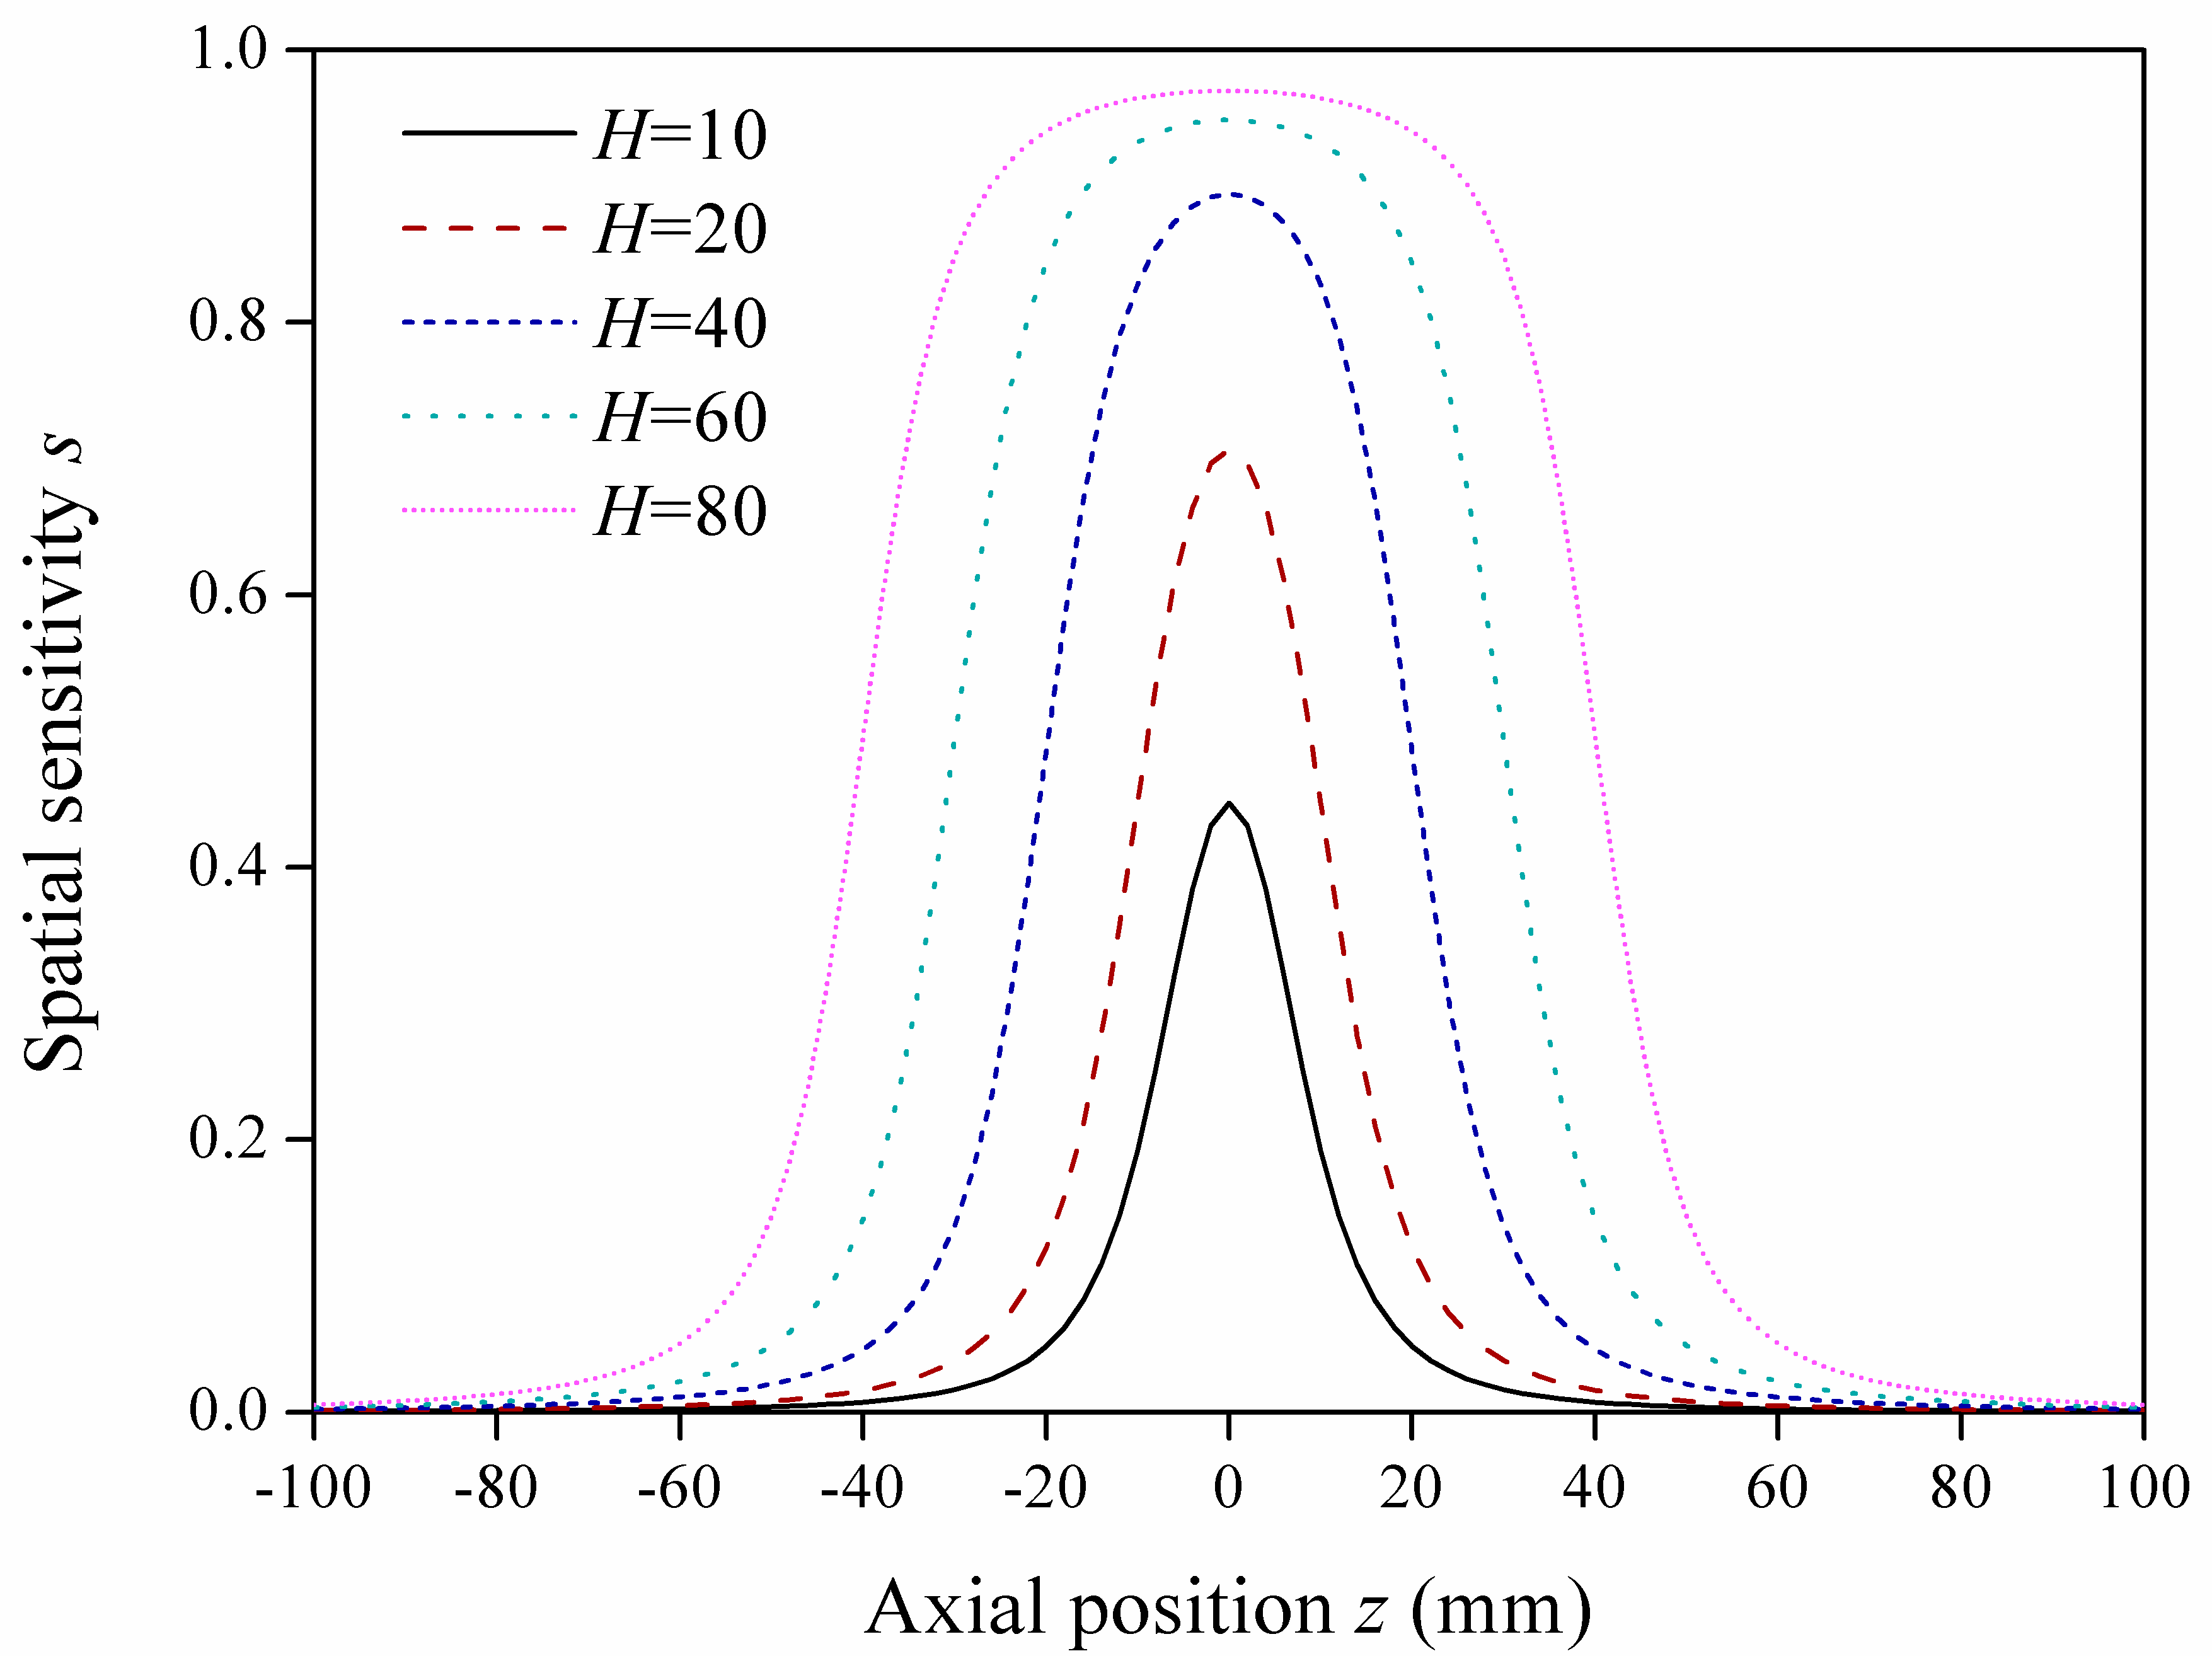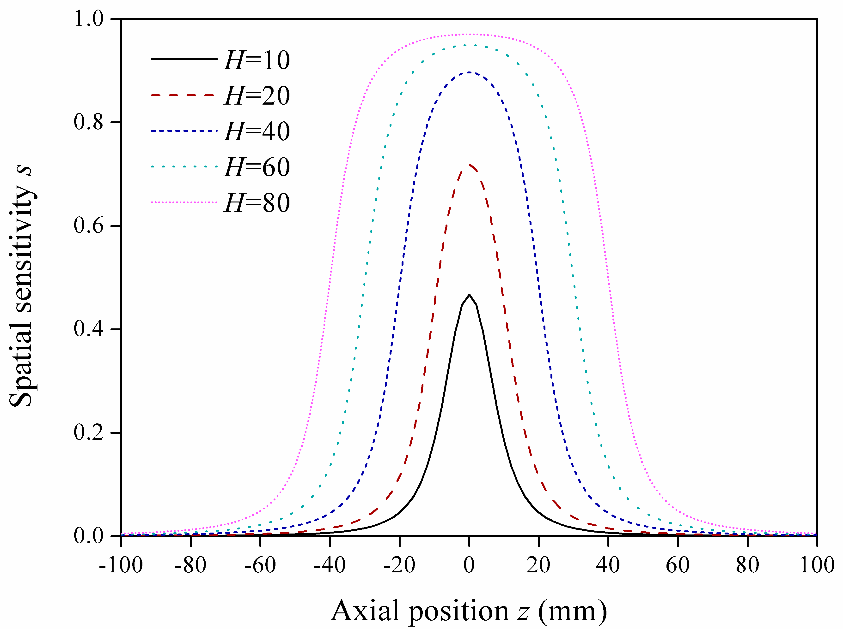
(a) (b)
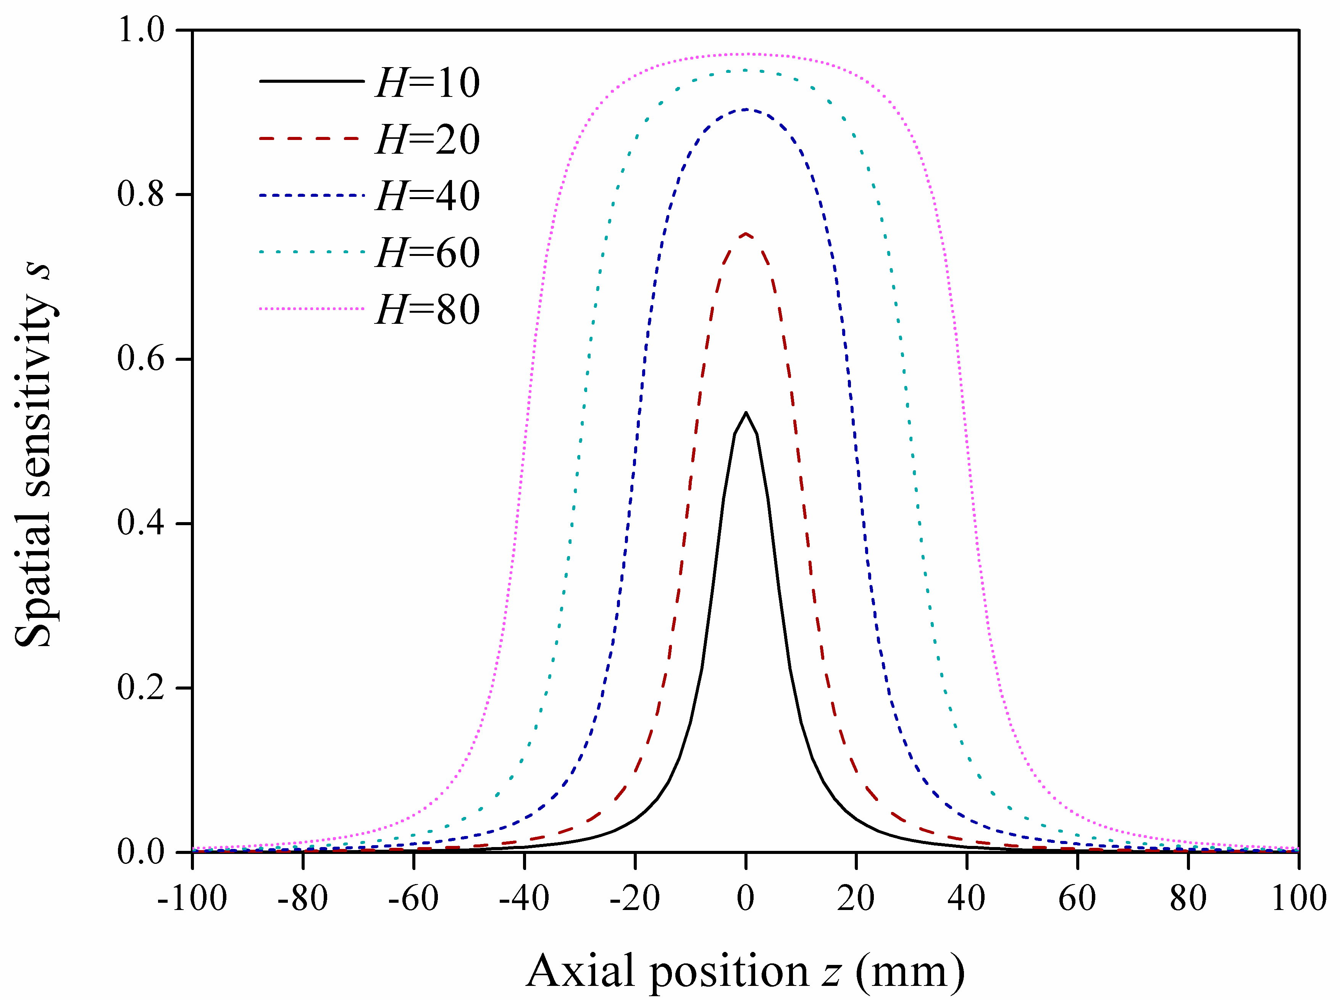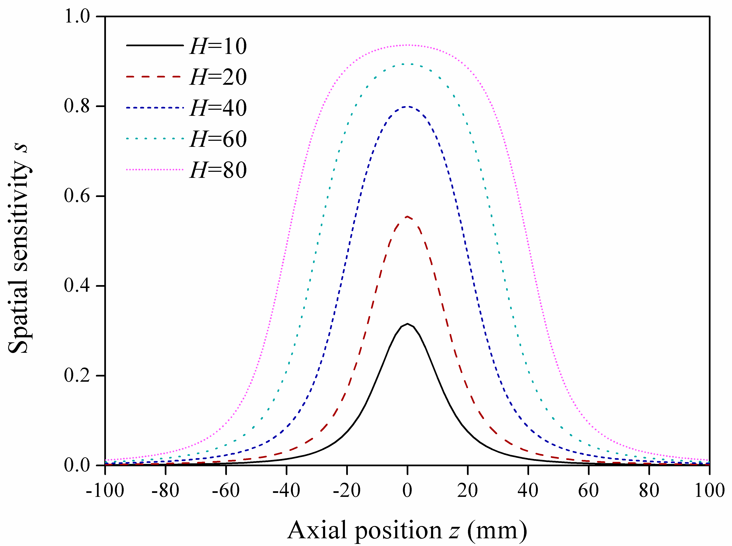
(c) (d)
Fig. 6. Spatial sensitivity distribution with different probe lengths at different radial positions (a) x=0 with D=20. (b) x=3 with D=20. (c) x=6 with D=20. (d) x=0 with D=30.
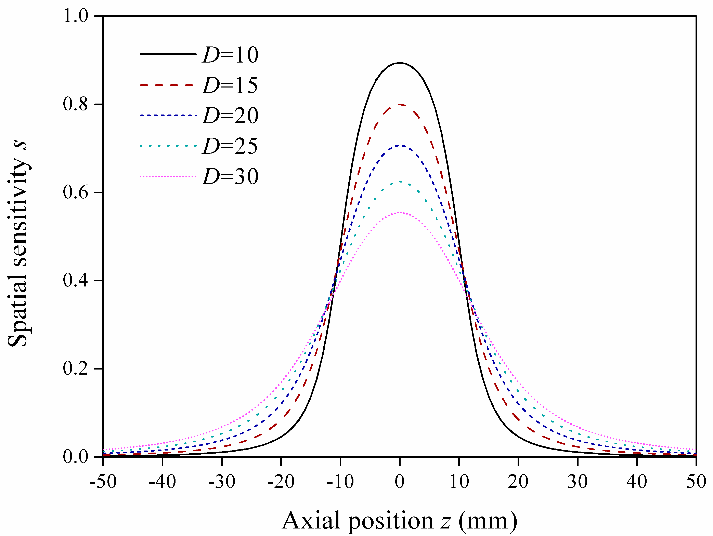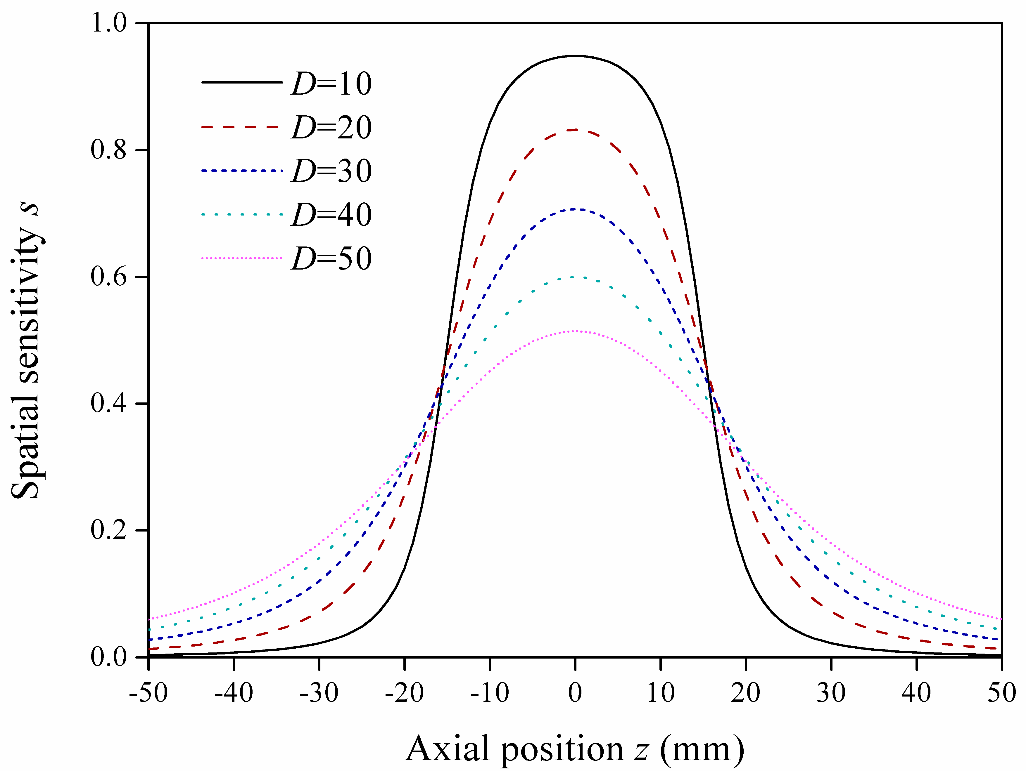
(a) (b)
Fig. 7. Spatial sensitivity distribution in axial direction at the central radial position (x=0) with different probe diameters at two probe lengths (a) H=20. (b) H=30.
Combining the two parameters, it is clear that the higher the ratio between the length and diameter, the higher the spatial sensitivity can be achieved for an electrostatic OLS. Thus the ratio of the probe length and diameter [22] has been defined as the ratio of an electrostatic OLS λ:
(8)
where λ is the ratio of electrostatic OLS, H is the length of the probe and D is the diameter of the probe.
Figs. 8(a)-(c) show the spatial sensitivity distributions in axial direction at radial position x=0 and a range of probe lengths at three different λ values (1, 0.5 and 1.5). It can be seen that, when the ratio λ is fixed, while the spatial sensitivity increases with the increase of H in the axial direction, the maximum spatial sensitivity is fixed at the center of the probe (z=0). This is demonstrated in Fig. 8(d), where a constant spatial sensitivity is achieved at z=0 and x=0 for any fixed λ values despite the change of the probe length. Fig. 8(d) also shows that the spatial sensitivity of an OLS at its center increases with the increase of the ratio between the probe length and diameter. Due to the special position of the geometric center of the probe, also the origin of the coordinate system, this position (x=0 and z=0) has also been used to represent the spatial sensitivity of OLS and to evaluate the sensor’s sensing efficiency, which means that the coordinate (x₀, z₀) in Equations (4) and (5) will be (0, 0). Hence the theoretical efficiency of OLSs with the change of ratios is calculated and the efficiency curve is presented in Fig. 8(e). It can be seen that the theoretical efficiency increases with the increase of ratio however the rate of increase decreases as the ratio increases, where the efficiency rises rapidly to about 0.6 when λ increases from very low to 1 then gradually increases towards to 1 when λ increases from 1 to 5.
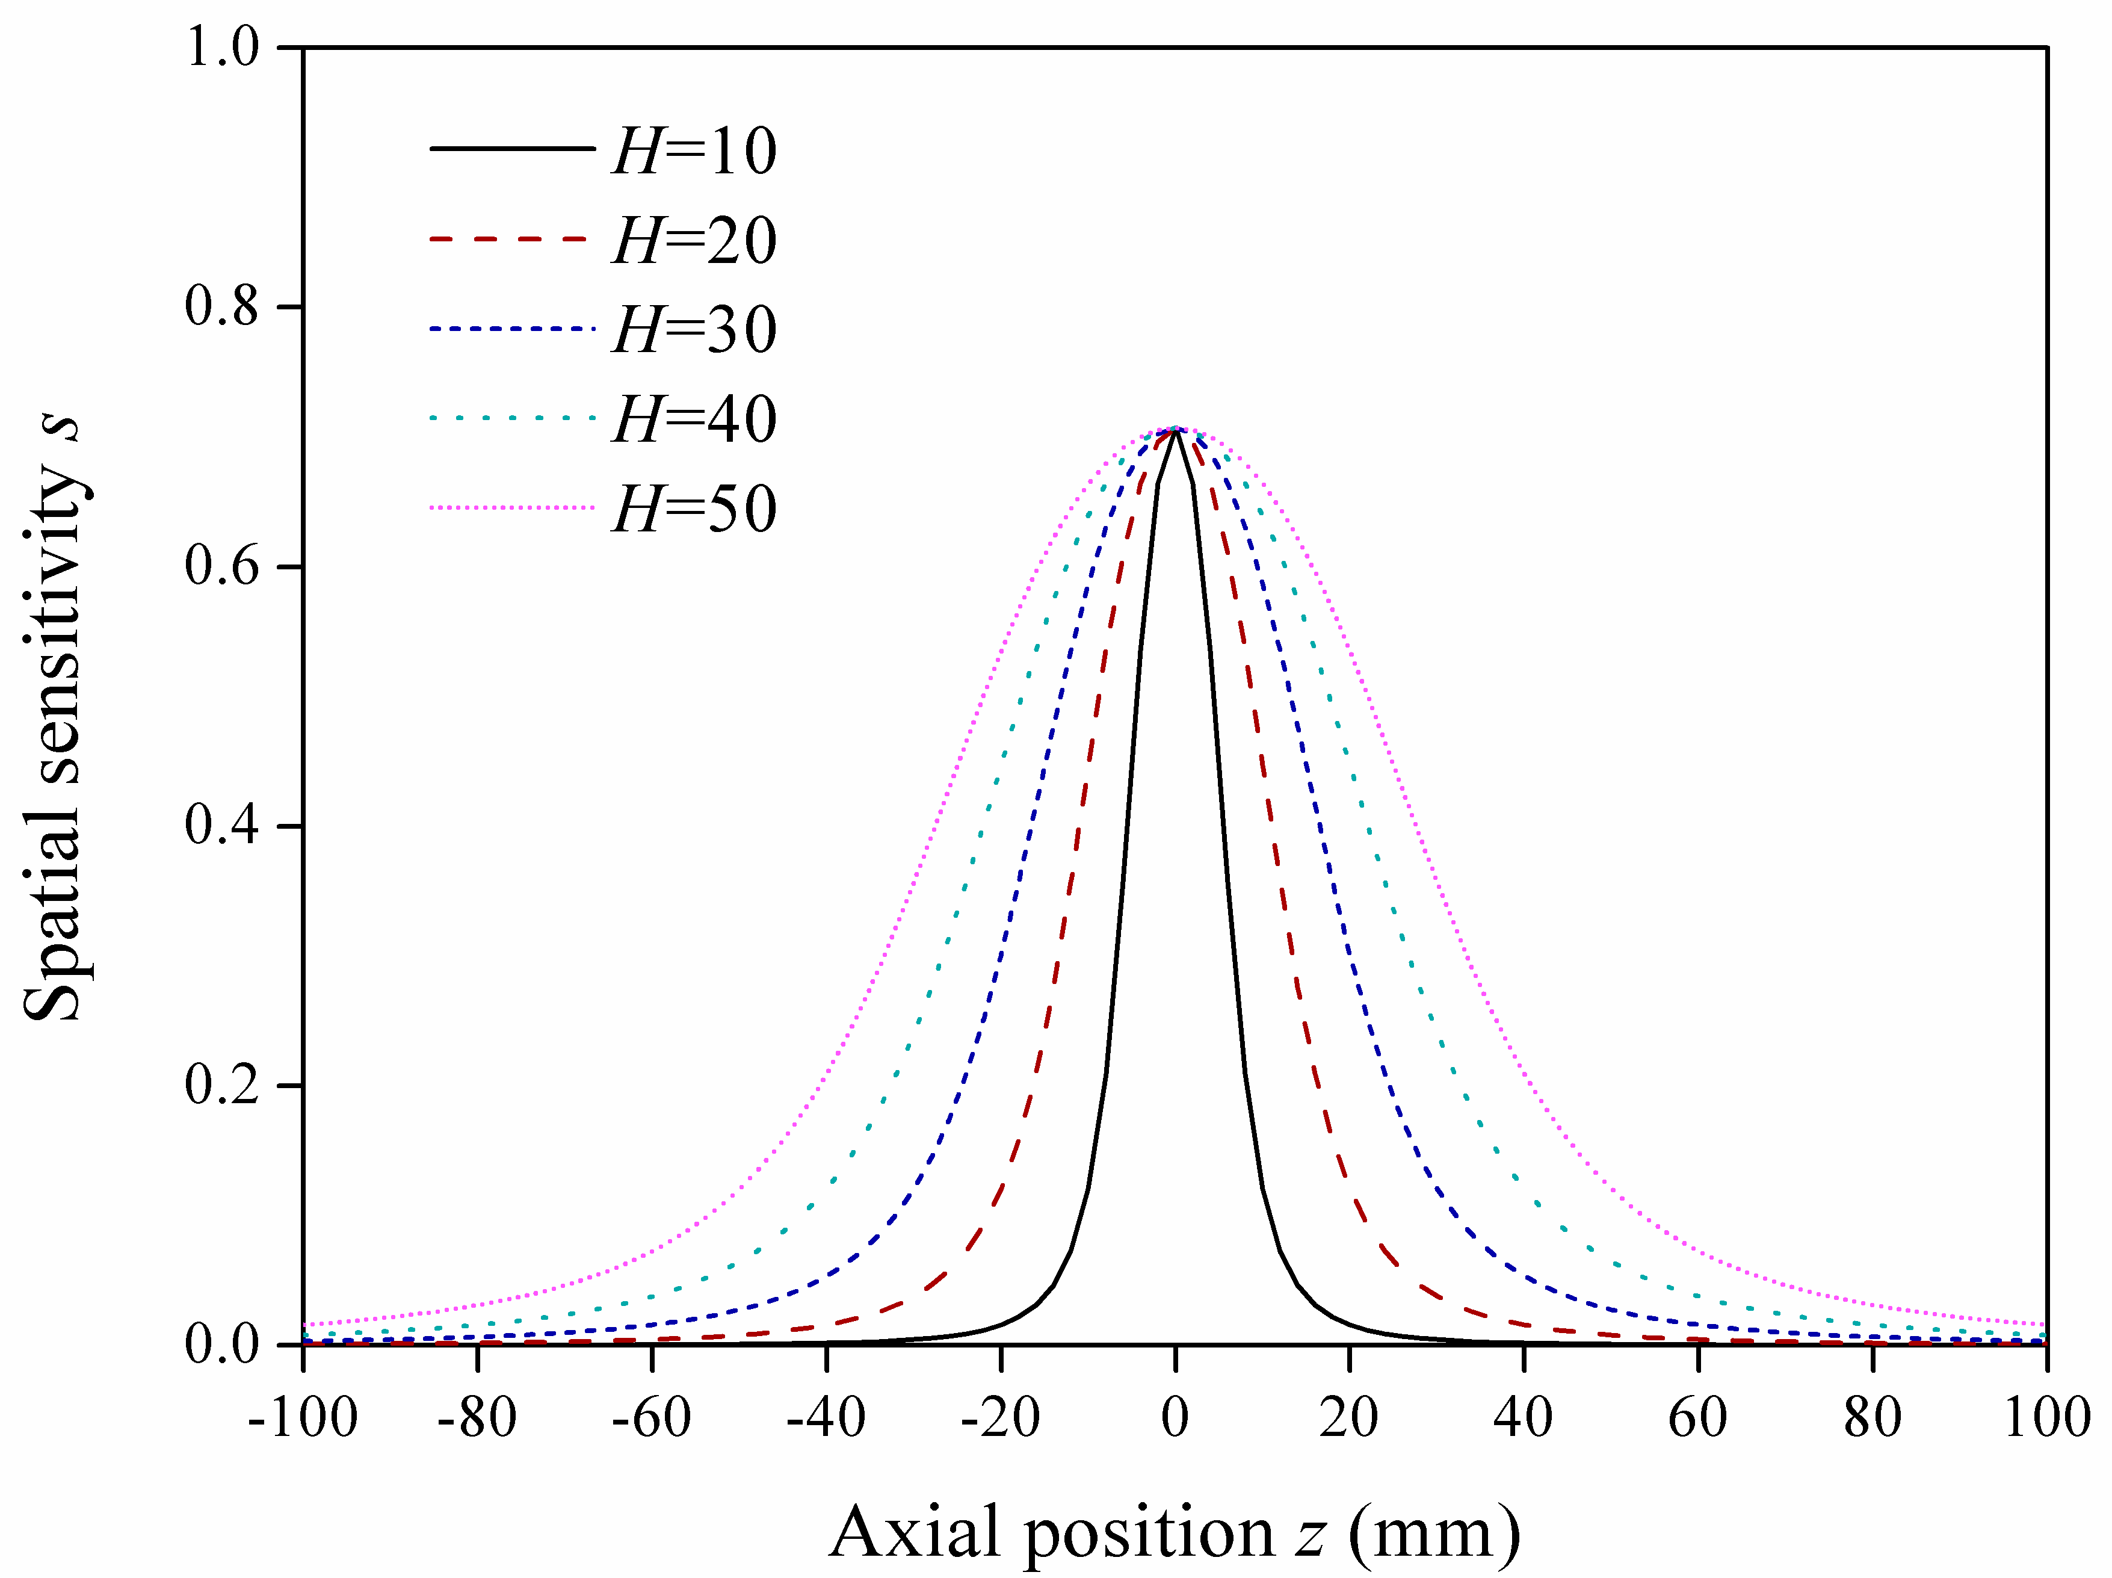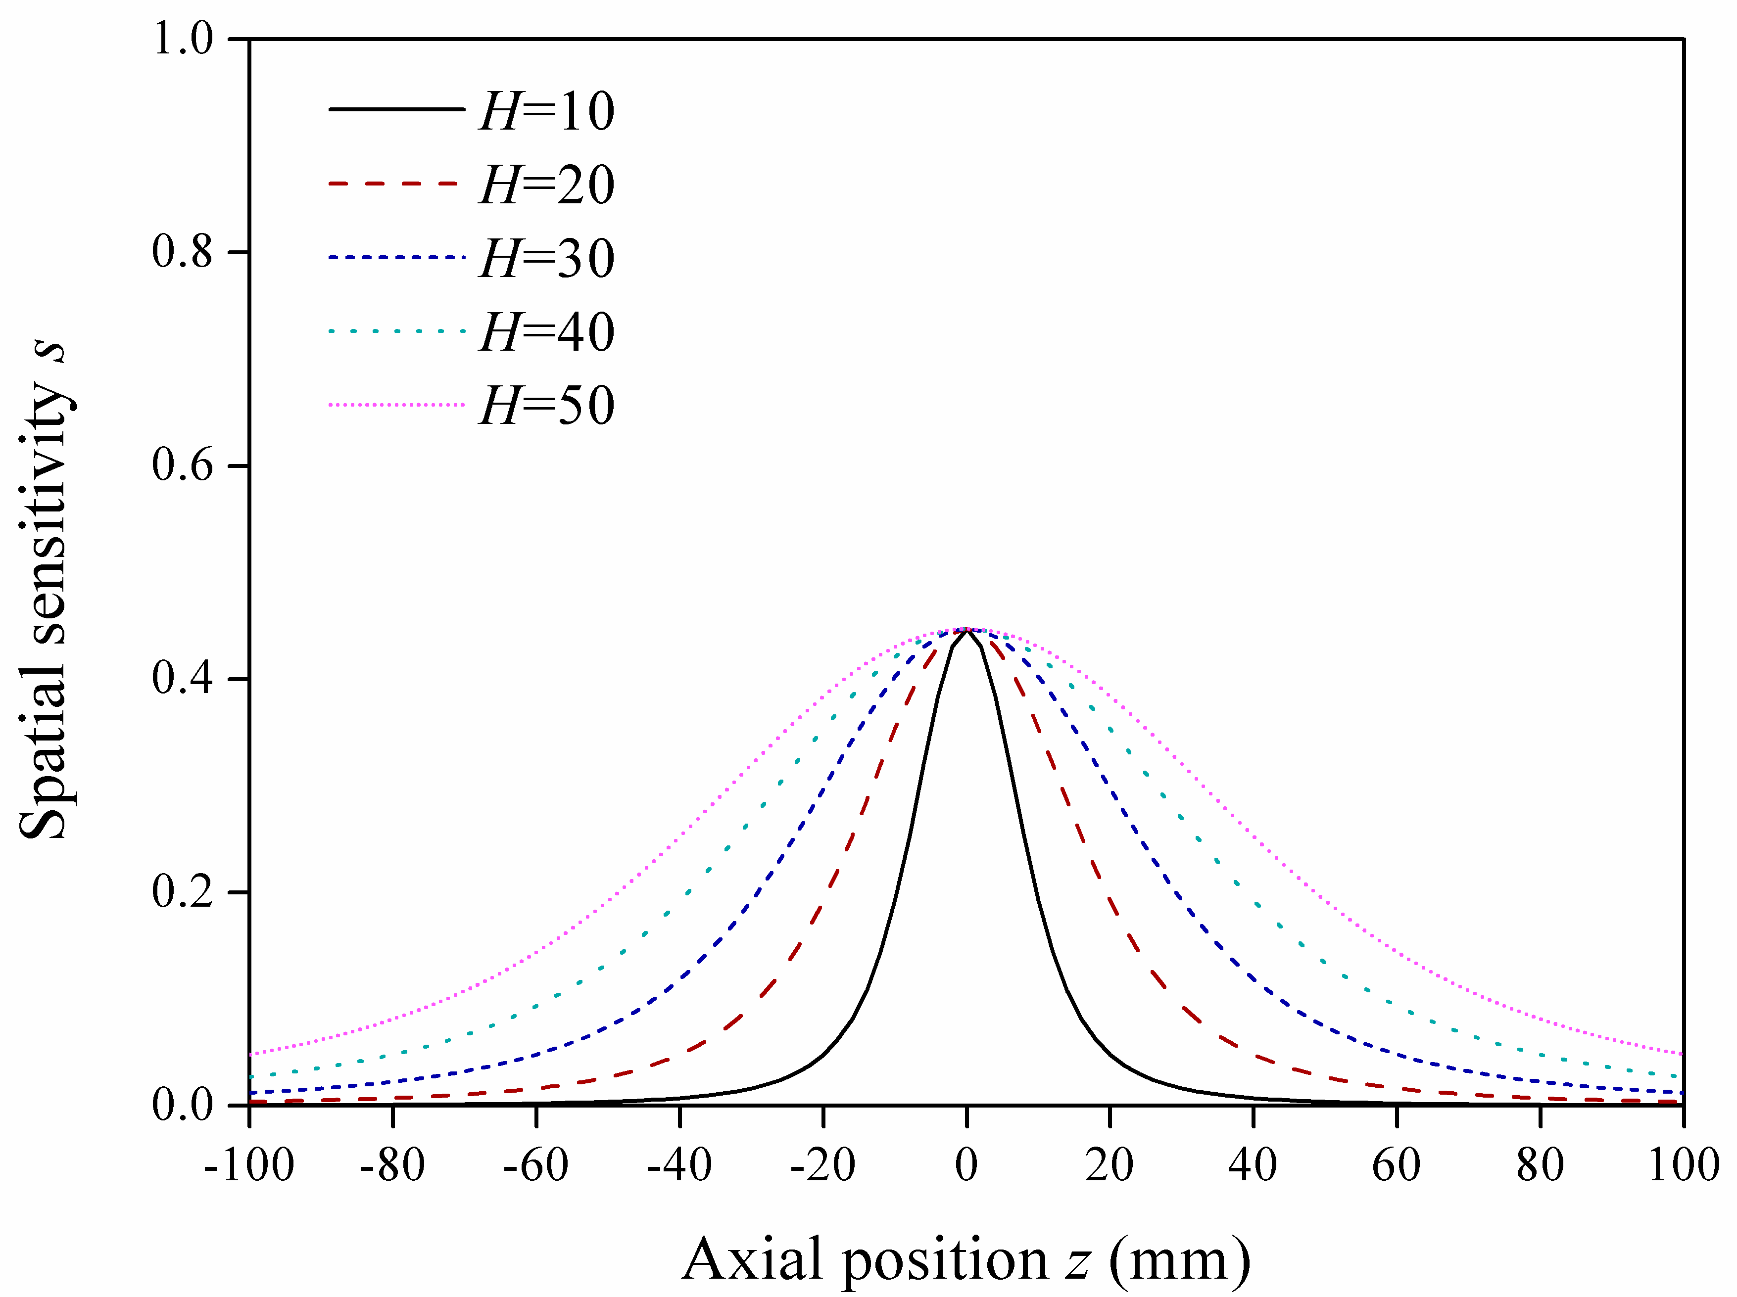
(a) (b)
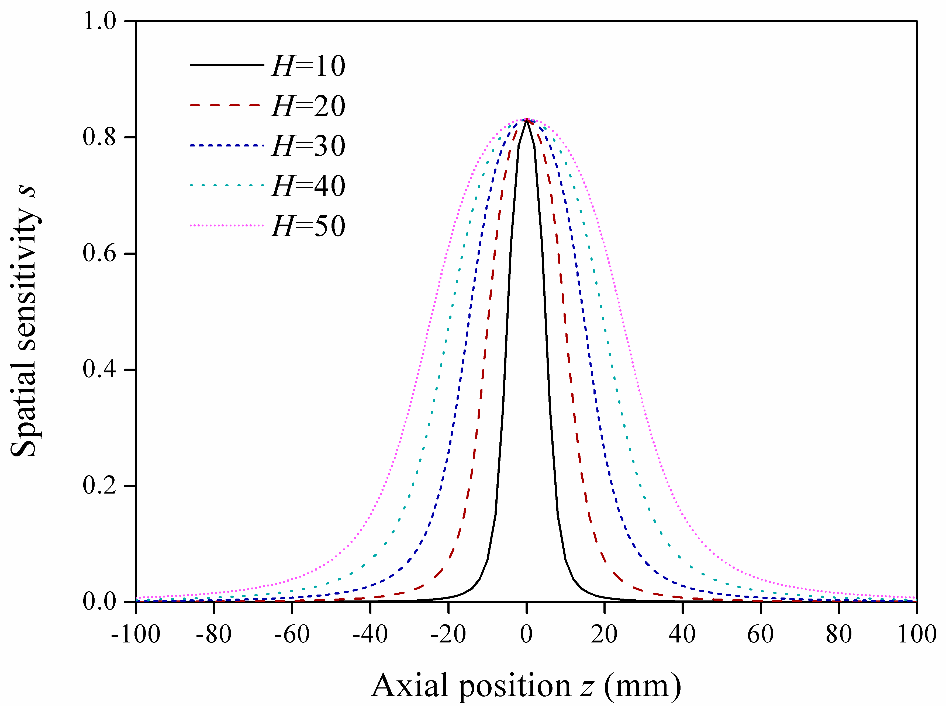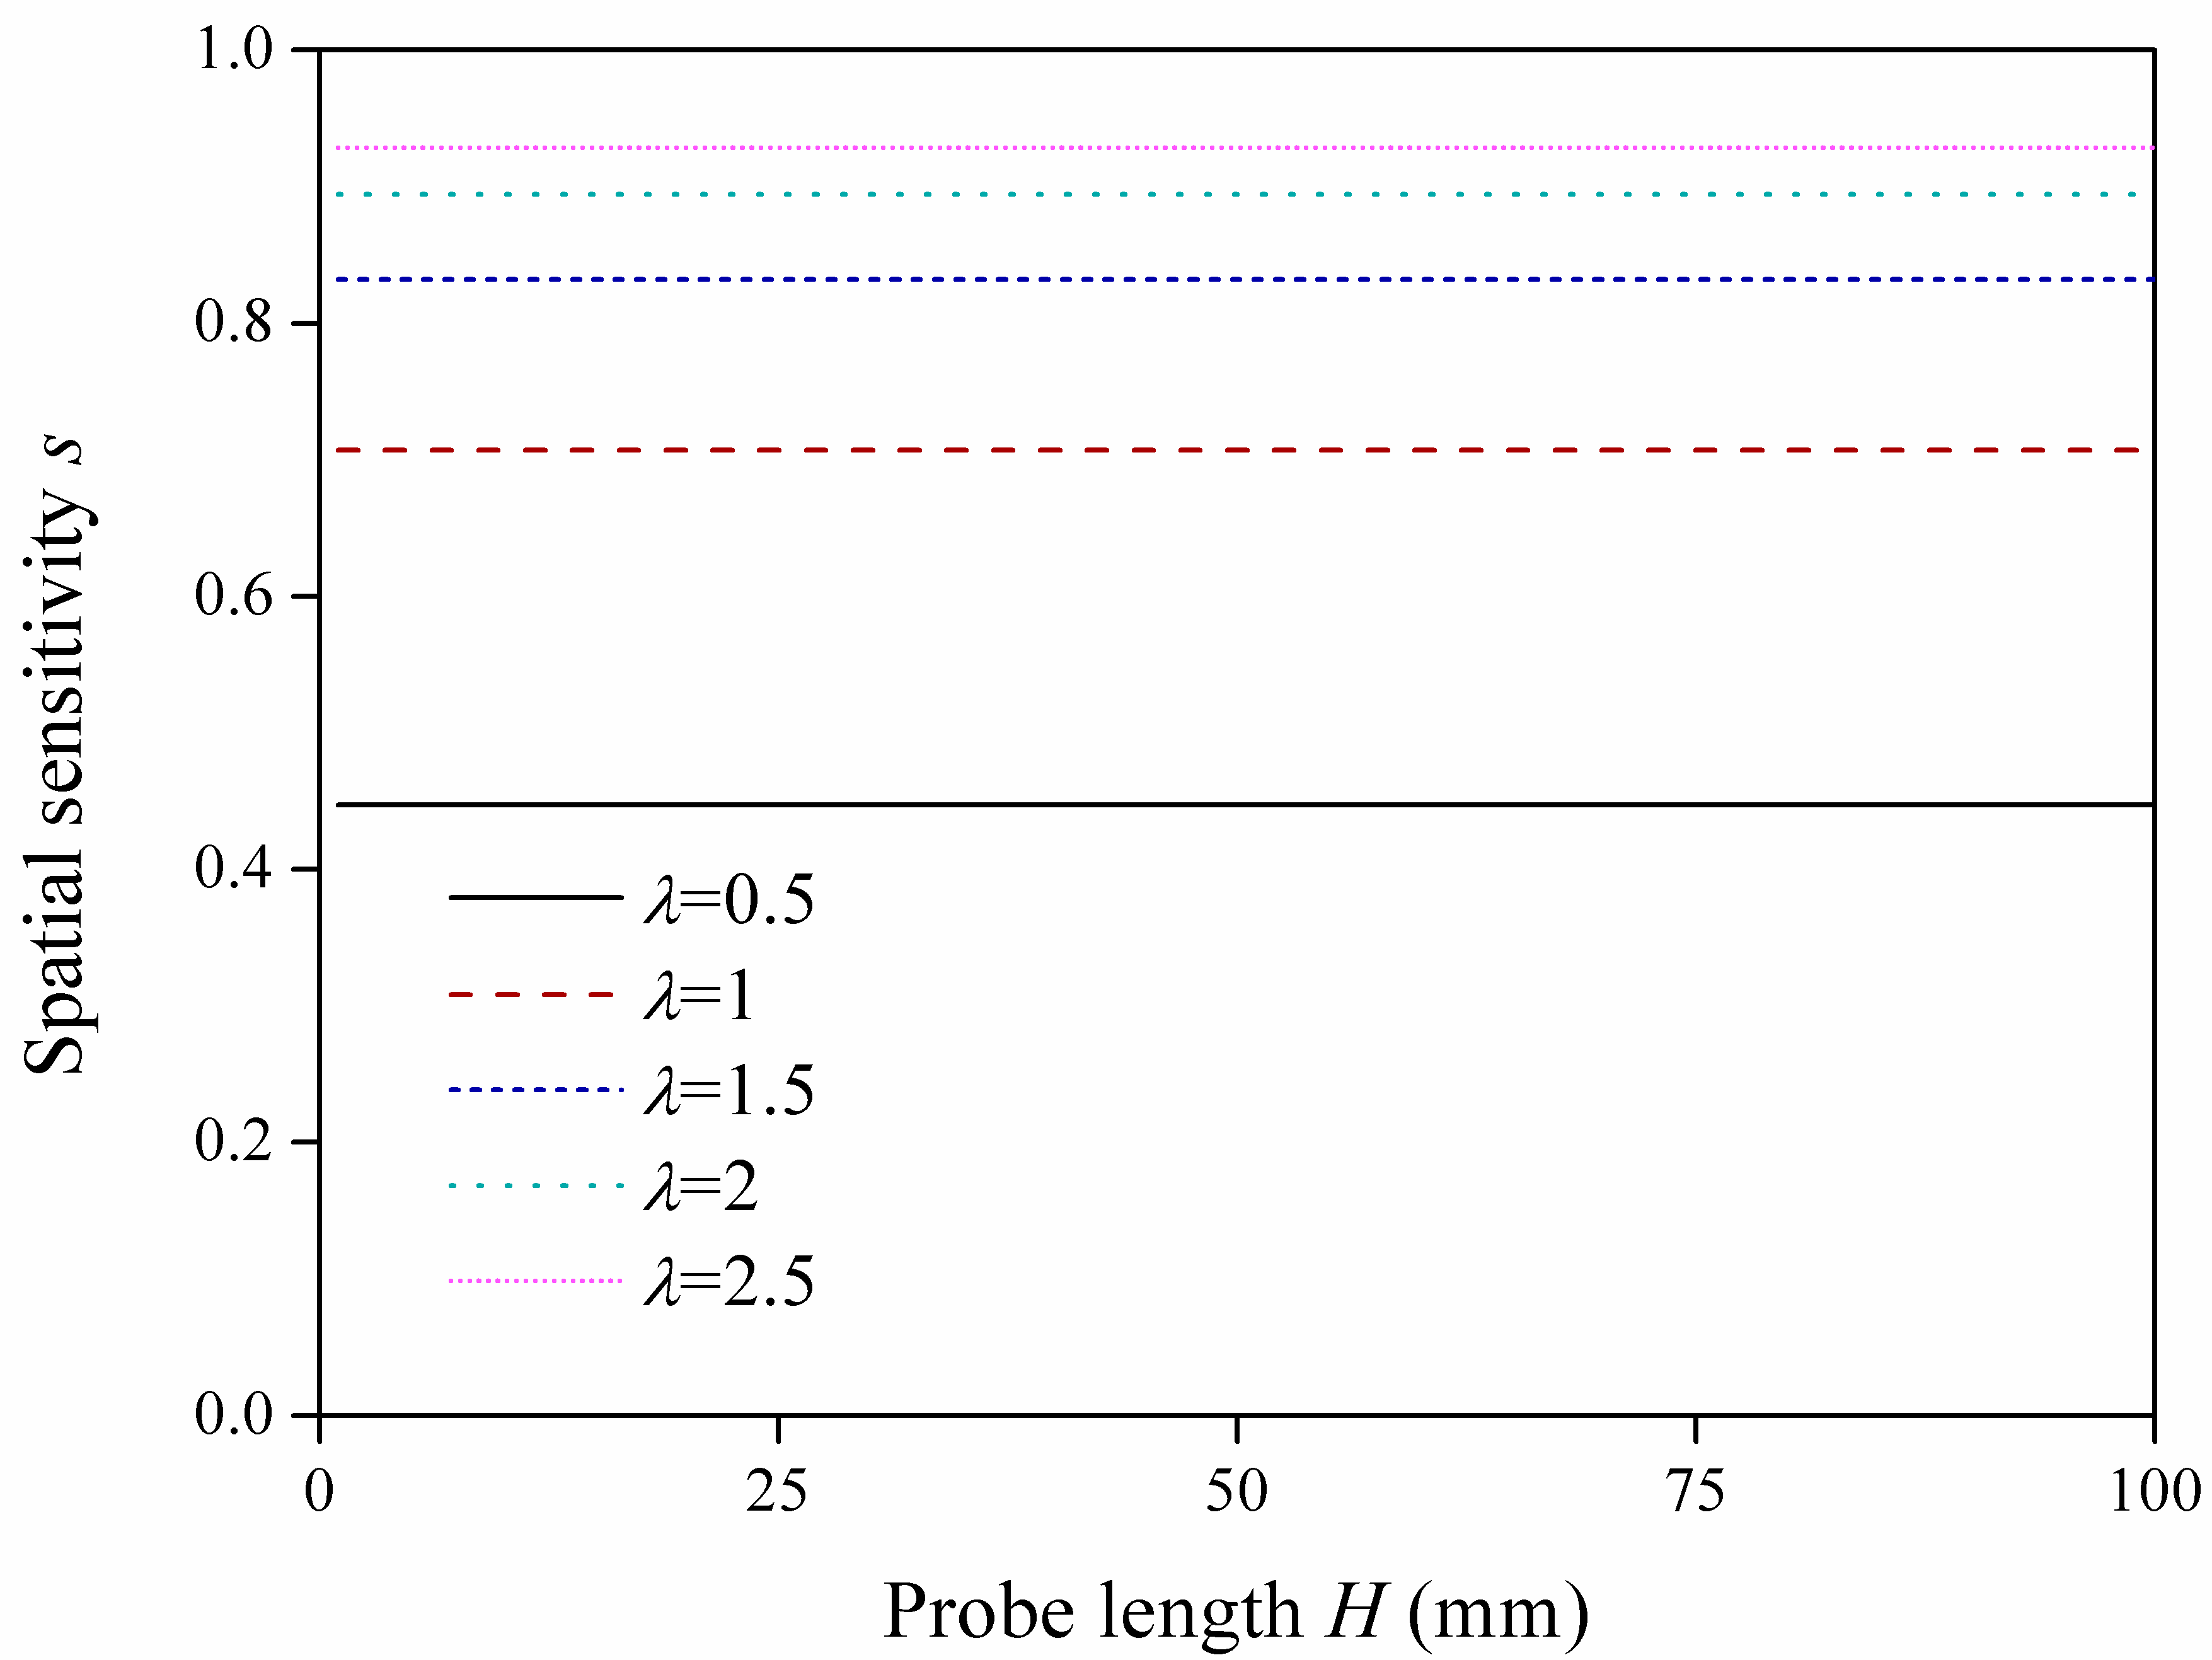
(c) (d)
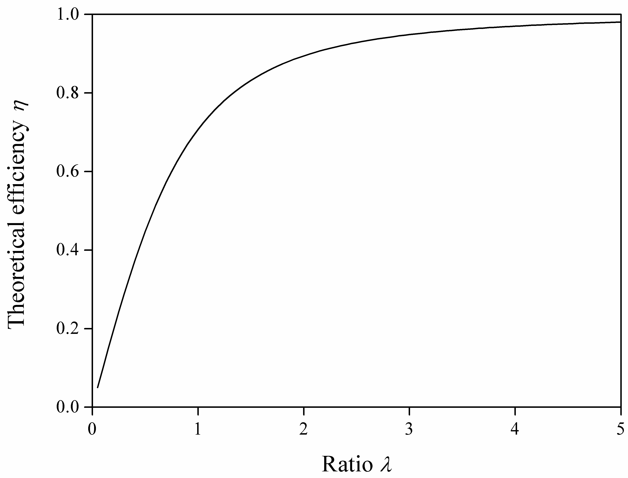
(e)
Fig. 8. Simulated spatial sensitivity of OLS with different ratios of length and diameter (a) Axial distribution at x=0 when ratio λ=1. (b) Axial distribution at x=0 when ratio λ=0.5. (c) Axial distribution at x=0 when ratio λ=1.5. (d) Distribution vs. probe length at a series of ratios x=0 and z=0. (e) Theoretical efficiency curve of OLS vs. the ratio.
This result is in agreement with the physical principle of electrostatic charging, i.e. the larger the ratio of the probe length to diameter, the more amount of electric flux that is produced by the inducing point charge positioned at the geometric center of the probe terminates on the sensing face and the more charge is induced on the sensor surface, the larger the theoretical efficiency of the OLS. As the ratio approaches infinity, theoretically, all the electric flux will terminate on the sensing face and the theoretical efficiency approaches 1. The accuracy and suitability of the mathematical model for electrostatic OLSs will be further validated through experimental study in the following sections.

5.2. Experimental input and output correlation curve
In the experiment, the input (or inducing) charge is the charge on the oil droplet, which is charged by the oil charging device described above. The amount of charge on the droplets is controlled by the voltage applied using the DC power supply and is measured using the electrometer in the Faraday cup. The linear relationship between the applied voltage U_{DC} and the charge on the oil droplets is demonstrated in the results plotted in Fig. 9.
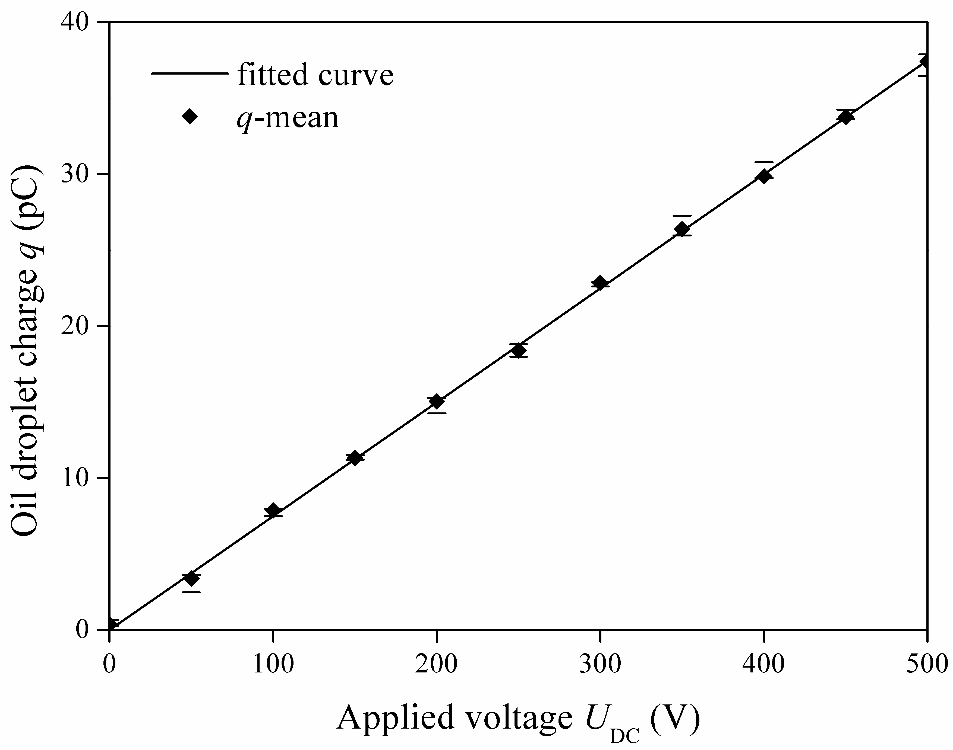
Fig. 9. Correlation between applied voltage and charge of oil droplet.
As mentioned above, the output of the sensor is obtained from the OLS. After a series of oil droplet experiments, the input and output correlation curves of the OLS were plotted and is shown in Fig. 10. During the experiment, an electrostatic OLS of 1 inch inner diameter with probe axial length H=20mm and radial diameter D=20mm was used. The path of oil droplet was firstly positioned at the center of the ring (x=0), while the applied voltage was increased from 0 V to 500 V at a 50 V increment. During each test, the oil droplet charge measured by the electrometer and the maximum of corresponding voltage signal (seen in Fig. 3) measured by the OLS were recorded. The tests were repeated at two more radial positions, x=4mm and x=8 mm. Fig. 10 summarizes the three experimental results together with the linear least square fitting for each of the test. It can be seen that, while good linear correlations between the output voltage from the OLS and input charge measured by the electrometer are found at all radial positions, the output voltage increases as the radial position of the oil droplet is closer to the sensor surface. The slope of output-input lines, which represents the static sensitivity of the OLS, increases with the radial position x, i.e. the sensing sensitivity increases as the distance between inducing charge and probe surface reduces, which is similar to the spatial sensitivity from the mathematical model.
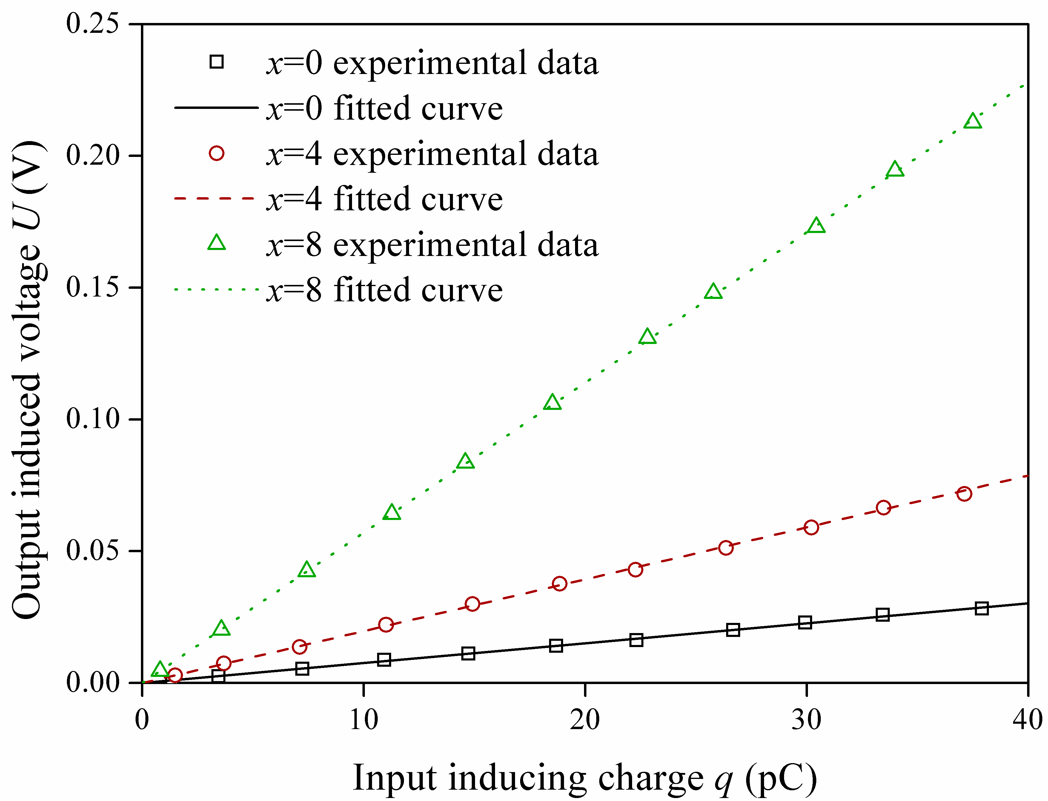
Fig. 10. Correlation between the output induced voltage from the OLS and the input inducing charge on the oil droplet measured by the electrometer.

5.3. Experimental static sensitivity and fitting results
In order to investigate the static sensitivity in more details, more experiments were conducted using the same OLS (named as 1# OLS) with the horizontal movement every 1mm from the center to the inner wall of the sensor. Each static sensitivity of the corresponding radial position was calculated from the slope of the line after the least square fitting of the measured data. Then the static sensitivities of the sensor were plotted against the radial position in Fig. 11, where a polynomial fit is also plotted over the experimental data. The mathematical expression of the polynomial fitted curve is given in formula (9) while the fitting parameters are presented in Table 1.
(9)
where x is the radial position of the OLS in meter (m), s'(x) is the static sensitivity of the OLS corresponding to the radial position x in V/pC and r is the inner diameter of OLS. From Table 1, it can be seen that the result fitted extremely well and is very similar to the trend found in the simulated spatial sensitivity in radial direction, i.e. the value changes slowly near the radial center and increases rapidly close to the sensor surface.
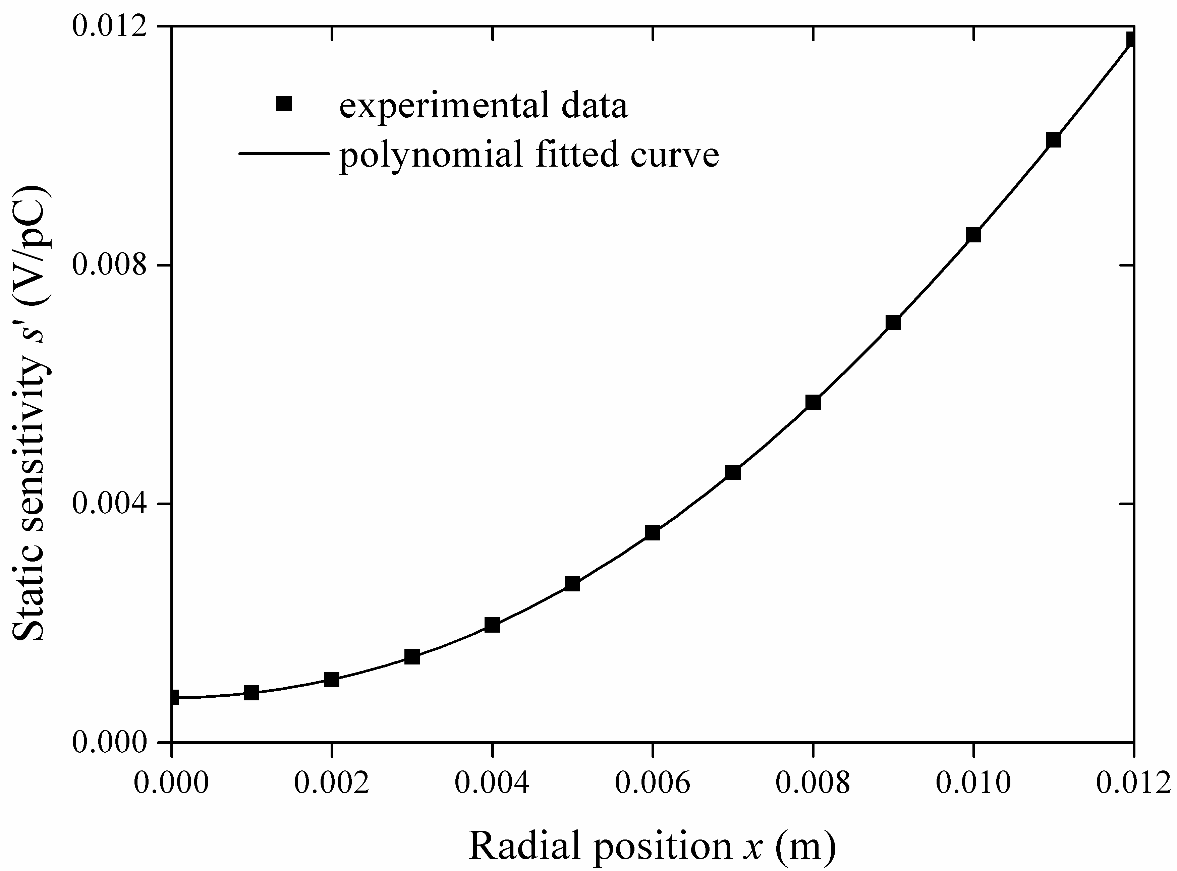
Fig. 11. Radial static sensitivity of 1# OLS.
Table 1
The polynomial fitting parameters of radial static sensitivity for 1# OLS
Parameter | Result
SSE | 2.483×10⁻¹⁰
R-square | 1
Adjusted R-square | 1
RMSE | 5.571×10⁻⁶
Further investigations have been taken to validate the calibration method through more experiments using a range of electrostatic OLSs. The probe parameters are listed in Table 2. All experiments followed the same procedure described in section 5.2 for the 1# OLS and the results are summarized in Fig. 12 with fitted curves. As can be seen, each OLS has a unique radial static sensitivity curve, which can be used as their calibration characteristics.

Table 2
Probe parameters of four experimental OLSs to be calibrated
OLS | Sensor inner diameter  d (in) | Probe axial length  H (mm) | Probe radial diameter  D (mm) | Ratio of length and diameter  λ
1# | 1 | 20 | 28 | 0.714
2# | 1 | 10 | 28 | 0.357
3# | 0.5 | 10 | 14 | 0.714
4# | 1.5 | 28 | 40 | 0.7
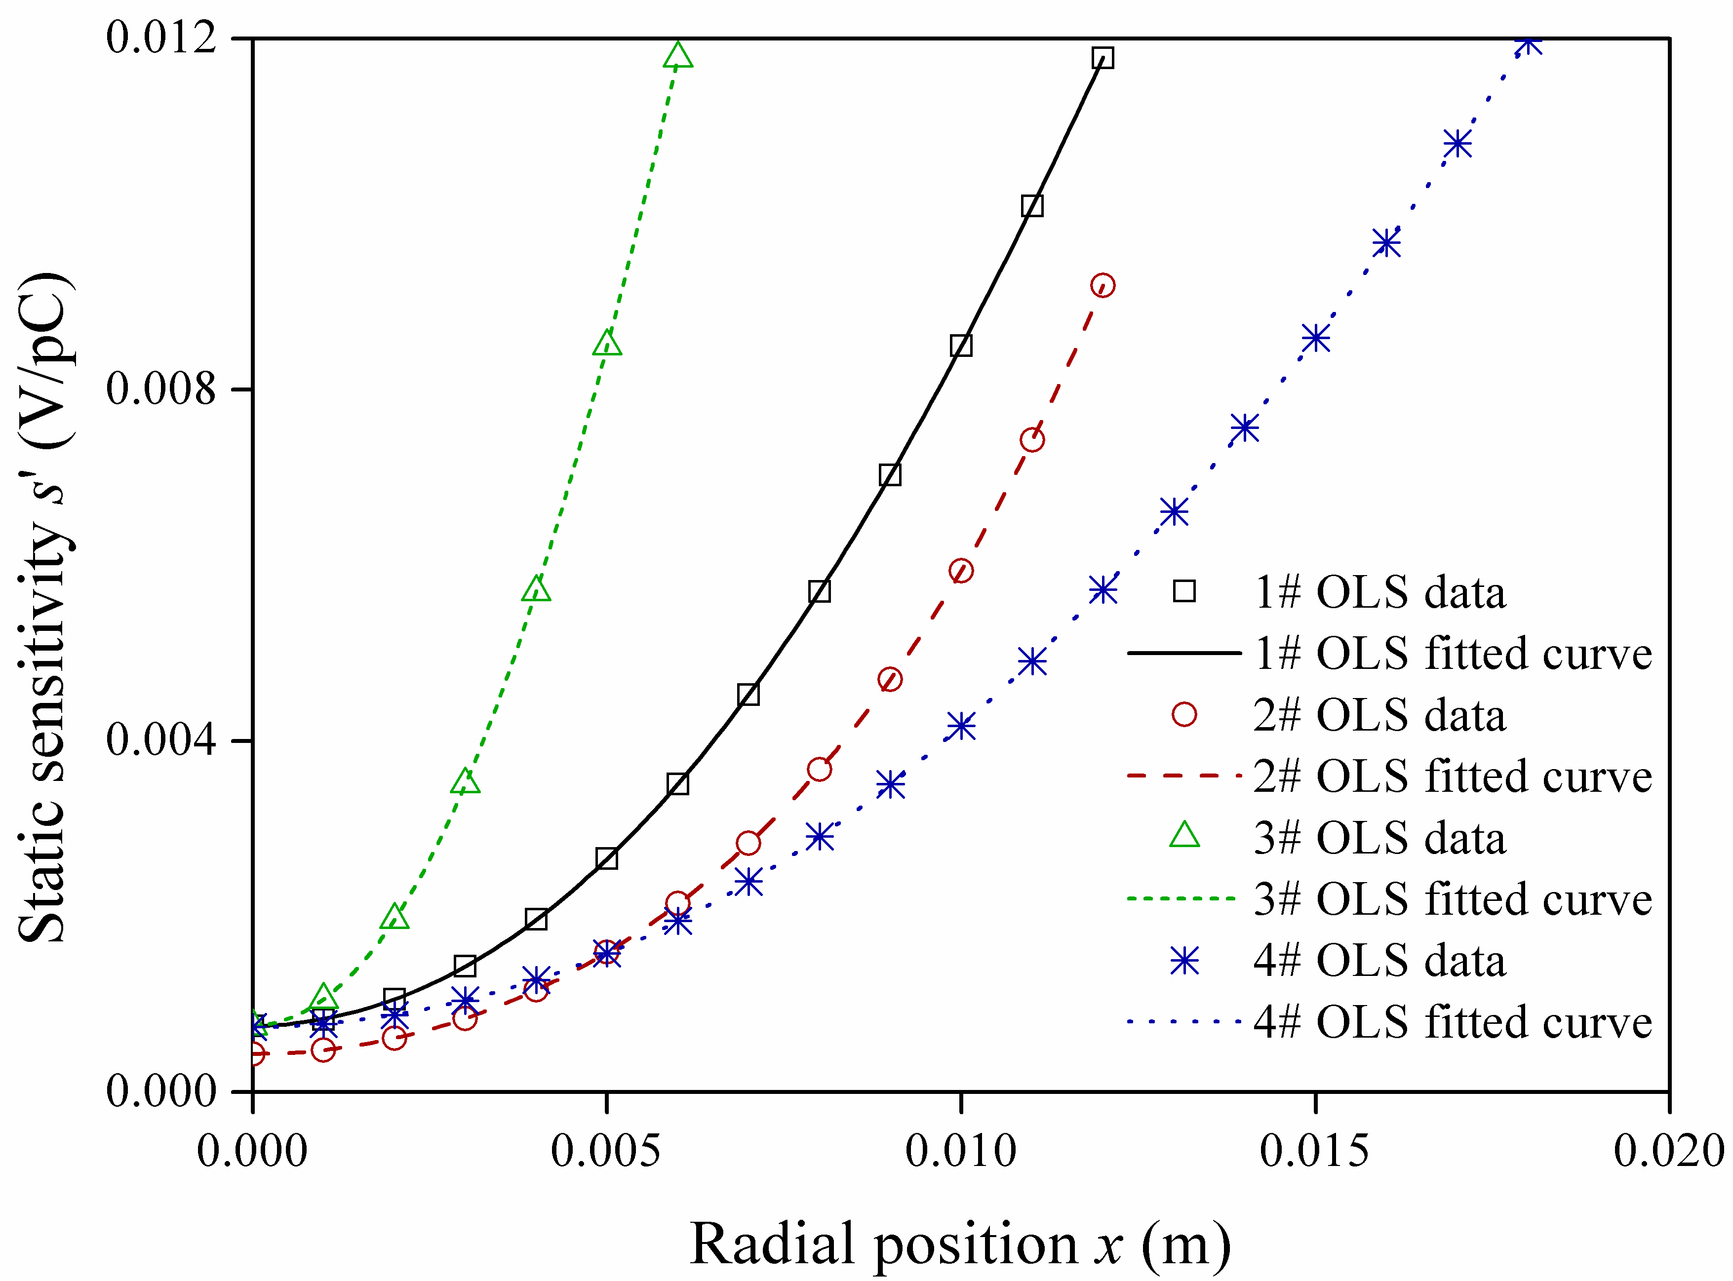
Fig. 12. Radial static sensitivity of four OLSs with different probe parameters.
From Fig. 12, it can be seen that the radial static sensitivity of OLS changes with the probe parameters. At the same radial position, it indicates that the OLS with a longer axial length has a higher static sensitivity under the same radial diameter by comparing 1# and 2#; whereas a smaller radial diameter has a higher static sensitivity under the same axial length by comparing 2# and 3#; it also indicate that a smaller size of OLS has a higher static sensitivity under the nearly same ratio of length and diameter by comparing 1#, 3# and 4#, while it equals at the center position i.e. x=0 for the three OLSs. The experimental conclusions are in accordance with the simulated analysis of spatial sensitivity distribution in section 5.1, which further validate the effectiveness of the designed and employed electrostatic calibration method and measured data while also prove the correctness of the built electrostatic OLS mathematical model and the results of induction simulation.

5.4. Real sensing efficiency and field of view
Transforming the experimental electrostatic signal acquired at the center position to charge, the corresponding Q_{max} can be noted to calculate the actual efficiency of OLS. The results from the four electrostatic OLSs are plotted in Fig. 13(a) using the box-plot method. It can be seen that the values of real sensing efficiency of 1#, 3# and 4# OLSs, which have nearly the same length to diameter ratios, are very similar at about 0.6, while the value for 2# OLS is at about 0.3. These values are very close to the theoretical efficiency values from the simulation in section 5.1. In order to validate the trend of real sensing efficiency, more OLSs with different probe ratios have been tested following the same experimental procedures as described above and the results are shown in Fig. 13(b). Both the maximum and minimum values are shown as the range and the median at each λ is shown in diamond shaped point based on multiple tests after outlier removal.
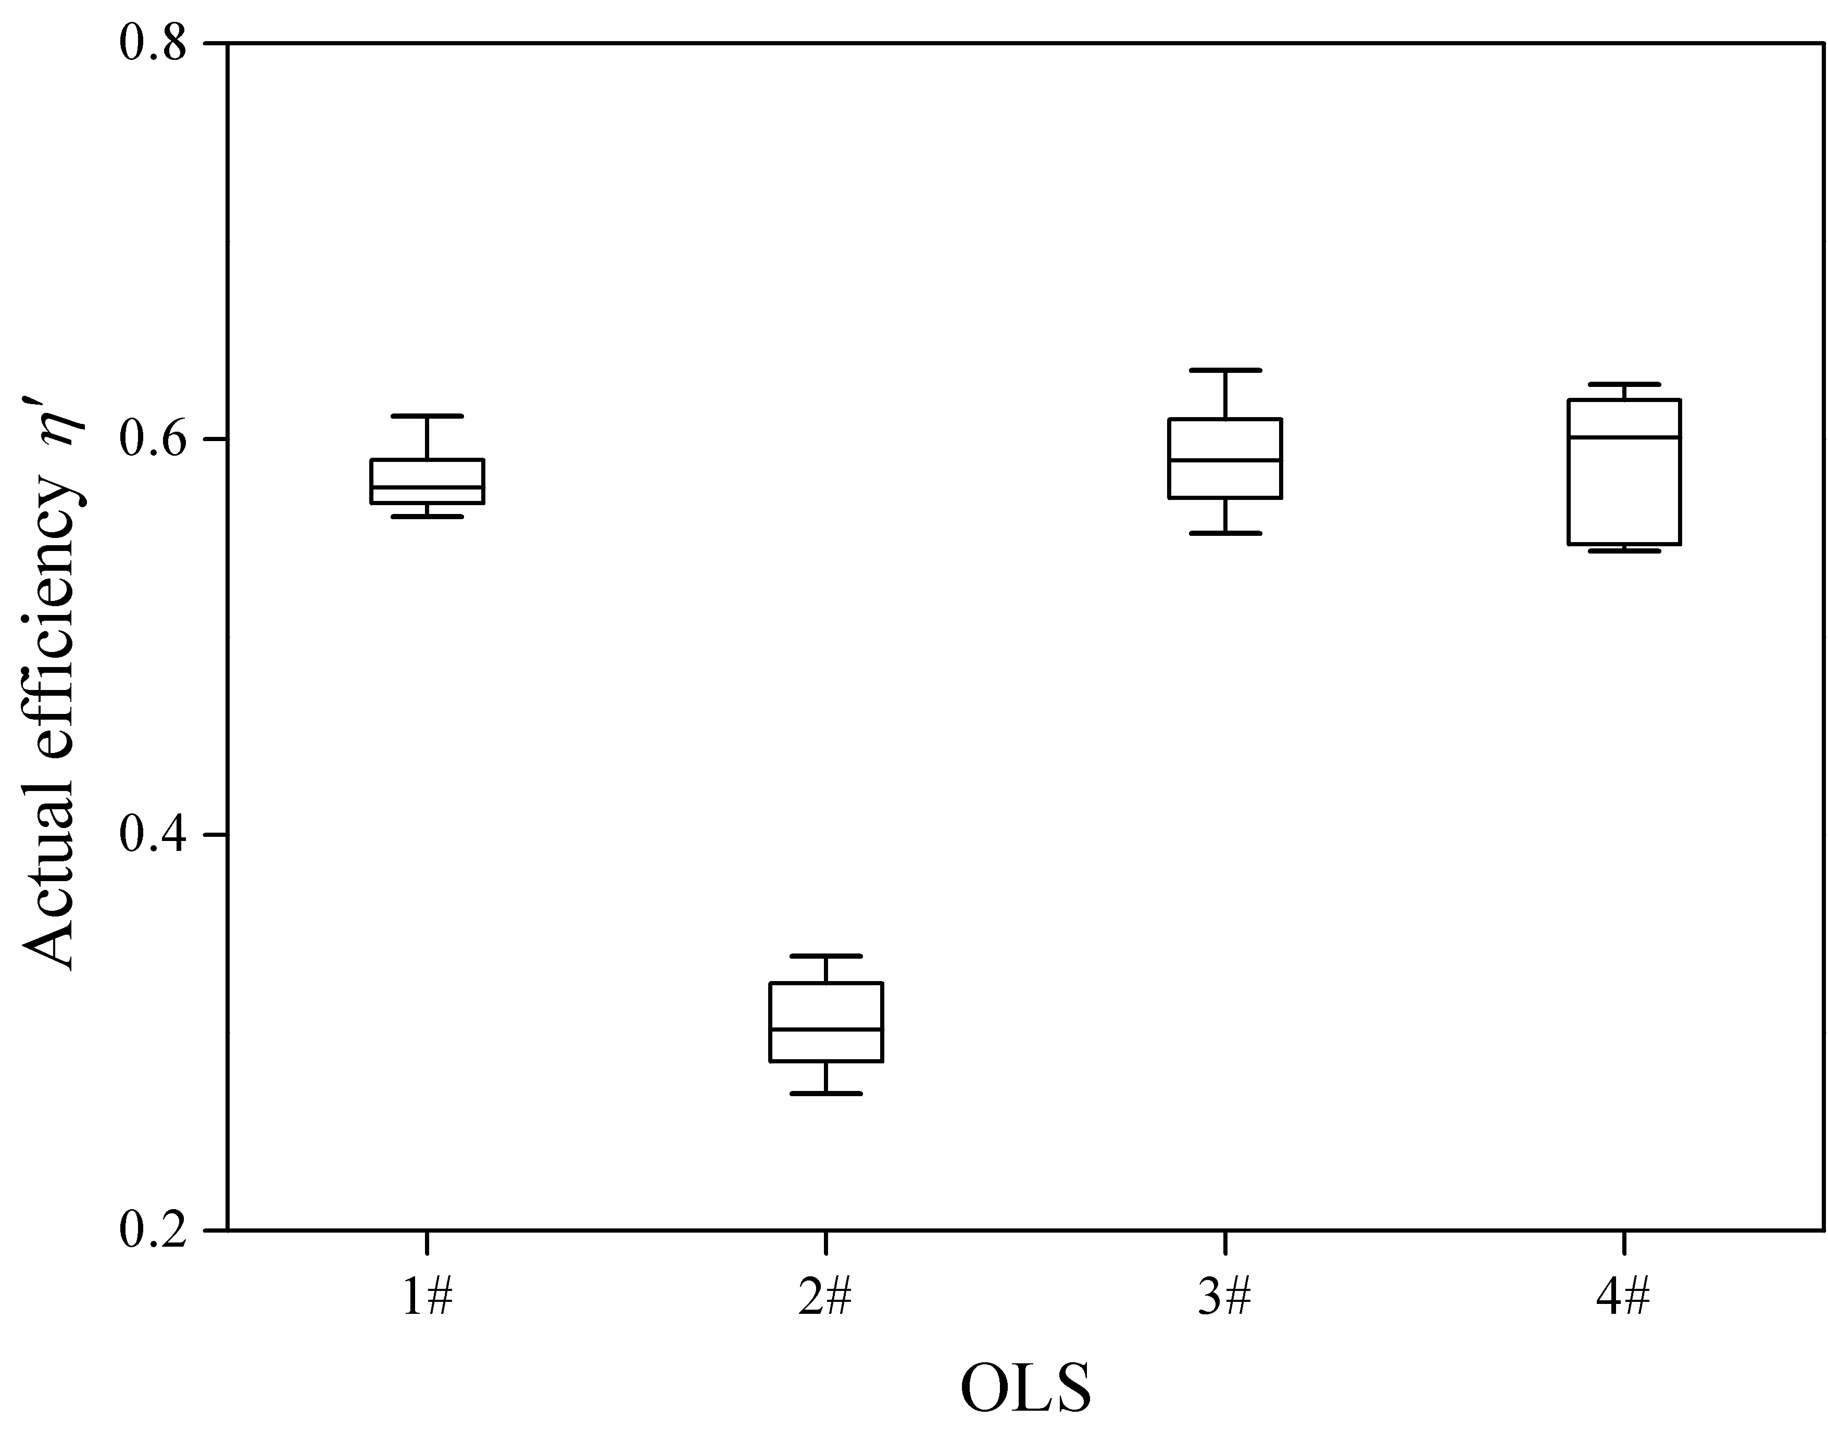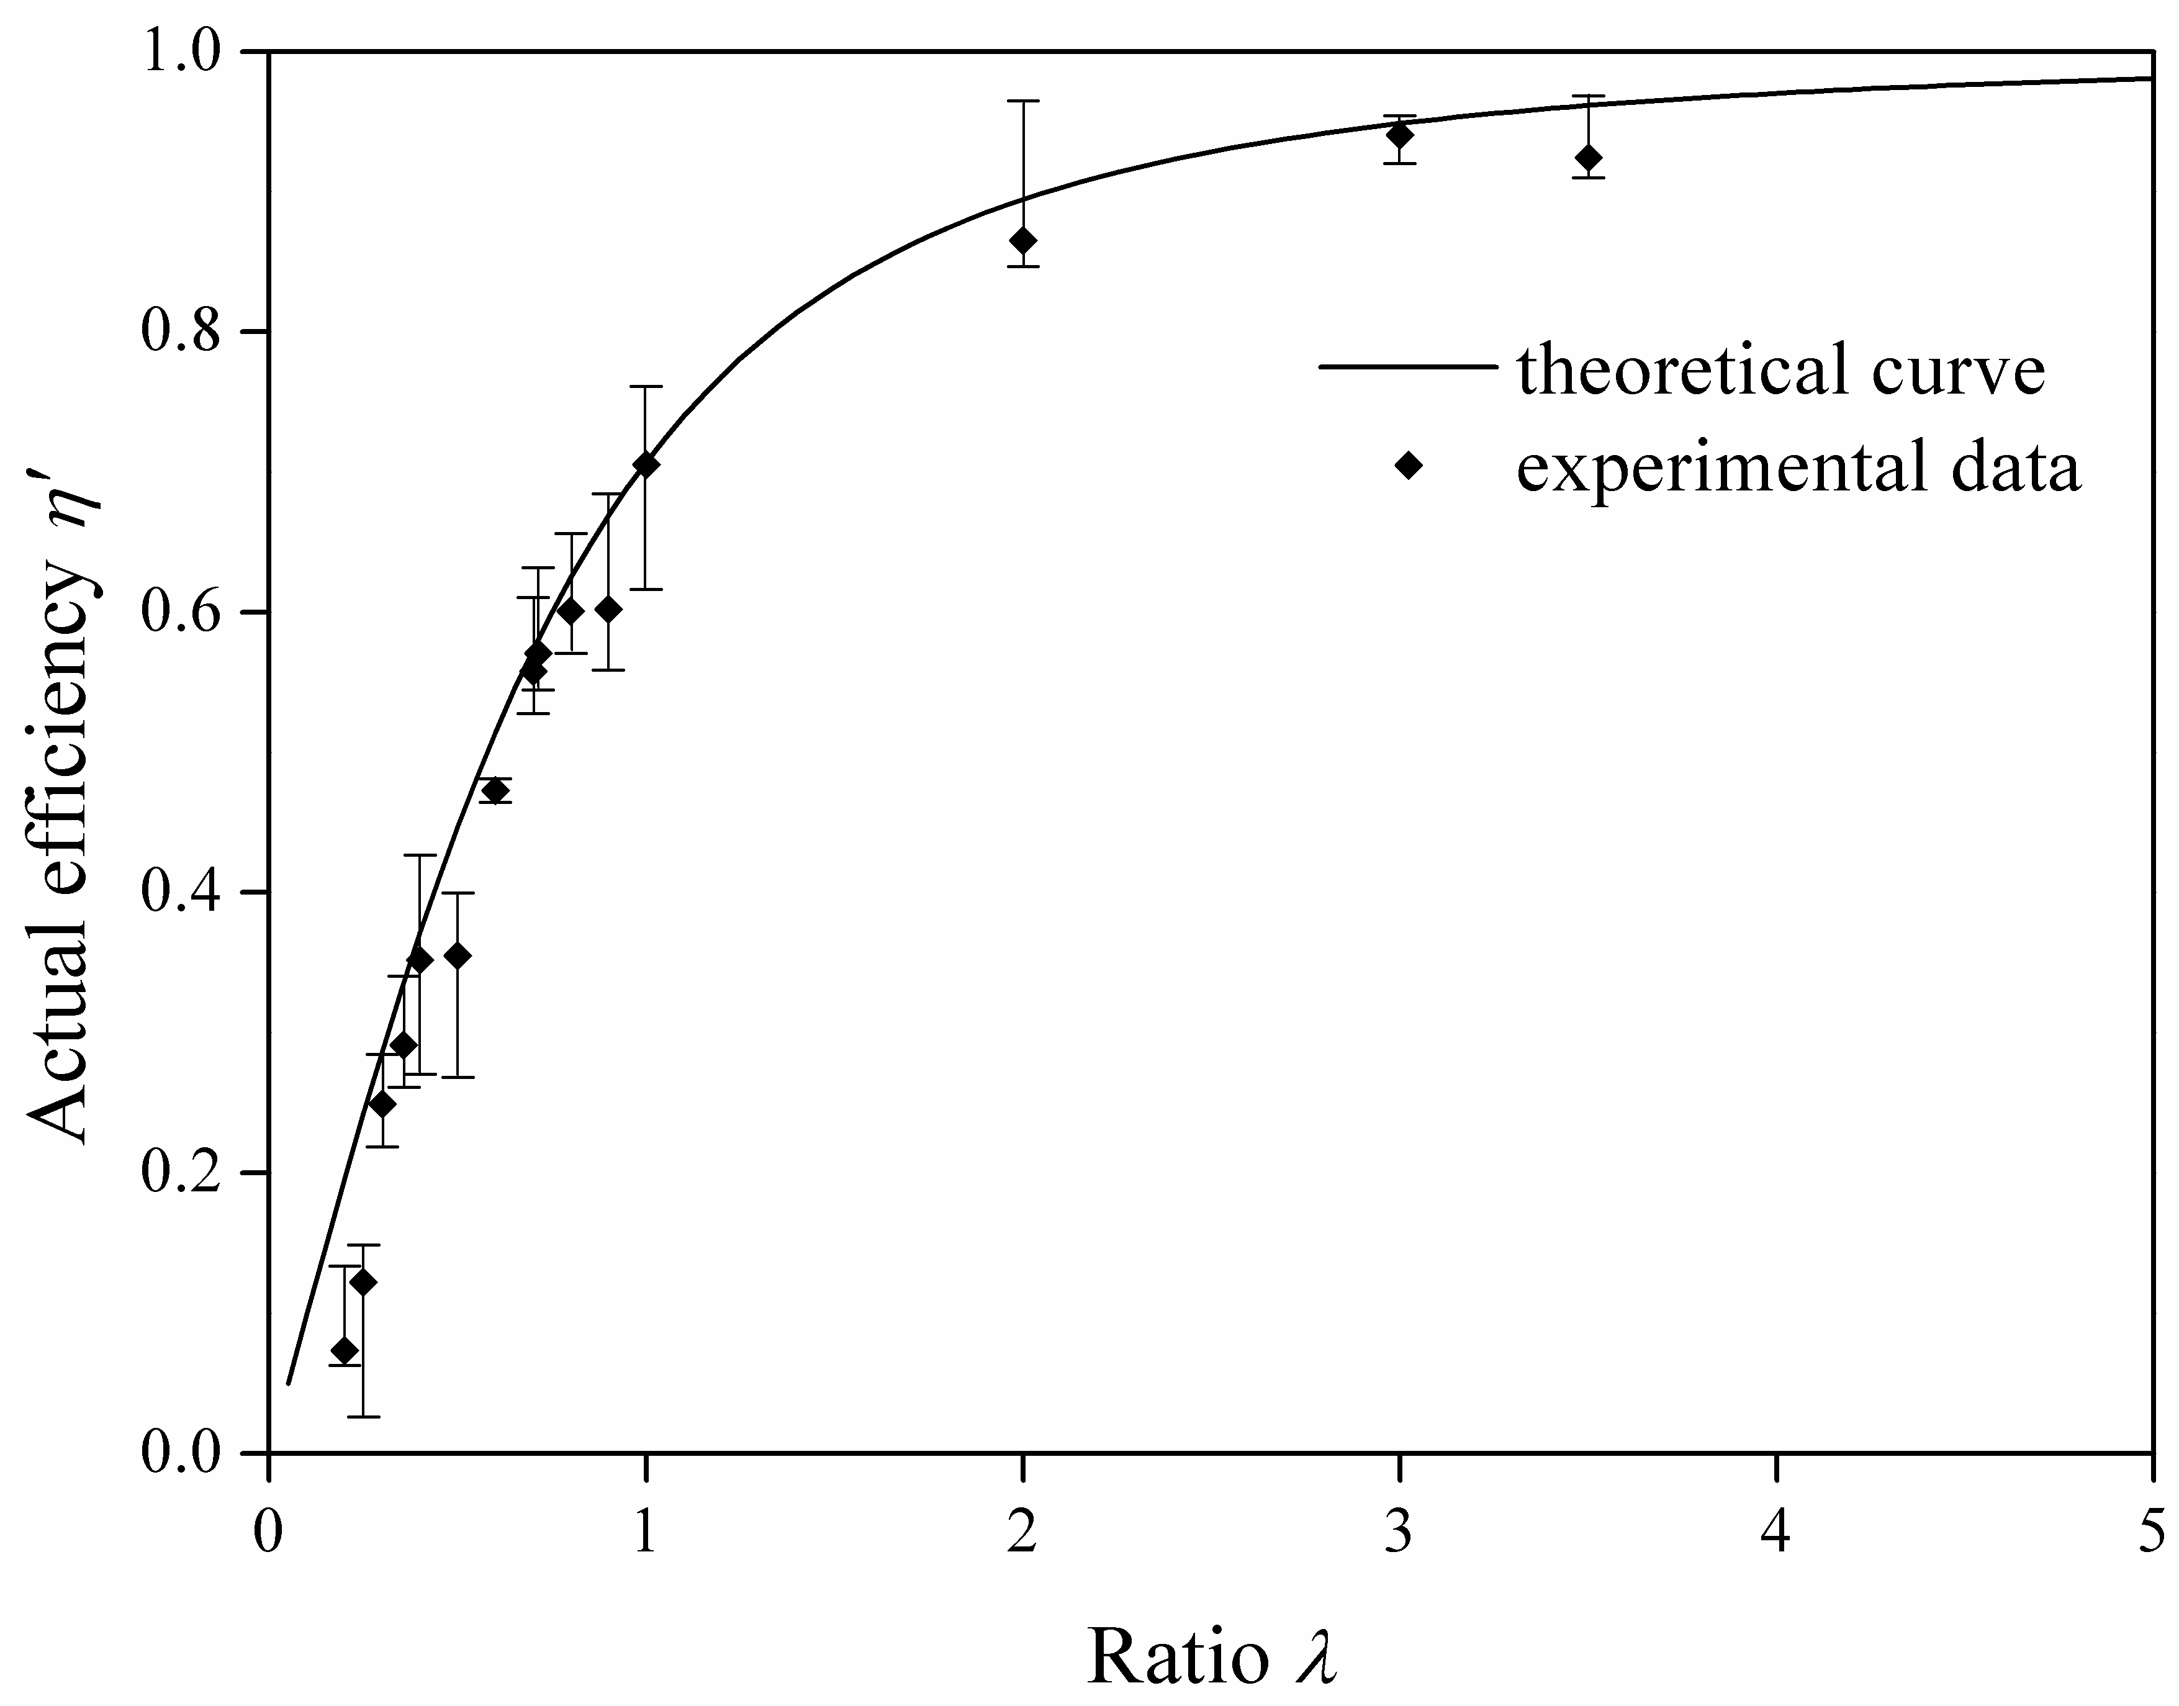
(a) (b)
Fig. 13. Actual efficiency of electrostatic OLS (1) Four experimental sensors (2) A series of probes with different ratios.
The trend shown in Fig. 13(b) is very similar to that in Fig. 8 from the modeling, which also agrees with Morris's simulation results [22. The experimental results have successfully proved that the theoretical model can be used to obtain the efficiency curve of known electrostatic OLSs and for designing new OLSs.
It is worth pointing out that, the output voltage and transformed charge are the maximum value of corresponding signal, as illustrated in Fig. 3. Also, the electrostatic data acquired using the OLSs contain background noise from the cables and the data acquisition system thus have caused an oscillation in the electrostatic signals and lead to variations in the time domain. This has caused difficulties in correlating them with the accurate positions compared to the simulation where the maximum of the signal was clear, steady and easy to be extracted.
The electrostatic field of view is an important parameter for OLSs and was therefore tested using similar methods. According to the definitions given in section 3.5, the speed of the charged oil droplet moving through the OLS is required for the calculation of the field of view. The velocity v_{c} of the charged oil droplet can be calculated using the equation below [22]:
(10)
where g is the gravitational acceleration and approximately equals to 9.81 m/s², h_{c} is the vertical distance between the bottom of the metallic needle, i.e. the release point of the oil droplet, and the center of the probe, v_{c} is the velocity of the droplet through the central section of the OLS.
Considering the sizes of probe and sensing zone are far less than the falling height of oil droplet, the velocity of oil droplet passing through the sensor can be considered as a constant that equals to v_{c}, while the falling height is easily measured. Then it is obvious that the field of view of an electrostatic OLS can be calculated using Equation (7) in association with Equation (10). The four OLSs described in Table 2 were tested and the field of view results are shown in Fig. 14. In order to compare the results between the sensors, the radial position of the OLSs has been normalized by the following equation:
(11)
where ρ_{nor} is the normalized radial position of OLS, x is the actual radial position of the oil droplet and D is the radial diameter of the probe.
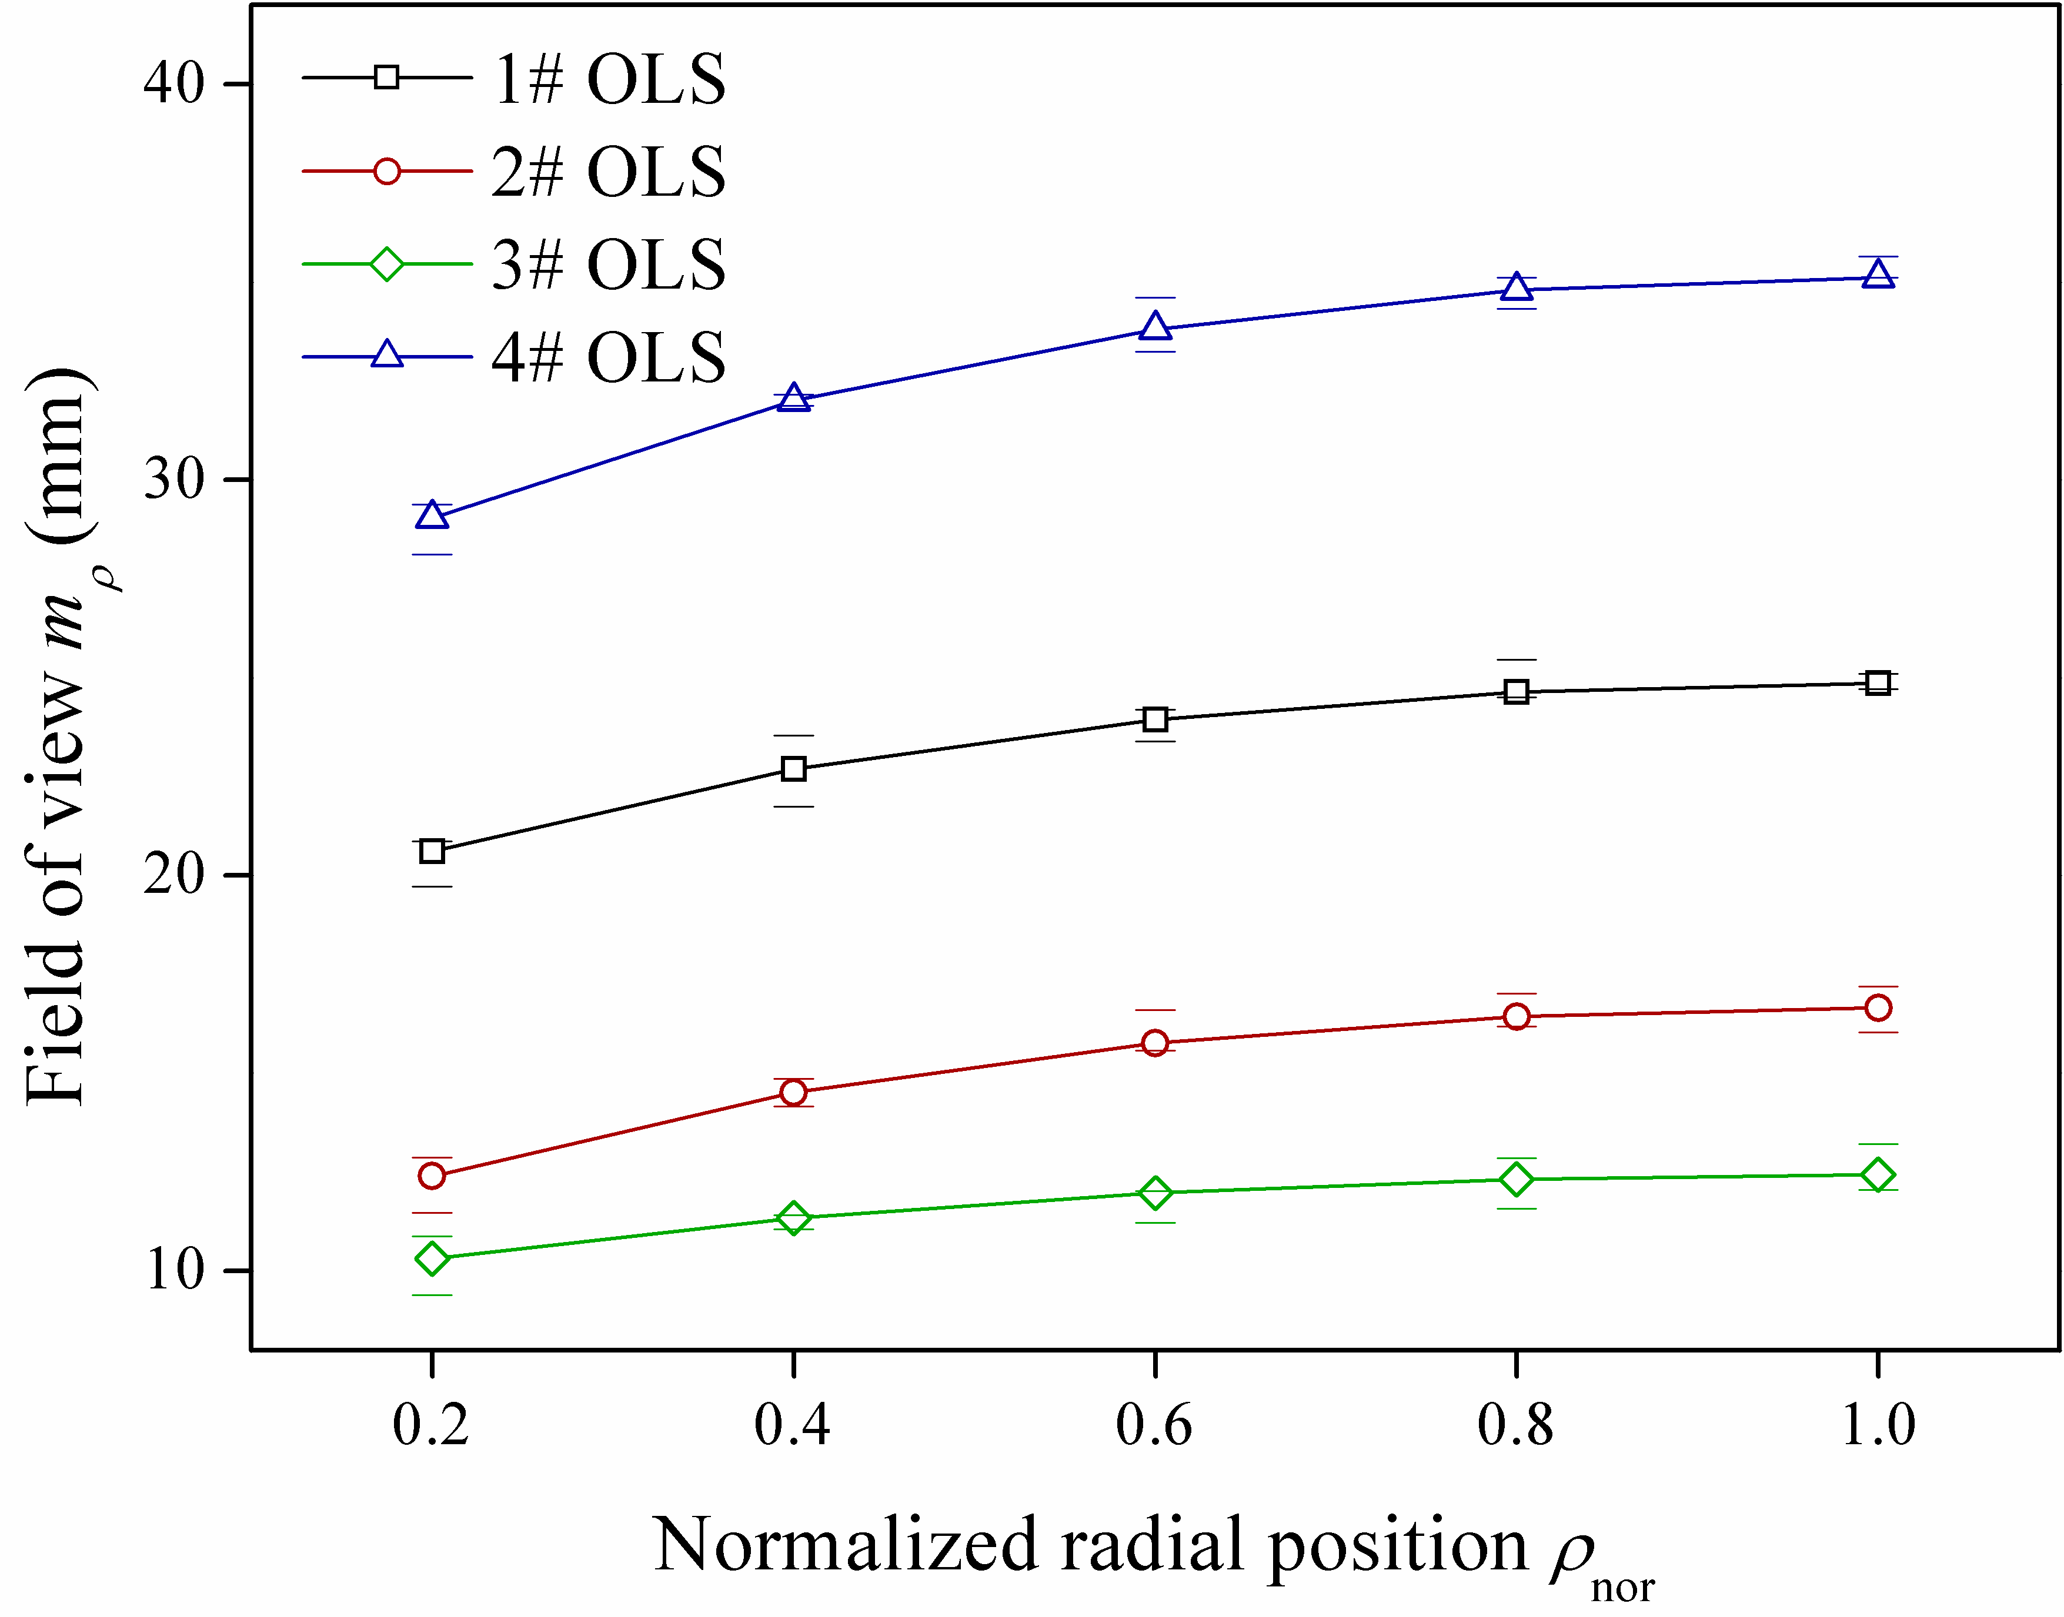
Fig. 14. Field of view of four OLSs with different probe parameters.
As it was mentioned above, the field of view in Fig. 14 only represents half of OLSs in the axial direction. The maximum, minimum and average values from multiple oil droplets measurements are plotted. For all the OLSs, the field of view in axial direction increases with the increase of the normalized radial position and reaches its maximum when ρ_{nor}=1 i.e. x=0. Thus the axial field of view at the center line (x=0) of OLSs can be regarded as the effective viewing field that represents the field of view of OLSs. It also indicates that the OLSs with a longer axial length have a longer field of view under the same radial diameter (comparing 1# and 2#); a larger radial diameter also has a longer field of view under the same axial length (comparing 2# and 3#); the 4# OLS with the maximum size (longest length and diameter) has the largest field of view. In brief, the larger size of a probe, the larger electrostatic field of view the OLS has. This also agrees with the findings in Morris' work [ref?]. From Fig. 14, it can also been seen that the range of the field of view is larger than the size of probe just like the spatial sensitivity predicted. As a result, in order to reduce the noise from the background and electromagnetic interference surroundings, it requires a larger size OLS especially a effective shielding layer in the axial direction to cover the probe and the electrostatic field of view.
Considering the applications electrostatic OLSs, it is recommended that sensors with the highest possible length to diameter ratio should be firstly considered to increase the sensor efficiency for a given diameter of oil pipes to be monitored. The overall size of the OLS should be increased within the limitations of installation and fixation. In general, selection of electrostatic sensors should consider both the sensor efficiency and its field of view according to the oil circulation system and the surroundings.

5. Conclusions
This paper has investigated the electrostatic sensing using OLSs through both theoretical modeling and experimental validation approaches. A number of parameters have been used to characterize OLS properties, including spatial sensitivity, sensor efficiency, static sensitivity and electrostatic field of view. The main conclusions are summarized below.
1. The spatial sensitivity of an OLS increases with the decrease of axial position and the increase of radial position inside the probe. The spatial sensitivity also exists outside of the probe but has the opposite trends as those inside the probe.
2. The ratio of the probe length and diameter is a significant parameter for electrostatic OLSs and the higher the ratio the higher the spatial sensitivity and theoretical efficiency can be achieved.
Electrostatic OLSs with the same ratio have the same theoretical efficiency, even when the probe length and diameter are different.
3. The real sensor efficiency obtained through experiment is in agreement with the theoretical efficiency, which successfully validated the simulated theoretical efficiency curve.
4.
The electrostatic field of view calculated based on the measurements from a range of OLSs at different probe lengths and diameters shows that, the field of view increases with the increase of normalized radial position and has the maximum at the center line of the sensor. However OLSs with larger probe length and diameter have a larger field of view, even when the ratios of the probe length and diameter are the same.
6. In the applications of electrostatic OLSs, it is recommended that sensors with larger ratio of the probe length and diameter should be firstly selected to increase the sensor efficiency with a given diameter of the oil pipe, while the overall size of the OLS should be increased as much as possible within the restriction of installation and fixation. A comprehensive consideration should be researched to decide the most suitable size of the electrostatic sensor eventually.
7. In addition, it is important to look into the actual industry environment where complex conditions may affect the performance of electrostatic OLSs such as strong background noises, which will be investigated in the future research on electrostatic sensing.

Acknowledgments
This work was supported by the major program of National Science Foundation of China (No. 60939003 & No. 61403198) and Natural Science Fund Project in Jiangsu Province (BK20140827). The authors would like to thank Prof Robert Wood and Dr Terry Harvey (nCATS) for their support to the leading author’s visit at University of Southampton.

References
- Wen Z, Zuo H, Pecht M G. Electrostatic monitoring of gas path debris for aero-engines. IEEE Transactions on Reliability, 2011, 60(1): 33-40.
- Liu P P, Zuo H F, Sun J Z. The electrostatic sensor applied to the online monitoring experiments of combustor carbon deposition fault in aero-engine. Sensors Journal, IEEE, 2014, 14(3): 686-694.
- Powrie H, McNicholas K. Gas path condition monitoring during accelerated mission testing of a demonstrator engine. AIAA paper, 1997: 97-2904.
- Powrie H, Novis A. Gas path debris monitoring for F-35 joint strike fighter propulsion system PHM. IEEE Aerospace Conference, 2006: 8.
- Wang L, Wood R J K, Harvey T J, et al. Electrostatic charge-a novel condition monitoring technology. Condition Monitor, 2007, 248: 5-9.
- Harvey T J, Wood R J K, Powrie H E G. Electrostatic wear monitoring of rolling element bearings. Wear, 2007, 263(7): 1492-1501.
- Tasbaz O D, Wood R J K, Browne M, et al. Electrostatic monitoring of oil lubricated sliding point contacts for early detection of scuffing. Wear, 1999, 230(1): 86-97.
- Morris S, Wood R J K, Harvey T J, et al. Electrostatic charge monitoring of unlubricated sliding wear of a bearing steel. Wear, 2003, 255(1): 430-443.
- Booth J E, Harvey T J, Wood R J K, et al. Scuffing detection of TU3 cam–follower contacts by electrostatic charge condition monitoring. Tribology International, 2010, 43(1): 113-128.
- Craig M, Harvey T J, Wood R J K, et al. Advanced condition monitoring of tapered roller bearings, Part 1. Tribology International, 2009, 42(11): 1846-1856.
- Morris S, Wood R J K, Harvey T J, et al. Use of electrostatic charge monitoring for early detection of adhesive wear in oil lubricated contacts. Journal of Tribology, 2002, 124(2): 288-296.
- Harvey T J, Wood R J K, Denuault G, et al. Investigation of electrostatic charging mechanisms in oil lubricated tribo-contacts. Tribology International, 2002, 35(9): 605-614.
- Harvey T J, Wood R J K, Denuault G, et al. Effect of oil quality on electrostatic charge generation and transport. Journal of Electrostatics, 2002, 55(1): 1-23.
- Wood R J K, Harvey T J, Morris S, et al. Electrostatic monitoring of boundary and mixed lubrication. Tribology Series, 2002, 40: 83-92.
- Wang L, Wood R J K, Harvey T J, et al. Wear performance of oil lubricated silicon nitride sliding against various bearing steels. Wear, 2003, 255(1): 657-668.
- Wang L, Wood R J K, Care I, et al. Electrostatic wear sensing of ceramic-steel lubricated contacts. Tribology Series, 2003, 43: 711-720.
- Sun J, Wood R J K, Wang L, et al. Wear monitoring of bearing steel using electrostatic and acoustic emission techniques. Wear, 2005, 259(7): 1482-1489.
- Wood R J K, Ramkumar P, Wang L, et al. Electrostatic monitoring of the effects of carbon black on lubricated steel/steel sliding contacts. Tribology and Interface Engineering Series, 2005, 48: 109-121.
- Booth J E, Nelson K D, Harvey T J, et al. The feasibility of using electrostatic monitoring to identify diesel lubricant additives and soot contamination interactions by factorial analysis. Tribology International, 2006, 39(12): 1564-1575.
- Hanzal R. Rolling contact fatigue failures in silicon nitride and their detection. University of Southampton, 2013.
- Liu R C, Zuo H F, Sun J Z, et al. Electrostatic monitoring of wind turbine gearbox on oil-lubricated system. Proceedings of the Institution of Mechanical Engineers, Part C: Journal of Mechanical Engineering Science, 2016: 0954406216648985.
- Morris S. Real-time electrostatic charge monitoring of the wear surfaces and debris generated by sliding bearing steel contacts. University of Southampton, 2003.
- Wang L, Wood R J K, Harvey T J, et al. Feasibility of using electrostatic monitoring for oil lubricated ceramic to steel sliding contacts. Tribology Series, 2003, 41: 625-635.
- Harvey T J, Morris S, Wang L, et al. Real-time monitoring of wear debris using electrostatic sensing techniques. Proceedings of the Institution of Mechanical Engineers, Part J: Journal of Engineering Tribology, 2007, 221(1): 27-40.
- Zhang Y, Zuo H F, Bai F. Feature extraction for rolling bearing fault diagnosis by electrostatic monitoring sensors. Proceedings of the Institution of Mechanical Engineers, Part C: Journal of Mechanical Engineering Science, 2014: 0954406214550014.
- Gajewski J B, Szaynok A. Charge measurement of dust particles in motion. Journal of Electrostatics, 1981, 10: 229-234.
- Gajewski J B. Electrostatic flow probe and measuring system calibration for solids mass flow rate measurement. Journal of Electrostatics, 1999, 45(4): 255-264.
- Gajewski J B. Static characteristics of an electrostatic flow probe. Journal of Electrostatics, 1999, 48(1): 49-64.
- Zhang J Q, Yan Y. On-line continuous measurement of particle size using electrostatic sensors. Powder Technology, 2003, 135: 164-168.
- Yan Y, Byrne B, Woodhead S, et al. Velocity measurement of pneumatically conveyed solids using electrodynamic sensors. Measurement Science and Technology, 1995, 6(5): 515.
- Hussain T, Kaialy W, Deng T, et al. A novel sensing technique for measurement of magnitude and polarity of electrostatic charge distribution across individual particles. International Journal of Pharmaceutics, 2013, 441(1): 781-789.
- Ball K, Owsley C. The useful field of view test: a new technique for evaluating age-related declines in visual function. Journal of the American Optometric Association, 1993, 64(1): 71-79.
- Di J, Zhao J, Jiang H, et al. High resolution digital holographic microscopy with a wide field of view based on a synthetic aperture technique and use of linear CCD scanning. Applied Optics, 2008, 47(30): 5654-5659.
- Wu J, Cui X, Zheng G, et al. Wide field-of-view microscope based on holographic focus grid illumination. Optics Letters, 2010, 35(13): 2188-2190.

