Spatial-temporal changes of coastal and marine disasters risks and impacts in Mainland China
Abstract:
China is amongst the countries most severely affected by coastal and marine disasters. In this study, the annual variation and geographic distribution of the direct economic losses and fatalities caused by rapid-onset coastal and marine disasters in China have been analysed. This was based on a collection of historical documents and official records. The five main hazards include storm surges, rough seas, sea ice, red tides and green tides. The results show that: (1) Storm surges caused the most economic losses (92% of the total); (2) At national scale, direct economic losses induced by coastal and marine disasters fluctuated with no clear trend; the number of fatalities per year declined, and in relative terms both economic losses and fatalities decreased dramatically throughout time; (3) Substantial heterogeneity exists across the 11 provincial-level administrative regions in terms of the spatial pattern and temporal trends of coastal and marine hazards, exposure, vulnerability and observed impacts. Guangzhou, Fujian, Zhejiang and Hainan provinces experienced the highest direct economic losses and fatalities due to repeated typhoon-induced storm surges. The decline in adverse impacts caused by hazards is due to substantial progress in coastal and marine disaster prevention and migration in China, largely thanks to institutional measures, plus adaptation and mitigation actions at both national and regional levels. Coastal China still faces growing risks due to socio-economic development, climate change, as well as subsidence and new emerging marine disasters (e.g. green tides). Further management needs to promote integrated solutions across socio-economic development, disaster risk reduction and environmental conservation in coastal regions. This should happen at national and international levels as disasters can affect neighboring countries and their marine environments and socio-ecological systems. Lessons may be learnt from countries experiencing similar problems over the long-term.

Keywords: Coastal and marine disasters, economic loss, fatalities, spatial-temporal pattern, risk

Abbreviation

CMDFDC | Chinese Maritime Disasters Four Decades Compilation
CPI | Consumer Price Index
ETSS | Extra-tropical-induced storm surge
GDP | Gross domestic product
MDB | Maritime Disaster Bulletin
MEQB | Marine Environment Quality Bulletin
NBS | National Bureau of Statistics of China
NMEFC | National Marine Environmental & Forecasting Center of China
SOA | State Oceanic Administration of China
SST | Sea surface temperature
PSMSL | Permanent Service for Mean Sea Level
TC | Tropical cyclone
TSS | Typhoon-induced storm surge

1 Introduction
Coastal and marine disasters are caused by natural hazards, usually anomalies or extreme changes in the marine environment. They often result in serious damage to the environment, society, economy, and livelihoods at sea or in coastal zones. According to EM-DAT, several of the most devastating natural disasters in the 21st century have been coastal and marine disasters. The 2004 Indian Ocean tsunami led to 230,000 deaths in 14 countries; hurricane Katrina in 2005 caused total property damage of nearly US$ 108 billion (in 2005 prices) in the United States; the 2011 Tōhoku earthquake in Japan led to a series of cascading effects including triggering powerful tsunami waves, massive economic damage, as well as severe nuclear accidents and social instability (Guha-Sapir et al., 2015). All these disasters had global ramifications, such as disruptions in global trade and adverse impacts in the marine environment. Coastal zones are often characterised by high densities of population and economic activities, and are vulnerable to natural disasters and climate change (Kron, 2013; McGranahan et al., 2007; Neumann et al., 2015). As the current trend of urbanisation continues worldwide, it is expected that economic and population growth in coastal areas will continue to grow at a faster rate than inland (Seto, 2011; Small and Nicholls, 2003; Vafeidis et al., 2008). Climate change will likely further exacerbate those presently exposed, and this is likely to continue, jeopardising the long-term sustainability of coastal regions (Hallegatte et al., 2013; Hanson et al., 2011; Hinkel et al., 2014; Neumann et al., 2015). Without effective adaptation measures or policies to withstand or reduce risk resulting from extreme events, damage from natural disasters will continue to increase around the world’s coasts.
Globally, China is one of the world’s fastest growing coastal nations (Liu and Diamond, 2005). With the advantages of resources and economic development, coastal regions have become the most developed and populated areas in China (see Section 3.2). The coastal area of Mainland China is comprised of 11 provincial-level administrative regions (including one autonomous region: Guangxi, two municipalities: Shanghai and Tianjin, and eight provinces from north to south: Liaoning, Hebei, Shandong, Jiangsu, Zhejiang, Fujian, Guangdong, Hainan), which encompasses a wide latitudinal range from Liaodong Bay (at 41° N) to the South China Sea (at 4° N) (Fig. 1). Approximately 2 % of China’s land area is located in the low elevation coastal zone (the contiguous area along the coast that is less than 10 meters above sea level) (Liu et al., 2015; McGranahan et al., 2007). These areas are affected by monsoon weather and extreme meteorological events, and are thus at risk of coastal and marine disasters. In recent decades, most regions in coastal China have experienced more frequent coastal and marine natural hazards, such as storm surges, marine ecological disasters and other meteorological/hydrological events (Feng and Tsimplis, 2014; He et al., 2015; Shi et al., 2015). These coastal and marine disasters threaten lives and livelihoods, properties, water resources and ecosystems. Additionally, rapid urbanisation leading to an increase in population density, combined with the fast growth of the coastal economy and associated assets in China’s coastal zones, makes coastal regions increasingly sensitive to natural disasters and climate change.
Various studies have focused on the intensity, frequency and trends of coastal and marine disasters (e.g. Adam et al., 2016), but most investigated either a single hazard or a country as a whole (e.g. Fischer et al., 2015; Shi et al., 2015; Yap et al., 2015). China’s coastal region encompasses a wide latitudinal range with a high variability in climate, socio-economic and ecological conditions. Multi-hazard analysis at sub-national scale is necessary to fully understand the heterogeneity and dynamics of coastal and marine disaster risk and impacts across China. As yet, no such studies are known to the authors. Given China’s fast economic growth, especially the recently expedited maritime activities (Zhao et al., 2014), it is crucial to determine (1) how coastal and marine disasters vary across Chinese coastal regions; (2) how these disasters have altered under changing climatic conditions; and (3) what policies, engineering or adaptation have been undertaken to reduce the potential risks of marine hazards and their associated impacts.
The aim of this study is to investigate the spatial-temporal changes of coastal and marine disasters and subsequent risks and impacts across Mainland coastal China at national and provincial level. This will be achieved through the following three objectives:
- To collate a state-of-art coastal and marine database noting the different types and occurrences of disasters;
- To analyse the spatial-temporal pattern of coastal and marine disaster risks, including hazard, exposure and vulnerability factors, and impacts at both national and provincial scales;
- To understand the observed trends from perspectives of policies, adaptation and regional differences.
The rest of the article is structured as follows. Section 2 describes the data and methods used. Section 3 presents the spatial-temporal patterns found in the data in terms of hazard (3.1), exposure (3.2), vulnerability (3.3) and physical impacts, economic losses and fatalities at both national and provincial scales (3.4). Section 4 explains the observed spatial-temporal patterns through the evolution of institutional arrangements, adaptation and mitigation actions and regional variations. Conclusions and recommendations are discussed in Section 5.

2 Data and method
To analyse coastal and marine disasters, official government statistics data were collected from three sources (Tab. S1). These were:
- Chinese Marine Disasters Four Decades Compilation (CMDFDC);
- Marine Environment Quality Bulletin (MEQB);
- Marine Disaster Bulletin (MDB).
CMDFDC was published by the National Marine Environmental & Forecasting Center of China (NMEFC) in 1991 (Yang et al., 1991). The remaining sources were issued by the State Oceanic Administration of China (SOA) (SOA, 1989-2014; SOA, 1998-2014). SOA has issued a series of bulletins annually to the public since 1989 to provide official statistical information about the development of the marine economy, marine environment and maritime disasters. This information is collected by marine administrative departments at various levels and provides first-hand information on how coastal and marine disasters affect the coastal economy and society.
In this paper, to assist the analysis, several other datasets were used alongside the disaster databases mentioned above. These include population and gross domestic product (GDP) for the 11 provincial-level coastal regions (National Bureau of Statistics of China (NBS, 2015)), plus maritime freight transportation data (China Marine Statistical Yearbooks (SOA, 1993; 1997-2014)). These were used to analyse changes in the exposure of coastal and marine disasters. The Consumer Price Index (CPI) (NBS, 1997; NBS, 2015) was used to adjust economic losses and GDP to 2014 values, so that economic losses could be directly compared across different years. A social vulnerability index to natural hazards in coastal areas (based on 29 indicators such as gender, age, occupation and education) was derived and modified from the results of a previous study (Fang et al., 2015) to help understand spatial patterns of social vulnerability resulting from maritime hazards.
Natural hazards can be divided into rapid-onset hazards and slow-onset hazards (Gill and Malamud, 2014). Rapid-onset hazards are temporal changes in hours, days and months, and includes storm surges, rough seas, sea ice, tsunamis, red tides and green tides (see Tab. S1). Slow-onset hazards (temporal scales more than three months) such as coastal erosion, seawater intrusion, coastal soil salinisation, and intrusion of tidal saltwater, also have long-term adverse consequences on ecosystems and the environment. However, few quantitative records of slow-onset hazards exist as they have not caused large direct economic losses and fatalities compared with rapid-onset events, and therefore draw less attention from the government. Typhoons (excluding storm surges) are not included in MDB as its impacts data is the responsibility of the China Meteorological Administration rather than the State Oceanic Administration of China. Thus, this paper focuses on rapid-onset hazards, which contain the five main causes of coastal and marine disasters (storm surges, rough seas, sea ice, red tides and green tides) recorded in the database.
The number of storm surge events including typhoon-induced storm surges (TSSs) and extra-tropical-induced storm surges (ETSSs) was recorded in CMDFDC and MDB. The methods used to describe the severity of rough seas was not temporally consistent between and within these data sets. According to MDB, before 2000, the number of days where significant wave height exceeding four metres was used to describe rough seas. This definition will be used throughout this study. After 2000, the methodology changed as rough seas were described by counting events which resulted in at least one fatality or economic loss resulting in damage to infrastructure and ships. The sea ice index reflects the severity and intensity of sea ice hazards issued by NMEFC, which was separately recorded in CMDFDC and MDB. The frequency and scale of red tides was recorded in CMDFDC, MDB and MEQB (SOA, 1998-2014) from 1951 (the first recorded event) to 2014. The extent of green tides have been recorded in MDB and MEQB every year since they have caused enormous losses in 2008. Duplicate disaster events reported in multiple databases were removed.
To avoid inconsistences in definitions of impacts and damage statistics, this study adopted the damage description of losses and fatalities from MDB (SOA, 1989-2014) as quantitative damage records began in 1989. Thus, a comprehensive database on coastal and marine disasters impacts caused by the five main disasters types was built for 11 provincial-level administrative coastal regions in Mainland China from 1989 to 2014. Both absolute and relative values of direct economic losses (absolute losses and the ratio of loss to GDP) and fatalities (total annual fatalities and fatalities per million people) were calculated respectively. The losses were adjusted to 2014 prices using the CPI (hereafter abbreviated to CPI-2014, and translated from Chinese Yuan (CN¥) into US dollars (US$) based on the 2014 exchange rate). The loss ratio (thousand percent) was calculated by dividing the annual direct economic loss by coastal GDP in each year. The Ordinary Least Squares model in Matlab was used to analyse trends of coastal and marine disaster frequency, as well as exposure and observed damages.

3 Results: Observed spatial-temporal patterns in coastal and marine disasters
A region’s disaster risk is determined by the severity and frequency of hazards, as well as its exposure and vulnerability to these hazards (Cardona et al. 2012; IPCC, 2014). Based on the core conceptual framework in the Working Group II contribution to the IPCC Fifth Assessment Report (IPCC, 2014), drivers of hazards, exposure, and vulnerability include many factors, such as climatic and societal changes and specific adaptation and mitigation measures that combine to form overall risk or potential impacts. Each component contributing to risks is discussed in Section 3.1-3.3, with impacts discussed in Section 3.4.

3.1 Hazard
Coastal and marine disasters are particularly sensitive to three key drivers, all related to climate change: sea-level rise, oceanic temperature changes and ocean acidification (Wong et al., 2014). Generally, the long-term accumulated impacts of sea level rise include an increase in coastal flooding due to extreme water levels or permanent inundation of the land, coastal erosion, saltwater intrusion, coastal soil salinisation, as well as the degradation of mangrove and coral reef ecosystems (Nicholls, 2011). The changes of sea surface temperature may reduce the incidence of sea ice at higher latitudes and increase the occurrence of algal blooms (Doney et al., 2012). Ocean acidification may facilitate pollution and negatively affect fertilisation (Hoegh-Guldberg and Bruno, 2010; Zeng et al., 2015).According to China’s recent Sea Level Bulletin, the average annual sea level rise around China’s coasts was 3.0 mm/yr from 1980 to 2014 (SOA, 2014). This is higher than the global mean of 2.0±0.3 mm/yr between 1971 and 2010 and within the 3.2±0.4 mm/yr range observed between 1993 and 2010 (Church et al., 2013). Sea-level data from 15 out of all 16 Chinese tide gauges (Holgate et al., 2012, PSMSL 2016) showed increasing trends. Fig. S1 shows that, excluding Yantai, relative sea-level rise varied from 0.04 mm/yr (Qinhuangdao) to 6.31 mm/yr (Haikou). According to the Third National Assessment Report on Climate Change of China, sea-level around the Chinese coast is projected to rise by 0.40 m to 0.60 m by the end of the 21st century relative to the 20th century (MOST, 2015). This is a smaller range of rise than projected by the most recent Intergovernmental Panel on Climate Change report (Church et al, 2013).
Anomalous and unprecedented acidification was identified from coral boron isotope-inferred pH records from the South China Sea from the 20th century (Liu et al., 2014). Warming trends in sea surface temperature were found in both summer and winter from 1950 to 2008 (Tang et al., 2009; Yeh and Kim, 2010; Yeh et al., 2010). Tab.1 summarises the main climate-related drivers for coastal and marine disasters in China, their main biogeophysical effects and observed trends. The table, and other hazards noted above indicate that coasts in China are facing growing risks from tropical cyclones, extreme sea levels and waves, as well as increasing human-induced pressures, where the latter will be described in subsequent sections.

3.2 Exposure
The exposure of assets and population in coastal regions has grown rapidly since China’s economic reform and opening up in 1978 (Fig. 2a and Fig, 2b). Average annual growth of GDP in coastal areas was 10.6%/yr from 1978 to 2014. Since 2000, coastal provincial GDP has accounted for up to 63% of China’s total GDP (Fig. 2a). In the same period, coastal regions hosted 40%-43% of China’s total population (Fig. 2b). Significant numbers of people have migrated to coastal China for improved employment opportunities and higher salaries. The proportion of the population living in cities increased from 17.9% to 52.6% from 1978 to 2012, with most city developments being on the coast (Bai et al., 2014). Since 2000, China has significantly accelerated its ocean and coastal developments, with unprecedented support from the government (CCICED, 2013). According to the Marine Economy Development Bulletin, China's total maritime production value was US$ 1,029 billion in 2015 (CN¥ 6,467 billion), a 7% increase from 2014. The maritime economy has played an important and growing role in China’s economy, which has accounted for 8.58%-10.03% of China’s GDP since 2001 (SOA, 2015). Coastal tourism, marine transportation and marine fisheries dominate China's maritime economy (Zhao et al., 2014). Fig. 2c shows that the total turnover volume of maritime freight transportation from 1978 to 2014 increased by 1,873 tonne-kilometre/yr (compound annual growth rate at 8.75%). With a larger population, increased maritime activities and assets exposed to hazards, potential damages could increase substantially when an extreme event occurs, unless there is greater protection.

3.3 Vulnerability
Vulnerability is multi-faceted, including physical, social, economic, and environmental aspects (UNISDR, 2015). The main drivers of vulnerability to coastal and marine hazards include both natural processes and anthropogenic processes. Natural processes include non-climatic processes such as geological uplift or subsidence. Natural processes may be exacerbated by anthropogenic factors such as excessive nutrient discharge, reduction of sediment delivery due to dam construction or land claim (Nicholls et al., 2013; Wong et al., 2014). Anthropogenic drivers can exacerbate or alleviate overall vulnerability (e.g. adaptation measures to sea-level rise, flooding or erosion).
With the fast growth of China’s coastal economy in recently decades, there has been a demand for large-scale coastal land reclamation. From an economic perspective, this has brought huge profits, but also resulted in the degradation of China’s coastal ecosystems and their environmental services (Cao and Wong, 2007; Wang et al., 2014). For example, over the past half century, 58% of China’s coastal wetlands disappeared due to reclamation and infrastructure construction (Sun et al., 2015). It also observed a decline of 50~80% of the Yellow Sea tidal ﬂat in the last 50 years (Murray et al., 2015) largely due to anthropogenic threats, such as river damming, channel engineering, catchment modiﬁcation and coastal reclamation. Around Hainan Island, where most of China’s coral reefs are located, 80%-90% of coral reefs have been damaged since the 1950s because of human activities as well as global climate change (Wu and Zhang, 2012). Fast coastal economic expansion severely polluted some coastal waters, including the bays of East Liaoning, Bohai, and Hangzhou and the estuaries of the Yellow, Yangtze and Pearl Rivers, plus inshore areas near to major coastal cities (He et al., 2014).
Subsidence has been observed in many coastal cities of China, such as Tianjin, where a maximum subsidence of 80-100 mm/yr was observed from 1967 to 1985 (Duan et al., 2014). In Shanghai a maximum of 99 mm/yr of subsidence was observed from 1957 to 1961 (Zhang et al., 2015) as a result of excessive groundwater withdrawal. Subsidence and human-induced processes add huge pressures to the environment and its ecosystems, making coastal systems more vulnerable to coastal and marine disasters.
Simultaneous to China’s socio-economic development, approaches in legal, administrative, market, technical and educational dimensions have been made in defending against natural disasters (See Section 4), all aiming to decrease vulnerability. For example, massive seawall constructions have improved regional resistance to extreme conditions and directly helped decrease physical vulnerability (Ma et al., 2014). China has experienced huge changes in its social fabric, which has induced complex changes in socio-economic vulnerability (Chen et al., 2013; Fang et al., 2015; Yang et al., 2015). Yang et al. (2015) shows social vulnerability is higher in inland regions than in coastal regions, mainly due to the lower level of economic development in inland regions. Furthermore, Fang et al. (2015) showed that urbanisation was the key contributor of decreasing social vulnerability to natural hazards. This showed that the most vulnerable areas are located along the coastal areas of Guangxi, Hainan and Liaoning, while Tianjin, the Pearl River Delta, the Yangtze River Delta (including Shanghai) were the least vulnerable areas (Fig. S2). Guangdong province has many developed cities around the Pearl River Delta and subsequently these areas have with low vulnerability to natural hazards. Conversely, in the sparsely developed western parts of Guangdong Province, social vulnerability is high.

3.4 Impacts
3.4.1 Physical impacts
Tab. 2 summarises the five main causes of coastal and marine disasters in China, including their definitions, effects, observations and examples of the worst recorded events in the databases. Two types of storm surges exist in China: typhoon-induced storm surges (TSSs), which mainly affect the East China Sea and the South China Sea, and extra-tropical-induced storm surges (ETSSs), which mainly affect northern coasts, in the Bohai Sea and the northern Yellow Sea. From the records available, TSSs have been more severe than ETSSs as metrological phenomenon, and also in impacts. There were 445 TSSs from 1951-2014 (approximately seven per year). There has been an increase in the frequency of the total number of TSSs and ETSSs since 2000 (Fig. 3a), which may be part of a meteorological cycle (for further details, see Tab. S2). Between 2001 and 2014, 473 rough sea disaster events were recorded, averaging 34 times per year. The number of days of occurrence of rough sea decreases from south to north (the South China Sea, the East China Sea, the Yellow Sea, the Bohai Sea). In 1999, there were 226 events of maritime accidents caused by rough seas, with 57 ships capsized or wrecked, and more than 600 fatalities (Tab. 2).
Sea ice poses a great threat to the northern coasts and associated infrastructure along the Bohai Sea and the northern Yellow Sea in winter, by damaging oil platforms and locking vessels in ice. Although there was a deceasing trend in the sea ice index (Fig. 3b), there were still high economic losses recorded in recent years. For example, in winter 2009-2010, direct economic loss amounted to US$ 1.18 billion (Tab. 2).
In recent decades, red tides have been frequently recorded in coastal China, posing a major threat to the overall health of coastal and marine ecosystems. There were rarely any red tides in China before the 1980s, but in the 1990s it became a common occurrence due to eutrophication. After 2000, the frequency of red tides increased where they peaked in 2002, following a decrease trend was observed (Fig. 3c).
New types of ecological disasters, such as green tides, have occurred annually in the Yellow Sea since 2007. Green tides usually start near the Jiangsu coastline (shown in Fig.1) in April every year, and are controlled by surface currents, wind and other marine environmental dynamic factors. They drift north to the south-east coastline of Shandong in summer. This makes the south-east coasts of Shandong the worst-affected coast in China by green tides (Qiao et al., 2011). For instance, in late June 2008, the waters and shores at Qingdao, a coastal city in Shandong (shown in Fig.1), which hosted the 2008 Beijing Olympic sailing regattas, experienced a massive green tide that almost derailed the regatta, until thousands of soldiers and volunteers were sent to clean up the algae (Hu and He, 2008). The direct economic loss of this disaster event (including outside of the Olympic city) was up to US$ 0.25 billion. Since 2008, the extent of green tides have been observed and recorded by SOA (Fig. S3). Green tides have threatened the marine environment of neighbouring countries as they drift eastwards to the west coast of South Korea, as noted in 2008 and 2011 (Son et al., 2012).

3.4.2 Direct Economic Losses
National Level
The total direct economic loss due to coastal and maritime disasters was US$ 76.74 billion (CPI-2014) from 1989 to 2014, with an annual average of US$ 2.95 billion/yr. Fig. 4a shows the direct economic loss (CPI-2014) due to each type of coastal and marine disaster and the total ratio of loss to coastal GDP. Storm surges have been the most destructive cause of disasters and accounted for 92.6% of total direct economic losses between 1989 and 2014 (that is, US$ 71.05 billion) (Fig. 4a). Both red tides and green tides are marine ecological disasters, and only accounted for 1.8% of total direct economic losses between 1989 and 2014, hence they are combined in the figure.The annual national direct economic losses shows no clear trend between 1989 and 2014, while the total loss ratio declined significantly at 95% at significance level in the same time period.
The highest overall damage was observed in 2005 (Fig. 4a), when there was a high frequency of 11 TSS events which struck China and resulted in US$ 7.05 billion of direct economic losses. The large loss in 2005 was mainly because the high frequency of TSS events occurred within in a short period of time, causing significant impacts. Two other years with similar high levels of losses were 1996 and 1997. As shown in Tab. S2, storm surge disasters were responsible for the majority of direct economic losses, but higher frequencies of storm surge events did not always correspond with higher damages. After 2000, there was a high frequency of storm surge events, but lower damages compared with the years before 2000 (Fig. 4a and Fig. 5). For example, the loss in 2012 was nearly one-third of those in 1997, but the frequency of storm surge events in 2012 was much higher than 1997. Furthermore, the intensity level of storm surge events in 2012 was at similar level to events in 1997 (SOA, 2012). Losses in 1997 and 2005 were at a similar level, but the loss ratio was 7.02‰ and 2.87‰, respectively. However, these losses were of relatively little significance, as between 1997 and 2005, coastal GDP increased by 2.55 times (Tab. S2). In summary, despite the increase frequency of hazard events and those exposed since approximately 2000, the overall economic losses at the national level did not increase. However, year-to-year variation was substantial.
Provincial Level
As shown in Fig. 6, direct economic losses at the provincial level is highly heterogeneous. The municipalities of Tianjin and Shanghai contain two of the largest and most important ports in China. They report the highest GDP per capita (Fig. 6a) at US$ 17,073 and US$ 15,191 (at 2014 prices), respectively. Both absolute and relative losses in these two cities were low, mainly due to high coping and adaptation capacities (Fig. 6b). In relative terms, Hainan suffered the most severe relative losses at approximately 1% of its GDP, followed by Fujian, Zhejiang and Guangdong (Fig. 6b). Guangdong, Zhejiang, Fujian and Hainan have the highest average annual economic losses mainly due to repeated typhoon-induced storm surges (Fig. 6c). The total losses in these four provinces accounted for 81% of the total economic losses among all the coastal provinces. A high level of heterogeneity also exists in the trends of losses and hazard types across the provinces. Direct economic losses per year have shown a significant increasing trend in four of the provinces (Liaoning, Hebei, Shandong, Guangxi) (Fig. 6c, Tab. S3). The northernmost of Liaoning suffered the highest sea ice damage, while Shandong suffered the highest damage from red tides and green tides (Fig. 6d).

3.4.3 Fatalities
National Level
7,138 deaths were recorded over the 26-year study period, averaging 275 fatalities per year. Fatalities were all caused by two hazards: storm surges (4376 fatalities) and rough seas (2762 fatalities). Sea ice, red tides and green tides did not cause any recorded fatalities in this database. Despite a rapid increase in coastal population in coastal China, both fatalities and fatalities per million people caused by coastal and marine disasters decreased significantly at 95% significance level (Fig. 4b). The decline was particularly prominent after 2000. Mostly rough seas caused a great fatalities than storm surges after 1998, may be due to construction of protective sea dikes. The highest death toll was recorded in 1994 with 1,248 fatalities. 1,216 of these were in Zhejiang province due to a single storm surge event which coincided with local high astronomical tides during Typhoon Fred on 21th August 1994. The combined effect of the typhoon and local high astronomical tides led to a cascading effect resulting in other failures of critical coastal infrastructure, especially the failure of the sea dike in Zhejiang. Over 520 km of dike was damaged by the storm surge, and nearly half of the dike was destroyed. The breaching of the dike resulted in many towns and villages being surrounded by flood waters. As this occurred at night, many people could not flee (SOA, 1994).
Provincial Level
Shanghai and Tianjin also have the highest population density among all provinces, at 3,810 and 1,277 people/km² in 2014, respectively. In comparison, population densities in other coastal provinces are generally between 180 and 1,000 people/km² (Fig. 6e). The spatial pattern of total fatalities at provincial level was found to be similar to that of direct economic losses. When fatalities were normalised against population, Hainan rose from the fifth in the absolute count of fatalities to the first in relative terms, at 2.36 fatalities per million people (Fig. 6f). Compared with Guangdong and Shandong, whose total fatalities was nearly double of those of Hainan, the fatalities per million people was just 0.382 and 0.381, respectively, because of the large population in those provinces. Zhejiang, Fujian, Guangdong, Shangdong and Hainan are the five provinces that suffered the most fatalities (Fig. 6g), which accounted for over 90.1% of the total fatalities. Province-level fatalities per year did not show clear trends over time in most provinces (Fig. 6g, Tab. S3), except in Hebei (increasing, at 90% significance level) and Shandong (decreasing, at 95% significance level). There was also distinct differences in the cause of the fatalities between the north and south of the country, as rough seas are the main contributor in north, while storm surges (from TSS) are the main cause in the south (Fig. 6h).

4 Explaining the observed spatial-temporal patterns
Globally, from 1980 to 2011 there was an increase in economic losses due to natural disasters in both developed and developing countries (Kron, 2012), which has also been reported at national level (e.g. United States (Smith and Katz, 2013) and Bangladesh (Alam and Dominey-Howes, 2015)). Conversely, in many counties, such as Bangladesh, fatalities caused by tropical cyclones has decreased as better storm shelters now protect people from adverse conditions (Alam and Dominey-Howes, 2015). The literature reports an increasing trend of coastal and marine hazards in China mainly due to extreme climatic events (Feng and Tsimplis, 2014; He et al., 2015; Yeh et al., 2010). While exposure to coastal and marine hazards has increased rapidly since China’s Economic Reform started in 1978 which resulted in tremendous economic growth, the results in Section 3.4 showed that at the same time absolute numbers of fatalities decreased and absolute direct economic losses induced by coastal and marine disasters did not increase at national scale. China’s efforts on enhancing the coastal and marine disaster risk management since the 1990s are seen to be the main reason behind these positive changes.
4.1 Evolution of institutional arrangements
In China, a centralized, top-down response scheme has been the dominant model for disaster risk reduction policies and initiatives (Shi et al., 2014). Once national strategies are determined, the lower administrative divisions tend to make similar regional policy-oriented plans. Roughly based on changes in related institutional arrangements and policies, coastal and marine disasters risk management system has evolved through four stages. Each stage is characterised from issuing and publishing a series of laws, schemes, bulletin and plans (Cao and Wong, 2007; Chen and Pearson, 2015), which are listed in Tab. 3. These stages are:
Stage 1. Limited intervention (1950s - 1970s): In the early years, few disaster mitigation measures existed due to low economic development and capacities (e.g. economic, technology). From the 1950s to the 1970s there were few laws and regulations related to coastal and marine environment and disasters. The SOA was established in 1964.
Stage 2. Formally recognition and action (1980s): The severity of marine environment degradation and disasters was formally recognised by central government. Laws and regulations related to marine environment protection were established, but there was no specific schemes or plans on alleviating coastal and marine disasters impacts once they had occurred.
Stage 3. Greater attention and preparedness (1990s): After a number of major catastrophes disasters (e.g. in 1994, 1996 and 1997, as shown in Fig. 4) and a series of severe environmental problems associated with wetland loss and pollution, central and local governments paid greater attention to marine environmental protection and disaster preparedness than before. The China Ocean Agenda 21 and the White Paper ‘The Development of China's Marine Programs’ were published in 1996 and 1998 respectively. Together these formed the foundation for a sustainable development strategy in China’s ocean and coasts, and also a national marine policy (CCICED, 2013).
Stage 4. Towards sustainable development of ocean and coasts (2000 - present): Since 2000, the government has paid more attention to coastal and marine development, recognising that coastal and marine disasters are a key stumbling block to sustainable marine development. The 10th Five-Year Plans firstly mentioned sustainable development of the ocean and coasts in the high-level national development strategy (State Council, 2001). Then in the 11th and 12th Five-Year Plans, each included an individual chapter on ocean and coasts, with an emphasis on coastal and marine disaster risk mitigation and reduction (State Council, 2006; 2011). The SOA has issued contingency plans against coastal and marine disasters (examples see Tab. 3, stage 4). More importantly, the National Marine Hazard Mitigation Service was established in 2011 and directly affiliated to SOA. The National Marine Hazard Mitigation Service is a special agency responsible for the prevention and reduction of coastal and marine disaster risks, operation of coastal and marine emergency platforms, and high-level personnel training in disaster risk management.
After over half a century of development of coastal and marine disaster risk management, China has established a comprehensive system that covers the cycle, from preparedness to emergency response to recovery and reconstruction.
4.2 Adaptation and mitigation actions
China has a long history of building seawalls and dikes, but this was insufficient enough to protect against all extreme conditions. For example, the two most destructive TSS happened during stage 3 with one with the greatest number of fatalities occurred in 1994 leaving 1,216 dead. The other, in 1996, resulted in direct economic losses of US$ 6.36 billion. As storm surges and coastal flooding had caused great economic losses and fatalities, they were given more attention by the government. Subsequently, a project called ‘‘Thousand kilometers of sea dike’’ was launched in Zhejiang. The Zhejiang provincial government invested nearly US$ 600 million (CN¥ 5 billion) to construct and strengthen more than 1,000 kilometers of ‘coastal standard seawall’ by the end of 2000, raising the capacity from being able to withstand 10-20 years return period floods to withstanding 50-100 years return period floods (Wang, 2007). Having learnt from Zhejiang, similar seawalls were built in other coastal provinces in the following years. Consequently, in Zhejiang and Guangdong, the ratio of seawall to coastline is more than 80% (Luo et al., 2015). The seawall presently covers nearly 60% of the total length of coastline along Mainland China (Cai et al., 2009; Ma et al., 2014).
However, it has been noted that the massive seawall construction has severely impacted and continues to threaten coastal biodiversity and ecosystems (Ma et al., 2014). Thus, soft engineering, such as mangrove afforestation, wetland creation, and/or combined engineering structures, such as seawall with wetland creation/beach nourishment, have become increasingly popular in recent years (Luo et al., 2015).
Other non-engineering measures such as strengthening the capacity of monitoring, forecasting and early warning by building more tidal observation stations (tide gauges) and using satellite monitoring systems, are widely adopted in coastal areas. For example, early warnings are released 24 hours before a typhoon makes landfall, and local residents in hazardous zones are relocated to shelters. This initiative has contributed to the decrease in fatalities in the 2000s. For other disasters, the “Storm surge, tsunami, sea wave and sea ice disaster contingency plan” and the “Red tide disaster contingency plan” were released by SOA in stage 4. This established emergency response mechanisms and disaster management systems, which increased public awareness and prevention skills (e.g. planning evacuation routes) (Shi et al., 2015). Furthermore, insurance schemes, such as fishery mutual insurance (Zhu and Tuo, 2011) and the recent pilot on mega-disaster insurance scheme for coastal and marine disasters (People’s Daily, 2014) are in development.
Effective adaptation measures and improved institutional arrangements have been the key driving forces to the reduction of coastal provinces’ vulnerability to coastal and marine disasters. For instance, to tackle the new problems associated with jellyfish blooms (Dong et al., 2010) being entangled with infrastructure, and also the huge impact from the 2008 green tides in Shandong Province and others, the Shandong government focused on improving sustainability of the marine ecological environment. This resulted in the building of the Key Laboratory of Marine Ecology and Environment & Disaster Prevention and Mitigation of Shandong Province in 2009. Zhejiang has suffered huge losses from TSS in the 1990s. Since then the local government has paid more attention to coastal and marine disaster mitigation than other coastal regions, which has set a good example for other regions to follow. The Zhejiang government invested US$ 80 million in the 12th five-year (2011-2015) plan of coastal and marine disasters prevention and reduction. Under this plan five projects were launched, including the integrated observation network, warning network, information service network, emergency command system and risk assessment and zoning of coastal and marine disasters (The People’s Government of Zhejiang Province, 2012). This suggests that governments at various levels have started to develop adaptation plans and mitigation policies against coastal and marine disasters and to integrate disaster risk management into broader development plans.
4.3 Regional variation
The coastal provinces demonstrated various capacities in managing coastal and marine disasters risks, with some provinces making substantial progress in reducing risk and damages, whilst in the others little progress have been made (see Tab. S3). There are substantial regional variations in hazards, exposure and vulnerability of each province. For hazards, TSS is the main cause of disaster in south China, while sea ice only occurs in the northern provinces. Exposure to hazards across provinces varies significantly, due to different economic and population circumstances. Social vulnerability also varies due to specific economic, historical and social factors (Fang et al., 2015; Fig. S2). For example, Zhejiang and Fujian are two adjoining provinces, are hit hard by typhoon and typhoon-induced hazards in a similar way. Zhejiang showed a larger decrease both in terms of annual average fatalities per million people and direct economic loss ratio of regional GDP than Fujian from1989-2000 to 2001-2014 (Tab. 4), even though Zhejiang had a more unfavorable geographic location and has greater exposure than Fujian. Zhejiang is more economically developed, thus is financially more capable to invest in disaster risk management. Crucially, past experience in coping with disasters and socio-economic development has influenced local adaptation and hazard mitigation (including institutional arrangements), which has helped reduce vulnerability. This further illustrates that an increase in the economic base and financial stability, has resulted in finances being diverted towards disaster risk management, augmented by the government’s plan to lay a greater emphasis on coastal and marine disaster reduction. This result clearly depicts regional differences, which indicates the need for considering heterogeneity of coastal and marine disasters and socio-economic development status across coastal China, and adjusting disaster risk reduction strategies and plans to local conditions.

5 Conclusions
In this study, a database of coastal and marine disasters was collated for Mainland China. The database was analysed to provide a critical overview of historical coastal and marine disasters impacts, potential risks and information for stakeholders such as national, regional and local governments, policy makers and government insurers. Since the 1950s, substantial progress has been made in coastal and marine disaster prevention and mitigation in China, largely thanks to institutional arrangements and adaptation and mitigation actions, at both national and regional levels. Annual average fatalities dropped from 0.82 fatalities per million people during 1989-2000 to 0.31 fatalities per million people during 2001-2014. Similarly, annual average direct economic loss to GDP has dropped from 3.88‰ to 0.70‰ (Tab. 4). However, significant heterogeneity exists across the provinces in terms of their capacities to cope with and adapt to coastal and marine disasters. Even the more economically strong provinces, such as Zhejiang, still suffer from the cascading effect of disasters (e.g. storm surge in Zhejiang in 1994) and multiple hazards (e.g. storm surge and heavy rainfall co-occurred due to the Typhoon Fitow in Zhejiang in 2013). While storm surges and coastal flooding have caused the majority of the physical damage, economic losses and fatalities in the past, other types of disasters are becoming more common, especially red and green tides. There has been a loss of biodiversity and key ecosystems, partly due to the large-scale construction of the dikes around numerous provinces to reduce physical hazards. As a result, this has made coastal social-ecological systems more vulnerable to disasters in the long term. Due to lack of data on detailed hazard parameters and losses and damages (e.g. specific parameters of each event and corresponding damage curve), the spatial-temporal interactions of multiple disasters and their impacts remains to be further investigated.
Despite improved management capacity and enhanced coastal protection, major challenges in reducing risk lie ahead. The greatest challenge in the hazard dimension probably comes from global climate change and sea-level rise, which will very likely induce an increase in frequency and intensity of extreme weather events (Chen et al., 2014; IPCC, 2013; Yin et al., 2013). Coastal subsidence is also a concern. Despite a potential increase in risk, national policies encourage new investment programmes, including coastal infrastructure development and maritime activities (e.g. China’s 21st Century Maritime Silk Road programme (Liu, 2014)). Under these challenges, a number of issues need to be further studied. For example, how do anthropogenic and biogeophysical drivers interact to influence disaster risks along China’s coasts, or how to assess the risk of multiple hazards, cascading effect of disasters, and large-scale disaster at national, regional and local scales, or what are the synergies and trade-offs between various mitigation and adaptation actions and development goals. Interdisciplinary approaches are necessary for a better understanding of dynamic interaction between anthropogenic and physical drivers (Brown et al., 2014).
In the future, coastal policy and management should encourage the uptake of harness new technologies for better monitoring, forecasting of extreme events and providing robust early warnings to the exposed population. Improving risk awareness of individual citizens and general public is also a priority, to encourage cross learning and bottom-up innovative solutions to reduce coastal communities’ vulnerability. Extending new insurance scheme (e.g. mega-disaster) for coastal and marine disasters to more regions, especially economically poorer communities, will provide critical financial leeway for disaster recovery and reconstruction. China’s coastal regions are economically important at both national and international levels. More integrated planning and management of these coastal regions in socio-economic development, disaster risk management and environmental conservation need be explored and encouraged to improve the long-term disaster resilience of China’s coastal social-ecological systems.

Acknowledgements
This work was funded by State Key Laboratory of Earth Surface Processes and Resource Ecology and China Scholarship Council; the Chinese National Basic Research Program (973 Program): ‘‘Global Change and Environmental Risk Relationships and Adaptability Paradigm’’ (2012CB955404) and National Key Research and Development Program ‘‘Global Change and Mitigation Project: Global change risk of population and economic system: mechanisms and assessments’’ (2016YFA0602404); the Innovative Research Group Project of National Natural Science Foundation of China (41321001); and supported by 2015 Young Scientist Summer Program (YSSP) at the International Institute for Applied Systems Analysis (IIASA) in collaboration with National Natural Science Foundation of China (4151101058). SY was funded by the International Center for Collaborative Research on Disaster Risk Reduction. SB, RJN and JH were funded by the European Commission's Seventh Framework Programme's collaborative project RISES-AM-(contract FP7-ENV-2013-two-stage-603396). JH was also funded by the European Union’s Horizon 2020 research and innovation programme under the project GREEN-WIN (grant agreement No 642018).

References
- Adam, E.F., Brown, S., Nicholls, R.J., Tsimplis, M., 2016. A systematic assessment of maritime disruptions affecting UK ports, coastal areas and surrounding seas from 1950 to 2014. Nat. Hazards 83 (1), 691–713.
- Alam, E., Dominey-Howes, D., 2015. A new catalogue of tropical cyclones of the northern Bay of Bengal and the distribution and effects of selected landfalling events in Bangladesh. Int. J. Climatol. 35 (6), 801-835.
- Bai, X., Shi, P., Liu, Y., 2014. Realizing China’s urban dream. Nature 509, 158–160. doi:10.1038/509158a.
- Brown, S., Nicholls, R.J., Hanson, S., Brundrit, G., Dearing, J.A., Dickson, M.E., Gallop, S.L., Gao, S., Haigh, I.D., Hinkel, J., Jiménez, J.A., Klein, R.J., Kron, W., Lázár, A.N., Neves, C.F., Newton, A., Pattiaratachi, C., Payo, A., Pye, K., Sánchez-Arcilla, A., Siddall, M., Shareef, A., Tompkins, E.L., Vafeidis, A.T., van Maanen, B., Ward, P.J., Woodroffe, C.D., 2014. Shifting perspectives on coastal impacts and adaptation. Nat. Clim. Chang. 4, 752–755. doi:10.1038/nclimate2344.
- Cai, F., Su, X., Liu, J., Li, B., Lei, G., 2009. Coastal erosion in China under the condition of global climate change and measures for its prevention. Prog. Nat. Sci. 19 (4), 415-426.doi:10.1016/j.pnsc.2008.05.034.
- Cao, W., Wong, M.H., 2007. Current status of coastal zone issues and management in China: a review. Env. Int. 33, 985–992. doi:10.1016/j.envint.2007.04.009.
- Cardona, O.D., van Aalst, M.K., Birkmann, J., Fordham, M., McGregor, G., Perez, R., Pulwarty, R.S., Schipper, E.L.F., Sinh, B.T., 2012. Determinants of risk : exposure and vulnerability coordinating. Manag. Risks Extrem. Events Disasters to Adv. Clim. Chang. Adapt. 65–108. doi:10.1017/CBO9781139177245.005
- CCICED (China Council for International Cooperation on Environment and Development), 2010. Ecosystem issues and policy options addressing sustainable development of China’s ocean and coast. CCICED Annu. Gen. Meet. 266–319.
- Chen, C., Zuo, J., Chen, M., Gao, Z., Shum, C., 2014. Sea level change under IPCC-A2 scenario in Bohai, Yellow, and East China Seas. Wat. Sci. Eng. 7 (4): 446-456.
- Chen, S., Pearson, S., 2015. Managing China’s coastal environment: Using a legal and regulatory perspective. Int. J. Environ. Sci. Dev. 6 (3), 225-230.
- Chen, W., Cutter, S.L., Emrich, C.T., Shi, P., 2014. Measuring social vulnerability to natural hazards in the Yangtze River Delta region, China. Int. J. Disaster Risk Sci. 4, 169–181. doi:10.1007/s13753-013-0018-6
- Church, J. A., Clark, P.U., Cazenave, A., Gregory, J.M., Jevrejeva, S., Levermann, A., Merrifield, M. A., Milne, G. A., Nerem, R.., Nunn, P.D., Payne, A. J., Pfeffer, W.T., Stammer, D., Unnikrishnan, A. S., 2013. Sea level change. Clim. Chang. 2013 Phys. Sci. Basis. Contrib. Work. Gr. I to Fifth Assess. Rep. Intergov. Panel Clim. Chang. 1137–1216. doi:10.1017/CB09781107415315.026
- Guha-Sapir, D., Below, R., Hoyois, P., 2015. EM-DAT: The CRED/OFDA International Disaster Database – www.emdat.be – Université Catholique de Louvain – Brussels – Belgium (accessed 02.12.15)
- Doney, S.C., Ruckelshaus, M., Emmett Duffy, J., Barry, J.P., Chan, F., English, C. A., Galindo, H.M., Grebmeier, J.M., Hollowed, A.B., Knowlton, N., Polovina, J., Rabalais, N.N., Sydeman, W.J., Talley, L.D., 2012. Climate change impacts on marine ecosystems. Ann. Rev. Mar. Sci. 4, 11–37. doi:10.1146/annurev-marine-041911-111611
- Dong, Z., Liu, D., Keesing, J.K., 2010. Jellyfish blooms in China: dominant species, causes and consequences. Mar. Pollut. Bull. 60, 954–963. doi:10.1016/j.marpolbul.2010.04.022
- Duan, X., Xu, X., Wang, N., 2014. Land subsidence and its influencing factors in Tianjin coastal area. Acta Scientiarum Naturalium Universitatis Pekinensis 50 (6): 1071-1076.
- Fang, J., Chen, W., Kong, F., Sun, S., Shi, P., 2015. Measuring social vulnerability to natural hazards of the coastal areas, China. Journal of Beijing Normal University (Natural Science) 03:280-286.
- Feng, J., von Storch, H., Jiang, W., Weisse, R., 2015. Assessing changes in extreme sea levels along the coast of China. J. Geophys. Res. Ocean. 120, 8039–8051. doi:10.1002/2015JC011336
- Feng, X., Tsimplis, M.N., 2014. Sea level extremes at the coasts of China. J. Geophys. Res. Ocean. 119, 1593–1608. doi:10.1002/2013JC009607
- Fischer, T., Su, B., Wen, S., 2015. Spatio-temporal analysis of economic losses from tropical cyclones in affected provinces of China for the last 30 years (1984–2013). Nat. Hazards Rev. 16 (4), 4015010.
- Gill, J.C., Malamud, B.D., 2014. Reviewing and visualizing the interactions of natural hazards. Rev. Geophys. 52 (4), 680-722. doi:10.1002/2013RG000445
- Hallegatte, S., Green, C., Nicholls, R.J., Corfee-Morlot, J., 2013. Future flood losses in major coastal cities. Nat. Clim. Chang. 3, 802–806. doi:10.1038/nclimate1979
- Hanson, S., Nicholls, R., Ranger, N., Hallegatte, S., Corfee-Morlot, J., Herweijer, C., Chateau, J., 2011. A global ranking of port cities with high exposure to climate extremes. Clim. Chang. 104, 89–111. doi:10.1007/s10584-010-9977-4
- Harris, D.L., 1963. Characteristics of the hurricane storm surge. Department of Commerce, Weather Bureau.
- He, H., Yang, J., Gong, D., Mao, R., Wang, Y., Gao, M., 2015. Decadal changes in tropical cyclone activity over the western North Pacific in the late 1990s. Clim. Dyn. 45, 3317–3329.
- He, Q., Bertness, M.D., Bruno, J.F., Li, B., Chen, G., Coverdale, T.C., Altieri, A.H., Bai, J., Sun, T., Pennings, S.C., Liu, J., Ehrlich, P.R., Cui, B., 2014. Economic development and coastal ecosystem change in China. Sci. Rep. 4, 1–9. doi:10.1038/srep05995
- Hinkel, J., Lincke, D., Vafeidis, A.T., Perrette, M., Nicholls, R.J., Tol, R.S.J., Marzeion, B., Fettweis, X., Ionescu, C., Levermann, A., 2014. Coastal flood damage and adaptation costs under 21st century sea-level rise. Proc. Natl. Acad. Sci. U. S. A. 111, 3292–7. doi:10.1073/pnas.1222469111
- Hoegh-Guldberg, O., Bruno, J.F., 2010. The impact of climate change on the world’s marine ecosystems. Science (80). 328, 1523–1528. doi:10.1126/science.1189930
- Holgate, S.J., Matthews, A., Woodworth, P.L., Rickards, L.J., Tamisiea, M.E., Bradshaw, E., Foden, P.R., Gordon, K.M., Jevrejeva, S., Pugh, J., 2012. New Data Systems and Products at the Permanent Service for Mean Sea Level. J. Coast. Res. 29, 493–504. doi:10.2112/JCOASTRES-D-12-00175.1
- Hu, C., He, M., 2008. Origin and offshore extent of floating algae in Olympic sailing area. Eos, Trans. Am. Geophys. Union 89, 302–303.
- Hu, C., Li, D., Chen, C., Ge, J., Muller‐Karger, F.E., Liu, J., Yu, F., He, M., 2010. On the recurrent Ulva prolifera blooms in the Yellow Sea and East China Sea. J. Geophys. Res. Ocean. 115, C05017.
- IPCC, 2013: Summary for Policymakers. In: Stocker, T.F., D. Qin, G.-K. Plattner, M. Tignor, S.K. Allen, J. Boschung, A. Nauels, Y. Xia, V. Bex and P.M. Midgley (Eds.) Climate Change 2013: The Physical Science Basis. Contribution of Working Group I to the Fifth Assessment Report of the Intergovernmental Panel on Climate Change. Cambridge University Press, Cambridge, United Kingdom and New York, NY, USA.
- IPCC, 2014: Summary for policymakers. In: Field, C.B., V.R. Barros, D.J. Dokken, K.J. Mach, M.D. Mastrandrea, T.E. Bilir, M. Chatterjee, K.L. Ebi, Y.O. Estrada, R.C. Genova, B. Girma, E.S. Kissel, A.N. Levy, S. MacCracken, P.R. Mastrandrea, and L.L. White (Eds.), Climate Change 2014: Impacts, Adaptation, and Vulnerability. Part A: Global and Sectoral Aspects. Contribution of Working Group II to the Fifth Assessment Report of the Intergovernmental Panel on Climate Change. Cambridge University Press, Cambridge, United Kingdom and New York, NY, USA, pp. 1-32.
- Kron, W., 2013. Coasts: The high-risk areas of the world. Nat. Hazards 66, 1363–1382. doi:10.1007/s11069-012-0215-4.
- Liu, J., Diamond, J., 2005. China’s environment in a globalizing world. Nature 435, 1179–1186. doi:10.1038/4351179a
- Liu, Y., Peng, Z., Zhou, R., Song, S., Liu, W., You, C.F., Lin, Y.P., Yu, K., Wu, C.C., Wei, G., Xie, L., 2014. Acceleration of modern acidification in the South China Sea driven by anthropogenic CO₂. Sci. Rep. 4:1-5. doi:10.1038/srep05148.
- Liu, J., Wen, J., Huang, Y., Shi, M., Meng, Q., Ding, J., Xu, H., 2015. Human settlement and regional development in the context of climate change: a spatial analysis of low elevation coastal zones in China. Mitig. Adapt. Strateg. Glob. Chang. 20, 527–546.
- Liu, Z., Zheng, C., Zhuang, H., Li, J., Yao, X., 2011. Long-term trend and special characteristics of sea surface wind speed in the northwest Pacific Ocean during the last 22 years. Ocean technology 30(2): 127-130.
- Luo, S., Cai, F., Liu, H., Lei, G., Qi, H., Su, X., 2015. Adaptive measures adopted for risk reduction of coastal erosion in the People’s Republic of China. Ocean Coast. Manag. 103: 134-145. doi:10.1016/j.ocecoaman.2014.08.008.
- Ma, Z., Melville, D.S., Liu, J., Chen, Y., Yang, H., Ren, W., Zhang, Z., Piersma, T., Li, B., 2014. Rethinking China’s new great wall. Science 346 (6211), 912–914. doi:10.1126/science.1257258.
- Murray, N.J., Ma, Z., Fuller, R.A., 2015. Tidal flats of the Yellow Sea: A review of ecosystem status and anthropogenic threats. Austral Ecol. 40, 472–481. doi:10.1111/aec.12211.
- McGranahan, G., Balk, D., Anderson, B., 2007. The rising tide: assessing the risks of climate change and human settlements in low elevation coastal zones. Environ. Urban. 19, 17–37. doi:10.1177/0956247807076960.
- MOST, 2015. The Third National Assessment Report on Climate Change. Beijing, Ministry of Science and Technology (MOST).
- NBS, 1997. Historic data of China National Accounting for gross domestic products (1952–1995). Dalian, Northeast Finance and Economics Press.
- NBS, 2015. National Bureau of Statistics of China: Consumer Price Index. GDP and population. http://data.stats.gov.cn (accessed 22.08.15).
- Neumann, B., Vafeidis, A.T., Zimmermann, J., Nicholls, R.J., 2015. Future coastal population growth and exposure to sea-level rise and coastal flooding - A global assessment. PLOS ONE 10 (6): e0131375. doi:10.1371/journal.pone.0118571
- Nicholls, R.J., 2011. Planning for the impacts of sea level rise. Oceanography 24, 144–157. doi:10.5670/oceanog.2011.34
- Nicholls, R.J., Townend, I.H., Bradbury, A.P., Ramsbottom, D., Day, S.A., 2013. Planning for long-term coastal change: Experiences from England and Wales. Ocean Eng. 71, 3–16. doi:10.1016/j.oceaneng.2013.01.025
- People's Daily, 2014. First catastrophe insurance pilot shows opportunities in Shenzhen, China. http://finance.people.com.cn/insurance/n/2014/0106/c59941-24032187.html (accessed 02.12.15)
- PSMSL (2016). Permanent Service for Mean Sea Level (PSMSL): Tide Gauge Data. http://www.psmsl.org/data/obtaining/ (accessed 11.4.16).
- Qiao, F.L., Wang, G.S., Lü, X.G., Dai, D.J., 2011. Drift characteristics of green macroalgae in the Yellow Sea in 2008 and 2010. Chinese Sci. Bull. 56, 2236–2242. doi:10.1007/s11434-011-4551-7
- Seto, K.C., 2011. Exploring the dynamics of migration to mega-delta cities in Asia and Africa: Contemporary drivers and future scenarios. Glob. Environ. Chang. 21. doi:10.1016/j.gloenvcha.2011.08.005
- Shi, P., Wang, M., Ye, Q., 2014. Achievements, Experiences and Lessons, Challenges and Opportunities for China’s 25-year Comprehensive Disaster Reduction. Planet@ Risk 2.
- Shi, X., Liu, S., Yang, S., Liu, Q., Tan, J., Guo, Z., 2015. Spatial–temporal distribution of storm surge damage in the coastal areas of China. Nat. Hazards 79, 237–247.
- Small, C., Nicholls, R.J., 2003. A global analysis of human settlement in coastal zones. J. Coast. Res. 19, 584–599. doi:10.2307/4299200
- Smith, A.B., Katz, R.W., 2013. US billion-dollar weather and climate disasters: Data sources, trends, accuracy and biases. Nat. Hazards 67, 387–410. doi:10.1007/s11069-013-0566-5
- SOA, 1989-2014. State Oceanic Administration: Marine Disaster Bulletin. http://www.coi.gov.cn/gongbao/zaihai/ (accessed 02.08.15).
- SOA, 1998-2014. State Oceanic Administration: Marine Environment Quality Bulletin. http://www.coi.gov.cn/gongbao/haipingmian/201207/t20120704_23137.html (accessed 02.08.15).
- SOA, 2014. State Oceanic Administration: China Sea Level Bulletin. http://www.coi.gov.cn/gongbao/haipingmian/201503/t20150326_32297.html (accessed 02.08.15).
- SOA, 2015. State Oceanic Administration: Marine economy development bulletin. http://www.coi.gov.cn/gongbao/zaihai/ (accessed 02.08.15).
- SOA, 1993, 1997-2013. State Oceanic Administration: China Marine Statistical Yearbook. China Ocean Press.
- Son, Y.B., Min, J.E., Ryu, J.H., 2012. Detecting massive green algae (Ulva prolifera) blooms in the Yellow Sea and East China Sea using geostationary ocean color imager (GOCI) data. Ocean Sci. J. 47(3), pp.359-375.
- State Council, 2001. The 10th Five-Year Plan for National Economic and Social Development. http://ghs.ndrc.gov.cn/ghwb/gjwngh/ (accessed 02.08.15).
- State Council, 2006. The 11th Five-Year Guideline for National Economic and Social Development. http://ghs.ndrc.gov.cn/ghwb/gjwngh/ (accessed 02.08.15).
- State Council, 2011. The 12th Five-Year Guideline for National Economic and Social Development. http://ghs.ndrc.gov.cn/ghwb/jwngh/ (accessed 02.08.15).
- Sun, Z., Sun, W., Tong, C., Zeng, C., Yu, X., Mou, X., 2015. China’s coastal wetlands: Conservation history, implementation efforts, existing issues and strategies for future improvement. Environ. Int. doi:10.1016/j.envint.2015.02.017
- Tang, X., Wang, F., Chen Y., Li M., 2009. Warming trend in northern East China Sea in recent four decades. Chinese Journal of Oceanology and Limnology 27: 185-191.
- The People’s Government of Zhejiang Province, 2012. The 12th five-year (2011-2015) plan of coastal and marine disasters prevention and reduction of Zhejiang Province. http://www.zj.gov.cn/art/2012/4/17/art_12460_121337.html (accessed 20.01.15).
- UNISDR, 2015. Making Development Sustainable: The future of disaster risk management. global assessment report on disaster risk reduction., International Stratergy for Disaster Reduction (ISDR). doi:9789211320282
- Vafeidis, A.T., Nicholls, R.J., McFadden, L., Tol, R.S.J., Hinkel, J., Spencer, T., Grashoff, P.S., Boot, G., Klein, R.J.T., 2008. A new global coastal database for impact and vulnerability analysis to sea-level rise. J. Coast. Res. 24 (4): 917 – 924.
- Wang, S., Kong., 2007. An empirical analysis of industry effectiveness of seawall construction of Zhejiang Province. J.Zhejiang Wat. Cons & Hydr.College. 19 (3): 75-78.
- Wang, J., Wu, J., 2009. Occurrence and potential risks of harmful algal blooms in the East China Sea. Sci. Total Environ. 407, 4012–4021. doi:10.1016/j.scitotenv.2009.02.040.
- Wang, W., Liu, H., Li, Y., Su, J., 2014. Development and management of land reclamation in China. Ocean Coast. Manag. 102, 415–425. doi:10.1016/j.ocecoaman.2014.03.009.
- Wong, P.P., I.J. Losada, J.-P. Gattuso, J. Hinkel, A. Khattabi, K.L. McInnes, Y. Saito, and A. Sallenger, 2014: Coastal systems and low-lying areas. In: Field, C.B., V.R. Barros, D.J. Dokken, K.J. Mach, M.D. Mastrandrea, T.E. Bilir, M. Chatterjee, K.L. Ebi, Y.O. Estrada, R.C. Genova, B. Girma, E.S. Kissel, A.N. Levy, S. MacCracken, P.R. Mastrandrea, and L.L.White (Eds.) Climate Change 2014: Impacts,Adaptation, and Vulnerability. Part A:Global and Sectoral Aspects. Contribution of Working Group II to the Fifth Assessment Report of the Intergovernmental Panel on Climate Change. Cambridge University Press, Cambridge, United Kingdom and New York, NY, USA, pp. 361-409.
- Wu, S., Zhang, W., 2012. Current status, crisis and conservation of coral reef ecosystems in China. Proceedings of the International Academy of Ecology and Environmental Sciences, 2 (1): 1-11.
- Yang, S., He, S., Du, J., Sun, X., 2014. Screening of social vulnerability to natural hazards in China. Nat. Hazards 1–18. doi:10.1007/s11069-014-1225-1.
- Yang, H., Tian, S., Ye, L., 1991. Chinese marine disasters four decades compilation. Beijing, China Ocean Press.
- Yap, W., Lee, Y., Gouramanis, C., Switzer, A.D., Yu, F., Lau, A.Y.A., Terry, J.P., 2015. A historical typhoon database for the southern and eastern Chinese coastal regions, 1951 to 2012. Ocean Coast. Manag. 108, 109–115. doi:10.1016/j.ocecoaman.2014.05.024.
- Yeh, S.W., Kang, S.K., Kirtman, B.P., Kim, J.H., Kwon, M.H., Kim, C.H., 2010. Decadal change in relationship between western North Pacific tropical cyclone frequency and the tropical Pacific SST. Meteorol. Atmos. Phys. 106, 179–189. doi:10.1007/s00703-010-0057-0.
- Yeh, S.W., Kim, C.H., 2010. Recent warming in the Yellow/East China Sea during winter and the associated atmospheric circulation. Cont. Shelf Res. 30, 1428–1434. doi:10.1016/j.csr.2010.05.002.
- Yeh, S.-W., Park, Y.-G., Min, H., Kim, C.-H., Lee, J.-H., 2010. Analysis of characteristics in the sea surface temperature variability in the East/Japan Sea. Prog. Oceanogr. 85, 213–223. doi:10.1016/j.pocean.2010.03.001.
- Yin, J., Yu, D., Yin, Z., Wang, J., Xu, S., 2013. Modelling the combined impacts of sea-level rise and land subsidence on storm tides induced flooding of the Huangpu River in Shanghai, China. Clim. Chang. 119: 919-932.
- Zeng, X., Chen, X., Zhuang, J., 2015. The positive relationship between ocean acidification and pollution. Mar. Pollut. Bull. 91 (1): 14-21. doi:10.1016/j.marpolbul.2014.12.001.
- Zhang, Y., Wu, J., Xue, Y., Wang, Z., Yao, Y., Yan, X., Wang, H., 2015. Land subsidence and uplift due to long-term groundwater extraction and artificial recharge in Shanghai, China. Hydrogeol. J. 23, 1851–1866.
- Zhao, R., Hynes, S., Shun He, G., 2014. Defining and quantifying China’s ocean economy. Mar. Policy 43, 164–173. doi:10.1016/j.marpol.2013.05.008.
- Zheng, C., Lin, G., Shao L., 2013. Frequency of rough sea and its long-term trend analysis in the China Sea from 1988 to 2010. Journal of Xiamen University (Natural Science) 52(3): 395-399.
- Zhu, J., Tuo G., 2011. China fishery mutual insurance association operation model and its improvement. Insurance studies 5: 36-46.
- 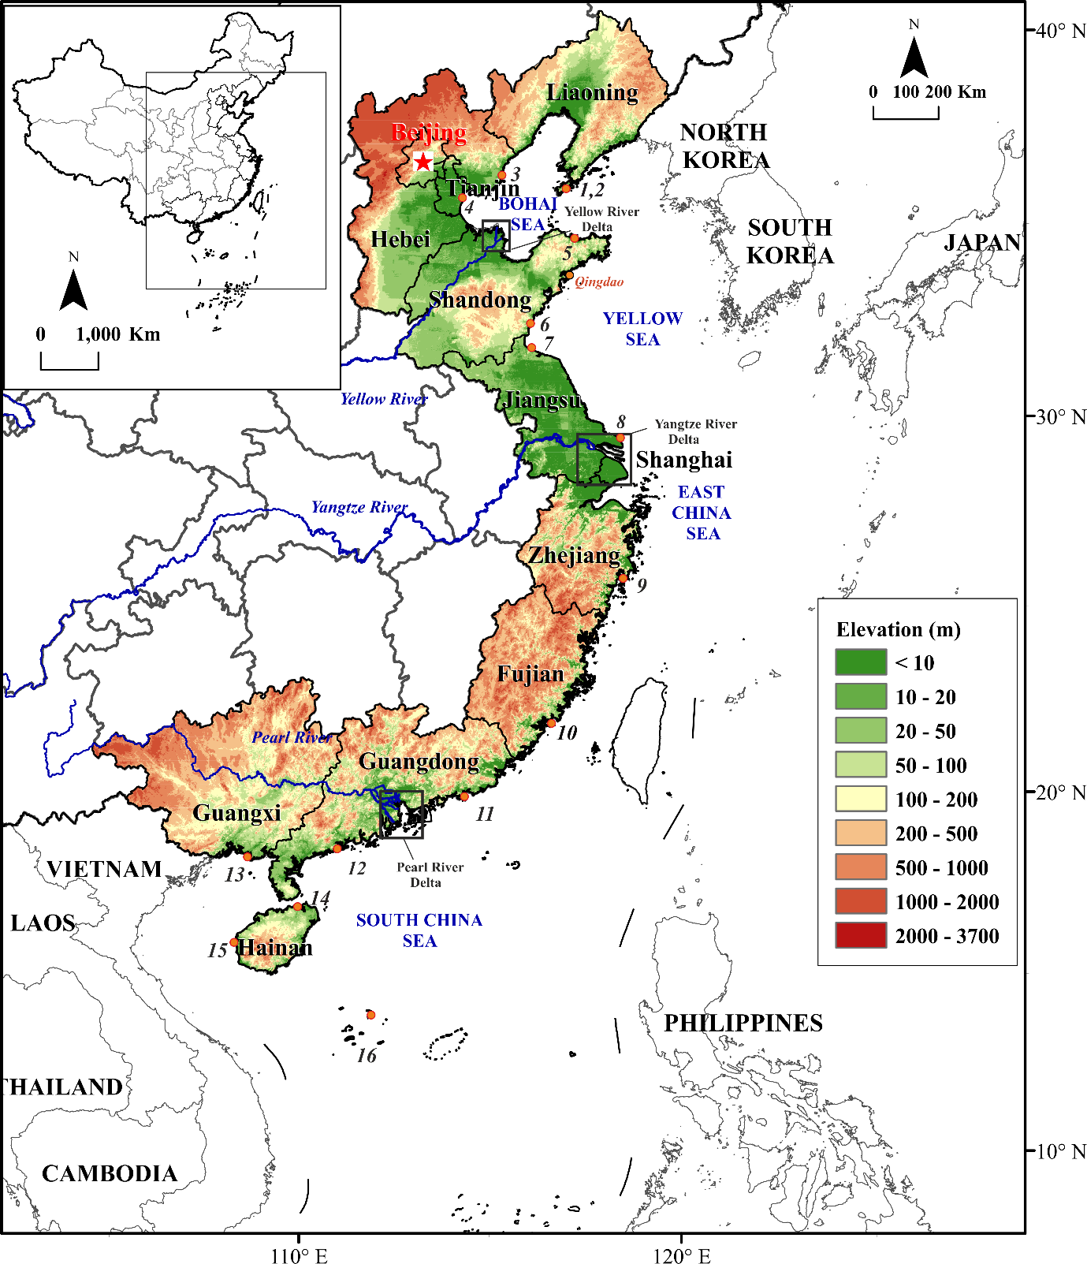
- Fig. 1 Geographical distribution of the 11 coastal provinces, municipalities and autonomous regions in Mainland China. Land elevation above sea-level is also shown (Numbers 1-16 indicate tide gauges corresponding to Fig.S1). Insert: Regional setting.
- 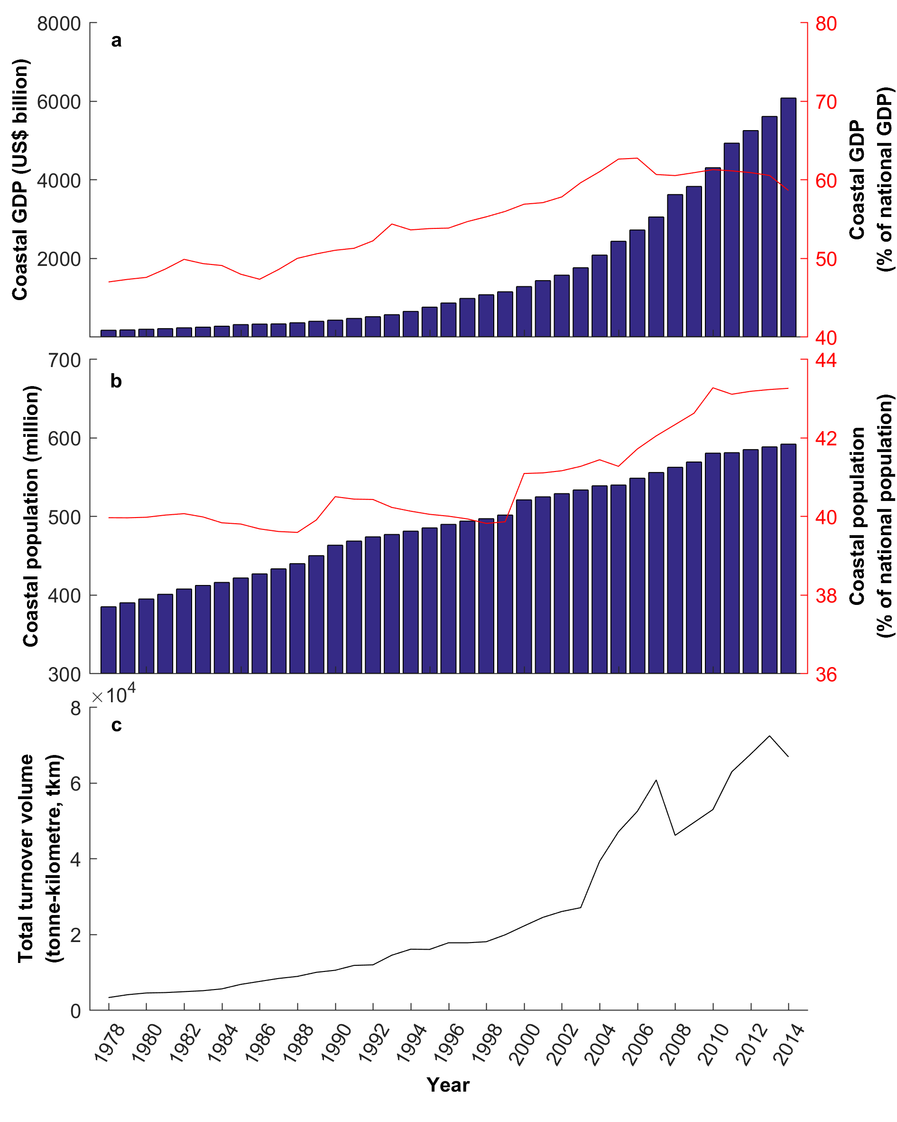
- Fig. 2 Coastal GDP, population and maritime freight transportation in Mainland China from 1978 to 2014. (a) China’s coastal GDP (CPI-2014) in absolute values and as a percentage of China’s total GDP; (b) China’s coastal population in absolute values and as a percentage of China’s total population; (c) Total turnover volume of maritime freight transportation.
- 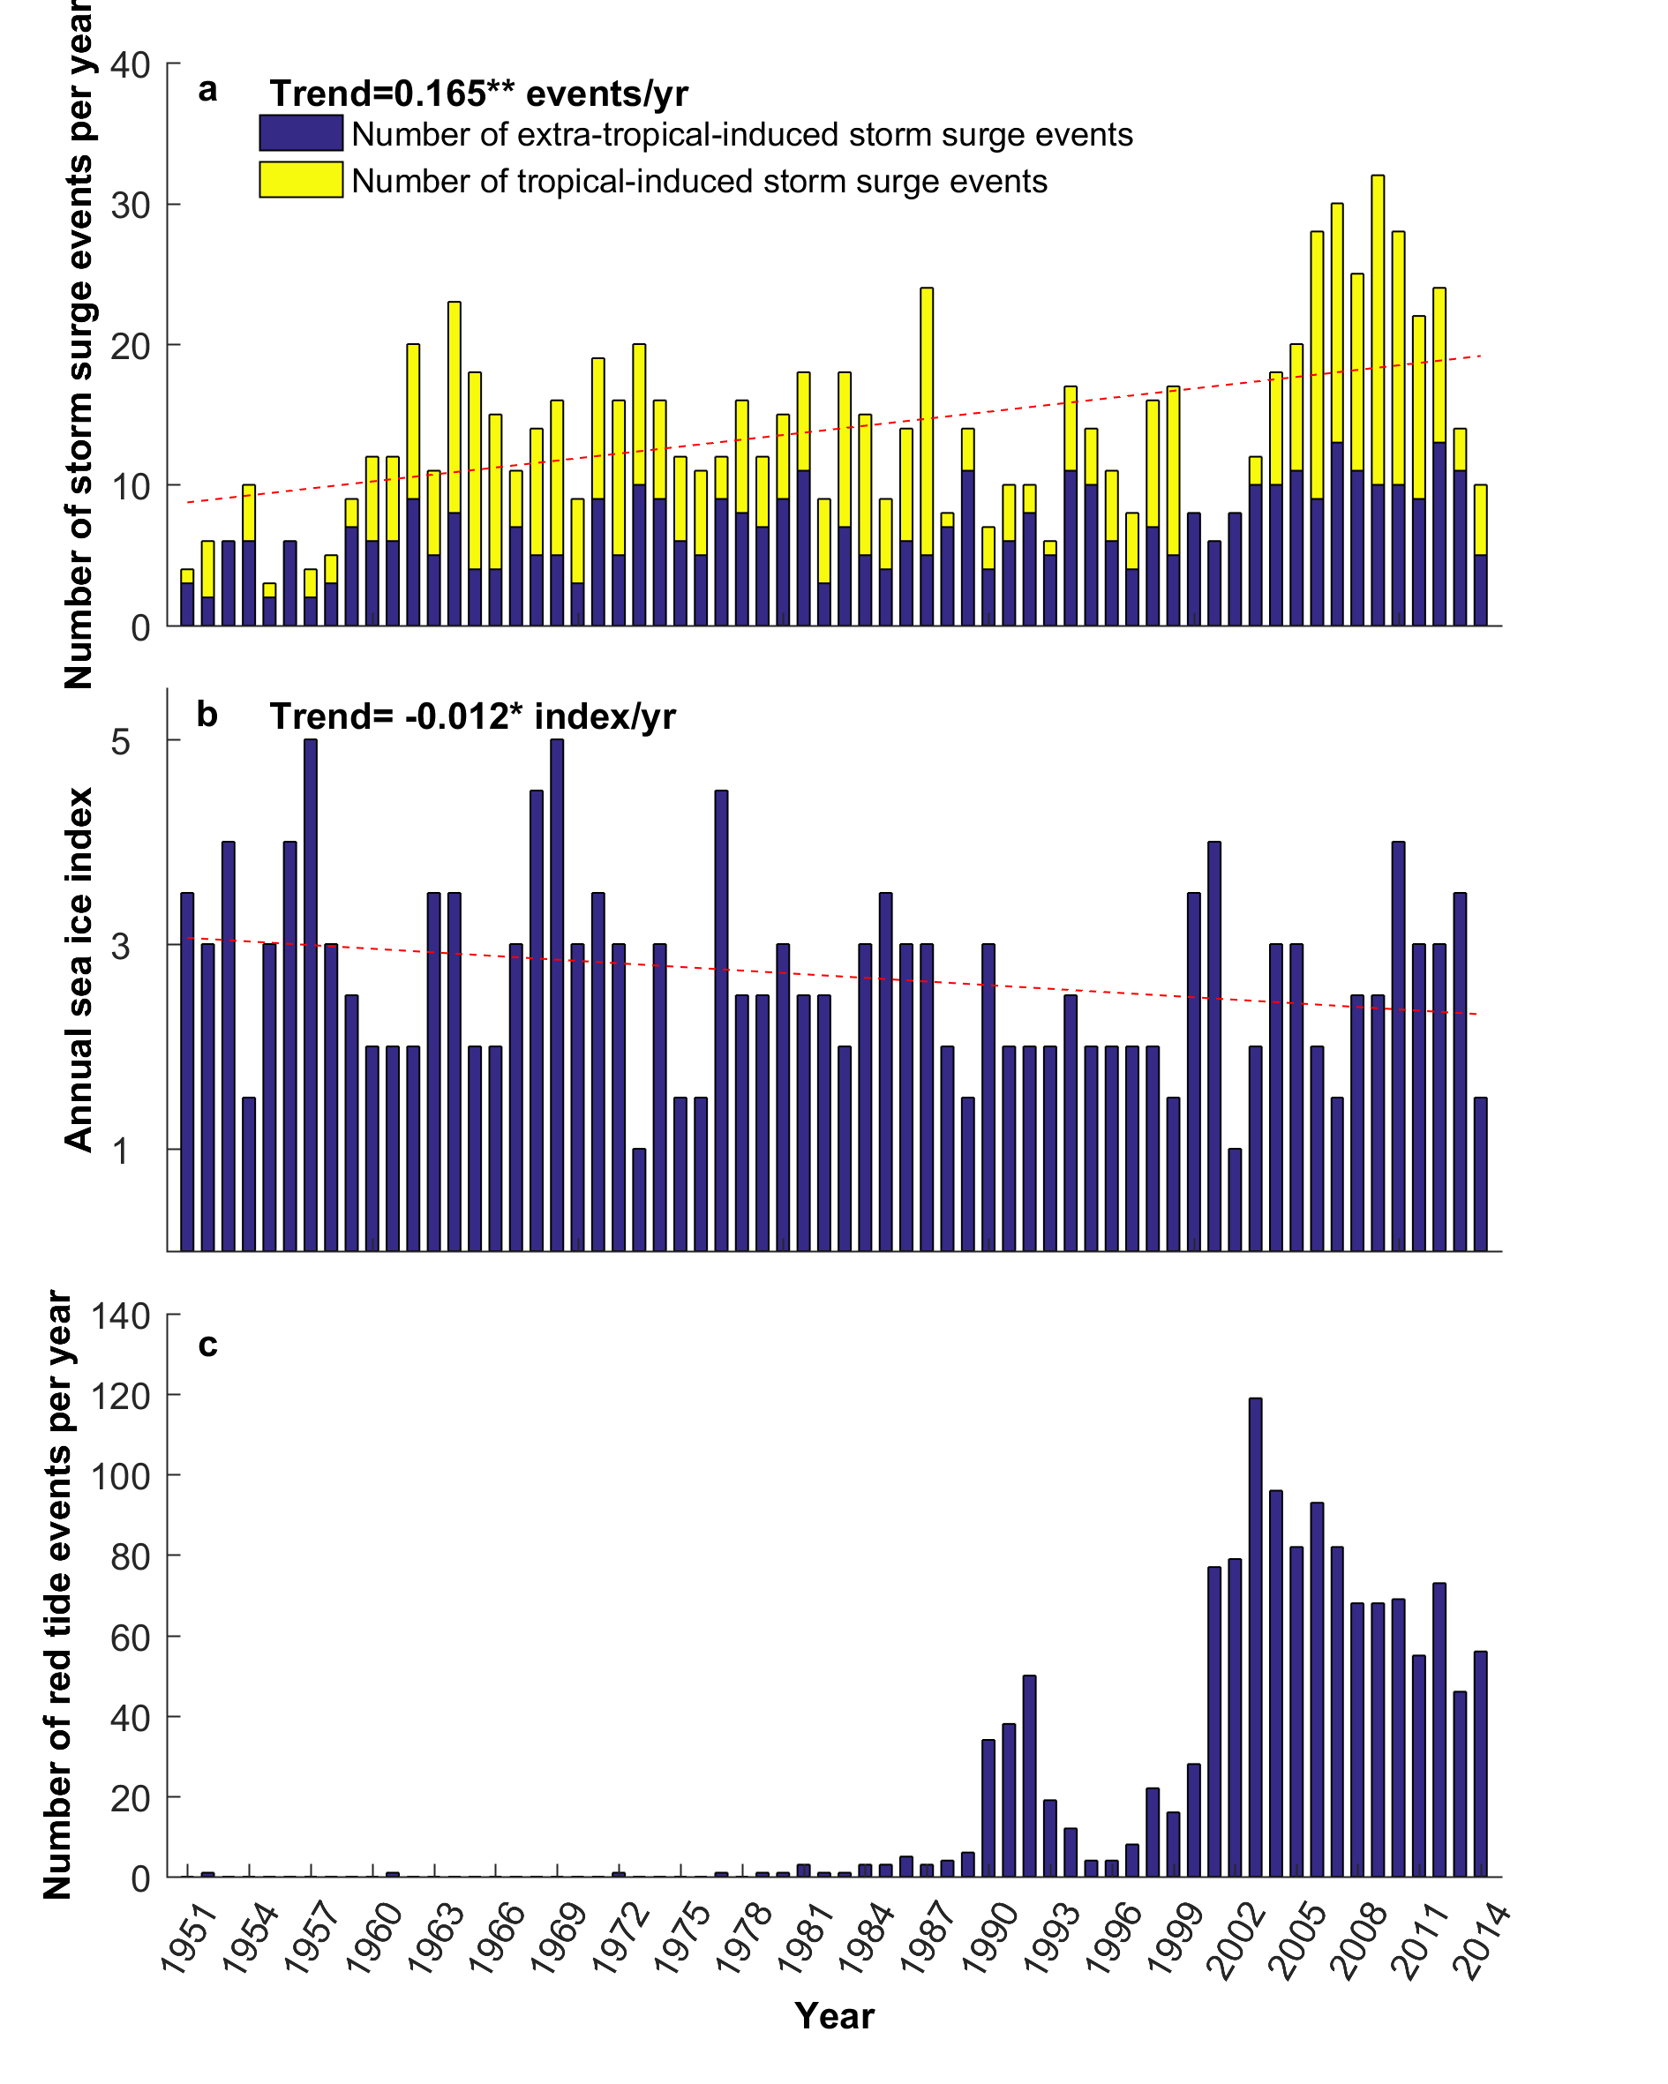
- Fig. 3 Observed changes of the causes of coastal and marine disasters from 1951 to 2014. (a) Number of storm surge events per year; (b) Annual sea ice index; (c) Number of red tide events per year. Red dash line are linear fitting curves, ** at 0.05 significance, * at 0.1 significance.
- 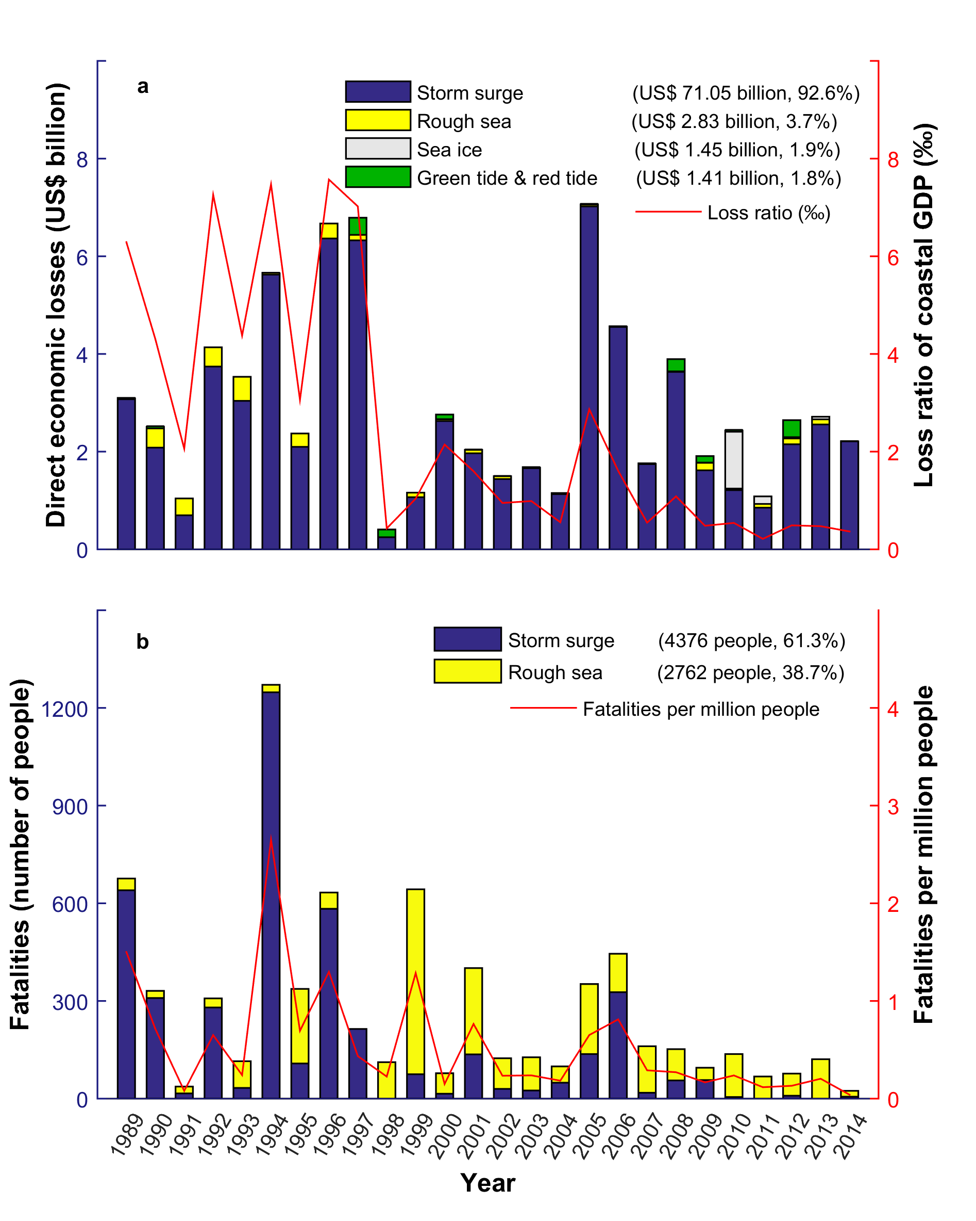
- Fig. 4 (a) Direct economic losses (CPI-2014) due to each cause of coastal and marine disaster, plus the loss ratio related to coastal GDP (‰). Numbers in the brackets indicate total losses from 1989 to 2014 with percentages indicating each disaster type ratio to total losses. (b) Fatalities and fatalities per million people caused by coastal and marine disasters. Numbers in the brackets indicate total fatalities from 1989 to 2014, and percentages indicate each disaster type ratio to total fatalities.
- 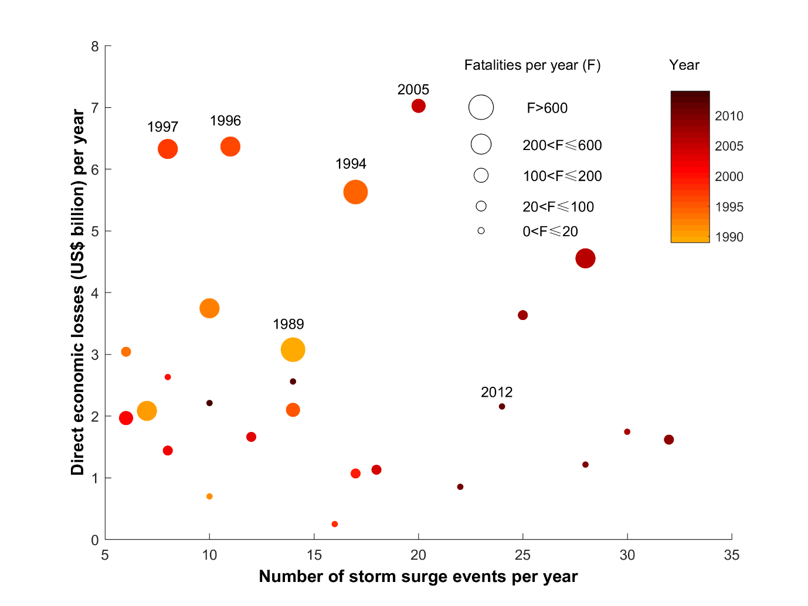Fig.5 Observed frequency of storm surge events per year with corresponding direct economic losses and fatalities per year from 1989 to 2014. The size of dots represents the number of fatalities.

- 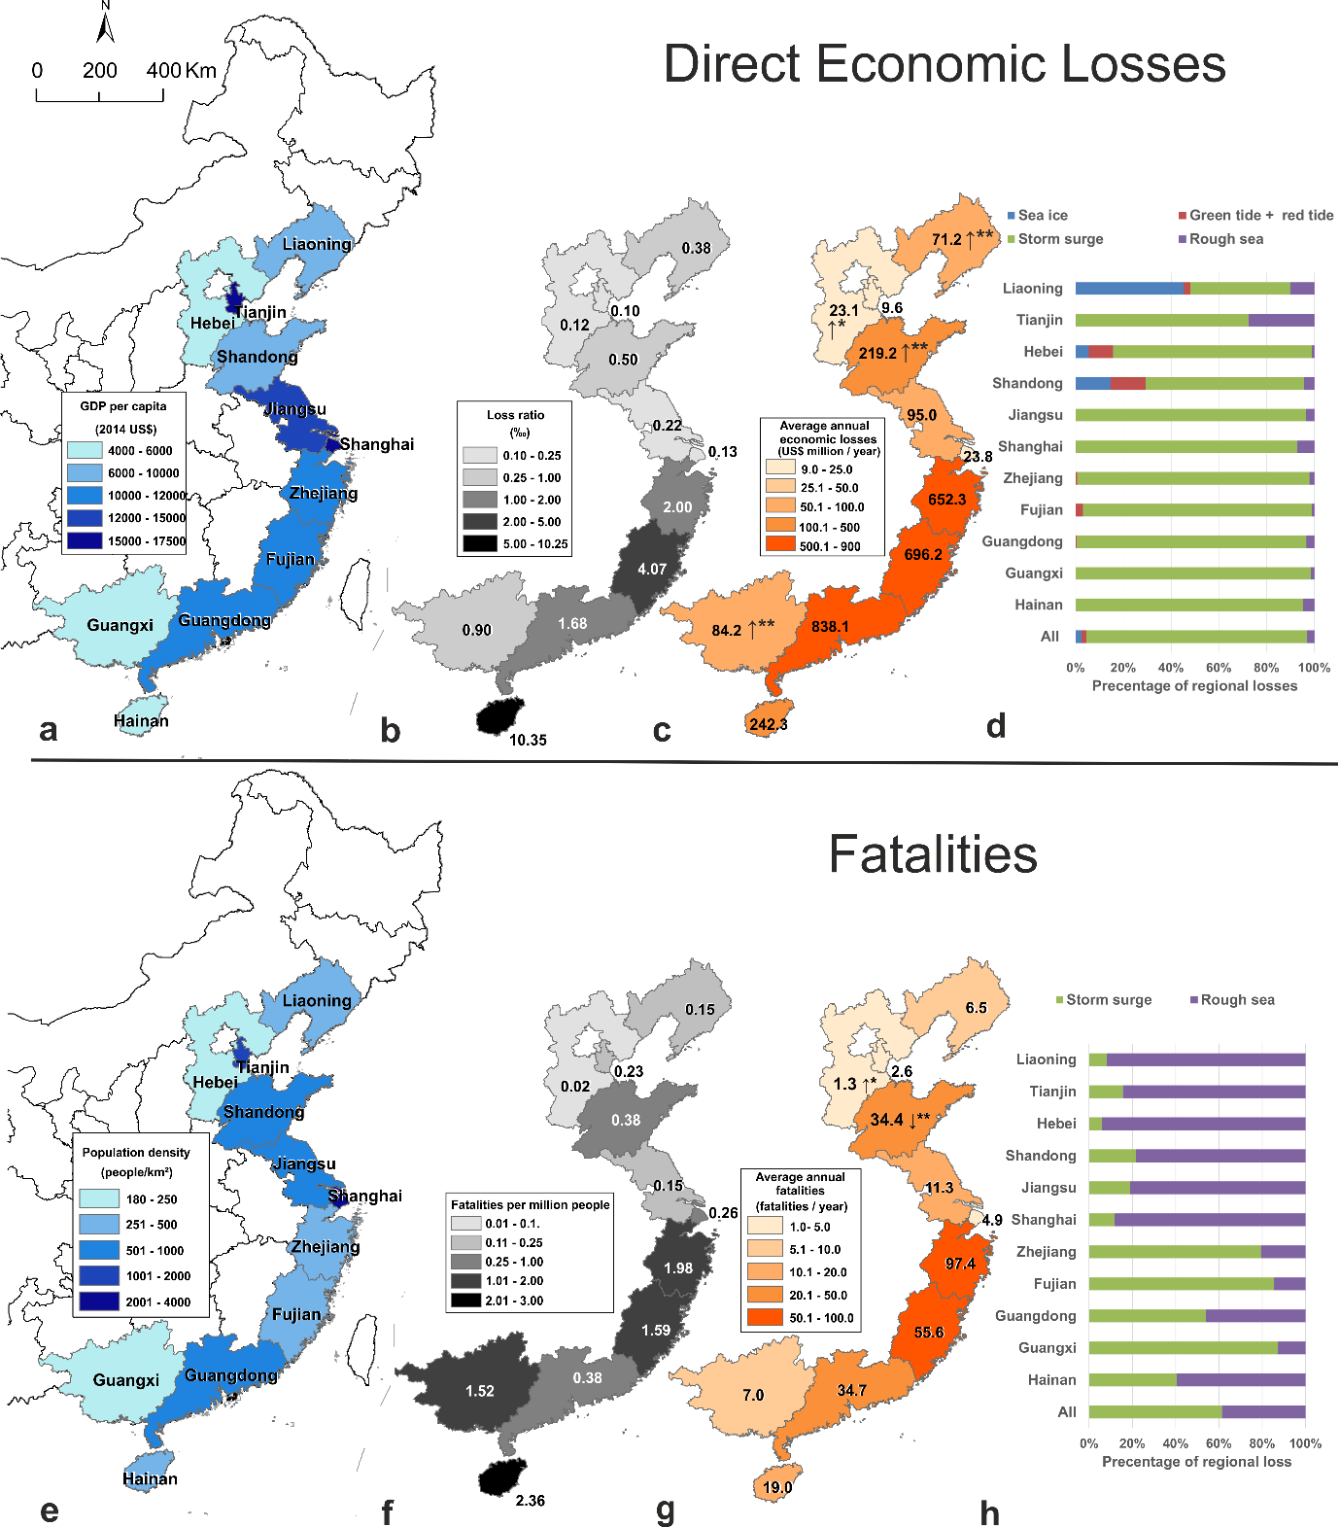
- Fig. 6 Direct economic losses and fatalities caused by five main coastal and marine disasters in China from 1989 to 2014. (a) GDP per capita in coastal provinces in 2014; (b) Direct economic loss ratio of GDP in each province; (c) Average annual economic losses and trend of losses per year between 1989 and 2014 in each coastal province (CPI-2014); (d) Proportion of disasters type that caused direct economic losses in each province; (e) Population density in coastal provinces in 2014; (f) Fatalities per million people in each province; (g) Average annual fatalities and trend of fatalities per year between 1989 and 2014 in each coastal province; (h) Proportion of disasters type that caused fatalities in each province. ↑represents an increasing trend, and ↓represents a decreasing trend.

Tab. 1 Main climate-related drivers for coastal and marine disasters in China, their main biogeophysical effects and their observed trends (updated and adapted from Wong et al. (2014)).
Climate-related drivers | Biogeophysical effects | Observations in China | References
Sea level | Submergence, flood damage, erosion, saltwater intrusion, rising water tables, impeded drainage and wetland loss and change. | Average rate of sea level rise was 3.0 mm/yr from 1980-2014, with local enhancement from subsidence. | SOA (2014)
Storms: tropical cyclones (TCs), extratropical cyclones | Storm surges and storm waves, coastal flooding, erosion, saltwater intrusion, rising water tables and impeded drainage. | The frequency of TCs has shown an increase over southeastern China, whereas over the South China Sea, a prominent decrease has been observed. The northwestward-moving track became the most dominant track mode after the late 1990s. | He et al. (2015);  Yeh et al. (2010)
Waves | Coastal erosion, overtopping and coastal flooding. | The frequency of rough sea events (significant wave height was higher than 2.5 m) (Zheng et al., 2013) in the China Sea had an increasing trend of 0.257%/yr from 1988 to 2010. | Zheng et al. (2013)
Winds | Wind waves, storm surges and coastal currents. | Sea surface wind speed increased in the of majority areas in the northwest Pacific Ocean, with coastal surface wind speed stronger than offshore. Extreme wind speeds reported in the east areas of Taiwan, the northern South China Sea and the Bohai Sea. | Liu et al. (2011)
Extreme sea levels | Coastal flooding, erosion and saltwater intrusion. | Significant increase in sea level extremes was found with trends between 2.0 mm/yr and 14.1 mm/yr from 1954 to 2012. | Feng and Tsimplis (2014);  Feng et al. (2015)
Sea surface temperature (SST) | Changes to stratification and circulation, reduced incidence of sea ice at higher latitudes, increased coral bleaching and mortality, poleward species migration and increase in algae blooms. | Warming trends of SST were found in both summer and winter from 1950-2008. | Yeh and Kim (2010);  Yeh et al. (2010);  Tang et al. (2009)
Ocean acidity | Increased CO₂ fertilization, decreased seawater pH and carbonate ion concentration (or “ocean acidification”). | Anomalous and unprecedented acidification was found based on coral boron isotope-inferred pH records from the South China Sea during the 20th century. | Liu et al. (2014)

Tab. 2 The five main causes of coastal and marine disasters in China, including their definition and effects, observations and examples of the worst recorded in the databases (Direct economic losses in CN¥ have been adjusted by CPI to 2014 US$).
Name | Definition and effects in China | Observations in China |  | Example of the worst recorded case in the database
 |  | Spatial | Temporal
Storm surge | Strong winds pushing on the water surface and low atmospheric pressure associated with cyclone storms, causing the water to pile up above normal levels (Harris, 1963). There are two types: Typhoon-induced storm surge (TSS) and extra-tropical-induced storm surge (ETSS).  This results in coastal flooding, coastal infrastructure damage and flood defence failure. | TSSs mainly effect the East China Sea and the South China Sea. ETSSs mainly effect the Bohai Sea and the northern Yellow Sea. | The frequency of TSS indicates an increasing trend from 1951-2014 (Shi et al., 2015). | A TSS occurred in Aug 1997 with 342 fatalities and a direct economic loss of US$ 6.41 billion. In Zhejiang, there were 11.4 million people affected, 169 fatalities, 776 km of seawall damaged and US$ 4.31 billion of direct economic loss.
Rough sea | Significant wave height exceeding 4 m (SOA, 1989-2014).  The impacts of rough seas are disruption of the progress of vessels or damaging of vessels or offshore platforms and related structures. | The number of days of occurrence of rough sea decreases from south to north (the South China Sea, the East China Sea, the Yellow Sea, the Bohai Sea). |  | In 1999, there were 226 maritime accidents caused by rough seas. 57 ships were capsized or wrecked, and there were more than 600 fatalities.
Sea ice | Where large expanses of sea water freezes in winter in the north of China, with ice thickness greater than 30 cm. It can occur dozens of kilometers from coast.  This effects marine shipping, port operation, and aquaculture. | Sea ice occur along the northern coasts of the Bohai Sea and the northern Yellow Sea | A decline in the sea ice index was reported from 1950 to 2014. Severe sea ice years were: 1957, 1968, 1969, 1977, 2000 and 2010. | In winter 2009-2010, sea ice extent at Liaodong Bay extended 108 nautical miles (200 km) from the coast. The maximum ice thickness was more than 50 cm. This resulted in direct economic losses of US$ 1.18 billion due to damage to infrastructure and vessels.
Red tide | A maritime ecological disaster from a harmful red algal bloom caused by a certain species of algae or phytoplankton (Wang and Wu, 2009).  It has multiple effects on marine ecosystems as well as public health, threatens other maritime species of fish, marine mammals, and other organisms. | Red tides mainly occur in the East China Sea | Significantly increased since the 1990s. The number of red tides reported peaked in 2002 with 120 events, annually about 50-100 events since 2002. | A red tide occurred in May and June 2012 in Fujian coastal area, with a cumulative area of approximately 323 km². This seriously affected local aquaculture, which was the major cause of abalone death. Overall, the total direct economic loss was US$ 0.18 billion.
Green tide | A maritime ecological disaster from a green algal bloom.  This effects coastal fisheries, aquaculture and tourism, as well as impacting on the natural landscape. | Green tides occurs mainly in the Yellow Sea | Massive blooms of the green macroalgae (Ulva prolifera) have occurred annually since 2007 (Hu et al., 2010) | In late June 2008, the waters and shores at Qingdao city in Shandong experienced a massive green tide covering about 600 km². The direct economic loss was US$ 0.25 billion.

Tab. 3 Coastal and marine disasters risk management history, and its corresponding key laws, regulations, measures, plans, suggestion and bulletins in China.
Stage name | Period | Key laws, regulations, measures, plans, suggestion and bulletins
Stage 1: Limited intervention | 1950s-1970s | - 1955: Instruction on defending against typhoon-induced disasters (State Council)  - 1964: Establishment of SOA
Stage 2: Formally recognition and action | 1980s | - Marine Environment Protection Law (1982, amended in 1999)  - Regulations on Control of Dumping of Wastes in the Ocean (1985)  - Regulations Concerning Prevention of Environmental Pollution by Ship-breaking (1988)  - Marine Disasters Bulletin (since 1989)  - Regulations Concerning Prevention and Control of Pollution Damages to the Marine Environment by Coastal Construction Projects (1990)  - Regulations Concerning Prevention of Pollution Damage to the Marine Environment by Land-based Pollutants (1990)
Stage 3: Greater attention and preparedness | 1990s | - Measures for Implementation of the Regulations Concerning the Dumping of Waste at sea (1992)  - Measures for Implementation of the Regulations Concerning Environmental Protection in Offshore Oil Exploration and Exploitation (1992)  - Provisions Governing the Management of Coastal Forest Belts under Special State Protection (1996)  - China’s Ocean Agenda 21 (1996)  - White Paper – The Development of China's Marine Programmes (1998)
Stage 4: Towards sustainable development of ocean and coasts | 2000 - present | - Sea Level Bulletin (2000, 2003, 2006 to present)  - Marine Environmental Quality Bulletin (2000 to present)  - Suggestion on Strengthening Marine Disaster Prevention (SOA 2005)  - Regulations Concerning Prevention and Control of Pollution Damage to the Marine Environment by Marine Construction Projects (2006)  - Suggestion on Marine Fields Response to Climate Change (SOA 2007)  - Red Tide Disaster Contingency Plan (Amended in 2009)  - Storm surge, Tsunami, Sea Wave and Sea Ice Disaster Contingency Plan (2006, amended in 2009, 2015)  - Notice on Further Strengthening the Marine Forecast Disaster Preparedness and Mitigation (SOA 2009)  - Regulations on Prevention and Control of Marine Environment Pollution from Ships (2009)  - Establishment of National Marine Hazard Mitigation Service (2011)  - Marine Functional Zonation Scheme 2011-2020 (2012)

Tab. 4 Annual average fatalities per million people and loss ratio related regional GDP between 1989-2000 (Stage 3 of Tab. 3) and 2001-2014 (Stage 4 of Tab. 3) for each coastal province and coastal China in total.
 | Annual average fatalities per million people |  | Loss ratio related regional GDP (‰)
Period | 1989-2000 | 2001-2014 | 1989-2000 | 2001-2014
Liaoning | 0.1 | 0.19 | 0.66 | 0.34
Hebei | 0 | 0.03 | 0.03 | 0.13
Tianjin | 0.46 | 0.06 | 0.49 | 0.06
Shandong | 0.79 | 0.05 | 2.02 | 0.31
Jiangsu | 0.09 | 0.19 | 1.76 | 0.03
Shanghai | 0.27 | 0.22 | 0.29 | 0.1
Zhejiang | 3.57 | 0.69 | 12.4 | 0.7
Fujian | 1.93 | 1.24 | 9.84 | 3.26
Guangdong | 0.46 | 0.28 | 5.72 | 1.16
Guangxi | 0.28 | 0.05 | 1.95 | 0.75
Hainan | 2.71 | 1.91 | 20.32 | 8.76
Coastal China | 0.82 | 0.31 | 3.88 | 0.7

Supplementary Material

Spatial-temporal changes of coastal and marine disasters risks and impacts in Mainland China
Jiayi Fang^{1,2,3}, Wei Liu⁴, Saini Yang^{1,3}, Sally Brown², Robert J Nicholls², Jochen Hinkel^{5,6}, Xianwu Shi⁷, Peijun Shi^{1,3}*(corresponding author)
Journal: Ocean & Coastal Management
- Academy of Disaster Reduction and Emergency Management, Ministry of Civil Affairs & Ministry of Education, P.R., Beijing 100875, China
- Faculty of Engineering and the Environment, University of Southampton, Highfield Campus, Southampton, SO17 1BJ, UK
- State Key Laboratory of Earth Surface Processes and Resource Ecology, Beijing Normal University, Beijing 100875, China
- International Institute for Applied Systems Analysis, Laxenburg, A-2361 Austria
- Global Climate Forum, 10829 Berlin, Germany
- Division of Resource Economics, Albrecht Daniel Thaer-Institute and Berlin Workshop in Institutional Analysis of Social-Ecological Systems (WINS), Humboldt-University, 10099 Berlin, Germany
- National Hazard Marine Mitigation Service, Beijing 100194, China

Figures:
Fig. S1 Relative sea-level change (solid line) with fitted linear trends (dotted line) at 16 gauges along China’s coast (for the locations of tide gauges, see Fig.1). Data extracted from Holgate et al. (2012) and PSMSL (2016). Records are offset for display purposes. Trends with standard errors are calculated within different time spans (in brackets) for each tide gauge.
Fig. S2 Spatial distribution of social vulnerability index to natural hazards of coastal China in 2010. The social vulnerability index was calculated and mapped based on 29 indicators such as gender, age, occupation and education. The counties with an index greater than +3 standard deviations from the mean are seen as the most vulnerable, whereas the counties with an index greater than -3 standard deviations from the mean are labelled as the least vulnerable (adapted from Fang et al., 2015). Boxes indicates main delta regions.
Fig. S3 Maximum cumulative area (km²) and maximum distribution area (km²) of green tides from 2008 to 2014.
Tables:
Tab. S1 Sources of data of coastal and marine disasters in coastal China (The capitals in brackets in the second column are abbreviation of data source).
Tab. S2 Annual number of typhoon-induced storm surge (TSS) events and extra-tropical-induced storm surge (ETSS) (hazard), coastal GDP (exposure) and economic losses of coastal China. Of the five hazards studied, 92.6% of economic losses were caused by storm surges, therefore their losses are represented in this table.
Tab. S3 Linear trends of losses and fatalities per year in each coastal province from 1989 to 2014 taking account of five main coastal and marine disasters. Direct economic losses per year have shown a significant increasing trend in four of the provinces (Liaoning, Hebei, Shandong, Guangxi). Provincial-level fatalities per year did not show clear trends over time in most provinces, except in Hebei (increasing trend) and Shandong (decreasing trend).
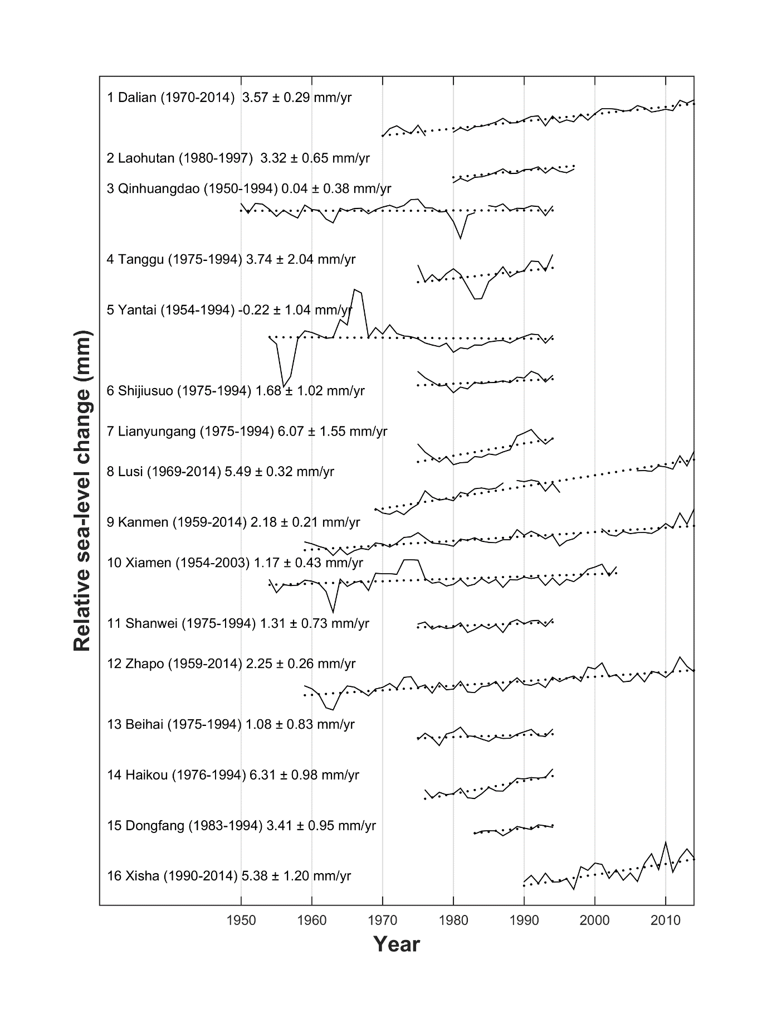
Fig. S1 Relative sea-level change (solid line) with fitted linear trends (dotted line) at 16 gauges along China’s coast (for the locations of tide gauges, see Fig.1). Data extracted from Holgate et al. (2012) and PSMSL (2016). Records are offset for display purposes. Trends with standard errors are calculated within different time spans (in brackets) for each tide gauge.

Fig. S2 Spatial distribution of social vulnerability index to natural hazards of coastal China in 2010. The social vulnerability index was calculated and mapped based on 29 indicators such as gender, age, occupation and education. The counties with an index greater than +3 standard deviations from the mean are seen as the most vulnerable, whereas the counties with an index greater than -3 standard deviations from the mean are labelled as the least vulnerable (adapted from Fang et al., 2015). Boxes indicates main delta regions.
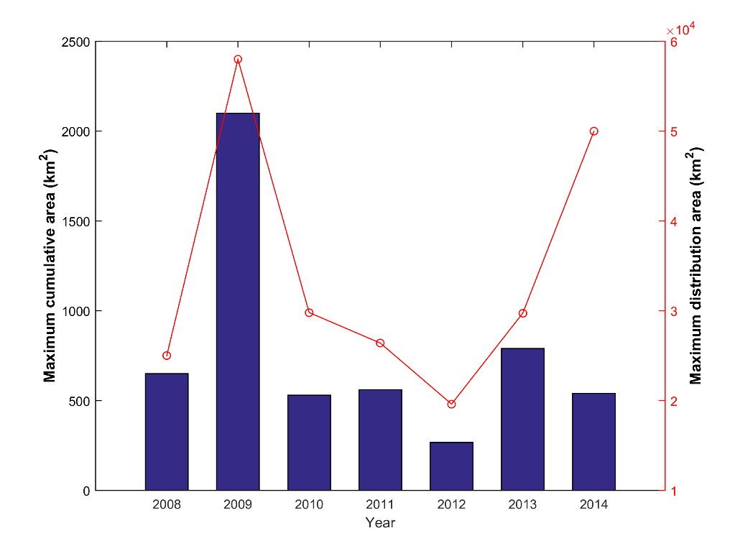
Fig. S3 Maximum cumulative area (km²) and maximum distribution area (km²) of green tides from 2008 to 2014.

Tab. S1 Sources of data of coastal and marine disasters in coastal China (The capitals in brackets in the second column are abbreviation of data source).
No | Data source | Time range | Description of hazards reported and used  (including timescales) | Reference
1 | Chinese Marine Disasters Four Decades Compilation (CMDFDC) | 1949–1990 | Rapid-onset hazards: Storm surges, rough seas, sea ice and red tides. | Yang et al. (1991)
2 | Marine Environment Quality Bulletin (MEQB) | 1998-2014 | Includes detailed information such as seawater quality, pollution and eutrophication.  Rapid-onset hazards: red tides and green tides.  Slow-onset hazards: coastal erosion, seawater intrusion and coastal soil salinisation. | SOA (1998-2014)
3 | Marine Disaster Bulletin (MDB) | 1989–2014 | Rapid-onset hazards: storm surges, rough seas, sea ice, red tides and green tides.  Slow-onset hazards: coastal erosion, sea-level change, seawater intrusion, coastal soil salinisation and intrusion of tidal saltwater. | SOA (1989-2014)

Tab. S2 Annual number of typhoon-induced storm surge (TSS) events and extra-tropical-induced storm surge (ETSS) (hazard), coastal GDP (exposure) and economic losses of coastal China. Of the five hazards studied, 92.6% of economic losses were caused by storm surges. Therefore their losses are represented in this table.
 | Hazard |  | Exposure | Economic Losses
Year | Number of TSS events | Number of ETSS events | Coastal GDP (US$ billion) | Annual losses by five main disasters (US$ billion) | Percentage of loss caused by storm surges per year (%) | Loss ratio of coastal GDP (‰)
1989 | 11 | 3 | 379 | 3.10 | 99.07 | 6.29
1990 | 4 | 3 | 407 | 2.52 | 82.60 | 4.31
1991 | 6 | 4 | 462 | 1.04 | 66.92 | 2.06
1992 | 8 | 2 | 547 | 4.14 | 90.49 | 7.26
1993 | 5 | 1 | 651 | 3.53 | 86.08 | 4.38
1994 | 11 | 6 | 706 | 5.66 | 99.33 | 7.47
1995 | 10 | 4 | 763 | 2.37 | 88.46 | 3.06
1996 | 6 | 5 | 825 | 6.67 | 95.41 | 7.57
1997 | 4 | 4 | 905 | 6.68 | 93.18 | 7.02
1998 | 7 | 9 | 985 | 0.41 | 61.11 | 0.43
1999 | 5 | 12 | 1075 | 1.16 | 91.98 | 1.04
2000 | 8 | 0 | 1204 | 2.76 | 95.16 | 2.15
2001 | 6 | 0 | 1326 | 2.04 | 96.22 | 1.60
2002 | 8 | 0 | 1486 | 1.50 | 95.80 | 0.95
2003 | 10 | 2 | 1709 | 1.68 | 98.67 | 0.99
2004 | 10 | 8 | 1982 | 1.15 | 98.11 | 0.55
2005 | 11 | 9 | 2311 | 7.05 | 99.25 | 2.87
2006 | 9 | 19 | 2668 | 4.57 | 99.67 | 1.61
2007 | 13 | 17 | 3025 | 1.76 | 99.00 | 0.55
2008 | 11 | 14 | 3367 | 3.89 | 93.30 | 1.08
2009 | 10 | 22 | 3703 | 1.91 | 84.67 | 0.48
2010 | 10 | 18 | 4249 | 2.45 | 49.56 | 0.54
2011 | 9 | 13 | 4738 | 1.08 | 78.62 | 0.21
2012 | 13 | 11 | 5047 | 2.64 | 81.35 | 0.49
2013 | 11 | 3 | 5360 | 2.71 | 94.18 | 0.47
2014 | 5 | 5 | 56959 | 2.22 | 99.74 | 0.36
Note: Losses and GDP have been adjusted by CPI to 2014 values.

Tab. S3 Linear trends of losses and fatalities per year in each coastal province from 1989 to 2014 taking account of five main coastal and marine disasters. Direct economic losses per year have shown a significant increasing trend in four of the provinces (Liaoning, Hebei, Shandong, Guangxi). Provincial-level fatalities per year did not show clear trends over time in most provinces, except in Hebei (increasing trend) and Shandong (decreasing trend).
 | Linear trends with significance
Region | Losses  (US$ million/yr) | Ln(Losses) | Fatalities  (people/yr) | Ln(Fatalities)
Liaoning | 4.28 | 0.15** | -0.01 | 0
Hebei | 2.95 | 0.09* | 0.13* | 0.04*
Tianjin | -0.09 | -0.02 | -0.19 | 0
Shandong | -3.29 | 0.13** | -2.81 | -0.11**
Jiangsu | -3.72 | 0.02 | 0.37 | 0.04
Shanghai | 0.16 | -0.04 | -0.1 | 0
Zhejiang | -41.89 | 0.01 | -9.85 | -0.01
Fujian | -7.00 | 0.06 | -3.36 | -0.02
Guangdong | -2.87 | 0.08 | -0.49 | 0.04
Guangxi | 4.91 | 0.18** | -0.45 | 0.02
Hainan | 3.12 | 0.04 | 0.01 | 0.06
Coastal China | -44.02 | -0.01 | -16.75** | -0.06**

Note: ** at 0.05 significance, * at 0.1 significance. In order to normalise the data, the natural logarithm was calculated allowing for easier comparison (column 3 and 5).

References
- Fang, J., Chen, W., Kong, F., Sun, S., Shi, P., 2015. Measuring Social Vulnerability to Natural Hazards of the coastal areas, China. Journal of Beijing Normal University (Natural Science). 03:280-286.
- Holgate, S.J., Matthews, A., Woodworth, P.L., Rickards, L.J., Tamisiea, M.E., Bradshaw, E., Foden, P.R., Gordon, K.M., Jevrejeva, S., Pugh, J., 2012. New Data Systems and Products at the Permanent Service for Mean Sea Level. J. Coast. Res. 29, 493–504. doi:10.2112/JCOASTRES-D-12-00175.1
- PSMSL (2016). Permanent Service for Mean Sea Level (PSMSL): Tide Gauge Data. http://www.psmsl.org/data/obtaining/ (accessed 11.4.16).
- SOA, 1989-2014. State Oceanic Administration: Marine Disaster Bulletin. http://www.coi.gov.cn/gongbao/zaihai/ (accessed 02.08.15).
- SOA, 1998-2014. State Oceanic Administration: Marine Environment Quality Bulletin. http://www.coi.gov.cn/gongbao/haipingmian/201207/t20120704_23137.html (accessed 02.08.15).
- Yang, H., Tian, S., Ye, L., 1991. Chinese marine disasters four decades compilation. Beijing, China Ocean Press.

A global disaster database which contains essential core data on the occurrence and effects of over 18,000 large disasters from 1900 to the present day. http://www.emdat.be/database
China's Five-Year Plans are a series of social and economic development initiatives made by central government. The plan maps strategies for economic development and sets growth targets.

