Ruihua Hou Inflammatory cytokines in Generalised Anxiety Disorder

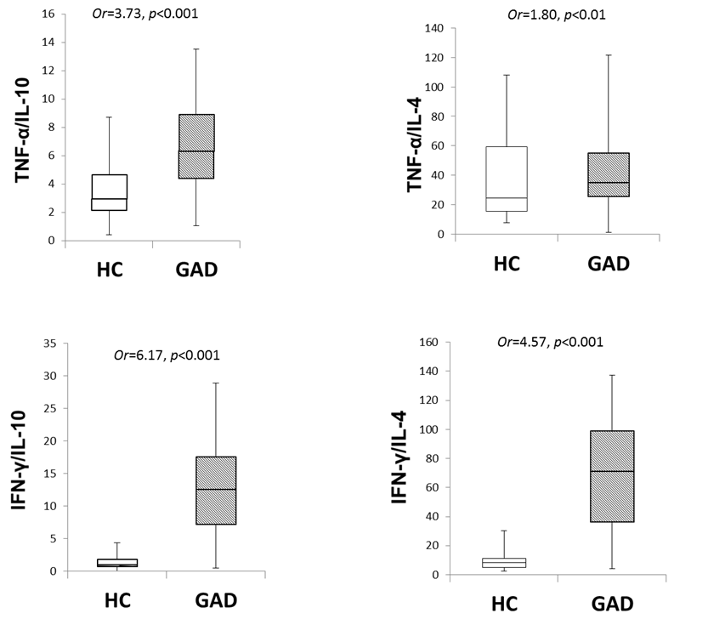

Figure 1 Comparison of pro-and anti-inflammatory cytokine ratios between groups
Four box- and- whisker plots were used to depict the distribution of pro-to anti-inflammatory cytokine ratios between the healthy control group and the patients group with generalised anxiety disorder. In comparison to the heathy control group, the patients group had significantly increased pro- to anti-inflammatory cytokine ratios, which suggests a distinct immune imbalance. HC, healthy control; GAD, generalised anxiety disorder.

