Is there a link between the divorce revolution and the cohabitation boom?

ABSTRACT
Over the past decades, divorce and cohabitation have increased dramatically throughout Europe. Divorce has fundamentally altered the institution of marriage from a life-long union to one that may dissolve. Cohabitation allows couples to live together without undertaking the vows of marriage, but also allows couples to avoid the potentially higher costs of divorce. Thus, divorce and cohabitation seem to be intrinsically linked. Here we theorize how the increase in divorce may be linked to the increase in cohabitation on the macro-, meso-, and micro- levels. Using focus group data from 8 countries, we explore how divorce may have changed attitudes and beliefs concerning marriage and cohabitation. We then investigate whether survey data and official statistics in 16 countries provide evidence consistent with a link. While exogenous factors have been important for the increase in cohabitation, we argue that the divorce revolution has been a catalyst for the cohabitation boom.

Divorce and cohabitation are two of the largest behavioral changes to affect the family over the past few decades. Both behaviors have received substantial media and public attention around the world, with some alarmingly calling these two behaviors a “breakdown in the family.” Undoubtedly, the two behaviors have fundamentally altered the institution of marriage. The increase in divorce has changed marriage from a union intended to be life-long to a relationship that has the potential to dissolve. At the same time, cohabitation has emerged as a way for two people to live in an intimate relationship without undertaking the vows of marriage and to avoid the potentially higher costs of divorce if the union does not last. Thus, divorce and cohabitation appear to be intrinsically linked.
Current theories explaining the emergence of these new behaviors tend to either explain divorce and cohabitation separately or include them in a broader set of changing family behaviors, often referred to as the Second Demographic Transition (Sobotka 2008, Lesthaeghe 2010, van de Kaa 2001). These theories usually point to economic shifts (Becker 1991, Oppenheimer 1997, Ruggles 2015) or social and ideational change (Giddens 1992; Lesthaeghe 2010, Perelli-Harris et al. 2010) to explain the emergence of the new behaviors. While these theories are crucial for understanding the underlying factors leading to the behaviors, they have not specifically examined whether or how the increase in divorce may have been fundamental to the development of cohabitation. Given the dramatic increase in both divorce and cohabitation throughout much of the industrialized world, in this paper we argue that the divorce revolution could have been an important catalyst for the cohabitation boom.
It is important to note, however, that the relationship between divorce and cohabitation is most likely not unidirectional, but instead could flow both ways and influence each trend through feedback loops (Bumpass 1990). For example, the experience of cohabitation as a less permanent relationship may lead to greater union instability in general (Berrington and Diamond 1999, Liefbroer and Dourleijn 2006). Furthermore, the emergence of cohabitation may have led to greater selection into marriage, resulting in a decline or stabilization of divorce, as appears to have occurred in the US (Kennedy and Ruggles 2014) and UK (Beaujouan and Ní Bhrolcháin 2014). Nonetheless, while the full development of these trends may be complicated, an investigation into whether or how the increase in divorce may have led to the rise of cohabitation is warranted.
To evaluate the evidence in support of a link between divorce and cohabitation, we search for trends and mechanisms at different hierarchical levels: the macro-, meso-, and micro-. Demographers are often interested in processes which occur at the population level (the macro), but recognize the importance of decisions made at the individual level (the micro) (Billari 2015). An intermediary level between the two is the family (the meso), often referred to as the intergenerational transmission of behaviors and attitudes. Studying evidence at each of these levels may produce a different understanding of how the link between divorce and cohabitation operates, and the mechanisms through which the two are linked.
To search for evidence and mechanisms, we use “a form of bricolage, knitting together diverse strands of evidence.” (Ní Bhrolcháin and Dyson 2007: 29). For each analytical level, we first use qualitative methods to describe social discourses surrounding cohabitation and marriage, which can elucidate potential mechanisms and provide explanations for the link. The qualitative evidence comes from focus group data collected in 8 European countries and emerged from a broader project that studied the meaning of cohabitation and marriage (see Special Collection: Focus on Partnerships in Demographic Research 2015-16). The issue of divorce arose in nearly every focus group, especially with respect to how cohabitation is useful as a “testing ground” to avoid divorce (Perelli-Harris et al 2014). Below we provide additional analysis of the focus group materials to better understand how people think about the link between divorce and cohabitation.
We then analyze quantitative data to see whether any evidence supports the idea that the increase in divorce fueled the increase in cohabitation. We draw on official sources and harmonized partnership histories based on surveys conducted in 16 countries in Europe. Since cohabitation was not collected in population registers before the 2000s, nationally-representative surveys are the only source of detailed cohabitation histories dating back several decades, and thus are the best available data. We also include information on legal reform; changes in the legal availability of divorce were important for facilitating the increase in divorce. Although the analyses we perform are not exhaustive and insufficient to conclusively demonstrate causality, they provide insights into whether the evidence is consistent with a direct link between divorce and cohabitation. Given that cohabitation has different meanings in different countries (Perelli-Harris et al 2014, Hiekel et al 2014), we expect that the relationship between divorce and cohabitation will be more evident in some countries than in others. In addition, we acknowledge that cohabitation has heterogeneous meanings across individuals, strata, and at different stages of the lifecourse (Perelli-Harris and Bernardi 2015). While we do not interrogate these meanings here, we believe that the divorce revolution has the potential to encourage cohabitation across a range of types, for example, as a precursor or an alternative to marriage (Kiernan 2004, Heuveline and Timberlake 2004).
Finally, we synthesize our findings to explain how the increase in divorce may have been one (among many) of the factors leading to the increase in cohabitation. Drawing on previous studies and our results, we elucidate mechanisms at each analytical level. We argue that divorce may have led to the adoption of cohabitation through the diffusion of new social norms and values about marriage, the process of social learning from parents who divorced, and the personal experience of divorce. Taken together, this study provides a new way of thinking about the development of cohabitation.

Data

Qualitative data
The focus group project as a whole was motivated by an interest in better understanding the increase in cohabitation throughout Europe. Although quantitative research had explored the development of cohabitation cross-nationally, little was known about how people discussed cohabitation and marriage in different countries. The goal of focus group research is not to provide representative data, but to understand general concepts and substantive explanations for social phenomena. Thus, focus group research allows the researcher to fill gaps in knowledge, generate research hypotheses, and propose avenues for new quantitative research (Morgan 1998), as we do below.
For the Focus Group project, collaborators conducted 7-8 focus groups in the following cities: Vienna, Austria (Berghammer et al 2014), Florence, Italy (Vignoli and Salvini 2014), Rotterdam, the Netherlands (Hiekel and Keizer 2015), Oslo, Norway (Lappegard and Noack 2015), Warsaw, Poland (Mynarska et al 2014), Moscow, Russia (Isupova 2015), Southampton, United Kingdom (Berrington et al 2015), and Rostock and Lubeck, Germany (Klärner 2015). The chosen countries represent a range of welfare-state regimes and historical family systems in Europe, but because of the urban location of the focus groups, the research does not necessarily reflect rural discourses, which may be more conservative. Each focus group comprised 8-10 participants, with a total of 588 participants across Europe. The focus groups followed a standardized guideline (see Perelli-Harris et al 2014) ensuring that each group discussed the same topics. The researchers transcribed the results in the native language of their countries, coded the results according to a standard procedure and produced a country report in English that covered general topics. The collaborators then wrote an overview paper, which synthesized the main findings of the project (Perelli-Harris et al 2014), as well as articles on each country. For the analysis below, we use the overview paper and the country reports, but we also asked each country team to revisit the transcripts and report on themes relating to the role of divorce in changing patterns of marriage and cohabitation.

Quantitative data
To assess the relationship between the diffusion of divorce and cohabitation with quantitative data, we evaluate several sources: official statistics, survey data, and changes in divorce legislation. The official statistics were compiled in the Divorce Atlas and show the Total Divorce Rate (TDR) (Spijker 2012). The TDR is “the mean number of divorces per marriage in a given year, or the divorce rate of a hypothetical generation subjected at each marriage duration to current marriage conditions” and can show period response to changes in policy. The individual survey data is based on female retrospective union histories from 16 surveys standardized in a dataset called the Harmonized Histories (Perelli-Harris et al. 2010, and see www.i-ggp.org). Because men’s histories were not available in all surveys, we only show women’s experiences. The data come from nationally representative Generations and Gender Surveys (GGS) for the following countries (year of survey in parentheses): Belgium (2008-10), Bulgaria (2004), the Czech Republic (2004-6), Estonia (2004-5), France (2005), Hungary (2004-5), Italy (2003), Lithuania (2006), Norway (2007-8), Poland (2010-11), Romania (2005), Russia (2004), and Sweden (2012-13). Because the GGS is not available for all countries (or the retrospective histories were not adequate for our purposes), we also used other data sources: the Dutch 2003 Fertility and Family Survey; the British Household Panel Survey (1991-2008) and the 2006 Spanish Survey of Fertility and Values. The surveys that comprise the Harmonized Histories have been frequently used in other studies and are generally considered high quality. In particular, fertility and marriage trends from most of the Generations and Gender Surveys reflect trends found in vital registration statistics (e.g. Vergauwen, Wood, and Neels 2015). Some countries such as the Netherlands only interviewed respondents of reproductive age, limiting the historical period we could analyze. Although we investigated using earlier Fertility and Family Surveys for some countries, the age range surveyed (15-49) and the numbers at older ages did not allow for additional analyses.

Divorce legislation reform
In addition to analyzing qualitative and quantitative data, it is also important to recognize when divorce laws developed in Europe over the past decades. In order for divorce to be a precondition for the increase in cohabitation, divorce must first be legal. Changes in the legal availability of divorce, as well as the simplification of divorce requirements and procedures, contributed to the deinstitutionalization of marriage by allowing more couples to dissolve a marriage if it no longer provided mutual benefits as well as signaling the acceptability of marital dissolution (Lewis, 2002; Cherlin, 2004). The timing and extent of divorce reforms has differed across countries, and studying these reforms provides insights into different family contexts. To facilitate the analysis of divorce reforms, we present Appendix 1, which provides an overview of the dates of important divorce reforms in selected European countries. We distinguish between dates when divorce first became available; no-fault divorce procedures simplified divorce; procedures became available for mutual-consent divorce; and divorce by unilateral decision was introduced. These different types of divorce are not mutually exclusive and have been available within the same jurisdictions at different points in time (Martiny 2004).
Appendix 1 shows that most countries already allowed spouses to divorce in 1950, and a majority of countries had also introduced divorce procedures which did not require fault to be established. Italy and Spain were the last countries to (re-)introduce divorce legislation in 1970 and 1981. Divorce by mutual consent was generally introduced only after fault- and no-fault divorce procedures had become firmly established. In countries such as Austria, the Czech Republic and Sweden, decades or even centuries passed between the adoption of fault-based divorce legislation and the introduction of divorce by mutual consent. Italy and Spain, in contrast, introduced divorce by mutual consent in parallel or within a period of few years after fault-based divorce procedures became possible. Unilateral divorce by one spouse against the will of the other was only introduced in some of the countries. In addition to the main divorce law reforms shown in Appendix 1, many countries adopted further reforms which changed court procedures, waiting periods or other requirements for divorce.
Previous research has shown that the implementation of no-fault divorce led to a short-term increase in crude divorce rates in European countries (González and Viitanen 2009, Kneip and Bauer 2009), possibly reflecting pent-up demand, due to changing attitudes towards marriage and gender roles. Pent-up demand for divorce may also have led to divorce law reform; in some countries governments were increasingly pressured to enact divorce reform, because so many couples had already separated. Hence, rates of union dissolution may have increased even without divorce reform, just not legally. In any case, it is clear that following the implementation of new divorce laws, legal divorce rates increased across most of Europe and the United States, although they may have leveled out more recently (Spijker 2012). In this paper, we will discuss the divorce reforms displayed on Appendix 1 and any other pertinent reforms as we interpret the results. While it is beyond the scope of this paper to analyze each reform in detail, we will highlight interesting links and point out when divorce reforms preceded the increase in cohabitation.
Note that couples can also separate without officially divorcing and some of the earliest increases in cohabitation could have occurred because individuals were unable to legally divorce and wanted to live with a new partner (Burgoyne 1991, Kiernan and Estaugh 1993, McRae 1993). This earlier period of post-separation cohabitation, however, was not widespread; we argue that only when divorce became legal and socially sanctioned did marital dissolution foster the increase in cohabitation. Nonetheless, the distinction between legal divorce and separation are elided in many datasets; for example, survey questions ask respondents whether their parents lived together in childhood rather than asking specifically about marital status. In reality separation and divorce can also be blurred, since divorce is usually a process that includes separation and can last for years. Thus, below we primarily use the word divorce, but imply the general process of marital dissolution because the definition is ambiguous in some of the datasets.

Macro-level links: the increase in divorce and the diffusion of cohabitation
Theories of the family often claim that the increase in divorce and cohabitation are part of the same package of family behaviors, emerging due to economic and social change. Women’s increasing labor force participation and men’s eroded position in the labor force have changed the marital bargain: as spouses began to resemble each other and gains from specialization are reduced, the value of marriage has deteriorated with divorce becoming a more advantageous option for some (e.g. Becker 1991). Women’s increased autonomy has also allowed women to postpone marriage and choose cohabitation as an attractive alternative (Oppenheimer 1997, Oppenheimer, Kalmijn et al. 1997, Kalmijn 2011). The economic uncertainty and inequality that increased throughout the last decades of the 21st century due to globalization (Blossfeld et al 2006) exacerbated these trends: in many countries, individual-level economic uncertainty is associated with union instability (Amato and James 2010), as well as cohabitation and childbearing within cohabitation, particularly among the least educated (Perelli-Harris et al 2010, Hiekel et al 2014). More broadly, social and ideational liberalization (Giddens, 1992; Lesthaeghe 2010), led to greater emphasis on individualization and personal fulfilment and reduced the influence of institutions such as religion (Lesthaeghe and Surkyn 1988). Finally, the contraceptive revolution may have facilitated these developments by separating sex from reproduction, liberalizing sexual norms and supporting feminism (Westoff and Ryder 1977). Hence, we recognize that many ideational and economic factors that are exogenous to the divorce-cohabitation link may have independently led to the rise of both behaviors.
Nonetheless, the increase in divorce itself could have been one of the social changes that exacerbated the increase in cohabitation. To explain the link at the macro-level, we draw on diffusion theory, which has frequently been used to explain how the spread of new attitudes and behaviors led to the decline in fertility (Casterline 2001). Diffusion theory posits that changes in behavior occur through behavioral innovation, ideational change, and social dynamics (Casterline 2001). Using the diffusion framework, we argue that the increase in divorce is a relatively new social phenomenon that changes attitudes and spreads throughout social networks. The unprecedented, widespread prevalence of divorce fundamentally altered social norms about the permanency of marriage, leading to the deinstitutionalization of marriage (Cherlin, 2004; Lewis, 2002). Marriage is then no longer perceived as an automatic way of organizing family life, but instead becomes more tenuous and uncertain. As noted above, the relaxation of divorce laws with the implementation of no-fault and mutual consent divorce reinforces the idea that divorce is acceptable and marriages can end. Cohabitation then arises as a response to the new marriage reality and becomes an acceptable alternative living arrangement, particularly as a means of testing the relationship to ensure it is strong enough for marriage (McRae, 1993, Perelli-Harris et al 2014, Hiekel and Keizer 2015). Thus, the diffusion of new attitudes about divorce and consequently the changing meaning and value of marriage allow for the expansion of a new innovative behavior - cohabitation.

Macro-level explanations and mechanisms from qualitative research.
Qualitative research has helped to elucidate this argument by providing further insights into possible mechanisms. Previous U.S. in-depth interview research found that individuals refer to a “fear of divorce” that leads them to be wary of the institution of marriage or to have doubts about marrying a particular individual (Miller et al. 2011). Qualitative evidence from the early 1990s in the UK also suggested that cohabitation emerged as a testing ground in response to divorce (McRae 1993). In our European focus group research, participants in nearly every country seemed to have an awareness of the link between divorce and cohabitation at the macro-level: they stated that the increase in divorce and partnership instability was one of the main reasons for the increase in cohabitation. In the Netherlands, this theme was so pervasive that Hiekel and Keizer (2015) argued that cohabitation was a strategic response to high marital instability. For example, this Dutch respondent states:
“Perhaps it is our generation that is brought up with the idea that [marriage] often goes wrong, that that is a catalyzing factor …this is of course not the initial factor why people start living together unmarried. But if it [marriage] goes wrong more often, you might think “’well, I’d better not risk a failure, because I will experience a lot of negative consequences.’”

Participants from the UK focus groups also articulated an awareness of how high divorce rates may discourage marriage at the macro-level, for example;
“I wonder if there’s something about the kind of way it’s portrayed in statistics…you’re kind of told about high levels of divorce and marriages which break down and things, so I wonder if there’s perhaps something about putting people off going through that process, if there’s a potential that there might not be a happy ending maybe.”

These types of responses indicate a general sense that marriage is no longer seen as a long-term, binding union; divorce has eroded the permanence of marriage. Some described a lack of confidence in marriage, as this UK respondent said, “I don’t think people have got as much faith in marriage either anymore… It’s not a forever thing anymore, is it, whereas before it was more of a commitment than nowadays.” For some, the disillusionment with marriage led to a rejection of marriage altogether. In most countries, a few participants saw marriage as little more than a piece of paper.
At the same time, however, participants in most countries did express the opinion that marriage was still a sign of a committed relationship. As discussed in Perelli-Harris et al (2014), in all of the countries examined, marriage was seen as valuable, with the exception of eastern Germany where it was seen as less relevant. The high value placed on marriage results in people wanting to test their relationship with cohabitation to ensure it is solid enough for marriage and to avoid divorce. Thus, the meaning of cohabitation as a “testing-ground” was one of the main findings of this comparative research (Perelli-Harris et al 2014). Cohabitation allows couples to ensure they are compatible and to avoid the costs and consequences of divorce. The qualitative evidence suggests that in some countries, for example Norway, living together before marriage has become normative, with marriage reserved for later in the lifecourse, sometimes as a celebration of surviving the period with young children (Lappegard and Noack 2015).
In all countries, focus groups participants perceived cohabitation as easier to dissolve than marriage, although in some cases children and mortgages could make a cohabiting partnership difficult to disentangle. Nonetheless, the costs of divorce were almost always perceived as higher than the costs of dissolving a cohabiting union. In Italy, one participant stated:
“Divorce is a complex, long, and expensive thing. So, although the couple is unhappy, you may be forced to remain together. By contrast, putting an end to a cohabiting union is much faster.”
Throughout the focus groups, participants discussed several types of costs: psychological, emotional, social, financial, and bureaucratic. In the Netherlands, one participant expressed the opinion that divorce would be “some kind of failure in public;” in Poland, some felt that those who divorced were labelled as a “divorcee;” and in Italy “divorce essentially means many psychological costs.” However, the focus group participants agreed that divorce rarely incurred the same social stigma as it did in the past. Instead, participants were more likely to point out the financial and legal or bureaucratic costs of divorce. This ranged from muttering about the “fuss” involved in changing names and legal documents to complaining about the substantial expense and time to divorce. The magnitude of the costs seemed to depend on legal setting. In Italy, participants in several focus groups mentioned the economic fear of divorce as well as the extensive court trials and long waiting periods. In Germany, this man described his brother’s divorce:
“That was a real ordeal, it took forever, with all this red tape and not keeping appointments and who knows what. A break-up is mean and nasty already for everyone involved. But a divorce is way worse.”

In Austria, one man even expressed a fear of marriage, because of the high consequences of divorce:
“This is maybe not the most important point but everyone that has witnessed a divorce that took some years, that is a bit scary. It is scary to risk the step towards marriage.”

In some countries, the participants pointed out that the men had to disproportionately bear the costs of divorce and in the process lose much of what they owned. As one Austrian man stated,
“For men, with respect to the law, it is not very advantageous to marry…The women and children get the flat plus maintenance…From the man’s point of view, it does not pay off to marry.”

As one eastern German man put it,
“People have become more cautious, it is not for nothing that one says: marry in haste, and repent at leisure. And then you can see what men sometimes have to endure and how much money they have to pay in a divorce. One should not get married before having the money for the divorce.”

To summarize, our analysis has shown how the general awareness and wariness of divorce in our studied countries has permeated throughout society and is a key factor leading to an increase in cohabitation at the macro-level. Divorce has eroded some peoples’ faith in marriage, leading them to eschew marriage altogether. At the same time, however, most participants still value marriage and want to avoid the high costs and consequences of divorce. Thus, cohabitation, which is usually easier to dissolve, plays an important role as a testing ground before marriage as a way of avoiding divorce.

Macro-level analyses with quantitative data
Establishing the divorce-cohabitation link at the macro-level is particularly difficult without falling prey to the over-interpretation of observed correlations due to exogenous factors, such as female employment or ideational change. Nonetheless, examining basic trends is useful for showing how the two behaviors developed and seeing whether these qualitative discourses might be reflected in macro-level data. When evaluating the quantitative data, we consider several criteria supportive of causal inference, but we primarily focus on temporal ordering (Ní Bhrolcháin and Dyson 2007). At bare minimum, if increasing divorce rates lead to increasing levels of cohabitation, the rise in marital dissolution must occur first.
To explore the evidence that the increase in divorce preceded the increase in cohabitation on the macro-level, we compare three different indicators in Figures 1a-1d. Two of the indicators measure the increase in divorce, while one represents the general level of cohabitation in each country. The dark solid line represents the Total Divorce Rate (TDR) and captures period “shocks” in divorce, for example due to changes in divorce law or economic conditions which may have curtailed divorce. In most countries, the TDR steadily increased throughout the period of observation, but it also reflects strong responses to divorce reform and socio-economic change, for example in Russia, Estonia, Lithuania, and Spain.
(Figures 1a-1c about here)

The black dashed line, compiled from retrospective partnership histories, shows the percent of women who have ever experienced marital dissolution among all ever married women aged 30-49. This line represents the stock of those who ever divorced, or the share of the ever divorced in the general population. The grey line, also based on retrospective partnership histories, shows the percent of women aged 20-49 in a cohabiting relationship among those in partnership in a given year. This indicator shows how common cohabitation is during any given period. Note that we are specifically interested in the decision to cohabit or marry for those in a partnership; the increase in divorce may have led to the delay or avoidance of co-residential unions, but we are less interested in the decision to remain single and more interested in whether people chose cohabitation over marriage. The trend lines start and end in different years in each country, because each survey year was different and each survey interviewed different age ranges and may not have interviewed sufficient numbers of older women to make meaningful estimates for earlier years. To ensure sufficient numbers of women, each line starts in the year in which each age group includes at least 50 women. We only show women up to age 50; although we would have liked to have included women who experienced divorce later in life, the age 50 cut-off allows us to look further back in time. Even with this age constraint, some countries still had only relatively short trend lines (e.g. in Belgium the trend line only starts in 1994, because insufficient women at older ages were interviewed).
In all countries, the increase in divorce preceded or started at the same time as the increase in cohabitation. The increase in the TDR always occurred before the increase in the percent currently cohabiting among those in a couple, i.e. it increased to above 0.2 before the percent currently in cohabitation among those in a couple reached 10%, (although both increases seemed to have occurred simultaneously in Spain - see below). Nonetheless, the indicator for the percent ever divorced does not always have a straightforward relationship to the percent currently cohabiting. In addition, the magnitude of the change and relative timing of the trends are more evident in some countries than others. To assist in interpretation of these different patterns, we cluster the countries into four groups (Figures 1a-1d). Group A, which has experienced a large increase in the prevalence of divorce and cohabitation, provides the strongest evidence that divorce facilitated the increase in cohabitation. Group B is characterized by relatively low divorce and cohabitation, but the increase in divorce still appears to have occurred before the increase in cohabitation. Group C shows very steep increases in the TDR and high levels of divorce and cohabitation, but due to data limitations in earlier periods it is difficult to conclude definitively that divorce preceded cohabitation. Group D, however, shows a pattern that seems to be inconsistent with the hypothesis: divorce increased substantially throughout or at the end of the observation period, but the increase in cohabitation appears to have occurred before the increase in divorce and may have developed for other reasons. We now provide a more detailed description of the country trends in each group.
Figure 1a (Group A) shows that divorce rates were already quite high by the 1970s and steadily increased thereafter. Cohabitation was initially low but then increased at a faster pace than divorce. For example, the graph for the United Kingdom shows an increase in the Total Divorce Rate over time, and the grey dots for the UK in 1970 and 1975, the only data available, suggest that divorce increased rapidly throughout the 1970s. This increase coincided with the reform of divorce laws in England and Wales (1971) and Scotland (1977), which allowed spouses to divorce by mutual consent and even entitled one spouse to divorce against the will of the other after five years of separation. The black dashed line, based on partnership histories from the British Household Panel Survey, show a similar pattern as the TDR, with the percent of ever married women who ever experienced divorce already increasing in the late 1970s. The percent of partnered women living in cohabitation started to increase only in the early 1980s (grey line), supporting the argument that the rise in divorce preceded the increase in cohabitation. Nonetheless, the percent of ever divorced women leveled off in the late 1980s, while the percent cohabiting continued to increase throughout the 1990s. The stabilization of divorce coupled with the increase in cohabitation may indicate that marriage is becoming more selective of stable relationships less likely to end in divorce (Beaujouan and Ní Bhrolcháin 2014, Berrington and Diamond 1999).
The post-Socialist countries in Group A - Russia, the Czech Republic, Hungary, Estonia, and Lithuania - also represent a situation in which divorce was initially high and steadily increased, and cohabitation was initially low, then increased at a faster pace than divorce (Figure 1a). In these countries, the Total Divorce Rate was already relatively high – above 0.2 – before the beginning of the observation period. In Russia, the TDR was above 0.3 in 1970, while in Lithuania it was closer to 0.5. In all four countries, the TDR stayed relatively high or increased, although in Lithuania the TDR decreased substantially, albeit with some very short-term peaks throughout the 1990s, possibly due to period shocks. A similar peak in Estonia in 1995 coincided with a reform in divorce law, which allowed couples to jointly apply for divorce. The short-term increase in the TDR in this year appears to reflect pent-up demand for such a faster divorce procedure. The legal change and the peak in the divorce rate may also have made people more wary of the institution of marriage, since we see a rapid increase in cohabitation rates after 1995. Thus, divorce and cohabitation increased in parallel during the 1970s and 1980s, but from the late 1990s, cohabitation accelerated in all four countries. All in all, the evidence is consistent with the expectation that the increase in divorce facilitated the increase in cohabitation.
Group B includes countries in Eastern Europe (Bulgaria, Poland, and Romania) and Italy. Figure 1b shows cases in which divorce was initially low, then slowly increased, while cohabitation increased later in the 1990s and 2000s. These countries have maintained traditional family values and tend to be more religious (Reher 1998; Vignoli and Salvini 2014; Mynarska et al 2014). Divorce was legalized much later in Italy, and mutual consent divorce is not available in Poland (Appendix 1). Only recently have family behaviors started to change (Lesthaeghe 2010). In all four countries, the TDR hardly increased above 0.2, except for a slight increase to about 0.3 in the most recent years in Bulgaria and Poland. Cohabitation also remained low; the proportion of partnered women aged 20-49 who were cohabiting remained below 5% until the 2000s when it increased. However, even though these countries experienced only a moderate increase in the two behaviors until recently, divorce does seem to have increased before the rise in cohabitation, in accordance with our expectations.

The countries in Group C - Belgium, the Netherlands, and Norway, - represent cases in which divorce potentially increased before cohabitation, but it is difficult to make strong conclusions due to the lack of data for earlier time periods (Figure 1c). In all three countries, the TDR was below 0.2 in 1970 and sharply increased to above 0.4 by the late 1990s and early 2000s, indicating that these countries currently have high levels of divorce. In Belgium, the short-term peak in the TDR in 1994 can be attributed to a reform which shortened divorce procedures. A further reform in 2000 reduced the necessary period of separation before divorce from five to two years. This may have contributed to the further increase in the TDR in the years that followed and the parallel increase in cohabitation. Note that in Norway, the introduction of unilateral divorce procedures in 1993 did not have a similar effect. Instead, the TDR decreased briefly in the late 1990s. Here, however, de facto unilateral divorce had already been granted by courts before, resulting in little change in practice (Sverdrup 2002).
In the 1990s and 2000s, cohabitation increased rapidly in all three countries, with the rate of acceleration more rapid than for divorce. By the mid-2000s the percentage of coupled women aged 20-49 who were cohabiting was over a third in Belgium and the Netherlands, and closer to half in Norway. While we know that the rate of increase in cohabitation was faster than the rate of increase in divorce in the 1990s or 2000s, the lack of comparable data on cohabitation during the 1970s and 1980s means we can only speculate that divorce increased earlier than cohabitation. Earlier surveys from Norway suggest that cohabitation was relatively rare in the 1970s, but increased rapidly throughout the 1980s, while divorce was well-established by the 1970s (Noack 2001). Prior estimates reflect similar developments in the Netherlands; divorce started to increase in the late-1960s, but took off in the 1970s, while cohabitation became more widespread in the 1980s (Latten 2005). In Belgium, census and register estimates suggest that the percent cohabiting was very low throughout the 1980s and only started to increase in the 1990s (Corijn 2005). Divorce rates, on the other hand, started to increase in the 1970s, well before cohabitation became acceptable (Matthijs 1988). Thus, earlier studies in these countries support our claim that divorce increased before cohabitation.
Group D, which includes France, Sweden, and Spain, represents countries which do not appear to be consistent with the claim of temporal ordering, although all countries have experienced steep increases in both divorce and cohabitation. In France, the TDR steadily increased over the three decades, from below 0.2 to above 0.5, but the percent of currently cohabiting couples rapidly outpaced the percentage ever divorced, suggesting that cohabitation may have developed independently. In, Sweden, the TDR sharply increased in 1975 due to a major divorce reform, which entitled spouses to demand divorce without a reason and even against the will of the partner after a maximum waiting period of six months. The TDR stayed relatively high in the years after this reform; however, the Swedish survey data shows that the percent currently cohabiting was much higher than the percent ever divorced at the beginning of the observation period and continued to increase much more rapidly than divorce. Data from the 1992 Swedish Family Survey shows that in 1975 cohabitation was already widespread; 71% of women in unions aged 20-24 were cohabiting, but this percent declined to 15% for 30-34 year olds and eventually most people did marry (Bernhardt 1998). Because divorce rates were relatively high in Sweden, especially after the 1974 reforms, it is likely that the two behaviors started to increase in parallel. Finally, Spain is difficult to categorize. Divorce only became available in 1981 and levels of cohabitation and divorce remained low throughout most of the period. Both experienced an increase in the early 2000s, and the TDR increased sharply in 2005 due to a legal reform which allowed divorce without a period of previous separation. However, because the increase in cohabitation appears to have taken off in 1995, we are reluctant to say that divorce definitely increased before cohabitation.
Thus, the evidence for a macro-level link between divorce and cohabitation seems to be stronger in some countries than others.

In some countries cohabitation increased earlier than divorce, as in France and Sweden, and more recently in Spain. Unfortunately, we do not have focus group data for these countries to see whether the explanations for the increase in cohabitation were substantially different from our other countries. Overall, however, our results suggest that in most countries the initial increase in divorce preceded the increase in cohabitation.

Meso-level links: The intergenerational transmission of divorce to cohabitation
In many countries, studies have found that the experience of parental divorce is a strong predictor of children’s divorce (e.g. Amato 1996; McLanahan and Sandefur 1994; Wagner and Weiß 2006; Dronkers and Härkönen 2008, Wolfinger 2005) and children’s cohabitation (e.g., Axinn and Thornton 1992: Axinn and Thornton 1996; Amato 1996; Bumpass, Sweet and Cherlin 1991; Thornton 1991; Berrington and Diamond 2000; Liefbroer and Elzinga 2012; Wolfinger 2005). Parents’ marital break-down can change children’s attitudes and decisions about relationships through a process of social learning (Cui and Fincham 2010; Smock et al 2013) and socialization (Axinn and Thornton 1996). The experience of parental divorce may lead children to be more accepting of alternatives to life-long marriage, reduce the perceived rewards of marriage, and make children more reluctant to enter committed relationships (McRae, 1993; Amato 1996; Axinn and Thornton 1992; Axinn and Thornton 1996; Cui and Fincham 2010; Dronkers and Härkönen 2008). American research has also shown that parental experience of cohabitation, especially after divorce, is positively associated with adult children’s own cohabitation, since they would have observed their parents choose this arrangement (Sassler et al 2009; Smock et al 2013).

Meso-level explanations and mechanisms from qualitative research
The intergenerational transmission of divorce to cohabitation emerged repeatedly throughout the focus groups. Individuals who experienced the divorce of their parents stated that they were unlikely to marry and would choose cohabitation instead. In eastern Germany, for example, one respondent bluntly stated, “I am a child of divorce, and that’s the reason I don’t want to marry.” Participants in the other countries repeated this sentiment, acutely aware of the fragility of marriage because they had lived through the pain of their parents’ divorce. In Poland, one woman said;
“I think it matters what children experienced at their own homes. I saw my parents getting divorced and I think that I won’t get married, because what for? To get a divorce? I prefer to live the way I do now.”

This idea that high divorce rates have made marriage less important was reiterated in a British focus group. The respondent does not reject the idea of a stable partnership, but instead the idea of marrying at all.
“Not just my parents but lots of my mates’ parents have got divorced and that, kind of, just makes me think, well, what’s the point? It’s more important to be with someone and stick with them than to get married.”

This participant in Austria, however, summarized how the intergenerational transmission of divorce may not necessarily lead to a complete rejection of marriage, but instead a delay of marriage, presumably in favor of cohabitation.
“…maybe our parents’ generation was the first generation where getting divorced was accepted and an option, and our generation is the first generation with many children of divorce. And maybe because of that, you have experienced it first hand or through your friends or acquaintances, and there is some reluctance to marry quickly.”

Thus, the previous sociological literature on the intergenerational transmission of family behaviors as well as the focus group discussions point to cohabitation as a way to cope with parental marital breakdown and the ensuing skepticism of marriage. Participants were aware that parental separation often leads individuals to reject the institution of marriage, or at the very least cohabit first to see whether their relationship will last. The qualitative research shows how attitudes, and indeed strong emotions, are an important mechanism in understanding the divorce-cohabitation link.

Meso-level analyses with quantitative data
To examine the divorce-cohabitation link at the meso-level, we use the Harmonized Histories to ascertain whether people whose parents separated or divorced are more likely to enter cohabitation for their first partnership compared to people whose parents remained married in childhood. This analysis allows us to directly investigate the causal link based on temporal ordering: by definition, parental divorce in childhood occurs before individuals make decisions about their first union formation. In figure 2, we present the proportion of ever partnered women aged 20-49 in 2005 who started their first union with cohabitation by whether their parents lived together at age 15. This measure was obtained from a survey question that is relatively consistent across all the countries.
(Figure 2 about here)

In all countries with the exception of Sweden, the proportion of women who began their first union with cohabitation was higher for those whose parents separated than those whose parents did not separate. The solid bars indicate that the difference in the two groups is significant (confidence intervals do not overlap) in all countries except France and Sweden (the shaded bars indicate an insignificant difference). In most countries, about 10% more women started their unions with cohabitation among those whose parents separated compared to those whose parents did not separate. The bars also indicate that direct marriage has remained more common among those whose parents stay married. In Sweden, France, and Norway, however, fewer than 25% of couples directly married, indicating that cohabitation is now the normative way of entering a co-residential partnership.
Because we chose women aged 20-49 in 2005, these analyses reflect cohorts who were age 15 in 1971-2000. In some countries, divorce legislation and the increase in divorce would have occurred earlier and would not be reflected in our analyses. In addition, selectivity into cohabitation may have declined over historical time as cohabitation became more normative. As a check, we repeated the analyses for each 10-year age group and found the same relationship; hence, the relationship is not due to the increase in both cohabitation and experience of parental separation across cohorts. Ideally we would like to repeat our analyses for the same age group in earlier years when divorce just started to emerge in some countries; however due to small sample sizes in most countries this was not possible. Nonetheless, overall these results are consistent with the idea that the intergenerational transmission of parent’s divorce to children’s cohabitation is common across countries, and that intergenerational transmission can be considered a potential causal pathway helping to explain the link between divorce and cohabitation.

Micro-level links: Individual experience of divorce and subsequent cohabitation
At the micro-level, an individual’s own experience of divorce may lead to a wariness of marriage and preference for cohabitation for subsequent unions. People who had a bad experience with their first marriage may be more likely to live together without marrying than those who were still influenced by the traditional norms of their families. This may especially be the case in countries with high divorce rates, but also in areas where marriage occurs at a young age, for example in countries east of Hajnal’s line (Coale 1992). In Hungary, Spéder (2005) found that post-divorce cohabitation drove the spread of cohabitation, with pre-marital cohabitation only emerging since the 1980s. Researchers in other countries have also speculated that the rise in cohabitation began with the previously married, for example in France (Villeneuve-Gokalp 1991), and the UK (Haskey 1994, Kiernan and Estaugh 1993, and Burgoyne 1991).

Micro-level explanations and mechanisms from qualitative research
In all countries, focus group participants discussed how their own personal experience of divorce led to skepticism about marriage and a preference for cohabitation in second unions. People who had divorced recounted their difficult experiences in the court systems, the expense, and bureaucratic frustrations. Their experiences often soured their opinion of marriage, as this Austrian woman stated;
“For me it [marriage] has become worthless. It has become like a piece of paper as I already had a divorce. I was expecting more, but in reality a credit agreement is worth more than the marriage certificate. Because it binds for a longer time than marriage.”

This Russian woman also expressed her reluctance to remarry and preference for cohabitation:
“My husband was the initiator of divorce. I wish him to be happy. I have a second union, too. I am happy. I am satisfied. I have been with this second man for two years; I like him. But I am not in a hurry to marry him, because my first marriage ended in divorce.”

And this Dutch woman recounted her negative experience with divorce:
“I have just learned that a lot of things can go wrong by getting married. Because then it is no longer your things, but your joint things. And when he does something wrong, you automatically do something wrong. Debts, for instance, that will then also be your responsibility, and may stay your responsibility even when you are divorced.”

Hence, personal experience of divorce often produces a dislike of the institution of marriage and choice of cohabitation for second unions and raises the question of whether cohabitation may have emerged first among those who experienced divorce.

Micro-level analyses with quantitative data
Cross-national quantitative research shows that in many countries of Europe, second unions are more likely to start with cohabitation than marriage, even in countries with a low prevalence of cohabitation (Galezewska 2016). These findings provide evidence that cohabitation is indeed the preferred type of union for those who have already experienced marriage and are at risk of repartnering. Here, however, we are interested in whether the majority of cohabiting couples have previously divorced relative to those who were never married. By examining the percentage of currently cohabiting women who were previously divorced, we can ascertain to what extent divorced individuals were the forerunners in the cohabitation boom. In line with our temporal ordering hypothesis, we expect that the divorced would make up a substantial share of cohabitors at the beginning of the period of observation, and this share would stay the same or decline over time as the never married group became more prevalent.
Table 1 shows the percentage of previously married women (i.e. divorced) aged 20-49 among all those who are currently cohabiting in a given five-year time period for each country.

The table shows that in any given time period, a relatively small percentage of cohabitors were previously married; most were never married. In nearly every country, over 75% of those cohabiting were never married. For the most part, contrary to our hypothesis, cohabitation seems to have increased more among the never married than the divorced. Nonetheless, in Hungary, Russia, and Estonia over a third of women cohabiting ever experienced divorce in some of the periods of observation (Table 1). As discussed above, many former socialist countries had a relatively young age at first marriage and high levels of divorce, resulting in a larger group exposed to repartnering. These divorced women may have broken with strong marriage traditions and cohabited rather than married. Hence, post-marital cohabitation may have played a substantial role in the increase in cohabitation in these countries.
Other countries may also have experienced a higher proportion of previously married women cohabiting when cohabitation was just starting to become widespread. The UK, for example, had a greater proportion of cohabitors who had divorced when cohabitation was just starting to increase (Table 1). In 1978-82, 25% of women cohabiting had previously divorced, suggesting that the initial increase in cohabitation may have been led by the newly divorced. Subsequently, the relative percent who had divorced declined, with those who had never married a much greater proportion of those currently cohabiting. This decline seems to have occurred in most other countries as well, or more commonly, the percent of the divorced relative to the never married stayed relatively stable, at around 15%. Partially this may be due to the age range analyzed; our analyses only capture women up to age 49, and cohabitation among the previously married may have initially increased more at older ages. Note also that we do not have early estimates for Norway, Sweden, and the Netherlands, when cohabitation was practiced by less than 15% of the population. In general, however, with the exception of the UK, Hungary, Russia, and Estonia, these results suggest that the divorced were not the primary forerunners of cohabitation, although they may have played a small role in the increase as cohabitation began to diffuse.

Conclusions
Throughout the industrialized world, divorce and cohabitation rapidly emerged from the 1970s onwards, buoyed by a wave of social, economic and ideational change. Although exogenous factors such as rising female employment and ideational change no doubt played a strong role in spurring these changes, divorce and cohabitation also seemed to be increasing through interactions with each other – in particular, divorce may have exacerbated the increase in cohabitation. In this article, we explored explanations and mixed methods evidence for this link on the macro-, meso-, and micro-levels. Our quantitative results were consistent with the argument that divorce played an important role in facilitating cohabitation at all three levels, but the evidence was stronger at some levels than others. The meso-level evidence was most consistent, indicating strong intergenerational transmission of divorce in all but two countries (Sweden and France). The macro-level evidence was partially consistent, with support for the causal link in 13 out of the 16 countries, but little support in Sweden, France, and Spain. The micro-level results, however, did not fully support the claim that the previously divorced drove the increase in cohabitation, although prior research suggests that the previously married have a greater likelihood of cohabiting than the never married (Galezewska 2016). We now reflect on this evidence in greater detail and provide an argument for why the divorce revolution may be linked to the cohabitation boom.
First, on the macro-level, the diffusion of attitudes and norms about divorce and marriage may have been one of the key causal pathways leading to the increase in cohabitation. The focus group research suggests that Europeans are cognizant of the consequences of divorce and that divorce may discourage people from marrying, or at least marrying quickly and without ensuring that the relationship is solid. These discourses arose in all of our study countries, but were especially prevalent in the Netherlands and the UK. Participants mentioned that cohabitation is a way to test the relationship in order to avoid the costs of divorce, which were usually described as higher than the costs of cohabitation dissolution. In fact, some participants - especially in Italy, Germany, and Austria where waiting times are long and divorce procedures more difficult - bitterly complained about the high costs of divorce, saying that they refused to marry and recommending that others not marry, especially men, who could suffer negative economic consequences. For these participants, cohabitation was seen as a favorable alternative to marriage. Nonetheless, except in eastern Germany, most focus group participants did not eschew marriage altogether and planned to marry in the future; for them, cohabitation was seen as a way to make sure their relationship was strong enough to get married (Perelli-Harris et al 2014).

Our quantitative macro-analyses partially supported this diffusion argument. In most of the observed countries, the increase in divorce occurred before the increase in cohabitation, indicating the appropriate temporal ordering for causality, although direct causality was impossible to determine from our analyses. In the remaining countries, the two behaviors increased simultaneously. In some countries, the increase in divorce rates was preceded by legal reforms which introduced (in Spain and Italy) or simplified divorce procedures. In some countries such as Belgium or Sweden, legal reforms had an immediate and clearly visible effect on divorce behavior. In other countries, legal reforms did not have a direct impact on the TDR, but may have contributed to changing attitudes towards marriage – and cohabitation - in the longer term. The magnitude of the increase and the strength of the link between divorce and cohabitation also differed across countries. In some countries, such as the UK, Russia, Estonia, Lithuania, and Hungary, divorce was widespread before cohabitation, suggesting that high levels of divorce may have changed social norms and attitudes about the institution of marriage. In France, and Sweden, on the other hand, cohabitation emerged early on and the increase outpaced divorce so rapidly that most likely other important factors led to the diffusion of cohabitation. In other countries such as Belgium, the Netherlands, and Norway, divorce increased rapidly from the 1970s, but we cannot conclude definitively that the increase in divorce preceded the increase in cohabitation. Nonetheless, in most of our countries, divorce seems like a necessary but insufficient cause for cohabitation to diffuse, and the explanations for the increase in cohabitation may be context specific.
On the meso-level, a substantial amount of evidence suggests that the link between divorce and cohabitation was driven by the intergenerational transmission of attitudes and behavior. Parental divorce emerged repeatedly in the focus group discussions, with the children of divorced couples often blunt in their rejection of marriage, or at least direct marriage. This finding was reflected in the quantitative analyses: the respondents whose parents separated during their childhood were significantly more likely to choose cohabitation for their first union than those whose parents stayed together, with the exception of France and Sweden, where nearly everyone enters cohabitation rather than directly marrying. These results suggest that on the meso-level, the diffusion of cohabitation occurred through the process of social learning: as individuals observed the breakdown of their parents’ relationship, they may have adopted conflict behaviors and attitudes that led them to be more skeptical of marriage and committed relationships in general (Cui and Fincham 2010; Axinn and Thornton 1996). These individuals may then have preferred cohabitation as an alternative living arrangement, allowing them to live with a partner without committing to a more permanent relationship. All in all, our findings suggest that social learning from parents was one of the most important pathways for the diffusion of cohabitation.
We also found evidence on the micro-level indicating that divorced individuals may prefer to cohabit when repartnering, because of their negative personal experience with marriage. The tendency to choose cohabitation after divorce was a widespread theme in our focus group research. Most divorced individuals expressed a very low opinion of marriage and a reluctance to marry again. Previous quantitative research supports these assertions by showing that throughout Europe, second and higher-order unions are much more likely to start with cohabitation than direct marriage and the propensity to cohabit is greater among the previously married than the never married (Galezewska 2016). Overall, these findings indicate that the institutional constraints of marriage and high costs of divorce dissuade people from marrying, but not necessarily repartnering in cohabitation. Nonetheless, the quantitative analyses in our study showed that the previously married did not appear to be the forerunners of cohabitation in most countries. A group of countries with relatively high divorce rates – Russia, Hungary, and Estonia - showed that over a third of cohabiting women were divorced in some periods, but the majority of cohabitors were never married. Even so, while the overall increase in cohabitation may have been driven by the never married rather than the divorced, the role of cohabitation for those who did divorce could still have been very important: individual experiences of divorce may have influenced others’ perspectives on marriage and revealed the advantage of cohabitation before marriage.
Overall, our analyses indicate that divorce played a more important role in some countries than in others. As already mentioned, the quantitative evidence in France and Sweden was scant at all three levels, and cohabitation seemed to have increased for other reasons. In France, cohabitation may have increased due to the rejection of the institution of marriage associated with the Catholic Church or changes in single-mother policies (Knijn et al. 2007). In Sweden, which is often held up as the forerunner of the Second Demographic Transition (Lesthaeghe 2010), cohabitation is a much longer-standing manifestation of gender equal ideology and permissiveness regarding sexual relationships and childbearing outside of marriage (Trost 1975; Matovic 1986). Spain also seemed to be an outlier, with cohabitation slightly outpacing divorce in the early 1990s until divorce spiked in 2005. In the other countries, however, divorce seemed to be key to the increase in cohabitation on the macro- and meso-levels, and played some role on the micro-level, especially in the UK and some Eastern European countries. Prior qualitative research from the UK described how divorce made young people more wary of marriage and led them to choose cohabitation as a testing-ground (McRae 1993), and indeed divorce was a prominent theme in the UK focus group research (Berrington et al 2015). The high levels of divorce in Russia, Hungary, and Estonia also seem to have altered individuals’ willingness to enter into marriage, particularly if they or their parents divorced (Spéder 2005). In Russia, for example, high divorce rates seem to be linked to a general lack of trust in society which has spread to decisions about cohabitation and marriage (Isupova 2015). Thus, some countries seem to have experienced greater marriage instability in earlier decades, which may have had implications for cohabitation developing as a testing ground for marriage rather than as an alternative to marriage, the more common type of cohabitation in France and Scandinavia.
While this project is a first step to understanding whether and how divorce and cohabitation are related, it has several limitations. The qualitative research had broad coverage by being conducted in eight countries in Europe, but it was not conducted in all of our study countries with quantitative data, and clearly does not reflect all European diversity, especially in rural areas. It would be particularly interesting to see whether divorce is an important theme in Sweden, Spain, and France or if other explanations for the increase in cohabitation predominate. Also, several of our hypotheses are implicitly about the initial rise in cohabitation, and we cannot go back in time to explore norms and attitudes when cohabitation was just beginning to emerge. This is also the case for some countries for the quantitative analyses: to our knowledge, data on cohabitation in the 1970s and 80s does not exist for several of our countries, so we cannot know for sure whether divorce or cohabitation emerged first. Finally, our analyses are relatively simple without co-variates or controlling for selection effects which may be very important for revealing confounders or explaining differences across countries. Our goal was to provide a broad, descriptive overview, but further, more sophisticated analyses may provide more robust evidence for or against a causal link.
In conclusion, this study provides fundamental insights into how divorce has shifted social norms and facilitated the increase in cohabitation to become an alternative way of living with a partner. Previous conceptualizations of family change have often assumed that family behaviors change in tandem. Our study, however, has demonstrated that the increase of one behavior can potentially lead to the emergence of another. Indeed, the timing and sequencing of the rise in divorce and cohabitation raises questions about whether all aspects of family change are linked to the same underlying phenomenon, and to what extent these phenomena are the same across countries. Nonetheless, while other exogenous factors may have been important for the increase in cohabitation, our study shows that the divorce revolution, with its concomitant shifting of attitudes and perceptions about marriage, may well have been a crucial catalyst for the cohabitation boom.

REFERENCES

Amato, Paul R. 1996. "Explaining the intergenerational transmission of divorce." Journal of Marriage and the Family: 628-640.
Amato, Paul R and Spencer James. 2010. "Divorce in Europe and the United States: Commonalities and differences across nations." Family Science 1(1): 2-13.
Axinn, William G. and Arland Thornton. 1992. "The relationship between cohabitation and divorce: Selectivity or causal influence." Demography 29(3): 357-374.
Axinn, William G and Arland Thornton. 1996. "The influence of parents’ marital dissolutions on children’s attitudes toward family formation." Demography 33(1): 66-81.
Baranowska-Rataj, Anna, Monika Mynarska and Anna Matysiak. 2014. "Free to stay, free to leave: Insights from Poland into the meaning of cohabitation." Demographic Research 31(36): 1107-1136.
Beaujouan, Éva and Máire Ní Bhrolcháin. 2014. "Cohabitation and marriage in Britain since the 1970s." Pp. 192-213 in Cohabitation and Non-Marital Births in England and Wales, 1600–2012: Springer.
Becker, Gary. 1991. A Treatise on the Family. Cambridge, Mass.: Harvard University Press.
Berghammer, Caroline, Katrin Fliegenschnee and Eva-Maria Schmidt. 2014. "Cohabitation and marriage in Austria: Assessing the individualization thesis across the life course." Demographic Research 31(37): 1137-1166.
Bernhardt, Eva. 1998. "Childless non-marital unions in Sweden: A normal stage in the family formation process." Pp. 71-81 in European Conference on Family Research, Vol. 4, edited by Vaskovics, Lazlo and Helmuth A. Schattovits. Vienna: Austrian Institute of Family Studies.
Berrington, Ann and Ian Diamond. 1999. "Marital dissolution among the 1958 British birth cohort: The role of cohabitation." Population Studies 53(1): 19-38.
Berrington, Ann and Ian Diamond. 2000. "Marriage or cohabitation: A competing risks analysis of first‐partnership formation among the 1958 British birth cohort." Journal of the Royal Statistical Society: Series A (Statistics in Society) 163(2): 127-151.
Berrington, Ann, Brienna Perelli-Harris and Paulina Trevena. 2015. "Commitment and the changing sequence of cohabitation, childbearing and marriage: Insights from qualitative research in the UK." Demographic Research: 1-46.
Billari, Francesco C. 2015. "Integrating macro-and micro-level approaches in the explanation of population change." Population Studies 69(sup1): S11-S20.
Blossfeld, Hans-Peter, Erik Klijzing, Melinda Mills and Karin Kurz. 2006. Globalization, Uncertainty and Youth in Society: The losers in a globalizing world: Routledge.
Bumpass, Larry L. 1990. "What's happening to the family? Interactions between demographic and institutional change." Demography 27(4): 483-498.
Bumpass, Larry L., James A. Sweet, and Andrew Cherlin. 1991. "The role of cohabitation in declining rates of marriage." Journal of Marriage and the Family 53(4): 913-927.
Burgoyne, Jacqueline. 1991. "Does the ring make any difference? Couples and the private face of a public relationship in post-war Britain." Marriage, Domestic Life, and Social Change: Writings for Jacqueline Burgoyne, 1944-88: 195.
Casterline, John. 2001. Diffusion Processes and Fertility Transition: Selected perspectives, Edited by J. Casterline: National Research Council.
Cherlin, Andrew J. 2004. "The deinstitutionalization of American marriage." Journal of Marriage and Family 66 848–861.
Coale, Ansley J. 1992. "Age of entry into marriage and the date of the initiation of voluntary birth control." Demography 29(3): 333-341.
Corijn, Martine. 2005. "“Huwen, uit de echt scheiden en hertrouwen in België en in het Vlaamse gewest: een analyse op basis van rijksregistergegevens.” [Marriage, divorce and remarriage in Belgium and the Flemmish Region: an analysis based on national register data”]." in Centrum voor Bevolkings-en Gezinsstudie [Center for Population and Family Studies], Vlaamse Wetenschappelijke Instelling [Flemmish Institute for Science]. Brussels
Cui, Ming and Frank D Fincham. 2010. "The differential effects of parental divorce and marital conflict on young adult romantic relationships." Personal Relationships 17(3): 331-343.
Dronkers, Jaap and Juho Härkönen. 2008. "The intergenerational transmission of divorce in cross-national perspective: Results from the Fertility and Family Surveys." Population Studies 62(3): 273-288.
Galezewska, Paulina 2016. "Repartnering after divorce and separation in Europe and the United States." PhD. Thesis, Department of Social Statistics and Demography, University of Southampton, Southampton, UK.
Galezewska, Paulina. 2016. "Repartnering Dynamics and Fertility in New Partnerships in Europe and the United States." PhD Manuscript. University of Southampton, Department of Social Statistics and Demography.
Giddens, Anthony. 1992. The Transformation of Intimacy: Sexuality, love and eroticism in modern societies: John Wiley & Sons.
González, Libertad and Tarja K Viitanen. 2009. "The effect of divorce laws on divorce rates in Europe." European Economic Review 53(2): 127-138.
Haskey, John. 1994. "Trends in marriage and cohabitation: the decline in marriage and the changing pattern of living in partnerships." Population Trends (80): 5-15.
Heuveline, Patrick and Jeffrey M. Timberlake. 2004. "The role of cohabitation in family formation: the United States in comparative perspective." Journal of Marriage and the Family 66(5): 1214-1230.
Hiekel, Nicole, Aart C Liefbroer and Anne-Rigt Poortman. 2014. "Understanding diversity in the meaning of cohabitation across Europe." European Journal of Population 30(4): 391-410.
Hiekel, Nicole and Renske Keizer. 2015. "Risk-avoidance or utmost commitment: Dutch focus group research on views on cohabitation and marriage." Demographic Research 32(10): 311-340.
Isupova, Olga. 2015. "Trust, responsibility, and freedom: Focus-group research on contemporary patterns of union formation in Russia." Demographic Research 32(11): 341-368.
Kalmijn, Matthijs. 2011. "The influence of men’s income and employment on marriage and cohabitation: Testing Oppenheimer’s theory in Europe." European Journal of Population 27(3): 269-293.
Kamp Dush, Claire M, Catherine L Cohan and Paul R Amato. 2003. "The relationship between cohabitation and marital quality and stability: Change across cohorts?" Journal of Marriage and Family 65(3): 539-549.
Kennedy, Sheela and Steven Ruggles. 2014. "Breaking up is hard to count: The rise of divorce in the United States, 1980–2010." Demography 51(2): 587-598.
Kiernan, Kathleen and Valerie Estaugh. 1993. Cohabitation: Extramarital Childbearing and Social Policy: Family Policy Studies Centre.
Kiernan, Kathleen. 2004. "Unmarried cohabitation and parenthood in Britain and Europe." Law & Policy 26(1): 33-55.
Klärner, Andreas. 2015. "The low importance of marriage in eastern Germany: Social norms and the role of peoples’ perceptions of the past." Demographic Research 33: 239-272.
Kneip, Thorsten and Gerrit Bauer. 2009. "Did unilateral divorce laws raise divorce rates in Western Europe?" Journal of Marriage and Family 71(3): 592-607.
Knijn, Trudie, Claude Martin and Jane Millar. 2007. "Activation as a common framework for social policies towards lone parents." Social Policy & Administration 41(6): 638-652.
Kuperberg, Arielle. 2014. "Age at coresidence, premarital cohabitation, and marriage dissolution: 1985–2009." Journal of Marriage and Family 76(2): 352-369.
Laplante, Benoît 2006. "The rise of cohabitation in Quebec: Power of religion and power over religion ". The Canadian Journal of Sociology 31(1).
Lappegård, Trude and Turid Noack. 2015. "The link between parenthood and partnership in contemporary Norway: Findings from focus group research." Demographic Research 32(9): 287-310.
Latten, Jan. 2005. "Trends in samenwonen en trouwen: informalisering en de schone schijn van burgerlijke staat” [“Trends in cohabitation and marriage: informalisation and keeping up appearances of marital status”]." in Gehuwd of niet: maakt het iets uit? [Married or not: does it matter?] edited by C. F. a. A. Verbeke. Antwerp, BE: Intersentia Uitgevers.
Lesthaeghe, Ron and Johan Surkyn. 1988. "Cultural dynamics and economic theories of fertility change." Population and Development Review 14(1): 1-45.
Lesthaeghe, Ron. 2010. "The unfolding story of the Second Demographic Transition." Population and Development Review 36(2): 211-251.
Lewis, Jane. 2002. The End of Marriage? Individualism and Intimate Relations. London: Edward Elgar.
Liefbroer, Aart C. and Edith Dourleijn. 2006. "Unmarried cohabitation and union stability: Testing the role of diffusion using data from 16 European countries " Demography 43(2): 203-221.
Liefbroer, Aart C and Cees H Elzinga. 2012. "Intergenerational transmission of behavioural patterns: How similar are parents’ and children's demographic trajectories?" Advances in Life Course Research 17(1): 1-10.
Lillard, Lee A, Michael J Brien and Linda J Waite. 1995. "Premarital cohabitation and subsequent marital." Demography 32(3): 437-457.
Martiny, Dieter. 2004. "Ehescheidung und nachehelicher Unterhalt in Europa." Electronic Journal of Comparitive Law.
Matthijs, Koen. 1988. Belgo Scopie. De Belgen, de Vlamingen en de Walen. Wie ze zijn, waar ze wonen en hoe ze leven. [Belgosciopie. The Belgians, the Flemish and the Walloons. Who they are, where they live and how they live] Tielt, BE: Lannoo.
McLanahan, Sara and Gary Sandefur. 1994. Growing Up with a Single Parent. What Hurts, What Helps: ERIC.
McRae, Susan. 1993. Cohabiting Mothers: Changing marriage and motherhood? Policy Studies Institute London.
Miller, Amanda J, Sharon Sassler and Dela Kusi‐Appouh. 2011. "The specter of divorce: Views from working‐and middle‐class cohabitors." Family relations 60(5): 602-616.
Morgan, David L. 1998. The Focus Group Guidebook. Thousand Oaks, CA: SAGE.
Mynarska, Monika, Anna Baranowska-Rataj and Anna Matysiak. 2014. "Free to stay, free to leave: Insights from Poland into the meaning of cohabitation." Demographic Research 31(36): 1107-1136.
Ní Bhrolcháin, Máire and Tim Dyson. 2007. "On causation in demography: Issues and illustrations." Population and Development Review 33(1): 1-36.
Noack, Turid. 2001. "Cohabitation in Norway: An accepted and gradually more regulated way of living." International Journal of Law, Policy and the Family 15(1): 102-117.
Oppenheimer, Valerie Kincade, Matthijs Kalmijn, and Nelson Lim. 1997. "Men's career development and marriage timing during a period of rising inequality." Demography 34(3): 311-330.
Oppenheimer, Valerie Kincade. 1997. "Women's employment and the gain to marriage: the specialization and trading model." Annual Review of Sociology 23: 431-453.
Perelli-Harris, Brienna, Wendy Sigle-Rushton, Trude Lappegård, Renske Keizer, Caroline Berghammer, Michaela Kreyenfeld. 2010. "The educational gradient of nonmarital childbearing in Europe." Population and Development Review 36(4): 775-801.
Perelli-Harris, Brienna, Michaela Kreyenfeld and Karolin Kubisch. 2010. "Harmonized histories: Manual for the preparation of comparative fertility and union histories." Vol.: Max Planck Institute for Demographic Research, Rostock, Germany.
Perelli-Harris, Brienna and Nora Sanchez Gassen. 2012. "How similar are cohabitation and marriage? Legal approaches to cohabitation across Western Europe." Population and Development Review 38(3): 435-467.
Perelli-Harris, Brienna, Monika Mynarska, Caroline Berghammer, Ann Berrington, Ann Evans, Olga Isupova, Renske Keizer, Andreas Klaerner, Trude Lappegard and Daniele Vignoli. 2014. "Towards a deeper understanding of cohabitation: insights from focus group research across Europe and Australia." Demographic Research 31(34): 1043-1078.
Perelli-Harris, Brienna and Laura Bernardi. 2015. "Exploring social norms around cohabitation: The life course, individualization, and culture: Introduction to Special Collection:" Focus on Partnerships: Discourses on cohabitation and marriage throughout Europe and Australia"." Demographic Research 33: 701-732.
Reher, David Sven. 1998. "Family ties in Western Europe: Persistent contrasts." Population and Development Review 24(2): 203-234.
Reinhold, Steffen. 2010. "Reassessing the link between premarital cohabitation and marital instability." Demography 47(3): 719-733.
Ruggles, Steven. 2015. "Patriarchy, power, and pay: The transformation of American families, 1800–2015." Demography 52(6): 1797-1823.
Sassler, Sharon, Anna Cunningham and Daniel T Lichter. 2009. "Intergenerational patterns of union formation and relationship quality." Journal of Family Issues 30(6): 757-786.
Smock, Pamela J, Wendy D Manning and Cassandra Dorius. 2013. "The intergenerational transmission of cohabitation in the US: The role of parental union histories." PSC Research Report 2013.
Sobotka, Thomáš. 2008. "Overview Chapter 6: The diverse faces of the Second Demographic Transition in Europe." Demographic Research 19(8): 171-224.
Spéder, Zsolt. 2005. "The rise of cohabitation as first union and some neglected factors of recent demographic developments in Hungary." Demográfia (English Edition) 48(77-103).
Spijker, Jeroen J. A. 2012. "Divorce Atlas." in https://divorceatlas.wordpress.com, Centre d’Estudis Demogràfics/Universitat Autònoma de Barcelona, Spain.
Sverdrup, Tone. 2002. "Norway: Grounds for divorce and maintenance between former Spouses." Vol.: Commission on European Family Law.
Thornton, Arland. 1991. "Influence of the marital history of parents on the marital and cohabitational experiences of children." American Journal of Sociology 96(4): 868-894.
van de Kaa, Dirk. 2001. "Postmodern fertility preferences: From changing value orientation to new behavior." Global fertility transition. Supplement to Population and Development Review 27: 290-338.
Vergauwen, Jorik, Jonas Wood, David De Wachter and Karel Neels. 2015. "Quality of demographic data in GGS Wave 1." Demographic Research 32(24): 723-774.
Vignoli, Daniele and Silvana Salvini. 2014. "Religion and union formation in Italy: Catholic precepts, social pressure, and tradition." Demographic Research 31(35): 1079-1106.
Villeneuve-Gokalp, Catherine. 1991. "From marriage to informal union: Recent changes in the behaviour of French couples ". Population: An English Selection 3: 81-111
Wagner, Michael and Bernd Weiß. 2006. "On the variation of divorce risks in Europe: Findings from a meta-analysis of European longitudinal studies." European sociological review 22(5): 483-500.
Westoff, Charles F and Norman B Ryder. 1977. The contraceptive revolution: Princeton University Press Princeton.
Wolfinger, Nicholas H. 2005. Understanding the divorce cycle: The children of divorce in their own marriages: Cambridge University Press.

Figure 1a. Total Divorce Rate, % Ever divorced women among ever married women (age 30-49), Currently cohabiting women among all couples (age 20-49), and Year of implementation of divorce reforms, in Group a: Divorce initially high and steadily increasing - Cohabitation initially low, then increasing at a faster pace than divorce
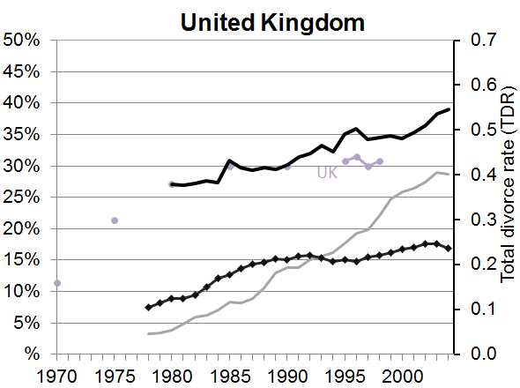 | 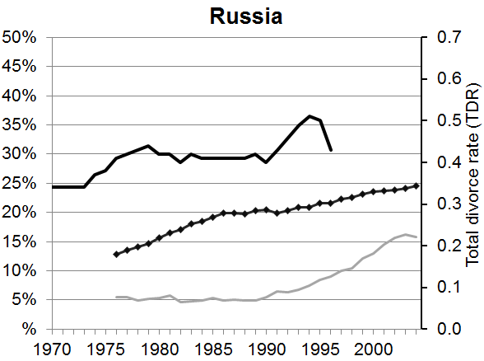 | 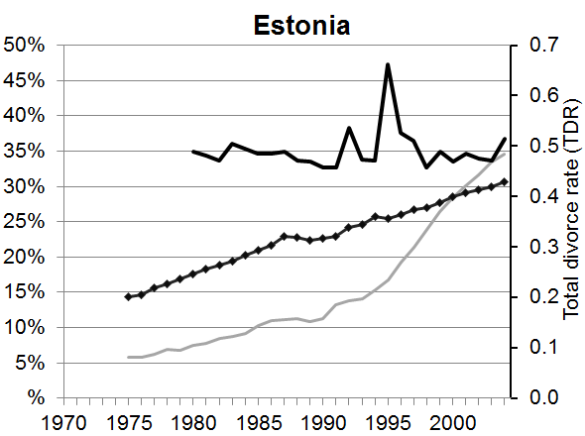
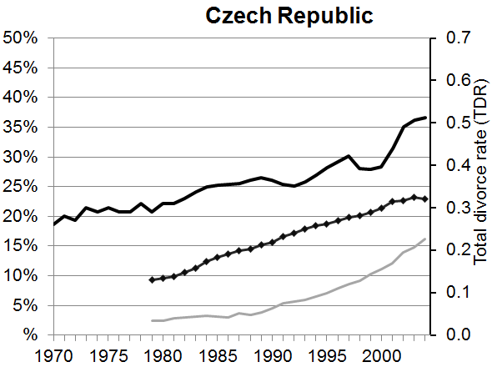 | 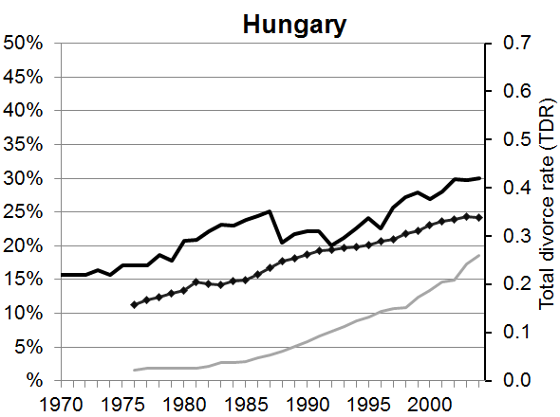 | 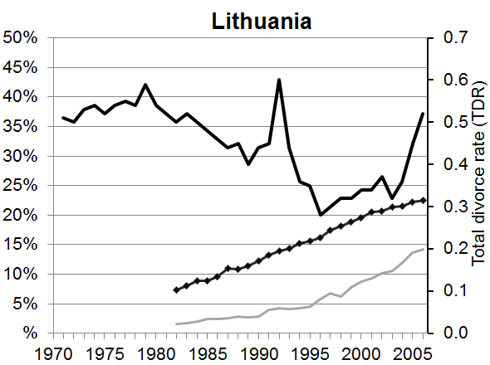
Figure 1b. Total Divorce Rate, % Ever divorced women among ever married women (age 30-49), Currently cohabiting women among all couples (age 20-49), and Year of implementation of divorce reforms, in Group b: relatively low divorce and cohabitation rates, but the increase in divorce appears to have occurred before the increase in cohabitation.
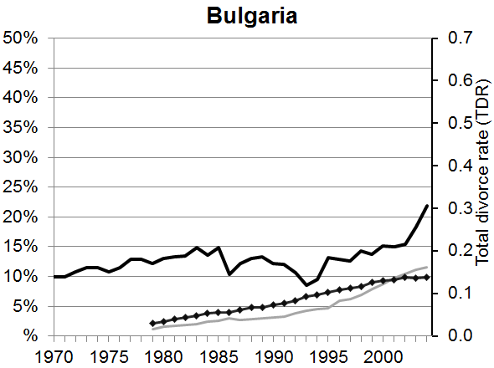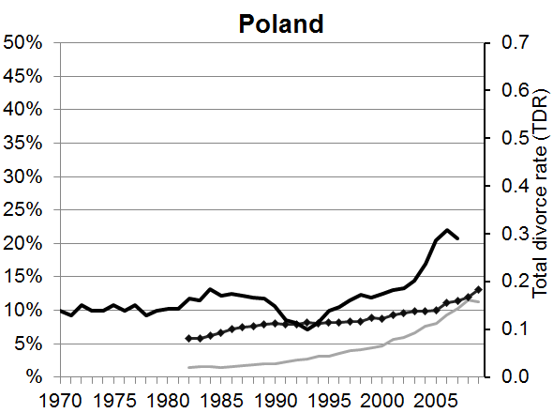
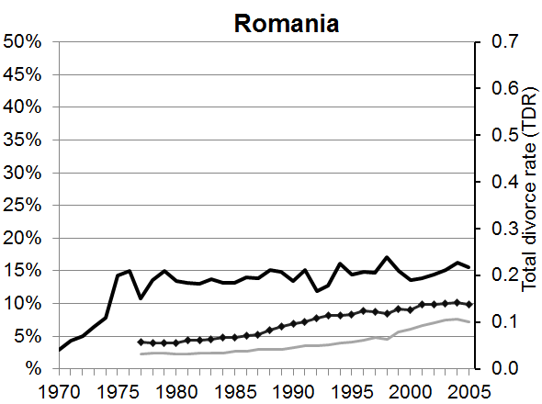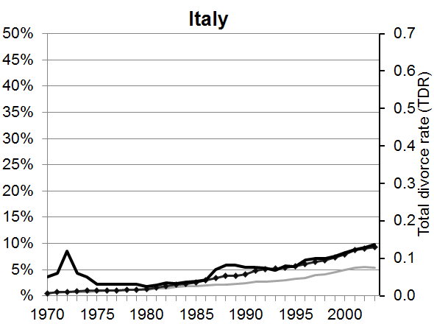

Figure 1c. Total Divorce Rate, % Ever divorced women among ever married women (age 30-49), Currently cohabiting women among all couples (age 20-49), and Year of implementation of divorce reforms, in Group c: Divorce increases rapidly – Cohabitation later outpaces divorce

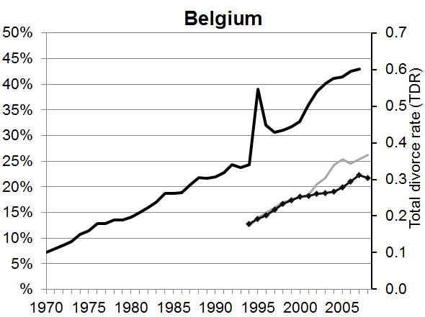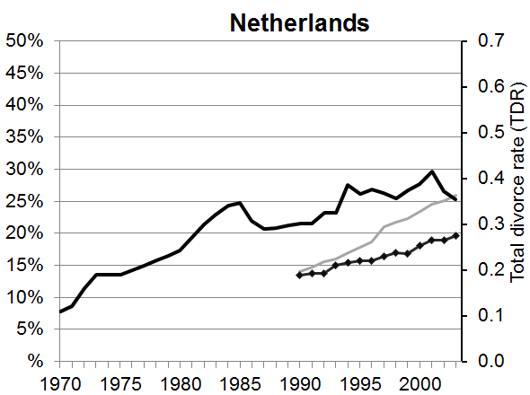
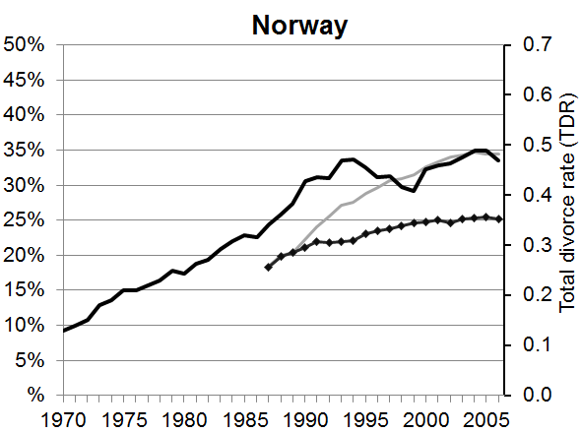

Figure 1d. Total Divorce Rate, % Ever divorced women among ever married women (age 30-49), Currently cohabiting women among all couples (age 20-49), and Year of implementation of divorce reforms, in Group d: Inconsistent with expectations: Cohabitation appears to have increased more rapidly and possibly earlier than divorce.
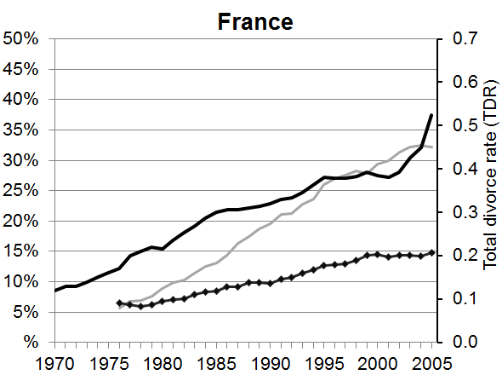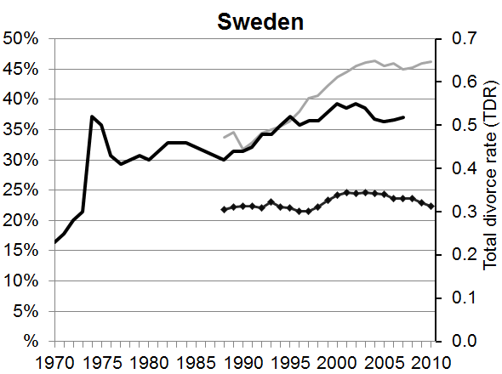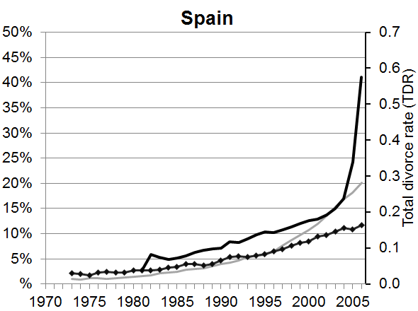

Figure 2. Percentage of ever partnered women aged 20-49, who started their first union with cohabitation, by parental union status at age 15 in 2005.

Notes: Solid bars indicate significant differences (non-overlapping confidence intervals) between parents’ union status at age 15 for those whose first union type is cohabitation. Striped indicates no significant difference. Weights applied if available. Years of analysis may differ depending on survey.

Table 1. Percentage of currently cohabiting women aged 20-49 who were previously married, by age and year.

 | 1978-82 | 1983-87 | 1988-92 | 1993-97 | 1998-02 | 2003-07
Bulgaria | 6.0 | 11.4 | 13.8 | 14.8 | 14.0 | 13.8
Czech Republic | 18.6 | 19.8 | 22.2 | 25.3 | 22.2 | 19.8
Estonia | 35.7 | 36.2 | 34.5 | 29.4 | 23.7 | 21.2
France | 14.8 | 14.2 | 12.5 | 11.6 | 9.3 | 9.5
Hungary | 29.2 | 38.2 | 36.1 | 32.8 | 24.7 | 19.0
Italy | 15.4 | 20.2 | 15.3 | 14.4 | 14.1 | 14.3
Lithuania | - | 15.8 | 19.2 | 18.1 | 19.9 | 20.0
Netherlands | - | - | 12.5 | 11.5 | 10.0 | 10.4
Norway | - | 12.5 | 14.7 | 14.6 | 14.3 | 13.0
Poland | - | 15.7 | 23.0 | 20.5 | 16.7 | 16.9
Romania | 9.9 | 16.9 | 15.4 | 15.7 | 15.6 | 15.5
Russia | 30.6 | 34.5 | 34.0 | 36.1 | 34.3 | 34.3
Spain | 5.8 | 12.9 | 18.0 | 16.1 | 13.0 | 10.9
Sweden | - | - | 10.7 | 8.7 | 8.8 | 8.3
United Kingdom | 25.1 | 16.5 | 12.4 | 14.1 | 11.9 | 11.6

Note: Belgium not shown, as the time series only starts in 1994. All data weighted, apart from that from the Czech Republic, Poland and Sweden where weights are not available. The results are based on 5-year information centered on January of each year. Final data range (2003-2007) centered around 2005 or the latest year for which we have data.

Appendix 1. Important divorce law reforms in 16 European countries
 | Legalization of divorce | Introduction of no-fault divorce | Introduction of divorce by mutual consent | Introduction of unilateral divorce
Belgium | before 1950 | before 1950 | before 1950 | 1975
Bulgaria | before 1950 | before 1950 | until 1952 and since 1968
Czech Republic | before 1950 | before 1950 | 1998
Estonia | before 1950 | before 1950 | 1969 | 2010
France | before 1950 | 1976 | 1976 | before 1950 and 1976
Hungary | before 1950 | before 1950 | until 1953 and since 1974
Italy | 1970 | 1975 | 1975 | 1970
Lithuania | before 1950 | before 1950 | 1970
Netherlands | before 1950 | 1971 | 1971
Norway | before 1950 | before 1950 | before 1950 | 1993
Poland | before 1950 | before 1950
Romania | before 1950 | before 1950 | 1993 | 2010
Russia | before 1950 | before 1950 | 1965 | before 1950 and 1996
Spain | 1981 | 1981 | 1981 | 1981
Sweden | before 1950 | before 1950 | before 1950 | 1974
United Kingdom
England and Wales | before 1950 | 1971 | 1971 | 1971
Scotland | before 1950 | 1977 | 1977 | 1977

The percentages were estimated in January of a given year. Weights have been applied if available.
The longer TDR line only includes England and Wales, while the short line shows the TDR for the UK as a whole.
In the UK, the question referred to age 16. The question was not asked in the Netherlands.
Note that these results do not control for any potential covariates. Our data does not provide further detail about the parents’ partnerships, including the experience of cohabitation or the formation of step-families.
Also relative to those widowed. The widowed make up a relatively small share across countries and the share remains stable over time.

