**H2-Rich Syngas Strategy to Reduce NOx and CO Emissions and Improve Stability Limits under Premixed Swirl Combustion Mode**

Nor Afzanizam Samirana, Jo-Han Ngb,c,e, Mohammad Nazri Mohd Jaafara, Agustin Valera-Medinad, Cheng Tung Chonga,e,*

a Faculty of Mechanical Engineering, Universiti Teknologi Malaysia, 81310 Skudai, Johor, Malaysia.

b Faculty of Engineering and the Environment, University of Southampton Malaysia Campus (USMC), 79200 Iskandar Puteri, Johor, Malaysia.

c Energy Technology Research Group, Engineering Sciences, University of Southampton, SO17 1BJ, Hampshire, UK.

d College of Physical Sciences and Engineering Cardiff University, Wales, UK.

e UTM Centre for Low Carbon Transport in cooperation with Imperial College London, Universiti Teknologi Malaysia, 81310 Skudai, Johor, Malaysia.

**Abstract**

The combustion performance of H2-rich model syngas was investigated by using a premixed swirl flame combustor. Syngas consisting mainly of H2 and CO was blended with components such as CH4 and CO2 in a mixing chamber prior to combustion at atmospheric condition. The global flame appearance and emissions performance were examined for high (H2/CO = 3) and moderate (H2/CO = 1.2) H2-rich syngases. Results showed that higher H2 fractions in the syngases produce lower NOx emissions per kWh basis across all equivalence ratios tested. CO emissions are equivalence ratio dependent and are less affected by the H2 fraction in the syngas. Increasing CO2 diluent ratios result in the decrease of NOx, particularly for moderate H2-rich syngases. In contrast, syngas without CO shows an increase of NOx with increasing CO2 for fuel-lean mixtures. Addition of CO2 increases the lean blowout limit of all syngases. Higher fraction of H2 produces lower lean blowout limits due to the characteristics of high diffusivity of hydrogen molecules and high flame speed that assist in the stabilisation of the flame under flame-lean conditions. The range of blowout limits for moderate and high H2-rich and pure hydrogen syngases under diluent ratios up to 25% were within the range of * *= 0.12-0.15.

Keywords: syngas, lean blowout, NOx, swirl, emissions, CO2 diluent

*Corresponding author

Address: Faculty of Mechanical Engineering Universiti Teknologi Malaysia 81310 Skudai

Johor, Malaysia.

Email: ctchong@mail.fkm.utm.my ; Phone: +60(7) 5534631 ; Fax: +60 (7) 5566159

1. **Introduction**

Synthesis gas, also known as syngas, produced from gasification processes is regarded as one of the promising alternative energies due to its clean fuel characteristics. The main components of syngas are H2 and CO, which can be produced via gasification of various feedstock, including coal, biomass and solid waste [1]. The use of syngas as fuel source can potentially reduce CO2, NOx and other pollutants [2]. One example of syngas application is in Integrated Gasification Combined Cycle (IGCC) power plants where syngas fuel is combusted in gas turbines to generate power and electricity [3, 4]. Despite the proven feasibility of syngas, the challenges that syngases face are the variation in their composition due to different feedstock and production methods. Furthermore, the lack of understanding of the combustion characteristics of syngases poses difficulty in the design of syngas-specific systems and combustors [5].

Most gasification processes typically produce syngases that are CO-rich or H2-rich depending on feedstock. CO-rich syngas has been produced by coal gasification with blends comprising 60% CO and 30% H2 by volume [6]. The relative molar fraction of H2 to CO for coal-derived syngasranges from 0.4 to 1.0 [7]. The use of catalytic gasification technique to gasify biomass was shown to produce H2-rich syngas with a composition of up to 50% H2 and 17% CO by volume [8]. The volume ratio of H2/CO in most syngas mixtures typically exceeds 0.25, where chemical kinetic and reaction mechanisms of hydrogen play a dominant role in syngas combustion. Hence, syngas generally exhibits large burning rates with small autoignition time, comparable to those of pure hydrogen combustion [9].

CO-rich syngas combustion shows combustion characteristics differ from those of H2-rich syngas. Low concentration of H atoms in the former affects fast oxidation pathways of CO, resulting in unstable combustion and high CO emissions that are not well understood [10]. Previous studies of syngas combustion are restricted to limited composition of mixtures. Zhang *et* *al*. [11] studied the effect of dilution of N2 and CO2 on the propagation and extinction of lean premixed syngas flames using an opposed-jet twin flame counter-flow configuration. CO-rich syngas with 50-90% CO and 8-50% H2 were used in the study. Results showed that the dilution effect of CO2 was more profound on flame propagation and extinction than that of N2. Syngas emissions were not measured. Joo *et al.* [12] investigated the emissions of H2-rich syngas in a partially premixed model gas turbine combustor. Syngas compositions of 25-50% H2 and 25-100% CH4 by mol were used as test fuels with the presence of CO ranging from 0-25% by mol. NOx emissions index showed proportional trends to the flame temperature within the equivalence ratio range of *  *0.7-1.3 under fixed heat inputs.

The effects of hydrogen composition in syngas on emissions performance have been studied by several groups. Azimov *et* *al.* [13] used syngas derived from the gasification of biomass and oven coke in a diesel-type dual-fuel engine. The use of higher H2 concentration syngas with H2/CO ratio of 20/22.3 compared to syngas with ratio of 13.7/22.3 resulted in reduced CO and HC emissions but an increase in emitted NOx. The baseline of pure H2 fuel without dilution produced low emissions at equivalence ratios ** ≤ 0.3. Diluting pure H2 with N2 at * *= 0.35 resulted in a decrease of NOx emissions but an increase in CO emissions. Similar trend of higher NOx emissions for H2-rich syngas was found by Lee *et* *al.* [14] in a 60 kW industrial gas turbine using pure syngas without diluent. NOx emissions were reported to increase exponentially as the heat input increased. The H2-rich syngas showed higher equivalence ratios, resulting in an increase in flame temperature and subsequently higher NOx emissions. Higher CO was emitted with lower combustion efficiency when the gas turbine was operated at low load or idle mode. However, Ouimette *et* *al.* [15] reported a different NOx emissions trend for syngas under partially premixed combustion mode. Syngas mixtures with H2/CO ratio of 0.8-1.3 produced rather constant NOx emissions, but NOx showed a decreasing trend at higher H2/CO ratios (> 1.3).

Numerical studies on the extinction limits and emissions for various syngas compositions have been conducted by Ding *et* *al.* [16]. Results showed that syngases with higher H2 content exhibit higher flame temperature profiles and wider flame front. The high H2 content in syngas resulted in high diffusion rate of hydrogen into the reaction zone of the flame compared to CO, thus accelerating the combustion rate. Huynh *et al.* [17] investigated the NOx emissions of syngases produced from pine, maple-oak mixture and seed corn via gasification process. The syngases produced contained a maximum of 16% H2, 20% CO, 20% CO2, 40% N2 and 55% H2O. Syngas blends were combusted in an 879 kW industrial burner that operates under the principles of non-premixed combustion with staged air supply. Combustion of the syngas derived from seed corn resulted in NOx emissions in the range of 450-990 ppm, which is significantly higher than those of wood-derived syngas due to the high nitrogen content in seed corn. Watson *et al.* [18] compared the emissions of methane with a syngas consisting of 37.5% H2, 37.5% CO, 5% CH4 and 20% CO2 by volume and syngas-biogas blends with a composition of 18.8% H2, 18.8% CO, 52.5% CH4 and 10% CO2 by volume using a jet-wall stagnation flame configuration. Result showed that the syngas and biogas mixture produced lower NO emissions than methane when the fuels were compared at equal power outputs.

The inherent variability in composition and heating value in synthesis gases cause significant challenges towards their usage in practical combustion system, especially for low emission combustors that operate near the blowout limit. Blowout occurs when the flame becomes detached from the anchored location and is “blown out” of the combustor. For syngas, the lean blowout limit (LBO) varies significantly depending on the fuel composition and chemical kinetic rates. Several groups have investigated the blowout phenomena of syngas at lean burning region [19, 20]. Li *et. al.* [21] studied the effects of diluents on the LBO limits of premixed syngas flames by using an atmospheric swirl flow combustor. Results showed that the LBO limits increase with the dilution ratio of N2, and that the inert dilution dominates the LBO behaviour of syngas with low H2 content. The effect of swirl intensity on the flame stability limit of a premixed variable swirl burner operated with syngas was investigated by Sayad *et al.* [22]. It was shown that LBO limit was not significantly affected by the change of swirl number, concurring with the result shown by Garcia-Armingol and Ballester [23]. The latter reported that the LBO limit of a turbulent premixed swirl burner ranges between **=0.4-0.7 for syngases with 0-50% H2 by volume. The stability limits for high H2-enriched syngas was not investigated.

Syngas produced from most gasification processes contains different H2, CO and diluent compositions. CO and H2 constitute the main reactive components in syngas ranging from 10% to 70% by volume [8, 24-26]. Diluents such as CO2, N2 and H2O are typical non-reactive components present in syngases derived from biomass or coal gasification. Due to a wide range of possible syngas composition produced from different feedstock and processes, thorough investigation of the combustion performance for any syngas is needed to allow further practical application and design of syngas-specific combustors. On the previous note, there is a lack of studies on the combustion characteristics of H2-rich syngases. The present study focuses on the combustion performance of H2-rich syngases under a continuous swirl flame mode. The flame appearance, post-flame emissions and lean blowout limits are investigated and compared against baseline pure hydrogen/air flames.

1. **Experimental**
   1. **Swirl burner and flow delivery system**

An axial swirl flame burner was utilised to establish continuous swirling syngas flames. The schematic of the swirl flame burner and flow delivery system is shown in Fig. 1a. The axial swirler (Fig. 1b) consists of 6 straight vanes with thickness of 1.5 mm. The swirler vanes are positioned at an angle of 45o from the axial centerline. The outer diameter of the swirler is 40 mm, while the swirler hub diameter is 20 mm. The swirler was placed at the burner outlet, concentric to the burner wall which consists of a quartz tube with a diameter of 120 mm. The use of a quartz tube allows optical access and enables visualisation of the flames. The geometric swirl number is approximate to be *SN* ~ 0.84 based on the equation, 

 

where *D*h and *Ds* represent the swirler hub diameter and the swirler diameter, respectively, and * * is the angle of the swirl blade from the centreline. The present swirler was able to generate sufficiently high swirl (*SN* > 0.6) to assist in flame stability [27]. For the flow delivery, hydrogen (99.99% purity) and carbon monoxide (99.97% purity) gases were supplied and regulated via mass flow controllers (Sierra) with an accuracy of ±1.5% full scale. The supplies of CH4 (99.95% purity) and CO2 (99.9% purity) were regulated using flow meters (Key Instrument) with an accuracy of ±5% respectively. The gases were premixed at room temperature of 298 K in a mixing chamber to ensure thorough mixing. The mixed gases then premixed with dried air at the burner plenum. The air was supplied and regulated using a mass flow controller (Sierra) with an accuracy of ± 1.5% full scale. The uncertainties of the flow meters for inlet gases (air + fuel) are 1.5-5%. A flame torch was used to ignite the combustible mixture at the burner outlet exposed to the atmosphere.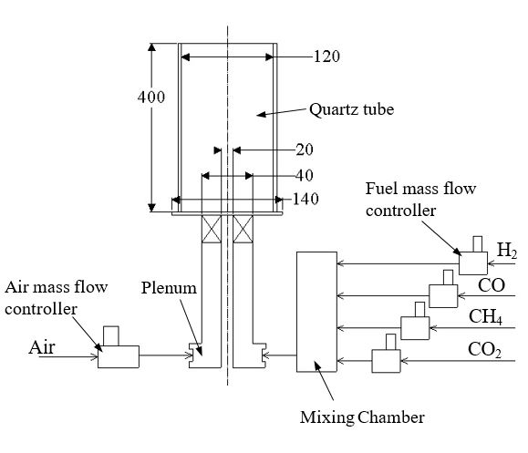

**a**

**b**

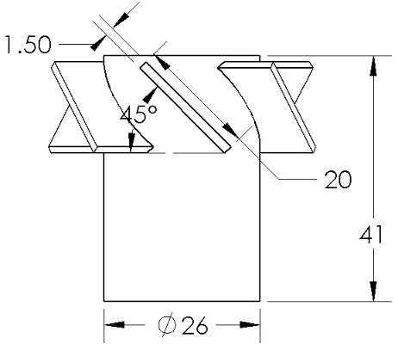

Axial Swirler

Fig. 1: Schematic diagram of (a) swirl burner with flow delivery system and (b) axial swirler. Dimensions are in mm.

* 1. **Operating conditions**

In the present study, H2-rich syngases blended with CO2 and CH4 as diluents are investigated. Table 1 shows all model syngases tested. For case S1-S5, the syngas H2/CO ratio is fixed at 3, while case S6-S10 set the H2/CO ratio to 1.2, representing high H2-rich syngas for the former and moderate H2-rich for the latter cases respectively. By fixing the main air flow rate at 2 g/s, the syngas fuel flow rates were regulated to form mixtures with equivalence ratio ranging from * *= 0.5 to 1.1, covering fuel-lean, stoichiometric and rich conditions. For the syngas baseline case B1-B5, the main air flow rate was fixed at 2.5 g/s. A constant 5% of CH4 was added to all test cases to increase the calorific value of the mixture. For emissions measurements, cases S1 and S6 were studied and compared against baseline B1. S1 is a high H2-rich syngas (67.5% H2) while S6 is a moderate H2-rich (49.5% H2) case. The baseline established in the present study consists of 90% H2, 5% CO2 and 5% CH4 by volume without CO. The effect of CO2 as diluent on the emissions is investigated by incrementally adding CO2 at 5% for both sets of syngas, S1-S5 and S6-S10 and compared against baselines B1-B5.

Table 1: Syngas mixture composition tested (vol. %)

|  |  |  |  |  |
| --- | --- | --- | --- | --- |
| **Mixture** | **H2**  **(vol. %)** | **CO**  **(vol. %)** | **CO2**  **(vol. %)** | **Lower heating value**  **(MJ/kg)** |
| S1 | 67.5 | 22.5 | 5 | 25.0 |
| S2 | 63.8 | 21.3 | 10 | 20.4 |
| S3 | 60.0 | 20.0 | 15 | 17.0 |
| S4 | 56.3 | 18.8 | 20 | 14.3 |
| S5 | 52.5 | 17.5 | 25 | 12.2 |
| S6 | 49.5 | 40.5 | 5 | 17.9 |
| S7 | 46.8 | 38.3 | 10 | 15.5 |
| S8 | 44.0 | 36.0 | 15 | 13.5 |
| S9 | 41.3 | 33.8 | 20 | 11.8 |
| S10 | 38.5 | 31.5 | 25 | 10.4 |
| B1 | 90 | 0 | 5 | 53.3 |
| B2 | 90 | 0 | 10 | 35.4 |
| B3 | 90 | 0 | 15 | 25.8 |
| B4 | 90 | 0 | 20 | 19.8 |
| B5 | 90 | 0 | 25 | 15.8 |

* CH4 is supplied as diluent at 5% by volume for all test cases

* S1-S5 are high H2-rich syngases with H2/CO ratio of 3

* S6-S10 are moderate H2-rich syngases with H2/CO ratio of 1.2

* B1-B5 are pure hydrogen syngases without CO

* 1. **Emissions measurements**

Measurements of post combustion emissions were performed by using a gas analyzer (Tempest 100) at the combustor outlet. The sampling probe was placed at the burner outlet to measure the emissions radially at 8 spatial locations that were equally spaced. The spatial emissions values were averaged and weighted by area-velocity to obtain the final global emissions value for each test case [28]. The emissions measured include NO, CO, O2 and CO2, with the measurement range of 0-1000 ppm, 0-10000 ppm, 0-25% and 0-99.9% respectively. The emissions readings from the gas analyser are reported in dry basis with the uncertainty of ± 5 ppm for NO, ± 5 ppm for CO, ± 0.2% for O2. The NO, CO emissions were measured by chemical sensors in the gas analyser, while the CO2 emissions was calculated based on the chemically measured O2. Sampling of the post-combustion gases was performed on the steady state, continuous swirl flame for 1 minute until the reading became stabilised. The propagated errors of the emission measurements for NOx, CO, O2 and CO2 are ± 22.3%, ± 1.3%, ± 1.3% and ± 4.2% respectively. Detailed specifications of the gas analyser and temperature sensors are summarised in Table 2.

Table 2: Specification of the gas analyser and temperature sensors.

|  |  |  |  |  |
| --- | --- | --- | --- | --- |
| Sensors | Range | Resolution | Accuracy | Propagated error |
| Temperature | 0 – 800 oC | ±1 oC | 0.3 %, 1 oC | ± 1.3 % |
| NO | 0-1000 ppm | ±1 ppm | < 100 ppm; ±5 ppm  >100 ppm; ±5 % | ± 22.3 % |
| CO | 0-10000 ppm | ±1 ppm | < 100 ppm; ± 5 ppm  > 100 ppm; ± 5 % | ± 1.3 % |
| O2 | 0-25 % | 0.1 % | 0.2% | ± 1.3 % |
| CO2* | 0-99.9 % | 0.1 % | N/A | ± 4.2 % |

*CO2 is calculated based on the measured O2

* 1. **CO2 diluent addition in syngases**

The effect of CO2 diluent on H2-rich syngases was investigated by varying the CO2 diluents while keeping the ratio of H2/CO fixed and CH4 constant at 5%. The diluent ratio Xdiluent is defined by, Xdiluent=Vdiluent/(Vdiluent+Vfuel), where ${\text{V}}_{\text{diluent}}\text{ and }{\text{V}}_{\text{fuel}}$ are the volume fractions of diluents and fuel (syngas) respectively in the reactant mixtures [29]. Dilution of CO2 was performed at 10-25% for high (S2-S5) and moderate H2-rich syngases (S7-S10). The emissions and lean blowout limits are compared to baselines (B2-B5) with corresponding diluent percentage.

* 1. **Blowout limit of syngases**

The blowout phenomena, often regarded as the upper static stability limit of combustors, occurs when the flame detaches from its anchored location and physically blows off [30]. Measurements of the high and moderate H2-rich syngases were performed in the present study to determine the blowout limit under non-diluted and CO2-diluted conditions. By gradually increasing the air flow rate of an established flame until the flame blows out, the equivalence ratio at which blowout occurs was recorded as the lean blowout limit. Comparison of the blowout limit of H2-enriched syngases against the baseline syngas was performed.

1. **Results and discussion**
   1. **Flame imaging**

A digital camera (CASIO; model EX-ZR1000) was utilised to image the global flame appearance of syngas swirl flame established at different equivalence ratios through the optically accessible quartz wall. The focal length and exposure time of the camera were set at 4 mm and 1/15 second, respectively. Figure 2 shows two sets of syngas flame images, case S1 and S6, established at ** = 0.5-1.1 with a constant composition of 5% CO2 and 5% CH4. Despite the differences in H2/CO ratios, syngas flames exhibit rather similar attributes. For fuel-lean mixtures of ** = 0.5-0.7, bluish flames were observed as a result of the intense heat reaction zones. The fuels chemically react in this region under sufficient oxygen, leaving no unburned hydrocarbon for post-flame reaction or soot formation. Increasing the equivalence ratio to near stoichiometric region results in the luminous orange-yellow region downstream of the main reaction zone. Visible orange-yellowish post flames are indicative of soot formation. The luminous post-flame region is evident for fuel-rich mixture, as shown in Fig. 2a and 2b for S1 and S6 respectively. The typical high temperature environment under stoichiometric or fuel-rich conditions increase the concentration of vapour consisting of combustion product of H2 component, e.g. H2O, and formation of C/H radical, paving the way for the production of acetylene and propargyl formation which are essential precursors for soot formation [31, 32].

It is observed that high H2-rich syngas (S1) shows less luminous post-flame region compared to moderate H2-rich syngas (S6) at the equivalence ratio* * = 1.1, indicating the lower tendency for soot formation for the former due to reduced availability of C radicals. The higher H2 concentration in S1 results in the overall decrease in flame reaction zone length due to reduced flame thickness [33]. Hydrogen has the intrinsic characteristic of greater molecular diffusivity. Increase of H2 concentration in fuel-air mixtures results in reducing the convective time scale for H2 to the flame front [34]. As a result, the burning intensity is increased while the main reaction zone length is decreased, as evident across the lean and rich region for S1 flames. The increase of equivalence ratios results in the decrease of diffusive-thermal instabilities for S1 and S6 due to the increase of Lewis number, *Le* (ratio of heat diffusivity to mass diffusivity). Correspondingly, hydrodynamic instability increases with increasing equivalence ratio as a result of reduced flame thickness and increased thermal expansion ratio (ratio of unburned gas density to burned gas density) [33]. Li *et al.* [33] quantitatively showed that the effect of diffusive-thermal instability is more dominant than hydrodynamic instability for the syngases with hydrogen fractions of 50% and 70% in an outwardly propagating flame test. No evident signs of intrinsic instabilities were observed for the present S1 (67.5% H2) and S6 (49.5% H2) syngas flames, partly in due to the weak flame intrinsic instability effect on the smallest wrinkled scale, and the sufficiently strong turbulent flame where the effect of intrinsic instability is nullified by the turbulence vortex scale. The effect of preferential diffusion of H2 in syngas is expected to affect the diffusive-thermal instability near the ultra-lean region (** < 0.4) of syngas where the intensity of the flame front wrinkling in turbulent flame is enhanced.

Temporarily removed as the file is too big

Figure 2:Global flame images of (a) high (S1) and (b) moderate (S6) H2-rich syngas at different equivalence ratios.

* 1. **Effect of equivalence ratio on syngas emissions**

Comparison of the NOx emissions indices for high H2-rich syngas (case S1) and moderate H2-rich syngas (case S6) against baseline (case B1) as a function of equivalence ratios is shown in Fig. 3a. The diluents of CH4 and CO2 for all the cases including baseline were both supplied at constant 5% by volume. For syngas S1, the trend is similar to baseline hydrogen fuel where fuel-lean region shows the lowest NOx but increases exponentially as the fuel/air mixture approaches stoichiometric and rich regions. This is due to the increase of flame temperature as the mixture becomes richer towards stoichiometric and fuel-rich region that favours the formation of thermal NOx [23, 35].

The NOx emissions indices for moderately H2-rich syngas S6 is comparatively higher than syngas S1 across the range of equivalence ratio (ER) tested. It also differs at the very lean range of * *= 0.4 – 0.6 where NOx  emissions can be 2.5 to 3.3 times greater than that of the H2-rich syngas S1. This can be attributed to the tri-effects of (i) the stack temperature which was found to be higher for S6 (467-517 **°**C) as compared to S1 (446-475 **°**C), (ii) the much lower power generated at the lower ER and (iii) the effect of CO on the NOx emissions is significant for H2-rich syngas. An increase of CO from 22.5% (S1) to 40.5% (S6) resulted in the average increase of NOx by a factor of 2. This is partly in due to the presence of oxygen atom in CO, which further promotes the formation of NOx via dissociations. The high H2/CO ratio in S1 is another reason that retarded the formation of NOx. The abundant H radical and lack of C radical prohibits the production of CH and CH2 radicals that are critical for the formation of HCN, which is a precursor responsible for the formation of prompt NOx emissions [15]. It is also observed that the ER range where NOx tend to plateau before increasing tends to shift towards higher ER with decreasing H2 proportion in the syngas.

The emissions index presented in log form for CO as a function of equivalence ratios is shown in Fig. 3b. Surprisingly the high H2-rich syngas (S1) shows CO emissions close to that of moderate H2-rich syngas (S6), except at ** = 0.4 and stoichiometric region where S6 exhibits slightly higher CO emissions. The high production of CO at fuel-lean ** = 0.4 is due the incomplete combustion of pockets of fuels and further aggravated by the presence of CO in the syngas fuels. The low flame temperature in fuel-lean region prohibits the conversion of CO into stable species of CO2 [23]. An increase of equivalence ratio to ** = 0.5 resulted in the reduction of CO formation by an order of magnitude. The combustion efficiency is increased with higher equivalence ratio as a result of higher flame temperature. Syngas S6 shows that * *= 0.9 produces the lowest CO before increasing again at stoichiometric and rich conditions, whereas syngas S1 produces the least CO at * *= 1.0. An increase of CO production in the fuel-rich region as shown by syngas S6 is attributed to incomplete combustion due to lack of oxygen. The baseline case B1 shows low CO emissions compared to H2/CO syngases. At ** = 0.4, the baseline shows CO emissions that is an order of magnitude lower than both syngas S1 and S6. High H2-rich syngas shows NOx emissions that are comparable to baseline but CO emissions is significantly higher in the lean region.

The emissions indices for CO2 and O2 for high (S1) and moderate (S6) H2-rich syngases are shown in Fig. 4a. Both syngases show higher CO2 emissions compared to baseline B1, in particular in the fuel-lean region of ** < 0.9. Despite the significant differences in CO values in the fuel-lean region, CO2 seems to converge in the stoichiometric region. The baseline hydrogen fuel shows significantly low CO2 emissions, with approximately a factor of 3 lesser compared to case S1 and S6. The high CO2 emissions for the latter in the fuel lean region were attributed to the presence of carbon monoxide in the fuels where part of the CO in the fuel was converted into CO2 [36]. The O2 emissions profiles were similar for cases S1, S6 and B1 as shown in Fig. 4b.

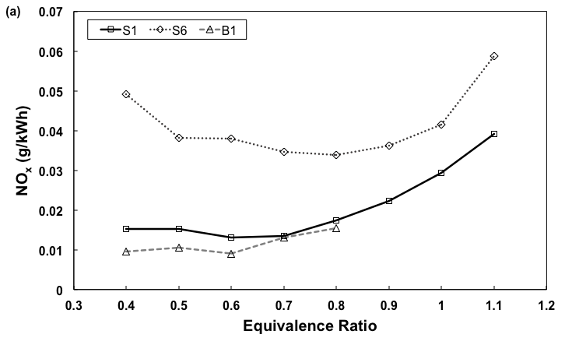

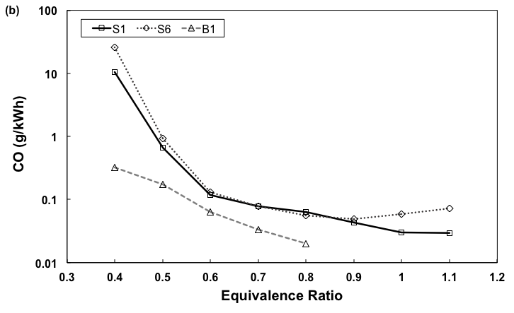

Figure 3: Emissions indices of (a) NOx and (b) CO for high H2-rich syngas (S1), moderate H2-rich syngas (S6) and baseline pure hydrogen syngas (B1) as a function of equivalence ratio.

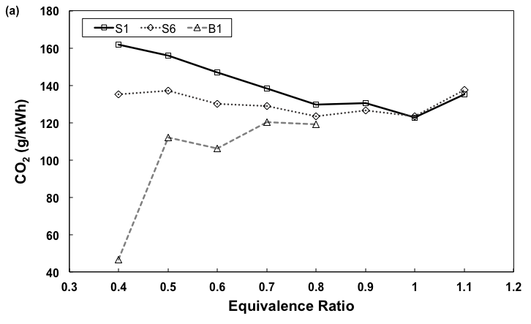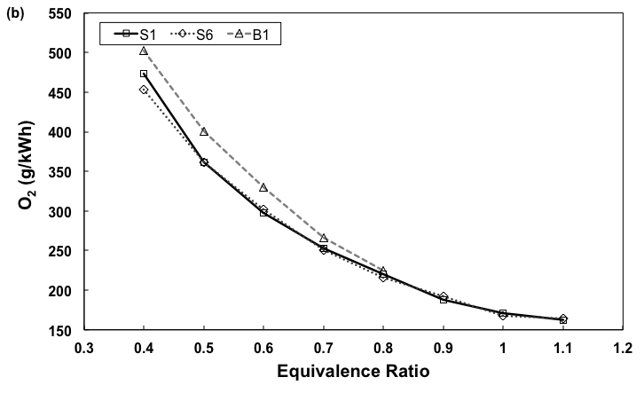

Figure 4: Emission indices of (a) CO2 and (b) O2 for syngas S1, S6 and baseline B1 as a function of equivalence ratio.

* 1. **Effect of CO2 diluent in syngases on emissions**

The NOx emissions index for moderate H2-rich syngases (S6-S10) are shown in Figure 5a. Overall, at the range of equivalence ratio tested, from lean to rich mixtures, a non-linear decreasing trend of NOx was shown with the increase of CO2 diluent ratio. The lower NOx at high CO2 diluent ratios can be attributed to both the thermal and chemical effects. CO2 diluent reduces the adiabatic temperature due to higher specific heat, which would result in a significant decrease in overall burning rate due to the reduction of laminar flame speed [11], subsequently reduces the production of thermal NO [37]. Addition of diluent to the air stream also causes a corresponding decrease in oxygen mole fraction. Consequently, the flame temperature and the mole fractions of H, O, and OH radicals reduce. On chemical effect, addition of diluents decreases the N and HCN mole fractions and subsequently reduces prompt NO [38]. At ** = 0.4 for moderate H2-rich syngases, thermal NOx effects were not significant due to low temperature. Hence, prompt NO from the CH and CH2 radicals and HCN from CO react to promote NOx production, resulting in the overall higher NOx emissions compared to * *= 0.6 and ** = 0.8.

Figure 5b shows the NOx emissions index for high H2-rich syngases (S1-S5) as a function of equivalence ratio. Interestingly, all equivalence ratio tested showed similar trend of non-monotonic emissions of NOx with diluent ratios. A slight increase of NOx was observed when CO2 diluent ratio increased from 5% to 10%, but the values drop to minima at diluent of 15% before increasing again at both the 20% and 25% CO2 dilutions. However, the absolute NOx emission (by volume) is reducing with increasing CO2 content in the fuel. When a linear trendline is used for S1-S5, then a flatter line can be seen with increasing CO2 content, signifying that NOx reduction is balanced out by the reduction in energy content, which in turn leads to the thermal NO producing higher temperature.

It is noted that for high H2-rich syngases, the high content of H2 and lack of C radicals are factors that prohibits NOx formation. At low dilutions of 5% and 10% for * *= 1.0 and * *= 1.1, NOx emissions are evidently high. Variation of the NOx emissions is not significant between ** = 0.4, 0.6 and 0.8 at all diluent ratios. The emissions index of NOx for baseline hydrogen (B1-B5) is shown in Fig. 5c. The NOx emissions for fuel-lean pure hydrogen syngas shows an increase in NOx production which is in reverse trend compared to moderate H2-rich syngas (S6-S10). The addition of CO2 increases the C radicals that promotes the formation of NOx. Overall, the lean pure hydrogen baseline shows comparatively less NOx emissions compared to high and moderate H2-rich syngases at all equivalence ratios.

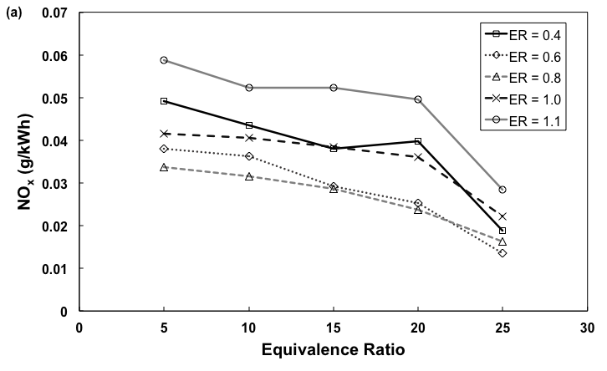

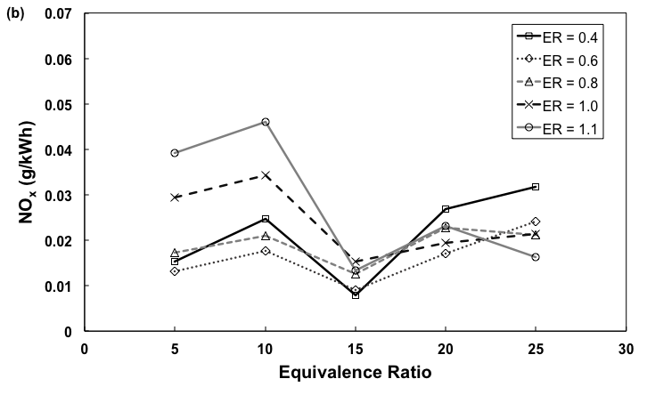

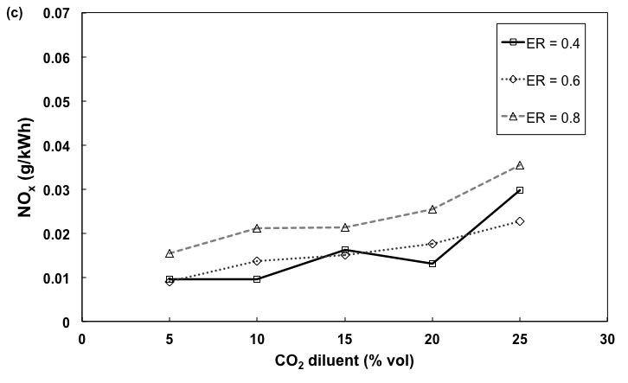

Figure 5: Emission indices of NOx for (a) moderate (S6-S10) and (b) high H2-rich syngas (S1-S5) and (c) baseline hydrogen (B1-B5) at different CO2 dilutions and equivalence ratios.

Figure 6a shows the emissions index of CO in log scale for moderate H2-rich syngases (S6-S10) at different CO2 diluent ratios. The increase in CO2 diluent ratios result in insignificant variation of CO for all equivalence ratios tested. For * *= 0.4, CO emissions index is higher than * *= 0.6 by two order of magnitude which is attributable to incomplete combustion of pockets of fuels. Emissions of CO is lower at higher equivalence ratio as a result of higher combustion efficiency. CO emissions level at * *= 1.0 and ** = 1.1 are rather similar across all diluent ratios tested. Compared to moderate H2-rich syngases (Fig. 6a), high H2-rich syngases show lower emissions for CO2 diluent ratios of < 20% at all equivalence ratios. However, slightly higher CO emissions were observed for high CO2 diluents ratio (20% and 25%), as shown in Fig. 6b. The increase of CO2 diluent prevents complete oxidation of fuels at high temperatures, causing an increase in CO concentrations as the reaction rate of combustion decreased. The existence of CO2 reduces the reactivity of O2 for atomic hydrogen and leads to the formation of CO [39]. The baseline hydrogen syngas flames (B1-B5) show significantly low CO emissions at fuel-lean conditions in Fig. 6c. In particular, for * *= 0.4, the average CO emissions is of two order of magnitude lower compared to moderate H2-rich syngas. Further evidence of lower CO emissions was shown when equivalence ratio was increased to * *= 0.6 and * *= 0.8, highlighting the significant effect of CO in syngas on CO emissions.

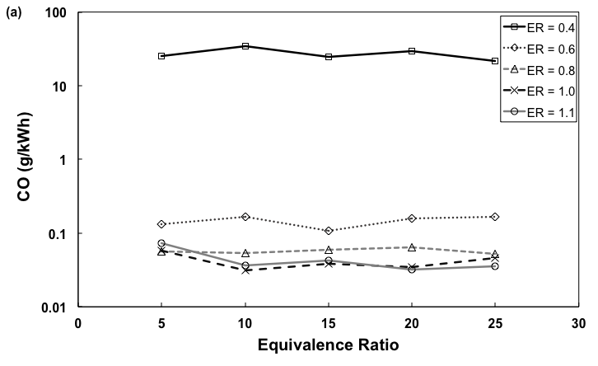

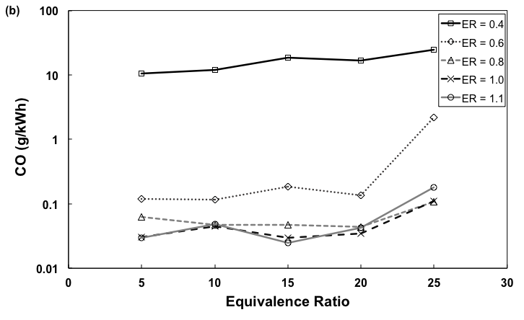

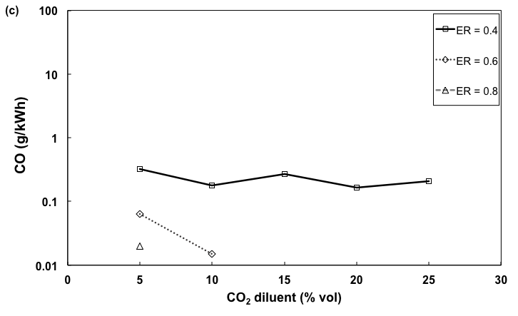

Figure 6: Emission indices of CO for (a) moderate (S6-S10) and (b) high H2-rich syngas (S1-S5) and (c) baseline hydrogen (B1-B5) at different CO2 diluent ratios and equivalence ratios.

**3.4 Effect of CO2 diluent addition in syngases on lean blowout limit**

Blowout limit can be related to Damkohler number, *Da*, where the order of magnitude of *Da* at blowout can be estimated from the values of the reference variables at the point of blowout given byt: , where *res* and *chem*represents the characteristic residence time and chemical time scales respectively in the combustor while, $d_{r}$ is the characteristic flow length, $u_{r}$ is the velocity, ** is thermal diffusivity and *SL* represents the laminar flame speed [23]. Blowout occurs when the characteristic chemical time exceeds the characteristic residence time.

The lean blowout limit for high (S1-S5) and moderate (S6-S10) H2-rich syngases at different CO2 diluent ratios is shown in Fig. 7a. In general, moderate H2-rich syngases show consistently higher LBO limit than high H2-rich syngases across all CO2 dilution rates. As expected, the baseline of pure hydrogen cases (B1-B5) show lower LBO limit compared to high H2-rich syngases. By increasing the diluent ratio of CO2, the LBO limit increases for all syngas composition as a result of reduced H2/CO ratio. Lower H2 fraction in the syngas leads to reduced laminar flame speed [22], resulting in short residence time that induces flame blowout. This effect is reflected in all syngas compositions including baselines. The addition of CO2 was shown to reduce Markstein length and Lewis number apart from reducing flame speed, causing the flame to be more sensitive to stretch and increases the susceptibility to diffusional-thermal instability [29].

Figure 7b shows the lean blowout limit as a function of H2 fraction in syngas at different CO2 diluent ratios, combining the cases of high, moderate H2-enriched syngas and baselines. Results show that higher H2 content extends the flammability limit of syngas and subsequently lowering the lean blowout limit, concurring with previous reports [30, 40]. The LBO trend for all tested cases converges to show the same trend when plotted as a function of H2 fraction by volume, highlighting the consistency of LBO limit depending on the H2 fraction in syngases. Higher H2 content in the mixture leads to higher mixture reactivity rate which increases flame speed and reduces chemical time for complete reactions [22]. The relative high flame speed of H2-rich syngases delays blowout phenomena as the velocity of the incoming unburnt reactants matches those of the flames to enable stabilisation of flame at the burner outlet [40-43]. With higher H2 fraction in syngas, the additional H2 in the free stream increases the concentration of radicals, thus increases the mixture’s reactivity [44].

The preferential diffusion of H2 in syngas strongly affects the diffusive-thermal instability and laminar flame speed. For syngas/air mixture, the intensity of flame front wrinkle is promoted with the increase of hydrogen fraction in the syngas due to the increased preferential diffusive-thermal instability [33]. Lewis number for lean syngas/air mixture is smaller than unity, resulting in flame cellular instability and enhances laminar flame speed. For any protuberance that appears on the flame front (stretch increasing), the local flame speed will increase, leading to flame front instability and flame wrinkling due to the development of fractal structure on the flame front [45]. It has been shown that the wrinkled flame fronts for syngas possess much finer cusps structure and higher turbulent speed compared to methane flame, as the flame intrinsic instability promotes turbulence wrinkling leading to the increase of flame front area [46, 47]. The intensity of flame front wrinkle is promoted with the increase of hydrogen fraction in syngas due to increased preferential diffusive-thermal instability, resulting in the extension of lean blowout limit.



Figure 7: Lean blowout limit (a) for high (S1-S5) and moderate (S6-S10) H2-rich syngases compared against baseline (B1-B5) H2 flames and (b) as a function of percentage of H2 fraction in syngas at different CO2 diluent ratios.

1. **Conclusion**

The combustion characteristic of rich-H2 syngases were investigated in a medium swirl stabilised premixed combustor at various equivalence ratios. Direct flame imaging shows that high H2-rich syngas exhibits cleaner flames with less luminous orange-yellowish flame in the post-flame zone, indicating the low tendency for soot formation. The high H2-content syngas shows a flame reaction zone length that is more intense and shorter due to reduced flame thickness compared to moderate H2-enriched syngas. From the emission tests, moderate H2-rich syngas shows higher NOx emissions than high H2-rich syngas at all equivalence ratios tested attributable to the presence of C from CO that promotes the formation of NOx. High H2-rich syngas shows slightly higher emissions compared to baseline pure hydrogen gas. For CO emissions, both the high and moderate H2-rich syngases show similar CO profiles. Both syngas type show higher CO than pure hydrogen baseline at fuel-lean regions. The effect of CO2 diluents on NOx emissions is pronounced for moderate H2-rich syngas, where a decreasing trend of NOx emissions was shown with increasing CO2 diluent ratios. The effect of diluents on CO is not evident for moderate H2-rich syngases, but slightly more evident for high H2-rich syngas at high diluent rates (>20%). The results show that higher fraction of H2 in the syngas relative to CO can potentially achieve both low NOx and CO simultaneously Diluting the syngas with CO2 results in blowout at higher equivalence ratio as the laminar flame speed decreases. High fraction of H2 in syngas exhibits extended flammability limit and lower lean blowout limit. The effect of preferential diffusion of H2 leads to higher mixture reactivity rate, increases flame speed and stability due to extended lean blowout limit.

**Acknowledgement**

Financial support from the Malaysian Ministry of Education and Universiti Teknologi Malaysia (Research University grant Tier-1 vot no.: 09H79) is gratefully acknowledged.

**References**

[1] Samiran NA, Jaafar MNM, Ng J-H, Lam SS, and Chong CT. Progress in biomass gasification technique – With focus on Malaysian palm biomass for syngas production*.* Renewable Sustainable Energy Rev. 2016; 62: 1047-62.

[2] Burbano HJ, Pareja J, and Amell AA. Laminar burning velocities and flame stability analysis of H2/CO/air mixtures with dilution of N2 and CO2*.* Int. J. Hydrogen Energy 2011; 36(4): 3232-42.

[3] Fu J, Tang C, Jin W, Thi LD, Huang Z, and Zhang Y. Study on laminar flame speed and flame structure of syngas with varied compositions using OH-PLIF and spectrograph*.* Int. J. Hydrogen Energy 2013; 38(3): 1636-43.

[4] He F, Li Z, Liu P, Ma L, and Pistikopoulos EN. Operation window and part-load performance study of a syngas fired gas turbine*.* Applied Energy 2012; 89(1): 133-41.

[5] Shih H-Y and Hsu J-R. A computational study of combustion and extinction of opposed-jet syngas diffusion flames*.* Int. J. Hydrogen Energy 2011; 36(24): 15868-79.

[6] Xu S, Ren Y, Wang B, Xu Y, Chen L, Wang X, and Xiao T. Development of a novel 2-stage entrained flow coal dry powder gasifier*.* Applied Energy 2014; 113: 318-23.

[7] Mansfield AB and Wooldridge MS. High-pressure low-temperature ignition behavior of syngas mixtures*.* Combust. Flame 2014; 161(9): 2242-51.

[8] Chacartegui R, Sánchez D, Muñoz de Escalona JM, Muñoz A, and Sánchez T. Gas and steam combined cycles for low calorific syngas fuels utilisation*.* Applied Energy 2013; 101: 81-92.

[9] Boivin P, Jiménez C, Sánchez AL, and Williams FA. A four-step reduced mechanism for syngas combustion*.* Combust. Flame 2011; 158(6): 1059-63.

[10] Williams TC, Shaddix* CR, and Schefer RW. Effect of Syngas Composition and CO2-Diluted Oxygen on Performance of a Premixed Swirl-Stabilized Combustor*.* Combust. Sci. Technol. 2007; 180(1): 64-88.

[11] Zhang Y, Shen W, Zhang H, Wu Y, and Lu J. Effects of inert dilution on the propagation and extinction of lean premixed syngas/air flames*.* Fuel 2015; 157: 115-21.

[12] Joo S, Yoon J, Kim J, Lee M, and Yoon Y. NOx emissions characteristics of the partially premixed combustion of H2/CO/CH4 syngas using artificial neural networks*.* Appl. Therm. Eng. 2015; 80: 436 - 44.

[13] Azimov U, Tomita E, Kawahara N, and Harada Y. Effect of syngas composition on combustion and exhaust emission characteristics in a pilot-ignited dual-fuel engine operated in PREMIER combustion mode*.* Int. J. Hydrogen Energy 2011; 36(18): 11985-96.

[14] Lee MC, Seo SB, Chung JH, Kim SM, Joo YJ, and Ahn DH. Gas turbine combustion performance test of hydrogen and carbon monoxide synthetic gas*.* Fuel 2010; 89(7): 1485-91.

[15] Ouimette P and Seers P. NOx emission characteristics of partially premixed laminar flames of H2/CO/CO2 mixtures*.* Int. J. Hydrogen Energy 2009; 34(23): 9603-10.

[16] Ding N, Arora R, Norconk M, and Lee S-Y. Numerical investigation of diluent influence on flame extinction limits and emission characteristic of lean-premixed H2–CO (syngas) flames*.* Int. J. Hydrogen Energy 2011; 36(4): 3222-31.

[17] Huynh CV and Kong S-C. Combustion and NOx emissions of biomass-derived syngas under various gasification conditions utilizing oxygen-enriched-air and steam*.* Fuel 2013; 107: 455-64.

[18] Watson GMG, Munzar JD, and Bergthorson JM. NO formation in model syngas and biogas blends*.* Fuel 2014; 124: 113-24.

[19] Lieuwen T, McDonell V, Petersen E, and Santavicca D. Fuel Flexibility Influences on Premixed Combustor Blowout, Flashback, Autoignition, and Stability*.* J. Eng. Gas Turbines Power 2008; 130(1): 011506.

[20] García-Armingol T, Sobrino Á, Luciano E, and Ballester J. Impact of fuel staging on stability and pollutant emissions of premixed syngas flames*.* Fuel 2016; 185: 122-32.

[21] Li S, Zhang X, Zhong D, Weng F, Li S, and Zhu M. Effects of inert dilution on the lean blowout characteristics of syngas flames*.* Int. J. Hydrogen Energy 2016; 41(21): 9075-86.

[22] Sayad P, Schönborn A, and Klingmann J. Experimental investigation of the stability limits of premixed syngas-air flames at two moderate swirl numbers*.* Combust. Flame 2016; 164: 270-82.

[23] García-Armingol T and Ballester J. Operational issues in premixed combustion of hydrogen-enriched and syngas fuels*.* Int. J. Hydrogen Energy 2015; 40(2): 1229-43.

[24] Chacartegui R, Torres M, Sánchez D, Jiménez F, Muñoz A, and Sánchez T. Analysis of main gaseous emissions of heavy duty gas turbines burning several syngas fuels*.* Fuel Process. Technol. 2011; 92(2): 213-20.

[25] Balu E and Chung JN. System characteristics and performance evaluation of a trailer-scale downdraft gasifier with different feedstock*.* Bioresour Technol 2012; 108: 264-73.

[26] Beneroso D, Bermúdez JM, Arenillas A, and Menéndez JA. Integrated microwave drying, pyrolysis and gasification for valorisation of organic wastes to syngas*.* Fuel 2014; 132: 20-26.

[27] Chong CT, Lam SS, and Hochgreb S. Effect of mixture flow stratification on premixed flame structure and emissions under counter-rotating swirl burner configuration*.* Appl. Therm. Eng. 2016; 105: 905-12.

[28] Tao H-G, Chen H-X, Xie J-L, and Hu Y-P. An alternative approach to quantifying fluid flow uniformity based on area-weighted average velocity and mass-weighted average velocity*.* Energy Build. 2012; 45: 116-23.

[29] Vu TM, Park J, Kwon OB, Bae DS, Yun JH, and Keel SI. Effects of diluents on cellular instabilities in outwardly propagating spherical syngas–air premixed flames*.* Int. J. Hydrogen Energy 2010; 35(8): 3868-80.

[30] Lieuwen T, McDonell V, Santavicca D, and Sattelmayer T. Operability Issues Associated with Steady Flowing Combustors. in: Lieuwen T, Yang V, and Yetter R, Editors.Synthesis Gas Combustion, Fundamentals and Application: Taylor & Francis Group;2010.

[31] Su S-S, Hwang S-J, and Lai W-H. On a porous medium combustor for hydrogen flame stabilization and operation*.* Int. J. Hydrogen Energy 2014; 39(36): 21307-16.

[32] Wu L, Kobayashi N, Li Z, Huang H, and Li J. Emission and heat transfer characteristics of methane–hydrogen hybrid fuel laminar diffusion flame*.* Int. J. Hydrogen Energy 2015; 40(30): 9579-89.

[33] Li H, Li G, Sun Z, Yu Y, Zhai Y, and Zhou Z. Experimental investigation on laminar burning velocities and flame intrinsic instabilities of lean and stoichiometric H2/CO/air mixtures at reduced, normal and elevated pressures*.* Fuel 2014; 135: 279-91.

[34] Khan N and Raghavan V. Structure and reaction zones of hydrogen – Carbon-monoxide laminar jet diffusion flames*.* Int. J. Hydrogen Energy 2014; 39(34): 19832-45.

[35] Glassman I and Yetter RA. Combustion. 4th ed. United States America: Elsevier Inc;2008.

[36] Whitty KJ, Zhang HR, and Eddings EG. Pollutant Formation and Control. in: Lieuwen T, Yang V, and Yetter R, Editors.Syntheis Gas Combustion, Boca Raton: CRC Press, Taylor and Francis Group;2010, p. 169-88.

[37] Lee MC, Seo SB, Yoon J, Kim M, and Yoon Y. Experimental study on the effect of N2, CO2, and steam dilution on the combustion performance of H2 and CO synthetic gas in an industrial gas turbine*.* Fuel 2012; 102: 431-38.

[38] Giles D, Som S, and Aggarwal S. NOx emission characteristics of counterflow syngas diffusion flames with airstream dilution*.* Fuel 2006; 85(12-13): 1729-42.

[39] Mordaunt CJ and Pierce WC. Design and preliminary results of an atmospheric-pressure model gas turbine combustor utilizing varying CO2 doping concentration in CH4 to emulate biogas combustion*.* Fuel 2014; 124: 258-68.

[40] Sigfrid IR, Whiddon R, Collin R, and Klingmann J. Influence of reactive species on the lean blowout limit of an industrial DLE gas turbine burner*.* Combust. Flame 2014; (161): 1365–73.

[41] Hwang J, Bouvet N, Sohn K, and Yoon Y. Stability characteristics of non-premixed turbulent jet flames of hydrogen and syngas blends with coaxial air*.* Int. J. Hydrogen Energy 2013; 38(12): 5139-49.

[42] Li H-M, Li G-X, Sun Z-Y, Zhai Y, and Zhou Z-H. Measurement of the laminar burning velocities and markstein lengths of lean and stoichiometric syngas premixed flames under various hydrogen fractions*.* Int. J. Hydrogen Energy 2014; 39(30): 17371-80.

[43] Liang W, Chen Z, Yang F, and Zhang H. Effects of Soret diffusion on the laminar flame speed and Markstein length of syngas/air mixtures*.* Proc. Combust. Inst. 2013; 34(1): 695-702.

[44] Yu G, Law CK, and Wu CK. Laminar Flame Speeds of Hydrocarbon+Air mixtures with H2 addition*.* Combust. Flame 1986; 63: 339-47.

[45] Okafor EC, Nagano Y, and Kitagawa T. Experimental and theoretical analysis of cellular instability in lean H2-CH4-air flames at elevated pressures*.* Int. J. Hydrogen Energy 2016; 41(15): 6581-92.

[46] Wang J, Zhang M, Xie Y, Huang Z, Kudo T, and Kobayashi H. Correlation of turbulent burning velocity for syngas/air mixtures at high pressure up to 1.0MPa*.* Exp. Therm Fluid Sci. 2013; 50: 90-96.

[47] Wang J, Zhang M, Huang Z, Kudo T, and Kobayashi H. Measurement of the instantaneous flame front structure of syngas turbulent premixed flames at high pressure*.* Combust. Flame 2013; 160(11): 2434-41.