Received 00th January 20xx,
- Faculty of Engineering and the Environment, University of Southampton, Southampton, U.K. SO17 1BJ.
- Institute for Life Sciences, University of Southampton, Southampton, U.K. SO17 1BJ.
‡ These authors contributed equally.
† Electronic Supplementary Information (ESI) available: Document with extra experimental data and description of the pump, and three dimensional models of all 3D printed pump parts. See DOI: 10.1039/x0xx00000x
* Email: x.niu@soton.ac.uk

Accepted 00th January 20xx
DOI: 10.1039/x0xx00000x
www.rsc.org/
Phased peristaltic micropumping for continuous sampling and hardcoded droplet generation†
Adrian M. Nightingale^{a,b,‡}, Gareth W.H. Evans^{a,b,‡}, Peixiang Xuª, Byung Jae Kimª, Sammer-ul Hassan^{a,b} and Xize Niu^{a,b,}*
Droplet microfluidics has recently emerged as a new engineering tool for biochemical analysis of small sample volumes. Droplet generation is most commonly achieved by introducing aqueous and oil phases into a T-junction or a flow focusing channel geometry. This method produces droplets that are sensitive to changes in flow conditions and fluid composition. Here we present an alternative approach, using a simple peristaltic micropump to deliver the aqueous and oil in antiphase resulting in a robust “chopping”-like method of droplet generation. This method offers controllable droplet dynamics, with droplet volumes solely determined by the pump design and is insensitive to liquid properties and flow rate. Importantly sequences of droplets with controlled composition can be hardcoded into the pump, allowing chemical operations such as titrations and dilutions to be easily achieved. The push-pull pump is compact and can continuously collect samples, generating droplets close to the sampling site and with short stabilisation time. We envisage this robust droplet generation method is highly suited to continuous in situ sampling and chemical measurement, allowing droplet microfluidics to step out of the lab and into field-deployable applications.

Introduction
The development and uptake of droplet microfluidics, in which sample fluids are broken into- and then manipulated in- a flow of discrete droplets, has seen rapid progress over recent years. This reflects the many advantages offered by droplet flow, including rapid fluid mixing, accurate reaction control and high analytical throughput. Consequently it has been used to address many wide-ranging challenges in chemistry, biochemistry, microbiology, and medicine.¹⁻⁴
The method by which droplets are generated is fundamentally important to all droplet-based microsystems. As droplets must be produced with tightly pre-defined composition and size distribution, much effort has been expended studying droplet breakup mechanisms and droplet generation methods. The most common method of droplet generation, so-called “passive” generation, involves flowing two or more streams of immiscible fluids into a microfluidic junction at constant flow rates. As studied by Garstecki et al. for T-junction geometry⁵ and Weitz and co-workers⁶ for flow focusing channels, formation of droplets in microchannels falls into three distinct regimes: “squeezing”, “dripping” and “jetting”, each of which have different generation characteristics. The regime is largely determined by the critical capillary number, $C_{a}=μV/γ$ (where $μ$ is the viscosity of the dispersed fluid, $V$ is flow velocity and $γ$ the interfacial tension determined by the carrier fluid and the dispersed phase). Under typical microfluidic conditions ($C_{a}<0.01$), droplets are generated in the squeezing regime and are found to be sensitive to changes in $C_{a}$, with droplet sizes shifting in response to changes in flow rate and interfacial tension⁷. Thus in addition to the high precision pumping methods necessary for stable flow rates, passive droplet generation requires that fluidic properties should be constant.
To allow droplet generation that can tolerate variable flow conditions, or tune droplet generation dynamics, various “active” approaches have been explored. These either volumetrically control the fluids or control one or more of the three parameters relating to $C_{a}$. Volumetric control such as alternative aspiration of sample and oil⁸, use of slipchips⁹, momentary acoustic pumping^{10, 11} or parallel chopping¹² offer ‘brutal’ but robust droplet generation by circumventing the dynamic competition between the viscous and capillary forces of co-flowing fluids. The alternative approach of controlling $C_{a}$ can be achieved in several ways: by tuning viscosity via local heating by microheater or laser beam¹³⁻¹⁶, tuning flow rate by using microvalves to change flow speed or local channel dimensions¹⁷⁻²¹, or by tuning surface tension (most notably in electrowetting on dielectric devices²²⁻²⁶). While all active approaches offer robust and tunable droplet generation, they require manual operation or extra pumping, valving or actuation systems. These additional control elements add complexity to the droplet microfluidic system and place additional barriers to its moving out of specialised labs to wider applications – perpetuating the problem of “chip-in-a-lab” microfluidics.
Here we present a new approach to droplet generation that offers the levels of control and robustness exhibited by active droplet generation methods, but without the need for extraneous equipment as is seen in passive generation. This is achieved by using a miniature peristaltic pump that can deliver the two immiscible phases (e.g. oil and aqueous) in anti-phase pulses such that the two phases are pumped into a microfluidic junction alternatively. In this way droplets are produced in a robust manner, with droplet size determined by the volume delivered in each aqueous pulse and with generation dynamics insensitive to total flow rate, viscosity or interfacial tension. Droplet size and composition can be pre-specified in the pump design and, as multiple droplets are produced in a single turn of the motor, droplets can be generated in repeated sequences with the characteristics of each sequence (size, composition) “hardcoded” into the pump. As proof of principle we designed and tested a system to perform rapid on-chip dilutions to allow continuous high-throughput measurement of enzymatic kinetics. In addition to the control it offers over droplet generation, the pump allows easy connection between outer-world to the microfluidic chip – enabling quick sampling and rapid subsequent on-demand droplet generation with minimal stabilisation times.
Experimental
Pump fabrication
All components of the pump are shown in Fig. 1 and detailed in the exploded diagram in supplementary Fig. S1. The main pump chassis, rotorhead, pumpline support bed and motor attachment plate were all 3D-printed. Each was first modelled using CAD software (SolidWorks, Dassault Systemes) and then printed in “VeroClear” material using an Objet500 Connex3 polyjet printer (Stanford Marsh Ltd). 3D models of the printed part files are included in the ESI along with additional details on the rotorhead design. A DC motor (Pololu 210:1 Micro Metal Gearmotor) was attached to the chassis via the motor attachment plate. The motor was used to drive the rotorhead (16.25 mm in diameter including raised features), which was fixed on a stainless steel square shaft (2 inch length, 3 x 3 mm cross section, Active Robots Ltd, UK), manually machined at both end to give a 3 mm circular cross section to fit the ball bearings (Technobots Ltd, UK). Additionally a “D” cross section was machined into one end to enable attachment to the brass shaft coupler (Technobots Ltd, UK) which connected the main shaft to the motor.
The PDMS chip which handled all fluid consisted of two parts: the pumplines and a droplet generation chip which were fabricated separately and then joined. The pumplines were monolithically cast as raised structures (see Fig. 1 inset) so that they could be easily and reproducibly deformed by the rotorhead. The procedure is shown schematically in supplementary Fig. S2 and is similar to that previously reported by Skafte-Pedersen et al.²⁷. First a mould was designed using CAD software and 3D printed in “VeroClear” material using an Objet500 Connex3 3D printer. The printed mould was dried overnight at 70 ºC to drive off any unreacted monomer or solvent and then wiped with a hydrophobic coating (Aquapel, PPG Industries) to ensure easy removal of the PDMS chip after casting. Sacrificial lengths of optic fibres (Thorlabs) were inserted into then 3D-printed mould. These sit within semi-circular channels at the bottom of the mould to produce the raised channel cross section as shown in Fig. 1. The outer diameter (OD) of the fibre optic defines the ID of the finished pumpline (typically 245 µm diameter fibre was used for aqueous lines and 320 µm diameter fibre for oil lines). The fibre optics were held in position in the mould using short (~2 mm) lengths of PVC tubing (Gradko International Ltd., 0.5 mm wall, ID chosen depending on the fibre optic being used). The use of this soft support around the fibres ensured they fitted snugly in the mould, leaving no gaps for the PDMS to leak through. Liquid PDMS (Sylgard 184, Farnell Onecall) was poured into the mould and oven cured at 70 ºC overnight. The fibre optics were then removed and the chip subsequently peeled from the mould. It was then cut to shape using guide lines included in the mould. It should be noted that the shape of the PDMS pumpline chip ensured it fitted into a similarly shaped recess in the 3D-printed pumpline support to ensure the pumplines didn’t move during pump operation.
The droplet generation chip was fabricated by standard PDMS casting procedures - moulding in PDMS²⁸ from a 3D printed mould and then sealing the channel structure with a layer of half-cured PDMS²⁹. The pumpline and droplet generation parts were linked by ~4 mm long PTFE tubing (0.4 mm ID, 0.15 mm wall, Adtech Polymer Engineering Ltd.) and then permanently bonded by sealing the join with a small amount of liquid PDMS on a hotplate (Fisher scientific) at 105 °C for approximately 5 minutes. After fabrication, the microfluidic channels were surface functionalised by manually flowing a small volume of Aquapel followed by flushing with air and drying in the oven at 70 ºC for ten minutes in order to render the channels hydrophobic and ensure the oil phase preferentially wet the channel.
Droplet generation and characterisation
The pump was assembled from its constituent parts. M3 nuts and bolts were used to hold the pump support bed and the motor attachment plate to the chassis. Fluid was brought to the pumplines via PTFE tubing (ID 0.3 mm, 0.15 mm wall) inserted into the pumpline channels. The oil used was a low-viscosity fluorocarbon (FC-40, 3M, UK) containing a 1.8 % w/w concentration of non-ionic tri-block copolymer surfactant synthesised in-house³⁰ while the aqueous phase varied depending on experiment. The fluid was pumped by supplying the motor with a constant power supply between 1.5 and 6 V and droplets were generated in the droplet generation chip (channel dimensions 300 µm wide, 450 µm deep). They were then subsequently taken off-chip using PTFE tubing (0.4 mm ID, 0.15 mm wall) inserted into the chip outlet. To characterise the generated droplets, a portable microscope camera (dnt Digimicro Mobile Mikroskope) was used to record either directly at the T-junction of the chip or off-chip within the PTFE tubing. The videos recorded were analysed using Droplet Morphology and Velocimetry (DMV) software³¹ and the data subsequently processed in Matlab. Droplet volume was calculated from DMV measurements of droplets recorded within tubing of known cross sectional area.
Glucose assay
D-glucose, Glucose oxidase (GOx), horseradish peroxidase (HRP), 4-aminoantipyrine (4-AAP) and phenol were purchased from Sigma-Aldrich (Dorset, UK) and used without further purification. Deionised water (18.2 MΩ cm, MilliQ) was used to prepare all the solutions and reagents. 0.1 M phosphate buffered saline (PBS, pH 7.0) was used throughout. The reagent consisted of 6.25 mM 4-AAP, 18.75 mM phenol, 22.5 U/mL HRP and 45 U/mL GOx in PBS. The enzymatic reagent was freshly made prior to the experiment and was covered from ambient light. The 15 mM glucose standards was also made up in 0.1 M PBS.

Results and discussion
Figure 1: Schematic showing pump operation. The 3D printed supporting chassis is shown semi-transparent to highlight the operational parts – motor, axle, rotorhead, PDMS pumpline chip and adjoining droplet generation chip. Inset top shows the method of droplet generation. Inset bottom shows the cross section of the monolithic pumpline chip.
Pump design
The pump is schematically shown in Fig. 1 and as an exploded model and representative image in the supplementary information (Fig. S1). Fluid is moved by the interaction of two main parts – the rotorhead (driven by the motor) and the pumplines. The pumplines are composed of six parallel raised microfluidic channels of circular cross-section (Fig. 1). The rotorhead is composed of a series of raised features which, when contacted with the pump chip, pinch the microfluidic channels so that fluid can be driven along the channel via peristalsis. The rotorhead is 3D printed, which allows the features on its circumference to be arbitrarily specified depending on pumping requirements.
As shown in Fig. 1, the pumplines directly adjoin a droplet generation chip based on a T-junction design. The close proximity of the droplet generation chip to the pumplines has two advantages: firstly, any unwanted Taylor dispersion effects from fluid passing through the pumplines are reduced, meaning compositions along the generated droplet train will be representative of compositional change over time at the inlet. Secondly it minimises any smoothing of the pulsatile flow due to compliance of the channel material, an effect which would be detrimental to our proposed approach to droplet generation. The assembled pump is small in size (see image in Fig. S1), easily fitting on the palm of the hand, making it suitable for field-deployable analytical monitoring or diagnostic devices.
Characterisation of pumping
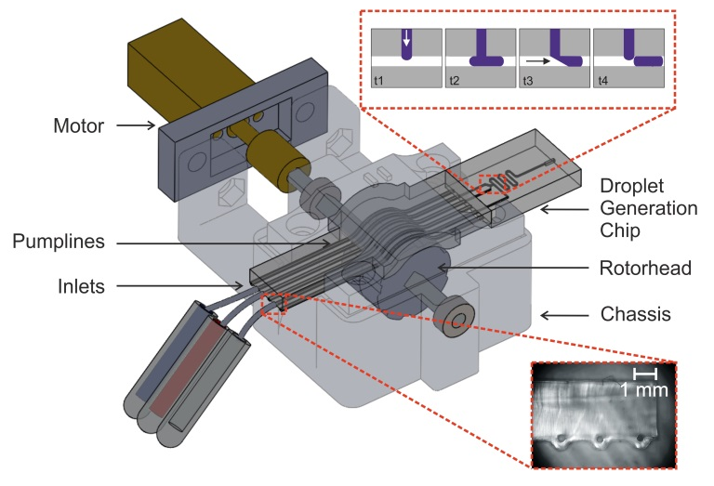
The pump’s ability to deliver accurate and tunable flow was first determined for individual lines pumping fluid in isolation. Fluid was pumped through pumplines of different diameter (245 µm and 320 µm), at different motor speeds and using different rotorhead designs (varying the spacing between pronounced features). The instantaneous flow rate was characterised by aspirating droplets (formed by moving the inlet between fluorous and dyed aqueous fluids), recording their movement downstream and then analysing the video.
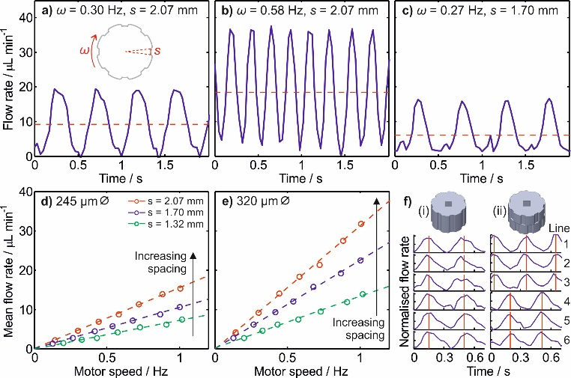
As expected for a peristaltic pump, the resulting flow was characteristically pulsatile. In all cases, the flow rate was seen to periodically rise and fall over time (Fig. 2a-c), with each period (peak and trough) corresponding to a single feature on the rotorhead. Fig. 2a and 2b show data for flow rate obtained using the same channel diameter (320 µm) and rotorhead spacing (1.7 mm, defined as shown in Fig. 2d inset) but with different motor speeds. As the motor rotation speed doubled from 0.30 Hz (Fig. 2a) to 0.58 Hz (Fig. 2b) the pulse period halved (375 to 175 ms) and both the peak flow rate and the mean flow rate (dashed red line) doubled. It should be noted that in both Fig. 2a and b, the area under each peak (which corresponds to the volume pumped in a single pulse) stayed constant regardless of motor speed, as each pulse corresponds to the volume in the pumpline occluded between adjacent features on the pump head. The average flow rate can also be changed by keeping the motor speed constant and changing the volume occluded between features as shown in Fig. 2c, where the space between the features was reduced from 1.70 mm in Fig. 2a to 1.47 mm.
Figure 2: Characterisation of pumping in individual pump lines. a-c) Volumetric flow rates for differing motor speeds and rotorhead feature spacings. Solid blue lines show transitory flow rate over time while dashed red lines show mean flow rates. d-e) Plots showing how mean flow rates can be tuned by controlling feature spacing, motor speed and cross-sectional area. f) Plot showing the relative flow profiles for all six pumplines when using rotorheads with features aligned (i) and features anti-phase offset (ii).
To quantify how the pump could be rationally designed to tune net flow rate, we measured the flow rate while systematically varying the motor speed for three different rotorhead feature spacings and constant cross sectional area, as shown in Fig. 2d. In each case, the pumpline diameter was kept constant at 245 µm. For all rotorheads, increasing the motor speed had the effect of linearly increasing the mean flow rate. The gradient increased with feature spacing due to the increase in the volume delivered in each individual pulse. Fig. 2e further shows that wider channels (diameter 325 µm) allow higher flow rates due to the increased volume delivered in each pulse, with the increase approximately equal to the ratio of the channel cross sectional areas. Thus careful design of the pump can tune the flow rate as required, with multiple different design options available (channel cross-section, spacing of the feature, number of spacing and pumping frequency).
The relative position of the rotorhead features for each individual pumpline can determine the relative timing (phase) of pulsing in different pumplines. Fig. 2f shows the flow profiles obtained when using rotorheads with the same topology (i.e. the same number and size of features) but with the topology offset around the rotorhead. These rotorheads were used to pump all six pumplines and the resulting downstream flow analysed simultaneously so as to characterise the phase difference of the pulses. Where the features were aligned, as shown in Fig. 2f(i), the obtained flow profiles were in phase. By contrast where the features on the top half of the rotorhead (which contacts lines 1-3) were anti-phase to those on the bottom half (which contacts lines 4-6) the resulting flow profiles in lines 1-3 were in phase, but exactly anti-phase to those in lines 4-6, as shown in Fig. 2f(ii). The rotorhead can be easily redesigned to deliver any arbitrary phase offset that might be required for each individual line. Importantly, however, the ability to introduce oil and aqueous fluid in alternating pulses into a junction enables robust droplet generation.
Droplet generation using anti-phased oil/aqueous pulses
As shown in the images in Fig. 3, two aqueous streams were merged at a Y-shaped conjunction and then segmented into droplets by the oil at a T-junction. The relative cross sectional areas of the pumplines (245 µm ID aqueous pumplines and 320 µm ID oil pumpline) gave approximately equal volumetric flow of the different phases, while the spacing between features on the rotorhead were deliberately offset, as shown in Fig. 2f(ii), so that the oil and aqueous flows were delivered in anti-phase pulses to the T-junction where the droplets were produced. The droplet velocity measured after the first bend of the channel shows clear periodicity against time. Each period is composed of two flow pulses as labelled with red and blue dashed lines respectively. A comparison of the video and flow velocity shows that the incursion of the red aqueous stream into the main channel (top images) gave rise to the pulse labelled with red dashed lines, while the following velocity peak (blue dashed lines) corresponds to the oil stream pushing the aqueous incursion downstream (bottom images), breaking it from the main aqueous stream to form a discrete droplet which is then carried downstream. In brief, each droplet was produced by firstly incursion of aqueous stream into the main channel and then ‘chopping’ of the aqueous incursion into a droplet by the pulse from oil stream.
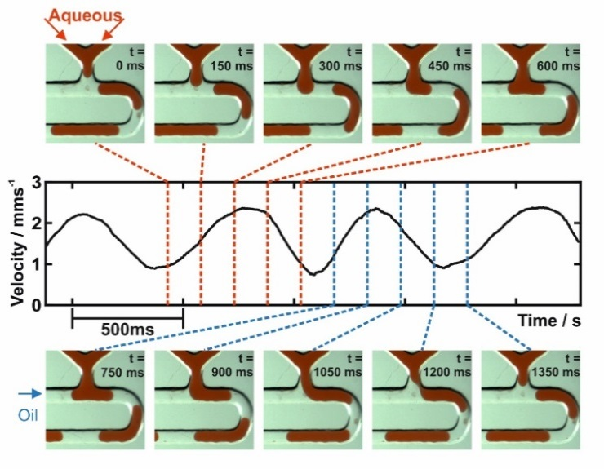
This method for droplet generation implies that the volume of each droplet should be solely defined by the volume injected by the corresponding aqueous pulse. To test this we designed a series of rotorheads where the spacing between features (defined in Fig. 2d inset) was systematically varied, hence varying the volume delivered in each pulse (see Fig. 4). For all rotorhead designs the droplet generation rate increased linearly with motor speed (Fig. 4a), indicating each pulse period universally generated a single droplet. A maximum generation rate of approximately 12 Hz was obtained here, however higher rates could be obtained by using rotorheads with more features, a more powerful motor or splitting the droplets downstream³².
Figure 3: Correlation of optical images of droplet generation at a T-junction with downstream flow velocity. Incursion of the aqueous phase into the main channel (images top) is associated with a single velocity pulse peak, while its subsequent break-up by oil flow (images bottom) is associated with the following velocity peak.
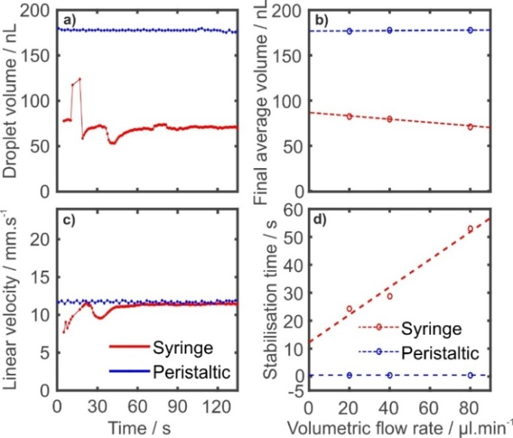
The droplet size remained constant irrespective of motor speed (and hence total flow rate) and droplet generation rate, as shown in Fig. 4b, with larger rotorhead spacing producing larger droplets (Fig. 4c). The coefficient of variation in droplet volume was between 2 and 5 % (as indicated by the error bars in Fig.s 4b and c) which compares favourably with previously reported droplet generation methods³³⁻³⁵. The droplet size was also invariant with aqueous viscosity (see supplementary figure S3), which means the system can be used in the analysis of more viscous biological fluids (e.g. blood serum and whole blood), or dealing with liquid samples with varied viscosities over time.
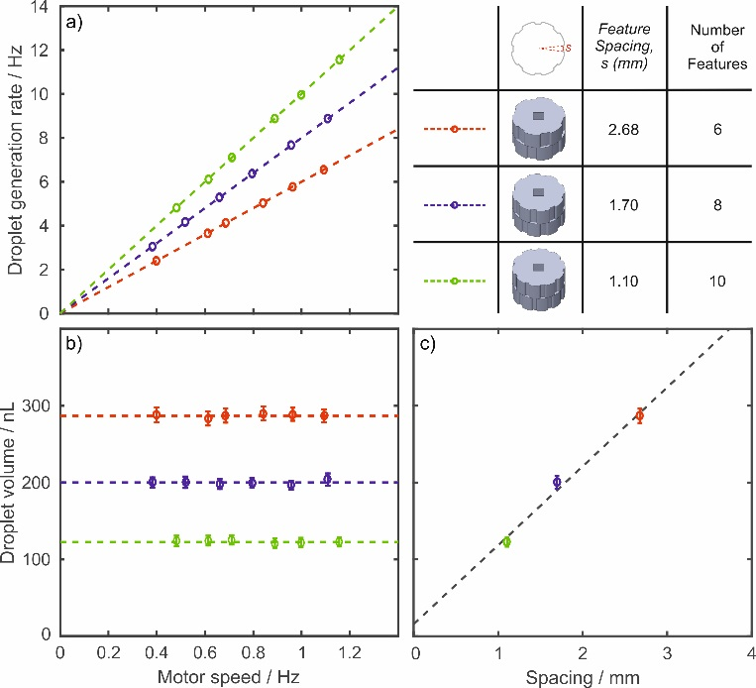
Droplet generation comparison with passive generation
Compared with traditional co-flowing droplet generation using syringe pumps, the anti-phase pulsed approach described here offers continuous operation (with no need to stop or refill) within a much smaller total package. More importantly, the short distance and small fluidic volume from rotorhead to droplet generation point (approximately 1 cm and 2 µL) means the system should achieve stabilised droplet generation much faster than syringe pumping.
To compare the difference in droplet generation dynamics, droplets were first generated using two syringe pumps (PHD 2000, Harvard Apparatus, with 1mL BD plastic syringes used) pumping fluorous oil and red food dye solution into the same droplet generation chip. The velocity and size of droplets were measured downstream and then compared to droplets generated using the peristaltic pump under same total flow rate and oil to aqueous ratio (0.85). At a total flow rate of 80 µL/min the syringe pumps took approximately 60 seconds to come up to pressure and deliver stable flow as shown in Fig. 5a and b. The size of the droplets varied from approximately 60 to 120 nL before stabilising at 71.0 nL. By contrast the peristaltic pump delivered stable droplet generation from the first droplet produced (in less than 0.5 second), also indicating that the pump could be operated in a stop/start fashion or for droplet generation-on-demand applications.
For lower total flow rates at 40 and 20 µL/min, the stabilisation time required for the syringe pump improved (to a minimum of 25 s at 20 µL/min, see Fig. 5c) but were consistently much worse than the peristaltic device which generated droplets with negligible stabilisation time. Comparing the size of the droplets once stabilised, (Fig. 5d), it is notable that the syringe pumps produced droplets 14 % smaller at 80 compared to 20 µL/min (71.0 versus 82.5 nL). In contrast, the peristaltic pump gave droplets of equivalent size regardless of total flow rate – consistent with our previous observation that droplet size is determined by the physical design of the pump and is independent of the total flow rate (Fig. 4).
Figure 5: Comparison of droplet generation via anti-phased peristalsis (blue) and syringe-pumped traditional passive co-flow (red). a) and b) show the variation of droplet volume (a) and droplet linear velocity (b) as a function of time following pump startup. The time taken for the flow to stabilise and the stabilised droplet volume are recorded in c) and d) respectively as a function of the total volumetric flow rate.

Figure 4: Droplet generation dynamics for rotorheads with different feature spacing. a) Droplet generation rate increases linearly with motor speed, with the gradient corresponding to the number of features on the rotorhead. b) Droplet volume corresponding to each feature spacing remains constant irrespective of motor speed. Error bars show the standard deviation in droplet volume, typically between 2 and 5 %. c) Droplet volume increases linearly with feature spacing. Error bars represent the total standard deviation of droplet volume over different motor speeds.

“Hard-coding” chemical operations – rapid titrations
In all the experiments described thus far, we used rotorhead topology comprising multiple identical features around the rotorhead circumference. However, each feature could be designed independently such that they each introduces a different volume of liquid. Thus, if so desired, a single turn of the rotorhead could deliver a sequence of droplets with a range of arbitrarily predetermined sizes, spacings and/or compositions. This ability to automatically generate an array of droplets with different pre-specified properties in a single turn of the rotorhead could be useful in changing reaction conditions for example screening reaction³⁶ or crystallisation conditions³⁷, studying mass transfer³⁸ or performing routine dilutions^{39, 40} or titrations⁴¹.
As a proof-of-principle, we designed a rotorhead that generated a dilution series in each turn to allow rapid and continuous measurement of enzyme reaction kinetics. The kinetics of enzyme-based reactions are dependent on the concentration of the substrate (the starting molecule converted by the enzyme), as described by the Michaelis-Menten law, $v_{0}=v_{max}\left[S\right]/(K_{m}+\left[S\right])$ , where $v_{0}$ is the initial reaction rate, [S] is the concentration of the substrate, $v_{max}$ is the maximum possible rate (when [S] is in large excess) and $K_{m}$ is the Michaelis constant representing the value of [S] at which $v_{0}$ = ½ $v_{max}$.⁴² The values of $v_{max}$ and $K_{m}$ define the kinetics of the reaction and in benchtop testing are usually determined by running the reaction multiple times, varying [S] in each test and measuring v₀. The measured values of $v_{0}$ are then plotted against [S] and fitted with a Michaelis-Menten curve to obtain the values of $v_{max}$ and $K_{m}$. As this involves accurate execution and analysis of multiple separate experiments, it can be a time-consuming process - even more so if additional reaction parameters such as temperature or the presence of molecular inhibitors need to be tested.
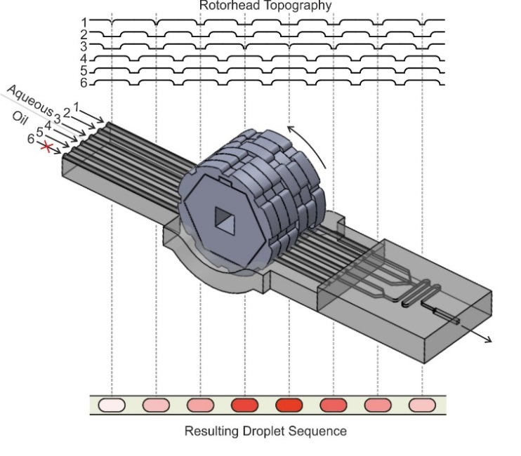
To continuously measure the Michaelis-Menten kinetics of an enzyme-based assay, we designed the rotorhead and droplet generation chip that could generate a sequence of droplets of constant size but varying composition (see Fig. 6). The chip featured three aqueous inlets which met at a single junction and then introduced into the oil stream. The three aqueous lines supplied the substrate (line 1), the reagent (line 2) and an additional stream of buffer (line 3). The size of the rotorhead features driving the substrate and buffer varied in opposition to each other, ensuring the volume of the droplets (and thus the final concentration of reagent) remained constant and producing a sequence of 8 droplets with varied substrate concentrations. This droplet sequence were measured downstream by absorption flow cells⁴³ which could optically measure the progress of the reaction and hence the reaction rates (shown in supplementary Fig. S4).
The system was firstly calibrated to quantify the range and reproducibility of droplet composition in each sequence by substituting the substrate for a food dye solution. As each droplet passed through the absorption flow cell it produced a characteristic dip in the signal (Fig. 7a), with the consistent width of each dip indicating a uniform droplet size (confirmed via separate video analysis of the droplet flow, which gave a 4 % relative standard deviation). By comparison to a series of blank droplets (obtained by later replacing the dye with water) the light intensity transmitted through each droplet could be converted to an absorbance value, as shown in Fig. 7b. The periodic nature of those responses clearly indicate that the system generated droplets with a highly reproducible range of dye concentrations. Fig. 7c shows that the dye content within the droplets varied by a factor of 4.6 (0.079 – 0.362 relative dye concentration). It is interesting to note that the relative spacings on the rotorhead should theoretically produce relative dye concentrations ranging from 0 to 0.5. The reduced range recorded here is likely due to "carry-over" in the short channel in between the confluence of the aqueous streams and the T-junction where they are broken into droplets. Larger concentration ranges should be possible by minimising the volume in this channel and the interfacial area between the two streams.
Figure 6: Schematic of roller and chip for creating a dilution series of droplets prespecified by the pumphead design. The topography of the rotorhead’s circumference is shown top and demonstrates how the aqueous lines (1-3) and oil lines (4-6) are antiphase, and how lines 1 and 3 vary in opposition to each other to maintain a constant droplet volume. The droplet sequence corresponding to the rotorhead topography is shown bottom and qualitatively shows the colour range expected if red dye was supplied to line 1 and water to lines 2 and 3.
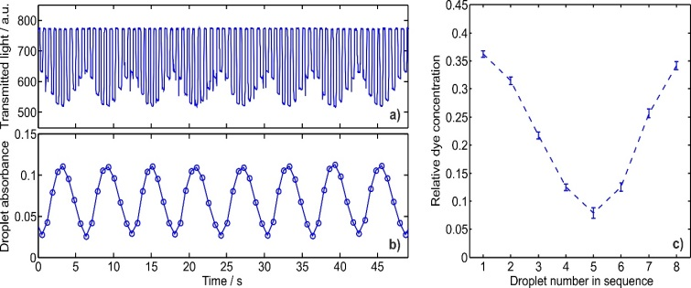
Following calibration with food dye, the system was then used to quantify the kinetics of the Trinder assay - a colorimetric glucose assay that uses a reagent based on glucose oxidase⁴⁴. A 15 mM solution of glucose in 0.1 M PBS was supplied to line 1, premixed reagent (see experimental for formulation) was supplied to line 2 and PBS to line 3, while fluorous oil was pumped through lines 4 and 5. Repeated sequences of droplets were generated with glucose concentrations ranging from 1.18 mM to 5.44 mM (as calculated from the calibration data). The absorbance is a direct measure of the assay product, hence the rate of absorbance increase gives the reaction rate (as shown in supplementary Fig. S5). In Fig. 8a the reaction rates for a single sequence of droplets are plotted against glucose concentration, and fitted with a Michaelis-Menten curve using non-linear regression (R² = 0.98), indicating that the reaction followed standard Michaelis-Menten enzyme kinetics, as expected. The K_{m} value was obtained from the fit, yielding a value of 5.9 mM which was in good agreement with previously reported values (7.63 ± 2.22 mM, 6.47 ± 0.85 mM)⁴⁵ for the same assay under the same reaction conditions (pH, temperature).
Figure 7: Calibration of dilution series produced using the “hard-coded” rotorhead and dye. a) Raw signal from the inline absorption flow cell showing characteristic square-wave-like traces as droplets of different composition pass through the light path. b) Absorbance of the droplets passing through the flow cell against time, calculated from the raw data in (a). c) Mean droplet composition within the dilution sequence, shown relative to the undiluted dye. Error bars show the standard deviation of multiple sequences (n=12).

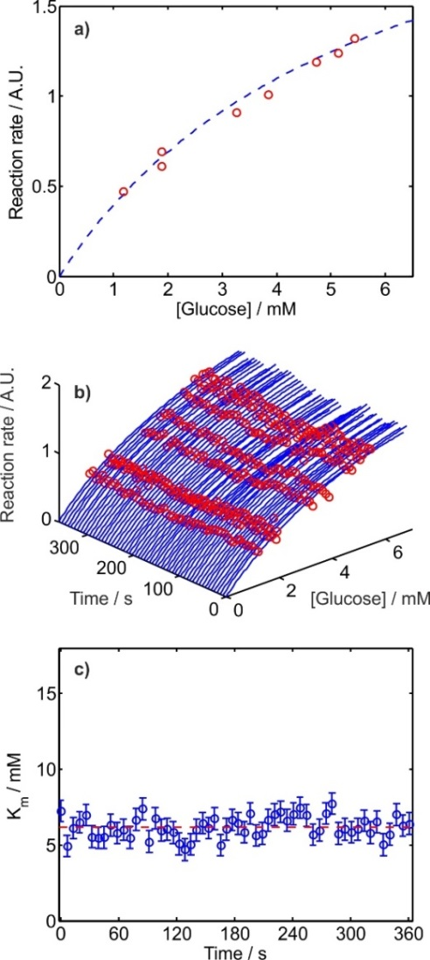
It should be noted that the Michaelis-Menten curve shown in Fig. 8a was obtained in the time taken to generate a single sequence of droplets (one turn of the motor) and flow them through the multi-detector flow cell, less than 60 seconds in total. By contrast, if these values were obtained using standard laboratory procedures they would involve multiple manual experiments and take much longer.
Figure 8: Continuous analysis of glucose (Trinder) assay kinetics. a) Reaction rates for the different concentrations of glucose produced within a single dilution sequence. The data is fitted with a curve described by the Michaelis-Menten equation. b) Reaction rate measurement and corresponding Michaelis-Menten fits continuously obtained over a 6-minute period. c) & d) Derived V_{max} and K_{m} values (respectively) obtained from the fits shown in (b).

Moreover, as the pump turns continuously and no manual operation are required, it is possible to continuously monitor the kinetics. Fig. 8b shows a sequence of Michaelis-Menten plots (like that shown in Fig. 8a) obtained by continuously generating and measuring sequences of droplets over 6 minutes. K_{m} values were obtained from each droplet sequence, to allow continuous measurement over the full 6 minutes as shown in Fig. 8c and d. Continuous measurement such as this would be impossible in bulk experimentation and allows the quantification of reaction kinetics in realtime, which could be used to explore the effect of perturbations such as variations in temperature⁴⁶ or continuous monitoring of inhibiting species⁴⁷ in realtime.

Conclusions
We have demonstrated a new method for droplet generation that produces droplets with robust tunable droplet size and composition, with negligible ramp-up time, and without having to resort to the extraneous and bulky actuation systems typically found in active droplet generation methods. Our method exploits the pulsatile flow generated by peristaltic pumping to deliver oil and aqueous fluid to a droplet generation junction. Each aqueous pulse delivers a discrete volume of fluid into the main channel which is subsequently broken into a droplet by the ensuing oil pulse. The droplet size and composition is solely defined by that delivered in each aqueous pulse and is insensitive to total flow rate and fluid viscosity, therefore the droplet can be specified by rational design of the pump. By careful control of the contours of the pump rotorhead, sequences of droplets with a range of prespecified compositions or sizes can be generated, as demonstrated here to generate a dilution series to continuously measure the reaction kinetics of an enzymatic assay. Moreover, as the pump can drive many channels of fluids and support droplet generation in parallel, it allows complex operations such as multiple sample analysis and multi-step droplet operations (e.g. multiple step reactions). While we note that the maximum droplet generation frequency is limited to a few Hz, much less than the kHz achievable with traditional co-flowing passive droplet generation⁴⁸, the droplets could be further divided to daughter droplets via splitting junctions if required³². Finally we note that the robustness, simplicity, fast stabilisation and compact nature of our system make it perfect for use in field-deployable devices, for both single time and continuous measurement or monitoring.
Acknowledgements
This work was supported by the Engineering and Physical Sciences Research Council UK (Grant EP/M012425/1).
References
1. H. Song, D. L. Chen and R. F. Ismagilov, Angewandte Chemie (International Ed.), 2006, 45, 7336-7356.
2. Y. Zhang and H.-R. Jiang, Analytica Chimica Acta, 2016, 914, 7-16.
3. W.-L. Chou, P.-Y. Lee, C.-L. Yang, W.-Y. Huang and Y.-S. Lin, Micromachines, 2015, 6, 1249.
4. N. Shembekar, C. Chaipan, R. Utharala and C. A. Merten, Lab on a Chip, 2016, 16, 1314-1331.
5. P. Garstecki, M. J. Fuerstman, H. A. Stone and G. M. Whitesides, Lab on a Chip, 2006, 6, 437-446.
6. A. S. Utada, A. Fernandez-Nieves, H. A. Stone and D. A. Weitz, Physical Review Letters, 2007, 99, 094502.
7. S. L. Anna, Annual Review of Fluid Mechanics, 2016, 48, 285-309.
8. F. Gielen, L. van Vliet, B. T. Koprowski, S. R. A. Devenish, M. Fischlechner, J. B. Edel, X. Niu, A. J. deMello and F. Hollfelder, Analytical Chemistry, 2013, 85, 4761-4769.
9. W. Du, L. Li, K. P. Nichols and R. Ismagilov, Lab on a Chip, 2009, 9, 2286-2292.
10. D. J. Collins, T. Alan, K. Helmerson and A. Neild, Lab on a Chip, 2013, 13, 3225-3231.
11. L. Schmid and T. Franke, Applied Physics Letters, 2014, 104.
12. R. M. Lorenz, G. S. Fiorini, G. D. M. Jeffries, D. S. W. Lim, M. He and D. T. Chiu, Analytica Chimica Acta, 2008, 630, 124-130.
13. N.-T. Nguyen, T.-H. Ting, Y.-F. Yap, T.-N. Wong, J. C.-K. Chai, W.-L. Ong, J. Zhou, S.-H. Tan and L. Yobas, Applied Physics Letters, 2007, 91, 084102.
14. S.-H. Tan, S. M. S. Murshed, N. Nam-Trung, W. Teck Neng and Y. Levent, Journal of Physics D: Applied Physics, 2008, 41, 165501.
15. C. A. Stan, S. K. Y. Tang and G. M. Whitesides, Analytical Chemistry, 2009, 81, 2399-2402.
16. S.-Y. Park, T.-H. Wu, Y. Chen, M. A. Teitell and P.-Y. Chiou, Lab on a Chip, 2011, 11, 1010-1012.
17. B. C. Lin and Y. C. Su, Journal of Micromechanics and Microengineering, 2008, 18, 115005.
18. S. Zeng, B. Li, X. o. Su, J. Qin and B. Lin, Lab on a Chip, 2009, 9, 1340-1343.
19. W. Lee, L. M. Walker and S. L. Anna, Physics of Fluids, 2009, 21, 032103.
20. K. Leung, H. Zahn, T. Leaver, K. M. Konwar, N. W. Hanson, A. P. Pagé, C.-C. Lo, P. S. Chain, S. J. Hallam and C. L. Hansen, Proceedings of the National Academy of Sciences, 2012, 109, 7665-7670.
21. J. Xu and D. Attinger, Journal of Micromechanics and Microengineering, 2008, 18, 065020.
22. A. Pit, M. Duits and F. Mugele, Micromachines, 2015, 6, 1768-1793.
23. T. B. Jones, Langmuir, 2002, 18, 4437-4443.
24. J. Zeng and T. Korsmeyer, Lab on a Chip, 2004, 4, 265-277.
25. J. Lee and C. J. Kim, Journal of Microelectromechanical Systems, 2000, 9, 171-180.
26. H. Moon, S. K. Cho, R. L. Garrell and C.-J. C. Kim, Journal of Applied Physics, 2002, 92, 4080-4087.
27. P. Skafte-Pedersen, D. Sabourin, M. Dufva and D. Snakenborg, Lab on a Chip, 2009, 9, 3003-3006.
28. J. C. McDonald and G. M. Whitesides, Accounts of Chemical Research, 2002, 35, 491-499.
29. M. A. Unger, H.-P. Chou, T. Thorsen, A. Scherer and S. R. Quake, Science, 2000, 288, 113-116.
30. V. Chokkalingam, J. Tel, F. Wimmers, X. Liu, S. Semenov, J. Thiele, C. G. Figdor and W. T. Huck, Lab on a chip, 2013, 13, 4740-4744.
31. A. S. Basu, Lab on a chip, 2013, 13, 1892-1901.
32. D. R. Link, S. L. Anna, D. A. Weitz and H. A. Stone, Physical Review Letters, 2004, 92, 054503.
33. S. Y. Jung, S. T. Retterer and C. P. Collier, Lab on a Chip, 2010, 10, 2688-2694.
34. A. R. Abate, M. Kutsovsky, S. Seiffert, M. Windbergs, L. F. V. Pinto, A. Rotem, A. S. Utada and D. A. Weitz, Advanced Materials, 2011, 23, 1757-+.
35. S. H. Tan, S. M. S. Murshed, N. T. Nguyen, T. N. Wong and L. Yobas, Journal of Physics D-Applied Physics, 2008, 41.
36. K. Churski, P. Korczyk and P. Garstecki, Lab on a Chip, 2010, 10, 816-818.
37. L. Li and R. F. Ismagilov, Annual Review of Biophysics, 2010, 39, 139-158.
38. Y. Bai, X. He, D. Liu, S. N. Patil, D. Bratton, A. Huebner, F. Hollfelder, C. Abell and W. T. S. Huck, Lab on a Chip, 2010, 10, 1281-1285.
39. X. Niu, F. Gielen, J. B. Edel and A. J. deMello, Nat Chem, 2011, 3, 437-442.
40. R. Thakur, A. M. Amin and S. Wereley, Analyst, 2015, 140, 5855-5859.
41. K. Kawai, M. Fujii and S. Shoji, Pricise Titration Microfluidic System using Sub-Picoliter Droplet Injection, 2009.
42. T. J. Berg JM, Stryer L, in Biochemistry, W.H.Freeman & Co Ltd, New York, 5th Edition edn., 2002.
43. S. Hassan, A. M. Nightingale and X. Niu, Analyst, 2016, 141, 3266-3273.
44. P. Trinder, Annals of Clinical Biochemistry: An international journal of biochemistry in medicine, 1969, 6, 24-27.
45. K. Karmali, A. Karmali, A. Teixeira and M. J. M. Curto, Analytical Biochemistry, 2004, 333, 320-327.
46. M. E. Peterson, R. M. Daniel, M. J. Danson and R. Eisenthal, Biochemical Journal, 2007, 402, 331-337.
47. S. Nakamura and Y. Ogura, Journal of Biochemistry, 1968, 64, 439-447.
48. D. Bardin, M. R. Kendall, P. A. Dayton and A. P. Lee, Biomicrofluidics, 2013, 7, 034112.

