New insights into the electrochemical formation of magnetite nanoparticles

I. Lozano^{1, 3}, N. Casillas¹, C. Ponce de León², F.C. Walsh², P. Herrasti* ³

¹Departamento de Ingeniería Química, Universidad de Guadalajara
Centro Universitario de Ciencias Exactas e Ingenierías (CUCEI)
Blvd. Marcelino García Barragán #1451, Guadalajara, Jalisco, México, CP. 44430.

²Electrochemical Engineering Laboratory, Energy Technology Research Group, Engineering Sciences, Faculty of Engineering and the Environment, University of Southampton, Highfield, Southampton SO17 1BJ, UK.

³Universidad Autónoma de Madrid, Facultad de Ciencias, Departamento de Química Física aplicada, 28049 Cantoblanco, Madrid, Spain.
*Corresponding author

ABSTRACT
The aim of this paper is to study the electrochemical mechanism of the formation of magnetite nanoparticles. The proposed mechanism suggests the formation of iron hydroxide Fe(OH)₂ in the presence of oxygen which produces lepidocrocite (γ-FeOOH) followed by its chemical dehydration. This is in contrast to other reported mechanisms that suggest the reduction of Fe(OH)₃ at the cathode. Video frames captured during the electrosynthesis of magnetite, in a typical two-electrode cell, indicate that the nanoparticles form in the region close to the anode. The pH value near the anode and cathode changes with time, indicating the formation of nanoparticles. Additional experiments in a two-compartment cell fitted with a cationic membrane, to avoid direct intermixing of Fe²⁺ and OH⁻ and possible oxide or oxyhydroxide reduction at the cathode, support this mechanism. The amount of dissolved oxygen in the electrolyte was found to be a key factor to produce magnetite by promoting the transformation of Fe(OH)₂ into (γ-FeOOH). Hydrogen bubbling during electrosynthesis does not contribute to the reduction of the oxyhydroxides, according to X-ray diffraction results. The paper presents a proposed mechanism for the formation of magnetite, based on previous and new evidence.

Key words: electrochemical mechanism; electrosynthesis; lepidocrocite; magnetite; nanoparticles

- Introduction

Magnetite nanoparticles are becoming an important material for several technologies, including medical¹, environmental², ferrofluid ³ and energy storage⁴ uses. Their production depends on the application of techniques including: chemical precipitation⁵, sol-gel process⁶, flame spray pyrolysis⁷, bacterial fermentation⁸, electrochemical^{9,10} and emerging techniques intended for large-scale production, such as the impinging stream-rotating packed bed (IS-RPB)¹¹. Among these rapidly growing techniques, electrochemical methods offer attractive features. For example, they produce a clean product with a well-controlled nanoparticle size, in the order of 20 to 30 nm, a narrow size distribution plus excellent magnetic properties, which is convenient for biomedical uses, such as hyperthermia for cancer treatment. In addition, they are suitable for scaling-up production by enlarging size and number of electrodes, varying current density, assembling a continuous electrochemical cell process or a combination of these approaches^{10,12,13}. The main characteristics of magnetite nanoparticles (NPs), such as morphology, structure, size and size distribution depend on the electrochemical cell geometry and operating conditions, including electrode separation, current density, applied cell potential, temperature and electrolyte composition^{10,12,13}.

In recent years, the electrochemical formation of magnetite NPs, has become increasingly studied. However, the electrochemical mechanism that controls this process remains unclear^{10,12–14}. It is well-known that the production of magnetite NPs by electrochemical methods can utilise a sacrificial iron anode and an iron cathode to produce both Fe²⁺ by oxidation of Fe and OH⁻ during the reduction of water. However, reported subsequent mechanism steps can vary depending on the source.
Some authors have reported that further oxidation of Fe²⁺ ions to Fe³⁺ can occur due to the high potential or current applied^{10,12,14–17}, these ferric species can then form ferric hydroxides in the presence of an alkaline media that can, in turn, be reduced on the cathode surface to produce the desired iron oxide^{10,12,14,15}. However, solid species such as ferric hydroxide are unlikely to reach the cathode to undergo reduction. An alternative proposed mechanism involves the reduction with hydrogen gas produced on the cathode^{18–20}. However, it is improbable that hydrogen gas is able to react with the iron hydroxide due to its high propensity to escape from the reacting medium. The direct reaction between ferrous and ferric ions formed on the anode’s surface has also been suggested as an electrochemical formation mechanism for magnetite^{16,17} but there is a lack of further explanation on this. Methods like the one proposed by Starowicz et al. ²¹ suggest that in an oxygen free medium, the mechanism follows the well-known Schikorr reaction after formation of Fe(OH)₂ in solution, additionally the production of oxygen on the anode can intervene in the reaction. Dissolved oxygen as an oxidizing agent for ferrous hydroxide in solution to produce magnetite has also been reported in several papers^{13,22}. This reaction mechanism seems the most likely, but more information is needed in order to support its validity.

A brief compilation of some of the most reported mechanisms for electrochemical formation of magnetite, is presented in Table 1. Due to the lack of a consensus on the mechanism, this paper aims to bring new information that can either confirm or refute some of the different proposed mechanisms. Several strategies exist to provide relevant information that can help to accomplish this goal. These include video frames captures, analysis of reaction products by X-ray diffraction (XRD) and transmission electronic microscopy (TEM) at different intervals, use of membranes to separate anodic and cathodic reactions, displacement of dissolved oxygen and injection of hydrogen gas into the reaction medium with further analysis of the reaction products.

- Experimental conditions

  - Chemicals and solutions
Iron electrodes were cut from a 0.2 mm thick iron sheet (99.5 % purity) purchased from Goodfellow. A 1 g dm⁻³ solution of $NaCl$ acquired from PANREAC (above 99% purity), was used as supporting electrolyte. The water employed for all solutions was treated in an Ecomatic deionizing equipment supplied by Wasserlab, to a conductivity of 0.1$μS{ cm}^{-1}$.

Before each experiment, fresh electrodes were washed and rinsed first with deionized water then with ethanol. The electrode area was secured using thread seal tape and the separation between electrodes was fixed by means of an inert and nonconductive separator with the desired dimensions. All experiments were exposed to the atmosphere and conducted under room temperature conditions, unless stated otherwise.

Direct current was supplied using a Dosban Industrial AFX3333C DC power supply and a multimeter connected in series in order to confirm the value of total current density as 50 mA cm⁻². Stirring was magnetically controlled and kept constant when used. A Crison basic 20 pH meter and probe were employed for pH recording.

A homemade double acrylic cell with a total capacity of 400 cm³ was adapted with a commercial Nafion 117® membrane (Dupont) for the experiments were the separation of cathode and anodes were required. The iron electrodes were immersed in the electrolyte, with a separation of 2 cm, during the electrosynthesis.

For oxygen effect evaluation, the solutions were deoxygenated by bubbling N₂ over 20 min before the iron electrodes were immersed in solution and connected to the power supply. The electrosynthesis would then be carried out typically (30 min reaction with 50 mA cm⁻²) or a stream of O₂ would be bubbled into the solution at a controlled rate of 1-35 cm³ min⁻¹ under normal conditions using a Bronkhorst EL-FLOW F-201CV mass flow controller. The effect of hydrogen on the electrosynthesis was also studied by electrochemically generating H₂ in an electrolysis cell. The cathodically produced gas was bubbled into a solution containing γ-FeOOH to investigate the possibility of oxyhydroxide reduction reported by some authors^{18–20}.

Reaction products were magnetically collected by placing a neodymium magnet underneath the cell. The electrolyte was decanted and the solid products were thoroughly rinsed three times with deionized water, they were then collected and centrifuged at 10,000 rpm for 10 min to remove excess water. Finally, they were dried in vacuum at 60 ºC to remove residual moisture. To obtain XRD data, the dried particles were used without any further treatment. Before TEM analysis, the nanoparticles were redispersed in deionised water and a drop of the dispersion was deposited on a carbon coated copper grid.

  - Characterization
The morphology of the synthesized nanoparticles was investigated by means of transmission electron microscopy (TEM). Micrographs of the synthesized nanoparticles were collected in a JEOL JEM 1010 equipment, operating at acceleration voltage of 100 kV. The crystalline phase and the crystal size of the resulting nanoparticles were investigated via X-ray diffraction (XRD). X-ray diffractograms were recorded between 10 deg and 80 deg 2θ in a D5000 diffractometer, equipped with a secondary monochromator and SOL-X Bruker detector with Cu Kα radiation and analysed using the FullProf Suite program, based on the Rietveld refinement method.

3. Results and discussion
3.1 Evolution of pH as a function of time.
As has been previously reported¹², the electrochemical production of magnetite is strongly influenced by the pH value in the electrolytic media. Figure 1 displays pH values near the surface of the anode and cathode as a function of time. In these experiments, pH values were recorded by placing the probe as close as possible to the corresponding electrode surface during continuous stirring of the solution. At time 0 min (no current flow), the pH of the bulk solution remained constant at 6.8, i.e. near neutral conditions. As soon as a current density of 50 mA/cm² was applied, the pH value close to the anode dropped to 4 due to the generation of H⁺ produced by oxidation of water. In the near cathode region, the pH increased to 9.5 due to OH⁻ generation during H₂ evolution from water reduction. After approximately 6 min, a sudden increase in pH was recorded near both electrodes. The pH reached a plateau (at ca. 12 min) then slightly decreased over time. The precipitation of magnetite occurred at approximately the same time as the sudden increase of pH at 6 min.

At first glance, the sudden increase in pH values at 6 min and its relation to the precipitation of magnetite may seem as a direct result of the electrochemical reaction depicted in Equation 1, in which hydrogen ions are consumed to generate magnetite, increasing the pH value^{10,12,15}. Even the reduction of γ-FeOOH represented in Reaction (2) could be a second source of hydroxyl ions effectively raising pH to more alkaline values¹⁴. However, as seen in Figure 2, screen captures of an electrochemical synthesis in absence of stirring reveal that magnetite precipitation occurs in the region surrounding the anode, rather than the cathode. As previous studies have realised, there is no clear pathway for a solid, such as Fe(OH)₃, to be reduced at the cathode surface, hence ferric hydroxide reduction on the cathode seems improbable.

$$3{Fe{(OH)}_{3}}_{(s)}+H^{+}+e^{-}={{Fe}_{3}O_{4}}_{(s)}+5H_{2}O$$ | (1)
$$3γ-FeOOH+e^{-}↔{Fe}_{3}O_{4}\left(s\right)+H_{2}O+{OH}^{-}$$ | (2)

In the video frame capture experiments, stirring was avoided in order to record the precise location and time of magnetite formation. While one could make the case that stirring would help γ-FeOOH species reach the cathode surface, in every experiment in which stirring was employed, a black precipitate was predominantly observed on the anode surface after completion of the electrosynthesis. The role of stirring is mainly to distribute the electrochemically produced species (OH⁻, Fe(OH)₂ and γ-FeOOH), which causes pH and concentrations to rise slowly and more uniformly throughout the electrolyte. However, a pH gradient normal to the electrode surface still exists and, when the high pH front coming from the cathode reaches the anode surroundings, it causes the local pH value to suddenly increase. An alternative explanation for this increment in the pH value is discussed later.

By adding phenolphthalein, as an alkaline pH indicator, the movement of the OH⁻ front can be monitored. It appears as a magenta cloud (Figure 3) being displaced from the cathode surrounding region moving towards the anode by diffusion, migration and the convection that arises from hydrogen bubbling, an outcome of the water reduction process represented in Equation 3.
$$2H_{2}O+2e^{-}↔H_{2}+2{OH}^{-}$$ | (3)

Hydrogen evolution would also make it very difficult for any precipitated species, such as Fe(OH)₃, to access the cathode surface. When the hydroxyl ion cloud reaches the anode surface, it reacts with species in solution producing a combination of a black precipitate (assumed to be magnetite) and a light brown substance (believed to be γ-FeOOH) visible to the naked eye.

3.2 Two compartment cell experiments
In order to obtain more information about the role of the electrodes on magnetite formation, the synthesis was carried out in a two-compartment cell separated by a 117 Nafion® cationic exchange membrane. In all experiments, magnetite nanoparticles were observed only to be produced in the anodic compartment. This result supports a mechanism in which the production of magnetite occurs via a chemical reaction instead of an electrochemical one, thus the reduction of the oxyhydroxides at the cathode as the main source for magnetite formation can be ruled out. Figure 4 shows the evolution of the reaction through colour changes that develop in the electrolyte that is enclosed in the anodic compartment only.

3.3 Fe³⁺ formation

Several mechanisms reported in the literature^{10,12,14–17,23} suggest that Fe³⁺ is electrochemically generated by Fe²⁺ oxidation at the anode due to high current or potential applied.
$$Fe→{Fe}^{2+}+2e^{-}$$ | (4)

Considering Faraday’s law of electrolysis and the 2-electron exchange process (n=2) in reaction (4), the theoretical weight of iron dissolved Δw, over a period of time t, at a constant current I, can be calculated using equation (5), where M stands for the molar mass of iron.
$$∆w=\frac{It}{F}\frac{M}{n}$$ | (5)
$$E=\frac{{∆w}_{experimental}}{{∆w}_{theorical}}×100\%$$ | (6)

The value of E in equation (6) represents the efficiency of the iron dissolution process, which was found to be between 91 and 98%. If, however, Fe²⁺ oxidation to Fe³⁺ is considered, the experimental weight loss on the anode would be higher than the theoretically calculated, which is impossible. Therefore, Fe²⁺ is believed to be the main species produced at the anode. Further oxidation of Fe²⁺ ions is necessary for magnetite formation given the 2:1 Fe³⁺:Fe²⁺ ratio, so Fe³⁺ species are believed to be produced by dissolved oxygen acting as an oxidizing agent for ferrous hydroxide as represented in equation (7) ^{13,22}:
$$3Fe{(OH)}_{2}+{\frac{1}{2}O}_{2}→2γFeOOH+Fe{(OH)}_{2}+H_{2}O$$ | (7)

The difference between the theoretical and experimental values reduces and the value of E increases for larger scale synthesis, since measurement errors become less significant.

3.4 Intermediate reaction products
The synthesis of magnetite can be, to an extent, followed by colour changes in the electrolyte as seen in Figure 5. At ca. 6 min, the colour of the electrolyte becomes darker (due to magnetite formation), eventually becoming black. Electrolyte samples were collected and analysed via TEM and X-ray diffraction.

A series of diffractograms acquired over 2 to 90 min are displayed in Figure 6. For samples collected within the first 2 to 3 min, only broad peaks corresponding to an amorphous phase identified as lepidocrocite (γ-FeOOH), are present without any sign of the inverse spinel structure of magnetite. After 4 min, the characteristic peak of magnetite (F₃O₄) at 2 θ = 35.6 deg°, corresponding to the (3 1 1) plane can be observed¹². At longer times, the lepidocrocite peaks diminished and the magnetite phase became well-defined. This result clearly shows that an oxyhydroxide, such as lepidocrocite, is the main precursor for the formation of magnetite. For synthesis longer than 30 minutes, the characteristic peaks for Fe₃O₄ are the only ones present in the diffractograms and they remain constant for up to 90 minutes or more.
This transformation from lepidocrocite to magnetite can also be observed in Figure 7, in which a series of micrographs show that at times shorter than 6 minutes, the main structures are needle-shaped particles that correspond to γ-FeOOH^{24,25}. The presence of these needles diminishes as time passes and eventually (at t > 6 min), quasi-spherical particles, corresponding to magnetite, become the predominant phase. This result helps to prove further that the mechanism of formation of magnetite via the electrochemical method, involves a chemical reaction in which a γ-FeOOH precursor gives rise to magnetite formation.

Given that Fe²⁺ is believed to be the only ionic iron species electrochemically generated, γ-FeOOH formation mostly originates from a chemical oxidation process of the hydroxide form of Fe²⁺. Fe(OH)₂ is known to be highly reactive to oxygen and depending on media conditions (i.e. pH, temperature, oxygen or nitrogen presence) can undergo a wide variety of transformations^{26,27}. When in alkali media and exposure to air, Fe(OH)₂ can be oxidized to FeOOH that can in turn transform to γ-FeOOH when oxidizing conditions are met²⁷. Additionally, it has been extensively reported that γ-FeOOH can undergo a topotactic transformation to magnetite when in the presence of Fe²⁺ species in solution^{27–33}. The high concentration of Fe²⁺ in the electrolyte near the anode surface can accelerate this phase transformation^{30–34} which is probably why magnetite is observed to mainly precipitate in such regions.

A chemical formation mechanism is also supported by the fact that magnetite was observed to precipitate even in the absence of an applied current. The current was interrupted 4 minutes into the electrosynthesis, when the reaction media (containing mainly γ-FeOOH and Fe(OH)₂) displayed a reddish brown colour and was then stirred, while exposed to the atmosphere. After 3 to 5 min, a black precipitate, identified as magnetite, became the main species in the reaction media. At 4 minutes, sufficient Fe²⁺ and OH⁻ ions have been produced, for the reaction to continue without current.

Alternatively, a direct chemical reaction involving γ-FeOOH and Fe(OH)₂ has been proposed by Fajaroh et al¹³. However, the specific process in which these 2 solid species interact in solution were not discussed, hence, we believe that the topotactic transformation of γ-FeOOH is more likely to be the actual route of magnetite formation. This mechanism has been reported as one of many formation pathways for the coprecipitation of Fe₃O₄ nanoparticles^{29,35}.

The topotactic transformation of lepidocrocite involves a Fe²⁺ adsorption process on the surface of the oxyhydroxide^{30–33} represented in reaction (8)³³.

$$γ-FeO(OH)[({OH)}_{s}{\left(O\right)}_{s}]+2Fe{\left(OH\right)}_{2}↔γ-FeO(OH)[\left({OH)}_{s}{{Fe(OH)}^{+}\left(O\right)}_{s}{Fe(OH)}^{+}\right]+2{OH}^{-}$$ | (8)

The subscripts specify the adsorption site and assuming one Fe²⁺ ion, in the hydrolysed form FeOH⁺, is adsorbed on the OH group of lepidocrocite and the other one on the oxo-bridge³³. The adsorption of Fe²⁺ ion is crucial for topotactic transformation of lepidocrocite and could help to explain the second source (apart from water reduction on the cathode) of OH⁻ ions that is observed in Figure 1. When sufficient γ-FeOOH has been generated, direct Fe²⁺ adsorption on lepidocrocite may slow down the production of Fe(OH)₂ due to increased competition for the ionic iron species. This, in turn, would cause an accumulation of OH⁻ ions at the cathode, raising the pH to more alkaline values.

The adsorbed intermediate undergoes a dissolution process and since both Fe³⁺ and Fe²⁺ are present, it transforms directly to magnetite. Reordering of the crystal structure can occur via a dehydration process; olation-oxolation allows cation rearrangement through the loose oxyhydroxide structure^{28,31}.

3.5 The effect of dissolved oxygen on the electrochemical synthesis of magnetite.
Oxygen present in the media is a key element in promoting Fe²⁺ oxidation to Fe³⁺ in order to produce magnetite. To assess oxygen effects on the magnetite electroynthesis, an experiment in absence of oxygen was carried out by bubbling a stream of N₂ into the electrolyte for 20 minutes prior to applying current. After oxygen evacuation, the magnetite electrosynthesis was performed as usual (at 50 mA cm⁻² for 30 minutes). The solution developed a greenish tone, characteristic of Fe(OH)₂ formation³⁰, as magnetite electrosynthesis progressed. However, magnetite (black precipitate) or lepidocrocite (reddish-brown precipitate) formation was not observed. The reaction mixture was then transferred to a 1 dm³ beaker and stirred for 30 minutes. Atmospheric O₂ dissolved in the media and oxidized Fe(OH)₂ to γ-FeOOH, displaying a reddish-brown precipitate. Nevertheless, magnetite formation was still not detected. When the same reaction mixture was stirred in an Erlenmeyer flask, however, magnetite formation was observed as shown in Figure 8.

In the case of the 1 dm³ beaker, the solution-atmosphere interface surface area is large enough to facilitate the incorporation of oxygen to the reactive media, this in turn creates highly oxidizing conditions that transform most of the Fe(OH)₂ to γ-FeOOH²⁷. On the other hand, when the reaction medium is stirred in the Erlenmeyer flask, the smaller interface surface, only permits oxygen to be incorporated at a slower pace and allows to meet the necessary conditions for Fe(OH)₂ to be transformed into Fe₃O₄. Slow oxidation to γ-FeOOH allows a subsequent topotactic transformation involving the remaining Fe²⁺ in solution^{29,35,36}.
Additional experiments, controlling the oxygen flow during the magnetite electrosynthesis, reveal that selectivity of the predominant iron oxide phase is highly sensible to the O₂ supply to the reactive medium. As shown in Figure 9, a mixture of iron oxyhydroxides (γ-FeOOH and α-FeOOH) and magnetite is obtained for oxygen flows between 35 and 10 cm³ min⁻¹ (highly oxidizing conditions), as oxygen flow is decreased (the lowest value measured was 1 cm³ min⁻¹), oxyhydroxide signal diminishes and magnetite peaks become sharper and more defined. Given that the amount of oxygen supply needed to synthesize magnetite is very low, Fe₃O₄ would be expected to precipitate in experiments in which oxygen is evacuated prior to magnetite electrosynthesis, thus electrochemical production of oxygen at the anode should be negligible. Additionally, since magnetite formation was not observed for the experiments in absence of oxygen, a mechanism involving the Schikorr reaction does not seem plausible, at least in the time range studied. In the experiments conducted by Starocwicz et al. the synthesis time was considerably longer and the current values smaller, in such conditions, the anaerobic formation of magnetite may be the main formation route.

3.6 Study of the hydrogen effect on magnetite electro synthesis
Cathodic water reduction produces intense hydrogen bubbling and some authors have proposed hydrogen as a possible reducing agent for γ-FeOOH to produce Fe₃O₄ and that the reaction depicted in reaction (9) may be the last step in magnetite precipitation^{18–20}.
$$3γ-FeOOH+{\frac{1}{2}H}_{2}→{Fe}_{3}O_{4}+2H_{2}O$$ | (9)

It has been previously discussed that the high tendency of hydrogen to escape from the reaction zone makes this process highly unlikely. Nevertheless, a simple experiment to test this statement was conducted. Hydrogen gas, generated in an electrolysis cell, was injected into a γ-FeOOH aqueous solution (electrochemically produced) for 30 minutes. The diffractogram presented in Figure 10 shows no major changes to the diffraction peaks, nor do other peaks, corresponding to a different phase of iron oxide, appear. This result suggests that the reaction depicted in equation (9) does not occur and that the hydrogen produced, mostly exits the electrolyte without participating in the reaction.

3.7 Proposed mechanism.
According to the above results, the electrochemical synthesis of magnetite involves two electrochemical reactions, the iron dissolution process on the anode and water reduction on the cathode. Iron dissolution provides ionic iron species (Fe²⁺) that in the presence of an alkaline media, generated by the OH⁻ production on the cathode, precipitate to Fe(OH)₂. Since magnetite electrosynthesis is carried out in the presence of dissolved oxygen, Fe(OH)₂ oxidizes to γ-FeOOH and through a topotactic process (catalysed by Fe²⁺ presence), γ-FeOOH transforms into Fe₃O₄. From the different mechanisms considered, the one proposed by Fajaroh et al. appears to agree the most with our results. However, Fajaroh et al. also proposed oxygen production on the anode, derived from water oxidation (Equation 10); the effect of this process seems to be negligible, as discussed earlier, so it has been omitted from the proposed mechanism.
$$H_{2}O→2H^{+}+2e^{-}+\frac{1}{2}O_{2}$$ | (10)

The proposed mechanism for the electrochemical formation of magnetite NPs appears summarised as:
Anode
$$Fe→{Fe}^{2+}+2e^{-}$$ | (11)

Cathode
$$2H_{2}O+2e^{-}↔H_{2}+2{OH}^{-}$$ | (12)

In solution
$${Fe}^{2+}+{OH}^{-}→Fe{(OH)}_{2}$$ | (13)
$$3Fe{(OH)}_{2}+O_{2}→2γFeOOH+Fe{(OH)}_{2}+2H_{2}O$$ | (14)
$$2γFeOOH+Fe{(OH)}_{2}→{Fe}_{3}O_{4}+2H_{2}O$$ | (15)

Reaction (15) represents the overall process of Fe(II) adsorption and subsequent topotactic transformation of lepidocrocite.

- Conclusions

The electrochemical mechanism for magnetite formation has been revisited. New experimental results support a chemical reaction route, rather than an electrochemical one. The present results, involving monitoring the pH near the anode and cathode clearly marks the condition for the formation of magnetite. Video frame captures of the anode as a function of time show that magnetite is formed in the electrolyte region near the anode. Additional video captures in the presence of a pH indicator demostrate the advance of the OH⁻ front with an increase in the pH value. XRD and TEM studies of the reaction products, as a function of time, indicate the formation of an oxyhydroxyde, in the form of lepidocrocite, as an intermediate that undergoes a topotactic transformation to magnetite. Additional experiments with an electrochemical cell employing an ion exchange membrane clearly demonstrate that the formation of magnetite only takes place in the anolyte of the cell. Oxygen diffusion into the solution from the environment was found to contribute significantly to the formation of magnetite. Slow incorporation of oxygen into the reactive media is required for Fe(II) (Fe(OH)₂) and Fe(III) (γ-FeOOH) species to precipitate in the form of magnetite. The final proposed mechanism agrees, to some extent, with previously reported mechanisms in the literature. A topotactic transformation of the oxyhydroxyde species caused by the adsorption of Fe(II) on the oxyhydroxide species is considered as the last step in magnetite precipitation. H₂ bubbling in the cell along with the difractograms studies of the products clearly demonstrate that H₂ is not capable of reducing the oxyhydroxide species to form magnetite as mentioned in the literature.

Acknowledgments
The authors gratefully acknowledge the scholarship for doctoral studies of Gerardo Ivan Lozano Gutierrez granted by the National Council of Science and Technology of Mexico (CONACyT). The authors are also grateful to the Ministry of Economy and Competitiveness for the project MAT2015-67557-C2-2-P. Support for a sabbatical leave for NCS from the National Council of Science and Technology of Mexico and Exportadora de Postes S.A. de C.V. are greatly appreciated.

- References

1. R. Tietze, J. Zaloga, H. Unterweger, S. Lyer, R. P. Friedrich, C. Janko, M. Pöttler, S. Dürr, and C. Alexiou, Biochem. Biophys. Res. Commun., 468, 463–470 (2015).
2. R. Kaur, A. Hasan, N. Iqbal, S. Alam, M. K. Saini, and S. K. Raza, J. Sep. Sci., 37, 1805–1825 (2014).
3. S. Genc and B. Derin, Curr. Opin. Chem. Eng., 3, 118–124 (2014).
4. Á. León, M. Epifani, T. Chávez, J. Palma, and R. Díaz, Int. J. Electrochem., 9, 3837–3845 (2014).
5. S. A. Kahani and M. Jafari, J. Magn. Magn. Mater., 321, 1951–1954 (2009).
6. O. Lemine, K. Omri, B. Zhang, L. El Mir, M. Sajieddine, A. Alyamani, and M. Bououdina, Superlattices Microstruct., 52, 793–799 (2012).
7. R. Strobel and S. E. Pratsinis, Adv. Powder Technol., 20, 190–194 (2009).
8. J.-W. Moon, C. J. Rawn, A. J. Rondinone, L. J. Love, Y. Roh, S. M. Everett, R. J. Lauf, and T. J. Phelps, J. Ind. Microbiol. Biotechnol., 37, 1023–1031 (2010).
9. C. Tsouris, D. W. DePaoli, J. T. Shor, M. C. Z. Hu, and T. Y. Ying, Colloids Surfaces A Physicochem. Eng. Asp., 177, 223–233 (2001).
10. T.-Y. Ying, S. Yiacoumi, and C. Tsouris, J. Dispers. Sci. Technol., 23, 569–576 (2002).
11. C. Lin and J. Ho, J. Alloys Compd., 4, 3–4 (1800).
12. L. Cabrera, S. Gutierrez, N. Menendez, M. P. Morales, and P. Herrasti, Electrochim. Acta, 53, 3436–3441 (2008).
13. F. Fajaroh, H. Setyawan, W. Widiyastuti, and S. Winardi, Adv. Powder Technol., 23, 328–333 (2012).
14. A. Rodríguez-López, A. Paredes-Arroyo, J. Mojica-Gomez, C. Estrada-Arteaga, J. J. Cruz-Rivera, C. G. Elías Alfaro, and R. Antaño-López, J. Nanoparticle Res., 14, 1–9 (2012).
15. M. Ibrahim, K. G. Serrano, L. Noe, C. Garcia, and M. Verelst, Electrochim. Acta, 55, 155–158 (2009).
16. W. Ying-Chieh, I. A. Rusakova, A. Baikalov, J. W. Chen, and W. Nae-Lih, J. Mater. Res., 20, 75–80 (2005).
17. H. Karami and E. Chidar, Int. J. Electrochem. Sci, 7, 2077–2090 (2012).
18. S. Franger, P. Berthet, and J. Berthon, J. solid state elecrochemistry, 8, 218–223 (2004).
19. V. Melnig and L. Ursu, J. Nanoparticle Res., 13, 2509–2523 (2011).
20. J. Manrique-Julio, F. MacHuca-Martinez, N. Marriaga-Cabrales, and M. Pinzon-Cardenas, J. Magn. Magn. Mater., 401, 81–85 (2016).
21. M. Starowicz, P. Starowicz, J. Zukrowski, J. Przewoźnik, A. Lemański, C. Kapusta, and J. Banaś, J. Nanopart. Res., 13, 7167–7176 (2011).
22. D. Gopi, M. Thameem Ansari, and L. Kavitha, Arab. J. Chem., 9, S829–S834 (2011).
23. C. Pascal, J. L. Pascal, F. Favier, M. L. E. Moubtassim, and C. Payen, Chem. Mater., 11, 141–147 (1999).
24. J. Kim, W. Li, B. L. Philips, and C. P. Grey, Energy Environ. Sci., 4, 4298–4305 (2011).
25. J. Kim, U. G. Nielsen, and C. P. Grey, J. Am. Chem. Soc., 130, 1285–1295 (2008).
26. R. M. Cornell and U. Schwertmann, The Iron Oxides: Structure, Properties, Reactions, Occurences and Uses, Second Edition - Cornell - Wiley Online Library, 2nd ed., Wiley Online Library, (2003).
27. J. D. Bernal, D. R. Dasgupta, and A. L. Mackay, Clay Miner. Bull, 4, 15–30 (1959).
28. Y. Cudennec and A. Lecerf, Solid State Sci., 7, 520–529 (2005).
29. T. Ahn, J. H. Kim, H. M. Yang, J. W. Lee, and J. D. Kim, J. Phys. Chem. C, 116, 6069–6076 (2012).
30. Y. Wang, G. Morin, G. Ona-Nguema, and G. E. Brown, Environ. Sci. Technol., 48, 14282–14290 (2014).
31. E. Tronc, P. Belleville, J. P. Jolivet, and J. Livage, Langmuir, 8, 313–319 (1992).
32. C. M. Hansel, S. G. Benner, and S. Fendorf, Environ. Sci. Technol., 39, 7147–7153 (2005).
33. Y. Tamaura, M. Saturno, K. Yamada, and T. Katsura, Bull. Chem. Soc. Jpn., 57, 2417–2421 (1984).
34. K. M. Rosso, S. V. Yanina, C. A. Gorski, P. Larese-Casanova, and M. M. Scherer, Environ. Sci. Technol., 44, 61–67 (2010).
35. J. Baumgartner, A. Dey, P. H. H. Bomans, C. Le Coadou, P. Fratzl, N. A. J. M. Sommerdijk, and D. Faivre, Nat. Mater., 12, 310–4 (2013).
36. M. Kiyama, Bull. Chem. Soc. Jpn, 47, 1646–1650 (1974).

Table 1 Compilation of mechanisms for the electrochemical formation of magnetite nanoparticles.

Description | Mechanism | Author
Iron hydroxide reduction on Cathode’s surface | Anodic:  ^{I, II, IV}$Fe↔{Fe}^{2+}+2e^{-}$  ^{I-IV} ${Fe}^{2+}↔{Fe}^{3+}+e^{-}$  ^{IV}$Fe+{3OH}^{-}↔γ-FeOOH$  ^{II}$H_{2}O↔2H^{+}+2e^{-}+\frac{1}{2}O_{2}$  Cathodic:  ^{II-IV}$2H_{2}O+2e^{-}↔H_{2}+2{OH}^{-}$  ^{I}$4H^{+}+{O_{2}}_{(g)}+4e^{-}↔2H_{2}O$  ^{I}$2H^{+}+2e^{-}↔{H_{2}}_{(g)}$  ^{III}${Fe}^{3+}+e^{-}→{Fe}^{2+}$  ^{III}${NO_{3}}^{-}+H_{2}O+2e^{-}→{NO_{2}}^{-}+2{OH}^{-}$  ^{I-III}$3{Fe{(OH)}_{3}}_{(s)}+H^{+}+e^{-}={{Fe}_{3}O_{4}}_{(s)}+5H_{2}O$  ^{IV}$3γ-FeOOH+e^{-}↔{Fe}_{3}O_{4}\left(s\right)+H_{2}O+{OH}^{-}$  In solution:  ^{I-IV}${Fe}^{3+}+{OH}^{-}→{Fe{(OH)}_{3}}_{(s)}$  ^{I}${Fe{(OH)}_{3}}_{(s)}↔{{Fe}_{2}O_{3}}_{(s)}+{3H}_{2}O$ | I. T. Ying et al. (2002)¹⁰  II. L. Cabrera et al. (2008)¹²  III. M. Ibrahim et al. (2009)¹⁵  IV. A. Rodríguez et al. (2012)¹⁴

Description | Mechanism | Author
Hydrogen gas as a reducing agent of iron hydroxide | Anodic:  ^{III}$Fe→{Fe}^{2+}+2e^{-}$  ^{I, II}$Fe+3{OH}^{-}↔γ-FeOOH+H_{2}O+3e^{-}$  Cathodic:  ^{I-III}$H_{2}O+e^{-}↔{\frac{1}{2}H}_{2}+{OH}^{-}$  In solution:  ^{III}${Fe}^{2+}+2{OH}^{-}+4{[H_{2}O]}_{solv}→{[Fe{\left(OH\right)}_{2}{(OH_{2})}_{4}]}^{0}$  ^{III}${[Fe{\left(OH\right)}_{2}{(OH_{2})}_{4}]}^{0}+O_{2}→4γ-FeOOH+6H_{2}O$  ^{I-III}$3γ-FeOOH+{\frac{1}{2}H}_{2}→{Fe}_{3}O_{4}+2H_{2}O$ | I. S. Franger et al. (2004)¹⁸  II. V. Melnig et al. (2011)¹⁹  III. J. Manrique et al. (2016)²⁰

Description | Mechanism | Author
Direct reaction between Fe²⁺ and Fe³⁺ | Anodic:  ^{I, II}$Fe↔{Fe}^{2+}+2e^{-}$  ^{I, II}${Fe}^{2+}↔{Fe}^{3+}+e^{-}$  Cathodic:  ^{I}$4H^{+}+{O_{2}}_{(g)}+4e^{-}↔2H_{2}O$  ^{II}$2H_{2}O+2e^{-}→H_{2}+2{OH}^{-}$  In solution:  ^{I, II}${Fe}^{2+}+2{Fe}^{3+}+8{OH}^{-}↔{{Fe}_{3}O_{4}}_{(s)}+4H_{2}O$  ^{II}${2Fe}^{3+}+6{OH}^{-}→{Fe}_{2}O_{3}+3H_{2}O$ | I. W. Ying et al. (2005)¹⁶  II. H. Karami et al. (2012)¹⁷

Description | Mechanism | Author
Oxygen as oxidant agent and subsequent in solution precipitation | Anodic:  ^{I}$Fe→{Fe}^{3+}+3e^{-}$  ^{II-IV}$Fe→{Fe}^{2+}+2e^{-}$  ^{I, II, IV}$H_{2}O→2H^{+}+2e^{-}+\frac{1}{2}O_{2}$  ^{III}$4{OH}^{-}→O_{2}+2H_{2}O+4e^{-}$  Cathodic:  ^{I-IV}$H_{2}O+e^{-}↔{\frac{1}{2}H}_{2}+{OH}^{-}$  In solution:  ^{II}${2Fe}^{2+}+Fe{(ClO_{4})}_{2}+8H^{+}+4\left(\frac{1}{2}O_{2}\right)→ {{Fe}_{3}O_{4}}_{(s)}+{2HClO_{4}}_{(l)}+3{H_{2}}_{(g)}$  ^{III}${Fe}^{2+}+2{OH}^{-}→Fe{(OH)}_{2}$  ^{III}$3Fe{(OH)}_{2}+\frac{1}{2}O_{2}→Fe{(OH)}_{2}+2FeOOH+H_{2}O$  ^{III}$Fe{(OH)}_{2}+FeOOH→{Fe}_{3}O_{4}+2H_{2}O$  ^{IV}$3Fe{(OH)}_{2}→{Fe}_{3}O_{4}+2H_{2}O+H_{2} (Schikorr)$ | I. C. Pascal et al. (1999)²³  II. D. Gopi et al. (2011)²²  III. F. Fajaroh et al. (2012)¹³  IV. M. Starowicz et al. (2011)²¹

Figure captions
Figure 1 Comparison of electrolyte pH near the anode and the cathode.
Figure 2 Video frame captures during the electrochemical synthesis of magnetite in a 1 g dm⁻³ NaCl solution, 2 cm electrode separation and j = 50 mA cm⁻².
Figure 3 Video frame captures during the electrochemical synthesis of magnetite in a 1 g dm⁻³ NaCl solution, 2 cm electrode separation and j = 50 mA cm⁻²; phenolphthalein as pH indicator.
Figure 4 Evolution of electrochemical synthesis using a Nafion® cationic membrane and j = 50 mA cm⁻² in 1 g dm⁻³ NaCl electrolyte.
Figure 5 Samples collected from the synthesis of magnetite at different reaction stages (numbers express time in minutes).
Figure 6 Comparison of X-ray diffractograms for solid samples at different reaction times.
Figure 7 TEM micrographs of nanoparticle samples collected during a synthesis at different time intervals for 2, 4, 6, 8, 10 and 30 min.
Figure 8 Electrochemical synthesis in absence of oxygen with j = 50 mA cm⁻² applied for 30 min and subsequent stirring for an additional 30 min in a 1 dm³ beaker and an Erlenmeyer flask.
Figure 9 X ray diffractograms of samples synthesised under different values of oxygen flow.
Figure 10 Effect of hydrogen gas bubbling on the diffractogram of a Lepidocrocite sample electrochemically produced under an excess flow of oxygen.

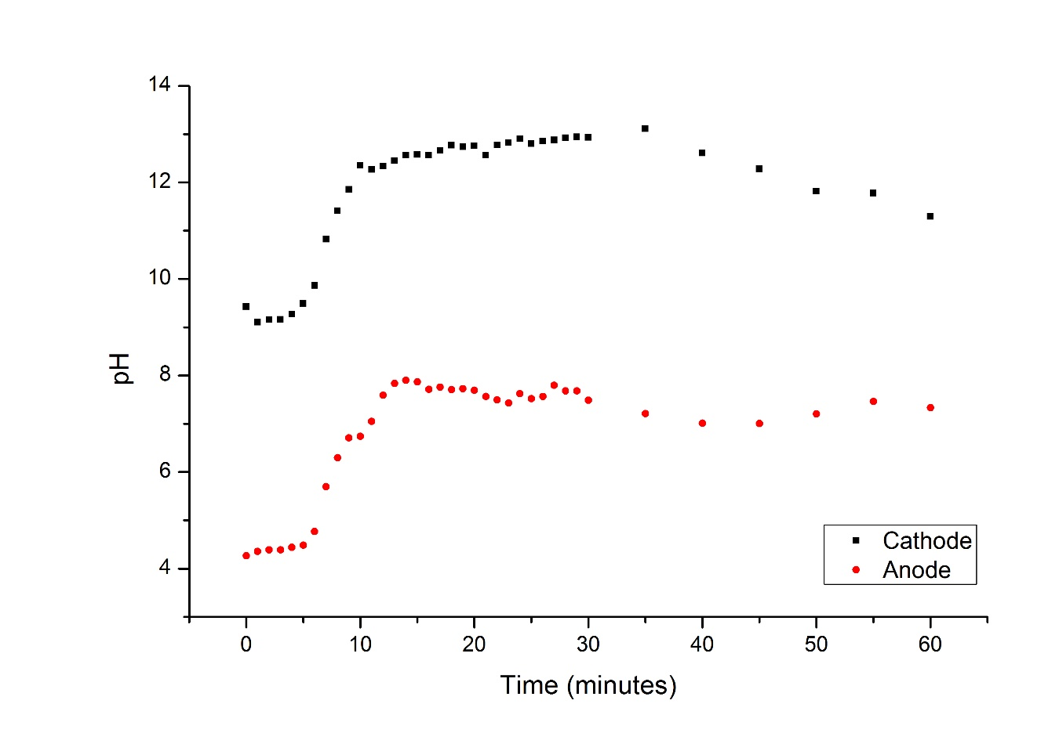
Figure 1

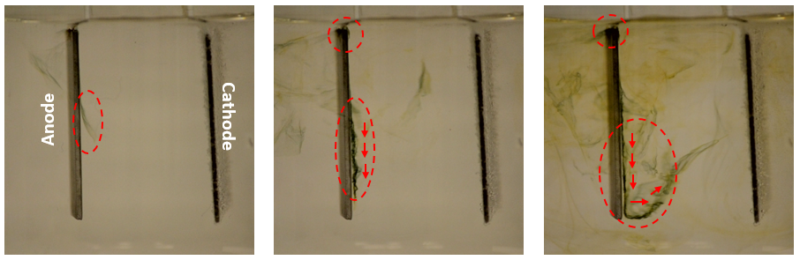

Figure 2

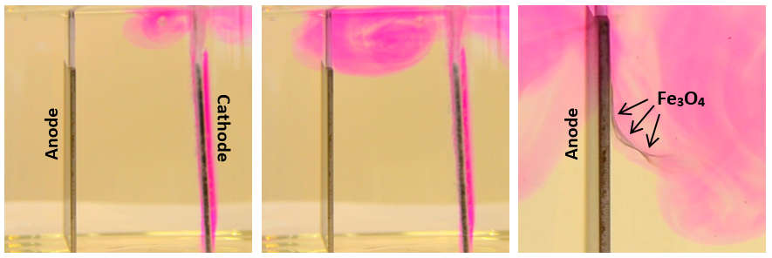

Figure 3

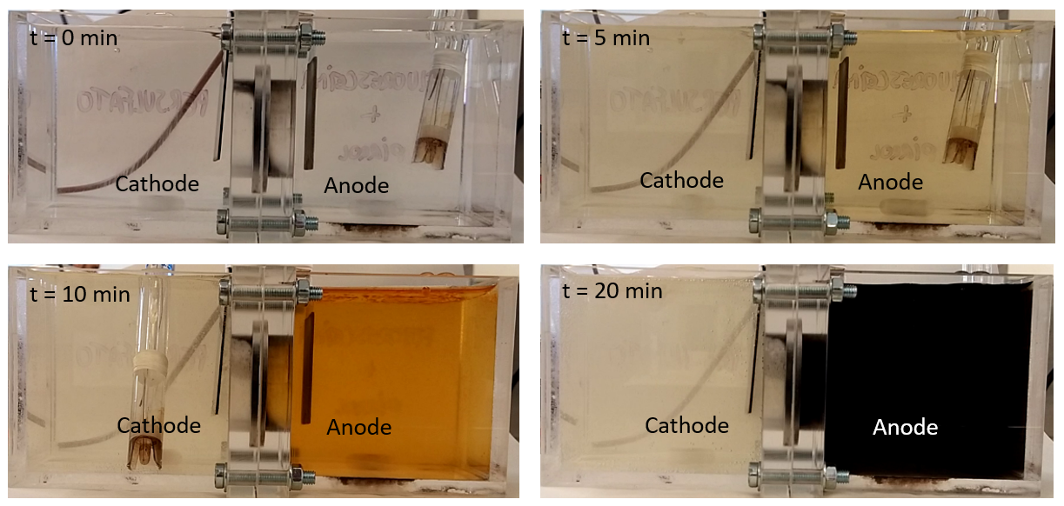
Figure 4

Figure 5

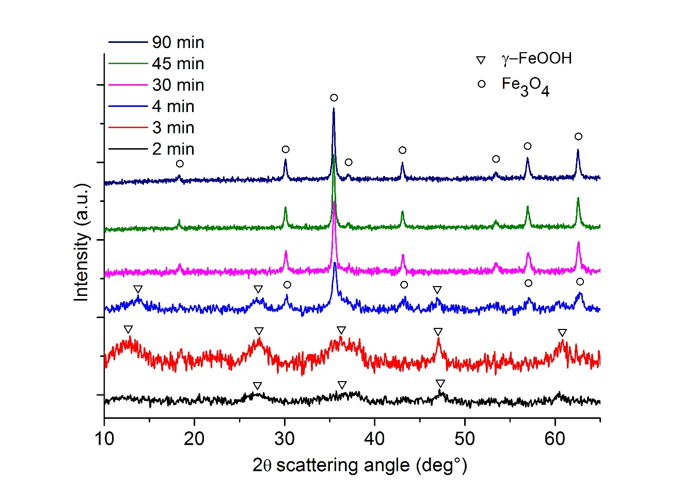
Figure 6
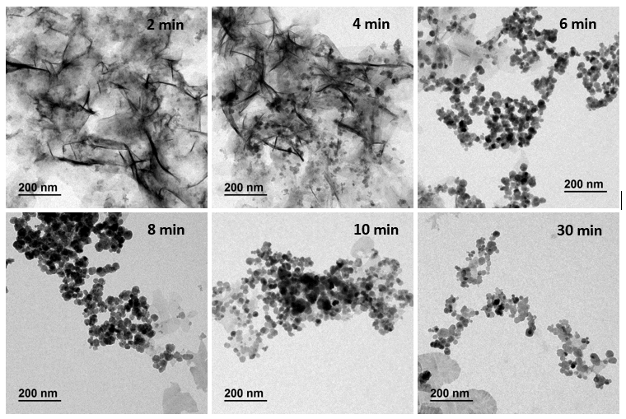
Figure 7
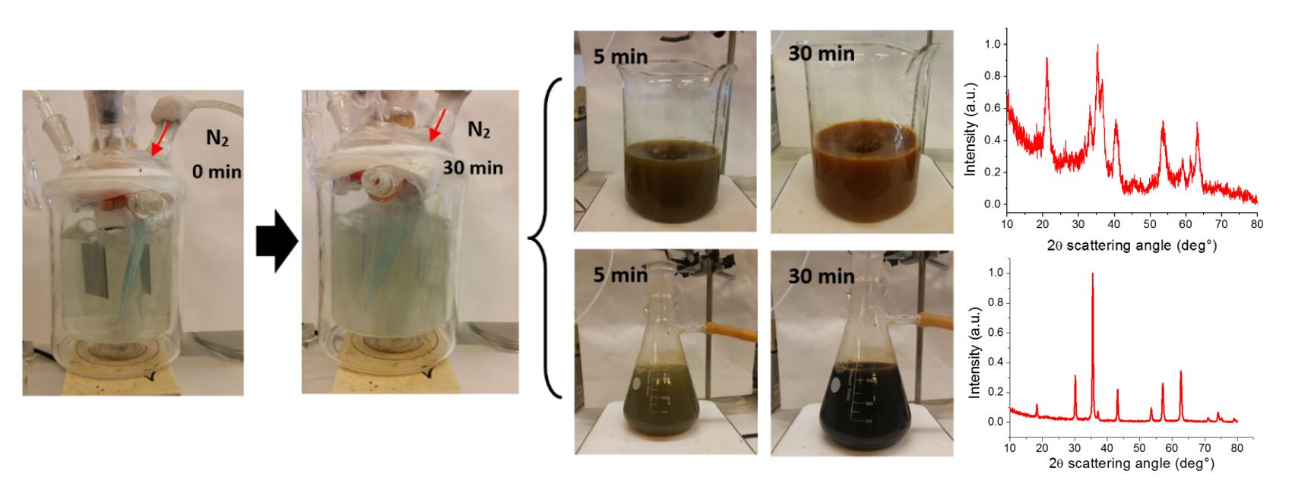

Figure 8

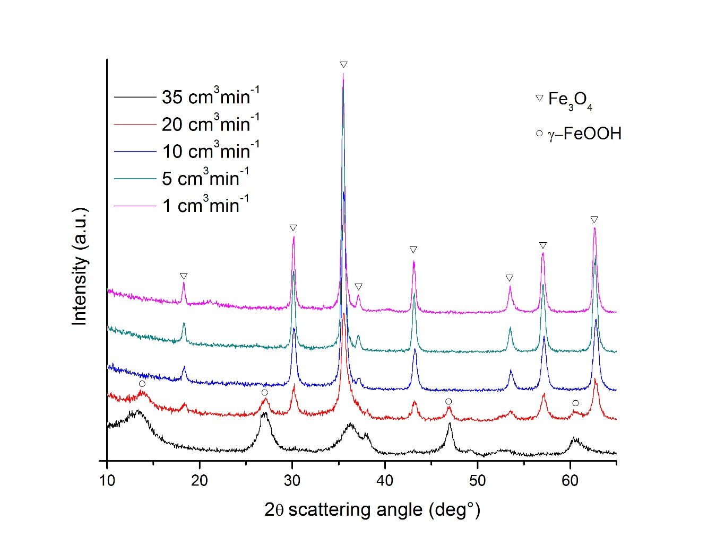
Figure 9
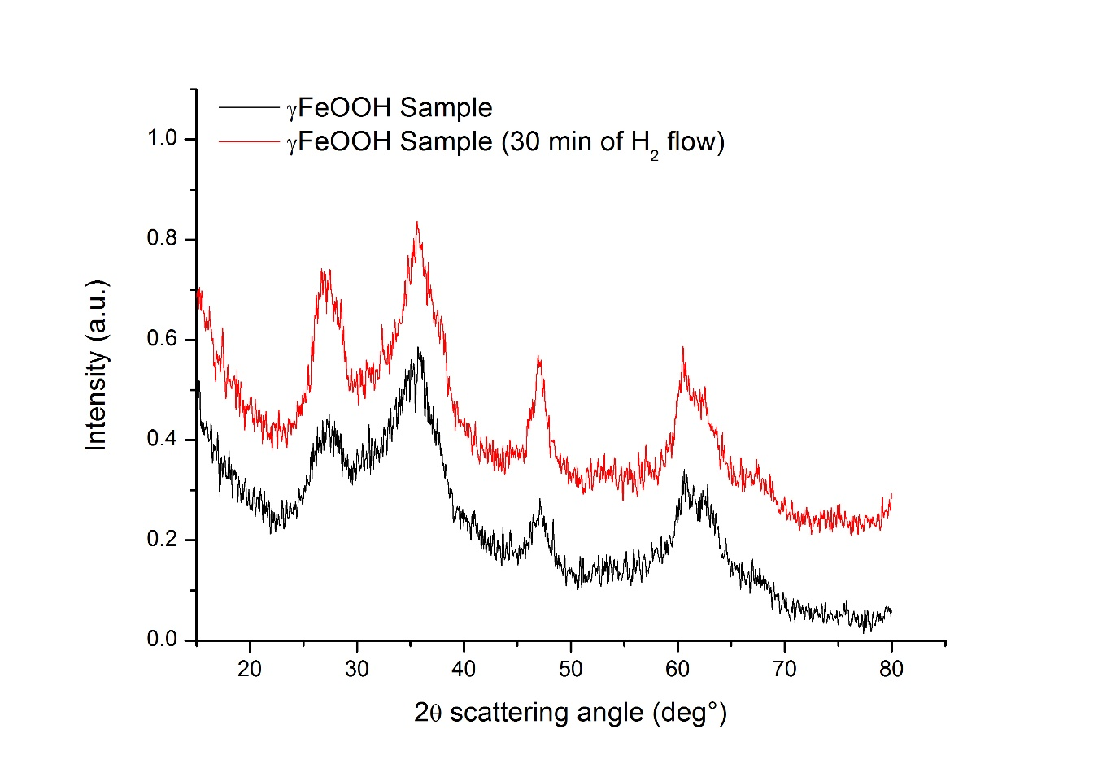
Figure 10

