THE MANAGEMENT OF BOYS UNDER 3-MONTHS OF AGE WITH AN INGUINAL HERNIA AND IPSILATERAL PALPABLE UNDESCENDED TESTIS

Naomi J Wright^{1,2}, Joseph R Davidson² (joint first author), Christina Major¹, Natalie Durkin³, Yew-Wei Tan³, Matthew Jobson⁴, Niyi Ade-Ajayi³, Nigel J Hall^{4,5} Nordeen Bouhadiba^{1,2}

¹ Department of Paediatric Surgery. Evelina Children’s Hospital, Guy’s and St.Thomas’ NHS Trust, London, UK.
² Department of Paediatric Surgery. University Hospital Lewisham, London, UK.
³ Department of Paediatric Surgery. Kings College Hospital, London, UK.
⁴ Department of Paediatric Surgery and Urology. Southampton Children’s Hospital, Southampton, UK.
⁵ Faculty of Medicine, University of Southampton, Southampton, UK.

Corresponding author:

Miss Naomi J Wright MBChB (Hons) BSc (Hons) MRCS DCH
Email: naomiwright@doctors.org.uk

ABSTRACT

Aims: The optimal management for boys under 3-months of age with an indirect inguinal hernia (IIH) and ipsilateral palpable undescended testis (IPUDT) is unknown. We aimed to: 1) determine the current practice for managing these boys across the UK, and 2) compare outcomes of different treatment strategies.
Methodology: We undertook two studies. Firstly, we completed a National Survey of all surgeons on the British Association of Paediatric Surgeons email list in 2014. Subsequently, we undertook a multi-centre, retrospective, 10-year (2005-2015) review across 4 paediatric surgery centres of boys under 3 months of age with concomitant IIH and IPUDT. Primary outcome was testicular atrophy. Secondary outcomes included need for subsequent orchidopexy, testicular ascent and hernia recurrence. Data are median (range). Chi squared test and multivariate binomial logistic regression analysis were used for analysis; p<0.05 was considered significant.
Results:
Survey: Consultant practice varies widely across the UK, with a tendency towards performing concurrent orchidopexy at the time of herniotomy under 3-months of age. Concurrent orchidopexy is favoured less in cases where the hernia is symptomatic.
Case Series Review: Forty-one boys with 43 concomitant IIH and IPUDT were identified, and all included. 32 (74%) hernias were reducible, 11 (26%) were symptomatic requiring urgent or emergency repair. Post-conceptual age at surgery was 45 weeks (36-65). Primary operations included: 29 (67%) open hernia repair and standard orchidopexy, 8 (19%) open hernia repair with future orchidopexy if required, 4 (9%) laparoscopic hernia repair with future orchidopexy if required, 2 (5%) open hernia repair and suturing of the testis to the inverted scrotum without scrotal incision.
Variation in atrophy rate between different surgical approaches did not reach statistical significance (p = 0.42). Overall atrophy rate was 18%. If hernia repair alone was undertaken (8 open and 4 laparoscopic), the testis did not descend in 8 patients, requiring subsequent orchidopexy (67%); if orchidopexy was undertaken at the time of hernia repair, 1 in 29 required a repeat orchidopexy (3%) (p=0.0001). No hernia recurred.
Conclusion: This study suggests that orchidopexy at the time of inguinal herniotomy does not increase the risk of testicular atrophy in boys under 3 months of age.

1. INTRODUCTION
Large patient population studies in children have demonstrated that indirect inguinal hernias tend to present early in life, particularly in premature infants, who are also at greater risk of having undescended testes [1]. Current literature suggests approximately 1-3% of boys with an inguinal hernia also have a concomitant undescended testis [1,2].
The majority of reducible inguinal hernias in infants under 3-months of age are managed operatively on a semi-urgent basis within 1-2 weeks of diagnosis or before discharge if an inpatient. Some are managed on an emergency basis sooner if complications arise. Infants with a palpable undescended testis are typically offered an orchidopexy between 6-12 months of age in keeping with recent commissioning guidelines from the Royal College of Surgeons of England in collaboration with the British Association of Paediatric Surgeons (BAPS) and the British Association of Paediatric Urologists (BAPU)[3]. The most recent BAPU consensus recommends undertaking orchidopexy from 3 months and operating upon all infants with an undescended testis before the age of 12 months [4]. However, orchidopexy is not recommended under 3 months due to presumed increased risks of testicular atrophy in smaller infants and the chance of spontaneous descent [5], which continues after birth but rarely after the age of 6 months [6,7].
The evidence base for these recommendations is limited and there is no guidance, to our knowledge, regarding the optimum management of boys less than 3 months of age with a concomitant indirect inguinal hernia (IIH) and ipsilateral palpable undescended testis (IPUDT).
We aimed to establish the current practice in the UK by way of a national survey. Following on from this, a multi-centre, retrospective analysis aimed to compare the outcomes of different treatment strategies.

2. MATERIALS AND METHODS

2.1 National Survey
We undertook a national online survey of all contactable consultant paediatric surgeons and paediatric urologists on the BAPS email list in 2014 (n = 100) (Appendix 1: Survey Questions). From this we have been able to define the current practices of paediatric surgeons for this patient population in the UK.

2.2 Case Series Review
A 10-year retrospective review of case notes across 4 centres was performed. Cases were identified through coding and departmental databases. We included all boys with concomitant IIH and IPUDT who were under 52 weeks post conceptual age at the time of diagnosis. This included boys with either bilateral inguinal herniae or bilateral undescended testes. We excluded any patient with an impalpable testis or where the unilateral hernia was contralateral to the UDT.
The primary outcome was testicular atrophy – defined as a documented decrease in the size of the operated testis. If the testicular size was not documented at the time of surgery, but later documented to be smaller than the contralateral side, then it was assumed to have atrophied. If post-operative follow-up information regarding testicular size was unavailable, the case was excluded from the analysis to avoid an underestimation of the atrophy rate, which could happen if included in the whole denominator. Secondary outcomes included need for subsequent orchidopexy, testicular ascent and hernia recurrence. Need for subsequent orchidopexy was determined from the patient’s notes, operation waiting lists and theatre logbooks; this information was available for all patients. Testicular ascent was defined as a testis that had been in the scrotum at the end of primary surgery and later was outside the scrotum requiring subsequent orchidopexy.
Data was collected on patient demographics, presentation of the hernia (reducible, difficult to reduce and operated urgently within 48-hours, or irreducible and operated as an emergency) and operation performed. Primary operation was categorised into: open inguinal herniotomy with standard orchidopexy using a dartos pouch as described by Brown[8], open inguinal herniotomy and modified orchidopexy with a suture to the inverted scrotum and no dartos pouch, open inguinal herniotomy and no orchidopexy, laparoscopic inguinal herniotomy and no orchidopexy. Detail regarding whether dissection was undertaken to lengthen the cord, as described in the survey, was not used in the case series review due to the inherent unreliability of such data retrospectively. Duration of follow-up was defined as time from primary surgery to last clinic appointment in months.
Chi-squared test and multivariate binomial logistic regression analysis were used for statistical analysis; p<0.05 was considered significant.

3. RESULTS

3.1 National Survey
Seventy-eight consultants responded (78%): 66 paediatric surgeons, 12 paediatric urologists. In the absence of an UDT, 81% respondents (n=63) routinely perform open herniotomy in boys <3months, whereas 19% (n=15) perform laparoscopic hernia repair. In the absence of clinical evidence of an inguinal hernia, 4% (n=3) undertake orchidopexy for a palpable UDT at 3-6months, 64% (n=50) at 6-12months and 32% (n=25) >12 months of age.
In boys <3 months with both reducible IIH and IPUDT, 54% (n=42) would proceed to herniotomy and orchidopexy at this age, 24% (n=19) would undertake herniotomy at this age and delay orchidopexy until over 3-months of age if necessary and 8% (n=6) would delay both until over 3-months (Fig.1). Fourteen percent (n=11) would vary management depending on clinical and operative findings. Among those who would proceed with IIH repair under 3-months (n=71), choice of operative procedure varied widely [Fig.2]. The most common was open herniotomy and standard orchidopexy using a dartos pouch; favoured by almost half of those choosing to operate at this stage (44%, N=31). A further 14% (N=10) would undertake a modified orchidopexy with a suture to the inverted scrotum, but no dartos pouch.
If the hernia was difficult to reduce, fewer surgeons would undertake concurrent standard orchidopexy (35%) and fewer still in the presence of an obstructed, irreducible hernia (22%). The proportion undertaking laparoscopic hernia repair and future orchidopexy was similar in all 3 scenarios, 15-18%.

3.2 Case Series Review
Forty-one patients were included in the study; this included 43 IIH with IPUDT. The patient demographics and presentation of the hernia are documented in Table 1. Median gestational age was 37-weeks (24-42) and birth weight 2.5kg (0.56-4.95). 20 (49%) herniae were right sided, 15 left (37%) and 6 (15%) bilateral; 4 bilateral IIH had unilateral undescended testes and 2 had bilateral. Thirty-two (74%) hernias were reducible and managed electively, 8 (19%) were incarcerated, reduced with difficulty and operated within 48-hours, 3 (7%) were irreducible requiring emergency surgery.
Post-conceptual age at time of diagnosis of IIH with IPUDT was 43 weeks (33-52). Post-conceptual age at surgery was 45 weeks (36-65). In 37/43 (86%) of the cases, the infant was < 3-months of age at the time of surgery; all were under 6-months of age at the time of surgery. The most commonly performed operation was open hernia repair and standard orchidopexy with a dartos pouch (67%, n=29), followed by open hernia repair with delayed orchidopexy if required (19%, n=8), laparoscopic hernia repair with delayed orchidopexy if required (9%, n=4) and open hernia repair with suturing of the testis to the inverted scrotum (5%, n=2).
The atrophy rate (including all operative types) for patients with a reducible hernia was 14% (4/28), 25% (2/8) for hernias that were difficult to reduce and operated urgently within 48-hours and 33% (1/3) for hernias operated as an emergency (p=0.60). The overall atrophy rate was 18% (7/39). Four elective cases were excluded from the analysis due to inadequate follow-up documentation.
The atrophy rate for open hernia repair with standard orchidopexy was 12% (3/26), open hernia repair with delayed orchidopexy if required 29% (2/7), laparoscopic hernia repair with delayed orchidopexy if required 25% (1/4) and for open hernia repair with suturing of the testis to the inverted scrotum 50% (1/2) [Table 2]. This variation in atrophy rate between different surgical approaches did not reach statistical significance (p = 0.42). Standard orchidopexy using a dartos pouch was undertaken in 72% (23/32) of patients operated electively for their hernia, in 63% (5/8) of those operated urgently within 48hrs and in 33% (1/3) of those operated as an emergency (p=0.37).
There was no statistically significant relationship between mode of presentation of the hernia (reducible versus difficult to reduce or irreducible) and testicular atrophy on either univariate analysis or multivariate analysis that also took into account the procedure performed and post-conceptual age at the time of surgery. On univariate analysis, there was no significant relationship between age at surgery and atrophy rate. On separate analysis of just those under 3-months of age at the time of surgery, the atrophy rate was 21% (7/34); this was not significantly different to the infants operated after 3-months of age (p=0.26). The atrophy rate between different surgical approaches did not reach statistical significance in those operated under 3-months of age (p=0.43).
If hernia repair alone was undertaken (8 open and 4 laparoscopic), the testis did not descend in 8, requiring subsequent orchidopexy (67%); if orchidopexy was undertaken at the time of the hernia repair, 1 in 29 required a repeat orchidopexy (3%) (p=0.0001). No hernia recurred. Median follow-up was 10-months (3-51).

4. DISCUSSION
Inguinal hernias are common occurring in 1-5% of term males and in up to 12% of preterm neonates at 32-weeks gestation[9]. The incidence of incarceration is variable at 12 – 17% [10]. There is evidence that younger infants, especially the premature, are more likely to present with a symptomatic hernia [11]. 39% of the premature infants in Ein’s study of 6361 inguinal hernias were incarcerated at presentation [1]. Hence, an inguinal hernia in an infant in the first 3-months of life necessitates surgical intervention, at least in an expedited elective fashion.
The incidence of undescended testes is 3% in term boys and as high as 33% in premature boys[11], with the ability to descend spontaneously up to 6-months of age [7]. The incidence of concomitant IIH with IPUDT has been quoted as 1-3%, but may be higher in the preterm population [1]. Testicular atrophy rates for boys undergoing orchidopexy over 6-months of age are reported at 2-5% [2,12,13]. The atrophy rate for orchidopexy in boys less than 3-months of age has not been previously documented. The overall atrophy rate in our study was 18%, with a median age at surgery of 45 weeks post-conceptual age. The atrophy rate was 12% in those undergoing standard orchidopexy at the time of inguinal hernia repair. Incarcerated hernias, which are more common in this population, have been associated with testicular atrophy rates up to 30% [1,14,15]. Consistent with this, in our study, the atrophy rate for hernias that were difficult to reduce and operated urgently was 25% and for those operated as an emergency, 33%. This information may be useful when counseling the parents of such boys.
67% (8/12) of infants who did not have an orchidopexy at the time of primary surgery required subsequent orchidopexy compared to 3% (1/29) of those who underwent orchidopexy at the time of primary surgery (p<0.0001). If orchidopexy is not undertaken at the time of primary surgery and the testis does not descend, a second general anaesthetic for subsequent orchidopexy is required. There is a growing body of evidence to suggest a detrimental impact of general anaesthesia on the developing brain [16–18]. A significant number of animal-based experiments have shown an objective loss in performance in learning and memory tasks [19], which has been identified to be more profound in models of multiple exposures [20]. This is proposed to carry across to human brain development. By extension, even in the absence of definitive evidence in humans, it may be prudent to avoid multiple exposures to general anaesthetic agents where possible. In addition, the presence of scar tissue from the previous procedure could make surgery more technically challenging in this group.
However, in 33% (4/12) of the infants who did not have an orchidopexy at the time of primary surgery, their testis descended spontaneously and hence an unnecessary orchidopexy was avoided. Operative time was not investigated in this study, however it could be argued that avoiding an orchidopexy at the primary operation could reduce the overall operative time and hence affect of the anaesthetic on the infants developing brain at this young age.
This study has some limitations; these include a relatively small cohort size, particularly of patients with a symptomatic hernia requiring urgent (n=8) or emergency herniotomy (n=3). Furthermore, the retrospective data collection means that definitions of ascent and atrophy were taken from medical record entries rather than being defined qualitatively and prospectively. A small number of cases had inadequate follow-up documentation to determine atrophy; these were excluded from the atrophy rate calculation to reduce the chance of underestimating the atrophy rate. The follow-up period was limited to a median of 10-months, which reflects common practice patterns. However, given the paucity of data to inform practice in this area, the information provided in this study may prove useful to the consenting surgeon dealing with such cases. We propose a large, prospective multi-centre study in order to further establish an evidence base for recommendation of best practice.

5. CONCLUSION
Within the limitations of our study, we have shown that performing a standard orchidopexy at the time of inguinal herniotomy in boys under 3-months of age did not increase the risk of testicular atrophy. Furthermore, this strategy resulted in a significantly lower need for subsequent orchidopexy and hence second general anaesthetic during infancy. This practice is in line with the clinical decisions being taken by the majority of surgeons within our UK national survey.

REFERENCES

[1] Ein SH, Njere I, Ein A. Six thousand three hundred sixty-one pediatric inguinal hernias: a 35-year review. J Pediatr Surg 2006;41:980–6.
[2] Erdoğan D, Karaman I, Aslan MK, Karaman A, Cavuşoğlu YH. Analysis of 3,776 pediatric inguinal hernia and hydrocele cases in a tertiary center. J Pediatr Surg 2013;48:1767–72.
[3] British Association of Paediatric Surgeons. Commissioning guide: Paediatric orchidopexy for undescended testis. 2015, http://www.baus.org.uk/_userfiles/pages/files/Publications/Commissioning%20guide%20for%20orchidopexy%20final%20v7.pdf [accessed 29.01.17].
[4] Murphy F, Urologist CP. The BAPU Consensus Statement on the Management of Undescended Testes. http://www.bapu.org.uk/wp-content/uploads/2013/03/UDT-Summary-document.pdf [accessed 29.01.17].
[5] Hutson JM, Nation T, Balic A, Southwell BR. The role of the gubernaculum in the descent and undescent of the testis. Ther Adv Urol 2009;1:115–21.
[6] Chan E, Wayne C, Nasr A. Ideal timing of orchidopexy: a systematic review. Pediatr Surg Int 2014;30:87–97.
[7] Wenzler DL, Bloom D a, Park JM. What is the rate of spontaneous testicular descent in infants with cryptorchidism? J Urol 2004;171:849–51.
[8] Brown S. Orchidopexy using a Dartos Pouch. Ulster Med J 1973:192–4.
[9] Scott V, Davenport M, Fisher R. Inguinal Hernias and Hydroceles. In: Sinha C, Davenport M, editors. Handb. Pediatr. Surg. 1st ed., London: Springer-Verlag; 2010, p. 229–34.
[10] Copp H, Shortliffe L. Undescended Testis and Testicular Tumors. In: Holcomb III G, Murphy J, editors. Ashcraft’s Pediatr. Surg. Fifth Ed. 5th ed., Philadelphia, PA: Saunders Elsevier; 2010, p. 676–86.
[11] Manoharan S, Samarakkody U, Kulkarni M, Blakelock R, Brown S. Evidence-based change of practice in the management of unilateral inguinal hernia. J Pediatr Surg 2005;40:1163–6.
[12] McIntosh L a, Scrimgeour D, Youngson GG, Driver CP. The risk of failure after primary orchidopexy: an 18 year review. J Pediatr Urol 2013;9:759–62.
[13] Powell S, Brown R, Millar A, De Wet P, Rode H. Is there a need for postoperative surveillance after day case groin surgery in children? S Afr J Surg 2002;40:91–4.
[14] Miltenburg D, Nuchtern J. Meta-analysis of the risk of metachronous hernia in infants and children. Am J Surg 1997;174:741–4.
[15] Fasching G, Höllwarth M. Risk of testicular lesions following incarcerated inguinal hernia in infants. Pediatr Surg Int 1989;4:265–8.
[16] Aker J, Block R, Biddle C. Anesthesia and the developing brain. ANAA J 2015;83:139–47.
[17] Sanders R, Hassell J, Davidson A, Robertson N, Ma D. Impact of anaesthetics and surgery on neurodevelopment: an update. Br J Anaesth 2013;110:i53–72.
[18] Davidson A, Flick R. Neurodevelopmental implications of the use of sedation and analgesia in neonates. Clin Perinatol 2013;40:559–73.
[19] Yu X, Liu Y, Bo S, Qinghua L. Effects of sevoflurane on learning, memory, and expression of pERK1/2 in hippocampus in neonatal rats. Acta Anaesthesiol Scand 2015;59:78–84.
[20] Amrock L, Starner M, Murphy K, Baxter M. Long-term effects of single or multiple neonatal sevoflurane exposures on rat hippocampal ultrastructure. Anaesthesiology 2015;122:87–95.

Figure 1. UK surgeons’ preference regarding the timing of surgery in boys presenting with an IIH and IPUDT under 3-months of age (n = 78)

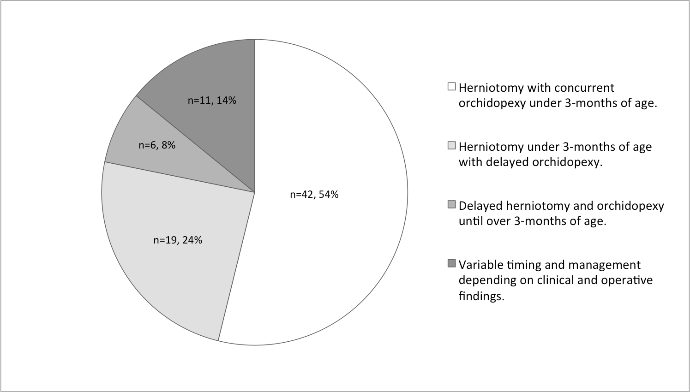

Figure 2. UK Surgeons’ preference regarding operative technique in boys undergoing surgery for a reducible IIH and IPUDT under 3-months of age (n=71, [7 would not operate at this age])

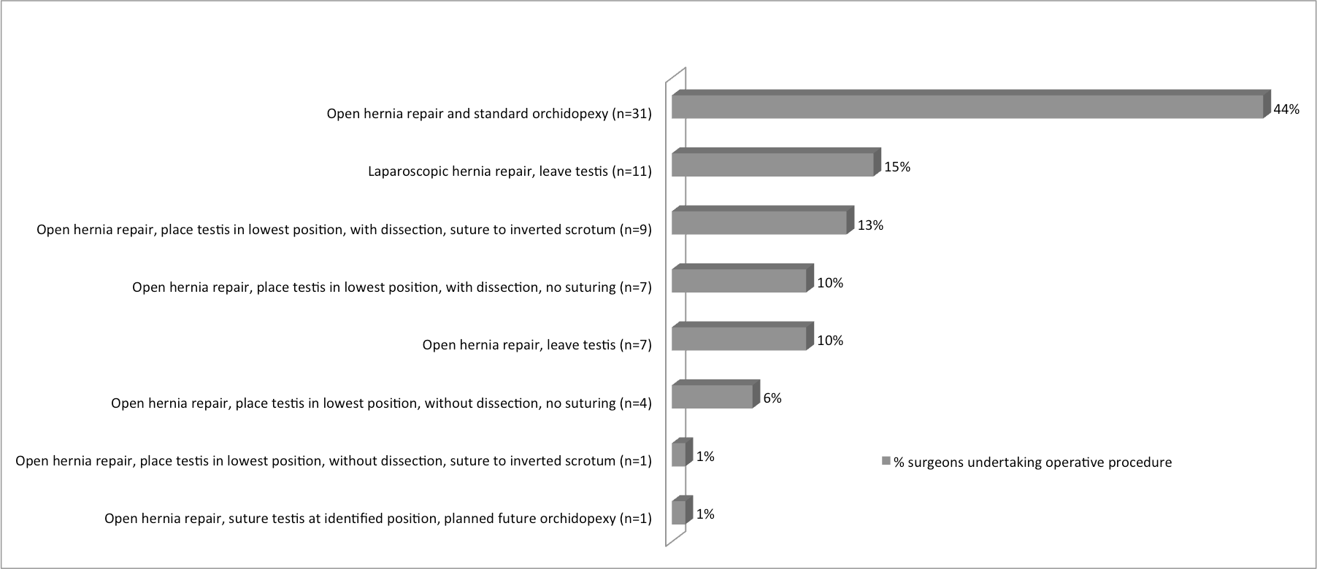

Table 1. Demographic data and presentation of hernia

 | Overall (n=43) | Open hernia repair and orchidopexy (n=29) | Open repair and subsequent orchidopexy if needed (n=8) | Laparoscopic hernia repair and subsequent orchidopexy if needed (n=4) | Open hernia repair and suturing of the testis to the inverted scrotum (n=2)
Demographic Data [median + range]
Gestational age at birth (weeks) | 37 (24-42) | 38 (24-42) | 35 (33-41) | 35 (26-37) | 35.5 (31-40)
Birth weight (kg) | 2.5 (0.6-4.95) | 2.2 (0.56-4.95) | 2.69 (1-3.2) | 2.58 | 2.5
Post-conceptual age at diagnosis of IH with IPUDT (weeks) | 43 (33-52) | 44 (33-52) | 41 (38–44) | 45 (38-47) | 40(39-41)
Post-conceptual age at surgery (weeks) | 45 (36-65) | 45 (36-65) | 46 (41-65) | 52 (44-53) | 43.5 (42-45)
Presentation of hernia [n, (%)]
Reducible | 32 (74%) | 23 (79%) | 4 (50%) | 4 (100%) | 1 (50%)
Incarcerated, reduced with difficulty, operated within 48 hours | 8 (19%) | 5 (17%) | 2 (25%) | 0 | 1 (50%)
Irreducible/ obstructed/ strangulated requiring emergency surgery | 3 (7%) | 1 (3%) | 2 (25%) | 0 | 0
Laterality [47 hernias; 43 associated with IPUDT and hence included in the study]
Right | 20 (49%) | 13 | 2 | 3 | 2
Left | 15 (37%) | 10 | 4 | 1 | 0
Bilateral | 6 (15%)  4 with a unilateral UDT and 2 with bilateral undescended testes | 5 (1 with bilateral undescended testes) | 1 (1 with bilateral undescended testes) | 0 | 0

Table 2. The outcome of different operative strategies for boys under 3-months of age with concomitant IIH and IPUDT

 | Open hernia repair and orchidopexy (n=29) | Open repair and subsequent orchidopexy if needed (n=8) | Laparoscopic hernia repair and subsequent orchidopexy if needed (n=4) | Open hernia repair and suturing of the testis to the inverted scrotum (n=2)
Atrophy
Partial | 2 reducible hernias  1 hernia that was difficult to reduce * | 1 reducible hernia  1 irreducible hernia | 1 reducible hernia | 0
Complete | 0 | 0 | 0 | 1 hernia that was difficult to reduce *
Not recorded | 3 | 1 | 0 | 0
Total | 3/26 (12%) | 2/7 (29%) | 1/4 (25%) | 1/2 (50%)
Subsequent orchidopexy | 1/29 (3%) | 5/8 (63%) | 3/4 (75%) | 0
* operated within 48-hours

APPENDIX 1: Survey Questions

1) Surgeon specialty:
- Paediatric surgeon
- Paediatric urologist
- Other. Please detail:

2) What is your usual/preferred operative approach to unilateral indirect inguinal hernias in infants <3months?
- open repair
- laparoscopic repair
- other. Please detail:

3) At what age do you normally undertake an elective orchidopexy in infants with a palpable unilateral undescended testis?
- 0-3months
- 3-6months
- 6-12months
- >12months

4) Scenario A
You are referred an infant <3months with concomitant reducible indirect inguinal hernia and ipsilateral palpable undescended testis:
a) how would you manage this patient?
- proceed to herniotomy and orchidopexy <3months of age. Go to question 4b.
- herniotomy at present and orchidopexy >3months of age. Go to question 4b.
- herniotomy and orchidopexy >3months of age. Go to question 5.

b) If you would proceed to surgery <3months of age what would be your operative approach?
- open repair of inguinal hernia, leave testis in current position.
- open hernia repair and suturing of the testis at the position it is identified in the groin with a planned future orchidopexy.
- open hernia repair, place testis in lowest position possible, but no suturing to scrotum.
i. with dissection to optimise length of cord.
ii. without dissection to optimise length of cord.
- open hernia repair, place testis in lowest position possible and in addition suturing the testis to the inverted scrotum (no scrotal incision).
i. with dissection to optimise length of cord.
ii. without dissection to optimise length of cord.
- open hernia repair and standard orchidopexy.
- open hernia repair and other method of managing undescended testis. Please detail:
- laparoscopic repair of inguinal hernia, leave testis in current position and undertake a future elective orchidopexy as required.
- other operative approach. Please detail:

5) Scenario B
You are referred an infant <3months of age with incarcerated indirect inguinal hernia and ipsilateral palpable undescended testis. You are able to reduce the inguinal hernia with difficulty.

What is your operative approach?
- open repair of inguinal hernia, leave testis in current position.
- open hernia repair and suturing of the testis at the position it is identified in the groin with a planned future orchidopexy.
- open hernia repair, place testis in lowest position possible, but no suturing to scrotum.
i. with dissection to optimise length of cord.
ii. without dissection to optimise length of cord.
- open hernia repair, place testis in lowest position possible and in addition suturing the testis to the inverted scrotum (no scrotal incision).
i. with dissection to optimise length of cord.
ii. without dissection to optimise length of cord.
- open hernia repair and standard orchidopexy.
- open hernia repair and other method of managing undescended testis. Please detail:
- laparoscopic repair of inguinal hernia, leave testis in current position and undertake a future elective orchidopexy as required.
- other operative approach. Please detail:

6) Scenario C
You are referred an infant <3months of age with bilious vomiting and incarcerated indirect inguinal hernia and ipsilateral palpable undescended testis. You are unable to reduce the hernia and hence proceed to emergency repair.

What would be your operative approach?
- open repair of inguinal hernia, leave testis in current position.
- open hernia repair and suturing of the testis at the position it is identified in the groin with a planned future orchidopexy.
- open hernia repair, place testis in lowest position possible, but no suturing to scrotum.
i. with dissection to optimise length of cord.
ii. without dissection to optimise length of cord.
- open hernia repair, place testis in lowest position possible and in addition suturing the testis to the inverted scrotum (no scrotal incision).
i. with dissection to optimise length of cord.
ii. without dissection to optimise length of cord.
- open hernia repair and standard orchidopexy.
- open hernia repair and other method of managing undescended testis. Please detail:
- laparoscopic repair of inguinal hernia, leave testis in current position and undertake a future elective orchidopexy as required.
- other operative approach. Please detail:

Additional comments:

