Comparative study of the structure and interaction of the pore helices of the hERG and Kv1.5 potassium channels in model membranes

Maïwenn Beaugrand†, Alexandre A. Arnold†, Steve Bourgault†, Philip T. F. Williamson‡ and Isabelle Marcotte†*

†Department of Chemistry, Université du Québec à Montréal, P.O. Box 8888, Downtown Station, Montreal, H3C 3P8, Canada

‡School of Biological Sciences, Highfield Campus, University of Southampton, Southampton, SO17 1BJ, UK

*Corresponding author
Isabelle Marcotte
Phone: 1-514-987-3000 #5015
Fax: 1-514-987-4054
Email: marcotte.isabelle@uqam.ca

Keywords
Ion channel, bicelles, lipids, dodecylphosphocholine, nuclear magnetic resonance, circular dichroism
Abstract
The hERG channel is a voltage gated potassium channel found in cardiomyocytes that contributes to the repolarization of the cell membrane following the cardiac action potential, an important step in the regulation of the cardiac cycle. The lipids surrounding K+ channels have been shown to play a key role in their regulation, with anionic lipids shown to alter gating properties. In this study we investigate how anionic lipids interact with the pore helix of hERG and compare the results with those from Kv1.5 which possesses a pore helix more typical of K⁺ channels. Circular dichroism studies of the pore helix secondary structure reveal that the presence of the anionic lipid DMPS within the bilayer results in a slight unfolding of the pore helices from both hERG and Kv1.5, albeit to a lesser extent for Kv1.5. In the presence of anionic lipids, the two pore helices exhibit significantly different interactions with the lipid bilayer. We demonstrate that the pore helix from hERG causes significant perturbation to the order in lipid bicelles, which contrasts with only small changes observed for Kv1.5. These observations suggest that the atypical sequence of the pore helix of hERG may play a key role in determining how anionic lipids influence its gating.

Introduction

The human ether-a-go-go related gene (hERG) voltage-gated potassium (K_{v}) channels are located in the myocardium cell membranes where they are responsible for the I_{Kr} current (Tamargo et al. 2004; Wulff et al. 2009; Trudeau et al. 1995) essential for repolarization following the cardiac action potential (Pearlstein et al. 2003; Sanguinetti et al. 1995; Wulff et al. 2009). Inhibition of the hERG channel, through mutation (inherited) or from the binding of channel blockers (acquired), prolongs the heart repolarization interval, resulting in long QT syndrome (LQTS) - a condition that may lead to cardiac arrhythmia or failure (Kamiya et al. 2006; Pearlstein et al. 2003; Vandenberg et al. 2012). This condition is of particular importance in drug development as many compounds have been shown to bind off-target to the hERG channel, resulting in enhanced risk of acquired LQTS (Pearlstein et al. 2003).

The hERG channel is composed of four monomers and each of these subunits contains six transmembrane helices (Sanguinetti and Tristani-Firouzi 2006). To date, its full structure has never been determined experimentally and our current knowledge of its structure has been predicted by homology with other voltage-gated K⁺ channels (Kutteh et al. 2007; Stansfeld et al. 2007; Subbiah et al. 2004), computational methods (Subbotina et al. 2010) and NMR studies of channel segments (Chartrand et al. 2010; Gravel et al. 2013; Ng et al. 2016) as reviewed by Ng et al. (Ng et al. 2013). The first four helices (S1 to S4) constitute the voltage sensor domain and the last two helices (S5 and S6) compose the pore domain. The extracellular loop that links S5 to S6 contains the S5P linker, the pore helix (PH) and the K⁺ selectivity filter, each of which exhibit a distinctive amino acid sequences when compared to other potassium channels (Vandenberg et al. 2012).

The segment encompassing residues Y₆₁₁ to S₆₂₁ of the hERG channel is predicted to form an α-helical PH, as illustrated in Fig. 1A. To date, the most extensive studies conducted on the PH have been done by solution NMR using detergent micelles (Ng et al. 2013). Pages et al. (Pages et al. 2009) have studied the hERG’s PH extended by three residues on the N-terminal side (from K₆₀₈ to S₆₂₁) in dodecylphosphocholine (DPC) and sodium dodecylsulfate (SDS) micelles. The additional charged residues K₆₀₈, D₆₀₉ and K₆₁₀, which were shown to sit at the membrane interface, are absent in a number of other potassium channels (Fig. 1B-E), many of which are used as templates for the generation of hERG homology models. Yet the inclusion of these residues may influence both the structure of the PH, its interaction with the bilayer, and its role in channel function.

The lipid bilayer is important for the structure and function of membrane proteins such as potassium channels (Lee 2004; Williamson et al. 2003). For example, the transmembrane helix of wild-type KcsA and KcsA mutant containing the turret region of Kv1.3 was shown to unwind and rewind in the presence of phospholipids, inducing conformational changes on both the turret region and the PH during the gating process (van der Cruijsen et al. 2013). Moreover, other K_{v} channels require the presence of specific lipids for potential regulation of the gating, such as Kv2.1 by sphingomyelin (Ramu et al. 2006; Swartz 2006), Kv7.1 by anionic phosphatidylinositol 4,5-bisphosphate (Zaydman and Cui 2014; Zaydman et al. 2013), and Kv1.2 channel mutant by anionic phosphatidic acid (Hite et al. 2014). A notable difference between the PH in hERG and other potassium channels is the absence of the double tryptophan motif (Fig. 1B) that is thought to contribute to the stability of the selectivity filter in other K⁺ channels (Doyle et al. 1998) and are close to the anionic lipid binding site important in regulating channel gating (Alvis et al. 2003; Lee 2003, 2004; Marius et al. 2008; Marius et al. 2012).

The objective of this work was to assess the effect of phospholipids’ charge on the hERG PH structure and on its membrane interaction. More specifically, we have studied the G₆₀₃-G₆₂₆ segment which comprises the Y₆₁₁-S₆₂₁ sequence believed to correspond to the PH, as discussed above. Considering the unique sequence of the hERG channel PH, we have performed comparative experiments on the PH of Kv1.5 (N₄₅₉-G₄₈₂) - a ‘typical’ representative of the K_{v} channels which possesses most of the key residues associated with this family of channels (Fig. 1B). Model membranes composed of dimyristoylphosphatidylcholine (DMPC) and dimyristoylphosphatidylserine (DMPS) were used to respectively mimic zwitterionic and negatively-charged membrane lipids. PCs are the most abundant lipids in eukaryotic membrane and PS is an anionic lipid present in human membranes (Warschawski et al. 2011). Circular dichroism (CD) studies were done to investigate how the bilayer properties modulate the structure of the pore helices. To probe the effect of the PH on the polar and apolar regions of the lipid bilayer, we have performed ³¹P and ²H solid-state (SS) NMR experiments, respectively.

Materials and methods

Materials
Protonated and deuterated 1,2-dimyristoyl-sn-glycero-3-phosphocholine (DMPC and DMPC-d₅₄), 1,2-dimyristoyl-sn-glycero-3-phospho-L-serine (DMPS) as well as n-dodecyl-phosphocholine (DPC) were purchased from Avanti Polar Lipids (Alabaster, AL, USA) or Anatrace (Maumee, OH, USA) and used without further purification. Deuterium-depleted water was obtained from Sigma Aldrich (Oakville, ON, Canada).

Peptide synthesis and purification
Kv1.5 (N₄₅₉-G₄₈₂) and hERG (G₆₀₃-G₆₂₆) PH peptides were synthetized on a Tribute peptide synthesizer (Protein Technologies, Tucson, AZ, USA) with standard Fmoc chemistry using 2-(6-chloro-1-H-benzotriazole-1-yl)-1,1,3,3-tetramethylaminium hexafluorophosphate (HCTU) as a coupling reagent and diisopropylethylamine (DIEA) as a base. Peptides were cleaved from the Rink-amide AM-functionalized polystyrene resin using a mixture of TFA:ethanedithiol:phenol:water (92:2.5:3:2.5; v/v), as previously reported (De Carufel et al. 2015). After filtration and evaporation of the cleavage mixture, peptides were precipitated and washed with diethylether, solubilized in water and lyophilized. Crude peptides were purified by reverse-phase high performance liquid chromatography (RP-HPLC) on a preparative Luna C18 column (250 mm x 21.2 mm; 5µm, 100Å, Phenomenex) using a linear gradient of ACN in H₂O/TFA (0.06% v/v). Collected fractions were analyzed by analytical RP-HPLC using an Aeris peptide XB C18 column (150 mm x 4.6 mm; 3.6µm, Phenomenex) and by ESI-TOF mass spectrometry. Fractions corresponding to the desired peptides, as confirmed by mass spectrometry, with purity higher than 95%, measured by analytical HPLC, were finally pooled and lyophilized.

Sample preparation
For circular dichroism (CD) studies, the appropriate peptide at a concentration circa 20 μM was dissolved into 8 mM DPC micelles and Tris HCl 10 mM, pH 7.4 buffer. The sample was then subjected to multiple cycles of freeze (liquid N₂), thaw (60°C) and vortex shaking until a uniform transparent solution was obtained. The DPC concentration was thus about 7 times above the critical micelle concentration (CMC). This mixture was then added to long-chain phospholipid (PL) DMPC or DMPC with 10 mol% DMPS, and submitted to further cycles of freeze/thaw/mixing. The total concentration of phospholipid and detergent was approximately 16 mM. The phospholipid-to-detergent molar ratio (q) was 1 while the phospholipid/peptide (PL/P) molar ratio was 400:1.
For SS-NMR, both bicellar and vesicular samples were studied. Bicelles samples were prepared in a similar manner to CD samples, albeit using nanopure water as opposed to Tris HCl buffer. The final peptide concentration was approximately 5 mM, with a total concentration of PL and detergent of 400 mM and 80% (w/v) hydration. The molar ratio q was 2 while the PL/P molar ratio was 50:1. Typically, 50% of the DMPC was deuterated. Vesicles of DMPC and DMPC doped with 10 mol% DMPS at total lipid concentration of 400 mM were prepared. Lipids and peptide at a PL/P molar ratio of 50:1 were mixed in nanopure water to achieve 80% (w/v) hydration, and subjected to multiple cycles of freeze (liquid N₂), thaw (60°C) and vortex shaking until a homogeneous suspension was obtained.

Circular dichroism spectroscopy
Far-ultraviolet spectra were recorded using a J-815 CD-spectropolarimeter (Jasco, Easton, MD, USA). Spectra were recorded from 190 to 260 nm at 37°C using a wavelength step of 0.5 nm, a scanning speed of 20 nm⋅min⁻¹, a bandwidth of 1 nm, and a response time of 1 s. For each sample, three scans were averaged and a background of the corresponding membrane model was subtracted. To evaluate the contributions of the secondary structure contributions, CD spectra data were deconvoluted using protein basis 7 and the CDSSTR algorithm (Sreerama and Woody 2000) on the DichroWeb server (Whitmore and Wallace 2008).

Solid-state NMR
³¹P and ²H SS-NMR experiments were performed on an Avance III HD 400 MHz spectrometer (Bruker, Milton, ON, Canada) equipped with a 4 mm double-resonance probe. For ³¹P SS-NMR spectra acquired with or without magic-angle spinning (10 kHz MAS), using a phase cycled Hahn echo pulse sequence (Rance and Byrd 1983) with 85 kHz (static) or 20 kHz (MAS) continuous wave proton decoupling during acquisition. A π/2 and π pulse of 4 μs and 8 μs were used respectively, with an interpulse delay of 27 μs (static experiments) or 100 μs (MAS). Acquisition times of 30 or 100 ms were used for static and MAS experiments respectively, with a dwell time of 10.2 μs and a recycle delay of 5 seconds. Typically between 256 and 2048 scans were acquired per spectra. Spectra were referenced externally with respect to the signal of 85% phosphoric acid set to 0 ppm. ²H SS-NMR spectra were obtained using a quadrupole echo pulse sequence (Davis et al. 1976) with a π/2 pulse length of 3 μs, an interpulse delay of 60 μs and a recycle delay of 1 s. Typically 2400 scans were acquired. A 10 minute equilibration time was allowed between each temperature step, ranging from 22°C to 62°C. All spectra were processed using MNova software (Mestrelab Research, Santiago de Compostela, Spain) with a line broadening of 25 and 50 Hz applied to ³¹P and ²H spectra, respectively. Spectral moments were calculated according to their classical definitions ((Tardy-Laporte et al. 2013) and refences therein) using dedicated MNova scripts courtesy of Pierre Audet (Université Laval, Québec, CA).

Calculation of the static and dynamic mosaic spreads
Static mosaic spread
In order to quantify the degree of perpendicular alignment of the bicelle normal with respect to the magnetic field, a static mosaic spread (ζ) has been proposed (Arnold et al. 2002; Zandomeneghi et al. 2003). This mosaic spread is modelled as a gaussian distribution of the bicelle orientation angle (β) around the main orientation at 90° (β₀), the mosaic spread is the standard deviation of this Gaussian distribution. The probability to find bicelles whose normal is at an angle β with respect to the magnetic field is thus given by (Arnold et al. 2002; Zandomeneghi et al. 2003):
$P\left(β\right)=\frac{1}{ζ\sqrt{2π}}e^{\frac{-{\left(β-β_{0}\right)}^{2}}{2ζ^{2}}}$ (1)
A spectrum with such an angular distribution can be simulated using dedicated MATLAB scripts and the calculated spectrum fitted to the experimental one to determine the static mosaic spread.
Dynamic mosaic spread
The static mosaic spread describes a distribution of bicelle orientation which is slow on the NMR timescale. However, additional motions such as bicelle wobbling for example will modify the phospholipid ³¹P resonance frequency ($δ_{obs}$). The observed peak position can thus be described as follows (Zandomeneghi et al. 2003; Triba et al. 2005) :
$δ_{obs}=δ_{iso}+\frac{1}{2}(3\cos^{2}θ-1)\overline{σ}×S_{bil}$ (2)
where $δ_{iso}$ is the isotropic chemical shift, $θ$ is the angle between the bilayer normal and the magnetic field direction, $\overline{σ}$ is the anisotropy and S_{bil} is the order parameter describing the motions of the bilayer normal with respect to its average orientation. Oriented bicelles have their bilayer normal perpendicular to the direction of the magnetic field, i.e., θ = 90º, thus:
$δ_{obs}=δ_{iso}+\frac{1}{2}\overline{σ}×S_{bil}$ (3)
Since bicelles undergo rapid fluctuations, S_{bil} is unequal to 1. These rapid fluctuations can be modelled as an oscillation of the bicelles within a Gaussian distribution of orientations. The dynamic averaging resulting from such a motion is given by (Triba et al. 2005):
$$S_{bil}=\frac{\int_{0}^{90°}{e^{\frac{\sin^{2}θ}{{2ε}^{2}}}}×\frac{1}{2}(3\cos^{2}θ-1)×sinθ×dθ}{\int_{0}^{90°}{e^{\frac{\sin^{2}θ}{{2ε}^{2}}}}×sinθ×dθ}$$
Here ($ε$) is the aperture of the angular Gaussian distribution and is called “mosaic dynamic spread”. By plotting S_{bil} as a function of ($ε$), the mosaic spread which corresponds to the experimentally determined S_{bil} can be determined graphically.

Results & Discussion
Secondary structure of the pore helices
To assess how the structures of the PH of Kv1.5 and hERG respond to changes of their lipidic environment, CD spectra were recorded in membrane mimetics exhibiting either a neutral or negative surface charge. More specifically, micelles and DPC-based fast-tumbling bicelles with either pure DMPC (Beaugrand et al. 2016) or DMPC with 10 mol% DMPS were used. The detergent DPC was selected for its ability to solubilize membrane proteins (Arora et al. 2001; Damberg et al. 2001; Kallick et al. 1995; Koehler et al. 2010; Warschawski et al. 2011), including a longer version of the hERG PH (S₆₀₀-I₆₄₂) that also encompassed the selectivity filter (Pages et al. 2009).
In the absence of lipid membranes, the PHs of both channels exhibited limited solubility. In zwitterionic DPC micelles, they revealed a classical α-helical spectrum (Fig. 2A and 2B) with minima at 208 nm and 222 nm and a maximum at around 195 nm. Although an accurate quantitative assessment of secondary structure remains challenging, it can provide a guide as to changes in the secondary structure in response to different environments. Deconvolution of the spectra acquired for the PH of the hERG and Kv1.5 channels in DPC exhibited 72% and 73% helicity, respectively, with the remainder arising from the contribution of β-strands, turns and random coil structures (Table 1). When reconstituted into DMPC/DPC bicelles (lipid-to-detergent molar ratio q of 2), a significant drop in the maximum at 195 nm is observed for both the hERG and Kv1.5 with a corresponding fall in helical structure to 67% and 68%, respectively. A further decrease in helicity of about 9 and 6% is seen when bicelles are negatively charged (DMPC/DMPS/DPC). These observations suggest that in both a micellar and bicellar environment the helical contribution is more than sufficient to account for the predicted helical structure (See Fig. 1). The introduction of anionic lipids in the bicelles results only in a small decrease in helicity, with a helical component only slightly larger than that predicted.

Table 1. Deconvolution of secondary structure contributions to CD spectra of hERG and Kv1.5 pore helices in micellar and bicellar environnements of DMPC/DPC (2:1) and DMPC/DMPS/DPC (1.8/0.2/1) using dataset 7 and CDSSTR algorithms on Dichroweb server. α: α-helix, β: β-sheet, T: β-turn, R: random coil, and NRMSD: normalized root mean square displacement.

Sample Environment |  | α | β | T | R | NRMSD
 | DPC micelle | 0.72 | 0.06 | 0.09 | 0.12 | 0.002
hERG | Zwitterionic bicelle | 0.67 | 0.12 | 0.07 | 0.15 | 0.002
 | Anionic bicelle | 0.61 | 0.18 | 0.04 | 0.17 | 0.002
 | DPC micelle | 0.73 | 0.09 | 0.06 | 0.11 | 0.003
Kv1.5 | Zwitterionic bicelle | 0.68 | 0.13 | 0.07 | 0.12 | 0.002
 | Anionic bicelle | 0.64 | 0.11 | 0.11 | 0.14 | 0.002

Interaction of the pore helices with model membranes
Considering the effect of the membrane composition on the structure of the PH of the hERG and Kv1.5 channels observed by CD, their interaction with magnetically-oriented DMPC/DPC (q=2) bicelles was studied by solid-state-NMR (Beaugrand et al. 2016). ³¹P and ²H NMR report on changes in organization and dynamics of the headgroup and apolar chain regions, respectively. As expected, in the absence of PHs these bicelles adopt a magnetically-aligned phase (Nolandt et al. 2012; Beaugrand et al. 2016) demonstrated by the two well-resolved peaks in the ³¹P SS-NMR spectrum and the well-resolved doublets in the ²H SS-NMR spectrum (Fig. 3A, black dotted line) over a temperature range of 37-42°C (Table 2).
The degree of orientation is affected by slow fluctuations around the membrane director that manifests as a distribution of resonances on the spectrum and fast fluctuations about the membrane normal that lead to increased averaging of the chemical shielding anisotropy of the phosphate headgroup. The slow fluctuations can be characterised by the static (Arnold et al., 2002) mosaic spread that models the distribution of lipid orientations about a membrane director as a Gaussian distribution. Similarly, the rapid fluctuations can be modelled as a dynamic mosaic spread characterised by a Gaussian distribution of the bicelle order parameter about the membrane normal (Triba et al. 2005; Zandomeneghi et al. 2003). In DMPC/DPC bicelles, this gives rise to a static mosaic spread of 4° and a dynamic mosaic spread of 20° (Table 2) as previously reported for pure bicellar systems (Zandomeneghi et al. 2003) and MAPCHO bicelles (Beaugrand et al. 2016).

Table 2. Effect of the hERG and Kv1.5 pore helices on DMPC/DPC (2:1) and DMPC/DMPS/DPC (1.8/0.2/1) bicelles. The left ($δ_{left}$) and right ($δ_{right}$) peak chemical shifts, order parameter of the bilayer (S_{bil}), static and dynamic mosaicities, as well as temperature at which oriented bicelles are observed are reported. The data used to calculate the S_{bil}, and the dynamic mosaicity are reported in Table S6. The static mosaicity is estimated with simulated spectra.

Sample | $δ_{left}$ (ppm) | $δ_{right}$ (ppm) | S_{bil} | Static mosaicity | Dynamic mosaicity | Temperatures over which oriented (°C)
Zwitterionic bicelle | -3.7 | -9.3 | 0.58 | 4º | 20º | 37-42
+hERG | -4.4 | -10.3 | 0.72 | 9º | 16º | 27-42
+Kv1.5 | -5.0 | -11.1 | 0.80 | 11º | 14º | 32-52
Anionic bicelle | -5.1 | -11.3 | 0.77 | 5º | 16º | 27-42
+hERG | Not oriented
+Kv1.5 | -6.1 | -12.0 | 0.82 | 12º | 13º | 27-42

Fig. 3A,B shows that the presence of the PHs from hERG (black line) and Kv1.5 (grey line) results in an upfield shift in both the DPC and DMPC peaks in the ³¹P SS-NMR spectrum and a broadening of the resonances. Also, the PHs from both channels extend the range over which stable oriented bicellar structures form, with both PHs lowering the temperature at which the bicelles begin to align (Table 2). The changes in resonance position and lineshape indicate that the PHs increase the static mosaic spread of the bicelles while the dynamic mosaicity is reduced with the most pronounced effects occurring in the case of Kv1.5 (Table 2). The perturbation in the DMPC/DPC spectra upon the addition of the PH’s is thus consistent with a reduction in the dynamics of the bicelle about its director.
To better understand the effect of the PHs on DMPC/DPC bicelles, their interaction with pure DMPC multilamellar vesicles (MLVs) was also studied by ³¹P SS-NMR. Magic-angle spinning (MAS) ³¹P NMR experiments showed no significant difference in the isotropic chemical shift (δ_{iso}) of DMPC in the presence of PH (Table 3), suggesting there is little change in overall surface charge (Lindström et al. 2005). Analyis of the static ³¹P NMR spectra (Fig. 4A, Table 3) reveals that the incorporation of the PHs from hERG and Kv1.5 results in an approximately 10% decrease of DMPC’s chemical shift anisotropy (CSA), indicative of an increase in lipid headgroup dynamics. These results indicate that that the increase in CSA observed in DMPC/DPC bicelles is attributable to the interaction of the lipid headgroup with the PHs and not linked to fluctuations within the bilayer.
Changes in the overall powder lineshapes are also observed upon the addition of PH from hERG or Kv1.5 (Fig. 4). Incorporation of the PHs into the DMPC vesicles (Fig 4A) reveals a significant increase in the relative intensity of the downfield region of the powder pattern compared to the pure DMPC vesicles. This is consistent with a change in the distribution of the relative orientation of the lipids within the sample. The reduction in the downfield intensity of the ³¹P spectrum of MLVs in the absence of PH is typically attributed to vesicle deformation as the lipids attempt to align perpendicular to the magnetic field due to their negative diamagnetic anisotropy (Briggs et al. 2015; Speyer et al. 1987; Seelig et al. 1985; Balla et al. 2004; Pott and Dufourc 1995; Russ et al. 2016). Analysis of the lineshape (Supplementary Figure S1) reveals a change in vesicle ellipticity from 1.5 to 1.0 and 1.05 upon the incorporation of the PHs of Kv1.5 and hERG repsectively, indicating in both cases these peptides rigidify the bilayer and inhibit deformation.
Table 3. Perpendicular ($δ_{⊥}$) and isotropic ($δ_{iso}$) chemical shifts of DMPC in pure DMPC as well as DMPC/DMPS 9:1 vesicles. The anisotropy of the chemical shielding tensor was calculated by: $2(δ_{iso}-δ_{⊥})$.

Sample | $δ_{⊥}$ (ppm) | $δ_{iso}$ (ppm) | $\overline{σ}$ (ppm)
DMPC liposome | -15.8 | -0.66 | 30.3
+hERG | -13.9 | -0.67 | 26.5
+Kv1.5 | -13.7 | -0.67 | 26.1
DMPC/DMPS liposome | -14.4 | -0.66 | 27.5
+hERG | -14.4 | -0.66 | 27.5
+Kv1.5 | -13.8 | -0.66 | 26.3

The changes in the lipid dynamics in the presence of the PHs are not restricted to the lipid headgroup since the lipid chains exhibit a similar ordering effect. This is evidenced by the increase in quadrupolar splitting (Δν_{Q}) of DMPC-d₅₄ in zwitterionic bicelles for both the methyl (Δν_{m}) and plateau (Δν_{p}) regions of the ²H SS-NMR spectra (Fig. 3A, Table 4), properties reflected in the increased second moment (Table 4). The quadrupolar splitting (Δν_{Q}) for a C–D bond in a lipid bilayer system with axial symmetry reports on the variations in the lipid chain order since:
${∆ν}_{Q}\frac{3}{4}\frac{e^{2}qQ}{h}(3\cos^{2}θ-1)S_{CD}$ (4)
where ($e^{2}qQ/h$) is the quadrupole coupling constant (∼167 kHz), $θ$ is the angle between the bilayer normal and the magnetic field direction, and $S_{CD}$ is the order parameter of a deuterium bond vector. The largest quadrupolar splitting is attributed to the deuterium bonds close to the lipid headgroup (plateau) while the smallest quadrupolar splittings arise from the more mobile (methyl) deuterium atoms at the end of the acyl chains. Table 4 shows an increase in Δν_{p} of 8% and 13% for the PH of hERG and Kv1.5, respectively. The ordering of the acyl chains extends along their length, although the PHs exhibit a smaller effect on the chain dynamics towards the methyl groups located in the centre of the bilayer. This apparent increased ordering could be at least in part attributed to the reduced dynamic mosaic spread.
Table 4. Quadrupolar splitting of the plateau (Δν_{p}) and methyl (Δν_{m}) regions of DMPC-d₅₄ in DMPC/DPC (2:1) and DMPC/DMPS/DPC (1.8/0.2/1) bicelles at 37°C.

Sample | Δν_{p} (kHz) | Difference (%) | Δν_{m} (kHz) | Difference (%) | M₂  (GHz²)
Zwitterionic bicelle | 16.1 |  | 2.3 |  | 2.54
+hERG | 17.4 | +8 | 2.4 | +4 | 3.11
+Kv1.5 | 18.2 | +13 | 2.5 | +9 | 3.20
Anionic bicelle | 18.9 |  | 2.7 |  | 2.38
+hERG | Not oriented |  |  |  | 2.70
+Kv1.5 | 19.5 | +3 | 2.7 | 0 | 2.07

Because the activity of a number of potassium channels (Alvis et al., 2003; Hite et al., 2014; Lee, 2003, 2004; Marius et al., 2008, 2012; Zaydman & Cui, 2014; Zaydman et al., 2013) is known to be influenced by the presence of anionic lipids within the membrane, the PHs were reconstituted into DMPC/DMPS/DPC bicelles with a q ratio of 2, but in which DMPC was replaced by 10 mol% DMPS (1.8:0.2:1). PC and PS are miscible (Silvius and Gagne 1984) and the T_{m} of the mixture is about 25 °C considering the molar fraction and T_{m} of DMPC (23°C) and DMPS (39°C) (Marsh 2013). Therefore the anionic bicelles are in the fluid phase at physiological temperature. In the DMPC/DMPS/DPC bicelles two peaks are resolved in the ³¹P spectrum (Fig. 3B, black dotted line), with DMPS appearing as a shoulder on the upfield peak assigned to DMPC. The resonances are shifted upfield compared to the pure DMPC/DPC system, consistent with the reduced dynamic mosaic spread in presence of DMPS (Table 3), although little change in the static mosaic spread is seen. The PS-containing bicelles also orient over a wider range of temperature, as was observed with DMPC/dihexanoylPC (DHPC) bicelles containing 10 mol% DMPS (Marcotte et al. 2003). The presence of DMPS seems to increase the alignment of the bicelles, as also revealed by the ²H SS-NMR spectrum which shows improved resolution, especially for the CD₂ positions close to the lipid headgroup. This possibly arises from the higher melting temperature of DMPS compared to DMPC, resulting in increased chain order and improved alignment – a hypothesis that remains to be verified.
Fig. 3B shows the effect of Kv1.5’s PH on the negatively-charged bicelles (grey line). Upon the addition of this PH, all ³¹P NMR resonances move upfield and exhibit broadening, similar to that observed with DMPC/DPC bicelles (Fig. 3A). This again is indicative of an increase in static mosaic spread and a reduction dynamic mosaic spread (Table 3). Only a negligible 3% increase of Δν_{p} was detected on the ²H NMR spectrum (Table 4), suggesting that the peptide does not insert deeply and influence the order within the membrane in the presence of DMPS - an observation supported by the absence of changes in the quadrupolar splittings in the methyl region (Table 4). It is possible that a repulsing effect between the negative charge of DMPS and the aspartic acid residue (D⁴⁶⁹, Fig.1A) on Kv1.5’s PH prevents this segment to insert deeper in the membrane.
In contrast to the Kv1.5 channel, the PH of hERG appears to cause significant perturbations to the ³¹P NMR spectrum of the DMPC/DMPS/DPC bicelles (Fig. 3B, black line). Over the temperature range studied (22-62°C) it proved impossible to identify a pure magnetically aligned phase. The presence of the hERG PH results in a broad resonance displaying a small shoulder upfield to the isotropic chemical shifts of the phospholipids, indicative of an isotropic phase or non-oriented bilayer under quasi-fast-tumbling. This disordering effect is mirrored in the ²H NMR spectrum, with a significant reduction in the width of the ²H spectrum arising from the increase in dynamic averaging of the quadrupolar splittings and a reduction in the alignment within the system. This is reflected in the higher M₂ in comparison to both the pure lipid and Kv1.5 systems despite their higher degrees of alignment and larger quadrupolar splittings. These effects suggest that the presence of the anionic lipids significantly enhances the interaction of the hERG pore helix with the bilayer, which bears two lysine residues in its sequence (K⁶⁰⁸ and K⁶¹⁰, Fig. 1A).
Incorporation of the PHs into MLV composed of DMPC/DMPS showed less dramatic changes in the membrane properties (Fig. 4B), with both helices retaining an axially symmetric powder pattern consistent with intact lipid bilayers in the liquid crystalline phase. Given the low concentration of DMPS within the bilayer, the powder spectrum is dominated by contributions from DMPC. Table 3 shows that the CSA of DMPC remains unchanged in the presence of the HERG PH, whilst the presence of the PH from Kv1.5 results in a small 4% decrease. In contrast to the DMPC MLV’s the ³¹P powder lineshape of DMPC/DMPS MLVs in the absence of PHs exhibit little magnetic deformation with an ellipticity of 1.0 (Fig 4B, Supplementary Figure S2), suggesting DMPS rigidifies the bilayer preventing deformation. The incorporation of the Kv1.5 and hERG PHs increase the ellipticity of the MLV to 1.05 and 1.07 respectively, indicating their presence inhibits the ability of DMPS to rigidify the bilayer.
The presence of the hERG PH in DMPC/DMPS vesicles does not disrupt the bilayer or alter the CSA of DMPC (Fig. 4B), this suggests that the hERG PH interacts preferentially with DMPS and these interactions are rather specific, with the large changes observed in the ³¹P and ²H bicellar spectra (Fig. 3B) resulting from small changes in bicelle size and/or morphology arising from PH/DMPS interactions and leading to the quasi-fast-tumbling observed. These ³¹P and ²H NMR studies suggest that the hERG PH exhibits a stronger interactions with negatively charged lipids within the bilayer compared to PH from Kv1.5 and homologous channels, leading us to speculate that the distinctive sequnece found in the hERG PH may play a key role in the regulation of the hERG channel by anionic lipids.

Conclusion
Our findings demonstrate that the pore helices from both hERG and Kv1.5 adopt a helical conformation when reconstituted into zwitterionic and negatively-charged lipid bilayers composed of DMPC/DPC and DMPC/DMPS/DPC, respectively, similar to that previously observed for a longer fragment of hERG’s PH in detergent micelles (Pages et al. 2009). Although the differences are slight, both hERG and Kv1.5 peptides become less helical when anionic lipids are present in the bilayer. Although the peptides exhibit similar structural changes upon introduction of anionic lipids into the bicelles, their interaction with the bilayer differs significantly. The Kv1.5 pore helix would sit at the bilayer surface while the hERG’s PH disrupts the bicelle organization to produce a distribution of lipid aggregates. These results suggest that subtle difference in PH sequence could influence their interaction with the surrounding lipids, impacting on their conformation and thus function within the channel.
When studying fragments of a whole channel, care must be taken when extrapolating to the functional relevance of our findings to the whole channel. Based on our current structural understanding of K⁺ channels, the pore helices are accessible to the local bilayer, and thus the interactions of the hERG channel with the anionic lipids and the proximity of the KDK motif to the surface of the bilayer suggest that these interactions may contribute to channel regulation. Interestingly, the region corresponding to the KDK motif of hERG is located close to anionic lipid binding sites that have been identified in other K⁺ channels (Alvis et al., 2003; Lee, 2003, 2004; Marius et al., 2008, 2012) suggesting that these residues may play a role in the regulation of the hERG channel, a hypothesis to be tested in future mutation experiments.

Acknowledgments

This work was supported by the Natural Sciences and Engineering Research Council (NSERC) of Canada. M.B. wishes to thank the Université du Québec à Montréal, the NSERC Training Program in Bionanomachines, the Canadian Institutes of Health Research Strategic Training Initiative in Chemical Biology, and the Centre Québécois sur les Matériaux Fonctionnels (CQMF) for the award of scholarships. Phuong Trang Nguyen is gratefully acknowledged for the peptide synthesis and purification. I.M. is a member of the CQMF and the Groupe de Recherche Axé sur la Structure des Protéines (GRASP). S.B. is a member of the GRASP and the Quebec Network for Research on Protein Function, Structure, and Engineering, PROTEO.

Figures
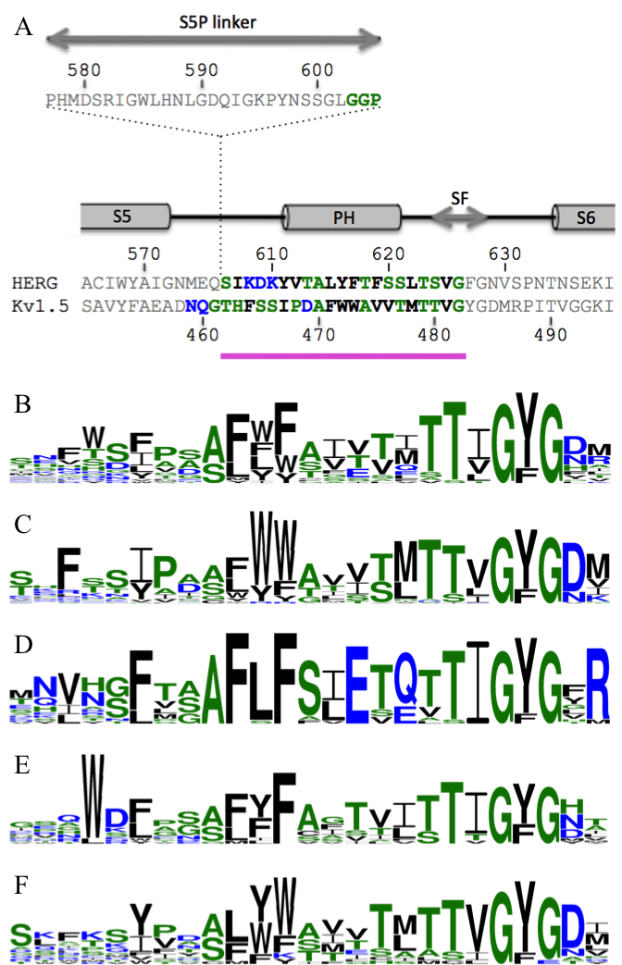

Figure 1: (A) Primary structure of the loop connecting the S5 and S6 helices of hERG and Kv1.5 with the 24 amino-acid residue peptides used in this study in bold. (B-F) Frequency plots of residues corresponding to the purple part in A comprising the pore-helix (PH) and selectivity filter (SF). (B) 22 α subunits of human cardiac potassium channels (Tamargo et al. 2004). (C) 39 human Kv channels. (D) 15 human Kir channels. (E) 14 human K2P channels. (F) 15 prokaryote and eukaryote channels with known structure used in the sequence homology for hERG (Kutteh et al. 2007; Stansfeld et al. 2007; Subbiah et al. 2004; Tseng et al. 2007). The height of the residues represents the frequency with which they occur. The color of the residues represents their hydrophobicity properties with neutral residues in green (S, G, H, T, A, P), hydrophilic charged residues in blue (R, K, D, E, N, Q) and hydrophobic residues in black (Y, V, M, C, L, F, I, W). The frequency plots were generated with WebLogo 3 (http://weblogo.threeplusone.com/). All sequences used were found on the UniProt website (http://www.uniprot.org/) and are listed in Tables S1-S5.

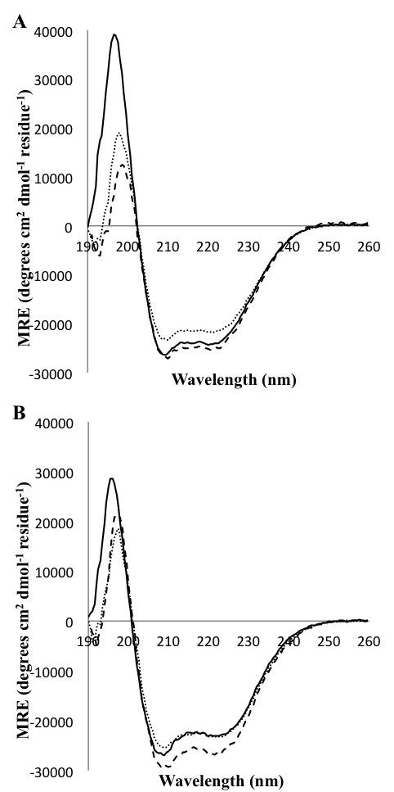
Figure 2: Circular dichroism far-UV spectra of peptides derived from the PH domain of (A) hERG and (B) Kv1.5 channels reconstituted into 8 mM DPC micelles (full lines), 16 mM DMPC/DPC 2:1 bicelles (dotted lines) and 16 mM DMPC/DMPS/DPC 1.8:0.2:1 bicelles (dashed lines).
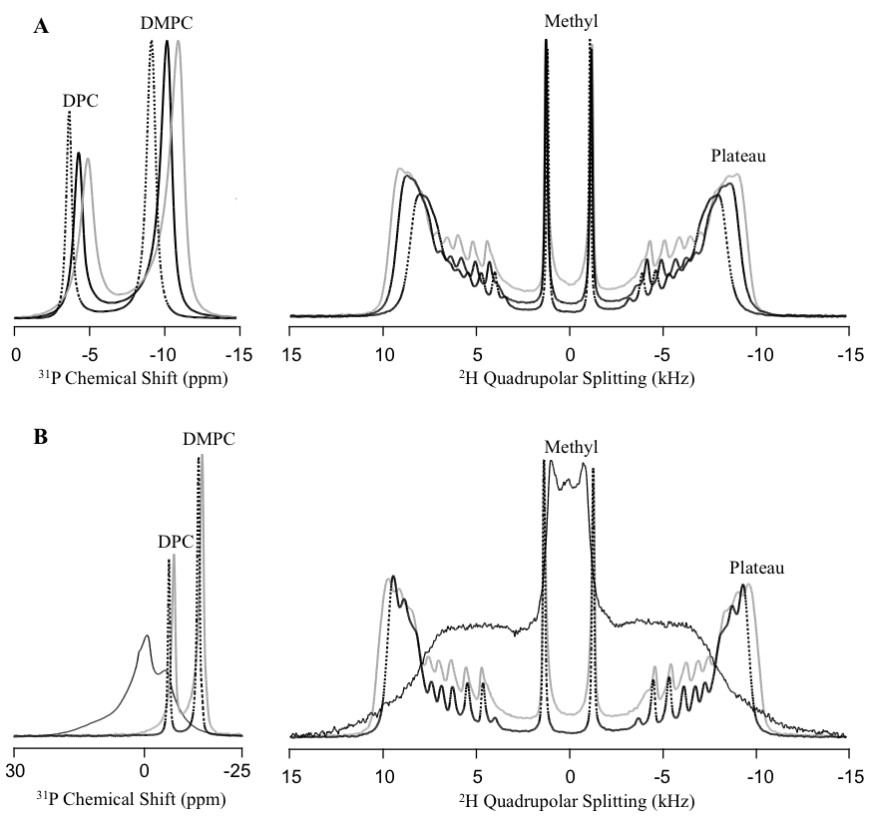

Figure 3: ³¹P (left) and ²H (right) solid-state NMR spectra of (A) DMPC/DPC 2:1 bicelles and (B) DMPC/DMPS/DPC 1.8:0.2:1 bicelles with and without pore-helix peptides recorded at 37°C. Pure bicelles are represented in black dotted lines, with hERG in black full lines and with Kv1.5 in grey full line. In panel B, the spectrum obtained in the presence of hERG’s pore helix was separated since it covers a broader chemical shift range.

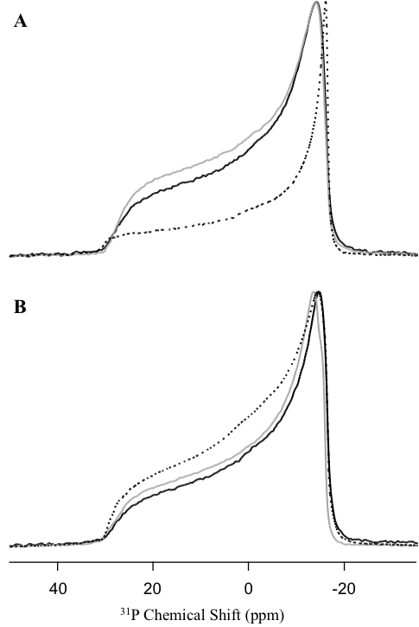

Figure 4: ³¹P solid-state NMR spectra of (A) DMPC and (B) DMPC/DMPS 9:1 MLVs in the presence and absence of pore-helix peptides, recorded at 37°C. Vesicles alone are represented in black dotted lines, with hERG in black full lines and with Kv1.5 in grey full line.

References
Alvis SJ, Williamson IM, East JM, Lee AG (2003) Interactions of Anionic Phospholipids and Phosphatidylethanolamine with the Potassium Channel KcsA. Biophys J 85:3828-3838.
Arnold A, Labrot T, Oda R, Dufourc EJ (2002) Cation modulation of bicelle size and magnetic alignment as revealed by solid-state NMR and electron microscopy. Biophys J 83:2667-2680.
Arora A, Abildgaard F, Bushweller JH, Tamm LK (2001) Structure of outer membrane protein A transmembrane domain by NMR spectroscopy. Nat Struct Mol Biol 8:334-338.
Balla MS, Bowie JH, Separovic F (2004) Solid-state NMR study of antimicrobial peptides from Australian frogs in phospholipid membranes. Eur Biophys J Biophy 33:109-116.
Beaugrand M, Arnold AA, Juneau A, Gambaro AB, Warschawski DE, Williamson PT, Marcotte I (2016) Magnetically Oriented Bicelles with Monoalkylphosphocholines: Versatile Membrane Mimetics for Nuclear Magnetic Resonance Applications. Langmuir 32:13244-13251.
Briggs ELA, Gomes RGB, Elhussein M, Collier W, Findlow IS, Khalid S, McCormick CJ, Williamson PTF (2015) Interaction between the NS4B amphipathic helix, AH2, and charged lipid headgroups alters membrane morphology and AH2 oligomeric state - Implications for the Hepatitis C virus life cycle. Bba-Biomembranes 1848:1671-1677.
Chartrand É, Arnold AA, Gravel A, Jenna S, Marcotte I (2010) Potential role of the membrane in hERG channel functioning and drug-induced long QT syndrome. Biochim Biophys Acta 1798:1651-1662.
Damberg P, Jarvet J, Gräslund A (2001) [13] - Micellar Systems as Solvents in Peptide and Protein Structure Determination. In: Thomas L. James VD, Uli S (eds) Methods in Enzymology, vol Volume 339. Academic Press, pp 271-285. doi:http://dx.doi.org/10.1016/S0076-6879(01)39318-7
Davis JH, Jeffrey KR, Bloom M, Valic MI, Higgs TP (1976) Quadrupolar Echo Deuteron Magnetic-Resonance Spectroscopy in Ordered Hydrocarbon Chains. Chem Phys Lett 42:390-394.
De Carufel CA, Quittot N, Nguyen PT, Bourgault S (2015) Delineating the Role of Helical Intermediates in Natively Unfolded Polypeptide Amyloid Assembly and Cytotoxicity. Angew Chem Int Ed Engl 54:14383-14387.
Doyle DA, Cabral JM, Pfuetzner RA, Kuo A, Gulbis JM, Cohen SL, Chait BT, MacKinnon R (1998) The structure of the potassium channel: molecular basis of K1 conduction and selectivity. Science 280:69-77.
Gravel AE, Arnold AA, Dufourc EJ, Marcotte I (2013) An NMR investigation of the structure, function and role of the hERG channel selectivity filter in the long QT syndrome. Biochim Biophys Acta 1828:1494-1502.
Hite RK, Butterwick JA, MacKinnon R (2014) Phosphatidic acid modulation of Kv channel voltage sensor function. eLife 3.
Kallick DA, Tessmer MR, Watts CR, Li C-Y (1995) The use of dodecylphosphocholine micelles in solution NMR. J Magn Reson B 109: 60-65.
Kamiya K, Niwa R, Mitcheson JS, Sanguinetti MC (2006) Molecular determinants of hERG channel block. Mol Pharmacol 69:1709-1716.
Koehler J, Sulistijo ES, Sakakura M, Kim HJ, Ellis CD, Sanders CR (2010) Lysophospholipid Micelles Sustain the Stability and Catalytic Activity of Diacylglycerol Kinase in the Absence of Lipids. Biochemistry 49:7089-7099.
Kutteh R, Vandenberg JI, Kuyucak S (2007) Molecular dynamics and continuum electrostatics studies of inactivation in the HERG potassium channel. J Phys Chem B 111:1090-1098.
Lee AG (2003) Lipid-protein interactions in biological membranes: a structural perspective. Biochim Biophys Acta 1612:1-40.
Lee AG (2004) How lipids affect the activities of integral membrane proteins. Biochim Biophys Acta 1666:62-87.
Lindström F, Williamson PTF, Gröbner G (2005) Molecular Insight into the Electrostatic Membrane Surface Potential by ¹⁴N/³¹P MAS NMR Spectroscopy: Nociceptin−Lipid Association. J Am Chem Soc 127:6610-6616.
Marcotte I, Dufourc EJ, Ouellet M, Auger M (2003) Interaction of the neuropeptide met-enkephalin with zwitterionic and negatively charged bicelles as viewed by ³¹P and ²H solid-state NMR. Biophys J 85:328-339.
Marius P, de Planque MRR, Williamson PTF (2012) Probing the interaction of lipids with the non-annular binding sites of the potassium channel KcsA by magic-angle spinning NMR. Biochim Biophys Acta 1818:90-96.
Marius P, Zagnoni M, Sandison ME, East JM, Morgan H, Lee AG (2008) Binding of Anionic Lipids to at Least Three Nonannular Sites on the Potassium Channel KcsA is Required for Channel Opening. Biophys J 94:1689-1698.
Marsh D (2013) Handbook of lipid bilayers. 2nd edition edn. CRC Press, Boca Raton
Ng C-A, Gravel AE, Perry MD, Arnold AA, Marcotte I, Vandenberg JI (2016) Tyrosine Residues from the S4-S5 Linker of Kv11.1 Channels Are Critical for Slow Deactivation. J Biol Chem 291:17293-17302.
Ng C, Torres A, Pagès G, Kuchel P, Vandenberg J (2013) Insights into hERG K⁺ channel structure and function from NMR studies. Eur Biophys J 42:71-79.
Nolandt OV, Walther TH, Grage SL, Ulrich AS (2012) Magnetically oriented dodecylphosphocholine bicelles for solid-state NMR structure analysis. Biochim Biophys Acta 1818:1142-1147.
Pages G, Torres A, Ju P, Bansal P, Alewood P, Kuchel P, Vandenberg J (2009) Structure of the pore-helix of the hERG K+ channel. Eur Biophys J 39:111-120.
Pearlstein R, Vaz R, Rampe D (2003) Understanding the structure-activity relationship of the human ether-a-gogo-related gene cardiac K⁺ channel. A model for bad behavior. J Med Chem 46:2017-2022.
Pott T, Dufourc EJ (1995) Action of Melittin on the Dppc-Cholesterol Liquid-Ordered Phase - a Solid-State H-2-Nmr and P-31-Nmr Study. Biophys J 68:965-977.
Ramu Y, Xu Y, Lu Z (2006) Enzymatic activation of voltage-gated potassium channels. Nature 442:696-699.
Rance M, Byrd RA (1983) Obtaining High-Fidelity Spin-1/2 Powder Spectra in Anisotropic Media - Phase-Cycled Hahn Echo Spectroscopy. J Magn Reson 52:221-240.
Russ KA, Elvati P, Parsonage TL, Dews A, Jarvis JA, Ray M, Schneider B, Smith PJS, Williamson PTF, Violi A, Philbert MA (2016) C-60 fullerene localization and membrane interactions in RAW 264.7 immortalized mouse macrophages. Nanoscale 8:4134-4144.
Sanguinetti MC, Jiang C, Curran ME, Keating MT (1995) A mechanistic link between an inherited and an acquired cardiac arrhythmia: HERG encodes the IKr potassium channel. Cell 81:299.
Sanguinetti MC, Tristani-Firouzi M (2006) hERG potassium channels and cardiac arrhythmia. Nature 440:463-469.
Seelig J, Borle F, Cross TA (1985) Magnetic-Ordering of Phospholipid-Membranes. Biochim Biophys Acta 814:195-198.
Silvius JR, Gagne J (1984) Calcium-induced fusion and lateral phase separations in phosphatidylcholine-phosphatidylserine vesicles. Correlation by calorimetric and fusion measurements. Biochemistry 23:3241-3247.
Speyer JB, Sripada PK, Dasgupta SK, Shipley GG, Griffin RG (1987) Magnetic Orientation of Sphingomyelin Lecithin Bilayers. Biophys J 51:687-691.
Sreerama N, Woody RW (2000) Estimation of protein secondary structure from circular dichroism spectra: comparison of CONTIN, SELCON, and CDSSTR methods with an expanded reference set. Anal Biochem 287:252-260.
Stansfeld PJ, Gedeck P, Gosling M, Cox B, Mitcheson JS, Sutcliffe MJ (2007) Drug block of the hERG potassium channel: Insight from modeling. Proteins: Struct, Funct, Bioinf 68:568-580.
Subbiah RN, Clarke CE, Smith DJ, Zhao J, Campbell TJ, Vandenberg JI (2004) Molecular basis of slow activation of the human ether-à-go-go related gene potassium channel. J Physiol 558:417-431.
Subbotina J, Yarov-Yarovoy V, Lees-Miller J, Durdagi S, Guo J, Duff HJ, Noskov SY (2010) Structural refinement of the hERG1 pore and voltage-sensing domains with ROSETTA-membrane and molecular dynamics simulations. Proteins: Structure, Function, and Bioinformatics 78:2922-2934.
Swartz KJ (2006) Greasing the gears of potassium channels. Nat Chem Biol 2:401-402.
Tamargo J, Caballero R, Gómez R, Valenzuela C, Delpón E (2004) Pharmacology of cardiac potassium channels. Cardiovasc Res 62:9-33.
Tardy-Laporte C, Arnold AA, Genard B, Gastineau R, Morançais M, Mouget JL, Tremblay R, Marcotte I (2013) A ²H solid-state NMR study of the effect of antimicrobial agents on intact Escherichia coli without mutating. Biochim Biophys Acta 1828:614-622.
Triba MN, Warschawski DE, Devaux PF (2005) Reinvestigation by phosphorus NMR of lipid distribution in bicelles. Biophys J 88:1887-1901.
Trudeau MC, Warmke JW, Ganetzky B, Robertson GA (1995) HERG, a human inward rectifier in the voltage-gated potassium channel family. Science 269:92-95.
Tseng G-N, Sonawane KD, Korolkova YV, Zhang M, Liu J, Grishin EV, Guy HR (2007) Probing the outer mouth structure of the hERG channel with peptide toxin footprinting and molecular modeling. Biophys J 92:3524-3540.
van der Cruijsen EAW, Nand D, Weingarth M, Prokofyev A, Hornig S, Cukkemane AA, Bonvin AMJJ, Becker S, Hulse RE, Perozo E, Pongs O, Baldus M (2013) Importance of lipid–pore loop interface for potassium channel structure and function. Proc Nat Acad Sci USA 110:13008-13013.
Vandenberg JI, Perry MD, Perrin MJ, Mann SA, Ke Y, Hill AP (2012) hERG K+ Channels: Structure, Function, and Clinical Significance. Physiol Rev 92:1393-1478.
Warschawski DE, Arnold AA, Beaugrand M, Gravel A, Chartrand É, Marcotte I (2011) Choosing membrane mimetics for NMR structural studies of transmembrane proteins. Biochim Biophys Acta 1808:1957-1974.
Whitmore L, Wallace BA (2008) Protein secondary structure analyses from circular dichroism spectroscopy: methods and reference databases. Biopolymers 89:392-400.
Williamson MI, Alvis JS, East MJ, Lee GA (2003) The potassium channel KcsA and its interaction with the lipid bilayer. Cell Mol Life Sci 60:1581-1590.
Wulff H, Castel NA, Pardo LA (2009) Voltage-gated potassium channels as therapeutic targets. Nature Review Drug Discov 8:982-1001.
Zandomeneghi G, Tomaselli M, Williamson PTF, Meier BH (2003) NMR of bicelles: orientation and mosaic spread of the liquid-crystal director under sample rotation. J Biomol Nmr 25:113-123.
Zaydman MA, Cui J (2014) PIP(2) regulation of KCNQ channels: biophysical and molecular mechanisms for lipid modulation of voltage-dependent gating. Front Physiol 5:195.
Zaydman MA, Silva JR, Delaloye K, Li Y, Liang H, Larsson HP, Shi J, Cui J (2013) Kv7.1 ion channels require a lipid to couple voltage sensing to pore opening. Proc Nat Acad Sci USA 110:13180-13185.

