Coupling the oceanic biogeochemical cycles of silicon and zinc through the Southern Ocean

Derek Vance^{1*}, Susan H. Little², Gregory F. de Souza¹, Samar P. Khatiwala³, Maeve C. Lohan^{4,} Rob Middag⁵

¹Institute of Geochemistry and Petrology, Department of Earth Sciences, ETH Zürich, Clausiusstrasse 25, 8092 Zürich.

²Department of Earth Science and Engineering, Imperial College London, South Kensington Campus, Exhibition Road, London, SW7 2AZ, UK.

³Department of Earth Sciences, South Parks Road, Oxford, OX1 3AN, UK.

⁴School of Ocean and Earth Sciences, National Oceanography Centre, University of Southampton, Southampton, UK.

5 Royal Netherlands Institute for Sea Research (Royal NIOZ) P.O. Box 59, 1790 AB Den Burg, Texel, The Netherlands

*Corresponding author: derek.vance@erdw.ethz.ch; phone +41 44 632 6881; fax +41 44 632 1376.

2998 words (including 247 in bold paragraph).
4 figures.
Online Methods

Supplementary Information.
The spatial and vertical distributions of macro- (e.g. phosphate, nitrate, silicate) and metal micro-nutrients (e.g. iron, zinc) control sequestration of carbon by the ocean’s biosphere. The very first data on the oceanic distribution of zinc (Zn)^{1,2} documented the striking similarity in its depth profiles to those of silicate (Si), suggesting coupled uptake into, and regeneration from, the opaline frustules of diatoms¹. However, recent results from culturing³, element distribution in oceanic diatom cells^{4,5}, and studies of regeneration^{6,7}, have shown that the Zn content of diatom opal is negligible, and that Zn is taken up into and regenerated from the organic parts of diatom cells. Thus, from a purely one-dimensional perspective, the similarity of Zn and Si, and the dissimilarity in Zn and PO₄ depth profiles, are at odds with the contrasting vertical length-scales for the regeneration of opal and organic material^{8,9}. Here we compile observations and employ a three-dimensional model of ocean circulation and biogeochemistry¹⁰ to show that the coupled vertical distribution of Zn and Si, as well as the decoupling of Zn and PO₄, can arise in the absence of mechanistic links between the uptake of Zn and Si, and despite these contrasting regeneration length-scales. Our simulations indicate that the oceanic Zn distribution is in fact, a natural result of the interaction between ocean biogeochemistry and the physical circulation through the Southern Ocean hub. This analysis analysis demonstrates the importance of uptake stoichiometry in controlling ocean biogeochemistry, and the utility of elemental co-variation in the ocean in understanding these controls.

Zinc (Zn) plays vital physiological roles in oceanic phytoplankton (e.g., ref 11). Moreover, phytoplankton contents of Zn are of the same order as the essential trace element, iron^{4,5,12}. As a result, and like the major nutrients (P, N, Si), Zn shows extreme depletions in the surface ocean and enrichments at depth (Fig. 1 see Fig. 2 for loactions and sources of all data used in the paper), a distribution that is often conceptualised in terms of one-dimensional vertical cycling involving uptake in the photic zone and regeneration beneath. Though the extent to which Zn concentrations limit photic zone primary productivity is still unclear (e.g., ref 17), the processes that control the removal of Zn from the photic zone, its regeneration in the deep ocean, and its return to the surface via the ocean circulation, are a key part of the dynamics of oceanic nutrient chemistry.

A remarkable feature of nutrient profiles (Fig. 1) is the tight co-variation of Zn and Si in all three major ocean basins. Both elements increase to maxima for each profile in the abyssal ocean, in marked contrast to the mid-depth maximum for PO₄. Though this coupling of Zn to Si has been repeatedly noted^{1,2,16}, its origin has been a puzzle. Rationales for the deep maximum in Si relative to organic-associated nutrients, nitrate and phosphate, have emphasised two key processes: (1) vertical cycling with the greater regeneration length-scale of diatom opal relative to organic matter (e.g., 9); (2) rapid depletion of Si relative to organic-associated nutrients in the surface Southern Ocean, creating distinct water mass signatures that are exported to the rest of the global ocean^{18,19}. And for Zn it has been tentatively suggested that Fe limitation of diatoms may explain co-variation of Zn and Si observed in high-latitude nutriclines²⁰. The first of these two views would suggest that the its oceanic cycle is dominated by uptake into and regeneration from diatom opal. But culturing studies³ have demonstrated that the Zn content of diatom opal is negligible (1-3% of the total cellular inventory), and that the Zn/Si ratio of diatom opal is nearly two orders of magnitude lower than observed in the deep ocean^{1,3}. This is confirmed by synchrotron micro-XRF data^{4,5} from both cultured and natural diatom cells, which clearly show that Zn is co-located with phosphorus in the organic matter of diatom cells and not in their opaline frustules, and that Zn is regenerated from this organic material in the upper ocean, with phosphate and not with silica from opal^{6,7}.

Coupling Zn and Si through diatom uptake in the Southern Ocean
We suggest that the solution to this paradox lies in the biogeochemistry and physical oceanography of the Southern Ocean. Water upwelled at the Antarctic divergence, and moved northward at the surface by Ekman transport to the Sub-Antarctic zone, is stripped of Si and Zn much faster than PO₄ (Fig. 2a). Thus, both Zn and Si concentrations drop by a factor of about 40 over the surface transect shown in Fig. 2, whereas PO₄ drops by only factor 3. This remarkable difference in relative drawdown rates is consistent with the ecological dominance of diatoms in this region (e.g. refs 22, 23), and their peculiarly high Zn/P uptake ratio, up to an order of magnitude greater than for average oceanic phytoplankton⁵. This surface layer is the ultimate source of Sub-Antarctic Mode Water (SAMW), and it is the northward advection of this water mass that, we suggest, sets the low dissolved Si and Zn concentrations, and low Si/PO₄ and Zn/PO₄ ratios, of most of the global upper ocean (Fig. 1). The data in Fig. 2a also imply a rather constant ratio for the removal of Zn and Si from the dissolved pool of the surface Southern Ocean, despite the fact that the Si is taken up into opal and Zn into organic material.

What is the ultimate fate of the large amounts of Zn and Si relative to PO₄ removed from the surface Southern Ocean? The Sub-Antarctic winter mixed layer from which SAMW forms is of the order of 200-400m thick (e.g., ref 24), beneath which the Southern Ocean water column is vigorously mixed and rather homogeneous (e.g., ref 25), including for Si, Zn and PO₄¹⁶. Thus, if diatom cells are exported beneath about 200-400m, their high Zn/P and Si/P characteristics will be imparted to the deep Sothern Ocean regardless of the exact cellular location (opal or organic matter) of the Zn, Si and PO₄. This export, which may be aided by the rapid blooming and equally rapid population collapse that is characteristic of diatom ecology (e.g., refs 22, 23), results in a Zn and Si deficit relative to PO₄ in the mixed layer, which is the source of upper ocean water masses such as AAIW and SAMW.

In summary, the hypothesis we put forward here consists of three components: (1) extreme drawdown of Zn and Si relative to PO₄ in the surface Southern Ocean (Fig. 2a) consistent with the known stoichiometry of Southern Ocean diatoms⁵, thus setting the biogeochemical signature of the surface Southern Ocean and the upper ocean water masses derived from it; (2) export of diatoms cells below the winter mixed layer depth, transferring both Zn and Si at high Zn/PO₄ and Si/PO₄ to the deep Southern Ocean, despite being located in two different components of the diatom cell with different regeneration length-scales, thus setting the biogeochemical signatures of deep and abyssal Southern Ocean-derived water masses (Fig. 1); and (3) lateral export of these water mass signatures to the low latitude oceans (Fig. 2b), as previously proposed to control Si-NO₃ nutrient systematics^{17,18}. The imprint of these processes can be seen on Fig. 3c. Zinc-PO₄ data for the Atlantic sector of the Antarctic zone of the Southern Ocean (including the surface transect in Fig. 3a and the entire water column at 67ºS black triangles¹⁶) indicate co-variation along a line with a slope of about 8 mmol mol⁻¹, consistent with a control by diatom uptake and regeneration. Data fro stations proximal to the Southern Ocean at 40oS in the South Atlantic (entire water column, blue squares¹³) clearly show two different behaviours, with the deep ocean lying close to the Antarctic zone data, and the upper ocean reflecting the much lower slope expected for water masses sources in the mixed layer of the Southern Ocean, from which Zn has been stripped. The red dashed lines indicate, schematically, how water mass mixing in locations more distal from the Southern COean sources would confound these clear distinctions.

Testing the Southern Ocean uptake hypothesis in an ocean model
To provide a quantitative test of these ideas, and taking advantage of the computational efficiency of the transport matrix method¹⁰, we performed a series of 11 sensitivity simulations (see Supplementary Information) using an ocean general circulation model (OGCM) coupled to a biogeochemical model of P, Si and Zn cycling. In the biogeochemical model, PO₄ and Si cycling are treated completely independently. Zinc in the dissolved pool of the oceans is present as both inorganic Zn (Zn’) and complexed with an organic ligand (ZnL). Culturing studies²⁶ have shown that Zn uptake by phytoplankton, and their Zn/P ratios, can be parameterized using the quantitative dependence of Zn uptake on free Zn concentrations, the approach we adopt here. It is currently unclear exactly why Southern Ocean diatoms exhibit high Zn/P uptake ratios, but the high values seen in data⁵ arise in the model simply from the fact that upwelled water in the Southern Ocean contains high concentrations of Zn so that not all of it is complexed by organic ligands, a finding that is also supported by data²⁷.

Although the lengthsclae of Zn regeneration is identical to P in these simulations, and though its cycling is entirely decoupled from that of Si, our simulations reproduce the observed near-linear correlation between Zn and Si at the global scale (Fig. 4c). They also reproduce the slow increase with depth in Zn concentrations through the upper ocean at low latitudes (Fig. 1), despite the fact that Zn is regenerated in the shallow subsurface in the model. The mechanism behind this model behaviour is indicated by our model’s sensitivity to the Zn/P uptake ratio in the Southern Ocean (see Supplementary Information for sensitivity tests): as the average Zn/P ratio of uptake in the Southern Ocean increases, the Zn distribution changes from being closely correlated with that of PO₄ (at Zn:P values of ~1 mmol mol⁻¹) to being very similar to the large-scale Si distribution (at values above ~4.5 mmol mol⁻¹).

The key feature of the Zn-PO₄ plot (Fig. 4d) is the curvature in the model array. This arises because of the partitioning of the global oceans into the two broad regimes in Fig. 3c: a mid-upper ocean that is severely depleted in Zn (and Si) relative to PO₄ as a result of the stripping of Zn (and Si) from the surface Southern Ocean, and the export of this water to the upper ocean globally; a deep and abyssal ocean that is dominated by water masses that originate in the deep Southern Ocean, containing the regenerated counterpart of this surface uptake process. The model is less good at representing the physical mixing outside the Southern Ocean (see schematic trajectories in Fig. 3c), so that it underestimates the scatter in the data in Fig. 4b,d.

We emphasize that our aim here is to provide an explanation for a first order fracture of global Zn-Si-P distributions and, as such, we have deliberately kept the model simple, attempting to restrict the process it represents to those that are well-established. Thus, Zn uptake is tied to that of P as dictated by the results of culturing experiments, and there are no mechanistic links between the update of Zn and Si. We have parameterized Zn speciation in the context of a single model (see Supplementary Information. The model does not consider the potential impacts of variations in metal uptake stoichiometry across different taxonomic groups. It does not consider the potential effects that Fe limitation may have on diatom physiology. Despite this simplicity, the model is very successful in reproducing global dissolved nutrient distributions. Invoking further complexity, such as a significant role for previously-proposed vertical process such as scavenging of Zn by particulate material or a second organic Zn pool associated with opal^{16,28,29} is not required to reproduce first-order global Zn-Si-PO₄ relationships. We have also avoided tuning the model to improve the fit to the data. For example, the slope of the model Zn-Si correlation on Fig. 4c is about 12% below that defined by the data, at 0.056 mmol mol⁻¹ versus 0.064 mmol mol⁻¹. The simulated slope is entirely dependent on assumed model values for the average oceanic Zn and Si concentrations, drawn from the literature (see Supplementary Information). The former, in particular, given the comparative lack of data coverage, is certainly only an estimate as this stage.

Our analysis of Zn-Si-PO₄ systematics in the global ocean has important implications for both Zn itself and for oceanic trace elements more broadly. The implication of our proposal is that Southern Ocean diatoms dominate oceanic cycling of Zn, transferring a large fraction of the oceanic pool to the abyssal ocean and trapping it there, in a direct analogy with Si trapping^{18,19}. The finding that Zn distributions in the global ocean are so profoundly influenced by the stoichiometry of uptake in the Southern Ocean has relevance for studies of other trace metals, their oceanic distributions, and relationships between different nutrients. For example, the “kink” in Zn-PO₄ is reminiscent of the well established “kink” in the relationship between the trace metal cadmium (Cd) and PO₄, whose precise origin is much debated³⁰⁻³². Phytoplankton uptake stoichiometry, speciation of metals in the photic zone, and their systematics in regions of the ocean that are hubs for the physical circulation, are likely as important for other metals as they are for Zn in determining global ocean distributions. The implication is that oceanic metal micronutrient distributions are set by a combination of Southern Ocean ecology and physical circulation, as for major nutrients^{18,19}. Therefore, changes in the Southern Ocean forced by past and future climate change will have global impact.

Methods
Physical model: Ocean general circulation model simulations were carried out using the transport
matrix method (TMM) of Khatiwala et al. (2005) using transport matrices (TMs) derived from a
coarse-resolution version of the MITgcm (Marshall et al., 1997) with 2.8° × 2.8° lateral resolution and 15 vertical levels forced with monthly mean climatological fluxes of momentum, heat and freshwater and with weak restoring of surface temperature and salinity to the Levitus climatology
(Levitus et al., 1998). Our sensitivity simulations were carried out using constant annual-mean circulation fields derived from the equilibrium state of the model after 5000 yr integration; thus, seasonal variability is not represented in our simulations. The physical model is coupled to a biogeochemical model that simulates the internal oceanic cycling of phosphorus (as phosphate,
PO₄, and dissolved organic phosphorus, DOP), zinc (Zn) and silica (Si). Biogeochemical model simulations were initialized with constant nutrient tracer fields (ocean-mean concentrations of 2.17 μM, 5.4 nM and 92 μM for PO₄, Zn and Si respectively) and integrated forward for 5000 model years.

Biogeochemical model: The nutrient-cycling model that forms the basis of our simulations is based on the formulation developed for the OCMIP-2 project (Najjar et al., 2007) and uses PO₄ as its nutrient currency. Phosphate uptake in the surface ocean is driven by restoring surface PO₄ concentrations (Najjar et al., 1992; Anderson and Sarmiento, 1995) towards the objectively analysed annual-mean PO₄ field of World Ocean Atlas 2013 (Garcia et al., 2013) with a restoring timescale of 36.5 days. A fraction of PO₄ taken up is immediately shunted towards DOP, whilst the remaining fraction is exported as an implicit particulate flux to depth, which remineralises following a power-law dependency on depth (Martin et al., 1987; Berelson, 2001). Any particulate flux reaching the bottom of the water column remineralises within the bottom ocean cell. Dissolved organic phosphorus is carried passively with the circulation and decays back to PO4 with a first order rate constant of (0.5 year)⁻¹.
The Zn-cycling model is explicitly coupled to the P-cycling model above. Zinc uptake in the surface ocean is tied to PO₄ uptake via a dimensionless stoichiometric parameter rZn:P (see Zn uptake parameterization below). This surface-ocean uptake drives an implicit export flux of particulate Zn, which remineralises identically to the implicit particulate P flux. The organic speciation of dissolved Zn is represented implicitly by assuming a constant ligand concentration of 1.2 nM with a conditional stability constant of 10¹⁰ M⁻¹, which reduces the calculation of the concentration of free Zn (i.e. organically and inorganically uncomplexed Zn²⁺) to the solution of a
quadratic equation (see Supplementary Information). Varying biogeochemical behaviours of the
Zn-cycling model are achieved by the formulation of the stoichiometric parameter 223 rZn:P, as detailed below.
Our silicon cycling model is conceptually very similar to our PO4-cycling model, and to the Si cycling model of de Souza et al. (2014). Dissolved Si uptake in the surface ocean (≤ 120m water depth) is driven by restoring surface Si concentrations towards the objectively-analysed annual mean Si field of World Ocean Atlas 2013 with a restoring timescale of 36.5 days. This surface
ocean uptake drives an implicit particulate export flux, which dissolves following an exponential dependency on depth with a length-scale of 1000 m (de Souza et al., 2014). Any particulate flux reaching the bottom of the water column remineralises within the bottom ocean cell. It is important
to note that in our model formulation, Si cycling is entirely biogeochemically independent of PO₄ and Zn cycling.
Zn uptake parameterization
Details of the parameterization of Zn uptake, including the rationale behind choices made in defining this parameterization, can be found in the Supplementary Information. Broadly, our
biogeochemical model represents the plasticity in the Zn:P stoichiometry of uptake by phytoplankton (diatoms and coccolithophorids) observed in culture experiments by Sunda and Hunstman (1992). These authors observed that the Zn:P uptake ratio varies non-linearly with the
concentration of free Zn (Zn2+) in the culturing medium, a dependency with the following
functional form (called the “two-site model”):
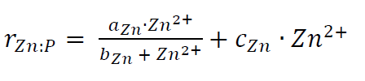 (Eqn. 1)
where rZn:P is the molar Zn:P uptake ratio, and parameters aZn, bZn and cZn are constants analogous to maximum uptake rate, half-saturation constant and non-saturable uptake rate, respectively. The culture data of Sunda and Huntsman (1992) were used to delineate the extent of variability of these parameters in our suite of sensitivity simulations, as detailed in the Supplementary Information. Parameters and key statistical metrics for the 11 sensitivity simulations carried out are listed in Table S1, together with a detailed discussion of the results.
References
1. Bruland, K.W. Oceanographic distributions of cadmium, zinc, nickel, and copper in the North Pacific. Earth Planet. Sci. Lett. 47, 176-198 (1980).
2. Martin, J.H., Gordon, R.M., Fitzwater, S. & Broenkow, W.W. VERTEX: phytoplankton/iron studies in the Gulf of Alaska. Deep-Sea Res. 36, 649-680 (1989).
3. Ellwood, M.C. & Hunter, K.A. The incorporation of zinc and iron in the frustule of the marine diatom Thalassiosira pseudonana. Limnol. Oceanogr. 45, 1517-1524 (2000).
4. Twining, B.S. et al. Quantifying trace elements in individual aquatic protest cells with a synchrotron X-ray fluorescence microprobe. Anal. Chem. 75, 3806-3816 (2003).
5. Twining, B.S. & Baines, S.B. The trace metal composition of marine phytoplankton. Ann. Rev. Mar. Sci. 5, 191-215 (2013).
6. Lee, B.-G. & Fisher, N.S. Release rates of trace elements and protein from decomposing planktonic debris. I. Phytoplankton debris. J. Mar. Res. 51, 391-421.
7. Twining, B.S. et al. Differential remineralization of major and trace elements in sinking diatoms. Limnol. Oceanogr. 59, 689-704 (2014).
8. Berelson, W.M. The flux of particulate organic carbon into the ocean interior: a comparison of four US JGOFS regional studies. Oceanogr. 14, 59-67 (2001).
9. Ragueneau, O., Dittert, N., Pondaven, P., Treguer, P. & Corrin, L. Si/C decoupling in the world ocean: is the Southern Ocean different? Deep-Sea Research II 49, 3127-3154 (2002).
10. Khatiwala, S., Visbeck, M. & Cane, M.A. Accelerated simulation of passive tracers in ocean circulation models. Ocean Modelling 9, 51-69 (2005).
11. Morel, F.M.M., Milligan, A.J. & Saito, M.A. Marine bioinorganic chemistry: the role of trace metals in the oceanic cycles of major nutrients. Treatise in Geochemistry 8, 123-150 (2014).
12. Boyd, P.W. & Ellwood, M.C. The biogeochemical cycle of iron in the ocean. Nature Geoscience 3, 675-682 (2010).
13. Wyatt, N.J. et al. Biogeochemical cycling of dissolved zinc along the GEOTRACES South Atlantic transect GA10 at 40°C. Glob. Biogeochem. Cycles 28, 44-56 (2014)
14. Vu, H.T.D. & Sohrin, Y. Diverse stoichiometry of dissolved trace metals in the Indian Ocean. Sci. Rep. 3, paper 1745. (2013)
15. Geotraces Intermediate Data Product. http://www.bodc.ac.uk/geotraces/data/idp2014.
16. Zhao, Y., Vance, D., Abouchami, W. & de Baar, H.J.W. Biogeochemical cycling of zinc and its isotopes in the Southern Ocean. Geochim. Cosmochim. Acta 125, 653-672 (2014).
17. Moore, C.M. et al. Processes and patterns of oceanic nutrient limitation. Nature Geosci. 6, 701-710. (2013)
18. Sarmiento, J.L., Gruber, N., Brzezhinski, M.A. & Dunne, J.P. High latitude controls of thermocline nutrients and low latitude biological productivity. Nature 427, 56-60 (2004).
19. Sarmiento, J.L. et al. Deep ocean biogeochemistry of silicic acid and nitrate. Global Biogeochem. Cycles 21, B1S90, 10.1029/2006GB002720 (2007).
20. Sunda, W.G. & Huntsman, S.A. Effect of Zn, Mn, and Fe on Cd accumulation in phytoplankton: implications for oceanic Cd cycling. Limnol. Oceanogr. 45, 1501-1516 (2000).
21. Schlitzer, R. Electronic atlas of WOCE hydrographic and tracer data now available. EOS Trans. AGU 81, 45 (2000).
22. Armbrust, E.V. The life of diatoms in the world’s oceans. Nature 459, 185-192. (2009)
23. Assmy, P. et al. Thick-shelled grazer-protected diatoms decouple ocean carbon and silicon cycle in the iron-limited Antarctic Circumpolar Current. Proc. Natl. Acad. Sci. 51, 20633-20638. (2013)
24. Sallée, J. B., Wienders, N., Speer, K. & Morrow, R. Formation of subantarctic mode water in the southeastern Indian Ocean. Ocean Dyn. 56, 525–542. (2006)
25. Marshall, J. & Speer, K. Closure of the meridional overturning circulation in the Southern Ocean. Nature Geosci. 5, 171-180. (2012)
26. Sunda, W.G. & Huntsman, S.A. Feedback interactions between zinc and phytoplankton in seawater. Limnol. and Oceanogr. 37, 25-40. (1992)
27. Baars, O. & Croot, P.L. The speciation of dissolved zinc in the Atlantic sector of the Southern Ocean. Deep Sea Res. II 58, 2720-2732. (2011)
28. Lohan, M.C., Statham, P.J. & Crawford, D.W. (2002) Total dissolved zinc in the upper water column of the subarctic North East Pacific. Deep-Sea Res. II 49, 5793-5808. (2002)
29. John, S.G. & Conway, T.M. A role for scavenging in the marine biogeochemical cycling of zinc and zinc isotopes. Earth Planet. Sci. Lett. 394, 159-167. (2014)
30. Elderfield, H. & Rickaby, R.E.M. Oceanic Cd/O ratio and nutrient utilization in the Southern Ocean. Nature 405, 305-210. (2000)
31. Cullen, J.T. On the nonlinear relationship between dissolved cadmium and phosphate in the modern global ocean: could chronic iron limitation of phytoplankton growth cause the kink? Limnol. Oceanogr. 51, 1369-1380. (2006)
32. Quay, P., Cullen, J.T., Landing, W.M. & Morton, P. Processes controlling the distributions of Cd and PO₄ in the ocean. Glob. Biogeochem. Cyc. 29, 830-841. (2015)

Figure captions

Figure 1: Example depth profiles of Zn, Si and PO₄ in the three main ocean basins
The striking similarity in the depth distributions of Zn and Si stands in marked contrast to the dissimilarity with PO₄. Phosphate shows a prominent increase with depth in the upper ocean, while both Zn and Si peak at greater depths. These depth profiles cannot be explained with a one-dimensional view of ocean biogeochemistry, in which vertical processes represented by uptake in the photic zone and regeneration in the deep dominate, given the different length-scales for regeneration of silica and organic matter, and the association of Zn and PO₄ with organic matter, not with diatom opal. The dashed grey lines mark the local depth of the surface with potential density anomaly σ = 26.80, that of Sub-Antarctic Mode Water (SAMW)¹⁸. The presence of SAMW in the South Atlantic and equatorial Indian oceans is reflected by the low Si and Zn concentrations compared to P; the North Pacific, in which this density level is occupied by another water mass, this difference is less marked. Locations of stations depicted as well as data sources are given in Figure 2.

Figure 2: Location Map
The locations of the stations from which nutrient data are depicted in Figs 1,3 and 4. Pacific data from Bruland et al.¹ (Pacific) and the GEOTRACES 2014 Intermediate Data Product¹³ (Atlantic GA02, H. de Baar, unpublished; Indian GI04¹⁴).

Figure 3: Contrasting variability in nutrient uptake in the Atlantic sector of the Southern Ocean
a: The global decoupling of Zn and PO₄ begins in the photic zone of the Southern Ocean (data shown from around zero meridian^{16,19}), where Si and Zn are strongly depleted (factor ~40 decrease) as water is moved northward from the upwelling zone, (b) whereas PO₄ depletion is much more moderate (factor 3 decrease). This contrast in behaviour, the coupling of Zn-Si depletion and the decoupling of Zn-PO₄ depletion, arises from the extreme Zn/PO₄ uptake ratio for diatoms⁵, up to an order of magnitude higher than for average oceanic phytoplankton. The physical features in a and b were identified using WOCE hydrographic data along the zero meridan²¹. AD, Antarctic Divergence; PF Polar Front; SAF, Sub-Antarctic Front; AZ Antarctic Zone, PFZ Ploar Frontal Zone; SAZ, Sub-Antarctic Zone. c: The distribution of Zn and PO₄ in the water column of the Atlantic sector of the Southern Ocean around the zero meridian. Data for the entire water column at 67°S¹⁹, and for the same surface transect as in a track the removal of Zn and PO₄ at a very high ratio (black triangles, line labelled with a Zn/PO₄ ratio of 8). Data for 40°S¹⁶ demonstrate how the contrasting Zn/PO₄ ratios are imprinted on water masses exported from the Southern Ocean, an extremely low ratio (line labelled 0.3) in the upper ocean, and a high ratio in the deep. The dashed red lines show possible trajectories for mixing between end-members on this diagram.

Figure 4: Coupled major and micro-nutrient distributions in the global ocean
a,b: The close correlation of Zn and Si concentrations is apparent in observations in all three ocean basins (a), in contrast to the decoupling of Zn and PO₄ (b). A large proportion of the Zn-PO₄ data are explained by the schematic scenario outline in Fig. 3c, involving mixing between two arrays created in the Southern Ocean (black arrows), one with a slope of around 0.3 mmol mol⁻¹, the Zn/PO₄ ratio in the surface sub-Antarctic zone where SAMW is sourced, and one drawn through the data for the deep Southern Ocean, which has a slope of 8 mmol mol⁻¹, within the range of Zn/PO₄ ratios in oceanic diatom cells⁵. Data plotted for all stations on each section, and for the entire water column (see Fig.2 for locations and data sources).
c,d: The same data as in the top two panels (grey), together with the results of a three-dimensional model of ocean circulation and biogeochemistry superimposed (colours represent the volume-weighted frequency of model cells with given Zn-Si or Zn-PO₄ characteristics). The model (Simulation 11 of our sensitivity suite: see Supplementary Information) simulates the tight linear relationship between Zn and Si concentrations. The model curvature in the Zn-PO₄ relationship arises because of the high Zn/PO₄ uptake ratio of Southern Ocean diatoms, creating upper Southern Ocean water masses with very low Zn concentrations and a low Zn/PO₄ ratio, and deep Southern Ocean with high Zn concentrations and a high Zn/PO₄ ratio.

Vance et al. Figure 1

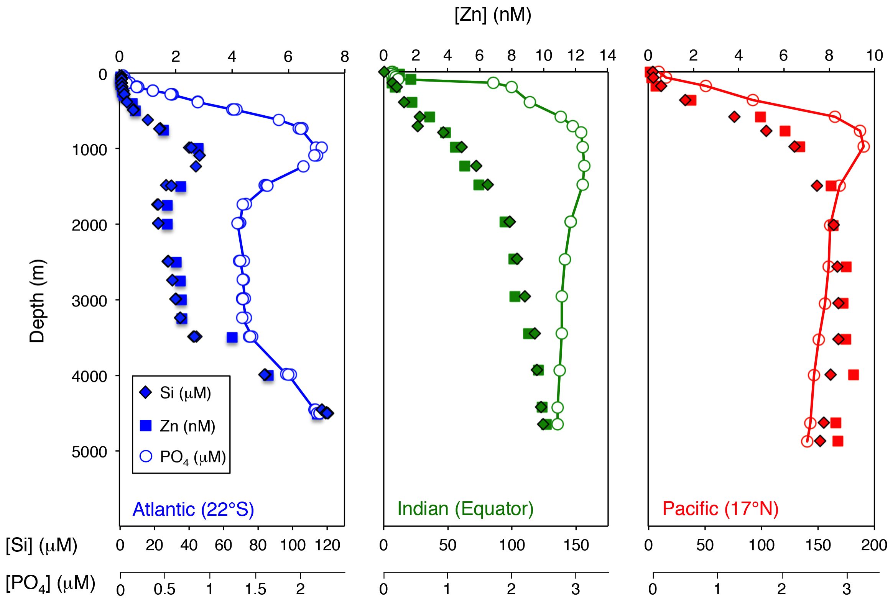

Vance et al. Figure 2

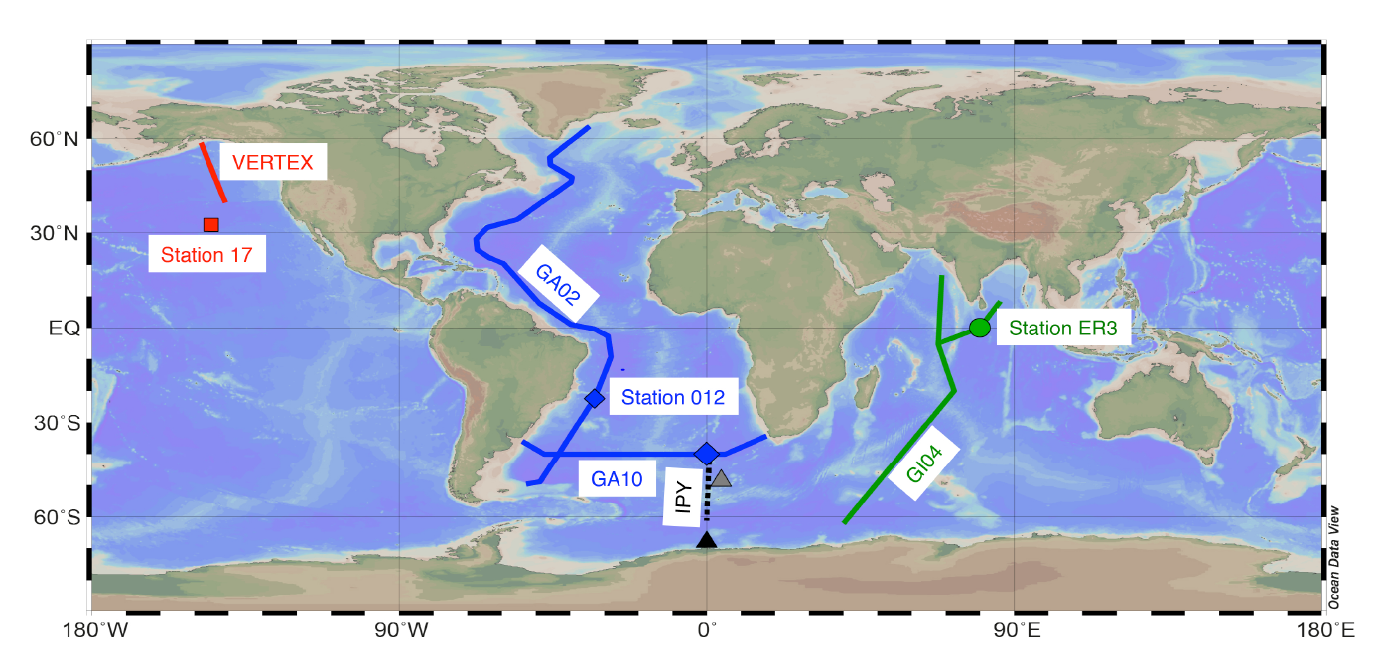

Vance et al. Figure 3

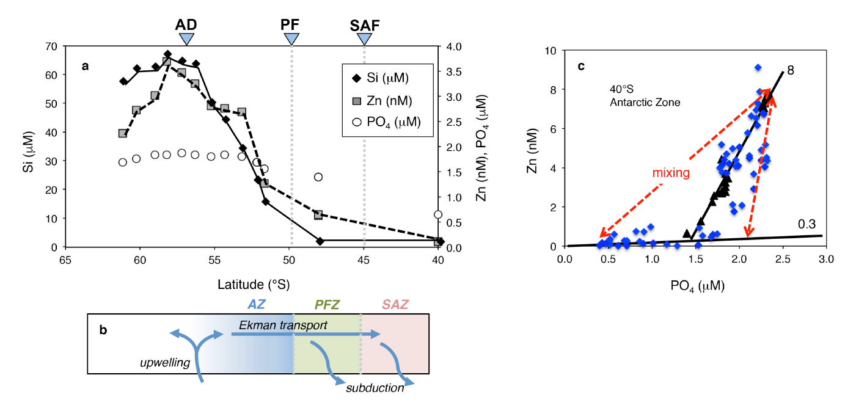

Vance et al. Figure 4

