Achievement of NICE Quality Standards for patients with new presentation of inflammatory arthritis: observations from the National Clinical Audit for Rheumatoid and Early Inflammatory Arthritis

Ledingham JM¹, Snowden N², Rivett A³, Galloway J⁴, Ide Z³, Firth J², MacPhie E⁵, Kandala N⁶, Dennison EM⁶, Rowe I³ on behalf of the BSR national audit Project Working Group

¹Rheumatology Department, Portsmouth Hospitals NHS Trust, Portsmouth, UNITED KINGDOM, ²Rheumatology Department, Pennine MSK Partnership, Oldham, UNITED KINGDOM,
³Clinical Affairs Department, British Society for Rheumatology, London, UNITED KINGDOM,
⁴Rheumatology Department, Kings College Hospital, London, UNITED KINGDOM
⁵Rheumatology Department, Lancashire Care NHS Foundation Trust, Preston, UNITED KINGDOM, ⁶MRC Lifecourse Epidemiology Unit, Southampton University, Southampton, UNITED KINGDOM.

Corresponding author
Dr JM Ledingham
Rheumatology Department
Queen Alexandra Hospital, Cosham,
Portsmouth,
PO6 3LY
E-mail: Jo.ledingham@porthosp.mhs.uk
Abstract
Objectives. A national audit was performed assessing the early management of suspected inflammatory arthritis by English and Welsh rheumatology units. The aim of this audit was to measure the performance of rheumatology services against National Institute for Health and Care Excellence (NICE) quality standards (QSs) for the management of early inflammatory arthritis benchmarked to regional and national comparators for the first time in the UK.
Methods. All individuals >16 years of age presenting to rheumatology services in England and Wales with suspected new-onset inflammatory arthritis were included in the audit. Information was collected against six NICE QSs that pertain to early inflammatory arthritis management.
Results. We present national data for the 6354 patients recruited from 1 February 2014 to 31 January 2015; 97% of trusts and health boards in England and Wales participated in this audit. Only 17% of patients were referred by their general practitioner within 3 days of first presentation. Specialist rheumatology assessment occurred within 3 weeks of referral in 38% of patients. The target of DMARD initiation within 6 weeks of referral was achieved in 53% of RA patients; 36% were treated with combination DMARDs and 82% with steroids within the first 3 months of specialist care. Fifty-nine per cent of patients received structured education on their arthritis within 1 month of diagnosis. In total, 91% of patients had a treatment target set; the agreed target was achieved within 3 months of specialist review in only 27% of patients. Access to urgent advice via a telephone helpline was reported to be available in 96% of trusts.
Conclusion. The audit has highlighted gaps between NICE standards and delivery of care, as well as substantial geographic variability.
Introduction
There is compelling evidence that the outcome of RA is dramatically improved by early diagnosis followed by prompt and intensive treatment. However, there is also evidence that most health systems in wealthy/developed nations struggle to provide early assessment and rapid access to treatment for people with RA. In 2009, the UK National Audit Office reported the cost-effectiveness of early aggressive treatment of RA as well as acknowledging significant geographical variation in RA care across the UK [1]. In the same year, the UK National Institute for Health and Care Excellence (NICE) published clinical guidance (CG79) for the treatment of RA [2] emphasizing the importance of early diagnosis and treatment. In 2013, NICE published quality standards (QSs) for the diagnosis and treatment of RA (QS33) that summarize the principles of rapid and intensive patient-centred treatment [3].
QS1, general practitioner (GP) referral time, states that people with suspected persistent synovitis (swelling) affecting the small joints of the hands or feet, or more than one joint, should be referred to a rheumatology service within 3 working days of presentation to their GP.
QS2, waiting time, states that people with suspected persistent synovitis (swelling) should be assessed in a rheumatology service within 3 weeks of referral.
QS3, time to DMARD, states that people with newly diagnosed RA should be offered short-term glucocorticoids (steroids) and a combination of DMARDs by a rheumatology service within 6 weeks of referral.
QS4, education and self-management, states that people with RA should be offered educational and self-management activities within 1 month of diagnosis.
QS5, treat to target, states that people who have active RA should be offered monthly treatment escalation until the disease is controlled to an agreed low disease activity target.
QS6, urgent access, states that people with RA and disease flares or possible drug-related side effects should receive advice within 1 working day of contacting the rheumatology service.
QS7, annual review, states that people with RA should have a comprehensive annual review that is co-ordinated by the rheumatology service.
However, NICE clinical guidelines and QSs do not place any statutory obligations on National Health Service (NHS) organizations in the UK. The provision of services is determined at local level, and anecdotal and local audit data suggest that there is widespread variation in rheumatologic practice across the NHS. Hitherto there have been no robust measures of this variation at national and local levels.
For this reason, a national audit of the management of RA and early inflammatory arthritis (EIA) was commissioned by the Healthcare Quality Improvement Partnership (HQIP) as part of the NHS National Clinical Audit and Patient Outcome Programme. These audits generally assess quality of care against nationally approved guidelines and provide detailed information on clinical and patient-reported outcomes to inform the wider NHS. For information about the background of the audit, please see the supplementary data section on ‘Background and methodology for the UK national clinical audit for rheumatoid and EIA’, available at Rheumatology Online.
This audit aims to assess the early management of patients referred to English and Welsh rheumatology trusts with suspected inflammatory arthritis and to enable patients to provide feedback on the services provided to them and on the impact of their arthritis on their lives. The audit enables rheumatology services to measure their performance against NICE QSs, benchmarked to regional and national comparators for the first time. All NHS provider organizations have a contractual obligation to participate in the National Clinical Audit and Patient Outcome Programme and hence the audit provides the first effective national lever to improve RA services within the UK.
Methods
The data collection tools were developed by the audit project working group, following extensive consultation, and were approved for use by HQIP and the NHS Review of Central Returns (now the Burden Advice and Assessment Service), who provide recommendations to minimize the burden of data collection. Ethical approval was not required and further information on governance structures, the information technology (IT) tool and on data security can be found in the supplementary data, available at Rheumatology Online.
The questionnaires and web-based IT tool were piloted prior to the national audit launch in February 2014. Patient consent, using HQIP- and Review of Central Returns–approved processes, was obtained for all analysed data. This was sought from patients at the first appointment and recorded on the baseline audit form. Consent guidance was provided to patients explaining the implications of agreeing to participate in the audit, how any personal details would be used and that data would be anonymized for analysis and publication.
All individuals >16 years of age presenting to specialist rheumatology services in England and Wales with new-onset peripheral joint polyarthritis were eligible for inclusion in the audit. Patients were recruited if they had RA, PsA, peripheral arthritis linked with SpA (not pure axial SpA) and undifferentiated arthritis, but were excluded if they had crystal arthritis or arthritis caused by infection (viral or septic arthritis) or linked with CTDs/vasculitis. Clinician-derived data were collected for 3 months from recruitment of each patient with an RA pattern of disease in relation to the NICE QSs. Patient-reported outcome and experience measures and information on each patient’s ability to work were also collected. In addition, organizational data were collected, including catchment population, staff numbers and availability of EIA clinics. Further details on the key measures are available as supplementary data, available at Rheumatology Online.
Results
Data are presented for patients recruited from 1 February 2014 to 31 January 2015. One hundred and forty-three of 148 eligible NHS rheumatology providers in England and Wales registered to participate in the audit and 94% of these supplied data. Data from 6354 patients were analysed, representing >40% of expected incident RA cases based on an expected incidence from previous studies of 15/100 000 [4, 5].
Tables 1 and 2 show the age, gender and ethnicity of patients. Patients were predominantly women (66%) and 70% were of working age (16–65 years). A higher proportion of men were found in the >65 year age group (39%). By far the majority of patients recruited were of white British origin (79%), but there was significant geographical variation in ethnicity, as shown in Table 2.
Table 1
Age and gender of participants
Age group | Total recruited during time window (12 months)
 | Male, n (%) | Female, n (%) | Total, n (%)
All | 2078 (33.6) | 4108 (66.4) | 6186 (100.0)
Working age (16–65 years) | 1353 (31.1) | 2993 (68.9) | 4346 (70.3)
Non-working age (>65 years) | 725 (39.4) | 1115 (60.6) | 1840 (29.7)
Age group | Total recruited during time window (12 months)
 | Male, n (%) | Female, n (%) | Total, n (%)
All | 2078 (33.6) | 4108 (66.4) | 6186 (100.0)
Working age (16–65 years) | 1353 (31.1) | 2993 (68.9) | 4346 (70.3)
Non-working age (>65 years) | 725 (39.4) | 1115 (60.6) | 1840 (29.7)
Table 2
Ethnicity of participants across NHS regions and Wales
Ethnicity | National, n (%) | London, n (%) | Midlands, n (%) | North, n (%) | South, n (%) | Wales, n (%)
All | 6354 (100) | 809 (12.7) | 1374 (21.6) | 2129 (33.5) | 1676 (26.4) | 366 (5.8)
White | 4987 (78.5) | 376 (46.5) | 1149 (83.6) | 1705 (80.1) | 1435 (85.6) | 322 (88)
Black | 175 (2.8) | 130 (16.1) | 27 (2.0) | 11 (0.5) | 7 (0.4) | 0 (0.0)
Asian | 336 (5.3) | 131 (16.2) | 74 (5.4) | 85 (4.0) | 43 (2.6) | 3 (0.8)
Mixed | 106 (1.7) | 41 (5.1) | 27 (2.0) | 17 (0.8) | 19 (1.1) | 2 (0.6)
Not provided | 750 (11.8) | 131 (16.2) | 97 (7.1) | 311 (14.6) | 172 (10.3) | 39 (10.7)
Ethnicity | National, n (%) | London, n (%) | Midlands, n (%) | North, n (%) | South, n (%) | Wales, n (%)
All | 6354 (100) | 809 (12.7) | 1374 (21.6) | 2129 (33.5) | 1676 (26.4) | 366 (5.8)
White | 4987 (78.5) | 376 (46.5) | 1149 (83.6) | 1705 (80.1) | 1435 (85.6) | 322 (88)
Black | 175 (2.8) | 130 (16.1) | 27 (2.0) | 11 (0.5) | 7 (0.4) | 0 (0.0)
Asian | 336 (5.3) | 131 (16.2) | 74 (5.4) | 85 (4.0) | 43 (2.6) | 3 (0.8)
Mixed | 106 (1.7) | 41 (5.1) | 27 (2.0) | 17 (0.8) | 19 (1.1) | 2 (0.6)
Not provided | 750 (11.8) | 131 (16.2) | 97 (7.1) | 311 (14.6) | 172 (10.3) | 39 (10.7)
At the first point of data collection, 46% of patients had an established diagnosis of RA, 16% had undifferentiated EIA, 10% had PsA, 3% had peripheral joint disease linked with AS, 9% had other forms of EIA and 16% had no data provided.
There was wide variation in the number of consultants per 100 000 population, with a mean nationally (England and Wales) of 1.1, which is below the Royal College of Physicians recommended levels of 1.16 [6]; the range was 0.8 (South of England)–1.2 (Wales and the North of England). Higher numbers of specialist nurses per 100 000 population (national average 1.1) were employed in regions with lower numbers of consultants.
Nationally only 75% of trusts reported access to specialist physiotherapy (range 44–86%), 77% to specialist occupational therapy (range 44–89%) and 55% to specialist podiatry services (range 42–83%).
QS 1: GP referral time
Nationally only 17% of patients were referred by their GP to rheumatology within 3 days of first presentation. A quarter of patients waited >3 months to be referred and the median time from first GP contact to referral was 34 days.
There was wide variation in the time intervals reported for this QS, with 40% of patients in Wales but only 11% in the Midlands and East of England meeting this QS. The median and interquartile range (IQR) for the time from GP presentation to rheumatology referral for each region and nationally are shown in Fig. 1, and was lowest in Wales [11 days (IQR 1–64)] and highest in the Midlands and East of England [47 days (IQR 18–124)]. Several trusts could not meet this QS for any patient. There were patients in all NHS regions that waited >1 year to be referred to rheumatology after presenting to their GP. Equally there were patients from all NHS regions that were referred on the day of presentation to their GP.
Figure 1 - variability for NICE Quality Standard 1 across NHS regions and Wales. Red line shows national median waiting time. Boxes show median (blue line) and interquartile range (IQR). Whiskers show 1.5x IQR and blue dots show outlying values.

NHS regions and Wales
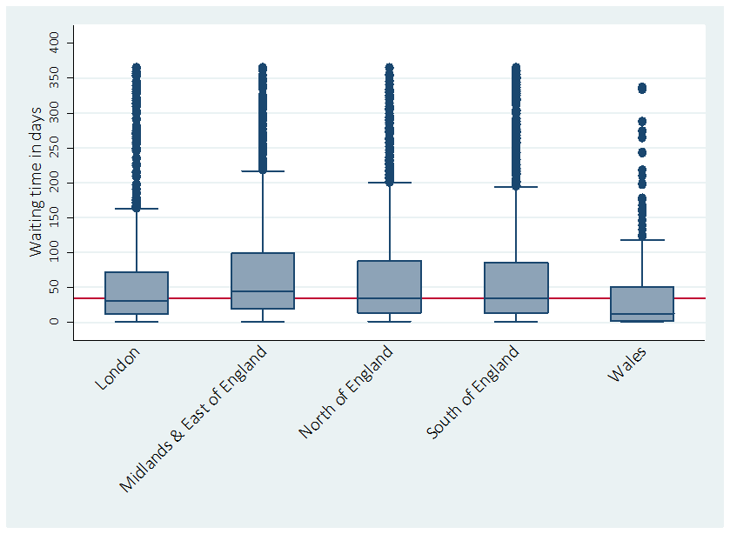

QS 2: waiting time
Nationally only 38% of patients met this QS. The median waiting time nationally was 4 weeks and 25% of patients waited >7 weeks to be seen. Again there was wide variation in results across individual trusts and across NHS regions; 55% of patients seen in London and 28% seen in Wales achieved this QS. The median and IQR for each NHS region are shown in Fig. 2. All NHS regions had patients seen on the same day as receipt of GP referral and all with the exception of Wales had patients waiting times of >60 days. Twelve per cent of referral letters did not indicate that EIA was suspected.
Figure 2 - variability in NICE Quality Standard 2 by NHS region and Wales. The red line represents the overall national median (4 weeks). Boxes show median (blue line) and interquartile range (IQR). Whiskers show 1.5xIQR and blue dots show outlying values.

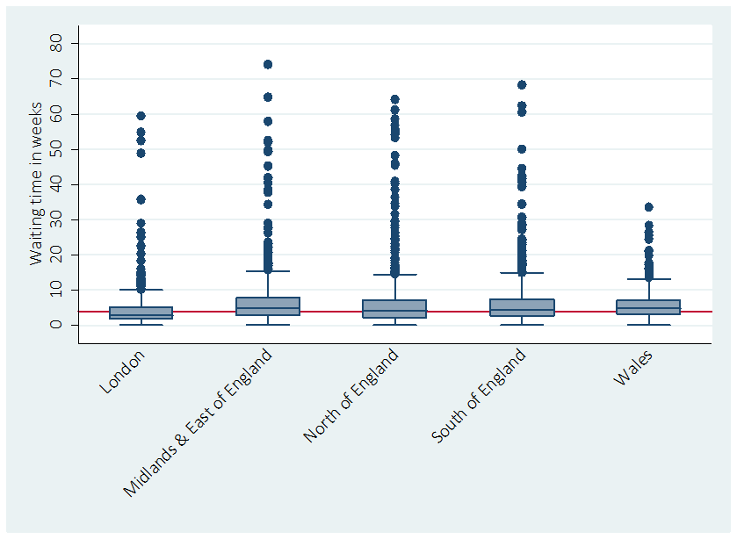
NHS regions and Wales

For the subsequent QSs (3–5) data were analysed only for RA patients (defined by the presence of polyarticular disease (more than five joints involved) or pauci-articular disease with positive CCP antibodies.
QS3: time to DMARD
Table 3 summarizes the data for this QS. Fifty-three per cent of RA patients were treated with DMARDs within 6 weeks of referral. This QS was achieved for the lowest proportion of patients in Wales (48%) and for the highest proportion of patients in the North of England (56%); one trust was unable to meet this QS for any patient.
Table 3
Number and proportion of RA patients started on DMARD/steroids nationally and within NHS regions and Wales
 | Number of RA patients diagnosed at baseline or follow-up | Number of RA patients commenced on DMARDs within 6 weeks, n (%) | Number of RA patients commenced on steroids at any time, n (%) | Number of RA patients commenced on combination DMARDs at any time, n (%)
National | 3268 | 1727 (53) | 2689 (82) | 1183 (36)
London | 318 | 166 (52) | 231 (73) | 133 (42)
Midland and East of England | 798 | 388 (49) | 646 (82) | 308 (39)
North of England | 1067 | 601 (56) | 893 (84) | 408 (38)
South of England | 867 | 464 (54) | 722 (83) | 294 (34)
Wales | 223 | 108 (48) | 197 (88) | 40 (18)
 | Number of RA patients diagnosed at baseline or follow-up | Number of RA patients commenced on DMARDs within 6 weeks, n (%) | Number of RA patients commenced on steroids at any time, n (%) | Number of RA patients commenced on combination DMARDs at any time, n (%)
National | 3268 | 1727 (53) | 2689 (82) | 1183 (36)
London | 318 | 166 (52) | 231 (73) | 133 (42)
Midland and East of England | 798 | 388 (49) | 646 (82) | 308 (39)
North of England | 1067 | 601 (56) | 893 (84) | 408 (38)
South of England | 867 | 464 (54) | 722 (83) | 294 (34)
Wales | 223 | 108 (48) | 197 (88) | 40 (18)
Nationally the reported use of combination DMARDs within the first 3 months of specialist care was relatively low, at 36%; combination DMARD use was lowest in Wales (18%) and highest in London (42%). Some trusts reported no use of combination DMARDs.
Eighty-two per cent of RA patients were reported to have been treated with steroids at some point during the audit. London and Wales used steroids for the lowest (73%) and highest (88%) proportion of patients, respectively.
QS4: education and self-management
Nationally 59% of patients were reported through clinician-derived follow-up data to have received structured education on their arthritis within 1 month of diagnosis. Data from London indicated that this QS was met for only 38% of patients; the North of England was able to achieve this QS for the highest proportion of patients (63%). Interestingly, London struggled to achieve this QS despite reporting the highest number of specialist nurses per 100 000 population (1.2) and the North of England achieved this QS in the highest proportion of patients despite having the lowest number of nurses per 100 000 population (0.8). Again some trusts failed to meet this QS for any patient.
QS5: treat to target
Data on setting and agreeing to treatment targets with patients were assessed for this QS. Potential targets included remission, low disease activity or a functional target. Details on the actual target set have not been analysed within the audit but are available to the individual trusts that provided data. Ninety-one per cent of patients nationally had a treatment target set. Wales set treatment targets in the lowest proportion of patients (82%) and the South of England and the Midlands and East of England achieved this in the highest proportion of patients (97%).
Nationally 90% of treatment targets set were reported to have been agreed with patients, with agreement reported for the lowest proportion of patients in the Midlands and East of England (87%) and for the highest proportion of patients in Wales (94%).
When set from the first appointment for patients with a confirmed EIA diagnosis, this treatment target was achieved by 3 months of specialist review in only 27% of patients nationally, as shown in Fig. 3. Treatment targets were met for the lowest proportion of patients in London (23%) and for the highest proportion in the South of England, North of England and in the Midlands and East of England (27%). Again there were trusts that were unable to meet this QS for any patient.
Figure 3 - proportion of RA patients who achieved a treatment target set at an earlier visit with whiskers showing 95% confidence intervals

NHS regions and Wales

QS6: urgent access
This standard was determined at the department level (rather than the individual patient level). Clinicians reported access to urgent advice via a telephone helpline in 96% of trusts, with very little national variation.
QS7: annual review
All providers reported that they offered an annual review service.
Discussion
This audit has allowed the first comprehensive national benchmarking of care given to people with newly diagnosed inflammatory arthritis in England and Wales. Data quality was generally good, with data collected from the vast majority of trusts. Missing data (detailed below) need to be borne in mind when interpreting the results; very few baseline data were missing, but follow-up data capture was more challenging.
Forty-two trusts did not achieve the numbers of patients anticipated by their catchment population and five trusts did not participate. Data collection for the audit was complex and time consuming and difficult to accommodate in a busy clinical setting. Feedback suggests poor staffing levels and a lack of resources made it difficult for some units to participate in the audit.
The population of patients recruited to this audit was largely as anticipated from epidemiological studies [4, 5]. The data support recent evidence for an increasing age of onset of disease and possible increasing incidence in men.
The spread of confirmed diagnoses at the first appointment was also largely as anticipated. The vast majority of patients had RA, with the next biggest group having undifferentiated arthritis, presumably reflecting diagnostic uncertainty at the time of presentation. Very few patients had spondylitis when presenting for the first time with a peripheral arthritis.
Data for QS1 (referral <3 working days) were available for 6220 patients (98%); working days were not distinguished from non-working days. Data on the date of first GP presentation relied on a combination of patient recall and the record in the GP referral letter. The record of the date of referral letter receipt was complicated by the many and varied systems used by trusts for processing referrals/booking appointments. Despite these considerations, there is clear evidence of significant delay between first presentation to a GP and referral to rheumatology for most patients in England and Wales. These delays are consistent with data from other more limited studies [7]. The wide variation in results is likely to reflect considerable variations in awareness of this QS among GPs, along with barriers within some localities to referral to rheumatology. The fact that referral was made for some patients on the day of presentation to a GP in all NHS regions suggests that for some patients and some GPs the decision to initiate referral is clearer than for others. This highlights the need for rheumatology units to promote the importance of early referral for specialist assessment and to help remove organizational barriers to timely referral.
Data for QS2 (assessment by rheumatology within 3 weeks) were available for 6331 patients (>99.5%). Again there was noteworthy variation in the ability to meet this QS. The data highlight that even after referral is initiated, there is significant delay in gaining a specialist assessment for a large proportion of patients, and this impacts on the ability to meet other QSs and potentially on the ability to preserve joint integrity and function. Higher levels of consultant staffing (>1 consultant per 100 000 population served) and the presence of specific EIA clinics were found to significantly associate with shorter waiting times for a specialist appointment [odds ratio 1.3 (95% CI 1.1, 1.4) and 1.6 (1.4, 1.7), respectively].
To assist in the processes for booking an urgent appointment, rheumatology units are encouraged to work with primary care colleagues to establish systems promoting the provision of important information in referral letters so that any potential for an inflammatory arthritis is clearly highlighted. Although not directly assessed in this audit, processes in some trusts that do not allow clinicians to see referral letters, and hence influence waiting times, are factors that are likely to impact on the ability to meet this QS that may warrant review. This audit confirms that staffing levels can impact on the timeliness of appointments, but how the configuration of staff and EIA clinics improve waiting times is yet to be elucidated and is a recommended topic for future research.
Data for QS3 (treatment with glucocorticoids and combination DMARDs within 6 weeks) were missing for 1813 clinician baseline forms (29%), so this needs to be borne in mind when interpreting the results. While the overall statistic of slightly more than half of RA patients starting one or more DMARDS within 6 weeks of referral might seem disappointing, the fact that only 38% of patients are seen within 3 weeks of GP referral suggests that most rheumatology services are swiftly starting DMARD treatment once a patient is diagnosed. Steroids are much more widely used in the early stages of disease management than DMARDs and clinicians use some form of disease-modifying treatment (steroids and/or DMARDs) for the vast majority of RA patients at the point of diagnosis and within the first 3 months of specialist care. There is some suggestion that the approach to early management of RA differs across NHS regions; for example, Wales had the highest use of steroids but the lowest use of DMARDs within 6 weeks and of combination DMARDs. This would be a further potential topic for future research. There are a huge number of factors that influence how rapidly RA treatment can be safely commenced and these need to be considered when looking at the results for QS3.
There may be inadequate time available at initial appointments to provide patients with sufficient information to safely initiate treatment. The increasing requirement to establish a diagnosis, supply adequate information to patients and gain consent to commence treatment at a single appointment has not been accompanied by an increase in appointment duration in most units. The importance of giving sufficient information about treatment risks and of gaining consent for treatment has been emphasized with recent high-profile UK court rulings such as the ‘Montgomery’ case [8, 9]. Unless a one-stop service is available, a further appointment with a specialist nurse at a later date is usually required to implement shared decision making prior to DMARD initiation. The lack of availability of baseline investigations, particularly in patients with co-morbidities, will also delay DMARD initiation for some patients.
Staffing levels and the availability of timely follow-up appointments become crucial if treatment is not initiated at the first appointment; only 6% of RA patients had timely (within 6 weeks of referral) initiation of DMARD therapy from a follow-up appointment. The reasons for this are clear: by the time most patients had their first follow-up appointment they had already passed the 6 week benchmark for QS3.
Of interest, slightly more than one-third of RA patients were started on combination DMARDs. The 2013 European guidelines for the treatment of RA [10] allow the use of monotherapy. The reasons for this audit finding warrant further research, but clinicians and patients may prefer the sequential introduction of DMARD treatment to the immediate initiation of combination DMARDs. An inability to see patients monthly for treatment escalation may have prevented initiation of combination DMARDs within the 3 month time frame assessed with this audit. Clinicians and patients may have reservations about combination therapy for patients with milder disease at presentation.
Data for QS4 (structured self-management and education within 1 month) were available for 2499 patients (80%) of those attending for follow-up. Approximately one-third of providers could not offer a structured patient education and self-management service within 1 month of diagnosis (QS4). It should be noted, however, that wide CIs were observed for NHS regions and trusts with lower achievement rates for this QS. No comment can be made on whether the problem when not achieving this QS was with availability of education, its format or the ability to provide education within 1 month. As nursing staff are most likely to provide this service, this relationship warrants further investigation.
Data were available on initial treatment target setting (component of QS5) for 6097 patients (96%). Reassuringly, the vast majority of clinicians report that they are setting treatment targets and agreeing to these with their patients as a measure of compliance with QS5. No verification of these data has been undertaken and no comment can be made on how reliably any such treatment target is set and documented. The reasons for not agreeing to a treatment target with patients cannot be derived from the data, but this may relate to time pressures within clinics. Patient verification of agreed upon targets was not possible from the audit data.
Since early control of inflammation is crucial in determining longer-term outcomes, it is of concern that only slightly more than one-quarter of patients achieve the treatment target set from their first appointment within 3 months of follow-up. However, data were missing at follow-up for 1658 patients (47%). The reasons for the low achievement of treatment targets are not clear from the audit data. One possible explanation is that the time frame for response was too short to truly assess response. Other factors might include a limited capacity for intensive follow-up; the use of suboptimal treatment regimes, including the underuse of combination DMARDs and steroids; problems of compliance with treatment and/or tolerance of treatment.
Data were available for 6338 patients (>99.5%) for QS6. Virtually all patients were considered by their clinicians to have rapid access to advice if needed, although it was not possible to determine the extent and quality of the facilities offered by individual trusts from the data gathered.
In summary, these data should prove invaluable to English and Welsh trusts when assessing any requirement for service improvements and there are a number of examples where the data have already been used to deliver improvements to patient care.
The key recommendations arising from this first year’s data include that rheumatology health professionals need to work closely with primary care colleagues to raise awareness of the symptoms and signs of EIA and of the importance of early referral for diagnosis and treatment; that mechanisms for ensuring key information are provided in referral letters from primary care should be explored, as this should help rheumatology departments to prioritize appointments; that processes and capacity within rheumatology services should be reviewed to ensure first appointments are available within 3 weeks; that intensive treatment can be delivered in the crucial early stages of disease; that patients receive appropriate and timely education packages and have access to rapid advice when needed and that further work is needed to improve recruitment in low-recruiting areas and to improve the quality of data collected.
Acknowledgements
The authors acknowledge and express their thanks to all clinicians, audit departments and patients that have submitted data to the audit, to HQIP for commissioning the audit, to Northgate Public Services for providing the IT platform for data collection, to the Medical Research Council Lifecourse Epidemiology Unit in Southampton for the statistical analysis and to all members of the National Audit Project Working Group and Steering Committee. The audit data are owned by HQIP and are held by HQIP in a secure repository.
Funding: The national clinical audit for RA and EIA was commissioned by the Healthcare Quality Improvement Partnership (HQIP) as part of the National Clinical Audit Programme. HQIP is led by a consortium of the Academy of Medical Royal Colleges, the Royal College of Nursing and National Voices. The programme is funded by NHS England, the Welsh government and, with some individual audits, by the Health Department of the Scottish government, Department of Health, Social Services and Public Safety Northern Ireland and the Channel Islands.
Disclosure statement: E.M. has been sponsored to attend international meetings by Pfizer and Roche and has accepted honoraria for educational meetings from Pfizer and Roche; her department has received sponsorships from Pfizer, AbbVie and MSD to support clinical meetings. J.G. has received an honorarium from Pfizer for an educational talk and holds an Inflammation Competitive Research Programme (i-CRP) grant to study polypharmacy in RA. All other authors have declared no conflicts of interest.
Supplementary data are available at Rheumatology Online.
References
- National Audit Office. Services for people with rheumatoid arthritis. In. http://www.nao.org.uk/report/services-for-people-with-rheumatoid-arthritis; 2009.

- National Institute for Health and Clinical Excellence. Rheumatoid arthritis: The management of rheumatoid arthritis in adults. https://www.nice.org.uk/guidance/cg79 2009 [accessed August 2015].

- National Institute for Health and Care Excellence. Rheumatoid Arthritis: NICE Quality Standard [QS33]. https://www.nice.org.uk/guidance/qs33 [accessed August 2015] 2013 [accessed August 2015].

- Rodriguez LA, Tolosa LB, Ruigomez A, Johansson S, Wallander MA. Rheumatoid arthritis in UK primary care: incidence and prior morbidity. Scand J Rheumatol 2009;38(3):173-7.

- Humphreys JH, Verstappen SM, Hyrich KL, Chipping JR, Marshall T, Symmons DP. The incidence of rheumatoid arthritis in the UK: comparisons using the 2010 ACR/EULAR classification criteria and the 1987 ACR classification criteria. Results from the Norfolk Arthritis Register. Ann Rheum Dis 2013; 72(8):1315-20.

- Royal College of Physicians. Consultant physicians working with patients. 2013; 5th Edition: 243.

- Raza K, Filer A. The therapeutic window of opportunity in rheumatoid arthritis: does it ever close? Ann Rheum Dis 2015; 74(5):793-4.

- Montgomery v Lanarkshire Health Board [2015] UKSC 11.

- Sokol D Update on UK Law on consent BMJ 2015; 350 doi: http://dx.doi.org/10.1136/bmj.h1481 (Published 16 March 2015)

- Smolen JS, Landewe R, Breedveld FC, et al. EULAR recommendations for the management of rheumatoid arthritis with synthetic and biological disease-modifying antirheumatic drugs: 2013 update. Ann Rheum Dis 2014; 73(3):492-509.

