A Rechargeable, Aqueous Iron Air Battery with Nanostructured Electrodes Capable of High Energy Density Operation
H.A. Figueredo-Rodríguez, ª R.D. M^{c}Kerracher, ª, M. Insausti ^{b}, A. Garcia Luis ^{b}, C. Ponce de Leόn ^{a,*}, C. Alegre ^{c}, V. Baglio ^{c}, A.S. Aricò ^{c}, F.C. Walsh ª
a. Electrochemical Engineering Laboratory, Engineering Sciences, University of Southampton, Highfield, Southampton, SO17 1BJ, UK.
b. Tecnalia Research & Innovation, Parque Tecnológico de San Sebastián, Mikeletegi Pasalekua, 2, Donostia San-Sebastian, E-20009, Spain.
c. Consiglio Nazionale delle Ricerche, Istituto di Tecnologie Avanzate per l'Energia "Nicola Giordano", Salita S. Lucia sopra Contesse, 5. 98126 Messina, Italy.

Abstract
In order to decrease the global dependence on fossil fuels, high energy density, rechargeable batteries with high charge capacity are required for mobile applications and efficient utilisation of intermittent sources of renewable energy. Metal-air batteries are promising due to their high theoretical energy density. In particular, the iron-air battery, with a maximum specific energy output of 764 W h kg⁻¹_{Fe}, represents a low cost possibility. This paper considers an iron-air battery with nanocomposite electrodes, which achieves an energy density of 453 W h kg⁻¹_{Fe} and a maximum charge capacity of 814 mA h g⁻¹_{Fe} when cycled at a current density of 10 mA cm⁻², with a cell voltage of 0.76 V. The cell was manufactured by 3D printing, allowing rapid modifications and improvements to be implemented before an optimised prototype can be manufactured using traditional computer numerical control machining.

Keywords: 3D printed battery; air electrode; metal-air battery; nanostructured electrodes;
- Introduction
Metal air batteries have a high theoretical energy density and show great promise for applications in transport and stationary energy storage. The development of a battery able to satisfy the energy and power requirements of a particular application requires considerable electrochemical engineering cell design and characterization of active materials. There are considerable advantages of rechargeable metal-batteries with aqueous electrolytes, namely, low cost, insensitivity to moisture (in contrast to lithium) and the ability to refurbish the electrolyte when required. The high corrosion rates and fire hazards of aluminium and lithium in liquid systems are challenging and the metal electrode must be protected from the electrolyte; for example by a porous ceramic layer or a surfactant making these systems expensive [1-3]. Zinc- and iron-air batteries do not suffer from such corrosion and safety problems therefore are attractive candidates for rechargeable aqueous metal-air batteries. Of the two, zinc-air batteries are the most-studied, with a higher theoretical cell voltage of 1.65 V compared to iron-air cells at 1.28 V [4, 5].

Unlike zinc-air, the iron-air battery does not suffer metal dendrite formation on repeated cycling, suggesting that the cycle lifetime of iron electrodes could, in theory, be longer, and an electrolyte flow system is not required to prevent dendrite formation since solid state reactions take place on the coated electrode surface [6]. All reaction and products are solid rather than being dissolved in the electrolyte, as in the zinc-air system [7, 8]. This simplifies the battery construction, as there is no need for a separator to prevent dissolved metal species reaching the air electrode and, in some cases, the electrolyte does not need to be circulated through the cell to ensure uniform electrodeposition of iron during recharging, except to remove heat and replenish the electrolyte. The objective of this paper is to characterize a rechargeable iron-air battery and to analyse the behaviour of the iron and oxygen half-cells.

Iron-air cells usually employ concentrated aqueous alkaline solution of NaOH or KOH at 3 - 6 mol dm⁻³ to ensure good ionic conductivity and to facilitate the reduction and evolution of oxygen reactions on the bifunctional catalyst of the oxygen electrode [6]. The solubility of the iron oxide products is very low in alkaline solution compared to neutral or acidic solutions, which help to maintain the stability of the solid-state iron electrode. It is particularly important that the catalytic surface of the air electrode is wetted with the electrolyte, whilst the gas diffusion layer remains dry to allow facile oxygen diffusion towards the catalyst layer [9].
The oxidation of the iron electrode during the discharging cycle involves two steps, each involving two electrons [10 - 12]:
Fe + 2OH⁻ Fe(OH)₂ + 2e- E = - 0.88 V vs. SHE (1)
3Fe(OH)₂ + 2OH⁻ Fe₃O₄ + 4H₂O + 2e⁻ E = -0.76 V vs. SHE (2)
The reverse reactions represent the charging half-cycle. The discharge reaction at the air electrode also involves 4 electrons [13, 14] :
O₂ + 2H₂O + 4e⁻ 4OH⁻ E = + 0.401 V vs. SHE (3)
The overall cell reaction is then:
3Fe + 2O₂ Fe₃O₄ E_{cell} = 1.16 – 1.28 V (4)
Previous studies of the iron-air battery, during the 1970s, reported overall practical specific energy densities up to 110 W h kg⁻¹, which compares well with other secondary batteries such as lead acid batteries at 40 – 50 W h kg⁻¹ [8] and the 200 W h kg⁻¹ energy density achieved with secondary zinc-air cells [7]. A battery produced by the Swedish Development Cooperation achieved more than 1,000 cycles of operation at an energy density of 80 W h kg⁻¹ [6, 8]. It is clear that there remains room for improvement, given that the theoretical values of the iron-air battery are larger at 764 W h kg⁻¹_{Fe}. Since these results were achieved in the 1970s and 80s, relatively little has been published in the literature on iron-air batteries [6].

One of the main limiting factors on the performance of any metal-air battery is the bifunctional air electrode. There is usually a high overpotential for the oxygen reduction reaction (ORR) at most catalysts and the oxygen evolution reaction (OER) requires a catalyst able to withstand corrosion at high positive potentials values [6]. The kinetics of the ORR and OER are notoriously slow [4, 5, 9]. Additionally, air electrodes are highly prone to structural damage, due to corrosion of the support [15 - 19], particularly during recharging. Recent half-cell studies showed that a nanostructured palladium catalyst deposited on highly graphitized carbon was able to cycle over 1,000 cycles at a current density of 10 mA cm⁻² [20]. The onset potential for oxygen reduction at this electrode was +10 mV vs. Hg/HgO (+122 mV vs. SHE), which is +279 mV below the theoretical potential for oxygen reduction in alkaline solution (+401 mV vs. SHE).

3D printing in electrochemistry
Traditionally, laboratory prototypes are manufactured in a workshop, on a one-off basis, by computer numerical control machining (CNC) involving milling and other machining techniques [21, 22]. The engineering design usually involves feedback from the manufactured prototype to improve the design until a satisfactory is developed. This traditional manufacturing route is costly and time consuming with little flexibility if the prototype requires subsequent modification. Additive manufacturing or 3D printing, has introduced a new level of digital, on-screen design and manufacturing freedom, due to the ability to conceive and manufacture prototypes in a matter of hours. There are limitations, however, on the availability of materials used for 3D printing, [23] and additional design complexity introduced by the anisotropy of the 3D printed material (including porosity) that might cause the piece to suffer deformations as a result of thermal stress after manufacturing.

This paper presents an iron-air battery, having a 3D printed cell body and nanocomposite electrodes that has achieved an energy density of 453 W h kg⁻¹_{Fe} and a maximum charge capacity of 814 mA h g⁻¹ when cycled at a current density of 10 mA cm⁻².

- Experimental details
2.1. Synthesis of air electrode catalyst
The Pd catalyst was synthesized by a colloidal method, employing sulphite as a complexing agent, as described elsewhere [20, 24]. The carbon support (supplied by Imerys Graphite & Carbon, 220 m² g⁻¹ specific surface area) was suspended in distilled water and stirred in an ultrasonic water bath at 80 °C to form a slurry. An acidic solution containing an appropriate amount of Na₆Pd(SO₃)₄, was added to the slurry to reach a final loading of 30 wt. % of Pd on the carbon support. The Pd sulphite complex solution decomposes by adding H₂O_{2,} and then the pH increased successively to 5.5 in order to form a PdOx/C suspension. The metallic oxide was reduced in a H₂ stream at room temperature (20 °C) to achieve a 30 wt. % Pd/C catalyst.

2.2 Synthesis of the iron electrode materials
The iron oxide was synthesized by a molten salt fusion method [25, 26] where the iron precursor FeCl₂, was dispersed in iso-propanol under magnetic stirring followed by addition of the necessary amount of NaNO₃. The mixture was left to evaporate for several hours and the resulting powder was calcined at 500 °C for 1 h, the resultant Fe₂O₃ being dried then ball-milled in ethanol for 48 h as described in [27]. The iron oxide was mixed in the ball-milling apparatus for 4 h with 10 % wt. carbon material (supplied by Imerys Graphite & Carbon) in the presence of ethanol to favour mixing of the solid ingredients. In order to suppress hydrogen evolution (a competing reaction with reduction/oxidation of the iron species), 4 % wt. Bi₂S₃ was also added to the Fe/C composite during ball-milling.

X-ray diffraction (XRD) patterns were obtained from a Philips X-pert 3710 diffractometer with Ni-filtered Cu Kα radiation operating at 40 kV and 20 mA in order to characterize phase composition of the Fe/C composites. Transmission electron microscopy (TEM) was used to study the morphology of the sample. The Fe/C composite was analysed in a FEI/Philips CM12 TEM microscope by depositing a few drops of solution containing the composite dispersed in isopropyl alcohol, on carbon-film-coated Cu grids.

2.3 Manufacture of the air electrodes
The Pd/C gas diffusion electrode comprised three main parts bound together by hot pressing: a gas diffusion layer, a catalyst layer and a current collector. In order to produce the gas diffusion layer, a paste was made from 80 wt% of high surface area (ca. 64 m² g⁻¹) carbon (supplied by IMERYS Graphite & Carbon) mixed with 20% wt. PTFE (DISP 30 solution, DuPont) and 10 cm³ water per 1 g of solids. The paste was rolled evenly over a 5 cm × 5 cm piece of carbon cloth (0.11 mm thickness, treated with 25% wt. PTFE from FuelCell.com) then hot-pressed at 140 ºC and 250 kPa for 10 minutes to a thickness of approximately 100 µm.
The catalyst layer included 30 % wt. Pd/C catalyst sonicated for 15 minutes in a 5% wt. Nafion solution containing aliphatic alcohols (from Sigma Aldrich), with a weight ratio of 3:2 catalyst:Nafion. The sonication resulted in a black viscous ink that was evenly spread on top of the gas diffusion layer (which was not allowed to dry out in order to prevent it from detaching from the carbon cloth before hot-pressing). The mass of the 30% wt. Pd/C catalyst was calculated to ensure a 0.5 mg cm⁻² loading of Pd on the surface of the electrode. Finally, a piece of expanded nickel mesh (Dexmet, 32 mesh, 0.05 mm thick) was cut to size and placed on top of the catalyst layer. The three layers comprising the air electrode were placed in a hydraulic press (Carver, model 3851) whilst still slightly wet and pressed for 2 minutes at 180 °C and 250 kPa.

The electrode was coated using non-stick silicone paper to prevent it from sticking to the plates of the hot-press. The electrode was carefully removed from the press and left to cool at room temperature (20 °C).

2.4 Manufacture of iron electrodes
The iron electrode consisted of 95% wt. iron-carbon active paste held together with 5 wt. % PTFE solution (Ion Power TE 3859 PTFE with 60% wt. polymer content) hot-pressed at 200 °C and 12 000 kPa for 1 h. The active paste was a combination of 85.7% wt. Fe₂O₃ corresponding to 60% wt. Fe, 10 % wt. C-TimCal® (Imerys Graphite & Carbon) and 4% wt. Bi₂S₃, synthesized as described in section 2.2.

The iron-carbon paste and the PTFE solution were mixed with 100 ml distilled water then placed in the ultrasonic bath for 5 hours at 70 °C until a thick paste developed. The carbon paste was dried under an infrared lamp and the resulting mixture was ground to a fine powder in an agate mortar following by hot-pressing between two steel mesh current collector (0.634 mm opening and 016 mm wire diameter) at 200 °C and 12 MPa for 1 h. The excess mesh was cut into a 1 cm × 5 cm strip, which used as the electrical connection. The iron electrode contained 2.5 g of Fe from the Fe₂O₃ active material.

2.5 Cell design and 3-D printing of the iron-air laboratory cell
The iron-air battery (IAB) laboratory prototype had the following design brief:
- Sufficient space to place a 5 cm × 5 cm negative iron electrode in parallel with one positive air electrode in each side.
- The material of the cell is chemically resistant to 6 mol dm⁻³ KOH electrolyte and capable of use in the range -20 to 80 ºC.
- The gas diffusion layer on the positive air electrode facilitates the transport of air/oxygen during its operation and its hydrophobicity keeps the electrolyte within the cell.
- The interelectrode gap should be as small as possible in order to reduce the resistance of the electrolyte in the inter-electrode gap and improve the cell performance whilst still allowing enough space for the evolved gases to escape; in this case, it was 5 mm.
- During operation, both H₂ and O₂ evolution might occur during the charging cycle: O₂ evolution on the air electrode while H₂ might evolve during this process on the iron electrode. The electrode design should allow the escape of these gases to minimise blockage at the electrode surface.
- Recyclability of the cell components, as well as facile assembly and disassembly of the cell.
- The cell should be robust and light in order to ensure the mechanical integrity and increase the overall specific energy.
In order to comply with these requirements, several designs were considered then drafted using Autodesk Inventor 2015 and 3D printed in ABS thermoplastic, with a “Dimensions 1200” printer manufactured by Stratasys.

2.6 Electrochemical characterization.
The iron and air electrodes were tested independently in a half-cell configuration in the 3D printed cell body described below.

2.6.1 Iron electrode half-cell electrochemical testing
A three-electrode cell configuration containing: 5 cm × 5 cm iron working electrode, a 7.5 cm × 8 cm nickel counter electrode (from a Changhong 10 A h Ni-Fe battery) and Hg/HgO as a reference electrode, was used. The electrolyte was 6 mol dm⁻³ KOH and the working and counter electrodes were separated by 3 mm using a PTFE frame punched with 5 mm diameter holes to improve ionic contact. The electrochemical tests consisted in galvanostatic charge-discharge cycles at 10 and 25 mA cm⁻² current densities with a potentiostat/galvonastat (Biologic VMP3). The electrodes were charged to different capacities in the range 625-1275 mA h g⁻¹_{Fe} (the capacity was measured against the mass of active material (Fe) in the electrode, denoted as mA h g⁻¹_{Fe}) to investigate the effect of state of charge on the discharge capacity.
2.6.2 Air electrode half-cell electrochemical testing
The air electrode was characterised in a specially designed three-electrode cell, with a flange that exposed a 0.785 cm² circular area to a 100 cm³ min⁻¹ flow of oxygen (99.999%, BOC) and the catalyst side to the 6 mol dm⁻³ electrolyte. The counter electrode was a 1 cm² platinum mesh, Hg/HgO (Hach-Lange Ltd., 112 mV vs. SHE) as reference electrode in 1 mol dm⁻³ KOH solution.
The air electrode was subjected to a galvanostatic charge-discharge procedure at current densities in the range of 20–2000 mA cm⁻² using a potentiostat (Ivium n-Stat), to check the stability of the air electrode under extremely oxidising/reducing potentials.

2.6.3 Iron-air battery electrochemical testing
A 3D printed iron air cell containing a single Pd/C air electrode parallel to the iron electrode was filled with 39 cm³ of 6 mol dm⁻³ KOH electrolyte. The electrodes were connected to the potentiostat (Ivium n-Stat) as the positive air electrode, and the negative iron electrode. The individual electrode potentials were measured with an Hg/HgO reference electrode (Hach-Lange Ltd., 112 mV vs. SHE) connected to a point in the centre of the solution between the iron and air electrodes via 25 cm long, 1.5 mm diameter PTFE tubing. A data logging system (National Instruments, NI USB-6225), connected to the reference and to the iron and air electrodes to different channels, was used to monitor the change in electrode potentials during the charge/discharge cycles. Air was fed continuously into the flow fields of the cell at a rate of 1 dm³ min⁻¹ with a small air compressor (Hidom, 4W Twin Valve HD-603). This is more realistic for the practical use than a pure oxygen supply.

The experimental procedure to characterise the complete iron-air battery was as follows: the IAB was charged at 10 mA cm⁻² current density to a capacity of 1000 mA h g⁻¹_{Fe} and was discharged at different current densities in the range 5-25 mA cm⁻² to investigate the effect of current density on the cell charge capacity and energy density. The electrodes were then replaced, and the cell was charged at 10 mA cm⁻² to a capacity of 1000 mA h g⁻¹_{Fe} and discharged at a constant current of 10 mA cm⁻² for 20 cycles.

2.7 Engineering design and 3-D printing of iron-air cell body
Rapid manufacturing using 3D printing allows rapid design evolution, and the development of a complete cell within a short time frame of few days. Figure 1 shows the design of the iron-air cell, which was printed in ABS polymer. The overall size of the cell was 110 mm × 97 mm × 58 mm with a weight of 243 g able to hold up to 40 cm³ of electrolyte. The gap between the iron and air electrodes was 5 mm. The iron electrode fits in the middle of the main body using a snap fit feature to hold it in position, the air electrodes were placed in between the end plates and the main body surrounded by two 3 mm thick silicone foam rubber gaskets (RS Components). The electrode connections fit through a small, rectangular slits in the cell lid. The gas diffusion side of the air electrode faced the serpentine flow field systems integrated in the end plates, through which oxygen or air was supplied. In order to reduce the overall weight, nylon screws were used to seal the cell. The design is flexible, since one or two air electrodes can be added at each side of the iron electrode; for simplicity only one air electrode was used in this work, but in the future two air electrodes could be used to increase the cell discharge potential by halving the current density flowing through each air electrode.

3. Results and Discussion
3.1 Iron electrode characterization
The iron electrode was composed of nanocomposite powder Fe₂O₃ ball-milled with carbon and Bi₂S₃ powders. Scanning electron microscopy images of the original powder, before being mixed with PTFE and hot-pressed to form the iron electrode (section 2.2), is shown in Figure 2(a) and (b). The images show that the particle size of the composite is in the 20-50 nm range. X-ray diffraction of the powder, and the separate Bi₂S₃ and Fe₂O₃/C, shown in Figure 2(c) also confirmed the presence of both Fe₂O₃ + Bi₂S₃ crystalline phases [28, 29]. The mean crystallite domain size, calculated by means of the Scherrer’s equation to the peaks (220), (311) and (400), is 26 nm, which is close to the particle size obtained by TEM, suggesting that the particles are mainly composed of a single crystal domain. The final hot-pressed iron electrode is presented in Figure 2(d). It has a geometrical surface area of 25 cm² (5 cm × 5 cm) and ca. 1.5 mm thickness. The weight of the electrode was ca. 7.5 g, of which 2.5 g corresponds to the active material Fe, while the total weight of the powder was almost 4.4 g; the remaining 3 g accounts for the mass of the conductive mesh.

3.2 Iron electrode: electrochemical performance in a half-cell configuration
The charge-discharge performance of the iron electrode at 25 mA cm⁻² current density is shown in Figure 3. The electrode was charged to 625, 875 and 1275 mA h g⁻¹ capacity during separate cycles. The corresponding discharge curves for each capacity show that the optimum charging capacity is close to 875 mA h g⁻¹ _{Fe}, since applying a further charge up to 1275 mA h g⁻¹ does not significantly increase the discharge performance. For optimum charge efficiency, the iron electrode should be charged in the range of 700-1000 mA h g⁻¹_{Fe} capacity. The discharge capacity at 25 mA cm⁻² current density was close to 600 mA h g⁻¹_{Fe}. The columbic efficiency in each case was 84%, 71% and 54%, this efficiency is usually hindered due to the evolution of H₂ but this could be improved by the use of different additives as had been reported in recent publications [30 - 32].

A separate freshly made iron electrode was also cycled at lower, 10 mA cm⁻² current density, using a charge capacity of 1000 mA h g⁻¹_{Fe} (Figure 4). At this lower current density, significantly higher discharge capacities could be reached, up to 854 mA h g⁻¹_{Fe} on the second cycle. This represents 67% of the theoretical electrochemical equivalent of iron (1273 mA h g⁻¹_{Fe}) [5]. Compared with recently published iron electrodes (Table 1), the performance of the iron electrode is promising, especially given the fact that the experiments presently reported were performed at much higher current densities than in the literature. For example, in a recent study [33], a nano Fe₂O₃ loaded tubular carbon nanofiber electrodes had a high capacitiy for the active material of 786 mA h g⁻¹_{Fe} and a cycling efficiency of 62% but these results were obtained at a current density of only ±0.5 mA cm⁻². With the iron electrode reported here, a higher charge capacity of 854 mA h g⁻¹_{Fe} was achieved at a current density of 10 mA cm⁻², which is higher than the current density used to evaluate the electrodes reported in Table 1.
Among the various sulphide additives, the most promising are bismuth and iron sulphide [34]; it has been mentioned that the use of both additives not only improves the charge/discharge cycling coulombic efficiency but also helps to maintain the capacity of the electrode even after 1200 cycles at 100% depth of discharge [35]. For example, in reference [34] different mixtures of iron powder with different additives were hot-pressed and compared. In that publication, the authors reported a very low coulombic efficiency for the plain electrode (no additives close to 1-2% coulombic efficiency) and a noticeable increment to 35% efficiency after the addition of 5% bismuth sulphide into the electrode formulation. Table 1 shows the performance of different iron electrodes.

3.4 Performance of air electrodes in a half-cell configuration
The hot-pressed air electrodes have a geometrical area of 25 cm² with ca. 0.5 mm thickness and a total mass of 3.1 g (see Figure 5a). The flat surface composed of Pd/C catalyst particles with PTFE binder, faces the electrolyte, see Figure 5b. Details of the air electrode composition and performance data have already been published and can be found elsewhere [20, 24]. The mass loading of the Pd/C catalyst on the air electrode is as low as 0.5 mg cm⁻², which is smaller than the precious metal found on commercially available air electrodes (typically 2-5 mg cm⁻² loading). Previous work [20] showed that the air electrode could perform for 4 hour cycles over 4 days (96 h) at 20 mA cm⁻² with a stable OER reaction potential of 625 mV vs. Hg/HgO, and a stable ORR at -235 mV vs. Hg/HgO, followed by some decrease in ORR potential during the first ten cycles. In addition, the electrode cycled at a stable potential for 1,000 cycles at 10 mA cm⁻². Figure 6 presents the charge-discharge cycles at various values between 40-2000 mA cm⁻², which show the tolerance of the air electrode towards very high current densities. The cycles increase stepwise, with the cycle at 200 mA cm⁻² being repeated 12 times to prove stability. The data shows that the air electrode is capable of withstanding highly oxidising current densities; it is only at >300 mA cm⁻² current density that the air electrode begins to show a strong overpotential increase for the OER, indicative of corrosion reactions occurring at the electrode or deterioration of the electrode structure. A repeat cycle at 300 mA cm⁻² after cycling at 2,000 mA cm⁻², confirmed that the air electrode had been damaged; the ORR potential had decreased significantly to ca.. -1500 mV vs. Hg/HgO, indicating destruction of the catalyst via oxidation of the support materials. The air electrode has shown reliability and consistency in the half-cell experiments, and could operate up to 300 mA cm⁻² current density; the electrode could tolerate rapid charging and would not easily fail if overcharged in a metal-air battery.
The Pd/C electrode has good catalytic activity for oxygen reduction and reasonable activity for oxygen evolution; this is a reasonable compromise given that there are better catalysts for oxygen evolution than Pd, such as nickel-iron hexacyanoferrate [24].

3.6. Performance characterisation of iron-air cell
Figure 7 shows a typical iron-air charge-discharge profile at 10 mA cm⁻², together with the individual potential at the iron and air electrodes. During charge, oxygen evolution is observed at the air electrode at 0.52 V vs. Hg/HgO respectively, whereas the magnetite (Fe₃O₄) contained in the iron electrode undergoes a two-stage reduction at -0.99 V and -1.16 V vs. Hg/HgO to metallic iron via Fe(OH)₂ as intermediate. During discharge, the oxygen reduction reaction takes place at the air electrode at -0.12 V vs Hg/HgO, and the iron electrode (Fe₂O₃) is reoxidised towards Fe₃O₄ via Fe(OH)₂ at -0.9 V and -0.7 V vs. Hg/HgO. The two-step redox process at the iron electrode is responsible for the two characteristic plateaux in the iron-air cell charge/discharge profile.

The discharge capacity of the cell after a 1000 mA h g⁻¹ charge was 814.5 mA h g⁻¹_{Fe} representing the 81% of the input charge. From this result, it seems that the capacity of the iron electrode is similar to that obtained in the half-cell presented in section 3.2; the presence of the air electrode instead of a nickel powder electrode does not affect cell discharge capacity. The faradaic efficiency is decreased by the parasitic hydrogen evolution at the iron electrode during charge, which was also evident in the half-cell cycling of the iron electrode. This is expected since the equilibrium potential for both reactions, the iron hydroxide to iron, and the hydrogen evolution reactions occurs at very similar potentials, - 880 mV and - 830 mV vs. SHE [6, 36, 37]. In order to improve the faradaic efficiency, many authors have reported that the use of different sulphides additives in the electrolyte and/or in the iron electrode formulation have a favourable effect in inhibiting H₂ evolution [32, 34 - 36]. The area under the discharge profile curves of Figure 8 gives an energy density of 453 W h kg⁻¹_{Fe} or 108 W h kg⁻¹_{mass of electrodes}. This compares favourably with other secondary batteries, such as lithium-ion (theoretical 448 W h kg⁻¹_{reactives,} practical 200 W h kg⁻¹) and nickel metal-hydride (theoretical 244 W h kg⁻¹_{reactives}, practical 135 W h kg⁻¹) [38] at cell level before considering all the additional components. It must be pointed out that during long-term operation, it is likely that the energy density of the iron-air battery system will be lower that the value obtained during these experiments; this highlights the point that the most compelling advantage of the iron-air battery is its low cost rather than outstanding performance.

An inherent feature of the iron air battery is the large voltage drop between the charge and the discharge reactions. As can be seen clearly on Figure 7, this voltage drop is mainly attributable to the air electrode, and results from the slow kinetics of both the oxygen evolution and reduction reactions. This is a limitation that is not easily overcome; most air electrodes in metal-air batteries have this large potential difference between the charge and discharge reactions [39].

The iron-air cell was cycled at several current densities in the range 5-25 mA cm⁻², after charging the cell at 10 mA cm⁻² to 1000 mA h g⁻¹ in each case. Figure 8a) shows the discharge profiles whereas Figure 8b) summarises the energy density and capacity calculated from these cycles against the current density. There is a clear non-linear trend in both properties with the current density; the capacity decreases from 988 to 814 mA h g⁻¹_{Fe} on increasing the current density from 5 to 10 mA cm⁻², and the energy density decreases from 638 to 453 W h kg⁻¹_{Fe}. The capacity and energy density follow an inverse power relationship with current density until 25 mA cm⁻², where the decrease in both properties is greater than expected. It is unclear why this is the case, given that the potential of both the iron and air electrodes would barely change in half-cell upon increasing from 20 to 25 mA cm⁻² current density.

Figure 9 shows the E_{air} (red), and the E_{iron} (blue) electrode potentials measured experimentally vs. the Hg/HgO reference electrode together with the calculated difference E_{air} – E_{iron} (blue), and the measured cell potential E_{cell} (black). The numerical difference between the individual electrodes vs. the Hg/HgO (blue) and the measured value (black) would correspond to the IR drop due to the ohmic resistance in the cell (cyan),. As expected, the IR drop as expected obeys the Ohm’s law and can be approximated using a standard linear fit by V_{IR} /mV = 4.8 (j/mA cm⁻² + 28). Given that the electrode has a geometrical area of 25 cm² and the interelectrode separation is 5 mm, the associated ohmic drop is 192 mΩ. If we assume that this resistance is only due to the electrolyte, this implies a resistivity value of 3.84 Ω cm. This value is in the same order of magnitude of the conductivity of 30% w/w KOH at 25 ºC in aqueous solutions of 1.6 Ω cm [40].

In order to investigate the durability of the cell over several cycles, the cell was evaluated over 20 cycles at a constant current density of 10 mA cm⁻². Since the first discharge plateau is at a higher potential, this plateau would be the main working phase of the IAB, so it was decided to focus on this plateau only, cutting off the discharge cycle at 0.5 V. Figure 10a) shows that the battery was able to maintain a relatively stable behaviour over 240 h of continued cycling. With the exception of cycle 15, where the discharge capacity dropped due to electrolyte evaporation, the capacity of the discharge plateau remained above 300 mA h g⁻¹ throughout the experiment (Figure 10b).

The mean cell voltage during the 20 cycles was 640 mV and the mean capacity and energy density were 454 mA h g⁻¹_{Fe} and 290 W h kg⁻¹_{Fe} respectively. In Figure 10c), the potential of the iron and air electrodes is shown alongside the overall cell potential. Over time, the iron electrode shows a steady increase in potential, meaning that the overpotential for the oxidation of Fe to Fe(OH)₂ is decreasing, to the detriment of the cell voltage. The air electrode undergoes an initial decrease in potential, but appears to stabilise after the fifth cycle. The cell voltage deterioration is most dramatic during the first four cycles and can mainly be attributed to deterioration in the air electrode performance.

The best energy output of the iron air battery was 1,132.5 W h. It is usual to report the energy density of the cell by dividing the energy output by the mass of active material in the battery in this case 2.5 g of iron, hence the reported energy density is 453 W h kg⁻¹_{Fe}. Nevertheless, a more practical energy density should consider the mass of the iron electrode (7.5 g), and the air electrode (3 g), which would give an energy density of 108 W h kg⁻¹. Several features of the cell could be modified to improve the specific energy, including lowering the electrolyte volume, a shorter interelectrode gap and an increased electrodes/case weight ratio. A further design improvement would be a single case for several single cells connected in series. Incorporating these features, would realise a battery stack having an energy density of 90-100 W h kg⁻¹.

3.7 Materials deterioration after cycling
In order to understand the change in potential at the iron and air electrodes during the 20 cycles at 10 mA cm⁻², SEM micrographs were used to compare the structure of the electrodes before and after cycling (Figure 11). Before cycling, the Fe₂O₃ nanoparticles in the iron electrode were spherical, and after continuous cycling they had adopted a prismatic shape with an increase in the size of the particles from around 20-80 nm to 100 nm. Additionally, elemental mapping (Figure 12) showed that some of the Fe₂O₃ had separated from the conductive graphitised C particles, which meant that the electrical conductivity between the iron particles would decrease. The increase in the Fe₂O₃ particle size and their separation from the C particles are indicative of a dissolution-precipitation ripening of the Fe₂O₃ particles. As the particle size increases and a greater mass of iron becomes inaccessible for electrochemical reaction, resulting in gradual passivation of the iron electrode. This is likely to be the main reason why the capacity of the cell undergoes a steady decrease during the 20 cycles.

Some of the paste that was hot-pressed to form the iron electrode leaked out from the stainless steel mesh after cycling the battery (Figure 11). Small bubbles of hydrogen during the charge cycle were trapped inside the iron electrode structure and tended to cause the detachment of some of the electrode active material. Both effects would result in a loss of capacity from the iron electrode in addition to problems caused by passivation.

In the case of the air electrode, there is no significant change in particle size observed during cycling of the IAB (Figure 12). The main difference is that the surface texture has changed, with some surface pitting, possibly due to loss of some of the PTFE binder and catalyst particles. Since the performance of the air electrode stabilised after the first four cycles, it is likely that these changes to the air electrode occurred during these first four cycles. The EDX was not sensitive enough to detect whether there had been significant loss of Pd/C particles from the electrode surface during cycling.

4. Conclusions
This paper reported an aqueous iron-air battery with an energy density of 453 W h kg⁻¹_{Fe} or 108 W h kg⁻¹_{Fe} considering the total mass of the electrodes (excluding excess electrolyte and electrical connections.
The iron electrode achieved capacity of 854 mA h g⁻¹_{Fe} at 10 mA cm⁻², which is higher than other iron electrodes reported in the literature and a half-cell columbic efficiency of ≈ 70%.
The air electrode was shown to be able to withstand high current densities, up to 300 mA cm⁻², and operated at a stable discharge potential of -0.18 V vs. Hg/HgO after the first four cycles at 10 mA cm⁻² when cycled in a half cell configuration against a Pt mesh electrode.
Although the cell charge capacity remains high throughout cycling, the cell undergoes performance degradation during the initial cycles due to the loss of active particles from the iron electrode during the charge, due to H₂ gas bubbles. Future electrode designs should improve the mechanical integrity of the electrode by optimising the components and manufacturing characteristics. The cell performance can improve by introducing lighter and thinner flow plates.
5. Acknowledgments
This work was enabled by an EU grant FP7 (NECOBAT Grant agreement no. 314159). The authors thank IMERYS Graphite & Carbon for providing the carbon materials. H.A.F-R acknowledges financial support from CONACYT, Mexico.

References
[1] G. Girishkumar, B. McCloskey, A.C. Luntz, S. Swanson, W. Wilcke, Lithium-air battery: promise and challenges, J. Phys. Chem. Lett., 1 (2010) 2193–2203.
[2] Y. Sun, Lithium ion conducting membranes for lithium-air batteries, Nano Energy, 2 (2013) 801–816.
[3] N. Imanishi, Y. Takeda, O. Yamamoto, Aqueous lithium-air rechargeable batteries, Electrochemistry, 80 (2012) 706–715.
[4] K. Kinoshita, Electrochemical Oxygen Technology. John Wiley & Sons, 1992.
[5] L. Jörissen, Bifunctional oxygen/air electrodes, J. Power Sources, 155 (2006) 23–32.
[6] R.D. McKerracher, C. Ponce de Leon, R.G.A. Wills, A.A. Shah, F.C. Walsh, A review of the iron–air secondary battery for energy storage, Chempluschem, 80 (2015 323–335.
[7] S.R. Narayanan, G.K.S. Prakash, A. Manohar, B. Yang, S. Malkhandi, A. Kindler, Materials challenges and technical approaches for realizing inexpensive and robust iron–air batteries for large-scale energy storage, Solid State Ionics, 216 (2012) 105–109.
[8] T. Reddy, Linden’s Handbook of Batteries. McGraw-Hill Professional, 2010.
[9] F. Cheng, J. Chen, Metal-air batteries: from oxygen reduction electrochemistry to cathode catalysts, Chem. Soc. Rev., 41 (2012) 2172–2192.
[10] B.T. Hang, T. Watanabe, M. Egashira, I. Watanabe, S. Okada, J. Yamaki, The effect of additives on the electrochemical properties of Fe/C composite for Fe/air battery anode, J. Power Sources, 155 (2006) 461–469.
[11] B.T. Hang, M. Eashira, I. Watanabe, S. Okada, J.-I. Yamaki, S.-H. Yoon, I. Mochida, The effect of carbon species on the properties of Fe/C composite for metal–air battery anode, J. Power Sources, 143 (2005) 256–264.
[12] G.P. Kalaignan, V.S. Muralidharan, K.I. Vasu, Triangular potential sweep voltammetric study of porous iron electrodes in alkali solutions, J. Appl. Electrochem., 17 (1987) 1083–1092.
[13] A.J. Bard, R. Parsons, Standard potentials in aqueous solution (monographs in Electroanalytical Chemistry & Electrochemistry). Marcel Dekker, Inc., 1985.
[14] G. Milazzo, S. Caroli, R.D. Braun, Tables of Standard Electrode Potentials, J. Electrochem. Soc., 125 (1978) 261C–261C.
[15] B. Avasarala, R. Moore, P. Haldar, Surface oxidation of carbon supports due to potential cycling under PEM fuel cell conditions, Electrochim. Acta, 55 (2010) 4765–4771.
[16] M.N. Golovin, I. Kuznetsov, I. Atijosan, L.A. Tinker, C.S. Pedicini, Influence of carbon structure and physical properties on the corrosion behavior in carbon based air electrodes for zinc air batteries, MRS Online Proc. Libr. Arch., 496 (1997) 43-50.
[17] T. Engl, L. Gubler, T.J. Schmidt, Think different! carbon corrosion mitigation strategy in high temperature PEFC: a rapid aging study, J. Electrochem. Soc., 162 (2015) F291–F297.
[18] M. Brodt, T. Han, N. Dale, E. Niangar, R. Wycisk, P. Pintauro, Fabrication, in-situ performance, and durability of nanofiber fuel cell electrodes, J. Electrochem. Soc., 162 (2015) F84–F91.
[19] C. Alegre, A. Stassi, E. Modica, C.Lo Vecchio, A.S. Arico, V. Baglio, Investigation of the activity and stability of Pd-based catalysts towards the oxygen reduction (ORR) and evolution reactions (OER) in iron-air batteries, RSC Adv., 5 (2015) 25424–25427.
[20] R.D. McKerracher, C. Alegre, V. Baglio, A.S. Aricò, C. Ponce de León, F. Mornaghini, M. Rodlert, F.C. Walsh, A nanostructured bifunctional Pd/C gas-diffusion electrode for metal-air batteries, Electrochim. Acta, 174 (2015) 508–515.
[21] L.F. Arenas, F.C. Walsh, C. Ponce de León, 3D-printing of redox flow batteries for energy storage: a rapid prototype laboratory cell, ECS J. Solid State Sci. Technol., 4 (2015) P3080–P3085.
[22] C. Ponce de León, W. Hussey, F. Frazao, D. Jones, E. Ruggeri, S. Tzortzatos, R.D. Mckerracher, R.G.A. Wills, S. Yang, F.C. Walsh, The 3D printing of a polymeric electrochemical cell body and its characterisation, Chem. Eng. Trans., 41 (2014) 1–6.
[23] S.V Murphy, A. Atala, 3D printing , Nat. Biotechnol., 32 (2014) 773–785.
[24] R.D. McKerracher, H.A. Figueredo-Rodríguez, C. Ponce de León, C. Alegre, V. Baglio, A.S. Aricò, F.C. Walsh, A high-performance, bifunctional oxygen electrode catalysed with palladium and nickel-iron hexacyanoferrate, Electrochim. Acta, 206 (2016) 127–133.
[25] R. Adams, R.L. Shriner, Platinum oxide as a catalyst in the reduction of organic compounds. Preparation and properties of the oxide of platinum obtained by the fusion of chloroplatinic acid with sodium nitrate, J. Am. Chem. Soc., 45 (1923) 2171–2179.
[26] S. Siracusano, N. Van Dijk, E. Payne-Johnson, V. Baglio, A.S. Aricò, Nanosized IrO_{x} and IrRuO_{x} electrocatalysts for the O₂ evolution reaction in PEM water electrolysers, Appl. Catal. B Environ., 164 (2015) 488–495.
[27] N. Randrianantoandro, A. Mercier, M. Hervieu, J. Grenèche, Direct phase transformation from hematite to maghemite during high energy ball milling, Mater Lett., 47 (2001) 150-158.
[28] W. Kim, C.-Y. Suh, S.-W. Cho, K.-M. Roh, H. Kwon, K. Song, I.-J. Shon, A new method for the identification and quantification of magnetite–maghemite mixture using conventional X-ray diffraction technique, Talanta, 94 (2012) 348–352.
[29] R. Piras, M. Aresti, M. Saba, D. Maroungiu, G. Mula, F. Quochi, A. Mura, C. Cannas, M. Mureddu, A. Ardu, G. Ennas, V. Calzia, A. Mattoni, A. Musinu, G. Bongiovanni, Colloidal synthesis and characterization of Bi₂S₃ nanoparticles for photovoltaic applications, J. Phys. Conf. Ser., 566 (2014) 012017.
[30] J.O.G. Posada, P.J. Hall, The effect of electrolyte additives on the performance of iron based anodes for NiFe cells, J. Electrochem. Soc., 162 (2015) A2036–A2043.
[31] J.O.G. Posada, P. J. Hall, Surface response investigation of parameters in the development of FeS based iron electrodes, Sustain. Energy Technol. Assessments, 11 (2015) 194–197.
[32] J.O.G. Posada, P.J. Hall, Towards the development of safe and commercially viable nickel--iron batteries: improvements to coulombic efficiency at high iron sulphide electrode formulations, J. Appl. Electrochem., 46 (2016) 451–458.
[33] A. Ito, L. Zhao, S. Okada, J. Yamaki, Synthesis of nano-Fe₃O₄-loaded tubular carbon nanofibers and their application as negative electrodes for Fe/air batteries, J. Power Sources, 196 (2011) 8154–8159.
[34] J.O.G. Posada, P.J. Hall, Post-hoc comparisons among iron electrode formulations based on bismuth, bismuth sulphide, iron sulphide, and potassium sulphide under strong alkaline conditions, Power Sources, 268 (2014) 810–815.
[35] A.K. Manohar, C. Yang, S.R. Narayanan, The role of sulfide additives in achieving long cycle life rechargeable iron electrodes in alkaline batteries, J. Electrochem. Soc., 162 (2015) A1864–A1872.
[36] A.K. Manohar, C. Yang, S. Malkhandi, G.K.S. Prakash, S.R. Narayanan, Enhancing the performance of the rechargeable iron electrode in alkaline batteries with bismuth oxide and iron sulfide additives, J. Electrochem. Soc., 160 (2013) A2078–A2084.
[37] J.O.G. Posada, P.J. Hall, The effect of electrolyte additives on the performance of iron based anodes for NiFe cells, J. Electrochem. Soc., 162 (2015) A2036–A2043.
[38] J.F. Jackovitz, G.A. Bayles, R.J. Brodd, Iron electrode batteries, in Linden’s Handbook of Batteries, 3rd Ed. D. Linden and T.B. Reddy, Eds. New York: McGraw-Hill Education, 25 (2002) 25.1–25.6.
[39] N. Dudley, Ed., Metal-air and Metal-water Batteries. ECS Transactions, 2010.
[40] F. Allebrod, C. Chatzichristodoulou, P.L. Mollerup, M.B. Mogensen, Electrical conductivity measurements of aqueous and immobilized potassium hydroxide, Int. J. Hydrogen Energy, 37 (2012) 16505–16514.
[41] A.K. Manohar, S. Malkhandi, B. Yang, C. Yang, G.K. Surya Prakash, S.R. Narayanan, A high-performance rechargeable iron electrode for large-scale battery-based energy storage, J. Electrochem. Soc., 159 (2012) A1209–A1214.
[42] H. Kitamura, L. Zhao, B.T. Hang, S. Okada, J. Yamaki, Effect of charge current density on electrochemical performance of Fe/C electrodes in alkaline solutions, J. Electrochem. Soc., 159 (2012) A720–A724.
[43] B.T. Hang, D.H. Thang, N.T. Nga, P.T.L. Minh, E. Kobayashi, Nanoparticle Fe₂O₃-loaded carbon nanofibers as iron-air battery anodes, J. Electrochem. Soc., 160 (2013) A1442–A1445.
[44] A. Sundar Rajan, M.K. Ravikumar, K.R. Priolkar, S. Sampath, A K. Shukla, Carbonyl-iron electrodes for rechargeable-iron batteries, Electrochem. Energy Technol., 1 (2015) 2–9.

Iron materials | Particle size  / µm | Support material | Additives | Electrode design | Discharge specific capacity  / A h g⁻¹_{Fe} | Percentage charging efficiency | Ref.
Fe₂O₃ | 0.015-0.050 | Carbon black | 4% Bi₂S₃ | Hot-pressed powder+PTFE binder | 0.850 at C/10 or 0.640 at C/4 | 88%-66% at C/10, C/4 respectively | This work
Commercial electrode (Changhong)  Fe₃O₄ particles | 1-3 | none | none | Pressed pocket-plate | 0.12  at C/5 rate, 9 mA cm⁻² | 70%  at C/20 rate | [38]
Carbonyl iron | 0.5-3 | none | 5 % Bi₂Si₃ | Pressed powder + PE binder | 0.29  At C/5 rate, 3 mA cm⁻² | 96%  at C/20 rate | [38]
Carbonyl iron | 0.5-3 | none | 10 % Bi₂O₃ | Pressed powder + PE binder | 0.14  at C/5 rate | 92%  at C/20 rate | [36]
Carbonyl iron | 0.5-3 | none | 10% Bi₂O₃ + 5% FeS | Pressed powder + PE binder | 0.22  at C/5 rate | 93%  at C/20 rate | [36]
Carbonyl iron | 0.5-3 | none | 5 % Bi₂O₃ + Na₂S | Pressed powder + PE binder | 0.24  at C/5 rate | Not measured | [36, 42]
Fe₂O₃ | < 0.05 | Acetylene black | K₂S | Pressed powder + PTFE | 0.67  at 5 mA cm⁻² | Not measured | [39]
Fe₂O₃ | < 0.05 | Carbon nanofibres | 2 % Bi₂S₃ + K₂S | Powder rolled with PTFE | 0.8  (at 2 mA cm⁻²) | Not measured | [43]
Fe₃O₄ | 0.02 | Carbon nanotubes | K₂S | Powder rolled with PTFE | 0.79  (at 0.5 mA cm⁻²) | 84% | [33]
Fe + Fe₃O₄ | 5-10 | Decomposed PVA carbon coating + carbon black | 1 % Bi₂S₃ | Powder spread with PTFE | 0.4  (C/5 rate) | 80% | [41, 44]

Table 1 Properties of various iron electrodes at 298 K. Adapted from [6]

Figure captions
Figure 1 Iron-air cell battery: a) overall view of the cell showing the electrode connections and the air inlet, b) exploded view of the iron-air cell indicating all the internal components, c) lateral view, and d) frontal view showing the internal serpentine flow fields.
Figure 2 Characterisation of iron electrode material by (a) TEM, (b) SEM, (c) XRD, and (d) photograph of iron electrode after hot pressing.
Figure 3 Charge-discharge cycles of iron electrode when charged up to three different charge capacities 625, 875, 1275 mA h g⁻¹ Fe at 25 mA cm⁻² and 298 K in 6 mol dm⁻³ KOH.
Figure 4 Charge-discharge performance of a second iron electrode in half-cell against commercial nickel electrode (Changhong), at 10 mA cm⁻² in 6 mol dm⁻³ KOH at 298 K.
Figure 5 (a) Photograph of the air electrode prior to use in iron-air cell. (b) SEM image showing the surface of the bifunctional air electrode.
Figure 6 Charge-discharge performance of the Pd/C air electrode cycled at current densities of ±40, ±80, ±120, ±150, ±200, ±300, ±500, ±750, ±1000 and ±2000) mA cm⁻². Each cycle was 1 hour long.
Figure 7 The first full charge-discharge cycle of the iron-air cell at a current density of 10 mA cm⁻².
Figure 8 a) Discharge performance of Cell 3 (after charging at 10 mA cm⁻² for 10 hours) at 5-25 mA cm⁻² with an airflow rate of 1 dm³ min⁻⁻¹. (b) Variation of the cell charge capacity and energy density with increasing current density.
Figure 9 (a) The variation of cell voltage of the first discharge plateau, showing air electrode potential, iron electrode potential and IR drop variation with increasing current density.
Figure 10 (a) The first 20 charge-discharge cycles of the iron-air cell during continuous cycling at 10 mA cm⁻², (b) Variation in the cell voltage, energy density and capacity of the cell, and (c) individual electrode potentials during discharge during the 10 cycles.
Figure 11 Iron and air electrode SEM comparison before and after 20 cycles in the iron-air cell over 240 hours.
Figure 12 Elemental mapping of an area of the iron electrode after cycling for 20 cycles and 220 hours, a) SEM of region of interest, b) EDX - Carbon intensity map, c) EDX - oxygen intensity map, d) EDX - iron intensity map.

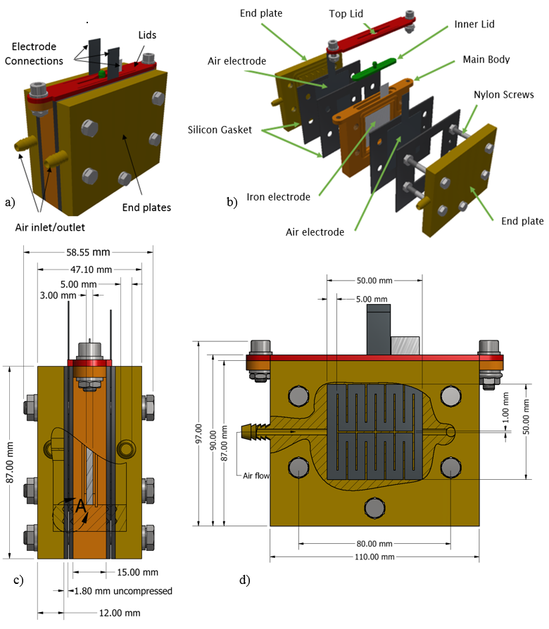Figure 1
(a) 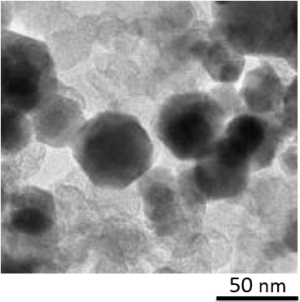 (b) 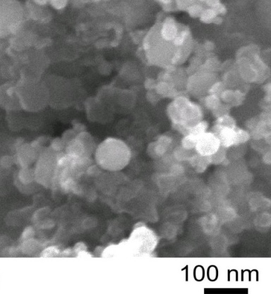
(c) 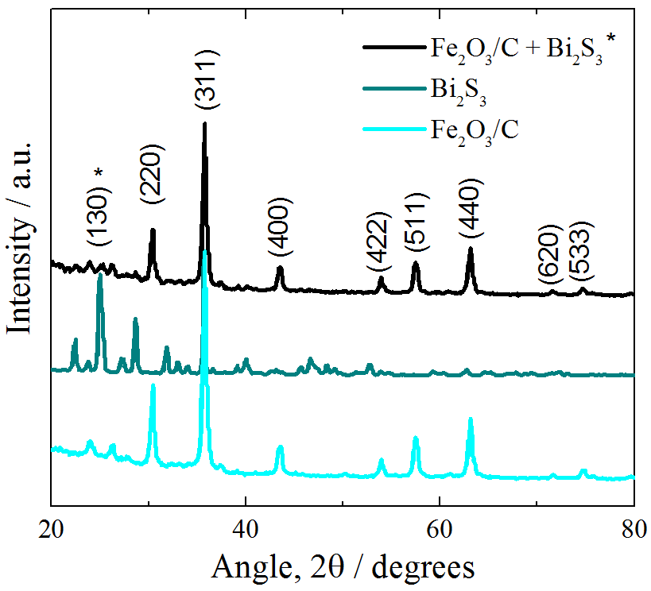 (d) 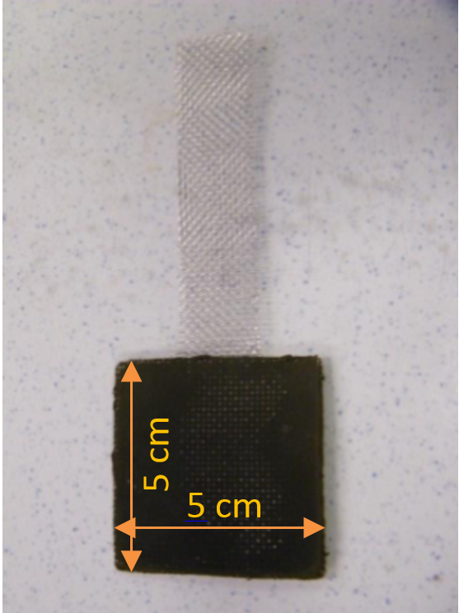
1.5 mm
Figure 2

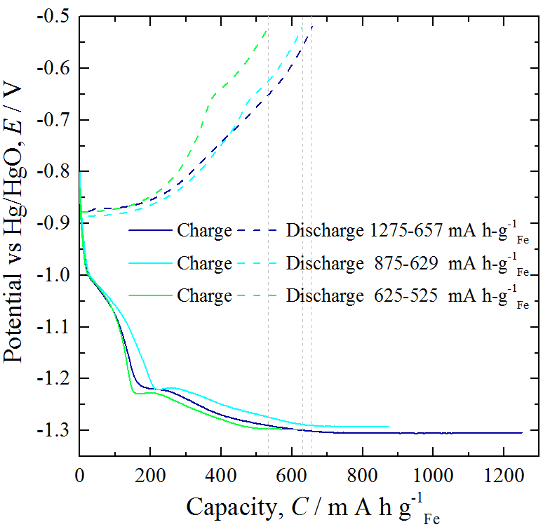
Figure 3

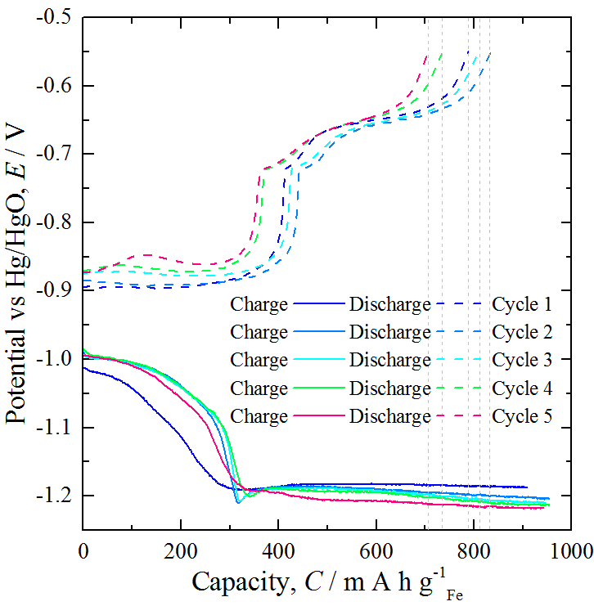
Figure 4

(a) 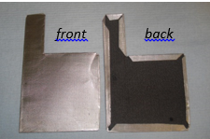 (b)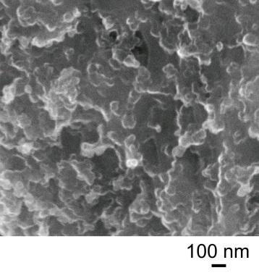
Figure 5

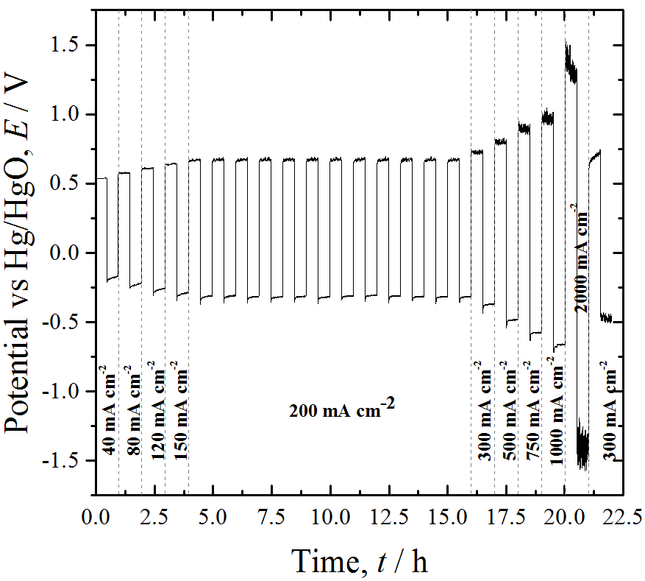
Figure 6

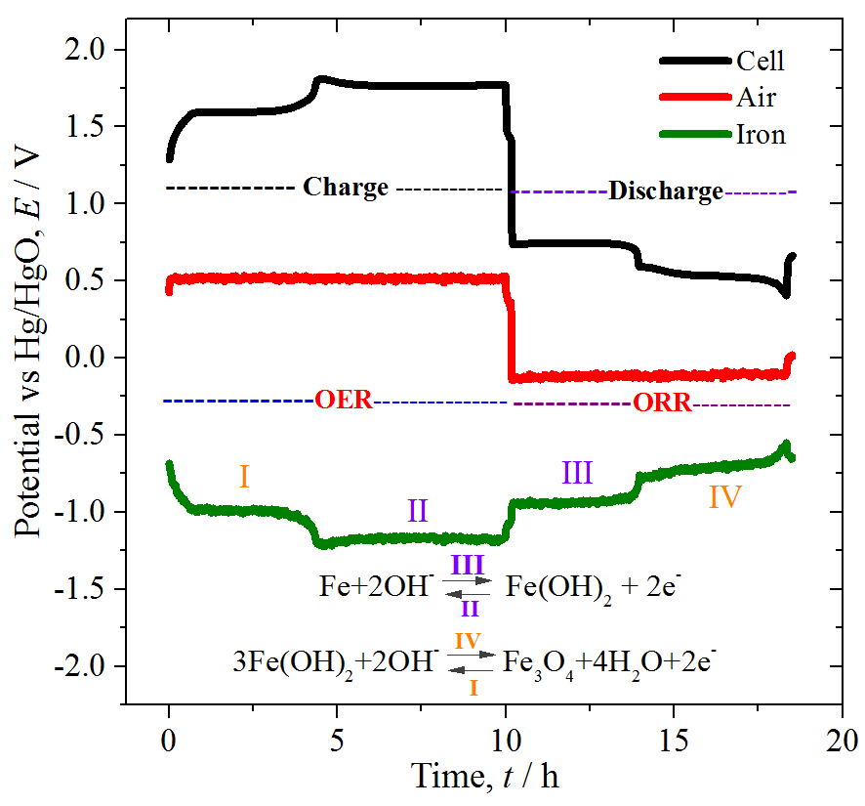
Figure 7

- 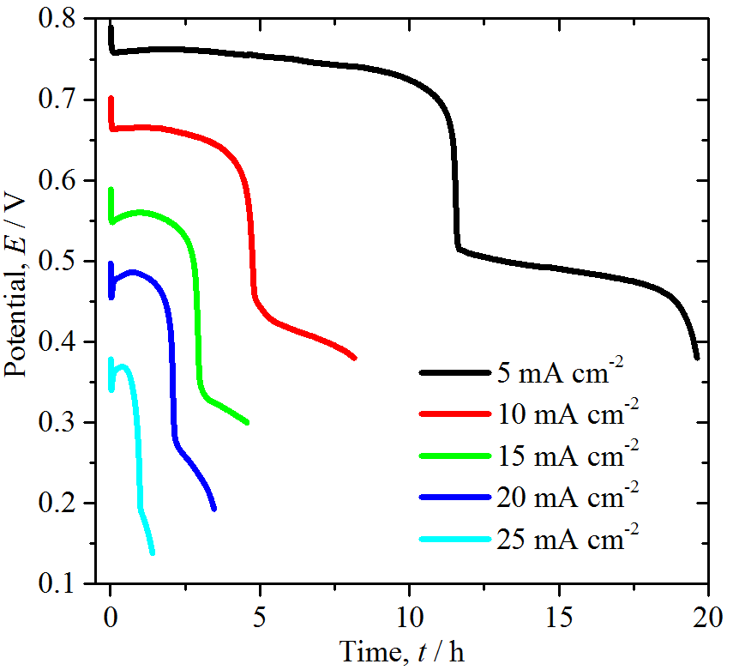

b) 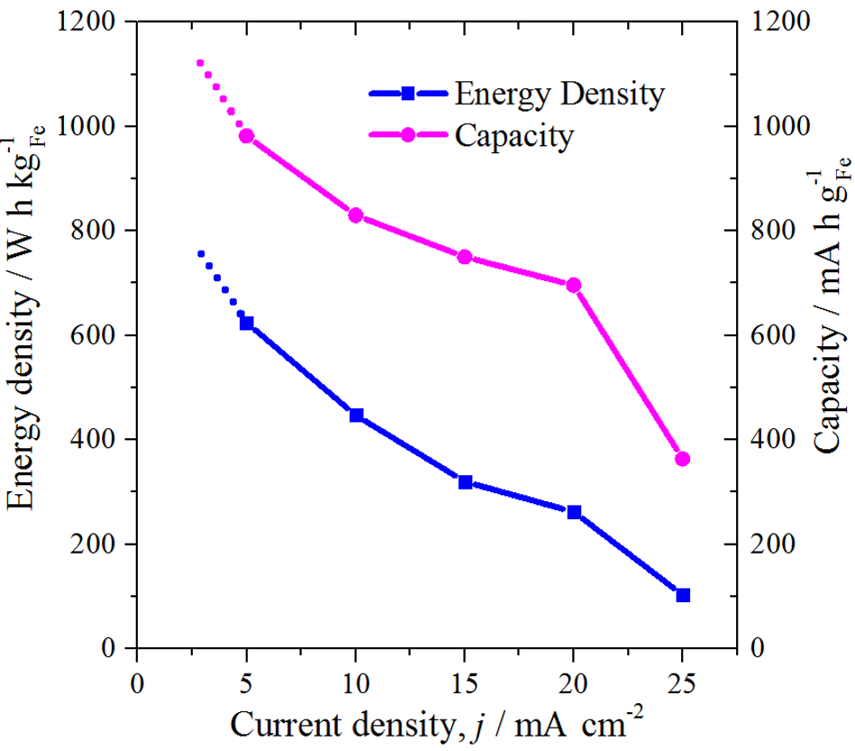
Figure 8
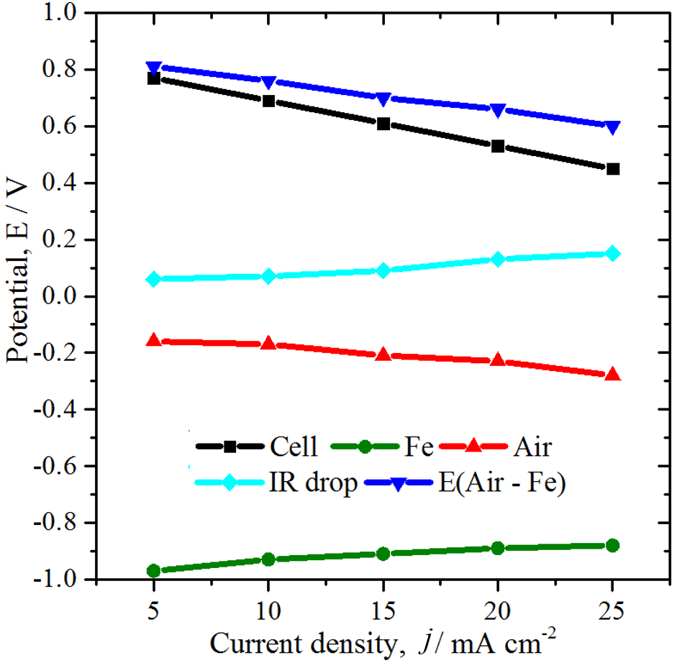
j
Figure 9

(a) 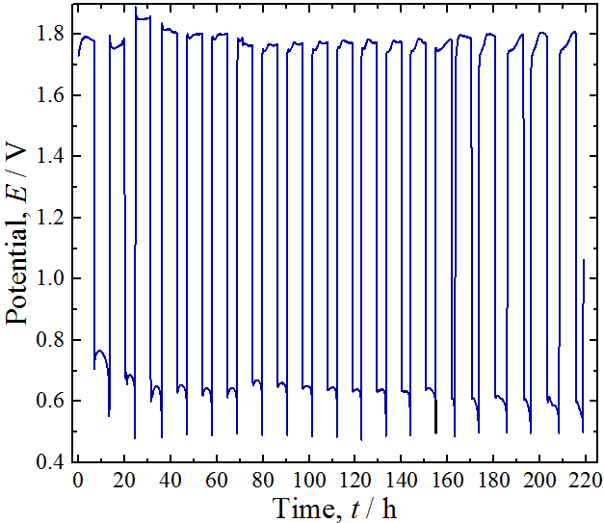
(b) 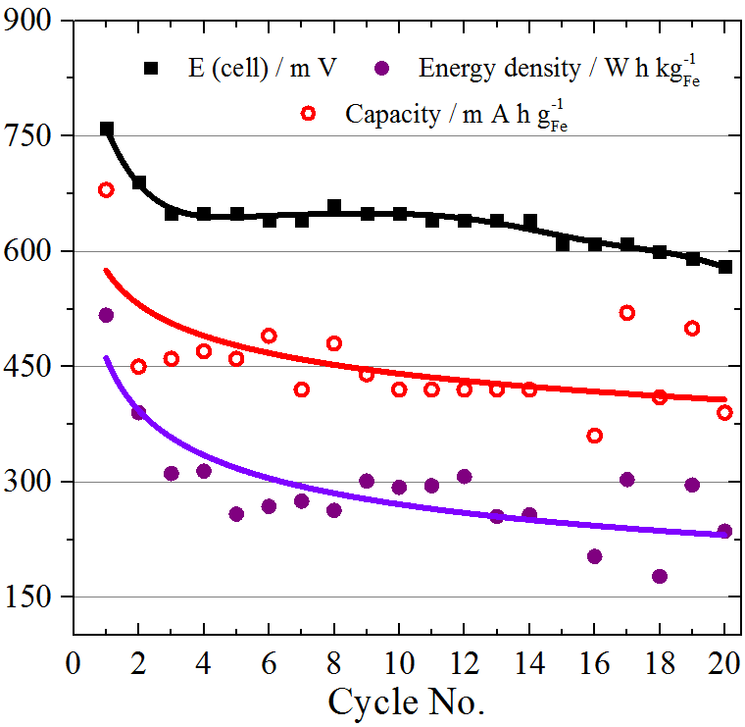 (c) 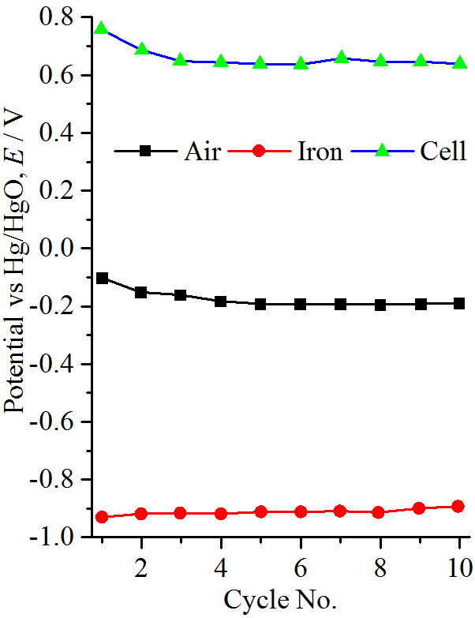

Figure 10
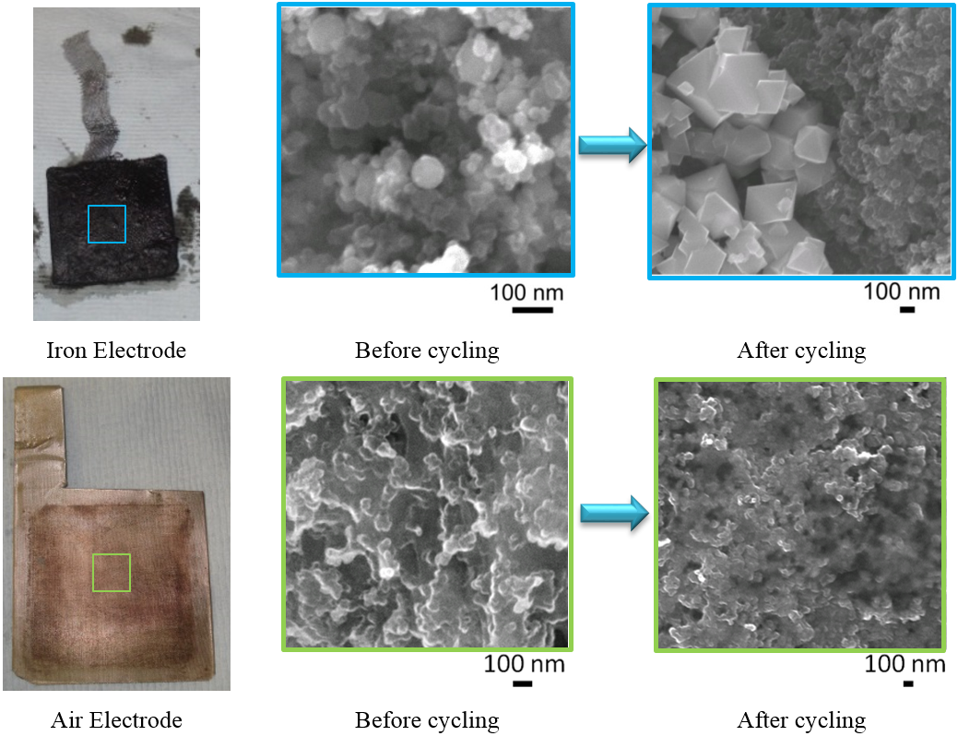
Figure 11

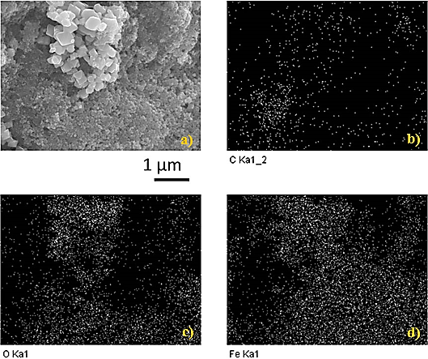Figure 12

