***Paper for the Transactions of the Institute of Materials Finishing, 2016***

**The influence of pre-treatment on zincating of aluminium prior to electroless nickel plating**

S. Court,2 C. Kerr,2+ C. Ponce de León,1 J.R. Smith,2 B.D. Barker,2 F.C. Walsh*1

1 Electrochemical Engineering Laboratory & Materials Engineering Group,

Engineering Sciences, University of Southampton, Highfield, Southampton, SO17 1BJ, United Kingdom.

2 Applied Electrochemistry Group, School of Pharmacy and Biomedical Sciences, University of Portsmouth, Portsmouth PO1 2DT, United Kingdom.

+ Current address: Atotech, Shanghai, China.

*Author for correspondence.

**Abstract**

Zincating is used as a pre-treatment for aluminium prior to electroless nickel deposition during preparation of magnetic computer memory discs. Four immersion zincating solutions were evaluated at 22 oC using single step or double zincating followed by electroless nickel deposition from a (high phosphorus) hypophosphite bath at 90 oC. The coating process was monitored by potential *vs.* time curves obtained under open-circuit conditions during zincating then electroless nickel plating. The surface morphology of the aluminium at various stages, was imaged by scanning electron microscopy and atomic force microscopy. Zero resistance ammetry was used to record galvanic currents between the aluminium and an inert platinum counter electrode during zincating.

**Keywords:** Electrode potential; electroless nickel; immersion plating; pre-treatment.

1. Introduction

The process of coating aluminium with electroless nickel can be achieved by aluminium providing a catalytic substrate .1 Aluminium is very reactive, however, and typically forms a ca. 0.02 μm thick oxide film on the surface of the metal when exposed to the atmosphere. The oxides are detrimental to the nickel coatings as they prevent metallic bonds forming between the coating and the substrate leading to poor adhesion, blistering and coating failure.

Methods such as zincating can be successfully used to remove the oxide and cover the aluminium with a thin layer of zinc and prevent the oxide from reforming. The zinc layer when immersed in electroless nickel solution, will dissolve and be codeposited with the electroless nickel at the interface between substrate and coating. 2-6

Zincate baths are usually alkaline solutions of zinc oxide. Modified alloy zincate pre-treatments 7 contain metallic additives such as nickel, copper and iron. This produces a thinner, more compact alloy layer which enhances adhesion by developing a finer grained, thinner deposit. 7, 8 Aluminium alloys contain metallic constituents which are unreactive during the displacement reaction. The metallic additives control the thickness of the immersion layer by inhibiting the displacement reaction occurring at the aluminium surface. 9 This leads to a more uniform and continuous, thinner deposit. Ritchie *et al*. 10 describe the addition of ferric chloride complexed with potassium sodium tartrate. The tartrate alone was shown to have no effect on the zincate process but the presence as a complexing agent kept iron (III) in solution. The ferric chloride was found to reduce the size of the zinc crystals as they formed, producing a more crystalline coating.

**2. Zincating and Pre-treatment**

Alkaline cleaners are used to remove any soils or dirt that may have been left during the manufacturing of the aluminium component. Alkaline cleaners may contain silicates which prevent the aluminium from being etched, borates to provide buffering and phosphates to remove grease and oils. 11 Environmental concerns over borate and silicate cleaners which have the potential to produce insoluble metallic silicates, have led to the development of borate and silicate free alkaline cleaners. A rinse step is necessary after the alkaline soak (and after all steps) to prevent any dragout and to prevent any cross contamination between pre-treatment chemicals.

The acid etch, which usually contains mixtures of sulphuric and phosphoric acids, is the first step in removing the oxide film. The aluminium is immersed in acid before it is transferred to the desmut cleaning solution which usually contains a 50 % vol. solution of nitric acid, but can also contain sulphuric acid and fluoride compounds. 9 The desmut procedure is intended to remove the non-adherent reaction products (metallic oxides of silicon, magnesium etc.) which remain after etching. A simple immersion deposit of zinc can then replace the oxide film on the aluminium. This is deposited by immersing the aluminium substrate in an alkaline zincate solution. The overall process can be represented by the following reactions: 12, 13

Dissolution of the aluminium substrate:

Al + 3OH- = Al(OH)3 + 3e- (1)

Al(OH)3 = H2AlO3- + H+ (2)

Is accompanied by the deposition of zinc from an alkaline, zincate ion containing solution:

Zn(OH )42- + 2e- = Zn + 4OH- (3)

together with the evolution of hydrogen:

H+ + e- = 0.5H2 (4)

A double zincating step which involves stripping the initial zincate layer in 50% vol. nitric acid then re-zincating, is used to give thinner, more uniform coating. 14 The addition of additives such as 2% vol. hydrofluoric acid, in the nitric acid strip has been shown to improve this process. 7

Dissolution of the zinc film occurs when the zincated aluminium is immersed into the electroless nickel plating bath and is codeposited with the nickel. A zinc rich zone is then found to exist between the electroless nickel deposit and the aluminium substrate. This zinc rich zone can often lead to adhesive and cohesive failure 3, 5 Adhesive failures are found in deposits from electroless nickel baths having high deposition rates and short induction times. Cohesive failures occur when deposition conditions lead to the formation of narrow zinc rich zones of relatively high zinc content. The adhesion of electroless nickel to the zincated aluminium is dependent on the composition of the zincating solution, the composition of the aluminium alloy, the electroless nickel bath itself 13, 15 and the process conditions.

The present studies were motivated by the need to characterise zincating prior to electroless nickel plating of aluminium discs for use as memory storage media for PCs. Extensive use of open-circuit potential measurements 18 was made due to their simplicity, low cost and simple instrumentation. Such potentiometric methods have proved to be an elegant means of determining defects in plated metallic coatings, e.g., through porosity of electrodeposited metal coatings 19, the monitoring of phosphating of steel, 20 electroless nickel coatings on steel 21 and corrosion of metals at open-circuit. 22 Preliminary studies have been summarised in a previous paper 23.

**3. Experimental Procedure**

**3.1 The Induction time for electroless nickel deposition**

Pure AnalaR aluminium wire was subjected to a single and double zincating immersion which varied from 0 to 120 seconds. Where a double step was used, the first zincating immersion time was fixed at 60 seconds. The complete pre-treatment stages and material composition are discussed in detail in sections 3.3 and 4.1. Four different zincate solutions were used: Fidelity 3116M (at 20 and 40% concentration) and two synthetic zincate solutions made up from AnalaR reagents (concentrated and dilute). The formulations of these solutions are given in Table 1. Two commercial, high phosphorus electroless nickel processes were used, Fidelity 4355 and 5010. Fidelity 5010 was developed to improve deposit thermomagnetic stability and to have a higher corrosion resistance than deposits from Fidelity 4355.

Aluminium wire was immersed into the electroless nickel baths with the potential monitored with respect to a standard calomel reference electrode, as shown in Figure 1. A datalogger (an Extech 383274 high impedance digital multimeter) was used to monitor the potential of the zincated aluminium in the electroless nickel bath and the induction of plating was calculated from the point where the curve began to level out. For the commercial zincating bath, the plating potential was at approximately –670 mV *vs*. SCE for the Fidelity 5010 solution and –640 mV *vs*. SCE for the Fidelity 4355 solution.

**3.2 Galvanic Current Measurements**

The galvanic current over time was monitored as the current recorded on a ZRA between the sample being coated and a platinum mesh counter electrode (3 cm2). The readings from the ZRA instrument were recorded with a datalogger in a similar manner to the potential-time curves.

**3.3 Zinc Deposition**

The weight gain analysis for assessment of the thickness of the zincate coating was calculated by using strips of commercially pure aluminium (grade 3105 H24). This material contained 0.60 % silicon, 0.70 % iron, 0.30 % copper, 0.30–0.80 % manganese, 0.20–0.80 % magnesium, 0.20 % chromium and 0.40 % wt. zinc, the remainder being aluminium.

The time of immersion in the zincating solution was varied from 0 to 120 seconds. The samples were then washed in alcohol, dried in a hot air stream and weighed. The zincate layer was chemically stripped off the aluminium surface using 50 % vol. nitric acid (AnalaR), water rinsed, dried and reweighed. The coating weight was then calculated. A second zincating stage was undertaken (with the first step fixed at 60 seconds) and the weight of zinc deposited was calculated in a similar manner.

**3.4 Surface Morphology**

To show the nature of the deposit, aluminium which had been coated with a single and double zincate deposit was examined using scanning electron microscopy and atomic force microscopy. The scanning electron microscopy was carried out on a Joel JSM-6100 microscope, with samples mounted on an aluminium stub using double-sided adhesive carbon tape.

**4. Results and Discussion**

**4.1 Induction of electroless nickel deposition**

A convenient method to study the nature of the surface during electroless plating of aluminium is by monitoring the electrode potential of the metal surface. Before electroless nickel can be plated on to the aluminium surface, the zinc dissolves and the potential of the sample becomes less negative as shown in Figure 2, point A being the potential of the zincate layer (approximately –1.00 V *vs.* SCE). At point B, the potential levels out at –0.66 V *vs.* SCE as the surface is covered with a continuous deposit of electroless nickel. The times for the complete dissolution of the zincate layer can then be estimated.

If the surface was uncoated aluminium, the expected potential is –0.685 V *vs.* SCE. A zinc covered aluminium surface would have value of –1.03 V *vs.* SCE while a perfect coating of electroless nickel on aluminium would have a value of approximately –0.66 V *vs*. SCE. By following the variation of potential with time, the change of nature of the surface during the early stages of electroless deposition can be tracked.

Typical *potential vs.* time plots for single and double zincating procedures are shown in Figures 3-5. The pre-treatment procedure was kept constant so that a direct comparison could be made. The induction times of electroless nickel deposition for a single zincate in the Fidelity 4355 bath varied from 22 to 27 seconds on increasing the zincating time from 15 to 120 seconds in an aqueous 40 % Fidelity 3116M zincating solution. When the concentration of the zincating solution was reduced to 20 % vol, the time taken for the induction of electroless nickel increased from 28 to 36 seconds. In the Fidelity 5010 bath, the induction time for electroless nickel deposition increased from 23 to 48 seconds in a 20 % vol. zincating solution and 32 to 45 seconds for a 40 % vol. zincating solution.

In general, the induction of electroless nickel plating increased as the concentration of the zincating bath was reduced. Zelley 16 has reported an increase in the thickness of zincate deposits with less concentrated baths. Robertson *et al***.** 17also reported this and suggested that at stronger concentrations the whole of the aluminium surface is covered with a thin layer of zinc*,* which blocks any further reaction. At lower concentrations, incomplete coverage leads to further dissolution of aluminium and a thicker coating as more of the anodic substrate sites are exposed to the solution.

For the double zincating procedure, the first zincating step was fixed at 60 seconds and the time of the second zincate was varied from 15 to 120 seconds. When using the Fidelity 4355 solution, the induction of electroless nickel increased from 18 to 29 seconds for a 40 % solution and from 16 to 23 seconds for a 20 % solution.

The commercially available zincating solutions were tested at the maximum (40 % vol.) and minimum (20 %) recommended strength. In a 20 % vol solution, the time for the dissolution of zinc increased with increasing zincating and shows the gradual build-up of zinc on the aluminium wire. For a double zincating procedure, altering the concentration of the zincate solution leads to similar induction times of electroless nickel, indicating that the concentration of zincating solution is not that critical for the efficiency of a double zincate treatment of this substrate.

For the concentrated zincate solution, followed by electroless nickel deposition in Fidelity 5010, the induction times increased from 14.4 seconds to 19.2 seconds after immersion in the zincate solution for 1 minute. Overlapping of the curves (Figure 6) suggests that the maximum thickness of zinc had been reached. This was not so apparent for the equivalent procedure in the Fidelity 4355 bath which had the slightly higher induction times seen in Table 4.

When the double zincating procedure was employed, the times for the induction of electroless nickel in both plating solutions were similar, ranging from 10 to 15 seconds as the double zincating immersion was increased. After 1 minute immersion, the curves converge, again indicating that the maximum thickness of zinc had been reached on the aluminium.

In the case of the diluted zincate solution, the induction of electroless nickel in Fidelity 5010 was slightly higher than the concentrated solution and ranged from ca. 14 to 28 seconds. The same trend was also seen in the commercially available baths. The double procedure also gave slightly higher induction times at 13.6 to 18.4 seconds. In the Fidelity 4355 bath, both procedures gave slightly lower induction times, possibly due to the differences in plating potential. The Fidelity 4355 bath allowed deposition at a slightly lower potential and the time taken to reach this potential was slightly lower.

The increase in starting potential as the aluminium is placed in the electroless nickel bath when a double zincating method is used can be explained by a more complete coverage of the surface. The SEM micrographs also showed a much smoother surface when a double zincating procedure is employed. For the laboratory prepared solutions, this increase in starting potential was not well defined, indicating a rougher, less completely covered surface. The main differences between the zincating solution is the presence of additives such as iron (III) and tartrate, which would account for the differences in the shape of the curves between the commercial and laboratory prepared solutions.

There are also differences in the plating potential between the electroless nickel baths and the commercial and laboratory prepared zincate solutions. There were no significant differences between a single and double zincating procedure. However, there was a difference between the Fidelity 4355 and 5010 plating solutions Fidelity 5010 was developed to give an improved corrosion resistance to that of 4355 so differences in the bath ‘make up’ are expected to produce differences in the potential. The differences were also apparent when monitoring the galvanic current over time (Figure 7) with the Fidelity 5010 bath showing a lower current flowing than the 4355 bath. i.e., fewer active aluminium sites were exposed to the electrolyte to sustain a galvanic current at open-circuit.

To assess the nature of electroless nickel depositing on aluminium over longer periods, potential *vs*. time curves were monitored over one hour. These are shown in Figure 8 and confirm the deposition potential of the process over a longer time period. The open-circuit galvanic current was also monitored over the same time period.

**4.2 Calculation of zincate layer thickness**

The thickness of the deposits when a single and double zincating step was employed for a 20 % and 40 % Fidelity 3116M zincate solution can be seen in Figures 9 and 10. At 20 % vol., the thickness of a single zincate deposit increased from 5 to 9 microns whilst the thickness of a double zincate deposit typically levelled out at around 4-5 m. The thickness of a single zincating step increased from 8 to 16 m. The thickness of the deposit using a double zincate was also lower than a single zincating step, increased from 4 to 7 m. Using a commercial zincating bath, the double zincate had a thinner coating than the single zincate and increasing the concentration increased the thickness for a single step, whereas concentration had little effect on the double zincating step.

The results for the laboratory prepared dilute zincate solution can be seen in Figure 11. The thickness of a single zincate increased from 6 to 9 m whereas the thickness of the double zincate which was also a lot lower than the first, increased from 1 to 5 microns. The results for the laboratory prepared concentrated zincate solution can be seen in Figure 12. The thickness of the single zincate remained similar at approximately 10 m. The thickness of the double zincate remained constant at around 3 m. Using a laboratory prepared zincating bath, the resulting double zincate had a thinner coating than the single zincate and increasing the concentration produced similar thicknesses for a single and double zincating step.

Laugton 3 has reported that the thickness of zincate coating increased from 1.6 μm to 22 μm after three minutes immersion time on increasing the temperature from 16 to 32 oC. It is unclear whether these values are based on a single or double zincating step although these authors showed that the thickness of the zincate layer increased with temperature.

The thickness of zinc deposited onto the aluminium can also be seen to affect the induction of electroless nickel plating times as the first zincating step typically had a greater dissolution time than the equivalent time of the second zincating step. Altering the zincating concentration resulted in small differences in the calculated zinc thickness.

**4.3 Scanning electron microscopy**

After a single zincating step of 60 seconds in Fidelity 3116M, complete coverage of the surface which follows closely the contours of the substrate was seen. Using SEM, zinc grains could be discerned on the surface after 30 seconds of zincating with good coverage of the surface after 40 seconds and it was clear that the double zincating step clearly results in a smoother zinc deposit surface. This is attributable to the etching and removal of the amorphous aluminium surface layers, darker areas indicating defects in the coating.

AFM images of the aluminium surface after a single zincate treatment are shown in Figures 13a) and 13b). Surface grains can clearly be seen with a defect in the coating being shown in Figure 13b). When a double zincating step was employed, the micrographs show a slight decrease in grain size (Figures 13c) and 13d) but the surface smoothing is not so apparent. We have found it important to use both SEM and AFM imaging techniques to provide a clear picture of the surface morphology after zincating.

Research at the University of Loughborough 6 studied the effects of concentration and temperature of sodium hydroxide and nitric acid + hydrofluoric acid pre-treatment solutions on the morphology of aluminium surfaces. SEM/EDS observations indicated that NaOH solutions produced etch concavities on the surface but failed to etch second-phase particles, namely FeAl3. Treatment in the acid solutions succeeded in preferentially removing these particles, while they did not change the surface roughness of the aluminium. In an attempt to improve the coverage rate of zinc alloy films, chemically deposited prior to nickel electroplating, a new pre-treatment sequence was proposed. It consisted of a double-step immersion in nitric and hydrofluoric acid solution, with NaOH treatment between the two acid steps. The results obtained indicated that the first acid step removes most of the biggest FeAl3 particles, as well as the previous oxide layer, while the alkaline step generates a micro-roughness on the surface whereby a net of shallow cellular cavities, as in a honeycomb structure, forms. The last acid treatment preferentially etched the small FeAl3 particles and the most protuberant inhomogeneities of the surface. This pre-treatment sequence was reported to be more effective than those previously considered, in terms of producing a good surface on which zinc alloy films could develop. The adhesion of nickel electrodeposits to such a surface reached values one order of magnitude higher than those for conventional two-step sequences. Interpretation of these results was based on the improved chemical homogeneity of the surface resulting from the removal of second-phase particles and on the small (ca. 1 μm in diameter) and uniform dimensions of the cells produced by the etch treatment. This effectively leads to a good surface coverage during the zincate treatment, as intially intended.

Studies at the University of Wolverhampton 24, 25 confirmed earlier findings by Szasz et al. 26 and Martyak 27. The surface characterization of zincated aluminium and selected alloys in the early stages of autocatalytic electroless nickel deposition was studied using SEM.

Research by Japanese workers 28 considered the detailed morphology and structure of zincate films formed as a pretreatment for electroless nickel-phosphorus coatings on commercial pure aluminum. By using a simple solution of sodium hydroxide and zinc oxide, a zincate film formed by single zincate treatment showed coarse zinc grains as large as 1–2 m in size whose (0001) planes were mainly parallel to the surface of the substrate. A double zincate treatment by using the basic solution reduced the coarse grains, and the thickness of the uniform zincate film was 30–40 nm. A commercial zincate solution which contained iron decreased the number and the size of coarse zinc grains for the single zincate treatment compared with the case of the basic solution, and the double zincate treatment formed a further thin zincate film of 10–20 nm in thickness. The single zincate treatment by using the basic zincate solution resulted in such poor adhesive strength of the electroless nickel-phosphorus plated film as to peel off the substrate due to its residual stress. Quantification of adhesive strength by a peeling test showed the double zincate pre-treatment increased the adhesive strength of the plated film up to 30 N m-1. In the case of the commercial zincate solution, the adhesive strength obtained by the single zincate treatment was 125 N m-1. Furthermore, the adhesive strength of the plated nickel-phosphorus film was too high to conduct the peeling test in the case of the double zincate treatment by the commercial solution, where dimple patterns were observed due to ductile fracture of the substrate. Observation by transmission electron microscopy of the interface between the nickel-phosphorus plated film and the substrate showed gaps in the case of the double zincate treatment by the basic zincate solution. On the other hand, the double zincate treatment by the commercial solution eliminated gaps and a strong interface was obtained.

**4.4 Monitoring of electrode potential**

The present work aimed to create a simple, readily available electrochemical measurement to be used in the screening of zincating solutions and pre-treatment stages. This was carried out by monitoring the potential decay curve over the first few seconds of plating, using a commercial zincating process (Fidelity 3116M) and laboratory prepared solutions. This provided an indication of the thickness of zinc deposited on to the surface of the aluminium substrate and the rate of induction of electroless nickel from the bath. The thickness of the zincate deposit was examined with time of immersion in the zincate bath using weight gain analysis and the surface morphology was examined using scanning electron microscopy and atomic force microscopy.

The current research formed part of a programme of study of electroless nickel deposition of on aluminium substrates for use in the computer memory disk industry. Such disks consist of an aluminium alloy substrate which is coated with electroless nickel then covered by a thin film magnetic coating followed by a protective carbon coating. The demand for increased storage space on computer memory disks is dependent on reducing the defects found in the layers below the magnetic memory film. 7 Therefore, the reduction in surface defects incorporated in the electroless nickel layer such as pores, nodules and magnetisation will greatly increase the performance of these disks. Electroless nickel is used as a protective coating for the aluminium alloy substrate to prevent pitting during the sputtering process used to deposit the magnetic recording layer. A variety of complementary direct current electrochemical techniques has been used to follow corrosion and porosity in thin electrodeposited layers, open-circuit electrode potential *vs.* time measurements being the most simple, needing only a reference electrode and high impedance digital voltmeter 29.

The corrosion resistance of electroless nickel deposits has been shown dependent on the surface roughness of the substrate, 8 pre-treatment procedure 9 and bath age 10 as well as the composition and structure of the coating 1. The overall aim of the project was to study the pre-treatment procedure and the effect of additives on the deposition together with an assessment of corrosion resistance of electroless nickel on aluminium alloy substrates. This was achieved in the current programme by development of an electrochemical process to be used in the screening of various zincating solutions and pre-treatment procedures.

The use of mixed potential theory to study the effects of additives on the electroless nickel plating process and deployment of known electrochemical techniques to evaluate the effects of additives on the corrosion resistance of electroless nickel deposits and to distinguish between similar high phosphorus deposits will be considered in detail in a future paper in this journal 30.

**5. Conclusions**

1. The zincating of aluminium surfaces as a pre-treatment prior to electroless nickel deposition has been studied by techniques including open-circuit electrode potential *vs*. time and coating thickness *vs.* time. The resulting surfaces were imaged by scanning electron microscopy and atomic force microscopy.

2. Potential-time measurements provided a simple and valuable method for following the zincating process followed by electroless nickel plating.

3. Double zincating enabled a shorter induction time for electroless nickel deposition and resulted in a more complete coverage of the surface by zinc.

4. Electrode potential monitoring can be used to follow the deposition process *in-situ*. A double zincate treatment promoted early and facile nucleation and growth of complete electroless nickel layers.

**Acknowledgements**

The authors are grateful to OMI Fidelity for contributions towards support of this research and provision of chemicals.

**References**

1. W. Riedel, Electroless Nickel Plating. Finishing Publications Ltd, Stevenage, UK, 1991.

2. R.G. King, Surface Treatment and Finishing of Aluminium. Pergamon Press, Oxford, 1988.

3. R.W. Laughton, Recent Developments for Electroless nickel plating onto aluminium, its basis and implications. *Trans. Inst. Met. Finish,* 1992, **70**, 120-122.

4. K.P. Thurlow, Electroless nickel plating on aluminium connectors *Trans. Inst. Met. Finish,* 1989, **67**, 82-6.

5. F.J. Monteiro, M.A. Barbosa, D.R. Gabe, D.H. Ross, Surface analysis of zinc alloy immersion films on aluminium. *Plating Surf, Finish*., 1989, **86**, 9-13.

# 6. [F.J. Monteiro](https://www.researchgate.net/researcher/83658191_FJ_Monteiro/), [M.A. Barbosa](https://www.researchgate.net/researcher/55800373_MA_Barbosa/), [D.R. Gabe](https://www.researchgate.net/researcher/17839389_DR_Gabe/), [D.H. Ross](https://www.researchgate.net/researcher/77476389_DH_Ross/), “Surface pretreatments of aluminium for electroplating”, [*Surf. Coat. Technol*](https://www.researchgate.net/journal/1879-3347_Surface_and_Coatings_Technology), 1988, 35, 321–331.

7. T. Pearson, S.J. Wake, Improvements in the pre-treatment of aluminium as a substrate for electrodepostion. *Trans. Inst. Met. Finish,* 1997, **75**, 93-7.

8. F.J. Monteiro, M.A. Barbosa, D.H. Ross, D.R. Gabe, Pre-treatments to improve the adhesion of electrodeposits on aluminium. *Surf. Interface Anal.*, 1991, **17**, 519-528.

9. M. Zitco, P. Vignati, Advances in electroless nickel and post treatment for enhanced corrosion protection of aluminium connectors. *Proc. 80th AESF Annual Technical Conference* 1993, 1001-11.

10. S.G. Robertson, I.M. Ritchie, The role of iron (III) and tartrate in the zincate immersion process for plating aluminium. *J. Appl. Electrochem.,* 1997, **27**,799-804.

11. D. Crotty, B. Clark, J. Greene, B. Durkin, Electroless nickel plating cycle design for thin film memory disks, *Plating Sur. Finish.,* 1992, 42-8.

12. N. Wernick, R. Pinner, P.G. Sheasby. The Surface Treatment and Finishing of Aluminium and its Alloys - 5th edn. Finishing Publications Ltd. Teddington, Middlesex, England, 1987, Volume 2.

13. G.O. Mallory, The relationship between stress and adhesion of electroless nickel-phosphorus deposits on zincated aluminium*,* *Plating Surf. Finish*, 1985, **70**, 21-25.

14. I.M. Sukonnik, J.S. Judge, W.T. Evans, Characterizing the interface of nickel-zincate-aluminium thin films, *J. Metals,* 1985, 1989, 41, 33-37.

15. M. Paramasivam, G. Suresh, B. Muthuramalingam, S. Venkatakrishna, V. Kapali, Different commercial grades of aluminium as galvanic anodes in alkaline zincate solutions, *J. Appl. Electrochem.,* 1991, **21**, 452-6.

16. W.G. Zelley, Formation of immersion zinc coatings on aluminium, *J. Electrochem. Soc.,* 1953, **100**, 328-33.

17. S.G. Robertson, I.M. Ritchie, D.M. Druskovich, A kinetic and electrochemical study of the zincate immersion process for aluminium, *J. Appl. Electrochem.*, 1995, **25**, 659-666.

18. G.A. Ottewill, F.C. Walsh, Electrode potential measurements, *Trans. Inst. Met. Finish,* 1992, **70**, 141-143.

19. C. Kerr, B.D. Barker, F.C. Walsh, Porosity and corrosion rate measurements for electroless nickel deposits on steel using electrochemical techniques, *Trans. Inst. Met. Finish,* 1997, **75**, 81-87.

20. B.D. Barker, P. Graham, T. Hoy, A.H. Nahlé, G.A. Ottewill, F.C. Walsh, Phosphating of steel and the effects of galvanic coupling to zinc and zinc-based coatings, *Arabian J. Sci. Eng.*, 1995, **20**, 343-359.

21. C. Gabrielli, F. Raulin, The application of electrochemical methods to the study of the electroless nickel deposition from hypophosphite solutions, *J. Appl. Electrochem.*, 1971, **1**, 167-177.

22. G. Kear, B.D. Barker, F.C. Walsh, Electrochemical corrosion of unalloyed copper in chloride media - a critical review, *Corr. Sci.*, 2004, **46**, 109-135.

23. S.W. Court, B.D. Barker, F.C. Walsh,Electrochemical measurements of electroless nickel coatings on zincated aluminium substrates*,* *Trans. Inst. Metal Finish*., 2000, **78**, 157.

24. [E. Khan](http://link.springer.com/search?facet-author=%22Enam+Khan%22), [C.F. Oduoza](http://link.springer.com/search?facet-author=%22C.+F.+Oduoza%22), [T. Pearson](http://link.springer.com/search?facet-author=%22T.+Pearson%22), Surface characterization of zincated aluminium and selected alloys at the early stage of the autocatalytic electroless nickel immersion process, [*J. Appl. Electrochem*](http://link.springer.com/journal/10800)., 2007, **37**, 1375.

25. [E. Khan](http://link.springer.com/search?facet-author=%22Enam+Khan%22), [C.F. Oduoza](http://link.springer.com/search?facet-author=%22C.+F.+Oduoza%22), Nickel-phosphorus deposition on pretreated aluminium alloys during immersion in electroless nickel bath, *J. Mats Sci. Eng. A*, 2011, **1**, 457.

26. A. Szasz, J. Kojnok, L. Kertesz, The process of formation of amorphous Ni-P layers made by electroless deposition, *Thin Solid Films*, 1984, **116**, 279.

27. N.M. Martyak, Characterisation of thin electroless nickel coatings, *J. Chem. Mats. Sci.*, 1994, **6**, 1667.

28. K. Murakami, M. Hino, M. Hiramatsu, K. Osamura, T. Kanadani, Effect of zincate treatment on adhesion of electroless nickel-phosphoruscoating for commercial purity aluminum”, *Mats. Trans.*, 2006, **47**, 2518.

29. C. Kerr, S. Court, B.D. Barker, F.C. Walsh, Electrochemical characterisation of porosity and corrosion resistance in electrodeposited metal coating*s,* *Surf. Coat. Technol.*, 2008, **202**, 5092.

30. S. Court, C. Kerr, C. Ponce de Leon, J.R. Smith,B.D. Barker,F.C. Walsh, The influence of iodate ion additions to the bath on the deposition of electroless nickel on mild steel, *Trans. Inst. Met. Finish,* 2015, to be submitted.

|  |  |
| --- | --- |
| **Zincate solution** | **Concentration** |
| Fidelity 3116M | 20 % vol. |
| Fidelity 3116M | 40 % vol. |
| Synthetic Laboratory, Dilute | 15 g dm-3 ZnO + 100 g dm-3 NaOH |
| Synthetic Laboratory, Concentrated | 70 g dm-3 ZnO + 450 g dm-3 NaOH |

**Table 1.** The composition of zincate solutions used in this study

|  |  |  |  |  |  |
| --- | --- | --- | --- | --- | --- |
| **Single zincate** | **Double zincate** | **Electroless nickel deposition induction time / s** | | | |
| **Synthetic laboratory** | | **Fidelity 3116M** | |
| **Dilute** | **Concentrated** | **20%** | **40%** |
| 120 | 0 | 24.1 | 28.8 | 36.0 | 27.2 | |
| 90 | 0 | 21.6 | 26.4 | 35.2 | 28.4 | |
| 60 | 0 | 20.2 | 24.0 | 34.4 | 27.2 | |
| 30 | 0 | 16.0 | 19.2 | 32.2 | 22.4 | |
| 15 | 0 | 12.2 | 14.4 | 28.1 | 21.6 | |
| 60 | 120 | 12.3 | 15.2 | 22.4 | 28.8 | |
| 60 | 90 | 11.2 | 14.4 | 20.8 | 29.6 | |
| 60 | 60 | 11.2 | 14.4 | 20.1 | 23.2 | |
| 60 | 30 | 9.6 | 13.6 | 16.8 | 19.2 | |
| 60 | 15 | 8.1 | 11.2 | 16.0 | 17.6 | |

**Table 2.** Induction times for electroless nickel plating in a Fidelity 5010 bath at 90 oC followingasingle or double zincating pre-treatment at 22 oC.

|  |  |  |  |  |  |
| --- | --- | --- | --- | --- | --- |
| **Induction time for electroless nickel deposition**  **/ s** | | | | | |
| **Single zincate** | **Double zincate** | **Synthetic laboratory** | | **Fidelity 5110** | |
| **Dilute** | **Concentrated** | **20% vol.** | **40% vol.** |
| 120 | 0 | 28.2 | 20.8 | 47.2 | 44.8 |
| 90 | 0 | 22.4 | 20.1 | 41.6 | 42.4 |
| 60 | 0 | 22.4 | 19.2 | 32.8 | 43.2 |
| 30 | 0 | 18.4 | 16.3 | 26.4 | 35.2 |
| 15 | 0 | 14.4 | 14.4 | 23.2 | 32.1 |
| 60 | 120 | 18.4 | 15.2 | 27.2 | 29.6 |
| 60 | 90 | 17.6 | 16.4 | 24.8 | 24.8 |
| 60 | 60 | 16.8 | 15.2 | 25.6 | 25.6 |
| 60 | 30 | 14.4 | 13.6 | 24 | 24.0 |
| 60 | 15 | 13.6 | 10.4 | 21.6 | 19.2 |

**Table 3.** Induction times of electroless nickel plating in a Fidelity 3116 bath at 90 oC following a single or double zincating in Fidelity 5010 solution at 22 oC.

|  |  |  |  |  |  |
| --- | --- | --- | --- | --- | --- |
| **Single zincate** | **Double zincate** | **Electroless nickel deposition induction time / s** | | | |
| **Synthetic laboratory** | | **Fidelity 3116M** | | |
| **Dilute** | **Concentrated** | **20% vol.** | **40% vol.** | |
| 120 | 0 | 24.0 | 28.8 | 36.3 | 27.2 | |
| 90 | 0 | 21.6 | 26.4 | 35.2 | 28.0 | |
| 60 | 0 | 20.0 | 24.0 | 34.4 | 27.2 | |
| 30 | 0 | 16.1 | 19.2 | 32.1 | 22.4 | |
| 15 | 0 | 12.1 | 14.4 | 28.0 | 21.6 | |
| 60 | 120 | 12.1 | 15.2 | 22.4 | 28.8 | |
| 60 | 90 | 11.2 | 14.4 | 20.8 | 29.6 | |
| 60 | 60 | 11.2 | 14.4 | 20.2 | 23.2 | |
| 60 | 30 | 9.6 | 13.6 | 16.8 | 19.2 | |
| 60 | 15 | 8.2 | 11.2 | 16.1 | 17.6 | |

**Table 4.** Induction times of electroless nickel plating in a Fidelity 4355 bath at 90 oC, following a single or double zincating pre-treatment at 22 oC.

|  |  |  |  |  |
| --- | --- | --- | --- | --- |
| **Zincating**  **solution** | **Open-circuit potential for initiation of electroless nickel deposition *vs*. SCE / V** | | | |
| **Fidelity** **5010 bath** | | **Fidelity** **4355 bath** | |
| **Single** | **Double** | **Single** | **Double** |
| Dilute synthetic laboratory | -0.655 | -0.652 | -0.633 | -0.629 |
| Concentrated synthetic laboratory | -0.650 | -0.650 | -0.634 | -0.631 |
| 20% Fidelity 3116M | -0.668 | -0.666 | -0.642 | -0.642 |
| 40% Fidelity 3116M | -0.668 | -0.668 | -0.638 | -0.641 |

**Table 5:** Open-circuit electrode potentials at which electroless nickel plating initiated in Fidelity 5010 and 4355 baths at 90 oC, following a single or double zincating pre-treatment at 22 oC.

**Figure captions**

**Figure 1.** The experimental arrangement used to monitor the induction time of electroless nickel coatings.

**Figure 2.** Potential *vs.* time curve for the deposition of electroless nickel on aluminium at 22 oC from which the induction time for electroless nickel plating can be calculated. The potentials of pure nickel, zinc and untreated aluminium are shown for comparison.

**Figure 3.** Potential *vs.* time curves in Fidelity 5010 electroless nickel at 90 oC for aluminium following a single zincate in 20% Fidelity 3116M zincate solution at 22 oC.

**Figure 4.** Potential *vs.* time curves in a Fidelity 5010 electroless nickel bath at 90 oC for aluminium following a double zincate in 20% Fidelity 3116M zincate solution at 22 oC.

**Figure 5.** Potential *vs.* time curves in a Fidelity 5010 electroless nickel bath at 90 oC for aluminium with a single zincate in 40% Fidelity 3116M zincate solution at 22 oC.

**Figure 6.** Potential *vs.* time curves in a Fidelity 5010 electroless nickel bath at 90 oC for aluminium following a single zincate in the Laboratory prepared, concentrated zincate solution at 22 oC.

**Figure 7.** Current *vs.* time curves during one hour immersion in a Fidelity 4355 electroless nickel bath at 90 oC for aluminium treated by a double zincate in 40% vol. Fidelity 3116M zincate solution at 22 oC.

**Figure 8.** Potential *vs.* time curves during one hour in a Fidelity 4355 electroless nickel bath at 90 oC for aluminium with a double zincate in 40% vol. Fidelity 3116M zincate solution at 22 oC.

**Figure 9.** Coating thickness *vs.* immersion time in 20% vol. zincate solution at 22 oC, showing the difference between a single and double zincating pre-treatment.

**Figure 10.** Coating thickness *vs.* immersion time in 40% vol. zincate solution at 22 oC, showing the difference between a single and double zincating pre-treatment.

**Figure 11.** Coating thickness *vs*. immersion time in laboratory prepared dilute zincate solution at 22 oC, showing the difference between a single or double zincating pre-treatment.

**Figure 12.** Coating thickness *vs.* immersion time in a laboratory prepared concentrated zincate solution at 22 oC, showing the difference between a single or double zincating pre-treatment.

**Figure 13.** AFM micrographs of an aluminium surface after zincate pre-treatments. a) a single zincate pre-treatment, showing an area of 10 m x 10 m, b) a single zincate pre-treatment, showing an area of 5 m x 5 m, c) a double zincate pre-treatment, showing an area of 10 m x 10 m and d) double zincate pre-treatment, showing an area of 5 m x 5 m.

**Figure 14.** Schematic cross-section of the surface layers on the aluminium alloy substrate following various zincate pre-treatments: a) single zincate in synthetic laboratory solution, b) double zincate in synthetic laboratory solution, (c) single zincate in proprietary solution and (d) double zincate in a proprietary solution. (To be drawn).

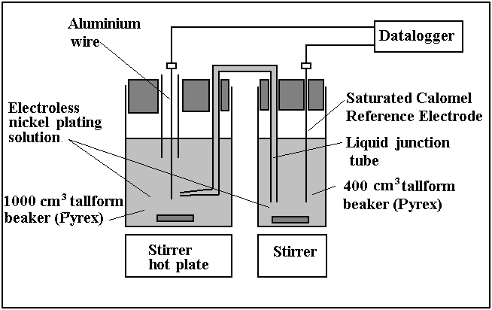**Figure 1**



**Figure 2**



**Figure 3**



**Figure 4**



**Figure 5**



**Figure 6**



**Figure 7**

Y axis: should read: Current density, *j* / A cm-2

X axis: Time, *t* / s



**Figure 8**



**Figure 9**

**X axis: Zincate immersion time, *t* / s**



**Figure 10.**

**X axis: Zincate immersion time, *t* / s**



**Figure 11**

**X axis: Zincate immersion time, *t* / s**



**Figure 12**

**X axis: Zincate immersion time, *t* / s**

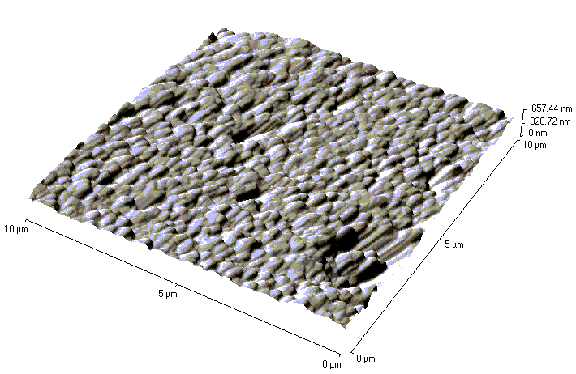

**a)**

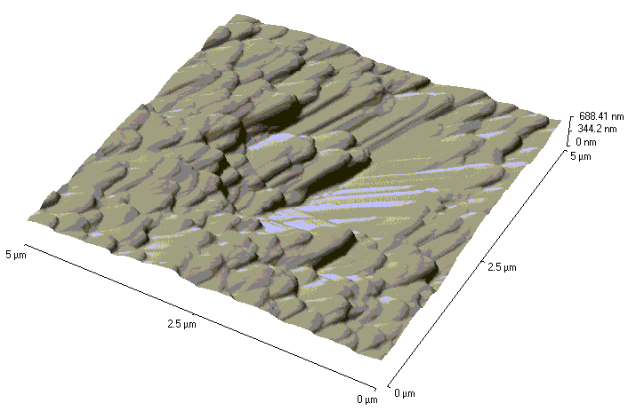

**b)**

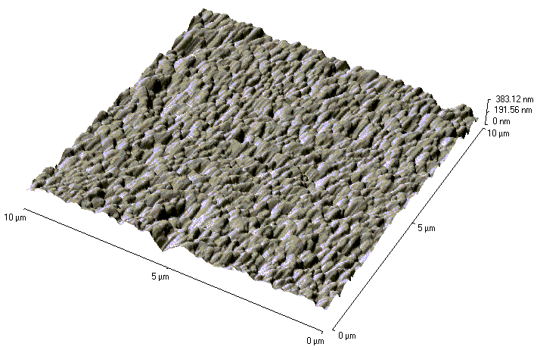

**c)**

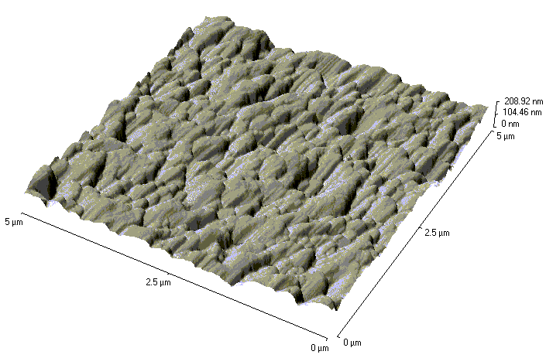

**d)**

**Figure 13**

**To be drawn**

**Figure 14**