Sensory enrichment for people living with dementia: increasing the benefits of Multisensory Environments in dementia care through design

Anke Jakob¹, Lesley Collier²
¹Faculty of Art, Design & Architecture, Kingston University London, UK; ² Faculty of Health Sciences, University of Southampton, UK.
Correspondence details: Dr Anke Jakob, Design School, Kingston University London; Knights Park, Kingston upon Thames, KT1 2QJ; a.jakob@kingston.ac.uk

Bios:
Dr Anke Jakob is a design researcher exploring the design of multisensory experiences and environments and their facilitation in the health and wellbeing sector, in particular to the benefit of people with cognitive disabilities.
Dr Lesley Collier is a senior lecturer and HCPC registered occupational therapist working in the fields of neurology and dementia care, focusing particularly on sensory processing and stimulation in relation to people with dementia in order to improve occupational performance, mood and behaviour.
Abstract:
Research has investigated the impact of design on providing multisensory experience for people with dementia living in care-homes, particularly the quality of Multisensory Environments (MSEs). This interdisciplinary research, a collaboration between design and occupational therapy, evolved from a broad consideration of the role of design in dementia care positively impacting on the wellbeing of people living with dementia, their carers and care givers.
Previous research suggests that using MSE in dementia care as a resource for meaningful engagement has beneficial effects. As a result, many MSEs have been installed in UK care-homes. However, evidence indicates that these spaces often fail to benefit the residents causing staff becoming discouraged, perceiving the space of little value, and subsequently the room becoming unused.
Sixteen care-homes participated in a study. Data regarding the facilitation of sensory experiences and MSE were collected using ethnographic methods. Two key themes emerged from this: a) set-up and design of existing MSEs in care environments is, in most cases, not suitable for older people; b) there is a lack of knowledge and information for care practitioners regarding the facilitation of sensory activities and environments.
Based on this new knowledge, design criteria potentially improving usability and accessibility for people with dementia were established and user-centred design recommendations developed. As a first step towards closing the identified knowledge gap amongst health care practitioners in providing multisensory experience, initial design guidelines were published as an online resource.

Keywords: dementia, design, Multisensory Environment (MSE), multisensory experience, care-home, user-centred, interdisciplinary

Introduction
Research focusing on the quality of multisensory experience and enrichment for people with dementia living in care-homes, particularly the design of multisensory spaces and its impact on engagement and wellbeing, is limited. This paper reports a number of results of a recent investigation examining the Multisensory Environment and its application in dementia care from a design perspective, focusing on functional and aesthetic qualities such as set-up, lighting, material, usability, and accessibility.
This interdisciplinary research evolved from a broad consideration of the role of design in dementia care and the positive impact design interventions can generate on the quality of life and wellbeing of people with dementia, their carers and care givers.

People living with dementia and their needs
The rapid growth of an ageing population, together with the rising number of people affected by dementia, has brought an urgent need for effective interventions in supporting dementia care. According to the World Alzheimer Report 2016, there are 47 million people living with dementia worldwide today, and it is expected that this number will have risen to more than 131 million by 2050 (Prince et al. 2016). Dementia is a process of cognitive decline affecting a person’s ability to cope with and adjust to their environment, to interact with others and to meet their own needs (Cohen-Mansfield et al. 2015; Lykkeslet et al. 2014). Recent treatment and care methods focus on optimising living conditions for people with dementia fostering a sense of wellbeing. Particularly in later stages of dementia, care practice needs to support people with dementia in maintaining quality of life, dignity and comfort (Strom et al. 2016) by alleviating behavioural and psychological changes associated with the condition.
Behavioural symptoms (such as challenging behaviour, agitation, apathy, and depression) are often an expression of frustration or confusion resulting from unsatisfying interactions with the environment, limited ability to communicate, and unmet needs pertaining to loneliness, boredom, need for meaningful activity and social contact, too much or too little stimulation, and discomfort (Cohen-Mansfield et al. 2015). Understanding and responding to these needs appropriately through non-pharmacological, person-centred interventions can therefore successfully ameliorate these symptoms (Goris et al. 2016; Bidewell and Chang 2013; Ward-Smith et al. 2009). Meeting one of the most common needs, the need for stimulation (Cohen-Mansfield et al. 2015), requires individualised, meaningful activities that are within a person’s abilities. These need to provide opportunities for success rather than causing stress (Murray et al. 2016). Activities are therapeutic not just to fill time but also to change negative emotions and promote feelings of purpose and accomplishment (Zeisel and Raia 2000).

The benefits of multisensory enrichment in dementia care
People with dementia, particularly in later stages, are limited in their ability to access appropriate sensory enrichment and meaningful activity. Often they are passive recipients of care, having little opportunity to engage in routine activities (Marques et al. 2012). Additionally, older people experience reduced acuity of vision, hearing, taste and smell which puts them at risk of sensory deprivation (Haigh and Mytton 2016). Deprivation of sensory-enriching experience and appropriate activity presents a significant challenge to wellbeing and health (Kovach 2000). Therefore, providing individualised activities that promote feelings of purpose and accomplishment enables a person to remain active and supports maintaining everyday skills such as self-care. For the person with dementia this might be engagement in multisensory and sensor motor activities (Pulsford and Thompson 2013). Also, sensory experiences can trigger emotional memories; a feeling of pleasure can be created when remembering previously positively experienced emotions (Treadaway et al. 2016b; LeDoux 1998).
A multisensory approach aims to reach individuals with dementia through sensory channels which are still intact (Bidwell and Chang 2011), through the primary senses of vision, touch, hearing, smell, taste, and movement with limited need for higher cognitive processing. Multisensory experience can be provided via daily care routine (e.g. bathing) (Marques et al. 2012; Van Weert et al. 2011), through sensory enhancement of residential or domestic environments (Marquardt et al. 2014), and through specially designated spaces called Multisensory Environments (Sánchez et al. 2016).
The Multisensory Environment (MSE) aims to provide an enabling, stress free, positive environment to provide both stimulation or relaxation in a controlled way. The MSE concept was first established at the De Hartenburg Institute, Netherlands (Hulsegge and Verheul 1987) as a leisure based activity for engaging people with learning disabilities, unable to participate in more conventional occupation. It then developed as a more therapeutic intervention for a range of users with cognitive and physical impairments, aiming to enhance feelings of comfort and wellbeing, supporting communication and functional performance, relieving stress and pain, and maximising a person's potential to focus. (Figure 1)
Research studies and anecdotal evidence have shown that the use of MSEs with people with dementia as a resource for meaningful engagement has beneficial effects. This includes decreased disruptive behaviour and agitation (Maseda et al. 2014a; Bidewell and Chang 2011; Ward-Smith et al. 2009), increased alertness (Strøm et al. 2016), reduced apathy, positive impact on mood and increased social engagement (Goris et al. 2016; Haigh and Mytton 2016; Marquardt et al. 2014), and improved communication (Maseda et al. 2014b) and functional performance (Collier et al., 2010). As a result, the person with dementia is more relaxed and engaged, and relates better to others. Research also confirmed the positive effects of MSE on carers and staff through increased wellbeing, improved interpersonal relationship with the person with dementia and increased job satisfaction (Maseda et al. 2014b; Riley-Doucet 2009). It was noted that MSE can contribute to improving quality of care by expanding the care worker’s repertoire of potential methods for making contact with the person with dementia (Lykkeslet et al. 2014; Anderson et al. 2011).
Consequently, MSEs have been established within a number of dementia care settings in the UK. However, the facilitation of sensory experiences and the use of MSE in practice have been inconsistent and limited. It has been reported that existing spaces are often underused and sensory sessions are not well designed (Andrews 2015: Anderson et al. 2011). It seems they fail to address the specific needs of people with dementia due to inadequate design and poor facilitation resulting in staff becoming discouraged, perceiving the space of little value, and subsequently the room becoming unused (Dalke and Corso 2011).
Furthermore, there is insufficient research and debate considering the actual design of MSEs, i.e. functionality and aesthetics. Previous studies of the benefits of MSE from a health care perspective, have not considered whether the current design is appropriate for individuals living with dementia and older people in general. They do not question whether the way such spaces are designed and set up, could have an impact on the engagement of residents and staff, and on the perceived outcomes of the experience provided.
Design research considering the needs of people living with advanced stage dementia is also limited, and very few products appropriately designed to support care for those individuals – hence products that engage the senses and offer playful, yet appropriate and meaningful occupation – are currently available (Treadaway et al. 2016c). Two papers critically reflecting on the design of MSEs found that the experience offered is often technology-dominated and single-sensory (Gaudion 2011), and lacking age-appropriate and accessible set up (Hedman 2008).

The aims of this research
This research endeavoured to establish reasons for success and failure of MSE used in a dementia care context, informing the development of user-centred design solutions that provide an improved and personalised experience. These outcomes aim to support contemporary dementia care practice and to contribute towards improved care services, positively enhancing the wellbeing of people living with dementia and their carers.

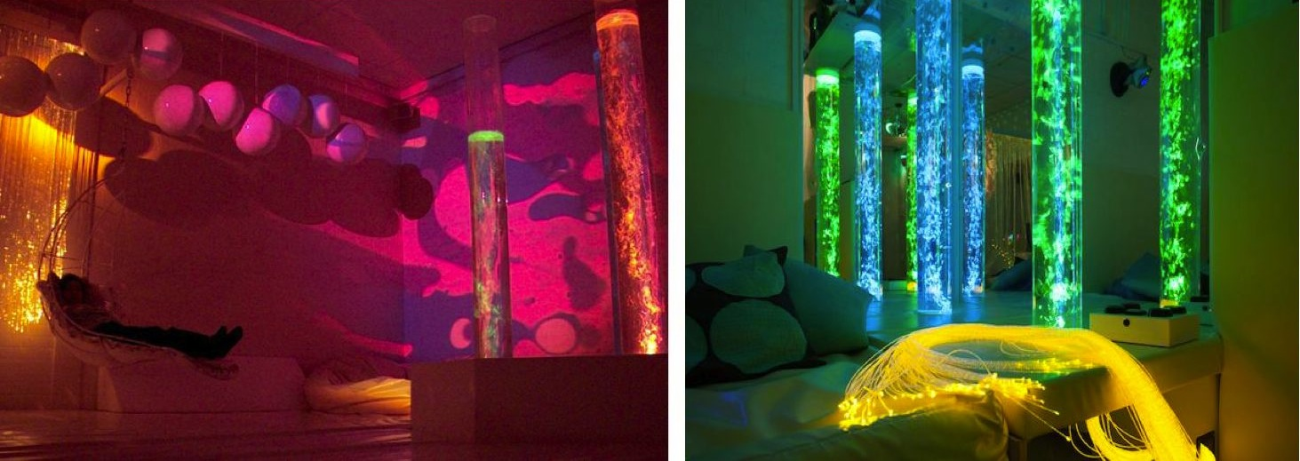
Figure 1: MSE examples: Snoezelen room for people with severe cognitive disabilities, De Hartenberg Centre, Netherlands (© A. Verheul); sensory space at Worcester Snoezelen, UK (© Worcester Snoezelen).

The MSE in dementia care: what is currently provided?
A purposeful sample of sixteen care-homes (including private and social service provision) within London and South UK participated in a study examining the current use of MSE facilities. Inclusion criteria included that the care-home had either existing or previously existing multisensory spaces, or were planning to set one up in the near future. Data were collected using ethnographic methods including semi-structured, in-depth, face-to-face interviews with care-home staff, observations from the perspective of the user, and recording examples of successful practice – utilising a questionnaire / interview schedule and observation template that provided a framework for consistency. Thirty-two staff including activity coordinators (14), care-home managers (12), and care workers (4) were interviewed to describe sensory facilities available and their experience in using the existing MSE rooms with residents. Observations were made of the design and spatial set-up of the MSEs, the sensory equipment and items available under each of the sensory domains (sight, sound, touch, taste, smell, movement), and how multisensory aspects had been considered in the general living environment of the home (Collier and Jakob, 2016). The visits varied in length - between two hours and half day depending on number of staff interviewed - and number, depending on schedule and availability of staff. In five homes sensory sessions were attended and observed from the point of view of the person with dementia. These observations were made by the design researcher within the research team who also carried out the majority of visits.
In addition to the visits in the care-homes, a focus group workshop was organised with activity coordinators from four of the collaborating care-homes. The aim was to explore in more depth the care practitioners’ approach to the use of MSE, their level of skills and knowledge, their ambitions and desire to improve care methods and practice. During this interactive brainstorming session the six participants were encouraged to reflect on their experiences of working with MSEs and adapting a multisensory approach, and to imagine how multisensory enrichment and activities for people with dementia should “look and feel”. Prompted by a series of questions including “What would be your ideal Sensory Room?” they were invited to develop a range of ideas based on their reflection, a “wish list” of multisensory features they would like to include in a sensory space, and how these can be implemented in a care environment. Engaging the care practitioners outside their work environment where they could feel more relaxed and free from work duties, the workshop provided an opportunity for them to adopt a designing attitude when considering solutions for improved dementia care.
Approval from Kingston University Ethics committee was gained prior to the start of the study. Written consent was given by all participants. The limitation of the study includes the relatively small number and location of the care-homes visited (restricted to South England and Greater London), and that the findings were based on observational reports and descriptive accounts from staff.

Key findings
Observations revealed that MSE facilities on offer did not feature an appropriate range of sensory equipment and accessories addressing all senses. The equipment available predominantly focused on visual and tactile experiences, with the risk of visual over-stimulation in some cases. Some consideration had been given to the other senses, although gustatory and vestibular/proprioceptive stimulation was often not offered at all. (Table 1)
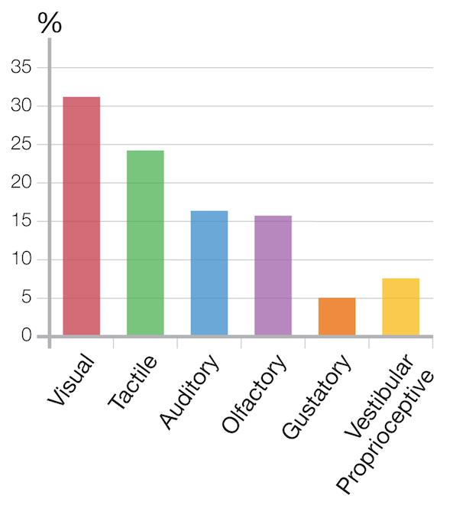
Table 1. Percentage of facilitating stimulation for each sense.

Equipment and items addressing sight included: bubble columns (used in 12 of participating care-homes), fibre-optic spray/curtain (10), projector with rotating image wheel or coloured light-wheel (9), glitter/disco ball (7), hand held lights (3), star projector (1), and LED net (1). In some rooms, there were pictures or other, often distracting decoration on the wall. Equipment/items for addressing touch included predominantly optic-fibres (10) and squeeze balls of soft rubber (9), soft toys (3), vibrating tubes (3), tactile cushions with ribbons and buttons (2), vibrating cushions (2).
In one home natural material such as shells, conkers, feathers, or polished wood were available. In another, staff made tactile books from textiles and offered ‘rummaging baskets’ with various materials and textile samples. In three homes foot bath or hand/foot massage was provided. Most homes featured a music system playing various relaxing sounds and music, and aroma diffuser with range of oils. In some homes tasting sessions were held outside the MSE.
Observed from a design perspective with the end-user in mind, the researchers found that none of the rooms viewed appeared suitable for older people with dementia regarding aesthetics and functionality. Some were very technical and ‘cold’ in appearance making it difficult for the user to connect with. Other rooms felt overwhelming due to the number of objects and equipment offered at the same time, or cluttered spaces with distracting and unnecessary accessories. The juvenile aesthetic in respect to imagery and items used in some homes the researchers regarded as problematic in terms of the dignity.
Some of these observations were confirmed by staff interviewed acknowledging that MSEs often were poorly constructed and limited through ineffective design, preventing the majority of residents from benefiting from the space. They felt the environment should include more age-appropriate sensory items and equipment, more familiar, natural, warm and soft items alongside a selection of technical equipment e.g. colour changing lights or bubble columns. Activity staff and managers were also dissatisfied with MSE equipment available through suppliers.
The belief that setting up a multisensory facility (MSE) is cost-intensive and therefore not justifiable or achievable because of lack of funding was prevalent. This view was based on the common understanding of what a ‘traditional’ MSE should contain (i.e. bubble columns, fibre optic strands, projectors, vinyl-covered padded seating areas - as the examples in Figure 1 illustrate) and on the set design advice from suppliers. Five of the care-homes spent large sums of money installing a multisensory room from one of the main suppliers, purchasing a range of technological equipment. This was funded through donations and through local government grants. Papers investigating the benefits of MSE in dementia care (Sánchez et al. 2016; Maseda et al. 2014b; Anderson et al. 2011) support the presumption that MSEs require significant investment of economic resources without explaining or giving evidence, or indeed questioning why it would or should be expensive.
Frequency of use varied greatly from home to home ranging from daily to weekly or less. The most common reason for infrequent use was insufficient time. In most homes the room was locked when not in use because of concerns regarding health and safety and/or equipment damage. Support to residents in accessing multisensory activities was mostly provided by the care homes’ activity staff. Care workers (primarily involved in personal care of residents) were less motivated to do so, based on their view that this was not in their remit and seen as an extra burden. Relatives were not involved in using the MSE.
The study revealed that whilst many homes have a MSE and staff were aware that engagement in sensory experiences is effective for improving wellbeing and quality of life of residents, particularly for those in later stages of dementia, they lacked the skills and knowledge to utilise the multisensory space to its full potential maximising the benefits for their residents. Training in multisensory approach and in facilitating multisensory experiences was very limited, and an apparent lack of guidance of what to include in a MSE was evident. Staff commented they felt overwhelmed by the range of products offered by specialist MSE suppliers, and expressed the view that clearer direction, training and on-going support was urgently needed. The workshop confirmed these findings regarding the lack of knowledge and skills in how to facilitate sensory activities and environments, but also demonstrated that the participants highly appreciated the advice and inspiration received during this session, giving evidence of their great passion and enthusiasm for the people they care for.
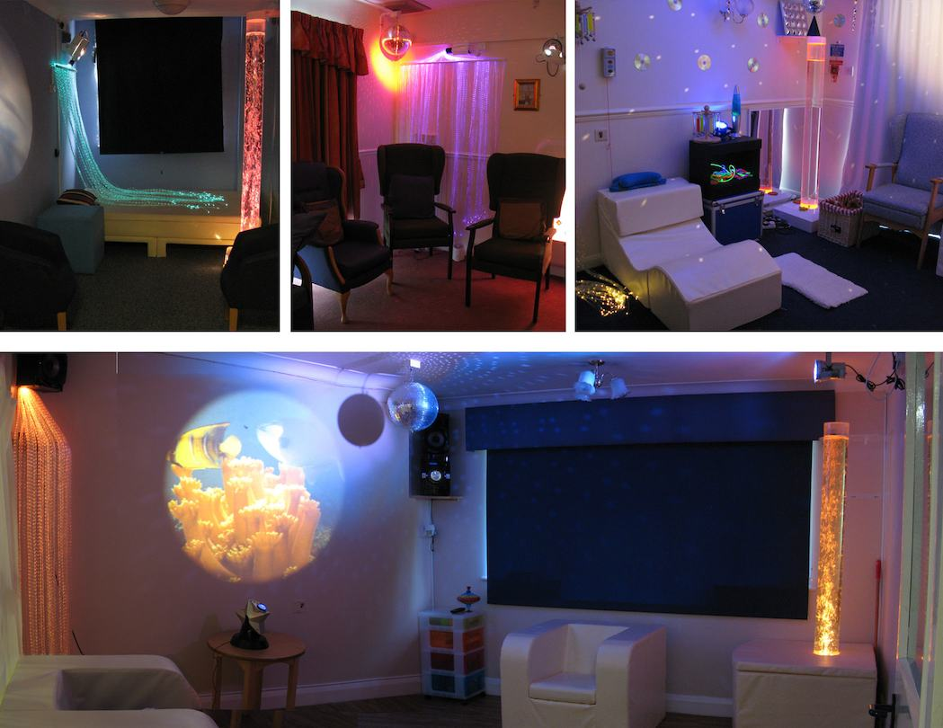
Figure 2: Examples of multisensory rooms visited - featuring MSE equipment available from suppliers: bubble column, disco ball, projector with image-wheel, coloured optic-fibres, CD player/sound system, waterbed and furniture with liquid resistant vinyl covering.

Conclusions drawn from the study
Findings suggest that most MSEs in care-home settings do not reach their full potential in achieving some of the benefits of multisensory enrichment in dementia care, revealing a gap between academic knowledge and implementation in practice. It appears that MSEs have been installed with little thought to their design or how they are used. Care-homes often relied on suppliers to design and set up rooms with little or no involvement of care home staff. Subsequently, the MSE does not always benefit the person with dementia as anticipated, thus staff have become despondent. The consequence is an unused space that is perceived as being of little value. Identifying the design features that potentially can improve accessibility for older people with dementia, will help care-homes to create an environment that is appropriate for residents, their relatives and staff (Jakob and Collier 2014a, 2014b, 2015).
In discussion with the project’s Panel of Experts, following conclusions were drawn regarding the improvement of use and benefits of MSE in dementia care:
The MSE should create opportunities for exploring and engaging in/with appropriate and meaningful activities/objects giving the person a sense of purpose. More emphasis should be placed on introducing ‘soft technology’, e.g. applying textiles and textile technology approaches. Considering economic resources, the use of cost-intensive hi-tech equipment should be more selective; current MSEs in care-homes have been too technology driven. To overcome funding issues, the design of an MSE needs to offer cost-effective solutions.
Nature based elements currently missing in most MSE as well as a greater variety of tactile experiences, tailored to the individual’s preferences and personality, need to be introduced. The experience of taste should not be neglected. Snacks and drinks should be served for comfort or refreshment. Users should be given more control over the environment as this helps to avoid over-stimulation and building up fear of the MSE. A multisensory space/area should always be accessible to residents and locked places should be avoided. Rather than being isolated, the MSE should better integrate with the rest of the care-home environment which should be more conducive to sensory enrichment.
All care staff should be encouraged to take responsibility of supporting activities with residents including multisensory enrichment. Staff and relatives should be more involved in making objects for the MSE to create a sense of ownership. An understanding needs to be fostered that MSEs are not only helpful in times of a resident’s distress but can positively enhance peoples’ lives. Mobilising other resources such as volunteers and relatives will help to enable sensory sessions more frequently, and the MSE should be designed in such a way that visitors feel more invited.

Designing multisensory spaces for people with dementia
Two important issues emerged from the study: a) the design of MSEs currently existing in care-homes is, in most cases, not appropriate and suitable for older people; b) there is a lack of knowledge and guidance for care practitioners about how to facilitate sensory activities and environments.
Addressing the problem of poor and inadequate design, the research team needed to establish what, in contrast, would represent ‘good’ design (design that effectively produces the desired benefits). Applying a mixed methodology, the process informed by: the conclusions drawn from the study (see above); previous research and literature on needs associated with age and dementia, and sensory related needs; the evaluation of best-practice examples; and the professional judgement of the researchers who are both experienced practitioners in their field.

Examples of best practice
Examples from organisations participating in the study as well as other healthcare and MSE facilities visited in UK and Finland were included, and successful methods, activities, practices embraced. Visiting multisensory spaces in four homes for older people in Helsinki (Finland) - designed and set up by care-home manager and textile artist Sari Hedman - was particularly informative and insightful. By using textiles, sheepskin, twigs, rocking chairs, tactile soft furnishing and careful lighting these rooms had been turned into soft, calm spaces, user friendly and appropriate for this age group (Figure 3).
Another example for an environment more in tune with the sensory needs of older people with dementia is the Marjory Warren ward at King’s Hospital in London. This new dementia ward features matt flooring to avoid glaring and reduce anxiety (patients frequently misinterpreted the shiny floor as water and refused to step on it), colour coded rooms and differing floral decoration around door frames to help navigate around the ward, seating areas with coloured lighting next to the nurses’ station helping patients to overcome social isolation. The ward’s multisensory room is equipped with a programmable, ambient lighting system colouring the otherwise white walls, and multimedia technology for sound/music and video projections.

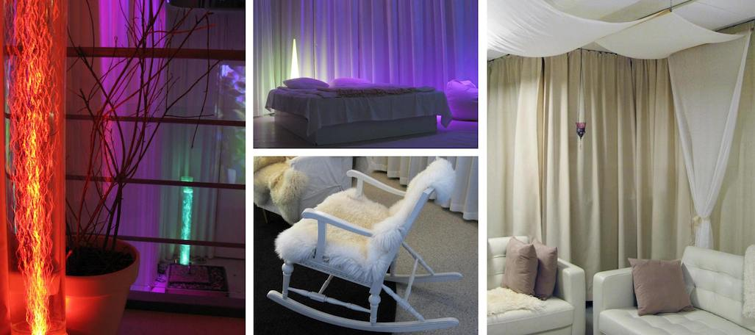
Figure 3: Multisensory rooms in Kontula, Riistavouri and Roihuvuori Centre, Helsinki, Finland.

Design criteria
According to Zeisel (2013) design interventions fostering a person-centred approach should aim to provide a sense of personal control, familiarity and feeling at home, support personalisation, a person’s capacities and independency. Guided by this statement, design criteria for creating sensory enriched environments and activities benefiting the person with dementia and their carers were derived from the evaluation process. The features that emerged as the most important criteria to be considered when designing a successful and effective multisensory space for people with dementia, are:

1) Feeling comfortable and safe
Creating an environment where the user feels comfortable and safe is vital. A soft, warm and intimate atmosphere within a contained and quiet space should be provided, with minimized or zero capacity for disturbance or distraction. Low-level sensory experience will activate the parasympathetic nervous system: inducing a state of calm (Poza et al. 2012), reducing stress and anxiety, helping the user to relax and to better focus on activities offered.

2) Meaningful and familiar
Promoting comfort and feeling save, the sensory experiences need to be within the range of the individual’s comprehension and coherent to all senses (Zeisel 2013). Offering familiar, personal and appropriate experiences relevant to the user’s life and stage of dementia is important. Reduced cognitive abilities and memory loss do not mean people stop searching for meaning or joy of activities (Cohen-Mansfield et al. 2015; Lykkeslet et al. 2014). Making the MSE feel familiar will help with transition into the room motivating residents to go into the space and join in the sensory activities.

3) Multisensory experience
A MSE should address all the primary senses to maximise the desired effect. A multisensory experience supports a person’s ability to comprehend their surroundings (multisensory integration) (Ayres 1972). Choosing from a range of sensory experiences enables the carer to better respond to individual preferences and needs, and to control the number, type and intensity of stimuli (Sánchez et al. 2016). All senses decline as part of the normal aging process. However, smell and taste are known to also alter as a result of the dementia process. Therefore stimulating these specific senses is particularly important (Strøm et al. 2016; Alves et al. 2014).

4) Stimulation and Relaxation
The MSE should offer a range of experiences that can be either stimulating or calming for the users. Residents might be exposed to excessive or inappropriate stimulation in their environment and therefore will benefit from a space to relax. A person with dementia is thought to have a decreased sensory threshold and can easily become over-stimulated. On the other hand, they might experience too little sensory stimulation, particularly in the late stages of dementia, leading to sensory deprivation. Both over-stimulation and sensory deprivation result in increased unhappiness, agitation, and depression (Ward-Smith et al. 2009; Kovach 2000).

5) Control and Interaction
Within their capacities users should be allowed and encouraged to control and interact with the environment, including modifying the amount and type of stimulating experience received and exploring the space or intervention at their own pace. Encouraging and empowering the user to play a more active role increases confidence and feelings of self-worth (Valenzuela 2008) and is considered a more effective care method than passive (receptive) interventions (Sánchez et al. 2016).

6) Age appropriate and usable
A multisensory space should be ergonomically designed and set up in such a way that suits older people with physical limitations. It is also important to select equipment and items that are not perceived as juvenile or childish, particularly regarding the aesthetics, to support dignity and respect for the individual living with dementia, as well as to consider the feelings of relatives of the residents (Hope and Waterman 2004).
Further, aiming to empower residents and care workers, multisensory spaces in residential homes should be:
- accessible and easy to use for all (overcoming fear of equipment);
- flexible and adaptable providing opportunities for a range of activities;
- integral part of care-home environment;
- cost-effective in their implementation (overcoming economic barriers).

Design recommendations
Based on these design principles informing the design brief, the researchers subsequently developed preliminary design recommendations for setting up MSE facilities for people with dementia, considering aspects such as lighting, accessibility, technology, use of material, climate, and maintenance. Examples of methods of how the required conditions can be achieved are specified below, focusing on main aspects.

Textiles and soft materials
The application of textiles (blankets, cushions, plain curtains, covers, fabric) offers benefits on many levels. The multisensory aspect of textiles is an intrinsic quality stimulating vision (colour and optical qualities, e.g. shiny surface of silk), touch (softness and warmth, e.g. velvet), smell (e.g. sheep skin), hearing (e.g. rustling satin), and even taste. Textiles wrapped around the body can provide a feeling of safety, protection and comfort. Surrounding the space and/or covering the walls with neutral coloured, soft textile curtains soften the acoustics and create a warm, intimate and soft atmosphere
Fabric and textile objects, such as sensory cushions, blankets, textile books, and clothing made from various textile materials, with zips, ribbons, buttons, pockets, and imagery attached, can encourage playful engagement and interaction providing experiences of pleasure (Treadaway et al. 2016a). Items can be personalised to the individual’s preferences, including photos and personal objects, making the experience more meaningful and communicating a sense of personhood. Sensory textiles encourage engaging in tactile stimulation via the hands (increasing emotional wellbeing), and can be useful for starting a dialogue between the person with dementia, family members and carers (supporting personal relationships) (Treadaway et al. 2016a, 2016b; Lambert 2008). Sensory armchair covers with pockets (for ‘hiding’ things) can provide instant sensory experience and allow residents to calm down and to self-soothe without drawing attention.

Lighting and lights
Visual acuity changes as we age. Besides presbyopia affecting the lens, the aging of the retina results in decreased contrast sensitivity, loss of peripheral vision, increased dark adaptation threshold, and declining colour sensitivity (Salvi et al. 2006; Heiting 2016). This decline of visual function impacts on an older person’s ability to see in low light conditions, to perceive depth, to tolerate glare, and to adapt to bright light and darkness.
Therefore providing appropriate lighting, balancing light and dark, is essential for people with dementia to be able to feel safe and relaxed as spaces that are too dark might cause disorientation and discomfort for the individual. Irritating reflections, moving or flickering lights (created for example by moving disco/glitter balls), and unusual shadows should be avoided as they can be misinterpreted and may therefore be confusing or frightening for people with dementia.
Immersing the space in soft, indirect light provided by e.g. wall washers or translucent textiles covering ceilings/walls prevents irritating shadows. Similarly, daylight can be softened by using filtering blinds and/or textiles. Dimmer switches are vital to facilitate slow transition from light to darker environment, and to control and adjust the intensity of light. Selected free standing, hanging or wall mounted lights within easy view of the user (e.g. fibre-optic curtain, bubble wall, LED net) or/and illuminated, hand-held items/equipment (e.g. fibre-optic strands, glowing balls) create visual focus points.

Low-tech vs. High-tech
Technology should be multisensory, age appropriate and balanced (hi-tech and low-tech). A technical appearance needs to be avoided. The space can be made more accessible and easier to connect with when blended with natural and familiar items, such as combining LED lights with sheer fabrics or bubble columns with dry twigs. Low-tech, more familiar items and everyday objects with sensory and reminiscent qualities, such as set of keys or a little bell, help with orientation and can trigger off memories or a conversation, whilst high-tech options may help with people with more severe dementia, as the stimulus is more intense and easier to detect.
Modern technology can be very helpful in creating age-appropriate switches to control the sensory environment. Switches with sensors operated by simply moving a hand or arm support the user in engaging in an enjoyable physical activity when they have limited motor control.
Using data projectors connected to a video streaming device is an effective intervention, providing an immersive, cinematic viewing experience combined with high flexibility regarding the choice of imagery/films suiting the users’ preferences.
Further aspects to be considered are:
- furniture: offering soft, tactile covering fabric rather than vinyl, providing comfortable and relaxing yet stimulating seating positions (e.g. rocking chair);
- providing pleasant climate: comfortable temperature, good air quality, sufficient oxygen level;
- providing a visually calm space with a visual focus to avoid over-stimulation: de-cluttering, removing unnecessary decoration, limiting visually stimulating equipment.

The guide book
As a first step towards closing the identified knowledge gap amongst healthcare practitioners in providing multisensory experiences, these initial design guidelines were published in the online source “How to make a Sensory Room for people living with dementia” (kingston.ac.uk/sensoryroom). As a tool, the guide aims to equip carers and staff in care-homes with ideas and information on providing multisensory spaces and activities that meet the specific needs and preferences of people living with dementia, their families and the care-homes they live in. The publication was developed in collaboration with graphic design students from Kingston University resulting in a user-friendly hand book that is visually clear and well structured, accessible and easy to navigate, yet inspiring and refreshing. It was reviewed by practicing professionals in dementia care, occupational therapy and design, and their feedback included. The guide book had been very well received amongst the healthcare community.

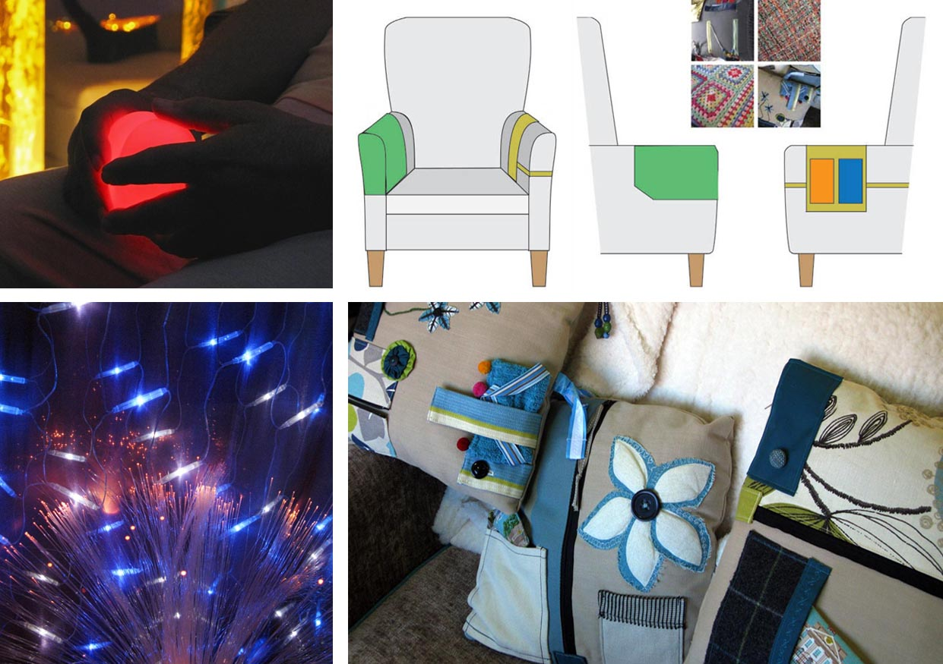
Figure 4: Examples of multisensory items and equipment: sensory armchair covers, sensory cushions, LED lights softened by sheer fabric, hand-held colour changing light.

Conclusion
The design research presented in this paper established new knowledge from which user-centred design recommendations supporting improved dementia care emerged. The outcomes - reflecting a positive design approach (Desmet and Pohlmeyer 2013) - aim to add value and meaning to the MSE experience maximising the benefits for users and enhancing quality of life of people living with dementia as well as their carers and care givers. Initial understanding of design features, needed for constructing a MSE within a dementia care setting, have been developed. Further research and proof-of-concept work is required to implement, test, evaluate, and adjust – if found necessary - the outcomes of the design brief.
Evidence-based MSE design guidelines are a first step to provide the means of enabling carers and care providers to design conditions that promote wellbeing. The authors argue that sustainable impact of design interventions in dementia care can be achieved through the active involvement and continued participation of users, carers and care practitioners in the design process - empowering them by mobilising their creativity and helping to adapt a designing attitude in care practice. In becoming co-creators, carers therefore need to be offered training on design skills and design making. Developing a research agenda to explore how such information should be conveyed and training delivered is a next step in the process of understanding the inherent value of MSEs for older people living with dementia.

Acknowledgements: The authors would like to thank the project’s Panel of Experts comprising practitioners and academic researcher from design and health care, all staff they have worked with at Care UK (health and social care service provider in UK and collaborating Project Partner), and all care practitioners participating in the study. Special thanks to Sari Hedman (Kinaporin Elderly Centre, Helsinki) for sharing her experience and ideas in designing multisensory spaces for older people.
The research was funded by the Arts & Humanities Research Council UK (AHRC) grant nos. AH/K003135/1.

References:
Alves, Jorge, Agavni Petrosyan, and Rosana Magalhães. 2014. “Olfactory dysfunction in dementia.” World Journal of Clinical Cases 2 (11): 661–667.
Anderson, Katrina, Michael Bird, Sarah MacPherson, Vikki McDonough, and Terri Davis. 2011. “Findings from a Pilot Investigation of the Effectiveness of a Snoezelen Room in Residential Care: Should We Be Engaging with Our Residents More?” Geriatric Nursing 32 (3): 166-177.
Andrews, June. 2015. Dementia: The One-Stop Guide – Practical advice for families, professionals, and people living with dementia and Alzheimer’s Disease. London: Profile Books Ltd.
Ayres, Jean. 1972. Sensory integration and learning disorders. Los Angeles: Western Psychological Services.
Bidewell, John W., and Esther Chang. 2011. “Managing dementia agitation in residential aged care” Dementia 10 (3): 299-315.
Cohen-Mansfield, Jiska, Maha Dakheel-Ali, Marcia S. Marx, Khin Thein, and Natalie G. Regier. 2015. “Which unmet needs contribute to behavior problems in persons with advanced dementia?” Psychiatry Research 228 (1): 59–64.
Collier, Lesley, and Anke Jakob. 2016. “The Multisensory Environment (MSE) in Dementia Care: Examining its Role and Quality from a User Perspective” Health Environments Research & Design Journal. doi:10.1177/1937586716683508
Collier, Lesley, Kathryn McPherson, Caroline Ellis-Hill, Jason Staal, and Romola Bucks. 2010. “Multisensory Stimulation to Improve Functional Performance in Moderate to Severe Dementia - Interim Results” American Journal of Alzheimer's Disease and Other Dementias 25 (8) 698-703.
Dalke, Hillary, and Alessio Corso. 2011. Living with dementia: Can design make a difference? London: Kingston University.
Desmet, Pieter M. A., and Anna E. Pohlmeyer. 2013. “Positive design: An introduction to design for subjective well-being.” International Journal of Design 7 (3): 5-19.
Gaudion, Katie. 2011. “The Multisensory Environment (MSE): Encouraging Play and Promoting Well-being for all ages. The role of the Textile Designer.” In Cumulus Proceedings Shanghai - Young Creators For Better City, Better Life, edited by Yongqi Luo and Xiaocun Zhu, 76-82. Helsinki, Shanghai: Aalto
University, Tongji University
Goris, Emilie Dykstra, Katherine N. Ansel, and Debra L. Schutte. 2016. “Quantitative systematic review of the effects of non-pharmacological interventions on reducing apathy in persons with dementia.” Journal of Advanced Nursing 72 (11): 2612-2628
Hedman, Sari. 2008. “Building a multisensory room for elderly care.” In Multisensory Work Interdisciplinary approach to multisensory methods, edited by Marja Sirkkola, Päivi Veikkola, and Tuomas Ala-Opas, 34-42. Hämeenlinna: HAMK University of Applied Sciences.
Heiting, Gary. 2016. “How your vision changes as you age.” Accessed 16/12/2016. http://www.allaboutvision.com/over60/vision-changes.htm
Haigh, Judith, and Carol Mytton. 2016. “Sensory interventions to support the wellbeing of people with dementia: A critical review.” British Journal of Occupational Therapy 79 (2): 120–126.
Hope, Kevin W., and Heather A. Waterman. 2004. “Using Multi-Sensory Environments (MSEs) with people with dementia” Dementia 3 (1): 54-68.
Hulsegge, Jan, and Ad Verheul. 1987. Snoezelen – Another World. Chesterfield: Rompa
Jakob, Anke, and Lesley Collier. 2014a. “The Multisensory Environment in dementia care: the role of design.” In Proceedings of the 2nd European Conference on Design4Health, edited by Alaster Yoxall and Kirsty Christer. 135-143. Sheffield: Sheffield Halam University
Jakob, Anke, and Lesley Collier. 2014b. “How to make a Sensory Room for people with dementia – a Guide Book.” Accessed 16/12/2016. www.kingston.ac.uk/sensoryroom/
Jakob, Anke, and Lesley Collier. 2015. “ ‘How to make a Sensory Room for people living with dementia’ – developing design guidance for health care practitioners” In Proceedings of the 3rd European Conference on Design4Health, edited by Kirsty Christer. Sheffield: Sheffield Halam University
Kovach, Christine R. 2000. “Sensoristasis and imbalance in persons with dementia.” Journal of Nursing Scholarship 32(4): 379-384.
Lambert, Kelly. 2008. Lifting depression: a neuroscientist's hands-on approach to activating your brain's healing power. New York: Basic Books.
LeDoux, Joseph. 1998. The Emotional Brain: The Mysterious Underpinnings of Emotional Life. London: Weidenfeld & Nicolson.
Lykkeslet, Else, Eva Gjengedal, Torill Skrondal, and May-Britt Storjord. 2014. “Sensory stimulation - A way of creating mutual relations in dementia care.” International Journal of Qualitative Studies on Health and Well-being 9 (23888)
Marquardt, Gesine, Kathrin Bueter, and Tom Motzek. 2014. “Impact of the design of the built environment on people with dementia: an evidence-based review.” Health Environments Research & Design Journal 8 (1): 127-157.
Marques, Alda, Joana Cruz, Ana Barbosa, Daniela Figueiredo and Liliana X. Sousa. 2012. “Motor and Multisensory Care-Based Approach in Dementia: Long-Term Effects of a Pilot Study” American Journal of Alzheimer's Disease and Other Dementias 28(1): 24-34.
Maseda, Ana, Alba Sanchez, M Pilar Marante, Isabel Gonzalez-Abraldes, Ana Bujan, and Jose Carlos Millan-Calenti. 2014a. “Effects of Multisensory Stimulation on a Sample of Institutionalized Elderly People With Dementia Diagnosis: A Controlled Longitudinal Trial” American Journal of Alzheimer’s Disease and other Dementias 29 (5): 463-473.
Maseda, Ana, Alba Sanchez, M Pilar Marante, Isabel Gonzalez-Abraldes, Carmen de Labra, and Jose Carlos Millan-Calenti. 2014b. “Multisensory Stimulation on Mood, Behavior, and Biomedical Parameters in People With Dementia: Is it More Effective Than Conventional One-to-One Stimulation?” American Journal of Alzheimer’s Disease and other Dementias 29 (7): 637-647.
Murray, Carolyn M., Susan Gilbert-Hunt, Angela Berndt, and Lenore de la Perrelle. 2016. “Promoting participation and engagement for people with dementia through a cognitive stimulation therapy programme delivered by students: A descriptive qualitative study.” British Journal of Occupational Therapy 79 (10): 620–628.
Poza, Jesús Pozaa, Carlos Gómeza, María T. Gutiérrezb, Nuria Mendozab, and Roberto Horneroa. 2012. “Effects of a multi-sensory environment on brain-injured patients: Assessment of spectral patterns.” Medical Engineering & Physics 35(3): 365-375.
Prince, Martin, Adelina Comas-Herrera, Martin Knapp, Maëlenn Guerchet, and Maria Karagiannidou. 2016. World Alzheimer Report 2016: Improving healthcare for people living with dementia - Coverage, Quality and Costs now and in the future. London: Alzheimer’s Disease International (ADI)
Pulsford, David, and Rachel Thompson. 2013. Dementia: Support for family and friends. London: Jessica Kingsley Publishers.
Riley-Doucet, Cheryl K. 2009. “Use of Multisensory Environments in the Home for People with Dementia.” Journal of Gerontological Nursing 35 (5): 42-52
Salvi, S.M., S. Akhtar, and Z. Currie. 2006. “Ageing changes in the eye.” Postgraduate Medical Journal 82 (971): 581–587.
Sánchez, Alba, Ana Maseda, M. Pilar Marante-Moarb, Carmen de Labrab, Laura Lorenzo-Lópeza, and Jose Carlos Millán-Calenti. 2016. “Comparing the Effects of Multisensory Stimulation and Individualized Music Sessions on Elderly People with Severe Dementia: A Randomized Controlled Trial.” Journal of Alzheimer’s Disease 52 (1): 303–315.
Strøm, Benedicte S., Siri Ytrehus, and Ellen-Karine Grov. 2016. “Sensory stimulation for persons with dementia: a review of the literature.” Journal of Clinical Nursing 25 (13-14): 1805-1834.
Treadaway, Cathy, Jac Fennell, David Prytherch, Gail Kenning, and Andrew Walters. 2016a. “Designing for wellbeing in late stage dementia.” Paper presented at Well-Being 2016: The third international conference exploring the multi-dimensions of well-being, Birmingham, September 5-6.
Treadaway, Cathy, and Gail Kenning. 2016b. “Sensor e-textiles: person centered co-design for people with late stage dementia.” Working with Older People 20 (2): 76-85.
Treadaway, Cathy, David Prytherch, Gail Kenning, and Jac Fennell. 2016c. “In the moment: designing for late stage dementia.” In Proceedings of DRS2016: Design + Research + Society – Future-Focused Thinking, edited by Peter Lloyd and Erik Bohemia, 1442-1457. London: Design Research Society.
Valenzuela, Michael J. 2008. “Brain reserve and the prevention of dementia.” Current Opinion in Psychiatry 21(3): 296-302.
Van Weert, Julia, Sandra Van Dulmen, and Jozien Bensing. 2011. Multisensory Stimulation in 24-hour Dementia Care: Effects of snoezelen on residents and caregivers. Saarbrücken: Lap Lambert Academic Publishing.
Ward-Smith, Peggy, Sarah M. Llanque, and Denise Curran. 2009. “The Effect of Multisensory Stimulation on Persons Residing in an Extended Care Facility.” American Journal of Alzheimer’s Disease & Other Dementia 24 (6): 450-455.
Zeisel, John, and Paul Raia. 2000. “Nonpharmacological treatment for Alzheimer's disease: A mind-brain approach.” American Journal of Alzheimer’s Disease and other Dementias 15 (6): 331-334.
Zeisel, John. 2013. “Improving person-centred care through effective design.” Generations: Journal of the American Society on Aging 37 (3): 45-52.

Also referred to as Snoezelen® or Sensory Room (the latter the most common term in dementia care practice).
The authors’ publication of 2016 (see ‘References’ below) reports on the methodology, analysis and results of this study in detail.
A detailed description of the thematic analysis of the study’s data including quotes from interviewees are provided in the authors’ publication of 2016 in HERD (see ‘References’ below).

