Editorial
Age, ageing and their influence on waste management behaviour
P.J. Shaw
International Centre for Environmental Science, Faculty of Engineering and the Environment, University of Southampton, Highfield, SOUTHAMPTON, Hampshire, SO17 1BJ, UK.
Email: ps@soton.ac.uk

There is little doubt that the projected increase in global human population will cause a broad range of impacts on society. One such expectation is that more people with needs for food, goods and services will generate more waste. This increase will present still greater challenges to society and call upon the skills of waste and resource managers to adapt to or mitigate future situations. However, it is easy to overlook the fact that higher human population will be an artefact of both higher birth rate and increasing life expectancy. Thus the future will see a marked shift in the age profile of global population. But how might an older population behave in terms of their waste management? How might the attitudes, perceptions and behaviours of older citizens in higher numbers affect the nature of waste generation and its management?
Recent data for the UK indicate that retired people retain relatively high levels of wealth, despite having ceased paid employment; they thus retain appreciable spending power at a time in their lives that they have more time to spend it. If it is assumed waste is, as widely agreed, a “symptom of prosperity”, there is a risk that more older – and wealthy – people could contribute disproportionately to waste generation. Behaviours in the context of waste management are not driven solely by wealth, but in part by individuals’ attitudes, experience and situation.
Life experiences can engender pro-environmental attitudes that translate into environmentally-positive behaviours orientated around waste generation and management. Were more mature individuals to attach higher value to goods and materials, ageing could well bring positive impacts, particularly if individuals’ intentions and actions were aligned with the higher echelons of the waste hierarchy and orientated around prevention and reuse. At the same time, age may also be associated with specific demands upon time and effort and/or constraints on individuals’ capabilities to carry out their intended actions.

Influences of age and ageing on waste management in practice
Recent research has highlighted that a person’s age may exert influences on their waste management behaviour; moreover, the influences of age are identifiably different to the influences of ageing (Pickerin & Shaw, 2015). There appear to be contrasts between longer term processes associated with ageing and facets associated with age, the latter acting as a broad indicator of or proxy for life-stage.
Processes associated with ageing may impact both positively and negatively on waste management behaviour, and impacts are not mutually exclusive. Decreasing self-centredness, as an artefact of ageing, may lead progressively to more positive attitudes and behaviours in relation to individuals’ waste management activity (Fig. 1A). Simultaneously, individuals’ diminishing physical capabilities may impede their ability to repair broken items; failing eyesight and loss of fine motor skills are problematic in this regard.
This analysis (Fig. 1) also highlights the roles of discrete periods in life and specific events as influences on individuals’ waste management behaviour. Periods of exposure to austerity, for example, are generally considered to exert a positive influence on individuals’ attitudes and behaviours. If experienced during formative years, experience of life under austere conditions can engender a view that goods and materials have – and retain – high value; the consequence is an aversion to the unnecessary disposal of items that retain their utility. Conversely, periods in life during which levels of disposable income are higher and high rates of consumption may be rife may well be associated with negative impacts on attitudes and behaviour and a commensurate increase in waste generation.
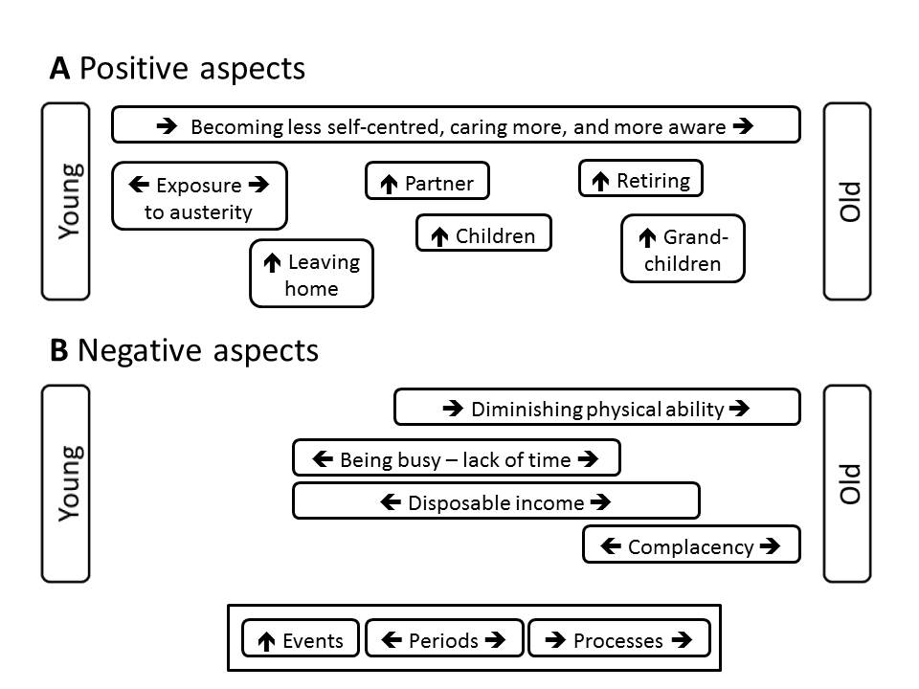
Figure 1. Schematic representation of events, periods and processes that are experienced during ageing: factors that may exert A a positive influence and B a negative influence on waste management attitudes and behaviour (derived from Pickerin & Shaw, 2015).

Those discrete events that influence waste management behaviour generally appear to be positive in terms of their impact (Fig. 1A). Although more work is needed to develop our understanding in this regard, there is a prospect that specific experiences of relatively short duration lead to positive changes in relation to waste management. These events and incidents may typically precipitate a need to behave in a different manner in response to changing circumstances. Leaving home, for example, may incur new responsibilities for managing a household, including activities related to waste management (e.g. product purchase, waste segregation, storage and setting out containers for collection). Likewise, the onset of parenthood or grandparenthood may also lead to refocusing of individuals’ attention, including heightened concerns regarding the environmental legacy that is passed on to children and grandchildren. Such refocusing stands to influence attitudes towards the conservation of resources, likely expressed via more concern for the profligate use of goods and the materials used in their production.
More generally, the process of ageing, although a long-term and cumulative response to experiences, is likely to be affected by multiple and discrete events (Fig. 1). Interactions between the longer-term migration of attitudes and behaviour and the shorter-term events and periods (Fig. 1) are highly probable but remain poorly understood. There is considerable scope for the attitudes, perceptions and behaviours of individuals to be influenced by the broader prevailing conditions and situational factors (austerity, familial and work responsibilities, income), and the nature of such influences may well be age-dependent.

Age and ageing in the context of the waste hierarchy
Whilst recognising that age and ageing may have both positive and negative effects on individuals’ waste management behaviour, it is important to understand more fully their implications. What, for example, are the most important factors influencing more mature individuals in terms of their behaviour with respect to facets of the waste hierarchy? Focus groups with older individuals have highlighted that prevention, reuse, and recycling feature as facets that correspond variously with attitudes, norms and behaviour (Pickerin & Shaw 2015). There also appears to be a concern amongst older people with “repairing”, arguably a sub-category of waste prevention. Evidence from these focus group studies (Table 1) highlights differences between waste management facets and the perceptions of the elderly; there is strong message here that those taking part aligned their views with the upper, more preferred facets of the waste hierarchy. As noted (Fig.1), physical impairment was again indicated as a negative factor.

Waste management facet | Situation and perceptions
Waste prevention | Attitudes are aligned positively with waste prevention and reuse, consistent with a view of the utility of products and the value of the materials used to make them.  Reuse and waste prevention are both considered behavioural norms.
Reuse of items and possessions
Repair of broken items and possessions | No strong attitude towards repair and no evidence of a strong behavioural norm.  Repair activity can be constrained by physical impairment.
Recycling activities | Participation in recycling considered a behavioural norm, but activity can be constrained by physical impairment, notably handling of containers.
Disposal of waste | Attitudes are aligned against waste, consistent with a negative view of losing the materials used to make products.  Avoidance of unnecessary waste is considered a behavioural norm.

Table 1. Facets of waste management as perceived by the elderly (Adapted from Pickerin & Shaw 2015).

Conclusions
Our understanding of how and why age and ageing influence waste management behaviours is in its infancy, but there also a clear need for improvement. There appear to be positive aspects to advancing age and the experience acquired through the ageing process. Attitudes borne of early exposure to austerity represent, in some respects, an idealised model for desirable waste behaviour, being centred on and acquired, in this instance, through the “make do and mend” culture of the post 2nd World War global environment. It is important to note, however, that these circumstances were not imposed by choice, but the scarcity of raw materials and consumer goods was arguably a major constraint to behaviour. Moreover, the status of consumer product technology in the 1940s and 1950s permitted widespread repair of consumer products, whilst durability was perhaps paid more attention than fashion. The twenty first century offers, by contrast, a world in which austerity is an economic phenomenon. Economic recession may reduce individuals’ capacity to purchase consumer goods, but the availability of materials and goods is not a constraint.
Contemporarily, reuse and waste prevention remain options that are preferred in terms of waste management but do not necessarily accord with the public; the technological complexity of consumer products and their miniaturisation present real and significant barriers to their reparation.
If we are to manage sustainably the wastes we generate in a world populated by 9 billion, there are lessons to be learned from the past. There is merit is seeking guidance from those with the most experience of life and considerable scope for better and more strategic intergenerational learning.

Pete Shaw is Associate Professor of Environmental Science at the University of Southampton, England.
Reference
Pickerin P.L., Shaw P.J. (2015). Age and ageing as factors influencing waste management behaviour. 15th International Waste Management and Landfill Symposium, S. Margherita di Pula, Sardinia 5-9 October 2015.

