Plastic reactor suitable for high pressure and supercritical fluid electrochemistry

Authors: Jack Branchª, Mehrdad Alibouri^{b}, David A. Cookª, Peter Richardsonª, Philip N. Bartlettª, Mária Mátéfi-Tempfli^{c}, Stefan Mátéfi-Tempfli^{c}, Mark Bampton^{b}, Tamsin Cookson^{b}, Phil Connell^{b}, David Smith^{b}.
ª Chemistry, The University of Southampton, Southampton SO17 1BJ, UK.
^{b} Physics & Astronomy, The University of Southampton, Southampton SO17 1BJ, UK
^{c} Mechatronics, University of Southern Denmark, Alsion 2, 6400 Sønderborg, Denmark
Abstract:
The paper describes a reactor suitable for high pressure, particularly supercritical fluid, electrochemistry and electrodeposition at pressures up to 30 MPa at 115 °C. The reactor incorporates two key, new design concepts; a plastic reactor vessel and the use of o-ring sealed brittle electrodes. These two innovations widen what can be achieved with supercritical fluid electrodeposition. The suitability of the reactor for electroanalytical experiments is demonstrated by studies of the voltammetry of decamethylferrocene in supercritical difluromethaneand for electrodeposition is demonstrated by the deposition of Bi. The application of the reactor to the production of nanostructures is demonstrated by the electrodeposition of ~80 nm diameter Te nanowires into an anodic alumina on silicon template. Key advantages of the new reactor design include reduction of the number of wetted materials, particularly glues used for insulating electrodes, compatability with reagents incompatible with steel, compatability with microfabricated planar multiple electrodes, small volume which brings safety advantages and reduced reagent useage, and a significant reduction in experimental time.
Introduction:
Electrochemistry in high pressure/supercritical fluids is interesting both technologically and scientifically for several reasons [1]. These include the study of corrosion in supercritical water, an important issue in supercritical water cooled reactors [2-4], applications in electrochemical detection in supercritical fluid chromatography [5-6], and emerging applications in electrosynthesis. Electrodeposition from supercritical fluids has received relatively little attention, however it has been shown to bring particular benefits [1, 7-8] when compared to electrodeposition from conventional solvents. These include the unique properties of the supercritical phase, such as low viscosity, high rates of mass transport [9, 10] and the absence of surface tension: features that make supercritical fluids particularly well suited to electrodeposition into few nanometer diameter pores [11]. In addition supercritical fluids present the opportunity to use specific fluids, with particular chemical properties, at temperatures above their critical point; as, for example, in the pioneering work of Crooks and Bard on electrodeposition of silver from supercritical ammonia [12-13]. Finally supercritical fluids have also been used in electrodeposition to suppress gas bubble formation this allowing the electrodeposition of high hardness metal films with reduced pin hole densities, although in this case the deposition was from a high pressure, multiphase water and CO₂ electrolyte [14] rather than a single supercritical phase.
Despite the many reasons why high pressure/supercritical electrochemistry is of interest, it is not commonly performed. This is, at least in part, because of the additional technical complexities and safety hazards associated with any form of high pressure chemistry. Whilst in principle these same problems apply to HPLC, critical point drying and supercritical extraction, these techniques are relatively wide spread because of the availability of systems for performing them which are engineered to make the experiments easier and safer.
A number of different reactor systems have been designed which allow high pressure/supercritical fluid electrochemistry to be performed, some of which have been reviewed by Giovanelli et al. [15] in 2004. One class of reactor can be described as “cells within a vessel” in which a cell containing the electrolyte, which is not a pressure vessel and is in some way able to change volume, is placed inside a pressure vessel surrounded by an electrically insulating fluid which transmits the pressure to the cell [16-18]. Whilst such cells have been used for very high pressure measurements, up to 800 MPa, they are only suitable for fluids which are liquids at room temperature and pressure and their complexity makes them impractical for many applications, particularly electrodeposition. All of the other reactor designs we have found in the literature involve the electrolyte being held in a metal reactor and being pressurised directly. One key design feature for all of these reactors is the form of the electrical feedthrough. These can be separated into three main types. The first common type is a shear force feedthrough [3, 19-20] such as those supplied commercially by Connex Ltd. and TC Ltd. In this case the conductor is passed through a tight-fitting hole in an electrically insulating sealant block which is then compressed in the direction of the hole, causing a shear force between the insulator and conductor. The second type involves the use of a swaged pressure seal [7, 21] in which the metal conductor is threaded into an insulating sheath, e.g. PTFE, and this is then sealed into the reactor using a standard swaged fitting in which the pressure seal is between the ferrule and the conductor via the insulating sheath. Finally, it is possible to make glued seals, [22] however these are not common, probably due to issues with chemical compatibility and stability at higher temperatures. The authors have experience with all of these feedthrough methods and experienced a number of different practical issues with them. In particular, there can be problems with the reliability of sealing, it is necessary to take precautions to ensure that electrodes cannot be ejected from the reactor at high pressure, and many flag electrodes require additional electrical insulation with glues which add significantly to the complexity of, and time required for, preparing an experiment, which in our experience is commonly approximately 1 day for a single experiment. The problem of corrosion and chemical reactivity of metallic reactors has been dealt with by varying the reactor alloy [3, 22] and inert inserts [7 and 23]. Our experience is that surface treatments can suffer from problems of longevity with repeated thermal cycling and inserts almost inevitably still allow access of the fluid to the metal and thus only reduce reaction rates and still allow corrosion and leaching. Whilst there are a number of designs of reactor which can be used for high pressure/supercritical fluid electrochemistry it is clear that there is plenty of room for further innovations in this field. Any innovations in reactor design which either make such research easier and/or opens up new fluids and experimental possibilities will lead to more interest in, and applications of, high pressure/supercritical fluid electrochemistry. It should also be noted that for many older designs of reactor the information available on the details of the design means that they can be considered as inspiration only and could not be reproduced exactly.
In this paper we present a novel reactor design suitable for high pressure/supercritical fluid electrochemistry and electrodeposition. The reactor incorporates a number of key innovations; a body made of a plastic that is resistant to acids and bases which would corrode metal reactors, flat electrodes o-ring sealed onto the reactor which allow the use of microfabricated electrodes with multiple electrodes sealed in a single, simple step, a limited set of wetted materials and a small active volume of 1.1 ml. We demonstrate various capabilities of the reactor and its application to depositing Te nanowires through an anodic alumina template onto a silicon based electrode which is o-ring sealed to the reactor. We then discuss how the various innovations demonstrated in this reactor might be used, separately and in combination, to produce a range of other reactors suitable for a range of high pressure/supercritical fluid electrochemistry applications.
Safety Warning:
Operation of high pressure apparatus is innately dangerous to the operator and those around them and could, in principle, lead to injury and/or death. High pressure experiments and manufacture of high pressure apparatus should only be undertaken by those suitably trained and able to understand the risks. The manufacturers and users of any equipment developed based upon the research and designs presented in this publication, and any associated supplementary materials, are solely responsible for its safe use.

2. Experimental:
2.1 Reagents and Procedure:
The solvents used were methanol (CH₃OH, Sigma-Aldrich, 99.9%), dichloromethane (CH₂Cl₂ DCM, Sigma Aldrich, Lab Grade, dried by distillation from CaH₂ under N₂ ), supercritical grade carbon dioxide (CO₂, BOC gases, 99.999%) and difluoromethane (R32, CH₂F₂, Apollo Scientific Ltd., 99.9%). The supporting electrolyte was tetrabutylammonium tetrafluoroborate ([NBu₄^{n}][BF₄], Aldrich, 99%). Decamethylferrocene (DMFc ,C₂₀H₃₀Fe, Aldrich, 97%) which was sublimed prior to use. tetrabutylammonium tetrachlorobismuthate(III) ([NBu₄^{n}][BiCl₄]) and tetrabutylammonium hexachlorotellurate(IV) [NBu₄^{n}]₂[TeCl₆] were prepared as described previously [24]. Stock solutions of decamethylferrocene, tetrabutylammonium tetrafluoroborate, tetrabutylammonium hexachlorotellurate(IV) and tetrabutylammonium tetrachlorobismthate were dissolved in CH₂Cl₂ and left in a N₂ purged glove box. Materials were introduced by auto-pipette and the CH₂Cl₂ allowed to evaporate, the resulting solid left behind will equal the mass required for the concentration desired in the cell.
Supported nanoporous anodic alumina (SNAT) templates were prepared for deposition according to the method described in [25], which permits the realization of different high aspect ratio nanostructures and of nanostructured electrodes both on solid [26] and on flexible [27] substrates on large surface areas. In brief, the substrate preparation started with 750 nm aluminium film sputter deposition onto silicon wafers previously pre-coated with a thin titanium adhesion layer (a few nm) on a gold (tens of nm) underlayer. The nanoporous template was prepared by electrochemical oxidation of the Al layer in 0.3 M oxalic acid solution at 2 °C under constant cell potential of 40 V. The process was monitored with a program written in IgorPro. Pore widening and barrier-layer etching were performed in 0.5 M orthophosphoric acid solution at 30 °C. The process was tuned to obtain nanopores with average diameter of about 80nm and spacing of ∼100 nm.
2.2 Reactor Design:
The reactor can conceptually be separated into three parts (Fig 1, 2 and 3). Detailed AutoCAD plans for the reactor are available in the supplementary material. The first part is an inner plastic vessel (Fig 1) that contains the supercritical fluids, i.e. to which all the high pressure seals are made. The second is a copper reactor support (Fig 2) which provides mechanical support for the inner vessel and acts as a heat spreader. The final part is a housing (Fig 3) which acts as a press to keep the two halves of the outer vessel together, contains the necessary fluid channels required for heating and cooling, and functions as a secondary “explosion” shield. This part also contains the electrical connectors for making electrical contact to the electrodes mounted on the inner vessel.

Fig 1 presents a close up of the inner plastic vessel plus o-rings and top and bottom electrodes. The inner vessel consists of a central conical shaped void with a volume 0.78 ml which is sealed top and bottom with planar electrodes. The bottom (counter) electrode is commonly a sapphire substrate (1 mm thick; UQG Optics Ltd.) onto which 10 nm Cr, as a sticking layer, plus 200 nm of Au are thermally evaporated on the wetted side. The top (working) electrode shown in Fig 1 consists of a strip of oxide coated silicon wafer (1 mm thick 001 Si: 200 nm IDB Technologies Ltd.) onto which two separate Cr/Au electrodes have been shadow evaporated. However, a wide range of possible top and bottom electrode designs have been tested and many other designs are possible. The reference electrode presents a particular problem in supercritical fluid electrochemistry because of the challenge of making a system that can withstand the temperature and pressure cycling required in use [28]. In the literature pseudo reference electrodes are almost always used [20, 29-32] even though they have obvious limitations. An alternative, although not an ideal solution, is to use an outer sphere redox couple as an internal redox standard and decamethylferrocene (DMFc) has been shown to be a suitable choice for used in supercritical difluoromethane (scR32) [33]. In the present case we have used the stainless steel body of the thermocouple as a pseudo reference electrode. It would also be possible to electroplate the thermocouple body with Pt or another metal and use this as a pseudo reference electrode or to incorporate a pseudo reference electrode, or other type of reference electrode, in one of the top or bottom electrode structures. The central void, between the top and bottom electrodes, has access for three 1/16 inch tubes or rods which are sealed onto the body using PEEK nuts and ferrules. These are intended to provide two high pressure fluid connections, e.g. for in and out flow, plus a thermocouple, which are available with plastic coating. In order to ensure good dissolution and mixing of the electrolytes, we usually place a small Teflon coated stirring magnet onto the bottom electrode which can be rotated from outside the reactor using a standard stirrer plate. We have found that the Cr/Au coating is sufficiently strong to survive vigorous stirring. Both electrodes are sealed onto the inner vessel using non-carbon black containing EPDM o-rings. As discussed in the supplementary material, many common o-rings include fine carbon particles leading to significant electrical conductivity when they are squeezed or exposed to the supercritical fluids. This in turn can lead to short circuits between electrodes on the same substrate. However there is a wide range of suitable o-rings which are also discussed later. Some safety channels have been milled into the top and bottom surface of plastic reactor to conduct supercritical fluids to the vent line should an electrode crack.
Fig 2 presents the design of the outer vessel. The copper outer vessel plays several roles in the reactor design. Firstly, it provides mechanical strength allowing higher pressures to be reached with thinner plastic walls. This mechanical strength also adds to the safety of the reactor. It acts as a heat spreader and increases the rate of heat transport into and out of the reactor. Finally, it acts as a mount for the inner vessel allowing the inner vessel to be assembled and sealed before pressurisation. To assemble the reactor the bottom electrode is first mounted into a recess in the bottom half of the outer vessel. This recess is the same depth as the electrode. It must be formed in such a way that the electrode is on a flat surface with no contact with the edges of the recess otherwise electrode cracking will be common. Next the plastic reactor, with the inlet and outlet pipes and thermocouple already fitted, is sealed onto the bottom electrode using an o-ring and held in place by the two screws shown in Fig 2. Once this step is complete, solid and liquid reagents and electrolytes can be placed into the reactor. The two halves of the copper outer vessel have been machined so that the nuts and ferrules used to seal the pipes and thermocouples are within the outer vessel and should one fail, the components will be retained. To complete the reactor vessel the upper electrode is placed into a recess in the upper half of the copper vessel and the final high pressure seal, between the plastic reactor and the upper electrode is made using an o-ring. The upper and lower copper vessels are held together by two spring locks. These have been designed to allow the reactor to be sealed whilst in a glove box and then removed without any water or air entering the reaction chamber.
Fig 3 presents the housing and the complete reactor vessel before the reactor vessel is installed. Fig 4 presents a cross-section of the whole reactor with the reactor vessel installed. The housing is effectively a screw press which applies force to the upper and lower parts of the copper vessel to keep them together when the inner vessel is pressurised. The press is closed by hand-tightening using the handle on top. The top and bottom plates of the press are formed from copper and contain fluid channels. The channels allow the reactor to be heated and cooled using fluid from a thermostatically controlled re-circulator. In general to decrease convection in the cell it is best that the upper plate be slightly hotter than the bottom plate. This can be achieved by placing them in series in the heating/cooling circuit with the hot fluid from the re-circulator coming to the top plate first. A spring electrical contact is mounted into the housing so that when the vessel is inserted into the housing the electrical connection is made. The electrical connection to the upper electrode is made with a glued on electrical connector. The housing is fitted with side walls and a lockable door with only the minimum necessary openings so that it acts as an outer explosion shield.
2.3 Pressure Testing:
The reactor was successfully hydrostatically tested with methanol at room temperature and 43.5 MPa and ethylene glycol at 115 ºC and 36 MPa. It was tested with supercritical CO₂ at 110 ºC and 30 MPa and CH₂F₂ at 115 ºC and 33 MPa. After an initial <5 min equilibration time the leakage rates measured were 16 KPa/min for CO₂ and 12 KPa/min for R32.
2.4 Temperature Testing:
In order to test the thermal and pressure dynamics of the reactor it was prepared and sealed at room temperature and a standard experimental cycle performed whilst the temperature and pressure inside the reactor were measured (fig 5). First the reactor was heated using water from a pre-warmed bath circulator set to 87 °C. Once the reactor had reached the critical point of CH₂F₂, at ten minutes, the reactor was then filled with CH₂F₂ using a high pressure Jasco pump (PU-2080-CO2) at a rate of 0.5 ml/min until the pressure reached the set point of 18 MPa, at 22 minutes. The pump was turned off and the reactor was in a condition suitable for an electrochemical experiment within 24 minutes. After the experiment was performed, at 30 minutes, the reactor was cooled by connecting it to tap water with the temperature of the reactor dropping to 40 °C within 10 minutes.

3. Results and Discussion:
3.1 Comparison of Reactors:
There are many drawbacks when using a steel cell for electrochemical measurements and the time taken to set up the experiments is one of the biggest of these. To make, prepare and polish the electrodes takes on the order of 1+ days. The time taken to prepare, heat and finally pressurise the steel cell takes on the order of a ½ day. This process means the electrodes cannot be polished immediately before taking electrochemical measurements. Our newly designed plastic reactor is specially made to overcome these drawbacks, as well as advance on the previous cell. The bulk of the reactor was made from polyether ether ketone (PEEK), this is to reduce impurities and also allow for the study of corrosive materials. Lithographically produced electrodes would also save time from making, preparing and polishing electrodes and also be one-time use. To reduce natural convection in the cell [34] the cell is heated top and bottom uniformly by a heater circulator as opposed to a band heater. This allows the cell to reach operating temperature within 20 minutes, which again is faster than the steel cell which can take 60 minutes or longer. The small volume of the plastic reactor (0.78 mL compared to 8.65 mL in the steel cell) allows for less chemical waste in an experiment and compounds that are difficult to synthesise can be used sparingly. The advantages of the new reactor design means experiments can be performed once or twice daily as opposed to two or three times a week in the steel cell.
3.2 Background Electrolyte Testing:
In order to determine if the plastic reactor was free of electrochemically active impurities, background scans in supercritical difluoromethane (scR32) were performed at a single strip Au electrode. Although the experimental section details a dual strip electrode, the reason for a single strip will be discussed later. The background scans consisted of performing cyclic voltammetry in a solution of 20 mM [NBu₄^{n}][BF₄] in scR32, at 86.5 °C and ≈ 18 MPa, shown in Figure 6, these conditions replicate those used in our previous works [35] . As can be seen from Figure 6, the background scan shows no signs of contamination, the high currents recorded are due to the large area of the electrode. The background, double layer charging current in the range +1 to -1 V is consistent with our previous work [35]. The large area of the electrode also means that any impurities would produce significant currents in the background scan. The features seen at 1.5 V and –2.1 V are those caused by electrolyte breakdown. As the background showed no signs of contamination or additional features, the reactor was considered to be suitable for electrochemical measurements. Additional testing of the reactor was performed by studying DMFc in scR32, the electrodeposition of bismuth and the deposition of tellurium nanowires.

3.3 Voltammetry of Decamethylferrocene:
To further investigate the capabilities of the plastic reactor for electrochemical measurements, cyclic voltammograms were performed in a solution of scR32 containing 0.4 mM DMFc and 20 mM [NBu₄^{n}][BF₄] at a single strip Au electrode at 87 °C and ≈ 18.6 MPa, these are shown in Figure 7. The data obtained from the voltammetry (peak currents, peak to peak separation etc.) are given in the supplementary material. Natural convection driven by thermal or density gradients is much more significant in supercritical fluids than in conventional liquid electrolytes because of the much lower viscosity of the supercritical fluid. As we have shown in our earlier studies [33-35] this manifests itself as noise in the mass transport limited current at microelectrodes and distortion of slow scan rate cyclic voltammetry. As can be seen from Figure 8 the voltammetry obtained in the plastic reactor shows well defined features with little to no intrinsic convection, even at scan rates of 10 mV/s. This is in contrast to the voltammetry obtained in our standard steel cell that shows convective noise which can be dampened by a baffle [34]. The small volume, shape, and uniform heating of the reactor acts to reduce natural convection allowing scans to be performed at low scan rate. In a recent publication [34], we demonstrated a simple, approximate, way to estimate the effects of iR drop by drawing lines connecting the anodic and cathodic peak positions at different scan rates (dashed lines in Figure 7). The separation of the two lines through the peak currents was estimated to be 82 mV. This is close to the expected value of 71.3 mV for a reversible 1 e⁻ process at 87 °C. The uncompensated solution resistance was also estimated from the slope of the lines and was found to be 1.88 kΩ, this is reasonable given the conductivity of the system [9].

3.4 Deposition of Bismuth onto Flag Electrodes:
Cyclic voltammograms recorded from a solution of scR32 containing 1 mM [NBu₄^{n}][BiCl₄] and50 mM [NBu₄^{n}][Cl] for a single strip Au electrode at a scan rate of 50 mV/s, at 87 °C and 19.3 MPa are shown in Figure 9. As can be seen from the Figure, there are characteristic deposition and stripping peaks, along with a nucleation loop seen only on the first scan. The process in which bismuth deposits onto the electrode surface is
${Bi}^{3+}+ {3e}^{-} → {Bi}^{0}$ (1)
It can also be seen in Figure 9 that the onset of deposition moves from -0.35 V to
-0.28 V after three scans. Taking the first scan (Figure 9), the total bismuth plating charge and stripping charge can be calculated, these were 2.05 mC and 0.83 mC, respectively. This leads to the total stripping being 40.5% of the total plating charge. This value is lower than that reported in the literature for deposition from the same bismuth complex in DCM at room temperature onto glassy carbon (91.1%) [36] but similar to the value obtained previously for deposition on gold in scR32 [35].

Bismuth was deposited onto the Au disk electrode by holding the potential at -0.6 V for 8475 s. The charge passed for the deposition was 64 mC, which leads us to a deposit thickness of 0.35 µm. The results of the deposition can be seen in Fig 10. The obvious feature seen in Figure 10 is that the growth of the deposit is solely contained within the o-ring confirming a good o-ring seal to the electrode. It can also be seen that the deposit is uniform across the electrode surface with thicker deposits being more apparent at the edges of the metal strip. This is consistent with the greater rate of diffusional mass transport to the edge of the electrode. The deposit was analysed using SEM and EDX and the results are presented in Figure 11 and Table 1, respectively.

The SEM image shows a thick bismuth deposit and upon higher magnification showed an “Aloe Vera leaf” type morphology. The EDX spectra showed a strong bismuth signal with a high atomic % and no signs of contamination from supporting electrolyte (no chlorine or carbon detected) or the reactor. The Au signal is from the evaporated gold substrate and the oxygen peak is most likely from the sample being handled in air prior to SEM.
3.5 Deposition of Tellurium into AAO Templates:
Cyclic voltammetry performed in a solution of scR32 containing 2 mM [NBu₄^{n}]₂[TeCl₆] with 50 mM [NBu₄^{n}][Cl] with an AAO template electrode (A = 0.126 cm²) at a scan rate of 100 mV/s, at 87 °C and 21.6 MPa is displayed in Figure 12. As can be seen from the Figure, there are characteristic deposition features, including a nucleation loop, but with very little stripping seen on the reverse scan. The appearance of the single reduction wave indicates that the Te(IV) species is directly reduced to its elemental state. The deposition onset, peak deposition current and stripping onset potential for the Te(IV) were -0.24 V, -0.62 V and -0.05 V respectively. The voltammetry recorded is very similar to that reported in our previous paper at a gold disc with comparable concentrations of analyte, supporting electrolyte and temperature and pressure [35]. Potentiostatic electrodeposition was performed, the potential was held at -1 V for 1200 s to ensure overgrowth of Te through the template. The working electrode area of the electrode was changed from a gold colour to a dark grey upon disassembly.

A photograph of the AAO substrate after deposition is shown in Figure 13A. The silver region in the photograph corresponds to unanodized aluminium, the gold region corresponds to the anodized region which allows the underlying gold to be observed, the black circle corresponds to the region of the AAO which has been exposed to the supercritical fluid which goes black after electrodeposition. The sample was cleaved through the central deposition zones and observed using scanning electron microscopy (Figure 13 B-D). These images show the Au coated substrate at the bottom, the AAO membrane which has delaminated from the substrate in the middle and overgrowth of Te on top of the AAO at the top. In a number of places on the substrate can be seen the initial segment of Te nanowires which have remained when the AAO delaminated. It is also possible to see segments of Te nanowires remaining in the cleaved face of the AAO and it is likely that the cleaving process has led to a loss of at least half the nanowires which were in the pores. Finally, apart from small patches such as that in Figure 13D where it is likely that the overgrowth has been lost post deposition, the top of the membrane is covered with Te. EDX measurements performed on the overgrowth indicate that the film is Te. The EDX spectra also show Al, O and Au, The Al and O are from the alumina oxide template which has not been removed prior to imaging. The Au is, as mentioned earlier, from the bottom of the pore and is where the electrodeposition occurs. EDX spectra taken on areas that did not have an overgrowth still showed significant Te signal. This result together with the images of nanowires proves that we have deposited tellurium nanowires from the new reactor. It should be noted that this was achieved using a brittle silicon substrate sealing a high pressure reactor.
4. Conclusions:
The results presented in this paper demonstrate that the new reactor design set out in this paper has a number of key capabilities. We have established that the new reactor design is capable of operating at pressures up to 30 MPa and temperatures up to 115 °C with low leakage rates allowing multi-hour experiments with the reactor isolated. We have shown that it is compatible with liquid methanol, supercritical CO₂ and supercritical CH₂F₂ and can be used with a standard stirrer plate. We have performed experiments in which we assemble the reactor, perform a supercritical fluid electrochemistry experiment and depressurise within one or two hours. This is much more practical than our previous reactor system which took a whole day for one experiment. The small volume of the reactor, 1.1 ml, means that it only requires small amounts of reagents, which can be expensive and time consuming to produce. We have demonstrated a number of key features of the reactor; the materials used in its construction do not introduce any contaminants which are electroactive in the operating window of our standard supporting electrolyte, 20 mM [NBu₄^{n}][BF₄] in scR32, or affect the purity of electrodeposited Bi and Te; its design supresses convection, eliminating this source of noise in cyclic voltammetry which can be very significant in other reactor designs.; it is suitable for both electroanalytical experiments, e.g. decamethylferrocene electrochemistry, and electrodeposition, e.g. bulk Bi; and it enables the use of microfabricated multi-electrode electrodes. We have used the reactor to electrodeposit Te nanowires directly into an AAO on silicon template. The o-ring sealing mechanism used in the reactor means that it is not necessary to insulate contacts with glue which often limits the operating temperature and/or can lead to contaminants leaching out due to the highly penetrating nature of supercritical fluids. Finally, we have demonstrated the counterintuitive fact that it is possible to seal brittle, crystalline electrodes onto a high pressure reactor without them cracking, opening up the possibility of deposition directly onto silicon and other crystalline semiconductors. The two major innovations in our high pressure cell design, the use of a plastic reactor vessel and the use of o-ring sealed brittle electrodes, open up opportunities for new science. For example, replacing the metal cell and feedthroughs allows the cell to be used to study more corrosive or reactive electrodeposition reagents that would otherwise react with, and be contaminated by corrosion products of, the metal cell such as some Si or Ge complexes. Second the use of the o-ring sealed brittle electrodes avoids the problem of the feedthroughs and the limitation this places on the number of electrode connections allowing the use of lithographically patterned multielectrode arrays for a range of new experiments. These include generator/collector electrode measurements [37] using microband arrays to study supercritical fluid solution chemistry and the use of individually addressable microelectrode arrays. The use of the o-ring seal also opens up the opportunity to use brittle transparent electrode materials (such as ITO) to carry out photoelectrochemical experiments in supercritical fluids using through electrode illumination.
In addition to being a useful reactor design in itself the current design incorporates a number of key innovations which could be incorporated in other reactor designs. For instance whilst plastic high pressure components are commonly produced commercially for HPLC systems no one had produced high pressure electrochemical reactors from plastics before, presumably because such reactors need a significant internal volume. This is possible in this design because of the mechanical support of metallic components which are not wetted. The use of microfabricated electrodes which are directly sealed to the reactor body opens up the possibility of very small internal volume flow reactors with multiple working, counter and reference electrodes patterned onto a single substrate. By either incorporating heaters onto the substrates or locally heating the substrates from outside it should be possible to increase the deposition temperature above the limit placed by sealants, which with our existing sealants is already 350°C. In addition to the suggestions we have made here we hope that others will take inspiration from this design in developing new and improved designs.
4. Acknowledgements
This research was supported by the Engineering and Physical Sciences Council of the UK via a Program Grant (EP/I033394/1). PNB gratefully acknowledges receipt of a Wolfson Research Merit Award. We thank Dr. Jenny Burt for the supply of the bespoke reagents.

4. References
[1] K. E. Toghill, M. A. Méndez and P. Voyame, Electrochem. Commun.s, 44, 27–30 (2014).
[2] M. J. Cocero and J. L. Mart´ınez, J. Supercrit. Fluid., 31, 41–55 (2004).
[3] X. Y. Zhou, S. N. Lvov, X. J. Wei, L. G. Benning and D. D. Macdonald, Corros. Sci., 44, 841-860 (2002).
[4] Y. Calzavara, C. Joussot-Dubien, H. A. Turc, E. Fauvel and S. Sarrade, J. Supercrit. Fluid., 31, 195–206 (2004).
[5] A. M. Girelli and E. Mattei, J. Chromatogr. B, 819, 3–16 (2005).
[6] J. Fedorowski and W. R. LaCourse, Anal. Chim. Acta, 657, 1–8 (2010).
[7] P. N. Bartlett, D. A. Cook, M. W. George, A. L. Hector, J. Ke, W. Levason,G. Reid, D. C. Smith and W. Zhang, Phys. Chem. Chem. Phys., 16, 9202-9219 (2014).
[8] J. A. Branch and P. N. Bartlett, Phil. Trans. R. Soc. A, 373, 1-16(2015).
[9] P. N. Bartlett, D. C. Cook, M. W. George, J. Ke, W. Levason, G. Reid, W. Su and W. Zhang, Phys. Chem. Chem. Phys., 13, 190-198 (2011).
[10] X. Han, J. Ke, N. Suleiman, W. Levason, D. Pugh,W. Zhang, G. Reid, P. Licence and M. W. George, Phys. Chem. Chem. Phys., 18, 14359-14369 (2016)
[11] J. Ke, W. Su, S. M. Howdle, M. W. George, D. Cook, M. Perdjon-Abel, P. N. Bartlett, W. Zhang, F. Cheng, W. Levason, G. Reid, J. Hyde, J. Wilson, D. C. Smith, K. Mallik and P. Sazio, P. Natl. Acad. Sci. USA, 106, 14768-14772 (2009).
[12] R. M. Crooks and A. J. Bard, J. Phys. Chem., 91, 1274–1284(1987).
[13] R. M. Crooks and A. J. Bard, J. Electroanal. Chem., 240, 253–279 (1988).
[14] H. Yoshida, M. Sone, H. Wakabayashi, H. Yan, K. Abe, X. T. Tao, A. Mizushima, S. Ichihara and S. Miyata, Thin Solid Films, 446, 194–199(2004).
[15] D. Giovanelli, N. S. Lawrence and R. G. Compton, Electroanal., 16, 789-810 (2004).
[16] J. Sachinidis, R. D. Shalders and P. A. Tregloan, J. Electroanal. Chem. 327, 219-234 (1992).
[17] T. W. Swaddle and P.A. Tregloan, Coord. Chem. Rev., 187, 255-289 (1999).
[18] J. Gorecki and J. Golas, Electroanal., 8, 630-634 (1996).
[19] D. L. Goldfarb and H.R. Corti, Electrochem. Commun., 2, 663–670 (2000).
[20] A. C. McDonald, F. F. Fan and A. J. Bard, J. Phys. Chem., 90, 196-202(1986)
[21] J. Jun and P.S. Fedkiw, J. Electroanal. Chem., 515, 113–122 (2001).
[22] P. Botella, F. Cansell, T. Jaszay, J. P. Frayret and M. H. Delville, J. Supercrit. Fluid., 26, 157-167 (2003).
[23] K. J. Stevenson and H. S. White, J. Phys. Chem., 100, 18818-181822 (1996).
[24] P. N. Bartlett, D. Cook, C. H. Groot, A. L. Hector, R. Huang, A. Jolleys, G. P. Kissling, W. Levason, S. J. Pearce and G. Reid, RSC Advances, 3, 15645- 15654 (2013).
[25] S. Mátéfi-Tempfli, Encyclopedia of Nanotechnology: Nanostructures Grown Via Electrochemical Template Methods (Ch), p. 459-481, Nova Science Publishers (Ed: E. D. Carlson), New York (2009).
[26] S. Habouti and M. Mátéfi-Tempfli, C.-H. Solterbeck, M. Es-Souni, S. Mátéfi-Tempfli, M. Es-Souni, Nano Today, 6, 12-19 (2011).
[27] S. Mátéfi-Tempfli and M. Mátéfi‑Tempfli, Adv. Mater., 21, 4005-4010 (2009).
[28] C. Y. Cummings, J. A. Branch, P. W. Richardson and P. N. Bartlett, Electrochimica. Acta, 187, 323-328 (2016).
[29] A.P. Abbott and C.A. Eardley, J. Phys. Chem. B, 103, 6157–6159 (1999).
[30] J. Ke, P.N. Bartlett, D. Cook, T.L. Easun, M.W. George, W. Levason, G. Reid, D. Smith and W. Su, W. Zhang, Phys. Chem. Chem. Phys., 14, 1517–1528 (2012).
[31] C. Liu, S.R. Snyder and A.J. Bard, J. Phys. Chem. B, 101, 1180–1185 (1997).
[32] S.A. Olsen and D.E. Tallman, Anal. Chem., 68, 2054–2061 (1996).
[33] P. N. Bartlett and J. Branch, J. Electroanal. Chem., 780, 282-289 (2016).
[34] J. A. Branch, D. A. Cook and P. N. Bartlett, Phys. Chem. Chem. Phys.,17, 261- 267 (2015).
[35] P. N. Bartlett, J. Burt, D. A. Cook, C. Y. Cummings, M, W. George, A. L. Hector, M. M. Hasan, J Ke, W. Levason, D. Pugh, G. Reid, P. W. Richardson, D. C. Smith, J. Spencer, N. Suleiman and W. Zhang, Chem. Eur. J., 22, 302-309 (2016).
[36] P. N. Bartlett, D. Cook, C. H. (Kees) de Groot, A. L. Hector, R. Huang, A. Jolleys, G. P. Kissling, W. Levason, S. J. Pearce and G. Reid, RSC Advances, 3, 15645-15654 (2012).
[37] E.O. Barnes, G.E.M. Lewis, S.E.C. Dale, F. Marken, R.G. Compton, Analyst, 137, 1068-1081 (2012)

Table 1
Element | Weight% | Atomic%
O K | 3.50 | 31.67
Au M | 35.46 | 26.06
Bi M | 61.04 | 42.27
Totals | 100.00

Table 2
Element | Weight% | Atomic%
O K | 14.79 | 58.90
Al K | 2.40 | 5.65
Au M | 33.57 | 10.86
Te L | 49.24 | 24.58
Totals | 100.00

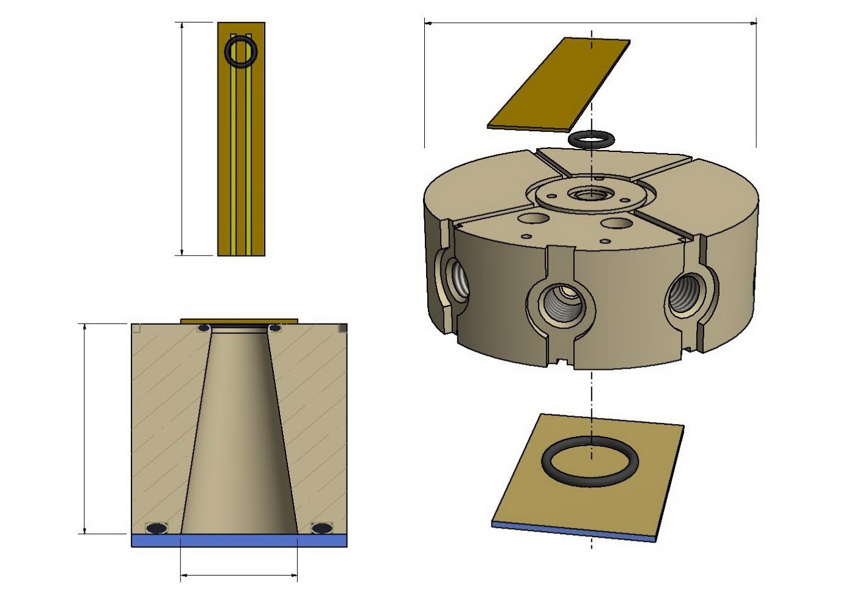
Ø 51mm
Upper Electrode
50mm
18mm
Cross-Section
Bottom Electrode
10mm
Figure 1

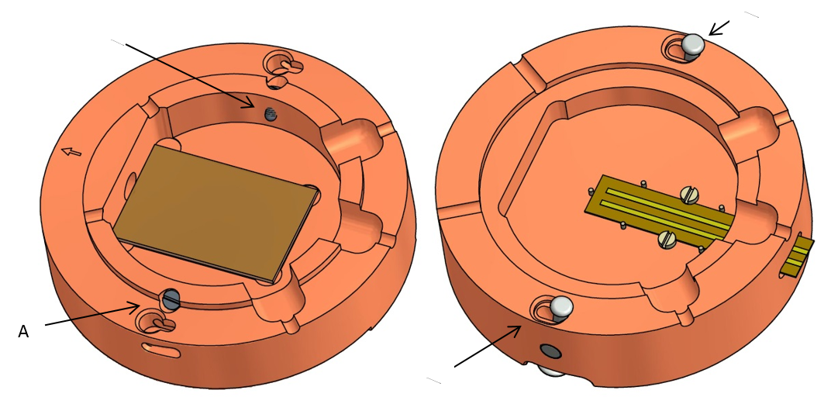
Figure 2

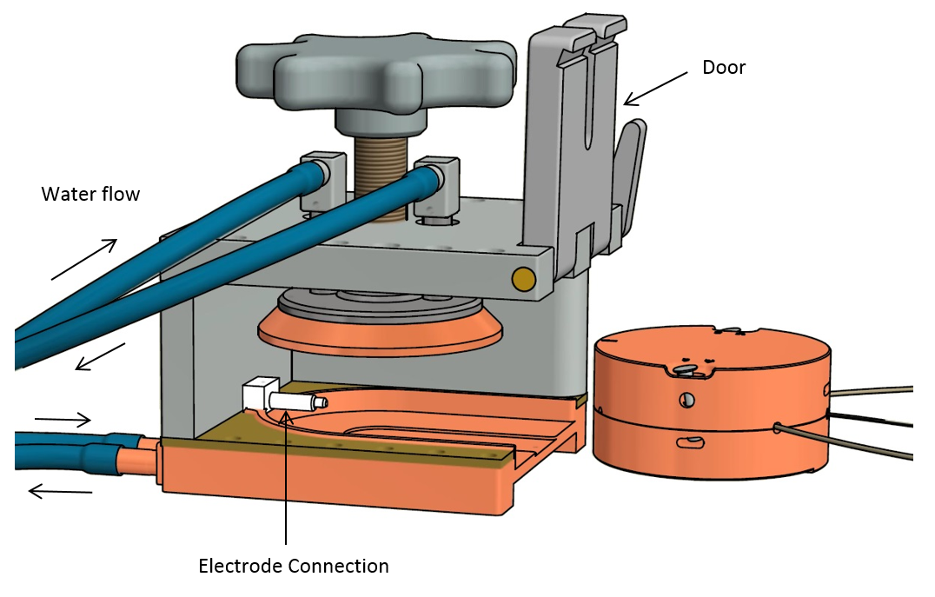
Figure 3

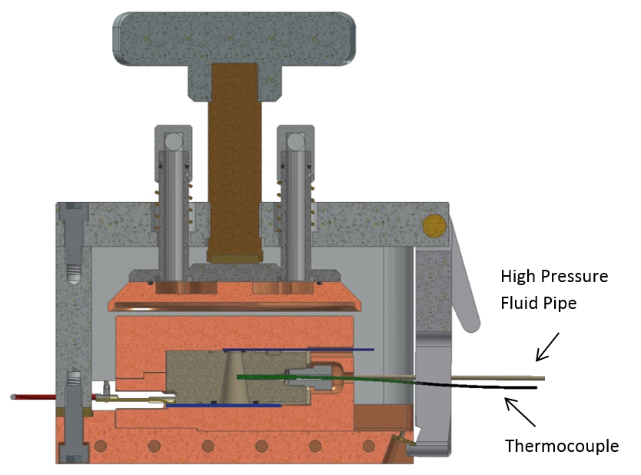
Figure 4

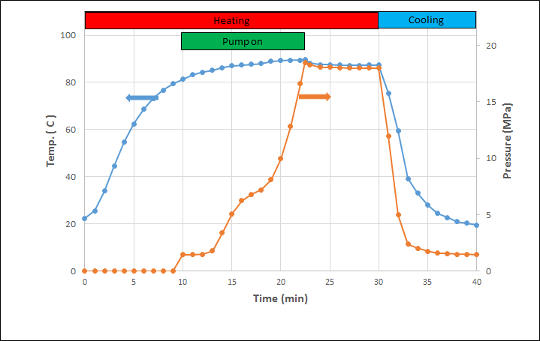
Figure 5

Figure 6

Figure 7

Figure 8

Figure 9

Figure 10

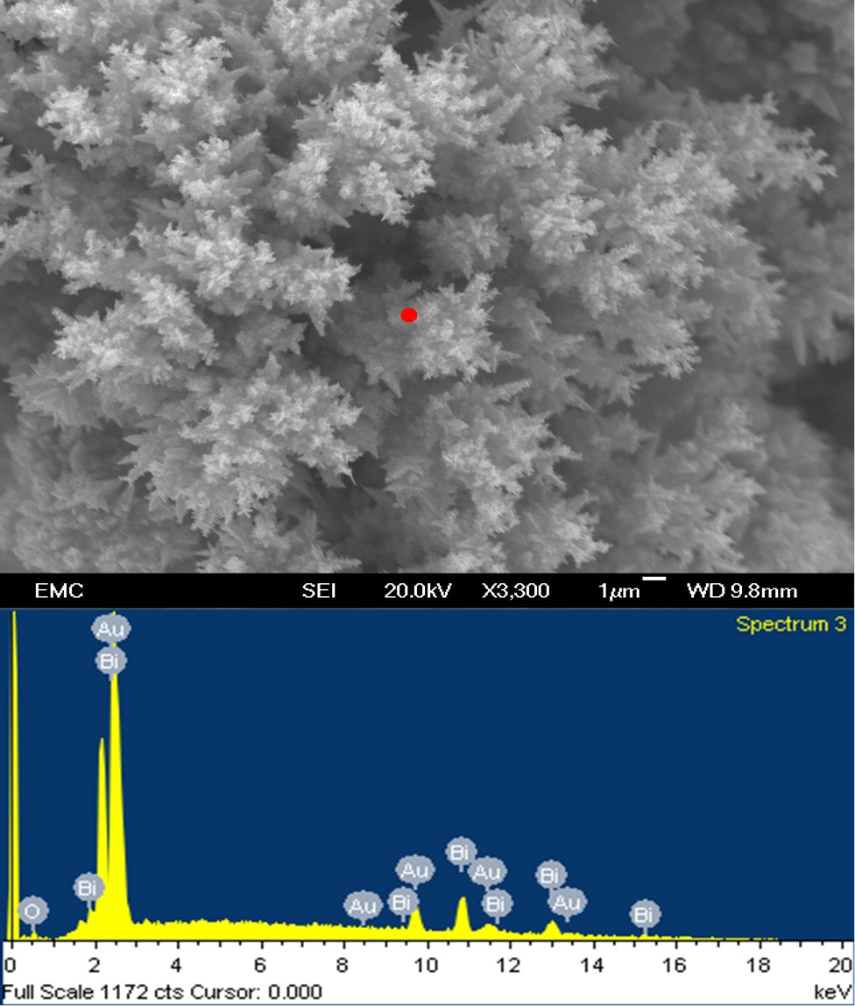

Figure 11

Figure 12

Figure 13
Table 1. Composition of bismuth film sample electrodeposited using the new reactor obtained from EDX analysis presented on Figure 11.
Table 2.Composition of AAO template sample presented in Fig 13 after tellurium deposition obtained by EDX analysis, FEGSEM (Model JEOL-JSM 6500F, volt = 20 kV). The spectrum is presented in supplementary material).
Fig 1: Inner plastic vessel assembly presented with top (working) and bottom (counter) electrodes and o-rings used to seal these to the plastic vessel to complete the reactor space. The cross section is shown with the electrodes and o-rings in place once the reactor is sealed. The wetted face of the top electrode is shown top left.
Fig 2: Copper reactor support with the electrodes fitted into the lower (left) and upper (right) halves. The retaining screws (A) are used to press the inner plastic vessel against the lower, Au coated sapphire electrode making the o-ring seal. The upper half of the reactor support is then placed onto the top of the inner plastic vessel (Fig 1) sealing the top (working) electrode to the inner vessel and held in place with the two spring locks (B) which engage with the bottom half of the reactor support.
Fig 3: View of reactor housing with nearest side wall (mirror image of far side wall) removed. The rest of the reactor is shown on the right ready for use. The copper coloured components of the reactor housing contain fluid channels through which heating/cooling fluid is passed from a thermostatically controlled bath to regulate the reactor’s temperature. When the rest of the reactor is placed into the housing the electrode connector passes through the relevant hole in the reactor support and makes a spring loaded electrical connection to the bottom Au coated sapphire electrode. Once the rest of reactor is installed the handle on top is used to press the reactor support halves together and the housing door is closed and locked.
Fig 4: Cross-section through reactor with all components and connections installed. The press is shown raised for clarity. Full CAD plans for the reactor are available in the supplementary material to enable interactive 3D viewing of the design. The stainless steel body of the thermocouple is used as the pseudo reference electrode.
Fig 5: Temperature and pressure inside reactor during a standard experimental cycle in which the reactor is first heated then pressurised, an experiment is performed and then the reactor is cooled. The target temperature and pressures were 87 °C and 18 MPa respectively.
Figure 6. Cyclic voltammetry for a solution containing 20 mM [NBu₄^{n}][BF₄] in scR32,
scan rate 100 mV s⁻¹, 87 °C and ~18 MPa. The working electrode was an evaporated gold strip
(A = 0.12 cm²), the potential is measured against the stainless steel casing of the thermocouple as a pseudo reference electrode and the counter electrode was an evaporated gold sapphire slide (A = 1.3 cm²).
Figure 7. Cyclic voltammograms for a solution of 0.4 mM DMFc and 20 mM [NBu₄^{n}][BF₄] in scR32 at 87 °C and ~18.6 MPa recorded at various scan rates as indicated. The working electrode was an evaporated gold strip (A = 0.12 cm²). The other electrodes were as in Fig 6.

Figure 8. Cyclic voltammetry for a solution of 0.4 mM DMFc and 20 mM [NBu₄^{n}][BF₄] in scR32 at 87 °C and ~18.6 MPa, scan rate 10 mV s⁻¹. The working electrode was an evaporated gold strip
(A = 0.12 cm²). The other electrodes were as in Fig 6..

Figure 9. Cyclic voltammograms for a solution of 1 mM [NBu₄^{n}][BiCl₄] and 50 mM [NBu₄^{n}][Cl] in scR32, scan rate 50 mV s⁻¹ for all scans, 359.7 K and ~19.3 MPa. The working electrode was an evaporated gold strip (A = 0.135 cm²). The other electrodes were as in Fig 6.
.
Figure 10. Left: A picture of the working electrode after electrodeposition of bismuth upon disassembly of the plastic reactor. Right: An SEM image of the same deposit. The circular edges of the bismuth deposit are defined by the inner diameter of the o-ring when compressed in the reactor.
Figure 11. SEM image of the thickest edge of electrodeposited bismuth film, the red spot represents where the EDX spectrum was obtained. FEGSEM (Model JEOL-JSM 6500F, volt = 20 kV).
Figure 12. Cyclic voltammetry for a solution of 2 mM [NBu₄^{n}]₂[TeCl⁶] and 50 mM [NBu₄^{n}][Cl] in scR32, scan rate 100 mV s⁻¹, 359.6 K and ~21.6 MPa. The working electrode was a Matefi-Tempfli templated electrode (A = 0.126 cm²). The other electrodes were as in Fig 6.
Figure 13: (A) Photograph of AAO template after deposition of tellurium, (B, C and D) SEM images of AAO template after tellerium deposition. The sample has been cleaved through the deposition region causing the AAO film to delaminate from the underlying gold.

