Beyond human error taxonomies in assessment of risk in sociotechnical systems: a new paradigm with the EAST 'broken-links' approach

Neville A Stanton^{1*} and Catherine Harvey²

¹Transportation Research Group, Civil, Maritime and Environmental Engineering and Science Unit, Faculty of Engineering and the Environment, Bouldrewood innovation Campus, Burgess Road, University of Southampton, Southampton, SO16 7QF, UK.
*Corresponding author: n.stanton@soton.ac.uk
²Human Factors Research Group, University of Nottingham, Nottingham, NG7 2RD, UK.

Abstract
Risk assessments in Sociotechnical Systems (STS) tend to be based on error taxonomies, yet the term ‘human error’ does not sit easily with sociotechnical systems theories and concepts. An alternative perspective is to propose sociotechnical system incidents as the consequence of information failing to be passed between agents and tasks. This approach posits incidents as a system communication failure rather than human error. A case study of the training of a Royal Navy crew detecting a low flying Hawk is presented. The Event Analysis of Systemic Teamwork (EAST) method was used to model the Hawk-Frigate STS in terms of social, information and task networks. A break-link approach was used to reveal the effect of information communication failures between agents and tasks on the entire STS. By breaking 19 social links and 12 task links 137 potential risks were identified. Discoveries included revealing the effect of risk moving around the system; reducing the risks to the Hawk increased the risks to the Frigate. Future research should look at the effect of breaking multiple links simultaneously, to examine the effects of compounded information communication failures on STS performance.

Practitioner Summary
The paper presents a step-by-step walk-through of EAST to show how it can be used for risk assessment in sociotechnical systems. The ‘broken-links’ method takes a systemic, rather than taxonomic, approach to identify information communication failures in social and task networks.

Keywords
Sociotechnical systems, Analytical models, Risk, EAST

Introduction
The term ‘Socio-Technical Systems’ (STS) is used to refer to the interaction between humans and machines, from the small and simple to the large and highly complex (Walker et al., 2008, Walker et al., 2010b, Read et al., 2015). These subsystems operate and are managed as independently functioning (autonomous) entities, with their own goals, but must collaborate with other subsystems to achieve the higher goals of the STS (Dul et al., 2012, Wilson, 2012). A key characteristic is that these goals can only be achieved by the STS and not by individual subsystems functioning in isolation (Rasmussen, 1997, von Bertalanffy, 1950). STS present unique challenges for safety management and risk assessment (Rasmussen, 1997, Alexander and Kelly, 2013; Flach et al, 2015; Waterson et al, 2015). Traditional approaches to risk assessment, such as HAZOP, THERP, HEIST and SHERPA, are typically reductionistic in nature (Stanton et al, 2013), focusing on individual tasks and technologies rather than the system as a whole (Stanton, 2006; Stanton and Stevenage, 1998; Stanton et al, 2009; Waterson et al, 2015). These methods use error taxonomies to identify risk but recent research has suggested that the term ‘human error’ is obsolete (Dekker, 2014). In its place the term ‘human performance variability’ has been proposed, which includes both normative and non-normative performance. This latter approach emphasises the broad spectrum of human behaviour, rather than a dichotomy, and therefore a need to build resilient systems (Hollnagel et al, 2006). The Systemic Accident Analysis (SAA) approach treats systems as whole entities with complex, non-linear networks (Underwood and Waterson, 2013). A number of SAA methods were assessed for their potential for prospective risk analysis within STS in a previous study (Stanton et al., 2012). Some system methods incorporate error taxonomies, such as CREAM, HFACS and STAMP, which, given recent shift away from the term of ‘human error’, is something of a conundrum. Rather than considering risks in systems to be the result of error, the approach taken in this paper is to propose risks as the failure to communicate information via social and task networks. This type of failure may be seen in several major incidents. For example, in the MS Herald of Free Enterprise accident (1987), the state of the bow doors was not communicated to the ships bridge (Noyes and Stanton, 1997). So the ship left harbour and subsequently capsized. In the Kegworth air disaster (1989), the aircraft failed to communicate which engine was on fire, leading to the pilots shutting down the wrong engine (Griffin et al, 2010; Plant and Stanton, 2012). In the Ladbroke Grove Rail incident (1999) the signals failed to communicate to the train driver that the section of the rail network was protected (Moray et al, 2016). Rather than stopping, the driver actually increased his speed as he passed the red signal leading to a collision with an oncoming high-speed intercity train (Stanton and Walker, 2011). So rather than conceive these behaviours as errors, we have reconceived them as the failure to communicate information in the system. In order to analyse the information communications in systems, the Event Analysis of Systemic Teamwork (EAST) method was selected. EAST takes a different approach to the error taxonomic methods, by modelling and analysing STS-level interactions. In a previous study, Stanton (2014) analysed communications between various actors within a submarine control room: in contrast, this case study analyses a retrospective account of actions within a Royal Navy training activity and is conducted at the macro-level (Grote et al, 2014). The aim of this paper is to extend the EAST network-level analysis to include risk prediction by ‘breaking’ links within networks.
The Event Analysis of Systemic Teamwork (EAST) method was first proposed by Stanton et al. (2005; 2013) and further elaborated by Stanton et al. (2008) for modelling distributed cognition in STS. The method represents distributed cognition in networks, which enables both qualitative and quantitative investigations to be performed (Stanton, 2014). One of the main advantages of EAST is its aim to capture the whole system, as opposed to reductionist methods which split a system into constituent parts for analysis (Walker et al., 2010a). It is therefore considered in this study to be a suitable technique for representing a STS and potential non-normative behaviours. The analysis describes a system as three different types of network:
- Social; representing the agents (human, technical and organisational) within a system and communications between them,
- Task; representing the activities performed by the system and the relationships between them,
- Information; representing the information that is used and communicated within a system and links between different information types.
The social, task and information networks are developed individually and then combined to create a complete social-task-information network diagram, showing all the links and information flows (i.e. distributed cognition) within a network-of-networks. EAST has been applied in many domains, including aviation (Stewart et al., 2008, Walker et al., 2010a), military (Stanton et al., 2006, Stanton, 2014), road (Salmon et al., 2014), rail (Walker et al., 2006) and the emergency services (Houghton et al., 2006). The aim of this work is to extend the EAST method to consider risk in systems via a case study and provide an initial STS method evaluation criteria presented by Harvey and Stanton (2014). The premise of the risk assessment being that STS failures are predominately caused by the failure to communicate information between agents and tasks. This will be studied within the context of the following case study.

Case Study of Hawk Missile Simulation Training
Operation of the Hawk jet to simulate missile attacks against surface ships by the UK Royal Navy was selected as the case study. This activity is viewed as a STS because it comprises many interconnected subsystems, which are themselves complex. The context for this study is illustrated in an AcciMap (Rasmussen, 1997, Jenkins et al., 2010) in Figure 1. The AcciMap places different subsystems within the STS at different levels and shows the links in communication and decision making between the subsystems. Each node in the Accimap is labelled (a, b, c…) to correspond with the description in the text in the following paragraphs. The year in which each event occurred is also included where applicable, to give an indication of timescale.
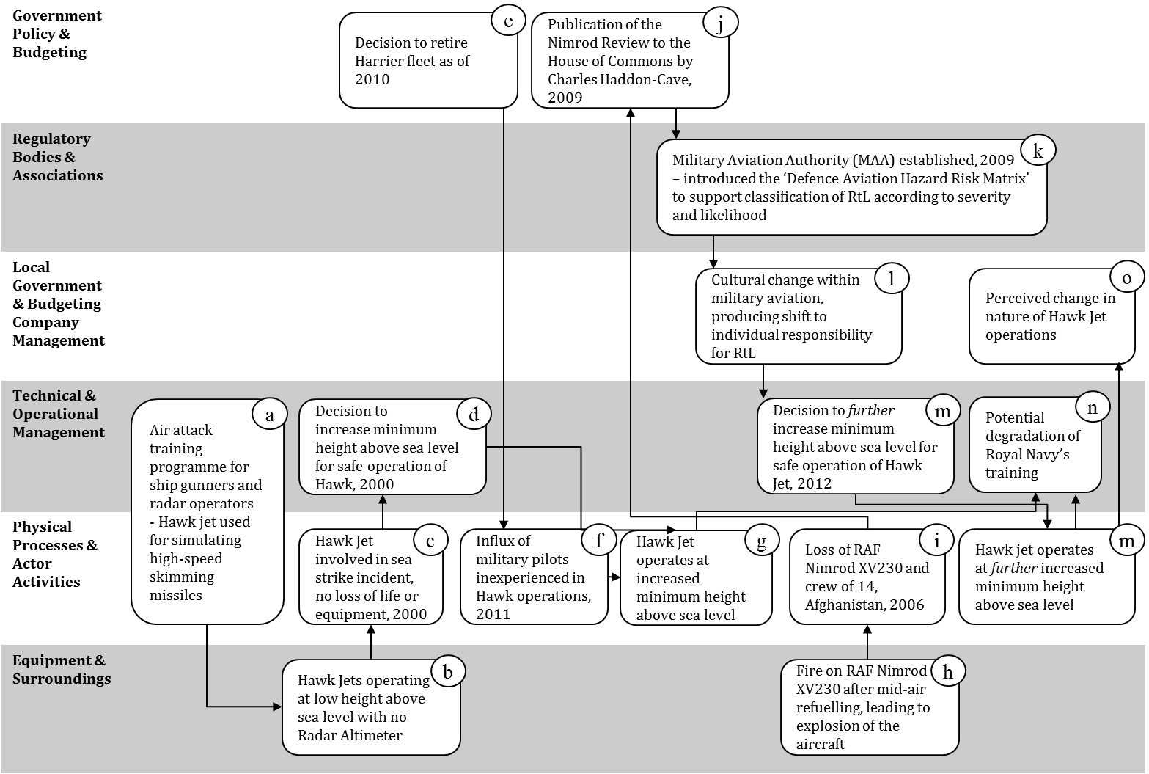
Figure 1. AcciMap showing subsystems within the Hawk Jet STS. [Please note that the labels do not indicate a timeline, rather they are added for clarity of the description below]

The Royal Navy uses the Hawk Jet to simulate air attacks on ships during sea training of ships’ gunners and radar operators (event ‘a’ in Figure 1). The Hawks are used to simulate enemy aircraft attacks and high-speed skimming missiles fired against ships (Royal Navy, 2012). In order to perform these simulation activities, the Hawk must be flown at a low height above sea level (b); however, the Hawk is not equipped with a Radar Altimeter (Rad-Alt), which provides a highly accurate measure of the altitude of the aircraft above the sea. This makes flying the Hawk accurately at very low levels extremely difficult, and requires a high level of expertise to perform safely. Prompted by events over a number of years, there have been some significant changes to the method for assessing the safety of the Hawk STS.
In 2000, a Hawk Jet was involved in a sea strike incident as a consequence of very low level flight (c). Although there was no resulting loss of life, this incident prompted a decision by the Royal Navy to increase the minimum allowable flying height above sea level for the Hawk (d).
As part of its Strategic Defence and Security Review, H M Government (2010) took the decision to retire the Harrier jet from service in October 2010 (e). As a result of this, a number of Royal Navy pilots who would have flown the Harrier were diverted into the Hawk program (f). Traditionally the Hawk has been flown by Civilian pilots under contract to the Royal Navy (2012): these pilots have extensive military experience in fast jets, which includes low level flight supported by a Rad Alt. This experience provided mitigation against the RtL for the Hawk air attack simulation task; however, the cohort of military pilots did not have this same level of experience and the RtL had to be reassessed in light of this (g).
In 2006, RAF Nimrod XV230 suffered a catastrophic explosion after a mid-air refuelling procedure (h): this caused the deaths of all 12 crew members plus two mission specialists and total loss of the aircraft (i). The Government requested a comprehensive review into the airworthiness and safe operation of the Nimrod (j), which was delivered by Haddon-Cave (2009). The report described the development of the safety case for the Nimrod as ‘a story of incompetence, complacency, and cynicism’ (p. 161) and concluded that it was undermined by the widespread assumption that the Nimrod was safe because it had been flown successfully for the preceding 30 years (Haddon-Cave, 2009). The report also identified organisational changes in the years prior to the Nimrod accident as having significant influence; these included a shift in organisational culture toward business and financial targets ‘at the expense of functional values such as safety and airworthiness’ (p, 355, Haddon-Cave, 2009). As a consequence of the findings, Haddon-Cave (2009) recommended the establishment of an independent Military Aviation Authority (MAA) to properly assess Risk to Life (RtL) and shape future safety culture (k). Further recommendations included the need for strong leadership, a greater focus on people to deliver ‘high standards of safety and airworthiness’ (p. 355, Haddon-Cave, 2009) and increased simplicity of rules and regulations. The tragic consequences of the Nimrod accident, along with the recommendations of the Haddon-Cave report, effected a culture change within military aviation: this resulted in a decision to assign individual accountability for RtL assessments to ‘Duty Holders’ (DH), where previously responsibility for risk had been held at the organisation level (l). The newly established MAA produced guidelines for the assessment of RtL, in the form of the Defence Aviation Hazard Risk Matrix (MAA, 2011) which supports the classification of single risks according to their estimated severity (catastrophic, critical, major, minor) and likelihood (frequent, occasional, remote, improbable). The resulting risk level determines at which level of DH the risk is held.
The organisational changes brought about by the events described above (i.e. influx of junior pilots) prompted reassessment of the RtL for the Hawk air attack simulation activity. The goal of safety management in the UK military is to reduce risk to a level which is As Low As Reasonably Practicable (ALARP): this is reached when ‘the cost of further reduction is grossly disproportionate to the benefits of risk reduction’ (Ministry of Defence, 2007). The RtL for all Hawk operations is frequently reassessed and the shift in pilot experience levels, as described above, prompted changes to the RtL for the Hawk air attack simulation activity. In order to reduce this RtL to a level which was ALARP, a decision was taken by the Royal Navy DH with SME advice to further increase the minimum height above sea level (m). A potential consequence of this decision is the degradation of Royal Navy surface fleet training against very live low level targets, as the Hawk can no longer accurately simulate sea skimming missile attacks on surface ships (n). These events have changed the nature of Hawk operations within the UK MoD (o).
Potential risks to the safe operation of the missile simulation activity are, in part, assessed according to the Military Aviation Authority’s (MAA) Regulatory Articles (MAA, 2011). This assessment is based on the principle that risks can be tolerated provided they are reduced to ALARP. The MAA regulatory policy outlined its approach to the management of Risk to Life (RtL):
‘Aviation DHs [Duty Holders] are bound to reduce the RtL within their AoR [Area of Responsibility] to at least tolerable and ALARP; the application of effective and coherent risk management processes will be fundamental to achieving this’
(p. 18, MAA, 2011).
Regulatory Article (RA) 1210 – Management of Operating Risk (Risk to Life) - defined risk as:
‘a measure of exposure to possible loss [combining] severity of loss (how bad) and the likelihood of suffering that loss (how often)’
(p. 1, MAA, 2011).
The MAA suggested that risks can be identified via a number of different methods including previous occurrences, checklists, HAZOPS, zonal hazard (safety) analyses and error trend monitoring. Previous work has showed that these techniques are likely to be inadequate for the analysis of STS (Stanton et al., 2012). RA 1210 specifically encourages the use of fault trees as accident models ‘to assist understanding of the interrelationship between risks and to support the prioritization of effort to maximise safety benefit’ (p. 6, MAA, 2010). This technique, along with other traditional error and risk prediction methods, does not account for the interactions of distributed actors within a STS (Salmon et al., 2011b). Furthermore, there is also no clear method outlined by the MAA for structuring risk identification; for example, the recommendation is that a combination of these methods should be used with the aim of identifying all credible risks, but there is no way of knowing when all possible credible risks have been defined and therefore how many methods to use and when to stop applying them.
The Hawk RtL case study was identified through interviews with a subject matter expert (SME) as part of this project. The analysts were provided with a high-level overview of the case study in an initial interview with the SME. This was followed up by a second, in-depth interview about the case study with the SME, conducted by two analysts. This resulted in a detailed account of the Hawk-Frigate STS, which was supplemented by extra information from official documentation including Military Aviation Authority (MAA, 2010, MAA, 2011) guidelines, the official report into the Nimrod accident (Haddon-Cave, 2009) and Royal Navy safety assessment guidance (Royal Navy, 2012). The EAST method (Stanton, 2014) was used to develop the three network diagrams, based upon the analysis of all case study information, in an iterative process which involved the SME providing feedback during development.

Analysis of Networks
Social Network Analysis (SNA) metrics provide quantitative measures that represent the structures and relations between nodes in the EAST networks (Baber et al., 2013, Driskell and Mullen, 2005, Walker et al., 2009). The SNA metrics describe individual nodes (including reception, emission, eccentricity, sociometric status, centrality, closeness, farness and betweeness). The SNA metrics applied in the current study, along with their descriptions, are presented in Table 1. Analysis software, AGNA version 2.1 (Benta, 2005), was used to calculate the SNA metrics. For each EAST network, key nodes were identified according to sociometric status. Sociometric status was selected to define key nodes because it identifies the prominence of an individual node’s communications with the rest of the network, which influences the whole network’s performance (Stanton, 2014). In a STS, all of the nodes will have complex safety management rules and behaviours; however, as the ‘key’ nodes have the largest number of connections to the rest of the network, these nodes will have the highest degree of influence over the behaviour of the entire STS. Sociometric status key nodes are defined as nodes which have a higher sociometric status score than the sum of the mean sociometric status score plus the standard deviation sociometric status score for all nodes in the network. SNA metrics were calculated for the EAST networks created for this case study: key agents for sociometric status are indicated in the social, task and information network diagrams below.
Table 1. SNA Metrics, along with their descriptions.
 | Safety constraint | Description
Node-level metrics | Emission  Reception  Sociometric status  Bavelas-Leavitt (B-L) centrality  Eccentricity  Closeness  Standard closeness  Farness  Betweeness | The number of edges (links to other nodes) originating at that node  The number of edges incident to that node  Number of communications received and emitted relative to the number of nodes in the network  Degree of connectivity to other nodes in the network  Length of the longest geodesic path originating in that node (a geodesic path is between two given nodes that has the shortest possible length)  Inverse of the sum of the geodesic distances from that node to all the other nodes, i.e. extent to which a node is close to all other nodes  Closeness multiplied by (g-1), where g is the number of nodes in the network  Sum of the geodesic distances from that node to all other nodes  Frequency with which a node falls between pairs of other nodes in the network

Results
The step-by-step application of the shortened version of EAST is described in detail in the following sections. This is accompanied by the outputs of the method along with interpretation of the results. The first stage in EAST was the identification of all social, task and information nodes within the Hawk missile simulation case study, based on the SME’s account of activities, which informed the analysts’ knowledge of the case study. The nodes were arranged in social, task and information networks and links drawn between related nodes. Related nodes were those between which some information was transferred. As well as providing a visual representation of a STS, the EAST network diagrams can be analysed to produce quantitative SNA metrics.

Social network
Seven social ‘agents’ and their connections were identified from the Hawk RtL case study with the SME: these are shown in Figure 2. The social network was constructed by first identifying the main agents that are in the system, then by examining the interdependencies between those agents. The SME agreed that the social network was a reasonable representation of the main agents and their relationships. The ‘edges’, or links, between the agents show where information is transferred and the direction of transfer. There are 19 edges in total; in some cases information transfer is reciprocal but in others it only goes in one direction between two agents. The ‘pilot’ node was identified as the key agent according to sociometric status (1.33): it has the highest number of links to and from other nodes in the network, in fact the pilot receives and/or emits information from/to all of the other agents in the social network.

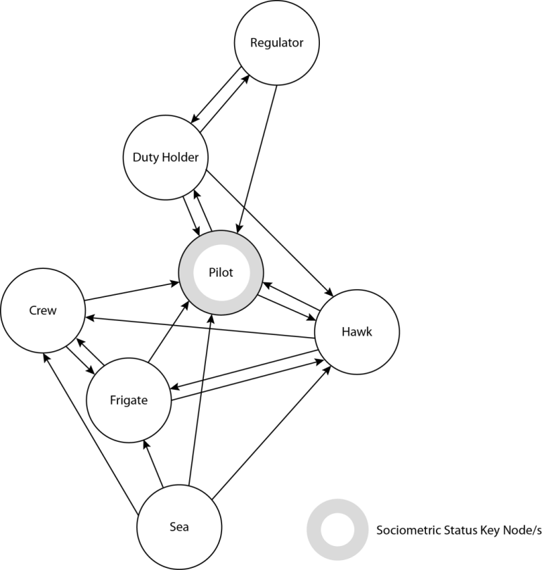
Figure 2. Social nodes and their links within the STS.
The pilot had the highest betweeness score (10.0) as it is located on the paths between a number of other agent pairs. The pilot also had the highest score for reception (6), highlighting a high degree of connectivity to other nodes in the network and indicating that the pilot’s actions and communications are integral to the functioning of the STS. The high farness score for the regulator (10) indicates that this agent is located furthest from most other nodes and this is supported by the information in the case study, which showed that the regulator really only communicates with the DH and possibly the pilots but has no contact with the frigate or crew. This is because the regulator in this case is the MAA, which does not have direct control over the Navy’s surface ship operations. The sea scored highest for emission (4) and lowest for reception (0) as it does not receive information from any other nodes but is used for feedback only. In this sense the sea can be regarded as a ‘passive’ agent, as it cannot respond to feedback; the social agents can only respond to it.

Task Network
Ten tasks nodes and their connections were identified from the Hawk RtL case study with the SME: these are shown in Figure 3. The task network was constructed by first identifying the main tasks that are performed by the system, then by examining the interdependencies between the tasks. The SME agreed that the task network was a reasonable representation of the system. There are 12 edges in total and in all cases the transfer is unidirectional.

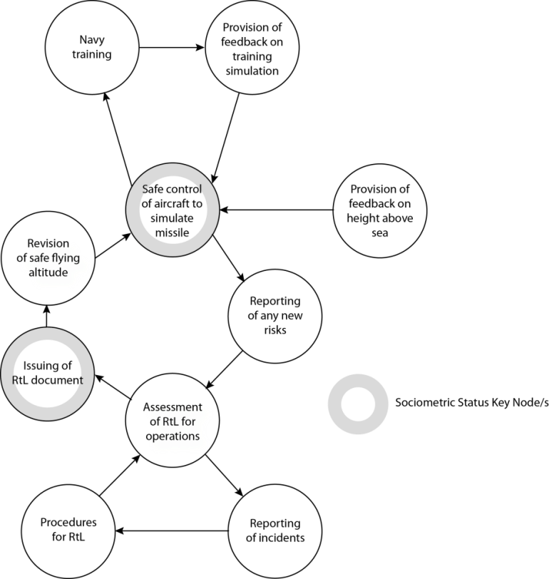

Figure 3. Task nodes and their links within the STS.
In the task network, key nodes were identified as ‘safe control of aircraft to simulate missile’ and ‘issuing of RtL document’, which had sociometric status scores of .56 and .44 respectively. The task network contains more nodes but fewer edges than the social network, indicating that there are fewer communications between tasks. Cohesion is zero because there are no mutual, or bidirectional, links between nodes. The highest score for betweeness was for ‘safe control of aircraft to simulate missile’ (45) demonstrating that this task is integral in the STS as it is located between a high number of other task nodes. This is unsurprising as this task can be considered to be the main objective of the STS configuration investigated in this case study. This task also scored highest on emission (2), reception (3) and B-L centrality (6.26), as well as sociometric status (.56), showing a high level of connectivity to other nodes.

Information Network
EAST identified 25 information nodes and their connections were based the Hawk RtL case study and further knowledge of the STS from the SME: these are shown in Figure 4. There are 50 edges in total; however, in this case, the links are not directional.

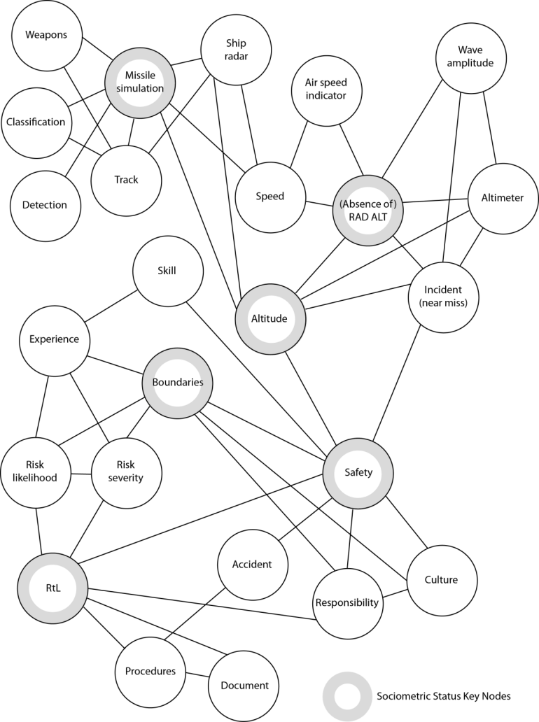
Figure 4. Information nodes and their links within the STS.
Six information nodes were identified as key nodes according to sociometric status: missile simulation, (absence of) Rad Alt, altitude, boundaries, safety and RtL. Safety had the highest betweeness (315.8), standard closeness (.53) and B-L centrality scores (18.51) and this reflects the importance of this in the case study: the aim within the STS is to achieve a safe solution for missile simulation. Density and cohesion were relatively low, i.e. compared with the social network, as the edges between nodes were single and non-directional.

Broken-links Analysis
Studies of networks have discussed the effects of removing one or more nodes from a network on the resilience of that network to systemic failures and the resulting destabilization (Baber et al., 2013, Houghton et al., 2008, Stanton, 2014). This has been used to explore the resulting influence on network structure, rather than as a method for predicting specific risks. Previously, the network diagrams in EAST have been used to provide a visual representation of a system to further the users’ understanding of distributed cognition (Stanton, 2014). In this study however, the EAST network analysis was extended to identify and examine possible risks by ‘breaking’ the links between the various nodes, in a similar approach to the removal of nodes, to explore system effects. Broken-links represent failures in communication and information transfer between nodes in the networks and these failures can then be used to make predictions about the possible risks within the STS. Previously, ‘broken-links’ have only been investigated by EAST analysts when looking retrospectively at accidents to identify underlying causes. Griffin et al., 2010 demonstrated that the broken link between the Engine Vibration Indicator and the pilots in the cockpit was a causal factor in their failure to shut down the correct engine in the Kegworth accident. If this information had been communicated more effectively it could have helped to prevent the crash. Similarly, the EAST method has been adapted to analyse incidents of fratricide (Rafferty et al, 2012) although this has been conducted as retrospective and concurrent, rather than predictive, analyses. The broken-links analysis was performed for the Hawk missile simulation case study, on the social and task networks shown in Figures 2 and 3 respectively. The information network was not subject to the broken-links analysis because broken-links between information nodes were not considered to represent risks, as they are caused by a failure in either the social or task networks. In other words, information does not fail in isolation; it is the failure to use or communicate the information correctly and in all cases this can be attributed to social nodes, task nodes or both. For the social and task networks, each link was identified and documented in a table. The combined EAST networks diagram (see Figure 5) shows the information network tagged with the social networks nodes (to show who owns each information node in the network) and grouped by the task network nodes (to show which task each information node belongs to). Details on construction of the combined network have been reported by Stanton (2014). This network was used to identify what information (from the information network) should be communicated from the origin node to the destination node in the task and social networks and therefore what information would not be communicated if the links between the nodes in the task and social networks were removed.
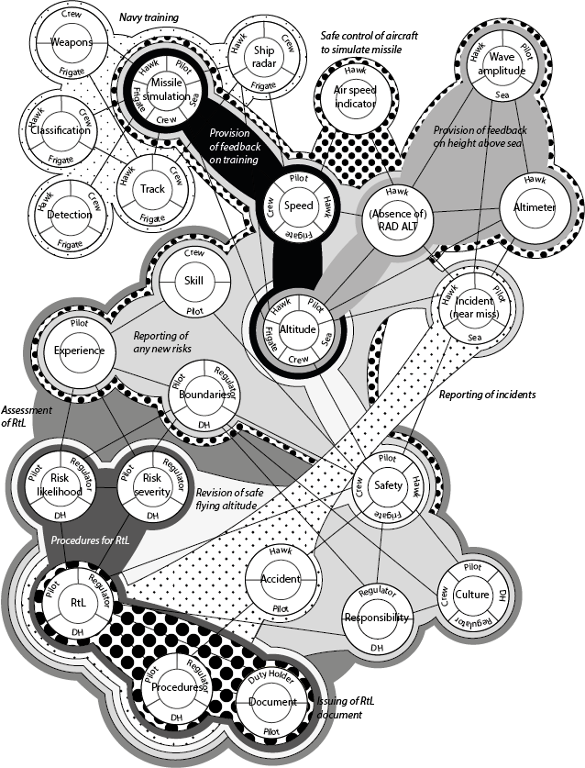
Figure 5. Combined information-task-social network for the Hawk case study (shading represents the different tasks being undertaken).
Figure 5 also shows the combined information-task-social network as a single depiction of the entire STS. This shows the overlaps between the three networks, in other words, which information is being communicated by which agents in which tasks, and how these nodes are interlinked.
In order to conduct the broken-links analysis, the social and task networks were compared to the combined information-task-social network in turn. For example, there is a reciprocal relationship between the duty holder and the pilot (in the social network shown in figure 2) and the duty holder and the pilot share the nodes of boundaries, RtL, risk likelihood, risk severity, procedures, document, responsibility and safety (in the combined information-task-social network shown in figure 5). The risk assessment procedure requires that the relationship between the duty holder and pilot be interrogated to see what would happen if each information element was not transmitted, as shown in table 2. The pilot was identified as having the highest Sociometric Status in the analysis presented in figure 2, so was chosen for the illustration of the broken-links analysis in table 2. Although the pilot is linked to all other agents in the social network, for the purpose of illustration just their reciprocal relationship with the duty holder is presented in table 2.
Table 2. Extract from broken-links analysis for EAST social network.
From (agent) | To (agent) | Information not communicated | Resulting risk | Mitigation strategy
Duty Holder | Pilot | Boundaries | Pilots are not aware of the boundaries for flight operations and for the identification and reporting of risks within this | Boundaries for risk reporting must be made clear to pilots as part of the RtL process
Duty Holder | Pilot | RtL | Pilots are not made aware of the results and consequences of the RtL assessment process after it is conducted at DH level | Results and consequences of the RtL assessment process must be effectively communicated to pilots
Duty Holder | Pilot | Risk likelihood | Pilots are not made aware of risks assessed that their likelihood of occurrence | Risks identified as having a high likelihood of occurrence must be reported to pilots
Duty Holder | Pilot | Risk severity | Pilots are not made aware of risks assessed and their severity of impact | Risks deemed as having a high severity of impact must be reported to pilots
Duty Holder | Pilot | Procedures | Pilots are not aware of how the RtL process is conducted at DH level and of procedures for reporting incidents to the DH | Pilots must be provided with clear procedures describing the assessment of RtL at DH level and the reporting of risks to DH
Duty Holder | Pilot | Document | Pilots are not provided with documentation covering the RtL process and its results | Pilots must be provided with documentation covering the RtL process and its results
Duty Holder | Pilot | Responsibility | Pilots are not aware of the DH's nor their own responsibilities for safety | The responsibilities of both the pilot and DH for safety must be clearly defined and understood by pilots
Duty Holder | Pilot | Safety | Pilots do not receive information about the safety of operations, based on the RtL assessment process | The safety of operations, as assessed during the RtL process, must be reported to the pilots
Pilot | Duty Holder | RtL | The DH does not receive information about new risks identified by the pilots | Pilots must clearly report all relevant risks to the DH
Pilot | Duty Holder | Risk likelihood | The DH does not receive information about the likelihood of new risks identified by the pilots | Pilots must report their estimate of the likelihood of occurrence of all relevant risks
Pilot | Duty Holder | Risk severity | The DH does not receive information about the severity of new risks identified by the pilots | Pilots must report their estimate of the severity of impact of all relevant risks
Pilot | Duty Holder | Incident (near miss) | The DH does not receive information about incidents (or near misses) which occur during Hawk operations | Pilots must clearly report all relevant incidents which occur during Hawk operations to the DH
Pilot | Duty Holder | Experience | The DH cannot learn from the pilots' experience of Hawk operations and the risks encountered | Pilots must clearly report their experience levels to the DH. Pilots must report their assessment of risks and any consequent assumptions, based on this experience
Pilot | Duty Holder | Skill | The DH cannot learn from the pilots' skill in Hawk operations | Pilots must clearly report their skill levels to the DH. Pilots must report their assessment of risks and any consequent assumptions, based on this skill level
Pilot | Duty Holder | Safety | The DH does not receive information about the safety of Hawk operations | Pilots must report their estimates of the safety impact of any risks identified in Hawk operations to the DH
Pilot | Duty Holder | Culture | The DH is not aware of the culture of safety amongst the Hawk pilots | Pilots must consider and report the estimated influence of safety culture on the risks to Hawk operations

Table 2 shows the risks resulting from the failure to pass relevant information between duty holder and pilot and vice versa. Anecdotal evidence from our SME suggests that there is variability in what individual pilots will chose to report back to the duty holder, as they have different interpretations of what they consider to be a risk and near miss. This shows that there is at least some face validity for the approach we have proposed.

In the similar manner to the social-information broken-links analysis shown in table 2, there is a task-information broken-links analysis in table 3. From the task network, there is a uni-directional relationship between the ‘Issuing of RtL document’ and the ‘Revision of safe flying altitude’ (in the task network shown in figure 3) and they overlap in the combined information-task-social network (shown in figure 5). The risk assessment procedure requires that the relationship between the ‘Issuing of RtL document’ and the ‘Revision of safe flying altitude’ be interrogated to see what would happen if each information element was not transmitted, as shown in table 3. The ‘Issuing of RtL document’ was chosen as it has the highest Sociometric Status in the analysis presented in figure 3. The ‘Safe control of aircraft to simulate missile’ was chosen for the same reason and is paired with ‘Navy training’ for the purposes of offering an illustrative example of the method in figure 3.

Table 3. Extract from broken-links analysis for EAST task network.
From (task) | To (task) | Information not communicated | Resulting risk | Mitigation strategy
Issuing of RtL document | Revision of safe flying altitude | Document | The information contained in the RtL document does not trigger a revision of safe flying altitude | The RtL document must be used by regulators to inform changes to regulations and safety guidance where appropriate
Issuing of RtL document | Revision of safe flying altitude | RtL | The outcome of the RtL process outlined in the RtL document does not trigger a revision of safe flying altitude | The outcomes of RtL assessment must be used by regulators to inform changes to regulations and safety guidelines where appropriate
Issuing of RtL document | Revision of safe flying altitude | Risk likelihood | The outcome of the Risk likelihood assessment, conducted as part of the RtL process and outlined in the RtL document, does not trigger a revision of safe flying altitude | The outcome of the Risk likelihood assessment, conducted as part of the RtL process and outlined in the RtL document, must be used to inform changes to regulations and safety guidelines where appropriate
Issuing of RtL document | Revision of safe flying altitude | Risk severity | The outcome of the Risk severity assessment, conducted as part of the RtL process and outlined in the RtL document, does not trigger a revision of safe flying altitude | The outcome of the Risk severity assessment, conducted as part of the RtL process and outlined in the RtL document, must be used to inform changes to regulations and safety guidelines where appropriate
Issuing of RtL document | Revision of safe flying altitude | Safety | The safety implications of the RtL process outlined in the Rtl document do not trigger a revision of safe flying altitude | The safety implications of RtL assessment must be used by regulators to inform changes to regulations and safety guidelines where appropriate
Issuing of RtL document | Revision of safe flying altitude | Responsibility | Responsibility for the revision of safe flying altitude is not outlined in the RtL document | Responsibility for changes to regulations and safety guidelines based on RtL assessment must be clearly assigned and accepted
Safe control of aircraft to simulate missile | Navy training | Missile simulation | The overall control of the Hawk does not adequately simulate missile attack on the frigate to aid with training | The operation of the Hawk must aid Navy training for missile attack situations
Safe control of aircraft to simulate missile | Navy training | Speed | The speed profile of the Hawk does not adequately simulate missile attack on the frigate to aid with training | The speed of the Hawk during missile simulation must be sufficiently realistic to aid Navy training for missile attack situations
Safe control of aircraft to simulate missile | Navy training | Altitude | The altitude profile of the Hawk does not adequately simulate missile attack on the frigate to aid with training | The altitude of the Hawk during missile simulation must be sufficiently realistic to aid Navy training for missile attack situations
Safe control of aircraft to simulate missile | Navy training | Track | The track of the Hawk does not adequately simulate missile attack on the frigate to aid with training | The track of the Hawk during missile simulation must be sufficiently realistic to aid Navy training for missile attack situations

Examination of the analysis in tables 2 and 3 offers a systematic approach for examining a system of operation in a holistic manner. For example, increasing the safe flying attitude (see figure 1) has led to the altitude profile of the Hawk not matching that of the low flying missile (see table 3). This has meant that reducing the risk for the Hawk pilots has had a negative effect on training of the crew on the Frigate, ultimately increasing their risk. So whilst the top of table 3 is about improving the safety of the pilot, by increasing altitude for example, the bottom of table three shows that this could reduce the safety of the Navy frigate crew as they do not receive realistic training. The benefit of systems approaches is that the knock-on effects become more readily apparent.

Discussion
This work aimed to explore the use of a modified version of EAST (network modelling and broken-links analysis, see Stanton, 2014) in a case study of a Royal Navy training activity. First, the findings of this study are discussed in terms of twelve criteria which were identified as essential for methods designed to analyse the human component of STS (Stanton et al., 2012; Harvey and Stanton, 2014). This enabled comparisons to be made between the method and the current RtL procedure used in the Hawk missile simulation case study. Second, the modifications and extensions to EAST are discussed with reference to use of the method as an assessment of potential risks within a STS.
Aviation accidents, as with most accidents in STS, usually occur due to a conjunction of factors (Hodgson et al., 2013, Jenkins et al., 2010) and it is therefore essential that analysis methods are able to explore all of these factors by taking an integrated and holistic approach (Ramos et al., 2012, Salmon et al., 2011b). EAST specifically enables the exploration of the social, task and information components of the STS, allowing a high-level model of the STS to be created (visual diagrams) and analysed (social network metrics). This visual component is likely to help analysts and other stakeholders to understand the interactions within networks: this is an advantage over many other methods such as HAZOP, Fault Tree analysis, as well as the MAA’s RtL / HRM approach. Baber et al. (2013) argued that it is sensible to speak of a ‘useful’ (rather than ‘complete’) network, as there will always be a possibility that some connections have been left out due to not being observed, reported and/or documented. This is certainly applicable to the networks generated by EAST, as it is impossible to know whether an analysis has been exhaustive and it is therefore sensible to assume that it has not. It is also particularly true in this case as the analysis was performed on an SME’s reports of activities within the STS, rather than communications between STS actors (as in Stanton, 2014). A consequence of this approach is a lack of richness of information, although if the main contribution of EAST lies in its ability to visually represent an STS then this may not be a significant issue. EAST includes the calculation of SNA metrics, which provide the analyst with quantitative values to represent various characteristics of the networks. In this way, the analysis encompasses all elements of a STS and provides the analyst with an understanding of the structure of a system as a whole and the relationships between individual system components. These metrics can provide potential insight into the resilience of the networks (Stanton, Harris and Starr, 2016).
The inclusion of particular agents in an accident model is dependent on the information put into the analysis and therefore on the analysts and SMEs involved. This is true for more traditional HAZOP and error identification methods and the current RtL assessment process, as well as EAST. However, because HAZOP and RtL assessment essentially focus on a list of potential errors, there is no formal procedure for identifying the decision makers involved. In contrast, EAST enabled a visual representation of the decision maker agents and their relationships with other nodes in a STS to be constructed, thereby encompassing the identification of decision makers into the analysis process. This can allow analysts to understand where responsibility for risks resides within the STS and so target mitigation strategies appropriately (Lundberg et al, 2010). This case study showed that EAST provided a useful visual representation of relationships between the various components of the STS. EAST examines the links between nodes and so is focused on communications, and therefore on the consequences of an action at a node, rather than its causes (Rafferty et al., 2012, Walker et al., 2010a).
In this case study the analysts used a modified version of EAST, concentrating on the social, information and task networks (Stanton, 2014). Guidance is provided on structuring a model of the system/STS under investigation and there are numerous examples of previous EAST models (e.g., Griffin et al., 2010, Rafferty et al, 2012; Walker et al., 2010a, Stanton, 2014) in the literature. The ‘break-link’ process is very straight forward indeed and would be a useful addition to the current RtL assessment process (Haddon-Cave, 2009). The guidance states that risks should be identified from a number of sources including HAZOP, error data and experience of previous events; however, there are no explicit instructions on how many of these methods to use and when to stop this analysis. This means that the RtL assessment may proceed without a comprehensive list of potential risks. It appears that EAST could be a useful model for ensuring that this does not happen; however, it is important to note that provision of guidance may not be sufficient for successful application of STS methods. The training requirements of these methods can often be high for practitioners, with many citing a lack of time and difficulty accessing new information as barriers to STS analysis (Underwood and Waterson, 2013).
Stanton et al. (2012, 2014) previously suggested that EAST could be suitable for prospective analysis of STS risks, however these studies only demonstrated the utility of methods for retrospective analysis (Salmon et al, 2011; Waterson et al, 2015). In this study, EAST has been applied to a STS that is currently in operation in order to investigate the ability of methods to model the future state of a STS. The Hawk missile simulation STS has already experienced and been impacted by incidents (e.g. Hawk sea strike) and accidents (e.g. Nimrod) but this analysis focused on the prediction of a future state given the changes in the STS, such as the alteration in safe flying altitude for the Hawk and the effects of this on missile simulation for the frigate and crew. Having said this, the emphasis with EAST is not on predicting accidents; rather, it is about creating a comprehensive model of the links and information flows within the STS and by doing so making the analysts aware of potential breakdowns and failures that may occur in the future. This means that the success of EAST for prospective analysis is dependent on the participation in the assessment process of those who will be impacted by these failures and those that can apply the appropriate mitigation strategies.
In summary, this study used a modified version of EAST, following the examples in Stanton (2014). In this case only the network analysis phases of EAST were applied (followed by a new phase: broken-links analysis which has not been previously reported) because the preliminary stages of EAST were negated by having already collected and represented the data via interviews with an SME. Furthermore, some of the EAST methods require communications data, which was lacking in this particular case study as the information came from a SME’s account of the STS. Compared to Stanton’s (2014) analysis of the operations within a submarine control room, the current study analysed activity at a more macro level, using an SME’s account of activities within the STS rather than a transcript of direct communications between STS actors. Recording and transcribing communications within a working system in real time is difficult, time-consuming and potentially disruptive to the STS under investigation. The approach presented in the current paper would be easier for personnel within the STS itself to apply, to support their own safety management and risk prediction activities, as it relies on a macro-level account of actions and relationships with a STS. This also allows these personnel to create a systems view of the STS of interest, which, as previously discussed, offers benefits over traditional analysis techniques. However, the absence of communications data obviously means that the analysis lacks detail and a richness of information which comes from speech data. This also meant that frequency of communications could not be represented in the same way as Stanton (2014). So in effect, the network diagrams in this case study offer a basic visual representation of a STS which could aid understanding of the relationships between agents, tasks and information as well as their combination. Of greater importance is the extension to EAST presented in this paper: the broken-links analysis. In order to identify potential risk in the STS, these links between nodes in the networks had to be examined in more detail; this was accomplished in the broken-links analysis. In this phase, each link between the task and social nodes was ‘broken’ to illustrate the effect of a communication breakdown between nodes. In this case study, 19 social links and 12 task links were broken and assessed against numerous information nodes, resulting in the identification of 137 risks in total. These breakdowns would result in a failure in information transfer, so each broken link was analysed against the information nodes to identify potential risks. This extension to the EAST method provides a structured method for identifying all of the risks within a STS. The broken-links can be listed in table form, along with ‘to’ and ‘from’ information detailing the origin and destination nodes between which information is transferred. The broken-links analysis is concluded by developing mitigation strategies for each of the identified risks, in a similar way to other error analysis methods.

Conclusions
This paper presented a case study of the extension to the EAST method applied in the analysis of a STS, specifically Hawk missile simulation to aid with training of Navy crew. The approach models the STS in two stages. The first stage is to model the system as three networks (social, information and task) and the second stage is to break the links in the social and task networks to discover what risks are introduced by the failure to communicate information. This approach is based on the premise that most, if not all, accidents and near misses are caused, at least in part, by the failure to communicate information between agents and tasks. By enabling the generation of a system-model, EAST ensures that all of the components of interest within a STS have at been identified and this should lead to a more comprehensive analysis of potential risks. The extension to EAST offers a holistic, structured and systematic approach to the identification of information communication failures in task and social networks. This is a radical departure to the taxonomic approaches traditionally used to model risk in systems. The approach can be applied to any STS in any domain where an EAST model has been constructed. Future work could explore the risks associated with multiple communication failures occurring simultaneously as well as considering the degree of resilience in the network models.

Acknowledgements
The authors would like to thank Wing Commander Neil Bing (Bingo) of Air Cap SO1 Lightning, RAF High Wycombe, for his account of the Hawk Risk to Life case study and his very valuable insights into the challenges faced by this complex Socio-Technical System. This work was part-funded by the Defence Human Capability Science and Technology Centre (DHCSTC) grant reference TIN 2.002.

References
ALEXANDER, R. & KELLY, T. 2013. Supporting systems of systems hazard analysis using multi-agent simulation. Safety Science, 51, 302-318.
BABER, C., STANTON, N. A., ATKINSON, J., MCMASTER, R. & HOUGHTON, R. J. 2013. Using social network analysis and agent-based modelling to explore information flow using common operational pictures for maritime search and rescue operations. Ergonomics, 56, 889-905.
BENTA, M. I. 2005. Studying communication networks with AGNA 2.1. Cognition, Brain, Behaviour, 9, 567-574.
DEKKER, S. 2014. The Field Guide to Understanding ‘Human Error’. Aldershot, Ashgate.
DRISKELL, J. E. & MULLEN, B. 2005. Social network analysis. In: STANTON, N. A., HEDGE, A., BROOKHUIS, K., SALAS, E. & HENDRICK, H. (eds.) Handbook of human factors and ergonomics methods. Boca Raton, FL, USA: CRC Press.
DUL, J., BRUDER, R., BUCKLE, P., CARAYON, P., FALZON, P., MARRAS, W. S., WILSON, J. R. & VAN DER DOELEN, B. 2012. A strategy for human factors / ergonomics: developing the discipline and profession. Ergonomics, 55, 377-395.
FLACH, J. M., CARROLL, J. S., DAINOFF, M. J. & HAMILTON, W. I. 2015. Striving for safety: communicating and deciding in sociotechnical systems, Ergonomics, 58 (4), 615-634.
GRIFFIN, T. G. C., YOUNG, M. S. & STANTON, N. A. 2010. Investigating accident causation through information network modelling. Ergonomics, 53, 198-210.
GROTE, G., WEYER, J. & STANTON, N. A. 2014. Beyond human-centred automation – concepts for human–machine interaction in multi-layered networks. Ergonomics, 57 (3), 289-294.
HADDON-CAVE, C. 2009. The Nimrod review. An independent review into broader issues surrounding the loss of the RAF Nimrod MR2 aircraft XV230 in Afghanistan in 2006. London: The Stationery Office.
HODGSON, A., SIEMIENIUCH, C. E. & HUBBARD, E.-M. 2013. Culture and the safety of complex automated sociotechnical systems. IEEE Transactions on Human-Machine Systems, 43, 608-619.
HOLLNAGEL, E., WOODS, D. D. & LEVESON, N. C. (Eds.) 2006. Resilience Engineering: Concepts and Precepts. Aldershot, UK: Ashgate.
HOUGHTON, R. J., BABER, C., COWTON, M., WALKER, G. H. & STANTON, N. A. 2008. WESTT (workload, error, situational awareness, time and teamwork): an analytical prototyping system for command and control. Cognition, Technology and Work, 10, 199-207.
HOUGHTON, R. J., BABER, C., MCMASTER, R., STANTON, N. A., SALMON, P. M., STEWART, R. & WALKER, G. H. 2006. Command and control in emergency services operations: a social network analysis. Ergonomics, 49, 1204-1225.
HARVEY, C. & STANTON, N. A. 2014. Safety in System-of-Systems: ten key challenges. Safety Science, 70, 358-366.
JENKINS, D. P., STANTON, N. A., SALMON, P. M. & WALKER, G. H. 2010. A systemic approach to accident analysis: a case study of the Stockwell shooting. Ergonomics, 53, 1-17.
LUNDBERG, J., ROLLENHAGEN, C. & HOLLNAGEL, E. 2010. What you find is not always what you fix - how other aspects than causes of accidents decide recommendations for remedial actions. Accident Analysis and Prevention, 42, 2132-2139.
MAA 2010. RA 1210: Management of operating risk (risk to life). In: AUTHORITY, M. A. (ed.) RA 1210. London: Military Aviation Authority.
MAA 2011. Regulatory instruction MAA RI/02/11 (DG) - Air safety: risk management. London: MAA.
MORAY, N., GROEGER, J. & STANTON, N. A. 2016. Quantitative Modelling in Cognitive Ergonomics: Predicting Signals Passed At Danger. Ergonomics, (Article in Press).
NOYES, J. & STANTON, N. A. (1997) Engineering Psychology: contribution to system safety. Computing & Control Engineering Journal, 8 (3), 107-112.
PLANT, K. L. & STANTON, N. A. 2012. Why did the pilots shut down the wrong engine? Explaining errors in context using Schema Theory and the Perceptual Cycle Model. Safety Science, 50 (2), 300-315.
RAFFERTY, L., STANTON, N. A. & WALKER, G. H. 2012. The human factors of fratricide, Surrey, Ashgate.
RAMOS, A. L., FERREIRA, J. V. & BARCELΌ, J. 2012. Model-based systems engineering: an emerging approach for modern systems. IEEE Transactions of Systems, Man and Cybernetics: Part C - Applications and Reviews, 42, 101-111.
RASMUSSEN, J. 1997. Risk management in a dynamic society: a modelling problem. Safety Science, 27, 183-213.
READ, G. J. M., SALMON, P. M., LENNÉ, M. G. & STANTON, N. A. 2015. Designing sociotechnical systems with cognitive work analysis: putting theory back into practice. Ergonomics, 58, 822-851.
ROYAL NAVY. 2012. Fleet requirements air direction unit (FRADU) [Online]. Royal Navy. Available: http://www.royalnavy.mod.uk/sitecore/content/home/the-fleet/air-stations/rnas-culdrose/fleet-requirements-air-direction-unit-fradu [Accessed 11.01.2013 2013].
SALMON, P. M., CORNELISSEN, M. & TROTTER, M. J. 2011a. Systems-based accident analysis methods: a comparison of Accimap, HFACS, and STAMP. Safety Science, 50, 1158-1170.
SALMON, P. M., LENNÉ, M. G., WALKER, G. H., STANTON, N. A. & FILTNESS, A. 2014. Using the event analysis of Systemic Teamwork (EAST) to explore conflicts between different road user groups when making right hand turns at urban intersections. Ergonomics, 57, 1628-1642.
SALMON, P. M., STANTON, N. A., LENNÉ, M., JENKINS, D. P., RAFFERTY, L. & WALKER, G. H. 2011b. Human factors methods and accident analysis, Surrey, Ashgate.
STANTON, N. A. 2006. Hierarchical task analysis: developments, applications, and extensions. Applied Ergonomics, 37, 55-79.
STANTON, N. A. 2014. Representing distribution cognition in complex systems: how a submarine returns to periscope depth. Ergonomics, 57, 403-418.
STANTON, N. A., BABER, C. & HARRIS, D. 2008. Modelling command and control: event analysis of systematic teamwork, Surrey, UK, Ashgate.
STANTON, N.A., HARRIS, D. & STARR, A. 2016. The future flight deck: Modelling dual, single and distributed crewing options. Applied Ergonomics, 53, 331-342.
STANTON, N. A., RAFFERTY, L. A. & BLANE, A. 2012. Human factors analysis of accidents in systems of systems. Journal of Battlefield Technology, 15, 23-30.
STANTON, N. A., SALMON, P., HARRIS D., MARSHALL A., DEMAGALSKI J.,YOUNG M.S., WALDMANN T. AND DEKKER S.W.A. 2009. Predicting pilot error: Testing a new methodology and a multi-methods and analysts approach. Applied Ergonomics, 40 (3), 464-471.
STANTON, N. A., SALMON, P. M., WALKER, G. H., BABER, C. & JENKINS, D. P. 2005. Human factors methods: a practical guide for engineering and design (first edition), Aldershot, Ashgate.
STANTON, N. A., SALMON, P. M., RAFFERTY, L. A., WALKER, G. H., BABER, C. & JENKINS, D. P. 2013. Human factors methods: a practical guide for engineering and design (second edition), Aldershot, Ashgate.
STANTON, N. A. AND STEVENAGE, S. 1998. Learning to predict human error: issues of reliability, validity and acceptability. Ergonomics , 41 (11), 1737-1756.
STANTON, N. A., STEWART, R., HARRIS, D., HOUGHTON, R. J., BABER, C., MCMASTER, R., SALMON, P., HOYLE, G., WALKER, G. H., YOUNG, M. S., LINSELL, M., DYMOTT, R. & GREEN, D. 2006. Distributed situation awareness in dynamic systems: theoretical development and application of an ergonomics methodology. Ergonomics, 49, 1288-1311.
STEWART, R., STANTON, N. A., HARRIS, D., BABER, C., SALMON, P., MOCK, M., TATLOCK, K., WELLS, L. & KAY, A. 2008. Distributed situation awareness in an airborne warning and control system: application of novel ergonomics methodology. Cognition, Technology and Work, 10, 221-229.
STANTON, N. A. & WALKER, G. H. (2011) Exploring the psychological factors involved in the Ladbroke Grove rail accident. Accident Analysis & Prevention, 43 (3), 1117-1127.
UNDERWOOD, P. & WATERSON, P. 2013. System accident analysis: examining the gap between research and practice. Accident Analysis and Prevention, 55, 154-164.
VON BERTALANFFY, L. 1950. An outline of general system theory. British Journal for the Philosophy of Science, 1, 134-165.
WALKER, G. H., GIBSON, H., STANTON, N. A., BABER, C., SALMON, P. & GREEN, D. 2006. Event analysis of systematic teamwork (EAST): a novel integration of ergonomics methods to analyse C4i activity. Ergonomics, 49, 1345-1369.
WALKER, G. H., STANTON, N. A., BABER, C., WELLS, L., GIBSON, H., SALMON, P. M. & JENKINS, D. 2010a. From ethnography to the EAST method: a tractable approach for representing distributed cognition in air traffic control. Ergonomics, 53, 184-197.
WALKER, G. H., STANTON, N. A., SALMON, P. M. & JENKINS, D. P. 2008. A review of sociotechnical systems theory: a classic concept for command and control paradigms. Theoretical Issues in Ergonomics Science, 9, 479-499.
WALKER, G. H., STANTON, N. A., SALMON, P. M. & JENKINS, D. P. 2009. Command and control: the sociotechnical perspective, Aldershot, UK, Ashgate.
WALKER, G. H., STANTON, N. A., SALMON, P. M., JENKINS, D. P. & RAFFERTY, L. A. 2010b. Translating concepts of complexity to the field of ergonomics. Ergonomics, 53, 1175-1186.
WATERSON, P., ROBERTSON, M.M., COOKE, N.J., MILITELLO, L., ROTH, E. & STANTON, N.A. 2015. Defining the methodological challenges and opportunities for an effective science of sociotechnical systems and safety. Ergonomics, 58 (4), 565-599.
WILSON, J. R. 2012. Fundamentals of systems ergonomics. Work, 14, 3861-3868.

