Characterisation of the Mechanical Behaviour of Annealed Glass–GFRP Hybrid Beams
Mithila Achintha*, Bogdan Balan
Faculty of Engineering and the Environment, University of Southampton, Southampton, SO17 1BJ, UK
* Corresponding Author – E-mail: Mithila.Achintha@soton.ac.uk

Abstract
This paper presents the results of a combined experimental and numerical investigation on the mechanical behaviour of annealed glass–Glass Fibre Reinforced Polymer (GFRP) hybrid beams. The experimental results showed that an adhesively-bonded GFRP interlayer significantly improved the strength and ductility of annealed glass beams. The paper also presents the post-breakage behaviour and the response of damaged beams in unloading. The paper numerically investigates the degree to which the strength and stiffness of the hybrid beams can be modelled by using finite element (FE) analyses. The novelty of work also includes numerical modelling and validating the through-thickness stress profiles in the hybrid beams.

Keywords:
Annealed glass, Ductility, Finite element, GFRP, Glass, Hybrid beams, Post-breakage, Reinforcement, Residual stress

1. Introduction
Owing to the fascinating physical, optical, chemical, and thermal properties of glass together with its potential to deliver energy efficient building envelopes, glass has become one of the most preferred construction materials in modern buildings. However, despite the great potential of glass as a construction material, its brittle material behaviour pose major challenges when constructing load-bearing structural members, such as large glass panels, roofs, floors, staircases and partitions. Poor post-breakage strength, lack of ductility and inefficient connections are the main inherent challenges compared to other construction materials, such as concrete, steel and timber. The usual industrial practice is to over-design glass structural elements and/or to use sacrificial layers [1]. However, neither approach will eliminate brittle failure of glass.

Annealed float glass has a low tensile strength (< 40MPa) [2] compared to steel, and hence, the structures made from annealed glass have modest load bearing capacities. The compressive strength of glass is much higher than the tensile strength, but the compressive strength is largely irrelevant in practical structural designs because compression members will most likely fail prematurely due to buckling or the tensile stresses developed due to Poisson’s ratio effects. Tempered glass (also known as toughened glass), which is produced by heating up annealed glass up to a high temperature and then rapidly cooled, has a surface compressive pre-stress (i.e. residual stress) of magnitude of 80–150MPa [2]. Tempered glass is often used in load bearing structural elements. Heat-strengthened glass, which is also used in construction industry, is produced in the same as way as fully-toughened glass, but the heated annealed glass is quenched at a slower cooling rate. Heat-strengthened glass has a low surface pre-compression, compared to toughened glass, of magnitude 40-80 MPa [2]. Residual stresses - i.e. the stresses generated in glass owing to the thermal misfit strains generated due to the differential cooling takes place during the manufacturing of float glass and during the quenching of tempered glass - has an influence on how glass breaks during a failure; annealed glass shatters into large pieces of sharp shards, whereas in tempered glass, cracks progress rapidly causing complete fragmentation of small dice of about 100 mm² [3].

One efficient way to ensure a notable post-breakage strength and ductility in glass is the use of reinforcing materials. Commercially available laminated glass, which is produced by combining two or more sheets of annealed/tempered glass with one or more thin PolyVinylButyral polymer interlayers, has relatively safe failure characteristics compared to single layer annealed/tempered glass. The recent developments of lighter and stronger laminated glass include the use of ionomer interlayers; laminated glass with ionomer interlayers are lighter and stronger than conventional laminated glass [4]. However, the low stiffness and strength of the thin interlayers mean careful designs are required to ensure an adequate post-breakage strength for laminated glass. At present, laminated glass cannot be made at constructions sites, and it is difficult to make alterations (e.g. cutting, drilling, etc.) in laminated glass. Therefore, all the processing steps are carried out before lamination.

The use of relatively strong reinforcing materials enables the development of glass hybrids that possess high pre-crack and post-breakage strengths, and ductilities [5]. A number of materials, such as timber, steel, reinforced concrete, fibre reinforced polymer (FRP), steel, etc. have been used in combination with glass [1]. The post-breakage strength and the ductility of glass hybrids have been mostly studied using experiments of beams. In most hybrid beams, the second material was used to make composites sections of ‘I’, ‘T’, ‘H’ and box profiles, and in other cases, small amounts of the second material was used to reinforce the glass without significantly altering the original rectangular shape. Detailed reviews of types of hybrid glass beams investigated in the literature can be found in [1, 6, 7]. Adhesive bonding of the reinforcement material to glass sheets has been preferred over mechanical connections (e.g. bolts), since the mechanical joining systems are largely structurally ineffective. Commonly available adhesives, such as polyurethane, epoxy and acrylic were used to make glass hybrid beams [6]; epoxy adhesives were found to be more effective in enhancing post-breakage strength and ultimate load capacity of the hybrid beams owing to the high strength and stiffness of the adhesive [6]. Although tempered and heat-strengthened glass hybrid beams provided higher load capacities compared to equivalent annealed glass hybrid beams, the latter provided better post-breakage behaviour [5].

Timber [8] and steel [5, 9] composite glass beams are already well developed and tested, largely resulting optimal designs for beams. Typically, ‘T’ – or – ‘Ι’ sections, in which the web is glass and the flanges are steel/timber were found to be structurally efficient. However, durability is a concern in timber/steel glass hybrids. Different shapes and forms of steel reinforcements, bars/strips [10] and steel reinforced polymer sheets along the tension edge of the glass beams [11] were also used in laminated glass beams. In these hybrid beams, the bonding surfaces were usually parallel to the direction of the applied load. The efficiency of redistributing the load upon failure of subsequent glass sheets and the resistance against lateral buckling of individual glass panes were critical to achieving improved post-breakage behaviour.

High strength, lightweight and non-corrosive characteristics of Carbon (CFRP) and Glass (GFRP) Fibre Reinforced Polymers make them attractive for reinforcing glass beams [12]. Mostly, CFRP/GFRP rods were used in the experiments reported in the literature [12]. As expected, the glass–FRP hybrid beams showed good structural performances, in particular, flat reinforcement rods were more effective compared to rounded reinforcement rods [10]. Glass–CFRP hybrid beams mostly failed prematurely in brittle manner due to debonding of the CFRP from the glass, whereas glass–GFRP hybrid beams showed higher deformation capacities. Laminated glass beams with embedded GFRP rods showed enhanced peak load and improved ductility at failure [13]. Recent studies (e.g. [6], [14], [15]) demonstrated the potentials of GFRP pultruded profiles in glass hybrid beams, either as a tension reinforcement unit in a stack of glass sheets bonded in the vertical direction, or as a web of composite section with glass sheets as flanges. GFRPs are cheaper than CFRP, and have translucent properties. Despite the potentials of annealed glass–GFRP hybrids have been noted in the literature, the existing knowledge is limited to the specific parameters chosen in each experimental programme, and prediction of the structural behaviour for a different set of load parameters or a different structural geometry requires a new experimental/numerical analysis. There is a need for a more detailed investigation which represents the basic mechanics of simple geometries and load cases.

The authors have previously presented [16] the preliminary results of a combined experimental and numerical investigation of annealed glass–GFRP hybrid beams. In the hybrid beam a GFRP strip was adhesively bonded in between two horizontal glass sheets (Fig. 1). The work presented in that conference presentation is limited to a single thickness of glass sheets and simple comparisons between the experimental results and the predictions from finite element (FE) analyses. The current paper extends the previous work [16] and shows the results of mechanical behaviour of a much larger matrix of hybrid beams made from glass of two different thicknesses. The paper also presents the post-breakage behaviour and the response of the damaged beams in unloading. The novelty of work also includes modelling and validating the through-thickness stress profiles in hybrid beams.
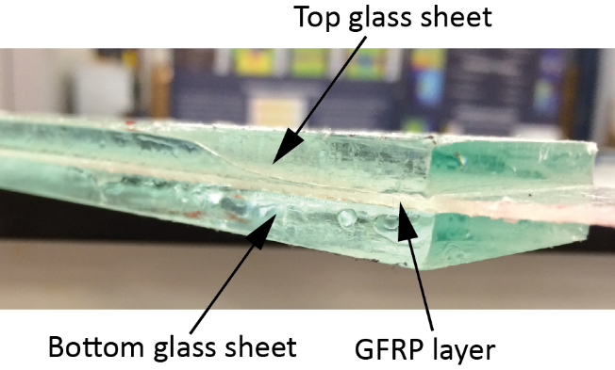
Fig. 1. Glass–GFRP hybrid beams

2. Glass–GFRP Hybrid Beams
The system of an adhesively-bonded GFRP strip in between two annealed glass sheets (Fig. 1) provides the flexibility required to use glass–GFRP hybrids in a range of geometries, including areas around joints and fixtures where a greater strength and a ductility are important. From an experimental investigation of hybrid glass beams made from plies of chemically toughened glass (as outer layers), conventional polymer interlayers and a heat treated/annealed glass core, Overend et al. (2014) [17] demonstrated improved post-fracture behaviour of the composite beams subjected to minor axis bending. The present study demonstrates the improved post-breakage behaviour of a simple arrangement of double layer annealed glass–GFRP hybrid beams subject to minor axis bending without chemically or thermally toughened surface layers. The arrangement of minor axis bending will ensure a higher lateral stiffness and a compressive load capacity compared to beams subject to major axis bending. Owing to the low thermal conductivity of GFRP that minimises the thermal bridging across the glass sheets, a significant improvement in thermal performance of glass–GFRP hybrids compared to single layer glass can be expected [15]. The GFRP interlayer also has potential to improve the resistance against impact and high rate loading. The present paper addresses the mechanical behaviour of glass–GFRP hybrid beams under quasi-static loads, and the analyses of the thermal performance and impact resistance are beyond the scope of the paper.

3. Materials
3.1 Glass
Commercially available annealed glass was used in the current study because of the potential for favourable post-breakage behaviour of annealed glass–GFRP hybrids. In order to facilitate a better understanding of the mechanical behaviour of the beams, the effects of residual stress in glass [18, 19] was considered. Fig. 2 shows the residual stress depth profiles in 6 and 10 mm thick annealed glass used in the study. The stress depth profiles shown in the figure were based on the stresses measured using a scattered-light-polariscope (SCALP-05) [20] at the central region of 150 mm x 100 mm flat glass specimens of 6 mm and 10 mm thick annealed glass. The details of the use of SCALP to measure residual stress depth profiles in annealed glass can be found in a previous publication of the authors [18]. The figure shows a similar parabolic stress depth profile in both thicknesses, with compression at the surface (~20% of the specimen thickness) and tension at the mid-thickness (~60% of the specimen thickness). The stresses in 10 mm glass are higher than that in 6 mm thick glass. For example, the surface compression of 8.5 MPa and mid-thickness peak tension of 4 MPa are higher than that of 5 MPa and 2.5 MPa in 6 mm thick glass.
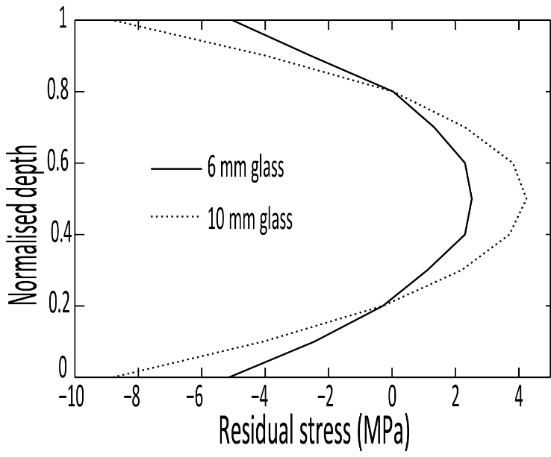
Fig. 2. Residual stress depth profiles in 6 mm and 10 mm thick annealed glass

The glass beams were cut using a glass cutter by a commercial glass supplier. No edge treatments were used after the cut. Since glass is a brittle material, its tensile strength depends on inevitably present surface and edge flaws [21]. An experimental investigation carried out using an optical microscope [22] showed that distributions and the sizes of the surface and edge defects were largely similar in all test beam specimens. Therefore, as a starting point, the experimental results of different beam test specimens were compared with the assumption that the edge effects were the same in all test beams. Fig. 3a and 3b show representative edge and surface flaws in one glass specimen respectively. The edge defects caused by the cutting process are semi-circular in shape (Fig. 3a). The maximum edge defect is ~680 µm long and has a radius of ~120 μm. The surface microcracks, which are much smaller than the edge defects, are more sparsely distributed. The projected length of the largest surface microcrack is ~490 μm and has a width of ~50 μm. Edge defects and surface microcracks of these sizes are inevitable in glass members used in real-life applications. The distribution, size and shape of the edge and surface flaws in other beams tested in the current study are similar to those shown in Fig. 3.
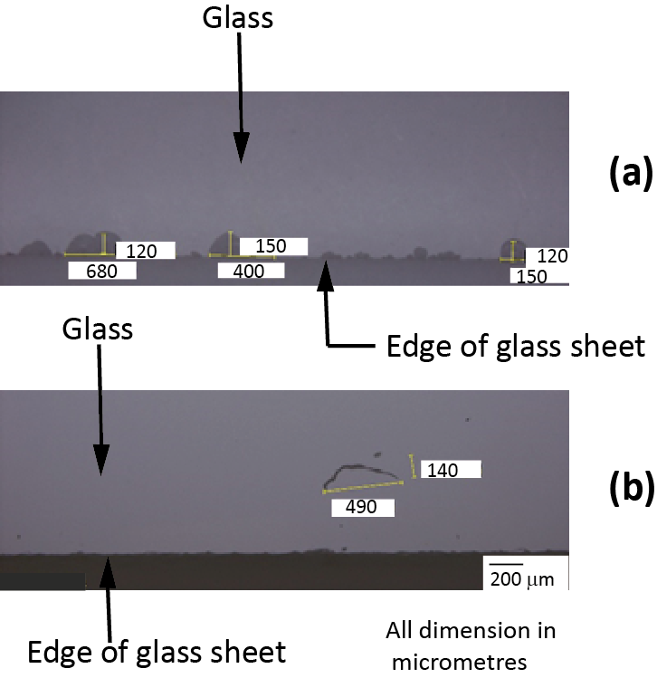
Fig. 3. Distribution of (a) Edge flaws and (b) Surface flaws in annealed glass

3.2 GFRP
The GFRP laminates were fabricated by impregnating a commercially available two-part epoxy resin, ‘EL2 Epoxy Laminate Resin’ with ‘AT30’ slow hardener [23], into two layers of unidirectional ‘E-glass’ dry fibre sheets (0.43 mm thick; 572 g/m2) [24] by means of a hand lay-up method. The fibre orientation was in the direction of the longitudinal axis of the beams. The fabricated GFRP laminates were cured at ambient conditions (temperature 22± 3 ºC and atmospheric pressure) for seven days. The average thickness of the final cured GFRP laminate was ~1.35 mm and the fibre volume fraction was calculated to be ~33%. The ultimate tensile strength, Young’s modulus and the Poisson’s ratio of the GFRP were determined from uniaxial tensile tests conducted in accordance with ASTM D3039-95a (1995) [25]. Three specimens of dimensions 250 x 20 mm were tested in an electro-servo test machine at displacement rate 2 mm/min. Strains in the longitudinal and the transverse directions were measured using strain gauges attached at the central region of the test specimens. As expected, all specimens showed linear stress–strain relationships until failure [26]. The results of all three specimens were comparable with each other with a variance less than 5% [26]. The average ultimate tensile strength, the Young’s modulus and the Poisson ratio of the GFRP were determined to be 450 MPa, 24.5 GPa and 0.10 respectively.

3.3 Adhesive
Bi-component epoxy adhesive, ‘Araldite 2020’ [27], which has a similar refractive index as glass, was used in the present study to bond glass and GFRP. A mixing ratio of 100:50 by weight epoxy resin to hardener was used. Epoxy adhesives are known to provide strong composite actions in glass hybrids [6]. The strength gain in the adhesive with time was investigated using uniaxial tensile tests conducted in accordance with ASTM D638-02 [28]. The dimensions of the test specimen are shown in Fig. 4a. The displacement controlled tensile tests were conducted at 1 mm/min rate. The effect of two curing conditions on strength gain was investigated using the experimental results of three test specimens from each group. The details of the curing conditions and the tensile strength of the test specimens after 1 day and 7 days of curing are presented in Table 1. The curing under room conditions (i.e. first group) is representative of most practical civil engineering applications, whereas 24 hours of curing in an autoclave at 40ºC was chosen, since the technical data provided by the manufacturer was based on results of test specimens cured at 40ºC for 16 hours. The results shown in Table 1 suggests that the adhesive cured in the autoclave showed a rapid strength gain compared to those cured in ambient conditions, although the 7-day strength of all the specimens are largely the same. The experimental results also showed that the 7-day strength largely remained unchanged for another three weeks [26].

Fig. 4b shows the stress–longitudinal strain relationships of three adhesive test specimens tested seven days after the fabrication. The specimens were first cured in an autoclave at temperature 40ºC for 24 hours due to the favourable early strength gain. Only the stress–strain relationships of the test specimens tested after seven days of curing are shown in the figure, since it was decided to test the glass–GFRP hybrid beams after seven days of curing. As can be seen from Fig. 4b, the adhesive showed a largely linear behaviour until the peak load, followed by a brittle failure. The pre-peak behaviour of all specimens is similar, whereas the failure behaviour might have influenced by the initial microstructure (e.g. internal voids) of each test specimen. Based on the average of the three test specimens, the ultimate tensile strength of the material was determined to be 45 MPa. By considering the initial approximately linear portion of the stress–strain curve (up to strain of 0.0015), the Young’s modulus and the Poisson’s ratio were determined to be 3 GPa and 0.45 respectively. The Poisson’s ratio was determined as the ratio between the lateral strain, measured using a strain gauge attached along the lateral direction at the central region of the test specimen, and the longitudinal strain. The experimentally determined mechanical properties of the adhesive agree with those reported in the literature for similar epoxy adhesives (e.g. [29]).
Table 1. Curing conditions and the 1-day and 7-days uniaxial tensile strength of the adhesive
Test group | Curing conditions |  |  |  | Uniaxial tensile strength (MPa)
 | First 24 hours |  | From 24 hours – day 7
 | Temperature (ºC) | Pressure  (KPa) | Temperature (ºC) | Pressure  (KPa) | After 1 day | After 7 days
Group 1ª | 22±3^{b} | ~100^{c} | 22±3^{b} | ~100^{c} | ~15 | ~45
Group 2ª | 40 | 100 | 22±3^{b} | ~100^{c} | ~35 | ~45
ª Three test specimens ^{b} Room temperature ^{c} atmospheric pressure
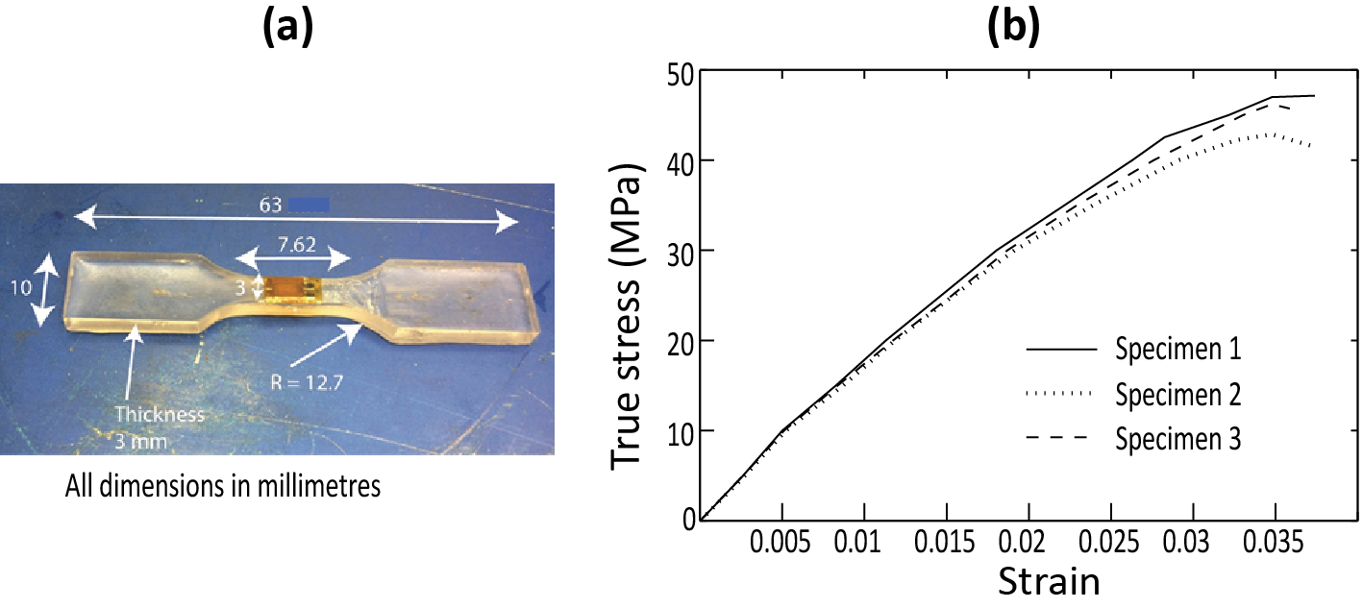
Fig. 4. (a) Geometry of adhesive test specimen (b) Tensile stress–strain relationship of Araldite 2020 (cured 24 hours at 40 ºC and tested 7 days after fabrication)

4. Beam test specimens and instrumentation
The load response and the failure behaviour of annealed glass–GFRP hybrid beams were experimentally investigated and compared against single-layer and adhesively-bonded double-layer glass beams. The results of an experimental investigation on glass–glass and glass–GFRP bond tests with ‘Araldite 2020’ (this investigation was carried out as a part of the present research [30]) showed that the bond strength was largely unaffected by the use of tin side or air side of the glass for bonding. Therefore, in the beam specimens tested in the present study, the multilayer beams were fabricated without specifying the tin or the air side of glass. All beam test specimens were 600 mm long and 40 mm wide. Three beams were tested from each category. The beams were tested seven days after the fabrication, displacement controlled at rate 1 mm/min in four-point bending with a constant moment zone of 400 mm and two equal shear spans of 50 mm (Fig. 5). Although the small size of the test matrix may not be appropriate to provide reliable design data of the mechanical properties, the authors believe the data presented in the paper demonstrate the improved post-breakage strength and ductility of the hybrid beams compared to single-layer and double-layer annealed glass beams.

The vertical deflection at the midspan of the beams were measured using digital displacement gauges. Strain data of the beams were recorded using strain gauges attached on the tension and compression glass surfaces at the midspan (Fig. 5). The stress depth profiles at the beam midspan were measured using a scattered-light-polariscope (SCALP-05) [20]. The results of the peak load, evolution of stress and strain within the pre-crack regime, and the load-deflection relationship in loading and unloading are presented in the paper. For brevity, only the results of one beam from each category of test specimens are presented. The average results based on all three test specimens of each category of test beams are presented in Table 2. The differences between the observed failure loads of the three test specimens (in all three categories of beams) were less than the coefficient of variation of flexural strength of annealed glass reported in the literature (e.g. 25% in [2]).
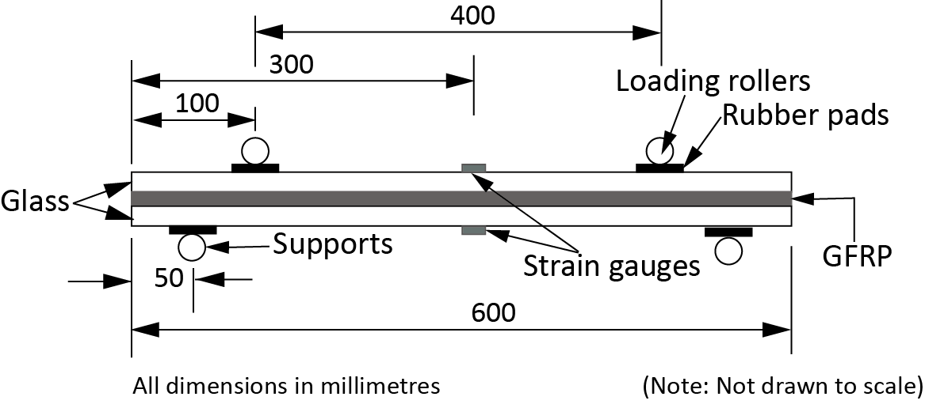
Fig. 5. Four-point bending test specimen
4.1 Single-layer glass beams
4.1.1 Load–midspan deflection relationship
6 mm and 10 mm thick single layer glass beams were tested to determine the flexural tensile strength of annealed glass and also to establish a reference to compare strength and ductility improvements in hybrid beams. Fig. 6a shows the applied load (P)–midspan deflection relationships of 6 and 10 mm thick glass beams. As expected, the beams showed a linear behaviour until failed in brittle manner due to the formation of a major crack in the constant moment zone. The failure load of the 6 mm thick glass beam was 420 N (the average based on three beams is 440 N), whereas the 10 mm thick glass beam failed at 1370 N (the average based on three beams is 1260 N). At the failure load (420 N), the midspan deflection of the 6 mm beam was 6.37 mm, whereas that of the 10 mm beam at the respective failure load (1370 N) was 4.93 mm. Using the elastic beam theory, the midspan deflections of the beams at the respective recorded failure load may be determined to be 6.42 mm and 4.53 mm respectively. The small discrepancy between the predicted and the actual displacements may be attributed to the assumption of small deformations in the theory and/or the slight variations in the thickness of the glass sheets. Random thickness measurements of the glass sheets suggest the actual thickness varied between nominal thickness ± 0.15 mm. According to the experimental results, the 10 mm thick beam was ~4 times stiffer than the 6 mm thick beam, and this value is comparable with the value of 4.6 predicted based on the elastic beam theory.
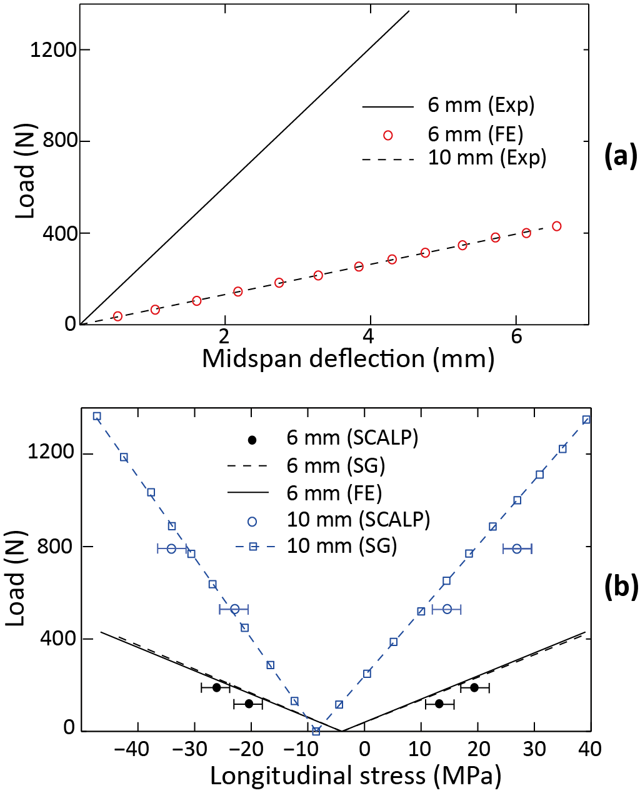
Fig. 6. Single-layer glass beams: (a) Load–midspan deflection (b) Load–surface stress at the midspan
4.1.2 Stress evolution
Fig. 6b shows the longitudinal tension (positive) and the compression (negative) surface stresses at the midspan of 6 mm and 10 mm thick beams, calculated using the readings of the strain gauges (shown as ‘SG’ in the figure) (the Young’s modulus of glass was assumed to 70 GPa [2] in the calculation of stresses using measured strain data). The readings obtained from the strain gauges were adjusted to ensure the measured strains at zero load match with the initial surface compressive residual stress of 4 MPa and 8.5 MPa in 6 mm and 10 mm glass respectively (Fig. 2). From Fig. 6b, it can be seen that the surface stresses increase linearly with the increase of the applied load, until the failure of the beam. The figure also shows that the stresses calculated from the strain gauge data agree with that measured using scattered-light-polariscope (SCALP-05) (shown as ‘SCALP’ in the figure) at the beam midspan (for brevity, only the stresses measured at two arbitrary chosen midspan displacement values (1 mm and 2 mm respectively) of the beam are shown in the figure). Prior to taking readings, the surface of the specimen was first cleaned to remove dirt and fingerprints, and then in order to ensure a good optical contact between the glass and the polariscope, a manufacture-recommended immersion liquid was used. Details of the use of SCALP for stress measurements in glass can be found in [18]. The measurable depth range of the polariscope was ~3 mm, therefore, the measurements were taken from both top and bottom surfaces of the beam. In the experiments, the measurements were repeated four times in order to achieve reliable stress data. The displacement of the stroke of the loading machine (and hence the applied load) was kept unchanged whilst taking the stress data. The effect of the curvature of the beams was not considered during the stress measurement - it is anticipated that the small displacement of the beam (at the time of the stress measurements) with respective to the length of the beam means the effect of curvature may not be significant. The expected error in a SCALP measurement is ± 2.5 MPa, and the error is shown in the figure using error bars. The peak tension at the failure load of the 6 mm thick beam is 39 MPa (the average based on three beams is 39.1 MPa) and the surface compression is -44.5 MPa (the average stress based on three beams is -45.2 MPa). The corresponding stress values at the failure load of the 10 mm thick beam are 40 MPa and -47.7 MPa respectively. Based on the test results, the average flexural tensile strength of the annealed glass used in the study was assumed to be 39 MPa, and this value was used in the finite element (FE) analyses presented in Section 6 of this paper to predict the failure load. The average flexural tensile strength determined by using the knowledge of average failure loads of 6 mm and 10 mm glass beams and the elastic bending theory is 46.6 MPa. The discrepancy between the computed and the actual flexural tensile strength may be attributed to the effect of residual stress in glass.

4.2 Double-layer glass beams
The double-layer beams were made by adhesively bonding two layers of glass sheets. The bonding surfaces were first thoroughly cleaned and degreased with acetone, and then the two glass sheets were bonded using a thin ‘Araldite layer’. The volume of the adhesive required to obtain an average 0.1 mm thick layer was first poured and evenly distributed with a spatula across the surface of one glass sheet. The second glass sheet was then placed on the top of the adhesive layer and a small pressure was applied to ensure no entrapped air or voids on the bond surfaces and also to ensure reasonably uniform distribution of the adhesive layer. The measurements of the overall thickness of the beams after the fabrication confirmed an approximately uniform 0.1 mm thick adhesive layer. The beams were cured in an autoclave at temperature 40ºC and atmospheric pressure for 24 hours, and then further six days of curing in ambient conditions.

4.2.1 Load-midspan deflection relationship
Fig. 7a shows the load–midspan deflection relationships of double-layer beams made from 6 mm and 10 mm thick glass. Similar to single-layer beams, all double-layer beams behaved linearly until brittle failure caused by a major crack developed in the bottom glass sheet (i.e. tension glass layer) within the constant moment zone. The adhesive layer, which bonded the two glass sheets, did not carry the load after the failure of the bottom glass sheet. The failure load of the double-layer beams made from 6 mm and 10 mm thick glass sheets were 1560 N (the average based on three beams is 1520 N) and 4200 N (the average based on three beams is 3950 N) respectively. The midspan deflection of the beams at the respective failure loads were 3.72 mm and 2.77 mm respectively. As expected, the double-layer beams were stiffer and had higher failure loads than the respective single-layer beams (about 6.5 and 5.6 times and 3.7 and 3.1 times, respectively). However, these increases in the failure load and the flexural stiffness are lower than the theoretically-predicted (based on the elastic beam theory and the full adherence between the two glass sheets) values of 4 and 8, respectively. The lack of full adherence between the two glass layers may have attributed to the discrepancy between the experimental results and the theoretical predictions. A comprehensive investigation of the adherence between to the two glass sheets is beyond the scope of the present paper.

4.2.2 Stress evolution
Fig. 7b shows the measured surface stresses at the midspan of 6 mm and 10 mm thick double-layer glass beams. As can be seen from the figure, the stresses measured using SCALP agree well with that determined from strain gauge data. The surface tension in the 6 mm double-layer beam at the failure is 38 MPa (the average stress based on three beams is 40.4 MPa), whereas the surface compression is -44.5 MPa (the average stress based on three beams is -47.6 MPa). The corresponding stress values at the failure of the 10 mm thick double-layer glass beam are 37.5 MPa and -45 MPa respectively. The results suggest that although the addition of a second glass layer increased the stiffness and the load capacity of the beams, there were no post-breakage strength or ductility. Similar to single-layer beams, double-layer beams failed in a brittle manner when the peak tensile stress in glass reached the flexural tensile strength of annealed float glass.
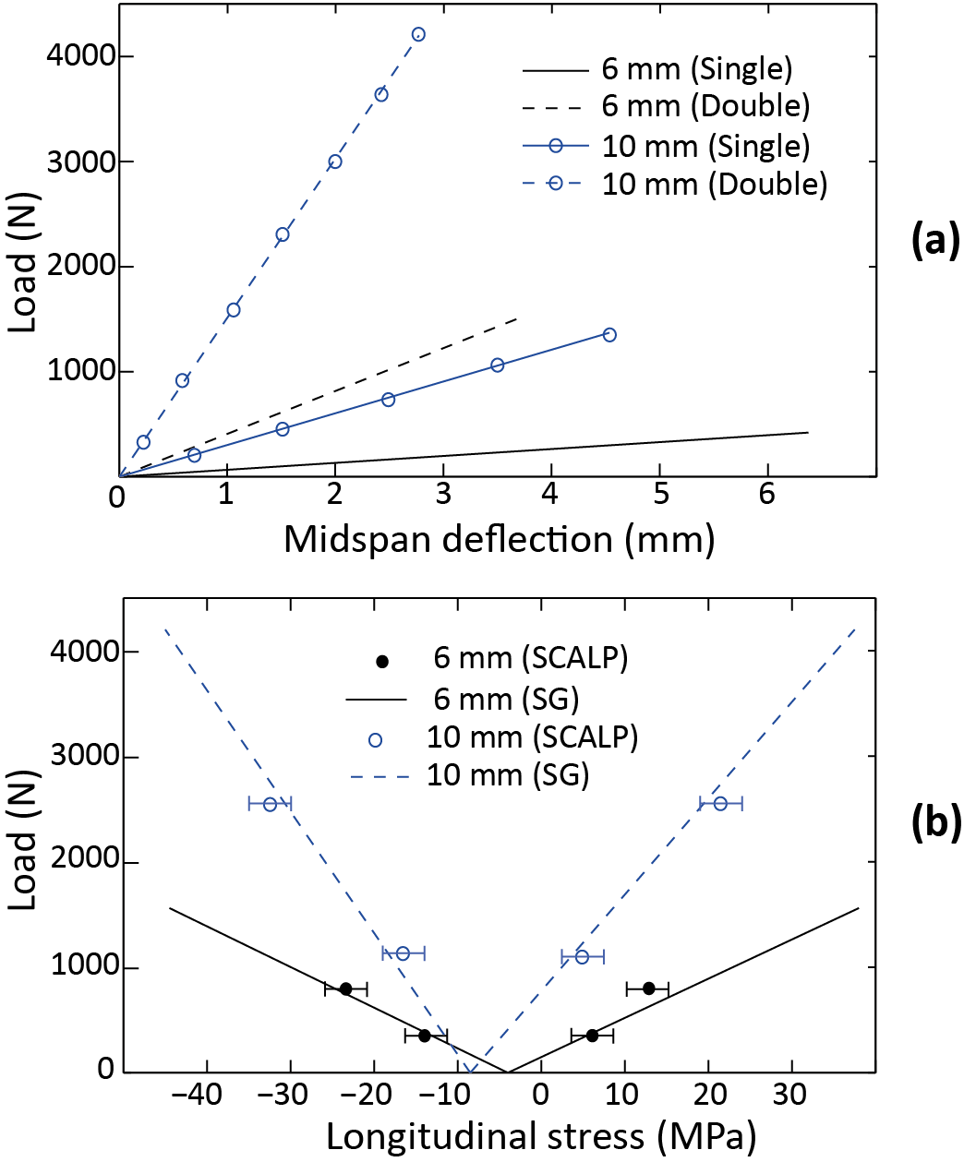
Fig. 7. Double-layer glass beams: (a) Load–midspan deflection (b) Load–surface stress at the midspan

4.3 Glass–GFRP hybrid beams
The glass–GFRP hybrid beams were made by bonding a GFRP strip, which has the same width and length as the glass beams, in between two annealed glass layers using ‘Araldite 2020’. Adhesive layer of ~0.1 mm thick was uniformly spread over one surface of each glass sheet, and then placed the GFRP strip on the top of one glass surface. The second glass sheet was then placed on the top of the GFRP. A small pressure was applied to ensure no entrapped air and voids. The hybrid beam was then secured with a duct tape and cured inside an autoclave at temperature of 40ºC and atmospheric pressure for 24 hours. The beams were then further cured for six more days under ambient conditions before testing.

4.3.1 Load–midspan deflection relationship
Fig. 8a shows the load–midspan deflection relationships of glass–GFRP hybrid beams made from 6mm and 10 mm thick glass sheets. As can be seen from the figure, until the formation of the first major crack, the beams showed linear behaviour, similar to other types of beams. The peak load (pre-crack regime) of the hybrid beam made from 6 mm thick glass sheets was 2060 N (the average based on three beams is 1950 N), and this value is higher than the average failure load of single (440 N) and double-layer (1520 N) beams. Similarly, the peak load of 5600 N of the hybrid beam made from 10 mm thick glass is higher than that of the single (1260 N) and double-layer (3950 N) glass beams. The initial flexural stiffness (pre-crack regime) of the 6 mm and 10 mm hybrid beams are 27.6% and 20.7% higher than that of the corresponding double-layer beams; the increase in stiffness may be attributed to the contribution of the GFRP interlayer in the composite section and also the increase in the overall height of the cross section.

As it can be seen from Fig. 8a, at the peak load, the load resistance of the hybrid beams dropped instantaneously due to the failure of the bottom (i.e. tension) glass layer (by ~67%, from 2060 N to ~700 N in the hybrid beam made from 6 mm thick glass, and by ~65%, from 5600 N to ~1960 N in the hybrid beam made from 10 mm thick glass). Simultaneously, the midspan deflection of the hybrid beams made from 6 mm and 10 mm thick glass were increased by ~57 % (from 3.85 mm to 6.05 mm) and by ~97 % (from 3.06 mm to 6.03 mm) respectively. The drop in the load resistance and the increase in deflection were due to the breakage of the tension glass layer (i.e. bottom glass sheet). Since the beams were tested displacement controlled, once the bottom glass layer has cracked, the combination of the GFRP and the top glass sheet carried the load. Although the GFRP strip ensured no separation of the broken glass pieces from the main beam, further cracks were developed in glass along the span of the beam during the post-breakage loading regime. In both hybrid beams, the load resistance increased markedly beyond the initial post-peak resistance. The tests were stopped when the midspan deflection of the damaged hybrid beams reached ~20 mm. The load resistance of the hybrid beams made from 6 mm and 10 mm thick glass at this maximum displacement were 1240 N and 4160 N respectively.
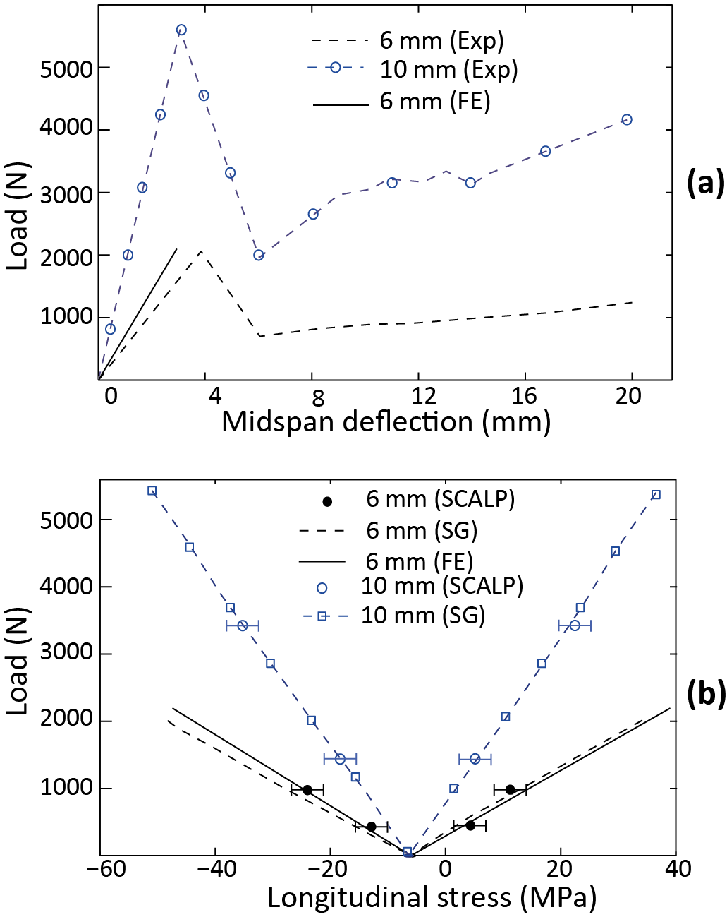
Fig. 8. Glass–GFRP hybrid beams: (a) Load–midspan deflection (b) Load–surface stress at the midspan

4.3.2 Stress evolution
Fig. 8b shows the measured surface stresses (pre-crack regime) at the midspan of glass–GFRP hybrid beams. A detailed study of the stress distribution within the post-breakage regime is beyond the scope of the present paper, so only the stresses measured within the pre-crack regime are presented. Similar to other types of beams, within the pre-crack regime, the surface stress in the hybrid beams increased linearly with the applied load. The surface tension at the peak load (2060 N) of the hybrid beam made from 6 mm thick glass is 38.2 MPa and the surface compression is -46.5 MPa. The corresponding stress values at the peak load (5600 N) of the hybrid beam made from 10 mm thick glass are 40 MPa and -43 MPa respectively. The results confirm that similar to the single and adhesively-bonded double-layer glass beams, the bottom glass layer of the hybrid beams failed in a brittle manner when the surface tension reached the flexural tensile strength of annealed glass (~38-40 MPa). The addition of the GFRP interlayer did not influence the strength of glass; but, the GFRP layer contributed to resist the applied load after the bottom glass layer has failed.

Table 2. The average of the peak load and the midspan deflection and the surface stresses at the peak load of glass beams
Thickness of glass sheets (mm) | Beam type | Peak load (N) | Midspan deflection at peak load (mm) | Surface stress at the peak load  (MPa)
 |  |  |  | tension | compression
6 | Single-layer | 440  1520  1950 | 6.37  3.72  3.85 | 39.1  40.4  38.2 | -45.2  -47.6  -46.5
 | Double-layer
 | Hybrid
10 | Single-layer | 1260  3950  5600 | 4.93  2.77  3.06 | 40  37.5  40 | -47.7  -45  -43
 | Double-layer
 | Hybrid

5. Strength and ductility of hybrid beams
Fig. 9 shows the failure locations and the crack pattern noted in all three types of beams (for brevity, only the results of 6 mm beams are presented in Fig. 9). As can be seen from Fig. 9a and 9b, the single and adhesively-bonded double-layer glass beams failed due to a major crack developed in the constant moment zone. The failures were brittle, breaking the glass completely into two pieces. In the hybrid beams too a major crack was formed in the tension glass layer at the peak load; however, the GFRP strip prevented a complete breakage (Fig. 9c). Moreover, the hybrid beams carried load after the formation of the first crack. The crack pattern that is distributed throughout the top (i.e. compression) glass layer suggests a composite action between the GFRP layer and this glass layer after the failure of the bottom glass layer. Fig. 9c shows that the GFRP held the cracked glass pieces together despite the continuous cracking in the beam during the post-breakage loading regime. This behaviour contributed to maintain a notable bending stiffness in the cracked beam.

Table 3. Peak load and the flexural stiffness (pre-crack regime) of the hybrid beams
Thickness of glass sheets (mm) | Increase in peak load compared to: |  | Increase in flexural stiffness compared to:
 | Single-layer | Double-layer | Single-layer | Double-layer
6 | 343.2% | 28.3% | 711.6% | 27.6%
10 | 344.4% | 41.7% | 558.6% | 20.7%

Fig.10a and 10b summarises the load–midspan deflection relationship of the single-layer, adhesively-bonded double-layer and hybrid beams made from 6 mm and 10 mm thick annealed glass. As depicted in the figure, unlike single and double-layer glass beams where both beams failed in brittle manner at the peak load, the hybrid beams continued to take load after the first major crack. Table 3 presents the increase in the peak load and the flexural stiffness (pre-crack regime) of the hybrid beams compared to single and double layer beams. The results suggests that despite the tension glass layers of the hybrid beams failed when the surface tension reached the flexural tensile strength of annealed glass (38-40 MPa), the peak load of the hybrid beam are higher than the average peak load of the corresponding double-layer beam. The effect of the GFRP interlayer on the flexural stiffness is more significant in thin (6mm) glass than thick (10 mm) glass. On the other hand, owing to the high load carrying capacity of the thick top (compression) glass layer, the relative strength gain is more significant in hybrid beams made from thick (10 mm) glass than those made with from thin (6 mm) glass.

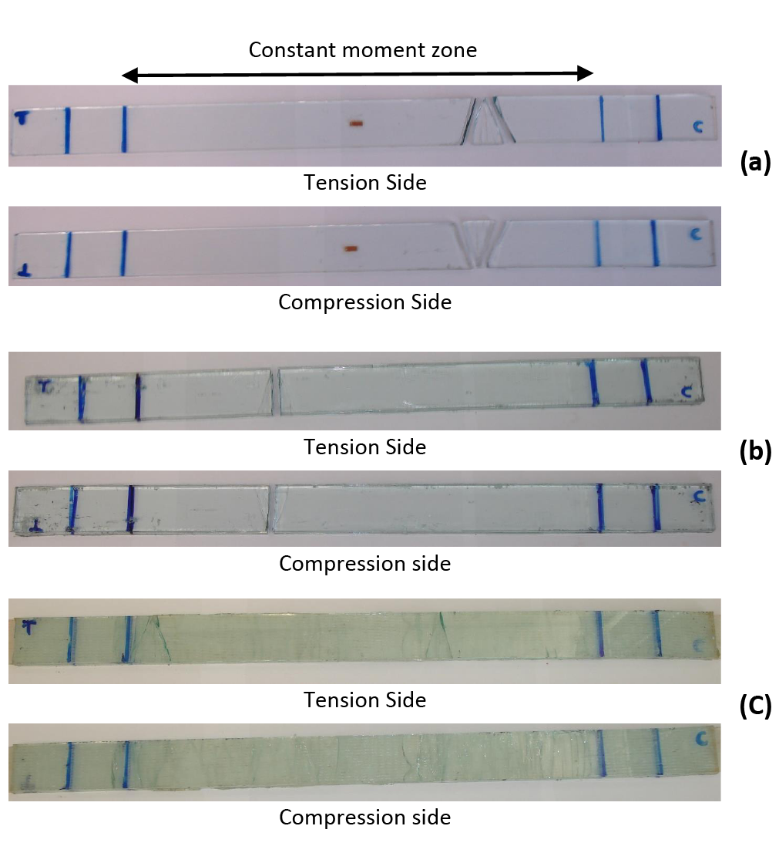
Fig. 9. Crack pattern: (a) Single-layer, (b) Double-layer and (c) Glass–GFRP hybrid beams
Since the hybrid beams resisted applied load beyond the peak load (i.e. at the first major crack in the tension glass layer), ‘ductility index’, may be defined as the ratio of the additional midspan deflection after the first major crack to the midspan deflection at the first major crack. Based on this definition, single and double-layer beams have zero ductility indices and that of the hybrid beams are greater than ~500%. The results confirm that despite neither the adhesive nor the GFRP contributed to improve the strength of glass, the use of an adhesively-bonded GFRP interlayer enables the development of stronger and ductile hybrid beams compared to conventional single and multi-layer annealed glass beams. A further advantage of the hybrid beams may be explored: the hybrid beams recovered the deflection upon unloading, as shown in Fig 11. The load–midspan deflection of the glass–GFRP hybrid beam made from 6 mm thick glass is shown in Fig. 10a. As can be seen from the figure, the load–midspan deflection relationship upon unloading is largely linear. ~16 mm of the maximum deflection of ~20 mm was recovered during unloading. This highlights the favourable post-breakage behaviour of the hybrid beams where a large part of the energy put into the beam during loading remained as stored strain energy without releasing in an explosive manner in the post-breakage regime.
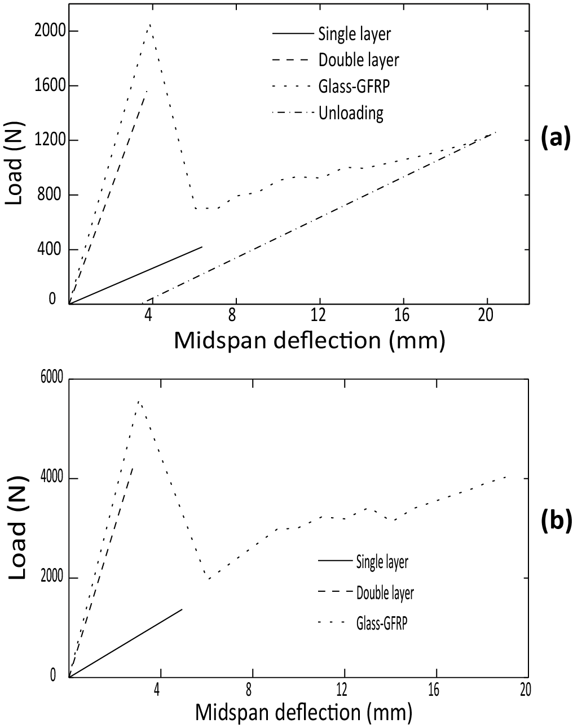
Fig. 10. Load–midspan deflection relationship of single-layer, double-layer and hybrid beams made from (a) 6 mm and (b) 10 mm thick annealed glass
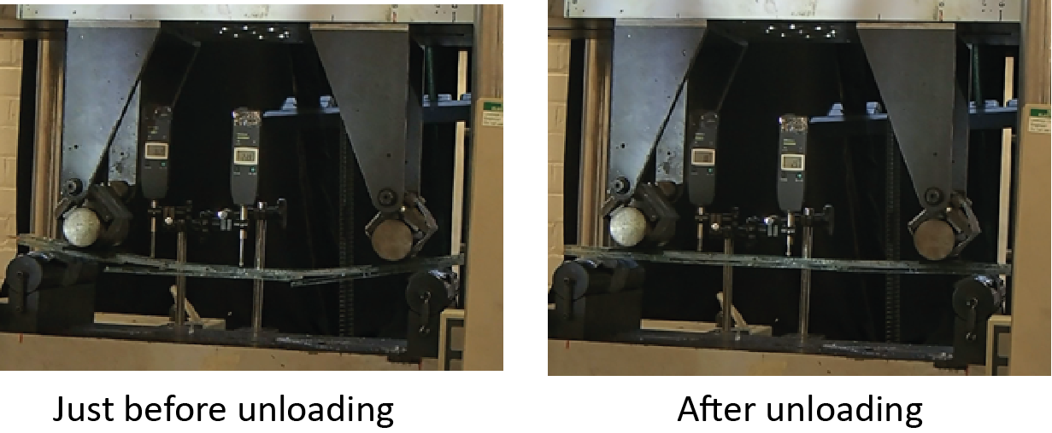
Fig. 11. The recovery of the deformation of the hybrid beams upon unloading

6. Finite Element Modelling
In order to establish a validated predictive tool that can be used to determine the load response of glass–GFRP hybrid beams, a 3D finite element (FE) modelling framework was developed using ABAQUS/Standard [31]. Since the objective of the present paper is to demonstrate the degree to which the strength and stiffness of the hybrid beams within the pre-crack regime can be modelled by using simple finite element (FE) analyses, a simple continuum mechanics modelling approach was used in order to keep the number of material/interface parameters to a minimum. The effect of the residual stress in glass had been incorporated in the FE analysis and this has not been attempted in the literature. The solutions were obtained after taking into account the possible large deformations of the beams with respect to the thickness of the beams. The predicted load–midspan deflection relationships and the stresses at the beam midspan were validated against the experimental results presented in Section 4. In the FE analyses, the peak load of a given beam was determined as the applied load at which the stress at the tension glass surface equals the flexural tensile strength of annealed glass, which was assumed to be 39 MPa (Section 3.1.2). For brevity, only the results of one single-layer and one hybrid beam made from 6 mm glass are presented in the paper. The comparisons between the FE results and the experimental results of 10 mm beams are similar to those of the 6 mm beams. Since the primary objective of the FE analyses was to study the degree to which the load response of the hybrid beams can be modelled using simple FE modelling technique adopted in the present study, only the FE results of 6 mm beams are presented in the paper.

6.1 Material mechanical properties
Glass was modelled as a linearly-elastic material. Based on well-established literature, the Young’s modulus and the Poisson’s ratio of glass were assumed to be 70 GPa and 0.23 respectively [3]. The initial residual stresses present in glass panes were modelled using the eigenstrain-based FE method previously developed by the present authors [18, 19]. Although ‘Araldite 2020’ showed a nonlinear material behaviour to a certain extent (Section 3.3), its behaviour is approximately linear up to stress of ~20-25 MPa. It is generally assumed that the epoxy adhesives such as Araldite 2020 are usually elastic within the initial linear regime (during loading) of the stress-strain curve [29]. Since the average shear strength of the glass–adhesive and glass–GFRP bond was determined to be about 5-7 MPa [26], the approximately linear-elastic regime of ‘Araldite 2020’ provides a simple representative material behaviour in the context of the present problem. The initial Young’s modulus (3 GPa) and the Poisson’s ratio (0.45) previously determined from the experiments (Section 3.3) were used to model ‘Araldite 2020’ as an isotropic elastic material. The GFRP was modelled as an orthotropic material with Young’s modulus = 24.5 GPa and Poisson’s ratio = 0.1 along the fibre direction (i.e. longitudinal direction) (Section 3.2). The Young’s moduli in other two directions were assumed to be 8 GPa and the Poisson’s ratio effects along these directions were ignored. Whilst accurate mechanical properties along the transverse directions of the GFRP appear to give a more appropriate representation of material behaviour, in practice the material parameters required are difficult to determine, and an FE analysis with such input data may unable to ensure a significant increase in fidelity in the basic simplified FE modelling technique adopted in the present paper. Since the paper focuses to investigate the degree to which the strength and stiffness of the glass-GFRP hybrid beams can be modelled by using simplified FE analyses, it is appropriate to start with a simple material model so as to keep the number of material parameters to a minimum.

6.2 Single layer beams
Fully-integrated 3D solid elements were used to model glass. After a detailed mesh sensitivity analysis, it was determined that six elements along the thickness of glass beam (i.e. element thickness of ~1 mm) are required to obtain reliable results. Because of symmetry, only a quarter of the beam was modelled. Fig. 12(a) shows the distribution of the longitudinal stress (σ_{xx}) at the peak load, determined from the FE analysis of a single-layer 6 mm glass beam. As expected, the figure shows tensile stresses in the bottom half of the beam, whilst the top half of the beam is in compression. The failure load, that was determined to be the load that caused a tensile stress of 39 MPa at the bottom glass surface, is 430 N; this value agrees with the average failure load (440 N) noted from the experiments (Section 4.1.1)
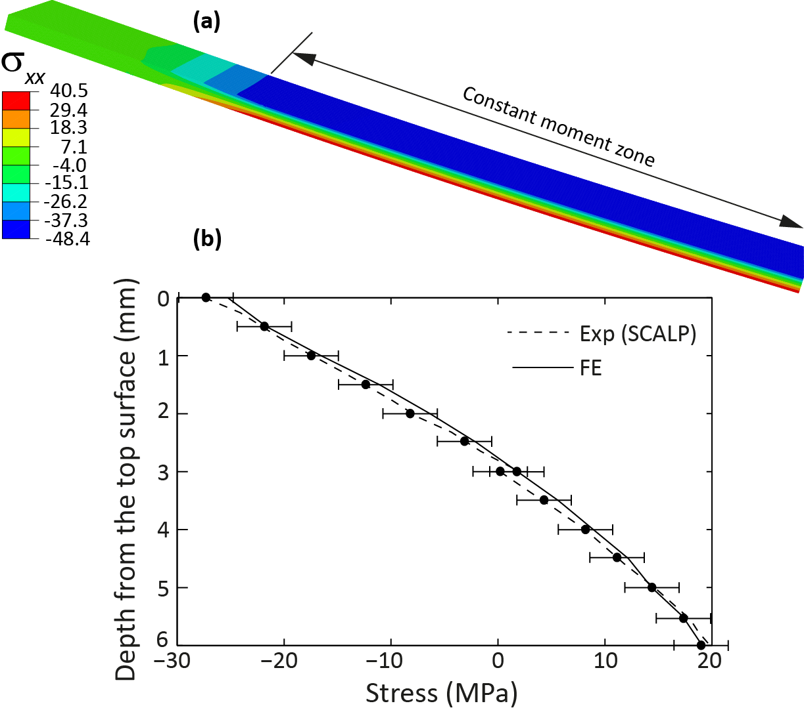
Fig. 12. 6 mm thick single-layer beam: (a) Distribution of the longitudinal stress and (b) Stress depth profile at the beam midspan (at applied load, P = 190 N)

The FE analysis was also used to estimate load–midspan deflection relationship of the beam. The comparison of the load–midspan deflection relationship shown in Fig. 6a suggests that the results of the FE analysis agree with the experimental results with a variance less than 5%. The applied load–surface stress (at the beam midspan) relationship predicted from the FE model is shown in Fig. 6b. The predicted stresses match well with that calculated based on strain gauge data, with a variance less than 5%. Fig. 12b shows the comparison between the stress depth profile (at the beam midspan) predicted from the FE model and those measured using SCALP-05. The results at one arbitrary chosen value of the applied load (190 N) is shown in the figure for brevity since very similar comparisons were noted at other values of the applied load. As can be seen from the figure, the predicted stress depth profile agree well with that measured using the polariscope (the expected error range of measured SCALP data is ± 2.5 MPa). It should be noted that since the measurement depth range of SCALP was limited to ~3mm from the surface, the measurements were taken from both sides of the beam to construct the full stress depth profile.

6.3 Glass–GFRP hybrid beams
The FE modelling technique that used to analyse single-layer glass beams was extended to analyse glass–GFRP hybrid beams. However, the modelling of the hybrid beams is non-trivial due to the difficulties associated with FE modelling of the glass–adhesive and GFRP–adhesive interfaces. It is common in the FE analyses of adhesive joints to use complex material and interface models, which incorporate cohesive behaviour of the adhesive as well as the material/geometric nonlinearities. Whilst these appear to give a more appropriate representation of the adhesive–adherend interfaces, in practice, the material parameters required are difficult to determine. Since the current paper focuses on modelling the load response of the hybrid beams before the failure, it is appropriate to start with a simple model that represents the interfaces to a reasonable accuracy. Therefore, the adhesive was modelled as an elastic solid and full strain compatibility was assumed at the interfaces.

Similar to the modelling of glass, fully-integrated 3D solid elements were used to model GFRP and adhesive. Minimum of four elements along the thickness direction of the GFRP and adhesive were used to achieve consistent results (the thickness of the GFRP and adhesive elements are ~0.35 mm and ~0.025 mm respectively). Fig. 13a shows the distribution of the longitudinal stress (σ_{xx}) at the peak load, determined from the FE analysis of a glass–GFRP hybrid beam made from 6 mm thick glass. As expected, the figure shows tensile stresses in the bottom glass layer, whilst the top glass layer is in compression. The failure load, which was determined to be the load that caused a tensile stress of 39 MPa at the bottom glass surface, is 2100 N; this value agree with the average failure load (1950 N) noted from the experiments (Section 4.3.1).

Comparison of the applied load–midspan deflection relationship shown in Fig. 8a suggest that the results of the FE model generally agree with the experimental results, although the FE model underestimated the deflection (i.e. FE model overestimated the stiffness) of the beam by ~20%. The authors believe the assumption of the local strain compatibility (i.e. full adherence) at the glass–adhesive and glass–GFRP interfaces contributed to this overestimation of the stiffness of the hybrid beam section. The results suggest the need of a more realistic modelling technique to incorporate the stiffness of the hybrid beam section, if a better precision is required in the FE model predictions.
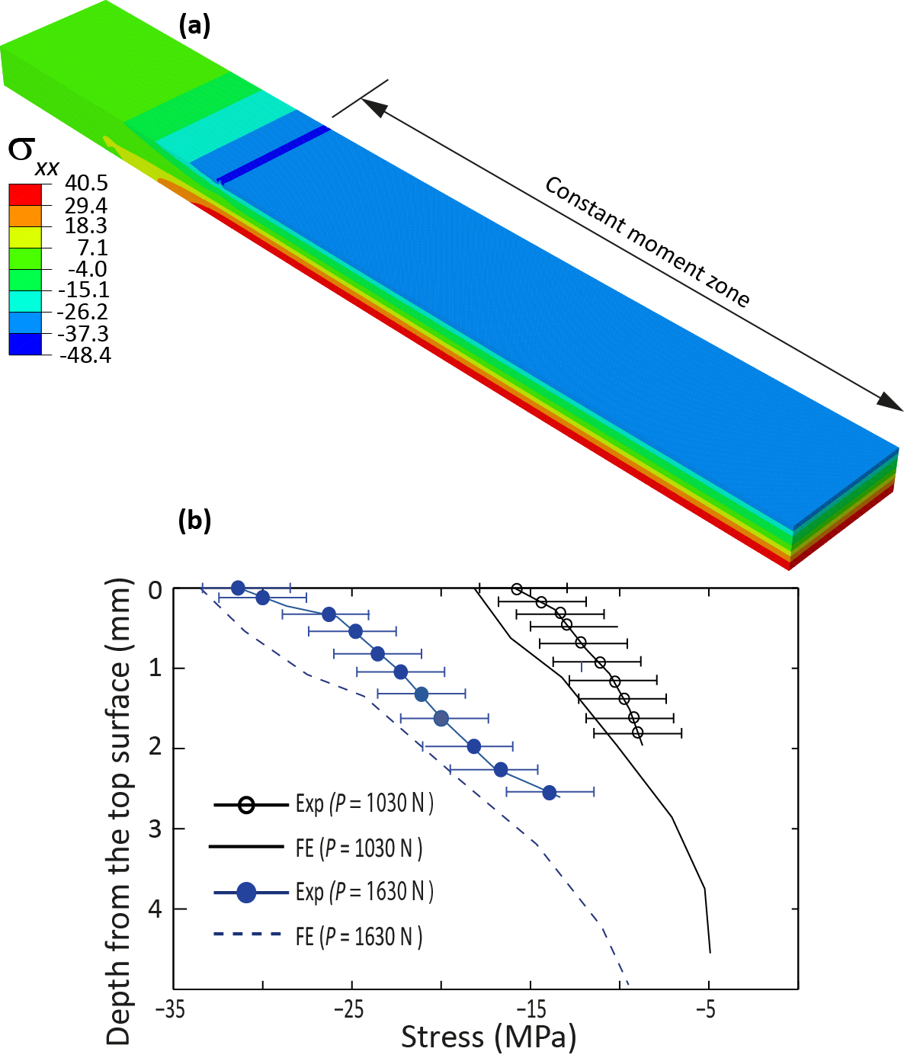
Fig. 13. Glass–GFRP hybrid beam: (a) Distribution of the longitudinal stress and (b) Stress depth profile at the beam midspan (at applied loads, P = 1030 N and P = 1630 N)

The applied load–surface stress (at the beam midspan) relationship predicted from the FE model is shown in Fig. 8b. The predicted surface stresses reasonably match well with that calculated using the measured strain gauge data (Fig. 8b). The difference between the predicted values and those determined based on experimental results is less than 10%. The authors believe this slight discrepancy may be attributed to the additional stresses developed in the beam during the bonding of GFRP strip and/or during the curing process of the hybrid beams. As described previously, the FE models assumed the same residual stress in the hybrid beams (Fig. 3) as that in pure single-layer glass beams. A detailed study of the stresses generated during the fabrication of the hybrid beams is beyond the scope of the present paper. The modelling approach adopted in the current paper is capable of predicting the behaviour of the hybrid beams to an acceptable accuracy.

Fig.13b shows the comparison between the stress depth profiles (at the beam midspan) predicted from the FE model for the hybrid beam and that measured using SCALP at two arbitrary chosen values of the applied load (1030 N and 1630 N respectively). Due to the difficulties encountered when using the polariscope from the bottom glass surface, i.e. holding the instrument upside down, only the measurements taken from the top side (i.e. compression surface) are shown in Fig. 13b. As can be seen from the figure, the predicted stress depth profiles are reasonably agreed with that measured using the polariscope. As commented in Section 6.3, the FE analysis adopted in the study has limitations and the experimental errors are inevitably associated with the stresses measurements using SCALP. Therefore, an exact match between the measured and the predicted stresses is not expected. However, as the results shown in Fig. 13b suggest, the agreement between the stress values is reasonably accurate with differences less than 10% between the two values.

7. Conclusions
- The results of four-point bending experiments show that the use of adhesively-bonded GFRP interlayers enable the development of annealed glass–GFRP hybrid beams which are stronger and ductile than single and double-layer annealed glass beams. However, since a small number of test specimens of dimensions smaller than actual building components was tested in the present study, a more generic validation of the results may be required. Characterisation of the benefits of the glass–GFRP hybrids compared to commercially available laminated glass may also be required.
- In the hybrid beams, once the bottom (i.e. tension) glass layer has cracked, the combination of the GFRP and the top (i.e. compression) glass layer carried the applied load. A reduced stiffness of the beam was noted in the post-breakage regime due to the formation of new cracks.
- The experiments showed that despite the heavy cracking, the hybrid beams recovered a large part of the deflection upon unloading.
- The experiments showed that Araldite 2020 is a viable structural adhesive that ensures sufficient composite behaviour in glass–GFRP hybrid beams under short-term quasi-static loadings in lab conditions.
- The modelling approach developed in the present paper is capable of predicting the load response and the stress evolution in the hybrid beams within the pre-crack regime to an acceptable accuracy.
- It has been shown that the incorporation of the effect of residual stress in glass ensures accurate predictions of the stress profiles in the hybrid beams.

Acknowledgements
Funding from the University of Southampton and the Institution of Structural Engineers Research Award (2012) are greatly acknowledged.

References
[1] K. Martens, R. Caspeele, J. Bellis, Development of composite glass beams – A review, Engineering Structures 101 (2015) 1-15.
[2] IStructE Structural use of glass in buildings, 2nd ed. The Institution of Structural Engineers, London, UK, 2014.
[3] M. Haldimann, A. Luible, M. Overend, Structural Use of Glass, International Association for Bridge and Structural Engineering IABSE, Zurich, Switzerland, 2008.
[4] Dupont, Laminated glass interlayers for stronger, safer glass.
http://www.dupont.com/products-and-services/construction-materials/safety-glass-interlayers/brands/sentryglas-ionoplast-interlayer.html, 2015 (accessed 15/07/2015).
[5] C. Louter, J. Belis, F. Veer, J.P. Lebet, Structural response of SG-laminated reinforced glass beams; experimental investigations on the effect of glass type, reinforcement percentage and beam size, Engineering Structures, 36 (2012), 292-301.
[6] J.R. Correia, L. Valarinho, A. Branco, Post-cracking strength and ductility of glass-GFRP composites beams. Composite Structures, 93 (2011), 2299-2309.
[7] F. P. Bos, Safety Concepts in Structural Glass Engineering, PhD thesis, TU Delft, The Netherlands, 2009.
[8] L. Blyberg, M. Lang, K. Lundstedt, M. Schander, E. Serrano, M. Silfverhiekm, C. Stalhandske, Glass, timber and adhesive joints – Innovative load bearing building component, Construction and Building Materials, 55(2014), 470-478.
[9] C. Bedon, C. Louter, Finite element analysis of post-tensioned SG-laminated glass beams with mechanically anchored tendons, Glass Structures and Engineering, 1(2016), 39-59.
[10] K. Martens, R. Caspeele, J. Bellis, Development of reinforced and posttensioned glass beams : Review of experimental research. Journal of structural engineering 142(5) (2016):04015173.
[11] E. Speranzini, S. Agnetti, Strengthening of glass beams with steel reinforced polymer, Composites: Part B, 67 (2014), 280-289.
[12] M. Palumbo, A new roof for the XIIIth Century “Loggia de Vicari” (Arquà Petrarca –PD, Italy)
based on structural glass trusses: a case study, Proceedings of the 9th international conference on
Architectural and Automotive Glass (GPD), Tampere, Finland, 2005.
[13] C. Louter, C. Leung, H. Kolstein, J, Vamberský. Structural Glass Beams with Embedded Glass Fibre Reinforcement, Proceedings of the Challenging Glass 2 – Conference on Architectural and Structural Applications of Glass. Delft, Netherlands, 2010.
[14] E. Speranzi, S. Agnetti, Flexural performance of hybrid beams made of glass and pultruded GFRP, Construction and Building Materials, 94 (2015), 249-262.
[15] C. Pascual, J. Montali, M. Overend, Adhesively-bonded GFRP-glass sandwich components for structurally efficient sandwich applications. Composite Materials, 160 (2017), 560-573.
[16] M. Achintha, B. Balan, An experimentally validated contour method/eigenstrains hybrid model to incorporate residual stresses in glass structural designs. Journal of Strain Analysis for Engineering Design. 50 (2015), 614-627.
[17] M. Overend, C. Butchart, H. Lambert, M.Parassas, The mechanical performance of laminated hybrid-glass units, Composite Structures 110 (2014), 163-173.
[18] B. Balan, M. Achintha, Experimental and numerical investigation of float glass–GFRP hybrid beams, Proceedings of the Challenging Glass 5 - Conference on Architectural and Structural Applications of Glass, Ghent, Belgium, 2016.
[19] B. Balan, M. Achintha, Assessment of stresses in float and tempered glass using eigenstrains. Experimental Mechanics, 55 (2015), 1301-1315.
[20] SCALP Instruction Manual, ver 5.0, GlassStress Ltd., Tallinn, Estonia (2015).
[21] M. Achintha, Sustainability of glass in construction, in: J. Khatib (Ed.), Sustainability of Construction Materials, 2nd Edition, Woodhead Publishing, United Kingdom, 2016, pp. 79-102.
[22] OLYMPUS instruction manual, Olympus Europa Holding GMBH, 2015.
[23] Technical data sheet product: EL2 Epoxy Laminating Resin, Easycomposites, 2015, p. 2.
[24] EL005 Unidirectional E-Glass, PRF Composite Materials, http://www.prfcomposites.com/store/index.php?route=product/product&path=97_71_102&product_id=109, 2016. (accessed 15/09/2016).
[25] ASTM D3039/D3039M-95, Standard test method for tensile properties of polymer matrix composite materials, ASTM International, United States, 1995.
[26] B. A. Balan, Analysis of strength of glass: modelling and experiments, PhD thesis, University of Southampton, UK, 2016.
[27] Araldite2020 Product Sheet, Huntsman Advanced Materials, Basel, Switzerland, 2015.
[28] ASTM D638-02. Standard test method for tensile properties of plastics, ASTM International, United States, 2002.
[29] C.D.M. Lijedahl, A.D Crocombe, M.A Wahab, I.A Ashcroft, Modelling the environmental degradation of the interface in adhesive bonded joints using a cohesive zone approach. The journal of Adhesion, 82(2006), 1061-1089.
[30] W. Guo, Strong and ductile float Glass–GFRP hybrid beams, MSc thesis, University of Southampton, UK, 2016.
[31] ABAQUS/Standard 6.9-3. Simulia, 2015.

