Adherence to enoxaparin in patients with cancer who experience a Venous Thromboembolism Cancer Nursing Practice

Diez de los Rios de la Serna, C., Lennan, E., Richardson, A.
Cancer Nursing Practice

Abstract: When a patient with cancer is diagnosed with a venous thromboembolism (VTE), management with low molecular weight heparin is an established form of treatment.
Patients with an incidental VTE are generally stable and can be treated as outpatients, and knowledge and ability to self-administer injections will contribute to treatment adherence.
The absence of symptoms in incidental events may influence negatively to the adherence to the treatment.
This audit examined patients' understanding about the event and information received with respect to management of their VTE (whether incidental or not). A difference in adherence was observed between respondents who experienced an incidental and symptomatic event.
Results demonstrated the need to develop written information for this patient group and revealed the absence of a clear pathway for the management of patients with VTE.

Keywords: Low-molecular-weight heparin; enoxaparin; Venous Thromboembolism; Cancer-
Associated Thrombosis; Cancer; Treatment; Adherence; Compliance

Introduction:
Venous thromboembolism (VTE) is a term that refers to a blood clot that forms in a vein. This term includes deep venous thromboembolism (DVT) and pulmonary embolism (PE) (NICE 2013). Approximately 1-2 per 1000 of the population in England experience thromboembolism each year (NICE 2013). VTE is a significant cause of morbidity as it is related to hospitalisation, reduced pulmonary function and post-thrombotic syndrome (Kuderer et al. 2009). In cancer patients VTE represents the second most common cause of death (Lyman and Khorana 2009).
There are numerous risk factors for developing a VTE that include older age, some medications (such as oral contraception), immobility, smoking and obesity (Khorana 2010). The risk is higher in cancer patients, who have a one-in-five risk of developing a VTE as well as a higher risk of recurrent VTE (Horsted et al. 2012). A cancer diagnosis itself raises the risk of VTE through impacting the three elements that predispose patients to thrombosis: stasis, vessel wall injury and hypercoagulability, known as Virchow’s triad (Health Select Committee 2005). Patients with cancer normally possess additional risk factors such as undergoing of chemotherapy, hospital admission, placement of intravenous catheters and surgery (Figure 1) (Eichinger 2016).
One of the most important risk factors is the administration of chemotherapy. Chemotherapy treatment increases the risk of VTE by causing damage to vessel wall, endothelium, platelet activation and a decrease in natural coagulation inhibitors (Mandala et al. 2011)
As well as the physical impact on the patient, the economic burden of VTE for the National Health Service (NHS) is substantial. A Health Select Committee (2005) estimated the cost of managing VTE was around £640 million annually. In addition, there is a substantial cost associated with hospital admission due to bleeding, complications related to the use of anticoagulants, or recurrent VTE (Lyman and Khorana 2009). VTE can also influence a chemotherapy schedule and interrupt or impact upon potential future therapeutic choices (Kuderer et al.2009).
- Management of VTE: Acute Oncology Practice
Some thromboses are detected when imaging for other indications. These types of thrombosis are termed incidental DVT or PE and have a prevalence of up to 6% in cancer patients (Douma et al. 2010). Half of these patients are asymptomatic, while the other half have symptoms often overlooked or attributed to their cancer such as breathlessness and cough (Sahut D'Izarn et al. 2012, Shteinberg et al, 2012).
Treatment is identical, irrespective of the symptoms. Incidental or symptomatic VTE have similar rates of complications, recurrence and mortality (Den Exter et al 2011). European and national guidelines (Mandala et al. 2011, NICE 2013) state that the treatment of VTE in cancer patients should comprise six months of low weight molecular heparin (LWMH) delivered by subcutaneous injections. The use of LWMH reduces the risk of recurrence, thereby reducing mortality and morbidity (Elyamany et al. 2014). Patients with haemodynamic or respiratory instability should be managed as inpatients in hospital, whilst stable patients with a low risk of adverse outcomes can be managed in the outpatient setting (Streiff 2009).
Patients with cancer can present in a number of different settings for emergency assessment. An Acute Oncology Service (AOS) provides specialist care for patients who experience complications of their cancer and treatment (Putt and Jones 2014). This type of service is relatively new and many interventions previously needing inpatient management can now be carried out in an outpatient setting. Furthermore, some aspects of care previously managed by doctors are now often managed by a multidisciplinary team approach and can be nurse-led (Palmer et al. 2013). This can avoid unnecessary admission and increase the efficiency of treatment and management (Putt and Jones 2014).
Patients with an incidental VTE may be assessed and managed as either inpatients or outpatients. Cancer patients considered as low risk of major complications can be managed as outpatients, for example through an AOS. In this context an ideal pathway may consist of patient assessment, instructions on how to inject the LMWH, a timely supply of injections, a follow up plan and communication with the GP. The process on average should be complete in less than one hour (Palmer et al. 2013).
- Adherence with treatment
LMWH therapy requires once a day subcutaneous injection. Optimally patients are managed as outpatients and treatment involves self-administration. Occasionally patients might require assistance with administration of the injection from a healthcare professional or a family member (Watson et al. 2015).
Healthcare outcomes will, to some degree, depend on patients’ adherence to treatment. A Cochrane review examining medication adherence in general (Nieuwlaat et al. 2014) concluded that when a medication needs to be self-administered people can receive as little as half of the prescribed dose. There are a number of factors that affect adherence. On some occasions patients unintentionally fail to follow the treatment as recommended, while others are result of a decision made by the patient. Factors such as misunderstanding, forgetting or ignoring healthcare advice affect medication adherence (Mengiardi et al. 2011). With the administration of LMWH, problems such as needle phobia or poor dexterity may affect adherence to treatment (Mengiardi et al. 2011). Most problems can be addressed by good communication, patient education and by helping patients make an informed decision about treatment and how to manage it (Nieuwlaat et al. 2014). Under-dosing with LMWH brings an increased risk of recurrence, whilst overdosing can increase the risk of bleeding (NICE 2010).
In the author’s centre, patients with symptomatic and incidental VTE are assessed in AOS. Diagnosis and treatment are explained and managed by the health professionals involved, and this service is largely nurse-led. The standard defined by the National Institute for Health and Care Excellence (NICE 2013) involves giving patients verbal and written information making patients aware of the risks and benefits of the treatment. To achieve this, healthcare professionals should not only offer information, but ensure any information has been understood and the patient is given the opportunity to ask questions (NICE 2009). However, when patients are seen in clinic or by a GP they often report lack of information or understanding of the event (Nunes et al. 2009). This creates confusion and potentially unnecessary and preventable problems for the patients.
Project:
This audit was developed to examine what information regarding VTE was provided to patients managed by the AOS and whether NICE guidelines were being followed. It aimed to examine the information given to the patient, assess their understanding of VTE, expected length of treatment and possible complications. It also assessed the degree of adherence with the treatment plan. It sought to compare levels of adherence in patients with a symptomatic or an incidental event, taking into account the information received and understanding of the diagnosis and treatment. The audit was approved by the Clinical Effectiveness Department in the author’s Trust.
Method:
The audit involved an investigator designed tool and a short questionnaire for patients. The data collection tool noted the type of VTE and if it was symptomatic or an incidental finding along with details on where patients were seen and any complications suffered during that period. The questionnaire posed questions about the information received and adherence to treatment. Additionally, it noted problems and questions, doubts or concerns experienced during treatment and included a combination of qualitative, free text questions and quantitative tick-box questions.
The data collection period covered a 6 month period from January to June 2016 in the author’s Trust. Patients with a diagnosis of VTE, and managed by AOS during the data collection period were identified. Data using the tool were extracted from clinical records for all of these patients.
A subsample of patients was also sent a questionnaire to collect patient experience data. A sample size of 15 was selected for pragmatic reasons. Those invited to complete a questionnaire included patients who were seen in Acute Oncology Service, up to 6 months post diagnosis of a VTE, under oncology care and having LMWH at the time of the data collection. Patients were approached by an ANP during a clinic appointment The questionnaire was piloted by some volunteer patients to check whether it was understandable and unambiguous. In the light of this feedback it was adjusted.
Patients were provided with an information sheet outlining the purpose of the audit and assurances of anonymity and confidentiality. They were offered the choices of completing the questionnaire with the help of the ANP face to face, taking it away and posting it back or completing it during a phone interview.
Results:
A total of 53 patients were seen in cancer care with a VTE during the 6 months of data collection (January to June 2016). From those, 49 patients were seen in the Acute Oncology Service and the other 4 in the cancer care inpatient wards. A VTE occurred in approximately the same number of males as females (54% males). Of the total number of diagnoses of thromboembolism, 73.5% were pulmonary embolism (53% incidental PE, 20.5% symptomatic) (Graphic 1).
Mean age was 64 years. The majority had colorectal cancer (27%), lymphoma (15%) or breast Cancer (12%) (Graphic 2). 61% of patients were receiving chemotherapy at the time, 25% had were having no treatment at the time of diagnosis of VTE, 6% were being treated with radiotherapy, 4% were having chemo-radiotherapy and 4% hormone therapy.
On admission to the AOS following diagnosis of VTE, a full set of observations were taken (blood pressure, pulse, saturation, respiratory rate and temperature) along with a blood test that included a full blood count, coagulation screen and renal profile. On receipt of these results patients were then prescribed and given their first dose of enoxaparin. They received teaching and verbal information on the administration of LMWH as recommended in the NICE guidelines (2013). A letter to the GP informing them of the diagnosis and management plan occurred in 80% of the patients, the remaining 20% had no such record. No patients reported that they have been given any written information
5 patients were admitted from AOS on diagnosis due to right heart strain diagnoses seen on the CT scan and they required oxygen support. All the other patients were seen and discharged on the same day.
Following discharge 4 patients had documented visits to the hospital due to bleeding. The dose of LMWH dose was reviewed in all these cases and in 2 cases anticoagulation treatment stopped for some days. A further 2 required platelets transfusion. They all then continued treatment.
25 patients met the inclusion criteria for questionnaire completion (Graphic 3.). The first 15 attending clinic were approached, and all agreed to complete the questionnaire and were given one. Of the patients who received the questionnaire 10 completed them (67%) giving a response rate of 66.7%. The other 10 patients that met the inclusion criteria didn’t attend to their clinic appointment or had an appointment booked more than 6 months post diagnosis of a VTE.
In response to the question: Can you tell me what you understand by the term VTE, 90% of the respondents answered that VTE meant a blood clot in a vein or a lung.
- Information before the event:
Respondents were asked if they received information about the risk and signs of VTE prior the event. The majority of them said they had not received any information (60%) or received it to some extent (30%) (Graphic 4).
In response to the question: Do you remember the signs of VTE? 80% did not answer or said they could not remember the signs. The other 20% said they thought that shortness of breath was due to other problems related to the treatment. “I thought my breathlessness was due to becoming unfit” (respondent 6), “Shortness of breath, but we thought it was due to anaemia” (respondent 9).
- Information on the day of the event:
100% of the patients felt they did receive information on VTE whilst they were attending the AOS but 70% of them reported they would have liked more written or verbal information. (Graphic 5)
- Administration of first dose of LMWH:
60% gave themselves the injection and the remaining 40% had a family member living with them who administered the injections. None of them needed a district nurse to administer the injection
- Adherence:
50% of respondents said they had their injections all or most of the time, the other 50% admitted having it some of the time.
Reason for non-adherence included problems with bleeding and bruising and one had a recurrent VTE two months after the diagnosis.
- Problems during administration of LMWH:
70% respondents reported knowing the 24 hour emergency telephone number of AOS but they did not know who to call with questions that were not an emergency. Just one respondent reported that they contacted the emergency phone when they had questions. One patient wrote “We didn’t really know who to contact for what. We have many numbers but who is best to call in case of regular questions?”(Respondent 9).
To the question: Have you had any questions regarding your treatment? The answers included: Not knowing if they should give an injection where there is bruising; not knowing they were going to bruise or bleed and also that they would have liked to have known that the injection stings.
Regardless of the fact that 70%of respondents felt there was nothing the staff could have done to make their treatment easy in the next question: Any comment/suggestion of how to treat or inform the patients? 70 % thought more information before and after would be beneficial.
The service from AOS was considered ‘efficient’, ‘very good’ and ‘helpful’. One respondent said it was stressful coming back to clinic and commented “I felt the doctor assumed I had to know the treatment and length of treatment” (respondent 8) and another said “didn’t know I could get another clot even having the treatment (LMWH)” (respondent 10).
Discussion:
Whilst the audit was limited in size, this data provides useful information about participants’ experiences. Although most respondents felt positive overall about their treatment they felt they had a lack of information. The NICE guidelines for VTE (2013) specify healthcare professionals should give patients both verbal and written information about treatment. However, in the Trust where the audit was conducted there is no specific written information to offer patients with cancer. Whilst many reported receiving verbal information, they often felt confused and reported they were lacking certain aspects information such as the questions exposed of the administration of LMWH.
The audit aimed to examine adherence to the treatment. Greenhalgh (2010) argues that some self-completion questionnaires have demonstrated discrepancies between answers and actual practice. Participants can feel prone to answer what they think is perceived to be a positive answer. Despite this fact, 50% of the total number of patients interviewed reported they had not given themselves all the prescribed injections.
When comparing incidental VTE with symptomatic VTE, 80% of the respondents with a symptomatic VTE answered that they administered all the necessary injections, in comparison with 67% of respondents with incidental VTE. This trend merits further investigation. In a study done by Elliott et al. (2007) it was noticed that patients were more likely to take the medications for a condition they feared. This is reinforced by NICE who states that patients’ beliefs and experiences influence their intention to take a medicine (NICE 2009). In symptomatic PE, it is possible patients will adhere to LMWH in the hope of relieving their symptoms and avoiding hospitalisation. In the case of incidental PE, patients may not notice any symptoms and therefore they do not feel any benefit in taking the treatment. Also, they may not appreciate the preventative application of the treatment. There is evidence that the use of medication to improve symptoms can increases adherence to the medication (Nunes. et al 2009). With regards to incidental PE which can cause mild to moderate symptoms such as fatigue, as the symptoms decline there is perhaps a higher risk of poor adherence to treatment as there is no longer clear symptomatic benefit.
Conclusion and further steps:
Whilst most respondents felt positive overall about their management, this audit has identified that it is important to develop specific written information to be offered to the patients in AOS. This written information would be used to ensure that patients understand the condition and reinforce the nature of the treatment. This information should also specify a telephone number or numbers to call with any concerns or emergency to avoid any confusion.
During the course of the audit it became obvious that the AOS did not have a clear well defined pathway for the management of patients with a VTE. It would be useful to consider the development and implementation of a pathway. This would identify patients at risk of complications and aid decisions as to whether outpatient treatment is appropriate or hospital admission is needed. There are numerous tools predicting the risk and mortality of patients with VTE. These are based on clinical parameters that have been proved useful in the prognostic assessment of patients with VTE (Torbicki et al 2008).
Despite the fact that all the respondents suffered a VTE, 80% could not remember the signs and symptoms.
Future studies should aim to: 1. examine patients’ understanding of the information provided by healthcare professionals, 2. explore the impact of different methods of presentation on how patients understand and interpret the information related to the treatment and possible complications, 3. aim to understand how to improve adherence to treatments.
Acknowledgements:
I would like to thank Health Education England (Wessex) for the support.
I would also like to thank Marion Lloyd, Vanessa Seilo and Bethany Hanan for their comments which greatly improved the manuscript

References:
Den Exter, P.L., Hooijer, J., Dekkers, O.M. & Huisman, M.V. (2011) Risk of recurrent venous thromboembolism and mortality in patients with cancer incidentally diagnosed with pulmonary embolism: a comparison with symptomatic patients. Journal of Clinical Oncology, 29, 2405-2409.
Douma RA, Kok MG, Verberne LM, Kamphuisen PW, Buller HR (2010) Incidental venous thromboembolism in cancer patients: prevalence and consequence. Thrombosis Research 125: e306-e309
Eichinger S (2016) Cancer associated thrombosis: risk factors and outcomes. Thrombosis Research 140S1: S12–S17
Elliott RA, Ross DD, Adams AS, Safran DG, Soumerai SB (2007) Strategies for coping in a complex world: adherence behaviour among older adults with chronic illness. Journal of General Intern Medicine 22(6):805-810.
Elyamany G, Alzahrani AM and Bukhary E (2014) Cancer-Associated Thrombosis: An Overview. Clinical Medicine Insights: Oncology 2014:8 129–137
Greenhalgh T (2010) How to read a paper the basics of evidence-based medicine (4th Edition). Chichester: Wiley-Blackwell. Available from: http://www.myilibrary.com?id=268650 [Accessed 15th November 2015]
Health Select Committee (2005) The prevention of venous thromboembolism in hospitalised patients. London: The stationery Office
Horsted F, West J, Grainge MJ (2012) Risk of Venous Thromboembolism in Patients with Cancer: A Systematic Review and Meta-Analysis. PLoS Med 9(7):1-19
Khorana AA (2010) Venous thromboembolism and prognosis in cancer. Thrombosis Research 125:490-493.
Kuderer NM, Ortel TL and Francis CW (2009) Impact of Venous Thromboembolism and anticoagulation on cancer and cancer survival. Journal of clinical oncology 27(29): 4902-4911
Lyman GH and Khorana AA (2009) Cancer, clots and consensus: New understanding of an old problem. Journal of clinical oncology 27 (29): 4821-4826
Mandala M, Falanga A, Roila F (2011) Management of venous thromboembolism (VTE) in cancer patients: ESMO clinical practice guidelines. Annals of oncology 22(6) vi85-vi92
Melnyk BM and Fineout-Overholt E (2005) Evidence-based practice in nursing and healthcare: a guide to best practice. Philadelphia: Lippincott Williams & Wilkins
Mengiardi S, Tsakiris DA, Lampert ML, Hersbeger KE (2011) Drug use problems with self-injected low-molecular-weight heparins in primary care. European Journal of clinical pharmacology 67(2):109-20
NICE National Institute for Health and care Excellence (2009) Medicines adherence: involving patients in decisions about prescribed medicines and supporting adherence. Clinical guideline (CG76). Available from: nice.org.uk/guidance/cg76 [accessed 28.4.16]
NICE National Institute for Health and care Excellence (2013) Venous thromboembolism in adults: diagnosis and management. Quality standard (QS 29). Available from: nice.org.uk/guidance/qs29 [accessed 28.4.16]
NICE National Institute for Health and Clinical Excellence (2010) Venous thromboembolism: reducing the risk. clinical guidelines 92. Available from: www.nice.org.uk/guidance/index.jsp?action=byID&o=12695 [accessed 12/05/2016]
Nieuwlaat R, Wilczynski N, Navarro T, Hobson N, Jeffery R, Keepanasseril A, Agoritsas T, Mistry N, Iorio A, Jack S, Sivaramalingam B, Iserman E, Mustafa RA, Jedraszewski D, Cotoi C, Haynes RB (2014) Interventions for enhancing medication adherence. Cochrane Database of Systematic Reviews Available from: 10.1002/14651858.CD000011.pub4. [Accessed 12/05/2016]
Nunes V, Neilson J, O’Flynn N, Calvert N, Kuntze S, Smithson H, Benson J, Blair J, Bowser A, Clyne W, Crome P, Haddad P, Hemingway S, Horne R, Johnson S, Kelly S, Packham B, Patel M, Steel J (2009). Clinical Guidelines and Evidence Review for Medicines Adherence: involving patients in decisions about prescribed medicines and supporting adherence. London: National Collaborating Centre for Primary Care and Royal College of General Practitioners.
Palmer J, Bozas G, Stephens A, Johnson M, Avery G, O’Toole L and Maraveyas A (2013)Developing a complex intervention for the outpatient management of incidentally diagnosed pulmonary embolism in cancer patients. BMC Health Services Research 13:235
Putt L and Jones P (2014) The Role of the Specialist Acute Oncology Nurse in the New Acute Oncology Services. Clinical Oncology 26 125- 127
Sahut D'Izarn M, Caumont Prim A, Planquette B, Revel MP, Avillach P, Chatellier G, Sanchez O and Meyer G (2012) Risk factors and clinical outcome of unsuspected pulmonary embolism in cancer patients: a case-control study. Journal of Thrombosis and Haemostasis 10: 2032-2038.
Shteinberg M, Segal-Trabelsy M, Adir Y, Laor A, Vardi M and Bitterman H (2012) Clinical characteristics and outcomes of patients with clinically unsuspected pulmonary embolism versus patients with clinically suspected pulmonary embolism. Respiration 84: 492-500.
Streiff MB (2009) Diagnosis and Initial treatment of venous thromboembolism in patients with cancer. Journal of clinical oncology 27 (29): 4889-4894
Torbicki A, Perrier A, Konstantinides S (2008) Guidelines on the diagnosis and management of acute pulmonary embolism: the Task Force for the Diagnosis and Management of Acute Pulmonary Embolism of the European Society of Cardiology (ESC). European Heart Journal 29: 2276–2315.)
Watson H, Keeling DM, Laffan M, Campbell Tait R and Mike Makris on behalf of the British Committee for Standards in Haematology (2015) Guideline on aspects of cancer-related venous thrombosis. British Journal of Haematology 170 (5):595–742

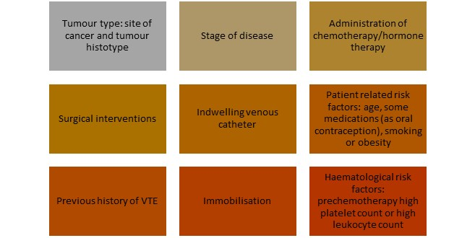
Figure 1: VTE risk factors associated with cancer

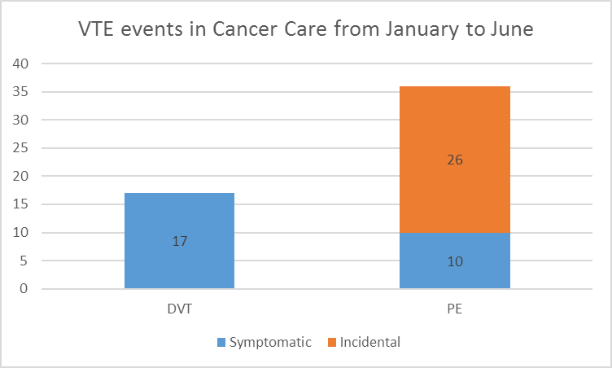
Graphic 1: VTE events in cancer care from January to June

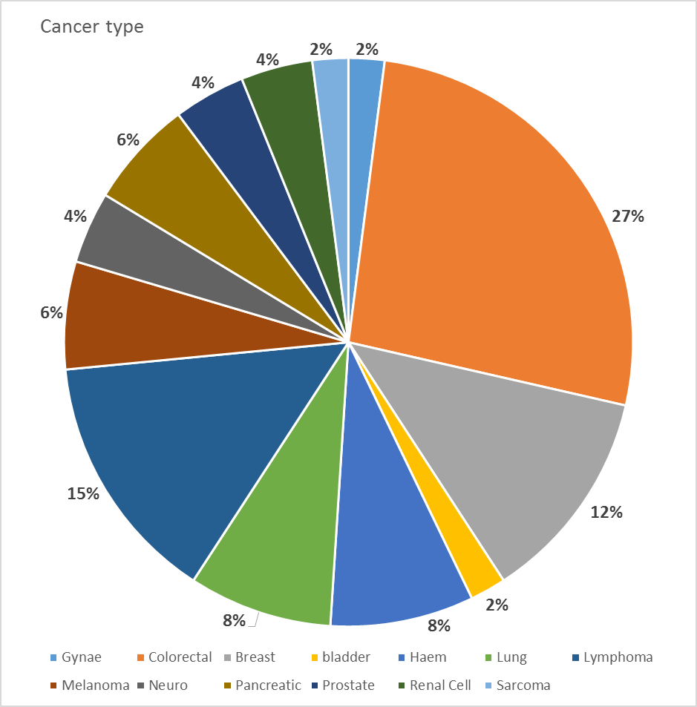
Graphic 2: Cancer type
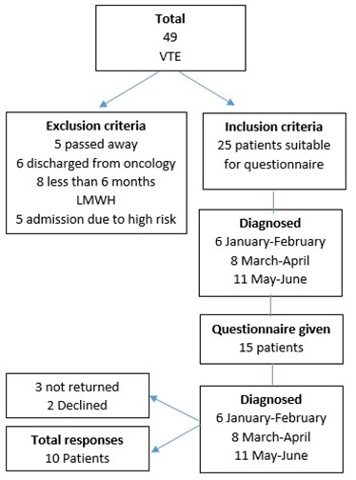
Graphic 3: Patient selection

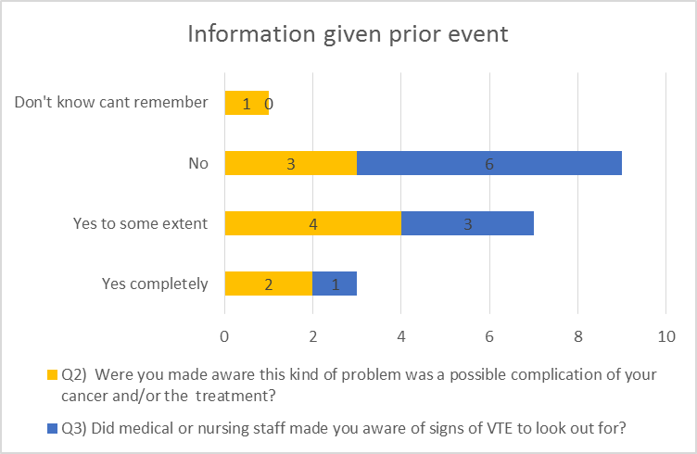
Graphic 4: Information given prior event

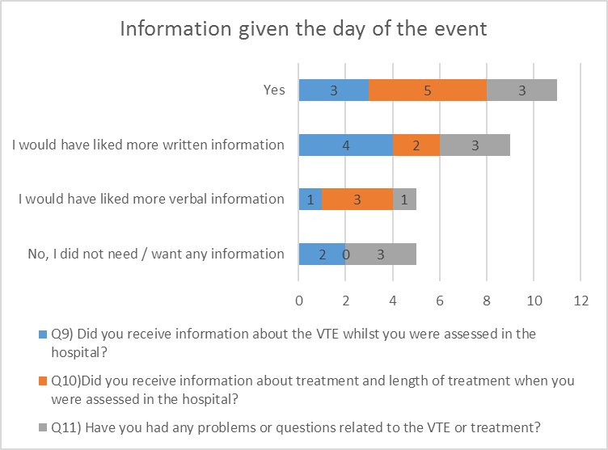
Graphic 5: Information given the day of the event

