A community-based prevalence study of rheumatic heart disease in rural Ethiopia

Tadesse Gemechuª, Hani Mahmoud^{b}, Eldryd H. O. Parry^{c}, David I.W. Phillips^{d}, and Magdi H Yacoub^{be}.

ªJimma University Hospital, Ethiopia, ^{b}Aswan Heart Centre, Aswan, Egypt, ^{c}London School of Hygiene and Tropical Medicine, London, U.K., ^{d}M.R.C. Lifecourse Epidemiology Unit, Southampton, U.K. and ^{e}Imperial College, NHLI, Heart Science Centre, London, UK.
Short title: Rheumatic heart disease in rural Ethiopia
Word count: 2729, Abstract 242
Correspondence: Prof DIW Phillips
Address: MRC Lifcourse Epidemiology Unit, Southampton General Hospital, Tremona Road, Southampton SO16 6YD, UK.
Telephone: +44(0) 2380 777624
Fax: +44 (0) 2380 704021
Email: diwp@mrc.soton.ac.uk

This study was supported by Chain of Hope
Abstract
Background
Chronic Rheumatic Heart disease (RHD) continues to be a health problem in many low and middle income countries and especially in sub-Saharan Africa. Echocardiography has shown that the disease is far more widespread than may be detected by clinical assessment, but data are lacking on the prevalence and epidemiological features in rural Africa.
Design
Community based prevalence survey
Methods
We used transthoracic echocardiography to carry out a population-based study of RHD in a rural area of Ethiopia. A total of 987 subjects aged 6 to 25 were selected by cluster sampling. The prevalence of RHD was assessed by the current consensus World Heart Federation (WHF) criteria.
Results
There were 37 definite cases of RHD and a further 19 borderline cases giving an overall prevalence of 37.5 cases per 1000 population (95% CI 26.9 to 51.8) rising to 56.7 (43.9 to 73.5) if the borderline cases are included. The prevalence of definite disease rose to a peak of 60 cases per 1000 in those aged 16-20 yr before falling to 11 cases per 1000 in subjects aged 21- 25 yr. Of the 37 with definite disease, 36 had evidence of mitral valve and seven evidence of aortic valve disease.

Conclusions
RHD has a high prevalence in rural Ethiopia. Although follow-up is needed to determine how the disease develops with advancing age, the data provide evidence that the disease is an important health problem in rural sub-Saharan Africa requiring urgent concerted action.
Key words: Chronic Rheumatic Heart Disease, Echocardiography, Rural, Ethiopia, Prevalence.
Introduction
Although RHD has virtually disappeared in most developed countries, it remains an important public health problem in low and middle income countries, and is estimated to affect some 15 million people worldwide.¹ The disease is widespread in the Middle East and Asia, the poor indigenous populations of some wealthy countries, and is particularly prevalent in sub-Saharan Africa where it is one of the commonest causes of heart disease and where it carries a grim prognosis because of the lack of specialised centres and the availability of cardiac surgery.²⁻⁵ Hospital-based studies in Africa report that RHD accounts for up to 34.0% of cardiovascular disease-related hospital admissions,⁶ and it is the most frequent cause of heart failure among children and young adults. One large study reported a 180-day mortality of 35.4%.⁷ While surveys based on auscultatory criteria have consistently indicated a high disease burden,⁸ echocardiographic screening has shown that RHD is far more widespread than previously appreciated - up to a 10-fold increase in sensitivity compared with clinical assessment.⁹ Using consensus guidelines developed by the World Heart Federation (WHF), recent echocardiographic surveys of schoolchildren in a number of African counties have shown a prevalence of between 15 and 34 cases per 1000,¹⁰⁻¹³ but they were largely based on urban or peri-urban communities; little is known about the prevalence of RHD in rural areas where most of the population still live. Furthermore, because rheumatic heart disease is linked with poverty,¹⁴⁻¹⁶ surveys of schoolchildren will tend to under-represent disease prevalence as poor children are much less likely to attend school.
We have therefore carried out echocardiographic screening of rheumatic heart disease in a population-based study of children and young adults to obtain realistic estimates of disease prevalence in rural Ethiopia.
Methods
Study area
Jimma Zone, Southwest Oromia State, is an administrative zone within Ethiopia (Figure 1) with an area of 15,568 km² and a population of nearly 2.5 million people (11% urban, 89% rural). The zone is divided into 17 Woredas or districts: each is divided into a number of Kebeles or neighbourhoods with an average population of about 5000 people. The majority of the population works in agriculture as the zone is one of the major coffee growing areas although typical incomes are very low (<500US$/year). Only 9% of the inhabitants of Jimma zone have access to electricity, 57% of all eligible children are enrolled in primary school, and 12% in secondary schools.¹⁷
Sample selection
We used a two-stage, cluster sampling technique. In a sample of ten Woredas we randomly selected 33 of a total of 54 possible Kebeles. Within each Kebele Health Extension Workers maintained a numbered list of households. We used a sequential sample of these households to obtain a list of approximately 40 households. If the household included an individual in the 6 to 25 year age group, its members were invited to attend for screening at the local health post. If there was more than one individual of this age-group in the household, we selected one by simple random sampling; if there was no individual of this age group, or the subjects were away, we selected the next household in the sequence. The Jimma University Ethical review Board approved the project and written, informed consent was obtained from each subject.

Data collection
A questionnaire was verbally administered in Oromifa (the local language). Subjects (and/or a family member) were asked about school attendance, their parents’ level of education and occupation. They were also asked about their birthplace, timing of birth (wet or dry season) and whether a parent had died. Details of their housing were recorded including the number of rooms, number of people living in the house, type of construction of the house, whether animals lived in the same house as the occupants and the source of their drinking water(piped or river). A brief medical history was recorded and a clinical examination was carried out to define symptoms and signs suggestive of rheumatic fever or cardiac valvular disease. A transthoracic echocardiogram was obtained with the use of a portable, battery operated echocardiographic system (Esoate MyLab30 gold) with M-mode, two-dimensional, and Doppler imaging. The views obtained included parasternal long axis, parasternal short axis, and apical four and five chamber views, noting valve morphology on cross-sectional 2-dimensional imaging, and the presence of mitral and aortic regurgitation using colour flow Doppler. Doppler interrogation of regurgitant jets was used to assess velocity, spectral envelope and duration.
Diagnosis and classification of RHD
The subjects were classified as having definite or borderline RHD on the basis of the 2012 WHF criteria.¹⁰ The criteria for definite RHD included the combination of pathological regurgitation and at least two morphological features of RHD, mitral stenosis with a mean gradient ≥4 mmHg, or borderline disease of both the aortic and mitral valve. Doppler criteria for regurgitation included a regurgitant jet seen in two planes with a jet length of ≥2cm for the mitral and ≥1cm for the aortic valve in at least one plane, a peak velocity of ≥3m/s for one complete envelope and the jet persisting through systole for the mitral and diastole for the aortic valve. Morphological features of RHD for the mitral valve were anterior mitral leaflet or chordal thickening, restricted leaflet motion, or excessive leaflet tip motion during systole, for the aortic valve irregular or focal thickening, a coaptation defect, restricted leaflet motion or prolapse. Borderline disease was defined as having either (i) at least two morphological features of RHD of the mitral valve without regurgitation or stenosis, or (ii) pathological mitral or aortic regurgitation.
All positive and borderline images and 10% of the negative scans were reviewed by an experienced cardiologist. Table 1 shows the comparison between the original field diagnosis and the diagnosis after expert review (the scans for three cases were not available). There was a high level of agreement (Kappa = 0.65, p<0.001). The marginal totals were very similar and 83% of categorisations were in complete agreement, while a further 18% differed by only one category. There was only one completely discordant assessment. Where there were discrepancies the categorization by the expert cardiologist was used in the analysis.
Statistical methods
For practical and logistic reasons we opted for a two stage, cluster sampling approach with each cluster comprising 35 subjects. Anticipating a prevalence of RHD of approximately 5% and a modest design effect of 1.5, we estimated that 29 clusters would be needed to enable us to estimate the prevalence with a standard error of 1.0%. Subsequent post hoc analyses showed that the design effect was negligible. Contingency tables were used to compare the prevalence of borderline and definite cases as determined by different observers and the kappa statistic computed to assess inter-observer reliability. The data are presented as cross-tabulations or means +/- SD and comparisons between groups were carried out using χ² tests or Fisher’s exact test where the cell counts were small.
Results
We carried out a total of 987 transthoracic echocardiograms, achieving a response rate of 82%. The mean age of the screened population was 13.2 (SD 4.7) yr. and 454(46.0%) of the participants were male. There were thirty seven definite cases of RHD and a further 19 borderline cases giving an overall prevalence of 37.5 cases per 1000 population (95% CI 26.9 to 51.8) rising to 56.7 (43.9 to 73.5) if the borderline cases are included. Prevalence did not differ by gender (overall prevalence, 61.8 per 1000 in males and 52.5 per 1000 in women). The prevalence of definite disease rose progressively from 24 cases per 1000 among subjects 6 to 10 years of age to a peak of 60 cases per 1000 in those aged 16-20 years of age before falling to 11 cases per 1000 in subjects aged between 21 and 25 years (Figure 2). Borderline disease was observed in the youngest two age groups (30 and 22 cases per 1000 respectively) but was not found in individuals over the age of 16 yrs. Of the 37 individuals with definite disease, 36 had evidence of mitral valve involvement and seven evidence of aortic valve disease. (Table 2) Eight of the cases diagnosed with definite disease had significant aortic or mitral regurgitation; the others had mild valve disease. The cases did not report any symptoms related to heart failure. None gave a convincing history of preceding rheumatic fever. Only one of the definite cases reported taking monthly prophylactic penicillin.

Table 3 shows that the population has a low level of education and a high level of unemployment. One third reported that they were not attending school. Parental illiteracy was high; over 70% were subsistence farmers or labourers. A quarter of households had thatched roofs, in almost half animals shared space with the family and a third reported that their water supply was unprotected. None of these measures, nor the measurements of crowding such as family size, persons per room or number sleeping together, differed between individuals with rheumatic heart disease and the healthy, unaffected controls. Table 3 also shows the data on the medical and family history. The only significant difference between definite cases and the unaffected population was a history of scabies (16.2% vs. 5.4%, p=0.02). Most cases of scabies were reported as being infected.
Discussion
There is very little population-based data on the prevalence of RHD in rural sub-Saharan Africa and this is the first study based on the current WHF definition of echocardiographic disease. Our prevalence of 37.5/1000 rising to 56.7/1000 if borderline cases are included is among the highest reported rates in the world and almost twice as high as the rates reported from urban/peri-urban populations of schoolchildren in Lilongwe,Malawi;¹¹ Jimma, Ethiopia; ¹² Cape Town, South Africa;¹² and Kampala, Uganda.¹³ These surveys, which used the same diagnostic criteria as the current study, reported prevalence rates ranging from seven to 17 per 1000 for definite and 20 to 34 per 1000 for total disease occurrence. These rates are, in turn, approximately 10 times higher than previously published prevalence rates in Ethiopian schoolchildren based on clinical criteria.^{18,19} The findings suggest that rural Ethiopia and probably therefore rural areas of sub-Saharan Africa have a high and largely undiagnosed prevalence of this disease. Our data may be directly compared with the prevalence of echocardiographic RHD using the same WHF criteria in Jimma, Ethiopia and in Cape Town, South Africa. Our study suggests a prevalence rate almost twice as high as in the previous Ethiopian study which was based on a survey of schoolchildren in a mixed urban/rural community and which reported a rate of 16.5 per 1000 rising to 30.5 per 1000 if borderline cases were included.¹² The prevalence rate in the largely urban South African population was much lower: 4.8 per 1000 for definite and 20.2 per 1000 for total cases.¹²
The current study was based on screening of a population-based sample and as the response rate (82%) was high, we believe our study to be representative of the rural population. This community, in turn, is typical of many rural areas of sub-Saharan Africa with a high prevalence of subsistence farming and low levels of literacy (Table 3). Medical care is very poor and only one of our definite cases was taking penicillin prophylaxis. We used the current WHF criteria for diagnosing rheumatic heart disease and diagnoses made in the field were verified by a senior cardiologist. Our findings show that echocardiographic screening of schoolchildren, and particularly urban children, greatly underestimates the true prevalence (rural and urban) of this disease in countries such as Ethiopia. The likely reason is that the poverty-related major risk factors for the disease are more prevalent and thus more important in rural areas and are linked with poor school attendance.

Prevalence rates were similar in boys and girls which accord with similar previous studies.^{9,11,12} In our study we included young adults up to the age of 25yr. – a difference from most other studies which only included children under the age of 16yr. We found that prevalence was fairly high in all age-groups studied with some evidence of a decline in rates among the 21-25 yr. age group, although this was not significant. All but one of the definite cases detected had evidence of mitral regurgitation and 7/37 (19%) had additional evidence of aortic regurgitation. (Table 2) None had evidence of valve stenosis. A curious feature of our data was the much higher ratio of definite to borderline disease than has been observed in South Africa and other African countries.^{9,12,20} This finding was also noted in a comparative study of echo screening of schoolchildren in Ethiopia and South Africa. In our study the ratio of definite to borderline disease was 1.5 compared with 1.2 in the previous Ethiopian study and 0.3 in Cape Town.¹² The higher proportion of definite to borderline disease in Ethiopia may be a consequence of more aggressive disease in this unselected Ethiopian population and further underlines the importance of carrying out population-based studies as opposed to surveys of schoolchildren.
The relationship between poverty and RHD may well explain the remarkable persistence of the disease in resource-poor countries. Yet, we found no significant differences in our measures of socioeconomic background between the cases of the disease and healthy controls (Table 3). The main evidence for the role of socio-economic factors in RHD derives from observations of high prevalence in disadvantaged, geographically defined populations, as observed historically in the UK and US,¹⁴ in meta-analyses of prevalence data,⁸ as well as currently in sub-Saharan Africa,^{16,21} Individual-level studies, however, have produced rather conflicting results and have largely failed to demonstrate convincing associations with either poverty or overcrowding, ^{15,22,23} which is surprising in view of the strength of the population associations.¹⁴ There are a number of possible reasons for this but are likely to be explained by the low degree of heterogeneity of populations living in rural Africa, where the environments of RHD cases and controls tend to be rather similar, or simply a failure to measure adequately the appropriate risk factor or factors related to RHD susceptibility.
We found that sixteen percent of RHD cases (Table 3) reported a history of scabies infection compared with five percent of the healthy population. Almost all cases also reported that their scabies had been infected. Although this needs to be replicated this finding is of interest as it has been suggested that infection of scabies lesions by group A streptococci could lead to RHD and may explain the high disease prevalence in Australian Aborigines, among whom scabies is very common.²⁴
In summary, our results show a high prevalence of subclinical RHD in a rural community in Ethiopia. Rural Ethiopia is in many ways a good model of other rural areas of sub-Saharan Africa as its rural population (81% in 2014) and rate of urbanization is comparable with other countries in the region, as are the indices of rural poverty, education, and maternal/child health.²⁵ Though follow-up is needed to assess how the disease develops with advancing age, the data provide evidence that RHD is an important and underestimated health problem in rural sub-Saharan Africa. There is a need for studies evaluating the prevalence elsewhere in rural communities in Africa, together with the development of effective strategies for the control and eradication of RHD.²⁶ This will require improved methods of detection and diagnosis, a programme for training rural nurses and health extension workers as well as ensuring that adequate supplies of benzyl penicillin are available at the primary care level. Nevertheless, the difficulties of access and geographical remoteness of many of these rural communities present a formidable challenge to achieving these goals. For those with advanced disease, access to specialist surgical facilities is much needed.⁵ Our studies also highlight the neglected research agenda in RHD; there is a pressing need to explain the persistence of this disease and investigate its association with poverty, an important feature of the disease in so many African countries. The identification of novel risk factors such as domestic air pollution²⁷ or other early life influences^{28,29} offer potentially important clues which could lead to improved preventative strategies but these will need proper evaluation. The recent Addis Ababa Communiqué has stressed the importance of a concerted and multi-sectoral partnership between governments, health ministries, international agencies and academia.³⁰ Finally, organizations such as the European Society of Cardiology have an important role to play in promoting awareness of the problem, stimulating research and encouraging the involvement of cardiologists within the constituent national cardiac societies.

Authors’ contributions
EHOP, DIWP and MHY conceived the study and its design, TG carried out the fieldwork; TG, EHOP, HM, DIWP and MHY carried out the analysis and the drafting of the manuscript; all authors gave final approval and agree to be accountable for all aspects of the work and ensuring its integrity and accuracy.
The authors have no conflict of interest
Acknowledgements
We thank Ehitunesh Shemsu and Yeshalem Belay for assistance with the fieldwork.

Table 1: Comparison between the original screening diagnosis and the diagnosis following expert review among borderline and definite cases and a sample of approximately 10% of the normal cases. (scans for three definite or borderline cases were not available for review)

 |  | Original diagnosis
 |  | Normal | Borderline | Definite | Total
Diagnosis after expert review | Normal | 84 | 7 | 0 | 91
 | Borderline | 9 | 6 | 3 | 18
 | Definite | 1 | 4 | 30 | 35
 | Total | 94 | 17 | 33 | 144

Table 2: Echocardiographic abnormalities in the subjects classified as having borderline or definite RHD.
 | Doppler abnormality detected
Finding | Borderline (n=19) | Definite (n=37)
Mild MR | 11 | 30
Significant MR | 0 | 6
Mild AR | 0 | 5
Significant AR | 0 | 2

Table 3: Socioeconomic, housing and medical characteristics of the RHD cases and the healthy population.
 | RHD diagnostic category
 | Normal | Borderline | Definite | p-value
Attending school/education (%)
Yes | 604(64.9) | 13(68.4) | 21(58.3) | 0.68
No | 326(35.1) | 6(31.6) | 15(41.7)
Parental education (%)
Illiterate | 572(61.6) | 11(57.9) | 26(72.2) | 0.41
Primary or more | 356(38.4) | 8(42.1) | 10(27.8)
Occupation of parent (%)
Farmer/Labourer | 682(73.3) | 15(78.9) | 26(70.3) | 0.79
Other | 249(26.7) | 4(21.1) | 11(29.7)
Mean family size (SD) | 5.87(1.9) | 5.95(1.3) | 5.43(2.0) | 0.40
Mean persons per room (SD) | 3.0(2.1) | 2.7(2.1) | 2.8(2.0) | 0.78
Mean number sleeping together (SD) | 2.6(0.96) | 2.7(1.1) | 2.6(0.92) | 0.91
Animals share house (%)
Yes | 404(44.5) | 10(52.6) | 17(50.0) | 0.65
No | 504(55.5) | 9(47.4) | 17(50.0)
House roof (%)
Thatched | 249(27.5) | 5(26.3) | 9(26.5) | 0.99
Corrugated | 656(72.5) | 14(73.7) | 25(73.5)
Water supply (%)
Piped | 344(37.8) | 8(42.1) | 7(20.6) | 0.11
River | 565(62.2) | 11(57.9) | 27(79.4)
Birth season (%)
Dry season | 63(7.0) | 3(15.8) | 4(12.1) | 0.19
Wet season | 841(93.0) | 16(84.2) | 29(87.9)
Place of birth (%)
Rural | 834(92.3) | 16(84.2) | 30(88.2) | 0.32
Urban | 70(7.7) | 3(15.8) | 4(11.8)
Loss of mother (%) | 42(4.6) | 1(5.3) | 4(11.8) | 0.17
Loss of father (%) | 129(14.2) | 0 | 5(14.7) | 0.21
History of scabies (%)
Yes | 49(5.4) | 1(5.6) | 6(16.2) | 0.02
No | 859(94.6) | 17(94.4) | 31(83.8)
Infected scabies | 37/49 | 1/1 | 5/6

Figure 1: Map of Ethiopia showing location of Jimma
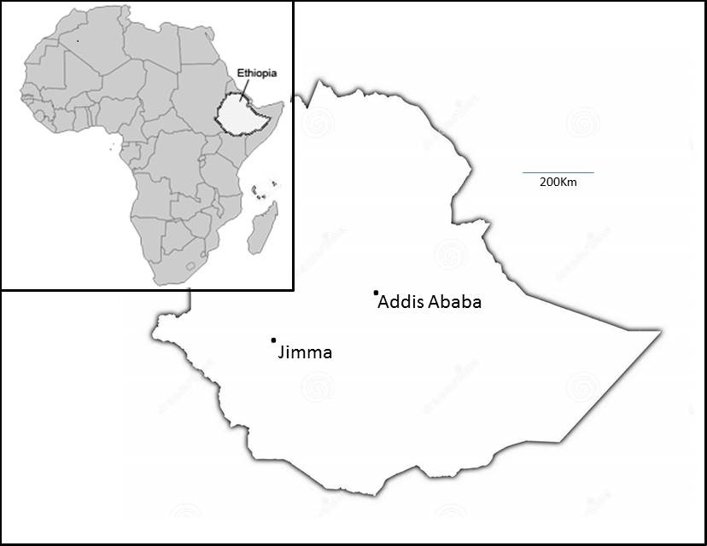

Figure 2: Age specific prevalence of echocardiographic rheumatic heart disease in the 987 screened individuals (error bars show SEM).
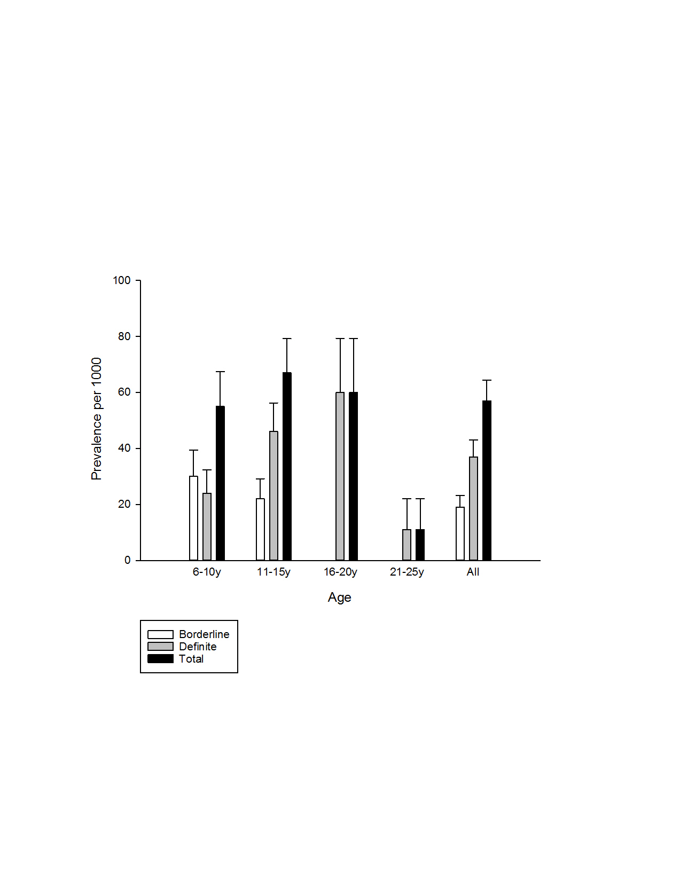

1. Carapetis JR, Steer AC, Mulholland EK, Weber M. The global burden of group A streptococcal diseases. Lancet InfectDis 2005; 5(11): 685-94.
2. Seckeler MD, Hoke TR. The worldwide epidemiology of acute rheumatic fever and rheumatic heart disease. ClinEpidemiol 2011; 3: 67-84.
3. Essop MR, Peters F. Contemporary issues in rheumatic fever and chronic rheumatic heart disease. Circulation 2014; 130(24): 2181-8.
4. Carapetis JR, Beaton A, Cunningham MW, et al. Acute rheumatic fever and rheumatic heart disease. Nature reviews Disease primers 2016; 2: 15084.
5. Remenyi B, ElGuindy A, Smith SC, Jr., Yacoub M, Holmes DR, Jr. Valvular aspects of rheumatic heart disease. Lancet 2016; 387(10025): 1335-46.
6. Sliwa K, Mayosi BM. Recent advances in the epidemiology, pathogenesis and prognosis of acute heart failure and cardiomyopathy in Africa. Heart 2013; 99(18): 1317-22.
7. Damasceno A, Mayosi BM, Sani M, et al. The causes, treatment, and outcome of acute heart failure in 1006 Africans from 9 countries. Arch Intern Med 2012; 172(18): 1386-94.
8. Rothenbuhler M, O'Sullivan CJ, Stortecky S, et al. Active surveillance for rheumatic heart disease in endemic regions: a systematic review and meta-analysis of prevalence among children and adolescents. The Lancet Global health 2014; 2(12): e717-26.
9. Marijon E, Ou P, Celermajer DS, et al. Prevalence of rheumatic heart disease detected by echocardiographic screening. N Engl J Med 2007; 357(5): 470-6.
10. Remenyi B, Wilson N, Steer A, et al. World Heart Federation criteria for echocardiographic diagnosis of rheumatic heart disease--an evidence-based guideline. NatRevCardiol 2012; 9(5): 297-309.
11. Sims Sanyahumbi A, Sable CA, Beaton A, et al. School and Community Screening Shows Malawi, Africa, to Have a High Prevalence of Latent Rheumatic Heart Disease. Congenital heart disease 2016.
12. Engel ME, Haileamlak A, Zuhlke L, et al. Prevalence of rheumatic heart disease in 4720 asymptomatic scholars from South Africa and Ethiopia. Heart 2015; 101(17): 1389-94.
13. Beaton A, Okello E, Aliku T, et al. Latent rheumatic heart disease: outcomes 2 years after echocardiographic detection. Pediatric cardiology 2014; 35(7): 1259-67.
14. Glover JA. Incidence of rheumatic diseases. Lancet 1930; i: 499-505.
15. Steer AC, Carapetis JR, Nolan TM, Shann F. Systematic review of rheumatic heart disease prevalence in children in developing countries: the role of environmental factors. JPaediatrChild Health 2002; 38(3): 229-34.
16. Longo-Mbenza B, Bayekula M, Ngiyulu R, et al. Survey of rheumatic heart disease in school children of Kinshasa town. IntJ Cardiol 1998; 63(3): 287-94.
17. World Bank. Four Ethiopias: A regional characterization assessing Ethiopia’s growth potential and development obstacles. . 2004.
18. Oli K, Tekle-Haimanot R, Forsgren L, Ekstedt J. Rheumatic heart disease prevalence among schoolchildren of an Ethiopian rural town. Cardiology 1992; 80(2): 152-5.
19. Oli K, Porteous J. Prevalence of rheumatic heart disease among school children in Addis Ababa. East AfrMed J 1999; 76(11): 601-5.
20. Beaton A, Lu JC, Aliku T, et al. The utility of handheld echocardiography for early rheumatic heart disease diagnosis: a field study. European heart journal cardiovascular Imaging 2015; 16(5): 475-82.
21. Beaton A, Okello E, Lwabi P, Mondo C, McCarter R, Sable C. Echocardiography screening for rheumatic heart disease in Ugandan schoolchildren. Circulation 2012; 125(25): 3127-32.
22. Okello E, Kakande B, Sebatta E, et al. Socioeconomic and environmental risk factors among rheumatic heart disease patients in Uganda. PloS one 2012; 7(8): e43917.
23. Dobson J, Steer AC, Colquhoun S, Kado J. Environmental factors and rheumatic heart disease in Fiji. Pediatric cardiology 2012; 33(2): 332-6.
24. Currie BJ, Carapetis JR. Skin infections and infestations in Aboriginal communities in northern Australia. The Australasian journal of dermatology 2000; 41(3): 139-43; quiz 44-5.
25. The Population Reference Bureau. The urban-Rural divide in Health and Development. Washington: The Population Reference Bureau, 2015.
26. Zuhlke LJ, Karthikeyan G. Primary prevention for rheumatic Fever: progress, obstacles, and opportunities. Glob Heart 2013; 8(3): 221-6.
27. Phillips DI, Osmond C, Williams ML, Jones A. Air pollution in early life and adult mortality from chronic rheumatic heart disease. Int J Epidemiol 2016.
28. Phillips DI, Osmond C. Is susceptibility to chronic rheumatic heart disease determined in early infancy? An analysis of mortality in Britain during the 20th century. Glob Cardiol Sci Pract 2014; 2014(4): 464-72.
29. Goodman A, Kajantie E, Osmond C, et al. The relationship between umbilical cord length and chronic rheumatic heart disease: a prospective cohort study. Eur J Prev Cardiol 2015; 22(9): 1154-60.
30. Watkins D, Zuhlke L, Engel M, et al. Seven key actions to eradicate rheumatic heart disease in Africa: the Addis Ababa communique. Cardiovasc J Afr 2016; 27(3): 184-7.

