300-km Transmission of Dispersion Pre-compensated PAM4 Using Direct Modulation and Direct Detection

Zhixin Liu^{1,2*}, Graham Hesketh¹, Brian Kelly³, John O’Caroll³, Richard Phelan³,
David J. Richardson¹, and Radan Slavík¹
¹Optoelectronics Research Centre, University of Southampton, Southampton, U.K.
²Now with Optical Networks Group, Dept. of Electronic & Electrical Engineering, UCL (University College London), London, U.K.
³Eblana Photonics, Dublin, Ireland.
z.liu@soton.ac.uk

Abstract: 20-Gbit/s PAM4 signal was generated by directly modulating two injection-locked Fabry-Perot lasers. Our transmitter can control the full field of the optical signal and achieved error-free transmission over 300-km SMF-28.
OCIS codes: (060.2330) Fiber optics communications; (060.4080) Modulation; (140.3520) Lasers, injection-locked

1. Introduction
The growing traffic demand in inter-data center communications and metro networks requires high-speed and low-cost optical transmission system over distance up to 300 km [1]. To reduce the cost, simplified coherent transceivers [2-4] or direct-detection schemes with enhanced data rate-distance product [5-8] are intensively researched. However, ultimate simplification (and thus also cost, size, and power consumption reduction) would come if Direct-modulation direct-detection (DM-DD) could be used over distances up to 300 km. Recently DM-DD has offered large capacities (up to 50 Gbit/s) for short-reach communication systems (up to 100 km) with the usage of spectrally-efficient modulation formats [6-7]. However, the frequency chirp associated with the direct laser modulation makes the DM-DD system sensitive to fiber dispersion, significantly limiting the transmission distance.
To mitigate the dispersion-induced penalty, optical filters were explored to reshape the optical spectrum for generating either vestigial sideband (VSB) or duobinary signals [7-8]. Up to 56 Gb/s data rate has been achieved for transmission over 100-km SMF-28 by aligning the laser wavelength to the filter edge of a delay interferometer [7]. The chirp managed laser [8] co-packages an optical filter in the laser module and reached a maximum distance of 200-km using 10-Gb/s duobinary format. All of these techniques concentrate on reducing the sensitivity to chromatic dispersion (CD), which is the main limiting factor of a long-reach direct-detection system. Indeed, full compensation of the CD (rather than minimizing its effect) would be far more desirable.
In this paper, we directly modulate two injection-locked Fabry-Perot laser diodes (FPLDs) to generate amplitude-modulated signals with controllable phase profile, i.e. modulation of In-phase (I) and Quadrature (Q) components using independent lasers. Our proposed transmitter enables the compensation of chromatic dispersion (CD) with directly modulated lasers for the first time and achieved an error-free direct-detected 4-level Pulse Amplitude Modulation (PAM4) transmission over 300-km SMF-28. It allows for all of the benefits of direct laser modulation to be realized including high optical signal-to-noise ratio (OSNR), reduced power consumption, small footprint, and ease of integration.
2. Experimental set-up
Fig.1a shows the schematic diagram our proposed transmitter. The principle of operation is explained using constellation diagrams. Our transmitter consists of two slave FPLDs (Laser _{I} and Laser _{Q}) that are injection-locked by the same master laser with an injection power of 0 dBm. After injection locking, the two independent FPLDs become mutually coherent and therefore can be combined orthogonally by introducing a 90° phase shift to the Q arm, yielding a complex (amplitude and phase) modulated signal with an optical carrier. The constellation of the synthesized signal lies in the first quadrant of the complex plane and its optical spectrum contains a carrier component. Our transmitter provides the capability of manipulating both In-phase and Quadrature (IQ) components of a double sideband (DSB) signal, enabling the CD to be pre-compensated at the transmitter side for intensity-modulated signal. As compared to the direct modulation based coherent transmitter in [4], our scheme simplifies the transmitter by removing the reflection of the master continuous wave (CW) for destructive interference.
The experimental setup of our proof-of-concept experiment is shown in Fig.1b. The transmitter has 7 dBm output power (corresponding to 7 dBm output power for each FPLD) and was modulated by two independent digital-to-analogue converters (DACs) operating at a peak-to-peak voltage (Vpp) of 1.8V and a fixed sampling rate of 92 GS/s. In practice, a lower DAC rate is needed (e.g. 25GS/s, corresponding to 2.5 times oversampling rate) for 10-GB PAM4 transmission with negligible performance degradation [9]. The output signals from both lasers have an extinction ratio (ER) of about 2 dB. A variable optical attenuator (VOA) was used to change the power launched into the fiber link for adjusting the OSNR after transmission. The transmission link comprised four spans of 75-km SMF-28 with average CD coefficient of 16.8 ps/(nm∙km). The link loss was compensated by the erbium-doped fiber amplifiers (EDFAs). After transmission, the signal was filtered by a 0.4-nm optical band pass filter before direct detection. The electrical signal was captured by a 16-GHz, 80-GS/s analogue-to-digital converter (ADC). Signal demodulation, receiver-side equalization, and BER calculation were implemented using offline DSP.
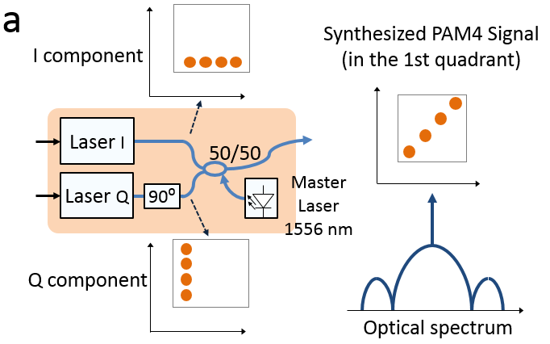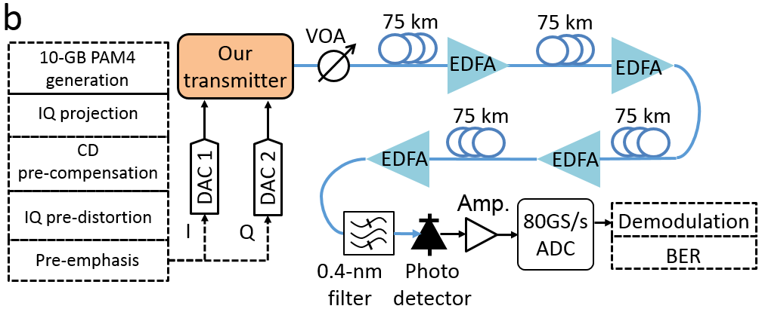
Fig.1 (a) Operation principle of our transmitter; (b) Experimental setup.
The driving waveforms for CD pre-compensated PAM4 signals were generated offline using a random bit sequence of a length of 2¹³-1. The pattern length was limited by the DAC memory. The generated digital PAM4 symbols were oversampled, interpolated, and projected onto the complex plane for generating corresponding I and Q components of the synthesized signal. The CD was pre-compensated using a finite impulse response (FIR) filter. The non-linear field distortion of the transmitter, which results from the laser direct modulation, was compensated using non-linear amplitude-phase pre-distortion (explained later in Fig.2). Finally, a digital pre-emphasis filter was applied to compensate for the frequency roll-off of the signal path.
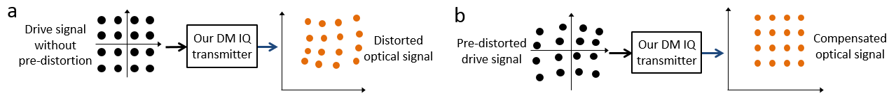
Fig.2 Non-linear field distortion of laser direct modulation: (a) Amplitude-phase distortion of our transmitter using 16QAM as example; (b) Generating linear optical constellation by distorting the electrical driving signal.
Although the optical injection locking can suppress the frequency chirp, the generated signal still experiences residual phase modulation [10]. In Fig. 2a, we explain the non-linear field distortion using a 16QAM constellation diagram. The equally spaced black points on the left represent the constellation of the 16QAM electrical driving signal. After direct modulation, the amplitude-modulated optical signal is accompanied with phase modulation. As a result, the constellation of the orthogonally combined optical signal is distorted, showing as the constellation diagram on the right side. Effective compensation of the CD requires pre-distortion of the electrical signal for correcting the amplitude-phase response of the directly modulated lasers for generating a linear constellation diagram in the optical domain, as shown in Fig.2b.
At the receiver side, both fixed-threshold symbol detection and equalization were used for measuring the bit error ratio (BER). The digital equalizer contains a 2-sample-per-symbol feed forward equalizer (FFE) and a 1-sample-per-symbol decision feedback equalizer (DFE) with 13 forward taps and 1 feedback tap. The BER was calculated by averaging 60 frames of different random bit sequences, which corresponds to 491460 bits.
3. Results
Fig.3 shows the eye diagrams of the direct-detected PAM4 signals after transmission over 75, 150, 225, and 300 km SMF-28, respectively. The corresponding OSNR values were 47, 44, 42, and 40 dB, respectively. The CD was pre-compensated so the main limiting factor for the system performance was the OSNR and the polarization mode dispersion (PMD). The RF spectrum of the detected PAM4 signal after 300-km transmission is shown as the solid line in Fig.4. For comparison, we plot the simulated RF spectrum of a chirp-free 10-GB PAM4 signal generated by a push-pull MZM using a dashed line. Without CD compensation, multiple dips are observed for the MZM generated PAM4 due to the CD-induced frequency fading. No such fading was observed in our experiment as our transmitter provides CD pre-compensated signal. It is worth mentioning that the lasers used in this experiment were low-cost FPLD designed for 2.5 Gb/s modulation. The use of optical injection locking enhanced the lasers’ modulation bandwidth to about 7 GHz [4]. The frequency-roll off beyond 7 GHz was due to the limited bandwidth of the semiconductor lasers. Up to 40 GHz modulation bandwidth has been demonstrated using injection-locked lasers, which justifies the feasibility of our proposed transmitter for high-speed transmission [11].
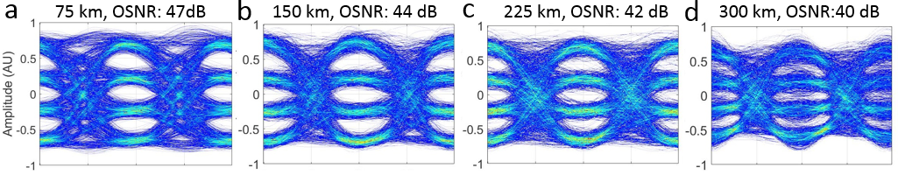
Fig. 3 (a) Eye diagrams of the direct detected PAM4 signal and the OSNRs after transmission over different length of SMF-28.

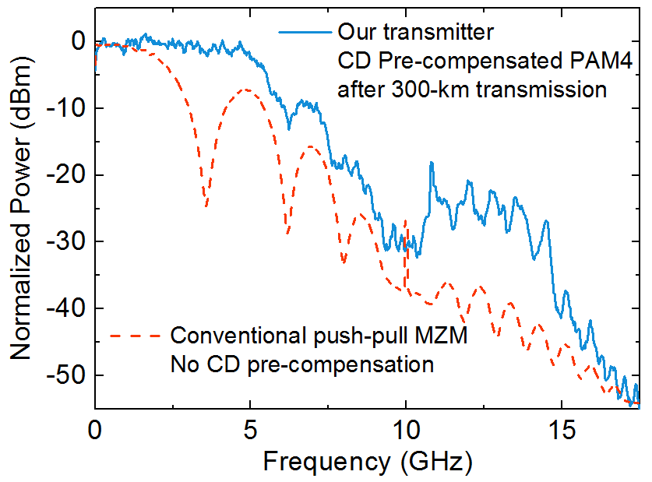
Fig. 4 RF spectrum of the detected signal after 300-km transmission. Solid line: Our transmitter with CD pre-compensation; Dashed line: Simulated push-pull MZM transmitter without CD compensation.
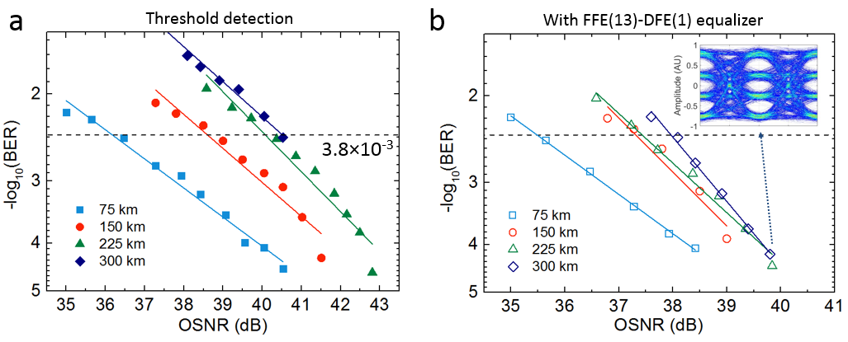
Fig. 5 Measured BER after transmission over different length of fiber using (a) threshold detection and (b) FFE(13)-DFE(1) equalizer. Markers in both figures: Square: 75 km; Circle: 150 km; Triangle: 225 km; Diamond: 300 km.

Fig. 5a shows the BER obtained at different OSNR values using fixed-threshold detection. Error-free transmission was achieved for transmission up to 225 km and a BER of 1.3×10⁻³ was obtained after 300-km transmission, which is below the hard-decision FEC threshold of 3.8×10⁻³. The required OSNRs for the BER of 3.8×10⁻³ were 36, 38.5, 40, and 40.5 dB, for the transmission distance of 75, 150, 225, and 300 km, respectively. The BER results with FFE-DFE equalizer are plotted in Fig. 5b. Using the simple equalizer, error free transmission was achieved for all distances. The inset shows the equalized eye diagram after 300-km transmission. The required OSNRs for the BER of 3.8×10⁻³ were 35.5, 37.3, 37.5, and 38 dB, for the distance of 75, 150, 225, and 300 km, respectively. The OSNR penalty is likely due to the different modulation depth, residual CD, and the PDM. In a deployed transmission link that normally has a loss of 0.3-0.4 dB/km, the OSNR after transmission could be lower. To meet the requirement we can improve our transmitter on several fronts, including increasing the modulation depth, optimizing injection-locking condition, and the usage of stronger equalizer such as maximum-likelihood sequence equalizer (MLSE).
4. Conclusion
We proposed a direct modulation transmitter that can fully compensate the CD for the direct detection system. Our proof-of-concept experiment achieved a record transmission distance of the directly modulated 20-Gbit/s PAM4. The data rate can be improved for 100-Gb/s transmission using higher speed lasers [6, 11] and the transmission distance could be further increased by further transmitter engineering.
This research has received funding from EPSRC Fellowship Grant Agreement No. EP/K003038/1, EPSRC grant EP/I061196X (Photonic Hyperhighway), and UNLOC EP/J017582/1.
5. References
[1] F. Karinou, et al., “Toward Cost-Efficient 100G Metro Networks Using IM/DD, 10-GHz Components, and MLSE Receiver,” JLT, 33, 4109-4117 (2015).
[2] M.S. Erkılınc, et al., “Bidirectional symmetric 8×10.7Gb/s WDM-PON over 108 km installed fiber using low complexity polarization-insensitive coherent ONUs,” Proc. ECOC, M.1.E.2 (2016).
[3] D. Che, et al., “Frequency Chirp Supported Complex Modulation of Directly Modulated Lasers,” JLT, 34, 1831-1836 (2016).
[4] Z. Liu, et al., “Modulator-free quadrature amplitude modulation signal synthesis,” Nature Comm., 5, 5911 (2014).
[5] Z. Li, et al., “Simplified DSP-Based Signal–Signal Beat Interference Mitigation Technique for Direct Detection OFDM,” JLT, 34, 866-872 (2016).
[6] Z. Liu, et al., “49 Gbit/s Direct-Modulation and Direct-Detection Transmission over 80 km SMF-28 without Optical Amplification or Filtering,” Proc. ECOC, M.2.D.6 (2016).
[7] S. Zhou, et al., “Transmission of 2 × 56 Gb/s PAM-4 signal over 100 km SSMF using 18 GHz DMLs,” OL, 41, 1805-1808 (2016).
[8] D. Mahgerefteh, et al., “Chirp Managed Laser and Applications,” JSTQE, 16, 1126-1139 (2010).
[9] F. Buchali, et al., “Implementation of 64QAM at 42.66 GBaud Using 1.5 Samples per Symbol DAC and Demonstration of up to 300 km Fiber Transmission,” Proc. OFC, M2A.1 (2014).
[10] S. Mohrdiek, et al. “Chirp Reduction of Directly Modulated Semiconductor Lasers at 10 Gb/s by Strong CW Light Injection,” JLT, 12, 418-424 (1994).
[11] N. K. Fountain, et al., “Chirp-Free Modulator using Injection Locked VCSEL Phase Array,” Proc. ECOC, post-deadline Th.3.A.4. (2016).

