Unveiling patterns of contestation over Better Regulation reforms in the European Union.

Version accepted for publication. April 10th, 2017.

Adriana Bunea, University of Southampton
Raimondas Ibenskas, University of Southampton

Abstract
Regulatory reforms labeled ‘Better Regulation’ are a prominent item on the political agendas of most advanced democracies and the European Union. Governments adopt Better Regulation measures to strengthen their democratic legitimacy and increase their regulatory and economic effectiveness. Notwithstanding their rhetorical appeal, their design and implementation are susceptible to high levels of political contestation. We therefore ask: are there systematic differences in stakeholders’ demands for what Better Regulation should achieve? What explains these differences? We argue that conflict over Better Regulation is rooted in what stakeholders prefer as a regulatory system of governance. Stakeholders demand for reforms that lead to one of the following three scenarios: deregulation, technocratic or participatory policymaking. We examine stakeholders’ demands expressed in the EU. We find that national authorities responsible for coordinating Better Regulation and cross-sectoral business organizations support deregulatory and technocratic reforms. Business and public interest organizations are equally supportive of strengthening participatory policymaking.

Key words

Better Regulation, European Union, regulatory governance, stakeholders, policy demands, deregulation, technocratic policymaking, participatory policymaking.

Introduction
Regulatory reforms labelled ‘Better Regulation’ have recently become one of the prominent items on the political reform agendas of several advanced industrial democracies and the European Union. Experiencing increasingly regulatory profiles (Majone 1994), contemporary Western systems of governance adopt Better Regulation measures to strengthen their democratic legitimacy and increase their regulatory and economic effectiveness (Baldwin et al. 2012, p. 377). Better Regulation tools such as regulatory impact assessments, consultations with stakeholders and ex-post evaluations of regulatory interventions are used by governments to ensure input, throughput and output legitimacy for their policymaking and to address perceived failures of regulation such as extensive administrative burdens on business, insufficient use of scientific evidence in preparing public policies, biased interest representation in decision-making (Lodge and Wegrich 2012).
Notwithstanding this legitimizing promise and rhetorical appeal, the design and implementation of Better Regulation reforms are susceptible to high levels of political contestation. On a conceptual level policy actors agree on the desirability of Better Regulation: ‘as a slogan “Better Regulation” invites neither contradiction nor even debate. Who would promote “Worse regulation”?’ (Weatherill 2007, p. 3). On a practical level however, actors diverge considerably in their expectations about how it should work and what it should deliver. The European Union illustrates this conundrum. The recent adoption of the EU Better Regulation package (May 2015) and the subsequent Inter-institutional Agreement on Better Law-making (April 2016) stirred significant controversy and debate. Its potential to affect the EU inter-institutional balance of power by extending the evidence-based (technocratic) policymaking and thus enhancing the European executive’s leverage was discussed. Its potential deregulatory consequences in areas of public interest (environment, public health) were debated, and public interest organizations established a large Better Regulation Watchdog network to ensure that the proposed measures would not ‘weaken or undermine essential regulations and subordinate the public good to corporate interests’ (Euractiv 2015).
We observe this intrinsic tension in the logic and workings of Better Regulation reforms and ask the following: are there systematic differences in stakeholders’ demands and expectations for what Better Regulation should achieve? If so, what explains these systematic differences?
We answer this by elaborating and testing empirically a theoretical argument suggesting that conflict over Better Regulation reforms is rooted in what different constituencies of stakeholders prefer as a regulatory system of governance. In line with classic theories of regulation (i.e. public choice, public interests and pluralist-deliberative approaches), stakeholders demand for Better Regulation measures that lead to one of the following three scenarios: deregulation, technocratic policymaking or participatory policymaking. We identify the main constituencies of stakeholders and derive a set of theoretical expectations about their demands for which of the three scenarios should prevail.
We test our argument in the EU context, a system of governance displaying one of the most well-established and influential models of Better Regulation (Lodge and Kai 2012). We detail our case selection in the research design section. We examine stakeholders’ demands expressed in the open consultation on Better Regulation organized by the European Commission in June-September 2012 to map actors’ preferences on what type of regulatory reform Better Regulation measures should achieve. In line with the theoretical argument, national public authorities responsible for the coordination and oversight of Better Regulation at national level support measures that promote deregulatory and technocratic reforms. Similarly, cross-sectoral business organizations support reforms towards technocratic policymaking and were also more likely to support deregulatory measures than other stakeholders. We found only limited support for the argument that public interest organizations support measures leading to participatory policymaking. The results indicate that business organizations and public interest groups are equally supportive of Better Regulation reforms leading to participatory policymaking.
Addressing this research question is relevant in several ways. First, Better Regulation represents a key approach to improving contemporary systems of governance and rests at the core of democratic states’ administrative functioning and policy performance. Better Regulation taps directly into the quality of governance. Therefore, Better Regulation debates offer valuable insights about the structuring of stakeholders’ preferences regarding the functioning of governance. Second, interest group theories constitute one of the main approaches used in economics, political science and public policy research to study regulatory regimes (Baldwin et al. 2012). The literature shows that private actors play a crucial role in the design, evolution and implementation of regulatory regimes across systems and levels of government (Ayres and Braithwaite 1992, Croley 2008). However, the literature still debates what is the structure (pattern) of private actors’ preferences relative to regulation in general and to Better Regulation in particular (Radaelli 2007). This is at least partly due to the heterogeneous nature of stakeholders and to the challenge of conceptualizing and operationalizing Better Regulation. This justifies our decision to limit our analytical focus to examine stakeholders’ preferences only, while not considering the preferences of formal decision-makers. Lastly, examining this question allows understanding to what extent Better Regulation reforms correspond to policy necessities (as indicated by its end-users’ preferences) or constitute a unilateral act of top-down policy entrepreneurship initiated by bureaucratic executive actors in order to increase the coherence and cohesiveness of their decision-making procedures and subsequent political power during legislative decision-making (Radaelli and De Francesco 2007, Radaelli and Meuwese 2010).
We contribute to the literatures on regulatory governance (Baldwin et al. 2012), supranational policymaking (Richardson 2012) and interest groups’ participation in rulemaking (Ayres and Braithwaite 1992, Croley 2008, 2011, Balla 2011). Theoretically, we elaborate an argument that relates three classic approaches to regulatory reform with a key explanatory variable in theories of interest representation: the constituency of interests represented. Empirically, we propose one of the first systematic studies identifying and mapping stakeholders’ preferences for what should be the direction of Better Regulation reforms, on a set of discrete policy issues. Methodologically, we innovate by employing a fine-grained identification of stakeholders’ demands expressed in public consultations that allows a disaggregate empirical analysis of any systematic differences in preferences over Better Regulation reforms. Our empirical strategy also contributes to policy research by proposing a systematic, quantitative analysis of a key Better Regulation tool, namely public consultations. This goes at the heart of a key issue in bureaucratic policymaking: how to best examine and process stakeholders’ policy feedback in a scientific, systematic and reliable manner.
The literature defines Better Regulation in several ways: ‘meta-regulation’ (Black 2007, Radaelli and Meuwese 2009), ‘second-order regulation’ (Lodge and Wegrich 2012, p. 195), or ‘soft constitutional law’ (Meuwese 2007, p. 276). In practice this reform consists of applying a set of tools that ensure the management of different aspects of regulation (Radaelli 2010). We build on these definitions and recognise the inherent reformatory nature of Better Regulation measures: they are introduced to improve regulatory systems of governance. This justifies our choice to interchangeably refer to Better Regulation ‘reforms’ and/or ‘measures’. We use the term ‘stakeholder’ to refer to interest organizations (business and non-business) and to national or regional-level authorities that participate in and are affected by (supranational) policymaking.
We first elaborate our theoretical argument and derive a set of expectations about stakeholders’ demands over the direction of Better Regulation reforms. Section two details the research design. Section three presents our analyses. Section four concludes.

Better Regulation and classic theories of regulation
Broadly defined, Better Regulation reforms aim to improve policymaking and regulation by adopting standards and procedures that govern regulatory decision-making across different public policy areas. These measures focus on the process through which the ‘very production of regulation’ happens (Croley 2011, p. 61), and try to shape the behavior and regulatory practices of regulators themselves. The underlying assumption of Better Regulation reforms is that the two main challenges of regulatory governance, namely ensuring regulatory effectiveness and legitimacy (Levi-Faur 2011, p. 15), can be satisfactorily addressed by focusing on the design and functioning of decision-making rules and tools. Better Regulation consists of administrative measures that stipulate how a set of specific policy tools should be applied to policy and decision-making processes to improve both regulatory procedures and outcomes. The most prominent among these tools is the regulatory impact assessment (RIA), an instrument usually employed during the policy formulation stage in drafting policy/legislative initiatives by executive bureaucratic bodies such as national ministries and/or regulatory agencies at national level and by the European Commission at supranational level (Radaelli 2010). Other instruments include stakeholders’ consultations, ex-post evaluations and simplification of existing regulation, measurement of compliance costs, market-based alternatives to traditional regulation, rules on enforcement (including risk-management approaches) (Baldwin 2007, Lodge and Wegrich 2012). These instruments structure ‘public and private action in regulatory processes’ (Radaelli 2010, p. 89) and allow addressing some of the problems that might emerge within the regulatory state such as interest groups’ capture of regulators and decision-making, biased policies, regulatory inefficiencies and market failures (Baldwin et al. 2011, p. 105).
Although the set of Better Regulation tools is quite institutionalized, there is disagreement among policymakers and stakeholders on what strategies of regulation and regulatory reform these tools should primarily support and, consequently, how Better Regulation measures should be designed and applied (Lodge and Wegrich 2012, p. 195). We argue that stakeholders’ preferences for the organization of a regulatory regime (i.e. Better Regulation measures) are likely to be informed by their preferences for the overall orientation of a regulatory regime, the latter being defined here as ‘state actors’ beliefs about the proper scope, goals, and method of government intervention in the economy and about how this intervention affects economic performance’ (Vogel 1996, p. 20-21 cited in Levi-Strauss 2011, p. 13). Since Better Regulation measures aim to improve a regulatory regime by improving administrative rulemaking, stakeholders’ preferences for the direction of these rulemaking reforms is likely to be informed by their preferences for what should be the orientation of the overall regulatory regime.
In line with the extant literature (Meuwese 2007, Wegrich 2011, Smith et al. 2015), we argue that Better Regulation measures are a regulatory reform aimed at reducing regulatory inefficiency and failure. Classic theories of regulation constitute thus an informative starting point to identify the main types of regulatory solutions that can be proposed as part of Better Regulation measures to address regulatory inefficiencies and sub-optimal regulatory decision-making procedures and outcomes. Public interest theories of regulation assume that regulators adopt measures that benefit the general public and increase societal welfare (Balla 2011, p. 71, Christensen 2011, p. 97). Proponents of this approach argue that most regulatory outcomes ‘will more frequently than not be characterized as general interest’ (Croley 2008), based on the assumption that regulators possess both the motivation and the information required to regulate in the general public interest. In this setting, regulatory decision-making is embedded in the economic analysis of costs and benefits of regulatory measures, in an attempt to increase their net-benefits. This implies that the solution to any potential regulatory inefficiency and bias is to improve the rationality of the regulatory decision-making process, which helps preventing rushed decisions adopted under bias, concern for short-term priorities and specific interests only, high public and media pressure which might make regulation susceptible to politicization (Weigrich 2010, p. 35). Only by carefully collecting and analyzing the evidence on the costs and benefits of different policy options, decision-makers can increase aggregate social welfare. This evidence-based, rationalized approach to regulatory decision-making also allows enhancing the transparency of policymaking and represents thus an antidote to regulatory capture by specific interest (Shapiro 2011, p. 396). This direction of regulatory reform is usually enthusiastically supported by ‘technocrats’ (Lodge and Wegrich 2009, p. 145).
Public choice theories of regulation ‘analogize regulatory decision-making to market decision-making’ and assume that the regulatory state is a market in which regulators supply the regulation demanded by the regulated interests, and receive in exchange various forms of support from these interests (Croley 2008). However, the most common and fundamental regulatory problem emerging within this setting is that regulation becomes ‘liable to fall under (or be established under) the sway of the economically powerful ones’ (Baldwin et al. 2011, p. 108) and susceptible to capture by concentrated and well-organized private interests (Stigler 1971, Posner 1974, Peltzman 1976). A corollary of this is the unequal and biased mobilization and participation of affected interests in regulatory decision-making due to unevenly distributed costs and benefits of regulation (Wilson 1980) and to the different degrees to which stakeholders manage to overcome collective action problems (Croley 2008). Regulatory capture and stakeholders’ biased participation result in sub-optimal and inefficient policy decisions and regulatory outcomes that are likely to reduce general societal welfare. In line with this reasoning, the best solution to address regulatory inefficiency and failure is to ‘increase reliance on markets as an alternative to government regulation’ (Croley 2008) and thus to prefer market-based alternatives to the traditional ‘command and control’ regulation. Supporters of such reforms are usually identified as ‘deregulators’ and they may support for example ‘cutting the red tape’ using a thorough measurement of the costs of complying with the existing or draft legislation for business (Lodge and Wegrich 2009, p. 146).
Neo-pluralist and deliberative theories of regulation (Becker 1983, Ayres and Braithwaite 1992, Croley 2008) emphasize the important role of interest groups’ participation in regulatory decision-making and propose increased interest groups competition in policymaking to address the problem of regulatory capture and bias. The solution to this problem is thus to create a ‘level playing field for all societal actors in the regulatory process, through consultation procedures and freedom of information rules’ (Wegrich 2010, p. 35). Proponents of this approach usually support regulatory reform measures aimed at increasing ‘participatory policymaking’.
We build on these three general perspectives on the direction of regulatory reforms and argue that these also inform debates about Better Regulation measures. As such, we expect to see stakeholders expressing demands for Better Regulation measures that lead to (1) technocratic (evidence-based) policymaking, (2) deregulation or (3) participatory policymaking.
We are aware that these directions of reform are not necessarily mutually exclusive and some level of agreement may characterize actors’ preferences over Better Regulation due to overlapping goals. For example, the inclusion of the Standard Cost Model for measuring administrative burdens in impact assessments by several European countries and the EU in the 2000s (following its development in the Netherlands) was seen by ‘deregulators’ as a first step towards the systematic measurement of all compliance costs for business. The ‘technocrats’ on the other hand saw this reform as being part of a broader agenda of systematizing the measurement of various costs and benefits of regulation in impact assessments (Wegrich 2010). However, research indicates that the probability of well crystallized and strongly contrasting views over Better Regulation reforms is likely to increase as they become more developed, comprehensive and a long-standing practice (Lodge and Wegrich 2012, p. 219-220). The EU context exemplifies this: the Better Regulation agenda was formalized in the early 2000s (with the publication of the White Paper on Governance and the Malderkern report on Better Regulation in 2001), and even earlier in some member states (Radaelli 2010). This aspect informs our expectation to observe clearly delineated and contrasting alignments of stakeholders in policy settings with well-established Better Regulation agendas such as the EU, which represents our case study and empirical testing ground.

Interests, stakeholders’ alignments and types of Better Regulation reforms
Classic theories of regulation and regulatory governance recognize the key role played by various constellations of constituencies of interests in the design and functioning of regulatory regimes (Wilson 1980). Building on this, we argue that the constituency of interests a stakeholder represents has a direct effect on its preference for what should be the primary goal of Better Regulation reforms. We expect that in policy debates, each of the three aforementioned perspectives over Better Regulation is put forward and advocated for by a specific group of stakeholders in line with their constituency’s goals.
Starting with politicians and bureaucrats, Wegrich (2011, p. 405-406) argues that they are usually divided into ‘deregulators’ and ‘technocrats’. For example, the former dominated the regulatory reform in the UK until the victory of the Labour party in the 1997 election, following which the focus shifted from ‘less regulation’ (deregulation) to ‘better regulation’ understood as evidence-based policymaking (Weatherill 2007). We therefore expect that public institutional actors would promote either of these two perspectives with a higher probability than most other stakeholders. In doing so, politicians and senior civil servants hope to increase the legitimacy of their rule-making and the economic competitiveness or broaden social welfare, thus assuring re-election (politicians) or the survival and expansion of their agencies (bureaucrats).
However, we note that this argument mainly applies to those public authorities that are responsible for the development of Better Regulation instruments and the enforcement and/or oversight of their application by sectoral ministries and agencies and sub-national public authorities. These latter, implementing actors are likely to be reluctant and sometimes even hostile to Better Regulation reforms given that these restrict their freedom of action and strengthen top-down political control. Indeed, Radaelli (2010) finds that political control of sectoral departments by the ‘core executive’ was an important motivation in the design of regulatory impact assessments in Europe, somewhat similar to the delegation from Congress to regulatory agencies in the US (McCubbins et al. 1987). Although the reform of Better Regulation in the EU only indirectly affects these public authorities, De Francesco (2012) finds that the length of the membership in the EU is one of the most important predictors of the diffusion of impact assessments in OECD and EU countries. Any support for strengthening the tools of Better Regulation at EU level (our empirical case study) therefore is likely to lead to stronger reforms in member states in line with the preferences of the public authorities responsible for the development and oversight of Better Regulation instruments but not with those public institutions and agencies that implement them.
The role of Better Regulation as a tool of political control of bureaucracy also suggests that the relative influence of ‘deregulators’ and ‘technocrats’ is driven to a large extent by the attitudes of government parties towards deregulation. Case studies in the literature support this argument: UK shifted from ‘deregulation’ to ‘less regulation’ and then ‘better regulation’ following the Labour Party coming to power in 1997 (Weatherill 2007). In Germany, the replacement of the Social Democrats with the liberal Free Democrats in the government coalition after the 2009 federal election strengthened the influence of ‘deregulators’ (Wegrich 2010, p. 40). We derive the following expectations:

H1: Public authorities responsible for the coordination/oversight of Better Regulation at national level are more likely to demand a deregulatory type of reform if the national government is controlled by pro-deregulation parties.

H2: Public authorities responsible for the coordination/oversight of Better Regulation at national level are more likely to demand the adoption of Better Regulation measures that strengthen technocratic policymaking if the national government is controlled by parties that oppose deregulation.

When discussing and theorizing the preferences of economic interests towards Better Regulation, two considerations are particularly important. On the one hand, deregulation by means of Better Regulation tools decreases the regulatory burden (Radaelli and De Francesco 2007, Lodge and Wegrich 2012). On the other hand, business groups might prefer having more regulation to increase their profits through rent-seeking (Stigler 1971). We expect that the former goal will be dominant in driving the preferences of broad, cross-sectoral business associations, active at European, national or sub-national level. For these actors, the profits of the members representing one sector generated through regulatory protection may lead to losses to the members representing another sector. For example, lower standards on CO2 emissions may prevent the development of the industry of electrical cars.
In contrast, sectoral business associations are more likely to perceive the imposition of Better Regulation measures on the regulators in their sectors as a risk. As the freedom of action of these regulators is restrained, so is their ability to pass or sustain regulation that benefits the existing market players. It follows that:

H3: Cross-sectoral business associations are more likely to demand a deregulatory type of Better Regulation reforms.
Finally, we argue that public interest organizations are most interested in Better Regulation reforms emphasizing participatory policymaking. As these organizations often lack the resources to compete with the more resource-rich interest organizations when trying to influence regulation, they should be eager to develop institutions (such as open consultations with low thresholds of participation) that could eventually create a more level-playing field in participation and interest representation. However, we note that this rationale does not apply to professional associations (trade unions) because usually they hold a privileged position of ‘social partners’ (e.g. the EU Social Dialogue between institutions and representatives of employers, Articles 153-155 of the Treaties of the EU). Thus, we conceptually and empirically distinguish between (1) public interest organizations representing consumers’ interests and environmental NGOs and (2) professional associations, and argue that only the former will promote the equal participation of all stakeholders in the regulatory decision-making through broader consultations and increased transparency:
H4: Public interest organizations are more likely to demand a participatory type of Better Regulation reforms.

In a nutshell, we expect that the debate over Better Regulation reforms is structured around four clusters of stakeholders. The deregulatory cluster includes public authorities responsible for the coordination/oversight of Better Regulation measures when the government has a pro-deregulatory inclination and cross-sectoral business. The technocratic cluster consists of public authorities that coordinate/oversee Better Regulation agenda at national level whose government is led by parties opposing deregulation. The participatory cluster includes public interest organizations. A fourth cluster includes stakeholders that are likely to oppose any type of Better Regulation reforms for different reasons: public authorities that implement Better Regulation measures are reluctant because this reform constrains their administrative behavior and autonomy; sectoral business associations because Better Regulation measures might introduce procedures that could reduce their ability to successfully capture and influence regulatory decision-making (Radaelli and de Francesco 2007, p. 45); professional associations because deregulation might reduce the overall societal welfare of their members, while both technocratic and participatory policymaking might threaten their special status of ‘social partners’ (Smismans 2014). Empirically, we expect to observe that stakeholders that are part of this opposition cluster make significantly less demands than all other stakeholders in relation to each of the three types of Better Regulation reform identified.

Research design
Case selection
The European Union system of governance represents an interesting and suitable testing ground for examining empirically Better Regulation reforms for several reasons. First, the EU has witnessed in the last fifteen years the development of the most elaborate and well-established set of Better Regulation measures. In many ways, the EU has a ‘state of the art’ Better Regulation policy (Radaelli 2010). Its strong ‘regulatory state’ characteristics place Better Regulation at the very heart of its regulatory functioning, making it fundamental for its policymaking processes. Second, the EU has recently adopted one of the most ambitious Better Regulation reforms (the Better Regulation package - May 2015) which resulted in an Inter-Institutional Agreement on Better Law-making signed by the Commission and the EP in April 2016. This indicates the high policy salience and political profile of Better Regulation in this setting, which translates into a high likelihood of well-crystallized and articulated lines of contestation and policy conflict over it. Third, the EU operates a highly institutionalized regime of open consultations that facilitates access to information that allows observing and mapping empirically stakeholders’ different preferences over what should be the direction and policy goals of Better Regulation reforms. Lastly, it is reasonable to argue that although the EU Better Regulation measures target supranational regulatory and policymaking processes, these measures affect national policymaking and are driving similar developments in member states. This makes our analysis relevant for examining and understanding the dynamics of similar Better Regulation initiatives at national level.
To identify stakeholders’ preferences on the EU Better Regulation, we examined the ‘Stakeholder consultation on Smart Regulation in the EU’ organized by the European executive in 2012. Based on the analysis of EC official documentation resulting from it, of websites and organizational online profiles, we built an original dataset recording information about stakeholders’ expressed discrete preferences and organizational characteristics.
Our decision to examine this public consultation builds on what has become a well-established approach in researching private and public actors’ preferences in the EU policymaking based on their positions expressed in open consultations organized by the European Commission. Open consultations were used to study interest mobilization, lobbying strategies and success at EU level (Bunea and Ibenskas 2015, Bunea 2017). This consultation included a diverse set of stakeholders, thus covering all types of interests that are relevant in shaping regulatory reforms in the EU. Such representativeness would have been very difficult to achieve through other methods of data collection (e.g. surveys). Additionally, the consultation call asked for stakeholders’ feedback on most instruments of Better Regulation, such as impact assessments, ex-post evaluations (including ‘fitness checks’ of the whole policy area), measurement of administrative burdens, consultations with stakeholders and the tools to improve implementation. The use of open and rather broad questions (e.g. ‘What can be done to better achieve the aims of impact assessments?’) allowed stakeholders to express a diverse set of preferences. Finally, the timing of the consultation is perfect for understanding the divisions between private and public actors before the last major reform of the EU Better Regulation policy. The information gathered from this consultation was used by the Commission for revising the guidelines on key Better Regulation instruments, all of which were adopted in the 2015 Better Regulation package.

Dependent variables: stakeholders’ policy demands
To identify the policy issues on which the Commission consulted on, we used two official data sources: the Commission consultation call and the Annex document accompanying the Commission’s report, which listed the positions expressed in the consultation and the actors expressing them. We identified a total of 53 open-ended question items, 284 preferences/demands expressed and 110 stakeholders submitting individual or joint policy position documents.
Based on this information, we constructed a dataset that includes 26 dichotomous items listed in Table 1. Each captures a demand for changing the institutional framework, procedures or practice in relation to one of the four key areas of Better Regulation: impact assessments (7 demands in total; this category also included demands on designing new regulations), implementation of regulations (2 demands), their ex-post evaluations (6 demands including three demands explicitly on administrative burdens) and consultations with stakeholders (11 demands). The demand with the highest frequency was that of extending the scope of consultations to more types of legislative acts and policymaking stages (cons.scope.extend) articulated by 80 of the 110 stakeholders. The second most frequent demand was for the methodology of impact assessment to be improved mostly by strengthening the scientific and quantitative analysis aspects (ia.meth.impprove, 79 stakeholders). The third most frequent demand was for improving the guidance offered by the Commission on the implementation of EU legislation (impl.improve), a concern shared by 69 stakeholders. The fourth most frequent demand expressed by stakeholders was for the methodology of ex-post evaluations of regulatory measures to be improved (67 stakeholders).
The dependent variables in the empirical analysis are the counts of demands associated with three perspectives over regulatory reform. Five demands were coded as being consistent with a deregulatory direction of Better Regulation reforms, twelve in line with a Better Regulation turn towards technocratic policymaking, while nine reflected preferences for a reform supporting participatory policymaking. The third column in Table 1 indicates the demand type. Although theoretically it is also possible for stakeholders to ask for less focus in the Better Regulation on each of these goals, we find very limited evidence for that. None of the demands explicitly asked for less evidence-based policymaking or participation and only two of them indicated explicit opposition to the deregulatory turn of the reform. Due to the small number of demands, these demands were excluded from analysis.
We developed the dataset in four steps. First, we excluded 14 stakeholder positions that referred to the support of the status quo on a particular issue (e.g. agreeing that the aims of impact assessments are right). Since the development of Better Regulation in the EU is the result of numerous compromises between different visions of regulatory reform (Wegrich 2011), the positions expressing support for status quo can be associated with all types of reform. Thus, they are of limited use in trying to understand the type of reform preferred by different stakeholders. To maximize the amount of information contained in our dataset, we have also fit an additional negative binomial regression model that had as dependent variable the number of demands for maintaining the status quo and interest type as a predictor. The results are presented in Table 2 in the Online Appendix and indicate little differentiation with regard to the positions on status quo among those stakeholders who were found to support at least one type of regulatory reform. This supports our argument that the status quo of Better Regulation in 2012 reflected numerous compromises of previous regulatory reforms.
Second, we also exclude 10 positions that summarized stakeholders’ own experience with the use of different Better Regulation tools (e.g. roadmaps). Third, we recoded the remaining positions into a smaller set of demands to account for the similarities among the positions in the Commission’s document (the recoded demands could encompass positions expressed in response to more than one question). For example, the demands for ‘the Impact Assessment Board to include external experts’ and ‘for the Impact Assessment Board to provide a positive opinion on draft legislation before a legislative proposal is adopted by the Commission’ were recoded into a single demand for increasing the powers and/or independence of the Impact Assessment Board (i.e. the Regulatory Scrutiny Board since 2015). The recoding of positions was both inductive (we compared positions based on the similarity of their wording) and deductive (we drew on the literature to identify the key issues of contention). For example, the demands on ex-post evaluations relate directly to four out of five variables used by Mastenbroek et al. (2016) to evaluate ex-post regulatory evaluations in the EU: 51 stakeholders requested for the improvement in the planning of evaluations, relating to Mastenbroek et al.’s variable of systematic coverage; 67 stakeholders demanded a better methodological quality of evaluations, which reflects the same variable in Mastenbroek et al. (2016). Finally, the demand to improve clarity and accessibility of evaluation reports, expressed by 7 stakeholders, relates to Mastenbroek et al.’s variables of process quality in terms of the availability of reports and usefulness of evaluation reports.
[Table 1]

Predictor variable: interest type
Based on stakeholders’ position documents and online profiles, we identified the type of interest they represented. We distinguish the following categories:
- Public authorities responsible for the coordination/oversight of Better Regulation at national level (21 actors). This category includes the government departments that were responsible for the development and enforcement of Better Regulation tools across public institutions and the bodies charged with the external oversight and control of the enforcement of these tools. This was coded based on Annex 7 of the Commission Report on ‘Best practice in Member States to implement EU legislation in the least burdensome way’ published in 2011 by the High-Level Group on Administrative Burdens. The information in the report was partially based on OECD data. In total, these actors represented 14 member states: Austria, Belgium, Bulgaria, the Czech Republic, Finland, Germany, Hungary, Italy, Latvia, Lithuania, Netherlands, Slovakia, Sweden and UK. The public institutions responsible for the coordination of Better Regulation in Flanders and Scotland were also included in this category due to their substantial policymaking powers. In line with expert assessments of the positions of parties in government towards deregulation, 12 actors were coded as favorable towards deregulation and 9 actors as having negative or mixed assessments. All governments with the average position of government parties (weighted by their legislative seat shares) on deregulation above 6 (on the 0-10 scale, where 0 indicates strong opposition and 10 indicates strong support to the deregulation of markets) were coded as supporting deregulation. All such government included only centre-right parties. All governments with the average position below 6 included either centre-left or both centre-left and centre-right parties with the exceptions of Hungary and Latvia, whose centre-right governments were not very supportive of deregulation, possibly due to the dominance of non-economic cleavages in these countries. Information about parties’ positions was coded based on Bakker et al. (2015).
- Public authorities not responsible for the coordination/oversight of Better Regulation (implementers) (15).
- Cross-sectoral business active at European, national or sub-national level (25).
- Sectoral business: companies or associations representing business in a distinct economic sector (27). Whether the sectoral business association represents large companies or small and medium enterprises (SMEs) may also matter, as the latter are both more likely to care more about regulatory burden and less likely to benefit from regulatory capture. However, in our empirical analysis we find very limited differences between sectoral associations representing big and small business. Also, given the small number of SMEs in our sample, we leave this argument for future inquiry and research.
- Public interest organizations (8).
- Professional associations: trade unions, farmers’ associations and organizations representing ‘free’ professions (14).
We are aware that the universe of stakeholders participating in the examined consultation does not entirely reflect the universe of all EU stakeholders having a stake in this reform process or providing the Commission with formal or informal feedback in this process. Methodologically this raises the issue of selection bias and casts a shadow of doubt about the potential to generalize our findings to the broader community of EU stakeholders. We address this with two arguments. First, the high level of institutionalization of interactions between stakeholders and policymakers in the EU setting, justifies our analytical focus on examining policy demands expressed in a formal EU policymaking setting such as public consultation. Second, the constellation of private actors participating in the consultation corresponds relatively well with the aggregate structure of stakeholders usually lobbying and participating in EU policymaking and marked by a stronger presence of business interests relative to all others (see Coen and Katsaitis 2013).

Analyses
As our dependent variables are counts of demands, we test our theoretical expectations with the help of four Poisson regression models. Table 2 shows the results of the regression models with the count of the demands of each type of regulatory reform as the dependent variables and the stakeholders’ interest type as the explanatory variable. On the predictor variable, the reference category is public authorities responsible for the coordination/oversight of Better Regulation measures at national level (‘pro-deregulation’ in Model 1 and ‘not pro-deregulation’ in Model 2), cross-sectoral business organizations (Model 3) and public interest organizations (Model 4). Each model tests one of the four hypotheses derived in the theoretical section.

[Table 2]

Starting with demands for deregulation (Models 1 and 3), the coefficients of the categories representing public authorities that are not responsible for Better Regulation coordination/oversight (implementers), sectoral business groups, public interest organizations and professional associations are negative and statistically significant at the 0.001 level. These stakeholder categories made between 2 and 2.5 less ‘deregulatory’ demands in comparison to pro-deregulation public institutions that oversee Better Regulation. This supports Hypothesis 1. The coefficient of the category for cross-sectoral business associations is also statistically significant, but its size is much smaller. Cross-sectoral business expressed 1.3 ‘deregulatory’ demands less than pro-deregulation public authorities that oversee Better Regulation.
The results of Model 2 reject Hypothesis 2. Public authorities that oversee Better Regulation and that were part of governments that were evaluated by experts as being generally animated by non-deregulatory inclinations, are less likely to support measures to strengthen technocratic (evidence-based) policymaking relative to their counterparts that are pro-deregulation and cross-sectoral business groups. In comparison to the latter two types of stakeholders, all other categories of stakeholders are also less supportive of this type of reform.
Model 3 shows that when cross-sectoral business is used as a reference category, the coefficients for the four categories of stakeholders that are less enthusiastic about deregulatory measures remain statistically significant in the same direction. This supports Hypothesis 3 postulating that cross-sectoral business associations are more supportive of deregulation than most other stakeholders.
Finally, Model 4 indicates only limited support for Hypothesis 4 expecting a greater propensity of public interest organizations to support measures aimed at increasing the participatory character of policymaking. This is the case only when public interest organizations are compared to public institutions that do not oversee national better regulation agendas: the latter on average made 2.2 ‘participatory’ demands less than the former. Except for this latter category of interests, all other actors expressed a roughly similar number of ‘participatory’ demands, with business and public interest groups being somewhat more likely to push for this type of reform than public institutions and professional associations. One explanation for this is that most stakeholders were equally interested in extending the scope of EU stakeholder consultations to more policy stages and to a broader set of legislative and non-legislative acts. This was the most frequent demand in the dataset. More consultations offer more access to policymaking, lobbying and influence venues, an aspect that is appreciated by all stakeholders.
The results are robust and remain very similar when random effects for countries of origin are included in the Poisson regression models. Furthermore, a multi-level logistic regression analysis was conducted as a robustness check to account for the unobserved heterogeneity in both the propensity of stakeholders to express demands and the frequency with which specific demands were expressed. The unit of analysis in this model was a stakeholder-demand dyad. Thus, the model included 2860 observations (110 stakeholders X 26 demands identified in Table 1). The dependent variable indicated whether the stakeholder expressed a particular demand. The predictor variables included the interaction between the categorical variables for the type of demand and the type of stakeholder. The results are presented in Table 3 in the Online Appendix and are in line with those presented in Table 2 in this study.
Figure 1 details the number of demands for the three reform scenarios made by each interest type identified and highlights two important findings: first, there was little appetite across stakeholders (business and non-business) for deregulatory reforms, in contrast to the concerns expressed by the Better Regulation Watchdog network in the public debates mentioned in the introduction. Second, the figure points to a relatively broad consensus amongst stakeholders that both evidence-based and participatory policymaking should be further developed as part of Better Regulation. This indicates a relevant and potentially problematic tension in policy goals and objectives that policymakers face when making institutional design choices in relation to regulatory forms of governance: how to design a policy formulation process that reconciles the imperatives of evidence-based policymaking and of efficiently processing highly complex policy input with that of participatory governance that emphasizes the importance of wide and effective inclusion of relevant stakeholders and affected interests in the design of regulatory policies. This illustrates a key challenge faced by European policymakers as part of Better Regulation: proposing innovative policy designs that would enable them to accommodate and reconcile the informational constraints of complex policy environments with the procedural and substantive constraints of legitimate decision-making.

[Figure 1]

With respect to the cluster of stakeholders that are likely to oppose any type of Better Regulation reform, we observe that indeed public authorities that implement these reforms at national level are significantly less likely to express demands across all three types of reform relative to the reference category used in each model. Similarly, the coefficients for professional organizations across all models indicate that they are less likely to articulate demands but the coefficient is significant only for deregulatory demands. The picture described by sectoral business’ demands is less clear: in line with our expectation they express significantly less demands for a deregulatory reform than pro-deregulation public authorities and cross-sectoral business but their coefficient in models 2 and 3 are positive although not significantly different from the reference category (i.e. public authorities supporting technocratic reform and public interest organizations).
Thus, the findings provide only partial support for our theoretical expectations. As we expected, cross-sectoral business associations and pro-deregulation public authorities were the main supporters of the deregulatory type of reform. However, our findings suggest that largely the same type of stakeholders also pushed for a ‘technocratic’ reform. The main supporters of such ‘technocratic deregulation’ included governments of Germany, Netherlands, Sweden and the UK, the independent advisory boards on Better Regulation in these countries, European cross-sectoral business alliances (such as BusinessEurope and the European Small Business Alliance) and key business groups in France (the Permanent Assembly of the Chambers of Trades and Crafts - APCMA), Germany (the German Business Representation - BDA/BDI) and the Bavarian Crafts Association - BHT) and the United Kingdom (the Confederation of Business Industry (CBI) and the Federation of Small Business - FSB). In contrast, the support for ‘participatory’ reforms was substantially more ‘diffuse’ and distributed evenly across all stakeholder types.

Conclusions
We examined the debate over Better Regulation reforms by investigating stakeholders’ demands expressed in relation to these measures in the context of EU policymaking. Building on classic theories of regulation, we argued that stakeholders have different preferences about what Better Regulation reforms should ultimately aim to achieve and that these preferences are informed by what stakeholders identify as sources of regulatory inefficiencies and what they consider to be the optimal solutions to failures in regulatory decision-making. In line with public choice theories, some stakeholders were expected to support Better Regulation measure that resulted in deregulation. In line with public interest theories, some stakeholders were expected to demand the strengthening of technocratic policymaking, while in line with neo-pluralist and deliberative accounts of regulation, we expected that some stakeholders would demand strengthening participatory policymaking.
We found moderate support for our theoretical expectations. Our empirical analysis unveils two relevant patterns of stakeholders’ preference alignments concerning the direction of Better Regulation reforms. The first pattern indicates that the same type of actors (i.e. cross-sectoral business organizations and some central public authorities) ask simultaneously for deregulation and technocratic policymaking. The second pattern indicates that the support for strengthening participatory policymaking through Better Regulation reform is equally favored by stakeholders across interest type. This suggests a regulatory setting in which stakeholders operate in line with a public choice logic of regulation and want an EU supranational authority that acts more like a free-market and less like a traditional ‘command and control’ regulatory state. When regulation occurs, it should be evidence-based and informed by broad consultations with a wide variety of stakeholders. This is consistent with the literature emphasizing the crucial importance of ‘transparency, public consultation and RIA […] for the overall legitimacy and ultimate acceptance of regulatory law’ (Dudley and Wegrich 2016, p. 1138; see also Meuwese 2007, Radaelli 2010, Mastenbroek et al. 2016).
These patterns also indicate the inherent complexity of Better Regulation reforms. This complexity has important implications for policymaking and academic research. In policymaking, this complexity facilitates compromise solutions and consensual decision-making: decision-makers may adopt measures that may please a wider variety of stakeholders for different reasons. This partially explains the rather broad appeal of the Better Regulation rhetoric. Second, this complexity may generate weak patterns of stakeholders’ preferences and alignments, and unstable advocacy coalitions during times of designing or reformulating Better Regulation measures. In the context of weak or unclear policy signals about the most preferred policy option(s) of stakeholders, decision-makers may use the lack of structure and constraint to gain more leverage in pursuing their own interests and agenda, being thus able to shape to a significant extent the content of Better Regulation reforms. Third, this indicates that media and public debates reducing Better Regulation reforms to the issue of deregulation only are simplistic and rather inadequate. Also, complexity makes it difficult to evaluate the level of success in the implementation of Better Regulation reforms and raises questions about the methodology used by policymakers to systematically and accurately process and integrate into policymaking processes stakeholders’ policy input and feedback.
The complexity of Better Regulation reforms also indicates that academics should focus more on theory-building and develop a well-specified theoretical framework aimed specifically at Better Regulation conceptualized as a case of ‘meta-regulation’. Equally, more systematic empirical research is required, ideally adopting a comparative research design. Our empirical analysis reveals that in the study of Better Regulation the analytical approach and level of analysis are of critical importance. The choice between a deductive, aggregate analysis and an inductive, disaggregate one might be of particular relevance in this respect: a question remains about which approach allows capturing best the fine-grained difference characterizing stakeholders’ demands for Better Regulation reforms. The choice of method is also relevant for policy research and raises the question of how policymakers themselves process and integrate into policymaking processes stakeholders’ input on multi-dimensional policy issues. In some ways, the high political and policy salience of Better Regulation remains to a certain extent unmatched by the theoretical and methodological advancements made in the literature. This indicates however that Better Regulation remains a generous topic for future research and debate.

AKNOWLEDGEMENTS
We thank Fabrizio de Francesco, Thomas König, Brittney Bolin, Lucas Leemann, Martin Lodge, Christine Reh, and our anonymous referees for their excellent comments and feedback. A significant part of this research was conducted when the authors were Marie Curie fellows at University College London and University of Exeter. We gratefully acknowledge the financial support from the Marie Sklodowska-Curie Actions Programme through our individual Intra-European Fellowships (Grant no. 622661 EULobbying; Grant no. 330446 PARTYINSTABILITY).

References
Ayres, I. and J. Braithwaite. 1992. Responsive regulation. Oxford: Oxford University Press.

Balla, S. J. 2011. ‘Institutional design and the management of regulatory governance’ in D. Levi-Faur (ed.) Handbook on the Politics of Regulation. Cheltenham UK: Edward Elgar, pp. 70-92.

Baldwin, R. 2007. ‘Better Regulation: Tension Abroad the Enterprise’, in S. Weatherill (ed.) Better Regulation, Oxford: Hart Publishing, pp. 27-47.

Baldwin, R., M. Cave and M. Lodge. 2012. Understanding regulation: Theory, Strategy and Practice. Oxford: Oxford University Press.

Bakker, R., E. Edwards, L. Hooghe, S. Jolly, G. Marks, J. Polk, J. Rovny, M. Steenbergen, and M. Vachudova. 2015. ‘2014 Chapel Hill Expert Survey.’ Version 2015.1. Available on chesdata.eu. Chapel Hill, NC: University of North Carolina, Chapel Hill. (Last accessed April 12th, 2017).

Becker, G.S. 1983. ‘A theory of Competition among Pressure groups for Political Influence’, Quarterly Journal of Economics 98, 3, 371-400.

Black, J. 2007. ‘Tensions in the regulatory state’, Public Law, (Spring), 58-73.

Bunea, A., and R. Ibenskas. 2015. ‘Quantitative text analysis and the study of EU lobbying and interest groups’, European Union Politics 16, 3, 429-455.

Bunea, A. 2017. ‘Designing stakeholder consultations: reinforcing or alleviating bias
in the European union system of governance?’, European Journal of Political
Research 56, 1, 46-69.

Coen, D., and A. Katsaitis. 2013. ‘Chameleon Pluralism in the EU: an empirical study of the European Commission interest groups density and diversity across policy domains’, Journal of European Public Policy 20, 8, 1104-1119.

Christensen, J.G. 2011. ‘Competing theories of regulatory governance: reconsidering public interest theory of regulation’, in D. Levi-Faur (ed.) Handbook on the Politics of Regulation. Cheltenham UK: Edward Elgar, pp. 96-112.

Croley, S.P. 2011. ‘Beyond capture: towards a new theory of regulation’, in D. Levi-Faur (ed.) Handbook on the Politics of Regulation. Cheltenham UK: Edward Elgar, pp. 50-69.

Croley, S.P. 2008. Regulation and public interests: The possibility of good regulatory government. Princeton: Princeton University Press.

De Francesco, F. 2012. ‘Diffusion of regulatory impact analysis among OECD and EU Member States’, Comparative Political Studies 45, 10, 1277-1305.

Dudley, S.E, and K. Wegrich. 2016. ‘The role of transparency in regulatory governance comparing US and EU regulatory systems’, Journal of Risk Research 19, 9, 1129-1140.

Euractiv 2015. ‘NGOs fear “better regulation” could hurt environment’, May 13th. Available at: http://www.euractiv.com/section/science-policymaking/news/ngos-fear-better-regulation-could-hurt-environment/. Last accessed: April 13th, 2017).

Levi-Faur, D. 2011. ‘Regulation and regulatory governance.’ In D. Levi-Faur (ed.) Handbook of Regulatory Politics Cheltenham: Edward Elgar. pp. 3-24.

Lodge, M., and K. Wegrich. 2012. Managing regulation: regulatory analysis, politics and policy. Basingstoke: Palgrave Macmillan.

Lodge, M and K. Wegrich. 2009. ‘High-quality regulation: its popularity, its tools and its future’, Public Money and Management 29, 3, 145-152.

Majone, G. 1994. ‘The rise of the regulatory state in Europe’, West European Politics 17, 3, 77-101.

Majone, G. 1996. ‘Theories of Regulation’, in G. Majone (ed.) Regulating Europe, London: Routledge, pp. 28-46.

Mastenbroek, E., S. van Voorst and A. Meuwese. 2016. ‘Closing the regulatory cycle? A meta evaluation of ex-post legislative evaluations by the European Commission’, Journal of European Public Policy 23, 9, 1329-1348.

McCubbins, M.D., R.G. Noll and B.R. Weingast. 1987. ‘Administrative procedures as instruments of political control’, Journal of Law, Economics, & Organization 3, 2, 243-277.

Meuwese, A. 2007. ‘Inter-Institutionalising EU Impact Assessment’, in S. Weatherill (ed.) Better Regulation, Oxford: Hart Publishing, pp. 27-47.

Peltzman, S. 1976. ‘Towards a More General Theory of Regulation’, Journal of Law and Economics, 19, 2, 211-240.

Radaelli, C. 2007. ‘Wither better regulation for the Lisbon agenda?’ Journal of European Public Policy 14, 2, 190-207.

Radaelli, C., and A.C.M Meuwese. 2010. ‘Hard Questions, Hard Solutions: Proceduralisation through Impact Assessment in the EU’, West European Politics 33, 1, 136-153.

Radaelli, C., and F. De Francesco. 2007. Regulatory Quality in Europe: Concepts, measures and policy processes. Manchester: Manchester University Press.

Radaelli, C. 2010. ‘Regulating Rule-Making via Impact Assessment’, Governance 23, 1, 89-108.

Radaelli, C., and A.C.M Meuwese. 2009. ‘Better regulation in Europe: Between Public Management and Regulatory Reform’, Public Administration, 87, 3, 639-654.

Richardson, J. (ed.) (2012) Constructing a Policy-Making state? Policy dynamics in the European Union. Oxford: Oxford University Press.

Shapiro, S. 2011. ‘The evolution of cost-benefit analysis in US regulatory decisionmaking’, in D. Levi-Faur (ed.) Handbook of Regulatory Politics, Cheltenham: Edward Elgar, pp. 385-396.

Smismans, S. (2014). ‘Regulating interest groups participation in the EU: changing paradigms between transparency and representation’ European Law Review 39, 4, 470-491.

Smith, K.E., G. Fooks, C. Jeff, and H. Weishaar. 2015. ‘Corporate Coalitions and Policy Making in the European Union: How and Why British American Tobacco Promoted Better Regulation’, Journal of Health Politics, Policy and Law 40, 2, 325-372.

Stigler, G.J. 1971. ‘The Theory of Economic Regulation’, The Bell Journal of Economics and Management Science, 2, 1, 3-21.

Weatherill, S. 2007. ‘The Challenge of Better Regulation’, in S. Weatherhill (ed.) Better Regulation, Oxford: Hart Publishing, pp. 19-26.

Wegrich, K. 2010. ‘Governing ‘Better regulation’ in Europe: The Logic, Limits of and Prospects for a Middle Aged Policy Reform.’ CESifo DICE Report, 8, 1), 397-410.

Wegrich, K. 2011. ‘Regulatory impact assessment: ambition, design and politics’, in D. Levi-Faur (ed.) Handbook of Regulatory Politics, Cheltenham: Edward Elgar. pp. 397-410.

Wegrich, K. 2015. ‘Which results? Better Regulation and Institutional Politics.’ European Journal of Risk Regulation 6, 3, 369-371.

Wilson, J.Q. 1980. ‘The politics of better regulation’, in J.Q. Wilson (ed.), The Politics of Regulation. New York: Basic Books. pp. 357-394.

Tables and figures

Table 1. Stakeholders’ demands expressed in the 2012 EU open consultation on Smart Regulation.
 | Demand code | Demand content | Demand type | Frequency
1 | abr.hlgabr | Increase the role of the HLG on Administrative Burden Reduction | Deregulatory | 14
2 | abr.new.prog. | New programme on administrative burden reduction | Deregulatory | 20
3 | eval.scope.regulburden | Evaluations should focus on the areas that generate regulatory burden | Deregulatory | 7
4 | ia.meth.dereg | Impact assessments should consider administrative and regulatory burden more carefully | Deregulatory | 59
5 | leg.sme.exemptions | Tailored approach for SMEs and micro-enterprises. | Deregulatory | 4
6 | better.use.online.tools | Improve the use of online tools for collecting information/outreaching stakeholders/monitor implementation. | Technocratic | 28
7 | cons.docs.improve.tech | Consultation documents should be reconsidered so as to improve evidence-based policymaking. | Technocratic | 24
8 | cons.format.moretarget | Commission should use more targeted consultations | Technocratic | 9
9 | eval.meth.needs.improve | The methodology of evaluations needs improvements. | Technocratic | 67
10 | eval.plan.improve | The planning of evaluations needs improvement. | Technocratic | 51
11 | eval.results.access | Access to evaluation results needs to be reformed. | Technocratic | 7
12 | ia.iab.power | The role and/or independence of the Impact Assessment Board should be increased | Technocratic | 25
13 | ia.meth.improve | The methodology of impact assessments must be improved. | Technocratic | 79
14 | ia.scope.increase | The Commission should carry out impact assessments for more initiatives | Technocratic | 25
15 | ialeg.meth.impl | Impact assessments and new legislation should consider issues related to implementation more carefully. | Technocratic | 32
16 | ialeg.roadmaps.quality | Improve the quality, accessibility and use of ‘Roadmaps’ | Technocratic | 25
17 | impl.improve | Improve guidance on implementation of EU legislation. | Technocratic | 69
18 | cons.broadness.not.allelementsia | Consultations do not cover all elements of impact assessments | Participatory | 22
19 | cons.docs.improve.partic | Consultation documents should be reconsidered so as to improve participation. | Participatory | 28
20 | cons.feedback.not.sufficient | Need to improve the quality and transparency of the feedback on the impact of consultations. | Participatory | 45
21 | cons.scope.extend | Consultations should be extended to more types of acts /initiative/events and policy stages. | Participatory | 80
22 | cons.input.weightmeth | Consultation responses should be weighted according to stakeholders’ representativeness. | Participatory | 17
23 | cons.outreach.improve | The outreach of consultation needs to be improved. | Participatory | 61
24 | cons.outreach.social | Improve consultation outreach to social partners and citizens. | Participatory | 8
25 | cons.timing.not.good | Not enough time to respond to consultations. | Participatory | 53
26 | stricter.applic.cons.principles | Consultation principles should be more strictly applied. | Participatory | 30
Table 2. Poisson regression models explaining stakeholders’ support for different types of Better Regulation reforms.
 | Model 1 | Model 2 | Model 3 | Model 4
 | Deregulation | Technocratic policymaking | Deregulation | Participatory policymaking
Intercept | 0.98***  (0.18) | 1.13***  (0.19) | 0.34*  (0.17) | 1.25***  (0.19)
Public authority – coord. (pro-deregulation) |  | 0.74***  (0.22) | 0.64**  (0.24) | -0.27  (0.26)
Public authority – coord. (not pro-deregulation) | -1.39**  (0.44) |  | -0.74†  (0.44) | -0.41  (0.29)
Public authority – implementing | -3.00***  (0.73) | -0.66*  (0.28) | -2.35**  (0.72) | -1.02***  (0.30)
Cross-sectoral business | -0.64**  (0.24) | 0.56**  (0.21) |  | 0.09  (0.21)
Sectoral business | -1.33***  (0.29) | 0.26  (0.21) | -0.69*  (0.28) | 0.15  (0.21)
Public interest organization | -1.96**  (0.60) | 0.04  (0.27) | -1.32*  (0.60)
Professional association | -1.67***  (0.42) | -0.09  (0.25) | -1.03*  (0.41) | -0.25  (0.25)
Log likelihood | -113.26 | -229.11 | -113.26 | -220.12
N | 110 | 110 | 110 | 110
Note: Standard errors in parentheses. Significance levels: ***p < 01, **p< 0.01, *p< 0.05, † p <0.1.

Figure 1. Number of demands for deregulatory, technocratic (evidence-based) and participatory Better Regulation reform expressed by each stakeholder interest type.
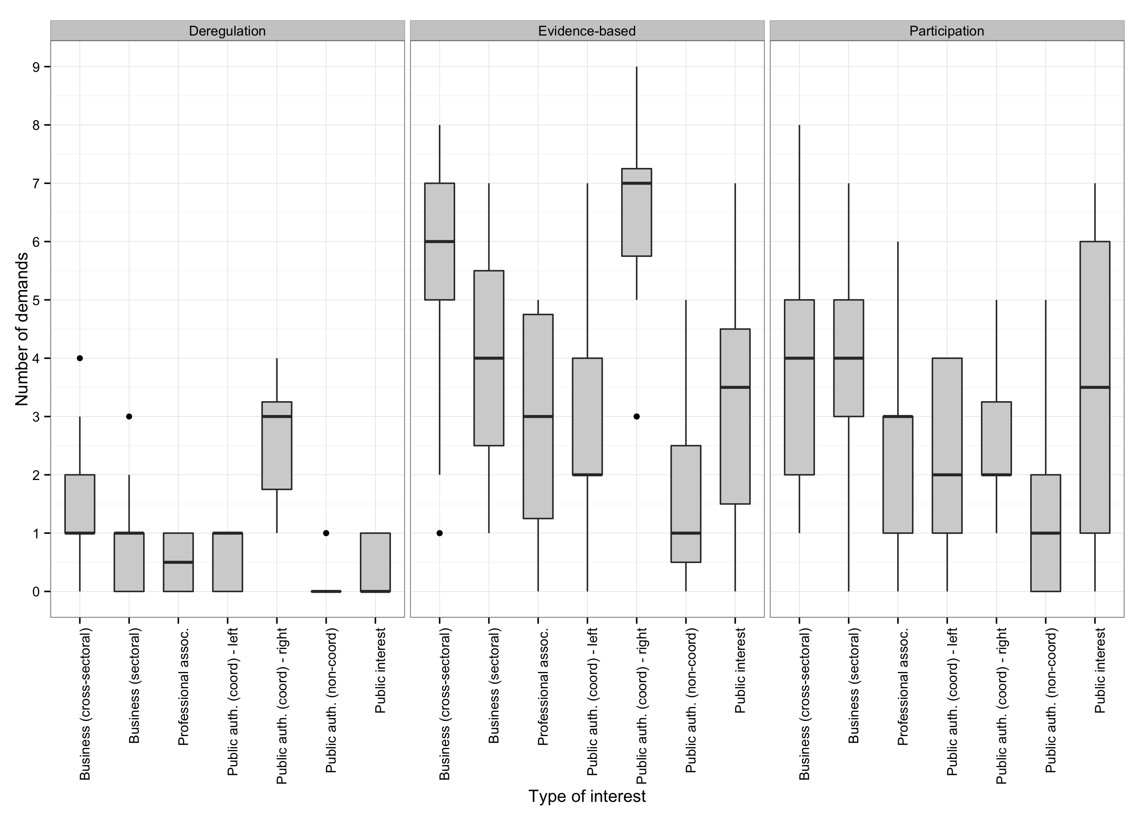
APPENDIX

Online Appendix 1: Analysis of stakeholders’ positions in support of Better Regulation status quo

The regression models reported in Table 2 in the article focus only on the demands for specific types of regulatory reform. However, in their position documents, stakeholders also expressed support for various regulatory (reform) measures implemented by the Commission prior to the open consultation in 2012. Substantively, these are demands expressed in support of the status quo. Table 1 in this Appendix lists these stakeholders’ positions supporting the status quo of regulatory policymaking.
Our rationale for excluding these demands from our main analysis is that the status quo of regulatory policymaking in the EU in 2012 reflected previous deregulatory, technocratic and participatory reforms without any of these reforms being dominant. Thus, support (or opposition) to the status quo of the Better Regulation policy does not tell us which specific type of reform a particular stakeholder prefers. For example, the economic, social and environmental criteria that have been used in impact assessments since the 2000s were compatible with both deregulatory and technocratic (and possibly participatory) types of reform. Thus, stakeholders supporting either of these two types of reform would have been equally likely to express support to the statement that goals of impact assessments should not be changed. Similarly, support to the statement that the general principles of consultations are good can be compatible with either technocratic or participatory type of reform. We therefore expect no significant differences in terms of support to status quo positions among the stakeholders who supported a reform of any type in 2012.
We hypothesize two types of behaviour among those stakeholders that are against any type of reform. On the one hand, given that the status quo of Better Regulation reflects some previous reforms, stakeholders may prefer to oppose it explicitly in line with their sincere policy preferences. On the other hand, they might also support it for strategic reasons, in order to increase the probability of their second least-preferred outcome (the preservation of status quo) as opposed to their least preferred option (further regulatory reform).
Table 2 presents the results of the negative binomial regression analysis that tests these expectations (Model 5). The dependent variable in this analysis is the count of status quo positions expressed by each stakeholder. Interest type is the independent variable, with cross-sectoral business groups as the reference category.
The results largely support our expectations. The stakeholders that we found were supportive of at least one type of reform (i.e. both cross-sectoral and sectoral business groups, public institutions responsible for the coordination and oversight of Better Regulation, and public interest groups) expressed a similar number of positions in support of the status quo of the regulatory policymaking. This is in line with our hypothesis that these stakeholders approved of the regulatory reforms they preferred and that were implemented prior to 2012.
The regression model in Table 2 also indicates important differences among those stakeholders that were found not to support any type of reform in the main analyses presented in the article. Specifically, while professional associations were significantly less likely to express support for status quo than all other groups, public institutions that are responsible for the implementation of Better Regulation measures at national level were rather supportive of the status quo. The stakeholders in the latter group might be unwilling to challenge directly regulatory reform; in contrast, professional associations, some of which have opposed Better Regulation openly (e.g. the European Trade Union Congress), had so such qualms about expressing their opposition also in the consultation.

Table 1. Stakeholders positions in support of the status quo of Better Regulation expressed in the 2012 EU open consultation on Smart Regulation.
 | Demand code | Demand content | Frequency
1 | cons.broadness.allelementsia | Consultation documents cover all elements of impact assessments | 15
2 | cons.docs.completeclear | Consultation documents are complete and clear | 17
3 | cons.feedback.sufficient | The quality and transparency of the feedback on the impact of consultations is sufficient | 13
4 | cons.outreach.good | The outreach of consultations is sufficient | 12
5 | cons.scope.good | Support to the existing practices in terms of the scope of the use of consultations | 11
6 | cons.timing.good | Support to the existing practices in terms of the timing of consultations is | 14
7 | eval.meth.good | Support to the existing methodology of ex-post evaluations | 6
8 | impl.info.commnotneedincrease | Information from the Commission on the implementation of legislation is sufficient | 12
9 | impl.info.ms.notneedincrease | Information from the Member States on the implementation of legislation is sufficient | 6
10 | ia.aims.right | Support to the existing goals of impact assessments | 46
11 | cons.format.mixopentarget | The mix of targeted and open consultations used by the Commission is appropriate | 18
12 | ialeg.roadmaps.good | Roadmaps on legislative process improve the participation of stakeholders in the policymaking process | 43
13 | cons.principles.good | Support to the principles and minimum standards of consultations | 26
14 | current.practices.effective.participation | Current practices of consultation assure effective participation | 15

Table 2. Negative binomial regression models explaining the support for the status quo of Better Regulation in the European Union.
 | Model 5
Intercept | 0.81***  (0.27)
Cross-sectoral business (ref. category)
Public authority – coord. (pro-deregulation) | 0.24  (0.46)
Public authority – coord. (not pro-deregulation) | -0.52  (0.55)
Public authority – implementing | 0.18  (0.43)
Sectoral business | 0.24  (0.36)
Public interest organization | 0.41  (0.52)
Professional association | -1.37***  (0.54)
Log likelihood | -215.15
N | 110
Note: Standard errors in parentheses. Significance levels: ***p < 01, **p< 0.01, *p< 0.05.

Online Appendix 2: Multi-level logistic regression analysis explaining stakeholders’ propensity to articulate a preference on the direction of the EU Better Regulation reforms.

In support of our decision to use count dependent variables in our analyses, we conducted a robustness check in the form of a multi-level regression analysis in which the unit of analysis is a stakeholder-demand dyad. Thus, the model includes 2860 observations (110 stakeholders X 26 demands identified in Table 1 in the article). The dependent variable codes whether the stakeholder expressed a particular demand. The predictor variables in this model are (1) a categorical variable for the type of demand (deregulatory, technocratic or participatory) and (2) another categorical variable for the constituency of interests represented by stakeholder (with identical categories to those in the Poisson regression models in Table 2 in the article). The model also includes the interaction effects between these two categorical variables. This empirical strategy allows us to model the differences between different types of stakeholders with regards to expressing the three types of demands. Furthermore, random intercept terms for stakeholders and demands in this analysis account for unobserved heterogeneity in both the propensity of stakeholders to express demands and the frequency with which specific demands were expressed. As such, the analysis addresses the reviewer’s concern that some stakeholders might be more likely to express demands than others. Additionally, the model accounts for the possibility that some demands are more likely to be expressed.
The results of this robustness check are presented in Table 3 below. As the interpretation of multiple interaction terms can be quite cumbersome, in Figures 1 - 4 we report the odds ratios for the change in stakeholder type for the three types of demands. Specifically, Figure 1 shows odds ratios for the propensity of different types of stakeholders to express deregulatory demands. Pro-deregulation public authorities are held as a reference category in this figure, thus providing evidence on Hypothesis 1. Figure 2 shows odds ratios for the propensity of different types of stakeholders to express technocratic demands. Public authorities (not pro-deregulation) are held as a reference category in this figure, thus providing evidence regarding Hypothesis 2. Figure 3 shows odds ratios for the propensity of different types of stakeholders to express deregulatory demands, but the reference category in this figure is cross-sectoral business groups. The figure thus provides evidence on Hypothesis 3. Finally, Figure 4 shows odds ratios for the propensity of different types of stakeholders to express participatory demands. Public interest organizations are held as a reference category in this figure, thus providing evidence on Hypothesis 4.
Although we observe substantial variability among both stakeholders in expressing demands and in the frequency of particular demands being expressed (as indicated by the substantial variance in random intercept terms for both variables), the statistical significance of the stakeholder type variable is very similar to that in the Poisson regression models reported in Table 2 in the article. Specifically, all categories with statistically significant regression coefficients in those models remain statistically significant in the multi-level model, and none of the categories that was not statistically significant in Poisson regression models becomes such in the multi-level logistic regression model.

Table 3: Multi-level regression analysis explaining stakeholders’ propensity to express a demand about the direction of the EU Better Regulation reforms.

 | Model 1
Intercept | 0.32 (0.72)
Demand type (ref. categ. - Deregulation demands)
Technocratic demands | -0.05 (0.80)
Participatory demands | -1.48† (0.85)
Interest type (ref. categ. - Public authority pro-deregulation)
Public authority - coord. (not pro-deregulation) | -3.24*** (0.76)
Public authority - implementing | -5.55*** (0.93)
Sectoral business | -3.13*** (0.57)
Cross-sectoral business | -1.74*** (0.52)
Public interest organization | -4.26*** (0.90)
Professional association | -3.76*** (0.70)
Interaction effects
Technocratic * Public authority - coord. (not pro-deregulation) | 1.45* (0.72)
Participatory * Public authority - coord. (not pro-deregulation) | 2.92*** (0.75)
Technocratic * Public authority - implementing | 2.59** (0.91)
Participatory * Public authority - implementing | 4.18*** (0.93)
Technocratic * Cross-sectoral business | 1.20* (0.48)
Participatory * Cross-sectoral business | 2.48*** (0.51)
Technocratic * Sectoral business | 1.87*** (0.53)
Participatory * Sectoral business | 4.02*** (0.55)
Technocratic * Public interest organization | 2.46** (0.86)
Participatory * Public interest organization | 4.73*** (0.88)
Technocratic * Professional association | 1.75** (0.67)
Participatory * Professional association | 3.68*** (0.69)
Interest group-level variance | 0.83
Demand-level variance | 1.79
Loglikelihood | -1317
No. of obs. | 2860
No. of interest groups | 110
No. of demands | 26
NOTE: Standard errors in parentheses. Significance levels: ***p < 01, **p< 0.01, *p< 0.05, † p <0.1.

Figure 1. Odds ratios for expressing deregulatory demands with pro-deregulation public authorities as a reference category.

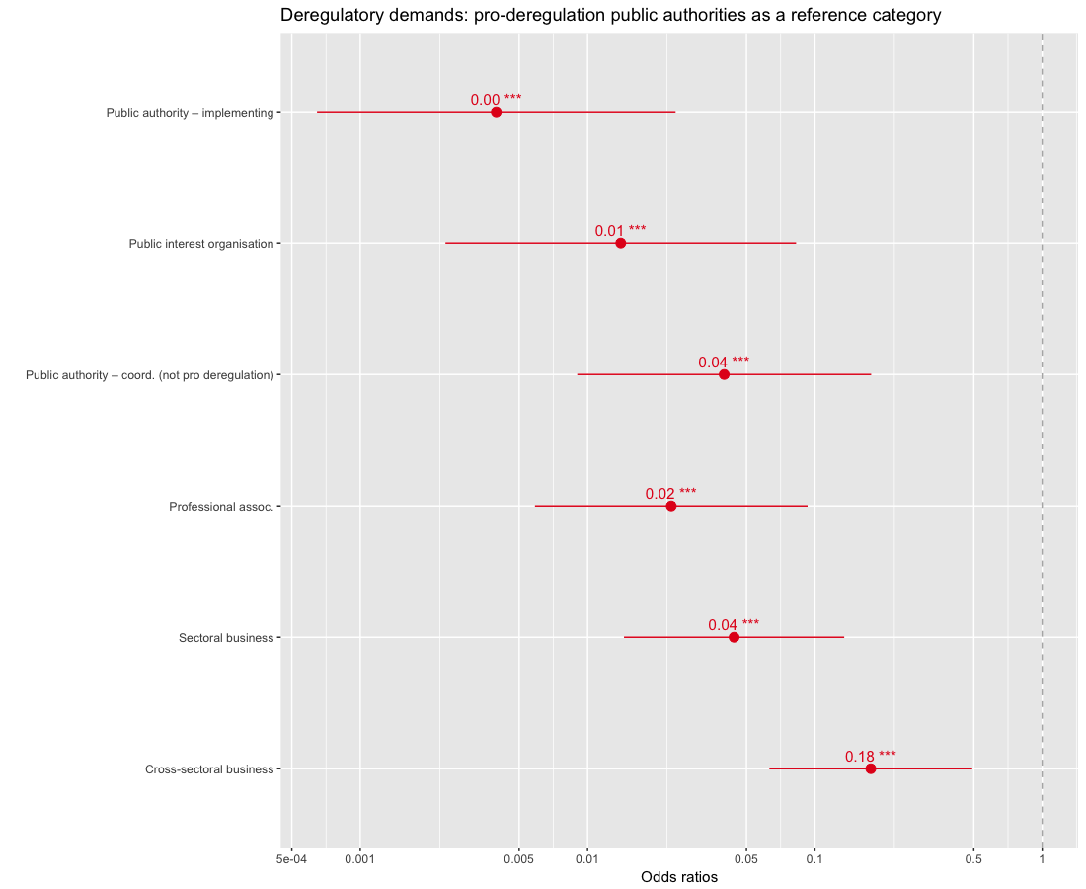

Figure 2. Odds ratios for expressing technocratic demands with public authorities (not pro-deregulation) as a reference category.

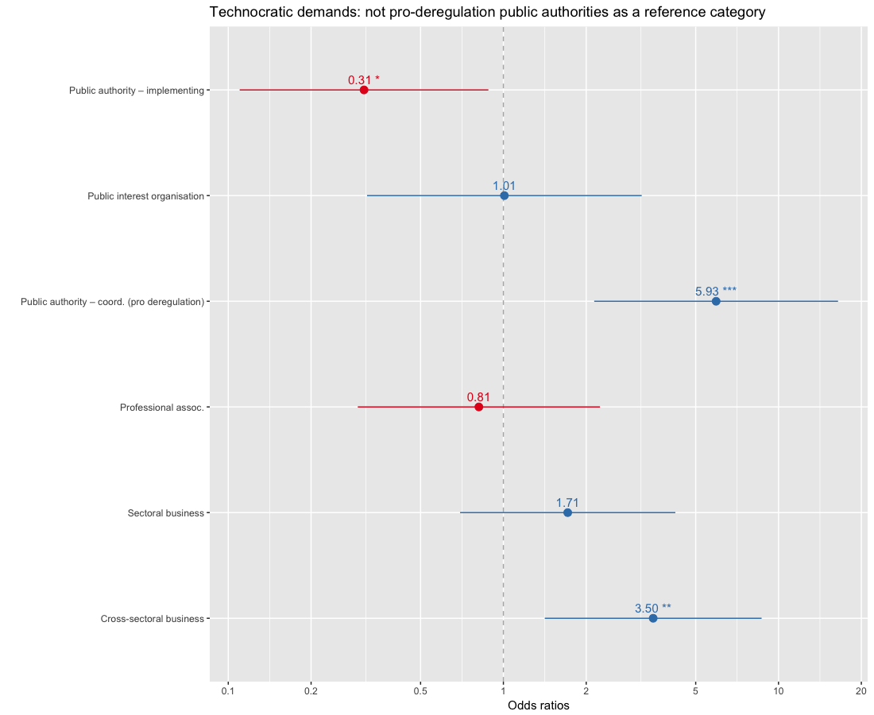

Figure 3. Odds ratios for expressing deregulatory demands with cross-sectoral business as a reference category.

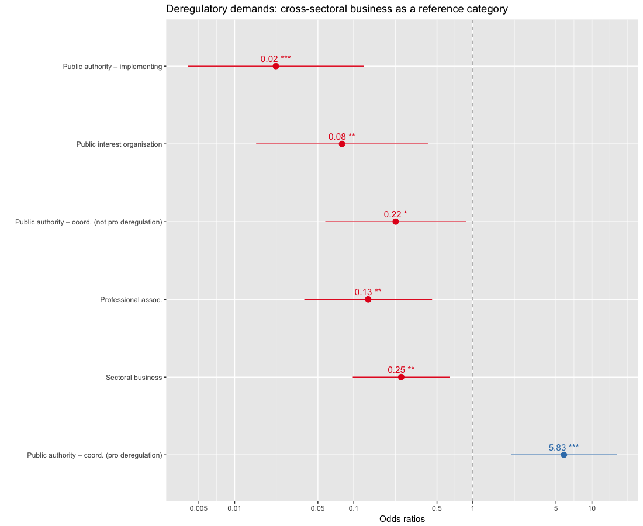

Figure 4. Odds ratios for expressing participatory demands with public interest organisations as a reference category.

