Do FDI Inflows Generate Economic Growth in Large Developed Economies? A New Empirical Approach, Applied to Spain

Abstract
It is often asserted with confidence that foreign direct investment (FDI) is beneficial for economic growth in the host economy. Empirical evidence has been mixed. The growth-enhancing effect of FDI is said to be largest in open, advanced economies with an educated work force and developed financial markets, but studies have focused on developing countries. We present an improved empirical methodology to examine whether FDI has enhanced growth in Spain, one of the largest receivers of FDI with above-average growth and ideal conditions for FDI to unfold its hypothesised positive effects, but few studies on it. An objective horse race between various potential explanatory variables, including 'bank credit for the real economy' and encompassing prior studies, yields no evidence that FDI stimulates economic growth. EU entry and euro adoption also had no positive effect on growth. The findings call for a rethinking of methodology in economics.
Keywords: bank credit creation; bank lending; credit creation; capital flows; foreign direct investment; foreign lending; FDI; economic growth;
JEL codes: F21, F34, O16, O23, R11
1. Introduction
"FDI is one of the most relevant aspects of the recent wave of globalization "
(Bajo-Rubio et al., 2010).
"Over the last 40 years …FDI… has been a prominent driver of Spanish economic
growth..." (Villaverde and Maza, 2012, p. 722).

The effect of foreign direct investment (FDI) on the host economy has attracted much research. Economic theorists and policy-makers frequently emphasise purported benefits of foreign direct investment. Rigorous empirical evidence has been less abundant. Most studies examine the impact of FDI on developing economies, but FDI is mainly received by developed countries (Lucas, 1990; Gourinchas and Jeanne, 2013). Macro-economic analyses that account for groups of developed countries not rarely report either a negative impact on growth (Mencinger, 2003; Türkcan et al., 2008; Carkovic and Levine, 2005, Johnson, 2006, and Herzer, 2012) or are inconclusive (De Mello, 1999). By contrast, some papers on both developed and developing countries indicate a positive effect of FDI inflows (Olofsdotter, 1998, and Reisen and Soto, 2001), albeit differing by country, and indicating the importance of host economy characteristics (Alfaro et al., 2004; Li and Liu, 2005 and Batten and Vo, 2010). The empirical literature seems to agree that FDI should boost growth most in developed countries, due to their the absorptive capacity to benefit from the foreign investment.

Since potential heterogeneity in the relationship between FDI and economic growth calls for single-country research, we examine new evidence from an important developed FDI receiver, using a new methodology. Our paper focuses on the neglected case of Spain, boasting developed financial markets, an educated workforce and one of the largest net FDI receivers during the last quarter-century (World Bank). Since Spain also recorded above-average growth (Garcia-Santana et al., 2016), it is ideally suited to showcase positive effects of FDI.
Ours is one of the first studies to deploy the general-to-specific econometric methodology, previously used with FDI only by Herzer (2012), on developing countries. It allows an objective and competitive selection of potential explanatory variables of GDP growth. Neutral statistical criteria are used to sequentially indentify the 'specific' (parsimonious) form without losing information or inadvertently influencing the analysis.
The literature has long ignored the banking sector, despite calls to include it in models of the economy and capital flows (e.g. Werner, 1994, 1997, 2005, 2012, 2013b). Now it has become an empirically established fact that banks create new money when extending loans, rendering prior savings unnecessary for investment and growth (Werner, 2014a, 2015) – and rendering prior models without banks biased. Werner (2015) points out that in our international financial architecture foreign-denominated money (bank-created and bank-based credit or accounting money) will never enter the receiver economy (but results in domestic bank credit expansion, which can be achieved without foreign investment). This greatly diminishes the theoretical case for FDI to boost growth, especially when domestic credit creation for the real economy is represented in a model of GDP growth (Werner, 1992, 1994, 1997, 2012).
We find bank credit creation for GDP-transactions survives the rigorous downward reduction to the parsimonious form of the GETS methodology as a significant explanatory variable of Spanish GDP growth. Prior studies that failed to include it suffered from omitted variable bias, rendering them unreliable. Our improved empirical model shows, with greater power than previously, that FDI has no significant positive effect on economic growth. We also help solve the puzzle of high Spanish growth from the mid-1990s to 2008, as our model accounts for Spanish GDP without structural breaks during the 27 years of our observation period from 1984 to 2010. In addition, interest rates and joining the EU and the euro are found to have no impact on Spanish growth.
Section 2 reviews the literature on growth and FDI. Section 3 summarises gaps in the literature. Section 4 discusses the Spanish case. Section 5 presents the new empirical evaluation of the impact of FDI on Spanish growth. Section 6 discusses the empirical findings. Section 7 concludes. We find no positive effect of FDI on GDP in the important Spanish case, when the environment was most favourable for FDI to deliver growth. The interest rate – emphasised by central bank spokespersons - is also not instrumental in influencing GDP, while a variable previously omitted in economic models (domestic credit creation for ‘real economy’ transactions) is. The parsimonious model does not suffer from visible statistical problems. This finding calls into question the wisdom of providing financial incentives to foreign firms to attract FDI, or of joining monetary, economic and political union.

- The link between FDI and growth
In the influential Harrod (1939) and Domar (1947) growth models, savings are key, driving capital accumulation and growth. Rostow (1959) seemed to provide evidence that savings are needed for development. Since raising savings may be difficult in the short-term, especially for developing countries, economists led by the IMF and the World Bank have advised nations to borrow ‘savings’ from abroad – via loans, portfolio investments and FDI - to augment domestic savings and achieve a targeted growth rate. Governments and regional administrations, keen to enhance growth, have since competed for foreign FDI through tax incentives and subsidies. Many developing countries were lured into incurring large foreign-denominated debts, which are hard to service and not rarely resulted in foreign control over their most valuable resources. Thus foreign investment is not without risks, such as the extraction of profits or retooling of an economy for foreign, not domestic purposes (see Hughes, 1979; Dixon and Boswell, 1996; Kentor, 1998). Herzer et al. (2014) found a significant increase of inequality in developing countries from FDI, with causality from FDI to inequality.
When neoclassical growth theory (Solow, 1956; Swan, 1956) replaced the Harrod-Domar theory, a new rationale for the flow of funds from rich countries to developing nations was found: As diminishing returns to capital and a lower capital stock are assumed in developing countries, returns on capital should be higher, enticing international capital from rich to poor countries, helping the latter catch up. This narrative also provided theoretical support for developing countries to utilise foreign investment, including FDI. But empirical evidence has suggested otherwise: Long-run growth is empirically due to technical progress, not capital or investment (Solow, 1957; Abramowitz, 1956). Moreover, capital was found not to flow from rich to poor countries, but from poor countries to the rich (e.g. Lucas, 1990; Gourinchas and Jeanne, 2013).
With technical progress outside neoclassical (‘exogenous growth’) models, technology-transfer from abroad via FDI remained a key recommendation by international organisations for countries to enhance growth (Balasubramanyam et al., 1996; Blomström and Kokko, 1998; Borensztein et al., 1998; Blomström and Sjöholm, 1999).
When the Solow-Swan ‘exogenous growth’ theory was challenged by ‘endogenous growth’ theory (Romer, 1990; Lucas, 1988; Barro, 1990), emphasising the role of technology, FDI remained justified to transfer technology, igniting domestic productivity (Johnson, 2006). Yet, evidence that technology gets transferred to receiver countries has remained sparse (e.g. Young and Lan, 1997; Ashraf et al., 2016, found no positive effect of FDI on total factor productivity in 123 countries).
A number of studies reported support for the theory that FDI benefits growth: Reisen and Soto (2001) report that foreign portfolio and direct investment boost growth. Basu and Guariglia (2007) conclude the link between FDI and growth is positive and significant in 119 countries (as is FDI and income inequality).
Several studies find growth-enhancing effects of FDI conditional on host environment (De Mello, 1997). Borensztein et al. (1998) argue FDI boosts growth via technology diffusion, if the host economy boasts sufficient absorptive capacity. Hermes and Lensink (2003) concur, finding a needed minimum level of human capital. Durham (2004) finds in a large multi-country study that FDI is not significantly correlated with growth, interpreting this as evidence that host economies need to have sufficient absorptive capacity. So developed economies with greater human capital should benefit from FDI. This is supported by Prasad et al. (2007) and Batten and Vo (2009). Likewise, Blomström et al. (1994) find no relationship between education and FDI inflows for developing countries. But others fail to concur: Campos and Kinoshita (2002) re-estimate the model in Borensztein et al. (1998) and find FDI exogenously affects growth, irrespective of human capital. Li and Liu (2005) report a positive and significant effect for both developed and developing countries and a significant role for human capital to enhance the impact of FDI.
The idea of the need for sufficient 'absorptive capacity' is supported by research on socio-economic conditions for R&D investment to be turned into innovation and growth (see, for instance, Bilbao-Osorio and Rodríguez-Pose, 2004). Hermes and Lensink (2003) report FDI is an insignificant determinant of growth and can only contribute positively when the domestic financial system has developed enough – so FDI should be more beneficial to developed economies. Alfaro et al. (2004) support Hermes and Lensink (2003). Later studies tried to incorporate more aspects of absorptive capacity: Carkovic and Levine (2005) test the hypotheses that the effect of FDI depends on the level of human capital, domestic financial markets (Alfaro et al., 2004, and Hermes and Lensink, 2003) and initial income (Blomström et al., 1994). They however conclude that FDI inflows do not robustly affect economic growth.
Bornschier et al. (1978) conclude that FDI has a negative impact on growth of developing countries. Fry (1993) concurs. De Mello (1999) shows that FDI has a positive effect on OECD countries, but a negative one for non-OECD countries. Agosin and Machado (2005) found that FDI “at best left domestic investment unchanged”, while at times it crowded it out. Carkovic and Levine (2005) criticise earlier studies on grounds of endogeneity, which they try to avoid in their multi-country study by using the generalised method of moments (GMM). They find no robust boost of growth from FDI. Herzer (2012) analysed the effect of FDI on economic growth in 44 developing countries, adopting the general-to-specific methodology and reports a negative effect, but also large cross-country differences. By contrast, Johnson (2006) reports FDI accelerates growth in developing countries but not in developed countries and Xu (2000) finds a positive effect of FDI on growth of the developed countries in his sample.
Nair-Reichert and Weinhold (2001) report causality from FDI to growth, though with heterogeneity across the panel. Hansen and Rand (2006) report strong causality from FDI to growth regardless of development level. Bi-directional Granger causality between FDI and growth was reported by Choe (2003) and Chowdhury and Mavrotas (2006). Duttaray et al. (2008) report ambiguous results. Zhang (2001) argues that country-specific conditions throw doubt on the hypothesis that FDI leads to higher growth. Mencinger (2003) finds that FDI exerts a negative impact on economic growth, with causality unidirectional from FDI to growth. Herzer et al. (2008) find no causality from FDI to growth.
In sum, there is no empirical consensus on a positive effect of FDI on host country growth, nor on the direction of causation. The contention that FDI positively affects growth, technological progress and capital accumulation remains “less controversial…in theory than in practice” (De Mello, 1999, p. 148). Most authors however agree that if a positive effect of FDI exists, it is more likely to be found in developed countries, as the required absorption capacity exists.
3. Gaps in the Literature
Much of the vast literature is premised narrowly on the hypothetico-deductive research methodology. There thus remains room for improvement: For one, the dominant focus on ‘real’ variables that are essentially unobservable is of doubtful utility (decision-makers are assumed to be perfectly informed and able to distinguish nominal and deflated variables with ease; there is no empirical evidence that agents base their decisions consistently on unobservable so-called ‘real’ variables. Thus there has been growing interest in models in observed market values, i.e. nominal terms (Werner, 1997, 2013a).).
Dominant post-war growth theories, from Harrod and Domar to Solow and beyond, assume that growth is driven by investment, which requires prior savings. Weak growth, due to insufficient savings, can then be remedied by foreign borrowing or FDI. Based on such arguments, the influential Washington-based institutions (IMF, World Bank, US Treasury, Federal Reserve, USAID; aka 'Washington consensus') have for the past seventy years encouraged developing countries to import ‘foreign savings’ via FDI or foreign investment to generate growth. This thinking remains dominant among IMF and central bank staff (e.g. Prasad et al., 2007). This Washington Consensus was welcomed by the international banking industry, as it enabled it to expand its lending business, especially to developing countries with valuable assets.
However, such arguments are based on largely bank-free theories. Dropping banks in models a particular theory of banking, namely the theory that is acceptable only if banks are mere financial intermediaries, unable to increase the money supply, merely gathering deposits and lending these out. Borrowing from abroad is thought to enter the economy in the same way as gold did in the monetary transmission of David Hume's price-species flow mechanism. Then there is no need to include banks and their operations in models of growth, or FDI and growth. Thus it came to pass that in the leading growth theories by Solow, Harrod and Domar, specifically, and the macroeconomics growth theories, in particular, banks do not feature; many models don’t even include money (since banks or money “would only obscure the analysis”, Romer, 2006, p. 3). Yet, models without banks' ability to create credit and money as central structural features of our economic system are of doubtful utility (Werner, 2013b). After 5000 years of banking, empirical work has finally demonstrated that banks are not financial intermediaries, but creators of the money supply (Werner, 2014a, 2015). All loan principals extended by banks are newly created and added to the money supply, accounting for about 97% of the money supply (see Werner, 2014c).
A rise in the number of transactions requires an increase in net purchasing power exerted to pay for these transactions (‘equation of exchange’ or ‘quantity equation’). This is in practice only achieved through banks’ credit creation (Werner, 1997). Hence, bank credit is the appropriate (though neglected) measure of the money supply (the neglect is surprising, since the IMF internally uses models centering on domestic credit creation; Werner, 2014b). Further, credit needs to be disaggregated into credit for GDP transactions (‘real credit’) determining nominal GDP growth and credit for non-GDP transactions ('financial credit', to non-banks, construction and property industries – since asset and property transactions are not part of GDP), determining asset markets (the Quantity Theory of Credit; Werner, 1992, 1997, 2005, 2012). Thus a test of the impact of FDI on growth needs to control for domestic credit creation for GDP transactions. This has not happened, so omitted variable bias could explain the ambiguous evidence on the impact of FDI on receiver-country growth.
Werner (2015) argues that the rules of international banking require foreign funds – since overwhelmingly digital ledger entries in foreign banks – to stay abroad, unable to 'enter' the domestic economy. If exchange into local currency, domestic credit creation results, a process fully under control of the domestic financial system. This implies that capital flows should not be expected to impact GDP growth independently, if domestic bank credit creation is included appropriately as explanatory variable – something lacking hitherto.
The majority of empirical studies on the impact of FDI has used the specific-to-general econometric research methodology. Its reliance on ‘ad hoc’ models imposes a priori restrictions without empirical justification. Since the true data-generating process is unknown, this introduces biases. A superior methodology nests hypotheses within general empirical models that include a variety of potentially relevant variables, including those emanating from competing hypotheses. This general model, with lags, is then reduced to the parsimonious form by following an objective procedure (e.g. sequentially dropping the variable with the most insignificant t-statistic and re-estimating until all variables are significant). This is the general-to-specific (GETS) methodology (Hendry and Mizon, 1978). It is particularly advisable when the literature has remained inconclusive: It allows an objective 'horse race' between potential explanatory variables, treating competing theories equally. The standard variables favoured by old theories are included in the initial general unrestricted model (GUM), but also new variables identified from the functioning of the international payments system - bank credit for real-economy transactions. The data then tells us which explanations are statistically significant and which can be dropped without losing information.
Endogeneity problems arise when components of the dependent variable are regressors (private investment). If the relationship between FDI and growth is heterogeneous among countries, panel results may be misleading: A large positive effect in one country may offset many small negative effects in others (Choe, 2003). Country studies avoid this.
4. The Spanish case
According to the literature, absorptive capacity allows FDI to enhance growth. This includes human capital, openness to trade and financial market development. By choosing a country that is open to trade, has an educated work force, well-developed financial markets and is a major receiver of FDI a positive effect of FDI on growth is more likely and hence constitutes a stricter test.
Table 1 lists the top-12 receivers of FDI from 1984 to 2010, by cumulative net inflows (USD). The US, UK, Canada and six eurozone countries are industrialised. The US and UK are outliers due to their present and past dominant economic, financial and political power. This leaves Canada and six eurozone countries.

Table 1 Total nominal FDI, stock of FDI and FDI to GDP by country (1984-2010)
Country | FDI net inflows (BoP),  cumulative total in US$ billions | Stock of FDI in US$ billions | Nominal GDP (2010) in US$ billions | Average of Cumulative FDI as % of 2010 GDP
United States | 3,472 | 3,915 | 14964 | 1%
Netherlands | 1,903 | 628 | 836 | 8%
United Kingdom | 1,725 | 1,428 | 2429 | 3%
China | 1,581 | 832 | 6100 | 1%
France | 858 | 717 | 2646 | 1%
Germany | 820 | 1,077 | 3417 | 1%
Belgium | 615 | 512 | 483 | 5%
Spain | 600 | 644 | 1431 | 2%
Canada | 578 | 953 | 1613 | 1%
Brazil | 428 | 675 | 2208 | 1%
Mexico | 362 | 376 | 1051 | 1%
Ireland | 362 | 364 | 221 | 6%
Column 2: Source: World Bank
Column 3: Source: UNCTADstat, 2012 data
Column 4: Source: World Bank

Eurozone countries encounter no trade barriers within the EU and Eurozone members no exchange rate uncertainty within the eurozone – both said to enhance trade, capital flows and growth, enabling a larger possible impact of FDI on growth. Several eurozone countries are major recipients of FDI. But Germany, France, Belgium and the Netherlands are in close geographical proximity with other EU countries, allowing them to trade and invest without a strong need for FDI. Thus one should expect peripheral economies to receive more FDI (viz. Gren, 2003). So it is an efficient research strategy to first investigate the role of FDI in a suitable peripheral eurozone country that meets the criteria above and is a major FDI recipient. Ireland, Portugal and Spain are possible (Barry, 2004). Of these, Spain is the largest FDI recipient: Within the eurozone, Spain is the fifth largest recipient of cumulative FDI from 1984 to 2010, just behind the more central Netherlands, France, Germany and Belgium (Table 1). The sixth largest FDI recipient, peripheral Ireland, received significantly less FDI. Considering cumulative FDI received by Eurozone countries (UNCTAD data, Table 1), Spain was by 2012 a top-3 eurozone FDI receiver. FDI relative to annual GDP (Table 1) puts Spain in league with major industrialised economies. The Netherlands, Belgium and Ireland are significantly smaller, thus show higher FDI/GDP ratios, but special factors apply to them (Ireland is a successful tax haven in the EU), rendering them of less interest.
So Spain is highly suitable for our methodology: Boasting highly developed financial markets, it is located inside the eurozone but on its geographic periphery, while there are few special (e.g. tax) reasons for the substantial incoming FDI. In 2015, a researcher reported: "Today, Spain is Europe's... second [economy] for inward FDI" (Mayo, 2015). Spain also recorded economic growth above EU average, which may be hypothesised to be due to FDI. According to the current state of research, if FDI has a positive effect on receiver country growth, it should be significant in the case of Spain.

4. 1. FDI in Spain
During the 1980s, under liberalisation and economic integration, including preparations for the European Common Market of 1992, an “FDI wave” poured into industrialised economies, including Spain (Graham and Krugman, 1993). FDI to Spain grew on average by 47%, while the stock of FDI grew on average by 12.2% (Bank of Spain) from 1984 to 2010, rendering Spain a top-ten FDI receiver among OECD countries in 2010 (OECD, 2010; Figure 1).
There are not many studies on FDI into Spain. Most assume a positive effect of FDI on growth and proceed to focus on identifying determinants of FDI, in the quest to help policy-makers attract even more FDI. Studies with bold claims about a positive effect of FDI on Spanish growth (“FDI has been a crucial factor in the process of intense growth enjoyed by the Spanish economy”, Bajo-Rubio et al., 2010, p. 374) provide little evidence. Villaverde and Maza (2012) assert a positive effect of incoming FDI on growth, but hide in a footnote the caveat that this link is not empirically established. Bajo-Rubio et al. (2010) present empirical work linking the cumulative stock of FDI-per-employee to GDP-per-employee (postulating a production function in real terms that includes the cumulative stock of gross nominal FDI per employee and focusing on productivity; as noted below, other researchers instead found weak productivity growth), but concede: “it would not be unlikely that the results found in the present paper should be qualified in the near future”.
From 1995 to 2008, 83.8% of total FDI was in manufacturing and services (Villaverde and Maza, 2012). Manufacturing FDI was dominant until about 1985 (chemicals, automobiles and machinery). From 1986 onwards, non-manufacturing FDI overtook, led by real estate, finance and insurance (Bajo-Rubio and Sosvilla-Rivero, 1994; Bajo-Rubio and Lopez-Pueyo, 2002). In the 1990s and 2000s, the financial sector and real estate-related activity increased substantially in Spain. FDI reflected this, with high-profile foreign investments in construction, property and hotel development. Construction FDI accounted for 17% of total FDI in 2010 (Invest in Spain, 2010).
Villaverde and Maza (2012) found extreme regional bias in the geographical distribution of FDI among the 17 regions (1995 to 2008): 79% of total FDI went to Madrid and Cataluña, of which most went to Madrid. In the words of Rodrígues-Pose (2000): “Madrid and Catalonia are too economically powerful and have attracted too much FDI to be compared with any of the declining regions” (p. 93). Díaz Vázquez (2002) suggested that the FDI impact on capital accumulation and growth was likely to be negligible in Spain, since until 1997 FDI predominantly took the form of acquisitions of existing Spanish firms (brownfield investment). But in the 2000s, greenfield investment became dominant (59% of FDI, Invest in Spain, 2010).
FDI has been a visible part of globalisation, but potential benefits have been concentrated, as Rodriguez-Pose (1998) warned about the “persistence of regional disparities” (p. 455f). Villaverde and Maza (2012) caution that their recommendations on how to enhance FDI hold only "under the assumption that FDI enhances economic growth" (p. 731). It is thus necessary to examine this more fundamental question: Does FDI have a positive effect on economic growth?
4. 2. Spanish GDP
Researchers wonder why Spanish GDP growth was so high from the mid-1990s until 2008 (3.5% vs. 2.2% EU average growth; Garcia-Santana et al., 2016). The latter noted that simultaneously Spanish productivity fell, while it increased in the EU and US. So Spanish GDP growth “was based on factor accumulation rather than productivity gains” (Garcia-Santana et al., 2016). They research why total factor productivity fell, not why factor accumulation and GDP grew so much, noting “It remains to be understood why the Spanish economy accumulated capital and labor at such a fast pace despite …negative …productivity” (2015, p. 3).
The hypothesis consistent with the pronouncements by politicians and economists is that the high growth was due to incoming FDI. Timing is suggestive: In 1992, EEC Council Directive No. 88/361/CEE became effective in Spain (Royal Decree 1816/1991), allowing free movement of capital among EEC members. Foreign investors have since been able to operate any type of business under the same conditions as local investors. In addition, Spain provided "various incentives for investors, such as grants, tax benefits, professional training, preferential access to credit, etc." (Santander, 2015). By conventional thinking, the unusually high economic growth should be due to incoming FDI – a testable hypothesis.

5. The Empirical Model
Our empirical test fills the gaps in the literature: Growth in a single major developed economy receiving significant FDI (Spain) is examined over a period of 27 years (1984-2010). The analytically superior general-to-specific (GETS) econometric methodology is adopted (Hendry and Mizon, 1978; Hoover and Pérez, 1999; Herzer, 2012), emphasising observed relevant variables (i.e. nominal variables, rendering the model dimensionally consistent). The general unrestricted model (GUM) has to pass the usual diagnostic tests to ensure validity, after which it is reduced sequentially to the parsimonious (‘specific’) form. The GETS approach allows testing for dynamic relationships difficult to identify in specific-to-general models (so that most studies focus on contemporaneous correlations) and thanks to it, explanatory variables favoured by prior authors compete with new variables.
The dependent variable is nominal GDP growth. Independent variables include exchange rates and foreign demand (needed due to the increasing external openness of the Spanish economy), G7 nominal GDP (Datastream) to proxy foreign demand, short-term interest rates (overnight interbank rates; Spanish National Bureau of Statistics, INE) as the proclaimed instrument of monetary policy (Woodford, 2003) and determinant of consumption and investment. The quantity of money (M1 and M2, Datastream) is included as relevant target of Spanish monetary policy until 1994 (Ballabriga et al., 1998), and to proxy financial development (King and Levine, 1993, Alfaro et al., 2004) upon which a beneficial effect of FDI may depend. Employment is included as factor of production (INE). Unlike investment, it is not a component of GDP, hence inclusion is unproblematic. Following Blomström et al. (1994), Borensztein et al. (1998) and De Mello (1999), the educational level of labour (‘human capital’; Valencia Institute of Economic Research) is a potential explanatory variable, not least since Spanish human capital implies a higher absorptive capacity to realise positive effects from FDI. As Spain is a commodity importer, the explanatory variables include the Reuters Commodities Index (Reuters Datastream).
According to the Quantity Theory of Credit (Werner, 1997, 2005, 2012), bank credit for GDP transactions represents the impact of domestic banks on GDP. Previous researchers that paid attention to the role of credit as a determinant of economic growth did not distinguish between the different categories of credit. ‘Credit for the real economy’ was significant in a model of Spanish nominal GDP (without analysing FDI; Werner, 2014b). We further subtract unproductive consumer credit from real economy credit to obtain a measure of ‘productive credit creation’ (Werner, 2005). This includes industry (excluding construction), credit to the agricultural sector and credit to commerce (Bank of Spain data). In addition, Spanish borrowers can easily receive euro-denominated loans abroad (since fixed exchange rates were introduced in January 1999), represented in the model by foreign bank lending (Bank of Spain).
FDI data (Bank of Spain) are included as potential source of funding and technology. Dummies are employed to account for two potential structural changes, implemented because of their expected positive impact on Spanish growth (Argandoña, 2006): the accession of Spain to the Common European Market in 1986, and the introduction of the euro in 1999.
A negative impact on growth is expected from currency appreciation, commodity price rises and short-term interest rate rises (Woodford, 2003), while a positive impact on growth is expected from external demand, labour, the educational level, bank credit creation for productive real economy transactions (Werner, 2005), foreign bank lending, monetary deepening (M1/M2), EU/ euro dummies, and, finally, FDI.
The general autoregressive distributed lag (ADL) model of nominal GDP (INE) is:
= + +
where X_{j}, in seasonal log-differences, symbolised by ∆, each with four lags, are as follows:
FDI= FDI inflows (Bank of Spain)
CREDIT= Spanish productive credit for real economy transactions (Bank of Spain, authors' calculations)
BANKL= Bank lending from abroad (Bank of Spain)
COMM= International commodities index (Reuters Datastream)
G7GDP= Total GDP of G7 countries (Spanish National Bureau of Statistics, INE)
EUR_DM= EUR/DM exchange rate (Peseta-derived)
EUR_USD= EUR/USD exchange rate (Peseta-derived)
LABOUR= Employed Spanish population (INE)
EDU= Educational level of employed population (Valencia Institute of Economic Research)
M1= Money supply M1 Spain (Datastream)
M2= Money supply M2 Spain (Datastream)
ST_RATES= Spanish overnight interbank interest rates (INE)

To manage seasonality, first seasonal log-differences are used. The observation period is, due to data availability, from 1984 (Q1) until 2010 (Q4). Unit root tests are carried out, including a drift and trend for GDP, and without trend for the other variables. The augmented Dickey-Fuller (ADF) and the PP (Phillips and Perron, 1988) tests of the null of the presence of a unit root (i.e. non-stationarity), and the more powerful KPSS (Kwiatkowski et al., 1992) test are conducted. The three tests, with lag length based on the Akaike information criterion, robustly show that none of the seasonal differenced variables have a unit root and are I(1) (integrated of order one). The general unrestricted ADL model is estimated with OLS. The regular diagnostic tests, including of error normality and omitted variables, are performed to analyse the validity of the model.

6. Results and Discussion
The general unrestricted model was found valid, without statistical problems. The subsequent elimination procedure to the parsimonious form re-runs the model each time a new restriction (of zero coefficient) is imposed, until all insignificant variables are eliminated. Linear restriction and redundant variable tests confirm validity of the simplification. The 'parsimonious' (specific) model is again subjected to the standard diagnostics (Gauss-Markov conditions must be met to allow inference of population parameters). Table 3 shows the parsimonious form of the ADL model. It passes all diagnostic tests.
Further reduction looks possible, as both the first and fourth lag of M2 have similar coefficients and significance, but opposite signs. The linear restriction test confirms this. As model reduction continues, other variables become insignificant, delivering a simpler model. Its general diagnostic tests indicate no statistical problems. The high RESET test F-statistic and the Durbin-Watson statistic suggest that the third lag of GDP, with the lowest significance, may not be needed. The redundant variable test indicates this variable is significantly different from zero at a 10% and 5% level of significance, but not at 1%. However, once dropped, the RESET result improves while other diagnostics still hold (Durbin-Watson is closer to two).
The parsimonious model is reported in Table 4. It passes all standard tests: It is a valid model from which inferences can be drawn. It reveals that economic growth depends on the growth rates of past GDP, past G7 GDP, the exchange rate EUR/USD, employment (labour), educational level, current M2 and past productive real-economy credit. All other potential explanatory variables dropped out as insignificant: Commodities prices, EUR/DM exchange rate, money supply M1, foreign bank lending, short-term interest rates, and FDI.
Several robustness tests are carried out, without evidence for structural breaks. The model is able to explain Spanish nominal GDP growth, including the high growth period since the mid-1990s, and the collapse in growth after the 2008 crisis.
Lastly, pair-wise Granger causality between nominal GDP and the independent variables is calculated by an ADL model with four lags (Table 5) to determine short-run exogeneity. It is found that past values of productive credit are important for forecasting future nominal GDP, but not the reverse (predictive power i.e. Granger-causality uni-directional from productive credit to nominal GDP). Ditto for G7-GDP and labour. However, in the case of M2, bi-directional causality between nominal GDP and M2, and human capital, respectively, is found. Thus, to avoid potential endogeneity problems involving M2 and human capital, the model is estimated using the instrumental variable (IV) technique and the TSLS method (Stock and Watson, 2007), using lagged values of the endogenous variables as instruments. The results of the TSLS estimation (Table 6) are almost identical, except for the insignificant coefficient of M2 under the former specification. Thus, the model is considered valid.
The variable on which this paper focuses – FDI – does not exert a significant impact on Spanish economic growth. However, in the specification of Table 3, it is possible to observe a significant (and small) negative effect of FDI on nominal GDP.
As expected, foreign demand, human capital, productive credit creation and labour have significant positive effects on growth, while the exchange rate EUR/USD exerts the expected negative impact. While other studies have also found a positive impact of human capital on economic growth, previous analyses did not control for its endogeneity. The positive and significant effect of money supply M2 on growth seems to support the conclusions by Alfaro et al. (2004). However, the significance of M2 is not robust in all specifications, as the TSLS estimation shows an insignificant positive impact of financial development on economic growth. Thus the findings are more in line with Carkovic and Levine (2005), who found that FDI is insignificant irrespective of degree of financial development.
Results differ from most previous papers concerning the effect of FDI on economic growth in advanced developed economies that used either cross-sectional or panel data in their analysis, but is in line with Herzer (2012) on developing countries. While Balasubramanyam et al. (1996), Borensztein et al. (1998) and more recently Durham (2004) find that a negative effect of FDI is due to the low absorptive capacity of the host economy, Spain has a high level of human capital that should help realise FDI benefits. Hermes and Lensink (2003) and Alfaro et al. (2004) conclude that negative FDI effects are due to low financial development, but Spain has high financial development. Xu (2000) finds that FDI exerts a positive and robust effect on economic growth of developed countries, but this is not the case in Spain. This underscores that cross-country conclusions cannot be extrapolated to the individual countries. Moreover, significant real economy credit leaves all prior studies exposed to the charge of omitted variable bias.
The negative impact of FDI in Table 3 suggests that FDI is a rival of domestic investment. This is when FDI is funded by the banking system of the receiver country, thus competing for funds with domestic investment (crowding out host investment). This and the insignificance of foreign bank lending confirm earlier findings that FDI and portfolio investment are substitutes (Ruffin and Rassekh, 1986; Werner, 1994), in line with recent research on financial flows concluding that foreign funds cannot enter receiver countries (Werner, 2015).
So far the literature on FDI has neglected the role of bank credit. Bank credit creation provides the theoretical reason why FDI cannot be expected to help economic growth (see above: foreign-denominated money stays abroad, and when ‘exchanged’ into domestic money results in domestic credit creation, which is more sustainably created by lending to domestic counterparties). Our results provide the first direct empirical support for this. With both foreign bank lending and FDI eliminated as explanatory variables, a primacy of domestic banking in economic development is established, in line with Werner (1997, 2005, 2014a, 2014b, 2015), as well as the longitudinal research on the determinants of nominal growth of a major industrialised economy by Ryan-Collins et al. (2016). It is also in line with the literature on the 'East Asian Economic Miracle' (Japanese high growth did not require any incoming investment; on the institutional foundations of investment credit policies, see Werner, 2003a, 2003b).
Short-term interest rates drop out from the final parsimonious model, contradicting the central banks’ claim that rates are a key monetary policy tool. In the first parsimonious reduction (Table 3), where short-term rates are significant, the coefficient is positive, as Werner (2005) had argued, and as Lee and Werner (2017) also report on the US, UK, Germany and Japan. To explore the possible cause-effect relationship between interest rates and growth in Spain, several pair-wise Granger causality tests with different lag specifications are performed (Table 7). It is found that changes in short-term rates are not cause but consequence of economic growth. This represents a further rejection of the pre-crisis ‘monetary policy consensus’ (Woodford, 2003) and raises questions about central banks’ claims about interest rates as monetary policy instrument: Interest-targeting cannot affect growth. This is another empirical ‘anomaly’ of conventional monetary theory (Belongia and Chalfant, 1990), and supports Werner (2005), who argues that markets are rationed, rendering quantities more important than prices. This calls for a fundamental rethinking of macroeconomics.
A corollary is that recent reductions of interest rates – including into negative territory – are unhelpful. Negative rates on banks' reserves at the central bank are a tax on banks - hurting especially those banks lending for the productive economy and thus reducing growth prospects.
Given counter-productive ECB policies also in earlier years, it would not be surprising if joining the Eurozone was not beneficial for Spanish GDP growth. We test this and the EU entry of Spain, by adding two dummy variables for the time periods of EU and euro entry, DUMMY_EU and DUMMY_EURO to the final parsimonious model. The general diagnostic tests are repeated to ensure valid inferences (Table 8): The accession to the Common Market has a negative and insignificant effect on economic growth. While Argandoña (2006) points out that the Spanish entrance in the EU might have negative effects, and Werner (2003a, 2006) warned countries against adopting the euro due to the danger of ECB-induced credit bubbles and crises, Frankel and Rose (2002) claimed that joining the EU free trade area would boost growth. This is not substantiated in the important Spanish case.
Table 9 shows the effect of the introduction of the euro on Spain: the dummy is even more insignificant. Neither EU entry nor the adoption of the Euro had demonstrable effects on Spanish growth. This is an important finding, relevant for countries considering whether to join, or exit the EU or eurozone.

7. Conclusions
There has been an insufficient number of relevant country studies on the quantitative impact of incoming FDI on economic growth of developed receiver countries. Spain, as major receiver of FDI, provides an environment considered most favourable for FDI to exert a positive impact on growth (developed financial markets, skilled labour, etc.), and Spanish GDP growth was surprisingly high from the mid-1990s onwards.
We examined the quantitative effect of incoming FDI on Spanish GDP growth using the general-to-specific (GETS) econometric methodology. Given the large body of inconclusive research on this question, this method offers a decisive new avenue to gain clarity, encompassing prior work and allowing objective tests of a number of hypothesises.
The general model reflects advances in the understanding of the role of banks as creators of the money supply. Domestic bank credit creation for productive GDP-transactions survived the rigorous sequential downward reduction to the parsimonious form to emerge as an important determinant of nominal GDP growth: Granger-causality tests indicate unilateral causation from real economy bank credit to nominal GDP growth, supporting the small but growing literature in economic geography calling for the role of bank credit to be included in empirical and theoretical studies (Werner, 2013b). Meanwhile, interest rates dropped out as insignificant (corroborating the Quantity Theory of Credit; Werner, 1997). The results are robust, as the estimated parsimonious model seems free from structural breaks, spurious correlation and problems with endogeneity of variables.
We highlight the neglected issue of how FDI is funded: Given the rules in international banking, FDI is usually funded locally using money of the receiver country, i.e. created by domestic banks. Since banks create money out of nothing (Werner, 2015), while foreign currency-denominated funds mostly do not physically enter the receiver country, it is neither possible nor necessary to boost economic growth with foreign-denominated ‘money’. Instead, FDI competes with private domestic investment for funds, crowding out domestic investment (previously shown by Werner, 1994). This seriously damages the theoretical case for beneficial FDI. In our study this crowding out effect of FDI was empirically supported even in euro-denominated Spain.
These empirical findings call for more research on the impact of our bank and payments system infrastructure on economic outcomes. They are consistent with the high economic growth observed in bank-centred economies that did not rely on foreign investment to boost their growth, but domestic credit (see Werner, 2003a).
We unambiguously show that FDI had no significant positive effect on Spanish GDP growth from 1984 to 2010, despite both high FDI and economic growth and ideal conditions for FDI to boost growth, as judged by previous literature. Since prior work is shown to suffer from omitted variable bias, our results supersede earlier studies concerning the impact of FDI on growth. FDI is not a determinant of Spanish economic growth. The stimulation of productive domestic credit creation, employment, foreign demand and education is beneficial for growth.
Tax breaks and other benefits to attract FDI have been criticised by economic geographers (e.g. Zhang, 2011). We find they are indeed inadvisable: Spanish policy makers had better not waste Spanish tax payers’ funds on attracting FDI, and instead focus on domestic education.
We also found that interest rates are not as useful for monetary policy as thought, because (1) they lag nominal GDP growth and drop out of the GETS model when it is reduced to the parsimonious form; and (2), they are positively correlated with growth (i.e. if one were to use them as policy tool to stimulate growth, a rise in rates would be appropriate). As Werner (2005) argued, in our world of disequilibrium, quantities are more important than prices (including the price of money). Therefore the Spanish central bank and ECB had better encourage vigorous bank credit growth for productive real economy investments (e.g. the implementation of new technologies). This can be done by switching support from big banks to small local community banks that lend to productive SMEs, or by guiding credit (Werner, 2005). Yet, to the contrary, the ECB’s negative interest policy and flat yield curve weakens small banks and has kept real economy credit depressed. ECB policies have merely encouraged financial speculation by big banks. To stimulate growth, the ECB should instead boost credit, raise rates and steepen the yield curve (e.g. by ending government bond purchases).
Our study also yields insights on the impact of EU membership: we found that neither joining the EU, nor the euro boosted Spanish nominal GDP growth, raising doubts about the reasons for Spanish politicians to promote these changes. Frequent claims by public figures concerning the growth-enhancing impact of EU membership need to be reconsidered. This is consistent with recent work on the UK (Ryan-Collins et al., 2016), which found evidence of a negative effect from joining the EU.
There are other corollaries from our findings. The contribution by Garcia-Santana et al. (2015) on the puzzle of high growth in the face of negative productivity growth in Spain is cast in a new light: FDI could not have been the source of the capital accumulation that caused the high growth. Instead, the high growth was credit-driven. The observed decline in productivity could have been a function of bank credit for non-GDP (i.e. asset) transactions, which expanded rapidly. Such bank credit causes property and asset bubbles (Werner, 1997, 2005), which lower the productivity of the workforce: As more people engage in speculative buying and selling of ownership rights in assets, productivity falls, because man-hours are devoted to what macro-economically amounts to a zero-sum game (which is why financial transactions are not part of national income). Rationing of time means the more a population is engaged in speculation, the fewer human resources are available for productive activities. The impression of ‘wealth creation’ through such bank credit-driven asset bubbles is an illusion, encouraged by the popular press and designed to allow the early movers in this pyramid scheme to sell to the late-coming – usually retail – investors, who will bear the brunt of the losses; ordinary tax payers are unnecessarily made to pay for the subsequent bank bailouts; Werner, 2014b.
The case for a beneficial effect of FDI is rejected. Governments should not spend resources on attracting FDI, since there is no discernible positive impact on growth. This further undermines pre-crisis mainstream macroeconomics. Using the ‘hypothetico-deductive-axiomatic’ methodology, this hitherto dominant approach in macroeconomics heaps unrealistic assumptions on empirically disproven ‘axioms’ to proclaim a theoretical dream world of ‘equilibrium’ and ‘efficient markets’ that cannot be improved upon by government intervention (although central bank intervention is strangely exempt).
By contrast, the present study adopted the scientific research method, also known as the ‘inductive’ methodology, using the objective general-to-specific econometric methodology. Such ‘scientific economics’ requires the reality of human institutions to be reflected in economic models, such as banks as creators of the money supply. It also rejects dogmatic postulation of empirically unproven, purely theoretical concepts such as ‘equilibrium’. As Werner (2005) argued, without adopting many unrealistic (and unnecessary) assumptions, market equilibrium cannot be expected, let alone ‘market efficiency’. Empirically-based scientific economics does not postulate that a nation must receive foreign investment to prosper, since many counter-examples exists, such as the meteoric rise of Japan in the 20th century, or the many successfully developed economic powers surveyed by Friedrich List (1841). Japanese policy-makers had in fact adopted the inductive methodology to reach a more useful understanding of development economics, upon which they implemented targeted government intervention, especially in institutional design and credit guidance, with phenomenal results (see Werner, 2003a; 2003b; Carrington and Edwards, 1979). This calls for a rethinking of modern economics.
Why have economists been reluctant to consider scientific research methods? An under-researched dimension is that of powerful actors influencing academic research (see Werner, 2015). FDI is at the centre of the drive towards globalisation, advanced by central banks. Our paper demonstrates the important role played by bank credit creation, which is under their control (on the influence of central banks on economics, see Ishii and Werner, 2003).

References
Abramovitz, Moses. 1956. Resource and Output Trends in the United States since 1870. American Economic Review. May 1956, 46(2), 5-23.
Agosin, Manuel R., and Machado Roberto. 2005. Foreign Investment in Developing Countries: Does it Crowd in Domestic Investment? Oxford Development Studies, 33 (2): 149-162.
Aitken B. J. and Harrison, A. E. 1999. Do Domestic Firms Benefit from Direct Foreign Investment? Evidence from Venezuela. The American Economic Review. Vol. 89, No. 3, 605-618.
Alfaro, L., Chanda, A., Kalemli-Ozcan, S. and Sayek, S. 2004. FDI and Economic Growth: The Role of Local Financial Markets. Journal of International Economics. Vol. 64, No. 1, 89-112.
Ashraf, Ayesha, Herzer, Dierk and Nunnenkamp, Peter. 2016. The effects of greenfield FDI and cross-border M&As on total factor productivity. The World Economy, 39 (11), 1728-1755.
Bajo-Rubio, Oscar, Díaz-Mora, Carmen and Díaz-Roldán, Carmen. 2010. Foreign Direct Investment and Regional Growth: An Analysis of the Spanish Case. Regional Studies, 44:3, 373-382, DOI: 10.1080/00343400802508844.
Bajo-Rubio, Oscar and Lopez-Pueyo, C. 2002. Foreign direct investment in a process of economic integration: the case of Spanish manufacturing, 1986–1992. Journal of Economic Integration 17, 85–103.
Bajo-Rubio, Oscar and Sosvilla-Rivero, Simón. 1994. An Econometric Analysis of Foreign Direct Investment in Spain, 1964-89. Southern Economic Journal, Vol. 61 (1, July): 104-12.
Balasubramanyam, V. N., Salisu, M. and Sapsford, D. 1996. Foreign Direct Investment and Growth in EP and IS Countries. The Economic Journal. Vol. 106, No. 434, 92-105.
Ballabriga, F. C., Álvarez, L. J. and Jareño, J. 1998. A Macroeconomic BVAR Model for the Spanish Economy: Methodology and Results. Bank of Spain Economic Papers. No. 64.
Banerjee, A., Marcellino, M. G. and Osbat, C. 2004. Some Cautions on the Use of Panel Methods for Integrated Series of Macroeconomic Data. Econometrics Journal. Vol. 7, No. 2, 322-340.
Barro, R. J. 1990. Government Spending in a Simple Model of Endogenous Growth. The Journal of Political Economy. Vol. 98, No. 5, Part 2: The Problem of Development: A Conference of the Institute for the Study of Free Enterprise Systems, S103-S125.

Barry, F. 2004. Enlargement and the EU Periphery. The World Economy, Volume 27, Issue 6, pages 753–759, June 2004.
Basu, P. and Guariglia, A. 2007. Foreign Direct Investment, Inequality, and Growth. Journal of Macroeconomics. Vol. 29, No. 4, 824-839.
Basu, P., Chakraborty, C. and Reagle, D. 2003. Liberalization, FDI, and Growth in Developing Countries: A Panel Cointegration Approach. Economic Inquiry. Vol. 41, No. 3, 510-516.
Batten, Jonathan A. and Vo, Xuan Vinh. 2009. An analysis of the relationship between foreign direct investment and economic growth. Applied Economics, 41 (13), 1621-1641.
Belongia, M. T. and Chalfant, J. A. 1990. Alternative Measures of Money as Indicators of Inflation: A Survey and Some New Evidence. Review, Federal Reserve Bank of St. Louis. 72, Issue Nov, 20-33.
Benhabib, J. and Spiegel, M. M. 1994. The Role of Human Capital in Economic Development Evidence from Aggregate Cross-Country Data. Journal of Monetary Economics. Vol. 34, No. 2, 143-173.
Bilbao-Osorio, Beñat and Rodríguez-Pose, Andrés. 2004. From R&D to innovation and economic growth in the EU. Growth and Change 35(4), October 2004: 434-455.
Blomström, M. and Kokko, A. 1998. Multinational Corporations and Spillovers. Journal of Economic Surveys. Vol.12, No. 3, 247–277.
Blomström, M. and Sjöholm, F. 1999. Technology Transfer and Spillovers: Does Local Participation with Multinationals Matter? European Economic Review. Vol. 43, No. 4-6, 915-923.
Blomström, M., Lipsey, R. E., and Zejan, M. 1994. What Explains the Growth of Developing Countries. National Bureau of Economic Research. Working paper No. 4132.
Borensztein, E., De Gregorio, J. and Lee J.-W. 1998. How does FDI affect economic growth? Journal of International Economics. Vol. 45. No. 1, 115-135.
Bornschier, V., Chase-Dunn, C. and Rubinson, R. 1978. Cross-national Evidence of the Effects of Foreign Investment and Aid on Economic Growth and Inequality: A Survey of Findings and a Reanalysis. American Journal of Sociology. Vol. 84, No. 3, 651–683.
Bradfield, M. 2006. Foreign Investment and Growth vs. Development: A Comparative Study of Ireland and Wales. Canadian Journal of Regional Science, 29(2), 321-334.
Campos, N. F. and Kinoshita, Y. 2002. Foreign Direct Investment as Technology Transferred: Some Panel Evidence from Transition Economies. Manchester School of Economic and Social Studies. Vo. 70, No. 3, 398-419.
Carkovic, M. and Levine, R. 2005. Does Foreign Direct Investment Accelerate Economic Growth? in Moran, T. H., E. M. Graham and M. Blomstrom (eds.), Does Foreign Direct Investment Promote Development?, 195–220. Institute for International Economics, Washington, DC.

Carrington, John C. and George T. Edwards. 1979. Financing Industrial Investment. Basingstoke: Palgrave Macmillan.
Choe, J. I. 2003. Do Foreign Direct Investment and Gross Domestic Investment Promote Economic Growth? Review of Development Economics, Vol. 7, No. 1, 44–57.
Chintrakarn, Pandej, Herzer, Dierk and Nunnenkamp, Peter. 2012. FDI and income inequality: Evidence from a panel of US states. 50 (3), 788-801.
Chowdhury, A. and Mavrotas, G. 2006. FDI and Growth: What Causes What? The World Economy. Vol. 2, No. 1, 9-19.
Cole, M. A., Elliott, R. J., & Zhang, J. 2011. Growth, foreign direct investment, and the environment: evidence from Chinese cities. Journal of Regional Science, 51(1), 121-138.
De Gregorio, J. and Guidotti, P. 1995. Financial Development and Economic Growth. World Development. Vol. 23, No. 3, 433-448.
De Mello, L.R. 1997. Foreign Direct Investment in Developing Countries and Growth: A Selective Survey. Journal of Development Studies. Vol. 34, No. 1, 1–34.
De Mello, R.L. 1999. Foreign Direct Investment-led Growth: Evidence from Time Series and Panel Data. Oxford Economic Papers. Vol. 51, No. 1, 133-151.
Dixon, W. J. and Boswell, T. 1996. Dependency, Disarticulation, and Denominator Effects: Another Look at Foreign Capital Penetration. American Journal of Sociology. Vol. 102, No. 2, 543-562.
Djankov, S. and Hoekman, B. 2000. Foreign Investment and Productivity Growth in Czech Enterprises. World Bank Economic Review. Vol. 14, No. 1, 49-64.
Domar, E. D. 1947. Expansion and Employment. The American Economic Review. Vol. 31, No. 1, 34-55.
Durham, J. B. J. 2004. Absorptive Capacity and the Effects of Foreign Direct Investment and Equity Foreign Portfolio Investment on Economic Growth. European Economic Review. Vol. 48, No. 2 285-306.
Duttaray, M., Dutt, A. K. and Mukhopadhyay, K. 2008. Foreign Direct Investment and Economic Growth in Less Developed Countries: An Empirical Study of Causality and Mechanisms. Journal of Applied Economics. Vol. 40, No. 15, 1927-1939.
Firebaugh, Glenn. 1992. Growth Effects of Foreign and Domestic Investment. American Journal of Sociology, Vol. 98, No. 1 (Jul., 1992), 105-130.
Firebaugh, Glenn 1996. Does Foreign Capital Harm Poor Nations? New Estimates Based on Dixon and Boswell's Measures of Capital Penetration. American Journal of Sociology, Vol. 102, No. 2, 563-575.
Frankel, J. A. and Rose, A. K. 2002. An Estimate of the Effect of Currency Unions on Trade and Growth. Quarterly Journal of Economics. Vol. 117, No. 2, 437-466.
Fry, M. J. 1993. Foreign Direct Investment in a Macroeconomic Framework – Finance, Efficiency, Incentives, and Distortions. The World Bank International Economics Department. Working Paper No. 1141.
Garcia-Santana, M., Moral-Benito E., Pijoan-Mas J., Ramos R. 2015. Growing like Spain: 1995-2007, Mimeo.
Garcia-Santana, M., Moral-Benito E., Pijoan-Mas J., Ramos R. 2016. Growing like Spain: 1995-2007, Banco de Espagna Working Paper No. 1609, Madrid: Banco de Espagna.
Graham, E. M. and Krugman, P. R. 1993. The Surge in Foreign Direct Investment in the 1980’s. National Bureau of Economic Research Chapters. In Foreign Direct Investment, 13-36.
Gourinchas Pierre-Olivier and Jeanne, Olivier. 2013. Capital Flows to Developing Countries: the Allocation Puzzle. Review of Economic Studies 80, 1484-1515.
Gren, Joergen. 2003. Reaching the Peripheral Regional Growth Centres: Centre-periphery convergence through the Structural Funds’ transport infrastructure actions and the evolution of the centre-periphery paradigm. European Journal of Spatial Development, Jan, no3., 2-22, accessed online on 24th August 2015.
Hansen, H. and Rand, J. 2006. On the Causal Links between FDI and Growth in Developing Countries. The World Economy, Vol. 28, No. 1, 21-41.
Harrod, R. F. 1939. An Essay in Dynamic Theory. The Economic Journal. Vol. 49, No. 193, 14-33.
Hendry, D. F. and Mizon, G. E. 1978. Serial Correlation as a Convenient Simplification, Not a Nuisance: A Comment on a Study of the Demand for Money by the Bank of England. The Economic Journal. Vol. 88, No. 351, 549-563.
Hermes, N. and Lensink, R. 2003. Foreign Direct Investment, Financial Development and Economic Growth. Journal of Development Studies. Vol. 40, No. 1, 142-174.

Herzer, Dierk. 2012. How Does Foreign Direct Investment Really Affect Developing Countries' Growth? Review of International Economics, Volume 20, Issue 2, pages 396–414, May 2012.
Herzer, D., Klasen, S. and Nowak-Lehmann, F. D. 2008. In Search of FDI-led Growth in Developing Countries: The Way Forward. Economic Modelling. Vol. 25, No. 5, 793-810.
Herzer, Dierk, Hühne, Philipp and Nunnenkamp Peter. 2014. FDI and Income Inequality – Evidence from Latin American Economies, Review of Development Economics, 18 (4), 778-793.
Hoover, K. D. and Pérez, S. J. 1999. Data Mining Reconsidered: Encompassing and the General-to-Specific Approach to Specification Search. Econometrics Journal, Royal Economic Society. Vol. 2, No. 2, pp-167-191.
Hsiao, F. S. T. and Hsiao, M. C. W. 2006. FDI, Exports and GDP in East and Southeast Asia: Panel Data versus Time Series Causality Analyses. Journal of Asian Economics. Vol. 7, No. 6, 1082-1106.
Hughes, H. 1979. Debt and Development: The Role of Foreign Capital in Economic Growth. World Development. Vol. 7, No. 2, 95-112.
Invest in Spain. 2010. Note on 2010 inward FDI data. Investment Registry. Information and Strategy Department: Publications and Reports.
Johnson, A. 2006. The Effects of FDI on Host Country Economic Growth. The Royal Institute of Technology, Centre of Excellence for Studies in Science and Innovation. Electronic Working Paper No. 58.
Jones, Jonathan and Wren, Colin. 2004. Inward foreign direct investment and employment: a project-based analysis in north-east England. J Econ Geogr (2004) 4(5): 517-543.
Kentor, J. 1998. The Long‐Term Effects of Foreign Investment Dependence on Economic Growth, 1940–1990. American Journal of Sociology. Vol. 103, No. 4, 1024-1046.
King, R. G. and Levine R. 1993. Finance and Growth: Schumpeter Might Be Right. The Quarterly Journal of Economics. Vol. 108, No. 3, 717-737.
Kwiatkowski, D., Phillips, P. C., Schmidt, P., and Shin, Y. 1992. Testing the Null Hypothesis of Stationarity against the Alternative of a Unit Root: How Sure Are We That Economic Time Series Have a Unit Root? Journal of Econometrics. Vol. 54, No. 1-3, 159–178.
Leichenko, R. M., & Erickson, R. A. 1997. Foreign direct investment and state export performance. Journal of Regional Science, 37(2), 307-329.
Li, X. and Liu, X. 2005. Foreign Direct Investment and Economic Growth: An Increasingly Endogenous Relationship. World Development. Vol. 33, No. 3, 393-407.
Lichtenberg, F. and van Pottelsberghe de la Potterie, B. 1998. International R&D Spillovers: A Comment. European Economic Review, Vol. 42, no. 8, 1483-1491.
Lucas, R. E., Jr. 1988. On the Mechanics of Economic Development. Journal of Monetary Economics. Vol. 22, No. 1, 3-42.
Lucas, R. E., Jr. 1990. Why Doesn't Capital Flow from Rich to Poor Countries? The American Economic Review. Vol. 80, No. 2, 92-96.
Mencinger, J. 2003. Does Foreign Direct Investment Always Enhance Economic Growth? Kyklos, International Review of Social Sciences. Vol. 56, No. 4, 491-508.
Myro, Raphael (ed.). 2014. España en la inversión directa internacional, Instituto de Estudios Económicos, Madrid.
Myro, Raphael. 2015. Foreign Direct Investment in Spain. SEFO - Spanish Economic and Financial Outlook, Vol. 4, N.º 1 (January 2015), 37-45.
Nair-Reichert, U. and Weinhold, D. 2001. Causality Tests for Cross-Country Panels: A New Look at FDI and Economic Growth in Developing Countries. Oxford Bulletin of Economics and Statistics. Vol. 63, No.2, 153–171.
Nelson, R. R. and Phelps, E. S. 1966. Investment in Humans, Technological Diffusion, and Economic Growth. The American Economic Review. Vol. 56, No. 1-2, 69-75.
Noorbakhsh, F. and Paloni, A. 2001. Human Capital and FDI Inflows to Developing Countries: New Empirical Evidence. World Development. Vol. 29, No. 9, 1593-1610.
OECD. 2010. OECD Factbook 2010: Economic, Environmental and Social Statistics”. Organisation for Economic Co-operation and Development.
Olofsdotter, K. 1998. Foreign Direct Investment, Country Capabilities and Economic Growth. Review of World Economics. Vol. 134, No. 3, 534-547.
Pantulu, Jyothi and Poon Jessie. 2003. Foreign direct investment and international trade: evidence from the US and Japan. Journal of Economic Geography, 3 (3), 241-259.
Pavlínek, P. 2004. Regional development implications of foreign direct investment in Central Europe. European Urban and Regional Studies, 11(1), 47-70.
Pavlínek, P. 2012. The Internationalization of Corporate R&D and the Automotive Industry R&D of East-Central Europe. Economic Geography, 88: 279–310.
Phelps, Nicholas A. and Wood, Andrew. 2006. Lost in translation? Local interests, global actors and inward investment regimes. J Econ Geogr (August 2006) 6(4): 493-515.
Phillips, P. C. and Perron, P. 1988. Testing for a Unit Root in Time Series Regression. Biometrika. Vol. 75, No. 2, 335–346.
Prasad, Eswar S., Raghuram G. Rajan and Subramanian, Arvind. 2007. Foreign capital and economic growth. Brookings Papers on Economic Activity, 38 (1), 153-230.
Ram, R. and Zhang, K. H. 2002. Foreign Direct Investment and Economic Growth: Evidence from Cross‐Country Data for the 1990s. Economic Development and Cultural Change. Vol. 51, No. 1, 205-215.
Reisen, H. and Soto, M. 2001. Which Types of Capital Inflows Foster Developing Country Growth? International Finance, Vol. 4, No. 1, 1-14.
Rodríguez-Pose, Andrés. 1998. Social conditions and economic performance: the bond between social structure and regional growth in western Europe. International Journal of Urban and Regional Research 22(3), September 1998: 443-459.
Rodríguez-Pose, Andrés. 2000. Economic convergence and regional development strategies in Spain: the case of Galicia and Navarre. European Investment Bank Papers 5(1), June 2000: 89-115.
Romer, P. 1993. Idea Gaps and Object Gaps in Economic Development. Journal of Monetary Economics. Vol. 32, No.1, 543-573.
Romer, P. M. 1990. Endogenous Technological Change. The Journal of Political Economy. Vol. 98, No. 5, 71-102.
Rostow, W. W. 1959. The Stages of Economic Growth. The Economic History Review. Vol. 12, No. 1, 1-16.
Roy, A. G. and Van den Berg, H. F. 2006. Foreign Direct Investment and Economic Growth: A Time-Series Approach. Global Economy Journal. Vol. 6, No. 1, Article 7.
Ruffin, Roy J., and Rassekh, Farhad. 1986. The role of foreign direct investment in US capital outflows. American Economic Review 76: 1126-30.
Ryan-Collins, Josh, Werner, Richard and Castle, Jenny. 2016. A half-century diversion of monetary policy? An empirical horse-race to identify the UK variable most likely to deliver the desired nominal GDP growth rate. Journal of International Financial Markets, Institutions & Money, 43 (July), 158–176 http://dx.doi.org/10.1016/j.intfin.2016.03.009
Santander. 2015. Spain: Foreign Investment, FDI in Figures, accessed at https://en.portal.santandertrade.com/establish-overseas/spain/foreign-investment
Solow, R. M. 1956. A Contribution to the Theory of Economic Growth. Quarterly Journal of Economics. Vol. 70, No. 1, 65-94.
Solow, Robert M. 1957. Technical Change and the Aggregate Production Function. Rev. Econ. Statist., Aug., 39(3), 312-20.
Stock, J. H. and Watson, M. W. 2007. Introduction to Econometrics, International Edition. Boston: Pearson/Addison Wesley, 2007. 2nd Edition.
Sun, H. 2001. Foreign direct investment and regional export performance in China. Journal of Regional Science, 41(2), 317-336.
Swan, T. W. 1956. Economic Growth and Capital Accumulation. Economic Record. Vol. 32, No. 2, 334-361.
Türkcan, B., Duman, A. and Yetkiner, I. H. 2008. How Does FDI and Economic Growth Affect Each Other? The OECD Case. International Conference on Emerging Economic Issues in a Globalizing World, Izmir, Turkey.
Villaverde, José and Maza, Adolfo. 2012. Foreign direct investment in Spain: Regional distribution and determinants. International Business Review, 21 (4), August 2012, 722–733.
Werner, Richard. A. 1992. A quantity theory of disaggregated credit and international capital flows. Paper presented at the Royal Economic Society Annual Conference, York, April 1993 and at the 5th Annual PACAP Conference on Pacific-Asian Capital Markets in Kuala Lumpur, June 1993, see Economist, ‘Economics Focus’, 19 June 1993.
Werner, Richard. A. 1994. Japanese Foreign Investment and the Land Bubble. Review of International Economics. Vol. 2, No. 2, 166-178.
Werner, Richard. A. 1997. Towards a New Monetary Paradigm: A Quantity Theory of Disaggregated Credit with Evidence from Japan. Kredit und Kapital. Vol. 30, No. 2, 276-309.
Werner, Richard. A. 2003a. Princes of the Yen, Central Bankers and the Structural Transformation of the Economy. New York: M. E. Sharpe
Werner, Richard A. 2003b. A Reconsideration of the Rationale for Bank-Centered Economic Systems and the Effectiveness of Directed Credit Policies in the Light of Japanese Evidence. The Japanese Economy, vol. 30, no. 3, New York: M. E. Sharpe, 3-45.
Werner, Richard. A. 2005. New Paradigm in Macroeconomics: Solving the Riddle of Japanese Macroeconomic Performance. Palgrave MacMillan.
Werner, Richard A. 2006. What accession countries need to know about the ECB: A comparative analysis of the independence of the ECB, the Bundesbank and the Reichsbank. International Finance Review, Emerging European Financial Markets, Vol 6, 99-116, ISSN: 1569-3767/doi:10.1016/S1569-3767(05)06005-X
Werner, Richard. A. 2012. Towards a New Research Programme on ‘Banking and the Economy’ – Implications of the Quantity Theory of Credit for the Prevention and Resolution of Banking and Debt Crises. International Review of Financial Analysis, 25, 94-105.
Werner, Richard. A. 2013a. The case for nominal GDP targeting. Central Banking. vol. 23, no. 4, May, 67-76.
Werner, Richard. A. 2013b. Commentary: Crises, the spatial distribution of economic activity and the geography of banking. Environment and Planning A, volume 45, 2789–2796 (December).
Werner, Richard. A. 2014a. Can Banks Individually Create Money Out of Nothing? – The Theories and the Empirical Evidence. International Review of Financial Analysis, 36, 1-19.
Werner, Richard. A. 2014b. Enhanced debt management: Solving the eurozone crisis by linking debt management with fiscal and monetary policy. Journal of International Money and Finance, 49, 443-469.
Werner, Richard. A. 2014c. How do banks create money, and why can other firms not do the same? An explanation for the coexistence of lending and deposit-taking. International Review of Financial Analysis, 36, 71-77.
Werner, Richard. A. 2015. A lost century in Economics: Three theories of banking and the conclusive evidence. International Review of Financial Analysis, 46, July, 361–379 http://www.sciencedirect.com/science/article/pii/S1057521915001477
Woodford, Michael 2003. Interest and Prices: Foundations of a Theory of Monetary Policy. Princeton University Press, New Jersey.
Xu, B. 2000. Multinational Enterprises, Technology Diffusion, and Host Country Productivity Growth. Journal of Development Economics, Vol. 62, No. 2, 47-493.
Young, Stephen and Ping Lan. 1997. Technology Transfer to China through Foreign Direct Investment. Regional Studies, 31:7, 669-679.
Zhang, J. 2011. Interjurisdictional competition for FDI: The case of China's “development zone fever”. Regional Science and Urban Economics, 41(2), 145-159.
Zhang, K. H. 2001. Does Foreign Direct Investment Promote Economic Growth? Evidence form East Asia and Latin America. Contemporary Economic Policy. Vol. 19, No. 2, 175-185.

Figures and Tables

Figure 1 Incoming Spanish FDI (1980-2010)
Stock of FDI
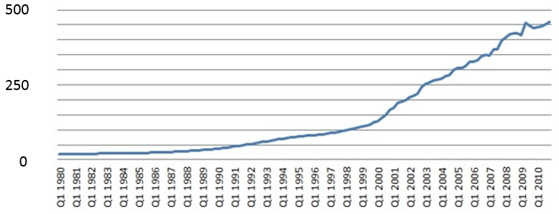
Flow of FDI
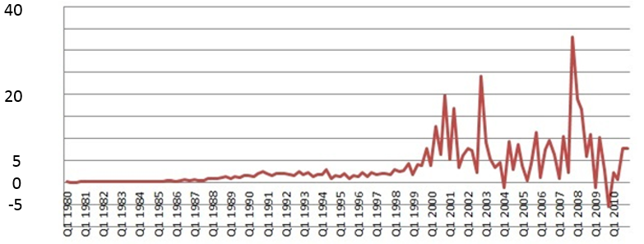

Source: Spanish National Bureau of Statistics (INE)

Table 1
- In main text! -

Table 2 Data Used
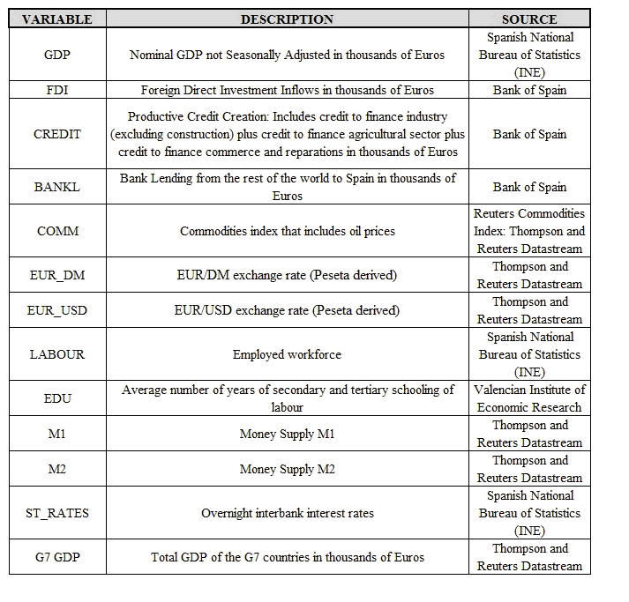

Table 3 Parsimonious Model (I)
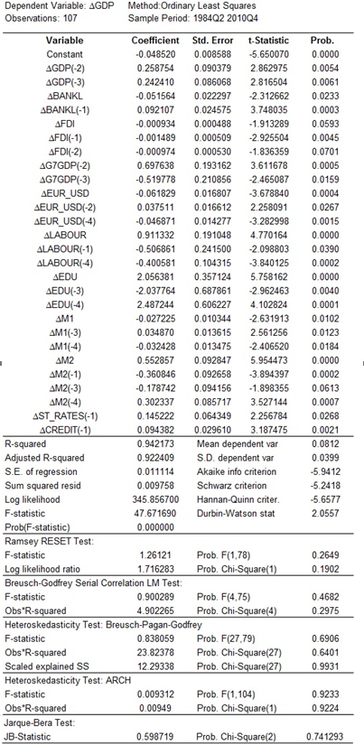

Table 4 Parsimonious Model (II)
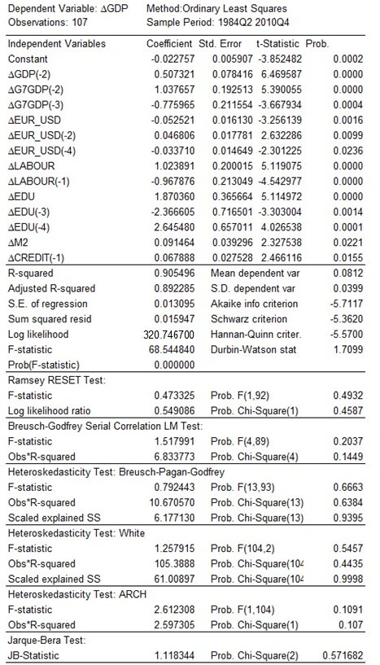

Table 5 Pairwise Granger-Causality Tests
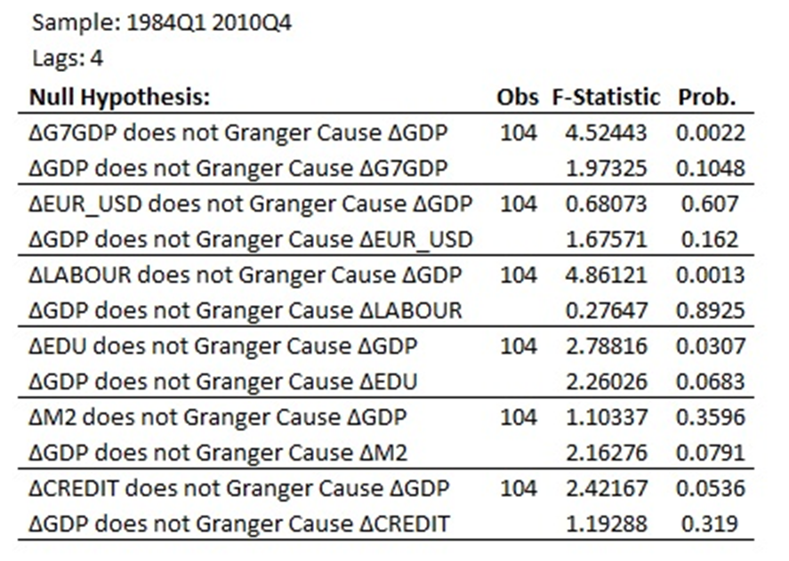

Table 6 Two-stage least square estimation
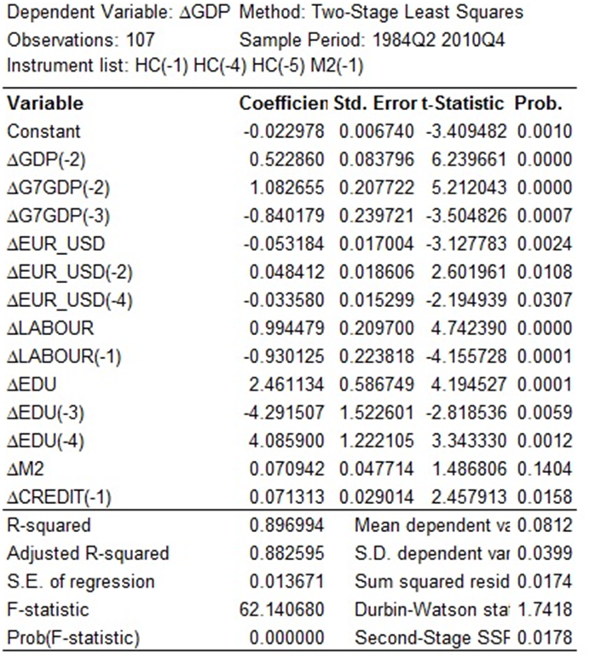
Table 7 Pairwise Granger-causality tests for nom.GDP and short-term interest
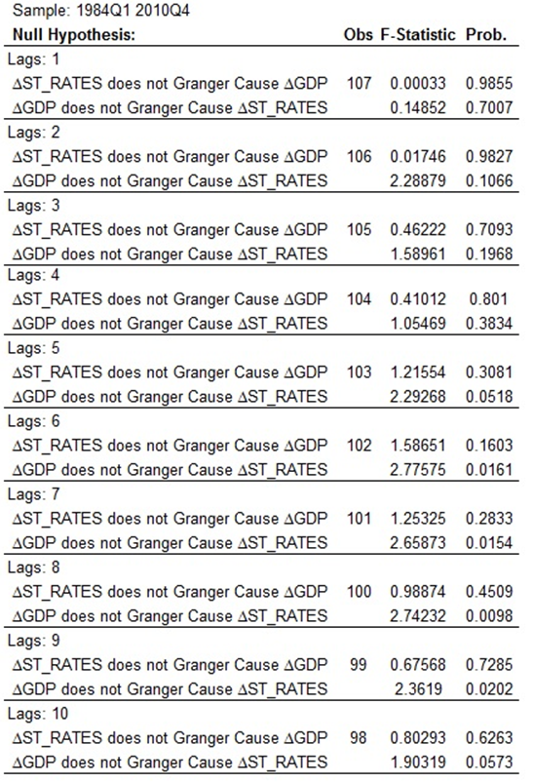
Table 8 Parsimonious model with EU dummy
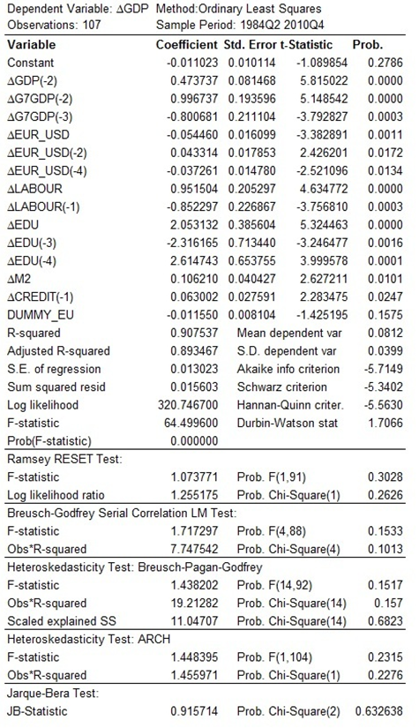

Table 9 Parsimonious model with Euro dummy

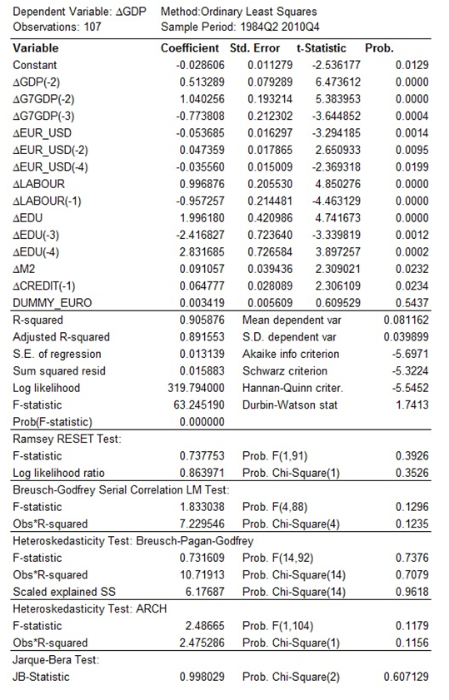

Bornschier et al. (1978); Firebaugh (1992, 1996). Pantulu and Poon (2003). Pavlínek (2004) reports adverse effects of FDI. Pavlínek (2012) reports no evidence FDI has boosted R&D and potential growth of receiver countries. Country studies in economic geography include Leichenko and Erickson (1997), who report a positive effect of FDI on US state-level export performance, and Sun (2001), reporting an uneven effect of FDI in China on export performance. Jones and Wren (2004) analyse the impact of FDI on employment in north-east England and question the policies of inward investment agencies. Cole et al. (2011) report an influence of FDI on the pattern of industrial pollution in China. Phelps and Wood (2006) analyse the political interaction between global capital and local stakeholders.
Chintrakarn (2011) found mixed results with US state-level data.
It is said FDI might improve host country transport/communication infrastructure and human capital formation (Noorbakhsh and Paloni, 2001).
Evidence from firms is mixed. Several papers found knowledge transfer effects on domestic firms (Blomström and Sjöholm, 1999). Lichtenberg and van Pottelsberghe de la Potterie (1998) find no effect of FDI on technology diffusion among 13 OECD countries, but knowledge extraction by foreign investors. Aitken and Harrison (1999) find FDI harms productivity in Venezuelan industry, as multinationals switch from indigenous output. Djankov and Hoekman (2000) detect negative spill-overs.
Borensztein et al. (1998) used human capital as proxy for the absorptive capacity of the economy. Previously, Nelson and Phelps (1966) and Benhabib and Spiegel (1994) argued that growth-enhancing effects of FDI depend on human capital.
Balasubramanyam et al. (1996) test the link between economic growth, FDI and trade strategies, making the case for export-orientation as another dimension of absorptive capacity, but only in export-oriented countries. They even suggest FDI is a more powerful determinant of growth than domestic investment (due to ‘crowding-in’, viz. Romer, 1993).
Roy and Van den Berg (2006) report US growth is enhanced by FDI. Ram and Zhang (2002) report FDI enhances economic growth, but not robustly - only with certain econometric specifications. Türkcan et al. (2008) employ six different models that predict a positive impact of FDI on growth but find significance only in two of them.
After removing Ireland from the sample, FDI no longer Granger-causes economic growth, showing lack of robustness and the importance of country-specific research. Basu et al. (2003) report bi-directional Granger-causality between FDI and growth. After controlling for factors such as degree of openness, less open economies yield unidirectional causality from growth to FDI. Hsiao and Hsiao (2006) report Granger-causality is heterogeneous across countries. Meanwhile, the panel data Granger-causality test indicates FDI Granger-causes economic growth directly and indirectly (through exports).
"...clearly, though, the reliance of these countries on domestic savings to finance investment comes at a cost – there is less investment and consumption than there would be if these countries could draw in foreign capital on the same terms as industrial countries" (Prasad et al., 2007).
If cointegration across economies exists, the hypothesis of “no panel co-integration” will be rejected when it may be untrue (Banerjee et al. 2004; Herzer et al., 2008).
Peripheral Spain in 2012 and 2013 received more money in EU funds than it contributed (EU Statistical Office). This makes a positive influence of FDI on GDP (and a positive EU effect) a priori more likely.
A study on FDI and growth in Ireland concludes the “Irish experience suggests that foreign investment is not necessary for growth. ... FDI was not catalytic; it was opportunistic” (Bradfield, 2006, p.331).
The authors in Myro (2014) point at limitations of the distributional data due to "strong dissociation" between a firm's Spanish registered office and actual location of tangible assets.
The period ends in 2010 due to changes in the definitions of disaggregated credit series in 2011.
We use the dollar exchange rate for the 1980s and the DM-exchange rate for the decade of the nineties (Datastream).
Long-term interest rates are excluded, because the debt market was not developed in Spain (the first 10-year government bond issuance occurred in February 1989). Earlier, the government was mainly financed by the Bank of Spain, saving money on interest.
De Gegorio and Guidotti (1995), Herzer (2012).
Unfortunately, data available on foreign bank lending is not disaggregated by use.
Frankel and Rose (2002) argued that free trade areas and even more so currency unions stimulate growth, due to greater trade with major partners. They find support in a cross-sectional analysis of over 200 regions and small countries. However, it is not clear that their finding is applicable to large countries, such as Spain.
Econometric software Eviews 6.0..
Both the ADF and the PP tests are significant at the 1%level (null of unit root is rejected), while the KPSS test is insignificant (null of stationary not rejected) for all seasonally differenced variables.
These tests include the Ramsey RESET test for misspecification error and residual tests such as ARCH LM test for the presence of autoregressive conditional heteroscedasticity in the errors, Breusch-Godfrey LM Serial Correlation test, Jarque-Bera normality test and Heteroscedastic errors tests –White’s (when possible) and Breush-Pagan-Godfrey’s Heteroscedasticity tests.
Although the Durbin-Watson statistic is low, the Breusch-Godfrey LM Serial Correlation test does not reveal autocorrelation of the residuals for any lag length.
A confirmation of the redundancy of the third lag of GDP is that after its elimination the coefficient of the first lag of GDP incorporates almost all the information in the third lag of GDP.
The recursive residuals plot showed a possible structural break in the third quarter of 1993, which is tested using the CUSUM and CUSUMSQ tests, which have greater power than the Chow test. The tests rejected this possibility. To further confirm parameter stability, the N-Step Chow Forecast test is performed, delivering no evidence of structural break. The recursive coefficients estimation does not show increased variation of any parameter as long as the sample size gets bigger.
As long as the number of lags increases, the probability that past values of nominal GDP help forecast future interest rates is higher, and for specifications of 5 lags or more, nominal GDP Granger-causes short-term interest rates, but short-term interest rates do not Granger-cause nominal GDP for any lag length.

