Palaeolithic Ceramic Technology: the artistic origins and impacts of a technological innovation

Rebecca Farbstein^{a*} & William Daviesª
ªDepartment of Archaeology
Centre for the Archaeology of Human Origins
University of Southampton
Avenue Campus
Highfield Road
Southampton SO17 1BF
United Kingdom

*Corresponding author
raf1y12@soton.ac.uk

Abstract
This paper analyses the assemblages of Upper Palaeolithic ceramic figurines and figurine fragments from Czech Republic (“Pavlovian”) and Croatia, which are some of the first iterations of this material and technological innovation in Europe. Using chaîne opératoire methodology, this paper compares both the technologies and gestures involved in the manufacture of these artefacts as well as the impact of these new materials on art and society in each context. These analyses reveal how the introduction of this innovative material and the associated technologies used to make ceramic art proved to be an important catalyst for more experimentation and play in the production of art, which led to innovations in artistic expression. Furthermore, this research highlights the need to study Palaeolithic ceramic artefacts using quantitative and nuanced analytical methodologies that move beyond the traditional focus on the most iconographically-striking Palaeolithic art.

Keywords
Upper Palaeolithic, ceramic, art, chaîne opératoire, innovation, micro-CT scanning

1. Introduction
Most archaeological research on prehistoric ceramics has analysed Holocene-aged ceramic pots, made and used primarily by sedentary, agricultural societies. This paper redirects attention, instead, to the relatively understudied but rich and surprisingly large assemblages of European prehistoric ceramics made by nomadic hunter-gatherers during the late Pleistocene, between c. 32,000-14,000 cal BP. Using a contextualized chaîne opératoire methodology, this research moves beyond merely identifying and discussing the chronological origins of ceramic technologies across Europe; it also explores the impact of these innovative materials and the technologies developed to work with them on the societies in which they were used. Ultimately, this research demonstrates how ceramic technologies were socially transformative not only when they were appropriated for utilitarian purposes, to make pots and vessels; the introduction of ceramic materials into Palaeolithic artistic oeuvres proved to be a catalyst for important creative and artistic shifts and transformations as well.

2. Background and Context
2.1 Ceramics, not pottery
The traditional research focus on prehistoric ceramic pots that post-date the Pleistocene-Holocene transition (c. 10,000 years ago) is understandable as these later prehistoric vessels are ubiquitous finds at many Holocene-aged archaeological sites. Perhaps unintentionally, this focus seems to have led to a research myopia that may have contributed to the widely-accepted assumption that the terms “pottery” and “ceramics” are largely interchangeable. However, the archaeological record from most periods of prehistory demonstrates that hunter-gatherer populations, from the Pleistocene until today, have made a diverse range of non-pottery ceramic material culture (see contributions to Jordan and Zvelebil (2009) for the diversity and richness of ceramic material culture made by hunter-gatherer societies). Thus, a more technological definition of ceramics is necessary to account for the true diversity of material culture made in this raw material. In this paper, we advocate for Darvill’s (2002, 337-338) definition of ceramics that does not elevate artefact form or function as a key characteristic; rather, he defines ceramic as “[c]lay that has been fashioned into a desired shape & dried to reduce its water content before being fired or baked to fix its form.”

2.2 Palaeolithic Ceramic Technocomplexes
With this more technological definition as a foundation, it is possible to identify numerous European and North African assemblages that include noteworthy quantities of late Palaeolithic ceramic artefacts. The largest, most widely-known, and most extensively-published assemblages were excavated from so-called “Pavlovian” sites in the southeast Czech Republic and Lower Austria, which date to the Early Gravettian (between c. 32-27 cal BP) (see Farbstein and Davies 2015, Soffer et al. 1993, Svoboda, Ložek and Vlček 1996, Vandiver et al. 1989). In the last decade, excavations at Vela Spila (Korčula, Croatia) uncovered more than 50 ceramic figurines and artefacts that post-date the Last Glacial Maximum and are associated with a typical Epigravettian technocomplex (between c. 17.5-15 kya) (Farbstein et al. 2012). These two regional assemblages form the basis for our analyses in this paper as they provide the opportunity not just to date and identify the origins of this technology but to compare the adoption, expression, and iteration of similar technologies for artistic purposes in two distinct Upper Palaeolithic contexts. Other smaller and more fragmentary assemblages found further afield, for instance at Tamar Hat (Saxon 1976) and Afalou bou Rhummel (Hachi 2003) (both in Algeria), Maina (Siberia) (Vandiver and Vasil’ev 2002), and Kostenki (Russia) (Zheltova and Yanshina 2015) offer evidence of how widely ceramic materials were appropriated by Palaeolithic hunter-gatherers, primarily for artistic, or at least non-functional, purposes. However, these assemblages will not be a focus of this publication due to their small sample sizes and/or lack of robust contextual information which would facilitate detailed archaeological analysis. Similarly, we contend that the well-known Magdalenian-aged unfired clay bison found deep within Tuc d’Audoubert cave in France (Begouën, Fritz, and Tosello 2012) and the Aurignacian clay-lined hearths from Klisoura (Karkanas 2004) in Greece are sufficiently different from our case studies, in terms of technology, application, and context, and they are not direct points of comparison to the Upper Palaeolithic ceramic art technologies we focus upon in this paper (Figure 1).

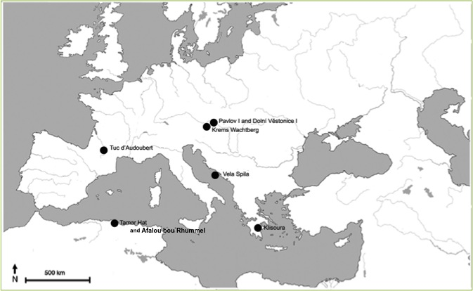
Figure 1. Map of the major Upper Palaeolithic sites with unfired clay and fired ceramic technologies across Europe and North Africa.

3. Case Study I: Pavlovian Ceramics
3.1 Pavlovian Art and Archaeology
The aesthetic character of Pavlovian art, including Pavlovian ceramics, has been well-researched and widely-discussed in publications over the past century (see recent contributions from Verpoorte 2001, Bougard 2010, Farbstein 2010, 2011). We highlight here the unique social and environment context supporting the production of the ceramic artefacts, which number more than 10,000 pieces across the sites in the Pavlov Hills (southern Moravia), with a particular concentration of finds at Dolní Věstonice I (hereafter DV I) and Pavlov I. These large archaeological sites are thought to be have been locations of repeated, intensive occupation in the landscape, where hunter-gatherers congregated on a seasonal or annual basis (Svoboda, Ložek and Vlček 1996). The repeated occupation of these sites is evidenced in numerous ways, one of which is the structured, multi-layer hearths found at the large sites of DV I, DV II, and Pavlov I, which demonstrate that people returned to these places in the landscape over the course of several millennia. These same hearths that demonstrate the punctuated and repeated occupation of this hillside are also where tens of thousands of ceramic artefacts and figurines were found. Conkey’s (1980) seminal research on the aggregation site of Altamira proposed that at places in the landscape where nomadic populations periodically gathered together, this population influx encouraged a spike in creativity and innovative behaviour. Following her hypotheses, we suggest that the large Pavlovian sites might have been similar aggregation sites that fostered exceptional creativity and innovation; these innovations included the production of the first ceramic artefacts and the appropriation of this material to make portable art.

The Pavlov Hills seem to have been a particularly significant locale within the broader Central European Gravettian landscape, and they may have attracted hunter-gatherers for a range of reasons beyond strict subsistence. Pavlovian stone tools were often made from exotic raw materials, some of which were imported from more than 150 kilometres away in northern Czech Republic, Poland, and Slovakia (Svoboda, Ložek and Vlček 1996, 153). This behaviour demonstrates a collectively-shared motivation both to acquire specific raw materials from distant locations and, furthermore, to transport them to settlement sites in the Pavlov Hills. While other locations in the landscape may have been valued due to the availability of high quality flints and radiolarites nearby, the Pavlov Hills remained attractive living sites for other reasons, some of which might relate to more enigmatic, social attributions of importance. The use of local organic raw materials, specifically mammoth ivory, animal bones and teeth, and reindeer antler (García-Diez 2005), to make art and personal ornaments may hint at the social significance of these locations in the Pavlov Hills. The predominance of local raw materials to make “symbolic” Pavlovian artefacts stands in sharp contrast to assertions advanced by Gamble (1999, 95) that within nomadic hunter-gatherer societies, the value of a raw material is often directly related to the distance it travels from source to settlement site. In the Pavlovian context, the value of local raw materials might have been connected, in part, to their association with a socially significant location in the landscape. Alternatively, the tools, techniques, time, and specialized skills involved in the production of art in these materials may have invested them with elevated meaning, highlighting how processes of manufacture can be as important as the final appearance of art.

3.2 Using chaîne opératoire to study Pavlovian ceramics
Many of the methodologies traditionally used to study Palaeolithic portable art focus on interpreting the superficial, iconographic characteristics of the most complete and recognizable figurines. These approaches are unsuitable for studying Palaeolithic ceramic figurines because of their largely ambiguous iconographic character; most Palaeolithic ceramics cannot be securely attributed to a specific subject matter or aesthetic style. The aesthetically ambiguous character of Pavlovian ceramics is another source of support for the notion that the final appearance of these figurines may not have been the primary locus of meaning to their makers. Furthermore, even the largest assemblages are poorly preserved, and almost every artefact is highly fragmented. Archaeological methodologies typically used to study non-artistic material culture may prove to be a more helpful way of approaching these datasets. One of the most appropriate and transferable of these methodologies is chaîne opératoire, which has historically been used to study lithic assemblages (although for noteworthy applications of chaîne opératoire to study of symbolic material culture, see Farbstein 2010, 2011, White 1993, 1997). Developed by Leroi-Gourhan in the 1960s (see Leroi-Gourhan 1964 and Schanger 1994), chaîne opératoire analysis facilitates quantitative understanding of the stages involved in the production of a class of material culture or of a single object, from the acquisition of the raw material, through its transportation, modification, use, damage, and eventual discard. The methodology lends itself to high-resolution, quantitative analytical methodologies. In this paper we employ macro- and micro-scopic analyses of entire ceramic assemblages alongside micro-CT scanning of a selected sub-assemblage of artefacts to gain invaluable and previously-inaccessible insight into the early stages of Palaeolithic ceramic production.

Importantly, chaîne opératoire can also be used to glean more qualitative and socially-contextualised information, which expands our analyses of these assemblages beyond strictly technological or material considerations. For instance, the time and labour involved in transporting a raw material from its source to the manufacturing site might imply social cooperation and a collective valuing of that material or the objects that could be made from it. Furthermore, if a group of artefacts was made in a similar way, using the same suite of tools and gestures, we might infer the development of a ‘technological style’ (following Lemonnier 1993).
Dobres (2000) demonstrated the potential of chaîne opératoire for revealing a suite of social choices implied by the use of various techniques for making Magdalenian bone and antler tools and artefacts, and our research on Palaeolithic ceramics aims to contribute another perspective in this field of research.

The first step in Pavlovian ceramic chaînes opératoires was the acquisition of the raw material, a loess-based sediment that was locally availability within the Pavlov Hills. Past research (Vandiver et al.. 1989) demonstrated that the loess sediment was mixed with water to form a paste. We amend their observations by noting that it was also possible the loess was collected from the nearby bank of the Dyje River, in which case it would have been wet. Craftspeople might have then added additional water or waited for the loess to partially dry until it reached the ideal consistency for manipulating. This paste was modeled into various shapes using hands. Soffer and Vandiver (1994, 1997, 2005) and Soffer et al. (1993) highlighted the importance of so-called ‘additive’ production sequences in which body parts (e.g. body torsos, limbs, heads, etc) were made as separate components before being combined together to create the complete figurine. However, our research has highlighted the importance of other, non-additive manufacturing sequences, in which the entire figurine was made as one unit, with appendages being pitched or pulled out from a core form (see Farbstein and Davies 2015). In some instances, both additively and non-additively formed figurines were engraved using a variety of tools, including bone and stone points as well as more ad hoc tools, such as twigs or sticks. Many Pavlovian ceramics show evidence of firing at a range of temperatures, which Soffer and colleagues identified as largely between 300-800 C (Vandiver et al. 1989, Soffer and Vandiver 1994). However, some are very soft and were probably dried without direct exposure to fire. Their preservation is fortuitous and they demonstrate that the final step in production was not always intentional firing in a heart. (Figure 2)
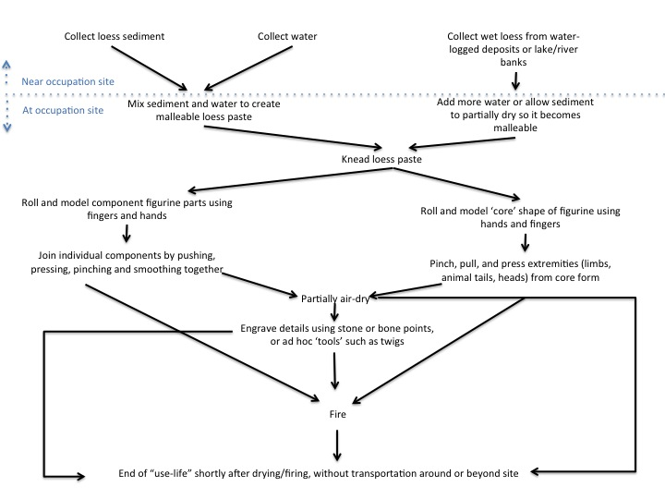
NEW FIGURE 2. Pavlovian ceramic chaînes opératoires

3.3 Micro-CT scans of Pavlovian ceramics
Soffer, Vandiver, and colleagues conducted some of the earliest quantitative and scientifically rigorous analyses of Pavlovian ceramics in the 1980s and 1990s (Vandiver et al. 1989, Soffer et al. 1993, Soffer and Vandiver 1994, 1997, 2005). However, much of their detailed research focused on later stages in the production of ceramics, particularly firing temperatures and firing conditions. Through a series of experiments, they determined that most ceramics were fired between c. 300-800° C (Soffer and Vandiver 1994). Our efforts have focused on recovering detailed and nuanced information about the earlier stages of ceramic production, before firing, specifically material preparation and manipulation during the forming of a figurine or non-figurative ceramic artefact. The plastic nature of loess paste allows a multitude of constructive methods to be used (e.g. pinching out vs. combination of components), and decisions can be enacted quickly; such options are more restricted for materials such as bone, antler, ivory and stone. Traditional thin-section petrography of ceramics is not permissible when working with the rare Palaeolithic ceramic assemblages, but non-destructive micro-CT scanning creates imagery of ‘slices’ through the internal structure of these artefacts, revealing differences in density that help determine the material heterogeneity and composition of these artefacts. This imagery can be used to build a more quantitative and nuanced understanding about the early stages of production, including material selection, material preparation (for instance sieving or tempering), and material manipulation (as gestures such as rolling, pinching, and pulling can sometimes be inferred through the internal structure of folds and fissures in an artefact. Full details and results of our scans are reported in Farbstein et al. (in prep). However, we summarise here that the micro-CT scans of Pavlovian ceramic pellets from DV I, performed in the mu-VIS laboratory at University of Southampton, do not appear to have been prepared by adding a temper or removing particularly large inclusions. (ADD IMAGE) Furthermore, a diverse suite of gestures indicative of working wet ceramic paste between one’s hands, including rolling, pressing, folding, and pinching are evident across the sample of six artefacts from DV I. These gestures, visible on micro-CT scanning, reinforce and support the diverse repertoire of chaînes opératoires we noted through more traditional macro- and micro-scopic analysis (see Farbstein and Davies 2015). The broad characterisation of ceramic production as primarily “additive,” as originally described by Soffer and Vandiver (1994), can now be more refined to include a range of means of engagement with this material. The micro-CT scans confirm our previous research that demonstrated that in addition to the ‘additive’ Pavlovian ceramic operational sequences, Pavlovian ceramicists also “extracted” shapes through pinching and pulling gestures that resulted in the formation of small appendages such as ears or stylistically shortened limbs and extremities.

3.4 Experimentation and Playful Production
Farbstein’s (2010, 2011) chaîne opératoire analysis of ivory, bone, and antler figurative and non-figurative art from the key Pavlovian sites of DV I and II, Pavlov I, and Předmostí repeatedly uncovered patterns that demonstrate the development of normative ‘technological styles’ that seem to have provided parameters not just for the final appearance of organic art, but also for the stages of manufacture, tools employed, and gestures used in making these forms of art. At Pavlov I, sheets or flakes of ivory, called lamellae, were repeatedly used to make flat ‘silhouette’ figurines, such as the famous lion and mammoth figurines, as well as non-representational ornaments, such as the numerous elaborately carved and engraved ‘diadems’ found at the same site (Farbstein 2010). The gestures craftspeople use when making art are particularly important points of reference because they relate to Marcel Mauss’ (1934) “techniques du corps” or culturally-variable, learned and prescribed bodily behaviours and gestures.

In comparison to the organic art found at the same sites, Pavlovian ceramic figurines and non-representational artefacts do not seem to have been subjected to such a strict repertoire of normative gestures or techniques du corps. More diversity, experimentation, flexibility, and individuality seem to have been not just tolerated but even encouraged when working with loess paste. At the sites with the two largest ceramic assemblages (DV I and Pavlov I), there are several identifiable series or groups of artefacts that depict a similar subject matter. Four ceramic animal heads (interpreted as “rhinoceros” heads) from Pavlov I are one noteworthy example of this type of iconographic ‘group‘ (Figure 3).
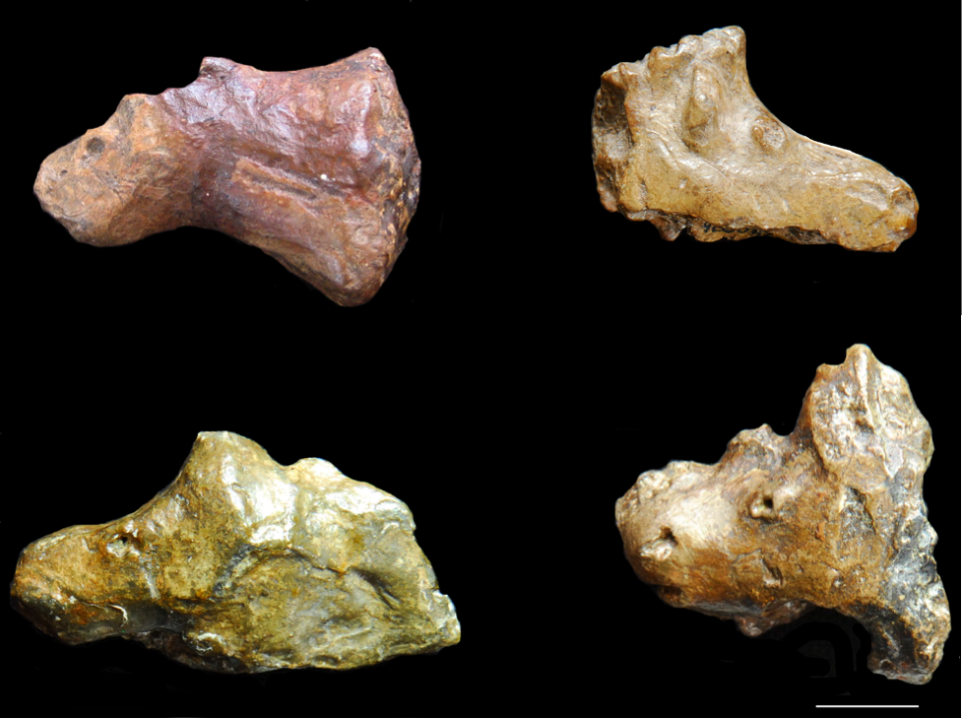
Figure 3. Four ceramic “rhinoceros” heads from Pavlov I. Scale bar is 1 cm.

Our contemporary inclination to ‘group’ figurines as related because they depict a similar subject and because they were made in the same raw material seems to have led past researchers to overlook the diverse array of ways they were made. If these artefacts were made in ivory, we would expect them to be much more uniform, both in their chaîne opératoires and techniques and tools of manufacture, as well as in their final aesthetic appearance. However, the ceramic figurine fragments display a large degree of experimentation in all aspects. For instance, the way the artist or artists made the eyes on each figurine is unique. Some are very superficially engraved, others are more deeply carved, while others are made by deeply puncturing or even fully perforating the material. One figurine features an eye that stands in low relief above the rest of the head, demonstrating it was added as a separate component. These differences imply not just a diverse suite of different types of tools employed during manufacture, but also distinct bodily gestures that were employed and allowed. On one lion head from DV I, the two eyes were actually made in different ways, demonstrating a degree of experimentation and diversity not witnessed in the assemblages of art made in organic raw materials (Figure 4). In this instance, a desire to experiment with different ways of making and expressing a lion’s eye seems to have trumped any concerns with naturalism or aesthetic uniformity across the figurine. This degree of diversity on a ceramic artefact is particularly instructive because of the temporal parameters on working with wet ceramic paste. The eye made by deeply puncturing the surface preserves a large and visible burr along its periphery, which suggests it was made when the paste was still quite wet. However, the other eye was made by much more superficially engraving the surface, and microscopic analysis reveals a smoother periphery to this mark, lacking such a pronounced burr, suggesting the paste may have been drier when the craftsperson executed this engraving. Thus, we might infer a temporal order for these marks, with the deeply-gouged or punctured eye being made first, and the more finely-engraved eye being made second, when the loess paste was less wet. The great degree of variability in the production of ceramic figurines of the same subject matter suggests that Pavlovian craftspeople working in this innovative material placed primary value on the opportunity to experiment in these stages of production. This offers a sharp contrast to the apparent socio-technical interest in uniformity, seriation and consistency in the production of ivory art at the same sites. The introduction of this new material may have spurred a new set of socio-artistic priorities, values, and interests.
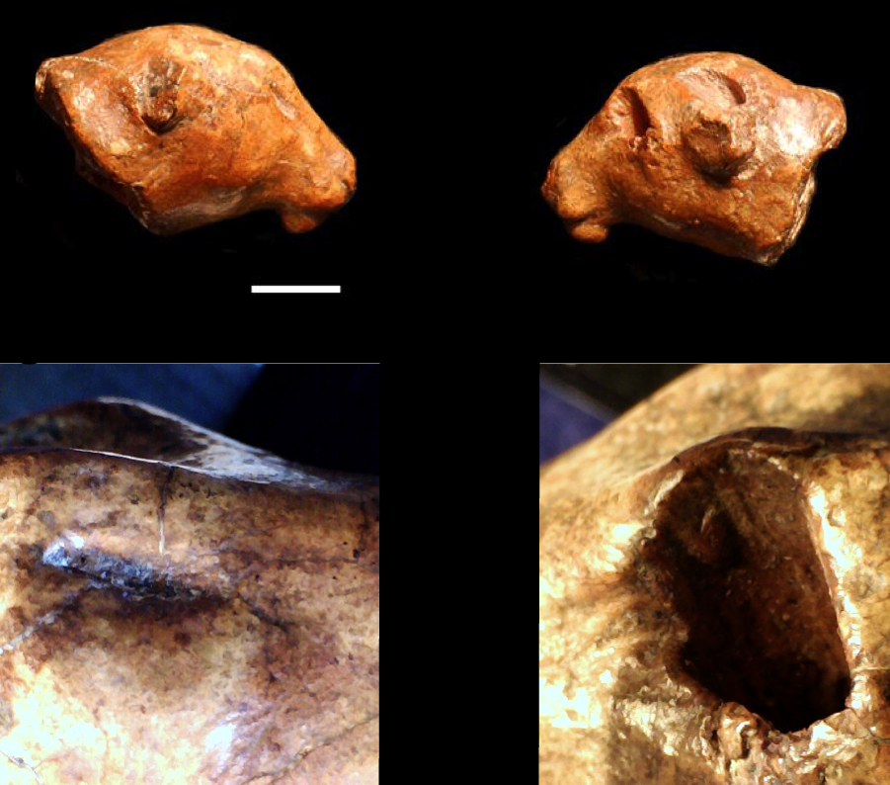
Figure 4. Macroscopic photos of two faces of a ceramic lion head from DV I (DV 23) (above). Below, microscopic photos (40x magnification) of the two eyes, showing differences in how they were made.

3.5 The impact of the material innovation on Pavlovian artistic expression
The use of ceramic seems to have facilitated new forms and styles of aesthetic expression in the Pavlovian artistic oeuvre. Ivory figurines, made by carving or “reducing” a shape from a larger mammoth tusk or lamella of ivory, would have been challenging to make; throughout their chaînes opératoires there were many points at which the figurine could have fractured or fragmented. If this happened, the artist could not have easily salvaged the figurine or re-used the material. They would have had to start again with a new piece of ivory. The combination of the time, difficulty, and technical skill involved in carving ivory, combined with the risk of breaking it through the process of carving, may have contributed to the development of one of the more persistent ‘technical styles’ in Pavlovian ivory representational art: consolidated limbs. On zoomorphic figurines, four limbs were often expressed as two appendages, as on the famous lion ‘silhouette’ from Pavlov I (Figure 5). 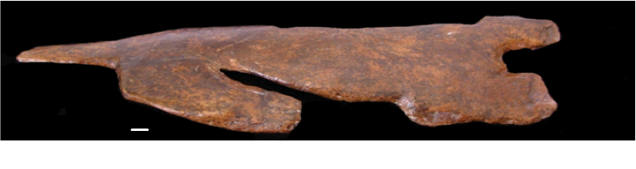

Figure 5. The ivory lion “silhouette” from Pavlov I. Scale bar is 1 cm.

A variant of this technical style is apparent on the similar ivory mammoth silhouette from the same site: the craftsperson consolidated the four limbs into two appendages; distinct fore-limbs and hind-limbs were stylistically differentiated by the presence of engraved lines (Figure 6). This convention is clever as it gives the aesthetic impression of four limbs without the risk of breaking the figurine by carving four fragile extremities.
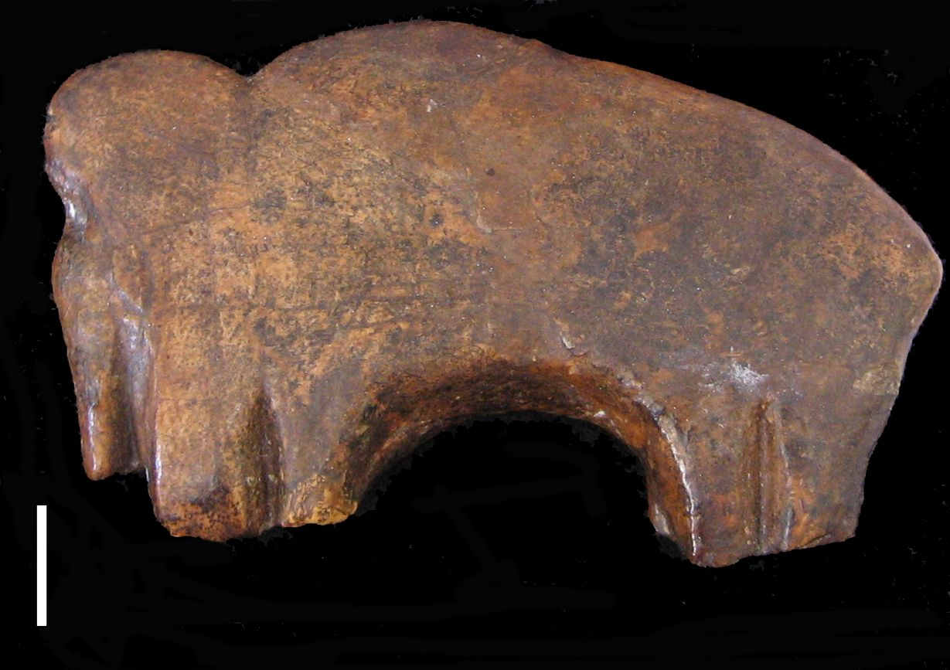
Figure 6. An ivory mammoth ‘silhouette’ from Pavlov I. Scale bar is 1 cm.

Ceramic figurines display a diverse range of both stylistic and technical conventions for building and expressing body parts and limbs. Some ceramic animal and human figurines retain the representational convention developed in ivory of consolidating or compressing limbs together. Sometimes two limbs were modeled as a single unit, with no visual distinction between the legs (Figure 7).
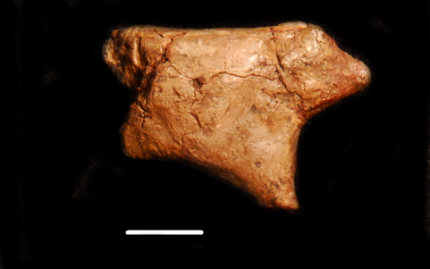
Figure 7. A ceramic zoomorphic figurine from DV I (DV 44), whose forelimbs were physically and aesthetically consolidated as a single unit. Scale bar is 1 cm.

In other instances, limbs were physically-consolidated but visually-differentiated by an engraved mark, similar to the ivory mammoth from Pavlov I. The DV I Venus (Figure 8) is a prime example of this, as her legs were modeled as a single unit but visually distinguished by one vertical engraving.

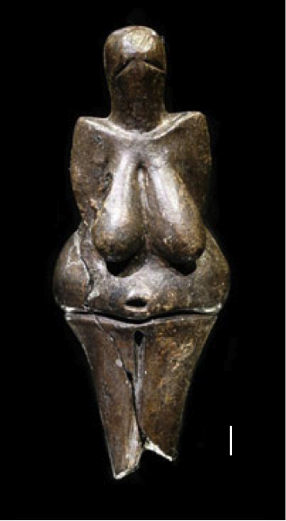
Figure 8. The famous Venus from Dolní Věstonice I, whose legs were formed as a single appendage. The two legs are aesthetically differentiated by the presence of a single, deeply carved, U-shaped vertical line. Scale bar is 1 cm.

In another variant still, limbs were made separately and then pressed together while the loess was still wet, possibly to impart more structural stability to the final figurine (Figure 9).
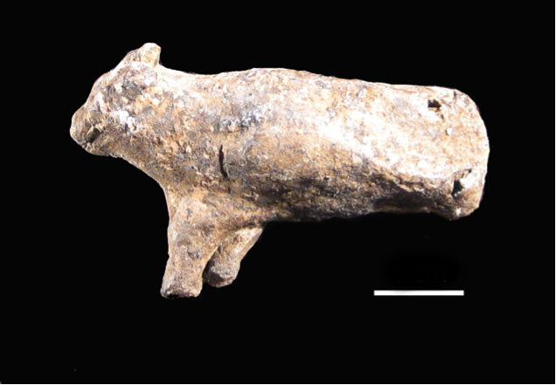
Figure 9. A zoomorphic ceramic figurine from DV I (DV 33), whose forelimbs were made separately but subsequently conjoined, possibly to impart more structural stability to the fragile appendages. Scale bar is 1 cm.

However, the prevailing convention when making body parts in ceramic was to model each limb separately, which had the potential to impart a greater impression of naturalism and less stylisation with regards to this aspect of expression. More than 70% of the figurines at the two largest sites of DV I and Pavlov I depict limbs in this way (Tables 1 and 2).

Table 1. Construction and Expression of Ceramic Limbs at DV I
Type of construction and expression | Number of artefacts | Percentage of the assemblage
Limbs modelled separately | 62 | 72%
Limbs modelled separately and later conjoined | 14 | 16%
Limbs physically consolidated | 5 | 6%
Limbs physically consolidated but visually differentiated | 5 | 6%

Table 2. Construction and Expression of Ceramic Limbs at Pavlov I
Type of construction and expression | Number of artefacts | Percentage of the assemblage
Limbs modelled separately | 39 | 70%
Limbs modelled separately and later conjoined | 11 | 20%
Limbs physically consolidated | 4 | 7%
Limbs physically consolidated but visually differentiated | 2 | 3%

In this instance, it seems reasonable to assert that the ceramic technological and material innovation facilitated and influenced this aesthetic and iconographic innovation in artistic expression.

4. Case Study II: Epigravettian ceramics from Vela Spila, Croatia
4.1 The archaeological context at Vela Spila
Pavlovian ceramic technologies spread across Moravia and Austria and seem to have persisted until the end of the early Gravettian in the region. Ceramic artefacts have not been found in late Gravettian or “Willendorf-Kostenkian” archaeological horizons at sites in the region, suggesting this technology was either abandoned or forgotten in the region by c. 24,000 cal BP. However, almost 10,000 years after the last ceramic artefacts were found in Central Europe, there is evidence of a similar technology developing more than 1,000 kilometres south of the Pavlov Hills, in the cave site of Vela Spila, on Korčula Island (Croatia) (Farbstein et al. 2012). To date, 45 ceramic artefacts, fragments, and more complete figurines have been found across several archaeological horizons in the site, with dates between c. 17,500 and 15,000 cal BP. These horizons have a typical Epigravettian character, with lithic blade technologies, finely made bone points, and a zooarchaeological assemblage that is dominated by horses and other mid-large sized herbivores (see Farbstein et al. 2012).

4.2 Reconstructing ceramic chaînes opératoires for the assemblage from Vela Spila
When viewed from a broad-brush perspective, the Vela Spila ceramics seem superficially quite similar to the Pavlovian assemblages from Moravia. The artefacts are a similar size (generally 2-3 centimetres in maximum dimension) and shape (cylindrical, conical, and domed shapes dominate) to the Pavlovian ceramics. Although only two representational ceramic figurine fragments have been uncovered at Vela Spila, this is a similar proportion of the overall ceramic assemblage to the large sites of DV I and Pavlov I. 4% of the ceramics at Vela Spila are representational, which is consistent with the roughly 4% of the DV I and Pavlov I ceramic assemblages that are either clearly figurative or very heavily worked/manipulated. More robust comparisons and points of contrast to the Pavlovian ceramics are only revealed through detailed chaînes opératoires analyses.

The first important difference between the Pavlovian ceramics and those from Vela Spila is in the raw material. Loess was not the predominant sediment in the coastal Balkans. Instead, the Epigravettian ceramics from the site were likely made using the sediment collected within or immediately adjacent to the cave itself. Within the cave, the sedimentary character of the archaeological horizons have been described as “gravely-sandy silts” with some more clay-rich lenses(see Pavicic, Mileusnic, and Radic 2009). Like at the Pavlovian sites, this sediment was probably made more malleable by either adding water to the sediment or allowing water-logged sediments to partially dry before kneading.

Additive, or building, chaînes opératoires are prevalent across the Vela Spila assemblage. Perhaps because the assemblage is smaller than the Pavlovian ones, there is not as much evidence of the non-additive production sequences that relied on pulling, pinching, or ‘extracting’ body parts from a core form. However, like the Pavlovian ceramics, a range of tools, including lithic and bone points (see Farbstein et al. 2012), were used to engrave the surfaces of the two most complete figurine fragments.

4.3 Inferring ceramic life histories at Vela Spila
However, it is the context within which these ceramic technologies were uncovered that offers the most compelling evidence that the Vela Spila assemblage is probably a distinct iteration of a similar material development. While Pavlovian ceramics were found in close spatial association with large, stratified hearths (see Soffer et al. 1993), ceramics were more broadly distributed across the site at Vela Spila, and were never found within or on the immediate periphery of combustion features inside the cave. This suggests that the ceramics were probably removed from the hearths in which they were fired and used, viewed, or circulated at least within the confines of this site. This behaviour represents a departure from the prevailing hypotheses about Pavlovian ceramics that most of the artefacts were never removed from the hearths in which they were fired. By extension, Pavlovian ceramics could be interpreted as having a life history that was not built around their final appearance, whereas ceramics from Vela Spila may have been made to be viewed, handled, or used to a greater degree.

4.4 The artistic impact of ceramic innovation in the Balkans
Furthermore, the artistic and aesthetic impact of this material innovation was considerable at Vela Spila. Across the Balkans, in all other Epigravettian contexts, artistic and ornamental material culture was exclusively non-representational. Perforated red deer canines and marine shells similar to those found at Vela Spila were also excavated from contemporaneous sites elsewhere in the region (see Cristiani, Farbstein and Miracle 2014), but the first and only evidence of representational art in the region is the two most complete ceramic figurines from Vela Spila. The first, which probably represents a deer or horse (“VS C1”, Figure 10), was made additively, with limbs, apparently formed by rolling, added to the torso using pinching and pressing actions. A round, precisely formed hole placed at the anatomical position of the anus, was made using a bone tool (see Farbstein et al. 2012). The other representational fragment might be the hindquarters of another animal (“VS C2”, Figure 11). This fragment preserves V-shaped incisions across most of its surfaces which were made with a stone point. The fragment also preserves a range of other marks, included a wider, U-shaped engraving that might be an aesthetic demarcation of the division between two hindlimbs (see Farbstein et al. 2012). These two fragments offer a tantalizing glimpse into the range of ways ceramicists at Vela Spila were experimenting with and exploring the possibilities of making representational art in this new material. Thus, the introduction of a new raw material, and the affordances it offered in terms of creativity and art production, may have been the impetus necessary for artists at Vela Spila to create the first representational art in the region.

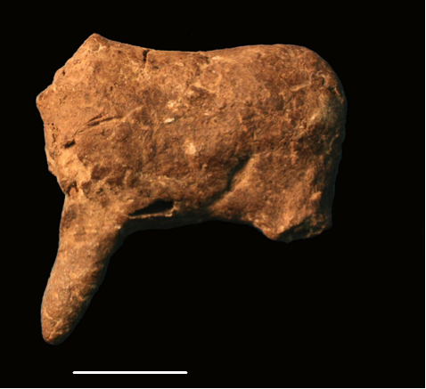Figure 10. The “C1” zoomorphic figurine from Vela Spila. Scale bar is 1 cm.
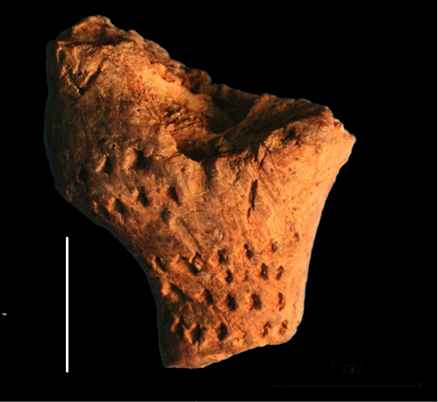
Figure 11. The C2 figurine fragment from Vela Spila. Scale bar is 1 cm.

5. Conclusions: From Origins to Impact, From Superficial to Substantive
Palaeolithic ceramic materials and technologies were embedded in complex social and artistic contexts. These contexts offer a more rigorous platform for analysis and comparison than the final aesthetic character of a handful of iconographically recognisable and relatively complete ‘figurines,’ especially if we accept that some of these artefacts (e.g. the Pavlovian ceramics) were not made with the primary aim of being viewed because many never left the hearths in which they were fired (following Soffer et al. 1993). Rather than tracing exclusively the “origins” of this innovation, our research uncovers the impetuses for adopting this technology and the impact of the innovation. Our results suggest that ceramic craftspeople had unique impetuses for the production of ceramic artefacts at the two key locations discussed in this paper. At Pavlovian sites, the flexibility and freedom afforded by working with ceramics may have been appealing, especially in comparison to the established technologies of carving and engraving ivory, bone, and antler in manufacturing sequences that were both time and labour intensive, and which required a great deal of care to avoid mistakes that would have been temporally, materially, and, potentially, socially costly to correct. At Vela Spila, the technological innovation may have been the primary impetus for the first artistic explorations with representational art. In both contexts, it is particularly interesting that the ceramic material was never used to make functional vessels or pottery, suggesting there was either no perceived need for such material culture, and/or that these societies ascribed this material with strictly artistic meanings.

More broadly, this research demonstrates the limits of the traditional aesthetic and iconographical foci that are often used to study Palaeolithic art. If we restricted our analyses to the superficial qualities related to the appearance of the most iconographically striking and physically complete ‘figurines,’ much of the true diversity and evidence of experimentation apparent across the broader ceramic assemblages would be overlooked. A more contextualized approach, similar to that employed in this paper, which uses methodologies that can recover both quantitative data and more qualitative interpretations, has a greater potential to reveal new insights about these important but enigmatic assemblages.

Acknowledgements
We are grateful to the Leverhulme Trust Project Grant RGP - 2013-073 for funding this research from 2013-2016. We are further grateful to Martin Oliva (Moravian National Museum, Brno) and Jiri Svoboda (Institute of Archaeology, Dolni Vestonice) for facilitating our research and allowing us to reproduce the images of Pavlovian figurines included in this paper. We are grateful to Dinko Radic (Cultural Centre, Vela Luka), Jadranka Lednaric (Institute of Arts and Science, Zagreb), and Preston T. Miracle (University of Cambridge), for facilitating our research in Croatia.

References
Begouën, R., Fritz, C., Tosello, G., 2012. Parietal art and archaeological context: activites of the Magdalenians in the cave of Tuc d’Audoubert, France. In: McDonald, J., Veth, P. (Eds.), A Companion to Rock Art. Wiley, New Jersey, pp. 364-380.

Bougard, E. J., 2010. The use of clay in the Upper Palaeolithic of Europe: symbolic applications of a material. BAR International Series 2069, Oxford.

Conkey, M., 1980. The identification of prehistoric hunter-gatherer aggregation sites: the case of Altamira. Current Anthropology 21 (5): 609-630.

Cristiani, E., Farbstein, R., Miracle, P. T., 2014. Ornamental traditions in the Eastern Adriatic: Upper Palaeolithic and Mesolithic personal adornments from Vela Spila (Croatia). Journal of Anthropological Archaeology 36: 21-31.

Darvill, T., 2002. The Concise Oxford Dictionary of Archaeology. Oxford, Oxford University Press.

Dobres, M.-A., 2000. Technology and Social Agency. Blackwell, New York.

Farbstein, R., 2010. The significance of social gestures and technologies of embellishment in Paleolithic portable art. Journal of Archaeological Method and Theory 18 (2): 125-146.

Farbstein, R., 2011. Technologies of art: a critical reassessment of Pavlovian art and society, using chaine operatoire method and theory. Current Anthropology 52 (3): 401-432.

Farbstein, R., Radic, D., Brajkovic, D., Miracle, P. T., 2012. First Epigravettian ceramic figurines from Europe (Vela Spila, Croatia). PLoS ONE 7 (7): e41437. doi: 10.1371/journal.pone.0041437

Farbstein, R. A., Davies, W., 2015. Rediscovering Paleolithic art: overlooked ceramic figurines from the Pavlovian. In: Sazelova, S., Novak, M., Mizerova, A. (Eds.), Forgotten Times and Spaces: new perspectives in paleoanthropological, paleoetnological and archeological studies. Institute of Archaeology of the CAS, Brno and Mazaryk University, Brno, pp. 328-339.

Gamble, C., 1999. The Palaeolithic Societies of Europe. Cambridge University Press, Cambridge.

García-Diez, M., 2005. Decorative patterns on the organic objects. In: Svoboda, J. (Ed.), Pavlov I Southeast: a window into the Gravettian Lifestyles. Academy of Sciences of the Czech Republic, Institute of Archaeology at Brno, Polish Academy of Sciences, Institute of Systematics and Evolution of Animals, Brno, pp. 309-373.

Hachi, S., 2003. Aux origins des arts premiers en Afrique du Nord: les figurines et les objets modeles en terre cuite de l’abri-sous-roche prehistorique d’Afalou Babors, Algerie (18000-11000 ans BP). Centre national de recherches prehistoriques, anthropologiques et historiques, Algiers.

Jordan, P., Zvelebil, M., 2009. Ceramics before Farming: the dispersal of pottery among prehistoric Eurasian hunter-gatherers. Walnut Creek (CA), Left Coast Press.

Karkanas, P., Koumouzelis, M., Kozlowski, J. K. , Sitlivy, V., Sobczyk, K., Berna, F., Weine, S., 2004. The earliest evidence for clay hearths: Aurignacian features in Klisoura Cave southern Greece. Antiquity 78 (301): 513-25.

Lemonnier, P., 1993. Introduction. In: Lemonnier, P. (Ed.), Technological Choices: transformation in material cultures since the Neolithic. Routledge, New York, pp. 1-35.

Leroi-Gourhan, A., 1964. La Geste et La Parole I: technique et langage. Biblioteque Albin Michel Sciences, Paris.

Mauss, M., 1934. Les techniques du corps. Journal da Psychologie 32 (3-4).

Pavicic, L. J., Mileusnic, M., Radic, D. 2009. Pleistocene and Holocene sediments in Vela Spila Cave, Croatia
Saxon, E., 1976. Pre-Neolithic pottery: new evidence from North Africa. Proceedings of the Prehistoric Society 42: 327-329.

Schlanger, N., 1994. Mindful technology: unleashing the chaine operatoire for an archaeology of mind. In: Renfrew, C., Zubrow, E. B. W. (Eds.), The Ancient Mind: elements of cognitive archaeology. Cambridge University Press, Cambridge, pp. 143-151.

Soffer, O., Vandiver, P., Klima, B., Svoboda, J.,1993. The pyrotechnology of performance art: Moravian Venuses and wolverines. In: Knecht, H., Pike-Tay, A., White, R. (Eds.), Before Lascaux: the complex record of the Early Upper Paleolithic. CRC Press, Boca Raton, FL, pp. 259-275.

Soffer, O., Vandiver, P., 1994. The ceramics. In: Svoboda, J. (Ed.), Pavlov I: excavations 1952-53. Etudes et Recherches Archeologiques de l’Universite de Liege, Liege, pp. 163-173.

Soffer, O., Vandiver, P., 1997. The ceramics from Pavlov I-1857 excavation. In: Svoboda, J. (Ed.), Pavlov I Northwest: the Upper Paleolithic burial and its settlement context. Academy of Sciences of the Czech Republic, Brno, pp. 383-401.

Soffer, O., Vandiver, P., 2005. Ceramic fragments. In: Svoboda, J. (Ed.), Pavlov I Southeast: a window into the Gravettian Lifestyles. Academy of Sciences of the Czech Republic, Institute of Archaeology at Brno, Polish Academy of Sciences, Institute of Systematics and Evolution of Animals, Brno, pp. 415-431.

Svoboda, J., Ložek, V., Vlček, E., 1996. Hunters between East and West: the Paleolithic of Moravia. Springer, New York.

Vandiver, P., Soffer, O., Klima, B., Svoboda, J., 1989. The origins of ceramic technology at Dolni Vestonice, Czechoslovakia. Science 246 (4933): 1002-1008.

Vandiver, P., Vasil’ev, S.A., 2002. A 16,000 year old ceramic figurine from Maina, Russia. MRS Proceedings 712: II6-119.

Verpoorte, A., 2001. Places of art, traces of fire: a contextual approach to anthropomorphic figurines in the Pavlovian. Faculty of Archaeology, University of Leiden, Leiden.

White, R., 1993. Technological and social dimensions of “Aurignacian-age” body ornaments across Europe. In: Knecht, H., Pike-Tay, A., White, R. (Eds.), Before Lascaux: the complex record of the Early Upper Paleolithic. CRC Press, Boca Raton, FL, pp. 277-299.

White, R., 1997. Substantial acts: from materials to meaning in Upper Paleolithic representation. In: Conkey, M., Soffer, O., Stratmann, D., Jablonski, N. (Eds.), Beyond art: Pleistocene image and symbol. The California Academy of Sciences, Berkeley, CA, pp. 93-121.

Zheltova, M., Yanshina, O., 2015. “Ceramics” and pigments of Kostienki-1 site (Russia): research results and perspectives. In: Sazelova, S., Novak, M., Mizerova, A. (Eds.), Forgotten Times and Spaces: new perspectives in paleoanthropological, paleoetnological and archeological studies. Institute of Archaeology of the CAS, Brno and Mazaryk University, Brno, pp. 340-346.

