Running Head: Orientation within a nested virtual environment
Title: Factors influencing orientation within a nested virtual environment: External cues, Active Exploration and Familiarity
Abstract
Three experiments using a spatial orientation task within a computer generated building examined the factors influencing maintenance of orientation to an external frame of reference within a nested environment. Having explored the outside and inside of a virtual building, participants were placed in 4 different rooms which had either external or internal views, and were either novel of previously visited. Participants were asked to face in the direction of a non-visible external cue. In Experiment 1 there were less orientation errors in external rooms and in internal rooms which had been visited. In order to assess the importance of active exploration of the environment and explicit instructions, participants in Experiment 2 were shown a video of the route taken around and through the building. Participants were again able to maintain orientation to non-visible external cues if they had previously visited the room. Participants in Experiments 1 and 2 were current students with experience of the building on which the computer model was based. In Experiment 3, participants were visitors with no experience of the building. Participants that were shown a video of the route were able to maintain orientation in the external rooms but not in the internal visited room. Results suggest that maintaining orientation to an external frame of reference within a nested environment requires either access to part of the frame of reference or active exploration. Without previous familiarity with the environment passive exposure was not sufficient to maintain orientation within the building.
Key words: Spatial orientation task; nested environment; frames of reference; active exploration

As we move through an environment, our egocentric relationship with the environment constantly changes. If an individual experiences, or perceives motion, they are required to reorient themselves via the use of constant static cues relative to their previous location. This process of reorientation is referred to as spatial updating (Reiser, 1989). For example if an individual is sitting facing a computer and turns to the right to answer the door, the computer is now on the individual’s left. Evidence suggests that spatial updating is an automatic cognitive process (Reiser, 1989; Farrell & Robertson, 1998; Wang, 2004) which operates to ensure that an individual’s egocentric reference matches their current alignment. Wan, Wang and Crowell (2009) showed when stimuli are presented via a VR headset (display for each eye had a resolution of 800 (horizontal) 600 (vertical) pixels. The optical field of view for each eye being 26º diagonal) and when physically moved participants were still able to spatially update their position with reference to the VR environment. Within traditional real world environments, spatial updating acts to ensure that individuals retain knowledge of their local environment, do not collide with near objects as they move and enables the tracking of distant targets. Visual cues are not, however, required for automatic spatial updating, with blindfolded participants being highly accurate at spatial updating tasks (Farrell & Robertson, 1998). Evidence suggests that vestibular and proprioceptive information are central in enabling accurate spatial updating processes to occur (Lackner & DiZio, 2005). Lackner and DiZio (2005) argue that in situations where visual information is available, it acts to reinforce and support vestibular information, available from a variety of sources, including body position and ocular muscle positioning, rather than being the primary driver of this information.
Vestibular and other body movement cues are not, however, available when examining digital spaces, consequently tracking object locations within such spaces is potentially a greater challenge than within the real world. Indeed, Witmer, Bailey, Knerr, and Parsons (1996) demonstrated that the acquisition of survey knowledge and orientation accuracy is reduced within digital compared to real world environments. Individuals must rely on visual cues to track changes in digital environments (Hartley, Trinkler & Burgess, 2004).
Riecke, Cunningham and Bulthoff (2007) explored the sufficiency of visual cues for spatial updating when exploring within a virtual environment. Using a pointing paradigm, participants were seated within a motion platform, and witnessed a tour of a city. The study used a 2 X 2 mixed design, whereby participants either had or did not have access to physical motion cues provided by the platform, and either visual stimulus provided by a pre-recorded video tour of a city or matching optic flow patterns but no distinctive images and cues. Reicke et al., found that participants provided with the realistic tour of the environment were able to engage in automatic spatial updating, regardless of whether they had access to physical motion cues, suggesting that visual cues were sufficient for spatial updating.
Expanding on this work, Riecke, Sigurdarson and Milne (2012) asked participants to perform point-to-origin tasks after visually simulated excursions along streets of varying curvature in a naturalistic virtual city. The majority of the participants were able to adjust for the curve of the streets even and point correctly even though they had been stationary. These findings suggest that participants were able to update their location even within an unreal environment. However, it should be noted that a minority of participants acted as if they had not turned and other research has noted that the neuro-activity associated with navigation in the real world and virtual environment can differ (Taube, Vaelian & Yoder, 2013).
Spatial environments do not exist in isolation, but rather are part of larger spatial contexts (Wang & Brockmole, 2003a; 2003b). Real world examples of this include rooms within a building. Carlson, Holscher, Shipley and Dalton (2010) have examined the factors which make navigating through a building more. These environments are not independent of each other, movement within one aspect of the environment, for example the room within the building, changes an individual’s spatial relationship with not just their immediate environment, items within the room, but also other elements in the larger environment.
Wang and Brockmole (2003a) investigated spatial updating within nested environments, specifically, a room within a university campus. After learning the locations of key targets within both the room and the wider campus, participants were blindfolded and required to turn and face objects within either the room or the campus (turning stage). After the last trial of the turning stage all participants, whether asked to turn toward cues that were in or outside of the room, were left facing in the same direction. They were then required to point to objects both in and outside of the room. All participants were able to point accurately at the internal cues. If during the turning stage they had been asked to face external targets, then in the test stage they were able to point accurately toward the other external cues but if during the turning stage they had been asked to face toward internal cues they subsequently could not accurately point at the external cues. Wang and Brockole took this as evidence that spatial updating with respect to the external landmarks was not automatic, it required specific attention to be paid to the external array while moving. Wang and Brockmole argue that this finding suggests that each sub-environment within nested environments is updated independently rather than simultaneously as part of a gestalt whole. The room and the campus were separate spatial reference frames.
Wang and Brockmole (2003b) found further evidence that participants had difficulty orienting to targets in a different frame of reference to their current local one. In a series of studies participants were asked to find their way to the Psychology lab and then walk to a place where they could point to a building on the campus. Only when they were outside of the building were the participants able to point to the Student Union and once there they were unable to point to lab within the psychology building. As with the previous experiment the authors took the results to show that spatial updating in respect to the external reference frame was disrupted by updating in reference to the internal reference frame.
Mou and Wang (2015) pointed out there was another way to remain orientated to an occluded target, Piloting (Gallistel & Matzel, 2013). If the spatial relationship is known between a visible cue and an occluded cue then it is possible to orientate to the occluded cue. Piloting could be used to describe how rats locate submerged platforms within a watermaze once the animals have learnt the platform’s spatial relationship to the cues around the pool (Redhead, Roberts, Good & Pearce 1997) and similarly with human participants in a virtual environment (Redhead & Hamilton, 2007; Redhead, Hamilton, Wai & Allison, 2013). Contrary to Wang and Brockmole’s findings Mou and Wang (2015) demonstrated that while piloting was disrupted by switching reference frames spatial updating was not. They suggested that path integration relies on participants’ inertial cues (e.g., proprioceptive
and vestibular cues) or optical flows to calculate the moving direction and speed. Unlike piloting, it does not rely on the spatial relations between visual landmarks (e.g., Gallistel, 1990; Gallistel, & Matzel, 2013). Accordingly, path integration should not be affected by the less useful visual landmarks due to boundary crossing.
The current set of experiments uses a computer generated building to examine the factors influencing maintenance of orientation with reference to an external array of cues within a nested environment. The experiments examine the relative use of the two strategies spatial updating and piloting manipulating type of exploration and familiarity with the environment.
Experiment 1
. The environment chosen for this experiment was a virtual model of the Psychology building, and the campus of the University of Southampton displayed on a computer screen Participants’ would be expected to be familiar with this location given they were all year 2 Psychology students and had received weekly lectures in the building. Participants were asked to take note of four features of the surrounding environment; the Physics building to the West of Psychology; the Main Campus area to the North of Psychology; the Union Building to the East; the Car park to the South (see Figure 1a for diagram of the layout of the buildings and the route participants took around the Psychology building). Participants were then allowed to explore inside the building, visiting rooms which had windows with views of the external cues and views of the internal court yard (See Figure 1b layout of rooms and route).
Participants were digitally placed into four different rooms. Napieralsk et al. (2012) Used a similar teleportation procedure into positions and found participants were able to establish orientation. Room External Unvisited (EU) had not been previously visited and had a view of the Physics Building (Figure 2a). Room Internal Unvisited (IU) had not been visited and only had a view of the internal courtyard (Figure 2b). Although there was no view of the external cues other rooms within the Psychology Building were visible for example the Computer room from which the location of the Main campus could be gauged. Room External Visited (EV) had been previously visited and the window offered a view of the Union Building (Figure 2c). Room Internal Visited (IV) had been previously visited but again only offered a view of the internal courtyard and computer room (Figure 2d). In each of the rooms participants were asked to face toward one of the non-visible external cues and Orientation Error was recorded.
It would be predicted that having learnt the spatial relationship of the external cues a partial view of the external environment in the external rooms should allow participants to maintain orientation via a process of piloting in both external rooms but only spatial updating in the external room which had been previously visited (EV). A view of only the computer room within the internal environment would disrupt piloting and according to Wang and Brockmole (2003a) disrupt spatial updating with the external environment. However, having followed a path to the internal visited room (IV) Mou and Wang would predict participants would maintain orientation to the external reference frame via spatial updating.
Method
Participants
Participants were 28 psychology year 2 undergraduate students (9 males and 19 females) of University of Southampton who completed the 20 minute study in partial fulfilment of a research participation scheme. Participants were recruited via the use of a departmental recruiting system. They were between the ages of 18 and 23 (M = 20.42, SD = 1.01). As part of their studies all participants had experience of the real campus and Psychology building having 4 lectures a week in the building, but not of the computer model.
Materials and Apparatus
The study took place within a windowless research cubicle, measuring 2.4 metres in length by 1.3 metres wide, with a height of 2 metres. The cubicle contained a single desktop computer. The computer used a standard Windows 7 operating system, with keyboard and mouse, placed on a 1.3m wide desk in the centre of the rear wall. The computer was connected to three identical 15 inch LCD monitors. The monitors were placed horizontally so that the displayed image was shown continuously across all three screens.
A virtual model of the Psychology Building, University of Southampton, and its surroundings was created for this study. This model was developed by Dr Matt Jones, University of Southampton, using 3DSMax 2012. The programme placed the participants within the environment and offered a first person perspective. The model enabled participants to freely explore both the surrounding area and the third floor of the Psychology building. The remaining areas of the campus, including other buildings and additional floors within the Psychology building were not accessible. Participants controlled their movement using the “FORWARD” “LEFT” and “RIGHT” arrow keys, but could not look up or down, or interact with items within the environment. Participants were unable to use the “BACK” arrow key in order to better simulate real life movement.
Procedure
The spatial task comprised of two sets of trials, acquisition and orientation test trials. Participants completed two acquisition trials to familiarise themselves with the environmental layout. For the first acquisition trial, participants were required to explore the outside campus environment, allowing participant to see, but not enter, surrounding buildings, including the physics building and the student union. Participants were provided written instructions regarding a route to take within the environment (See Table 1 and Figure 1a for route and campus layout). As movement was controlled by the participants, they were free to divert from the suggested route if they wished to explore further. For the second acquisition trial, participants were required to enter the virtual building and to explore the third floor of the model. Participants were provided with a route to follow in order to ensure that they had visited key locations within the building and looked out of key windows (See Table 2 and Figure 1b for route and building layout).
During the Orientation test trials participants were digitally placed in 4 rooms: External Unvisited (EU); Internal Unvisited (IU); External Visited (EV); Internal Visited (IV) (See Figures 2 a-d for the views from each of the rooms). In all rooms participants were asked to turn to face one of the non-visible, but previously seen, external target cues; Car Park, Physics Building, Main Campus, and Union Building. The target cue for each room was counterbalanced across participants excluding the visible cue in the external rooms (EU Physics; EV Union). Participants were not able to leave the room during the orientation trial, however, they were free to move within the room. The instructions for the orientation trials can be seen in Table 2. The orientation trial was not timed and participants were free to take as long as they wished before pressing the TAB key to progress to the next trial. The direction in which the participant was facing at the end of each orientation trial was recorded for each orientation trial and the orientation error calculated.

Results and Discussion
Figure 3 illustrates the mean orientation error for the four rooms. For the two rooms where there was an external view (EU and EV) orientation error was low. In the previously visited internal room (IV) the orientation error was again low. Only in the internal room that had not been visited (IV) was the mean orientation error close to chance (90°). A repeated measures 2 room type (Internal x External) x 2 visit (Visited x Unvisited) analysis of variance (ANOVA) was performed using the orientation errors. There was a significant effect of room view, F(1, 27) = 31.54, p<0.000, (η_{p}² = .54) with lower orientation error in the external rooms. There was a significant effect of visit, F(1, 27) = 12.62, p=0.001, (η_{p}² = .32), with lower orientation errors in the rooms that had been visited previously. There was also an significant interaction, F(1, 27) = 6.03, p=0.021, (η_{p}² = .18). Further analysis of the simple main effects (Keppel, 1973) revealed that the effect of visit was only significant in the internal rooms, F(1, 54) = 17.14, , p<0.001, while the effect of room view was only significant in the unvisited rooms, F(1, 54) = 31.03, p<0.001.
The results suggest that participants were able to maintain their orientation in the building with respect to the external array of cues if they could see some element of the external set of cues from the external rooms (EU and EV). In the external rooms participants would be able to use piloting to locate the hidden target using the spatial relationship between the visible landmark and hidden external landmark. In room EV participants might also have been able to use spatial updating as they had already visited the room. However, there was no difference between orientation errors in EV and EU suggesting either piloting was accurate enough that there was a floor effect so spatial updating could not improve accuracy or participants were unable to use spatial updating in this environment. Evidence that participants were able to use spatial updating comes from the low orientation error in IV. There was no external cue visible so participants would not have been able to use piloting. It may be argued that the participants could use the spatial relationship between the computer room and the Main Campus to identify the correct direction of the external cue. However, the poor score in the unvisited internal room IU, where the computer was also visible but participants were not able to rely on spatial updating, would suggest that they were not able to use the internal cue to locate the external cue via piloting. The results from the internal cues taken together would suggest the participants were able to maintain orientation with the external cues via spatial updating within the internal environment. This would support the findings of Mou and Wang (2015) who demonstrated piloting was disrupted by moving between different reference frames but spatial updating was not. It must be acknowledged that another reason for the poor performance in IU might be the computer room was not salient and so participants could not discriminate it from the other three walls of the inner courtyard. For whatever reason they were unable to use the computer room to pilot the low orientation error in IV is likely to be due to spatial updating.
The low orientation error in IV would not have been expected from Wang and Brokmole’s (2003a) finding that without specific attention being paid to the external cues automatic updating with respect to the external cues was not achieved. Wang and Brockmole (2003a) demonstrated spatial updating across different reference frames could be maintained if participants were explicitly instructed to attend to the position of the external cues in relation to themselves. Possible the instructions given to the participants to guide them round the environment focussed the participants’ attention on the external cues. Experiment 2 will change the presentation of the environment to a passive video so that there is no need for instructions naming the external cues to guide them around the environment.
Experiment 2
Experiment 2 examined whether maintenance of orientation in room IV with respect to the external cues relied on the instructions given to the participants to guide them around the environment. In Experiment 2, participants were shown a video of the route being traversed around and through the building but no instructions were given regarding paying attention to the position of the external cues. If the low orientation error in IV seen in Experiment 1 was due to the instructions given then the orientation error in this room should increase when no instructions are given.
Using a passive presentation will also allow us to test the generality of the low orientation error seen in the external rooms in Experiment 1. Using a digital environment, Tan, Gergle, Scupelli and Pausch (2006) found that participants who controlled their movement during acquisition phases travelled shorter distances within test trials than those who watched a passive video of the exploration, suggesting that interactivity aided participants in learning about the environment. Maintenance of orientation was once again tested via orientation trials.
Method
Participants
Participants were 26 Year 2 psychology undergraduate students (13 males and 13 females) attending a psychology seminar at the University of Southampton. They were between the ages of 18 and 24 (M = 22.08, SD = 1.17). Participants who took part in Experiment 1 were not eligible to participate in Experiment 2.
Materials and Apparatus
A video following the same routes given to the participants in Experiments 1, exploring the inside and outside of the computer generated building was presented on a large screen at the front of a 50 seat lecture theatre. Participant responses to questions regarding demographics and orientation within the building were recorded via Turningpoint software and clickers.
Procedure
Participants were shown a 2 minute video exploring the outside of the computer generated building used in Experiments 1 from a first person perspective. The route followed the directions given to the participants in Experiment1. The participants were then shown a 2 minute video exploring the inside of the computer generated building following the route taken by the participants in Experiments 1. During the orientation test trials participants were shown a video of the rooms used in Experiment 1. On each wall of the room there was a letter (Figure 4). Participants were asked to respond on the clickers whether they would be facing wall A, B C or D, if they were to face the external target cue. A response referring to the correct wall would be given a score of 0° orientation error, a response referring to either wall adjacent to the correct wall would be given a score of 90° and a response referring to the opposite wall would receive a score of 180°.

Results
Figure 5a illustrates the mean orientation error for the four rooms. The pattern of results is very similar to those in Experiment 1. For the two rooms where there was an external view (EU and EV) orientation error was low. For the two internal rooms, when the participants had previously visited the room (IV) the orientation error was again low. Only in the internal room that had not been visited (IU) was the mean orientation error high. Unlike Experiment 1, where participants could face in any direction, the orientation error was a continuous scale from 0-180°, Participants in Experiment 2 could choose four directions in which the target cue might be. The orientation error rather than being a continuous scale might be better characterised as falling in to 3 different categories, Correct (0° error when choosing the correct direction), small error (90° error when choosing the direction adjacent to the correct choice) and large error (180° error when choosing the direction opposite the correct choice). Figure 5b illustrates the proportion participants which fell into these categories within the four rooms. In EU, EV and IV the majority of participants made the correct choice, only in IU did a majority of participants make the wrong choice. Given the non-normal distribution of the data it would be more appropriate to analyse the difference between the orientation error scores across the various rooms using non-parametric tests. A non-parametric Friedman test of differences across the orientation rooms was conducted and rendered a Chi-Square value of 29.62 which was significant (p<0.001). To assess whether the orientation error was significantly more in the Internal rooms than the External five Wilcoxon Singed Ranks Tests were performed. It was found that there was a significant difference between the orientation error in IU and EU, z=-3.91, p<0.001, IU and EV, z=-3.7, p<0.001, and IU and IV, z=-3.20, p=0.001, but the difference was not significant between IV and EU, z=-1.30, p=0.166 and IV and EV, z=-1.38 p=0.193.
Results replicate and extend the findings of Experiment 1. Participants were able to maintain their orientation in the building with respect to the external array of cues if they could either see some element of the external set of cues in the external rooms (EU and EV) or they had visited the room during the previous acquisition stage (IV) without active exploration of the environment or being given explicit directions highlighting the external cues. The low orientation error in room IV once again supports Mou and Wang’s (2015) finding that spatial updating is not disrupted by orientation across a barrier.
Experiment 3
Previous research (Presson, 1987; Siegel & White, 1975) has argued that substantial familiarity with an environment leads to the development of orientation free survey knowledge. Li and Klipel (2016) have also demonstrated the role familiarity plays in learning spatial knowledge about complex buildings. Participants in Experiments 1 and 2 were Psychology undergraduates at the University of Southampton in their second year. They had had at least 1 year experience of attending lectures in the building that the computer model was based on. It would not seem unreasonable to assume that they had taken the routes around and through the actual building depicted in the experiments. It may be that they could use this knowledge to remain oriented with respect to the external array of cues. Experiment 3 sought to examine the effect of familiarity with the building on the ability of participants to remain orientated.
Method
Participants were 54 visitors to a series of University of Southampton Academic Unit of Psychology open days. Participants completed this study as part of a research demonstration activity. Participants received no compensation for time spent completing this research study. Participants had limited experience of the real University campus, completing this study prior to a campus tour and had not seen or interacted with the model previously. The participants were split into two groups Group Active (11 Males 18 Females; Mean Age 17.3; SD 1.21) and Group Passive (8 Males 17 Females; Mean Age 17.8; SD 1.07).
Materials and Apparatus
Two separate sessions were run with the separate groups one in a computer classroom containing 30 computers and a one with a screen at front of the class.
Procedure
In session 1 Group Active were allowed to explore the computer model in the way participants had in Experiment 1. In session 2 Group Passive were shown short videos in the way participants had in Experiment 2.
Results
Figure 6a illustrates the mean orientation error for the two groups in the orientation trials. The pattern of results for Group Active is very similar to those in Experiments 1 and 2. For the two rooms where there was an external view (EU and EV) orientation error was low. For the two internal rooms, when the participants had previously visited the room (IV) the orientation error was again low. Only in the internal room that had not been visited (IV) was the mean orientation error close to chance (90°). For Group Passive orientation error was only low in the External rooms, there appeared to be no effect of being able to visit room IV as the orientation error here was as large as in room IU. Figure 6b illustrates the proportion of participants in Group Passive which fell into the three categories described in Experiment 2, correct, small error and large error within the four rooms. In EU and EV the majority of participants made the correct choice, in IU and IV the majority made the wrong choice.
Given the different nature of the distributions of the scores for the two groups they were analysed separately. The normally distributed data for Group Active was analysed with a repeated measures 2 room type (Internal x External) x 2 visit (Visited x Unvisited) ANOVA with the orientation errors the dependant variable. There was a significant effect of room type, F(1,28 ) = 10.28, p=0.003, (η_{p}² = .26) with lower orientation error in the external rooms. There was also a significant effect of visit, F(1, 28) = 6.24, p=0.019, (η_{p}² = .18) and a significant interaction between the two factors, F(1, 28) = 4.22, p=0.049, (η_{p}² = .15). Further analysis of the simple main effects revealed that there was a significant effect of visit but only in the internal rooms, F(1, 56) = 10.36, p=0.002, orientation errors were lower in visited internal room than the unvisited internal room, there was also a significant effect of room type in the unvisited rooms, F(1, 56) = 13.74, p>0.001, orientation errors was lower in the external room.
Given the non-normal distribution of the data for Group Passive a non-parametric Friedman test of differences across the orientation rooms was conducted and rendered a Chi-Square value of 28.79 which was significant (p<0.001). To assess whether the orientation error was significantly more in the Internal rooms than the External five Wilcoxon Singed Ranks Tests were performed. It was found that there was a significant difference between the orientation error in IU and EU, z=-4.05, p<0.001, IU and EV, z=-4.53, p<0.001, but not between IU and IV, z=-1.28, p=0.201, the difference was significant between IV and EU, z=-2.81, p=0.005 and IV and EV, z=-3.46, p=0.001.
The results of Group Active replicated the findings of Experiments 1 and 2. Even with no familiarity with the building on which the computer model was based, there were less errors in rooms which provided a view of some part of the external cue array. Similarly, if participants were able to actively explore the building and visit the internal room they were able to maintain their orientation in relation to the external cue array. This was not true for Group Passive, unlike in Experiment 2, being shown a video of visiting the internal room did not enable the participants to maintain their orientation in the room. It would seem that some familiarity of walking round the building or actively exploring the computer model is necessary to maintain orientation. The latter findings would support those of Tan et al (2006) where active exploration enhanced the survey knowledge of the environment compared to passive exposure. In the case of participants in Experiment 2 this knowledge must have transferred from experience of walking around the real world Psychology Building.
General Discussion
The accurate orientation to an occluded external cue in the external rooms in all experiments suggest that allowing participants to view a part of the external cue array will allow them to remain oriented with respect to the external cue array most likely via a process of piloting (Gallistel & Matzel, 2013). This result would rely on the participants forming an allocentric representation of the surrounding cues detailing the spatial relationships between the different cues. For example, when participants were shown the Physics building they were able to face in the direction of the other non-visible external cues. This knowledge would be like the allocentic knowledge about distal cues required to locate a hidden platform from different release points in a watermaze shown in rats (Redhead, Roberts, Good & Pearce 1997) and human participants in a virtual environment (Redhead & Hamilton, 2007; Redhead, Hamilton, Wai & Allison, 2013). The current paradigm, although still within a virtual environment, might be considered a more ecologically valid test of the spatial ability, than a watermaze. We are often in nested environments such as buildings and we rely on our allocentric knowledge of the surrounding environment to exit the building at the closest point to our goal such as the nearest coffee shop.
The low orientation errors in the visited internal room in Experiments 1, 2 and 3 Group Active would suggest the participants were able to maintain orientation with the external cues via spatial updating within the internal environment. This would support the findings of Mou and Wang (2015) who demonstrated spatial updating was not disrupted by moving between different reference frames. However, these findings did not support those of Wang and Brokmole (2003a) who showed that without specific attention being paid to the external cues automatic updating with respect to the external cues was not achieved.
The results of Group Passive in Experiment 3 would suggest that active exploration was necessary for participants to use spatial updating to orient within the internal room IV. When participants were only shown a video of the route there was no difference between the orientation error in IV and IU. This was not true of participants in Experiment 2 who had been shown a similar video, however, given the familiarity of the participants in Experiment 2 with the real world building on which the computer model was based it would not seem unreasonable to suggest that they had been able to use the knowledge gained moving through the actual building. This possible transfer of knowledge between actual building and computer model and vice versa should form the base of further testing and could be important to the use of models in training people to navigate around new buildings.
The active exploration trials of the external and internal environments in Experiment 1 and for Group Active in Experiment 3 were not timed and participants were allowed to take as long as they wished during these trials. It may be argued that extended exploration would lead to better spatial knowledge compared to the passive presentation for Group Passive in Experiment 3 and thus the difference in orientation error in room IV. However, Allison, Redhead and Chan (in press) ran a very similar study, where the exploration trials were timed and there was no association between the length of exploration and the orientation error in any of the rooms. It should also be noted that in Experiment 2 the exploration trials were all so passive and of a set length but participants showed low orientation errors.
Facilitating performance within virtual environments can lead to the development of more effective training programmes for the use of real world spaces. It has been noted that real world environments can be difficult to navigate and orient within (Carlson et al., 2010; Li & Klipel, 2016). Slone, Burles and Iaria (2016) have illustrated that complexity of a building’s layout can affect neural activity. The evidence of the external rooms that views of the external array can help participants remain oriented with the wider environment via piloting might help the design of more easily navigable buildings.
Many individuals might potentially benefit from an available virtual exploration prior to their visit (Wilson, Foreman, Gillett & Stanton, 1997). This would be of primary advantage in buildings such as hospitals, which are complex environments that users are required to navigate. When considering these spaces it is also worth considering that many users of hospital environments may also suffer from impairment to their spatial abilities, potentially as a consequence of age related decline (Taillade et al., 2013), a result of neurological impairment or damage (Barkas, et al., 2010) or anxiety (Lawton & Kallai, 2002). Legge, Gage, Baek, and Bochsler (2016) demonstrated the impact of poor visual acuity on navigation within buildings.
The studies within the current paper have focussed on mean scores across a group of individuals. However, it must be noted that recent work has demonstrated differences between individuals based on variations in spatial ability (e.g. Hegarty et al , 2006; Ishikawa, & Montello, 2014; Weisberg, Schinazi, Newcombe, Shipley, & Epstein, 2014; Weisberg & Newcombe, 2016). For example, Weisenberg and Newcombe showed that imprecise navigators based on their poor accuracy in a pointing task had lower verbal and spatial working memory. It would further our understanding of spatial updating if we were to investigate the differences between individuals to assess how much can be apportioned to differences in such things as spatial working memory.
References
Barkas, L. J., Henderson, J. L., Hamilton, D. A., Redhead, E. S., & Gray, W. P. (2010). Selective temporal resections and spatial memory impairment: cue dependent lateralization effects. Behavioural Brain Research, 208(2), 535-544.
Bederson, B. B. (2011). The Promise of Zoomable User Interfaces. Behaviour & Information Technology, 30, 853–866
Carlson, L. A., Holscher, C., Shipley, T. F., & Dalton, R. C. (2010). Getting Lost in Buildings. Current Directions in Psychological Science, 19, 284-289.
Farrell, M. J., & Robertson, I. H. (1998) Mental rotation and the automatic updating of body-centred spatial relationships. Journal of Experimental Psychology: Learning, Memory, and Cognition, 2, 227 -233.
Hartley, T., Trinkler, I., & Burgess, N. (2004). Geometric Determinants of Human Spatial Memory. Cognition, 94 (1), 39-75.
Keppel, G. (1973). Design and analysis: A researchers’ handbook. Englewood Cliffs, NJ: Prentice-Hall.
Lackner, J. R., & DiZio, P. (2005) Vestibular, Proprioceptive, and Haptic Contributions to Spatial Orientation, Annual Review of Psychology, 56, 115-147.
Lawton, C. A., & Kallai, J. (2002). Gender differences in wayfinding strategies and anxiety about wayfinding: A cross-cultural comparison. Sex Roles, 47(9-10), 389-401.
Napieralski
Presson, C. C, (1987) "The development of spatial cognition: Secondary uses of spatial information", in Contemporary Topics in Developmental Psychology Ed. N Eisenberg (New York: John Wiley) 87-112.
Redhead, E. S. & Hamilton, D. A. (2007) Interaction between locale and taxon strategies in human spatial learning. Learning and Motivation, 38, (3), 262-283.
Redhead, E. S., Hamilton, D. A., Parker, M. O., Chan W. & Allison, C. (2013). Overshadowing of Geometric Cues by a Beacon in a Spatial Navigation Task. Learning & Behavior, 41, 179-191.
Redhead, E. S., Roberts, A., Good, M., & Pearce, J. M. (1997). Interaction between piloting and beacon homing in a swimming pool. Journal of Experimental Psychology: Animal Behavior Processes, 23, 3, 240-250.
Riecke, B.E., Cunningham, D.W., & Bulthoff, H.H. (2007) Spatial updating in virtual reality: The sufficiency of visual information Psychological Research – Psychologische Forschung, 71, 298-313
Riecke, B.E., Sigurdson, S., & Milne A. P. (2013) Moving through virtual reality without moving? Cognitive Processing, 13, 293-297.
Rieser, J. J. (1989). Access to knowledge of spatial structure at novel points of observation. Journal of Experimental Psychology: Learning, Memory, and Cognition, 15, 1157-1165.
Taube, J.S., Valerio, S. & Yoder, R. M. (2013) Is Navigation in Virtual Reality with fMRI Really Navigation? Journal of Cognitive Neuroscience, 25, 1008-1019.
Ruddle, R. A., Payne, S. J., & Jones, D. M. (1997). Navigating buildings in "desk-top" virtual environments: Experimental investigations using extended navigational experience. Journal of Experimental Psychology: Applied, 3, 143-159.
Siegel, A. W., & White, S. H. (1975). The development of spatial representations of large-scale environments. In H. W. Reese (Ed.).Advances in child development and behaviour, 10, 9–55. New York: Academic Press.
Taillade, M., Sauzéon, H., Dejos, M., Arvind Pala, P., Larrue, F., Wallet, G., & N'Kaoua, B. (2013). Executive and memory correlates of age-related differences in wayfinding performances using a virtual reality application. Aging Neuropsychology and Cognition, 20, 298-319.
Tan, D.S., Gergle, D., Scupelli, P., & Pausch, R. (2006). Physically large displays improve performance on spatial tasks. ACM Transactions on Computer-Human Interaction, 13, 71-99.
Tolman, E. C. (1948) Cognitive maps in rats and men. Psychological Review. 55, 189–208.
Wan, X. I., Wang, R. F., & Crowell, J. A. (2009). Spatial updating in superimposed real and virtual environments. Attention, Perception & Psychophysics, 71, 42-51.
Wang, R. F. (2004). Between reality and imagination: When is spatial updating automatic? Perception & Psychophysics, 66, 68-76.
Wang, R. F, & Brockmole, J. R. (2003a). Simultaneous spatial updating in nested environments. Psychonomic Bulletin & Review, 10, 981-986.
Wang, R. F., & Brockmole, J. R. (2003b). Human navigation in nested environments. Journal of Experimental Psychology: Learning, Memory, and Cognition, 29, 398-404.
Weisberg, S. M., Schinazi, V. R., Newcombe, N. S., Shipley, T. F., & Epstein, R. A. (2014). Variations in cognitive maps: Understanding individual differences in navigation. Journal of Experimental Psychology: Learning, Memory, and Cognition, 40(3), 669.
Weisberg, S. M., & Newcombe, N. S. (2016). How do (some) people make a cognitive map? Routes, places, and working memory. Journal of Experimental Psychology: Learning, Memory, and Cognition, 42(5), 768.
Wilson, P. N., Foreman, N., Gillett, R., & Stanton, D. (1997). Active versus passive processing of spatial information in a computer-simulated environment. Ecological Psychology, 9(3), 207-222.
Witmer, B. G., Bailey, J. H., Knerr, B. W. & Parsons, K. C. (1996). Virtual spaces and real-world places: Transfer of route knowledge. International Journal of Human-Computer Studies, 45, 413-428.

Figure Captions
Figure 1a Layout of Buildings around Psychology Building and external route taken by participants in acquisition trial 1.
Figure 1b Layout of Rooms in Psychology Building and internal route taken by participants in acquisition trial 2.
Figure 2a View from Room External Unvisited.
Figure 2b View from Room Internal Unvisited.
Figure 2c View from Room External Visited.
Figure 2d View from Room Internal Visited.
Figure 3 Mean Orientation Errors in rooms EU, IU, EV and IV in Experiment 1. The standard error bars are the standard error of the mean.
Figure 4 View from Room Internal Visited in video.
Figure 5 a Mean Orientation Errors in rooms EU, IU, EV and IV in Experiment 2. The standard error bars are the standard error of the mean.
Figure 5 b Percentage of participants in rooms EU, IU, EV and IV with no orientation error, small error or large error
Figure 6 Mean Orientation Errors for Group Active (black bars) and Group Passive (grey bars) in rooms EU, IU, EV and IV. The standard error bars are the standard error of the mean.
Figure 5 b Percentage of participants in passive condition with no orientation error, small error or large error

Table 1 Instructions for Acquisition Trail 1
Table 2 Instructions for Acquisition Trial 2
Table 3 Instructions for Orientation trials

Figure 1 a 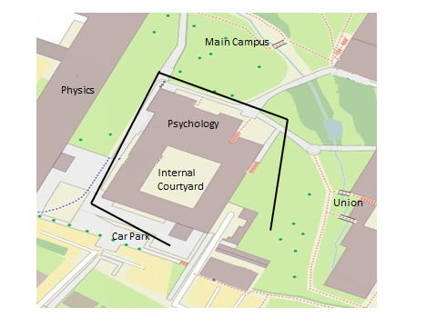
10m
N

Figure 1b
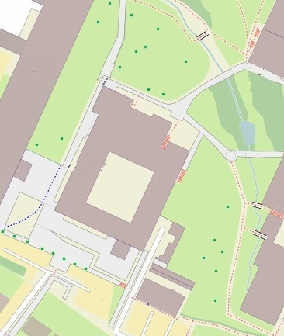
15m
N
Computer room
IV
Internal
Courtyard
IU
EU
EV
Car Park
Union
Main Campus
Physics
IU
Figure 2a

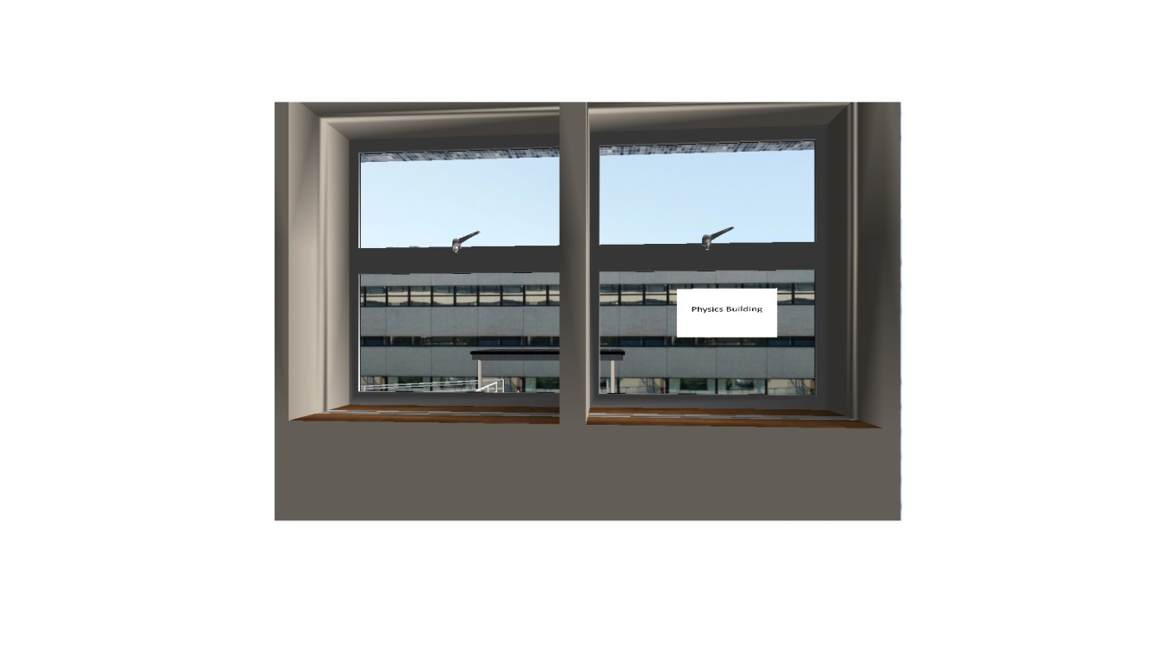

Figure 2b
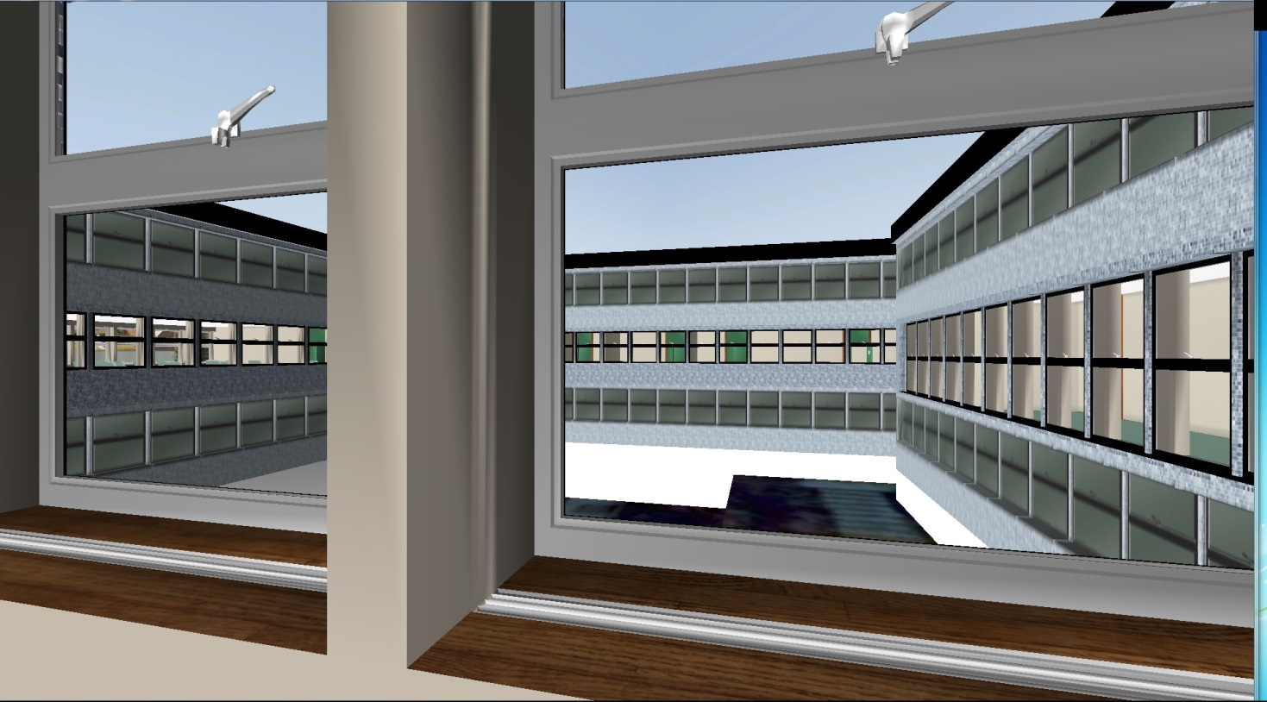
Figure 2c

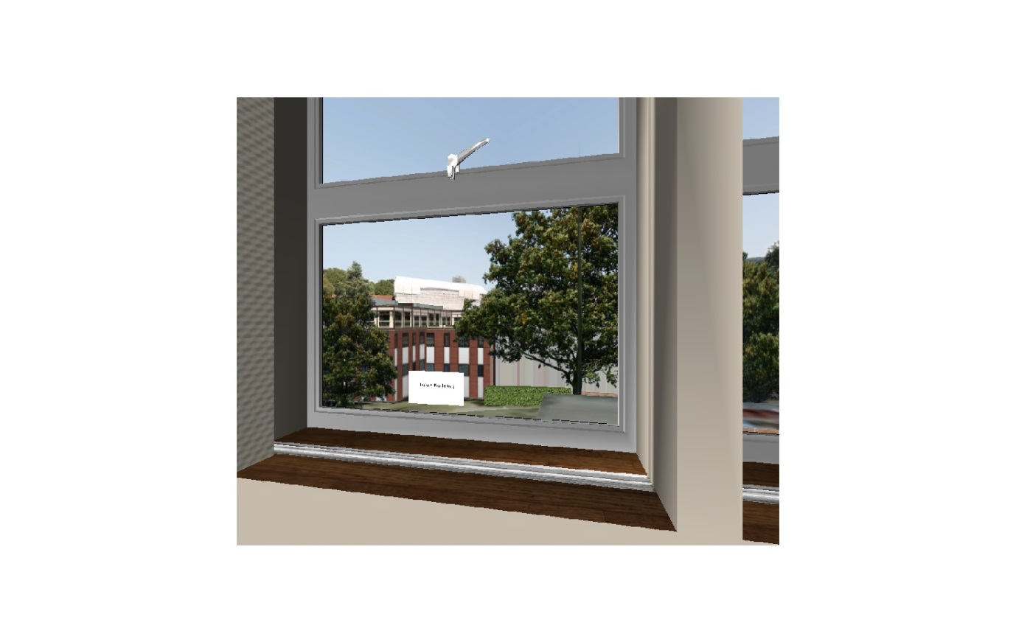

Figure 2d
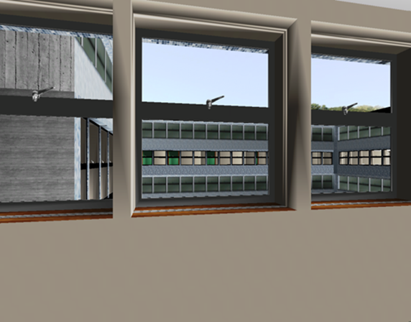

Figure 3

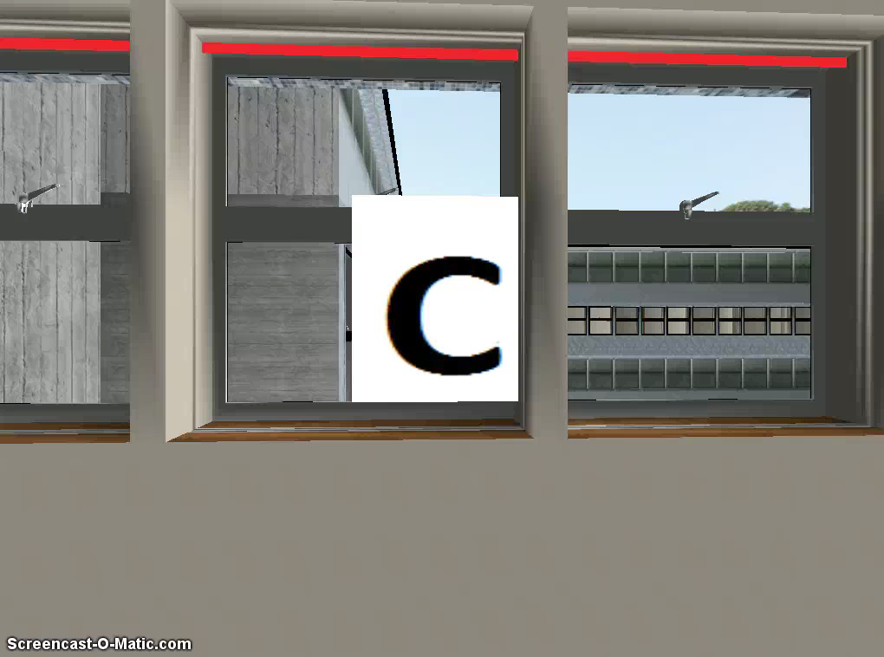
Figure 4
Figure 5a
Figure 5b

Figure 6

Figure 6b

Table 1
Instructions for Acquisition Trial 1 where participants explore outside of building
You are placed at the Psychology building, you will now explore the outside of the building. Take as long as you need to familiarise yourself with the environment, where things are, where things relative to outside landmarks etc.
We recommend that you take the route laid out below whilst exploring this space to ensure that you see all you need to see and do not get lost.
Turn left to look at the physics building
Walk forward as you do you will see the car park on your left. Keep walking until you approach the entrance of the physics building.
Turn right and walk towards the main campus, follow this down until you reach the front of the building, the physics building is to your left.
When you have reached the end of the building turn right, you'll see the university student union straight ahead of you and to the left of this is the main campus.
Walk ahead until you reach the end of the building, if you look to your right you will see a set of stairs.
Retrace your steps and proceed to the main entrance, your initial starting location, for the purpose of this study, other entrances are unavailable.
When you're happy that you have reached your starting location, please inform the experimenter
Instructions for Acquisition Trial 2 where participants explore inside of building
You will now explore the inside of the building. Again take as long as you need to familiarise yourself with the environment, where things are, where things relative to outside landmarks etc.
Again we recommend that you take the route laid out below whilst exploring this space to ensure that you see all you need to see and do not get lost.
Enter the building and walk up the stairs to your left, walk up one flight of stairs so you're just outside the lift.
To the left of the lift you will see an open door. Enter the room and look out of the window to see the Union building in front of you.
Turn and walk out of the door and you will see a corridor, walk down this corridor. Proceed down the corridor into the open room directly ahead.
Take a moment to look out of the windows in this room to see the Physics building in front of you and the Car Park to your left.
Leave the room and turn to your left, proceed down this corridor. Do not try and enter any of the other rooms.
Proceed past the door on the left to the very bottom of the corridor.
Turn to your right, walk through the large room with computers and desks.
Upon exiting the large room, turn to your left you will see large windows please take a moment to look out of these windows. You will see the Main Campus. Now turn to your right and exit the room.
You'll find yourself in a new corridor. At the end of the corridor turn right and proceed down the corridor. As you do so one room on your right will be open, enter this room.
Again you will see large windows, please familiarise yourself with the view available. Please note you can see the computer room that you have just walked through.
Please find your way out of the building to the start location.
When you have reached the starting location please inform the experimenter

Table 2
Orientation trial 1 where participants are asked to face occluded target cue in Room EU
Please turn toward the Main Campus.
Once you are happy that you are facing in the correct direction press the Tab key.

Orientation trial 2 where participants are asked to face occluded target cue in Room IU
Please turn toward the Physics Building.
Once you are happy that you are facing in the correct direction press the Tab key.

Orientation trial 3 where participants are asked to face occluded target cue in Room EV
Please turn toward the Car Park.
Once you are happy that you are facing in the correct direction press the Tab key.

Orientation trial 4 where participants are asked to face occluded target cue in Room IV
Please turn toward the Union Building.
Once you are happy that you are facing in the correct direction press the Tab key.

