The known unknowns of avoidable early life environmental exposures

Mark A. Hanson PhD ^{1,2}, Kirsten R. Poore PhD ¹, Elaine M. Faustman PhD ³, Maria Neira PhD ⁴

¹ Institute of Developmental Sciences, University of Southampton, Southampton General Hospital, Mailpoint 887, Tremona Road, Southampton, SO16 6YD, UK.
² NIHR Southampton Biomedical Research Centre, University Hospital Southampton NHS Trust, Southampton General Hospital, Mailpoint 218, Tremona Road, Southampton, SO16 6YD, UK.
³ Department of Environmental and Occupational Health Sciences, University of Washington, 4225 Roosevelt Way NE, Suite #100, Seattle, WA 98105, USA.
⁴ Department of Public Health, Environmental and Social Determinants of Health, World Health Organization, Geneva, Switzerland.

Corresponding Author:
Dr Kirsten R. Poore
Institute of Developmental Sciences, University of Southampton, Southampton General Hospital, Tremona Road, Southampton, SO16 6YD, UK.
Email: kpoore@soton.ac.uk
Telephone: +44 (0)2381 208663

“It is easier to build strong children than to repair broken men" wrote Frederick Douglass, whose early years in slavery had given him first-hand experience of a poor start to life. Our early years matter because the developmental environment shapes our future health and our responses to later challenges. The risks for the offspring’s health if the mother is obese, smokes during pregnancy, develops pre-eclampsia or gestational diabetes, or if the child’s diet is high in sugar, salt and trans-saturated fat are well known. ¹ But it is the under-recognized risks to the health of future generations that are of increasing concern. The World Health Organisation (WHO) has recently produced a new Atlas on children’s health and the environment ², noting that “26% of the deaths of 5·9 million children who died before reaching their fifth birthday could have been prevented through addressing environmental risks – a shocking missed opportunity”.
Environmental risks such as air pollution, unsafe food and water and exposure to a range of environmental toxic substances, operate during critical windows in the life course (Figure). Such exposures can have an impact on developing organs and physiological systems at all stages, from the embryo, through childhood and into adolescence. As the ability of tissues to repair this damage decreases as development advances across these critical windows, so too do the opportunities to reverse detrimental effects. Although the prevalence of problems such as asthma and obesity is increasing in childhood itself, the effects of some environmental conditions may not be manifest until many years later. For example, in low-middle income countries an adverse childhood environment may prevent 43% of children from achieving later their full neurocognitive potential. ³
Taking a life course approach to disease risk indicates that greater emphasis needs to be placed on young people, especially since adolescents account for nearly one fifth of the world’s population ⁴, both for their own future health and because they are prospective parents. While the United Nations General Comment 4 of the Convention on the Rights of the Child states that “adolescents are in general a healthy population group” ⁵, they can be on a high-risk trajectory to later non-communicable diseases (NCDs) ⁶, even if they appear outwardly healthy. Importantly, many of those at higher risk are often not on the radar of primary health care, due to their place in society, and are unlikely to be informed about risks to their health. Moreover, we now understand that they can pass the risk of NCDs to their children. The biological processes involved can operate from early pregnancy before the woman knows she is pregnant and accesses healthcare. And so the cycle of risk is perpetuated.
A new WHO initiative, “Avoidable Early Environmental Exposures”, is working to highlight how early life exposure to many environmental toxic substances can be avoided and has proposed a roadmap for action to address the issue. WHO already has detailed information on a wide range of environmental toxicants from a multitude of reports (see ⁷ for example). The initiative calls for this information to be better communicated to health care professionals at all levels, alongside new WHO-supported educational packages. In parallel, both public health departments and communities need to be better informed about how exposure to toxicants during early life is of concern and can be minimised or avoided altogether. At an individual level, education prior to the time of pregnancy is an ideal opportunity to promote awareness of good health habits for both men and women. Exposure to environmental toxicants occurs every day and the levels of some can accumulate in the mother’s body, potentially giving greater exposure of her fetus and infant than anticipated and producing additive effects, even if the levels of individual toxicants are within the “safe” range, if indeed an “acceptable” level of exposure is known. And fathers are not excluded: paternal effects on offspring development can operate via epigenetic effects on the sperm. ⁸
Environmental prevention of diseases is key to achieving the Sustainable Development Goals ⁹ and there is much that can be achieved without an additional burden on resources. As the “Avoidable Early Environmental Exposures” initiative emphasises, risks to our health are most damaging when they are unrecognised. An absence of overt developmental abnormalities does not necessarily imply all is well. Recognition of the importance of exposure to hazardous environmental factors in our early years should be a core component of the training of all health care professionals. This needs to be coupled with primary prevention measures by governments to protect populations, coupled with “public” education to reduce individual exposure, and is essential for ensuring the future health of all citizens on this planet.

We declare no competing interests.

No funding sources.

Author contributions:
Mark Hanson: conceptual framework, literature search, writing of commentary
Kirsten Poore: conceptual framework, literature search, writing of commentary
Elaine Faustman: conceptual framework, writing of commentary
Maria Neira: conceptual framework, writing of commentary

References
1. Gluckman PD, Hanson MA, Cooper C, Thornburg KL. Effect of in utero and early-life conditions on adult health and disease. N Engl J Med 2008; 359(1): 61–73.
2. Inheriting a sustainable world? Atlas on children’s health and the environment. 2017; Geneva: World Health Organization. http://www.who.int/ceh/publications/inheriting-a-sustainable-world/en/ (accessed April 10, 2017).
3. Black MM, Walker SP, Fernald LC et al. Early childhood development coming of age: science through the life course. Lancet 2017 389; 10064: 77–90.
4. Progress for children: A report card on adolescents (No. 10). UNICEF 2012. https://www.unicef.org/publications/index_62280.html (accessed April 10, 2017).
5. United Nations Committee on the Rights of the Child (CRC), General comment No. 4 (2003): Adolescent Health and Development in the Context of the Convention on the Rights of the Child. https://www.unicef-irc.org/portfolios/general_comments/GC4_en.doc.html (accessed April 10, 2017).
6. Twig G, Yaniv G, Levine H et al. (2016) Body-Mass Index in 2.3 Million Adolescents and Cardiovascular Death in Adulthood. N Engl J Med 374(25): 2430–40.
7. Prüss-Ustün A, Wolf J, Corvalán C, Bos R, Neira M Preventing disease through healthy environments: a global assessment of the burden of disease from environmental risks. 2016; Geneva: World Health Organisation. http://www.who.int/quantifying_ehimpacts/publications/preventing-disease/en/ (accessed April 10, 2017).
8. Estill MS, Krawetz SA. The epigenetic consequences of paternal exposure to environmental contaminants and reproductive toxicants. Curr Envir Health Rpt 2016; 3: 202–213.
9. United Nations, Sustainable Development Goals https://sustainabledevelopment.un.org/sdgs (accessed April 10, 2017).

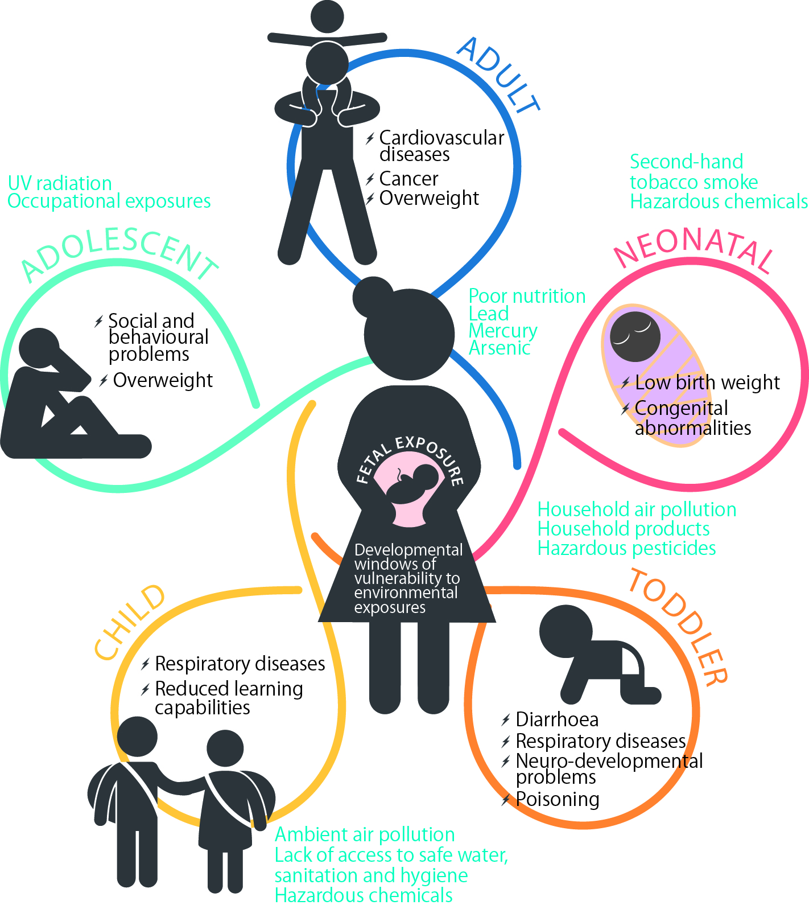

Figure. The effects of environmental hazards cross generations.
Environmental exposures in early life can have immediate effects on health or accumulate over time to increase disease risk later. Exposure can start in the womb and can have effects throughout life. Children and adolescents are exposed to a variety of hazards from the environments in which they live, learn, work and play. Children are especially vulnerable to these exposures because of their developing systems and behaviours. (Figure revised from ²)

