2H → 1T Phase Engineering of Layered Tantalum Disulphides in Electrocatalysis: Oxygen Reduction Reaction
Jan Luxa,^{[a]} Vlastimil Mazánek,^{[a]} Martin Pumera,^{* [b]} Petr Lazar,^{[c]} David Sedmidubský,^{[a]} Mauro Callisti,^{[d]} Tomáš Polcar,^{[e]} and Zdeněk Sofer*^{[a]}
[a] J. Luxa, V. Mazánek, Prof. D. Sedmidubský, Prof. Z. Sofer
Department of Inorganic Chemistry
University of Chemistry and Technology
Technická 5, 166 28 Prague 6,Czech Republic
E-mail: zdenek.sofer@vscht.cz
[b] Prof. M. Pumera
Division of Chemistry & Biological Chemistry
School of Physical and Mathematical Sciences, Nanyang Technological University
Singapore, 637371, Singapore
E-mail: pumera@ntu.edu.sg
[c] P. Lazar
Department of Physical Chemistry and Regional Centre of Advanced Technologies and Materials
Palacký university Olomouc
tř. 17. Listopadu 1192/12, 771 46 Olomouc
[d] M. Callisti
Engineering Science, Faculty of Engineering and the Environment, University of Southampton
Southampton SO17 1BJ, UK
[e] T. Polcar
Department of Control Engineering, Faculty of Electrical Engineering
Czech Technical University in Prague
Technicka 2, Prague 6 166 27, Czech Republic
Supporting information for this article is given via a link at the end of the document

Abstract: Tremendous attention is paid to renewable sources of energy. Transition metal dichalcogenides (TMDs) are intensively studied for their promising catalytic activities in hydrogen evolution reaction (HER) and oxygen reduction reaction (ORR). In this fundamental work, we explore the catalytic properties of TMDs family members: 2H TaS₂ and 1T TaS₂. Our findings reveal that both polytypes exhibit poor HER performance which is even more pronounced when subjected to electrochemical treatment with reduction/oxidation. Our experimental data show that 1T TaS₂ has a lower overpotential at a current density of -10 mA.cm⁻¹, despite our theoretical density functional theory (DFT) calculations indicating that more favorable free energy of hydrogen adsorption should make perfect 2H TaS₂ a better HER catalyst. By a thorough characterization, it is shown that the higher conductivity of 1T TaS₂ and a slightly higher surface oxidation of 2H TaS₂ explains this discrepancy. Moreover the changes in catalytic activity after electrochemical treatment are addressed here. For the oxygen reduction reaction (ORR) the electrochemical treatment leads to an improvement of catalytic properties. With onset potentials similar to that of Pt/C catalyst, TaS₂ is found to be an efficient catalyst for oxygen reduction, rather than for proton reduction, in opposite to the behaviour of group VIB layered TMDs.

Introduction
Layered two dimensional (2D) materials have been studied for over a decade. This group of materials includes graphene, transition metal dichalcogenides (TMDs) and many others such as black phosphorus. This interest has been mainly motivated by numerous potential and realized applications in the fields of electronics,^{[1]} optoelectronics,^{[2]} batteries^{[3]} and electrocatalysis.^{[4]} Enormous attention has been devoted to the last mentioned field of research, especially in the case of TMDs, because the global demand of green energy sources is at the forefront of the scientific and knowledge based society.
Most of the previous research on catalytic properties of TMDs has been devoted to group 6 TMDs such as MoS₂ and WS₂.^{[5]} However, due to the vast possibilities of metal and chalcogen combinations, the catalytic properties of the majority of TMDs remain uncovered. The main reason for this pursue of new catalysts, which is limited not only to hydrogen evolution, is based on the high price and low availability of current state of the art catalyst: platinum. TMDs have shown to be a promising replacement of this metal for these applications. However in terms of catalytic properties, most of the TMDs still lie in the unexplored waters.^{[6]}, ^{[7]} In this work we show that on the contrary to group 6 TMDs, such as MoS₂ and WS₂, TaS₂ shows strong electrocatalytic activity towards oxygen reduction reaction and whereas it is rather inefficient for proton (HER) reduction, which is highly unexpected.^{[8]} We show that the phase engineering of TaS₂ from 2H to 1T phase can tune its catalytic activity.
Recent investigations of layered TaS₂ described a phase transition induced by gate controlled Li ion intercalation in TaS₂ transistors.^{[9]} More detailed studies of ion intercalation through several methods have been also performed in the past.^{[10]} As for the catalytic activity of TaS₂, there have been only sporadic reports.^{[11]} Thanks to the fact that TaS₂ forms so-called charge density wave, a state where lattice symmetry is broken and superlattice is formed, there have been numerous studies, both experimental and theoretical, dealing with this problematic.^{[12]}
Layered TaS₂ material is attractive because it crystallizes in three basic polytypes: 2H, 1T and 3R.^{[13]} Only 1T and 2H can be prepared with a satisfactory phase purity, because 3R usually contains a mixture of other phases .^{[14]} Previous reports of superior performance of 1T phase in MoS₂ raise the question of how different will be the performance of various polytypes for other TMD such as TaS₂.^{[15]}
In this work we prepared and probed 2H TaS₂ and 1T TaS₂ in terms of electrochemical properties including heterogeneous electron transfer (HET), hydrogen evolution reaction (HER) and oxygen reduction reaction (ORR). The possibility of electrochemical activation of the materials by reduction/oxidation was also studied in detail. Structure and morphology were investigated by scanning electron microscopy (SEM) combined with energy dispersive spectroscopy (EDS), X-Ray diffraction (XRD) and high-resolution transmission electron microscopy (HR-TEM). Surface composition was studied by X-ray photoelectron spectroscopy (XPS). Our results were also correlated with DFT calculations. Findings in this work revealed that 1T TaS₂ surpasses catalytic properties of 2H TaS₂ in both hydrogen evolution reaction (HER) and oxygen reduction reaction (ORR). Furthermore it is shown that electrochemical pretreatment significantly influences these properties. A decrease in terms of HER activity is seen when both 2H TaS₂ and 1T TaS₂ are reduced/oxidized. On the other hand an increased ORR activity is observed with onset potentials similar to that of Pt/C catalyst. Similar findings are reported for the heterogeneous electron transfer (HET). The interpretation of reduction/oxidation products formation is eventually given.

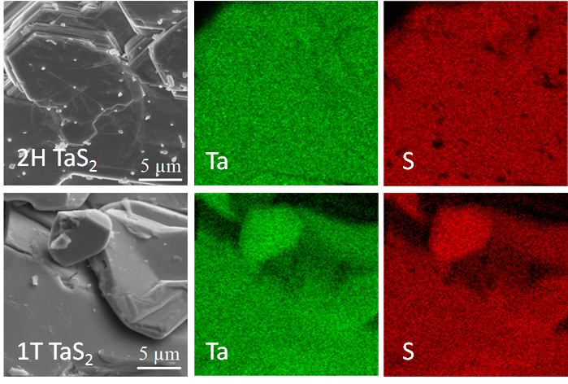
Results and Discussion
In this paper we have synthesized and characterized two polytypes of TaS₂: 2H and 1T and studied their materials and electrocatalytic properties. Both materials were thoroughly examined by a variety of analytical techniques with the aim of revealing their catalytic properties towards some of the most industrially important electrocatalytic processes. Furthermore, we attempted to activate materials by electrochemical pretreatment. The phase composition can be controlled by the temperature profile during synthesis from elemental materials. On the basis of processes used for activation, materials in this paper are denoted as 2H TaS₂ and 1T TaS₂ (untreated), 2H TaS₂ red. and 1T TaS₂ red. (treated by reductive potential) and 2H TaS₂ ox. and 1T TaS₂ ox. (treated by oxidative potential).
Morphology of 2H TaS₂ and 1T TaS₂ polytypes was examined by scanning electron microscopy (SEM). SEM micrographs are shown in Figure 1. Both polytypes are well crystallized

Figure 1. SEM micrographs of 2H TaS₂ and 1T TaS₂.
consisting of hexagonally shaped crystals and well developed layered structure which is clearly visible on the edges of individual crystals.
Large sheets with sharp edges, typical for bulk transition metal dichalcogenides, can be observed for both samples. Additionally, energy dispersive spectroscopy (EDS) was conducted to verify the elemental composition and homogeneity. EDS analysis (Figure 2) revealed homogeneous distribution of both elements. Some oxygen was also detected by SEM-EDS indicating a small degree of oxidation (Table 1). The concentration of oxygen was much lower in the case of 1T TaS₂ which is in very good agreement with XPS results (see the following sections). S/Ta ratios also agreed well with XPS measurements and indicate an almost stoichiometric TaS₂ phase.

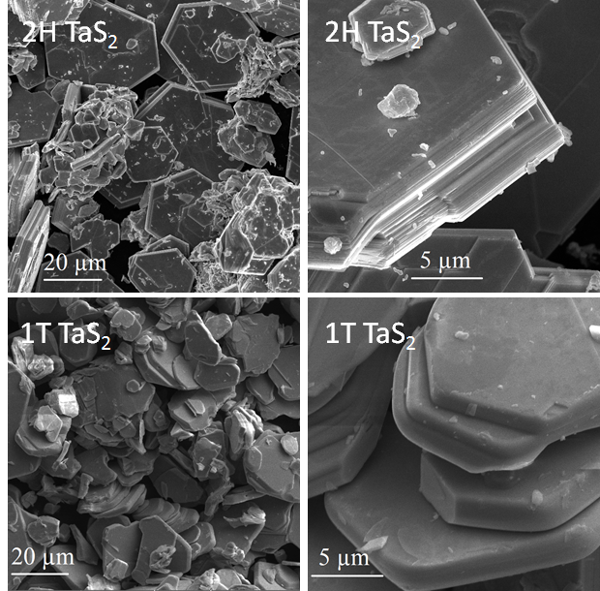
Figure 2. SEM-EDS elemental maps showing homogeneous distribution of tantalum and sulfur in TaS₂.

Table 1. Elemental composition obtained from SEM-EDS.
 | Ta (at. %) | S (at. %) | O (at. %) | S/Ta
2H TaS₂ | 32.9 | 52.4 | 14.7 | 1.6
1T TaS2 | 31.8 | 61.8 | 6.4 | 1.9

Morphology of the flakes and atomic arrangement of the fabricated materials were examined by scanning transmission electron microscopy (STEM) by using a high angle annular dark field (HAADF) detector. Figure 3a and Figure 3b show the typical morphology of produced flakes. Most of the flakes consisted of a stack of few layers. No aggregation of particles was found, thus confirming the high quality of the prepared materials. Monolayer or few-layers structures were observed at the edge of the flakes (see lighter contrast in Figure 3a and Figure 3b). High-resolution HAADF-STEM imaging was performed along these edges and followed by digital filter processing. Figure 3c shows the atomic arrangement of the 2H TaS₂ sample, where a hexagonally symmetric structure is clearly observed. A different atomic arrangement is observed in Figure 3d, where tantalum and sulphur atomic planes seem to have slipped each other compared to the ideal 1T structure indicating a formation of a distorted 1T phase. The FFT patterns shown in the inset of Figure 3c and Figure 3d suggest a high degree of crystallinity of the prepared samples.
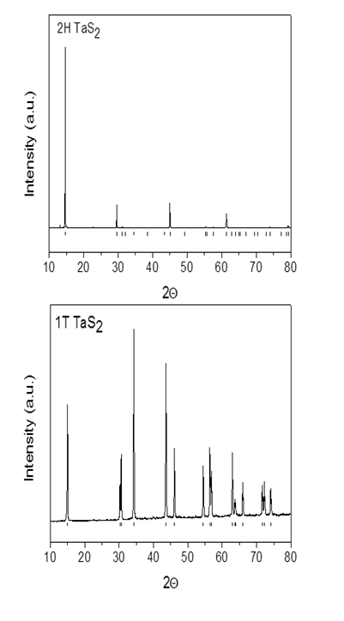
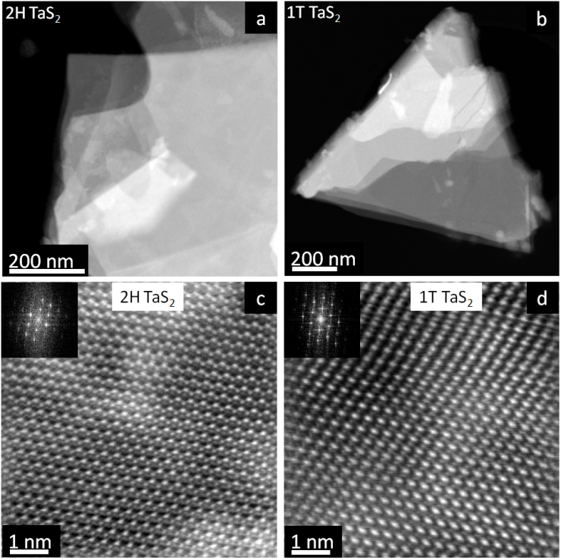
Figure 3. HAADF-STEM (top-view) images of TaS₂ samples: low and high resolution images of 2H (a - c) and 1T (b - d) structures.

Composition as well as further structural information was acquired by X-ray diffraction (XRD) displayed in Figure 4. XRD analysis revealed pure phases (2H TaS₂ PDF# 04-006-9329; 1T TaS₂ PDF# 01-088-1008), which indicates that the oxygen is in the form of surface oxide impurities only. Sharp lines are also indicative of a very good crystallinity, which is in good agreement with SEM data showing clearly well developed hexagonal crystals of micron size can be clearly observed.
Because of its surface sensitivity, X-ray photoelectron spectroscopy (XPS) is an excellent method for the investigation of surface composition changes accompanying electrochemical treatment. Composition of untreated bulk TaS₂ was firstly examined by measuring the survey spectra. The survey spectra are shown in Figure S1 and the composition obtained from them is summarized in Table 2. Results in Table 2 show that the S/Ta ratios were 1.7 and 2.0 for 2H TaS₂ and 1T TaS₂, respectively. The slightly lower value for 2H TaS₂ most likely originates from higher concentration of surface oxide, which was introduced
during the synthesis (see Methods section for more details about the synthesis). This fact is also very well documented by a slightly higher oxygen concentration in the survey spectra.

Figure 4. XRD patterns of 2H TaS₂ and 1T TaS₂. The reference lines at the bottom represent reference data taken from PDF database.

Table 2. Elemental composition of 2H TaS₂ and 1T TaS₂ extracted from XPS survey spectra.
 | C 1s (at. %) | O 1s (at. %) | Ta 4f (at. %) | S 2p (at. %) | S/Ta
2H TaS₂ | 23.9 | 23.7 | 19.20 | 33.2 | 1.7
1T TaS₂ | 30.4 | 15.4 | 17.9 | 36.3 | 2.0

Detailed high-resolution spectra of S 2p shown in Figure S2 revealed that sulphur was present in the form of sulfide represented by a doublet with maxima at ca. 161.5 eV and 162.5 eV. No peak at ca. 168 eV being indicative of sulfates,^{[19]} was observed. Since metal in transition metal sulfides usually undergoes chemical changes,^{[20]} high-resolution Ta 4f spectra were recorded together with spectra after electrochemical reduction/oxidation were recorded. The results of these measurements are shown in Figure 5 and the potentials used for treatment are summarized in Table S1.

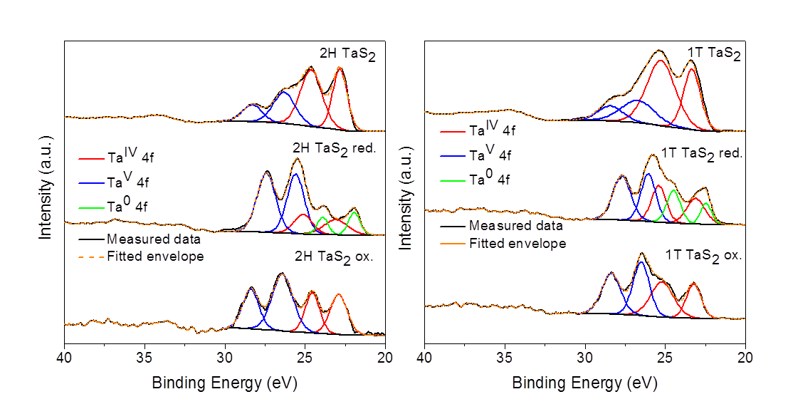
Figure 5. High-resolution core level spectra of Ta 4f state in pure bulk 2H TaS₂ and 1T TaS₂ and in reduced and oxidized 2H TaS₂ and 1T TaS₂.

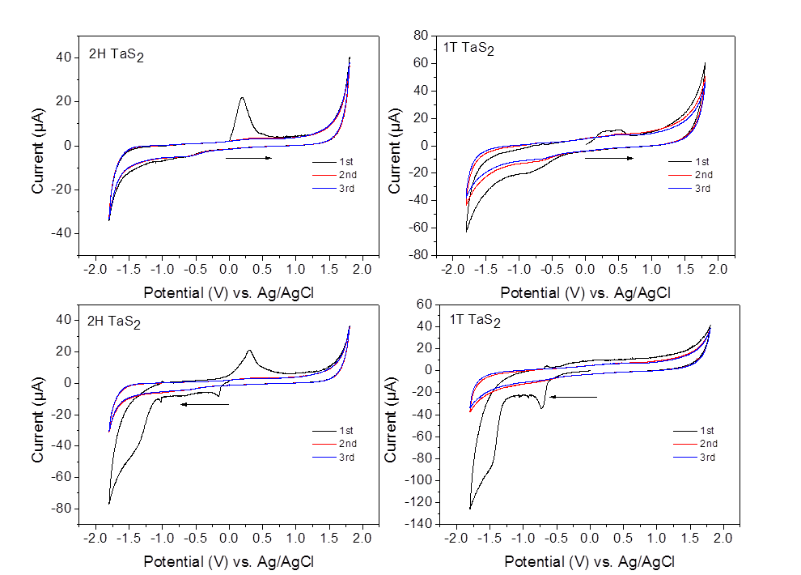
Deconvolution revealed that several chemical states contribute to the overall spectrum. A doublet of Ta^{IV} 4f_{7/2} and Ta^{IV} 4f_{5/2} located at ca. 22.8 eV and 24.6 eV, respectively, was attributed to tantalum sulfide on the basis of good agreement with literature.^{[21]} Another pair of peaks at ca. 26.3 eV and 28.3 eV can be ascribed to Ta^{V} 4f_{7/2} and Ta^{V} 4f_{5/2}, respectively.^{[21]} Finally, elemental tantalum peaks emerged in both reduced samples and are represented by Ta⁰ 4f_{7/2} and Ta⁰ 4f_{5/2} peaks at ca. 22.4 eV and 24.4 eV, respectively.^{[22]} Concentrations of individual states are summarized in Table 3. The majority of tantalum in untreated TaS₂ is present in Ta^{IV} oxidation state and we ascribe the remainder of tantalum in Ta^{V} valency to natural oxidation of samples. However, treating the material with potential brings crucial changes in the surface composition. Exposure to positive potential leads to a rapid increase in Ta^{V} concentration in both TaS₂ samples. From this, we can conclude that the surface of both 2H TaS₂ and 1T TaS₂ is oxidized into Ta₂O₅. A treatment with reductive potential leads to a formation of elemental tantalum and also to an increase in Ta^{V} concentration compared to untreated samples. We suggest that beside the reduction to elemental tantalum, additional products undergoing further oxidation to Ta₂O₅ are formed during the reduction of TaS₂. More discussion on this issue is given in the electrochemistry section of this paper.

Table 3. Concentration of individual Ta 4f states extracted from the deconvolution of Ta 4f spectra.
 | Ta^{IV} (at. %) | Ta^{V} (at. %) | Ta⁰ (at. %)
2H TaS₂ | 67.2 | 32.8 | -
2H TaS₂ red. | 21.9 | 64.3 | 13.8
2H TaS₂ ox. | 41.8 | 58.2 | -
1T TaS₂ | 71.8 | 28.2 | -
1T TaS₂ red. | 31.7 | 47.1 | 21.2
1T TaS₂ ox. | 44.5 | 55.5 | -

Inherent electrochemistry, which reveals intrinsic redox properties of the electrode material in an electrolyte, is an essential tool in terms of identifying the potential window in which the material can operate.^{[23]} Additionally it provides information about the oxidizable/reducible species present on the surface of the material under examination. This information can be then used in an attempt to activate the material, by oxidation or reduction, for all kinds of purposes including catalysis or sensing applications.^{[20]} We performed both anodic and cathodic scans with results shown in Figure 6.

Figure 6. Inherent electrochemistry of 2H TaS₂ and 1T TaS₂ in anodic and cathodic scan directions. Measurements were performed in an Ar purged 50 mM PBS, scan rate 100 mV/s.

A strong oxidation peak at ca. 0.25V with a slight shoulder peak at ca. -0.6V emerged when anodic potentials were firstly applied to 2H TaS₂. However, the oxidation peak disappeared in subsequent scans indicating that the first oxidation on the surface of 2H TaS₂ led to a formation of irreducible species, which prohibited any further reduction or limit it only to a small extent attributable to the reduction peak at -0.6V. To shed more light onto this issue, XPS measurements after oxidation or reduction of both 1T and 2H TaS₂ were performed (Figure 5). The increase in intensity of peaks formerly attributed to Ta^{V} suggests that the oxidation at 0.25V is related to oxidation of 2H TaS₂ surface into Ta₂O₅. Cathodic scan of 2H TaS₂, on the contrary, revealed several reduction peaks at ca. -0.1V, -1.05V and a shoulder peak at ca. -1.4V followed by an oxidation peak at ca. 0.25V. The presence of these peaks suggests, that a variety of reducible moieties are present on the surface of an unoxidized 2H TaS₂ surface. Sweeping back into positive potentials resulted in the same oxidation peak observed for anodic scan. Interestingly, all the reduction peaks observed in the first scan vanish and only inconspicuous reduction peak at ca. -0.6 V emerges. This suggests that the product of oxidation (e.g. Ta₂O₅) at 0.25V is insoluble and blocks the surface of 2H TaS₂. The fact that oxidation occurs even after several reduction reactions seen in the cathodic scan could be explained in two ways: the products of reduction are either soluble or they oxidize into Ta₂O₅. Based on the oxidation peak profile, which is broader than that seen in anodic scan, the latter is likely to occur. Because different species can be oxidized at slightly different potentials, the broader peak profile can be a result of such phenomenon. Additional information was obtained from XPS performed after reduction of 2H TaS₂ (Figure 5). Surprisingly an increase in concentration of Ta^{V} was observed together with a new pair attributed to Ta⁰. From this we conclude that some of the reduction peaks lead to reduction to elemental tantalum while the others are a result of different reduction processes leading to formation of unstable products which later oxidize to Ta^{V} species. This is in good agreement with the fact, that some of tantalum compounds are unstable and easily oxidize to Ta₂O₅ since the Ta^{V} is the most stable oxidation state of tantalum.
Several differences can be seen in the case of 1T TaS₂ inherent electrochemistry. First of all, the oxidation observed in the anodic scan of 2H TaS₂ now splits into two separate peaks with a maximum at ca. 0.25V and 0.5V. Similarly to 2H TaS₂ this oxidation is followed by an inconspicuous reduction peak at ca -0.5V. One possible explanation is that basal plane and edge plane are oxidized at slightly different potentials, which is the case of MoS₂.^{[24]} The XPS results after oxidation (Figure 5) reveal the same results as in the case 2H TaS₂ suggesting the formation of insoluble Ta₂O₅ on the surface of 1T TaS₂. Differences can be also seen in the cathodic scan of 1T TaS₂. Unlike the case of 2H TaS₂, reduction peaks at -0.1V and -1.05V are absent and a new peak at -0.73V emerged. The only match in cathodic scans is a shoulder reduction peak at ca. -1.4V. No subsequent oxidation occurs in the case of 1T TaS₂. This indicates that reduction of 1T TaS₂ leads to a formation of species that cannot be re-oxidizied. The XPS measured after reduction of 1T TaS₂ gave a similar result as for the 2H TaS₂ (Figure 5), however, the absence of oxidation and reduction peaks in subsequent scans suggests that other products are formed in the case of 1T TaS₂.
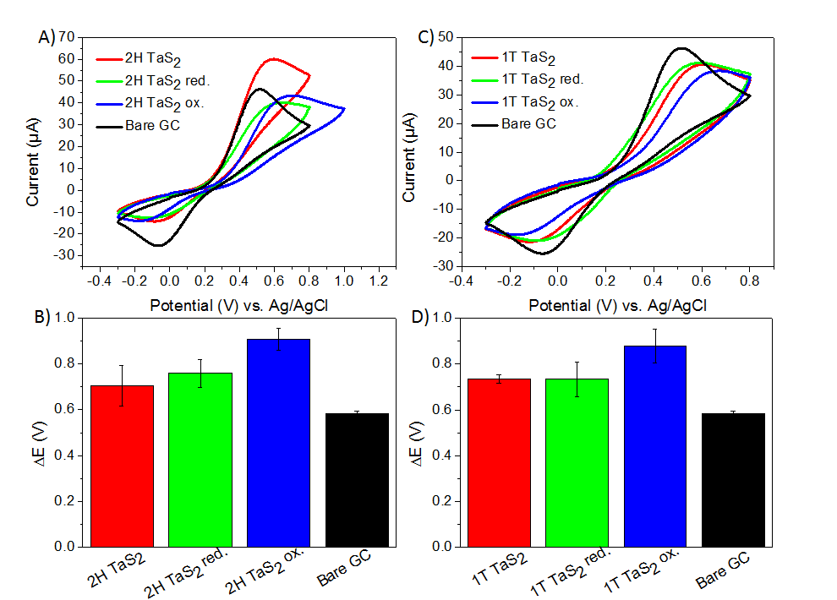
Another important property of an electrode material is the heterogeneous electron transfer (HET) rate, which is an important parameter due to the fact that high HET rate is desirable in electrochemical and biosensing devices.^{[4b]} Ferrocyanide/ferricyanide redox probe has been shown to be suitable for these purposes in other similar materials such as graphene or other TMDs.^{[4b, 25]} This method is based on Nicholson’s approach and utilizes several experimental parameters together with a peak-to-peak separation (∆E) of ferrocyanide/ferricyanide probe to determine the rate constant.^{[26]} In this work we measured the HET rate in a 5 mM ferrocyanide/ferricyanide solution in 50 mM PBS. Triplicate measurements (each with a new portion of material) were performed and an average value of ∆E was used to calculate the k⁰_{obs}. The results of our measurements together with standard deviations of ∆E are shown in Figure 7 and the list of calculated k⁰_{obs} is shown in Table S2. Also to examine the possibility of TaS₂ activation by electrochemical treatment, both samples were oxidized/reduced by chronoamperometry at -1.6 V for 2H TaS₂ red. and 1T TaS₂ red. and at 0.7 V and 0.8 V for 2H TaS₂ ox. and 1T TaS₂ ox., respectively. Samples were then submitted to the HET measurement.

Figure 7. CV measurements in a solution of 5 mM K₃[Fe(CN)₆]/ K₄[Fe(CN)₆] in 50 mM PBS of (A) 2H TaS₂ and (C) 1T TaS₂ and peak-to-peak separation ∆E of (B) 2H TaS₂ and (D) 1T TaS₂. Error bars are based on triplicate measurements.

The peak separation of 2H TaS₂ is higher than that of bare GC electrode by about 115 mV. The higher ∆E of both reduced and oxidized 2H TaS₂ compared to untreated 2H TaS₂ shows that unlike other TMDs,^{[20]} 2H TaS₂ HET rate cannot be improved by electrochemical pre-treatment of the material. 1T TaS₂ also exhibits worse HET rate than bare GC electrode by about 140 mV and it does not exhibit any kind of improvement upon electrochemical activation of the material via its reduction/oxidation. While the reduction leaves the material with the same ∆E as untreated material, oxidation significantly increases ∆E leading to even slower HET rate.
Probing the catalytic activity of various kinds of TMDs is of great interest because of the exceptional activity, especially towards hydrogen evolution reaction (HER), of some TMDs such as MoS₂, WS₂ and their composites with graphene. Therefore, it is desirable to extend the knowledge about catalytic properties to as many TMDs as possible. To the best of our knowledge, electrocatalytic activity of TaS₂ has never been examined up to this date.
Electrocatalytic properties of TaS₂ towards HER were examined by linear sweep voltammetry (LSV) (Figure 8). Average values and standard deviations are also shown. A value of current density -10 mA.cm⁻² was used to compare the untreated and treated TaS₂, bare GC electrode and commercially used Pt/C catalyst. While the untreated 2H TaS₂ requires a potential of -1.22V, it goes down to -1.1V and up to -1.27V for 2H TaS₂ red. and 2H TaS₂ ox., respectively. Compared to bare GC electrode, which requires -0.95V in order to achieve this current density, 2H TaS₂ seems to be a poor HER catalyst. Similarly to HET rate, electrochemical oxidation leads to an impairment of HER activity, while the electrochemical reduction leads to an enhancement of HER activity. The reason for such deactivation most likely stems from the fact that insoluble products such as Ta₂O₅ are formed during the electrochemical oxidation and block the intrinsic active sites of TaS₂.

Figure 8. LSV measurements of (A) 2H TaS₂ and (C) 1T TaS₂ and a value of overpotential needed for current density -10 mA.cm⁻² of (B) 2H TaS₂ and (D) 1T TaS₂. Error bars are based on triplicate measurements. Measurements were performed in a 0.5M H₂SO₄ solution with a scan rate of 2mV/s.

1T TaS₂ exhibits an overpotential of –0.77V vs RHE. This is better than both the bare GC electrode and 2H TaS₂. Just like in the case of 2H TaS₂, electrochemical oxidation leads to an increase in overpotential required to reach the current density of -10 mA.cm⁻². However, in this case electrochemical reduction also leads to higher overpotential. 1T TaS₂ red. has an overpotential of -1.06V and 1T TaS₂ ox. requires -1.08V to reach the desired current density. The reason for higher overpotential in the case of 1T TaS₂ ox. is most likely the same as in the case of 2H TaS₂ ox. We suggest that different trend for 1T TaS_{2,} compared to 2H TaS₂ red., originates in different inherent electrochemistry, which leads to a formation of different reduction products. This is also very well documented by the absence of oxidation peak after sweeping back to positive potentials in the 1T TaS₂ cathodic scan. Thus, the product of 1T TaS₂ reduction seems to be insoluble and remains on the surface of 1T TaS₂ red..
The relatively high overpotentials for 1T TaS₂ and, in particular, 2H TaS₂ are rather surprising in the light of recent DFT results. Tsai et al.^{[27]} calculated differential hydrogen adsorption enthalpies ΔG_{H} for several TM dichalcogenides, and found that 2H TaS₂ has ΔG_{H} = 0.06 eV, the value very close to thermoneutral. Such value should be indicative of promising HER catalyst, which is in contrast to our experimental results. We thus performed further DFT calculations to elucidate this issue.
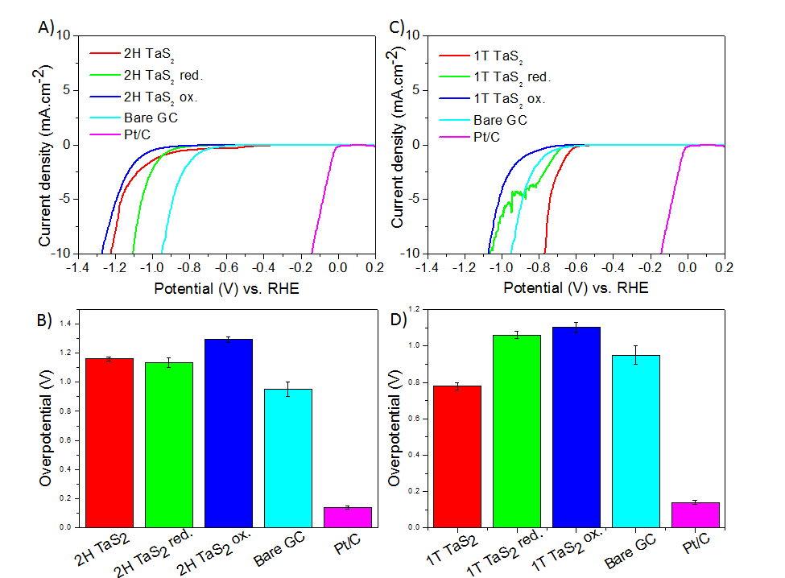
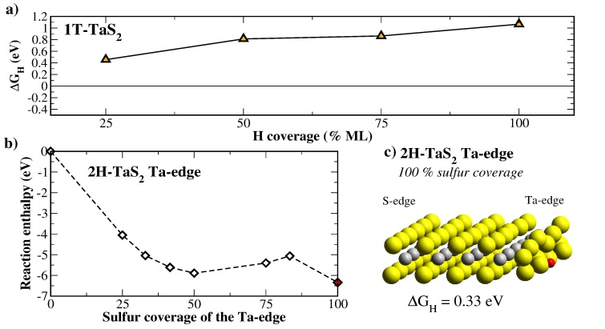
We calculated firstly ΔG_{H} for the basal plane and edge of 1T TaS₂. The hydrogen atoms are bound rather weakly to the edge, which results in positive values of ΔG_{H} in the whole hydrogen coverage range (Figure 9a). The value closest to thermoneutral (ΔG_{H}=0.46 eV) occurs at low hydrogen coverage of 25 %. At higher coverages, the hydrogen adsorption becomes even less favorable. The basal plane seems to be totally inactive for HER, because it binds hydrogen atoms only very weakly (ΔG_{H}=1.24 eV). Thus, according to our DFT calculation, the modest HER performance of 1T TaS₂ (compared to prototypical dichalcogenide MoS₂) can be explained by its unfavorable thermodynamics of hydrogen adsorption.

Figure 9. Differential hydrogen adsorption free energy ΔG_{H} for hydrogen adsorption on the edge of 1T TaS₂ (a), the free energy as a function of sulfur coverage of the Ta-edge of 2H TaS₂ (b), and the structure of 100% sulfur covered Ta-edge (c).

In the case of 2H TaS₂, the basal plane adsorbs hydrogen better than that of 1T TaS₂ (ΔG_{H}=0.22 eV). Similarly, hydrogen bonding to the Ta-edge becomes much stronger. The adsorption at low hydrogen coverage of 25 % results in negative ΔG_{H} of -0.30 eV. At 50% coverage, we obtained ΔG_{H} of -0.09 eV, the value which is close to zero and in excellent agreement with the result of Tsai et al.^{[27]} It should be noted that it is complicated to model the edge, as the coverage of sulfur atoms on the edge is highly dependent upon the operating conditions. The abovementioned values of ΔG_{H} were calculated for the Ta-edge covered by 50% sulfur atoms, which is a common model of the metal edge in TM dichalcogenides. The reason is that this edge structure was calculated to be the most stable under a broad range of conditions in prototypical dichalcogenide MoS₂.^{[28]} In order to find the proper edge structure of 2H TaS₂, we calculate the sulfur coverage of the Ta-edge explicitly. The edge is modeled by a 6×4 nanostripe, i.e. there are six Ta-S units along the edge, which allows one to consider broader range sulfur coverages. The results are rather surprising; the 50% sulfur coverage represents only a local minimum, whereas the global minimum of the energy occurs at 100% sulfur coverage (Figure 9b). There appears an unusual reconstruction of sulfur atoms on the edge at 100% coverage, which bears the periodicity of three Ta-S units (Figure 9c). Apparently, such reconstruction cannot be reproduced by a standard 4×4 nanostripe model of the edge. More importantly, the hydrogen adsorption on 100% sulfur covered Ta-edge becomes much less favorable (ΔG_{H}=0.33 eV), which is more in line with the observed modest HER performance of 2H TaS₂. Needless to say, this value of hydrogen adsorption enthalpy is still slightly better than those we obtained for 1T TaS₂, but the surface oxidation of 2H TaS₂ (see above) most probably hampers its HER performance. In addition, there are further factors which may reduce HER performance of 2H TaS₂ such as its lower conductivity, number of active sites, possibly higher reaction barriers for the Volmer-Tafel reaction.^{[29]}
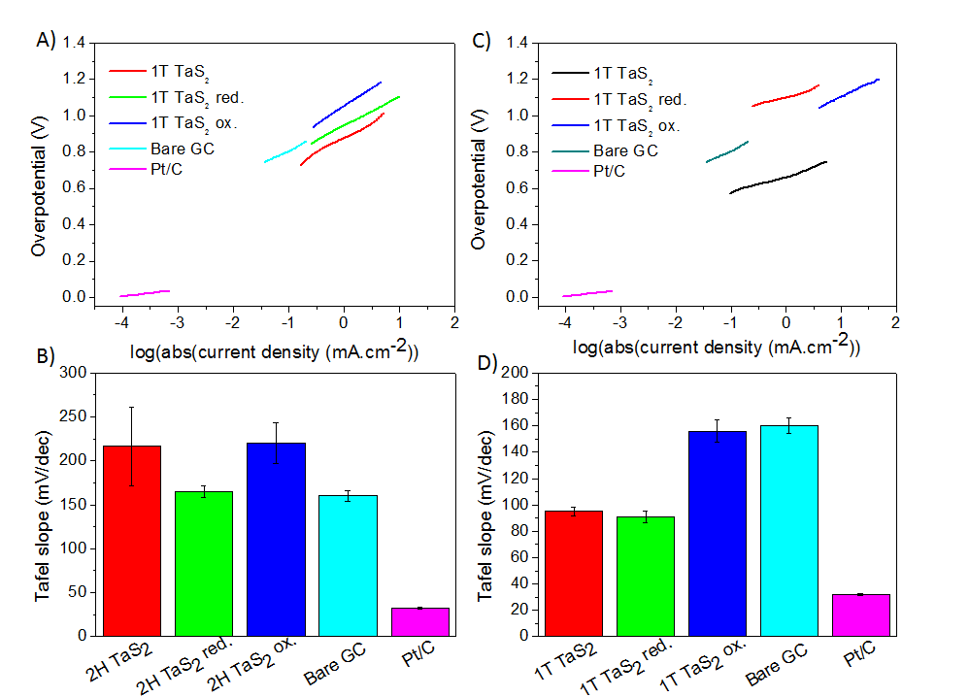
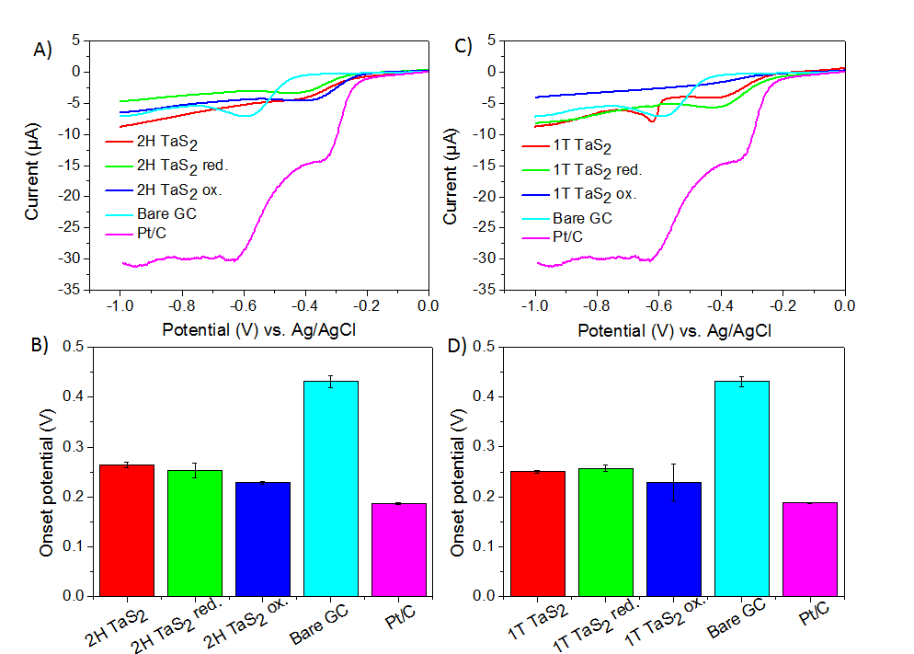
Another key parameter easily accessible from the LSV curves is the Tafel slope. Beside the information about the voltage differential needed for an increase of current density by one order, it also gives information about the rate limiting step. Several rate limiting steps were proposed on the basis of previous studies.^{[30]} Volmer adsorption step has been shown to be rate limiting when the Tafel slope is 120 mV/dec or higher. Heyrovsky desorption step is rate limiting when the Tafel slope is around 40 mV/dec and Tafel desorption step is rate limiting with Tafel slope values around 30 mV/dec. Tafel slope curves and their average values together with standard deviations are shown in Figure 10.

Figure 10. Tafel slope curves of (A) 2H TaS₂ and (C) 1T TaS₂ and their respective average values of (B) 2H TaS₂ and (D) 1T TaS₂. Error bars are based on triplicate measurements.

All the 2H TaS₂ samples exhibit large Tafel slope above the value of 120 mV/dec indicating that the Volmer adsorption step is the rate limiting. Only 2H TaS₂ red. exhibits a slightly lower Tafel slope, nevertheless this is in good agreement with the total HER activity improvement. In the case of 1T TaS₂ and 1T TaS₂ red., which both have Tafel slope below 100 mV/dec we can infer, that the combination of Volmer and Heyrovsky is the rate limiting step. Finally 1T TaS₂ ox. has a large Tafel slope and a Volmer step is the rate limiting.
Ultimately, catalytic activity towards the oxygen reduction reaction (ORR) of TaS₂ was tested (Figure 11). In this case, the onset potential was taken as a comparative value. Both 2H and 1T TaS₂ outperform bare GC electrode and have their onset potential close to that of Pt/C catalyst. 2H TaS₂ has an onset potential at ca. -0.26V which lowers after electrochemical treatment up to -0.23V in case of 2H TaS₂ ox. The increased activity of 2H TaS₂ may actually stem from the presence of oxides (Ta₂O₅) formed during the oxidation. This is in good agreement with previous reports on tantalum oxides used for ORR catalysis, where they exhibited improved performance compared to GC electrode.^{[31]} The case of 1T TaS₂ exhibits the same trend and can be explained in the same manner as for 2H TaS₂. Also the additional peak in the LSV line of 1T TaS₂ at ca -0.7V originates from inherent electrochemistry. Therefore, it would be necessary to use potential lower than -0.6V when used in practice.

Figure 11. ORR LSV curves of (A) 2H TaS₂ and (C) 1T TaS₂ and their respective average values of (B) 2H TaS₂ and (D) 1T TaS₂. Error bars are based on triplicate measurements. Measurements were performed in a 0.5M KOH solution with a scan rate of 50 mV/s. Solution was bubbled with air for at least 5 minutes prior to each measurement. Onset potential is shown as an absolute value.
Conclusions
We have prepared bulk single phase 2H TaS₂ and 1T TaS₂. The prepared materials are formed of large uniform crystals with good crystallinity, which was confirmed by both SEM and XRD. Homogeneous distribution of elements was confirmed by SEM-EDS. Electrochemical treatment by means of oxidation/reduction introduces higher concentration of Ta^{V} species in both cases, but reduction also yields tantalum in Ta⁰ state. The increase of Ta^{V} concentration in the reduced samples most likely originates from a formation of unstable products which undergo degradation into Ta^{V} species. As far as heterogeneous electron transfer goes, all TaS₂ samples exhibit slow HET rates, compared to GC electrode, which impairs their employment in devices such as electrochemical sensors. Moreover electrochemical treatment does not lead to any improvement in HET rates. Application in hydrogen evolution is also unfavorable as these materials exhibit relatively large overpotentials required for the current density of -10 mA/cm². Only untreated 1T TaS₂ exhibits overpotential lower than that of bare GC electrode but still requires much larger potential compared to Pt/C catalyst. 1T TaS₂ exhibits higher catalytic activity than 2H TaS₂, although the theoretical calculations indicated the opposite. However, this discrepancy can be explained in terms of inherent electrochemistry, which seems to dominate the electrochemical performance of both TaS₂ polytypes. The most promising seems to be the employment in the oxygen reduction reaction catalysis, where both 2H TaS₂ and 1T TaS₂ show performance relatively close to that of Pt/C catalyst. This effect is even more pronounced when subjected to electrochemical pretreatment.

Experimental Section
Materials
Tantalum (99.9%) and sulfur (99.999%) were obtained from Strem, USA. Potassium hydrogenphosphate, potassium dihydrogenphosphate, sulfuric acid and potassium ferrocyanide were obtained from PENTA, Czech Republic.
Synthesis procedure
Stoichiometric amounts of sulfur and tantalum necessary for the synthesis of 12 g of TaS₂ were placed in quartz glass ampoule and 100 mg of additional sulfur were added. The ampoule was sealed under vacuum (< 5x10⁻³ Pa) using oxygen-hydrogen welding torch. The ampoule was placed in the furnace and heated at 600 °C for 48 hours using 1 K/min heating rate and 5 K/min cooling rate. Subsequently the ampoule was heated at 800 °C for 48 hours with a heating rate and cooling rate of 5 K/min. The obtained TaS₂ consisted of a mixture of 2H and 3R phase. In order to obtain a pure 2H or 1T TaS₂, further thermal treatment was necessary. For the synthesis of 1T TaS₂ 5g of synthesized TaS₂ was placed in a quartz glass ampoule and heated to 300 °C under high vacuum (< 5x10⁻³ Pa) in order to remove traces of excess sulfur from the previous synthesis. Subsequently, the ampoule was melt sealed under a similar vacuum using oxygen-hydrogen welding torch. The ampoule was heated at 900 °C for 48 hours and subsequently quenched in liquid nitrogen. For the synthesis of 2H TaS₂ 5g of the synthesized TaS₂ were placed in a quartz glass ampoule and heated at 300 °C under high vacuum (< 5x10⁻³ Pa) in order to remove traces of excess sulfur from the previous synthesis. Subsequently, the ampoule was melt sealed under similar vacuum using oxygen-hydrogen welding torch. The ampoule was then heated at 900 °C with a heating rate of 5°C/min and held at the temperature for 48 hours and subsequently slowly cooled to room temperature (0.1 K/min). A faster cooling led to a formation of 2H and 3R phase mixture.
Analytic techniques
X-ray powder diffraction data were collected at room temperature on Bruker D8 Discoverer - powder diffractometer with parafocusing Bragg–Brentano geometry using CuK radiation ( = 0.15418 nm, U = 40 kV, I = 40 mA). Data were scanned with an ultrafast detector LYNXEYE XE over the angular range 5 - 80° (2) with a step size of 0.019° (2) and a counting time of 1 s step⁻¹. Data evaluation was performed using the EVA software package.
The morphology was observed by scanning electron microscope (SEM) equipped with FEG source of electron (Tescan Lyra dual beam microscope). Composition of the samples was determined by means of energy dispersive spectroscopy (EDS) analyzer (X-MaxN) with a 20 mm² SDD detector (Oxford instruments). Data were evaluated using AZtecEnergy software. Before the measurement, samples were placed onto a conductive carbon tape. All measurements were carried out with 15 kV acceleration voltage.
Further structural analyses were carried out by using a Cs-corrected JEOL ARM200F (cold-FEG) TEM/STEM operated at 200 kV providing information on the atomic structure of the produced materials was observed. TEM samples were prepared for observations by drop-casting of isopropanol suspension (1 mg.mL⁻¹) on copper TEM grids.
High resolution X-ray photoelectron spectroscopy (XPS) was performed using ESCAProbeP (Omicron Nanotechnology Ltd, Germany) spectrometer with a monochromatic aluminium X-ray radiation source (1486.7 eV). A wide-scan survey of all elements was performed by acquiring subsequent high-resolution scans of the C 1s, Mo 3d, W 4f, S 2p and O 1s core level spectra. Relative sensitivity factors were used in evaluation of element concentrations from the survey spectra. Samples were applied onto conductive carbon tape and the electron gun was used to eliminate sample charging during measurement (1–5 V).
The electrochemical characterization was performed by cyclic voltammetry using potentiostat Autolab PGSTAT with three electrode set-up. Glassy carbon working electrode (GC), platinum auxiliary electrode (Pt) and saturated Ag/AgCl reference electrode were obtained from Gamry. For the inherent electrochemistry measurements a 1 µl of 1 mg/ml of TaS₂ in DMF was drop-casted onto the surface of GC electrode and dried to obtain a homogeneous layer. CV curves were then measured in an argon purged 50 mM phosphate buffer solution with a scan rate of 100 mV/s. A new portion of material was applied before every measurement. An argon purged 5 mM solution of potassium ferrocyanide/ferricyanide in 50 mM PBS was used for heterogeneous electron transfer (HET) measurements. A scan rate of 100 mV/s was applied for HET measurements. Hydrogen evolution reaction (HER) was performed in an argon purged 0.5M H₂SO₄ solution with a scan rate of 2 mV/s. Oxygen reduction reaction (ORR) was performed in air purged 0.5M KOH solution with a scan rate of 50 mV/s. All the measurements were performed three times, always with a new portion of material drop-casted on the GC electrode. For the electrochemical treatment measurements, materials were reduced/oxidized at potentials given in Table S1 for 5 minutes, rinsed in distilled water, dried and then used for individual measurements with conditions described above.
Theoretical calculations
DFT calculations were performed using the projector-augmented wave method implemented in the Vienna Ab initio Simulation Package (VASP).^{[16]} The energy cutoff for the plane-wave expansion was set to 350 eV. We used an optimized van der Waals functional optB86b-vdW functional,^{[17]} that proved to describe the structural properties of various TaS₂ phases including the commensurate charge density wave phase.^{[17b]} We calculated the catalytic properties of 2H TaS₂ and 1T TaS₂. The free energy of the adsorption of atomic hydrogen (∆G_{H}) was a quantity used to describe the HER activity of the catalyst.^{[18]} We considered the adsorption of hydrogen onto the surface and edge sites of single layered TaS₂. The surface (basal plane) was modeled by a 4×4 supercell (16 Ta and 32 S atoms) in connection with 3×3×1 k-point sampling. The layers were separated by 18 Å of vacuum. The edge of 1T TaS₂ was modeled by a 4×4 nanostripe, i.e. it contained four Ta atoms along the edge and the nanostripe was four atoms wide. The edge of 1T TaS₂ was modeled by a 6×4 nanostripe, i.e. it contained six Ta atoms along the edge. The nanostripe model of the as-cleaved edge of the 2H structure einvolved both sulfur terminated edge (S-edge) and metal terminated edge (Ta-edge). We focused on the metal terminated edge, which should be more stable than the S-edge. The specific structure (the coverage of sulfur atoms on the edge) depends mainly on the chemical potential of sulfur containing compounds under the operating conditions. The nanostripe of the 1T structure is symmetric in the sense that it exposes the same edge having 50% sulfur coverage at both sides. The Brillouin zone of the nanostripes was sampled by 1×3×1 k-points where three k-points belonged to the only direction in which the cells were periodically repeated. As the edge of 1T TaS₂ contained four adsorption sites on sulfur atoms, possible hydrogen coverages of the edges were 25%, 50%, 75%, and 100%. The edge was gradually (one-by-one) covered with hydrogen atoms and the differential energy of adsorption ∆E was calculated as ∆E= E_{TOT}(nH*) - E_{TOT}[(n-1)H*] - 1/2 E_{TOT}(H₂). The Gibbs free-energy of the atomic hydrogen adsorption (∆G_{H}) was obtained as ∆G_{H}=∆E+∆E_{ZPE}-T∆S_{H}, where ∆E_{ZPE} and ∆S_{H} are, respectively, the difference in zero point energy and entropy between the adsorbed hydrogen and hydrogen in the gas phase. These thermal corrections were found to be independent of the particular adsorption site, and thus ∆G_{H} at standard conditions was determined by ∆E plus a thermal correction constant of 0.29 eV.^{[18]}

Acknowledgements
The project was supported by Czech Science Foundation (project GACR No. 16-05167S) and by specific university research (MSMT no. 20/2016). M.P. was supported by Tier 2 grant. M.C acknowledges support of EPSRC (EP/K040375/1) grant. P.L. acknowledges the support by the LO1305 of the Ministry of Education, Youth and Sports of Czech Republic.

Keywords: Transition metal dichalcogenides, Electrocatalysis, Tantalum disulfide, Hydrogen evolution reaction, Oxygen reduction reaction
[1] a) H. Wang, L. Yu, Y.-H. Lee, W. Fang, A. Hsu, P. Herring, M. Chin, M. Dubey, L.-J. Li and J. Kong, arXiv preprint arXiv:1302.4027 2013; b) M. Chhowalla, D. Voiry, J. Yang, H. S. Shin and K. P. Loh, MRS Bull 2015, 40, 585-591; c) W. Cao, J. Kang, W. Liu, Y. Khatami, D. Sarkar and K. Banerjee, ESSDERC 2013, pp. 37-44.
[2] a) Q. H. Wang, K. Kalantar-Zadeh, A. Kis, J. N. Coleman and M. S. Strano, Nat. Nano. 2012, 7, 699-712; b) K. F. Mak and J. Shan, Nat. Photon. 2016, 10, 216-226; c) F. Bonaccorso, Z. Sun, T. Hasan and A. C. Ferrari, Nat. Photon. 2010, 4, 611-622.
[3] a) E. Yang, H. Ji and Y. Jung, J. Phys. Chem. C, 2015, 119, 26374-26380; b) H. Wang, H. Feng and J. Li, Small 2014, 10, 2165-2181; c) J. B. Cook, H.-S. Kim, Y. Yan, J. S. Ko, S. Robbennolt, B. Dunn and S. H. Tolbert, Adv. Energ. Mater. 2016, 6, n/a-n/a.
[4] a) J. Yang and H. S. Shin, J. Mat. Chem. A 2014, 2, 5979-5985; b) L. Li, Y. Yu, G. J. Ye, Q. Ge, X. Ou, H. Wu, D. Feng, X. H. Chen and Y. Zhang, Nat. Nano. 2014, 9, 372-377; c) D. R. Cummins, U. Martinez, A. Sherehiy, R. Kappera, A. Martinez-Garcia, R. K. Schulze, J. Jasinski, J. Zhang, R. K. Gupta, J. Lou, M. Chhowalla, G. Sumanasekera, A. D. Mohite, M. K. Sunkara and G. Gupta, Nat. Commun. 2016, 7; d) X. Chia, A. Y. S. Eng, A. Ambrosi, S. M. Tan and M. Pumera, Chem. Rev., 2015, 115, 11941-11966; e) C. Zhu and S. Dong, Nanoscale 2013, 5, 1753-1767; f) Y. Li, H. Wang, L. Xie, Y. Liang, G. Hong and H. Dai, J. Am. Chem. Soc. 2011, 133, 7296-7299.
[5] a) J. Benson, M. Li, S. Wang, P. Wang and P. Papakonstantinou, ACS Appl. Mater. Interfaces 2015, 7, 14113-14122; b) D. Voiry, H. Yamaguchi, J. Li, R. Silva, D. C. B. Alves, T. Fujita, M. Chen, T. Asefa, V. B. Shenoy, G. Eda and M. Chhowalla, Nat. Mater. 2013, 12, 850-855.
[6] X. Chia, A. Adriano, P. Lazar, Z. Sofer, J. Luxa and M. Pumera, Adv. Funct. Mater. 2016, 26, 4306-4318.
[7] X. Chia, A. Ambrosi, Z. Sofer, J. Luxa, D. Sedmidubský and M. Pumera, ACS Nano 2016, 10, 112-123.
[8] A. Y. S. Eng, A. Ambrosi, Z. Sofer, P. Šimek and M. Pumera, ACS Nano 2014, 8, 12185-12198.
[9] Y. Yu, F. Yang, X. F. Lu, Y. J. Yan, H. ChoYong, L. Ma, X. Niu, S. Kim, Y.-W. Son, D. Feng, S. Li, S.-W. Cheong, X. H. Chen and Y. Zhang, Nat. Nano. 2015, 10, 270-276.
[10] a) A. Thompson, Physica B+ C 1980, 99, 100-106; b) G. Boebinger, N. Wakefield, E. Marseglia, R. Friend and G. Tatlock, Physica B+ C 1983, 117, 608-610; c) A. S. Nagelberg and W. L. Worrell, J. Solid State Chem. 1979, 29, 345-354.
[11] a) Z. Zeng, C. Tan, X. Huang, S. Bao and H. Zhang, Energ. Environ. Sci. 2014, 7, 797-803; b) J. Wu, M. Liu, K. Chatterjee, K. P. Hackenberg, J. Shen, X. Zou, Y. Yan, J. Gu, Y. Yang, J. Lou and P. M. Ajayan, Adv. Mater. Interfaces 2016, 3, n/a-n/a.
[12] a) S. Uchida, K. Tanabe and S. Tanaka, Solid State Commun. 1978, 27, 637-640; b) S. Tanda, T. Sambongi, T. Tani and S. Tanaka, J. Phsy. Soc. Japan 1984, 53, 476-479; c) B. Sipos, A. F. Kusmartseva, A. Akrap, H. Berger, L. Forró and E. Tutiš, Nat. mater. 2008, 7, 960-965; d) R. Delaplace, P. Molinie and D. Jerome, J. Phys. Lett. 1976, 37, 13-15; e) J. A. Wilson, F. J. Di Salvo and S. Mahajan, Adv. Phys. 2001, 50, 1171-1248.
[13] F. Jellinek, J. Less Common Met. 1962, 4, 9-15.
[14] R. Lieth, Preparation and crystal growth of materials with layered structures, Springer Science & Business Media, 1977, p.
[15] A. Ambrosi, Z. Sofer and M. Pumera, Chem. Commun. 2015, 51, 8450-8453.
[16] a) P. E. Blochl, Phys. Rev. B 1994, 50, 17953-17979; b) G. Kresse and D. Joubert, Phys. Rev. B 1999, 59, 1758-1775.
[17] a) J. Klimes, D. R. Bowler and A. Michaelides, Phys. Rev. B 2011, 83; b) P. Lazar, J. Martincova and M. Otyepka, Phys. Rev. B 2015, 92.
[18] B. Hinnemann, P. G. Moses, J. Bonde, K. P. Jørgensen, J. H. Nielsen, S. Horch, I. Chorkendorff and J. K. Nørskov, J. Am. Chem. Soc. 2005, 127, 5308-5309.
[19] R. V. Siriwardane and J. M. Cook, J. Colloid Interface Sci. 1986, 114, 525-535.
[20] X. Chia, A. Ambrosi, Z. Sofer, J. Luxa and M. Pumera, ACS Nano 2015, 9, 5164-5179.
[21] a) E. Coronado, M. Giménez-Marqués, C. Martí-Gastaldo, G. M. Espallargas, E. Navarro-Moratalla and J. C. Waerenborgh, Inorg. Chem. 2013, 52, 8451-8460; b) Y. Tison, H. Martinez, I. Baraille, M. Loudet and D. Gonbeau, Surf. Sci. 2004, 563, 83-98.
[22] G. R. Gruzalski and D. M. Zehner, Phys. Rev. B 1986, 34, 3841-3848.
[23] M. Z. M. Nasir, Z. Sofer, A. Ambrosi and M. Pumera, Nanoscale 2015, 7, 3126-3129.
[24] W. Kautek and H. Gerischer, Surf. Sci. 1982, 119, 46-60.
[25] C. Punckt, M. A. Pope, Y. M. Liu and I. A. Aksay, J. Electrochem. Soc. 2016, 163, H491-H498.
[26] R. S. Nicholson, Anal. Chem. 1965, 37, 1351-1355.
[27] C. Tsai, K. R. Chan, J. K. Norskov and F. Abild-Pedersen, Surf. Sci. 2015, 640, 133-140.
[28] P. Raybaud, J. Hafner, G. Kresse, S. Kasztelan and H. Toulhoat, J. Catal. 2000, 189, 129-146.
[29] Y. F. Huang, R. J. Nielsen, W. A. Goddard and M. P. Soriaga, J. Am. Chem. Soc. 2015, 137, 6692-6698.
[30] a) J. G. N. Thomas, Trans. Farad. Soc. 1961, 57, 1603-1611; b) J. O. M. Bockris and E. C. Potter, J. Electrochem. Soc. 1952, 99, 169-186.
[31] Z. Awaludin, T. Okajima and T. Ohsaka, J. Power Sources 2014, 268, 728-732.

Entry for the Table of Contents (Please choose one layout)

Layout 1:

FULL PAPER
Text for Table of Contents |  | ((Insert TOC Graphic here: max. width: 5.5 cm; max. height: 5.0 cm)) |  | Author(s), Corresponding Author(s)*  Page No. – Page No.  Title

Layout 2:
FULL PAPER
Text for Table of Contents  ((Insert TOC Graphic here; max. width: 11.5 cm; max. height: 2.5 cm)) |  | Author(s), Corresponding Author(s)*  Page No. – Page No.  Title

