Partner choice and timing of first marriage among the children of immigrants in Norway and Sweden

Kenneth Aarskaug Wiik (corresponding author)
Senior researcher
Statistics Norway
Research Department
PO Box 8131 Dept.
NO-0033 Oslo
Norway
Phone: +47 21094866
Email: kaw@ssb.no

Jennifer A Holland
Assistant Professor,
Department of Public Administration and Sociology,
Erasmus University Rotterdam,
Burgemeester Oudlaan 50,
3062 PA Rotterdam,
The Netherlands
Phone: +31 (0) 10 4082719
Email: j.a.holland@fsw.eur.nl

Abstract
Using population register data from Norway (N = 209,532) and Sweden (N = 592,491), this study addressed the relationship between partner choice and the timing of first marriage. We considered all migrant background individuals born between 1972 and 1989, who were either native-born or who immigrated prior to age 18, relative to 10% random samples of the majority populations. Results demonstrate that marital timing patterns of migrant background individuals who married exogamously (i.e., with a majority background spouse or across their global region of origin) were more similar to the majority populations than among those who married endogamously (i.e., with another migrant background individual originating in the same global region). However, among immigrant background individuals who endogamously married, there was evidence of a shift toward the Scandinavian pattern of later marriage across generations. Taken together results provide an important starting point for investigations into the family life courses and social position of children of immigrants in Europe, an increasingly large population subgroup currently entering family formation ages.

Keywords
Marriage timing, Assortative mating, Exogamy, Endogamy, Second generation, Children of immigrants

Introduction
Numerous studies confirm that exogamous marriages (i.e., marrying outside of one’s national or ethnic and migrant generation group) is associated with and perhaps promotes social and economic integration into their receiving societies (Kalmijn, 1998; Nystedt and Dribe, 2015; Song, 2010). Endogamous marriages (i.e., marrying within one’s national or ethnic and migrant generation group), on the other hand, may provide poorer opportunities for family members’ socioeconomic integration into receiving societies because they are subjected to stronger social control and perhaps render close contacts with majority background individuals less necessary (Kulu and González-Ferrer, 2014).
The timing of first marriage may also be a useful indicator of the incorporation of immigrants and their descendants (Kulu and González-Ferrer, 2014), particularly in the Nordic context where the age at first marriage has increased in the last half century (Sobotka and Toulemon, 2008). Deferral of first marriage among immigrant background individuals could signal adaptation of the receiving country’s family formation patterns and norms (DeValk and Liefbroer, 2007), as well as be associated with expanded education and labor market participation, particularly among immigrant background women (Dale et al., 2006; Heath et al., 2008).
Considering the processes of partner choice and the timing of marriage simultaneously may further increase our understanding of the social position of immigrants and their descendants. For instance, deferral of first marriage among migrant background individuals who marry endogamously may nonetheless signal adaptation to receiving country’s marriage pattern (Alba, 2005). Moreover, if there are differences in marital timing among majority individuals who marry individuals of immigrant background and those who marry endogamously, minority-majority adaptation may indeed be a “two-way street.”
Using Norwegian and Swedish register data on individuals born 1972 to 1989, we
investigate how exogamy, defined as marrying outside of one’s migrant generation or region of origin groups, and endogamy (i.e., marrying inside one’s migrant generation and region of origin group) are associated with differential marriage timing across migrant generations. Our main focus is on the children of immigrants, that is, native-born men and women with two (i.e., the second generation) or one (i.e., generation 2.5) immigrant parents as well as those arriving in their countries of residence prior to age 18 (i.e., generation 1.5). We focus on all first marriages occurring from 1990 to 2012, for all never married individuals comprising these groups residing in Sweden and Norway at age 18. 10% random samples of never married majority background individuals were included as comparison groups.
Norway and Sweden are useful contexts for investigating the association between partner choice and the marriage timing of immigrant background individuals. Both countries share similar family and social welfare policy regimes and are on the leading edge of demographic trends associated with the Second Demographic Transition (Lesthaeghe, 2010), in particular, having high shares of unmarried cohabitation and comparatively late mean ages at marriage (Sobotka and Toulemon, 2008). The few extant studies investigating the interrelationship between partner choice and marriage timing were not able to exploit such large variation between the dominant family formation timing regimes in countries of residence and origin (Sassler and Qian, 2003; Soehl and Yahirun, 2011). At the same time, the two countries have distinct histories of migration and different composition of their immigrant populations. Comparisons of family behavior across sub populations within similar family formation regimes allow us to better identify aspects of behavior that are attributed to migrant background, rather than to unobserved differences between country contexts. Uniformity in the association between partner choice and marriage timing across these contexts will make a stronger theoretical contribution regarding processes of adaptation among immigrants and their descendants in contemporary Nordic societies (Neyer and Andersson, 2008).
Partner selection and its determinants
Marriages between one native-born and one foreign-born partner are becoming more common in Scandinavia and elsewhere in Europe (Lanzieri, 2012). The second generation is more likely to marry majority individuals than immigrants (Kulu and González-Ferrer, 2014; Muttarak and Heath, 2010), though in many countries the second generation has been so young that it was only possible to gain a vague impression of their family behavior up until recently. Most large-scale European studies of the union formation behavior of the second generation have been restricted to those with parents from the largest and oldest sending countries, most notably Turkey (Huschek et al., 2010; Milewski and Hamel, 2010).
Theoretical explanations for patterns of assortative mating can broadly be categorized into cultural and structural perspectives (Kalmijn, 2012). According to the cultural perspective, individuals’ preferences, norms, and values are important factors when choosing a spouse. Apart from obviously important factors like love and looks, there is a well-documented tendency toward “like seeking like” (Kalmijn, 1998; Schwartz, 2013), with individuals selecting in-group partners, with whom they share traits such as language, culture, and religion. Individuals are socialized into their group’s values and norms, and it is usually expected that they marry within their own or a similar group. Indeed, research confirms that immigrants’ family behavior is influenced by the norms of their countries of origin (Dribe and Lundh, 2011; Holland and DeValk, 2013; Scott and Stanfors, 2011). Third parties, such as family and friends, play a role in directly reinforcing or relaxing group identity and cohesion, discouraging marriage across group lines (Huschek et al., 2012; Kalmijn, 1998; DeValk and Liefbroer, 2007). At the same time, children internalize parental expectations and attitudes through childhood socialization. Children’s own preferences for when and who to marry is thus a product of their parents’ preferences, even when parents do not invoke social control techniques (Barber, 2000; Jennings et al., 2012).
The structural perspective emphasizes the chances that people have to meet in-group and
out-group members and the way such chances are shaped by social and geographical constraints. Individuals may face a limited partnership market, due to residential segregation and the degree to which they interact with others of similar backgrounds (Blau et al., 1982). Moreover, partnership markets are shaped by structural and demographic factors, such as the population’s sex and age ratios, as well as the relative availability of co-ethnic partners or partners with a similar migrant background (Qian and Lichter, 2007). A shortage of available men or women could limit the number of partners with the desired traits thus constraining the partner selection, resulting in higher levels of exogamy (Nì Bhrolchàin and Sigle-Rushton, 2005). On the other hand, endogamous marriages are more common in countries with large immigrant populations (Lanzieri, 2012), as well as in urban areas, where immigrants are more likely to settle (Castles and Miller, 2009).

Linking “when” and “who”
Partner choice and marriage timing are two connected processes. According to search theory, individuals spend time searching for a suitable match and a union is formed if the “offers” are above an acceptable minimum utility level (Oppenheimer, 1988). If no suitable partner is found or individuals are themselves deemed unsuitable, marriages are postponed. The timing of marriage in the life course may also condition the cultural and structural influences on intermarriage. As individuals age, in-group preferences may weaken and spousal characteristics other than nativity or ethnicity, such as socioeconomic potential, may become more important (Kalmijn, 2012). If so, those who delay first marriage might be less likely to marry endogamously. Norms held by parents, third parties and by society at large influence not only the choice of a partner, but also the timing of demographic events, such as
childbearing and first union formation (Liefbroer and Billari, 2010; Willoughby et al., 2012).
But, as children reach adulthood, independence and intellectual maturity may put them in a
stronger bargaining position vis-à-vis third parties. Pressure to marry endogamously may be stronger for those who marry at younger ages, as family and friends have more influence on younger adults’ choice of spouse (Kalmijn, 1998). At the same time, children may also actively delay marriage to avoid objections on their choice of partner. Correspondingly, Norwegians of Pakistani origin who reported autonomous spouse choice married at older ages than those who reported more parental influence (Elgvin and Grødem, 2011). Among Turkish and Moroccan immigrants in the Netherlands, parents’ involvement in the partner choice was greatest among those who married at younger ages (van Zantvliet et al., 2014).
The tendency toward exogamy at older ages may also be reinforced by unsuccessful partnership searches. As many groups of immigrant background individuals tend to marry earlier than their majority counterparts (Andersson et al., 2015; Bernhardt et al., 2007; Milewski and Hamel, 2010), there may be “temporal separation” in the marriage market (Soehl and Yahirun, 2011). That is, those who marry relatively late may fail to find a suitable partner from their own group and have to “cast a wider net,” partnering exogamously with majority spouses. Both cultural and structural theories of assortative mating suggest that migrant background individuals who defer first marriage are more likely to marry exogamously than those who marry earlier in life (Hypothesis 1).
Few studies have considered partner choice and marriage timing simultaneously. Soehl and Yahirun (2011) studied the timing of union formation and its implications for partner selection using urban samples from Germany (Berlin and Frankfurt am Main) and the US (Los Angeles). They found that second generation Turks (Germany) and Mexicans (the US) who married within their ethnic group did so at younger ages than those who married exogamously. Other studies have included marital age as an independent variable and found that there is a positive age gradient in intermarriage. This is true in countries like Britain
(Muttarak and Heath, 2010), the US (Kalmijn and Van Tubergen, 2010), France (Safi, 2010)
and the Netherlands (Van Tubergen and Maas, 2007; Huschek et al., 2012).

Differences across migrant generations and gender
Taken separately or in combination, intermarriage and marriage timing can be understood as facets of the adaptation process into receiving societies. Structural assimilation may lead immigrants to adopt patterns of family formation more similar to those of the majority population over time and across generations, either as strategies for optimizing socioeconomic success (Adserà and Ferrer, 2014) or as a result of institutional contexts shared with majority populations, such as educational systems, political institutions and cultural outlets (Huschek et al., 2010; Bernhardt et al., 2007; DeValk and Milewski, 2011). Even so, norms, practices and behaviors of their parents’ countries of origin may be transmitted and maintained through links to family and friends in countries of origin and first generation migrants in countries of residence (DeValk and Liefbroer, 2007; Nauck, 2001). In such a way, immigrants, and particularly the children of immigrants, occupy a “sociocultural middle ground” between their countries of origin and residence (Holland and DeValk, 2013; Foner, 1997).
There is evidence that immigrant women’s fertility converges towards non-immigrant levels with length of stay (Sobotka, 2008). Immigrants with longer durations of residence and the children of immigrants may adopt marital timing preferences (Holland and DeValk, 2013) and actual marital behavior (Sassler and Qian, 2003) that are more similar to majority populations. Correspondingly, Swedish immigrants with longer duration were more likely to intermarry than their recently arriving counterparts (Dribe and Lundh, 2008). Still, this pattern may be contingent upon social distance between countries of origin and residence (Dribe and Lundh, 2008; Portes and Zhou, 1993). Taken together, this leads us to hypothesize that second generation immigrants who postpone first marriage are more prone to intermarry than their
1.5 generation counterparts, net of differences in countries of origin (Hypothesis 2a).
Those with one native-born and one foreign-born parent, on the other hand, may identify less strongly with the minority group than those with two immigrant parents. Correspondingly, recent research using data on 14 year old Swedes confirm that these “mixed children” have more contact with natives and hold more liberal family values than their counterparts with two immigrant parents (Kalmijn, 2015). We therefore expect to find that 2.5 generation individuals are more likely to follow the dominant marriage timing pattern and to be more prone to marry a majority individual and less likely to marry endogamously than those belonging to the second and 1.5 generations (Hypothesis 2b).
To be sure, there are important gender differences in marriage timing, the incidence of exogamy, and their determinants. In several European countries, immigrant women are more likely to partner exogamously and majority background men are generally more likely to have a foreign-born wife (Lanzieri, 2012). This pattern is probably due to marriage-related immigration, i.e. men “importing” wives from abroad (Van Bavel, 2012), and would thus not apply to 1.5 and second generation women. There is evidence that the level of parental involvement in children’s spouse choice is greater for immigrant women (Van Zantvliet et al., 2014). Some have argued that gender socialization teaches women to be submissive and to prioritize family over career (Xiao, 2000). This is true for majority and immigrant women alike, though immigrant background women may have a central role in transmitting ethnic traditions to the next generation (Kalmijn and Van Tubergen, 2010; Liversage, 2012). This could imply that immigrant background women are more susceptible to social pressure to marry within their group at prescribed ages than their male counterparts. We therefore expect to find that second and 1.5 generation women will be more likely to partner endogamously and that we will observe greater age differentiation in marriage by immigrant generation among women (versus men) (Hypothesis 3).
The Scandinavian context
While there is a long history of migration flows within Scandinavia, in the past 50 years European and global migration flows have changed the composition of migrant stocks in the region (Castles and Miller, 2009). Although Norway and Sweden share many similar institutional, economic and cultural characteristics, they have different migration histories, with implications for the size and composition of immigrant background populations. Whereas a large number of migrant workers, mainly from Southern Europe, had been arriving in Sweden already in the 1950s, Norway first became a country of net immigration in the late 1960s, with the arrival of labor migrants from new sending countries, such as Pakistan, Turkey, Morocco and India. Since the non-Nordic immigration stop was introduced in the mid-1970s, non-Nordic/non-EU immigration to both countries has been dominated by family reunification and humanitarian migrants (Brochmann and Hagelund, 2011), although EU enlargements in 2004 and 2007 increased labor immigration from Eastern Europe.
In 2015, immigrants and their descendants constituted 16.3% of the total population in Norway (Statistics Norway, 2016) and 22.2% in Sweden (Statistics Sweden, 2017). As elsewhere in Europe, the second generation is a young and growing population subgroup, currently comprising 2.9% of the total population in Norway (Statistics Norway, 2017) and 5.2% in Sweden (Statistics Sweden, 2017). In both countries, large shares of the migrant-background populations come from countries in Asia, the Middle-East and North-Africa, with a predominantly Islamic cultural heritage (Dribe and Lundh, 2011; Elgvin and Tronstad, 2013), characterized by traditional family formation patterns centered on early and universal marriage and larger families (DeValk and Milewski, 2011). This contrasts with dominant Scandinavian family formation systems, characterized by high rates of cohabitation, deferral of first marriage, and fertility just below replacement level (Sobotka and Toulemon, 2008).

Method
Data and samples
We used comparable Norwegian and Swedish longitudinal register data on all individuals born 1972 to 1989 residing in their countries at age 18, with information on first marriages contracted in the two countries from 1990 to 2012. We selected these birth cohorts in order that all civil status changes from age 18 could be obtained. These data were linked with longitudinal register data on vital demographics such as age, children, dates of immigration and emigration, (parents’) country of birth, and education. Regrettably, using these data it was not possible to identify complete non-marital cohabiting union histories.
Because our data contain no information about marriages contracted abroad and including such marriages may overestimate rates of endogamy (Hwang and Saenz, 1990), we excluded immigrants who arrived at ages above 18 (n = 337,653 (Norway), 446,480 (Sweden)).¹ Note that we made no such restrictions on married individuals’ spouses. In order to have balanced samples across majority and migrant generation groups, we took 10% random samples of majority background individuals (excluding 813,507 Norwegians and 1,331,072 Swedes). Our final analysis samples comprised 209,538 for Norway and 592,491 for Sweden.

Dependent variable and approach
The transition to first marriage was modelled in discrete-time using multinomial logistic
regression. The model takes the form

$\ln{\frac{{\hat{π}}_{ij}}{{\hat{π}}_{iJ}}}=α_{ij}+X_{ij}β_{ij}$ (1)

where $α$ is a constant and $X$ is a vector of regression log-odds ratios on covariates $β$ for individuals i. The error term is suppressed for simplicity. The dependent variable is the log of the odds of categories of marriage, with j corresponding to three categories of marital partnerships relative to continuing to be (i) unmarried: (ii) married to an immigrant background individual, defined as a spouse born abroad or native-born with at least one foreign-born parent, from the same region of origin (iii) married to an immigrant background individual from a different region of origin or (iv) married to a majority background individual, defined as a native-born spouse with two native-born parents. As information on countries of origin was aggregated for smaller country groups in the Swedish register extract used here, we used seven regions of origin to make analyses comparable across countries (see below for further details). As the data were stored at the Norwegian and Swedish statistical offices, it was not possible to conduct pooled analyses of the two country subsamples.
The duration dependence was age in years, which was specified with linear and second-degree polynomial terms, and spells consisted of unmarried periods after age 18. Alternative specifications of the age variable (e.g., linear splines) yielded similar results. Individuals were censored if they out-migrated, died, or at the end of the observation period (December 2012), giving a maximum duration of 22 years. Individuals marrying spouses with missing country of origin information (n = 9,108 (Norway), 27,103 (Sweden)) were included in the analysis but censored at marriage.²
In the multivariate results section, we first present models pooled by gender. To assess the association between partner choice and marriage timing by generation and gender, we ran separate models by gender including interactions between age and age squared and immigrant generation. For ease of interpretation, we present the results from these interaction models graphically as predicted probabilities.

Independent variables
We grouped individuals into four migrant generations based on country of (parents’) birth: (i)
the 1.5 generation (i.e., foreign-born, migrated prior to age 18), (ii) second generation (i.e., native-born with two foreign-born parents), (iii) 2.5 generation (i.e., native-born with one foreign-born parent), and (iv) majority individuals (i.e., native-born with two native-born parents). We further disaggregated individuals by seven regions of (parents’) origin: (i) Nordic countries, (ii) Europe (excluding Eastern Europe), North America, Australia, and New Zealand, (iii) Eastern Europe, (iv) Asia and rest of Oceania, (v) Sub-Saharan Africa, (vi) Middle-East and North-Africa, including Turkey (MENA); and (vii) South and Middle America.³ As women marry at younger ages than men (Huschek et al., 2010; Wiik, 2009) and there are gender differences in intermarriage (Kalmijn, 1998), in pooled models we controlled for gender with values 0 for men and 1 for women.
We controlled for available characteristics related to marriage timing and assortative mating. First, immigrants with higher levels of education are more likely to marry a majority spouse (Kalmijn, 2012), and education is positively related to marriage timing once accounting for student status (Wiik, 2009). Using information on educational level achieved as of the previous year, education was recoded into four categories: (i) primary (<11 years), (ii) secondary (11-13 years), (iii) tertiary (14+ years), and (iv) missing. We also accounted for enrollment in education at time t-1. A time-varying dummy measured whether individuals were parents to at least one child (1 = yes, 0 = no) at time t-1. Another potential confounder is place of residence. Those living in the municipalities of one of Norway’s (i.e., Oslo, Bergen, and Trondheim) and Sweden’s (i.e., Stockholm, Gothenburg, Malmö) three most populated cities at time t-1 were defined as urbanites and coded 1. Otherwise, this indicator was set to 0. As immigration in Europe is an urban phenomenon and most migrants and their decedents live in cities (Castles and Miller, 2009), this variable serves as a proxy for a marriage market
providing a higher opportunity for partnership with an immigrant background individual.
Descriptive statistics on the independent variables are presented in the Appendix. 75.0% of the Swedish sample and 56.9% of the Norwegian immigrated as children or teens or have at least one parent with a migration experience. This distribution reflects the fact that we include only a 10% random sample of the majority. Given Sweden’s longer migration history, the share of second generation immigrants was higher there (16.7%) than in Norway (6.6%). In both countries, immigrant background individuals from Asia and MENA comprised the two largest non-European region of origin groups. Whereas a larger share of immigrant background Swedes originated from countries in Eastern Europe and South and Middle America, the share from Western Europe and Sub-Saharan Africa was higher in Norway.

Results
One quarter of both country samples married during the period of observation. As shown in Table 1, there were notable differences across migrant generations in their spouse choice. Nearly three quarters of married Norwegians belonging to the 1.5 and second generations married endogamously, i.e., with an immigrant background partner from the same region of origin, compared with respectively 50.4% and 38.0% in Sweden. The corresponding shares among those native-born with one foreign-born parent (i.e. generation 2.5) were 8.1% (Norway) and 9.4% (Sweden). Table 1 further confirm that in both country samples 1.5 and second generation individuals more often married a majority spouse than an immigrant background spouse originating from a different global region, though marriages with majority individuals were more frequent among these groups in Sweden than in Norway. Among married majority individuals, 86.9% (Norway) and 82.5% (Sweden) of the samples married endogamously, whereas 8.4% and 7.4% married an immigrant background spouse originating in another Nordic country. Of majority Norwegians, 4.7% married an immigrant background spouse from a non-Nordic country, compared with 10.1% of majority Swedes.
[Table 1 about here]
Table 2 presents results from gender-pooled discrete-time multinomial models of marrying
an individual of majority or migrant background from the same or different region of origin
relative to remaining unmarried. The results are reported as average marginal effects (AMEs) indicating the difference in marriage probabilities in any given year relative to the reference group. For continuous variables, the average marginal effect indicates to what extent the marriage probability changes if the covariate increases by one unit. From this table we first note that individuals belonging to the second and 1.5 generations were significantly more likely to marry an immigrant background spouse, as compared to majority individuals. This relationship was particularly strong for those 1.5 and second generation individuals marrying an immigrant background spouse from the same region of origin. On the other hand, the chance of marrying an immigrant background spouse originating from the same region relative to remaining unmarried was significantly lower among the 2.5 generation than among majority individuals in both countries. Immigrant background individuals belonging to all generations were, however, more likely to marry an immigrant background spouse from a different region of origin compared with their counterparts without migrant background.
The results presented in Table 2 further confirm that the 1.5 and second generations were less likely to marry a majority spouse, as compared to majority individuals, net of the other characteristics. Whereas in Sweden, 2.5 generation individuals were also less likely to marry a majority person compared with majority Swedes, this difference failed to reach statistical significance in Norway. Taken together, these results are consistent with our hypothesized generational gradient among immigrant background individuals (Hypotheses 2a and 2b).
[Table 2 about here]
Regarding region of origin, the results presented in Table 2 show that immigrant
background Norwegians from all global regions were significantly more likely to marry
another immigrant background individual compared with their majority counterparts and immigrants and their descendants from other Nordic countries (reference category). This was particularly so for immigrants and their descendants from Asia and MENA. A similar relationship was found in Sweden, though immigrants and descendants originating from Asia, Western Europe and South America were less likely to marry an immigrant background individual from the same region of origin compared with their counterparts of Nordic origin and majority individuals. In both countries, however, individuals originating from non-Nordic countries were significantly less likely to marry a majority spouse relative to remaining unmarried compared with majority individuals and Nordic immigrants and their descendants.
In line with prior research on marital timing, the likelihood of marriage first increased but then decreased with age.⁴ The results in Table 2 further confirmed that women were more likely to marry than men, likely attributable to an earlier age at first marriage. Having a non-marital birth was positively related to marrying a majority spouse in both countries, but increased the chance of marrying an immigrant background spouse in Sweden only. This finding suggests that immigrant background Swedes increasingly follow the Nordic family formation pattern of having their first birth outside of marriage. Education level was positively associated with marriage, but missing education and school enrolment were negatively associated with marriage. To be sure, the education gradient was stronger for marriage to a majority than to an immigrant background spouse. Last, we see from Table 2 that urbanites were more likely to marry an immigrant background spouse from a different region of origin and less likely to marry a majority spouse, compared with those living elsewhere in Norway and Sweden.
To further assess the association between partner choice and marriage timing by generation and gender, we included interaction terms between age and age squared and migrant generation in separate models for men and women. The results from these interaction models are presented as predicted probabilities in Figures 1 to 3 (full model results available upon request). Note that these figures represent a standard profile: childless individuals of Western European immigrant descent with a secondary education, not currently enrolled in education, and living in an urban area. Given differences in coefficient and intercept estimates across countries, the magnitude of the probability of marriage in any one year varies by country and by the chosen profile of individuals. However, because our hypotheses concern the relative propensity to marry by age, generation, and gender, different proportionate shifts in the magnitude of the propensity to marry (by country or due to differences in the selected predicted probably profile) will not affect our interpretations of our results.
[Figure 1 about here]
As shown in Figure 1, there were notable differences across migrant generations in the marital timing patterns among those who married an immigrant background spouse originating from the same global region. Among the second and 1.5 generations, such endogamous marriages were most likely to occur in the early-to-mid-20s for women and the mid-to-late 20s for men. Second generation women in such marriages did, however, marry slightly later as compared with their 1.5 generation counterparts. Among the 2.5 generation endogamous marriages were more common at older ages, in the early 30s for men and late 20s for women (Figure 1).
[Figure 2 about here]
[Figure 3 about here]
Exogamous marriages, whereby immigrant background individuals partnered across
regions of origin (Figure 2) or with majority spouses (Figure 3), on the other hand, occurred at
later ages, when compared with that of their counterparts who partnered endogamously (Figure 1). Taken together, our findings thus confirmed Hypothesis 1 that exogamous marriages tend to occur at later ages than endogamous marriages among immigrant
background individuals.
In nearly all cases, we find evidence of a uniform age pattern of marriage for majority individuals, regardless of their partner choice: marriage tends to occur in the early 30s for men and the late 20s for women. One exception to this overall pattern was Norwegian majority men who partner immigrant background women originating in non-Nordic countries (Figure 2) who tend to marry later, on average, compared to their endogamously partnering majority counterparts (Figure 3). Still, the uniformity in the age pattern of marriage where there was at least one majority spouse suggests that the Scandinavian marriage pattern tends to dominate, even where the immigrant background composition of the couple is mixed.
The results from these gender differentiated models provide further nuance with respect to our generational gradient hypotheses (2a and 2b). We expected to find that second generation immigrants would be more likely to intermarry than their 1.5 generation counterparts, particularly among those deferring first marriage (Hypothesis 2a). Correspondingly, Figure 3 shows that second generation men who married exogamously tended to fall in between their 2.5 and 1.5 generation counterparts. As shown in the upper left panel of Figure 3, a similar pattern was found among second generation women in Norway. The marital timing and propensities of the 2.5 generation who married a majority spouse, on the other hand, was similar to patterns observed for endogamously marrying majority populations, consistent with
Hypothesis 2b (Figure 3).
Comparing men and women in each country, we find evidence in support for our hypothesis that differences in the timing of marriage by generation and type of marriage was greater for women than for men (Hypothesis 3). Notably, as shown in Figure 1, although there was a clear distinction between the 1.5 and the second generations, on the one hand, and the 2.5 generation and majority individuals, on the other, in the timing of endogamous marriages for men and women alike, there was greater generational variation among women. There was a slightly higher tendency for 1.5 and second generation women to marry endogamously as compared to their male counterparts in Norway; however this was not the case in Sweden (Figure 1, upper panel).

Discussion
Using Norwegian and Swedish register data on all migrant background individuals born 1972 to 1989 who were either native-born or who immigrated prior to age 18, the current study addressed patterns of partner choice, but also how these were associated with differential marriage timing across migrant generations, a topic that has received little study so far (Kulu and González-Ferrer, 2014). Simultaneously considering partner choice and marriage timing opens up the possibility to conceptualize adaptation as a process and provides further insights into processes of social change, as the changing timing of marriage may represent a more subtle form of adaptation than intermarriage.
Our results confirmed that in both countries the marital timing patterns of migrant background individuals who married exogamously, particularly those marrying a majority spouse, were more similar to the majority populations than among those who married another migrant background individual from the same region of origin. In line with previous research, this finding implies that intermarriage is a boundary crossing behavior (Alba, 2005): exogamy and the adoption of the dominant Scandinavian pattern of later marriage seem to go hand-in-hand. There was, however, evidence of delayed first marriage across generations among immigrant background individuals who partnered endogamously. Whereas the age pattern of marriage among 2.5 generation individuals partnering with spouses from the regions of origin of their immigrant parent still tended to follow the dominant age pattern of marriage in Sweden and Norway, there was evidence of a gradient in marriage timing when comparing women of the 1.5 and second generations.
On the one hand, this shift in marriage timing across generations could be indicative of “boundary blurring” between majority and minority groups, whereby the social profile of marital behavior becomes less distinct, particularly among the second generation (and in future years among the third generation) (Alba, 2005). However, the differences in the marital timing of the 1.5 and second generations, on the one hand, and the 2.5 generation, individuals with one majority parent, on the other, suggest that socialization and the intergenerational transmission of family formation behaviors may be a key pathway for determining marriage timing. That is, children of mixed parental origin may have adapted the majority family behavior to a larger extent than the children of two immigrants.
Overall, endogamy among immigrant background individuals was associated with younger
ages at marriage, while exogamy tended to occur at older ages. Still, there was evidence that these patterns were gendered and varied across generation. In line with Hypothesis 3, the relationship between partner choice and marital timing was particularly strong among 1.5 and second generation women; these women who married endogamously were most likely to do so in the first half of their 20s. It may be that young immigrant background women experience greater social pressure to marry within their group at prescribed ages than their male counterparts, while older women and men can exert more autonomy over the timing of their marriages and their choice of partner (Van Zantvliet et al., 2014). In order to more fully understand the shifting age gradient of marriage across generations and the gendered nature of these patterns, it may be important to also consider the experience of immigrants arriving as adults. While we chose to exclude these individuals from our analysis due to concerns that migration and family formation may be endogenous processes (Andersson, 2004), this may be
a fruitful avenue for future research.
Few studies have investigated intermarriage from the perspective of majority individuals (Kalmijn, 1998); the nature of these unions can help us understand processes of social change in countries with large or growing shares of migrants and their descendants. If there are differences in marital timing among majority individuals who marry individuals of immigrant background and those who marry endogamously, minority-majority adaptation may indeed be a “two-way street.” The country contexts under investigation here provided mixed evidence with respect to the marital timing of majority individuals. For women in both countries and for men in Sweden, where at least one of the partners was of majority background, the Scandinavian pattern of later marriage seemed to dominate. However, among majority men in Norway, we did find evidence of later first marriage if that marriage was with an immigrant background woman originating from a non-Nordic country, suggesting that these men search longer and “cast a wider net” in order to find a partner. A deeper exploration of the gendered nature of (simultaneous) adaptation processes among both immigrant and majority background populations is warranted.
The comparison between Sweden and Norway, two countries sharing a pattern of relatively
late marriage and family formation and similar institutional, economic and cultural
characteristics, was ideal for investigating processes of adaptation in partner choice and marriage timing. Despite these similarities, the countries represent two different immigrant destination contexts with compositional differences in their immigrant background subpopulations. Sweden has a longer history of modern immigration than Norway and thus the second generation comprises a larger share of Sweden’s population. Net of compositional and historical differences, we nonetheless found similarities in the patterns of partner choice and marriage timing across the two countries. Given the sufficiently similar contexts, our findings more likely reflect social changes in partner choice and marriage timing across immigrant generations rather than unobserved differences between countries (Neyer and Anderson 2008).
Register data are a promising source of information on immigrant background populations, a hard-to-reach group that is sometimes too small to be captured in nationally representative surveys. Moreover, using these data we were able to give particular attention to the children of immigrants, who are now just entering family formation ages, as well as highlighting the unique position of the 2.5 generation, the children of one immigrant and one majority parent. Despite these strengths, the data also had several limitations. Due to the nature of the Swedish register extract available to us, we had to aggregate countries of origin into global regions for purposes of comparison. Swedish research on intermarriage among first generation immigrants (Dribe and Lundh, 2008, 2011) and the childbearing behavior of children of immigrants (Scott and Stanfors, 2011) demonstrate important differences by countries of origin. Immigrant background individuals from countries that are socioculturally dissimilar to Sweden and Norway may be less likely to conform to the dominant family formation pattern than those from more similar contexts. While we were in part able to capture differences in sociocultural similarity of countries of origin with our aggregated regional specification, future research should investigate differences by countries of (parents’) origin. Furthermore, research should draw in more information on spouses and assess whether the marriage timing of individuals marrying an immigrant differ from those marrying someone of immigrant origin who has lived in the country since childhood.
A focus on other individual characteristics, such as attitudes and values, may provide greater insights into sociocultural distance between migrant and majority populations. For instance, religiosity is often used as a proxy for culture and/or normative attachment of immigrants (Foner and Alba, 2008). Regrettably, the data used here do not provide information on attitudes, values, or religiosity. Also, using these data it was not possible to identify non-marital cohabiting union histories. Although many immigrant background individuals marry directly (Andersson et al, 2015; Bernhardt et al., 2007; Milewski and Hamel, 2010), cohabitation before marriage is universal behavior among majority populations in the two countries. Given the prevalence of cohabitation in Norway and Sweden an investigation into the propensity to cohabit endogamously and exogamously and the timing of entry into both marital and non-marital co-residential unions would provide additional insights into immigrant adaptation processes.
Our results nonetheless suggest some uniformity in changing patterns of marriage formation for men and women across migrant generations in the two countries. Moreover, these results demonstrate that we can draw richer insights about processes of adaptation by drawing in information about the timing of marriages, in addition to the characteristics of spouses. The composition of immigrant background subgroups entering marital ages will change in the years to come, and more children of immigrants will enter family formation ages. The results are an important starting point for new insights into adaptation drawn from investigations into the family life courses of immigrants and their descendants now coming of age in Europe.
Acknowledgements
The authors would like to thank Helga de Valk, three anonymous reviewers as well as the editors for their useful comments and suggestions.

Funding
This work was funded by the Norwegian Research Council [grant number 250486] and the European Research Council [grant number 263829].

Notes
- We excluded those born in Sweden with missing information about their parents’ countries of origin (n = 8,538), as well as Swedish 1.5 generation immigrants with missing information on year of migration or country of birth (n = 1,011).
- In additional analyses, we separated between those who married an immigrant or majority background spouse. These analyses, where information on all spouses was available, yielded similar results (available on request).
- In multivariate analyses majority populations were grouped with immigrants and descendants of Nordic origin. If parents were from different countries, we used information on mother’s country of birth.
- Table 2 includes average marginal effect of age across the full age distribution. B coefficients for age and age squared not shown, but available upon request.

References
Adserà, A. and Ferrer, A. (2014) The fertility of married immigrant women to Canada. International Migration Review, Epub ahead of print 2 September 2014. DOI: 10.1111/imre.12114
Alba, R. (2005) Bright vs. blurred boundaries: Second-generation assimilation and exclusion in France, Germany, and the United States. Ethnic and Racial Studies 28(1): 20–49.
Andersson, G. (2004) Childbearing after migration: Fertility patterns of foreign-born women in Sweden. International Migration Review 38(2): 747–775.
Andersson, G., Obucina, O. and Scott, K. (2015) Marriage and divorce of immigrants and descendants of immigrants in Sweden. Demographic Research 33(2): 31–64.
Barber, J. S. (2000) Intergenerational influences on the entry into parenthood: Mothers’ preferences for family and nonfamily behavior. Social Forces 79(1): 319–48.
Bernhardt, E., Goldscheider, F., Goldscheider, C. and Bjerén, G. (2007) Immigration, Gender and Family Transitions to Adulthood in Sweden. Lanham: University Press of America.
Blau, P. M., Blum, T. C. and Schwartz, J. E. (1982) Heterogeneity and intermarriage. American Sociological Review 47(1): 45–62.
Brochmann, G. and Hagelund, A. (2011) Migrants in the Scandinavian welfare state. The emergence of a social policy problem. Nordic Journal of Migration Research 1(1): 13–24.
Castles, S. and Miller, M. J. (2009) The Age of Migration: International Population Movements in the Modern World. New York: Guilford Press.
Dale, A., Lindley, J. and Dex, S. (2006) A life-course perspective on ethnic differences in women’s economic activity in Britain. European Sociological Review 22(3): 323–337
De Valk, H. A. G. and Liefbroer, A. C. (2007) Timing preferences for women’s family-life
transitions: Intergenerational transmission among migrants and Dutch. Journal of Marriage and Family 69(1): 190–206.
De Valk, H. A. G. and Milewski, N. (2011) Family life transitions among children of
immigrants: An introduction. Advances in Life Course Research 16(4): 145–151.
Dribe, M., and Lundh, C. (2008) Intermarriage and immigrant integration in Sweden. Acta Sociologica 51(4): 329–354.
Dribe, M. and Lundh, C. (2011) Cultural dissimilarity and intermarriage. A longitudinal study of immigrants in Sweden 1990-2005. International Migration Review 45(2): 297–324.
Elgvin, O. and Tronstad, K. R. (2013) New country, new religiosity? Religiosity and secularization among non-Western immigrants in Norway. Tidsskrift for Samfunnsforskning 54(1): 63–90.
Elgvin, O. and Grødem, A. S. (2011) Hvem bestemmer? Ektefellevalg blant unge med innvandrerbakgrunn. Fafo report no. 25, 2011. Oslo, FAFO.
Foner, N. (1997) The immigrant family: Cultural legacies and cultural changes. International Migration Review 31(4): 961–974.
Foner, N. and Alba, R. (2008) Immigrant religion in the U.S. and Western Europe: Bridge or barrier to inclusion? International Migration Review 42(2): 360–392.
Heath, A., Rothon, C. and Kilpi, E. (2008) The second generation in Western Europe: Education, unemployment, and occupational attainment. Annual Review of Sociology 34:
211–234.
Holland, J. A. and DeValk, H.A.G. (2013) Ideal ages for family formation among immigrants in Europe. Advances in Life Course Research 18(4): 257–269.
Huschek, D., Liefbroer, A. and DeValk, H.A.G. (2010) Timing of first union among second-generation Turks in Europe: The role of parents, peers and institutional context. Demographic Research 22(16): 473–504.
Huschek, D., DeValk, H.A.G. and Liefbroer, A.C. (2012) Partner choice patterns among the descendants of Turkish immigrants in Europe. European Journal of Population 28(3): 241–268.
Jennings, E.A., Axinn, W.G. and Ghimire, D. J. (2012) The effects of parents’ attitudes on sons’ marriage timing. American Sociological Review 77(6): 923–945.
Kalmijn, M. (1998) Intermarriage and homogamy: Causes, patterns, trends. Annual Review of Sociology 24: 395–421.
Kalmijn, M. (2012) The educational gradient in intermarriage: A comparative analysis of immigrant groups in the United States. Social Forces 91(2): 453–476.
Kalmijn, M. (2015) The children of intermarriage in four European countries. Implications for school achievement, social contacts, and cultural values. The Annals of the American Academy of Political and Social Science 662(1): 246–265.
Kalmijn, M. and Van Tubergen, F. (2010) A comparative perspective on intermarriage: Explaining differences among national-origin groups in the United States. Demography 47(2): 459–479.
Kulu, H. and González-Ferrer, A. (2014) Family dynamics among immigrants and their
descendants in Europe: Current research and opportunities. European Journal of
Population 30(4): 411–435.
Lanzieri, G. (2012) Merging populations – A look at marriages with foreign-born persons in European countries. From: http://ec.europa.eu/eurostat/documents/3433488/5584928/KS-SF-12-029-EN.PDF/4c0917f8-9cfa-485b-a638-960c00d66da4 (accessed 20 February 2015).
Lesthaeghe, R. J. (2010) The unfolding story of the second demographic transition. Population and Development Review 36(2): 211–251.
Liefbroer, A.C. and Billari, F. C. (2010) Bringing norms back in: A theoretical and empirical discussion of their importance for demographic behaviour. Population, Space and Place 16(4): 287–305.
Liversage, A. (2012) Gender, conflict and subordination within the household: Turkish migrant marriage and divorce in Denmark. Journal of Ethnic and Migration Studies 38(7): 1119–1136.
Milewski, N. and Hamel, C. (2010) Union formation and partner choice in a transnational context: The case of descendants of Turkish immigrants in France. International Migration Review 44(3): 615–658.
Muttarak, R. and Heath, A. (2010) Who intermarries in Britain? Explaining ethnic diversity in intermarriage patterns. The British Journal of Sociology 61(2): 275–305.
Nauck, B. (2001) Intercultural contact and intergenerational transmission in immigrant families. Journal of Cross-Cultural Psychology 32(2): 159–173.
Neyer, G. and Andersson, G. (2008) Consequences of family policies on childbearing
behavior: Effects or artifacts? Population and Development Review 34(4): 699–724.
Nì Bhrolchàin, M. and Sigle-Rushton, W. (2005) Partner supply in Britain and the US.
Estimates and gender contrasts. Population 60(1): 37–64.
Nystedt, P. and Dribe, M. (2015) Is there an intermarriage premium for male immigrants? Exogamy and earnings in Sweden 1990–2009. International Migration Review 49(1): 3–35.
Portes, A. and Zhou, M. (1993) The new second generation: Segmented assimilation and its variants. Annals of the American Academy of Political and Social Sciences 530(1): 74–97.
Qian, Z. and Lichter, D. T. (2007) Social boundaries and marital assimilation: Interpreting trends in racial and ethnic intermarriage. American Sociological Review 72(1): 68–94.
Oppenheimer, V. K. (1988). A theory of marriage timing. American Journal of Sociology
94(3): 563–591.
Safi, M. (2010). Patterns of immigrant intermarriage in France: Intergenerational marital assimilation? Zeitschrift für Familienforschung 22(1): 89–108.
Sassler, S. and Qian, Z. (2003) Marital timing and marital assimilation: Variation and change among European Americans between 1910 and 1980. Historical Methods 36(3): 131–148.
Schwartz, C.R. (2013) Trends and variation in assortative mating: Causes and consequences. Annual Review of Sociology 39: 451–470.
Scott, K. and Stanfors, M. (2011) The transition to parenthood among the second generation:
Evidence from Sweden, 1990-2005. Advances in Life Course Research 16(4): 190–204.
Sobotka, T. (2008) The rising importance of migrants for childbearing in Europe.
Demographic Research 19(9): 225–248.
Sobotka, T. and Toulemon, L. (2008) Changing family and partnership behaviour:
Common trends and persistent diversity across Europe. Demographic Research 19(6): 85–
135.
Soehl, T. and Yahirun, J. (2011) Timing of union formation and partner choice in immigrant societies: The United States and Germany. Advances in Life Course Studies 16(4): 205–216.
Song, M. (2010) What happens after segmented assimilation? An exploration of intermarriage and “mixed race” young people in Britain. Ethnic and Racial Studies 33(7): 1194–1213
Statistics Norway (2017) Immigrants and Norwegian-born to immigrant parents. Available at: www.ssb.no/en/befolkning/statistikker/innvbef/aar/2016-03-03 (Accessed 23 February 2017).
Statistics Sweden (2017) Summary of population statistics 1960–2016. Available at:
www.scb.se/en/finding-statistics/statistics-by-subject-area/population/population-
composition/population-statistics/pong/tables-and-graphs/yearly-statistics--the-whole-
country/summary-of-population-statistics/ (Accessed 23 February 2017).
Van Bavel, J. (2012) The reversal of gender inequality in education, union formation and fertility in Europe. Vienna Yearbook of Population Research 10: 127–154
Van Tubergen, F. and Maas, I. (2007) Ethnic intermarriage among immigrants in the Netherlands: An analysis of population data. Social Science Research 36(3): 1065–1086.
Van Zantvliet, P. I., Kalmijn, M., and Verbakel, E. (2014) Parental involvement in partner choice: The case of Turks and Moroccans in the Netherlands. European Sociological Review 30(3): 387–398.
Wiik, K. Aa. (2009) “You’d better wait!” Socio-economic background and timing of first marriage versus first cohabitation. European Sociological Review 25(2): 139–153.
Willoughby, B., Carroll, J., Vitas, J. and Hill, L. (2012) “When are you getting married?” The intergenerational transmission of attitudes regarding marital timing and marital importance. Journal of Family Issues 33(2): 223–245.
Xiao, H. (2000) Class, gender, and parental values in the 1990s. Gender and Society 14(6): 785–803.

Author biographies

Kenneth Aarskaug Wiik is senior researcher at the Research Department, Statistics Norway. He obtained a Ph.D in sociology from the University of Oslo in 2010. His main research area is family demography, with a particular focus on union formation and differences between cohabitation and marriage. Currently he is leading the project “The Family Lives of Children of Immigrants in Norway” (Research council of Norway), from which the current research received support.

Jennifer A. Holland is an assistant professor in the Department of Public Administration and Sociology at Erasmus University Rotterdam and a lecturer in the Department of Social Statistics and Demography at the University of Southampton. She holds a Ph.D in sociology from the University of Wisconsin-Madison. Her current research investigates the social and economic consequences of family change for individuals and societies in Europe and the United States.

Table 1. Type of first marriage by migrant generations. Married men and women born 1972-1989 residing in Norway (N = 53,961) and Sweden (N = 145,803) at age 18.
Generation | Immigrant background spouse, same region of origin | Immigrant background spouse, different region of origin | Majority background spouse | N
 | Norway
1.5 generation | 72.2 | 9.1 | 18.7 | 11,200
2nd generation | 74.0 | 8.4 | 17.6 | 3,803
2.5 generation | 8.1 | 13.5 | 78.4 | 13,472
Majority | 8.4 | 4.7 | 86.9 | 25,486
 | Sweden
1.5 generation | 50.4 | 15.1 | 34.4 | 39,886
2nd generation | 38.0 | 16.9 | 45.1 | 24,069
2.5 generation | 9.4 | 16.0 | 74.6 | 41,204
Majority | 7.4 | 10.2 | 82.4 | 40,644
Note: 10% random samples of majority background individuals.

Table 2. Results from two discrete-time multinomial logistic models of first marriage with a) immigrant background spouse from same region of origin, b) immigrant background spouse from different region of origin, or c) majority spouse versus continued to be unmarried (base category). Norwegian and Swedish men and women born 1972 to 1989. Average marginal effects (AME).
 | Norway |  |  |  |  |  |  |  |  |  |  |  |  | Sweden
 | Immigrant background spouse, same region of origin |  |  | Immigrant background spouse, different region of origin |  |  |  | Majority background  spouse |  |  |  |  |  | Immigrant background spouse, same region of origin |  |  | Immigrant background spouse, different region of origin |  |  | Majority background  spouse
 | AME | SE |  | AME |  | SE |  | AME |  | SE |  |  |  | AME |  | SE | AME |  | SE | AME | SE
Generation
Majority (ref.)
1.5 generation | 0.008*** |  | 0.000 |  | 0.001*** |  | 0.000 | –0.006*** |  |  | 0.000 |  |  | 0.006*** | 0.000 |  | 0.000*** |  | 0.000 | –0.004*** | 0.000
2nd generation | 0.008*** |  | 0.000 |  | 0.001** |  | 0.000 | –0.005*** |  |  | 0.000 |  |  | 0.005*** | 0.000 |  | 0.001*** |  | 0.000 | –0.004*** | 0.000
2.5 generation | –0.001*** |  | 0.000 |  | 0.001** |  | 0.000 | –0.001 |  |  | 0.000 |  |  | –0.000*** | 0.000 |  | 0.000*** |  | 0.000 | –0.001*** | 0.000
Region of Origin
Majority/ Nordic (ref.)
Western Europe ª | 0.001* |  | 0.000 |  | 0.001*** |  | 0.000 | –0.001*** |  | 0.000 |  |  |  | –0.000*** | 0.000 |  | 0.001*** |  | 0.000 | –0.001*** | 0.000
Eastern Europe | 0.004*** |  | 0.000 |  | 0.001** |  | 0.000 | –0.003*** |  | 0.000 |  |  |  | 0.006*** | 0.000 |  | 0.001*** |  | 0.000 | –0.004*** | 0.000
Asia ^{b} | 0.010*** |  | 0.000 |  | 0.001*** |  | 0.000 | –0.007*** |  | 0.000 |  |  |  | –0.001*** | 0.000 |  | 0.001*** |  | 0.000 | –0.000 | 0.000
MENA | 0.009*** |  | 0.000 |  | 0.001*** |  | 0.000 | –0.006*** |  | 0.000 |  |  |  | 0.009*** | 0.000 |  | 0.002*** |  | 0.000 | –0.007*** | 0.000
Sub-Saharan Africa | 0.003*** |  | 0.000 |  | 0.001* |  | 0.000 | –0.007*** |  | 0.000 |  |  |  | 0.000 | 0.000 |  | –0.000 |  | 0.000 | –0.010*** | 0.000
South America | 0.001*** |  | 0.000 |  | 0.001*** |  | 0.000 | –0.002** |  | 0.000 |  |  |  | –0.001*** | 0.000 |  | 0.001*** |  | 0.000 | –0.004** | 0.000
Age | 0.001*** |  | 0.000 |  | 0.001*** |  | 0.000 | 0.001*** |  | 0.000 |  |  |  | 0.000*** | 0.000 |  | 0.000*** |  | 0.000 | 0.001*** | 0.000
Woman | 0.003*** |  | 0.000 |  | 0.001*** |  | 0.000 | 0.003*** |  | 0.000 |  |  |  | 0.002*** | 0.000 |  | 0.001*** |  | 0.000 | 0.004*** | 0.000
Any children | –0.002*** |  | 0.000 |  | –0.001*** |  | 0.000 | 0.010*** |  | 0.000 |  |  |  | 0.001*** | 0.000 |  | 0.001*** |  | 0.000 | 0.010*** | 0.000
Education
Primary (ref.)
Secondary | 0.001 |  | 0.000 |  | 0.001* |  | 0.000 |  | 0.005*** |  | 0.000 |  |  | –0.000 | 0.000 |  | 0.000*** |  | 0.000 | 0.003*** | 0.000
Tertiary | 0.002*** |  | 0.000 |  | 0.001*** |  | 0.000 | 0.010*** |  | 0.000 |  |  |  | 0.001*** | 0.000 |  | 0.002*** |  | 0.000 | 0.012*** | 0.000
Missing | –0.002*** |  | 0.000 |  | –0.001** |  | 0.000 | –0.005*** |  | 0.000 |  |  |  | 0.001*** | 0.000 |  | –0.001*** | 0.000 |  | –0.005*** | 0.000
Enrolled in school | –0.003*** |  | 0.000 |  | –0.001*** |  | 0.000 | –0.005*** |  | 0.000 |  |  |  | –0.002*** | 0.000 |  | –0.001*** | 0.000 |  | –0.004*** | 0.000
Urban residence | –0.001 |  | 0.000 |  | 0.001* |  | 0.000 | –0.002*** |  | 0.000 |  |  |  | –0.000 | 0.000 |  | 0.001*** | 0.000 |  | –0.001*** | 0.000
N Events | 13,180 |  |  |  | 5,307 |  |  | 35,474 |  |  |  |  |  | 36,157 |  |  | 20,842 |  |  | 88,732
N Person-years | 2,353,888 |  |  |  |  |  |  |  |  |  |  |  |  | 6,824,595
X² (df) | 81381.42 (54) |  |  |  |  |  |  |  |  |  |  |  |  | 145187.53 (54)
Note: *p <0.05; **p <0.01; ***p <0.001. 10% random samples of majority background individuals. ª This category comprises countries in Europe (excluding Eastern Europe) as well as the US, Canada, Australia, and New Zealand. ^{b} This category also comprises countries in rest of Oceania

Figure 1. Interactions between age and migrant generation. Marriage to immigrant background spouse from the same region of origin. Predicted probabilities. Women and men.
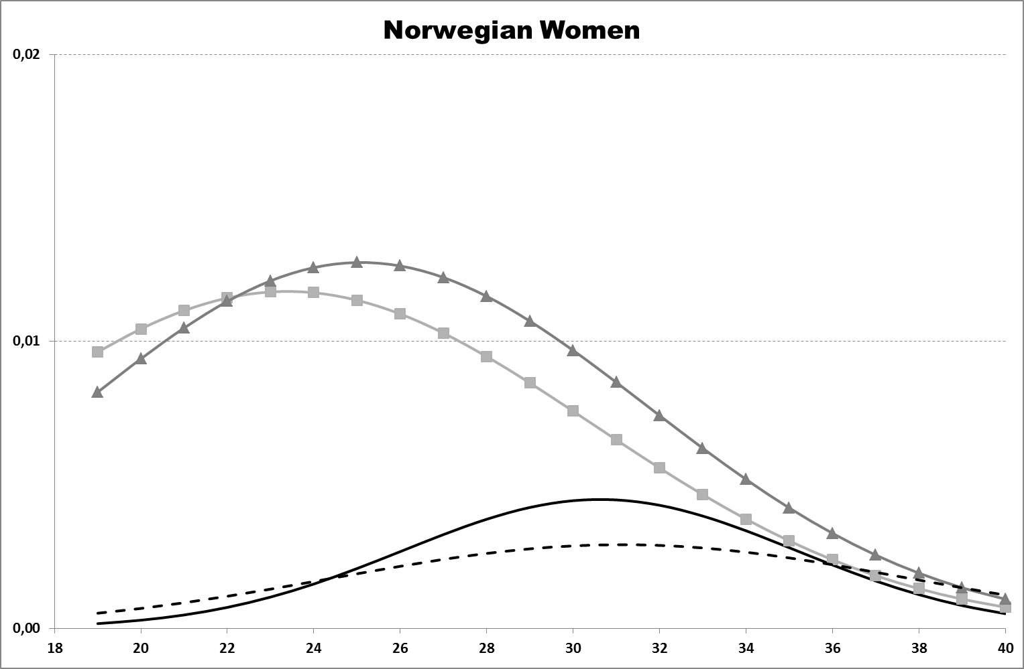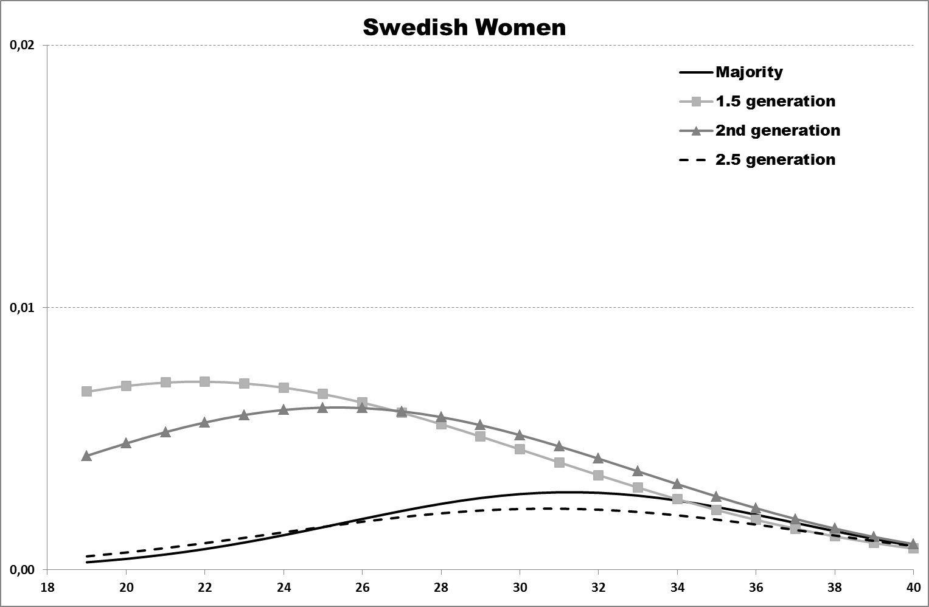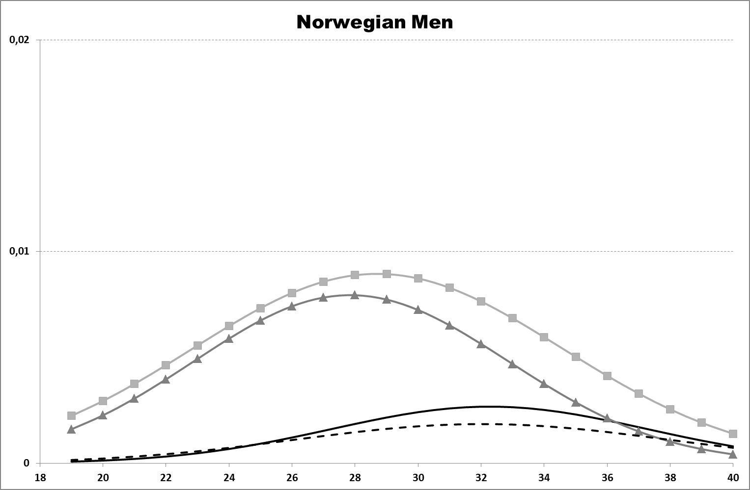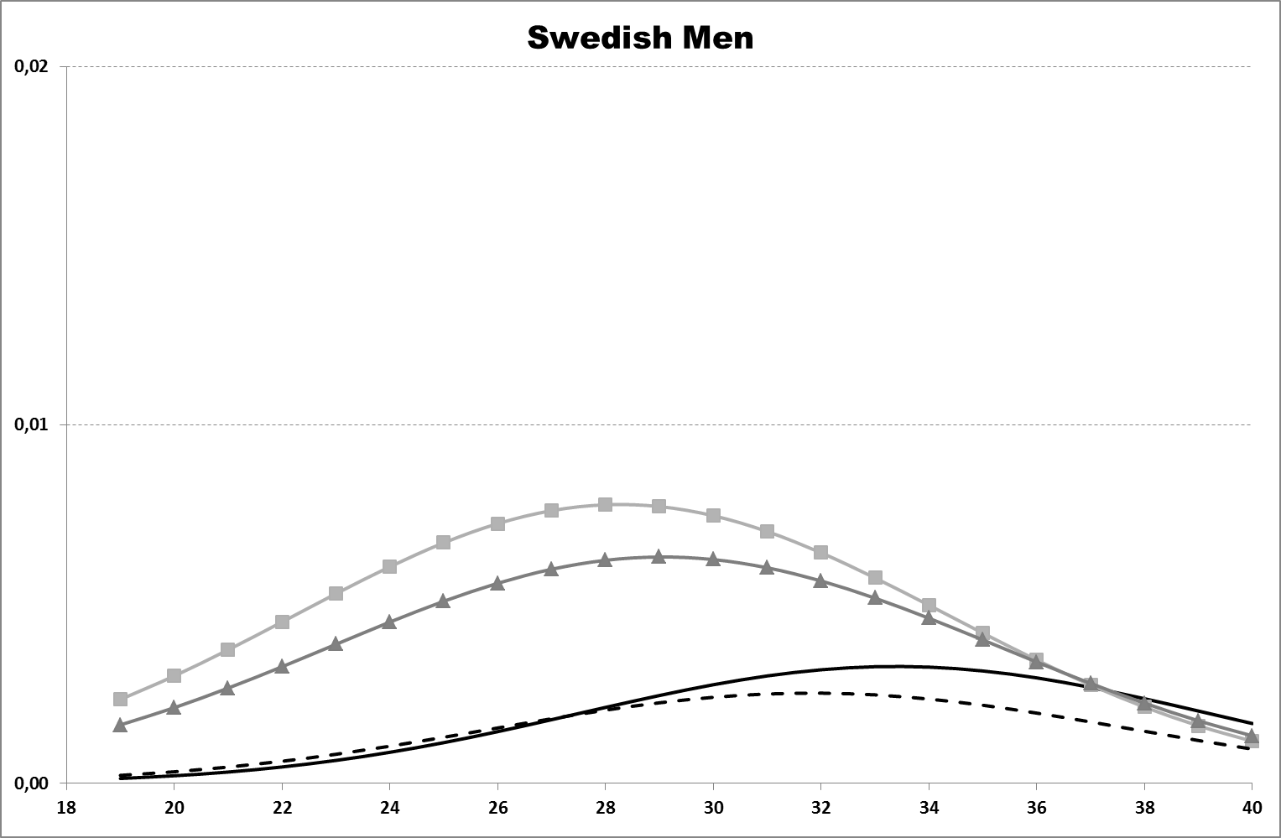
Note: 10% random samples of majority background individuals. The control variables were set at the following fixed values: Immigrant background individuals originating in Western Europe, without children, secondary educated, not enrolled in education, living in a large city.
Figure 2. Interactions between age and migrant generation. Marriage to immigrant background spouse from different region of origin. Predicted probabilities. Women and men.
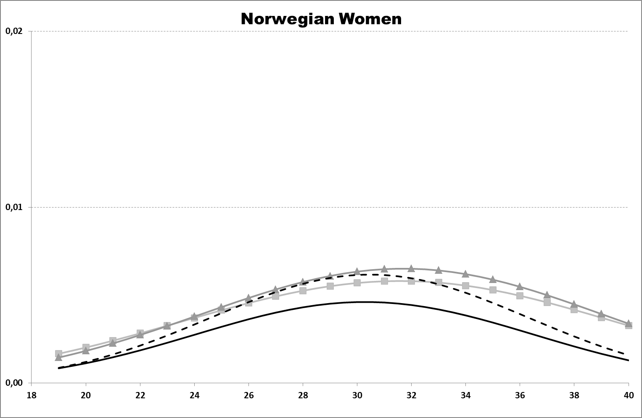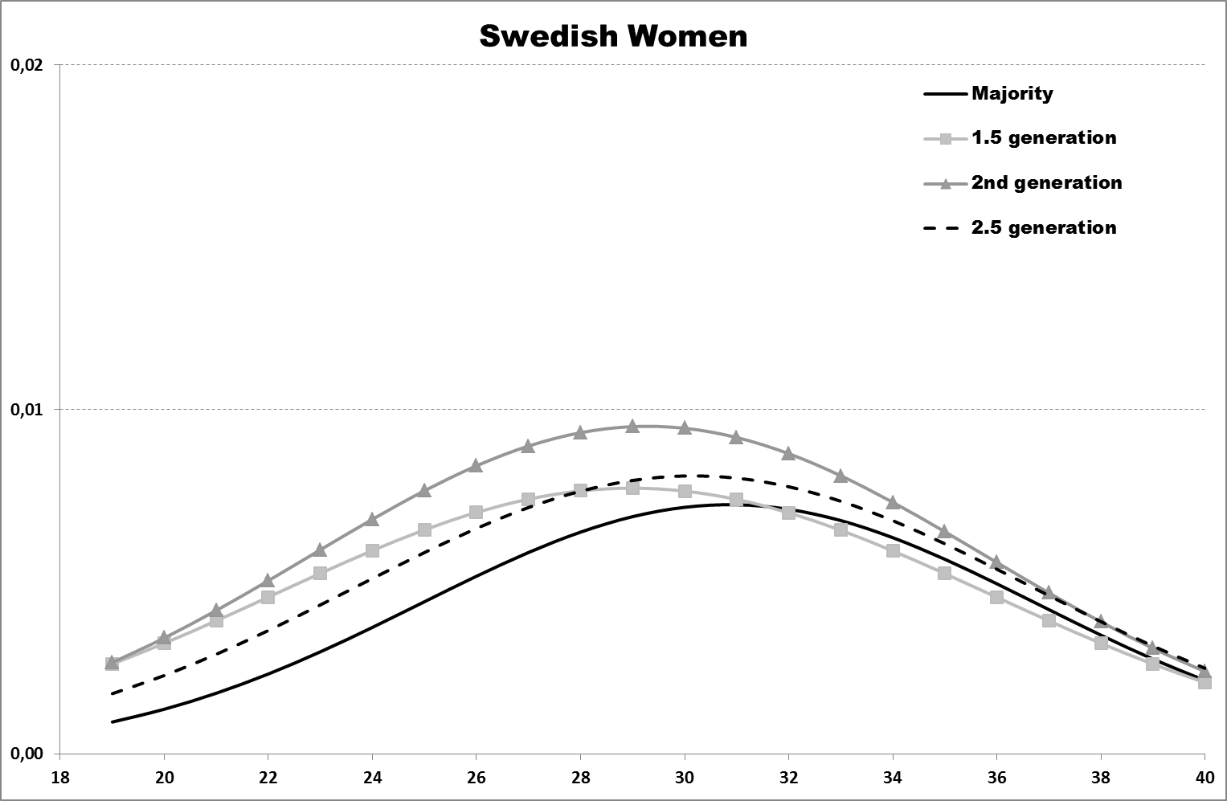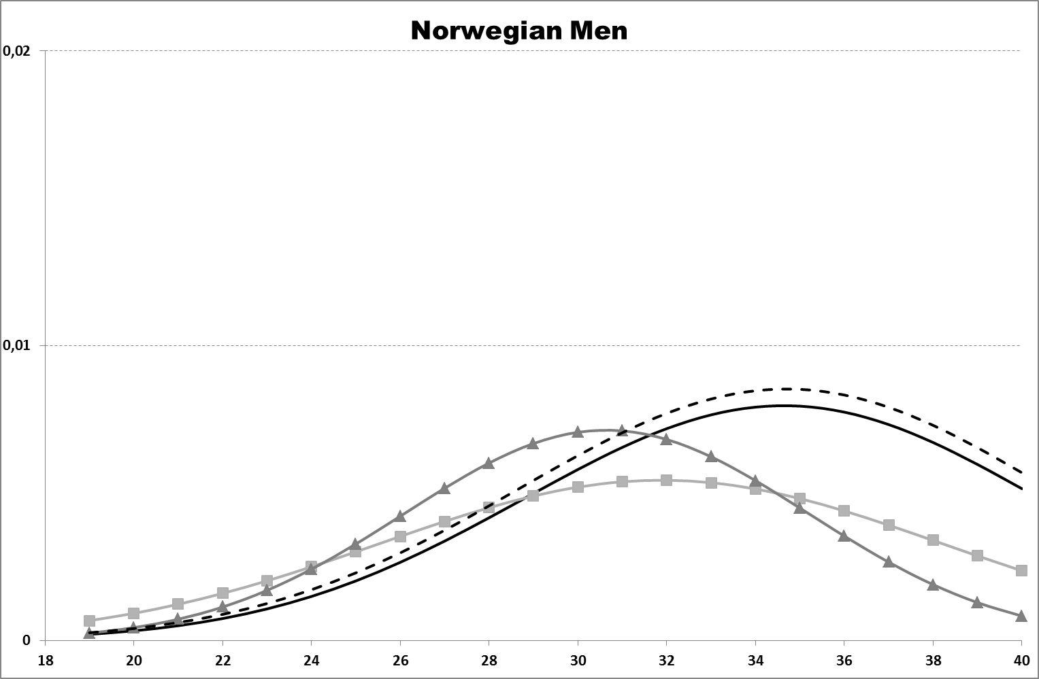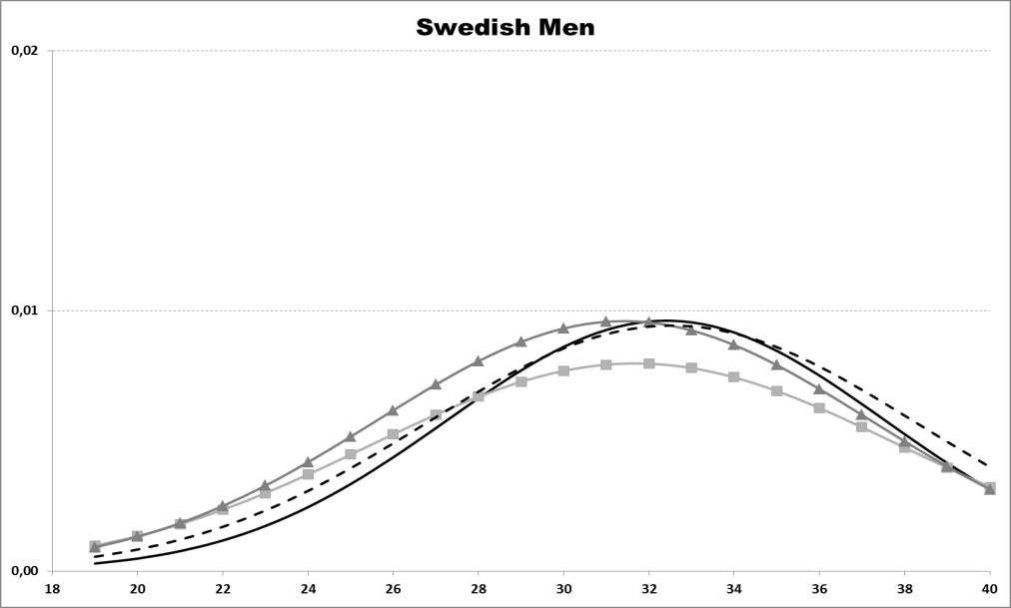
Note: 10% random samples of majority background individuals. The control variables were set at the following fixed values: Immigrant background individuals originating in Western Europe, without children, secondary educated, not enrolled in education, living in a large city.
Figure 3. Interactions between age and migrant generation. Marriage to majority background spouse. Predicted probabilities. Women and men.
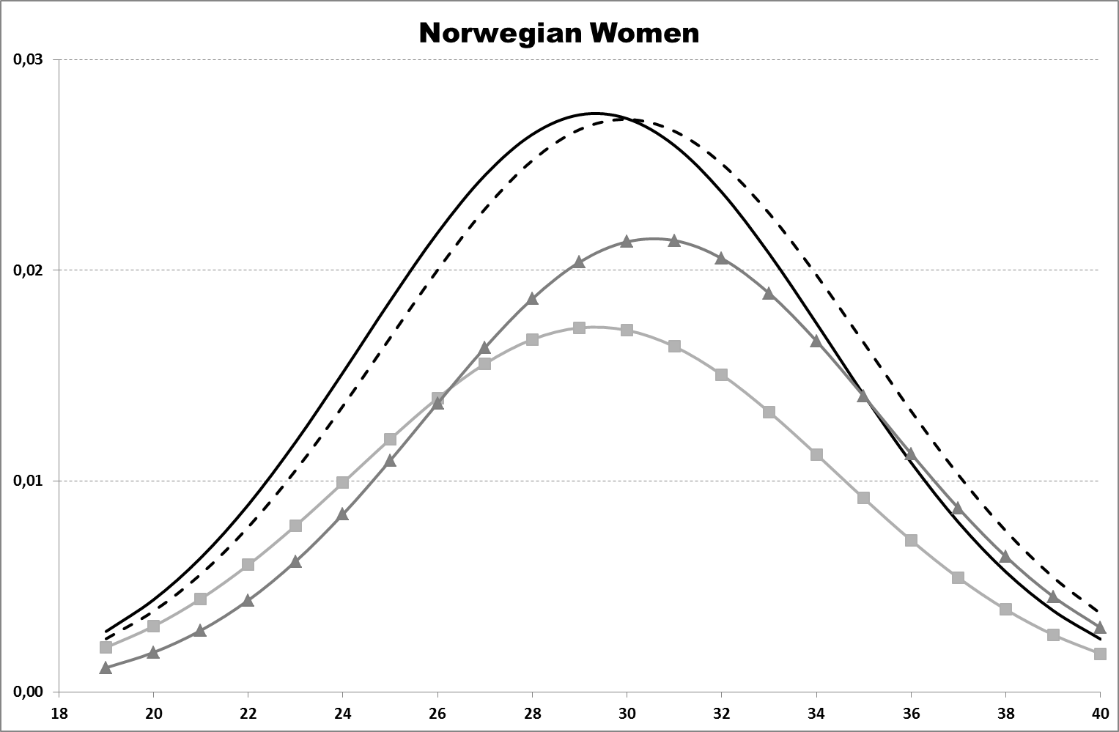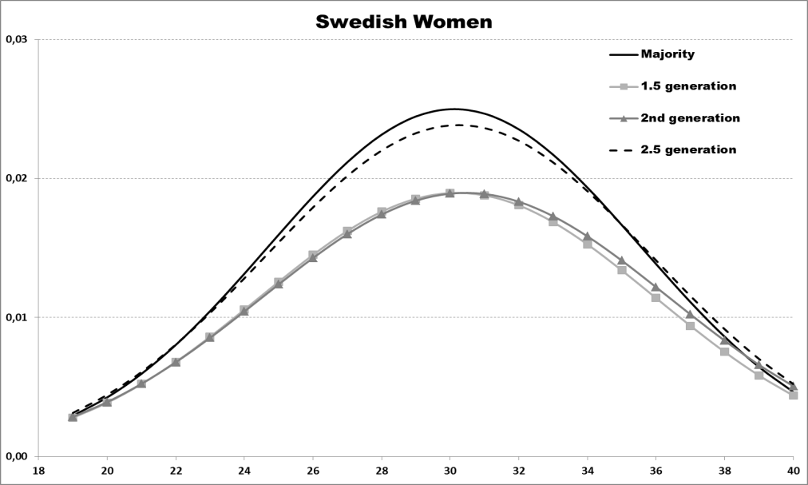
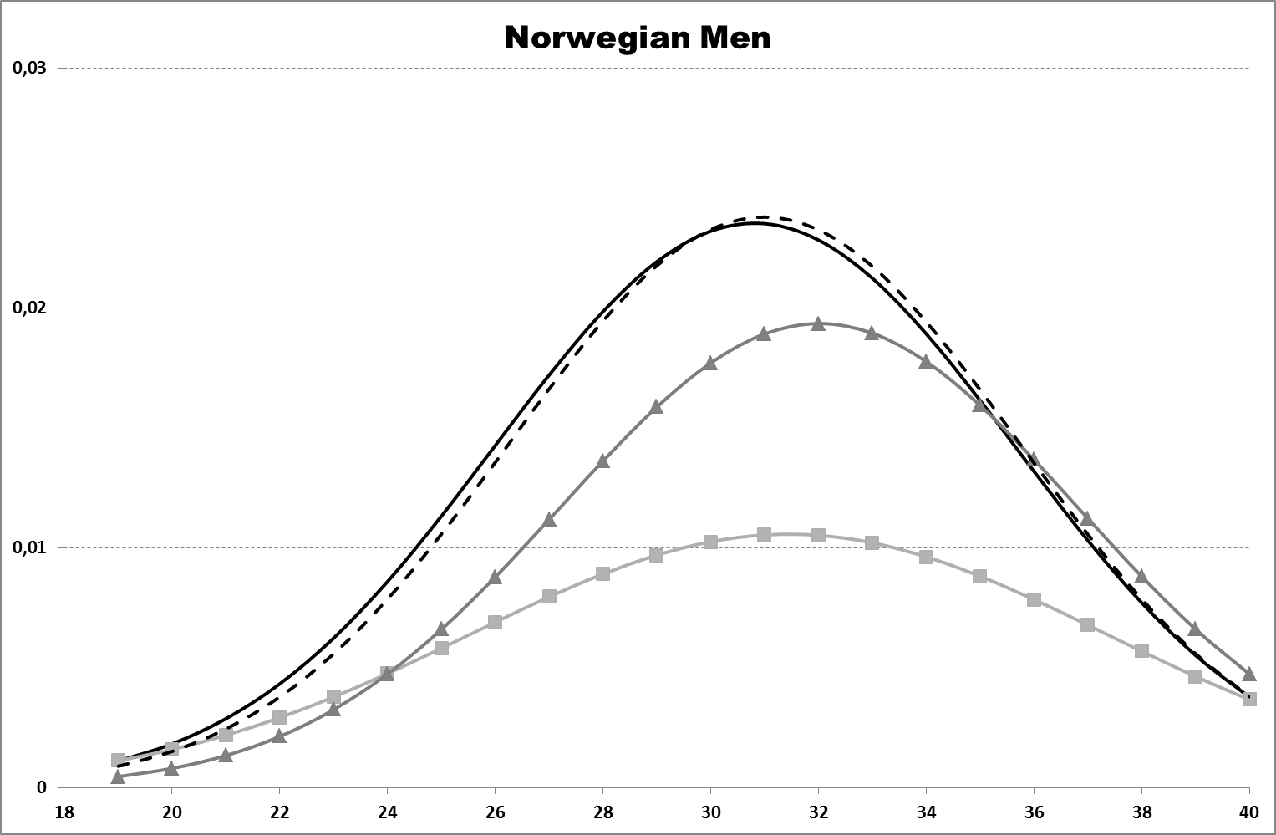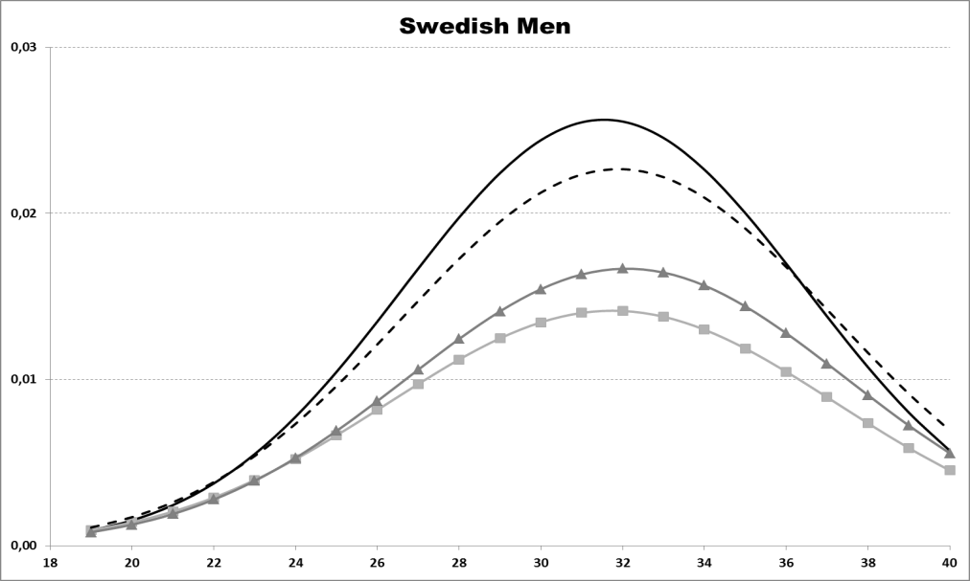
Note: 10% random samples of majority background individuals. The control variables were set at the following fixed values: Immigrant background individuals originating in Western Europe, without children, secondary educated, not enrolled in education, living in a large city.

Appendix. Descriptive statistics of Norwegian and Swedish analysis samples.
 | Norway |  |  | Sweden
Variable | n | % |  | n | %
Time-fixed covariates
Generation
1.5 generation | 45,006 | 21.5 |  | 173,146 | 29.2
2nd generation | 13,914 | 6.6 |  | 98,709 | 16.7
2.5 generation | 60,289 | 28.8 |  | 172,739 | 29.2
Majority | 90,323 | 43.1 |  | 147,897 | 25.0
Region of origin, immigrant
background individuals
Nordic countries | 25,799 | 21.6 |  | 139,840 | 31.4
Western Europe ª | 28,827 | 24.2 |  | 71,459 | 16.1
Eastern Europe | 12,997 | 10.9 |  | 70,634 | 15.9
Asia, rest of Oceania | 25,219 | 21.2 |  | 39,054 | 8.8
MENA | 13,573 | 11.4 |  | 74,025 | 16.7
Sub-Saharan Africa | 7,344 | 6.2 |  | 11,356 | 2.6
South America | 5,450 | 4.6 |  | 38,226 | 8.6
Gender
Woman | 101,682 | 48.5 |  | 288,463 | 48.7
Man | 107,850 | 51.5 |  | 304,028 | 51.3
Time-varying covariates
Any children | 335,471 | 14.2 |  | 895,136 | 13.0
Educational attainment
Primary | 894,183 | 38.0 |  | 2,647,217 | 38.6
Secondary | 896,250 | 38.1 |  | 3,301,799 | 48.1
Tertiary | 443,992 | 18.9 |  | 682,256 | 9.9
Missing | 119,463 | 5.1 |  | 232,277 | 3.4
Enrolled in education | 989,581 | 42.0 |  | 3,120,069 | 46.1
Urban residence | 665,446 | 28.3 |  | 1,708,823 | 24.1
N Person-years | 2,353,888 |  |  | 6,863,549
N Individuals | 209,532 |  |  | 592,491
Note: 10% random samples of majority background individuals. ª This category comprises countries in Europe (excluding Eastern Europe) as well as the US, Canada, Australia, and New Zealand.

