Stinking to High Heaven: Olfactory Aspirations and the Language of Desire.
Professor Jonathan Faiers.
Biography:
Jonathan is Professor of Fashion Thinking, Winchester School of Art, University of Southampton and his research examines the interface between popular culture, textiles and dress. His publications include Tartan (Berg, 2008) and Dressing Dangerously: Dysfunctional Fashion in Film (Yale University Press, 2013). Recently he has written essays for Alexander McQueen (V&A 2015), Developing Dress History: New Directions in Method and Practice (Bloomsbury, Nov. 2015), London Couture 1923-1975: British Luxury (V&A, Nov. 2015), Critical Luxury Studies: Art, Design and Media (Edinburgh University Press, March 2016) and an edited collection of new scholarship on Colors in Fashion (Bloomsbury 2016) In 2014 Jonathan launched Luxury: History, Culture, Consumption (Taylor & Francis Routledge) http://www.tandfonline.com/toc/rflu20/current; the first peer-reviewed, academic journal to investigate this globally contested term. He lectures internationally on textiles and dress and is a founding member of the Winchester Luxury Research Group and the Advisory Committee for the Costume Colloquium, Florence. His current research includes a new, single authored, socio-cultural history of Fur (Yale University Press 2019)

Abstract:
At once ephemeral and intrinsically corporeal, fragrance for many of us offers an entry point into luxury. As is well known, the perfume industry is fundamental to the economic viability of the contemporary luxury industry, but with basic ingredients consisting of water, chemicals, and infinitesimal amounts of plant and animal extracts, the frugality of its composition must be offset by the richness of the discourses used to promote it. This article will discuss how these olfactory discourses in fact constitute fragrance’s rarest of ingredients, their linguistic riches far surpassing the supposed costliness of its chemistries.

Key Terms: Perfume, aspiration, olfactory, discourse, ephemerality.

In 2004 the first incarnation of Donald Trump’s fragrance line was launched entitled simply Donald Trump The Fragrance. This legendary perfume manufactured in conjunction with Estée Lauder the American perfume and cosmetics corporation, was discontinued due, presumably, to poor sales and is now largely unavailable, although it is still possible to purchase 50 ml of Donald Trump eau de toilette on specialist fragrance retail sites such as Fragrantica, as well as Amazon and eBay for between £30 to £50. Described as containing top notes of mint, cucumber, black basil and citruses alongside woody, spicy and herbal middle notes, the packaging consisted of a golden box and stopper to the bottle and was decorated with a motif of thrusting, priapic architectural stripes reminiscent presumably of the Trump Tower. Leaving aside the ironic topographical linguistic slippage, in the U.K. at least, where ‘to trump’ is an archaic and vulgar (according to the Oxford English Dictionary) expression meaning ‘to break wind audibly’, the manner in which Donald Trump The Fragrance is typical. Its borrowed musical discourse, the aspirational promise inherent in its packaging and its now legendary status compounded by its comparative rarity amounting to an absence are all fundamental to the language of desire that envelops the marketing of fragrance. It is this particular, yet surprisingly consistent combination of linguistic and visual semiotics that has characterized the promotion of perfume, certainly since its commercial, mass produced origins in the nineteenth century, and which will be the subject of this article. In order to understand the implied exclusivity and elitism enshrined in the rhetorics of fragrance a range of examples drawn from the history of perfume manufacturing, both costly and more affordable, will be considered, to hopefully reveal that this same discourse of elitism is at once an impossibility; veiling an absence both material and conceptual, yet ironically deployed to promote fragrance’s olfactory aspirations as obtainable with price points guaranteeing entry levels for nearly all to the ephemeral world of desire.

It should be noted that those still hankering after the smell of Trump should not be too disappointed by his first fragrance’s scarcity, as he has followed up his original foray into perfume with Success in 2012, which according to the Trump Fragrance website ‘captures the spirit of the driven man’ and most recently Empire in 2015 ‘for those who aspire to create their own empire through personal achievement, this dynamic scent is both compelling and leaves a lasting impression’.
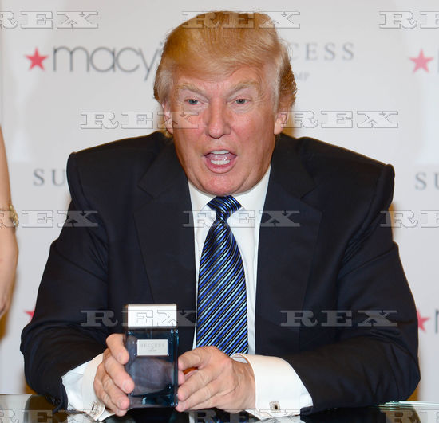

Fig. 1 ‘Success by Trump’ fragrance launch, New York 2012

Again the impossibility of empire building achieved by purchasing a bottle of £25.00 scent is matched by the physical unreality of Trump’s fragrances in that they are both now primarily available online, since Macy’s the chief retail outlet for Trump merchandise was forced to cease stocking his products due to the successful ‘Dump Trump’ campaign and petition following some of his most inflammatory remarks concerning immigration. The fragrances might achieve even further exclusivity following a statement by Perfumania, the manufacturers of the fragrance who according to their publicist are ‘winding down its retail business with the Donald Trump fragrance brand’

The ephemerality of fragrance, it’s temporary olfactory seduction is matched by the instability of the various sign systems used in its marketing. Contemporary perfume marketing’s obsession (no pun or reference to Calvin Klein intended here) with grafting the image of celebrity onto its other semiotic systems is a risky business, as we can deduce, not entirely surprisingly, from the Trump examples. Just as fragrances are subject to the whims and dictates of olfactory fashion, with very few lasting the test of time to reach the elevated status of ‘classic’ or ‘timeless’ (although many are deemed as such from their point of creation according to the copy used to advertise them), so too are the personalities utilised in their marketing. Take, for example, the now notorious and much derided 2012 advertising campaign for the re-launch of possibly the most ‘classic’ fragrance of all time; Chanel No. 5.

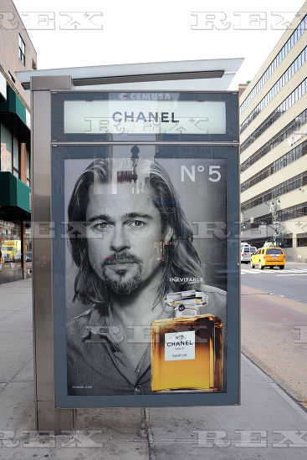

Fig. 2 Bus stop advertisement for Chanel No. 5 featuring Brad Pitt.

The advert used the film star Brad Pitt as the face of No. 5 and included a video for which he was paid 7 million dollars and which included Pitt delivering the following lines:

“It's not a journey.
Every journey ends, but we go on.
The world turns and we turn with it.
Plans disappear.
Dreams take over.
But wherever I go, there you are.
My luck, my fate, my fortune.
Chanel No. 5.
Inevitable.”

The discourse used to sell No. 5 is intentionally enigmatic, and deploys a semantic arsenal in order to convince the purchaser of the inevitability of No.5, its inevitable purchase, the inevitable union with Pitt, the inevitability of his fee and indeed the inevitability, or rather inescapability, of the myth of Chanel No. 5 itself. Whether that now needs to include the inevitability of Pitt’s split from Angelina Jolie, the inevitability of his infidelity (to Jolie and No. 5?) and his inevitable exposure as a possible alcohol and substance abuser remains to be seen. Myth, of course, is what Chanel, alongside most established luxury brand perfumes, has found increasingly lucrative to exploit in their marketing, and which as Roland Barthes reminded us so long ago is impervious to attack and able to continuously reinvent itself (Barthes 1973). The exploitation of the eternally lucrative myth of Chanel was recently taken to new heights in the exhibition Mademoiselle Privé held in October 2015 at the Saatchi Gallery, London (ironically an institution founded on the wealth accrued from the Saatchi advertising agency’s manipulation of elitist discourses) and which according to the press release was: a journey through the origins of CHANEL's creations capturing the charismatic personality and irreverent spirit of Mademoiselle Chanel and Karl Lagerfeld.

The exhibition was in truth an elaborate advert for Lagerfeld’s latest couture collection, the re edition of the 1932 Chanel jewellery collection and Chanel No. 5 perfume. The ‘No. 5 Room’ contained a series of cauldrons that periodically opened to allow the viewer a glimpse of bubbling essential oils supposedly used to create the fragrance, while dramatically, another five golden cauldrons raised their lids to permeate the air with blasts of vapour whose olfactory purpose was to mix together in the atmosphere of the gallery and re create for each visitor the smell of No.5. Underscoring this alchemical spectacle was the legend on the wall:

No. 5 is the grammar of a style. It is the grammar of Chanel fragrances. It’s a revolutionary fragrance especially in its abstraction, which opened the way to the modern perfumery. The mysterious composition of its floral accords without any reference to an identified flower makes it audacious. Gabrielle Chanel indisputably linked the world of perfumery to fashion. It was the first fragrance to wear the name of a fashion designer.

At the exhibition it was also possible to book for an olfactive workshop and even a children’s introduction to the world of the sense of smell and, additionally of course: Discover Gabrielle Chanel’s vision and the creation of CHANEL N°5, from Ernest Beaux, the first house perfumer, to Jacques Polge. A retelling of the myth of No. 5 that was conveniently brief, leaving out facts such as Chanel’s attempts in 1941 in Nazi occupied France to use the laws of Vichy France and her status as an ‘Aryan’ to petition the German officials to regain sole ownership of the company and oust her Jewish backers; Pierre and Ernest Wertheimer, whose money had helped her expand the perfume’s production, marketing and distribution in 1924.

Perfume’s discourse of absence, both an absence of fact whether, commercial or political in this case, or the more recognisable and marketable absence of love, time and place which I shall return to shortly, was recognised and critiqued by the Swiss artist Sylvie Fleury long before the hyperbolic marketing of the Mademoiselle Privé Exhibition, when for her installation for the 1991 Cologne Art Fair she placed 100 bottles of Chanel’s fragrance Egoiste on plinths, all of which were immediately stolen by visitors, leaving none at the close of the first day of the Fair; a comment perhaps on the ephemerality of art and fragrance, its impermanence, but above all the irresistible seductions of consumerism.

But to leave the mythic realm occupied by parfums Chanel, and return to the other point of this article, namely the remoteness of perfume’s rhetoric delivered cost-effectively, it is possible to buy a 50 ml. bottle of Chanel No. 5 eau de parfum in Boots the chemist for £68.00. Boots (the largest chemist chain in the UK) is where I was first struck by a display in the fragrance section and which became the catalyst for this article. Walking past the usual array of brands, the Diors, the Yves Saint Laurents and the Chanels, I was stopped short by rows of bottles unfamiliar to me, unfamiliar as perfume at least, but not as names, for these fragrances bore the names of pop stars and boy bands. These included: Justin Bieber, Taylor Swift, Britney Spears, Rihanna, Nicky Minaj and One Direction.

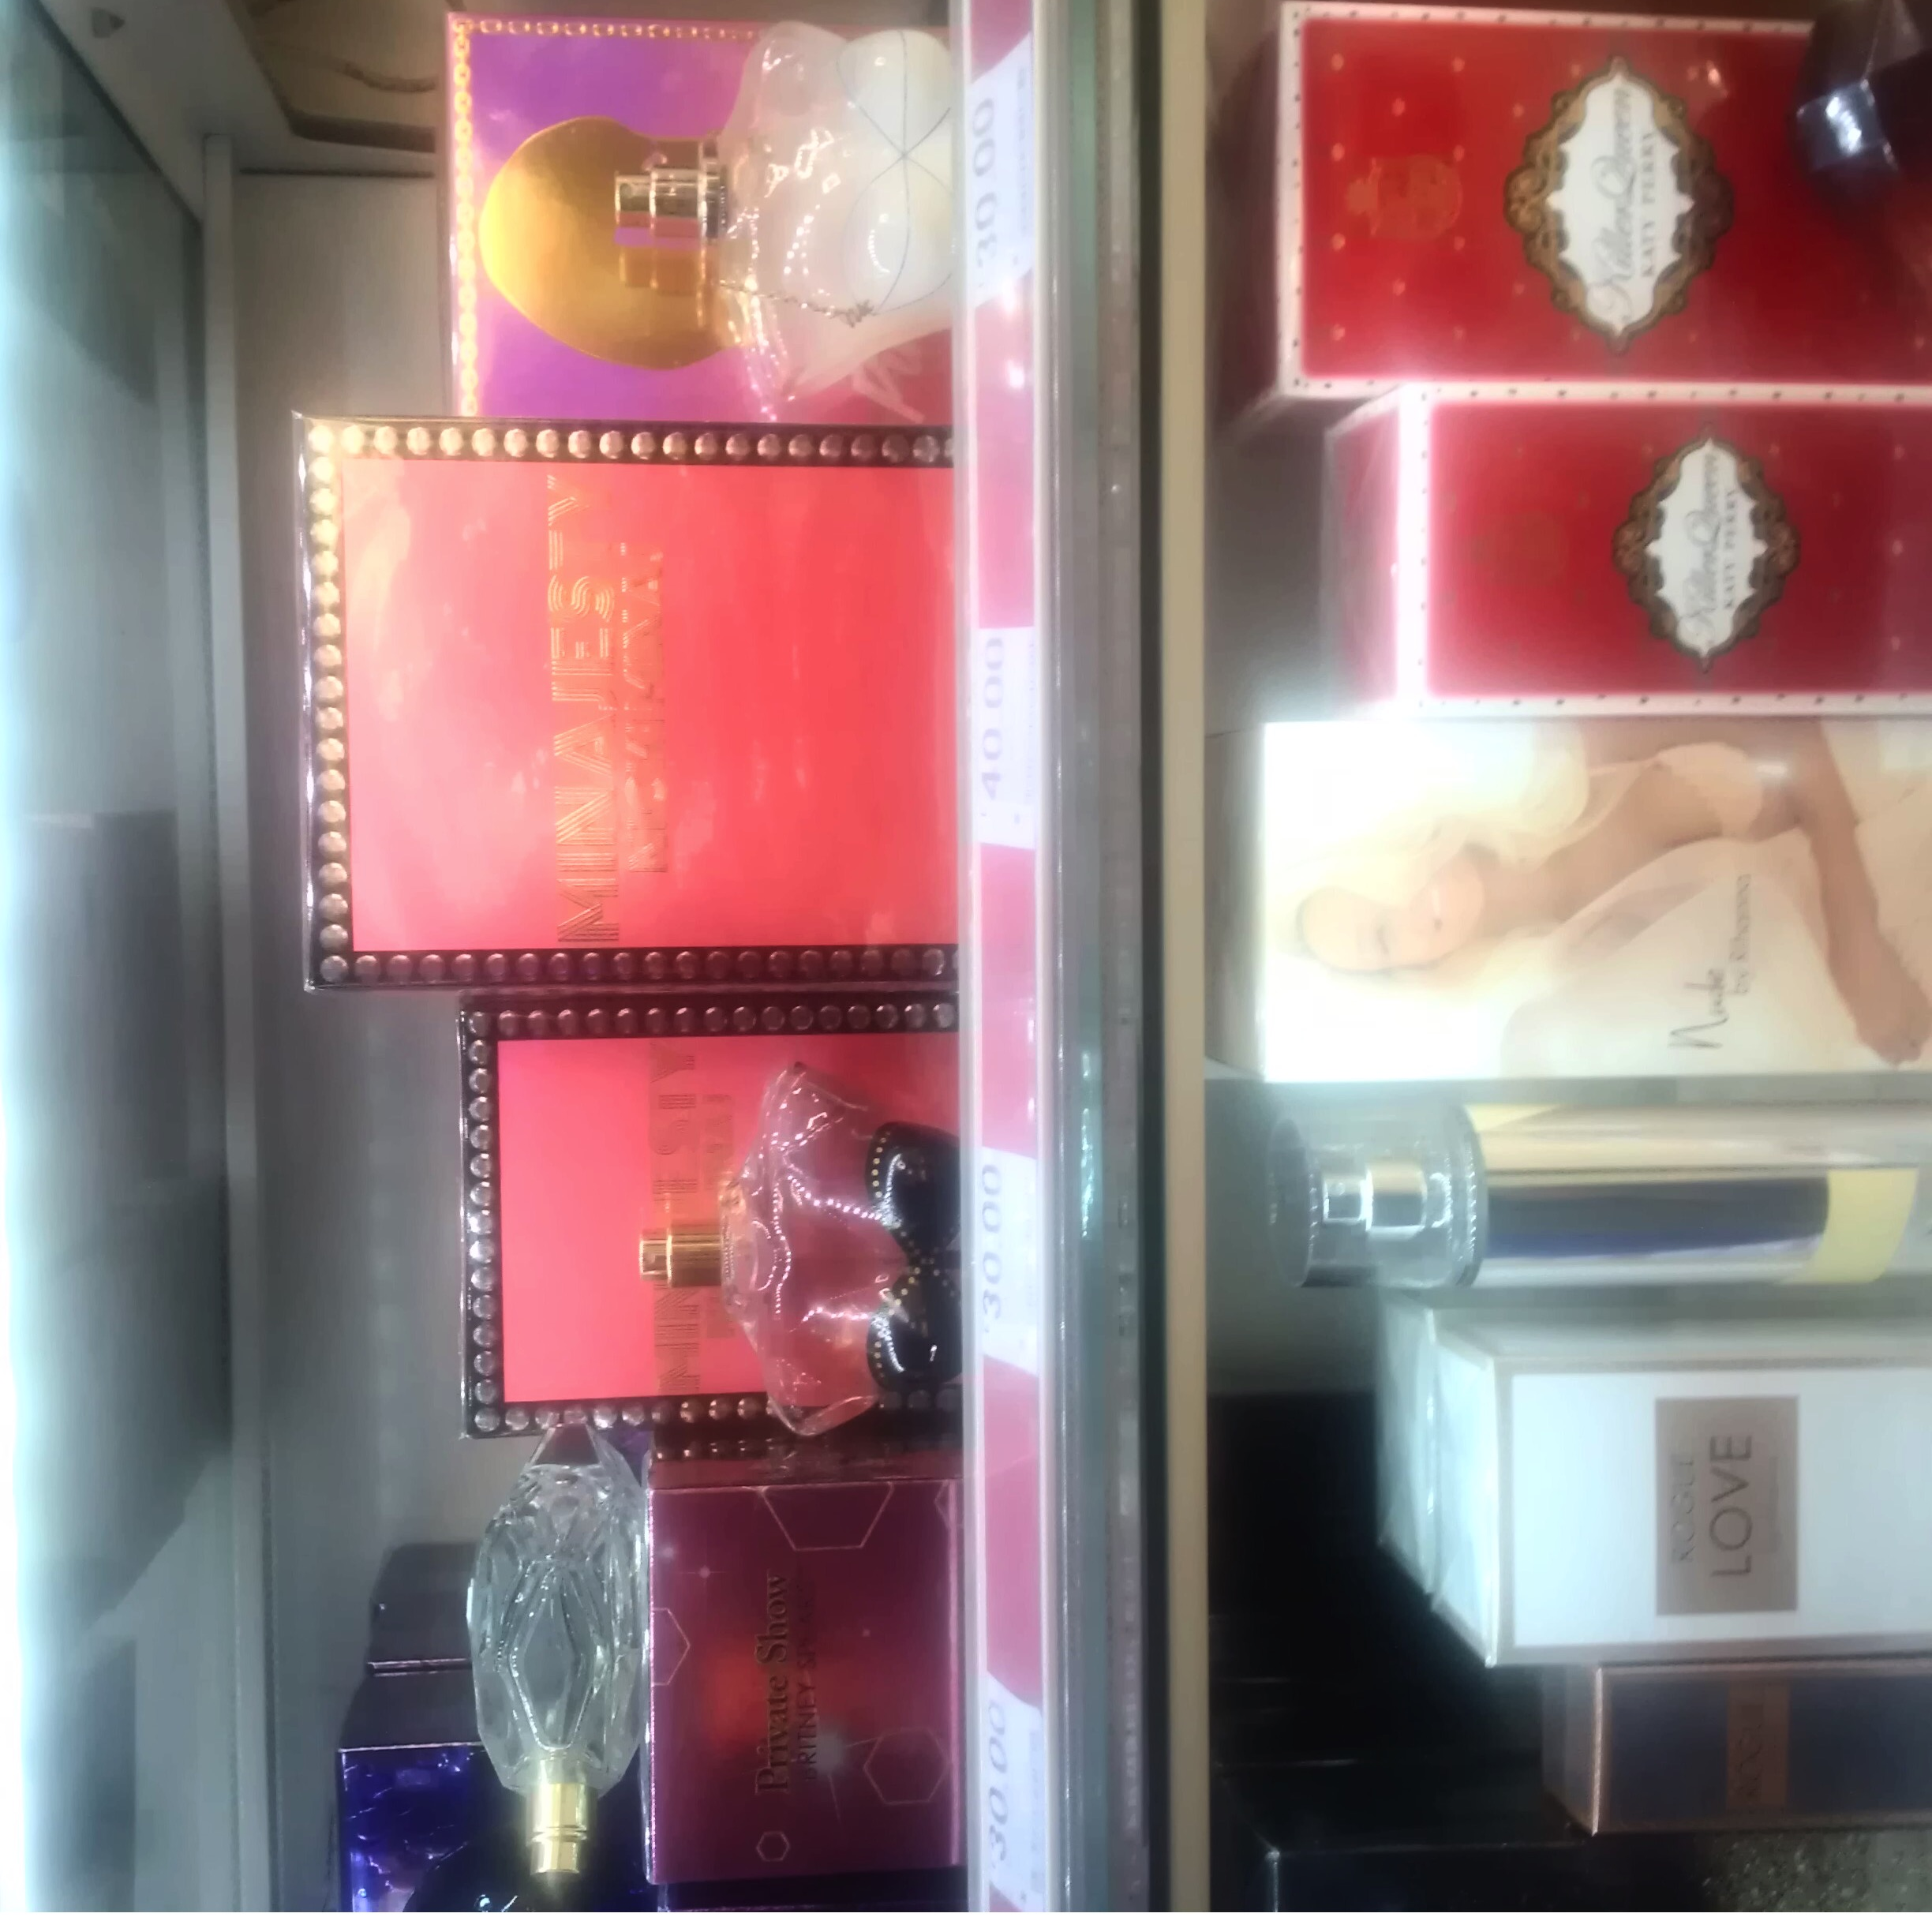

Fig. 3 Celebrity branded fragrance

Celebrity endorsed fragrance is, of course, nothing new, for example Elizabeth Taylor’s White Diamonds created in 1991 is one of the most successful examples of direct, commercially expedient celebrity branding of fragrance. However, the association of certain perfumes with celebrities and persons of note goes back far earlier than Taylor’s shrewd marketing of her reputation, and so we might re-visit Marilyn Monroe’s famous response: ‘nothing but five drops of Chanel’ when asked what she wore in bed. Or journey further back into myth and fable stopping by way of Anne Marie Orsini, the Princess of Nerola, Italy who made the fragrance of the bitter orange tree fashionable at the end of the seventeenth century using it to scent her bath and gloves and which would forever afterwards be known as neroli oil, still an essential ingredient in many perfumes today. Or to Louis XIV insisting the soft furnishings of the rooms at Versailles be scented with a different perfume for each day of the week, until we reach all those fabled perfumes of which the Old Testament reeks including the fabled Queen of Sheba with her cargoes of perfumes and spices or this example from Exodus: And the LORD said unto Moses, Take unto thee sweet spices, stacte, and onycha, and galbanum; these sweet spices with pure frankincense: of each shall there be a like weight: And thou shalt make it a perfume, a confection after the art of the apothecary, tempered together, pure and holy. (Exodus 30:34-5)

Mention of the Queen of Sheba brings to mind the imbrication of exotic fragrance and female sexuality that has remained especially pungent in literature, fuelling nineteenth century orientalist visions such as Gustave Flaubert’s piquant descriptions of Salammbo:
For earrings she had two little sapphire scales holding a hollow pearl filled with liquid perfume. From holes in the pearl there fell from time to time a tiny drop which wet her bare shoulder as it fell…His nostrils flared to breathe in more deeply the perfume exhaled from her person. It was an indefinable, fresh smell, but as heady as the smoke from an incense burner. She smelled of honey, pepper, incense, roses, and something else as well. (Flaubert 1977: 183-4)
Returning to the present day, sexuality naturally continues to be a central element in the exotic discourses of the contemporary perfume industry and its marketing. So if the alliance between celebrity and fragrance is nothing new, was it the garish packaging that separated out the range on display in Boots? Certainly the electric pinks and blues contrasted sharply with the customary severity of the packaging of more expensive branded perfume, Chanel’s minimal black and white or Prada’s insouciant monotones, and indeed the bottles inside these brightly coloured boxes maintained the promise of the Technicolor fragrant fantasies proclaimed by their packaging and indeed their advertising copy. But extravagant bottling and garish packaging is not the exclusive preserve of these lower priced, pop star perfumes, and it is possible to find examples of the tortured visions of the glass makers art put to the service of some of the most expensive perfumes in the world. These ‘limited edition’, gem-studded and gold-collared flacons, containing exactly the same perfume as the brand normally produces, regularly appear at the top of the now ubiquitous ‘world’s most expensive…’ lists suggesting that it is often the bottle and the case rather than the perfume that justifies its price.

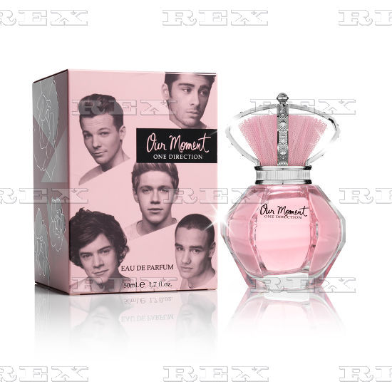

Fig. 4 ‘Our Moment’ by One Direction
Admittedly these lower priced celebrity perfumes are priced to be within reach, just, of the average besotted teenage fan but in some cases compare favourably with more respected brands (50 ml of One Direction’s Our Moment eau de parfum costs £28.50, for example) and so even price, apparently, is not necessarily a distinguishing factor. In fact what quickly emerges is that very little separates the visual and textual discourses of these celebrity endorsed fragrances from supposedly more exclusive perfume, and that the language of desire and its olfactory aspirations is on closer scrutiny universally impoverished. This elite discourse is anything but elite and instead speaks of collective dissatisfaction whether it has cost the consumer a few pounds or thousands. What this discourse of popular dissatisfaction masquerading as elitism might be composed of is the central subject of this article, but concludes by speculating on whether there has recently emerged a truly elite olfactory discourse that remains largely unknown and unsmelt? But before considering this it is necessary to examine more closely the particular components of the discourse of fragrance.
It is of course entirely understandable that such an ephemeral, evanescent and insubstantial product as perfume, that in terms of the materials used in its manufacture (bottle and packaging aside) is disproportionately expensive (no matter how extravagant and mythic the claims made for the rarity of its ingredients) and completely unnecessary (the true definition of a luxury item perhaps), and necessarily requires an equally mythic, or perhaps or rather greedily appropriated layering of discourses. In terms of its actual chemistry perfume tends to adopt a musical discourse. Descriptions are full of references such as ‘citrus notes’, ‘base notes’ and ‘top notes’, ‘floral themes’, ‘a chorus of musk and tuberose’, and endless descriptions of perfumes as symphonies, as refrains, as building to crescendos of fragrance as leaving haunting perfumed melodies and constructing chromatic complexities of flowers, woods, musk and so on.
This description of the perfume Enlèvement au Sérail given in the popularly acclaimed Perfumes: The A-Z Guide by Luca Turin and Tania Sanchez is typical: It starts with an intensely animalic floral top note; moves on to a golden, seraphic chord of jasmine and peach…and gradually settles to a classical, well poised voice with a hint of spicy wood rasp.” (Turin & Sanchez 2009: 248). Even more technical, musicological language is used amongst perfumiers themselves such as ‘accord’, a term meaning the process where a series of fragrant notes are combined to create an effect, similar to a musical chord, while musical referents are even used to devalue certain perfumes when they are deemed discordant, or their use of certain flowers is judged jarring or too strident.
One of the most highly regarded and commercially successful fragrances Arpège by Lanvin exploits this musical discourse in the story of its creation. Created for Jeanne Lanvin in 1927 and presented to her musician daughter Marie-Blanche on the occasion of her 30th birthday, the name is derived from the musical term arpeggio. This musical discourse has been regularly revisited and exploited by many of the most famous perfume brands, including Chanel, who in a 1937 advertisement suggests that No. 5 ‘is like the soft music that underlies the playing of a love scene’.
This borrowed musical linguistic terminology, is possibly due to the similarity between music and perfume in that largely speaking they each appeal to just one sense (hearing and smell respectively) unlike other traditional luxury products such as wine, which depend on both taste and smell. But more probably is the result of the relatively low discursive status attributed to the sense of smell, which, when it isn’t being compared to the source of the smell itself, has accrued its own negative olfactory terminology; stinks, stenches, reeks, pongs, or smelling high, fetid, fusty, malodorous, putrid, even halitotic.
Ann-Sophie Barwich of the Konrad Lorenz Institute suggests: The lack of interest in the nature of smells stems perhaps from its very character. As the most volatile sense of them all, smell does not appear to be sufficiently ‘‘real’’; odors are seen as too insubstantial and too brief in their appearance. In comparison to the primacy of other senses, especially vision, the ability to smell had been considered unimportant. (Barwich 2014: 258) She then goes to support this view by quoting Immanuel Kant from his Anthropology from a Pragmatic Point of View:

Which organic sense is the most ungrateful and also seems the most dispensable? The sense of smell. It does not pay to cultivate it or to refine it at all in order to enjoy; for there are more disgusting objects than pleasant ones (especially in crowded places), and even when we come across something fragrant, the pleasure coming from the sense of smell is fleeting and transient. (Barwich 2014: 258)
Kant’s discussion of the sense of smell here signals two of the primary characteristics of perfume one physical; its insubstantiality, and one social; its ability to hide other more unpleasant odours. So given these arguably unfavourable properties it again perhaps provides the answer as to why it has borrowed the discourse of its more noble sense – hearing and its largely esteemed object of sensation; music.
This reticence to engage with the olfactory seems especially telling when we consider that it is the sense of smell that alerts us to danger, the smell of smoke, of the rotten, of toxic gasses for example, that it is the sense that most effectively renders us conscious again from the depths of sleep, and evokes the absent or lost more directly than any of the other senses. How much has been written about the smell of the absent loved one left lingering on clothes, or of the association of specific perfumes with lost loves and objects of desire?
Leaving perfume’s borrowed musical discourse to one side for now, the mention of the evocative power of smell, of perfume’s ability to conjure up absent loved ones prompts a consideration of perfume’s other discourses which may be considered elitist or not, but which can also be understood as discourses of absence. Discourses that the perfume industry, from those engaged in producing mass market, competitively priced fragrance, to the artisan perfumier who composes (again the insistent musical terminology) bespoke, individual fragrances for wealthy clients, have found especially powerful. These discourses of absence take a number of forms but are attached to perfume to suggest that, with the acquisition of a few overpriced drops of water, alcohol, chemicals and if lucky essential oils, may be obtained something which the purchaser of the perfume currently does not have, and, in that sense, will admit them into an elite, a class that is somehow set apart from the rest, i.e. those not wearing this particular fragrance.
What this absenteeism may comprise of is varied and it is this very diversity of possible deficiency that has been so enthusiastically exploited by the perfume industry, certainly since its modern mass produced industrial formation, which many would date from the production of Jicky by Guerlain. The visual and textual discourses that flow around Jicky can be useful here to look at in a little more detail. Jicky is credited with being the oldest commercially produced perfume still in continuous production, since its creation by the leading perfume house Guerlain for the Paris Exposition Universelle of 1889. It is the first of the so called modern ‘abstract’ fragrances, that is a fragrance not just consisting one particular essence, for example, violets or roses, but a combination of these natural extracts with synthetic fragrance compounds, resulting in a perfume that perhaps smells floral, but not of one particular flower. It also broke new ground by not being named after its ingredients, but according to its myth the name is derived from the diminutive form of Jacqueline, a girl Aimé Guerlain the perfume’s creator, fell in love with in England whilst studying chemistry there, but whom he was not allowed to continue seeing due to her family’s disapproval. And so Jicky the perfume becomes the memory of a lost, or rather unobtainable love, an olfactory reminder of an unfulfilled desire, a key trope in texts related to perfume.
This discourse of love (possibly blocked by privilege) is both complicated and made to seem surmountable by the perfume’s bottle itself, and in particular its stopper which is fashioned in the shape of a champagne cork. A shape connoting celebration, France obviously, but also aspiration, the good life, and a privileged luxurious existence, another key element of perfume’s elite discourses, the promise of wealth, success and luxury delivered by a few drops of liquid. Unsurprisingly this discourse of affluence and privilege has become one of the most dominant for contemporary perfume marketing, which perhaps has lost interest in fragrance delivering reminders of lost loves, and is more interested in perfume being directly equated to wealth. The unmistakeable visual discourse of perfume equalling wealth accounts for the ubiquitous images of Charlize Theron as the face of Dior clad in gold, walking through a golden glowing Versailles, decapitated by golden, distinctly tribal, necklaces, even emerging from her golden bath, all which have no doubt added to the success of Dior’s J’Adore. Love here is reduced, via the linguistic pun contained in the name of the perfume, to the love of gold itself, to the love of oneself ‘as’ gold. Theron (and by extension the consumer) becomes the bottle of J’Adore itself with its collared, attenuated neck.
Unlike contemporary examples such as J’Adore, earlier manifestations of perfume as wealth maintained the myth that there was an intrinsic value in perfume itself, supposedly comprising rare and costly essences and ingredients, perhaps offsetting its disproportionate price tag. Joy by Jean Patou is perhaps the classic example of this, always marketed with the accompanying text: ‘the costliest perfume in the world’ a somewhat crass statement given that it was released to the American public in 1930 at the height of the great depression! Its price was justified by Patou who insisted that 1 ounce of Joy demanded 10,600 jasmine blossoms and 28 dozen roses. In an early example of luxury brand strategy the designer sent 250 bottles of his new perfume to his recently cash strapped American customers suggesting that: “If you can't afford our couture, we know you'll still want something desirable”, a strategy model that ever since has provided the template, and indeed the economic and commercial lifeblood of all luxury fashion houses.
The shameless promotion of wealth has, since Joy, become a familiar trope in the discourse of perfume from the relatively discreet Trésor, to the all out profligacy of recent fragrances such Paco Rabanne’s 1 Million, Lady Million and its variant Eau my Gold, Armani Diamonds, Estee Lauder’s Dazzling Gold, and Agent Provocateur’s limited edition Diamond Dust, which contains real diamond dust to produce shimmering skin, evidently. A trend that is apparently being critiqued by Moschino’s Cheap and Chic perfume that was packaged in a bottle modelled on Olive Oyl rather than a glamorous golden model and its Fresh Couture fragrance that is contained in a bottle that mimics household cleaning sprays. However chic these conceits maybe, their ‘cheapness’ is debateable since they cost the same as more aspirationally titled scents.
Having strayed into the territory of precious stones especially diamonds, ushers in the now ubiquitous presence of celebrity perfumes mentioned earlier, with Elizabeth Taylor’s White Diamonds if not the first (that honour goes to the short lived fragrance named Sophia named after Sophia Loren launched in 1981) possibly one of the most successful, both in terms of its actual smell achieving a 3 star rating by the oracle of perfume, critic Luca Turin who deems it: “…lush, creamy and sweet, with a tropical white-flowers accord smelling slightly like ripe bananas…Seems designed to waft up from cleavage.” (Turin & Sanchez 2009: 556) but also achieving a suitable synergy between its muse and inspiration Elizabeth Taylor, regularly voted one the most beautiful women in the world, and with one of the most valuable collections of jewellery in the world, certainly something which purchasers of White Diamonds in 1991 may well have aspired to. Whether the same degree of aspiration is promised by the entry level celebrity perfumes such as those made for Rihanna or Nicky Minaj, for example, it is difficult to ascertain. But for the One Direction devotee prior to the band’s demise, the promise of You and I, Our Moment or That Moment, with a particular idolised member was probably as desirable as Taylor’s famous 33-carat diamond gift from Richard Burton.
So, from Jicky to Our Moment the discourses of identification with a loved one; non-existent, unobtainable or past, underscores the essential impossibility at the heart of the discourses of absence that characterise perfume. There is a deathliness that haunts perfume’s discourse. Its association with memory, its ability to conjure up those no longer present is of course well known, the smell of a loved one now gone propels them back to us from the grave and has been the stuff of countless narratives. Interestingly, one of the most timeless and revered of all fragrances; Worth’s Je Reviens launched in 1932 threatens by its name alone (‘I will return’) an inevitable, almost supernatural reincarnation, a reputation bolstered by it becoming a favourite gift from servicemen in WWII to their loved ones.

Artists, along side critiquing the discourses used to sell perfume, its commercial seductions and indeed perfume’s own mythic heritage, as with Sylvie Fleury, have also been quick to exploit perfume’s olfactory and memorialising power. One of Louise Bourgeois’ most enigmatic works directly references perfume’s ability to evoke the absent presence and by using one of the most celebrated and iconic perfumes of the twentieth century; Guerlain’s Shalimar. In Cell II (1991), one of the series of intensely personal and enigmatic works that preoccupied Bourgeois for some twenty years or so, she enclosed within a series of interlocking doors, a small glass vanity table on which is placed a sculpture by the artist of a pair of wringing hands and a group of empty, or nearly empty Shalimar perfume bottles. This particular scent, evocative of her mother, recreates the perfumed aura of the absent maternal presence, a recurring theme throughout Bourgeois’ work, but also distils the centrality of perfume to twentieth century, Western socio-cultural formation.

Shalimar created by Jacques Guerlain in 1921 and relaunched in 1925 at the Exposition des Arts Decoratifs in Paris was supposedly inspired by Mumtaz Mahal for whom the Taj Mahal was built and was immediately successful with its exotic notes of lemon, jasmine, rose, iris, incense, opopanax, tonka bean and vanilla, conjuring up a distant orientalist fantasy for fashionable Europeans and North Americans. An exoticised conflation between a mythical orient, certain smells and an Orientalist eroticism left over from the 19th century and that still informs Guerlain’s contemporary campaigns for the fragrance.

To be transported somewhere, and at some point in time that we are not, by the application of fragrance is an even more insistent trope in the discourse of longing that envelops perfume and the absence of the loved ones of Jicky, of One Direction or even Louise Bourgeois’ mother is nothing compared to the yearning for fabled, exotic locations, of which Shalimar is a classic example. The olfactory fantasy of fabled lands, of experiences out of this world and out of time, are the mainstay of perfume’s discourses and inspired the Japonisme of another classic Guerlain fragrance; Mitsouko, created in 1919 as well as more recent fantasies of olfactory travel to far off fabled lands that saturate perfume’s discourses of absence including the 1970s success Xanadu onto Yves Saint Laurent’s commercial hit Opium, which taps into another nineteenth century Orientalist fantasy of the joys and perils of the East in the form of narcotics. Similarly the a-temporality of L’Heure Bleu, and Nina Ricci’s L’Air du temps, (incidentally, the fragrance Hannibal Lecter identifies on Clarice Starling in the film Silence of the Lambs) are just two of any number of apparently ‘timeless’ fragrances. Suggesting that olfactory pleasure both transcends time and is out of time, existing in a vacuum of ephemerality, soon to be atomised and dispersed forever.

This longing for elsewhere for another time and place is perhaps only a commercialised form of the same discourse of longing that characterised fin de siècle literature and at the same time as Flaubert was imagining Salammbo’s perfumed artifice, Dorian Gray in Wilde’s novel used the study of perfume to help him escape the ennui of his present and steep himself in the perfumed fantasies of elsewhere:

“And so he would now study perfumes, and the secrets of their manufacture, distilling heavily-scented oils, and burning odorous gums from the East. He saw that there was no mood of the mind that had not its counterpart in the sensuous life, and set himself to discover their true relation, wondering what there was in frankincense that made one mystical, and in ambergris that stirred one’s passions, and in violets that woke the memory of dead romances, and in musk that troubled the brain, and in champak that stained the imagination…and of dark and fragrant woods, of spikenard that sickens, of hovenia that makes men mad, and of aloes that are said to be able to expel melancholy from the soul.” (Wilde 1966: 106)

It is now possible to purchase from Ravenscourt Apothecary Dorian Gray. Ravenscourt is one of the ever growing number of ‘artisanal’ or ‘bespoke’ perfumiers, where specific recipes are created for individual clients in a revival of the practice common with privileged eighteenth and nineteenth century perfume connoisseurs. These same artisanal perfumiers market, and create so-called ‘conceptual’ fragrances, both exclusive in their accessibility, often being stocked by only a few specialist retailers, and excluding in their complex and often alienating smell and which have found a growing, if still niche market, in the noses of those bored with high street orientalism. Presumably Dorian Gray appeals to the elitism of the customer who would rather smell like an immoral, never ageing fin de siècle aesthete than either Justin Bieber or for that matter David Beckham.

Naturally the more conceptual fashion houses have long shunned the easy fame of a Chanel No. 5 or Miss Dior for example and so reminiscent of the aesthetic reveries of Dorian Gray, Commes des Garcons produce, amongst a number of conceptual fragrances an Incense range which recreate specific incense laden, spiritually associated atmospheres from around the world including the cathedral at Avignon or Ouarzazate; the so-called door of the desert in Morocco. A similar exercise in olfactory recreation is that carried out by Maison Martin Margiela with their replica series of perfumes evoking the smell of specific locations at specific times including Jazz Club Brooklyn 2013 or At the Barber’s Madrid 1992.

So with perfume’s discourses becoming ever more elitist, and regardless of the conceptual perfumiers mission to de-romanticize scent, it appears, as Roland Barthes observed, that perfume’s myth remains as resilient and impervious to atomisation as ever, proving that: It thus appears that it is extremely difficult to vanquish myth from the inside: for the very effort one makes in order to escape its stranglehold becomes in its turn the prey of myth: myth can always, as a last resort, signify the resistance which is brought to bear against it. (Barthes 1973: 147)

So, perhaps Viktor & Rolf, the Dutch design duo offer the final insight on perfume’s discourses, separating out the text from the fragrance entirely in their 1996 project; Le Parfum. Their odorless Le Parfum was conceived as an homage to Yves Klein’s Le Vide. Sealed shut, it was given the same reverent attention as a functional branded perfume including packaging and a full advertising campaign. As they later commented: “the scent has an intoxicating effect. Anticipated by its advertisement, [it can] only be imagined: sealed by a wax cap, the flask cannot be opened. The perfume can neither evaporate nor give off its scent, and will forever be the potential of pure promise” (Evans 2008: 53) Le Parfum leaves the consumer with the pure myth, an elitist discourse of concentrated absence, of absolute deficiency as the most potent and lingering of all fragrances….

References

Barthes, R. 1973, Mythologies, Collins, London.
Barwich, A. S. 2014 ‘A Sense So Rare: Measuring Olfactory Experiences and Making a Case for a Process Perspective on Sensory Perception’ in Biological Theory Sept. 2014 vol. 9 issue 3 pp258-268
Evans, C. & Frankel, S. 2008, The House of Viktor & Rolf, Merrell, London Flaubert, G. 1977, Salammbo, Penguin, London.
Turin, L & Sanchez, T. 2009, Perfumes: The A-Z Guide. Profile Books, London.
Wilde, O. 1966, Complete Works of Oscar Wilde, Collins, London

http://www.fragrantica.com/perfume/Trump/Donald-Trump-22530.html https://www.amazon.co.uk/Trump-Fragrance-Men-Toilette-Spray/dp/B000E9BZG0 http://www.ebay.com/itm/Donald-Trump-The-Fragrance-Spray-100ml-Unbox-/321242850906
http://www.trump.com/merchandise/trump-fragrance/
http://www.msnbc.com/msnbc/trump-success-no-more-perfume-maker-drops-mogul-scent
Dialogue taken from the Chanel No. 5 promotional video available at https://www.youtube.com/watch?v=mGs4CjeJiJQ
http://www.saatchigallery.com/current/mademoiselle_prive.php
Wall text by Olivier Polge from the ‘No. 5 room’ Mademoiselle Privé exhibition, Saatchi Gallery, London. 30th October to 1st November 2015.
http://www.saatchigallery.com/current/mademoiselle_prive.php
All prices quoted in this article are correct at the time of writing, but necessarily are subject to fluctuation according to outlet, I have where possible given a typical high street retailer price.
From advertisement reproduced on the website http://inside.chanel.com/en/no5
Quoted on the website http://www.adweek.com/news/advertising-branding/how-jean-patou-squeezed-10600-jasmine-flowers-16-ounce-bottle-163874

