**Sedimentary heavy metal(loid) contamination in the Veracruz shelf, Gulf of Mexico: a baseline survey from a rapidly developing sub-tropical coast.**

**Celis-Hernandez, Omara,b; Rosales-Hoz, Leticiaa; Cundy, Andrew B.b*; and Carranza-Edwards, Arturoa**

aInstituto de Ciencias del Mar y Limnología, Universidad Nacional Autónoma de México, Circuito Exterior, Ciudad Universitaria, Coyoacan, C.P. 04510, Ciudad de México, México.

bOcean and Earth Science, National Oceanography Centre (Southampton), University of Southampton, Southampton, SO14 3ZH, United Kingdom.

*Corresponding author

Tel: +44(0)2380 596719; Email address: [A.Cundy@soton.ac.uk](mailto:A.Cundy@soton.ac.uk)

**Abstract**

This study examines sediment texture, geochemistry and sediment accumulation in cores from four sites in the Veracruz shelf area of the Gulf of Mexico, to assess the inputs of heavy metal(loid)s (and their potential biological impacts) in this carbonate-dominated shelf system, and to examine the rate of sedimentation near to the mouths of the La Antigua and Jamapa Rivers. The use of different pollution indices showed enrichment with Pb in all cores studied, although based on sediment quality guidelines As was the only element that has potential to occasionally cause damage to the benthic organisms present in the area. Heavy metal(loid) and sediment input from terrestrial and coastal sources is limited compared to more proximal, nearshore areas. The sediment core data presented however give a baseline dataset for heavy metal(loid) concentrations in the Veracruz shelf, against which future anthropogenic inputs can be assessed.

**Keywords**: heavy metals; shelf sediments; sediment quality; baseline; Mexico

*Published in Marine Pollution Bulletin, 119, 204-213, 2017*

*http://dx.doi.org/10.1016/j.marpolbul.2017.03.039*

**Paper text**

Many highly biodiverse sub-tropical nearshore / shelf environments and ecosystems are under increasing threat from the rapid development of adjacent coastlines. Enhanced sediment supply from dredging and coastal run-off (from urbanized areas and deforested river catchments), coupled with increased inorganic and organic contaminant loadings from industry and agriculture, may severely impact these ecosystems. Indeed, a number of studies have noted a range of degradative effects around Australian, Chinese, Asian and African sub-tropical coasts due to sediment and contaminant input (e.g. Ayyamperumal et al. 2006, Mckinley et al. 2011, Song et al. 2014, and Salem et al. 2014). Along the Mexican coast, several authors have noted increases in terrestrially-derived materials, and contaminant loading, in coastal and estuarine sediments (Rosales et al. 2003, Ruiz et al. 2004, Muños et al. 2012, Celis et al. 2013, Botello et al. 2015, Ruiz et al 2016), particularly due to enhanced river catchment erosion and urban and industrial inputs. It is unclear however to what extent this increased sediment and contaminant loading has impacted more distal, carbonate-rich offshore areas. Here, we report results from a baseline survey of marine sediments from the Veracruz shelf area of the Gulf of Mexico, to

1. Assess the inputs of heavy metal(loid)s, and their potential biological impacts, in this carbonate-dominated shelf system.
2. Examine the rate of sedimentation near the mouths of the La Antigua and Jamapa rivers on the Veracruz shelf.

The Veracruz coast in the southwest Gulf of Mexico, from 18° 30.08’ to 19° 57.77’ north latitude and from 94° 53.26’ to 96° 29.59’ west longitude, receives freshwater and terrestrial sediments from the La Antigua and Jamapa rivers (Figure 1). The combined population of both river catchments is 1,656,285 (INEGI, 2012) which represents 70.9 % of the total state population. The main potential sources of anthropogenic heavy metals in the area are from agriculture, cattle production and local urban and industrial activities, particularly around Veracruz City, which contains 43.5 % of all state infrastructure, is the most important industrial and manufacturing center in this region of Mexico, and contains one of the major Mexican ports on the Gulf of Mexico. The lithology of the La Antigua and Jamapa basins consists of varied sedimentary, intrusive and igneous rocks (INEGI, 1984).

Four sediment cores (Figure 1) were collected using a box corer and subsampled with a PVC pipe (10 cm inner diameter) aboard the O/V Justo Sierra in August 2008. Samples labeled as J25 and J29 were collected 6.5 and 11.8 km from the mouth of the Jamapa River at water depths of 21.3 and 25.5 m; cores marked as A15 and A16 were collected 13.6 and 40 km from the La Antigua River mouth at water depths of 43.1 and 50 m. Core A16 was taken closer to the Laguna Verde nuclear plant. Every core was extruded and subsampled at 1 cm intervals. All analyses, except grain size, were applied to ground samples stored in polyethylene bags. All concentrations are expressed with reference to dry weight.

Particle size distribution within sediment samples was determined using a Coulter Model LS-230 laser diffraction analyzer, following dispersion with sodium hexametaphosphate. For other analyses, sediment samples were dried at 55 °C for 48 h and ground to a fine flour consistency in an 8000 SPEX MIL. Organic carbon content was determined by oxidation with K2Cr2O7 (Gaudette et al. 1974)**.** Carbonates were determined by titration (after Hesse, 1971), in which excess HCl that did not react with the carbonate was reverse titrated with sodium hydroxide. Glass beads were prepared from the samples in a 1:1 ratio of LiBO2 and LiB4O7 (ultrapure grade), and major elements determined using a Siemens SRS 3000 XRF spectrometer. The accuracy of this method was evaluated using the AGV-1 standard, and was 100 ± 2 % for all of the oxides, except for MnO and P2O5, which showed values of 93 and 106 % respectively. The precision was between 0.2 and 1.5 %, except for P2O5 which was 3.79 %. Trace metal analysis was performed on 0.5 g of each sample. Each sample was mixed with 10 mL H2O and concentrated HNO3 (5 mL), HF (4 mL) and HCl (2 mL) and placed in a Teflon vial. The samples were then digested in a MarsXpress microwave for 40 min at 180 °C and 20 min at 185°C; later, the liquid was poured into a 25 mL Nalgene volumetric flask with 2 g of H3BO3 and shaken for 2 min; the extracts were then centrifuged and diluted to a final volume of 25 mL. Trace metals were measured on a Thermo Electron Corporation S Series Atomic Absorption Spectrometer, with the exception of Arsenic which was measured using a (Vapor system) VP100 Thermo Electron Corporation Hydride Generator. The quality of the results was evaluated with reagent blanks, and a PACS-2 reference material (National Research Council, Canada) was included in each sample run. Percentage recovery was: Cu 112 %; Ni 87.7 %; Zn 98.2 %; Pb 101.1%; Cr 94.1 %; and As 59.1 %. Precision (2) was better than 4.3% for all analytes.

The results were interpreted using descriptive and multivariate statistical tools, and geochemical indices (Enrichment Factor (EF), Geo-accumulation Index, Modified Degree of Contamination (mCd) and Sediment quality guidelines (SQG)). In order to test the relationships between variables a Pearson Correlation Analysis was performed. To identify associations between the four sediment cores studied, a Cluster Analysis was performed; also, to evaluate the main parameters controlling the characteristics of the sediment cores and to identify the causes of variation between samples in each core a Factor Analysis by Principal Components was carried out. Each multivariate analysis was carried out using 49 subsamples from the four sediment profiles.

The enrichment factor (EF) was used to evaluate the natural or anthropogenic origin for each heavy metal(loid) and was calculated using the equation:

$\text{EF = }\frac{{\left(\frac{\text{X}}{\text{Y}}\right)}_{\text{sample}}}{{\left(\frac{\text{X}}{\text{Y}}\right)}_{\text{Background}}}$……… (Forstner U. et al. 1979)

Where Xsample and Xbackground are the concentration of the metal(loid) (X) in the sample and in local geological background materials respectively. Ysample and Ybackground are the concentrations of a conservative element chosen to normalize the data in the sample and in geological background materials. In this work aluminum was used as a conservative element to normalize the data, and concentrations previously reported for the Upper Continental Crust were used as the geological background (McLennan, S. M., 2001).

The geo-accumulation index (Igeo) was used to estimate the anthropogenic contribution of every heavy metal(loid) and was determined using the following equation:

${\text{I}}_{\text{geo}}= {\text{Log}}_{2}\left(\frac{{\text{C}}_{\text{n}}}{1.5{\text{B}}_{\text{n}}}\right)$………. (Müller, 1969)

Where “Cn” represents the concentration of any metal in the sediment sample and “Bn” represents the background concentration of the same metal; the value of 1.5 is a factor that considers possible variability generated by lithological variations. In this study, Upper Continental Crust values were used as background (McLennan, S. M., 2001). The modified degree of contamination (mCd) was also used to obtain an integrated view of the conditions in each core and was determined as follows:

${\text{mC}}_{\text{d}}=\frac{{\sum_{\text{i=1}}^{\text{N}}{\text{C}}f}_{\text{i}}}{\text{N}}$…(1)…….. (Abrahim and Parker, 2008)

$\text{Cd = }\sum_{\text{i=1}}^{\text{N}}{{\text{Cf}}_{\text{i}}}$…(2)…….. (Hakanson, 1980)

${\text{C}f}_{i}= \frac{{\text{C}}_{s}^{i}}{{\text{C}}_{n}^{i}}$…..(3)……. (Hakanson, 1980)

Where ${\text{C}f}_{\text{i}}$ is the contamination factor, N= the number of analyzed elements and i= ith element. ${\text{ C}}_{s}^{i}$ and ${\text{C}}_{b}^{i}$ are the concentrations of the metal in the sample and in geological background materials. Again, average values for Upper Continental Crust were used as background (McLennan, S. M., 2001).

Sediment quality guidelines (SQG, based on the effects range indices of Long et al. 1995) were used to assess the potential sediment toxicity to benthic ecosystems. The resulting ERL (Effect of low range) and ERM (mid-range effect) indices delimited three concentration intervals of estimated potential biological effect: rarely, occasionally and frequently toxic. SQG indices have significant limitations, such as not taking into account the potential effects of sediment texture, total carbon or volatile acid sulphide content that can affect the bioavailability and toxicity of any contaminant. In addition, they do not consider mixtures of contaminants that may cause antagonistic or synergistic effects in benthic organisms. Despite this, they can give a fast and reliable evaluation of ecosystem health, and are an important tool for identifying areas with potential adverse biological effects (Hübner et al. 2009., Crane 2003, McCauley et al. 2000 and Chapman et al. 1999).

The four cores collected were dated using the 210Pb and 137Cs methods. Subsamples of approximately 3.5 g (dry weight) were counted in a Canberra well-type, high resolution HPGe gamma ray spectrometer to determine the activities of 210Pb and 137Cs. Calibration was carried out using a matrix and geometry-matched IAEA mixed-radio nuclide standard. All samples were counted for a minimum of 40,000 seconds. Counting errors were in the order of 30 % (2σ) for both 210Pb and 137Cs (due to the low activities observed for 137Cs and the low energy of the 210Pb gamma emission line (46 keV)). Detection limits depend largely on count time but are nominally 0.5 Bqkg-1. 210Pb dating used the CF: CS or “simple” model proposed by Appleby et al., (1992), which is based on the assumption that both the input flux of 210Pb and the sedimentation rate remain constant over time. Sedimentation rate was calculated by multiplying the decay constant of 210Pb (λ= ln (2)/t1/2) by the slope of the equation of the line obtained through linear least square regression of the natural logarithm of the activity of 210Pbexcess versus depth.

Sediment textural analysis indicated that sand content in the sampled cores varied significantly from 7.9 to 63.9 %, silt concentration ranged from 20.6 to 69.8 %, and clay from 7.9 to 27.8 %. In every core, intervals with higher sand concentrations were observed (Figure 2); the presence of these peaks reflects periods of higher energy in the area, possibly generated by hurricane or storm activity. The sand, silt and clay averages from each core (Table 1) indicated that the textural characteristics were broadly affected by the distance from the river mouths (Figure 2), i.e. the coarse-grained fraction decreased and the fine fraction (silt + clay) increased in the cores collected at greater distance from the La Antigua and Jamapa river mouths.

Carbonate concentration varied from 14.7 to 28 %. The average carbonate concentration in each core was 16.4 % (J25), 26.3 % (J29), 18.3 % (A15) and 19.4 % (A16). This parameter is influenced by the presence of the Veracruz Reef System (SAV) which supplies biogenic (allogenic) carbonate, most notably in core J29. Intervals with higher carbonate concentration in each core correlate with the presence of observable shell fragments (Figure 2). The slightly lower concentrations of carbonate present closer to the sediment surface in cores J25, A15 and A16 may be due to increased detrital (non-biogenic) clastic input.

Organic carbon percentages were generally low, and varied between 0.48 and 0.82 %. The average concentration in each core was 0.59 % (J25), 0.66 % (J29), 0.70 % (A15) and 0.68 % (A16); with slightly higher values observed in the La Antigua area. Variation with sediment depth was greatest in core J29 (σ= 0.08) and lowest in core A16 (σ= 0.05). Cores J25 and A15 showed higher organic carbon values within the upper 5cm of the core (Figure 2). The organic carbon present in the cores is likely to be sourced from a combination of planktonic production and terrestrial inputs, with the latter particularly important in areas adjacent to river inputs or anthropogenic sources (Rosales et al. 2008).

Major element concentrations in the studied cores varied within the following ranges: 52.2 to 59.1 % for SiO2, 10.4 to 13.2 % for Al2O3, 3.95 to 5.25 % for Fe2O3, 0.62 to 0.85 % for TiO2, 0.05 to 0.09 % for MnO, and 9.62 to 12.31 % for CaO (Table 1). The average concentrations of CaO were higher in all the cores than those found in the UCC, while the major elements were lower (except TiO2, Fe2O3, MnO and P2O5 in J29). The ratio of SiO2/Al2O3 showed little variation with depth. The average ratios for each core (J25 (5.04), J29 (4.22), A15 (4.75), A16 (4.82)) were similar to the average UCC ratio of 4.23, indicating derivation of detrital sediment from the continental margin. The Fe2O3/Al2O3 ratio was also relatively constant with depth. The mean Fe2O3/Al2O3 ratio was 0.40, higher than the UCC value of 0.33; this suggests a minor influence of oxyhydroxides and terrigenous soils. MgO/Al2O3 is constant with depth, with values of 0.15 for A15 and A16 similar to the UCC value of 0.145; on the other hand, J25 and J29 had higher values of 0.20 and 0.17, suggesting an external MgO source in addition to that supplied by terrigenous sediment.

In core J25 a significant negative correlation of SiO2 with Fe2O3 (-0.84), MgO (-0.61) and CaO (-0.80) suggested the presence of mineral silica, varying with depth. This core also exhibited a simultaneous increase of CaO and Al2O3 with depth over the first 6 cm of the core and at greater core depths (Figure 3); possibly related to the presence of terrigenous plagioclase feldspar in the samples. This core was the only one that did not show a relationship between carbonate and CaO content and this could indicate a partly terrigenous rather than biogenic origin for the CaO measured. Highest concentrations of alumina (13.2 %) were present at 14 cm depth in J29 (Figure 3), and this core showed the highest average Al2O3, Fe2O3, Na2O, TiO2 and MnO concentrations overall, suggesting the presence of aluminosilicate minerals (clays). This is supported by the strong positive correlation between Al2O3 and Fe2O3 (0.94). Iron concentration was relatively homogeneous along the Jamapa cores, with a slight decrease from the core base to the surface similar to that seen for Al2O3 (Figure 3). The cores collected closer to La Antigua exhibited lower values of Al2O3, SiO2, Fe2O3, Na2O, TiO2, MnO and MgO than the cores from Jamapa. In these cores a strong correlation of Al2O3 with Fe2O3, and Fe2O3 with K2O, was observed, indicating the possible presence of potassium feldspar, in addition to an inverse correlation of Al2O3 with CaO (due to the presence of carbonate associated Ca) (Table S1).

Concentration ranges for the studied heavy metal(loid)s, and their average values, are presented in Table 1 and Figure S1. J25 exhibited the lowest average concentrations of V, Ni, Cu, Zn and Pb; while J29 had the highest average values of V, Cr, Co, Ni and Cu. The cores located adjacent to the La Antigua River mouth showed the highest Zn and Pb concentrations (in A15), and the lowest values of Cr and Co. The metal concentrations recorded in the sediment cores are lower than those reported for the UCC, with the exception of As and Zn (Table 2). They are however more consistent with, or exceed, those reported for carbonate rocks (Krauskopf et al. 1995). Comparison of metal concentrations from this study with those reported previously for the Veracruz shelf, and for other sub-tropical coasts (Table 2), showed that the heavy metal and metalloid concentrations observed offshore of Jamapa and La Antigua are relatively low compared to previously reported data, particularly with respect to more proximal, nearshore areas.

In order to more clearly analyze the distribution pattern of metals along the sediment core profiles, normalization to Al2O3 was carried out (Figure 4). The normalized values show a clearer tendency of marginal enrichment of heavy metals in the upper parts of the cores, with the exception of the metalloid arsenic. Core A15 showed near-surface enrichment of Ni/Al2O3, V/Al2O3, Zn/Al2O3, Cr/Al2O3, Cu/Al2O3, Co/Al2O3 and Pb/Al2O3; A16 showed near-surface enrichment for the same metals, with the exception of Ni/ Al2O3, Cu/Al2O3 and Co/Al2O3. Cores from Jamapa exhibited a relatively erratic depth-distribution for Pb/Al2O3 and Co/Al2O3, with other normalized metals being either almost invariant with depth or (most clearly in the case of Cr/ Al2O3 and Zn/ Al2O3) showing a slight increase towards the sediment surface. The broad tendency (although not consistently for all heavy metals) for marginally higher normalized metal concentrations in surface and near-surface sediments could reflect an increase in anthropogenic influence over the past several decades associated with urban and industrial activity (Zhou et al., 2014).

A cluster diagram generated using the geochemical data shows the existence of two groups (A and B, Figure 5); these groups correspond to the two areas studied: La Antigua (group A) and Jamapa (group B). The differentiation of the data into two groups was based mainly on the higher contents of clay, silt, CaO, K2O, V, Zn, Cu and Pb in samples from La Antigua (group A); and higher concentrations of sand, MgO, Cr, Co, and As in samples from Jamapa (group B).

The factor analysis identified three factors that explained 90 % of the variance in the four sediment profiles. The first factor was associated with mineralogy; reflecting the interactions between carbonates, major elements and trace elements (Table S2), and explained 62 % of total variance. The second factor explained 20% of the total variance (Table S2) and was associated with sand, clay and lead content; therefore, it referred dominantly to the texture - the association between texture and lead suggested that Pb was influenced at least partly by textural changes rather than mineralogical influences. The third factor was associated with V, Ni, and Cu content, explaining 8 % of total variance - this was related mainly to anthropogenic influence.

Based on the calculated enrichment factors, V, Zn, Cr, Ni, Cu, Co and As showed no to minor enrichments along the four cores studied (Table 3). Pb enrichments were variable – this element exhibited minor enrichment in J25, J29 and A15, and moderate enrichment in core A16, although the degree of enrichment varies with depth (Figure S2). Lead apart, the pattern of EF distribution along the four sediment columns for most metals suggested that metal input from the continental area had not grossly changed over time, although a slight increase in EF for some elements (most notably Ni and V) is observed towards the sediment surface (i.e. for more recently deposited sediments). Despite potential textural controls on its measured concentrations (see above), the fact that Pb showed variable enrichments suggested possible anthropogenic inputs from the mainland: indeed, Rosales et al. 2007 reported EFs for Pb of 7.6 in sediments collected close to Veracruz Port (near to the study area), compared to a maximum value of 5.23 found in core A16.

The Geo-accumulation index ranges obtained for Zn, Cr and Cu were below zero in all cores, according to the scale established by Müller (1969) (Table 3); this is equivalent to non-contaminated sediment. The ranges found for Pb (up to 1.91), Co (up to 0.86) Ni (up to 0.74), As (up to 0.55) and V (up to 0.25) are standard values for non-contaminated to moderately contaminated sediments. The only element with Igeo values above one was Pb (up to 1.91) in A16 (Figure S3), equivalent to a situation of moderate pollution.

Calculated Modified Degree of Contamination ranges revealed that A16 contains the highest values of mCd (1.31 to 1.86), showing significant fluctuations with depth; A15 exhibited mCd values from 1.36 to 1.86. In general, cores from La Antigua had the higher mCd values, which support the idea that the area receives greater anthropogenic inputs than Jamapa. J29 showed the lowest mCd values. With the exception of core J29, a tendency towards an increase of mCd values towards the sediment surface was observed (Figure S4).

Based on sediment quality guidelines (SQG), Cr, Cu, Pb, Ni and Zn concentrations in the four cores studied were all below the ERL limit (Figure S4); therefore, they are likely to be only rarely associated with adverse effects on organisms in the sediment. Arsenic was the only element analyzed in the four profiles that showed concentrations between ERL (Effect Range Low) and ERM (Medium Range Effect), which could occasionally cause damage to benthic organisms present in the area (Figure S4).

210Pb activity-depth profiles for J25 and J29 were relatively erratic with depth (Figure 6), indicating either rapid, non-uniform sedimentation, or sediment disturbance or physical mixing (possibly by storm or hurricane events) of these sediments (e.g. Cundy et al. 2003). In contrast, 210Pb activities in cores A15 and A16 showed a quasi-exponential decline with depth (Figure 6), consistent with a constant flux of 210Pb and constant sedimentation suggesting that neither sedimentary column had been significantly disturbed by physical or biological processes and had experienced relatively uniform sedimentation, allowing calculation of age and sedimentation rates in the cores collected in the La Antigua area.

The 210Pb-derived sedimentation rates for A15 and A16 were 3.2 mm yr-1 (1σ range 2.9 – 3.7 mm yr-1) and 4 mm yr-1 (1σ range 3.7 – 4.3 mm yr-1) respectively. These sedimentation rates are noticeably lower than those previously reported by Ruiz A.C. et al., (2012) for the coastal area adjacent to the Coatzacoalcos River (5.9 and 4.2 mm yr-1), located approximately 238 km south of La Antigua, and presumably reflect a lower sediment supply from the La Antigua River.

137Cs activity was below detection limits (3 - 6 Bq kg-1) for most samples (trace 137Cs activities were recorded in deeper sediments from cores J29 and A15). With such low 137Cs activities, it was not possible to use this radionuclide to verify the 210Pb results. There was no evidence of any significant inputs of 137Cs, or of other anthropogenic gamma emitting radionuclides, from the Laguna Verde nuclear facility (notably in core A16).

In summary, the geochemical parameters examined indicated a marginal increase in heavy metal(loid) contamination over time (i.e. within the last 50 – 80 years, based on 210Pb dating of La Antigua cores) in sediments from the Veracruz Shelf, possibly reflecting increasing input from Veracruz City which is adjacent to the study area and is one of the most important ports of the Gulf of Mexico. The degree of enrichment varied between cores, and between metals: enrichment factors and geo-accumulation index calculations showed that V, Zn, Cr, Ni, Cu, Co and As exhibited minor enrichments in the sampled sediments, with cores classed as non-contaminated to moderately contaminated, while Pb showed moderate enrichment in two of the four cores analyzed, which can be considered as moderately contaminated with respect to this element. According to Sediment Quality Guidelines (SQG) calculations however, As was the only element that has potential to occasionally cause damage to the benthic organisms present in the area. Overall, heavy metal(loid) (and sediment) input from terrestrial and coastal sources is limited compared to reported data for more proximal, nearshore areas. The sediment core data presented however give a baseline dataset for heavy metal(loid) concentrations in the Veracruz shelf, against which future anthropogenic inputs can be assessed.

**Acknowledgements**

OCH is grateful to the Consejo Nacional de Ciencia y Tecnologia (CONACYT), Mexico for funding through the scholarship program (No 209683/202662). This research Project was supported by DGESCA (UNAM) through PAPIIT Project IN. 108808. Thanks are due to the crew of R/V Justo Sierra. We are also grateful to Susana Santiago and Edwardo Morales for their technical assistance with analyzing the samples, and to the University of Brighton for the 210Pb analysis.

**References**

Abrahim, G. M. S., Parker, R. J., 2008, Assessment of heavy metal enrichment factors and the degree of contamination in marine sediments from Tamaki Estuary, Auckland, New Zealand, Environ. Monit. Assess. 136, 227-238.

Appleby, P.G., Oldfield F., 1992. Application of lead-210 to sedimentation studies, In: Ivanovich M., Harmon, R.S. (eds.), Uranium-series disequilibrium, 2nd ed.: Application to earth, marine and environmental sciences. Oxford Science, Oxford, pp 731-778.

Ayyamperumal, T., Jonathan, M.P., Srinivasalu, S., Armstrong, J.S., Ram, V., 2006. Assessment trace metals in sediment cores from River Uppanar, Cuddalore, Southeast coast of India. Environ. Pollut. 143, 34-45.

Birth, G., 2003. A scheme for assessing human impacts on coastal environments using sediments; In: Woodcoffe, C.D., Furness, R.A (Eds.), Coastal GIS 2003. Wollongong University Papers in Center for Maritime Policy. 14, Australia.

Botello, A.V., Soto, L.A., Ponce, G., Villanueva, S., 2015. Baseline for PAHs and metals in NW Gulf of Mexico related to the Deepwater Horizon oil spil. Estuar. Coast. Shelf S. 156, 124-133.

Brady, J.P., Ayoko, G.A., Martens, W.N., Goonetilleke, A., 2014. Enrichment, distribution sources of heavy metals in the sediments of Deception Bay, Queensland, Australia. Mar. Pollut. Bull. 81, 248-255.

Celis-Hernández, O., Rosales-Hoz, L., Carranza-Edwards, A., 2013. Heavy Metal enrichment in Surface sediments from the SW Gulf of Mexico. Environ. Monit. Assess. 185(12), 8891-8907.

Chapman, P. M., Mann, G. S., 1999. Sediment Quality Values (SQVs) and Ecoligical Risk Assessment (ERA). Mar. Pollut. Bull. 38 (5), 339-344.

Crane, M., 2003. Proposed development of Sediment Quality Guidelines under the European Water Framework Directive: a critique. Toxicol. Lett. 142, 195-206.

Cundy, A.B., Croudace I.A., Cearreta A., Irabien M. J., 2003. Reconstructing historical trends in metal input in heavily-disturbed, contaminated estuaries: studies from Bilbao, Southampton Water and Sicily. Appl. Geochem. 18, 311-325.

Forstner U., Wittmann G., 1979, Metal Pollution in Aquatic Environment, Springer- Verlag, Berlin, 475 pp.

Gaudette, H.E., Flight, W.R., Toner, L., Folger, D.W., 1974. An inexpensive titration method for determination of organic carbon in recent sediments. J. Sediment. Petrol. 44, 249-253.

Hakanson, L., 1980. An ecological risk index for aquatic pollution control, a sedimentological approach. Water. Res. 14, 975-1001.

Hesse, P., 1971. Insoluble carbonates and sulphur requirement: Soils Chemicals Analysis: John Murray; USA.

Hübner R., Astin K. B., Herbert J.H.R., 2009. Comparison of sediment quality guidelines (SQGs)for the assessment of metal contamination in marine and estuarine environments. J. Environ. Monit. 11, 713-722.

INEGI, 2012. Anuario Estadístico de los Estados Unidos Mexicanos; Instituto Nacional de Estadística, Geografía e Informática (in Spanish).

INEGI, 1984. Anuario Estadístico del estado de Veracruz; Instituto Nacional de Estadística, Geografía e Informática (in Spanish).

INEGI, 2012. Anuario Estadístico del estado de Veracruz; Instituto Nacional de Estadística, Geografía e Informática (in Spanish).

Krauskopf, K., Bird, D.K., 1995. Introduction to geochemistry, McGraw-Hill, New York. 3rd Ed, 640 pp.

Long, E., MacDonald, D., Smith, S., Calder, F., 1995. Incidence of adverse biological effects within ranges of chemical concentrations in marine and estuarine sediments. Environ. Manag. 19, 81-87.

McCauley, D.J., DeGraeve, G.M., Linton, T.K., 2000. Sediment quality guidelines and assessment: overview and research needs. Environ. Sci. Policy. 3, S133-S144.

Mckinley, A.C., Miskiewicz, A., Taylor, M.D., Johnston, E. L., 2011. Strong Links between metal contamination, Habitat modification and estuarine larval fish distributions. Environ. Pollut. 159, 1499-1509.

McLennan, S. M., 2001. Relationship between the trace element composition of sedimentary rocks and upper continental crust. Geochem. Geophy. Geosy. doi: 10.1029/ 2000GC000109.

Müller, G., 1969. Index of geoaccumulation in sediments of the Rhine River. Geol. J. 2, 109-118.

Muños, A., Gutierrez, E.A., Daessle, L.W., Orozco, M.V., Segovia, J.A., 2012. Relation between metal enrichments and biological adverse effects index in sediments from Todos Santos Bay, northwest coast of Baja California, Mexico. Mar. Pollut. Bull. 64, 405-409.

Prajith, A., Rao, P., Chakraborty, P., 2016. Distribution, provenance and early diagenesis of major and trace elements in sediment cores from the Mandovi Estuary, Western India. Estuar. Coast. Shelf S. 170, 173-185.

Qiao, Y., Yang, Y., Zhao, J., Tao, R., Xu, R., 2013. Influence of urbanization and industrialization on metal enrichment of sediment cores from Shantou Bay, South China. Environ. Pollut. 182, 28-36.

Rosales-Hoz, L., Kasper, J., Carranza, A. Celis, O., 2008. Geochemical composition of surface sediments near Isla de Sacrificios coral reef ecosystem, Veracruz, Mexico. Hydrobiologica. 18, 155-165.

Rosales-Hoz, L., Carranza, A., Celis, O., 2007. Environmental Implications of Heavy Metals in Surface Sediments near Isla de Sacrificios, Mexico. Bull. Environ. Contam. Toxicol. 78, 353-357.

Rosales-Hoz, L., Cundy, A.B., Bahena-Manjarrez, J.L., 2003. Heavy metals in sediment cores from a tropical estuary affected by anthropogenic discharges: Coatzacoalcos estuary, Mexico. Estuar. Coast. Shelf S. 58, 117-126.

Ruiz, A.C., Betancourt, J.M., Sericano, J.L., Sanchez, J.A., Espinosa, L.F., Cardoso, J.G., Pérez, L.H., Garay, J.A., 2016. Coexisting sea-based and land-based sources of contamination by PAHs in the continental shelf sediments of Coatzacoalcos River discharge area (Gulf of Mexico). Chemosphere. 144, 591-598.

Ruiz, A. C., Sanchez, J. A., Alonso, C., Martínez, V., Hascibe, L., Preda, M., Hillaire, C., Gastaud, J., Quejido, A., 2012. Effects of land use change and sediment mobilization on coastal contamination Coatzacoalcos River, México. Cont. Shelf Res. 37, 57-65.

Ruiz, A.C., Páez, F., Machain, M.L., Arellano E.T., 2004. 210Pb geochronology and trace metal fluxes (Cd, Cu, and Pb) in the Gulf of Tehuantepec, South Pacific of Mexico. J. Environ. Radioactiv. 76, 161-175.

Salem, D.M.S.A., Khaled, A., El-Nemr, A., El-Sikaily, A., 2014. Comprehensive risk assessment of heavy metals in Surface sediments along the Egyptian Red Sea Coast. Egypt. J. Aquat. Res. 40, 349-362.

Song Y., Yu K., Zhao J., Feng, Y., Shi, Q., Zhang, H., 2014. Past 140-year environmental record in the northern South China Sea: Evidence from coral skeletal trace metal trace metal variations. Environ. Pollut. 185, 97-106.

Williams, N., Block, K.A., 2015. Spatial and vertical distribution of metals in sediment cores from Rio Santo Estuary, Puerto Rico, United States. Mar. Pollut. Bull. 100, 445-452.

Zhou, G., Sun, B., Zeng, D., Wei, H., Liu, Z., Zhang, B., 2014. Vertical distribution of trace elements in the sediment cores from major rivers in east China and its implication on geochemical background and anthropogenic effects. J. Geochem. Explor. 139, 53-67.

**Tables and figures**

Table 1 Range and average concentration of textural and chemical parameters in the four cores studied. Values for Upper Continental Crust (UCC) are also shown where available.

|  |  |  |  |  |  |  |  |  |  |  |  |  |  |
| --- | --- | --- | --- | --- | --- | --- | --- | --- | --- | --- | --- | --- | --- |
| **Core** | **J25** | | | **J29** | | | **A15** | | | **A16** | | | **UCC** |
|  | **Range** | | **Aver.** | **Range** | | **Aver.** | **Range** | | **Aver.** | **Range** | | **Aver.** | **Aver.** |
| **Sand (%)** | 21.4 | 63.9 | **46.6** | 26.3 | 47.3 | **36.6** | 5.3 | 36.8 | **23.5** | 2.5 | 30.2 | **14.6** | **-** |
| **Silts (%)** | 31.9 | 62.8 | **45.2** | 44.8 | 61.4 | **51.9** | 20.5 | 66.9 | **53.6** | 49.8 | 69.7 | **61.9** | **-** |
| **Clays (%)** | 4.12 | 15.7 | **8.25** | 7.83 | 15.4 | **11.4** | 13.8 | 27.6 | **20.9** | 17.8 | 27.7 | **22.8** | **-** |
| **CO3 (%)** | 14.7 | 17.5 | **16.3** | 24.0 | 28.0 | **26.2** | 16.9 | 19.2 | **18.3** | 17.8 | 21.2 | **19.3** | **-** |
| **O.C (%)** | 0.48 | 0.74 | **0.59** | 0.48 | 0.82 | **0.66** | 0.59 | 0.82 | **0.70** | 0.59 | 0.79 | **0.68** | **-** |
| **SiO2 (%)** | 56.0 | 59.1 | **56.8** | 52.2 | 53.4 | **52.9** | 52.4 | 55.0 | **53.7** | 52.2 | 53.9 | **53.3** | **65.9** |
| **TiO2 (%)** | 0.64 | 0.69 | **0.66** | 0.80 | 0.85 | **0.83** | 0.62 | 0.71 | **0.66** | 0.62 | 0.66 | **0.64** | **0.68** |
| **Al2O3 (%)** | 10.4 | 11.4 | **11.1** | 12.0 | 13.2 | **12.5** | 10.8 | 11.7 | **11.3** | 10.3 | 11.3 | **11.0** | **15.2** |
| **Fe2O3 (%)** | 4.46 | 4.66 | **4.60** | 4.90 | 5.25 | **5.09** | 4.17 | 4.52 | **4.37** | 3.95 | 4.27 | **4.16** | **5.0** |
| **MnO (%)** | 0.07 | 0.07 | **0.07** | 0.08 | 0.09 | **0.08** | 0.05 | 0.06 | **0.06** | 0.06 | 0.07 | **0.06** | **0.07** |
| **MgO (%)** | 2.14 | 2.28 | **2.23** | 2.06 | 2.21 | **2.12** | 1.58 | 1.86 | **1.75** | 1.62 | 1.74 | **1.66** | **2.2** |
| **CaO (%)** | 9.62 | 10.7 | **10.2** | 9.66 | 10.6 | **10.2** | 10.0 | 10.6 | **10.4** | 10.6 | 12.3 | **11.4** | **4.2** |
| **Na2O (%)** | 2.53 | 2.69 | **2.64** | 2.80 | 3.23 | **2.92** | 2.27 | 2.56 | **2.35** | 2.22 | 2.52 | **2.39** | **3.9** |
| **K2O (%)** | 1.58 | 1.62 | **1.60** | 1.68 | 1.75 | **1.72** | 1.87 | 1.99 | **1.93** | 1.92 | 2.04 | **1.99** | **3.3** |
| **P2O5 (%)** | 0.14 | 0.16 | **0.15** | 0.18 | 0.20 | **0.19** | 0.06 | 0.18 | **0.15** | 0.15 | 0.17 | **0.16** | **0.16** |
| **V (mg kg-1)** | 45.3 | 76.7 | **60.4** | 72.8 | 84.7 | **80.9** | 67.9 | 85.3 | **75.9** | 52.6 | 93.9 | **75.3** | **107** |
| **Zn (mg kg-1)** | 64.2 | 71.8 | **68.0** | 71.8 | 78.6 | **76.4** | 79.3 | 90.0 | **86.0** | 73.9 | 87.8 | **83.9** | **71** |
| **Cr (mg kg-1)** | 50.2 | 58.4 | **54.2** | 53.4 | 63.4 | **57.5** | 34.3 | 51.2 | **42.4** | 39.0 | 51.1 | **44.1** | **83** |
| **Ni (mg kg-1)** | 4.50 | 18.6 | **10.6** | 14.0 | 18.6 | **15.9** | 34.3 | 51.2 | **42.4** | 8.98 | 13.7 | **11.9** | **44** |
| **Cu (mg kg-1)** | 6.10 | 8.20 | **7.2** | 9.90 | 12.8 | **11.3** | 9.7 | 18.9 | **13.3** | 10.3 | 11.8 | **11.1** | **25** |
| **Co (mg kg-1)** | 10.5 | 18.3 | **16.6** | 13.7 | 27.4 | **17.8** | 9.57 | 25.9 | **15.0** | 7.80 | 12.4 | **9.62** | **17** |
| **Pb (mg kg-1)** | 3.10 | 9.70 | **5.6** | 3.10 | 15.1 | **8.23** | 7.10 | 16.6 | **12.5** | 2.90 | 16.4 | **9.97** | **17** |
| **As (mg kg-1)** | 11.3 | 16.6 | **14.0** | 5.20 | 11.4 | **9.3** | 7.20 | 14.5 | **10.0** | 9.40 | 16.2 | **12.4** | **1.6** |

Note: Trace elements (n=16 (J25), n=20 (J29), n=19 (A15), n=21 (A16)) Major elements (n=10 (J25), n=10 (J29), n=19 (A15), n=10 (A16)) and UCC (Upper Continental Crust) McLennan (2001).

Table 2 Comparison of sedimentary trace metal(loid)s in various coastal regions around Mexico and the world (mg kg-1).

|  |  |  |  |  |  |  |  |  |  |
| --- | --- | --- | --- | --- | --- | --- | --- | --- | --- |
| Coastal area from Jamapa River (J25) **Mexico** (Core) | V | Zn | Cr | Ni | Cu | Co | Pb | As |  |
| Mínimum | 45.3 | 64.2 | 50.2 | 4.5 | 6.1 | 10.5 | 3.1 | 11.3 | This work |
| Máximum | 76.7 | 71.8 | 58.4 | 18.6 | 8.2 | 18.3 | 9.7 | 16.6 |  |
| Coastal area from Jamapa River (J29) **Mexico** (Core) | V | Zn | Cr | Ni | Cu | Co | Pb | As |  |
| Mínimum | 72.8 | 71.8 | 53.4 | 14.0 | 9.9 | 13.7 | 3.1 | 5.2 | This work |
| Máximum | 84.7 | 78.6 | 63.4 | 18.6 | 12.8 | 27.4 | 15.1 | 11.4 |  |
| Coastal area from La Antigua River (A15) **Mexico** (Core) | V | Zn | Cr | Ni | Cu | Co | Pb | As |  |
| Mínimum | 67.9 | 79.3 | 34.3 | 9.7 | 10.3 | 9.5 | 7.1 | 7.2 | This work |
| Máximum | 85.3 | 90.0 | 51.2 | 18.9 | 12.6 | 25.9 | 16.6 | 14.5 |  |
| Coastal area from La Antigua River (A16) **Mexico** (Core) | V | Zn | Cr | Ni | Cu | Co | Pb | As |  |
| Mínimum | 52.6 | 73.9 | 39.0 | 8.9 | 10.3 | 7.8 | 2.9 | 9.4 | This work |
| Máximum | 93.9 | 87.8 | 51.1 | 13.7 | 11.8 | 12.4 | 16.4 | 16.2 |  |
| Coastal area from La Antigua River **Mexico**. (Bottom Sediment) | V | Zn | Cr | Ni | Cu | Co | Pb | As |  |
| Mínimum | 87.7 | 76.7 | 55.4 | 25.2 | 17.4 | 9.8 | 11.9 | 8.2 | Celis (2013) |
| Máximum | 157.06 | 122.4 | 156.1 | 33.3 | 97.3 | 32.0 | 21.5 | 12.9 |  |
| Coastal area from Jamapa River **Mexico**. (Bottom Sediment) | V | Zn | Cr | Ni | Cu | Co | Pb | As |  |
| Mínimum | 74.5 | 56.3 | 70.4 | 21.6 | 13.0 | 14.0 | 10.8 | 6.5 | Celis (2013) |
| Máximum | 119.3 | 123.4 | 111.5 | 33.3 | 92.6 | 17.6 | 15.1 | 13.5 |  |
| Coatzacoalcos River **Mexico** (Cores) | V | Zn | Cr | Ni | Cu | Co | Pb | As |  |
| Mínimum | 23 | 69 | 37 | 12 | 12 | 10 | 21 | - | Rosales (2003) |
| Máximum | 80 | 235 | 73 | 68 | 125 | 28 | 40 | - |  |
| Coastal area from Coatzacoalcos River **Mexico** (Cores) | V | Zn | Cr | Ni | Cu | Co | Pb | As |  |
| Mínimum | 63 | 64 | 29 | 18 | 15 | - | 11 | 5 | Ruíz A.C. (2012) |
| Máximum | 128 | 109 | 92 | 35 | 30 | - | 30 | 10 |  |
| Deception Bay **Australia**  (Bottom Sediment) | V | Zn | Cr | Ni | Cu | Co | Pb | As |  |
| Mínimum | 8.0 | 4.9 | 107 | 6.5 | 1.9 | 9.0 | 3.4 | 0.7 | Brady (2014) |
| Máximum | 146 | 548 | 233 | 36.7 | 20.8 | 13.0 | 14.7 | 10.0 |  |
| Mandovy estuary **India** (Cores) | V | Zn | Cr | Ni | Cu | Co | Pb | As |  |
| Mínimum | 61.0 | 40.0 | 75.8 | 25.7 | 20 | 11.1 | 3.5 | - | Prajith (2016) |
| Máximum | 217 | 779 | 1561 | 217 | 187 | 32.9 | 25.5 | - |  |
| Shantou Bay **China** (Bottom Sediment) | V | Zn | Cr | Ni | Cu | Co | Pb | As |  |
| Mínimum | - | 87.04 | 14.65 | 16.53 | 26.15 | 3.85 | 44.52 | - | Qiao (2013) |
| Máximum | - | 184.36 | 63.11 | 32.70 | 68.95 | 11.55 | 105.61 | - |  |
| Espiritu Santo Estuary and River **Puerto Rico** (Cores) | V | Zn | Cr | Ni | Cu | Co | Pb | As |  |
| Mínimum | - | 68 | 42 | 18 | 104 | - | 11 | - | Williams (2015) |
| Máximum | - | 83 | 55 | 26 | 156 | - | 13 | - |  |
| **Upper Continental Crust (UCC)** | V | Zn | Cr | Ni | Cu | Co | Pb | As |  |
| Average | 107 | 71 | 83 | 44 | 25 | 17 | 17 | 1.6 | McLennan (2001) |
| **Carbonate rocks** | V | Zn | Cr | Ni | Cu | Co | Pb | As |  |
| Average | 20 | 20 | 4 | 20 | 4 | 11 | 9 | 1 | Krauskopf (1995) |

Table 3 Range of enrichment factor (EF), Geoaccumulation index (Igeo) and Modified Degree of Contamination (mCd) values, and comparison with Sediment Quality Guidelines (SQGs) for cores from Jamapa (J25, J29) and La Antigua (A15, A16).

|  |  |  |  |  |  |  |  |  |  |
| --- | --- | --- | --- | --- | --- | --- | --- | --- | --- |
|  |  |  |  | **Enrichment** | **Factor** | **(EF)** |  |  |  |
|  | **Core J25 Jamapa** | **Core J29**  **Jamapa** | **Core A15**  **Antigua** | **Core A16**  **Antigua** |  |  | **EF** | **Interpretation** |  |
|  | Range | Range | Range | Range |  |  |  |  |  |
| **V** | 1.00-1.66 | 0.95-1.14 | 1.03-1.25 | 1.00-1.79 |  |  | < 1 | Not enriched | |
| **Zn** | 0.98-1.10 | 0.95-1.05 | 1.02-1.12 | 1.00-1.17 |  |  | 1-3 | Minor enrichment | |
| **Cr** | 0.98-1.14 | 0.94-1.18 | 1.03-1.45 | 0.99-1.25 |  |  | 3-5 | Moderate enrichment | |
| **Ni** | 0.59-2.46 | 0.95-1.33 | 1.03-1.95 | 0.97-1.52 |  |  | 5-10 | Moderate to severe enrichment | |
| **Cu** | 0.98-1.32 | 0.95-1.23 | 1.02-1.21 | 0.96-1.14 |  |  | 10-25 | Severe enrichment | |
| **Co** | 0.99-1.74 | 0.95-1.90 | 1.00-2.66 | 0.93-1.59 |  |  | 25-50 | Very severe enrichment | |
| **Pb** | 0.98-3.13 | 0.61-2.80 | 1.04-2.32 | 1.00-5.23 |  |  | > 50 | Extremely severe enrichment | |
| **As** | 0.98-1.44 | 0.95-2.15 | 0.99-2.0 | 0.94-1.72 |  |  |  |  |  |
|  |  |  |  |  |  |  |  | Birth (2003) |  |
|  |  |  |  |  |  |  |  |  |  |
|  |  |  | **Geo-accumulation Index (Igeo)** | | | |  |  |  |
|  | **Core J25 Jamapa** | **Cores J29 Jamapa** | **Core A15**  **Antigua** | **Core A16**  **Antigua** |  |  | **Igeo** | **Interpretation** |  |
|  | Range | Range | Range | Range |  |  | < 0 | Not polluted | |
| **V** | -0.58-0.17 | -0.58-(-0.37) | -0.58-(-0.25) | -0.58-0.25 |  |  | 0-1 | Not to moderately polluted | |
| **Zn** | -0.58-(-0.42) | -0.58-(-0.45) | -0.58-(-0.40) | -0.58-(-0.34) |  |  | 1-2 | Moderately polluted | |
| **Cr** | -0.58-(-0.37) | -0.58-(-0.34) | -0.58-(-0.01) | -0.58-(-0.20) |  |  | 2-3 | Moderately to strongly polluted | |
| **Ni** | -1.31-0.74 | -0.58-(-0.18) | -0.58-0.38 | -0.58-0.03 |  |  | 3-4 | Strongly polluted | |
| **Cu** | -0.58-(-0.16) | -0.58-(-0.21) | -0.58-(-0.29) | -0.58-(-0.39) |  |  | 4-5 | Strongly to extremely polluted | |
| **Co** | -0.58-0.22 | -0.58-0.41 | -0.58-(-0.86) | -0.58-0.09 |  |  | 5-6 | Extremely polluted | |
| **Pb** | -0.58-1.06 | -1.29-1.00 | -0.58-0.64 | -0.58-1.91 |  |  |  |  |  |
| **As** | -0.58-(-0.03) | -0.58-0.55 | -0.58-0.43 | -0.58-0.20 |  |  |  |  |  |
|  |  |  |  |  |  |  |  | Müller (1969) |  |
|  |  |  |  |  |  |  |  |  |  |
|  |  | **Modified** | **Degree of** | **contamination** | **(mCd)** |  |  |  |  |
|  |  | Jamapa |  |  |  | Antigua |  |  |  |
|  | J25 |  | J29 |  | A15 |  | A16 |  |  |
|  | Range | **Average** | Range | **Average** | Range | **Average** | Range | **Average** |  |
|  | 1.32 - 1.76 | **1.54** | 1.33 – 1.61 | **1.44** | 1.36 – 1.86 | **1.52** | 1.31 – 2.03 | **1.70** |  |
|  |  |  |  |  |  |  |  |  |  |
|  |  | **Sediment** | **Quality** | **Guidelines** |  |  |  |  |  |
|  |  |  |  |  | **SQG’s** |  |  | **Percent (ratios)** | |
|  |  | **Area** |  |  | **(mg kg-1)a** |  |  | **incidence of effects** | |
|  | **Jamapa** |  | **Antigua** |  |  |  | **Rarely** | **Occasionally** | **Frequently** |
|  | J25 | J29 | A15 | A16 | ERL | ERM | < ERL | ≥ ERL and <ERM | ≥ ERM |
| **As** | 16.6 - 11.3 | 11.4 - 5.2 | 14.5 – 7.2 | 16.2 – 9.4 | 8.2 | 70 | 63 | 5 | 11.1 |
| **Cr** | 58.4 – 50.2 | 63.4 – 53.4 | 51.2 – 34.3 | 51.1 – 39.0 | 81 | 370 | 95 | 2.9 | 21.1 |
| **Cu** | 8.2 – 6.1 | 12.8 – 9.9 | 12.6 – 10.3 | 11.8 – 10.3 | 34 | 270 | 83.7 | 9.4 | 29.1 |
| **Pb** | 9.7 – 3.1 | 15.1 – 3.1 | 16.6 – 7.1 | 16.4 – 2.9 | 46.7 | 218 | 90.2 | 8 | 35.8 |
| **Ni** | 18.6 – 4.5 | 18.6 – 14.0 | 18.9 – 9.7 | 13.7 – 8.9 | 20.9 | 51.6 | 16.9 | 1.9 | 16.7 |
| **Zn** | 71.8 – 64.2 | 78.6 – 71.8 | 90.0 – 79.3 | 87.8 – 73.9 | 150 | 416 | 69.8 | 6.1 | 47 |

Note: a) ERL = Effect Range Low, EFM = Effect Range Median (Modified from Long et al. 1995), all concentrations are in mgkg-1.

Figure 1 Study area and sampling locations.



Figure 2 Variation in sand, organic carbon and carbonate content (%) in core profiles. Vertical dashed lines show average values over entire core depth.

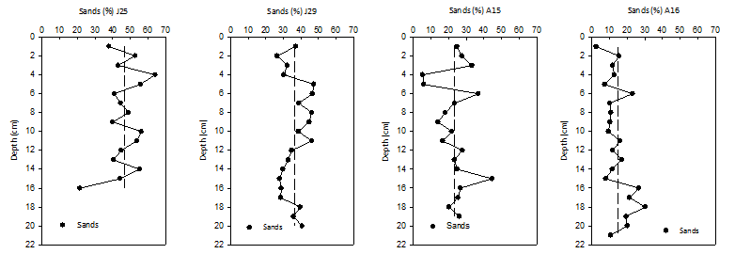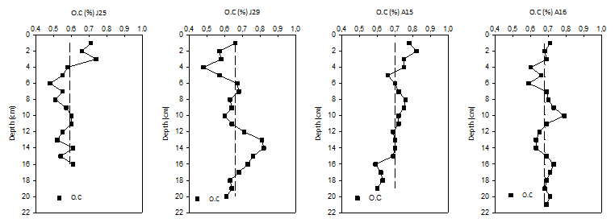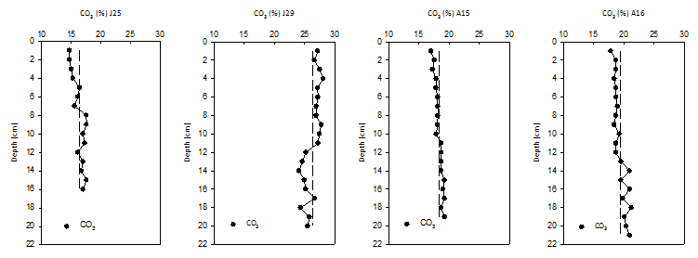

Figure 3 Variation of SiO2, CaO, Al2O3, Na2O, Fe2O3, K2O, MgO, MnO, P2O5, and TiO2 in core profiles. Vertical dashed lines show average values over entire core depth.

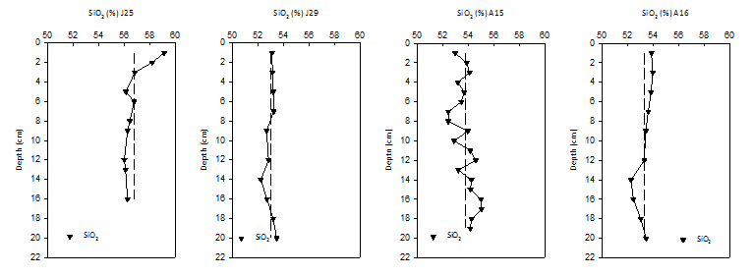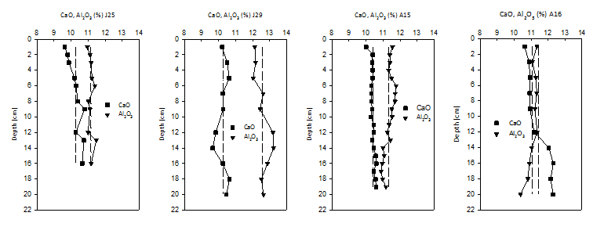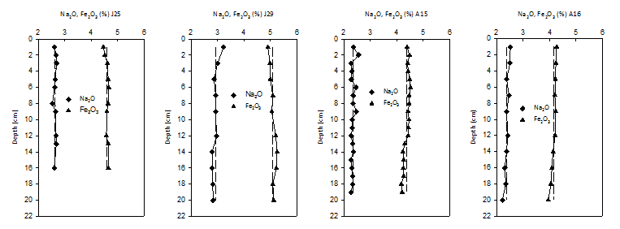

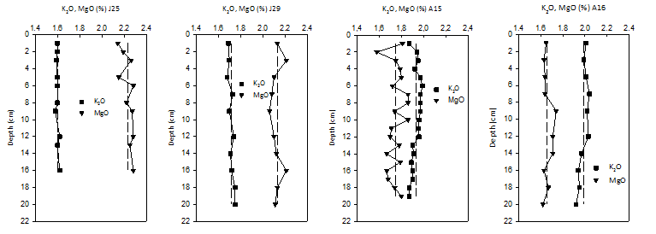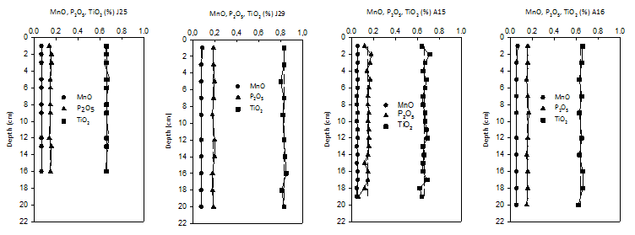Figure 4 Variation of Ni, V, Cr, Zn, Cu, Co, Pb and As, normalized to Al2O3 (wt.%) in core profiles. Vertical dashed lines show average values over entire core depth.

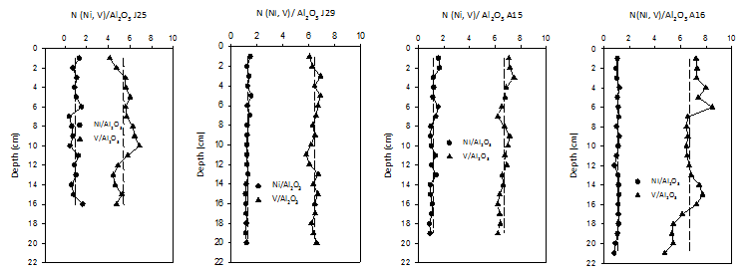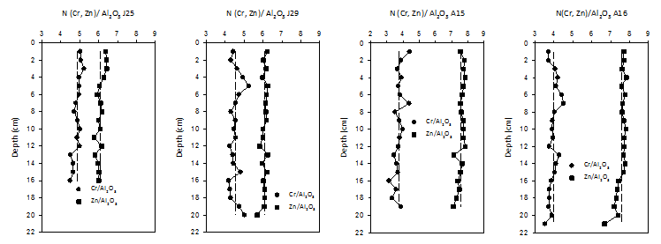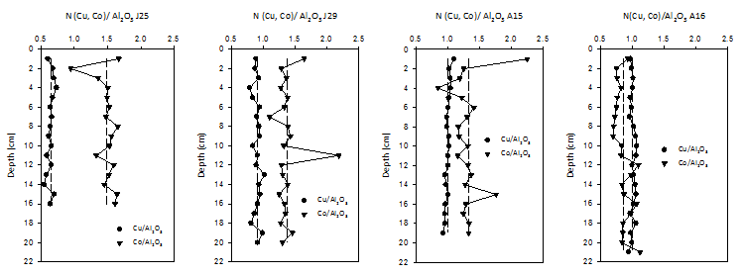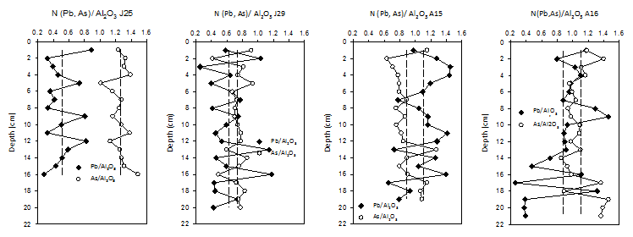

Figure 5 Tree diagram from cluster analysis. See text for further discussion.



Note: n= 49 cases, Complete linkage, City-block (Manhattan) distances.

Figure 6 Variation of 210Pb activity concentrations vs depth in cores J25, J29, A15 and A16.



**Supplementary material**

Table S1 Correlation matrix for major elements (SiO2, TiO2, Al2O3, Fe2O3, MnO, MgO, CaO, Na2O, K2O, P2O5), organic carbon (O.C) and carbonates (CO3) in the four cores studied. Correlations shown in red are statistically significant at 95% confidence.

|  |  |  |  |  |  |  |  |  |  |  |  |  |
| --- | --- | --- | --- | --- | --- | --- | --- | --- | --- | --- | --- | --- |
|  | SiO2 | TiO2 | Al2O3 | Fe2O3 | MnO | MgO | CaO | Na2O | K2O | P2O5 | CO3 | O.C |
| **(J25)** SiO2 | 1 | -0.45 | -0.4 | **-0.84** | 0.12 | **-0.61** | **-0.80** | -0.08 | -0.15 | -0.12 | **-0.77** | **0.64** |
| **(J29)** SiO2 | 1 | -0.45 | **-0.61** | -0.56 | 0.12 | -0.03 | **0.77** | 0.21 | 0.23 | -0.12 | 0.34 | **-0.8** |
| **(A15)** SiO2 | 1 | 0.26 | **-0.82** | -0.56 | 0.5 | **-0.72** | **0.68** | -0.16 | -0.35 | -0.05 | 0.57 | -0.58 |
| **(A16)** SiO2 | 1 | -0.01 | 0.32 | -0.02 | 0.33 | -0.32 | **-0.77** | 0.49 | 0.49 | 0.15 | **-0.80** | 0.18 |
| **(J25)** TiO2 |  | 1 | 0.25 | 0.28 | 0.07 | -0.13 | 0.25 | 0.1 | 0.23 | -0.23 | 0.29 | **-0.70** |
| **(J29)** TiO2 |  | 1 | 0.59 | 0.52 | 0.07 | 0.46 | **-0.60** | -0.02 | 0.19 | -0.10 | -0.30 | **0.68** |
| **(A15)** TiO2 |  | 1 | 0.10 | 0.52 | **0.61** | -0.54 | -0.06 | 0.35 | 0.54 | **0.66** | -0.15 | 0.30 |
| **(A16)** TiO2 |  | 1 | 0.3 | 0.54 | 0.37 | -0.19 | -0.12 | 0.49 | 0.12 | 0.44 | -0.02 | 0.21 |
| **(J25)** Al2O3 |  |  | 1 | **0.68** | -0.38 | 0.31 | 0.43 | 0.32 | -0.11 | 0.57 | **0.67** | **-0.63** |
| **(J29)** Al2O3 |  |  | 1 | **0.94** | -0.38 | -0.05 | **-0.78** | -0.47 | 0.56 | 0.2 | **-0.75** | **0.84** |
| **(A15)** Al2O3 |  |  | 1 | **0.84** | -0.07 | 0.49 | **-0.72** | 0.35 | **0.69** | 0.31 | **-0.67** | **0.63** |
| **(A16)** Al2O3 |  |  | 1 | **0.82** | 0.3 | 0.37 | **-0.82** | **0.79** | **0.93** | 0.38 | **-0.72** | -0.26 |
| **(J25)** Fe2O3 |  |  |  | 1 | **-0.59** | 0.54 | **0.7** | -0.11 | 0.07 | 0.32 | **0.67** | **-0.63** |
| **(J29)** Fe2O3 |  |  |  | 1 | **-0.59** | 0.04 | -0.59 | **-0.72** | 0.56 | 0.1 | **-0.78** | **0.74** |
| **(A15)** Fe2O3 |  |  |  | 1 | 0.22 | 0.18 | **-0.6** | 0.37 | **0.86** | **0.61** | **-0.67** | **0.66** |
| **(A16)** Fe2O3 |  |  |  | 1 | 0.14 | 0.37 | -0.50 | **0.70** | **0.63** | 0.45 | -0.31 | -0.22 |
| **(J25)** MnO |  |  |  |  | 1 | 0.38 | -0.24 | 0.25 | 0.40 | 0.13 | 0.34 | -0.07 |
| **(J29)** MnO |  |  |  |  | 1 | 0.04 | -0.07 | **0.84** | -0.38 | 0.00 | 0.28 | -0.01 |
| **(A15)** MnO |  |  |  |  | 1 | **-0.67** | -0.16 | 0.3 | 0.24 | 0.49 | -0.22 | 0.09 |
| **(A16)** MnO |  |  |  |  | 1 | -0.12 | -0.42 | 0.48 | 0.19 | 0.11 | -0.46 | 0.22 |
| **(J25)** MgO |  |  |  |  |  | 1 | **0.61** | 0.19 | 0.15 | 0.13 | 0.43 | -0.32 |
| **(J29)** MgO |  |  |  |  |  | 1 | 0.16 | -0.02 | -0.07 | -0.22 | -0.15 | 0.01 |
| **(A15)** MgO |  |  |  |  |  | 1 | -0.36 | -0.44 | 0.1 | -0.35 | -0.19 | 0.05 |
| **(A16)** MgO |  |  |  |  |  | 1 | -0.12 | 0.07 | 0.38 | 0.41 | -0.10 | -0.27 |
| **(J25)** CaO |  |  |  |  |  |  | 1 | -0.07 | 0.04 | 0.09 | **0.92** | **-0.68** |
| **(J29)** CaO |  |  |  |  |  |  | 1 | -0.04 | -0.05 | -0.44 | 0.38 | **-0.89** |
| **(A15)** CaO |  |  |  |  |  |  | 1 | -0.29 | -0.28 | -0.25 | **0.80** | **-0.68** |
| **(A16)** CaO |  |  |  |  |  |  | 1 | **-0.82** | **-0.88** | -0.39 | **0.96** | 0.02 |
| **(J25)** Na2O |  |  |  |  |  |  |  | 1 | -0.20 | 0.43 | -0.36 | 0.29 |
| **(J29)** Na2O |  |  |  |  |  |  |  | 1 | -0.44 | 0.08 | **0.60** | -0.22 |
| **(A15)** Na2O |  |  |  |  |  |  |  | 1 | 0.31 | 0.38 | -0.33 | 0.52 |
| **(A16)** Na2O |  |  |  |  |  |  |  | 1 | **0.74** | 0.36 | **-0.69** | -0.17 |
| **(J25)** K2O |  |  |  |  |  |  |  |  | 1 | -0.39 | -0.01 | -0.16 |
| **(J29)** K2O |  |  |  |  |  |  |  |  | 1 | -0.22 | **-0.64** | 0.17 |
| **(A15)** K2O |  |  |  |  |  |  |  |  | 1 | **0.68** | -0.37 | 0.40 |
| **(A16)** K2O |  |  |  |  |  |  |  |  | 1 | 0.41 | **-0.81** | -0.23 |
| **(J25)** P2O5 |  |  |  |  |  |  |  |  |  | 1 | -0.05 | 0.12 |
| **(J29)** P2O5 |  |  |  |  |  |  |  |  |  | 1 | -0.08 | 0.18 |
| **(A15)** P2O5 |  |  |  |  |  |  |  |  |  | 1 | -0.39 | 0.44 |
| **(A16)** P2O5 |  |  |  |  |  |  |  |  |  | 1 | -0.37 | 0.57 |
| **(J25)** CO3 |  |  |  |  |  |  |  |  |  |  | 1 | **-0.73** |
| **(J29)** CO3 |  |  |  |  |  |  |  |  |  |  | 1 | **-0.61** |
| **(A15)** CO3 |  |  |  |  |  |  |  |  |  |  | 1 | **-0.76** |
| **(A16)** CO3 |  |  |  |  |  |  |  |  |  |  | 1 | -0.08 |
| **(J25)** O.C |  |  |  |  |  |  |  |  |  |  |  | 1 |
| **(J29)** O.C |  |  |  |  |  |  |  |  |  |  |  | 1 |
| **(A15)** O.C |  |  |  |  |  |  |  |  |  |  |  | 1 |
| **(A16)** O.C |  |  |  |  |  |  |  |  |  |  |  | 1 |

Note: n = 10 (J25, J29, A16), n=19 (A15) and α = 0.05 (J25, J29, A15, A16)

Table S2 Factor Analysis, including data, for the four cores studied.

|  |  |  |  |  |  |
| --- | --- | --- | --- | --- | --- |
| **Factor 1** | | **Factor 2** | | **Factor 3** | |
| Mineralogy | | Texture | | Anthropogenic influence | |
| CO3 | **0.85** | Sand | **-0.83** | V | **0.70** |
| O.C. | **-0.94** | Silt | **0.63** | Ni | **0.77** |
| SiO2 | **0.94** | Clay | **0.88** | Cu | **0.70** |
| TiO2 | **-0.95** | Pb | **0.81** |  |  |
| Al2O3 | **0.93** |  |  |  |  |
| Fe2O3 | **0.92** |  |  |  |  |
| MnO | **-0.95** |  |  |  |  |
| MgO | **-0.96** |  |  |  |  |
| CaO | **0.95** |  |  |  |  |
| Na2O | **0.68** |  |  |  |  |
| K2O | **0.98** |  |  |  |  |
| P2O5 | **-0.95** |  |  |  |  |
| Zn | **0.96** |  |  |  |  |
| Cr | **0.82** |  |  |  |  |
| Co | **0.60** |  |  |  |  |
| As | **-0.96** |  |  |  |  |
| **Exp. Var.** | **14.8** |  | **4.86** |  | **2.02** |
| **Prop. Total** | **0.62** |  | **0.20** |  | **0.08** |

Note: n=49 (includes all cores) and α = 0.05

Figure S1 Variation of Ni, V, Cr, Zn, Cu, Co, Pb and As in core profiles. Vertical dashed lines show average values over entire core depth.

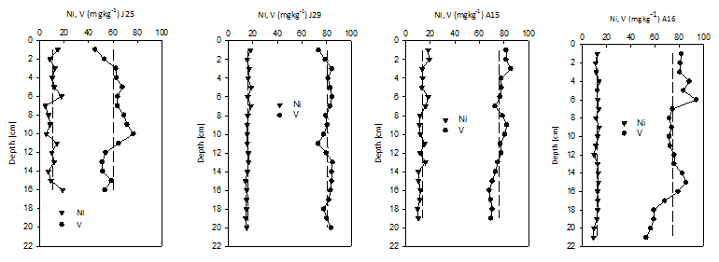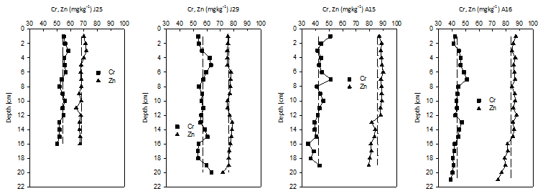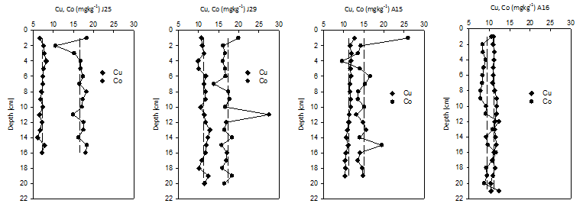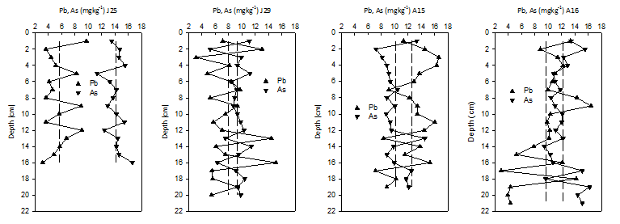

Figure S2 Variation of Enrichment Factors (EFs) for Ni, V, Cr, Zn, Cu, Co, Pb and As in core profiles. Vertical dashed lines show EF = 1.

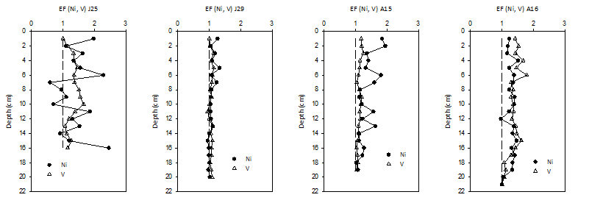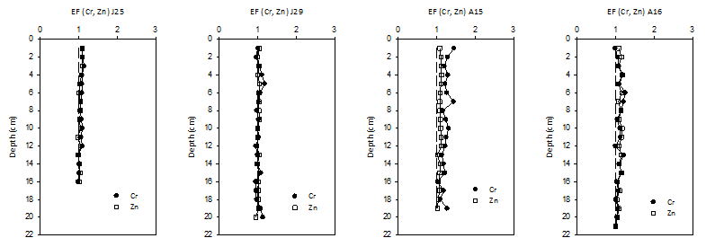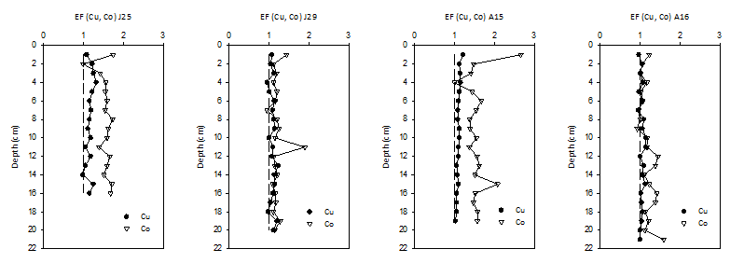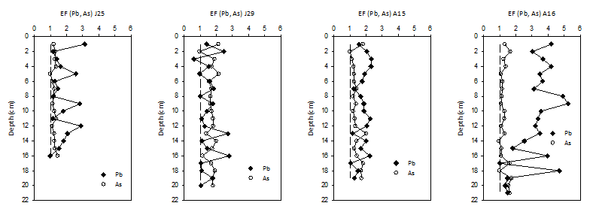

Figure S3 Variation of Geo-accumulation Index (Igeos) for Ni, V, Cr, Zn, Cu, Co, Pb and As in core profiles. Vertical dashed lines show Igeo = 0.









Figure S 4 Variation of Modified Degree of Contamination (mCd) (vertical dashed lines show mCd = 1) for every core and Sediment Quality Guidelines (vertical dashed lines show ERL (Effect of low range) and ERM (Mid-Range Effect)) for Ni, V, Cr, Zn, Cu, Co, Pb and As in core profiles.





