Autonomous Unmanned Aerial Vehicle Perching and Manipulation on a Street Lamppost

Chang Liu, Leyton Paget, Peter Turner, Mehmet Ali Erbil, Stephen Prior

In the last decade, with the maturing capabilities of Unmanned Aerial Vehicles (UAVs) for autonomous operations, there has been an increased interest in UAVs physically interacting with the environment. This is useful for those tasks that have to be carried out in remote locations, due to the significant safety risks to people and the difficulties of access by ground vehicles. Moreover, there are estimated 7.5 million street lamps across the UK, which present a dense array of elevated sites from which crucial elements of various counter-terrorism operations could be conducted remotely, using the UAV as a platform for the efficient deployment of tactical sensors.

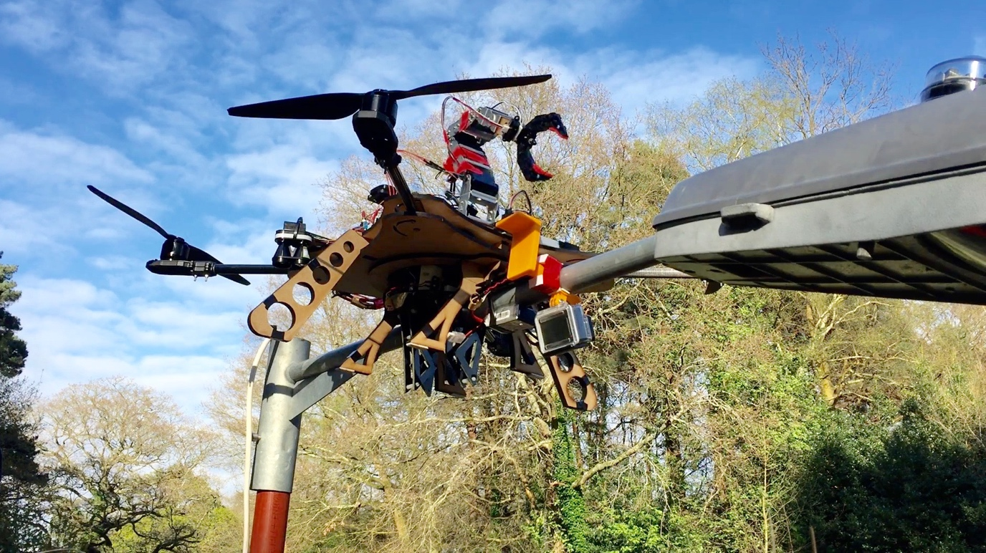

This paper presents a low-cost UAV system using commercial-off-the-shelf (COTS) components, that is capable of autonomously perching on a street lamppost, and performing sensor (camera) (un-)installation on the lamppost with its onboard robotic arm.

The platform’s autonomous perching was realized by integration of an Infra-Red (IR) tracking sensor and a laser rangefinder which tracks an IR emitter pre-installed on the lamppost. The IR tracking sensor measures the horizontal offset of the vehicle relative to the IR emitter, while the laser rangefinder is used to measure the distance from the vehicle to the IR emitter. Both measurements are fused to provide feedback command to guide the platform to land on the lamppost with ±10 cm accuracy. The perching mechanism is also described in this paper.

Additionally, a four degree of freedom (DoF) robotic arm was installed on the platform to perform autonomous sensor (un-)installation. The robotic arm was custom made to have the minimal mass while still have sufficient strength for the task, which was controlled by an Arduino, with an IR ranger for the detection of the sensor.

The system provides an efficient, safe and low-cost method for installing and removing temporary security sensors to/from street lamps to combat various anti-social behaviour offences. It can also be deployed with alternative sensors for disaster response or Chemical, biological, radiological and nuclear (CBRN) measurement.

