Correlated Resistive/Capacitive State Variability in Solid TiO₂ based Memory Devices
Qingjiang Li^{1*}, Iulia Salaoru², Ali Khiat², Hui Xu¹ and Themistoklis Prodromakis²
¹ College of Electronics Science and Engineering, National University of Defense Technology, Changsha, 410073, China
² Nano Group, Southampton Nanofabrication Centre, Department of Electronic and Computer Science, University of Southampton, Southampton, SO17 1BJ, UK
*Email: qingjiangli@nudt.edu.cn

Abstract
In this work, we experimentally demonstrated the correlated resistive/capacitive switching and state variability in practical TiO₂ based memory devices. Based on filamentary functional mechanism, we argue that the impedance state variability stems from the randomly distributed defects inside the oxide bulk. Finally, our assumption was verified via a current percolation circuit model, by taking into account of random defects distribution and coexistence of memristor and memcapacitor.
Keywords: state variability, defects distribution, memcapacitor

1. Introduction
Four decades ago, Chua proposed the concept of memory-resistors (memristors) based on a symmetry argument [1]. In 2009, two new memory elements were proposed and named as memory-capacitors (memcapacitors) and memory-inductors (meminductors) [2]. Nowadays, there is an ever increasing interest in implementing such memory elements in solid-state format [2]-[5]. Recently, coexistence of memristive and memcapacitive behaviors has been experimentally observed in practical resistive switching devices [6]-[9]. In these reports, it was shown that the switching trends of resistance and capacitance could be correlated [6], [9] or anti-correlated [7], [8] depending on the employed materials and devices’ dimensions. To date, the underlying physical mechanism of this coexistence of resistance and capacitance is still a bone of contention with nano-battery effects [10], Schottky barriers between interface and oxide [6], [7], and non-uniform displacement of ionic species forming and rupturing conductive filaments [8], [9] being proposed to account for this phenomenon.
In previous studies [7], [11]-[13], the dispersion of resistive OFF state has been ascertained to be significantly larger than that of ON state. Yet, the capacitive state distributions and their relation with resistance dispersion have not been explored so far. In this work, we experimentally demonstrate the correlated resistive/capacitive switching in TiO₂-based devices, and show that both resistance and capacitance state variance is in proportion with the mean of each programmed state. We further explore the origin of this observation by employing a modified random circuit breaker (RCB) network model [14] with each branch consisting of a resistor and a capacitor in parallel, and demonstrated that the impedance variability could be transcribed via randomly distributed defects within the devices’ active cores.

2. Methods

2.1 Fabrication of TiO₂ based active cells
In this study, metal-insulator-metal (MIM) devices were fabricated with a Pt/TiO_{2-x}/TiO₂/Pt structure. Initially, 200 nm SiO₂ was thermally grown on top of 4” Silicon wafer for insulating purposes. Then, bottom electrodes (BE), composed of 5 nm adhesive Ti and 30 nm Pt, were deposited by e-gun evaporation. On top of BEs, bilayer titanium oxide was deposited by RF Sputtering start from stoichiometric TiO₂ target at a power of 300 watts; the first layer was sputtered with an Argon flow of 30 sccm and the second with an Argon flow of 2 sccm and an Oxygen flow of 12 sccm; the total thickness of the deposited active core film is 31 nm. Finally, 30 nm Pt Top Electrodes (TE) were deposited.

2.2 Electrical measurements
All devices were electrically investigated utilizing a low-noise Keithley 4200 semiconductor characterization suite. I-V characteristics were initially explored with sweeping potentials bounded between ±4V in steps of 0.1V. Then, to investigate the impedance properties, 20 repeated cycles of programming and evaluating pulses were applied. In each specific cycle, the programming pulses (5V, 10µs for Set and -5V, 10µs for Reset, respectively) were firstly employed to switch the cells to distinct resistive states, with a small 0.5V, 1ms evaluating pulse to measure the resistance. For capacitance measurements, C-V tests were implemented via 30mV, 1MHz AC signals with DC bias being set at 0.5V. Specifically, the measuring option for devices was set to the parallel capacitance and conductance (C_{p}-G_{p}).

3. Results and discussion
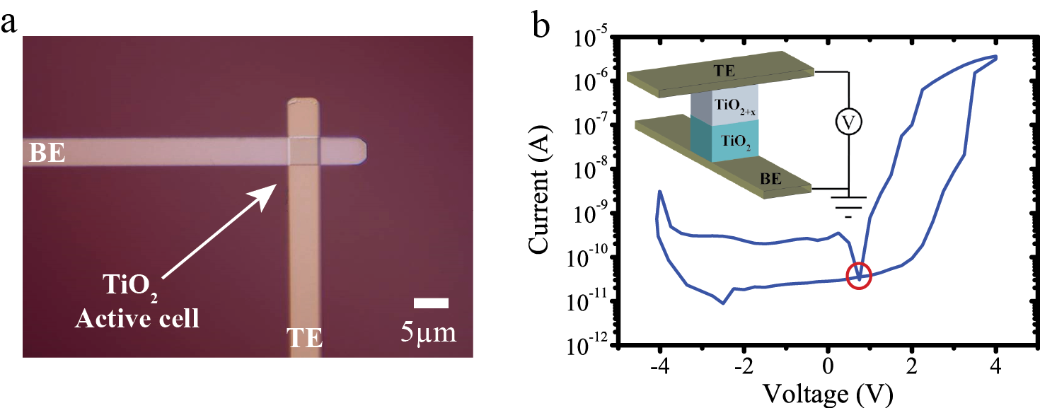
Figure 1 I-V characteristics of TiO₂ based devices. (a) Optical microscope image of a TiO₂ based prototype with an active area of 5×5µm². (b) Measured I-V characteristics biased with sweeping voltages bordered between ±4V in steps of 0.1V. Inset: Schematic view of the device with the measurement configuration.

Fig. 1(a) depicts a top view optical image of a prototype based on the MIM stand-alone architecture. Bilayer active core composed of TiO_{2-x}/TiO₂ is sandwiched between TE and BE, as illustrated in the inset of Fig. 1(b). To verify the resistive switching properties, we employ quasi-state sweeping potentials across the active cell with results demonstrated in Fig. 1(b), which is a typical bipolar memristive signature. The I-V response shows a rectification behavior, indicating a Schottky contact. The plausible mechanisms are as follows: the adequate oxygen vacancies in TiO_{2-x} layer lead to an ohmic contact between TE and active TiO_{2-x} layer, while the contact between TiO₂ layer and BE is still Schottky contact [13], which together contribute a rectification behavior showing in Fig. 1(b). It is worth noting that a non-zero-crossing behavior is experimentally observed at 0.75V. This phenomenon has recently been considered to be contradicting the original memristor theory and a plausible extension is to incorporate a nano-battery effect [10]. In case of TiO₂ based devices, we have recently demonstrated that it manifests the co-existence of memristive and memcapacitive features [8], [9].
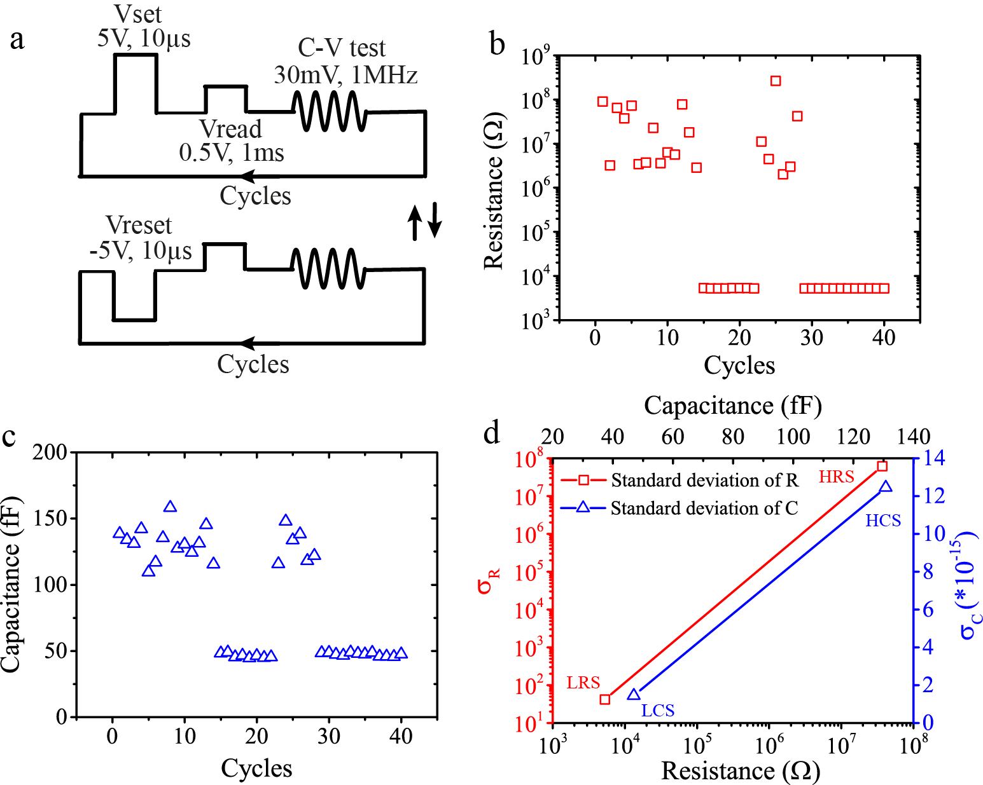
Figure 2 Measured resistive and capacitive state variability. (a) Impedance programming evaluating scheme. (b) Resistive switching and state dispersion in HRS and LRS. (c) Capacitive switching and state dispersion in HCS and LCS. (d) The relation between standard deviation and distinct programmed resistive (capacitive) states.
As illustrated in Fig. 2(a), a series of pulse-induced Set programming cycles were repeated until resistive states toggled from HRS to LRS, and then the Reset cycles were implemented till it switched back. The corresponding resistance and capacitance switching behaviors were depicted in Figs. 2(b) and 2(c), respectively. These experimental results demonstrate the correlation between resistive and capacitive switching behaviors. Specifically, the impedance states toggled from the high resistive state (HRS) to low resistive state (LRS), and correspondingly from high capacitive state (HCS) to low capacitive state (LCS) when positive programming pulses were employed. Meanwhile, an opposite impedance switching trend was shown to occur with negative programming polarities. It should be noted that the all capacitance measurement is implemented at 1MHz and the frequency dispersion of the capacitance measurement will not influent the correlated resistive/capacitive switching though the capacitance switching ratio is frequency-dependent [9]. Similar correlated resistive/capacitive switching has been previously reported in perovskite [6] and HfO_{x} [15] based devices. It should be noted that all tested devices were electrically characterized without employing electroforming step, which enhances the devices interoperability with low-voltage CMOS technologies. As a result, the activation energy supplied by a single Set or Reset pulse is not sufficient to switch the device. Resistive switching events are thus not available at each programming pulse, rather at multiple pulses that facilitate an accumulative behavior, as demonstrated in Figs. 2(b) and 2(c). Obviously, the state variability of HRS is significantly larger than that of LRS [13]. It is intriguing to note that similar trend applies for the capacitive switching, namely the variance of HCS outweighs that of LCS. Detailed analysis and comparisons are depicted in Fig. 2(d). Specifically for resistive switching, the average resistance increased from 5.27KΩ to 37MΩ whilst the standard deviation increased from 41.83 to 6.11×10⁷. In case of capacitive switching, when the mean value increased from 47fF to 130fF, the standard deviation also raised up, with a difference of 9 times.
In practical devices, randomly distributed local defects (oxygen vacancies and/or titanium interstitials for TiO₂ based devices) could act as conductive percolation branches within the devices’ active cores. When biased with external stimuli, these percolation branches would render continuous filaments that bridge the barrier between TE and BE. We thus argue that in HRS, the barrier between annihilated filament and BE would render a poor DC conduction that can be modelled as a large-value capacitor (HCS) [15]. Thus, the randomly distributed defects would significantly affect the dispersion of the impedance states in repeated programming and evaluating cycles. In case of LRS however, most of the current would percolate through the formed continuous filaments, thus the bulk capacitance would be short-circuited, leading to the LCS. As a result, the influence of the defects distribution on impedance dispersion would be minimized. Our hypothesis was further verified by employing a modified RCB network model, taking into account of correlated resistive and capacitive switching. It should be noted that the employed RCB model only simulate functional filamentary dynamics and cannot reveal the underlying physical nature of filamentary dynamics as discussed in [16].
To evaluate the correlated resistive/capacitive switching and state dispersion, a two-dimension 20×20 RCB model was employed. Inside the network, each branch was modelled as a parallel combination of a resistor and a capacitor. As illustrated in Fig. 3(a), a red branch represents a conductive defect with R_{ON} (400Ω, represents LRS) and C_{ON} (15fF, represents LCS) in parallel, while the insulating TiO₂ branches were modelled via high-value resistors (R_{OFF}=80MΩ, represents HRS) and capacitors (C_{OFF}=1.5pF, represents HCS) in blue. At the OFF state, the active TiO2 film is ideally considered as stoichiometric and thus purely insulating. Nonetheless, in practice a finite number of intrinsic defects will exist, which are accounted for in our model as a number of randomly distributed small resistors. Considering that a SET potential will facilitate some local modification of the active material in the form of a conductive filament that in turn will result in a state modulation, we represent this change by altering some of the branch resistances to higher conductance values. The density of added percolation branches in all states obeys a normal distribution (200, 60), while these defects were randomly distributed. But in LRS and LCS, a continuous percolation channel bridging from TE to BE was added within the network. It is worthy to point out that these parameters may largely change for different set of samples, dielectric materials and structures. Nonetheless, the above values were found in good fits for the measured data in Fig. 2. As demonstrated in Figs. 3(b) and 3(c), in consecutive simulation cycles, the resistive switching was always accompanied by a correlated capacitive switching, and the simulated state dispersion keeps synchronous with the results observed experimentally. In essence, state dispersions in high impedance states were demonstrated to stem from the randomly distributed defects within the oxide bulk, while the influence of defects would be minimized in low impedance states where a continuous filament would short-circuit the active core.
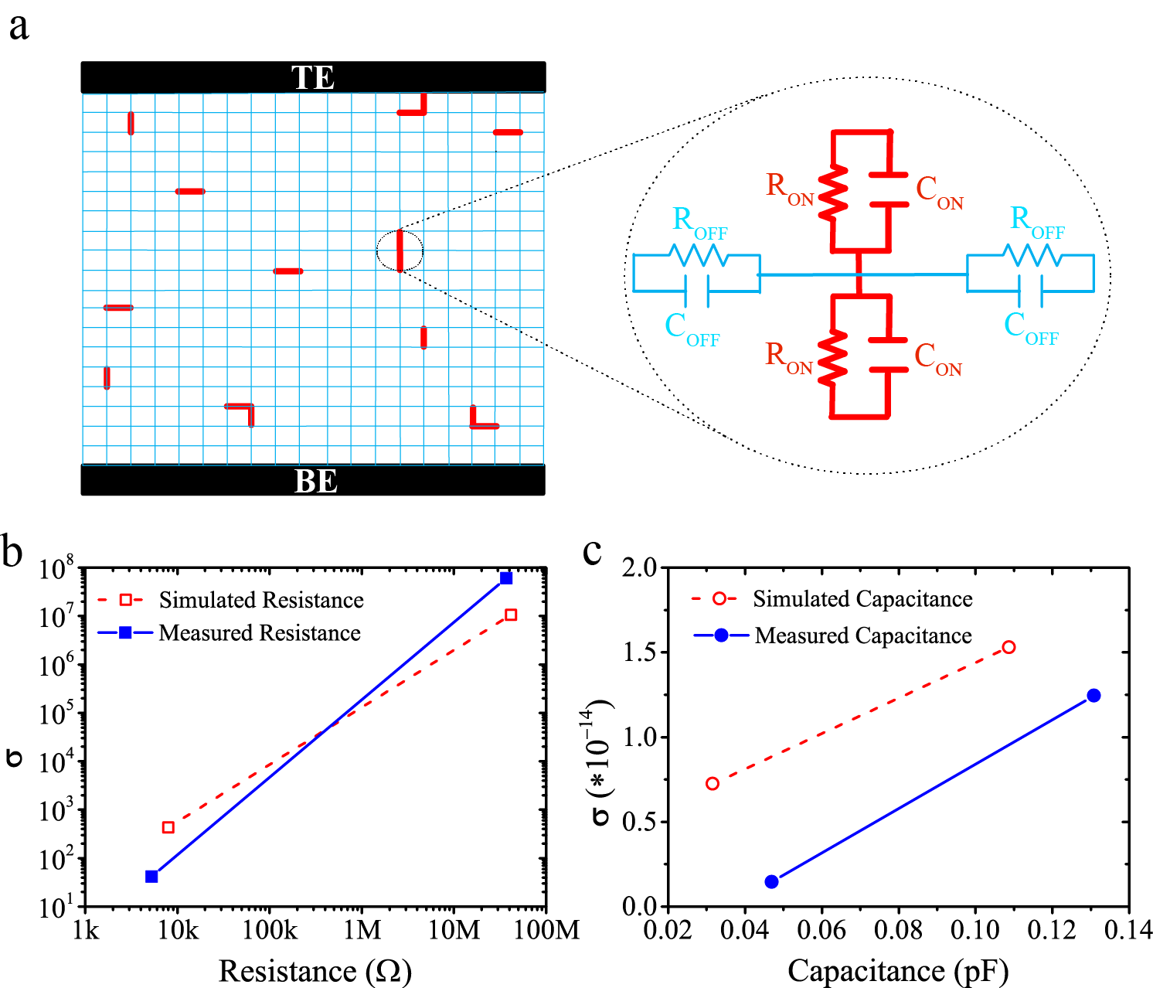
Figure 3 Simulated resistive and capacitive state variability. (a) Schematic of the modified RCB model. Within the network, each percolation branch is modeled as a parallel of a resistor and a capacitor. (b) and (c) The relation between standard deviation and programmed resistive/capacitive states for simulated and measured cases.
It should be noted that the above analysis only hold for the assumed current percolation model. In TiO₂ based practical devices, multiple mechanisms (Schottky barriers and/or filamentary formation and rupture) would be dominant concurrently, which could result in a more complex behavior.

4. Conclusion
In conclusion, we have experimentally demonstrated the synchronous resistive/capacitive switching trends, and the correlation between resistance/capacitance variance and programmed states. We finally demonstrated this phenomenon stems from the random distributed defects within the active cores. It is thus of critical importance to consider this phenomenon in further ReRAM development, as the resistance and capacitance variability at high impedance states would significantly affect the accurate control of devices’ states and add additional parasitism.

Acknowledgements
We acknowledge the finicial support of the National Nature Science Foudation (61604177, 61471377), NUDT Science Support Program (JC-15-04-02), and EPSRC (EP/K017829/1).

References
- L. Chua, IEEE Transactions on Circuit Theory 18 (5), 507 (1971).
- M. Di Ventra, Y. V. Pershin, and L. O. Chua, Proceedings of the IEEE 97 (10), 1717 (2009).
- Dmitri B Strukov, Gregory S Snider, Duncan R Stewart, and R Stanley Williams, Nature 453 (7191), 80 (2008).
- Rainer Waser, Regina Dittmann, Georgi Staikov, and Kristof Szot, Advanced Materials 21 (25‐26), 2632 (2009).
- Y. V. Pershin and M. Di Ventra, Advances in Physics 60 (2), 145 (2011).
- Shangqing Liu, N. J. Wu, A. Ignatiev, and Jianren Li, Journal of applied physics 100 (5), 056101 (2006).
- Z. B. Yan and J. M. Liu, Scientific Reports 3 (2013).
- Iulia Salaoru, Ali Khiat, Qingjiang Li, Radu Berdan, and Themistoklis Prodromakis, Applied Physics Letters 103 (23), 233513 (2013).
- Li Qingjiang, Ali Khiat, Iulia Salaoru, Christos Papavassiliou, Xu Hui, and Themistoklis Prodromakis, Scientific Reports 4 (2014).
- Ilia Valov, Eike Linn, Stefan Tappertzhofen, Sebastian Schmelzer, Jan van den Hurk, Florian Lentz, and Rainer Waser, Nature communications 4, 1771 (2013).
- F. Miao, Yi Wei, Ilan Goldfarb, and J. Joshua Yang, ACS nano 6 (3), 2312 (2012).
- Hai Yang Peng, Yong Feng Li, Wei Nan Lin, and Yu Zhan Wang, Scientific Reports 2, 442 (2012).
- Salaoru Iulia, Khiat Ali, Li Qingjiang, Berdan Radu, Papavassiliou Christos, and Prodromakis Themistoklis, Journal of Physics D: Applied Physics 47 (14), 145102 (2014).
- Seung Chul Chae, Jae Sung Lee, Sejin Kim, Shin Buhm Lee, Seo Hyoung Chang, Chunli Liu, Byungnam Kahng, Hyunjung Shin, Dong‐Wook Kim, and Chang Uk Jung, Advanced Materials 20 (6), 1154 (2008).
- Shimeng Yu, Rakesh Jeyasingh, Yi Wu, and H-S Philip Wong, Applied Physics Letters 99 (23), 232105 (2011).
- S. Yu, X. Guan, and H. S. P. Wong, IEEE Transactions on Electron Devices 59 (4), 1183 (2012).

