Supporting Information

What do we actually see in intracellular SERS? Investigating nanosensor-induced variation

J. Taylora, J. Miltonb, M. Willettc J. Wingfieldd and S. Mahajana*

aDepartment of Chemistry and Institute of Life Sciences (IfLS), bBiological Sciences,cOcean & Earth Sciences, University of Southampton, United Kingdom, SO17 1BJ.

dDiscovery Sciences, Screening and Compound Management, AstraZeneca, Unit 310 - Darwin Building, Cambridge Science Park, Milton Road, Cambridge, United Kingdom, CB4 0WG.



Figure S1: Optimisation of AuNP incubation period

The cellular uptake of AuNPs was observed as a percentage of cell area following incubation of SH-SY5Y cells over a 38 h period. Maximal uptake was observed at 24 h. This incubation duration was thus carried into our investigation of cellular stress events induced by AuNP internalisation.

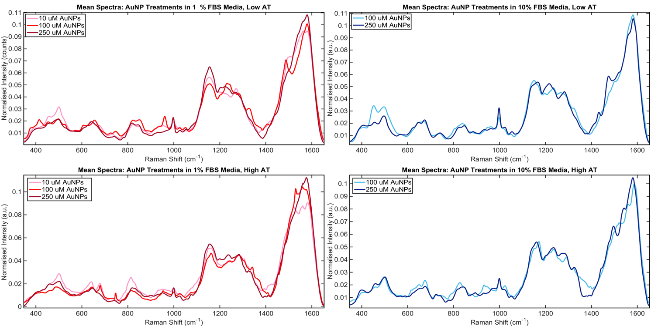

Figure S1: Effect of different acquisition times on spectra

Spectra acquired under two different acquisition conditions yield very similar spectra. Top row are SERS spectra acquired with acquisition times (AT) of 1 s with 3 averages and on the bottom are SERS spectra acquired with 10 s AT with 3 averages. Spectra for all treatments are shown. The other conditions for acquisition were exactly the same between the different acquisitions.

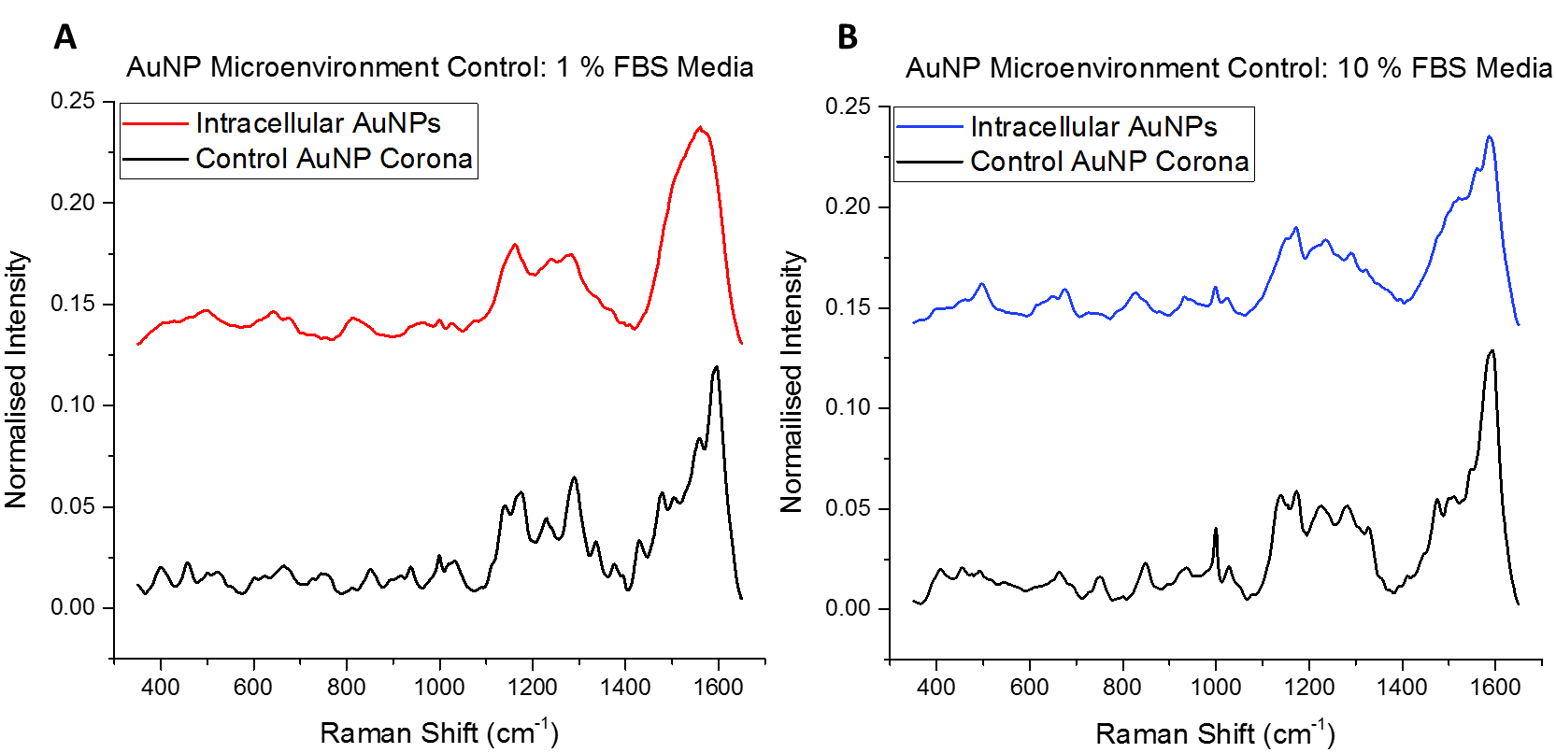

Figure S3A-B

In order to confirm SERS measurement from intracellular AuNPs, control AuNPs were incubated in 1 and 10 % FBS-media compositions for 24 h before washing, storage and taking SERS measurements in PBS. 5 spectra were recorded from different regions of AuNPs in each treatment. Acquired spectra from A) 1 % and B) 10 % FBS conditions are compared to respective spectra taken from cells incubated with 100 µM AuNPs. In both cases, distinct vibrational peaks, attributed to serum proteins forming a protein corona about the AuNPs, are observed. Cellular internalisation is confirmed by the spectral differences between control and cell spectra, primarily involving increased complexity of spectra in cellular cases which gives rise to broadened, overlapped peaks as a direct result of sampling complex cellular environments.

Table S1A-B: Tentative SERS spectral peak assignments of mean spectra

Mean spectral assignments across studied concentrations in A) 1 % FBS and B) 10 % AuNP treatments

**A**



**B**

