Case Report
Novel presenting phenotype in a child with autosomal dominant Best’s vitelliform macular dystrophy

Introduction
Autosomal dominant Best’s vitelliform macular dystrophy (AD BVMD) is reported to be caused by mutations in the Bestrophin 1 gene (BEST1)¹, ². The bestrophin protein, found in the basolateral plasma membrane of the retinal pigment epithelium (RPE), possibly modulates Ca²⁺ influx into the cells.³, ⁴. When mutated, RPE dysfunction results in lipofuscin accumulation, leading to RPE and photoreceptors degeneration.⁵ The electro-oculogram (EOG), measuring the potential across the RPE, is typically reduced with a reduced Arden ratio (light peak to dark trough).⁶ This test is pathognomic of Bestrophinopathies and is rarely used in the clinical setting unless this diagnosis is being sought.
BVMD usually manifests with visual failure in the first or second decade of life; however, there is a large variability in expressivity of the disease and some patients have no manifestation other than a pathological EOG.^{1,} ⁷
AD BVMD phenotype varies with the stage of the disease.^{8,9} In the previtelliform stage, the macula is either normal or there might be subtle RPE changes. Well-circumscribed, dome shaped yellow or orange lesion; about a disc diameter in width described as an egg-yolk appearance appears in the vitelliform stage (stage 2). There is a variable amount of admixed transparent fluid which increases in time resulting in Stage 3 (pseudohypopyon), yellow material can break through the RPE and accumulate in the subretinal space in a cyst with a fluid level formed. This stage most often is found in the teenage years, but it has been described in individuals aged 8-38 years. Stage 4 (vitelliruptive), ‘scrambled egg’ appearance is due to the breakup of the uniform vitelliform lesion. Pigment clumping and early atrophic changes may be noted.
Autofluorescence imaging has shown that after disappearance of the vitelliform lesion there is a wide spread of fluorophore deposition.¹⁰ In the later stages Spaide et al ¹¹described OCT findings comparable to central serous retinopathy with subretinal fluid depositions.
Alternatively, Autosomal Recessive (AR) BVMD was described as a distinct entity due to a biallelic mutation in the BEST1 gene.¹² Phenotypic features include RPE irregularities, more evident as flecks on autofluorescence, in addition to intraretinal and subretinal fluid seen clinically and on optical coherence tomography (OCT). However no vitelliform lesions are seen.

In this report, we describe an atypical clinical presentation of AD BVMD in a 6 year old more typical of that seen in AR disease or other retinal pathologies. Importantly, BEST1 associated disease was only sought because of a very typical AD BVMD phenotype identified in the probands father.

Case Report
A five year old female was referred to us from another centre with reduced vision and family history of AD macular dystrophy, and a pedigree was drawn (Fig.1)
Her presenting vision was 0.325 logMAR for the right eye and 0.300 for the left by SLT testing, she had a small well controlled exophoria and normal colour vision when tested with ishihara plates.
On fundus examination her macula had a mottled appearance (Fig.2) and spectral domain (SD) - OCT (Heidelberg Spectralis, Heidelberg Engineering, Germany) showed intraretinal pseudocysts resembling a schisis and mainly localized in the outer nuclear layer. Notably, SD-OCT showed no recognizable foveal depression and multiple pseudocysts at the level of the inner and outer nuclear layers. The outer plexiform layer was well visible and demarcated very well the pseudocysts of the inner retina from those of the outer retina. The outer plexiform layer, the ellipsoid and the cone outer segment termination (COST) lines appeared to be crowded. The left eye also showed larger pseudocyst formation in the outer nuclear layer, pinpoint reflectivity representing damaged photoreceptors and a small flat area of hyporeflectivity representing subretinal fluid. (Fig.3).

EOG was abnormal in both eyes. The ratio of light peak to dark trough (Arden Ratio) was 1.3 for the left eye and 1.4 for the right eye (values of >1.7 are considered normal).

Cone and Rod flash electroretinograms (ERGs) were present but smaller than age matched controls and marginally degraded.
Occipital pattern visual evoked potentials (VEPs) were normal with the exception of those to the smallest 10’ checks which were degraded (right eye worse than left) which was consistent with her level of vision.
The degraded small check VEPs with sub-optimal ERGs and reduced EOG Arden ratios correlated with clinical findings and when coupled with the family history, were suggestive of AD Bestrophinopathy.

The proband’s father had a typical burnt out Best’s phenotype with 0.46 log MAR vision in the right eye and 0.40 in the left, with normal colour vision on ishihara and full fields. His fundus showed a central scrambled egg lesion on both maculae with an area of hyperpigmentation in the right eye. Subretinal fluid and RPE disruption is evident on high resolution SD- OCT.
Both the proband and her father were screened for coding sequence variants in the BEST1 gene by bidirectional sanger sequencing. Both were found to be heterozygous for a previously reported pathogenic AD BVMD variant c.37C>T p. (Arg13Cys). ¹³
After our proband had received 3 months of topical Dorzolamide BD in both eyes, no affect on intra-retinal fluid load was seen (Fig 3)
The proband’s younger sister is currently being screened for the family mutation.

Figure 1.

Figure 2. Probands fundus photograph

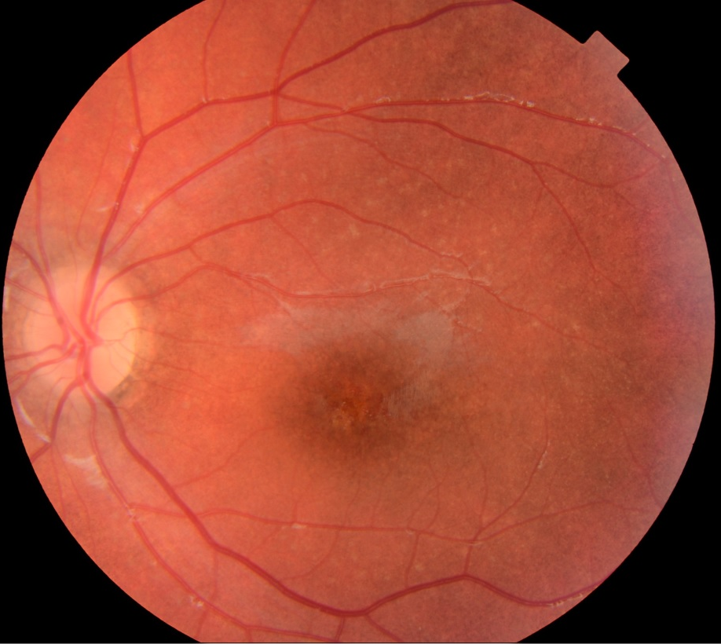
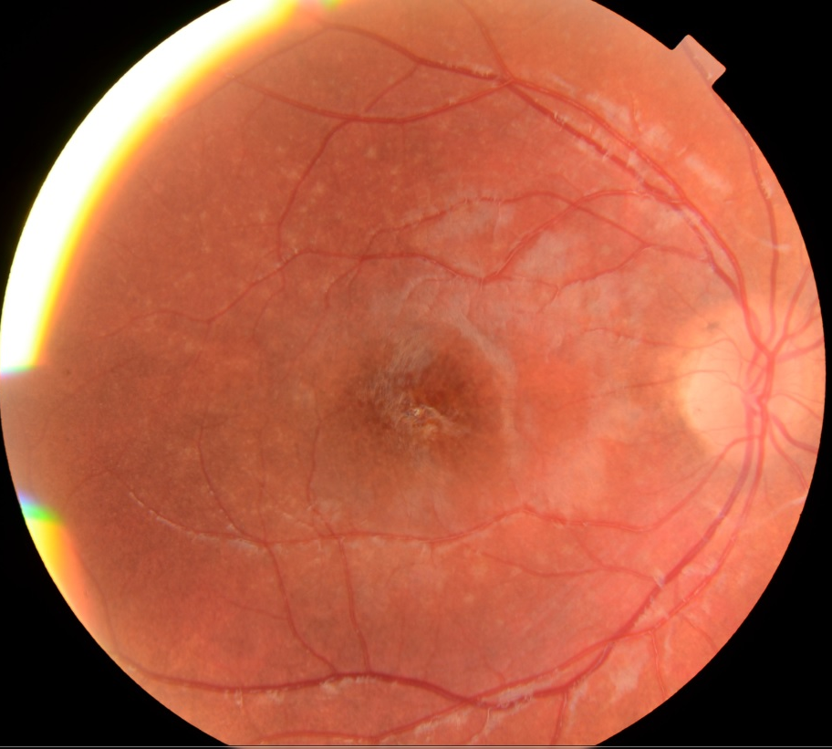

Figure 3. Proband spectral domain (SD) - OCT

A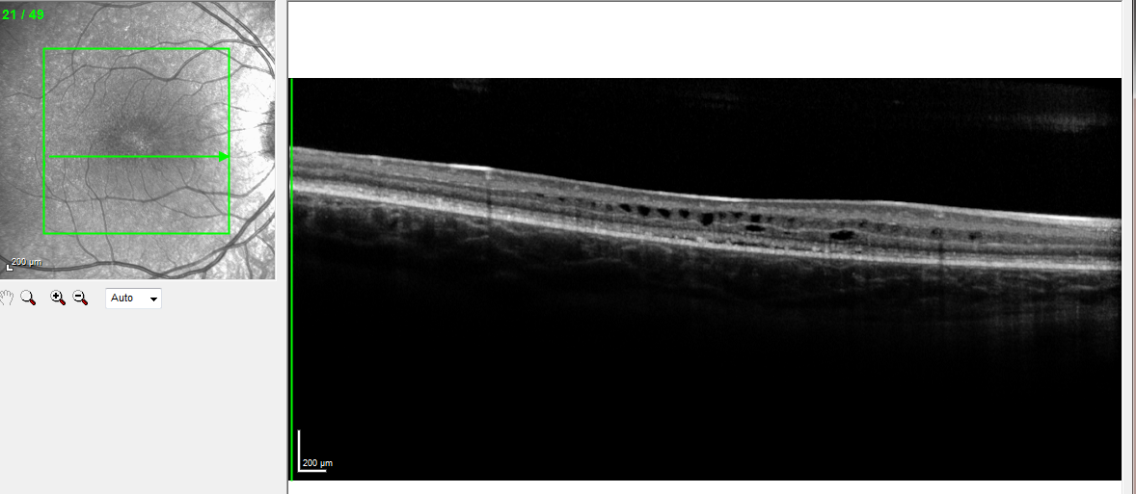
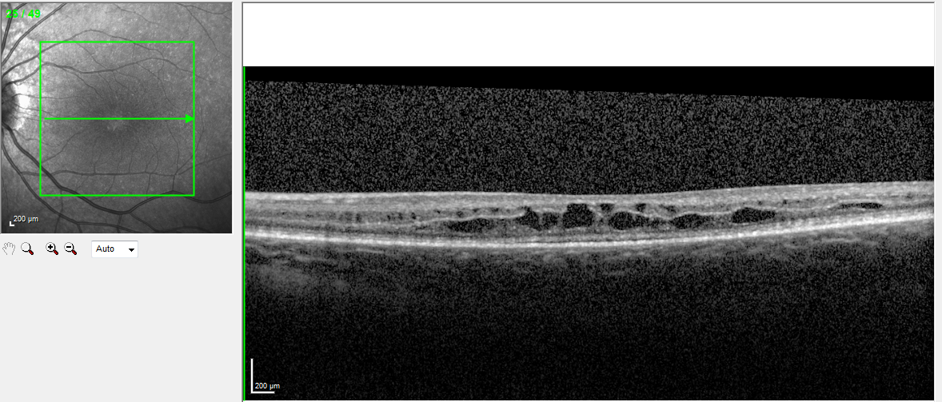
B

Figure 4. Fathers fundus photograph and autofluorescence

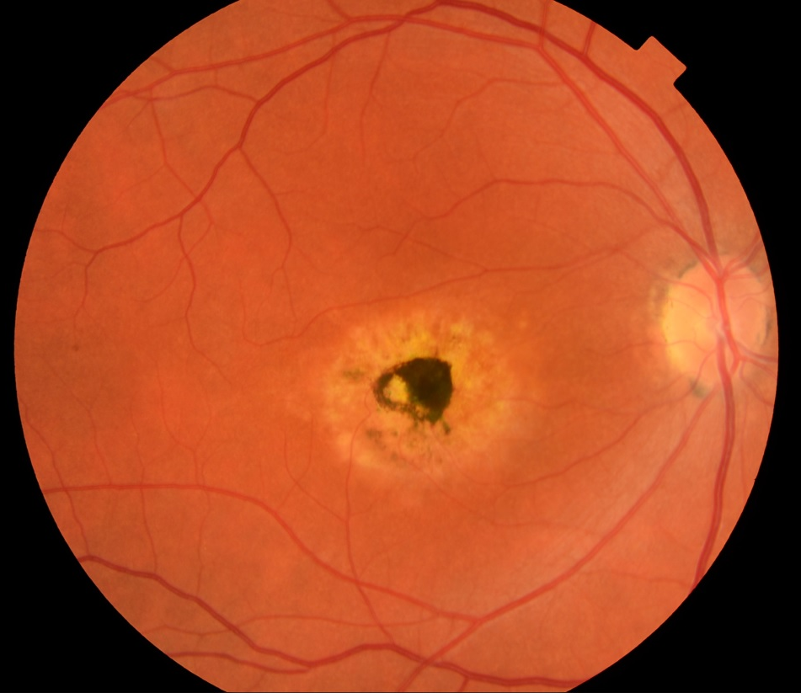 | 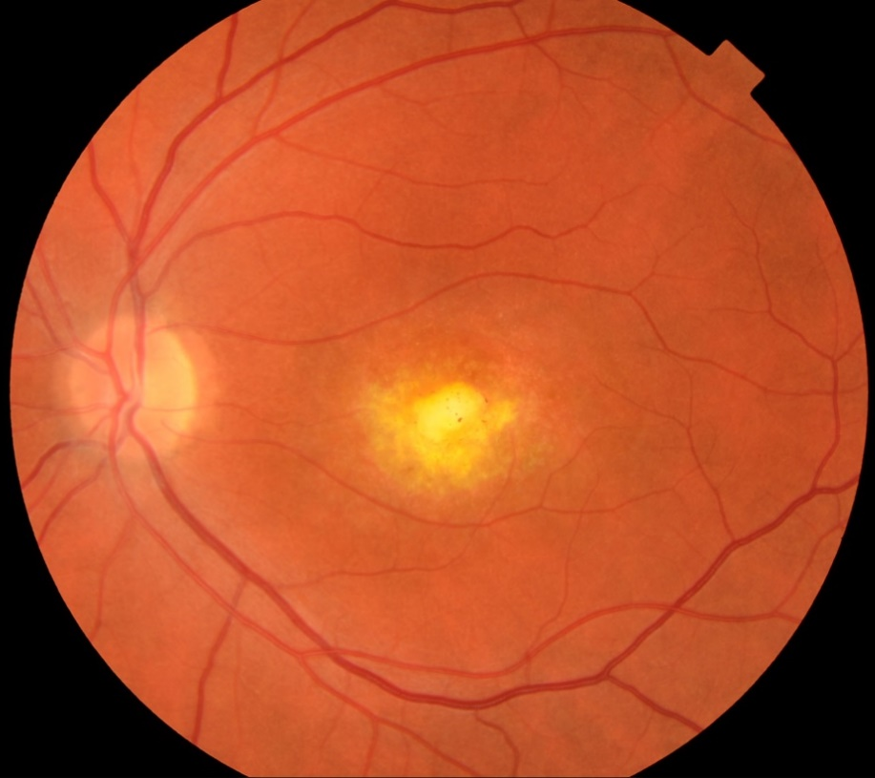
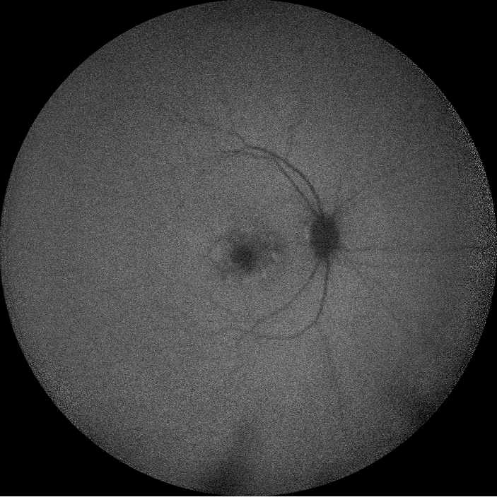 | 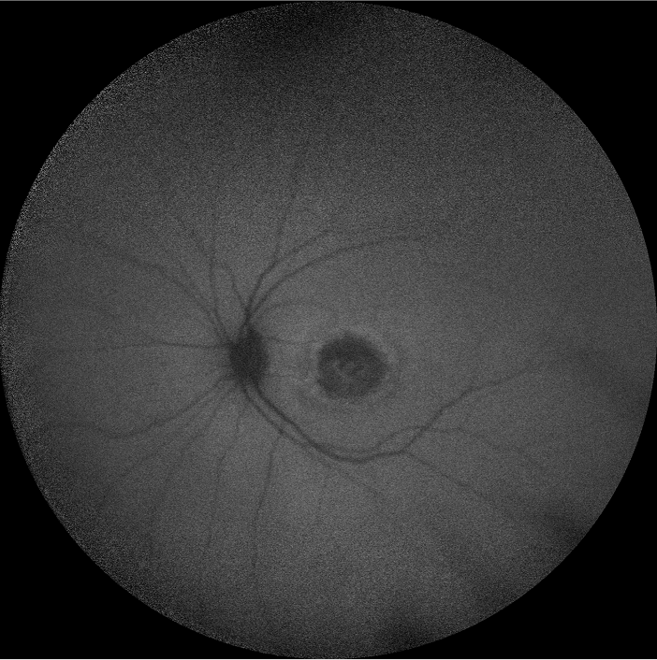

Figure 5. Fathers spectral domain (SD) - OCT

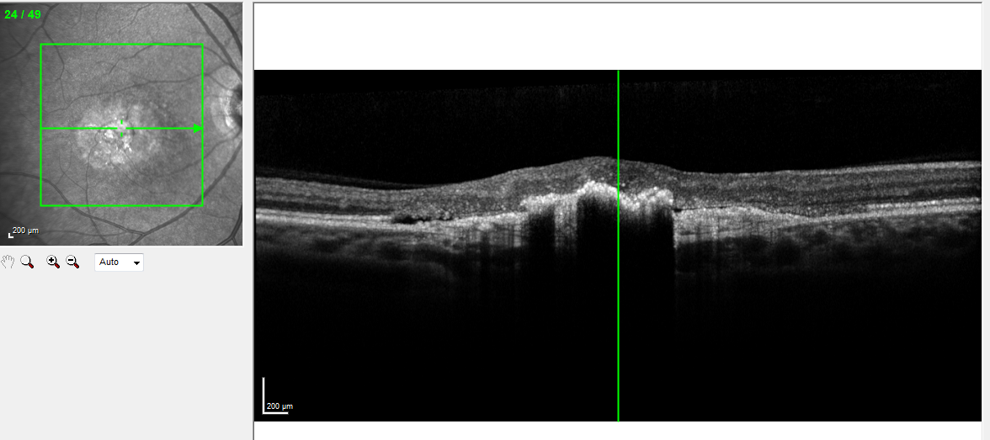

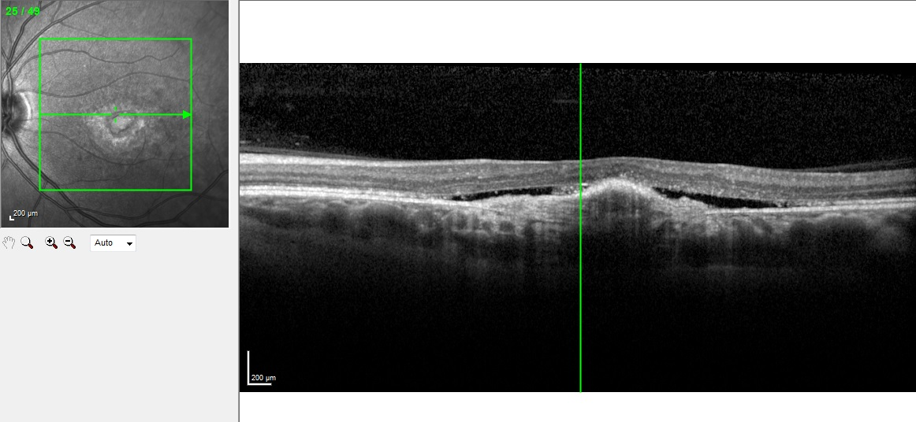

Discussion

The clinical picture of AD BVMD is quite variable even among members of the same family¹⁴. Phenotyping in the early stages of BEST1 disease in children is limited in the literature due to the challenging nature of examination the techniques making good quality retinal imaging and electro diagnostic data challenging. A number of case reports describe advanced disease and neovascular complications in children aging 8 to 9 but the early atypical phenotype we describe here in a young girl, has not been described before. ¹⁵⁻¹⁷

In 2006, Schatz et al¹⁸ reported the first documented instance in which compound heterozygosity for 2 mutations (Y29X and R141H) caused an especially severe and early-onset BVMD phenotype. In 2008, Burgess et al¹² reported a series of patients with clear-cut AR BVMD and described differences in the clinical appearance of these patients compared to patients with AD BVMD. In brief, the distinctive features of AR BVMD were reported to be subretinal or intraretinal fluid in the absence of subfoveal vitelliform lesions, disseminated punctate retinal flecks, hyperopic refraction, and subnormal delayed rod- and cone-driven ERG responses. Burgess¹² et al proposed the term autosomal recessive bestrophinopathy to characterize the presentation of these AR BVMD cases and noted that the unusual case reported by Schatz¹⁷ et al was likely to be a case of AR bestrophinopathy as well.
In the case presented here, the SD-OCT findings (Figure 3) are more consistent with AR BVMD or indeed another retinal pathology. She was found heterozygous to BEST1 c.37C >T p.(Arg 13 Cys), which has been reported previously in literature in cases with the typical AD phenotype ¹³
We believe this is the first report of AD Best disease presenting with intraretinal and subretinal fluid in the absence of other typical features. This novel finding should alert clinicians to consider AD BVMD in the differential diagnosis when seeking a cause for macular fluid in this young age group in addition to encouraging the use of EOG in children with atypical intraretinal fluid.

Figure legends
Figure 1 - Family Pedigree

Figure 2 – Proband Colour fundus photographs showing mottled appearance of both maculae and normal appearance of peripheral retina

Figure 3 – Proband A. Spectral coherence tomography (SD-OCT) of the right eye showing absent foveal depression and multiple pseudocysts at the level of the inner and outer nuclear layers. The outer plexiform layer is well visible and demarcates very well the pseudocysts of the inner retina from those of the outer retina. The outer plexiform layer, the ellipsoid and the cone outer segment termination (COST) lines appear to be crowded. B. SD-OCT of the left eye showing a similar aspect to the right eye, but with larger pseudocysts in the outer nuclear layer. Pinpoint reflectivity representing damaged photoreceptors is seen in the outer retina together with flat hyporeflectivity representing subretinal fluid.
Figure 4 – Fathers Fundus Photos and auto fluorescence showing typical Best’s Phenotype

Figure 5 - Fathers spectral domain (SD) - OCT of both eyes with typical Best’s appearance A. Right eye B. Left eye

References
1. Ponjavic V, Eksandh L, Andreasson S, Sjostrom K, Bakall B, Ingvast S, Wadelius C, Ehinger B. Clinical expression of Best's vitelliform macular dystrophy in Swedish families with mutations in the bestrophin gene. Ophthalmic Genet 1999; 20(4)251–257.
2. Petrukhin K, Koisti M J, Bakall B, Li W, Xie G, Marknell T, Sandgren O, Forsman K, Holmgren G, Andreasson S, Vujic M, Bergen A A, McGarty-Dugan V, Figueroa D, Austin C P, Metzker M L, Caskey C T, Wadelius C. Identification of the gene responsible for Best macular dystrophy. Nat Genet 1998; 19(3)241–247.
3. Marmorstein A D, Marmorstein L Y, Rayborn M, Wang X, Hollyfield J G, Petrukhin K. Bestrophin, the product of the Best vitelliform macular dystrophy gene (VMD2), localizes to the basolateral plasma membrane of the retinal pigment epithelium. Proc Natl Acad Sci USA 2000; 97(23)12758–12763.
4. Strauss O, Marmorstein A D, Marmorstein L Y, Bakall B, Stanton J B, Wadelius C, Peachey N S, Rosenthal R. Bestrophin modulates the activity of L-type Ca2+ channels in RPE cells. April, 26 2004. ARVO, Fort Lauderdale, FloridaUSA, Poster
5. O'Gorman S, Flaherty W A, Fishman G A, Berson E L. Histopathologic findings in Best's vitelliform macular dystrophy. Arch Ophthalmol 1988; 106(9)1261–1268.
6. Pinckers A, Cuypers MH, Aandekerk AL. The EOG in Best's disease and dominant cystoid macular dystrophy (DCMD). Ophthalmic Genet. 1996 Sep. 17(3):103-8.
7. Eksandh L, Bakall B, Bauer B, Wadelius C, Andreasson S. Best's vitelliform macular dystrophy caused by a new mutation (Val89Ala) in the VMD2 gene. Ophthalmic Genet 2001; 22(2)107–115.
8. Falls HF. The polymorphous manifestations of Best's disease (vitelliform eruptive disease of the retina).Trans Am Ophthalmol Soc. 1969. 67:265-82.
9.Krill AE, Morse PA, Potts AM, Klien BA. Hereditary vitelliruptive macular degeneration. Am J Ophthalmol. 1966 Jun. 61(6):1405-15.
10.Chung JE, Spaide RF. Fundus Autofluorescence and vitelliform macular dystrophy. Arch Ophthalmol 2004; 122:1078-9.

11. Spaide RF, Noble K, Morgan A, Freund KB. Vitelliform macular dystrophy Ophthalmology. 2006 Aug;113(8):1392-400.
12. Burgess R, Millar I, DLeroy BP et al. Biallelic mutation of BEST1 causes a distinct retinopathy in humans. Am J Hum Genet 2008;82 (1) 19- 31
13. Kinnick TR¹, Mullins RF, Dev S, Leys M, Mackey DA, Kay CN, Lam BL, Fishman GA, Traboulsi E, Iezzi R, Stone EM. Autosomal recessive vitelliform macular dystrophy in a large cohort of vitelliform macular dystrophy patients. Retina. 2011 Mar;31(3):581-95.

14. Kellner S, Stöhr H, Fiebig B, Weinitz S, Farmand G, Kellner U, Weber BH. Fundus Autofluorescence and SD-OCT Document Rapid Progression in Autosomal Dominant Vitreoretinochoroidopathy (ADVIRC) Associated with a c.256G > A Mutation in BEST1. Ophthalmic Genet. 2016 Jan 15:1-8.
15.CELEA, C., POP, M., AVIDIS-ZAMFIROIU, N., & CELEA, C. (2015). Evolution of Choroidal Neovascular Membrane in Best Disease after Single Intravitreal Bevacizumab. Case Report. Mædica, 10(1), 61–64.
16.Iannaccone A, Kerr NC, Kinnick TR, Calzada JI, Stone EM. Autosomal Recessive Best Vitelliform Macular Dystrophy: Report of a Family and Management of Early-Onset Neovascular Complications. Arch Ophthalmol. 2011;129(2):211-217. doi:10.1001/archophthalmol.2010.367.

17. Perol J¹, Wolff B, Sahel JA, Le Mer Y. Intravitreal bevacizumab treatment for choroidal neovascularization in Best's disease. J Fr Ophtalmol. 2011 May;34(5):281-6.

18. Schatz PKlar JAndréasson SPonjavic VDahl N Variant phenotype of Best vitelliform macular dystrophy associated with compound heterozygous mutations in VMD2. Ophthalmic Genet2006;27 (2) 51- 56

